MANIPAL INSTITUTE OF TECHNOLOGY

PARALLEL PROGRAMMING LAB (CSE 3241)

q1.c
//Name : Princita Zina Miranda
//Section : SCE-C
//Roll no. C17, Reg. no. 220905115

// Q) Write a simple MPI program to find out pow(x, rank) for all the processes where 'x' is the integer constant and 'rank' is the rank of the process. Write a program in MPI where even ranked process prints "Hello" and odd ranked process prints "World".

#include "mpi.h"
#include<stdio.h>
#include<stdlib.h>

int main (int argc, char *argv[]){
int x = 4, rank, size;

MPI_Init(&argc, &argv);
MPI_Comm_rank(MPI_COMM_WORLD, &rank);
MPI_Comm_size(MPI_COMM_WORLD, &size);

int val = 1;
for (int i = 0; i < rank; i++)
val *= x;
printf("Power of %d^%d is %d\n", x, rank, val);

if(rank%2==0){
printf("Rank: %d, Hello\n", rank);
printf("\n");
}
else{
printf("Rank: %d, World\n", rank);
printf("\n");
}
MPI_Finalize();
return 0;
}
Output
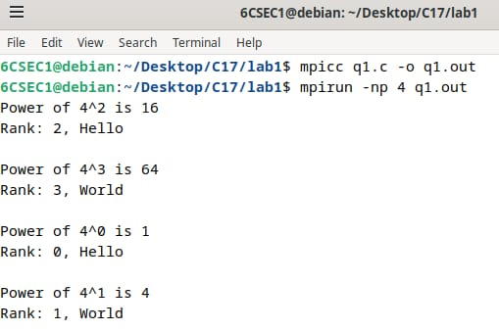

q2.c
//Name : Princita Zina Miranda
//Section : SCE-C
//Roll no. C17, Reg. no. 220905115

// Q) Write a program in MPI to simulate simple calculator. Perform each operation using different process in parallel.

#include "mpi.h"
#include<stdio.h>
#include<stdlib.h>

int main (int argc, char *argv[]){
int a = 2, b = 4, x, rank, size;

MPI_Init(&argc, &argv);
MPI_Comm_rank(MPI_COMM_WORLD, &rank);
MPI_Comm_size(MPI_COMM_WORLD, &size);
switch(rank){
case 0:
x = a+b;
printf("Rank %d gives a+b = %d\n", rank, x);
break;
case 1:
x = a-b;
printf("Rank %d gives a-b = %d\n", rank, x);
break;
case 2:
x = a*b;
printf("Rank %d gives a*b = %d\n", rank, x);
break;
case 3:
x = a/b;
printf("Rank %d gives a/b = %d\n", rank, x);
break;

default:
printf("Invalid rank number %d \n", rank);
break;
}
MPI_Finalize();
return 0;
}
Output
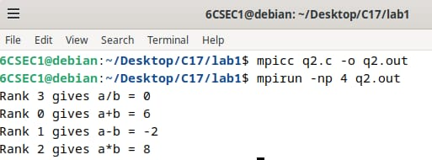

q3.c
//Name : Princita Zina Miranda
//Section : SCE-C
//Roll no. C17, Reg. no. 220905115

// Q) Write a program in MPI to toggle the character of a given string indexed by the rank of the process.

#include<stdio.h>
#include<stdlib.h>
#include "mpi.h"
#include<string.h>

int main(int argc, char *argv[]){
int rank, size;
char str[]="ZINA";
MPI_Init(&argc, &argv);
MPI_Comm_rank(MPI_COMM_WORLD, &rank);
MPI_Comm_size(MPI_COMM_WORLD, &size);
str[rank]=str[rank]+32;
printf("Process %d :%s\n",rank, str);
MPI_Finalize();
return 0;
}

Output
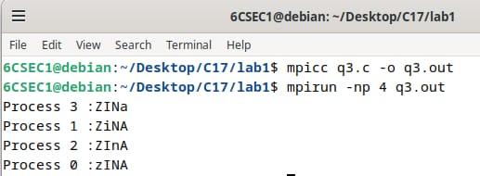
q4.c
//Name : Princita Zina Miranda
//Section : SCE-C
//Roll no. C17, Reg. no. 220905115

// Write a program in MPI where even ranked process prints factorial of the rank and odd ranked process prints rank's Fibonacci number.

#include<stdio.h>
#include<mpi.h>

long long factorial(int n) {
return (n <= 1) ? 1 : n * factorial(n - 1);
}

int main(int argc, char *argv[]){
int fib[15] = {0, 1, 1, 2, 3, 5, 8, 13, 21, 34, 55, 89, 144, 233, 377};
int rank, size;
MPI_Init(&argc, &argv);
MPI_Comm_rank(MPI_COMM_WORLD, &rank);
MPI_Comm_size(MPI_COMM_WORLD, &size);
if(rank % 2 == 0){
printf("Process %d - Fact %d\n", rank, factorial(rank));
}
else{
printf("Process %d - Fib %d\n", rank, fib[rank]);
}
printf("\n \n");
MPI_Finalize();
return 0;
}
Output
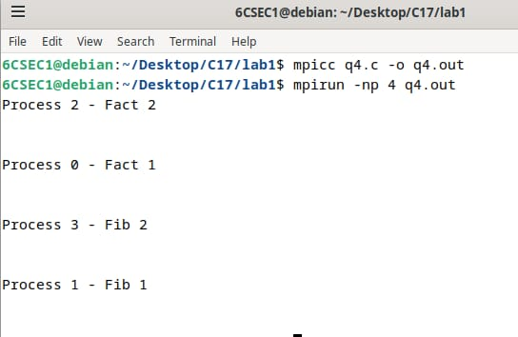

q5.c
// ex1_reverse_digits.c
#include <mpi.h>
#include <stdio.h>

int reverse_num(int n) {
int rev = 0;
while (n > 0) {
rev = rev * 10 + (n % 10);
n = n / 10;
}
return rev;
}

int main(int argc, char *argv[]) {
int rank, size;
int input[9] = {18, 523, 301, 1234, 2, 14, 108, 150, 1928};
int output[9];

int my_num, my_rev;

MPI_Init(&argc, &argv);
MPI_Comm_rank(MPI_COMM_WORLD, &rank);
MPI_Comm_size(MPI_COMM_WORLD, &size);

if (size != 9) {
if (rank == 0) {
printf("Run this program with exactly 9 processes.\n");
printf("Example: mpirun -np 9 ./ex1\n");
}
MPI_Finalize();
return 0;
}

// Scatter: 1 integer to each process (rank 0..8)
MPI_Scatter(input, 1, MPI_INT, &my_num, 1, MPI_INT, 0, MPI_COMM_WORLD); // [web:0]

my_rev = reverse_num(my_num);

printf("Process %d got %d and reversed to %d\n", rank, my_num, my_rev);

// Gather: collect 1 integer result from each process back to rank 0
MPI_Gather(&my_rev, 1, MPI_INT, output, 1, MPI_INT, 0, MPI_COMM_WORLD); // [web:0]

if (rank == 0) {
printf("\nInput array : ");
for (int i = 0; i < 9; i++) printf("%d ", input[i]);

printf("\nOutput array: ");
for (int i = 0; i < 9; i++) printf("%d ", output[i]);
printf("\n");
}

MPI_Finalize();
return 0;
}
Output
q6.c
// ex2_primes_1_to_100.c
#include <mpi.h>
#include <stdio.h>

int is_prime(int n) {
if (n < 2) return 0;
for (int i = 2; i * i <= n; i++) {
if (n % i == 0) return 0;
}
return 1;
}

int main(int argc, char *argv[]) {
int rank, size;
int start, end;

MPI_Init(&argc, &argv);
MPI_Comm_rank(MPI_COMM_WORLD, &rank);
MPI_Comm_size(MPI_COMM_WORLD, &size);

if (size != 2) {
if (rank == 0) {
printf("Run this program with exactly 2 processes.\n");
printf("Example: mpirun -np 2 ./ex2\n");
}
MPI_Finalize();
return 0;
}

if (rank == 0) {
start = 1; end = 50;
} else {
start = 51; end = 100;
}

printf("Process %d checking primes from %d to %d:\n", rank, start, end);
for (int n = start; n <= end; n++) {
if (is_prime(n)) {
printf("%d ", n);
}
}
printf("\n");

MPI_Finalize();
return 0;
}
Output

