# Course name

CE631-Simulation and IT Applications in Construction

# Project title

Wildfire Modelling Simulation in Wildland-Urban-Interface

# Group name

Wildfire Modelling Team

# Authors and affiliation

Yizhou Li1, Zhiqing Pan2

*1 Department of Building Environment and Energy Engineering, The Hong Kong Polytechnic University, Hong Kong*

*2 Department of Land Surveying and Geo-Informatics, The Hong Kong Polytechnic University, Hong Kong*

# 1. Introduction

Fire has been a long-existent phenomenon on Earth and an essential part of different ecosystems (Running 2006; Belcher 2013). With the rise of human civilization and the expansion of living space, humans are gradually occupying the wildlands to create more urban areas. Meanwhile, our human activities have caused more and more wildfires and increased the frequency of extreme wildfires. Once a wildfire occurs (Fig. 1), it primarily affects the residents who live in the emerging wildland-urban interface (WUI) (Theobald and Romme 2007; Gill and Stephens 2009).

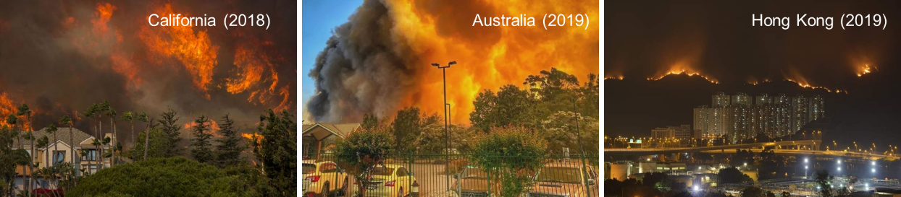

**Fig. 1.** Recent global wildfire incidents

Hong Kong is a highly populated modern city with over 4,000 skyscrapers, but it also has ~70% of its land covered by woodland, shrubland, and wetland (Lee *et al.* 2017). Therefore, it is a typical WUI that is constantly threatened by wildfires. According to the data from Hong Kong Fire Services Department, about 1,000 wildfires (or hill fires) are reported annually. Over 80% of wildfires witness a burning area of less than 1,000 m2 and a burning time of 24 h because of significant firefighting efforts. Still, some wildfires spread to nearby high-population urban areas that cause significant safety issues and air pollution.

Wildfire behavior is a complex and dynamic phenomenon influenced by various factors, including the characteristics of the fuel, topography, weather conditions, and local landscape. As such, fire spread is not always linear or steady-state, and predicting its course can be challenging. In particular, sudden changes in weather conditions or the ignition of new fires can cause rapid shifts in the pattern of wildfire spread, potentially breaching established firebreaks and endangering previously safe areas. Therefore, accurate forecasting of real-time or short-term trends in fire spread is essential for effective wildfire management, particularly in wildland-urban interface (WUI) zones. Real-time fire spread forecasts can aid fire services in allocating resources, planning evacuations, and implementing other emergency response measures by predicting a fire's expected trajectory and intensity. These predictions can also assist residents in making informed decisions about their safety and help to prevent loss of life and property damage.

# 2. Literature Review

Researchers have attempted to simulate wildfires and forecast their spread behaviors since the 1950s or even earlier (Fig. 2). In the early days, most models were simple and probabilistic, based on limited human observation and experience.​ These models mainly assessed the wildfire risk but could not predict wildfire spread (Skinner and Chang 1996). Later in the 1970s, more understanding of wildfire dynamics was introduced to the mathematical model. Notably, Rothermel proposed a widely used semi-physical formula that considers different factors of fire, fuel, landscape, and weather to calculate the wildfire spread (Rothermel 1972).​ In the 1990s, several software tools had been developed to program these semi-physical models and environment parameters to predict 2-D wildland fire spread. For example, FARSITE (later becoming a part of FlamMap) coded Rothermel's equation to simulate and visualize wildfire propagation (Finney 1998). The running of FARSITE needs input from the Geography Information System (GIS), but the data from wildland fuel, weather, and landscape are often challenging to acquire accurately.

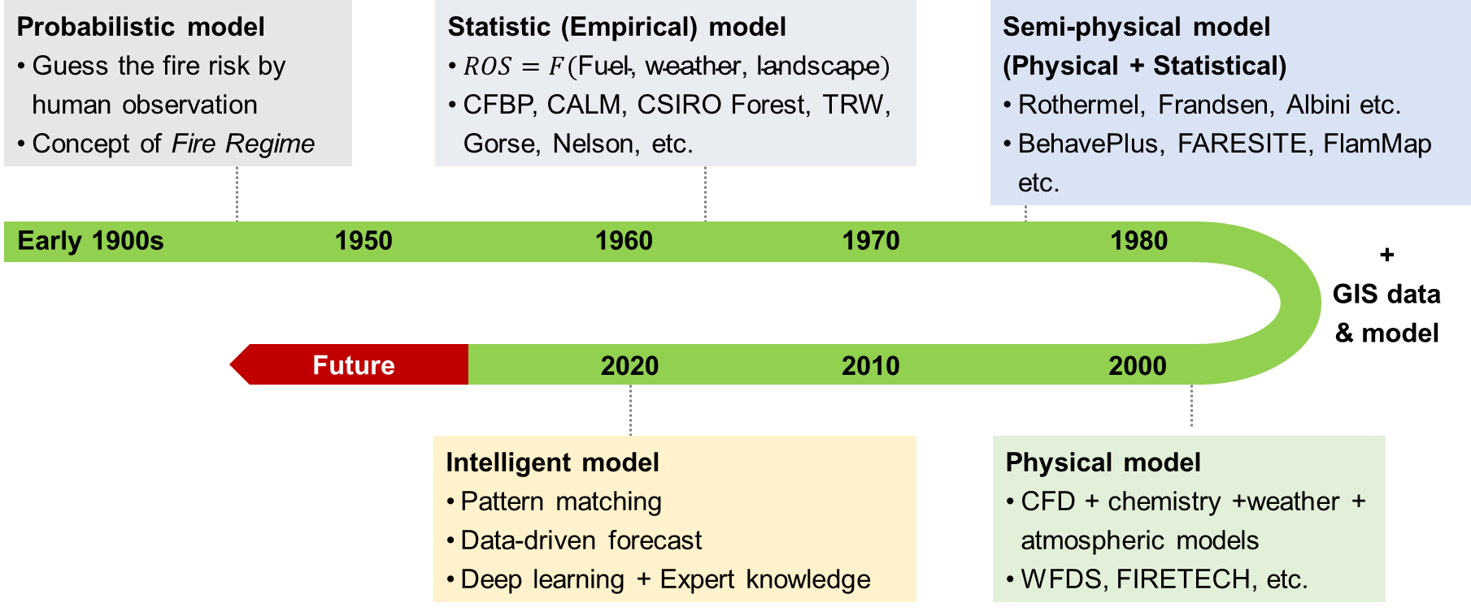

**Fig. 2.** Evolution progress of wildfire modelling

Since the 2000s, several numerical software was developed for physics-based fire modellings, such as HIGRAD/FIRETEC and Wildland Fire Dynamics Simulator (WFDS) (Hoffman *et al.* 2016). These tools are based on computational fluid dynamics (CFD) that can solve the atmospheric flow field and ground boundary flow near the fire (Anderson and Wendt 1995). These tools make wildfire simulation exquisite but consume considerable time and require high computation costs. Overall, the wildfire modelling method is evolving from statistics-based models to physical-based models. Nevertheless, all these computational tools are too slow to give real-time forecasts of wildland fire development. For example, forecasting the wildfire front in a few minutes often takes CFD-based software to run hours, so these kinds of wildfire simulations neither help guide the wildfire emergency response nor plan the prescribed burning.

To overcome the above issues, more recently, new artificial intelligence (AI) models have been proposed for fire forecast (Wang *et al.* 2022; Wu *et al.* 2022; Zhang *et al.* 2022), including wildfire forecast, which is an emerging research topic (Radke *et al.* 2019; Allaire *et al.* 2022; Jiang *et al.* 2022). The mathematic-based computation can be switched into a data-driven matchup in the database, where AI models calculate the mathematical relations among different parameters within seconds. Many researchers optimized the traditional models with AI models to increase the accuracy of forecasts (Radke *et al.* 2019; Zhou *et al.* 2020). Also, deep learning was widely used to explain and predict the wildfire spread rate (Zhai *et al.* 2020; Storey *et al.* 2021; Li, Lin, *et al.* 2022). Deep learning models were also adopted to map and forecast the wildfire risk possibility (Jaafari *et al.* 2019; Le *et al.* 2020; Allaire *et al.* 2022). Meanwhile, the AI-based models primarily decreased the computation time and made the long-term forecast possible in simulating wildfires (Hodges and Lattimer 2019; Sung *et al.* 2021; Li, Zhang, *et al.* 2022).

# 3. Cycle and Steps Description

We can use the grid division method to simulate the spread of the fire, where each grid represents a small area and stores a value between 0 and 1, indicating the degree of burning in that area. 0 indicates no burning (or self-extinguishing), and 1 indicates maximum burning. Now, for a single grid, from meeting the conditions for ignition to complete burning and extinguishing, we can simulate it with a simple loop (Fig. 3).

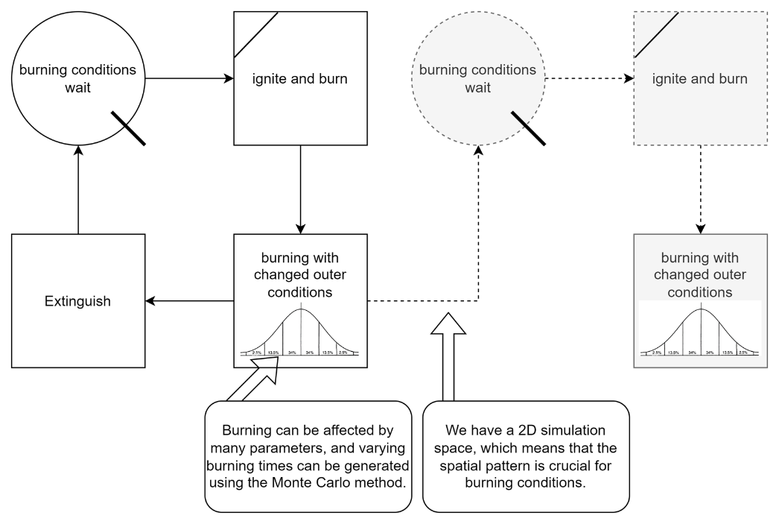

**Fig. 3.** Single grid burning cycle

At each time step, we can calculate the direction and speed of the flame spread based on factors such as wind direction, wind speed, terrain, and vegetation, and then update the burning degree of each grid. In this way, we can simulate the spread of the fire. For the burning time of each grid, we will use the Monte Carlo simulation method to simulate it. We can calculate the probability distribution of the burning time of the vegetation based on historical data and then simulate the burning time of each grid based on this probability distribution (Fig. 4). For the fire spread conditions, we will consider factors such as wind direction, wind speed, terrain, and vegetation. We can calculate the probability of fire spread for each grid based on these factors and then control the spread of the fire based on this probability.

**Fig. 4.** Spatial pattern effect

# 4. Factors that affect simulation

As mentioned above, the wildfire burning process is a complex dynamic process, and we have built a simple burning model cycle for a single grid. From a static perspective, the burning potential of the current grid is at least affected by the following factors:

**Surface combustible reserves:** mainly including vegetation type, vegetation density, vegetation height, vegetation humidity, etc. This part determines the initial conditions of the burning model (fuel quantity and quality) and is the first part that needs to be investigated and modeled.

**Terrain:** mainly including slope, aspect, altitude, etc. For the same vegetation type, the burning speed and direction under different terrain conditions may vary greatly, especially in mountainous areas.

From the dynamic perspective of the burning process:

**Meteorological conditions:** mainly including wind speed, wind direction, temperature, etc. These factors will continuously affect the spread speed and direction of the fire during the burning process. From the perspective of the simulation algorithm, in the "burning with changed outer conditions" step, the model will continuously accept external parameters and continuously update the burning degree of the current grid until the current grid is completely extinguished. When spreading the fire between grids, the spread probability will be calculated based on external parameters and burning grids spacial pattern, and the spread of the fire will be controlled based on this probability.

**Firefighting measures:** mainly including firefighting personnel, firefighting equipment, etc. For dynamic firefighting actions, we can establish a new loop; for static facilities such as firebreaks, they can be part of the terrain and dynamically updated in the simulation.

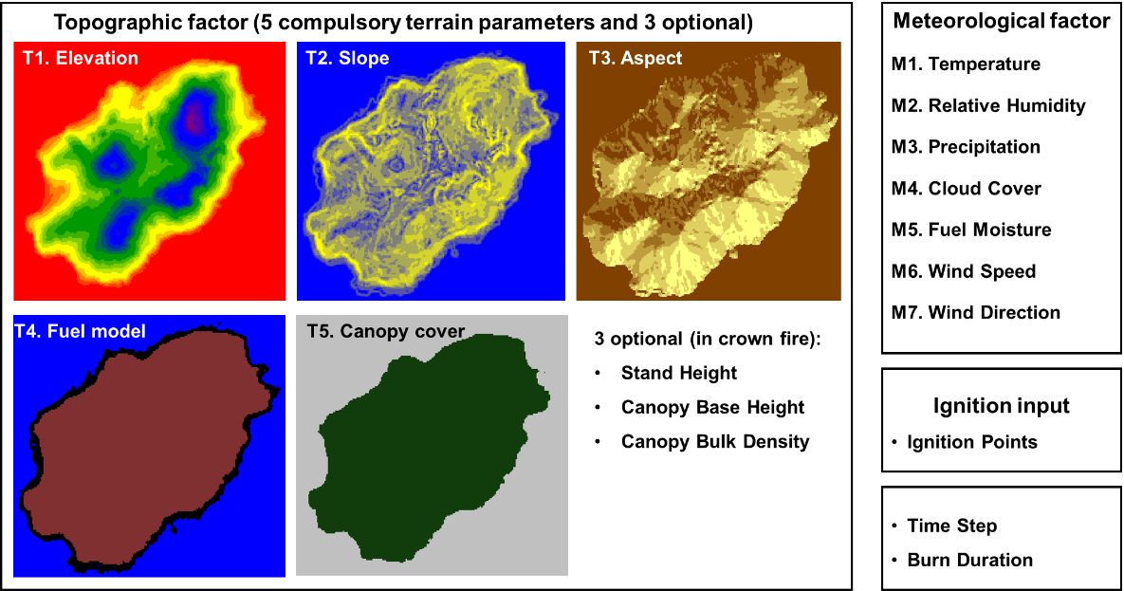

**Fig. 5.** Topographic factors and meteorological factors that influence the simulation

# 5. Data Collection Procedure of the Selected Project

From the perspective of GIS data collection, the data we have collected or are collecting mainly include:

**Fire History Data:** We will first use the fire history data from the Hong Kong Fire Services Department to determine the frequency and scale of wildfires in the Hong Kong area and select potential study areas based on this information.

**Vegetation Data of the Study Area:** We consider the vegetation in a region to be the primary fuel for wildfires, so information such as vegetation type, density, height, and humidity is important initial conditions. We use remote sensing images (especially near-infrared bands), vegetation data from the Hong Kong government, etc., to obtain vegetation information in the study area and convert it into fuel grid data with a resolution of 5 meters using GIS methods.

**Meteorological Data of the Study Area:** We downloaded meteorological data from the Hong Kong Observatory for the past year and performed statistical analysis on the temperature, humidity, wind speed, wind direction, etc., in the study area to obtain the probability distribution of each meteorological parameter for use in Monte Carlo simulations and obtain suitable time-step meteorological simulation data.

**Topographic Data of the Study Area:** Download topographic data of the study area directly from the Hong Kong government's open data website, and then post-process these data using ArcGIS 10.2 software to obtain topographic data with an accuracy of 5 meters. Topographic data includes elevation, slope, and aspect information, which will be used to simulate the terrain conditions during the wildfire spread process.

# References

Allaire F, Filippi J-B, Mallet V, Vaysse F (2022) Simulation-based high-resolution fire danger mapping using deep learning. *International Journal of Wildland Fire* **31**, 379–394.

Anderson JD, Wendt J (1995) ‘Computational fluid dynamics.’ (Springer)

Belcher CM (2013) ‘Fire Phenomena and the Earth System.’ (Wiley)

Finney MA (1998) FARSITE: Fire Area Simulator - Model Development and Evaluation. *USDA Forest Service - Research Papers RMRS* 1–36.

Gill AM, Stephens SL (2009) Scientific and social challenges for the management of fire-prone wildland-urban interfaces. *Environmental Research Letters* **4**, 34014.

Hodges JL, Lattimer BY (2019) Wildland fire spread modeling using convolutional neural networks. *Fire technology* **55**, 2115–2142.

Hoffman CM, Canfield J, Linn RR, Mell W, Sieg CH, Pimont F, Ziegler J (2016) Evaluating Crown Fire Rate of Spread Predictions from Physics-Based Models. *Fire Technology* **52**, 221–237.

Jaafari A, Zenner EK, Panahi M, Shahabi H (2019) Hybrid artificial intelligence models based on a neuro-fuzzy system and metaheuristic optimization algorithms for spatial prediction of wildfire probability. *Agricultural and forest meteorology* **266**, 198–207.

Jiang W, Wang F, Su G, Li X, Wang G, Zheng X, Wang T, Meng Q (2022) Modeling Wildfire Spread with an Irregular Graph Network. *Fire* **5**, 185.

Le H V, Bui QT, Bui DT, Tran HH, Hoang ND (2020) A Hybrid Intelligence System Based on Relevance Vector Machines and Imperialist Competitive Optimization for Modelling Forest Fire Danger Using GIS. *Journal of Environmental Informatics* **36**,.

Lee M, Brauer M, Wong P, Tang R, Tsui TH, Choi C, Cheng W, Lai P-C, Tian L, Thach T-Q (2017) Land use regression modelling of air pollution in high density high rise cities: A case study in Hong Kong. *Science of the Total Environment* **592**, 306–315.

Li X, Lin C, Zhang M, Li S, Sun S, Liu J, Hu T, Sun L (2022) Predicting the rate of forest fire spread toward any directions based on a CNN model considering the correlations of input variables. *Journal of Forest Research* 1–9.

Li X, Zhang M, Zhang S, Liu J, Sun S, Hu T, Sun L (2022) Simulating forest fire spread with cellular automation driven by a LSTM based speed model. *Fire* **5**, 13.

Radke D, Hessler A, Ellsworth D (2019) FireCast: Leveraging Deep Learning to Predict Wildfire Spread. In ‘IJCAI’, 4575–4581

Rothermel RC (1972) ‘A mathematical model for predicting fire spread in wildland fuels.’ (Intermountain Forest & Range Experiment Station, Forest Service, US …)

Running SW (2006) Is global warming causing more, larger wildfires? *Science* **313**, 927–928.

Skinner CN, Chang C (1996) Fire regimes, past and present. In ‘Sierra Nevada Ecosyst. Proj. Final Rep. to Congr. Vol. II. Assessments Sci. Basis Manag. Options. Wildl. Resour. Cent. Rep. No. 37. Centers Water Wildl. Resour. Univ. California, Davis. 1041-1069’, 1041–1069

Storey MA, Bedward M, Price OF, Bradstock RA, Sharples JJ (2021) Derivation of a Bayesian fire spread model using large-scale wildfire observations. *Environmental Modelling & Software* **144**, 105127.

Sung S, Li Y, Ortolano L (2021) WildfireNet: Predicting Wildfire Profiles (Student Abstract). In ‘Proc. AAAI Conf. Artif. Intell.’, 15905–15906

Theobald D, Romme W (2007) Expansion of the US wildland–urban interface. *Landscape and Urban Planning* **83**, 340–354.

Wang Z, Zhang T, Wu X, Huang X (2022) Predicting transient building fire based on external smoke images and deep learning. *Journal of Building Engineering* **47**, 103823.

Wu X, Zhang X, Jiang Y, Huang X, Huang GGQ, Usmani A (2022) An intelligent tunnel firefighting system and small-scale demonstration. *Tunnelling and Underground Space Technology* **120**, 104301.

Zhai C, Zhang S, Cao Z, Wang X (2020) Learning-based prediction of wildfire spread with real-time rate of spread measurement. *Combustion and Flame* **215**, 333–341.

Zhang T, Wang Z, Wong HY, Tam WC, Huang X, Xiao F (2022) Real-time forecast of compartment fire and flashover based on deep learning. *Fire Safety Journal* **130**, 103579.

Zhou T, Ding L, Ji J, Yu L, Wang Z (2020) Combined estimation of fire perimeters and fuel adjustment factors in farsite for forecasting wildland fire propagation. *Fire safety journal* **116**, 103167.