Midterm Progress Report

**Group Name:** Mr. Li and Mr. Pan's Group

**Project Process Name:** Fire Spread Simulation

**Class Project Title:** Wildfire Spread Simulation in Wildland-Urban Interface

(WUI) Zones

**Suggested Executer Name:** Yizhou Li, Zhiqing Pan

# Introduction

Fire has been a long-existent phenomenon on Earth and an essential part of different ecosystems (Running 2006; Belcher 2013). With the rise of human civilization and the expansion of living space, humans are gradually occupying the wildlands to create more urban areas. Meanwhile, our human activities have caused more and more wildfires and increased the frequency of extreme wildfires. Once a wildfire occurs, it primarily affects the residents who live in the emerging wildland-urban interface (WUI) (Theobald and Romme 2007; Gill and Stephens 2009).

Hong Kong is a highly populated modern city with over 4,000 skyscrapers, but it also has ~70% of its land covered by woodland, shrubland, and wetland (Lee et al. 2017). Therefore, it is a typical WUI that is constantly threatened by wildfires. According to the data from Hong Kong Fire Services Department (‘Hong Kong Fire Services Department - Access to Information’ 2021), about 1,000 wildfires (or hill fires) are reported annually. Over 80% of wildfires witness a burning area of less than 1,000 m2 and a burning time of 24 h because of significant firefighting efforts. Still, some wildfires spread to nearby high-population urban areas that cause significant safety issues and air pollution.

Wildfire behavior is a complex and dynamic phenomenon influenced by various factors, including the characteristics of the fuel, topography, weather conditions, and local landscape. As such, fire spread is not always linear or steady-state, and predicting its course can be challenging. In particular, sudden changes in weather conditions or the ignition of new fires can cause rapid shifts in the pattern of wildfire spread, potentially breaching established firebreaks and endangering previously safe areas. Therefore, accurate forecasting of real-time or short-term trends in fire spread is essential for effective wildfire management, particularly in wildland-urban interface (WUI) zones. Real-time fire spread forecasts can aid fire services in allocating resources, planning evacuations, and implementing other emergency response measures by predicting a fire's expected trajectory and intensity. These predictions can also assist residents in making informed decisions about their safety and help to prevent loss of life and property damage.

# Literature Review

Researchers have attempted to simulate wildfires and forecast their spread behaviors since the 1950s or even earlier. In the early days, most models were simple and probabilistic, based on limited human observation and experience.​ These models mainly assessed the wildfire risk but could not predict wildfire spread (Skinner and Chang 1996). Later in the 1970s, more understanding of wildfire dynamics was introduced to the mathematical model. Notably, Rothermel proposed a widely used semi-physical formula that considers different factors of fire, fuel, landscape, and weather to calculate the wildfire spread (Rothermel 1972).​ In the 1990s, several software tools had been developed to program these semi-physical models and environment parameters to predict 2-D wildland fire spread. For example, FARSITE (later becoming a part of FlamMap) coded Rothermel's equation to simulate and visualize wildfire propagation (Finney 1998). The running of FARSITE needs input from the Geography Information System (GIS), but the data from wildland fuel, weather, and landscape are often challenging to acquire accurately.

**Fig.1.** (a) Recent global wildfire incidents and (b) the historical evolution of wildfire modelling.

Since the 2000s, several numerical software was developed for physics-based fire modellings, such as HIGRAD/FIRETEC and Wildland Fire Dynamics Simulator (WFDS) (Hoffman et al. 2016). These tools are based on computational fluid dynamics (CFD) that can solve the atmospheric flow field and ground boundary flow near the fire (Anderson and Wendt 1995). These tools make wildfire simulation exquisite but consume considerable time and require high computation costs. Overall, the wildfire modelling method is evolving from statistics-based models to physical-based models. Nevertheless, all these computational tools are too slow to give real-time forecasts of wildland fire development. For example, forecasting the wildfire front in a few minutes often takes CFD-based software to run hours, so these kinds of wildfire simulations neither help guide the wildfire emergency response nor plan the prescribed burning.

To overcome the above issues, more recently, new artificial intelligence (AI) models have been proposed for fire forecast (Wang et al. 2022; Wu et al. 2022; Zhang et al. 2022), including wildfire forecast, which is an emerging research topic (Radke et al. 2019; Allaire et al. 2022; Jiang et al. 2022). The mathematic-based computation can be switched into a data-driven matchup in the database, where AI models calculate the mathematical relations among different parameters within seconds. Many researchers optimized the traditional models with AI models to increase the accuracy of forecasts (Radke et al. 2019; Zhou et al. 2020). Also, deep learning was widely used to explain and predict the wildfire spread rate (Zhai et al. 2020; Storey et al. 2021; Li, Lin, et al. 2022). Deep learning models were also adopted to map and forecast the wildfire risk possibility (Jaafari et al. 2019; Le et al. 2020; Allaire et al. 2022). Meanwhile, the AI-based models primarily decreased the computation time and made the long-term forecast possible in simulating wildfires (Hodges and Lattimer 2019; Sung et al. 2021; Li, Zhang, et al. 2022).

# Equipment and Steps Description

We can use the grid division method to simulate the spread of the fire, where each grid represents a small area and stores a value between 0 and 1, indicating the degree of burning in that area. 0 indicates no burning (or self-extinguishing), and 1 indicates maximum burning. Now, for a single grid, from meeting the conditions for ignition to complete burning and extinguishing, we can simulate it with a simple loop.

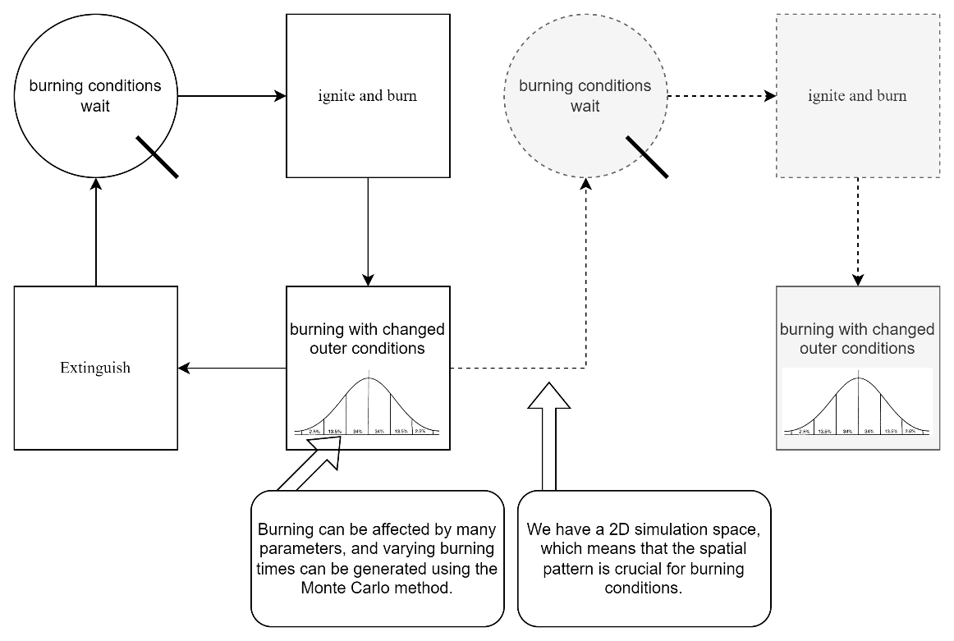

**Fig.2.** Single Grid burning Cycle

At each time step, we can calculate the direction and speed of the flame spread based on factors such as wind direction, wind speed, terrain, and vegetation, and then update the burning degree of each grid. In this way, we can simulate the spread of the fire. For the burning time of each grid, we will use the Monte Carlo simulation method to simulate it. We can calculate the probability distribution of the burning time of the vegetation based on historical data and then simulate the burning time of each grid based on this probability distribution. For the fire spread conditions, we will consider factors such as wind direction, wind speed, terrain, and vegetation. We can calculate the probability of fire spread for each grid based on these factors and then control the spread of the fire based on this probability.

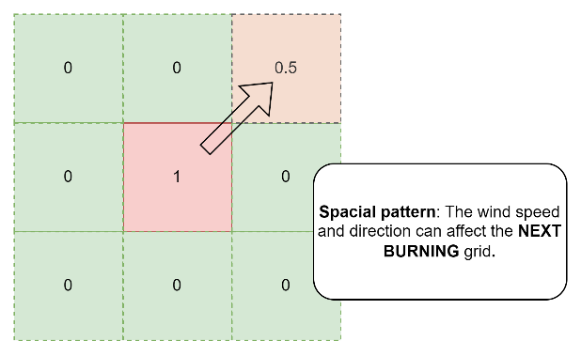

**Fig.3.** Spacial Pattern Effect

# Factors that Affect Productivity

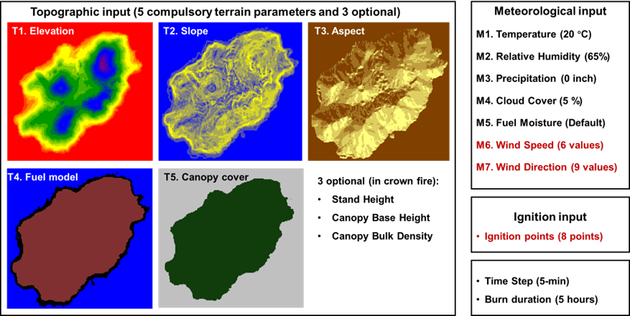

**Fig.4.** Required input parameters for simulation

**Fuel Type and Moisture Content:** The type of fuel and its moisture content significantly affect the spread of wildfires. Dry fuels burn more easily and quickly than wet fuels. The moisture content of the fuel can be influenced by weather conditions such as rainfall and humidity.

**Topography:** The slope and aspect of the terrain can affect the spread of wildfires. Steep slopes can cause fires to spread more rapidly, while flat terrain may slow down the fire's progress. The aspect of the terrain can also influence the direction in which the fire spreads.

**Weather Conditions:** Wind speed and direction, temperature, and humidity can all impact the spread of wildfires. Strong winds can cause fires to spread more quickly, while high temperatures and low humidity can increase the likelihood of fires starting and spreading.

**Vegetation Density:** The density of vegetation in an area can affect the spread of wildfires. Dense vegetation can provide more fuel for the fire to burn, while sparse vegetation may slow down the fire's progress.

**Firefighting Efforts:** The effectiveness of firefighting efforts can also impact the spread of wildfires. Prompt and well-coordinated firefighting efforts can help contain fires and prevent them from spreading further.

# Data Collection Procedure of the Selected Project

**Topographic Data:** Download topographic data of the study area directly from the Hong Kong government's open data website, and then post-process these data using ArcGIS 10.2 software to obtain topographic data with an accuracy of 5 meters. Topographic data includes elevation, slope, and aspect information, which will be used to simulate the terrain conditions during the wildfire spread process.

**Meteorological Data:** We will use meteorological data from the Hong Kong Observatory, including wind speed, wind direction, temperature, and humidity information. This data will be used to simulate the meteorological conditions during the wildfire spread process.

**Fuel Data:** Vegetation data from the Hong Kong government to determine the vegetation types and densities in the study area. This data will be used to customize the fuel model to more accurately simulate the wildfire spread process.

**Fire History Data:** Fire history data from the Hong Kong Fire Services Department to determine the frequency and scale of fires on the island. This data will be used to assess fire risk and develop emergency response plans.

# References

Albini FA (1985) A model for fire spread in wildland fuels by-radiation. *Combustion Science and Technology* **42**, 229–258.

Allaire F, Filippi J-B, Mallet V, Vaysse F (2022) Simulation-based high-resolution fire danger mapping using deep learning. *International Journal of Wildland Fire* **31**, 379–394.

Allaire F, Mallet V, Filippi J-B (2021) Emulation of wildland fire spread simulation using deep learning. *Neural networks* **141**, 184–198.

Anderson JD, Wendt J (1995) ‘Computational fluid dynamics.’ (Springer)

Arca B, Duce P, Laconi M, Pellizzaro G, Salis M, Spano D (2007) Evaluation of FARSITE simulator in Mediterranean maquis. *International Journal of Wildland Fire* **16**, 563–572.

Belcher CM (2013) ‘Fire Phenomena and the Earth System.’ (Wiley)

Benali A, Ervilha AR, Sá ACL, Fernandes PM, Pinto RMS, Trigo RM, Pereira JMC (2016) Deciphering the impact of uncertainty on the accuracy of large wildfire spread simulations. *Science of the Total Environment* **569**, 73–85.

Benali A, Sá ACL, Ervilha AR, Trigo RM, Fernandes PM, Pereira JMC (2017) Fire spread predictions: Sweeping uncertainty under the rug. *Science of the total environment* **592**, 187–196.

Burgués J, Marco S (2020) Environmental chemical sensing using small drones: A review. *Science of The Total Environment* **748**, 141172.

Fernandes PM, Botelho HS (2003) A review of prescribed burning effectiveness in fire hazard reduction. *International Journal of wildland fire* **12**, 117–128.

Finney MA (1998) FARSITE: Fire Area Simulator - Model Development and Evaluation. *USDA Forest Service - Research Papers RMRS* 1–36.

Finney MA (2006) An overview of FlamMap fire modeling capabilities. *USDA Forest Service Proceedings RMRS-P-41* 213–220.

Fung PT (2020) What does the Policy Formulation Process of East Lantau Metropolis and Lantau Tomorrow Vision Policy Imply Hong Kong Policy Style.

Gill AM, Stephens SL (2009) Scientific and social challenges for the management of fire-prone wildland-urban interfaces. *Environmental Research Letters* **4**, 34014.

Hochreiter S, Schmidhuber J (1997) Long short-term memory. *Neural computation* **9**, 1735–1780.

Hodges JL, Lattimer BY (2019) Wildland fire spread modeling using convolutional neural networks. *Fire technology* **55**, 2115–2142.

Hoffman CM, Canfield J, Linn RR, Mell W, Sieg CH, Pimont F, Ziegler J (2016) Evaluating Crown Fire Rate of Spread Predictions from Physics-Based Models. *Fire Technology* **52**, 221–237.

Hong Kong Fire Services Department - Access to Information (2021) https://www.hkfsd.gov.hk/eng/access/.

Jaafari A, Zenner EK, Panahi M, Shahabi H (2019) Hybrid artificial intelligence models based on a neuro-fuzzy system and metaheuristic optimization algorithms for spatial prediction of wildfire probability. *Agricultural and forest meteorology* **266**, 198–207.

Jiang W, Wang F, Su G, Li X, Wang G, Zheng X, Wang T, Meng Q (2022) Modeling Wildfire Spread with an Irregular Graph Network. *Fire* **5**, 185.

Jolly WM, Cochrane MA, Freeborn PH, Holden ZA, Brown TJ, Williamson GJ, Bowman DMJS (2015) Climate-induced variations in global wildfire danger from 1979 to 2013. *Nature Communications* **6**, 1–11.

Le H V, Bui QT, Bui DT, Tran HH, Hoang ND (2020) A Hybrid Intelligence System Based on Relevance Vector Machines and Imperialist Competitive Optimization for Modelling Forest Fire Danger Using GIS. *Journal of Environmental Informatics* **36**,.

Lee M, Brauer M, Wong P, Tang R, Tsui TH, Choi C, Cheng W, Lai P-C, Tian L, Thach T-Q (2017) Land use regression modelling of air pollution in high density high rise cities: A case study in Hong Kong. *Science of the Total Environment* **592**, 306–315.

Li X, Lin C, Zhang M, Li S, Sun S, Liu J, Hu T, Sun L (2022) Predicting the rate of forest fire spread toward any directions based on a CNN model considering the correlations of input variables. *Journal of Forest Research* 1–9.

Li X, Zhang M, Zhang S, Liu J, Sun S, Hu T, Sun L (2022) Simulating forest fire spread with cellular automation driven by a LSTM based speed model. *Fire* **5**, 13.

Nevins B (2022) Rage blazes in New Mexico against failed government fire management. *Green Left Weekly* 12.

Penman TD, Christie FJ, Andersen AN, Bradstock RA, Cary GJ, Henderson MK, Price O, Tran C, Wardle GM, Williams RJ (2011) Prescribed burning: how can it work to conserve the things we value? *International Journal of Wildland Fire* **20**, 721–733.

Radke D, Hessler A, Ellsworth D (2019) FireCast: Leveraging Deep Learning to Predict Wildfire Spread. In ‘IJCAI’, 4575–4581

Ronneberger O, Fischer P, Brox T (2015) U-net: Convolutional networks for biomedical image segmentation. In ‘Int. Conf. Med. image Comput. Comput. Interv.’, 234–241. (Springer)

Rothermel RC (1972) ‘A mathematical model for predicting fire spread in wildland fuels.’ (Intermountain Forest & Range Experiment Station, Forest Service, US …)

Running SW (2006) Is global warming causing more, larger wildfires? *Science* **313**, 927–928.

Scott J, Burgan R (2005) Standarc fire behavior fuel models: a comprehensive set for use with Rothermel’s surface fire spread model.

Shi X, Chen Z, Wang H, Yeung D-Y, Wong W-K, Woo W (2015) Convolutional LSTM network: A machine learning approach for precipitation nowcasting. *Advances in neural information processing systems* **28**,.

Skinner CN, Chang C (1996) Fire regimes, past and present. In ‘Sierra Nevada Ecosyst. Proj. Final Rep. to Congr. Vol. II. Assessments Sci. Basis Manag. Options. Wildl. Resour. Cent. Rep. No. 37. Centers Water Wildl. Resour. Univ. California, Davis. 1041-1069’, 1041–1069

Spitzer M, Wildenhain J, Rappsilber J, Tyers M (2014) BoxPlotR: A web tool for generation of box plots. *Nature Methods* **11**, 121–122.

Srivas T, Artés T, De Callafon RA, Altintas I (2016) Wildfire spread prediction and assimilation for FARSITE using ensemble Kalman filtering. *Procedia Computer Science* **80**, 897–908.

Storey MA, Bedward M, Price OF, Bradstock RA, Sharples JJ (2021) Derivation of a Bayesian fire spread model using large-scale wildfire observations. *Environmental Modelling & Software* **144**, 105127.

Sung S, Li Y, Ortolano L (2021) WildfireNet: Predicting Wildfire Profiles (Student Abstract). In ‘Proc. AAAI Conf. Artif. Intell.’, 15905–15906

Theobald D, Romme W (2007) Expansion of the US wildland–urban interface. *Landscape and Urban Planning* **83**, 340–354.

Tompson JJ, Jain A, LeCun Y, Bregler C (2014) Joint training of a convolutional network and a graphical model for human pose estimation. *Advances in neural information processing systems* **27**,.

Walker XJ, Rogers BM, Veraverbeke S, Johnstone JF, Baltzer JL, Barrett K, Bourgeau-Chavez L, Day NJ, de Groot WJ, Dieleman CM, Goetz S, Hoy E, Jenkins LK, Kane ES, Parisien MA, Potter S, Schuur EAG, Turetsky M, Whitman E, Mack MC (2020) Fuel availability not fire weather controls boreal wildfire severity and carbon emissions. *Nature Climate Change* **10**, 1130–1136.

Wang L, Chen L, Tsang DCW, Kua HW, Yang J, Ok YS, Ding S, Hou D, Poon CS (2019) The roles of biochar as green admixture for sediment-based construction products. *Cement and Concrete Composites* **104**, 103348.

Wang Z, Zhang T, Wu X, Huang X (2022) Predicting transient building fire based on external smoke images and deep learning. *Journal of Building Engineering* **47**, 103823.

Witze A (2020) The Arctic is burning like never before — and that’s bad news for climate change. *Nature* **585**, 336–337.

Wu Z, He HS, Liu Z, Liang Y (2013) Comparing fuel reduction treatments for reducing wildfire size and intensity in a boreal forest landscape of northeastern China. *Science of the total environment* **454**, 30–39.

Wu X, Zhang X, Jiang Y, Huang X, Huang GGQ, Usmani A (2022) An intelligent tunnel firefighting system and small-scale demonstration. *Tunnelling and Underground Space Technology* **120**, 104301.

Zhai C, Zhang S, Cao Z, Wang X (2020) Learning-based prediction of wildfire spread with real-time rate of spread measurement. *Combustion and Flame* **215**, 333–341.

Zhang T, Wang Z, Wong HY, Tam WC, Huang X, Xiao F (2022) Real-time forecast of compartment fire and flashover based on deep learning. *Fire Safety Journal* **130**, 103579.

Zhou T, Ding L, Ji J, Yu L, Wang Z (2020) Combined estimation of fire perimeters and fuel adjustment factors in farsite for forecasting wildland fire propagation. *Fire safety journal* **116**, 103167.

Zhou D, Fang J, Song X, Guan C, Yin J, Dai Y, Yang R (2019) Iou loss for 2d/3d object detection. In ‘2019 Int. Conf. 3D Vis.’, 85–94. (IEEE)

Zigner K, Carvalho LM V, Peterson S, Fujioka F, Duine G-J, Jones C, Roberts D, Moritz M (2020) Evaluating the ability of FARSITE to simulate wildfires influenced by extreme, downslope winds in Santa Barbara, California. *Fire* **3**, 29.