# Course name

CE631-Simulation and IT Applications in Construction

# Project title

Wildfire Modelling Simulation in Wildland-Urban-Interface

# Group name

Wildfire Modelling Team

# Authors and affiliation

Yizhou Li1, Zhiqing Pan2

*1 Department of Building Environment and Energy Engineering, The Hong Kong Polytechnic University, Hong Kong, 21037484R*

*2 Department of Land Surveying and Geo-Informatics, The Hong Kong Polytechnic University, Hong Kong,* [*24037665G*](https://github.com/pzq123456/CE631/blob/main/report/ZhiqingPAN24037665g.docx)

# 1. Introduction

Fire has been a long-existent phenomenon on Earth and an essential part of different ecosystems (Running 2006; Belcher 2013). With the rise of human civilization and the expansion of living space, humans are gradually occupying the wildlands to create more urban areas. Meanwhile, our human activities have caused more and more wildfires and increased the frequency of extreme wildfires. Once a wildfire occurs (Fig. 1), it primarily affects the residents who live in the emerging wildland-urban interface (WUI) (Theobald and Romme 2007; Gill and Stephens 2009).

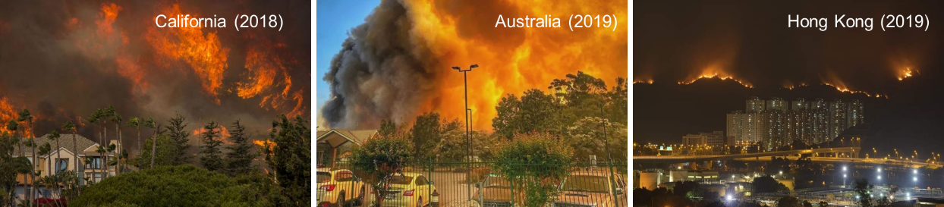

**Fig. 1.** Recent global wildfire incidents

Hong Kong is a highly populated modern city with over 4,000 skyscrapers, but it also has ~70% of its land covered by woodland, shrubland, and wetland (Lee *et al.* 2017). Therefore, it is a typical WUI that is constantly threatened by wildfires. According to the data from Hong Kong Fire Services Department, about 1,000 wildfires (or hill fires) are reported annually. Over 80% of wildfires witness a burning area of less than 1,000 m2 and a burning time of 24 h because of significant firefighting efforts. Still, some wildfires spread to nearby high-population urban areas that cause significant safety issues and air pollution.

Wildfire behavior is a complex and dynamic phenomenon influenced by various factors, including the characteristics of the fuel, topography, weather conditions, and local landscape. As such, fire spread is not always linear or steady-state, and predicting its course can be challenging. In particular, sudden changes in weather conditions or the ignition of new fires can cause rapid shifts in the pattern of wildfire spread, potentially breaching established firebreaks and endangering previously safe areas. Therefore, accurate forecasting of real-time or short-term trends in fire spread is essential for effective wildfire management, particularly in wildland-urban interface (WUI) zones. Real-time fire spread forecasts can aid fire services in allocating resources, planning evacuations, and implementing other emergency response measures by predicting a fire's expected trajectory and intensity. These predictions can also assist residents in making informed decisions about their safety and help to prevent loss of life and property damage.

# 2. Literature Review

Researchers have attempted to simulate wildfires and forecast their spread behaviors since the 1950s or even earlier (Fig. 2). In the early days, most models were simple and probabilistic, based on limited human observation and experience.​ These models mainly assessed the wildfire risk but could not predict wildfire spread (Skinner and Chang 1996). Later in the 1970s, more understanding of wildfire dynamics was introduced to the mathematical model. Notably, Rothermel proposed a widely used semi-physical formula that considers different factors of fire, fuel, landscape, and weather to calculate the wildfire spread (Rothermel 1972).​ In the 1990s, several software tools had been developed to program these semi-physical models and environment parameters to predict 2-D wildland fire spread. For example, FARSITE (later becoming a part of FlamMap) coded Rothermel's equation to simulate and visualize wildfire propagation (Finney 1998). The running of FARSITE needs input from the Geography Information System (GIS), but the data from wildland fuel, weather, and landscape are often challenging to acquire accurately.

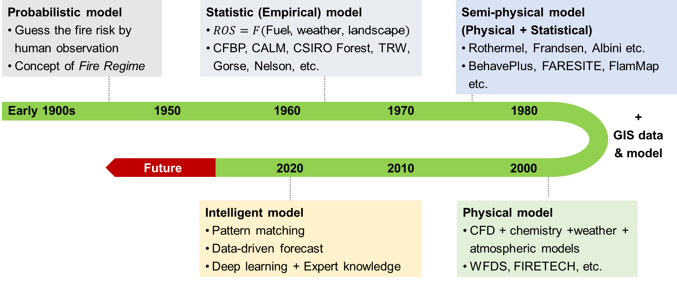

**Fig. 2.** Evolution progress of wildfire modelling

Since the 2000s, several numerical software was developed for physics-based fire modellings, such as HIGRAD/FIRETEC and Wildland Fire Dynamics Simulator (WFDS) (Hoffman *et al.* 2016). These tools are based on computational fluid dynamics (CFD) that can solve the atmospheric flow field and ground boundary flow near the fire (Anderson and Wendt 1995). These tools make wildfire simulation exquisite but consume considerable time and require high computation costs. Overall, the wildfire modelling method is evolving from statistics-based models to physical-based models. Nevertheless, all these computational tools are too slow to give real-time forecasts of wildland fire development. For example, forecasting the wildfire front in a few minutes often takes CFD-based software to run hours, so these kinds of wildfire simulations neither help guide the wildfire emergency response nor plan the prescribed burning.

To overcome the above issues, more recently, new artificial intelligence (AI) models have been proposed for fire forecast (Wang *et al.* 2022; Wu *et al.* 2022; Zhang *et al.* 2022), including wildfire forecast, which is an emerging research topic (Radke *et al.* 2019; Allaire *et al.* 2022; Jiang *et al.* 2022). The mathematic-based computation can be switched into a data-driven matchup in the database, where AI models calculate the mathematical relations among different parameters within seconds. Many researchers optimized the traditional models with AI models to increase the accuracy of forecasts (Radke *et al.* 2019; Zhou *et al.* 2020). Also, deep learning was widely used to explain and predict the wildfire spread rate (Zhai *et al.* 2020; Storey *et al.* 2021; Li, Lin, *et al.* 2022). Deep learning models were also adopted to map and forecast the wildfire risk possibility (Jaafari *et al.* 2019; Le *et al.* 2020; Allaire *et al.* 2022). Meanwhile, the AI-based models primarily decreased the computation time and made the long-term forecast possible in simulating wildfires (Hodges and Lattimer 2019; Sung *et al.* 2021; Li, Zhang, *et al.* 2022).

# 3. Cycle and Steps Description

We can use the grid division method to simulate the spread of the fire, where each grid represents a small area and stores a value between 0 and 1, indicating the degree of burning in that area. 0 indicates no burning (or self-extinguishing), and 1 indicates maximum burning. Now, for a single grid, from meeting the conditions for ignition to complete burning and extinguishing, we can simulate it with a simple loop (Fig. 3).

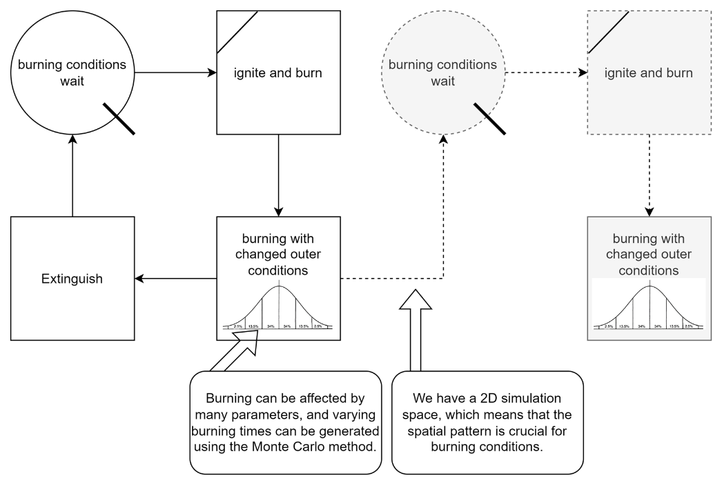

**Fig. 3.** Single grid burning cycle

At each time step, we can calculate the direction and speed of the flame spread based on factors such as wind direction, wind speed, terrain, and vegetation, and then update the burning degree of each grid. In this way, we can simulate the spread of the fire. For the burning time of each grid, we will use the Monte Carlo simulation method to simulate it. We can calculate the probability distribution of the burning time of the vegetation based on historical data and then simulate the burning time of each grid based on this probability distribution (Fig. 4). For the fire spread conditions, we will consider factors such as wind direction, wind speed, terrain, and vegetation. We can calculate the probability of fire spread for each grid based on these factors and then control the spread of the fire based on this probability.

**Fig. 4.** Spatial pattern effect

# 4. Factors that affect simulation

As mentioned above, the wildfire burning process is a complex dynamic process, and we have built a simple burning model cycle for a single grid. From a static perspective, the burning potential of the current grid is at least affected by the following factors:

**Surface combustible reserves:** mainly including vegetation type, vegetation density, vegetation height, vegetation humidity, etc. This part determines the initial conditions of the burning model (fuel quantity and quality) and is the first part that needs to be investigated and modeled.

**Terrain:** mainly including slope, aspect, altitude, etc. For the same vegetation type, the burning speed and direction under different terrain conditions may vary greatly, especially in mountainous areas.

From the dynamic perspective of the burning process:

**Meteorological conditions:** mainly including wind speed, wind direction, temperature, etc. These factors will continuously affect the spread speed and direction of the fire during the burning process. From the perspective of the simulation algorithm, in the "burning with changed outer conditions" step, the model will continuously accept external parameters and continuously update the burning degree of the current grid until the current grid is completely extinguished. When spreading the fire between grids, the spread probability will be calculated based on external parameters and burning grids spacial pattern, and the spread of the fire will be controlled based on this probability.

**Firefighting measures:** mainly including firefighting personnel, firefighting equipment, etc. For dynamic firefighting actions, we can establish a new loop; for static facilities such as firebreaks, they can be part of the terrain and dynamically updated in the simulation.

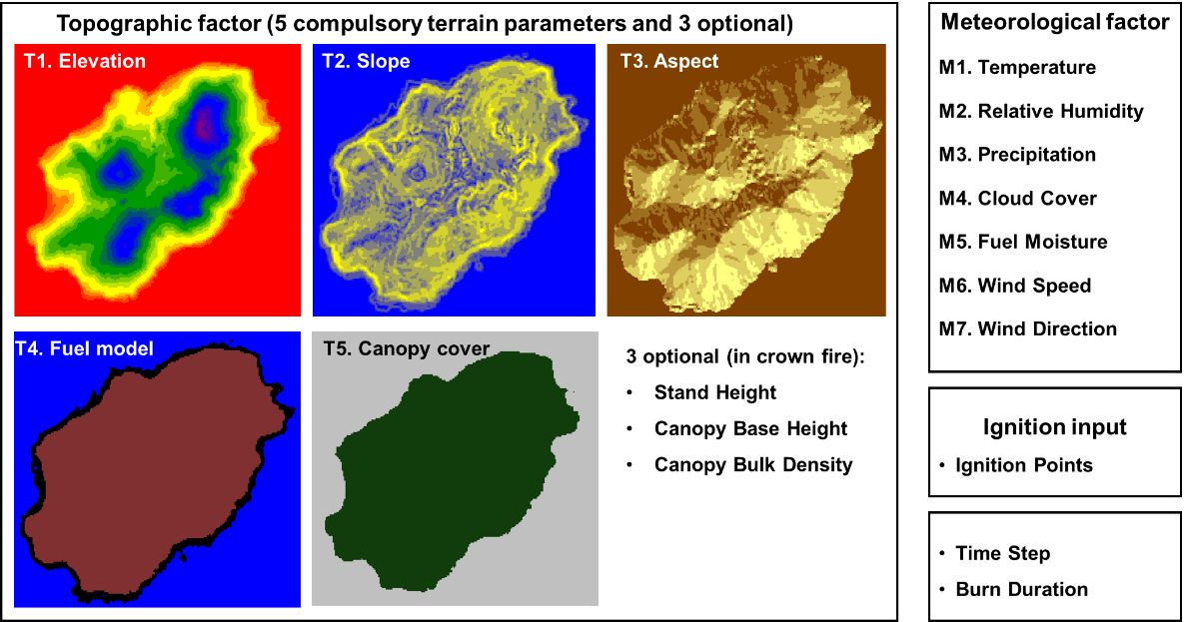

**Fig. 5.** Topographic factors and meteorological factors that influence the simulation

# 5. Data Collection

## Wind Direction and Speed

Over the past two decades, we procured wind direction, wind speed, and humidity data from the Hong Kong Observatory's open data platform. Through a detailed analysis of this extensive dataset, we have been able to derive the statistical distribution of key meteorological parameters specific to our study area. This endeavor lays the foundation for future Monte Carlo simulations based on these findings.

The wind direction data is represented in degrees, where 0 degrees signifies due north and 90 degrees indicates eastward direction, and so forth. During data collection by the meteorological station, certain records are incomplete and denoted by "#" in the dataset. By filtering out these incomplete entries, we retain only the fully recorded data for further analysis.

For the sake of analytical convenience in our statistical procedures, we classify the wind direction data into eight cardinal directions: N (North), NE (Northeast), E (East), SE (Southeast), S (South), SW (Southwest), W (West), NW (Northwest). We have conducted an assessment of the distribution of wind direction data and determined that the prevalent wind directions in our study area are predominantly from the north, east, and northeast sectors. Notably, the most dominant wind direction is from the north, succeeded by eastward winds, with northeast winds exhibiting the least prevalence. This pattern can be attributed to the geographical positioning of our study area, situated in the northwest region of Hong Kong, where prevailing winds primarily originate from the north, east, and northeast directions.

**Table 1**. Notation of wind direction data integrity

|  |  |
| --- | --- |
| Notation | Description |
| *** | unavailable |
| # | data incomplete |
| C | data Complete |

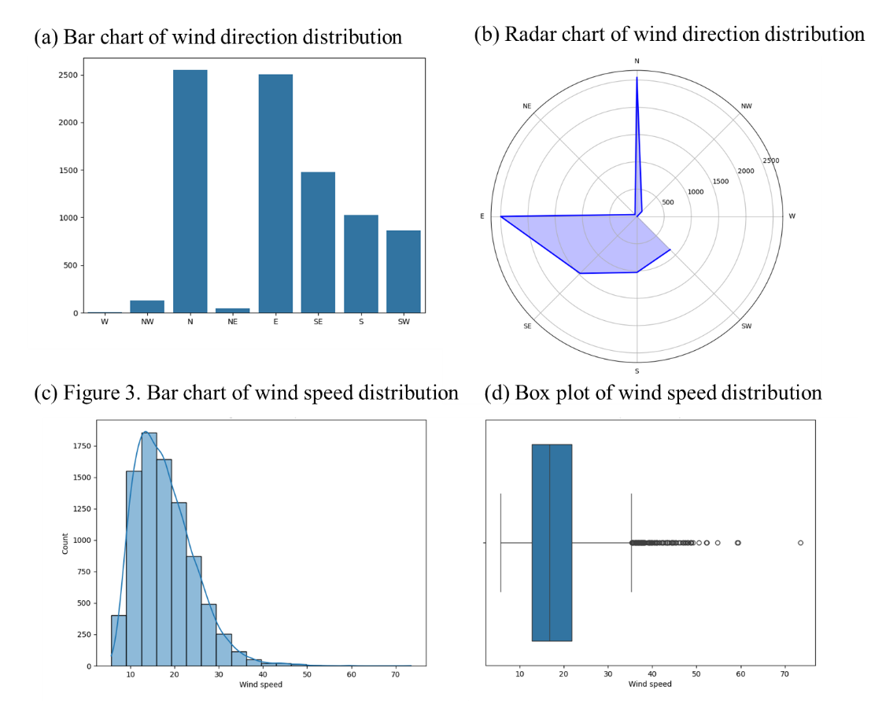

**Fig. 6.** Wind direction and speed analysis of simulations

After accumulating all the data, we obtained the statistical distribution of wind direction data as follows:

**Table 2**. Wind direction distribution statistics

|  |  |
| --- | --- |
| Wind Direction | Proportion |
| N | 0.296650 |
| E | 0.290949 |
| SE | 0.171591 |
| S | 0.119358 |
| SW | 0.100163 |
| NW | 0.015123 |
| NE | 0.005700 |
| W | 0.000465 |

Wind speed data is expressed in meters per second (m/s). We have counted the distribution of wind speed data. The wind speed in the study area is mainly concentrated between 10m/s and 20m/s, with 17m/s wind speed accounting for the highest proportion. The distribution of wind speed is shown in the following figure.

The wind speed data is visualized year by year, and overlaid on one chart:

**Figure 7**. Wind speed distribution by year

## Humidity Data

Humidity data is expressed as a percentage. We have counted the distribution of humidity data. The humidity in the study area is mainly concentrated between 70% and 90%, with 80% humidity accounting for the highest proportion. The distribution of humidity is shown in the following figure.

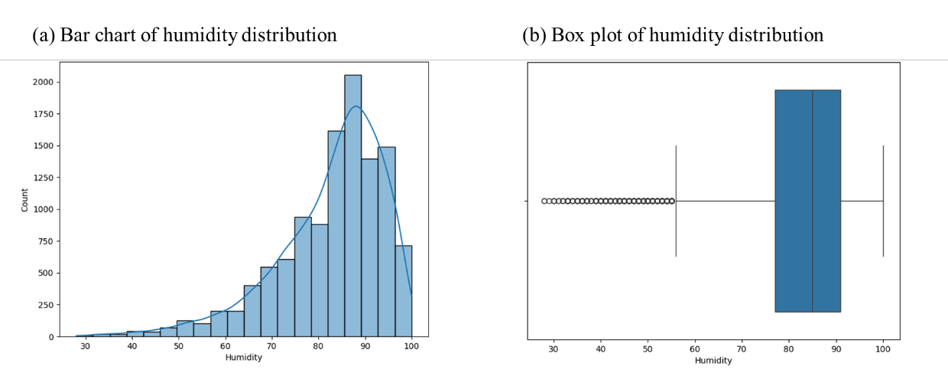

**Fig. 8.** Humidity analysis of simulations

**Fig. 9.** Humidity distribution by year

Upon analyzing the accumulated data, we have obtained the statistical distribution of humidity data as follows:

The average extinguishing time for firefighters varies significantly due to a multitude of factors, including fire size, fire type (surface, crown, or underground), meteorological conditions, terrain complexity, resource availability, and the proficiency level of the firefighting team. As per statistics from the National Interagency Fire Center (NIFC), fires can be broadly categorized into small, medium, and large fires, each requiring varying durations for containment. Small fires, spanning a few hectares, are typically brought under control within hours to a day. Medium-sized fires, ranging from tens to hundreds of hectares, necessitate additional resources like helicopters, aerial firefighting units, and seasoned firefighters, often taking 1 to 7 days for complete suppression. In regions plagued by drought and strong winds, large fires exceeding several thousand hectares may require weeks or even months for containment, often relying on passive extinction methods such as natural weather changes and gradual burnout.

Different firefighting teams, countries, and regions exhibit varying levels of efficiency in fire suppression. Notably, China demonstrates relatively high efficacy in forest firefighting, swiftly containing small fires within 1 to 2 days. Conversely, combating large mountain fires in regions like Yunnan and Sichuan may extend over several weeks. The United States boasts proficient firefighting capabilities; however, due to its expansive terrain and frequent mountain infernos, extinguishing large-scale mountain fires poses challenges and prolonged efforts. Australia, characterized by vast expanses and low population density, grapples with extended duration in quelling large mountain blazes. In Canada, fire duration is heavily influenced by climatic conditions and fuel moisture content, with a marked escalation in the frequency and duration of extensive fires owing to climate fluctuations in recent decades.

The timely initiation of fire suppression measures holds paramount importance, as early intervention significantly curtails fire spread. Hence, rapid response times and effective firefighting operations are crucial. During the initial stages of a fire outbreak, responders leverage aerial assets such as helicopters, aerial firefighting units, and ground crews to establish fire lines and douse flames. As the fire progresses, augmented resources like additional aircraft, fire trucks, and personnel are deployed to bolster containment efforts through reinforced fire line construction and intensified suppression activities.

# 6. Simulation procedures

We have developed a basic discrete event simulation system using JavaScript. Discrete event simulation involves the upkeep of an ordered queue of events, sorted chronologically. Upon processing each event from the queue, the system state undergoes modifications according to the event's type and particulars, and fresh events are appended to the queue. Our implementation leveraged a straightforward "EventQueue" class to facilitate this operational mechanism.

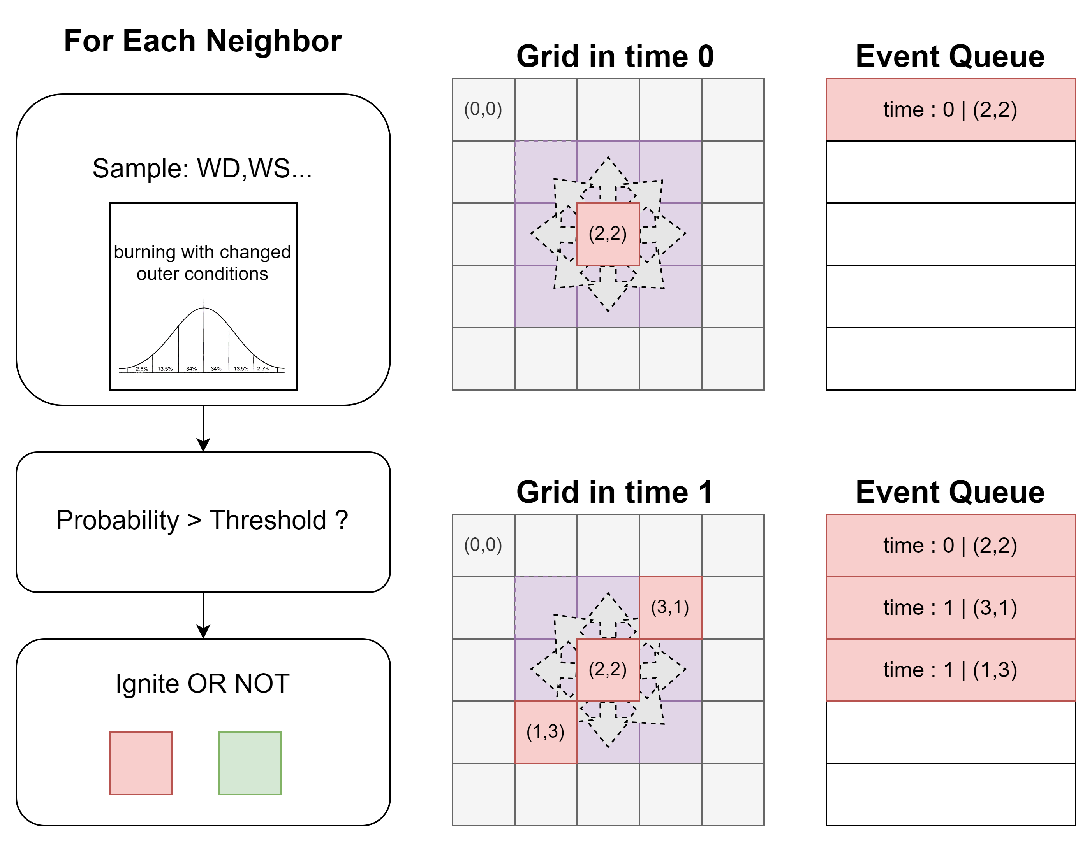

**Fig.10.** Discrete Event Simulation Structure

We have developed a comprehensive fire simulation system that incorporates various classes and modules to simulate the spread of fire, firefighter behavior, and environmental factors. Here is an overview of the key components and functionalities of the system:

1. Grid Model: The two-dimensional grid model represents a burnable area where each cell can be in one of three states: unburned, burning, or burned out. The state of each cell changes over time, and fire can spread to neighboring cells based on Monte Carlo simulations of wind speed and direction. The "Cell" and "Grid" classes manage grid behavior and store grid data.
2. Fire Spread Model: The "FireSpreadEvent" class inherits from the "Event" class and describes the behavior of fire spread. It considers parameters obtained from real-world statistics and uses Monte Carlo simulations to simulate environmental factors. The event triggers fire spread, updates burning times, and calculates the impact of wind on the fire.
3. Monte Carlo Simulation: The "MonteCarloDistribution" class provides a common interface for different distribution classes used in Monte Carlo simulations. Subclasses like "GaussianDistribution" and "DiscreteDistribution" implement specific distribution types and sampling methods.
4. Firefighter Model: The "Firefighter" class simulates firefighter behavior, including extinguishing fires, setting isolation zones, and formulating action strategies based on resource constraints. It interacts with the grid and dynamically responds to complex situations in the simulation environment.
5. Behavior Design: The "Firefighter" class implements key functions through method modularization, such as moving in the grid, selecting behaviors based on position, setting isolation zones, and managing resources like stamina and water level. The design aims to realistically represent firefighter behavior and dynamically adapt to changing scenarios.

Overall, the fire simulation system integrates grid modeling, fire spread simulation, Monte Carlo simulations, and firefighter behavior modeling to create a realistic and dynamic simulation environment. This comprehensive approach allows for detailed analysis of fire behavior, firefighting strategies, and environmental factors in a simulated setting.

**Fig.11.** Firefighter Behavior Strategies

Firefighters utilize a range of strategies in fire simulations to combat fires, prevent their escalation, and enhance resource management efficiency. These strategies, grounded in firefighters' environmental awareness, are executed through logical reasoning and target optimization. The primary focus of firefighters is on extinguishing fires promptly by initiating a sequence of actions when positioned at a burning cell. This involves the efficient use of water and time to swiftly contain the fire source, reflecting the critical urgency of firefighting tasks.

Moreover, proactive measures, such as establishing firebreaks near unburned cells adjacent to the fire zone, play a crucial role in limiting the spread of fires in large-scale scenarios. This strategic decision depends on the availability of firefighters' stamina resources to ensure optimal defensive outcomes within resource constraints. When not engaged in fire suppression activities, firefighters strategically locate and move towards the nearest fire source, following the shortest path principle while incorporating random offsets to diversify path planning decisions. By randomly selecting from multiple targets, firefighters ensure comprehensive fire coverage and operational efficiency by minimizing redundant movements.

Resource management remains a key consideration, with firefighter actions constrained by stamina and water resources. In instances of limited resources, firefighters prioritize low-consumption tasks, such as movement, to maintain operational continuity and prevent resource wastage. Additionally, tactical responses, such as ceasing all actions when firefighters are incapacitated due to external factors, underscore the link between firefighter states and environmental circumstances. These strategies enable firefighters to adapt swiftly to dynamic environmental changes, effectively manage firefighting duties and resources, and contain fire propagation efficiently. The robust foundation provided by these behavioral strategies supports complex fire simulations, offering scalability and flexibility for future enhancements.

## Productivity and cost estimation and analysis

In this study, we propose a fire spread probability model that comprehensively considers multiple environmental factors to more accurately simulate the spread of fires in a two-dimensional grid. The formula for calculating the fire spread probability P is as follows:

Where P represents the probability of fire spreading from the current cell to the target cell, with a range limited to [0, 1]. The spread probability is influenced by the following factors: D, R, W, and H. The wind direction factor D is used to characterize the guiding effect of wind direction on the direction of fire spread, and its calculation formula is:

The wind direction factor D is calculated based on the angle between the target cell's direction and the wind direction. By normalizing the angle difference between the current cell's direction and the wind direction using the cosine function, the model can reflect the promoting or inhibiting effect of wind direction on fire spread.

The neighbor resistance factor R represents the resistance of the target cell to fire spread and depends on the properties of the target cell (such as vegetation type or fuel density). It is dynamically obtained by the function getSpreadResistance(). The wind speed W affects the spread probability through an exponential decay model , which effectively simulates the slow increase in spread probability at low wind speeds and the rapid increase at high wind speeds.

The humidity factor H simulates the inhibitory effect of humidity on fire spread through normalized processing of humidity h, with the formula:

Where h ranges from 0 to 100. The higher the humidity, the smaller the factor H, reflecting the significant inhibitory effect of humidity on fire spread. To prevent the spread probability from dropping to zero when the humidity is too high, a minimum value of 0.1 is set in the formula to retain a weak possibility of spread.

The implementation of this model is achieved through a modular code structure, with the addition of the function getHumidityFactor() to calculate the humidity factor H. The core function calculateSpreadProbability() integrates the above factors to dynamically calculate the fire spread probability. In addition, the wind direction angle calculation and neighbor resistance retrieval are implemented as independent modules to ensure the flexibility and scalability of the model. This design provides interface support for further incorporating complex environmental factors such as temperature and altitude. The application and validation of the model demonstrate its good physical rationality and computational efficiency in capturing the combined effects of wind speed, humidity, and neighbor resistance.

# 7. Results and conclusions

We combined the meteorological probability statistics data of the study area calculated above with the fire spread model to simulate the fire spread process, considering multiple factors such as wind direction, wind speed, humidity, and resistance. In the experiment, we constructed a 10x10 grid environment, set the initial fire source position, and simulated the spread of the fire. Through multiple simulation experiments, we observed the dynamic process of fire spread and analyzed the effects of different factors on the speed and range of fire spread.

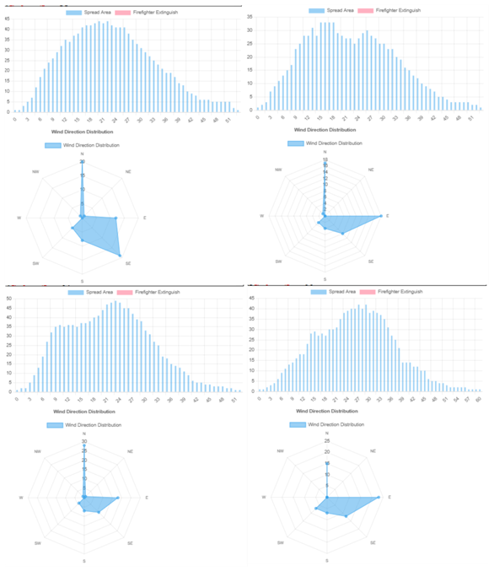

**Fig.12.** Different Fire Spread Curves(Without Firefighter Intervention)

We plotted the fire development curve by counting the number of burning cells at each time step to dynamically monitor the process of simulated fire development. We also analyzed the characteristics of fire spread under different wind directions, wind speeds, humidity, and resistance conditions, including fire spread speed, fire range, and burning intensity. By comparing the experimental results, we determined the degree of influence of different factors on fire spread, providing a scientific basis for further fire prevention and emergency management.

We found that in the absence of firefighting intervention, due to the relatively limited resources in the virtual study area, fires tend to gradually extinguish after spreading to approximately 85% of the area. This is consistent with the natural spread pattern of fires, which will self-extinguish without external intervention. The fire spread curve often has a process of rising and then falling, indicating that the fire spread speed is relatively fast in the early stage, and gradually weakens as the fuel decreases and the resistance factor increases. The fire spread curve generally has a peak structure, and in some cases, there may be multiple peaks, which are related to the complexity and randomness of fire spread.

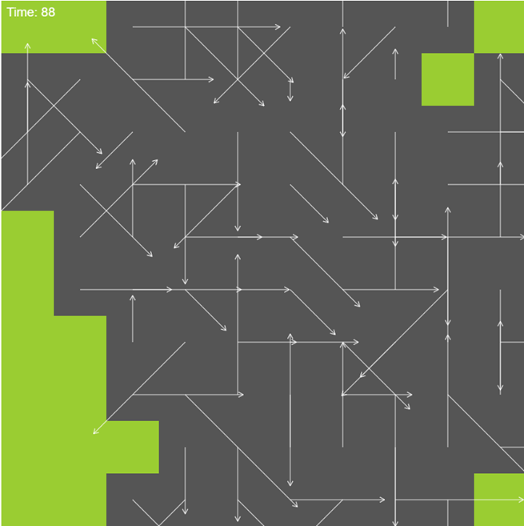

**Fig.13.** Bad Fire Spread Snario (more than 95% of the area)

However, in some special cases, the fire may spread to more than **95%** of the area. At this time, its fire curve will have multiple peaks, that is, when the fire is about to extinguish, it will reignite due to the lack of human intervention. This may be due to the instability of the fire caused by factors such as wind direction and wind speed.

When the wind direction is relatively concentrated (e.g., most of the wind is from the northeast), under the limited space simulation conditions, it is conducive to suppressing the spread of the fire, and the range of the fire is limited to a certain extent, and the maximum fire area is also limited to about **60%**.

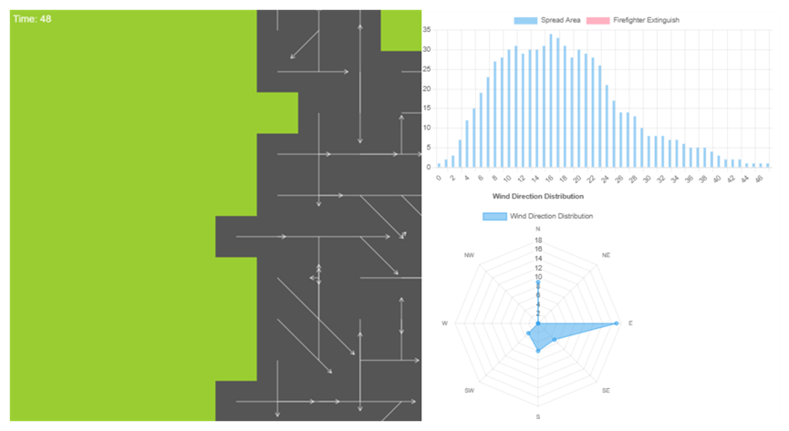

**Fig.14.** Good Fire Spread Snario (less than 60% of the area)

When the wind direction is more dispersed, the speed of fire spread will accelerate, and the range of the fire will rapidly expand. In extreme cases, the fire may spread to the entire study area. This indicates that wind direction has a significant impact on fire spread, and changes in wind direction will increase the uncertainty of fire spread, increasing the difficulty of firefighting.

In summary, in the absence of human intervention, the maximum fire area in a single time step often exceeds 40%. In most cases, the fire will gradually extinguish after spreading to about 85% of the area, which is about 60-90 time steps. Assuming each time step is 1 hour, the fire will last for about 2-3 days. In this process, the speed and range of fire spread are jointly affected by factors such as wind direction, wind speed, humidity, and resistance. Changes in these factors will increase the uncertainty of fire spread, increasing the difficulty of firefighting.

Next, we introduce firefighter agents for intervention. The firefighter agents will formulate action strategies based on the current environmental conditions and resource constraints, including extinguishing fires, setting firebreaks, and moving to fire source locations. At the same time, the firefighter agents are directed to move in a direction perpendicular to the prevailing wind direction to maximize the suppression of fire spread. Firefighters will stop moving after exhausting their stamina or water, ensuring that the firefighter's action strategy is more intelligent and realistic.

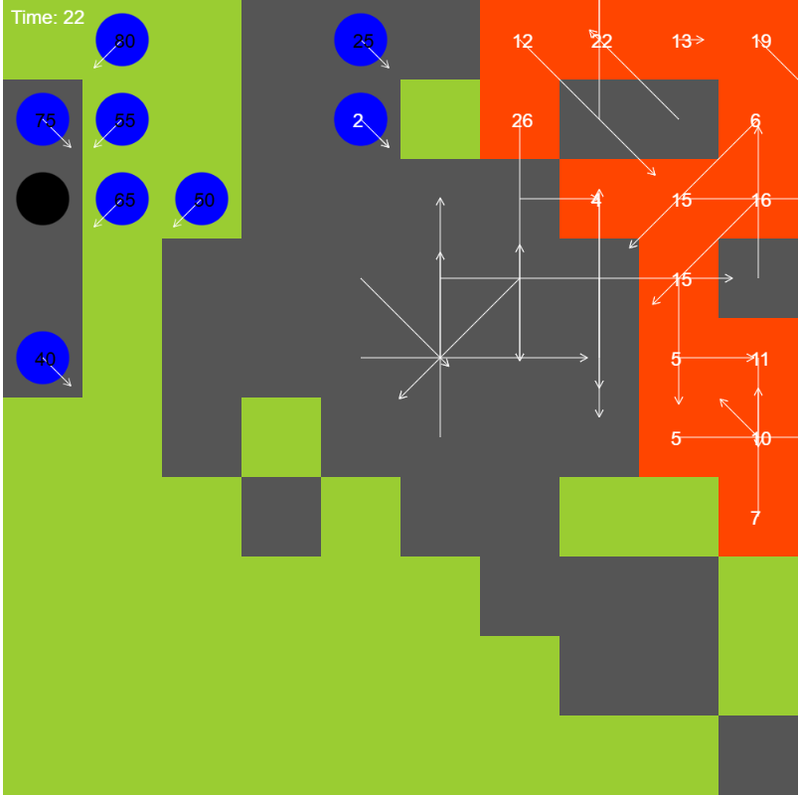

**Fig.15.** Fire Spread Scenario with Firefighter Intervention

After introducing firefighters for firefighting intervention, the fire spread speed significantly slows down, and the fire range is effectively controlled. In most cases, the maximum fire area will be reduced to about half of the original, and the duration of the fire will be effectively shortened. At the same time, the fluctuation of the fire spread curve will decrease. This indicates that firefighter intervention has a significant effect on controlling fire spread and can effectively reduce the losses caused by fires.

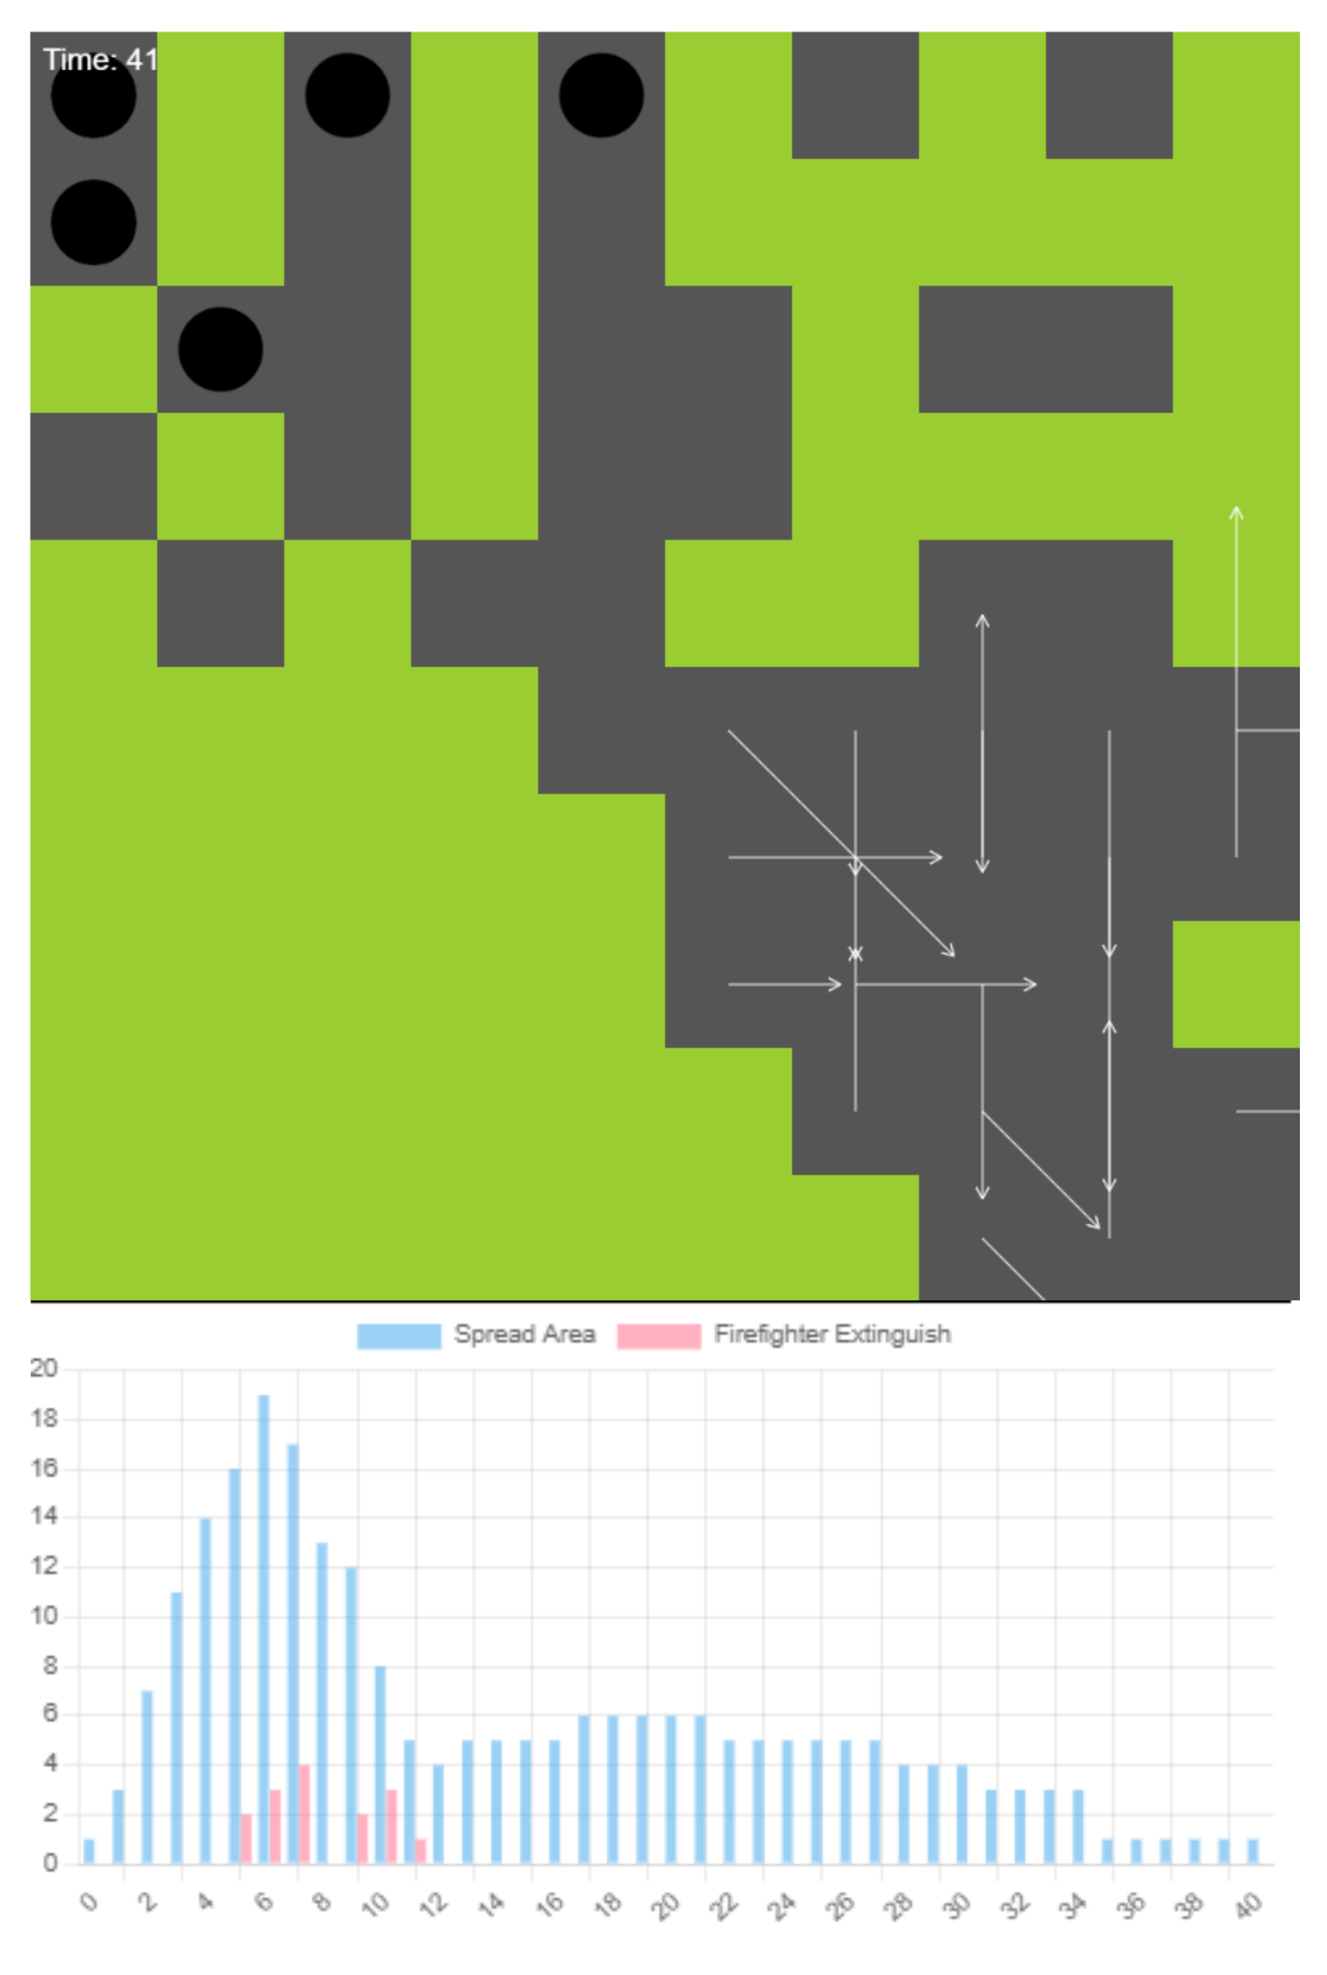

**Fig.16.** Effect of Firefighter Intervention on Fire Spread

# References

Allaire F, Filippi J-B, Mallet V, Vaysse F (2022) Simulation-based high-resolution fire danger mapping using deep learning. International Journal of Wildland Fire 31, 379–394.

Anderson JD, Wendt J (1995) ‘Computational fluid dynamics.’ (Springer)

Belcher CM (2013) ‘Fire Phenomena and the Earth System.’ (Wiley)

Finney MA (1998) FARSITE: Fire Area Simulator - Model Development and Evaluation. USDA Forest Service - Research Papers RMRS 1–36.

Gill AM, Stephens SL (2009) Scientific and social challenges for the management of fire-prone wildland-urban interfaces. Environmental Research Letters 4, 34014.

Hodges JL, Lattimer BY (2019) Wildland fire spread modeling using convolutional neural networks. Fire technology 55, 2115–2142.

Hoffman CM, Canfield J, Linn RR, Mell W, Sieg CH, Pimont F, Ziegler J (2016) Evaluating Crown Fire Rate of Spread Predictions from Physics-Based Models. Fire Technology 52, 221–237.

Jaafari A, Zenner EK, Panahi M, Shahabi H (2019) Hybrid artificial intelligence models based on a neuro-fuzzy system and metaheuristic optimization algorithms for spatial prediction of wildfire probability. Agricultural and forest meteorology 266, 198–207.

Jiang W, Wang F, Su G, Li X, Wang G, Zheng X, Wang T, Meng Q (2022) Modeling Wildfire Spread with an Irregular Graph Network. Fire 5, 185.

Le H V, Bui QT, Bui DT, Tran HH, Hoang ND (2020) A Hybrid Intelligence System Based on Relevance Vector Machines and Imperialist Competitive Optimization for Modelling Forest Fire Danger Using GIS. Journal of Environmental Informatics 36,.

Lee M, Brauer M, Wong P, Tang R, Tsui TH, Choi C, Cheng W, Lai P-C, Tian L, Thach T-Q (2017) Land use regression modelling of air pollution in high density high rise cities: A case study in Hong Kong. Science of the Total Environment 592, 306–315.

Li X, Lin C, Zhang M, Li S, Sun S, Liu J, Hu T, Sun L (2022) Predicting the rate of forest fire spread toward any directions based on a CNN model considering the correlations of input variables. Journal of Forest Research 1–9.

Li X, Zhang M, Zhang S, Liu J, Sun S, Hu T, Sun L (2022) Simulating forest fire spread with cellular automation driven by a LSTM based speed model. Fire 5, 13.

Radke D, Hessler A, Ellsworth D (2019) FireCast: Leveraging Deep Learning to Predict Wildfire Spread. In ‘IJCAI’, 4575–4581

Rothermel RC (1972) ‘A mathematical model for predicting fire spread in wildland fuels.’ (Intermountain Forest & Range Experiment Station, Forest Service, US …)

Running SW (2006) Is global warming causing more, larger wildfires? Science 313, 927–928.

Skinner CN, Chang C (1996) Fire regimes, past and present. In ‘Sierra Nevada Ecosyst. Proj. Final Rep. to Congr. Vol. II. Assessments Sci. Basis Manag. Options. Wildl. Resour. Cent. Rep. No. 37. Centers Water Wildl. Resour. Univ. California, Davis. 1041-1069’, 1041–1069

Storey MA, Bedward M, Price OF, Bradstock RA, Sharples JJ (2021) Derivation of a Bayesian fire spread model using large-scale wildfire observations. Environmental Modelling & Software 144, 105127.

Sung S, Li Y, Ortolano L (2021) WildfireNet: Predicting Wildfire Profiles (Student Abstract). In ‘Proc. AAAI Conf. Artif. Intell.’, 15905–15906

Theobald D, Romme W (2007) Expansion of the US wildland–urban interface. Landscape and Urban Planning 83, 340–354.

Wang Z, Zhang T, Wu X, Huang X (2022) Predicting transient building fire based on external smoke images and deep learning. Journal of Building Engineering 47, 103823.

Wu X, Zhang X, Jiang Y, Huang X, Huang GGQ, Usmani A (2022) An intelligent tunnel firefighting system and small-scale demonstration. Tunnelling and Underground Space Technology 120, 104301.

Zhai C, Zhang S, Cao Z, Wang X (2020) Learning-based prediction of wildfire spread with real-time rate of spread measurement. Combustion and Flame 215, 333–341.

Zhang T, Wang Z, Wong HY, Tam WC, Huang X, Xiao F (2022) Real-time forecast of compartment fire and flashover based on deep learning. Fire Safety Journal 130, 103579.

Zhou T, Ding L, Ji J, Yu L, Wang Z (2020) Combined estimation of fire perimeters and fuel adjustment factors in farsite for forecasting wildland fire propagation. Fire safety journal 116, 103167.