Sample: CHIPS-6-02-25-04-full

Optical Model
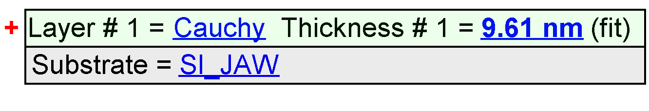
Fit Results
Parameter | Average | Min. | Max. | Std. Dev. | % Range
MSE | 6.983 | 3.602 | 346.395 | 31.394 | 4909.192
Thickness # 1 (nm) | 41.35 | 8.82 | 3729.20 | 340.93 | 8997.7246
A | 2.2104 | 2.1432 | 3.0000 | 0.0736 | 38.7633
B | -0.0275 | -0.0349 | 0.0016 | 0.0041 | -132.7840
C | 0.0018 | -0.0005 | 0.0024 | 0.0004 | 160.7714
n of Cauchy @ 632.8 nm | 2.1527 | 2.1247 | 2.9454 | 0.0741 | 38.1192

Model Parameters vs. Position
