Sample: CHIPS-6-02-25-08-full

Optical Model
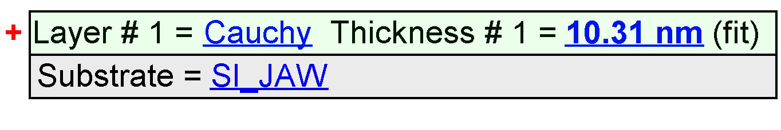
Fit Results
Parameter | Average | Min. | Max. | Std. Dev. | % Range
MSE | 6.703 | 6.248 | 7.216 | 0.234 | 14.438
Thickness # 1 (nm) | 9.67 | 8.95 | 10.37 | 0.36 | 14.6707
A | 2.2579 | 2.2502 | 2.2668 | 0.0031 | 0.7341
B | -0.0224 | -0.0296 | -0.0153 | 0.0030 | -64.1370
C | 0.0008 | 0.0002 | 0.0014 | 0.0003 | 155.4766
n of Cauchy @ 632.8 nm | 2.2071 | 2.1928 | 2.2199 | 0.0063 | 1.2313

Model Parameters vs. Position
