Final Project Report

The Divorce in the US
ISM6419 Data Visualization
Pablo X Zumba

Introduction

My interest in social problems has always been piqued because they involve a lot of complex variables that have a cumulative effect on society and one of those problems is Divorce. My wife, who is a psychologist who provides marital therapy, wondered if there are significant differences in divorce rates between the United States and other countries as well as possible causes and effects of divorce on families with children.

This project aims to study:

Compared to other countries, what is the divorce rate and the number of divorces as a percentage of marriages in the US?
- What has been the trend in marriage and divorce rates in the US alone over time?
- What month is the most popular for divorces in the US only?
- Is there a predominant religion, ethnicity, or academic level among divorced people in the US?
- Within a divorced group studied, how do children respond to divorce?

Methodology

To address the questions stated, multiple datasets from different sources are going to be downloaded, cleaned (if necessary), joined, and analyzed. As the project focuses on the United States, most of the data can be joined by "Country/Region" as the primary key, and other data will be joined by "Date".

For the first two questions, joining data from "Our World in Data" and the “United Nations”, seems to be the most effective and accurate method. Marriage and divorce rates by country and year "Our World in Data". [1] [2]
The first dataset includes data extracted from external sources as follows:
- For European countries, the data comes from the Eurostat dataset.
- For the US the series is composed of data taken from three sources: Carter et al. (2006) for the period 1920 - 1995; the US Census Bureau (2007) for the period 1996 - 2004; and the CDC for the period 2005 to present.
- For other non-European countries that are OECD members, the data comes from the OECD Family Database.
- The data comes from the UN World Marriage Database for all other countries.

To answer the question: What are the most prevalent religions, races, and academic levels by divorced people? the NLSY97 survey provided by the United States Department of Labor and National Longitudinal Surveys was used. NLSY97 consists of 8,984 respondents born between 1980 and 1984 who lived in the United States in 1997 and have demographic data and parental status regarding Divorce. [3]

Finally, to examine how children respond to divorce, the "Consequences of Recent Parental Divorce for Young Adults, 1990-1992 (ICPSR 24400)" study provided by DSDR (Data Sharing Demographic Research) was used. [4]

Analysis

Compared to other countries, what are the divorce rate and the number of divorces as a percentage of marriages in the US?
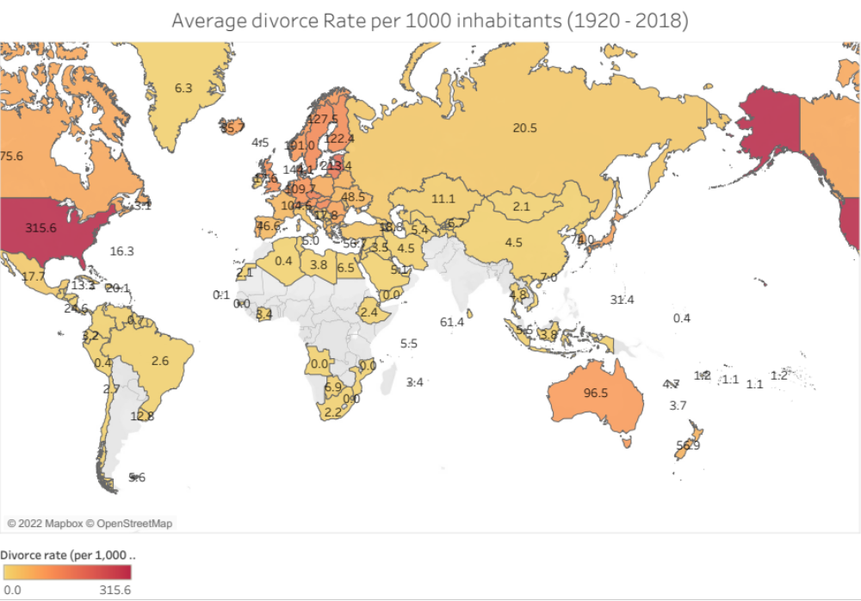
Figure 1 Average divorce Rate per 1000 inhabitants (1920 - 2018)
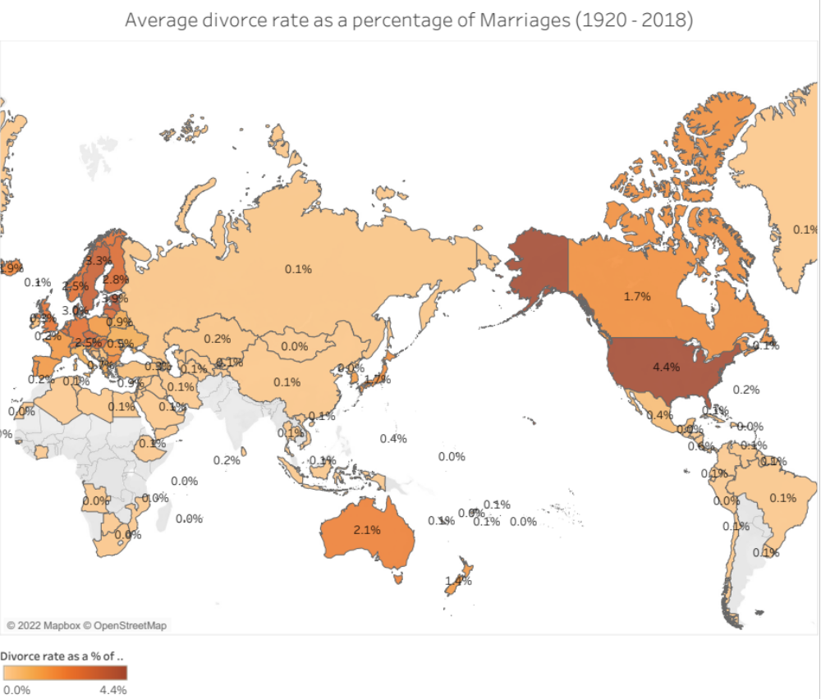
Figure 2 Average divorce rate as a percentage of Marriages (1920 - 2018)
Analysis: Figure 1 shows that the divorce rate per 1000 inhabitants in the US from 1920 to 2018 is significantly higher than in other countries. However, this does not provide much detail because we are not considering the number of marriages in each country. To have a broader picture, figure 2 shows the Average divorce rate as a percentage of marriages from 1920 to 2018 by country. The United States has an average of 4.4% of divorces of the total of marriages in a year. We can see that the difference is not significant compared to other eastern European countries like Estonia (3.9%) or Latvia (3.8%). Using this analysis, we conclude that the United States has one of the highest divorce rates.

What has been the trend in marriage and divorce rates in the US alone over time?
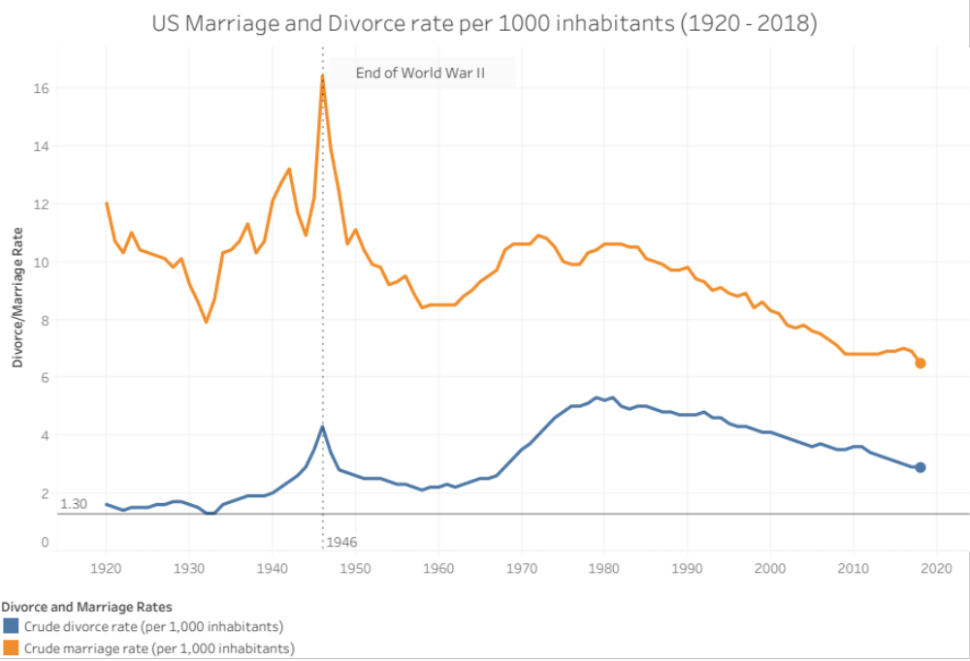
Figure 3 US Marriage and Divorce rate per 1000 inhabitants (1920 - 2018)
Analysis: The number of marriages and divorces considerably fluctuated between 1920 and 1960 with a special increase at the end of World War II, but after 1960 both rates increased until the 70s decade and have been decreasing since then. Despite the population growth, both divorce and marriage rates are declining, which means that fewer people are getting married, and therefore, fewer people are getting divorced.

- What month is the most popular for divorces in the US only?
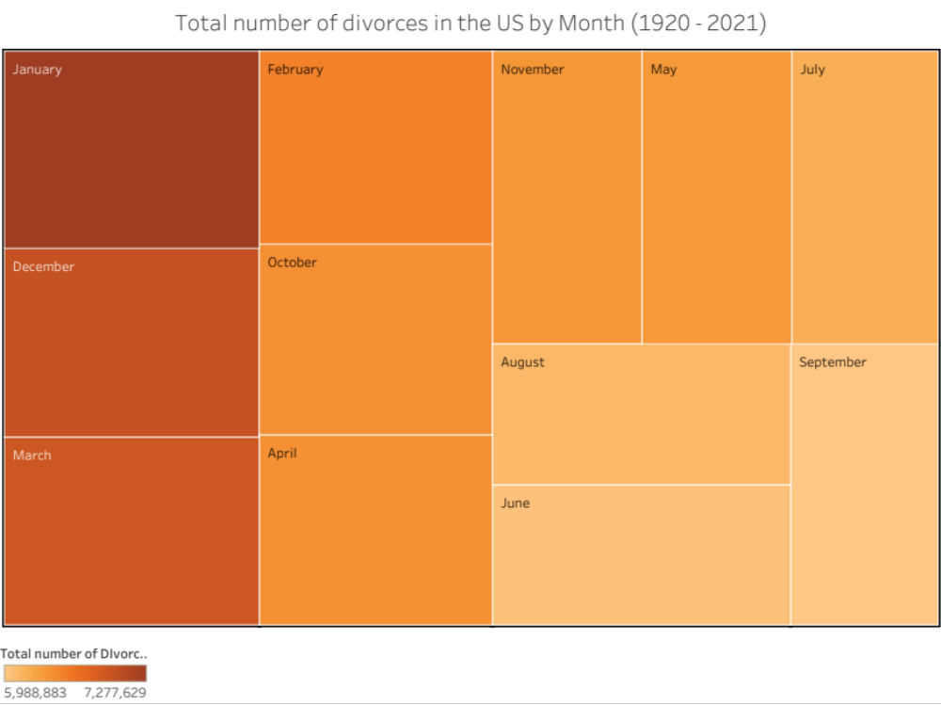
Figure 4 Total number of divorces in the US by Month (1920 - 2021)

Analysis: Figure 4 shows that most divorces occurred between January and December according to United Nations records.

- Is there a predominant religion, ethnicity, or academic level among divorced people in the US?
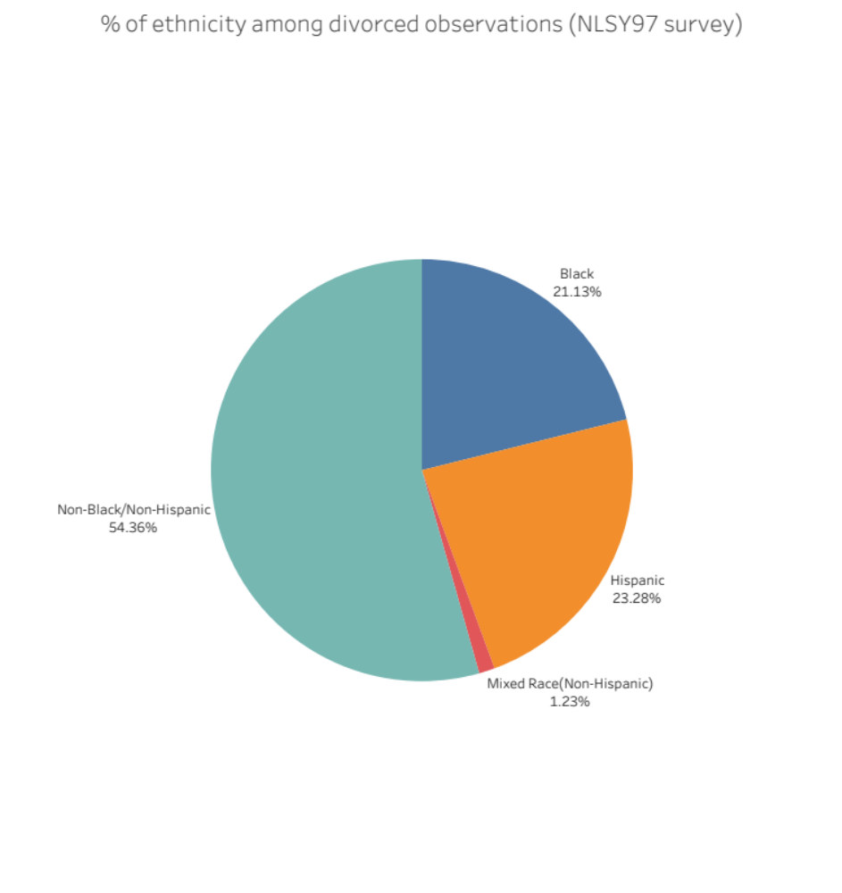
Figure 5 Percentage of ethnicity in Divorced people|NLSY97 Data Survey [3]
Analysis: While the NLSY97 acknowledges that it covered the entire nation with demographic details, we can observe that there are no specific ethnicities in the Non-Black/Non-Hispanic group, so we can conclude that the Non-Black/Non-Hispanic group covers whites, Asians, Pacific Islanders, and Native Americans and they represent most of the divorced population.

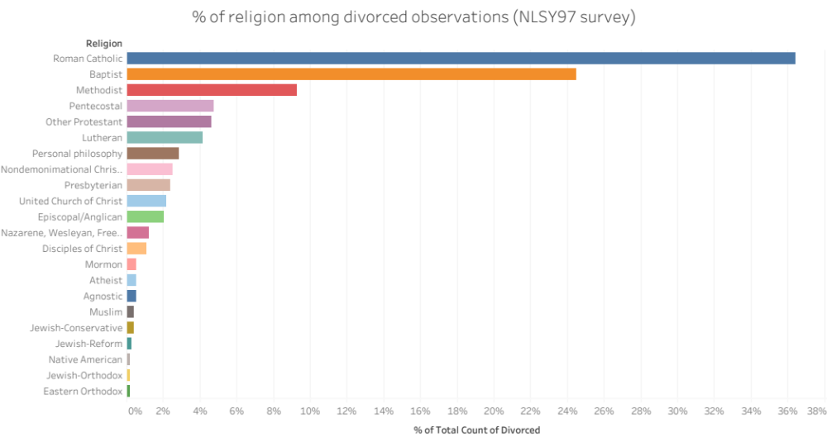
Figure 6 Percentage of religions among the divorced population.
Analysis: According to the NLSY97 study, Roman Catholics, Baptists, and Methodists had the highest percentage of divorces, while Orthodox churches had the lowest percentage of divorces.
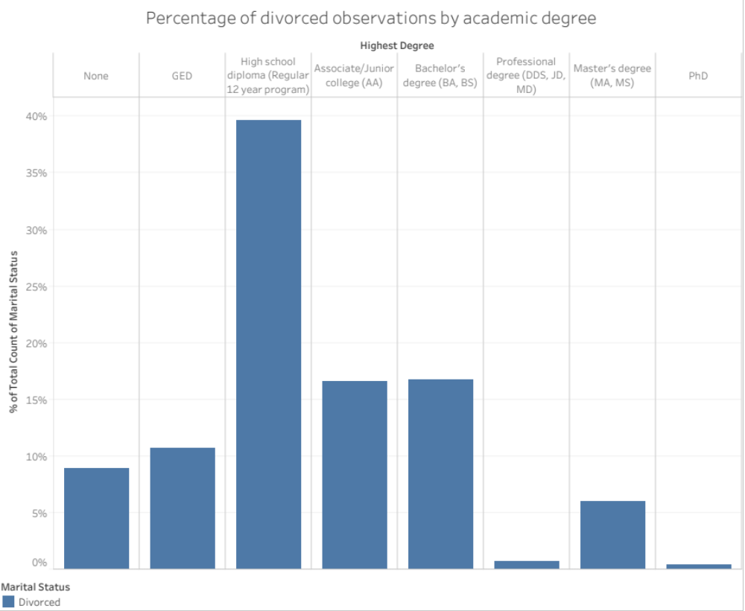
Figure 7 Percentage of Degrees obtained among the divorced population.

Analysis: The NLSY97 survey covers the period 1997 - 2020, so people earned new academic degrees during that timeframe. This analysis is based on the highest academic degree obtained until 2020. The percentage of divorce decreases with higher degrees, such as bachelor, master, and doctoral degrees. Additionally, we have a significantly higher percentage of divorced High school graduates, so I might speculate it's probably because the lower the degree, the lower the salary increases the divorce rate. However, additional analysis on wages should be performed to answer this question more accurately.

- Within a divorced group studied, how do children respond to divorce?

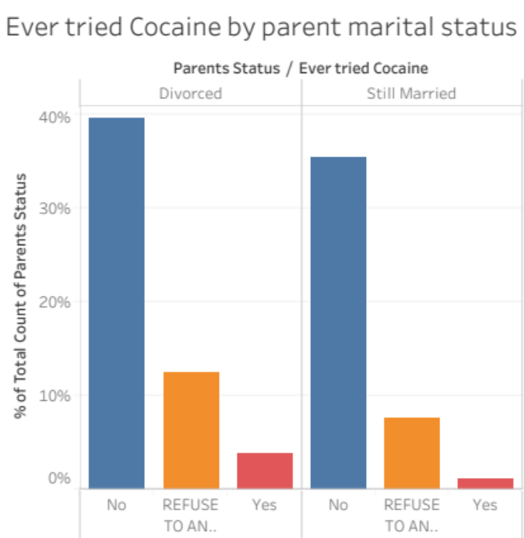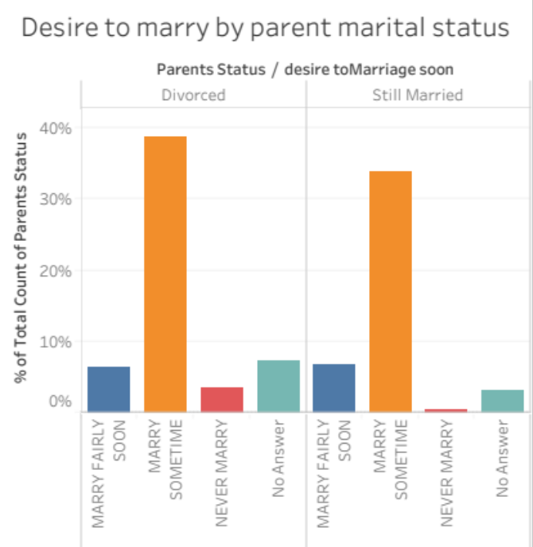
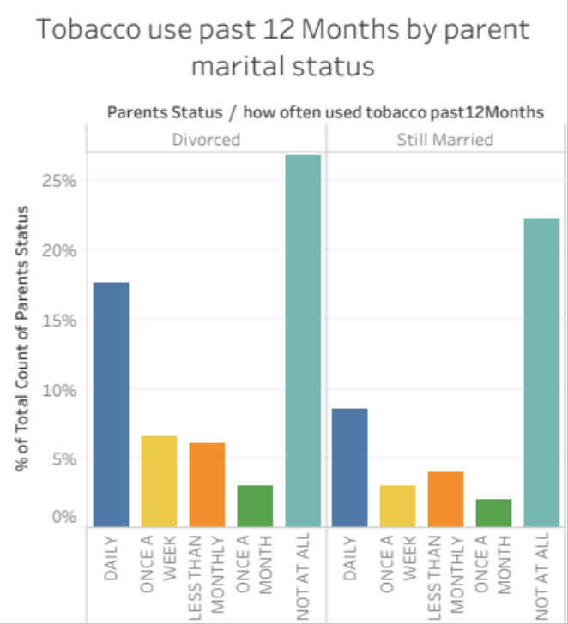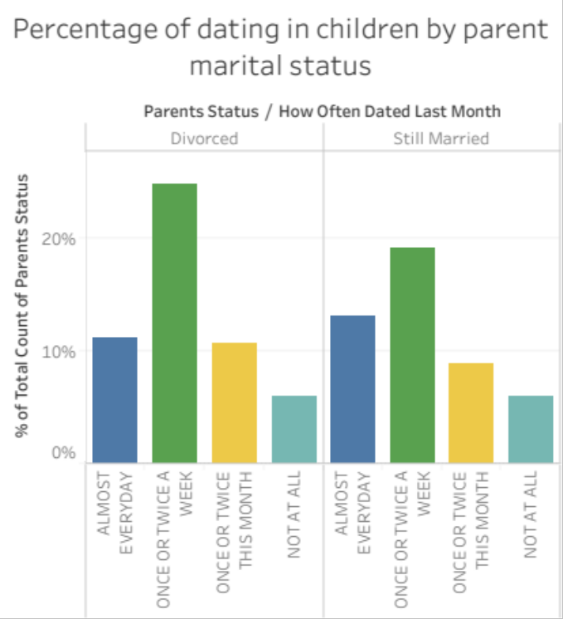
Figure 8 Response to divorce of female children between 18-23 years old. Source: ICPSR 24400. [4]

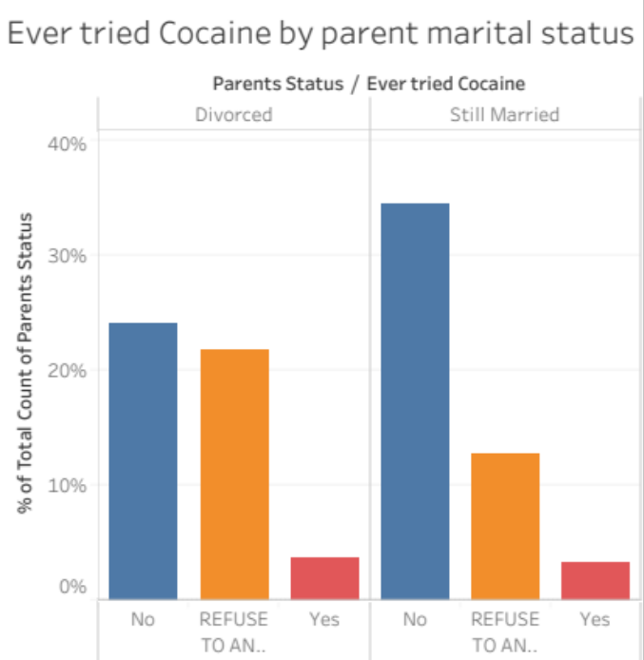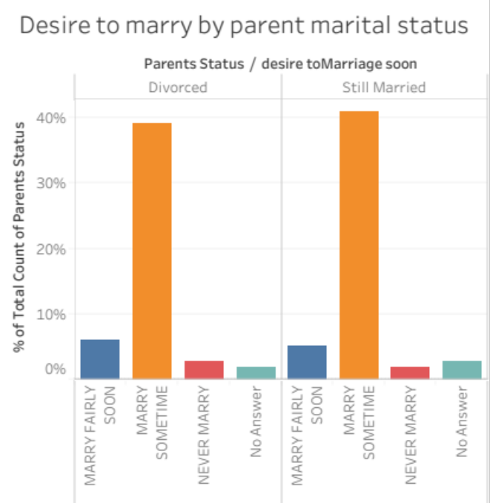
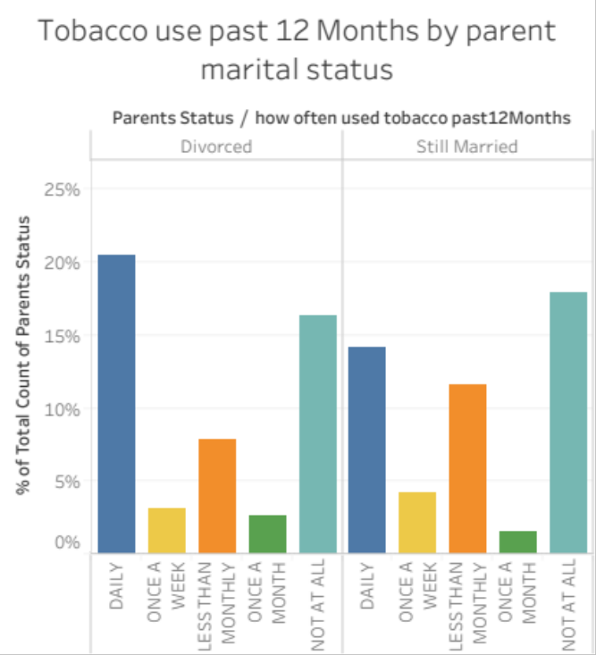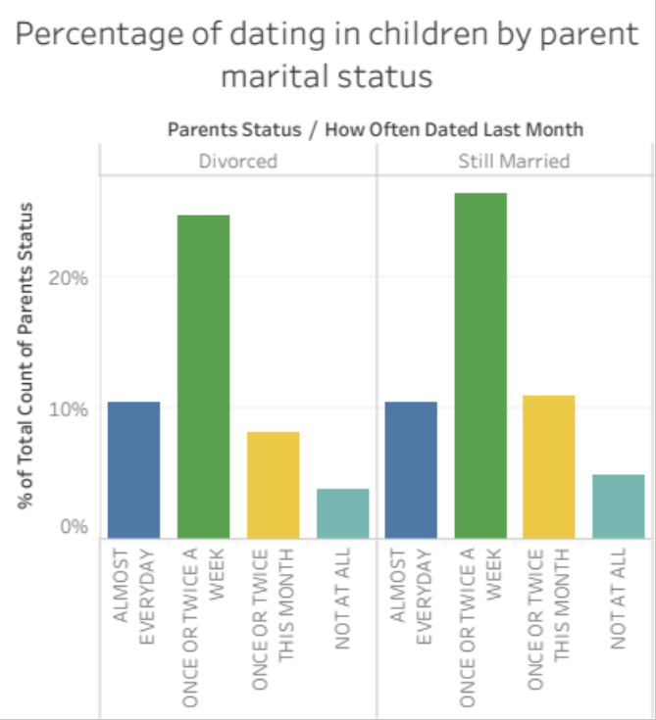
Figure 9 Response to divorce of male children between 18-23 years old. Source: ICPSR 24400. [4]
Analysis: A comparison of the bar charts of female and male children between 18-23 years old in the parent-divorced group shows a significant increase in the percentage of females not consuming cocaine after their parents got divorced. Regarding the desire to marry chart, we can see that females from divorced parents have an increase in never being married compared to males. According to the data, males from divorced parents consume more tobacco than females from the same parent's marital status. In addition, the data indicates that there is no significant difference between males and females regarding the percentage of dating in children of divorced parents. It is necessary for further analysis to be conducted in this section before any conclusions can be drawn.

Conclusions
- According to United Nations Data, the United Estates has one of the highest divorce rates compared to other countries.
- Both divorce and marriage rates are declining since roughly 1980, which means fewer people are getting married, and therefore, fewer people are getting divorced.
- There is a tendency for couples to file for divorce in January and December of each year.
- Predominant religions like Roman Catholic, Baptist, and Methodist are among the religions where most divorces occur.
- Non-Black/Non-Hispanic represent most of the divorced population.
- More divorces occur among people with a high school diploma.

Further Research Questions
- Using the United States population as a normalization factor, how do ethnicity, religion, and academic level change among the divorced population?
- How does the percentage of the highest academic level achieved in the divorced group change when comparing the data with their income?
- How do children of divorced and still married couples differ by age? Are younger children more susceptible to divorce than young adult children?

References

[1] https://ourworldindata.org/marriages-and-divorces
[2] https://data.un.org/Data.aspx?q=Divorce&d=POP&f=tableCode%3a16
[3] https://www.bls.gov/nls/nlsy97.htm
[4] https://www.icpsr.umich.edu/web/DSDR/studies/24400

