BridgeU
Software Requirement Specification

Zhiyi Pan 652115558

Bachelor of Science
Software Engineering Program

Department College of Arts, Media, and
Technology
Chiang Mai University
December 2025
Project Advisor
Pattama Longani, Ph.D.

Chapter 1 Introduction

1.1 Purpose and Scope
The purpose of the software design development is to present a complete software design of the BridgeU project. This document contains the outline of the software architecture, functions used, and activity diagrams with the user interface for this project. BridgeU aims to eliminate language barriers through AI technology and establish a bilingual mutual assistance ecosystem connecting Chinese students, global students, and local Thai merchants.

1.2 User Characteristics
Users:
All people who can log in.
Description:
The target users of our software are international students studying in Thailand, merchants providing services to the international student community,they share the common goal of creating a supportive bilingual community that facilitates adaptation to life in Thailand and enables seamless information sharing and communication.

1.3 Acronyms and Definitions
SRS | Software Requirement Specification
URS | User Requirement Specification
UTC | Unit Test Case
STC | System Test Case
UC | Use Case
SRC | Software Requirements Specification
RSS | Really Simple Syndication
JWT | JSON Web Token
AI | Artificial Intelligence
LLM | Large Language Model

Definition
Name | Definition
IEEE | Institute for Electrical and Electronics Engineers. Biggest global interest group for engineers of different branches and computer scientists.
Plan | A document series of tasks requires meeting an objective, typically including the associated schedule, budget, resources, organizational description and work breakdown structure.
Feature | Feature Transformation of input parameters to output parameters based on a specified algorithm. It describes the functionality of the product in the language of the product. Used for requirements analysis, design,coding, testing or maintenance.
Project  Management | The application of knowledge, skills, tools, and techniques to project activities in order to meet or exceed stakeholder needs and expectations from a project.
Project Plan | A formal, approved document used to guide both project execution and project control. The primary uses of the project plan are to document planning assumptions and the decision, to facilitate communication among stakeholders, and to document approved scope, cost, and schedule baseline.
Risk | An uncertain event or condition that, if it occurs, has a positive or  negative effect on a project’s objectives. It is a function of the  probability of occurrence of a given threat’s occurrence.
Risk  Management | The systematic application of management policies, procedures and practices to the tasks of identifying, analyzing, evaluating, treating and monitoring risk.
System Testing | Testing conducted on a complete and integrated system for evaluate the system’s compliance with its specified requirements.
Unit Test | A test of individual programs or modules in order to remove a design or programming errors.
Use Case | A use case is a description of a specific interaction between a system and its users to accomplish a particular goal or task. It outlines the sequence of steps or actions that a user performs in the system and describes the system's responses to those actions. Use cases help to identify and define the functional requirements of a system from the perspective of its users.
Activity Diagram | Activity diagram is another important behavioral diagram in UML diagram to describe dynamic aspects of the system. Activity diagram is essentially an advanced version of flow chart that modeling the flow from one activity to another activity.

Chapter 2 Specification Requirement

2.1 Feature 1
Feature 1: Daily Briefing System
The Daily Briefing System automatically captures and summarizes Thai news from Google News, providing bilingual (Chinese/English) access to daily news briefings for User. At 8 a.m. every day, the system captures news from the Google News, and saves each article as a Daily Briefing record, including original title, summary generated by the system call Qwen AI to summarize, source website name, original URL, publication time provided by the source. The system generates both Chinese and English versions for the title and abstract, and the interface only displays one of them in the current language. When the User opens the Daily Briefing page, the system returns a paginated list of Daily Briefing record from new to old according to the release time. The list card displays: title, summary, source, publication time (using only the current interface language), and provides a button to enter the detail page. User can also click original button to opens the original URL of the news. Users can enter any keywords in the search box on the page. System searches by keyword among Daily Briefing titles and abstracts (both Chinese and English versions) in the database,then System returns Daily Briefing items related to that word in the current language
User can set filtering conditions: start date(daymonthyear), end date(daymonthyear). The system applies all filtering conditions, only returns the Daily Briefing news that meets the conditions, and displays them in chronological order(new to old).

2.1.1 Use Case Diagram
This system is centered around the "Daily Briefing" function. Users can view the daily news briefings obtained by the system from Google News and generated by Qwen AI's summary on the page. By clicking on any item, they can view the more detailed news content and, when necessary, quickly jump to the original news link. At the same time, users can freely switch between the interface languages in Chinese and English. They can also use the date filtering function to view the briefings within a time range, or quickly locate the news they are interested in through keyword search, thereby efficiently browsing and managing daily news information within a unified interface.
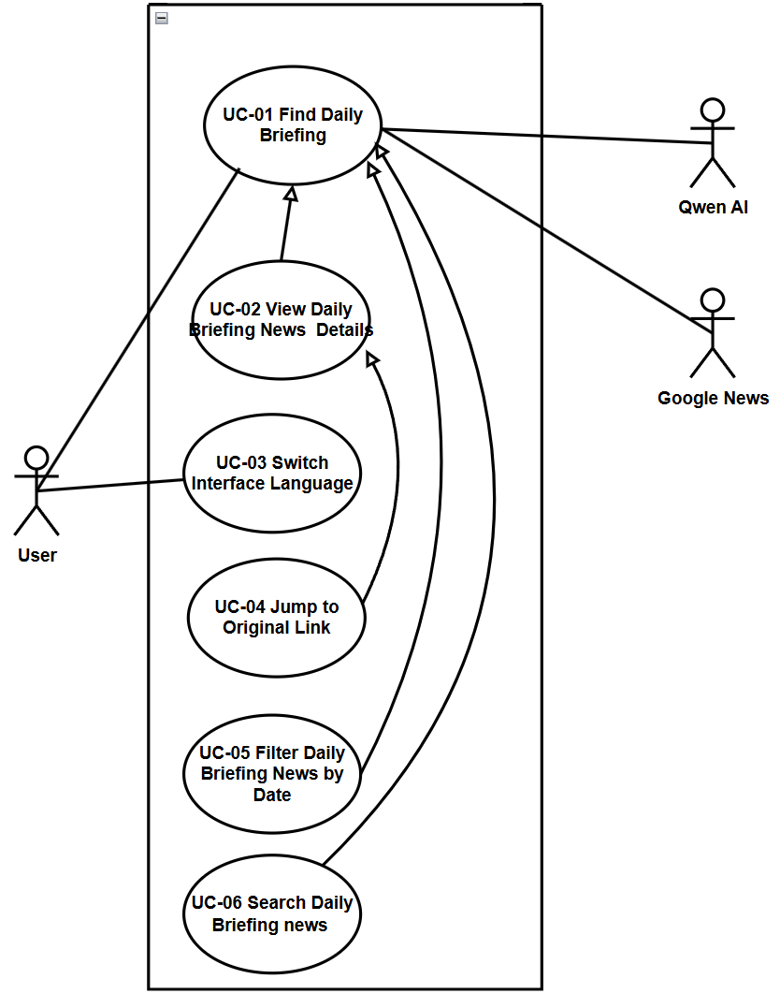

2.1.2 User Requirement Specification
URS01 – View Daily Briefings
User can open the Daily Briefing page and browse a paginated list of recent Daily Briefing items ordered from newest to oldest by publication time in their current interface language. User can use the sidebar to navigate to the Daily Briefing page in the application.
URS02 – View Daily Briefing news details
User can select a Daily Briefing item from the list and view a news detail page that shows the complete information (title, AI generated summary of News, publication time,View Original button, "Back" button) for that item in their current interface language (English/Chinese).
URS‑03 – Switch Interface Language
User can click a language switch button at any time to change the interface language between Chinese and English and continue browsing Daily Briefing items in the newly selected language.
URS‑04 – Jump to the original link
User can click an “Open original article” button on a Daily Briefing item and read the full original news article on the external official website in a new browser tab.
URS‑05 – Filter Daily Briefings News by Date
The User can filter news based on specific criteria (start date and end date) while browsing.
URS06 – Search for Daily Briefing News
User can type Chinese or English keywords into a search box on the Daily Briefing page and view only Daily Briefing items that match the entered keywords.

2.1.3 Use Case Description and Activity Diagram

2.1.3.1 UCD01 Find Daily Briefings
URS01: User can open the Daily Briefing page and browse a paginated list of recent Daily Briefing items ordered from newest to oldest by publication time in their current interface language. User can use the sidebar to navigate to the Daily Briefing page in the application.
SRS01: The system shall display the "Briefing" navigation item in the sidebar navigation menu on every page.
SRS02: The system shall display the Daily Briefing page [UI01] when the "Briefing" navigation item is clicked, showing a paginated list(The list is displayed in sections by page, and users can switch between pages via the Next / Previous / Page number buttons) of Daily Briefing items.
SRS03: The system shall order Daily Briefing items from newest to oldest based on publication time from the source website.
SRS04: The system shall display Daily Briefing items in the user's current interface language (Chinese or English), showing only the title and summary in the selected language.
SRS05: Each Daily Briefing card on the list shall display: title, AI generated summary, source website name (original or localized name), and publication time (formatted according to the current interface language).
SRS06: The system shall implement pagination to display Daily Briefing items, providing pagination controls (page number, previous/next buttons) for users to navigate through pages.
SRS07: The system shall provide a "View Detail" button on each Daily Briefing card to navigate to the news detail page.The system shall provide a “Read Original” button to navigate to News original website.
Use Case ID | UC01
Use Case Name | Find Daily Briefings
Actors | User
Description | This use case describes the process by which a user navigates to the Daily Briefing page and browses a paginated list of recent news items from Google News. The list displays news items ordered from Google News new to old by publication time, with all content displayed in the user's current interface language (Chinese or English).
Trigger | User clicks on the "Briefing" navigation item in the sidebar menu.
Preconditions | 1. User is logged into the BridgeU platform.  2. User has an active internet connection.  3. The Daily Briefing system has successfully crawled news from approved sources (Google News).
Use Case Input Specification
Input | type | Constraint |  | Example
Current Interface Language | String | Must be "zh" (Chinese) or "en" (English) |  | "en"
Post conditions | User are in "Daily Briefing page" (UI01: Daily Briefing page)
Normal Flows | User |  | System
 | 1.User clicks on the "Briefing" navigation item in the sidebar  6. User clicks pagination controls (e.g., "Next" button). |  | 2. System retrieves the user's current interface language preference (Chinese or English)  3. System queries the database for the first page of Daily Briefing items, ordered by publication time (newest first)  4. System retrieves the corresponding language version (Chinese or English) for each Daily Briefing item's title and summary  5. System displays the Daily Briefing page (UI01) with paginated list of news items(Each card includes title, summary, source, time, and "View Detail" button,“Read Original” button)  7. System loads and displays the next set of news items.  8. System navigates to the News Detail Page.
Alternative Flow
Exception Flow
Assumption | The user has an internet connection .

AD01: View Daily Briefings
Activity Diagram for View Daily Briefings, which explains the steps between a User and the System for browsing aggregated news.
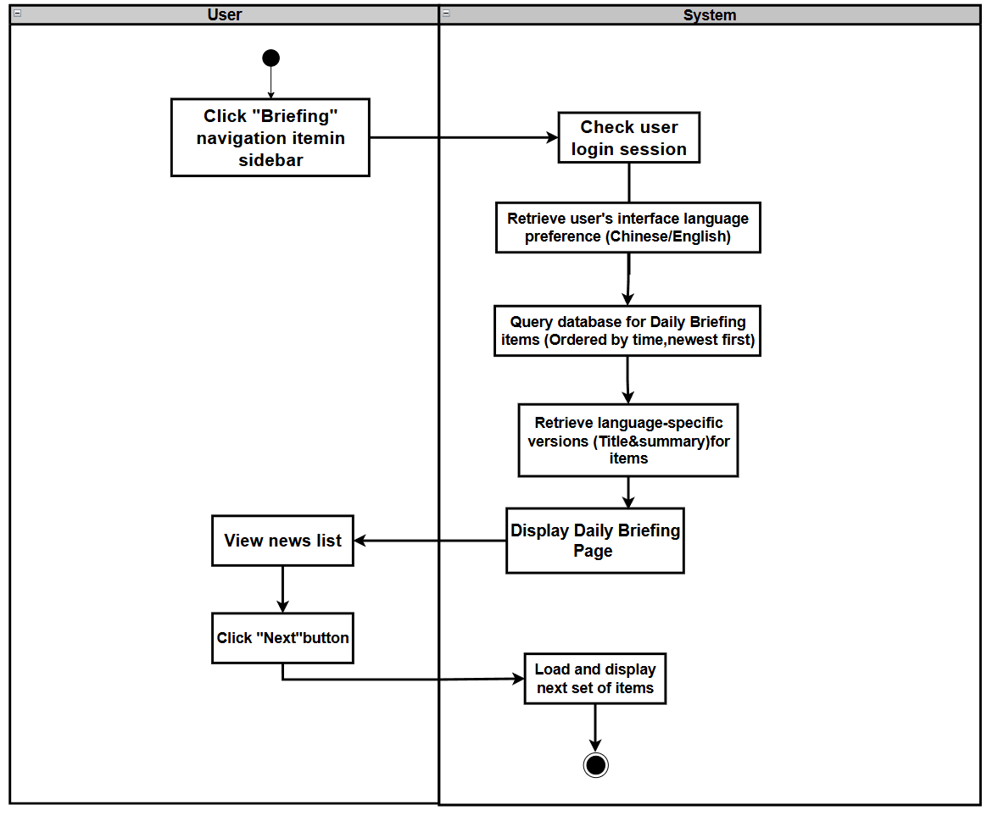

2.1.3.2 UCD02 View Daily Briefing news details
URS02: User can select a Daily Briefing item from the list and view a news detail page that shows the complete information (title, summary, publication time, View Original button) for that item in their current interface language (English/Chinese).
SRS08: The system shall provide a "View Detail" button on each Daily Briefing card in the list page (UI01) to navigate to the news detail page (UI02).
SRS09: The system shall display the News Detail page (UI02) when a user clicks the "View Detail" button on a Daily Briefing card.
SRS10: The system shall retrieve the selected Daily Briefing item from the database using the news item ID passed from the list page.
SRS11: The system shall display the news detail page content in the user's current interface language (Chinese or English), showing the title and summary in the selected language.
SRS12: The News Detail page (UI02) shall display the following information in the user's current interface language:
News title
AI generated summary
Source website name
Publication time
SRS13: The system shall provide a "Back" button on the News Detail page to return to the Daily Briefing list page.
SRS14: The system shall provide a "View Original" button that triggers the browser to open the original news article URL in a new tab when clicked.
Use Case ID | UC02
Use Case Name | View Daily Briefing news details
Actors | User
Description | User can select a Daily Briefing item from the list and view a news detail page that shows the complete information (title, AI generated summary of News, publication time,View Original button, "Back" button) for that item in their current interface language (English/Chinese).
Trigger | User clicks the "View Detail" button on a Daily Briefing card in the Daily Briefing list page (UI01)
Preconditions | 1. User has an active internet connection.  2. User is viewing the Daily Briefing list page (UI-01).  3. At least one Daily Briefing item exists in the list.
Use Case Input Specification
Input | type | Constraint |  | Example
Current Interface Language | String | Must be "zh" (Chinese) or "en" (English) |  | “en”
Post conditions | User is viewing the News Detail page (UI02) displaying the complete information for the selected Daily Briefing item
Normal Flows | User |  | System
 | 1. User clicks the "View Detail" button on a Daily Briefing card in the list page  12. User views the news details  13. User switches the interface language (Chinese/English) using the language switcher (optional)  18. User clicks the "View Original" button (optional)  20. User clicks the "Back" button (optional) |  | 2. System retrieves the news item ID from the clicked card  3. System retrieves the user's current interface language preference (Chinese or English)  4. Frontend sends HTTP request to backend API with news item ID and language parameter  5. Backend receives request (authentication not required for this endpoint)  6. Backend queries the database for the Daily Briefing item using the news item ID  7.Backend retrieves the corresponding language version (Chinese or English) for the news item's title and summary  8. Backend returns response with success status and news detail data  9. Frontend receives HTTP response from backend  10. Frontend checks if response.status is 200 and response.data.success is true  11. System displays the News Detail page (UI-02) with the complete information:  - News title (in current interface language)  - AI-generated summary (in current interface language)  - Source website name  - Publication time (formatted according to current interface language)  - "View Original" button (disabled if originalUrl is invalid or missing)  - "Back" button  14. Frontend triggers a language change event and updates the current language preference  15. System re-fetches the news detail data from the API with the new language parameter  16. System updates the News Detail page display with content in the new language (title, summary, formatted dates)  17. Use case continues from Step 12  19. System triggers the browser to open the original URL in a new tab  21. System navigates the user back to the Daily Briefing page (UI-01)
Alternative Flow
Exception Flow
Assumption | The user has an internet connection .

AD02 View Daily Briefing news details
The Activity Diagram for View Daily Briefings shows how the User and the System interact when view the daily briefing list（UI01）
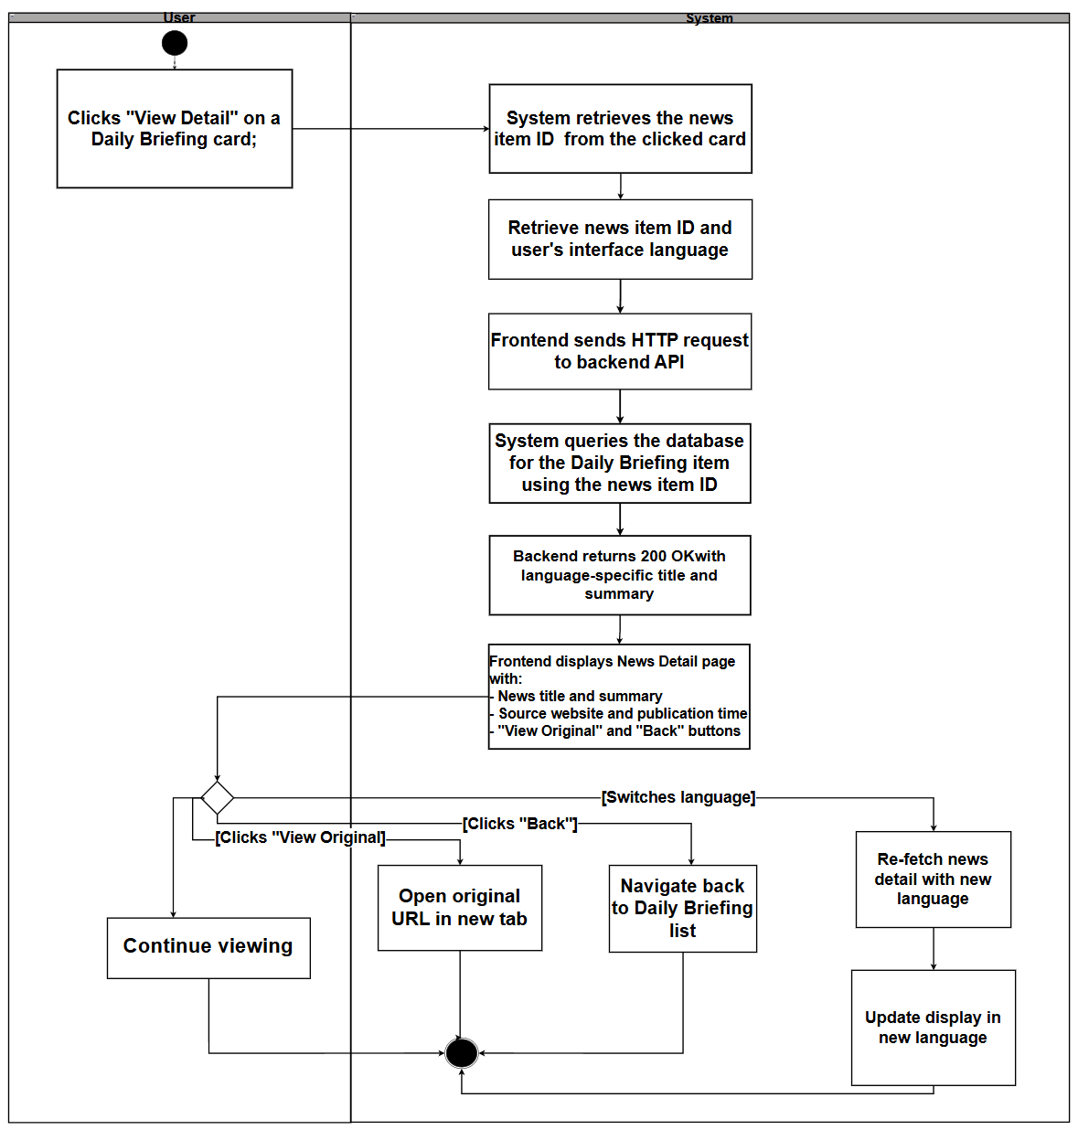

2.1.3.3 UCD03 Switch Interface Language
URS‑03 :User can click a language switch button at any time to change the interface language between Chinese and English and continue browsing Daily Briefing items in the newly selected language.
SRS15: The system shall provide a language switch button on every page of the application, accessible from the sidebar (for loggedin users) or login page (for nonloggedin users). The sidebar displays two separate buttons:"中文" (Chinese) and "EN" (English),while the login page displays a single toggle button showing "EN/中文".
SRS16: The system shall display the current interface language (Chinese or English) in the language switch control, allowing users to toggle between "中文" (Chinese) and "English" (English).
SRS17: When the user clicks the language switch button, the system shall immediately update the user's interface language preference and persist it in local Storage with the key 'user Language'. Note: The user profile's preferred Language field is only updated when the user explicitly saves their profile in the My Profile page. Language switching via the sidebar buttons only updates local Storage for the current session.
SRS18: The system shall refresh the current page content immediately after the language switch, displaying all interface text, labels, buttons, and content in the newly selected language.
SRS19: The system shall refetch any displayed content (e.g., Daily Briefing items, news details) from the backend API with the new language parameter (lang="zh" or lang="en") to ensure content is displayed in the selected language. The system triggers a 'language Changed' custom event with detail { lang: new Lang } to notify all components to refresh their content.
SRS20: The system shall maintain the user's current page context (e.g., current page number, selected news item ID, filter parameters) when switching languages, so the user can continue browsing without losing their place. For example, if the user is on page 3 of the Daily Briefing list, switching language will reload page 3 in the new language.
SRS21: The system shall format dates and times in the format "DD-MM-YYYY HH:mm" (daymonthyear hour:minute) for both Chinese and English interfaces. The date format remains consistent across languages, but all interface labels and content text are translated according to the selected language.
Use Case ID | UC03
Use Case Name | Switch Interface Language
Actors | User
Description | User can click a language switch button at any time to change the interface language between Chinese and English and continue browsing Daily Briefing items in the newly selected language.
Trigger | User clicks the language switch button on any page of the application
Preconditions | 1. User may or may not be logged into the BridgeU platform (language switching is available on both login page and authenticated pages).  2. User is viewing any page of the application.  3. The system has bilingual content available (Chinese and English versions) for the current page.  4. The browser supports local Storage (for storing language preference).
Use Case Input Specification
Input | type | Constraint |  | Example
Selected Language | String | Must be "zh" (Chinese) or "en" (English) |  | "en"
Post conditions | 1.User's interface language preference is updated to the newly selected language  2.Current page content is refreshed and displayed in the newly selected language  3.User can continue browsing in the newly selected language without losing their current context
Normal Flows | User |  | System
 | 1. User clicks the language switch button (e.g., "🇨🇳 中文" or "🇺🇸 EN" in sidebar, or "EN/中文" toggle on login page) on the current page  7. User continues browsing in the newly selected language |  | 2. System calls setLanguage (newLang) function, which validates the language code ("zh" or "en")  3. System updates the current language state and attempts to store the preference in localStorage with key 'userLanguage'  4. All components listening to 'languageChanged' event receive the notification  • Each component uses its current state (page number, selected item ID, filter parameters, etc.) to maintain context  • Components refetch their content from the backend API with the new language parameter (lang="zh" or lang="en")  • For Daily Briefing list: calls fetchDailyBriefing() with params.lang = newLang, maintaining current page and filters  • For News Detail: calls fetchNewsDetail(newsId) with params.lang = newLang, maintaining the same newsId<br>  5. Components receive the content in the newly selected language from API responses  6. System refreshes the current page display with:  - All interface text, labels, and buttons in the new language (via i18n translation system, automatically updated when language changes)  - All content (titles, summaries, etc.) in the new language (from API response)<br>  - Dates and times formatted as "DD-MM-YYYY HH:mm" (consistent format for both languages)<br>  - Current page context maintained (same page number, same selected item ID, same filter parameters if applicable)<br>  - Element Plus UI components locale updated (zhcn or en)
Alternative Flow
Exception Flow
Assumption | The user has an internet connection .

AD03: Switch Interface Language
The Activity Diagram for Switch Interface Language illustrates the interaction between the User and the System when the user changes the interface language:
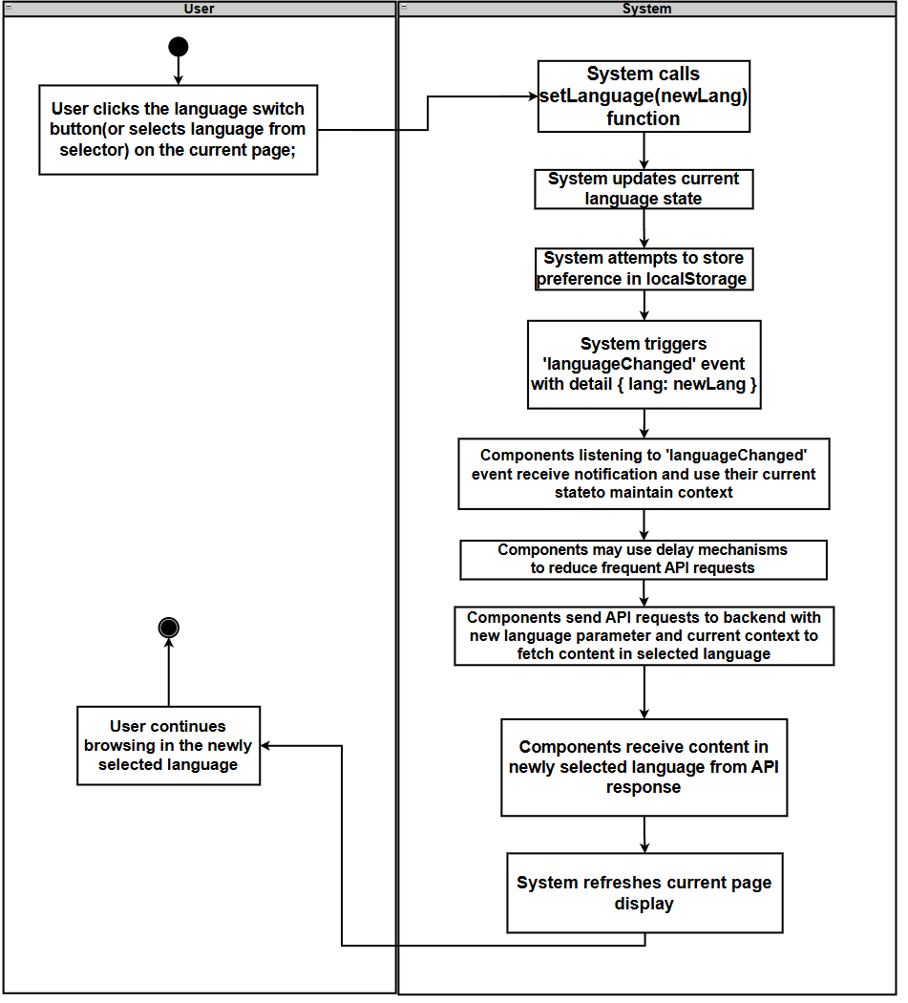

2.1.3.4 UCD04 jump to original Link
URS04: The User can jump to the original text link to read the full report from the source website when viewing news details.
SRS22: The system shall display a "Read Original" button on both the Daily Briefing list page and the News Detail page.
SRS23: The system shall display the "Read Original" button to indicate that clicking it will open an external website in a new browser tab.
Use Case ID | UC04
Use Case Name | Jump to Original Link
Actors | User
Description | User can click the "Read Original" button on the Daily Briefing list page or News Detail page to open the original news article from the source website in a new browser tab.
Trigger | User clicks the "Read Original" button on a Daily Briefing card (list page) or on the News Detail page
Preconditions | 1. User is viewing the Daily Briefing list page (UI01) or the News Detail page (UI02).  2. The user has internet connectivity to access external websites.
Use Case Input Specification
Input | type | Constraint |  | Example
Post conditions | The original news article from the source website is opened in a new browser tab
Normal Flows | User |  | System
 | 1. User views a Daily Briefing item on the list page or the News Detail page.  4. User click the “Read Original” button |  | 2. System checks whether a "Read Original" action is available for the current news item.  3. System renders the "Read Original" button in the current interface language ("Read Original" in English, "阅读原文" in Chinese).  5. System opens original link in new browser tab(keeps current BridgeU page unchanged
Alternative Flow
Exception Flow
Assumption | The user has an internet connection .

AD04:
This activity diagram show the jump to orginal link shows the interaction between the user and the system when the user selects the jump to orginal link
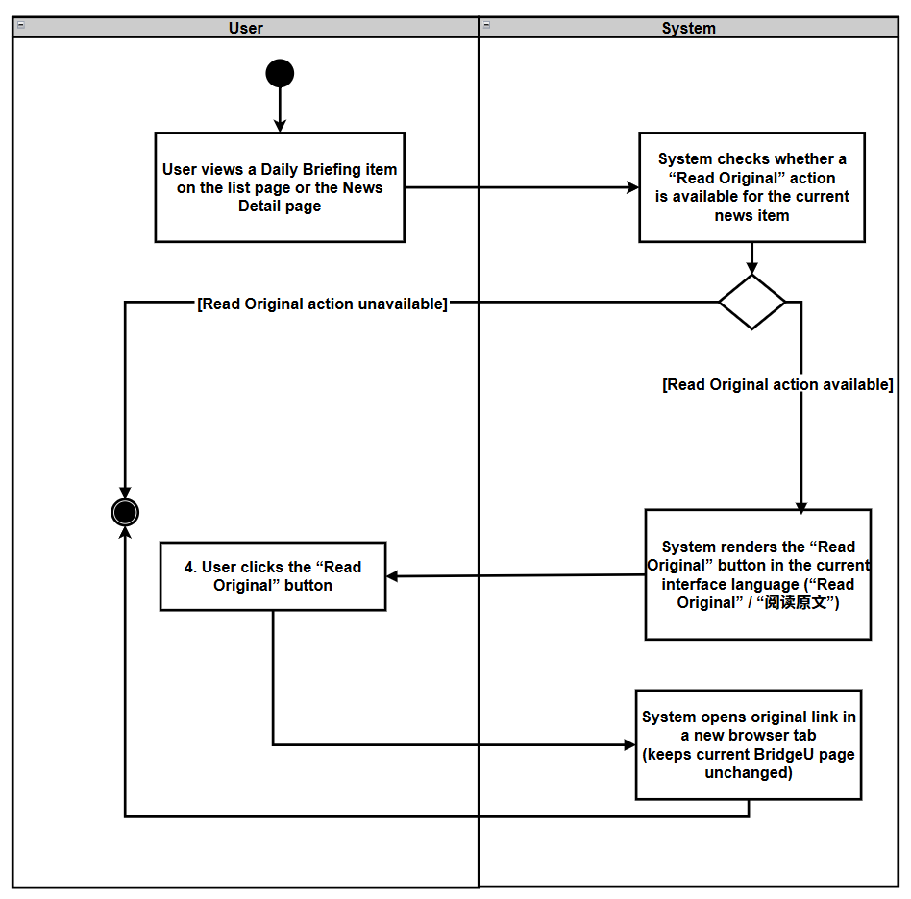

2.1.3.5 UCD05 Filter Daily Briefings News by Date
URS‑05：The User can filter news based on specific criteria (start date and end date) while browsing.
SRS24: The system shall provide a filter panel on the Daily Briefing list page (UI01) containing:
A “Start Date” picker (optional).
An “End Date” picker (optional).
A "Filter" action button.
A "Reset" action button that clears both date fields.
SRS25: When the user clicks the "Filter" button, the system shall validate that:
If both dates are provided, Start Date ≤ End Date.
If validation fails, the system shall display an appropriate error message and shall not send a filter request to the backend.
SRS26: When validation succeeds, the system shall send a filter request to the backend including the provided filter parameters:
`startDate` (optional)
`endDate` (optional)
SRS27: The backend shall query the Daily Briefing data such that:
If `startDate` and/or `endDate` is provided, only news items whose publication date (`publishDate`) falls within the date range (inclusive) are returned.
If only `startDate` is provided, the backend shall set `endDate` to today.
If only `endDate` is provided, the backend shall set `startDate` to 30 days before the provided end date.
Results shall be paginated and ordered from newest to oldest by publication date (`publishDate` descending).
SRS28: The system shall update the Daily Briefing list page (UI01) to display only the filtered news items, resetting the results view to the first page while preserving pagination controls for navigating through multiple result pages.
SRS29: If no news items match the filter conditions, the system shall display an empty list and a user-friendly message "No news data available" while keeping the filter panel visible so that the user can adjust conditions and retry.
Use Case ID | UC-05
Use Case Name | Filter Daily Briefings News by Date
Actors | User
Description | User can filter Daily Briefing items by choosing an optional start date and an optional end date, and then browse only the items that meet these filter conditions.
Trigger | User is on the Daily Briefing list page (UI-01) and interacts with the filter panel (selects dates, then clicks the "Filter" button).
Preconditions | 1. User is logged into the BridgeU platform.  2. User has an active internet connection.  3. The Daily Briefing system has successfully crawled news from approved sources and stored publication dates.  4. The filter panel (date pickers) is visible on the Daily Briefing list page (UI-01).
Use Case Input Specification
Input | type | Constraint |  | Example
Start Date | Date | Must be a valid calendar date; must not be later than End Date |  | 01-01-2026
End Date | Date | Must be a valid calendar date; must not be earlier than Start Date |  | 03-01-2026
Post conditions | The Daily Briefing list page (UI-01) displays only news items that match the provided date conditions (if any), ordered from newest to oldest by publication date, with pagination.
Normal Flows | User |  | System
 | 1. User opens the Daily Briefing list page (UI-01) and sees the filter panel with date pickers.  3. User sets filter criteria (“Start Date” and/or “End Date”).  5. (Optional) User clicks the "Reset" button.  7. User clicks the "Filter" button.  13. User browses the filtered news list and can navigate between pages using pagination controls.  15. User may adjust filter criteria and click "Filter" again (or reset). |  | 2. System displays the filter panel with empty (optional) fields and shows the current news list (unfiltered), with pagination controls when multiple pages exist.  4. System updates the filter model accordingly.  6. System clears Start Date and End Date and refreshes the list as unfiltered (page reset to 1).  8. System validates the filter inputs (if both dates are provided, Start Date ≤ End Date).  [E1: Invalid date range]`  9. If validation passes, the system sends a filter request to the backend API including any provided parameters (`startDate`, `endDate`) and the current UI language (`lang`).  10. Backend queries the database for Daily Briefing items matching the provided conditions (date range on `publishDate`), orders results from newest to oldest by `publishDate`, and applies pagination.  11. Backend returns the filtered news list (with pagination data) to the frontend.  12. System updates the Daily Briefing list on UI-01 to show only filtered items (page reset to 1) and updates pagination controls accordingly.  [A1: No news match filter conditions]`  14. System loads and displays the corresponding page of filtered results while preserving the current filter conditions.  16. System repeats the validation-and-query flow with the new conditions.
Alternative Flow | A1: No news match filter conditions  A1.1 Backend returns an empty result set for the specified Filter (no records match date range conditions).  A1.2 System displays an empty list on the Daily Briefing page and shows a message "No news data available"  A1.3 Filter panel remains visible and retains the user's selected dates (if any) so that the user can easily adjust them.  A1.4 Use case ends or continues when the user modifies filter conditions and clicks "Filter" again.
Exception Flow | E1: Invalid date range  E1.1 System detects that Start Date is later than End Date during validation.  E1.2 System displays an inline validation error message (e.g., "Start date cannot be later than end date") near the date fields.  E1.3 System does not send a request to the backend.  E1.4 User can correct the dates and click "Filter" again (return to step 7).
Assumption | The user has an internet connection .

AD-05:
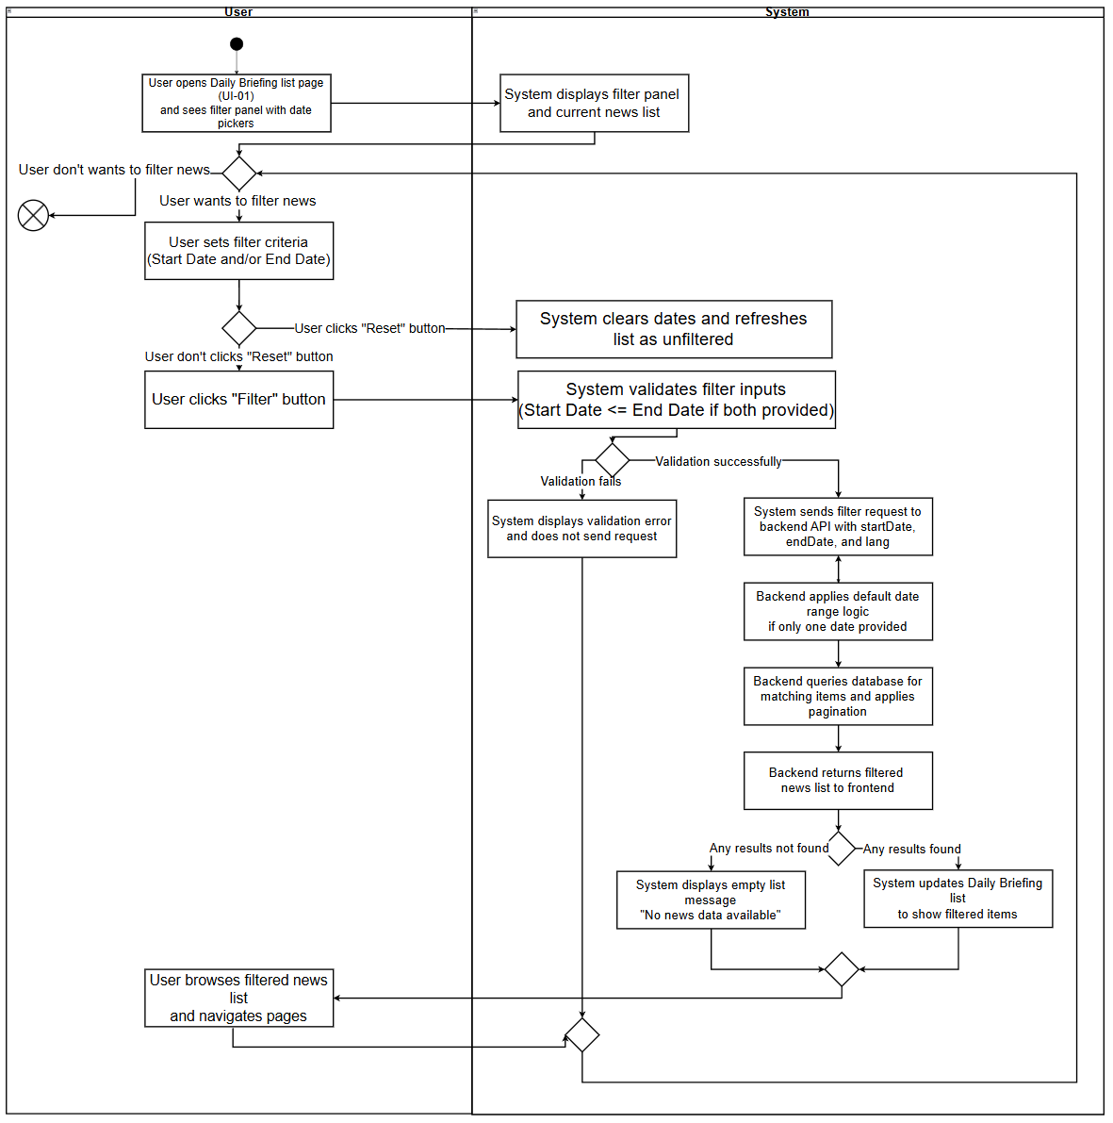
The Activity Diagram for Filter Daily Briefings News by Date illustrates the interaction between the “User“ and the “System” when the user filters Daily Briefing items by date range.

2.1.3.6 UCD06 Search for Daily Briefing News
URS06：User can type Chinese or English keywords into a search box on the Daily Briefing page and view only Daily Briefing items that match the entered keywords.
SRS-30: The system shall provide a search box on the Daily Briefing list page (UI-01) that allows users to enter keywords in Chinese or English. The search box shall have:
A text input field with placeholder text "Search by keywords (Chinese/English)..."
A filter button that triggers the search when clicked.
Support for triggering search by pressing the Enter key.
A “Reset” button that appears when the search box contains text, allowing users to clear the search keyword and trigger a new search.
SRS-31: When the user enters keywords and triggers the search (by clicking the search button or pressing Enter), the system shall:
Reset the current page to page 1.
Send a search request to the backend API including the keyword parameter (`keyword`) and the current UI language (`lang`).
If the user has also set date filter conditions (Start Date and/or End Date), the system shall include those parameters in the same request, allowing combined search and date filtering.
SRS-32: The backend shall search for Daily Briefing items where the keyword matches any of the following fields (case-insensitive partial match):
`title` (original title)
`originalContent` (original content)
`summary` (AI-generated summary)
`titleZh` (Chinese translated title)
`titleEn` (English translated title)
`summaryZh` (Chinese translated summary)
`summaryEn` (English translated summary)
SRS-33: The backend shall apply the search logic as follows:
If only a keyword is provided (no date filter), the system shall search across all historical news in the database.
If both keyword and date range are provided, the system shall search only within news items whose publication date (`publishDate`) falls within the specified date range (inclusive).
Results shall be “paginated” and ordered from newest to oldest by “publication date”(`publishDate` descending).
SRS-34: The system shall update the Daily Briefing list page (UI-01) to display only the news items that match the search keyword, “resetting the results view to the first page” while preserving pagination controls for navigating through multiple result pages.
SRS-35: If no news items match the search keyword (and any date filter conditions), the system shall display an empty list and a user-friendly message "No news data available" while keeping the search box visible and retaining the entered keyword so that the user can modify it and retry.
SRS-36: When the user clears the search keyword (by clicking the “Reset Filters” button), the system shall:
Clear the search keyword from the input field.
Reset the current page to page 1.
Send a new request to the backend without the keyword parameter, effectively showing all news (or filtered by date range if date filters are active).

Use Case ID | UC-06
Use Case Name | Search for Daily Briefing News
Actors | User
Description | User can type Chinese or English keywords into a search box on the Daily Briefing page and view only Daily Briefing items that match the entered keywords. The search can be combined with date filtering to narrow down results.
Trigger | User is on the Daily Briefing list page (UI-01) and enters keywords into the search box, then clicks the search button or presses Enter.
Preconditions | 1. User is logged into the BridgeU platform.  2. User has an active internet connection.  3. The Daily Briefing system has successfully crawled news from approved sources and stored publication dates and content.
Use Case Input Specification
Input | type | Constraint |  | Example
Keyword | String | Can be Chinese or English characters; can contain spaces; will be trimmed of leading/trailing whitespace |  | "泰国" or "Thailand" or "travel"
Post conditions | The Daily Briefing list page (UI-01) displays only news items that match the entered keyword (and any date filter conditions if set), ordered from newest to oldest by publication date, with pagination.
Normal Flows | User |  | System
 | 1. User opens the Daily Briefing list page (UI-01) and sees the search box.  3. User types keywords (Chinese or English) into the search box.  5. User clicks the "Search" button or presses “Enter”.  12. User browses the search results and can navigate between pages using pagination controls.  14. User may modify the search keyword and click "Search" again (or clear the keyword).  16. (Optional) User clicks the “clear button” in the search box. |  | 2. System displays the search box with placeholder text and shows the current news list (unfiltered), with pagination controls when multiple pages exist.  4. System updates the search keyword model accordingly.  6. System trims whitespace from the keyword input.  7. System resets the current page to page 1.  8. System sends a search request to the backend API including the keyword parameter (`keyword`), any date filter parameters (if set), and the current UI language (`lang`).  9. Backend searches the database for Daily Briefing items where the keyword matches any of the searchable fields (title, originalContent , summary, and all translation fields). If date filters are provided, the search is limited to items within the date range. Results are ordered from newest to oldest by `publishDate` and paginated.  10. Backend returns the search results (with pagination data) to the frontend.  11. System updates the Daily Briefing list on UI-01 to show only matching items (page reset to 1) and updates pagination controls accordingly.  [A1: No news match search keyword]  13. System loads and displays the corresponding page of search results while preserving the current search keyword and any date filter conditions.  15. System repeats the search flow with the new keyword.  17. System clears the search keyword, resets the current page to page 1, and sends a new request without the keyword parameter (showing all news or filtered by date range if date filters are active).
Alternative Flow | [A1: No news match search keyword]  A1.1 Backend returns an empty result set for the specified search keyword (and any date filter conditions).  A1.2 System displays an empty list on the Daily Briefing page and shows a message "No news data available" .  A1.3 Search box remains visible and retains the user's entered keyword so that the user can easily modify it and retry.  A1.4 Use case ends or continues when the user modifies the keyword and clicks "Search" again.
Exception Flow
Assumption | The user has an internet connection .

AD-06
The Activity Diagram for Search for Daily Briefing News illustrates the interaction between the User and the System when the user searches for Daily Briefing items by entering keywords:
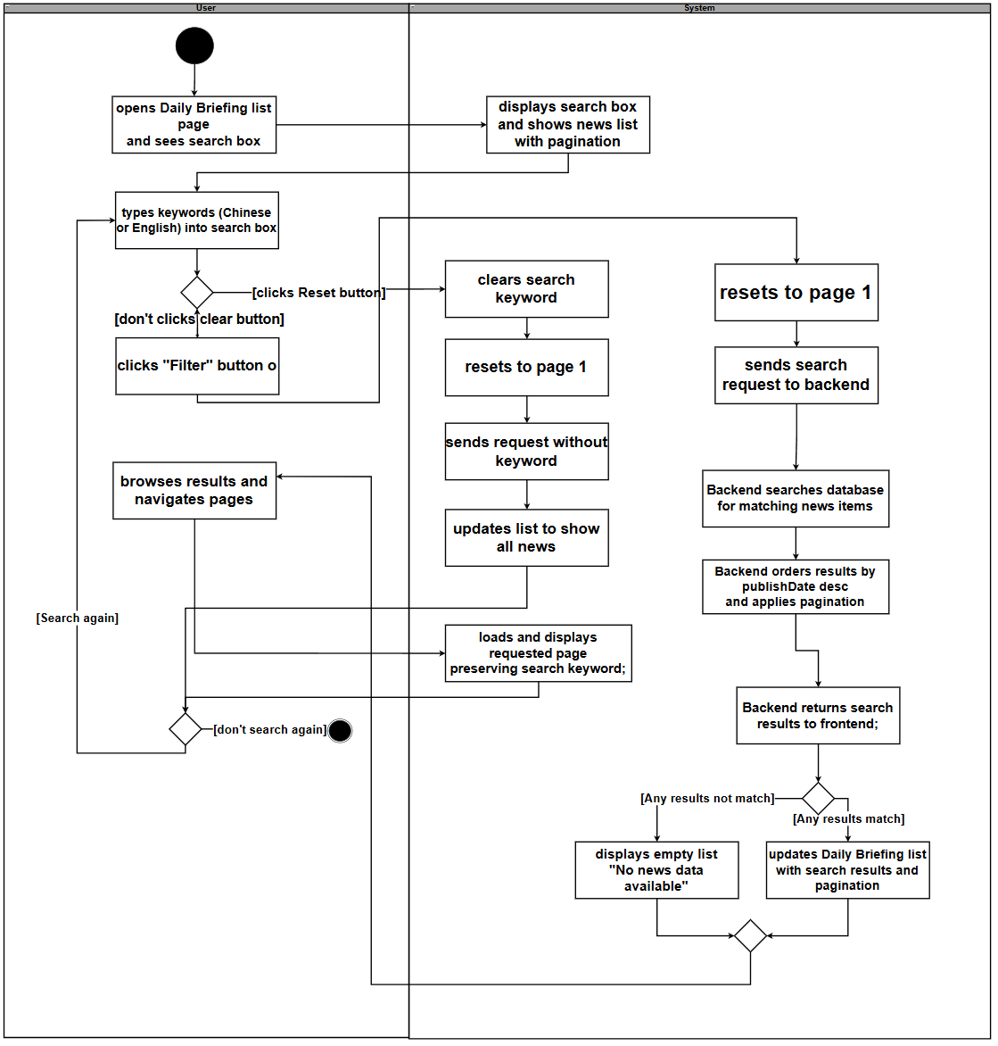

2.2 Feature 2

2.2.1 Use Case Diagram
The Community Interaction Platform centers on a single actor (User): the user can browse public posts (UC-07) and optionally filter by tag (UC-10) or search by keyword (UC-14), then view post details (UC-11) where they may like (UC-09), post comments (UC-13), or report inappropriate content (UC-12, including UC-12.1 reporting a post and UC-12.2 reporting a comment); the system may invoke Qwen AI to support content processing during post creation/publishing (UC-08) and to generate an AI comment summary (UC-015), and users can also manage private messages(UC-16) with message status management (UC-17) as an extension of messaging.
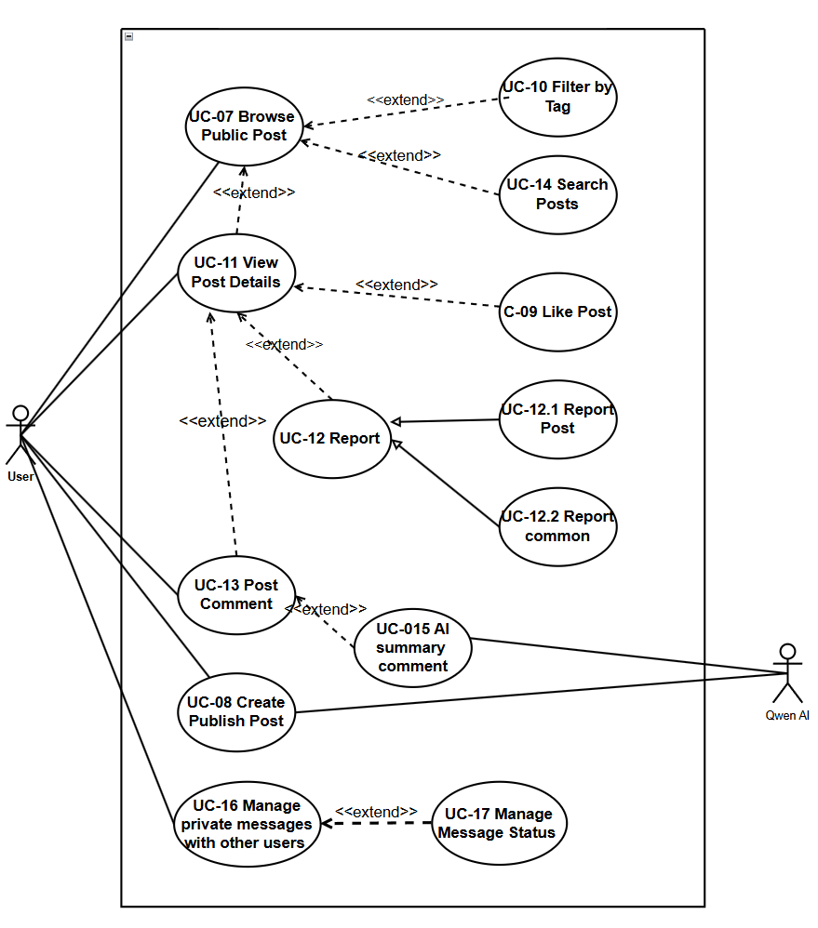

2.2.2 User Requirement Specification
- URS-07: The User can browse the community feed with posts ordered from newest to oldest, showing title, preview, tags, like count, and comment count.

- URS-08: The User can create or edit posts in their preferred language (Chinese, English), upload images, select a tag from predefined categories (Study, Housing, Travel, Part-time Job, Life Services), and have the system automatically generate bilingual (Chinese/English) content using Qwen AI for later display.

- URS-09 : The User can like or unlike posts to express feedback, and the like count updates immediately in the interface.

- URS-10: The User can filter posts in the community feed by selecting tags from the predefined list (Study, Housing, Travel, Part-time Job, Life Services).

- URS-11: The User can view post details including full text, images, tags, engagement metrics (likes, comments), and author profile when clicking on a post, in their current interface language.

- URS-12: The User can report posts/comments with structured reasons (Spam, Fraud or Scam, Illegal Service Promotion, Abusive Language, Other) and provide explanatory text.

- URS-13: The User can post comments to interact with other users, which will be automatically translated by the system into Chinese and English; users can delete their own comments.

- URS-14: The User can search posts by keyword across bilingual content (titles and body texts in both Chinese and English)。

- URS-15 : The User can view AI-generated summaries of all comments under a post in their chosen language.

- URS-16: After following each other, users can send and receive private messages to each other, and view the complete historical message history. If you only follow the other party unilaterally and have not formed a mutual follow-up relationship, you can send an initialized invitation message to the other party first.
- URS-17: Users can automatically mark messages as read by opening a session, and users can delete message records on their side as needed (effective only for the current user, not affecting the messages seen by the other party).

2.3 Feature 3

2.3.1 Use Case Diagram
This use case diagram covers user account and personal-center functions. The primary actor is the User, who can register an account (UC-19), with two alternative registration paths: register with phone number (UC-19.1) which relies on an external SMS service for verification, and register with email (UC-19.2) which relies on an external Email service. After registration, the user can log in (UC-20) and log out (UC-21), edit their profile (UC-22), view their friends/followers list (UC-18), view their own community posts (UC-23), and view their submitted reports (UC-24).
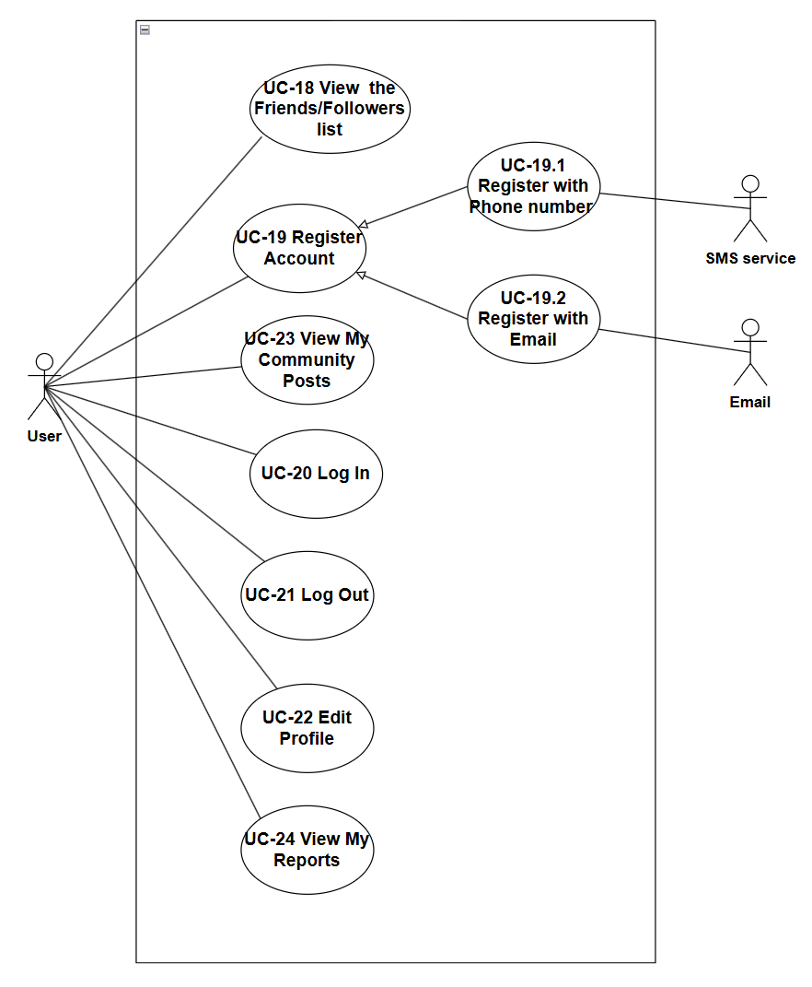

2.3.2 User Requirement Specification
URS-18：The User can view lists of mutual Friends and Followers, and navigate to their profiles.The User can view a Friends list that shows only users who have a mutual follow relationship with the User (both sides follow each other), and a Followers list that shows users who follow the User. From either list, the User can click a user’s avatar to open that user’s profile page.
URS‑19 – Log In:User can log in to the system by entering their registered email address/phone number and password.
URS‑20 – Log Out:User can log out from the system by clicking a logout button, and then they are redirected to the login page and must log in again to access the system.
URS‑21 – View and Edit Profile:User can open their personal profile page to view their stored account information, including display name, avatar, and preferred interface language.User can edit any of these profile fields by entering new values and submitting the changes.
URS‑22 – View My Community Posts:User can open a dedicated list page under their profile to view all community posts created by their current account.
User can see each post’s title, publication time and current moderation status (published, pending review, or rejected) on this list page.

Chapter 3 User Interface Design
UI-01 Daily Briefing Page
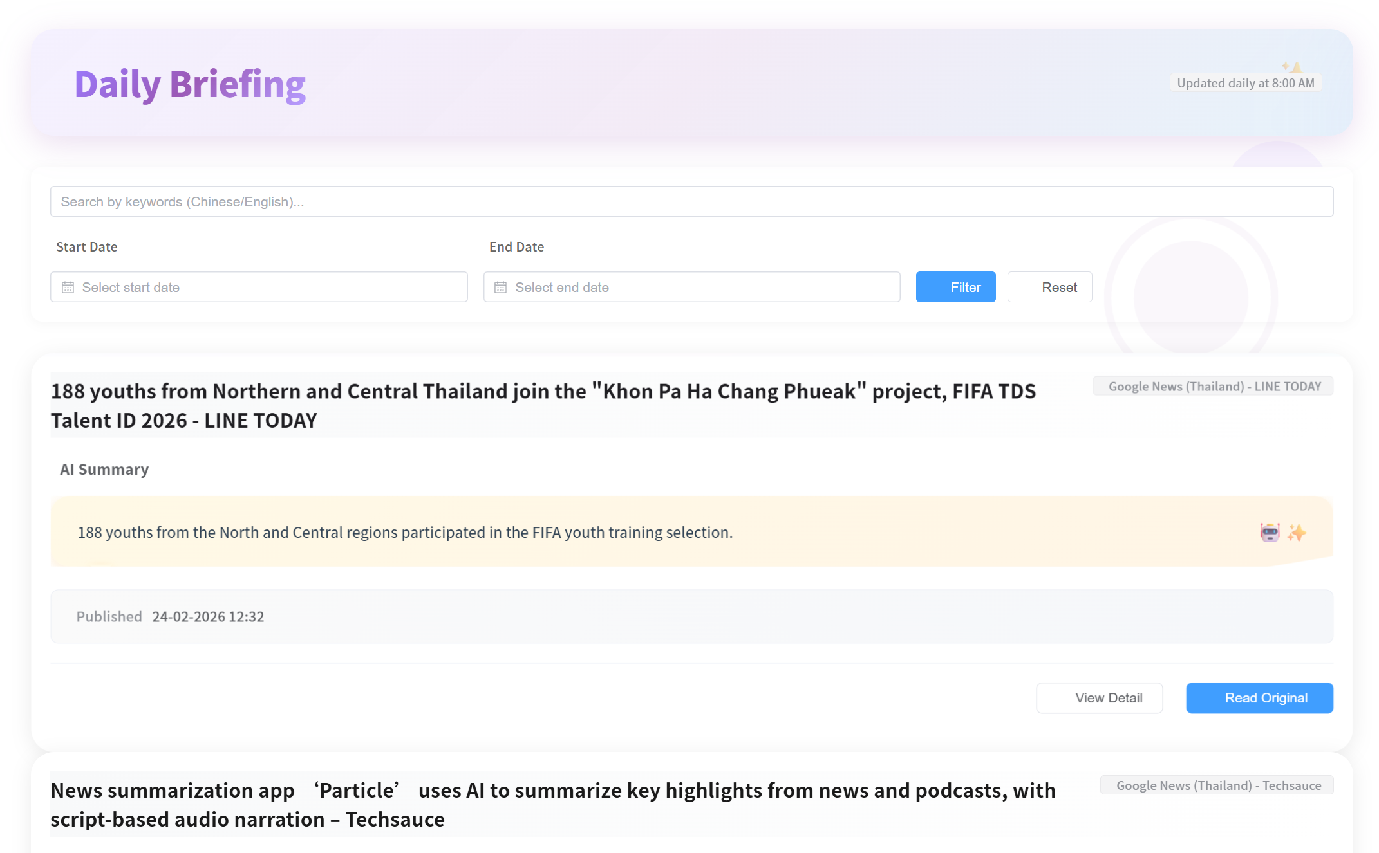
UI-01-01 Invalid date filtering
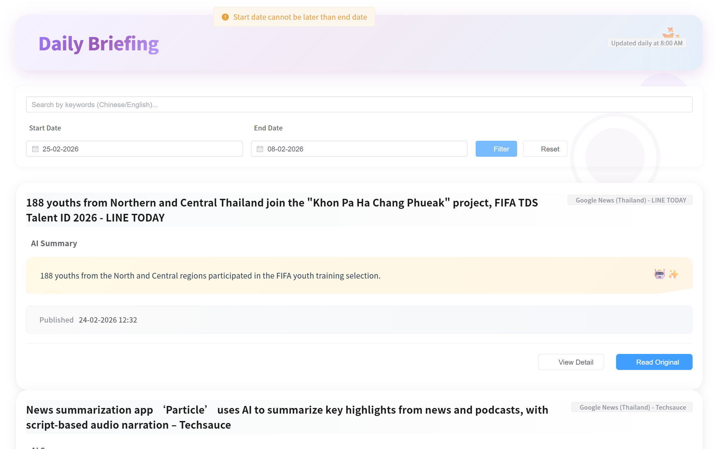
UI-01-02 Select the page number
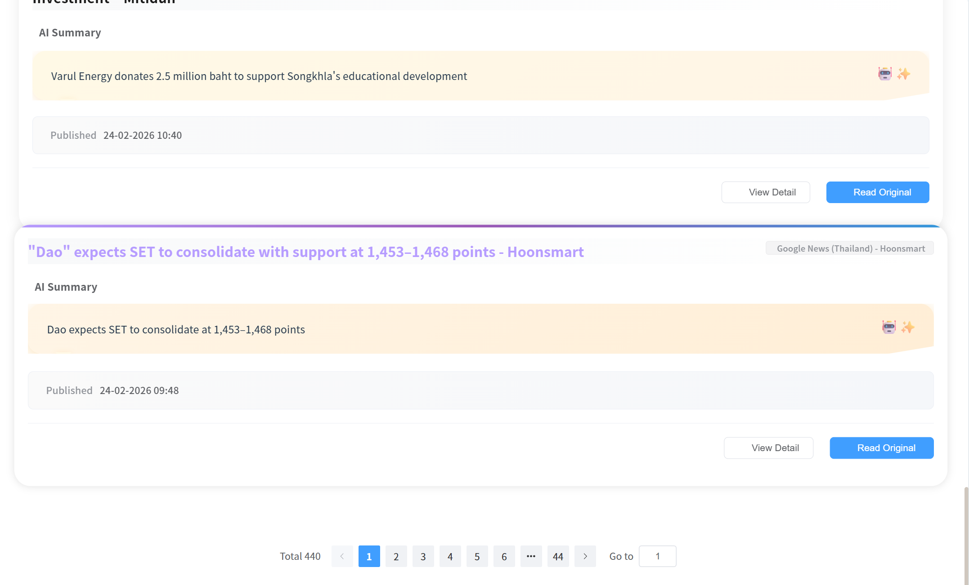
UI-02 Daily Briefing Page
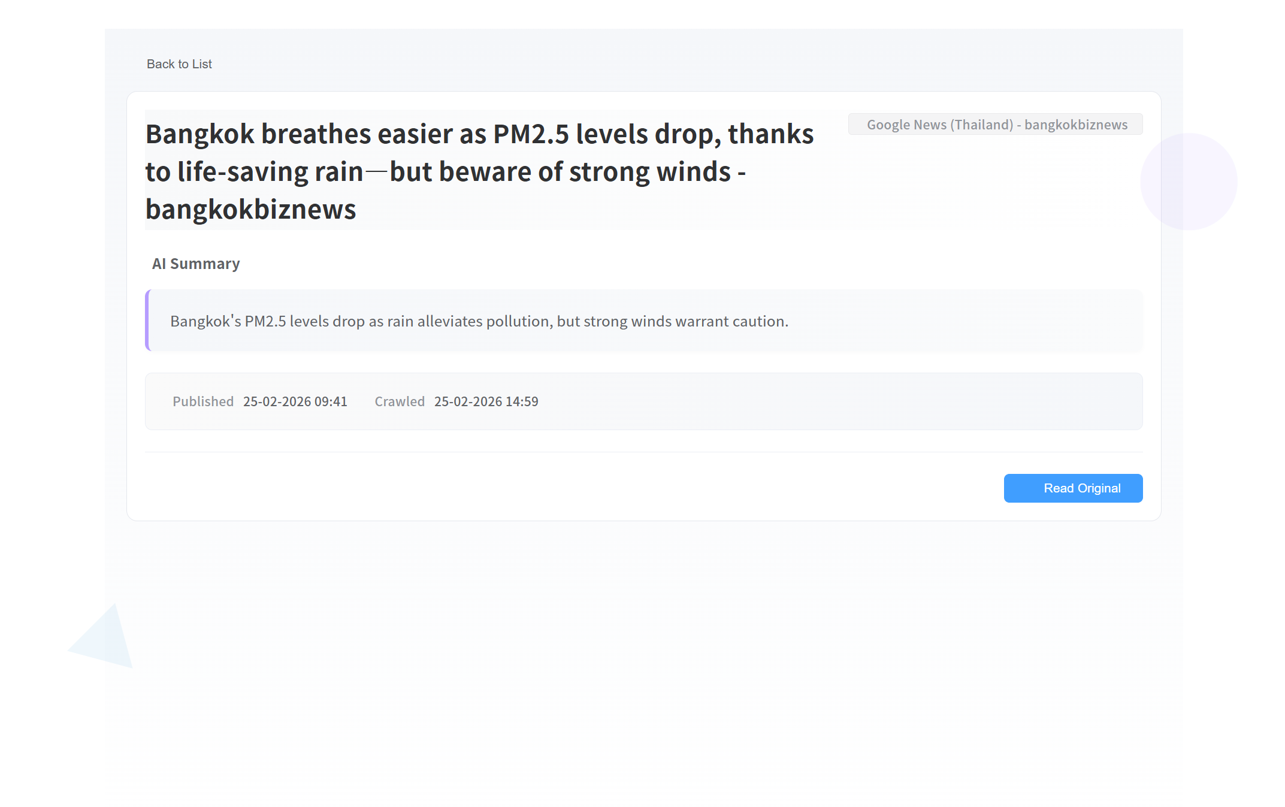

Chapter 4 Chinese and English comparison table
1. Universal button
18n Key | English | 中文
common.loading | Loading... | 加载中...
common.error | Error | 错误
common.success | Success | 成功
common.cancel | Cancel | 取消
common.confirm | Confirm | 确认
common.save | Save | 保存
common.delete | Delete | 删除
common.edit | Edit | 编辑
common.close | Close | 关闭
common.retry | (无) | 重试
common.back | (无) | 返回
common.saving | (无) | 保存中...

2. Login / Registration page
i18n Key | English | 中文
login.username | USERNAME | 用户名
login.email | EMAIL | 电子邮箱
login.phone | PHONE NUMBER | 手机号码
login.password | PASSWORD | 密码
login.confirmPassword | CONFIRM PASSWORD | 确认密码
login.login | LOGIN | 登录
login.register | REGISTER | 注册
login.create | Create an account | 创建新账户
login.hasAccount | Have an account? Login | 已有账户？登录
login.forgotPassword | Forgot Password? | 忘记密码？
login.backToLogin | Back to Login | 返回登录
login.pleaseWait | Please wait... | 请稍候...
login.preferredLanguage | Preferred Language | 语言偏好
login.selectMethod | Select Registration Method | 选择注册方式
login.emailOrPhone | Email or Phone | 邮箱或手机
login.sendCode | Send Verification Code | 发送验证码
login.resendCode | Resend Code | 重新发送
login.verificationCode | Verification Code | 验证码
login.verify | Verify | 验证
login.completeRegistration | Complete Registration | 完成注册
login.resetPassword | Reset Password | 重置密码

3. Sidebar navigation
i18n Key | English | 中文
sidebar.platform | PLATFORM | 平台
sidebar.briefing | Briefing | 每日简报
sidebar.communityFeed | Community | 社区
sidebar.newPost | New Post | 发布帖子
sidebar.messages | Messages | 私信
sidebar.semanticSearch | Semantic Search | 语义搜索
sidebar.profile | Profile | 个人资料
sidebar.logout | Logout | 退出登录

4. Post list / search
i18n Key | English | 中文
postList.search | Search | 搜索
search.search | Search | 搜索
search.searching | Searching... | 搜索中...
search.noMatches | No matches | 无匹配结果

5. button on the post details page
i18n Key | English | 中文
postDetail.back | Back | 返回
postDetail.follow | Follow | 关注
postDetail.following | Following | 已关注
postDetail.addComment | Add a comment | 添加评论
postDetail.submitComment | Submit | 提交
postDetail.summarizeComments | Summarize Comments | 总结评论
postDetail.summarizing | Summarizing... | 总结中...
postDetail.report | Report | 举报
postDetail.reportPost | Report Post | 举报帖子
postDetail.reportComment | Report Comment | 举报评论
postDetail.submitReport | Submit Report | 提交举报
postDetail.myReports | My Reports | 我的举报
postDetail.viewMyReports | View My Reports | 查看我的举报
postDetail.delete | Delete | 删除
postDetail.deleting | Deleting... | 删除中...
postDetail.confirmDeleteComment | Are you sure you want to delete this comment? | 确定要删除这条评论吗？
postDetail.commentDeleted | Comment deleted successfully | 评论删除成功

6. Message
i18n Key | English | 中文
messages.title | Private Messages | 私信
messages.newConversation | New Conversation | 新建会话
messages.sendMessage | Send Message | 发送消息
messages.sending | Sending... | 发送中...
messages.deleteConversation | Delete Conversation | 删除会话
messages.confirmDelete | Are you sure you want to delete this conversation? | 确定要删除此会话吗？
messages.deleted | Conversation deleted | 会话已删除
messages.deleteFailed | Failed to delete conversation | 删除会话失败
messages.markAsRead | Mark as Read | 标记为已读

7. myProfile, myPosts.
I8n Key | English | 中文
myProfile.editProfile | Edit Profile | 编辑资料
myProfile.changeAvatar | Change Avatar | 更换头像
myProfile.updateSuccess | Profile updated successfully | 个人资料更新成功
myProfile.updateFailed | Failed to update profile | 更新个人资料失败
myProfile.saving | Saving... | 保存中...
myPosts.title | My Community Posts | 我的社区帖子

8. newPost.
i18n Key | English | 中文
newPost.title | New Post | 发布新帖
newPost.autoTranslation | Auto Translation: | 自动翻译：
newPost.selectTag | Select Tag (Mandatory) | 选择标签（必填）
newPost.community | Community | 社区
newPost.authorId | Author ID | 作者ID
newPost.postTitle | Title | 标题
newPost.content | Content | 内容
newPost.uploadImage | Upload Image (Optional) | 上传图片（可选）
newPost.publish | Publish Now | 立即发布
newPost.publishing | Publishing... | 发布中...

9. dailyBriefing, dailyBriefingDetail.
i18n Key | English | 中文
briefing.readOriginal | Read Original → | 阅读原文 →
briefing.previous | Previous | 上一页
briefing.next | Next | 下一页
dailyBriefing.filter | Filter | 筛选
dailyBriefing.reset | Reset | 重置
dailyBriefing.resetFilters | Reset Filters | 重置筛选
dailyBriefing.viewDetail | View Detail | 查看详情
dailyBriefing.readOriginal | Read Original | 阅读原文
dailyBriefingDetail.back | Back to List | 返回列表
dailyBriefingDetail.readOriginal | Read Original | 阅读原文

