BridgeU: A Bilingual Community Platform for International Students in Thailand
Zhiyi Pan  Software Engineering Program  College of Arts, Media and Technology  Chiang Mai University  Chiang Mai, Thailand  pzyllll@outlook.com | Pattama Longani  Software Engineering Program  College of Arts, Media and Technology  Chiang Mai University  Chiang Mai, Thailand  pattama.l@cmu.ac.th

Abstract—International students in Thailand face significant barriers in accessing local news, building social connections, and adapting to an unfamiliar environment. This paper presents BridgeU, a bilingual (Chinese/English) web-based community platform designed to address these challenges. BridgeU provides three integrated features: a Daily Briefing system that automatically aggregates Thai news via Google News RSS and translates it into Chinese and English using Qwen AI; a Community Page that enables peer-to-peer knowledge sharing with AI-powered moderation and translation; and an Authentication and Profile system with email and SMS verification. The system is built using Vue.js 3 on the frontend and Spring Boot 3 on the backend, with MySQL 8 as the primary database and JWT-based stateless authentication. A competitive analysis against Facebook Groups, Xiaohongshu, and Reddit confirms that BridgeU uniquely combines bilingual AI news aggregation with a structured, moderated community space. Testing covered 25 unit test suites and 21 system test cases across all features, confirming that all core functional requirements were satisfied.
Keywords—international students, community platform, news aggregation, bilingual interface, Vue.js, Spring Boot, JWT authentication, Qwen AI, cross-cultural adaptation
I. Introduction
The globalization of higher education has driven rapid growth in international student mobility. According to UNESCO, the number of internationally mobile students exceeded 6 million by 2022, with institutions in Southeast Asia, including Thailand, receiving a growing share [1]. Chinese students represent one of the largest groups of internationally mobile students globally, and their presence at Thai universities has increased substantially in recent years.
International students frequently encounter compounded challenges upon arrival in a host country. Research by Hofhuis et al. [2] demonstrated that social network site (SNS) use significantly affects the wellbeing of international students through acculturation and adaptation processes. The study found that interactions with host-country contacts on SNS were positively associated with sociocultural adaptation, while isolation from local information sources remained a persistent barrier. Similarly, Zhou and Yin [3] conducted an integrative review of research on international students’ social media use, concluding that platform affordances play a critical role in determining whether technology facilitates or impedes cross-cultural adjustment.
In Thailand, international students face a specific challenge: the majority of local news, public announcements, and community information is published exclusively in Thai. Existing general-purpose tools such as Facebook Groups, Xiaohongshu, and Reddit do not fully address this need, as analyzed in Section II-B. Furthermore, no dedicated platform exists to connect Chinese-speaking international students in Thailand or provide a unified community space tailored to their needs.
To address these gaps, this paper proposes and evaluates BridgeU, a bilingual web-based community platform. BridgeU is designed around three core features: (1) the Daily Briefing System automatically collects Thai news via Google News RSS and translates summaries into Chinese and English using Qwen AI; (2) the Community Page provides an AI-moderated forum for likes, comments, and follow relationships; and (3) the Authentication and Profile System supports registration via email or SMS verification and JWT-based session management. This paper describes the design rationale, competitive positioning, system architecture, feature implementation, and testing outcomes.
II. Related Work
A. Challenges Faced by International Students
A growing body of literature documents the multi-dimensional difficulties experienced by international students. Gautam et al. [4] identified language barriers, cultural distance, loss of social support networks, and academic adjustment as primary stressors. Dong et al. [5] found that social media usage significantly affects social capital and learning engagement among international students in the United States, highlighting the dual role of digital platforms as both connectors and potential sources of isolation. The British Council [6] further reported strong demand among international students for private, topic-specific digital communities where they can discuss practical matters such as visa policies, housing, and affordability. These findings directly motivate the design of BridgeU as a specialized, structured platform rather than a repurposed general-purpose social network.
B. Competitive Analysis of Existing Platforms
Several widely used platforms are currently adopted by international students in Thailand as informal information and community channels. A comparative analysis of three key platforms—Facebook Groups, Xiaohongshu (Little Red Book), and Reddit—reveals important limitations that BridgeU is designed to overcome.
1) Facebook Groups:
Facebook Groups are currently one of the most widely used mutual-aid tools among international students worldwide [15]. Their advantages include a large existing user base and broad reach. However, Facebook Groups have a high language threshold: content is predominantly in Thai and English, making them difficult for Chinese students to use. Information retrieval is extremely poor, with no structured tags, so rental listings, job posts, and casual chat are all mixed together, making targeted search effectively impossible.
2) Xiaohongshu (Little Red Book):
Xiaohongshu is the most popular lifestyle sharing platform among Chinese international students [16]. It offers rich content, algorithm-based recommendations, and an aesthetically pleasing interface. However, it suffers from a serious “tourist perspective” bias: content is overly focused on travel, food, and check-ins, and lacks in-depth, practical accumulation for long-term residents. Its closed Chinese ecosystem means it is impossible to reach local Thais, landlords, or international students from other language backgrounds.
3) Reddit:
Reddit is one of the world’s largest online forums and hosts numerous study-abroad-related subreddits (e.g., r/Thailand, r/studyabroad) [17]. It offers structured topic-based categorization and an environment where users feel comfortable asking genuine questions under pseudonymity. However, its interface is unfriendly to non-technical users, and it operates as a pure English environment with no multilingual translation support, effectively excluding most Chinese students and local Thai community members.

TABLE I. Competitive Feature Comparison
Feature | Facebook Groups | Xiao- hongshu | Reddit | BridgeU
Web-based Access | ✓ | ✓ | ✓ | ✓
Bilingual (CN/EN) Interface |  |  |  | ✓
AI News Aggregation (RSS) |  |  |  | ✓
AI Auto-Translation | ✓ | ✓ |  | ✓
AI Content Moderation |  |  |  | ✓
Structured Post Tags |  |  | ✓ | ✓
Community Forum / Post Feed | ✓ | ✓ | ✓ | ✓
Thailand-Focused Content |  |  |  | ✓

As shown in Table I, none of the existing platforms combines bilingual AI news aggregation, structured post tags, AI-powered content moderation, and Thailand-focused community features in a single free-to-use web platform. BridgeU is designed to fill this gap by integrating all of these capabilities.
C. News Aggregation and Automatic Translation
RSS (Really Simple Syndication) has been established as a practical and standardized mechanism for news aggregation. Kasioumis et al. [7] proposed a distributed RSS platform demonstrating the scalability of RSS-based approaches. Atlas [8] showed that combining RSS feeds with third-party news APIs significantly improves content coverage. The integration of large language models into translation pipelines has become increasingly feasible. Yuen and Schlote [9] reviewed AI applications in language learning and noted that AI-powered tools can bridge cultural and linguistic gaps effectively, provided appropriate quality controls are in place. BridgeU applies this principle by using Qwen AI (Alibaba Cloud) to generate Chinese and English summaries at ingestion time, so translated content is always immediately available to users.
D. Web Application Architecture
Wang et al. [10] demonstrated the effectiveness of Vue.js and Spring Boot for building scalable online education platforms, noting that Vue.js’s reactivity system and component-based model reduce frontend complexity while Spring Boot’s auto-configuration accelerates backend development. Kaya and Ozdemir [11] further evaluated Spring Boot-based REST API implementations under the OWASP security framework, identifying JWT authentication as the recommended stateless session mechanism. BridgeU adopts this architecture with Vue.js 3 on the frontend and Spring Boot 3 on the backend, connected via RESTful APIs over HTTPS. MySQL 8 is used as the primary relational database, and Docker provides containerized deployment.
E. Authentication and Security
JSON Web Tokens have become the de facto standard for stateless authentication in modern web applications. Bucko et al. [12] demonstrated that JWT-based authentication can be further strengthened by incorporating user behavior history for anomaly detection. The OWASP Cheat Sheet for JWT [13] prescribes best practices including HTTPS for all token transmissions, short expiry windows, and server-side signature validation. BridgeU implements these practices: passwords are hashed using BCrypt with salt before storage, tokens are signed with HMAC-SHA256, and all protected endpoints validate the token on every request.
F. Community Platforms and AI-Assisted Moderation
Hofhuis et al. [2] showed that interactions within peer networks on SNS platforms are associated with improved adaptation outcomes for international students. Roczey and Szenasi [14] proposed an automated moderation helper system using AI-based text classification, demonstrating that machine learning classifiers can reliably flag rule-violating content with high precision. BridgeU applies Qwen AI for both automatic translation of user-generated content and content security review before publication, maintaining community quality without requiring immediate manual review for every submission.
III. Platform Design and Implementation
A. System Overview
BridgeU is designed as a web-based platform targeting Chinese-speaking international students at Thai universities. The frontend is implemented with Vue.js 2 and Element UI, using Axios for HTTP communication between the frontend and backend. The backend is built with Spring Boot, exposing RESTful APIs and using MyBatis as the persistence framework for database access. MySQL 8 serves as the primary relational database for storing structured user and post data. Elasticsearch is integrated to provide high-performance semantic search capabilities. The system also connects to the Aliyun Qwen API to perform natural language processing tasks such as summarization and translation. The overall system architecture is illustrated in Fig. 1.
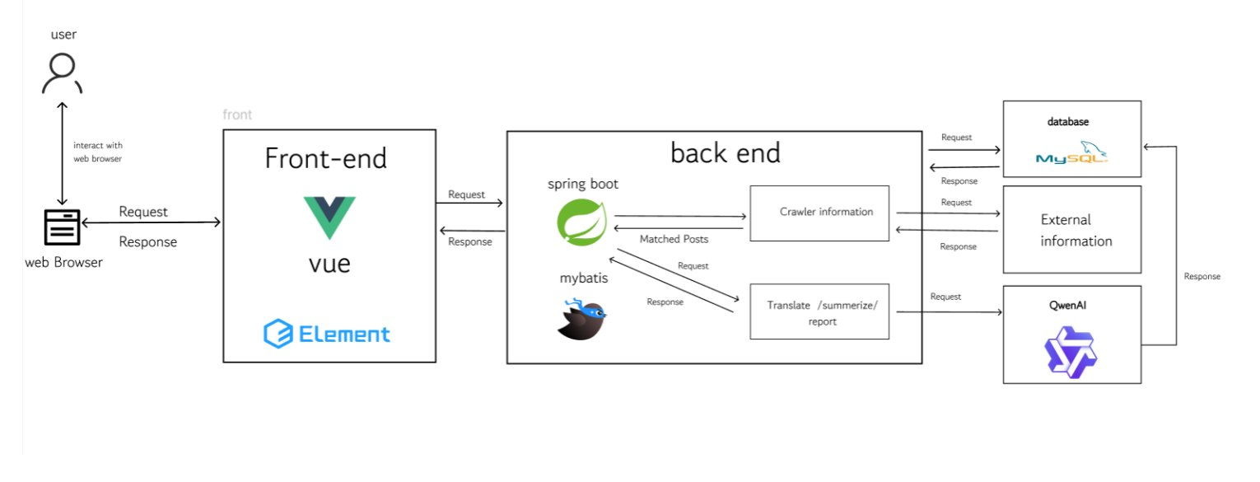
Fig. 1. System Architecture
B. Feature 1: Daily Briefing System
The Daily Briefing System addresses the most critical information barrier: the inaccessibility of Thai-language local news for non-Thai-speaking international students. At 08:00 daily, the system crawls Google News RSS feeds. For each item, the system calls the Qwen AI API to generate Chinese and English versions of the title and summary, which are stored persistently in the database. This batch-preprocessing approach eliminates real-time API latency during user browsing [9].
The frontend renders a paginated list of 10 news cards per page, each showing the translated title, AI-generated summary, source label, and publication date in the user’s current language. Users can search by keyword across both Chinese and English translation fields simultaneously, filter by publication date range, and toggle between Chinese and English interfaces dynamically. The backend’s Data Transfer Object (DTO) conversion suppresses all Thai original text from user-facing responses. Custom JPQL repository queries support keyword search (findByKey word),date-range filtering (findByPublishDateBetween Ordered), and combined filters, all returning results ordered by publication date descending. The feature interface is shown in Fig. 2.
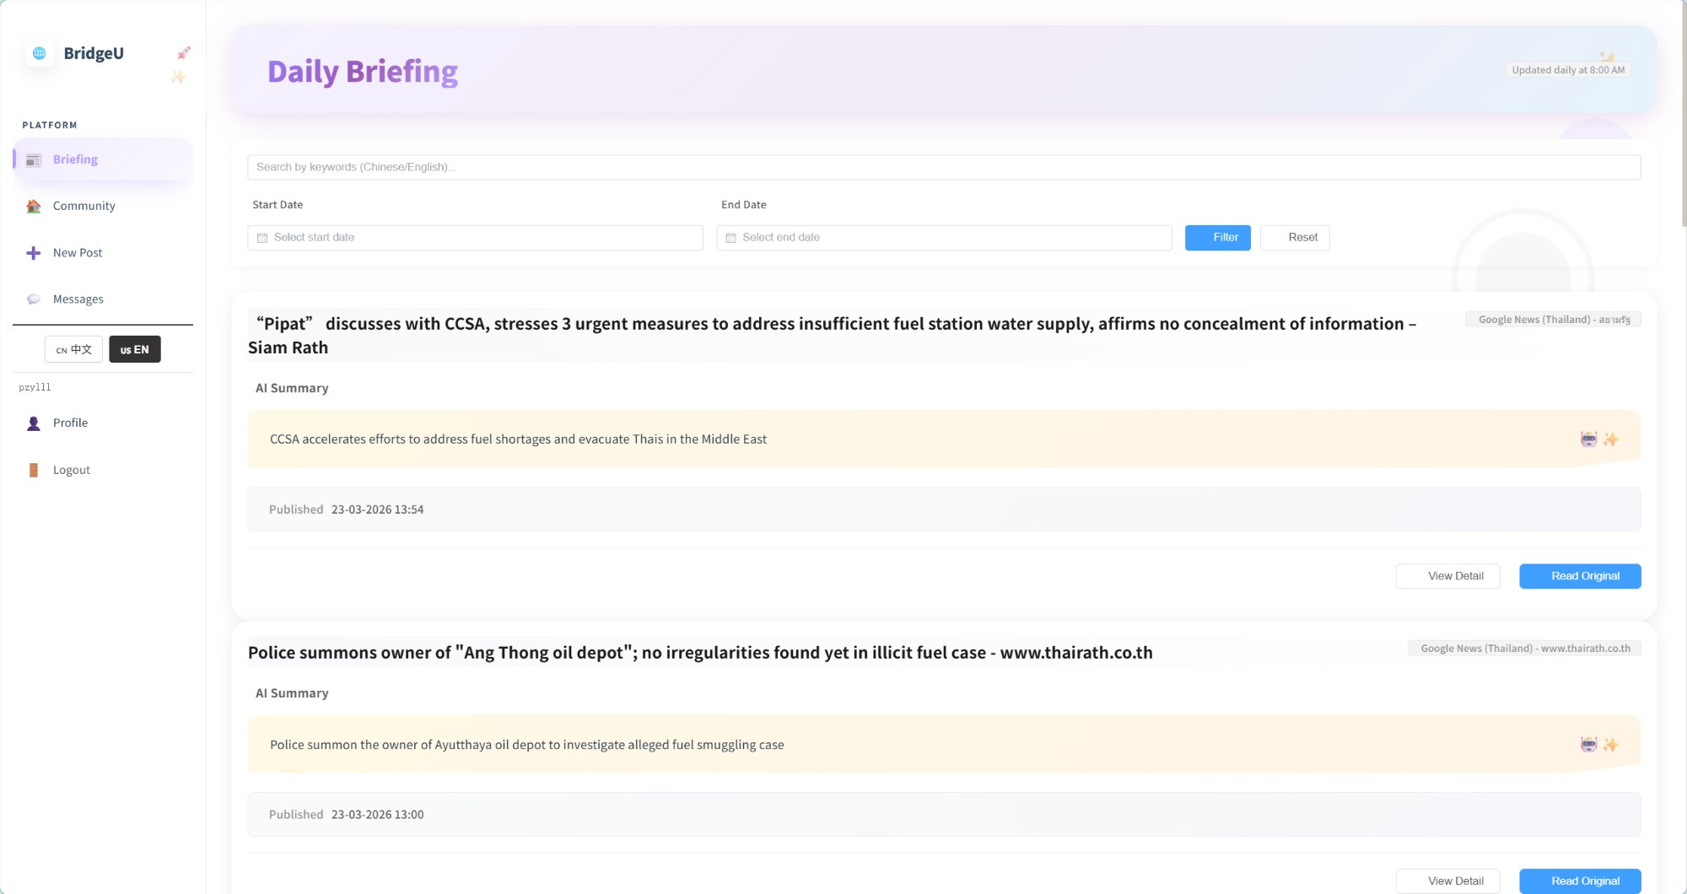
Fig. 2. Daily Briefing System interface
C. Feature 2: Community Page
The Community Page enables peer-to-peer knowledge sharing among international students across five predefined categories: Study, Housing, Travel, Part-time Job, and Life Services. When a user submits a post in Chinese or English, the system asynchronously calls Qwen AI to generate the other language version and conduct a content security review. The original content is immediately saved and the user receives a response, while AI processing runs in the background [14]. Only after Qwen AI confirms the content passes moderation checks does the post appear in the community feed.
Within each post, users may add comments, toggle a like reaction, and generate an AI-summarized paragraph of all comments—useful for long discussion threads. The follow relationship is asymmetric: mutual follows create a “Friends” relationship enabling unrestricted private messaging, while one-way follows are limited to a single initial message to reduce unsolicited contact. Users can report posts or comments by selecting predefined reasons (Spam, Fraud or Scam, Illegal Service Promotion, Abusive Language, Other), after which Qwen AI reviews the reported content and provides a judgment. The Community Page also supports keyword search across post titles and body texts in currently languages. The Community Page feed, New Post form, and private messaging interface are shown in Fig. 3, Fig. 4, and Fig. 5 respectively.
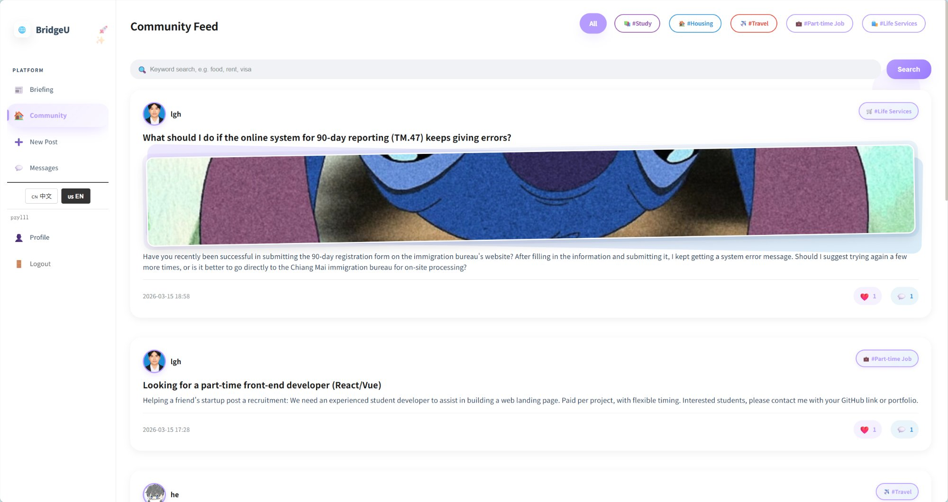
Fig. 3. Community Page feed with category filters and post cards
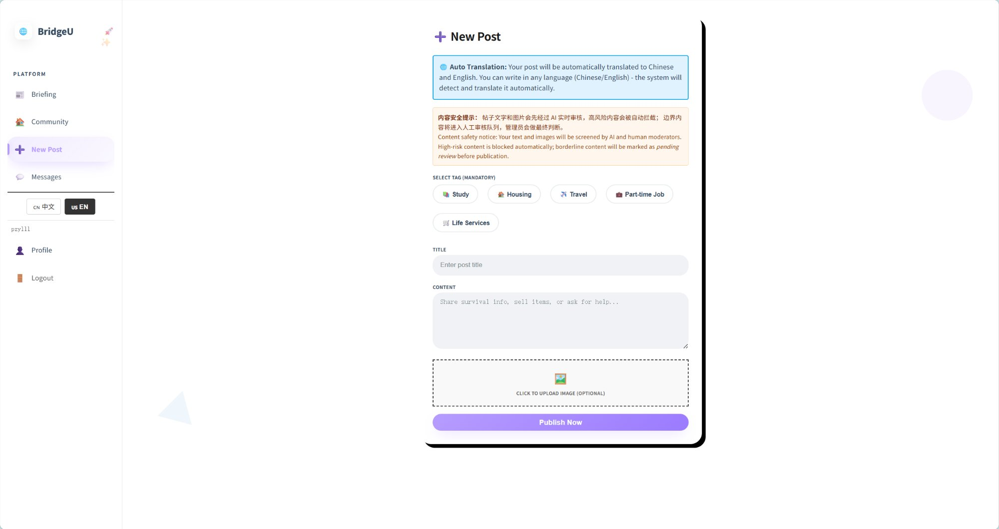
Fig. 4. Create New Post interface
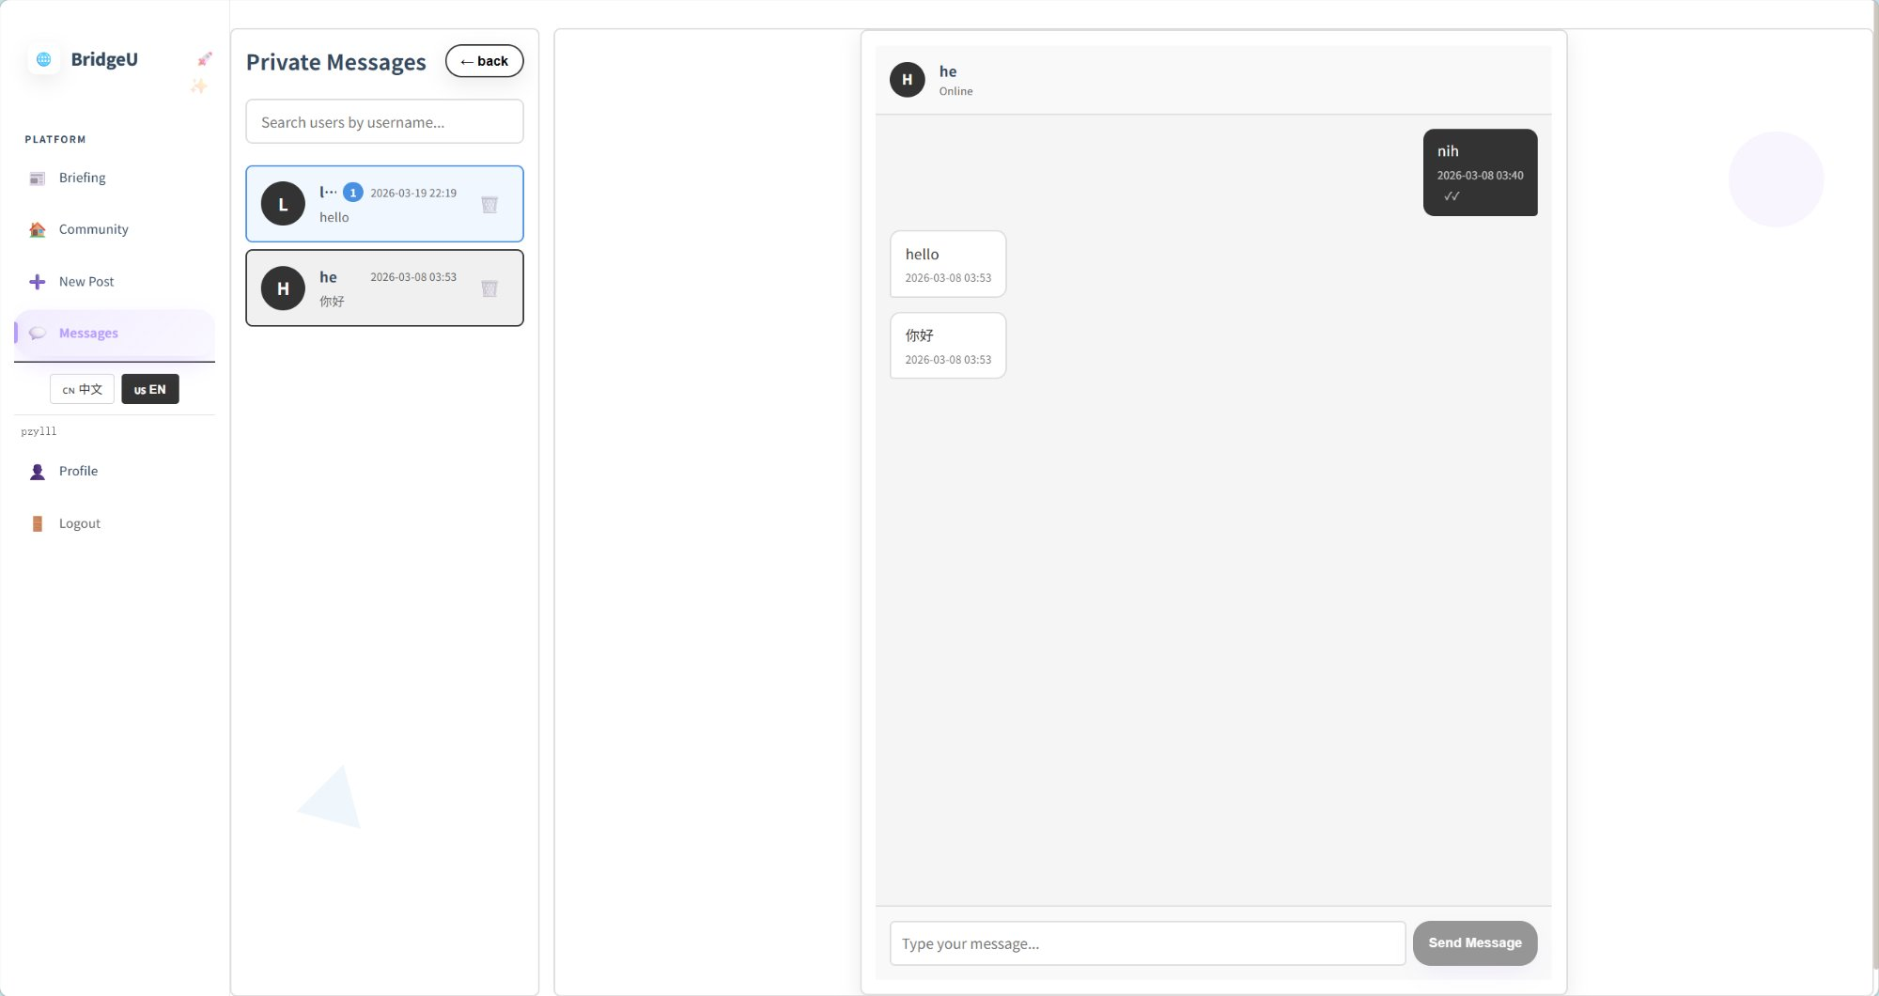
Fig. 5. Private messaging interface showing conversation threads
D. Feature 3: Authentication and Profile System
The Authentication and Profile System provides secure user registration, login, and profile management. Registration supports two verification pathways: email (via server-side SMTP verification code) and phone (via Firebase SMS). Both pathways require a 6-digit verification code before the registration form is unlocked. Passwords are validated to contain both uppercase and lowercase letters and are stored as BCrypt hashes [13]. Display names are restricted to English characters to prevent encoding conflicts. If the user forgets the password, the option to forget the password is provided on the login page, and the user can send a verification code to reset the password through the phone number or email.
Upon successful login, Spring Security generates a JWT signed with HMAC-SHA256, containing the user’s ID, username, and token expiry. The client stores the token in sessionStorage and attaches it as a Bearer token in the Authorization header of all authenticated requests. The Profile page displays avatar, display name, username, and social statistics (posts, followers, mutual follows). Users can edit their display name, avatar URL, and preferred language; changing the username requires re-authentication. Additional profile views include My Community Posts (with Qwen AI moderation status: published, pending, or rejected), My Reports (showing AI review judgments for submitted reports), and Followers/Friends lists with direct navigation to user profiles or the messaging interface when click the user’s avatar. The feature interface is shown in Fig.6.
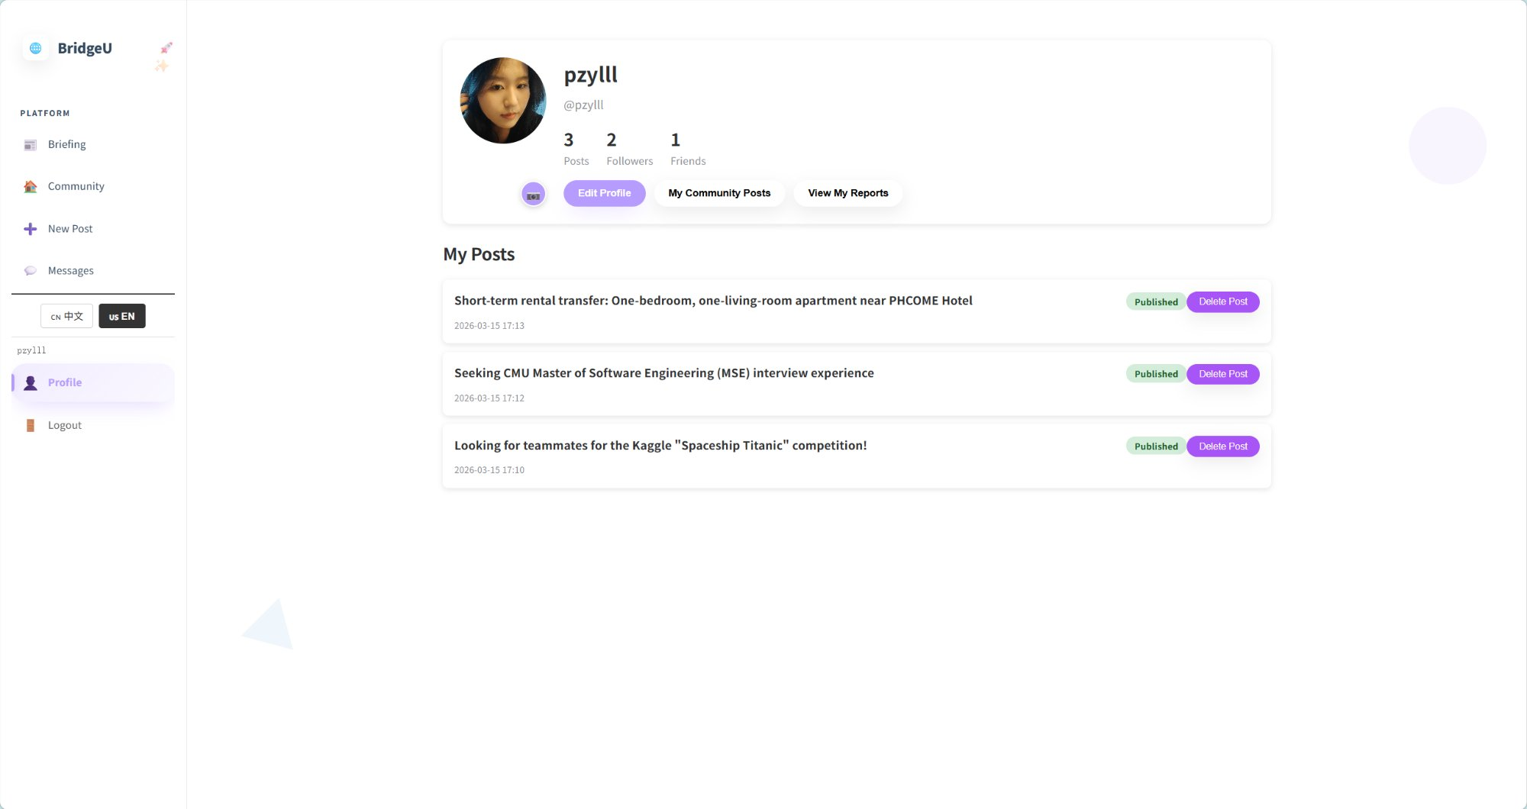

Fig. 6. User profile page
IV. Testing
A. Test Strategy
Testing followed a structured three-level strategy: unit testing, system testing, and integration testing. Unit tests targeted individual frontend Vue.js component methods and backend Spring Boot controller, service, and repository methods. System tests verified end-to-end workflows through the fully integrated system. A total of 25 unit test suites (UTC-01 through UTC-25) and 21 system test cases (STC-01 through STC-21) were defined. The pass/fail criterion required an exact match between actual results and the expected results specified in the Test Plan document.
B. Unit Testing Summary
Feature 1 (Daily Briefing) contributed 13 unit test suites covering frontend methods—fetchDailyBriefing, fetchNewsDetail, handleSearch, applyFilters, resetFilters, handlePageChange, normalizeDateValue, and formatDate—and backend methods—convertToDTO,getDailyBriefing,getNewsDetail, findByKeyword, and findByPublishDateBetweenOrdered.
Feature 2 (Community Page) contributed 8 suites covering fetchPosts, fetchPostDetail, createPost, addComment, getCommentSummary, deleteComment, toggleLike, and searchAll.
Feature 3 (Authentication) contributed 4 suites covering registerWithVerification, login, Auth API wrapper functions, and user follow API wrapper functions. All unit test cases passed upon final execution.
C. System Testing Summary
System tests were grouped into 21 scenarios spanning all implemented features, as shown in Table II. Each scenario specifies a test script with numbered steps, test cases with descriptions, inputs, and expected results, and supporting UI screenshots captured from the deployed system. All 21 system test scenarios ultimately passed; several defects identified during initial execution were corrected and verified in retesting.

TABLE II. System Test Case Summary
STC ID | Description | Feature | Result
STC-01 | View Daily Briefing list with default parameters | Daily Briefing | Pass
STC-02 | Filter news by publication date range | Daily Briefing | Pass
STC-03 | Search Daily Briefing by keyword | Daily Briefing | Pass
STC-04 | Switch interface language (EN/ZH) | Daily Briefing | Pass
STC-05 | View news item detail page | Daily Briefing | Pass
STC-06 | Open original news article link | Daily Briefing | Pass
STC-07 | View community feed list with tag filters | Community | Pass
STC-08 | View post detail and interact (like, comment, follow) | Community | Pass
STC-09 | Create new post with field validation | Community | Pass
STC-10 | Report post or comment | Community | Pass
STC-11 | Manage message status and user search | Community | Pass
STC-12 | Login with valid and invalid credentials | Auth | Pass
STC-13 | Registration with email verification | Auth | Pass
STC-14 | Registration with phone (Firebase SMS) | Auth | Pass
STC-15 | Logout | Auth | Pass
STC-16 | Forgot password via email | Auth | Pass
STC-17 | Forgot password via phone | Auth | Pass
STC-18 | View and edit user profile | Auth | Pass
STC-19 | View my community posts | Auth | Pass
STC-20 | View my submitted reports | Auth | Pass
STC-21 | View friends and followers list | Auth | Pass

V. Discussion and Conclusions
BridgeU demonstrates that a focused, bilingual community platform can address the intersection of information barriers and social isolation faced by international students in Thailand. As shown in Table I, no existing platform—Facebook Groups [15], Xiaohongshu [16], or Reddit [17]—combines bilingual AI news aggregation, structured community tags, AI-powered content moderation, and Thailand-focused content in a single accessible web application. BridgeU uniquely provides all of these capabilities.
The Daily Briefing System successfully eliminates the language barrier for accessing local Thai news by batch-preprocessing Qwen AI translations at ingestion time. This design choice, consistent with the principle established by Yuen and Schlote [9] that AI tools are most effective when integrated seamlessly into the user workflow.
The Community Page demonstrates the viability of an AI-assisted moderation model for a niche student community. Asynchronous Qwen AI processing ensures that content review does not block user interactions, consistent with the moderation approach recommended by Roczey and Szenasi [14]. The asymmetric follow model with a one-message limit for one-way connections mitigates unsolicited contact risk. The Authentication and Profile System achieved a 100% pass rate across all test scenarios, including boundary cases for rate limiting, wrong verification codes and password strength. The JWT implementation follows OWASP best practices [13] including BCrypt password hashing, HTTPS-only token transmission, and server-side signature validation.
Several limitations warrant future attention. First, Qwen AI translation quality has not been evaluated against human translator benchmarks; future work should incorporate BLEU score evaluation. Second, the platform currently supports Chinese and English only; the architecture supports additional language pairs (Japanese, Korean, Vietnamese) with minimal structural changes. Third, the crawler is limited to publicly available sources and cannot access paywalled or private content.
In conclusion, BridgeU successfully delivers bilingual news aggregation, AI-moderated community interaction, and authenticated profile management for international students in Thailand. All 21 system test scenarios and 25 unit test suites passed. The platform demonstrates that targeted software engineering—combining RSS-based news aggregation, Qwen AI translation and moderation, Vue.js reactivity, Spring Boot REST APIs, and JWT authentication—can meaningfully reduce the information and social integration barriers documented in the literature [2], [3], [5].

Acknowledgment
The author thanks Pattama Longani, Ph.D. (Project Advisor, Software Engineering Program, College of Arts, Media and Technology, Chiang Mai University) for guidance throughout the development and documentation of BridgeU. This project was completed as part of the Bachelor of Science in Software Engineering program.

References
[1] UNESCO, "Global flow of tertiary-level students," UNESCO Institute for Statistics, 2022. [Online]. Available: http://uis.unesco.org/en/uis-student-flow
[2] J. Hofhuis, M. C. van Egmond, F. E. Lutz, and K. von Reventlow, "The effect of social network sites on international students' acculturation, adaptation, and wellbeing," Frontiers in Communication, vol. 8, 2023, doi: 10.3389/fcomm.2023.1186527.
[3] S. Zhou and J. Yin, "International students' social media use: An integrative review of research over a decade," Journalism & Mass Communication Quarterly, 2024, doi: 10.1177/10283153241275037.
[4] C. Gautam, A. Lowery, C. Mays, and D. Durant, "Challenges for global learners: A qualitative study of the concerns and difficulties of international students," Journal of International Students, vol. 6, no. 2, pp. 501–526, 2016.
[5] J. Dong, S. Lee, C. Wang, and D. M. Shannon, "Impact on social capital and learning engagement due to social media usage among the international students in the U.S.," Education and Information Technologies, vol. 28, no. 7, pp. 8027–8050, 2023, doi: 10.1007/s10639-022-11520-8.
[6] British Council, "Social media analysis of the UK's prospective international students," 2023. [Online]. Available: https://opportunities-insight.britishcouncil.org/
[7] N. Kasioumis, V. Banos, and H. Kalb, "Towards building a personal RSS feed manager," in Proc. Int. Conf. on Web Engineering, 2013, pp. 194–201.
[8] V. Papageorgiou and I. Drakoulis, "Atlas: News aggregation service," in Proc. IEEE 4th Int. Conf. on Information, Intelligence, Systems and Applications (IISA), 2013, doi: 10.1109/IISA.2013.6623756.
[9] C. L. Yuen and N. Schlote, "Learner experiences of mobile apps and artificial intelligence to support additional language learning," Journal of Educational Technology & Society, vol. 27, no. 2, 2024, doi: 10.1177/00472395241238693.
[10] K. Wang et al., "Design and implementation of an online education platform based on microservice architecture," in Proc. 2022 IEEE Int. Conf. on Artificial Intelligence in Education, 2022.
[11] A. Kaya and B. Ozdemir, "A secure digital image marketplace: Microservices and OWASP API security using Spring Boot," in Proc. 2024 IEEE Int. Conf. on Engineering and Emerging Technologies (ICEET), 2024, doi: 10.1109/ICEET.2024.10750956.
[12] A. Bucko, K. Vishi, B. Krasniqi, and B. Rexha, "Enhancing JWT authentication and authorization in web applications based on user behavior history," Computers, vol. 12, no. 4, p. 78, 2023, doi: 10.3390/computers12040078.
[13] OWASP Foundation, "JSON Web Token for Java Cheat Sheet," OWASP Cheat Sheet Series, 2024. [Online]. Available: https://cheatsheetseries.owasp.org/cheatsheets/JSON_Web_Token_for_Java_Cheat_Sheet.html
[14] B. Roczey and S. Szenasi, "Automated moderation helper system using artificial intelligence based text classification," in Proc. 2023 IEEE 17th Int. Symp. on Applied Computational Intelligence and Informatics (SACI), pp. 477–482, doi: 10.1109/SACI58269.2023.10158593.
[15] Meta Platforms, Inc., "Facebook," [Online]. Available: https://www.facebook.com
[16] Xiaohongshu, "Xiaohongshu (Little Red Book)," [Online]. Available: https://www.xiaohongshu.com
[17] Reddit, Inc., "Reddit," [Online]. Available: https://www.reddit.com
[18] K. Kawaguchi, "Vue I18n Documentation," [Online]. Available: https://kazupon.github.io/vue-i18n/
[19] Alibaba Cloud, "Tongyi Qianwen (Qwen) Large Language Model API Documentation," 2024. [Online]. Available: https://www.alibabacloud.com/help/en/model-studio/developer-reference/use-qwen-by-calling-api

