BridgeU
Software Requirement Specification

Zhiyi Pan 652115558

Bachelor of Science
Software Engineering Program

Department College of Arts, Media, and
Technology
Chiang Mai University
December 2025
Project Advisor
Pattama Longani, Ph.D.

Chapter 1 Introduction

1.1 Purpose and Scope
The purpose of the software design development is to present a complete software design of the BridgeU project. This document contains the outline of the software architecture, functions used, and activity diagrams with the user interface for this project. BridgeU aims to eliminate language barriers through AI technology and establish a bilingual mutual assistance ecosystem connecting Chinese students, global students, and local Thai merchants.

1.2 User Characteristics
Users:
All people who can log in.
Description:
The target users of our software are international students studying in Thailand, merchants providing services to the international student community,they share the common goal of creating a supportive bilingual community that facilitates adaptation to life in Thailand and enables seamless information sharing and communication.

1.3 Acronyms and Definitions
SRS | Software Requirement Specification
URS | User Requirement Specification
UTC | Unit Test Case
STC | System Test Case
UC | Use Case
SRC | Software Requirements Specification
RSS | Really Simple Syndication
JWT | JSON Web Token
AI | Artificial Intelligence
LLM | Large Language Model

Definition
Name | Definition
IEEE | Institute for Electrical and Electronics Engineers. Biggest global interest group for engineers of different branches and computer scientists.
Plan | A document series of tasks requires meeting an objective, typically including the associated schedule, budget, resources, organizational description and work breakdown structure.
Feature | Feature Transformation of input parameters to output parameters based on a specified algorithm. It describes the functionality of the product in the language of the product. Used for requirements analysis, design,coding, testing or maintenance.
Project  Management | The application of knowledge, skills, tools, and techniques to project activities in order to meet or exceed stakeholder needs and expectations from a project.
Project Plan | A formal, approved document used to guide both project execution and project control. The primary uses of the project plan are to document planning assumptions and the decision, to facilitate communication among stakeholders, and to document approved scope, cost, and schedule baseline.
Risk | An uncertain event or condition that, if it occurs, has a positive or  negative effect on a project’s objectives. It is a function of the  probability of occurrence of a given threat’s occurrence.
Risk  Management | The systematic application of management policies, procedures and practices to the tasks of identifying, analyzing, evaluating, treating and monitoring risk.
System Testing | Testing conducted on a complete and integrated system for evaluate the system’s compliance with its specified requirements.
Unit Test | A test of individual programs or modules in order to remove a design or programming errors.
Use Case | A use case is a description of a specific interaction between a system and its users to accomplish a particular goal or task. It outlines the sequence of steps or actions that a user performs in the system and describes the system's responses to those actions. Use cases help to identify and define the functional requirements of a system from the perspective of its users.
Activity Diagram | Activity diagram is another important behavioral diagram in UML diagram to describe dynamic aspects of the system. Activity diagram is essentially an advanced version of flow chart that modeling the flow from one activity to another activity.

Chapter 2 Specification Requirement

2.1 Feature 1
Feature 1: Daily Briefing System
The Daily Briefing System automatically captures and summarizes Thai news from Google News, providing bilingual (Chinese/English) access to daily news briefings for User. At 8 a.m. every day, the system captures news from the Google News, and saves each article as a Daily Briefing record, including original title, summary generated by the system call Qwen AI to summarize, source website name, original URL, publication time provided by the source. The system generates both Chinese and English versions for the title and abstract, and the interface only displays one of them in the current language. When the User opens the Daily Briefing page, the system returns a paginated list of Daily Briefing record from new to old according to the release time. The list card displays: title, summary, source, publication time (using only the current interface language), and provides a button to enter the detail page. User can also click original button to opens the original URL of the news. Users can enter any keywords in the search box on the page. System searches by keyword among Daily Briefing titles and abstracts (both Chinese and English versions) in the database,then System returns Daily Briefing items related to that word in the current language
User can set filtering conditions: start date(daymonthyear), end date(daymonthyear). The system applies all filtering conditions, only returns the Daily Briefing news that meets the conditions, and displays them in chronological order(new to old).
Note: In this Feature, search/filter operations are limited to news items that have already been collected and stored in the local database. The system does not support searching all news or full article content across the entire Internet.

2.1.1 Use Case Diagram
This system is centered around the "Daily Briefing" function. Users can view the daily news briefings obtained by the system from Google News and generated by Qwen AI's summary on the page. By clicking on any item, they can view the more detailed news content and, when necessary, quickly jump to the original news link. At the same time, users can freely switch between the interface languages in Chinese and English. They can also use the date filtering function to view the briefings within a time range, or quickly locate the news they are interested in through keyword search, thereby efficiently browsing and managing daily news information within a unified interface.
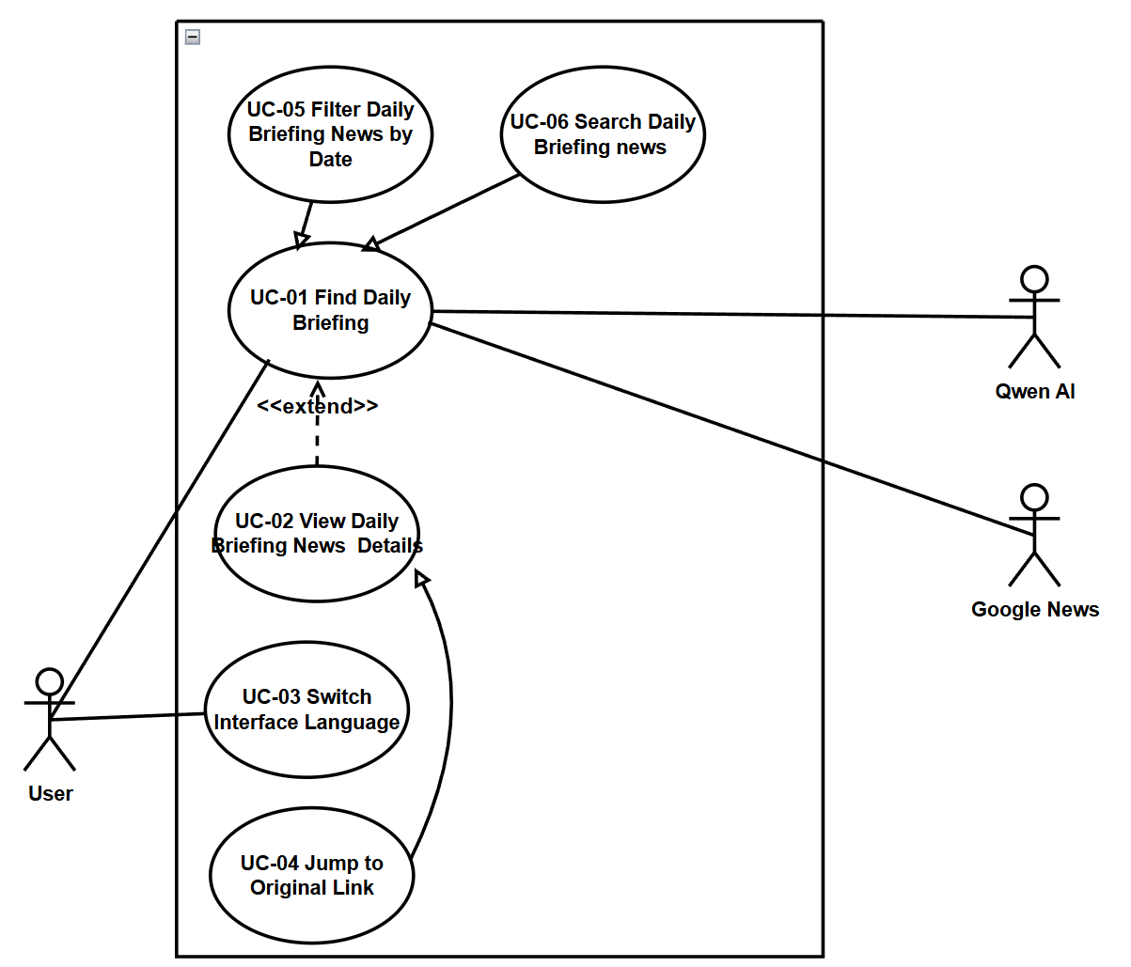

2.1.2 User Requirement Specification
URS01 – Find Daily Briefings
User can open the Daily Briefing page and browse a paginated list of recent Daily Briefing items ordered from newest to oldest by publication time in their current interface language. User can use the sidebar to navigate to the Daily Briefing page in the application.
URS02 – View Daily Briefing news details
User can select a Daily Briefing item from the list and view a news detail page that shows the complete information (title, AI generated summary of News, publication time,View Original button, "Back" button) for that item in their current interface language (English/Chinese).
URS‑03 – Switch Interface Language
User can click a language switch button at any time to change the interface language between Chinese and English and continue browsing Daily Briefing items in the newly selected language.
URS‑04 – Jump to the original link
User can click an “Open original article” button on a Daily Briefing item and read the full original news article on the external official website in a new browser tab.
URS‑05 – Filter Daily Briefings News by Date
The User can filter news based on specific criteria (start date and end date) while browsing.
URS06 – Search for Daily Briefing News
User can type Chinese or English keywords into a search box on the Daily Briefing page and view only Daily Briefing items that match the entered keywords.

2.1.3 Use Case Description and Activity Diagram

2.1.3.1 UCD01 Find Daily Briefings
URS01: User can open the Daily Briefing page and browse a paginated list of recent Daily Briefing items ordered from newest to oldest by publication time in their current interface language. User can use the sidebar to navigate to the Daily Briefing page in the application.
SRS-001: The system shall display the "Briefing" navigation item in the sidebar navigation menu on every page.
SRS-002: The system shall display the Daily Briefing page [UI01] when the "Briefing" navigation item is clicked, showing a paginated list(The list is displayed in sections by page, and users can switch between pages via the Next / Previous / Page number buttons) of Daily Briefing items.
SRS-003: The system shall order Daily Briefing items from newest to oldest based on publication time from the source website.
SRS-004: The system shall implement pagination to display Daily Briefing items, providing pagination controls (page number, previous/next buttons) for users to navigate through pages.
SRS-005: At 8:00 every morning, the system shall trigger scheduled job for Daily Briefing.
SRS-006: System shall send a request to Google News to fetch the latest news items (title, content, source, publish time, original link, etc.).
SRS-007: System shall parse the returned data and saves/updates the news items in the local database.
SRS-008: System shall send news titles and content to Qwen AI to generate or refine bilingual summaries and translations.
SRS-09: System shall write Qwen AI’s summaries and translations into the corresponding fields in the database (e.g., Chinese title, English title, Chinese summary, English summary).
SRS-010: System shall retrieve the user’s current interface language preference (Chinese or English).
SRS-011: System shall query the first page of Daily Briefing items from the local database, ordered by publication time (newest first).
SRS-012: System selects the proper language version (Chinese or English) of title and summary for each item and assembles the display data (title, summary, source, time, “View Detail” button, “Read Original” button)
SRS-013: System displays the Daily Briefing page (UI01) with a paginated list of news cards.
SRS-014: System shall load the next page of news items from the database and updates the list on the page.
SRS-015: System shall navigate to the News Detail page and shows the full content with the stored AI‑generated summary/translation.
Use Case ID | UC01
Use Case Name | Find Daily Briefings
Actors | User
Description | This use case describes the process by which a user navigates to the Daily Briefing page and browses a paginated list of recent news items from Google News. The list displays news items ordered from Google News new to old by publication time, with all content displayed in the user's current interface language (Chinese or English).
Trigger | User clicks on the "Briefing" navigation item in the sidebar menu.
Preconditions | 1. User is logged into the BridgeU platform.  2. User has an active internet connection.  3. The Daily Briefing system has successfully crawled news from approved sources (Google News).
Use Case Input Specification
Input | type | Constraint |  |  | Example
Current Interface Language | String | Must be "zh" (Chinese) or "en" (English) |  |  | "en"
Post conditions | User are in "Daily Briefing page" (UI-01: Daily Briefing page)
Normal Flows | User |  | System | QwenAI |  | Google News
 | 8. User clicks on the “Briefing” navigation item in the sidebar.  13. User views the list of news items on the page.  14. User clicks pagination controls (e.g., “Next” button).  16. User clicks the “View Detail” button of a news item. |  | 1. At 8:00 every morning, the system’s scheduled job for Daily Briefing is triggered.  2. System sends a request to Google News to fetch the latest news items (title, content, source, publish time, original link, etc.).  4. System parses the returned data and saves/updates the news items in the local database.  5. System sends news titles and content to Qwen AI to generate or refine bilingual summaries and translations.  7. System writes Qwen AI’s summaries and translations into the corresponding fields in the database (e.g., Chinese title, English title, Chinese summary, English summary). This completes the daily data preparation.  9. System retrieves the user’s current interface language preference (Chinese or English).  10. System queries the first page of Daily Briefing items from the local database, ordered by publication time (newest first).  11. System selects the proper language version (Chinese or English) of title and summary for each item and assembles the display data (title, summary, source, time, “View Detail” button, “Read Original” button).  12. System displays the Daily Briefing page (UI01) with a paginated list of news cards.  15. System loads the next page of news items from the database and updates the list on the page.  17. System navigates to the News Detail page and shows the full content with the stored AI‑generated summary/translation. | 6. Qwen AI returns summaries and translated titles in the required languages. |  | 3. Google News returns a list of news items that match the request.
Alternative Flow
Exception Flow
Assumption | The user has an internet connection .
AD01: View Daily Briefings
Activity Diagram for View Daily Briefings, which explains the steps between a User and the System for browsing aggregated news.
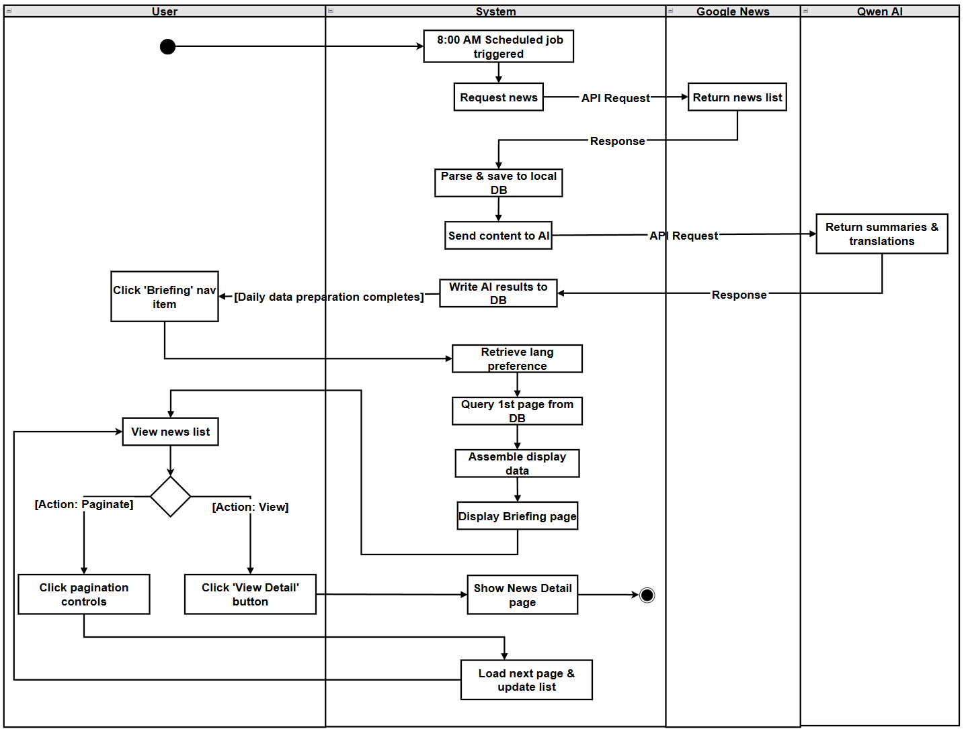

2.1.3.2 UCD02 View Daily Briefing news details
URS02: User can select a Daily Briefing item from the list and view a news detail page that shows the complete information (title, summary, publication time, View Original button) for that item in their current interface language (English/Chinese).
SRS-016: System shall retrieve the news item ID from the clicked card.
SRS-017: System shall retrieve the user's current interface language preference (Chinese or English).
SRS-018: Fronted shall send HTTP request to backend API with news item ID and language parameter.
SRS-019: Backend shall receive request (authentication not required for this endpoint).
SRS-020: Backend shall query the database for the Daily Briefing item using the news item ID.
SRS-021: Backend shall retrieve the corresponding language version (Chinese or English) for the news item's title and summary.
SRS-022: Backend shall return response with success status and news detail data.
SRS-023: Frontend shall receive HTTP response from backend.
SRS-024: Frontend shall check if response.status is 200 and response.data.success is true.
SRS-025: System shall display the News Detail page (UI-02) with the complete information:
- News title (in current interface language)
- AI-generated summary (in current interface language)
- Source website name
- Publication time (formatted according to current interface language)
- "View Original" button (disabled if originalUrl is invalid or missing)
- "Back" button.
SRS-026: Frontend shall trigger a language change event and updates the current language preference.
SRS-027: System re-fetche the news detail data from the API with the new language parameter.
SRS-028: System shall update the News Detail page display with content in the new language (title, summary, formatted dates).
SRS-029: System shall trigger the browser to open the original URL in a new tab.

Use Case ID | UC02
Use Case Name | View Daily Briefing news details
Actors | User
Description | User can select a Daily Briefing item from the list and view a news detail page that shows the complete information (title, AI generated summary of News, publication time,View Original button, "Back" button) for that item in their current interface language (English/Chinese).
Trigger | User clicks the "View Detail" button on a Daily Briefing card in the Daily Briefing list page (UI01)
Preconditions | 1. User has an active internet connection.  2. User is viewing the Daily Briefing list page (UI-01).  3. At least one Daily Briefing item exists in the list.
Use Case Input Specification
Input | type | Constraint |  | Example
Current Interface Language | String | Must be "zh" (Chinese) or "en" (English) |  | “en”
Post conditions | User is viewing the News Detail page (UI02) displaying the complete information for the selected Daily Briefing item
Normal Flows | User |  | System
 | 1. User clicks the "View Detail" button on a Daily Briefing card in the list page  12. User views the news details  13. User switches the interface language (Chinese/English) using the language switcher (optional)  18. User clicks the "View Original" button (optional)  20. User clicks the "Back" button (optional) |  | 2. System retrieves the news item ID from the clicked card.  3. System retrieves the user's current interface language preference (Chinese or English).  4. Frontend sends HTTP request to backend API with news item ID and language parameter.  5. Backend receives request (authentication not required for this endpoint).  6. Backend queries the database for the Daily Briefing item using the news item ID.  7.Backend retrieves the corresponding language version (Chinese or English) for the news item's title and summary.  8. Backend returns response with success status and news detail data  9. Frontend receives HTTP response from backend  10. Frontend checks if response.status is 200 and response.data.success is true  11. System displays the News Detail page (UI-02) with the complete information:  - News title (in current interface language)  - AI-generated summary (in current interface language)  - Source website name  - Publication time (formatted according to current interface language)  - "View Original" button (disabled if originalUrl is invalid or missing)  - "Back" button  14. Frontend triggers a language change event and updates the current language preference.  15. System re-fetches the news detail data from the API with the new language parameter.  16. System updates the News Detail page display with content in the new language (title, summary, formatted dates).  17. Use case continues from Step 12  19. System triggers the browser to open the original URL in a new tab.  21. System navigates the user back to the Daily Briefing page (UI-01)
Alternative Flow
Exception Flow
Assumption | The user has an internet connection .

AD02 View Daily Briefing news details
The Activity Diagram for View Daily Briefings shows how the User and the System interact when view the daily briefing list（UI01）
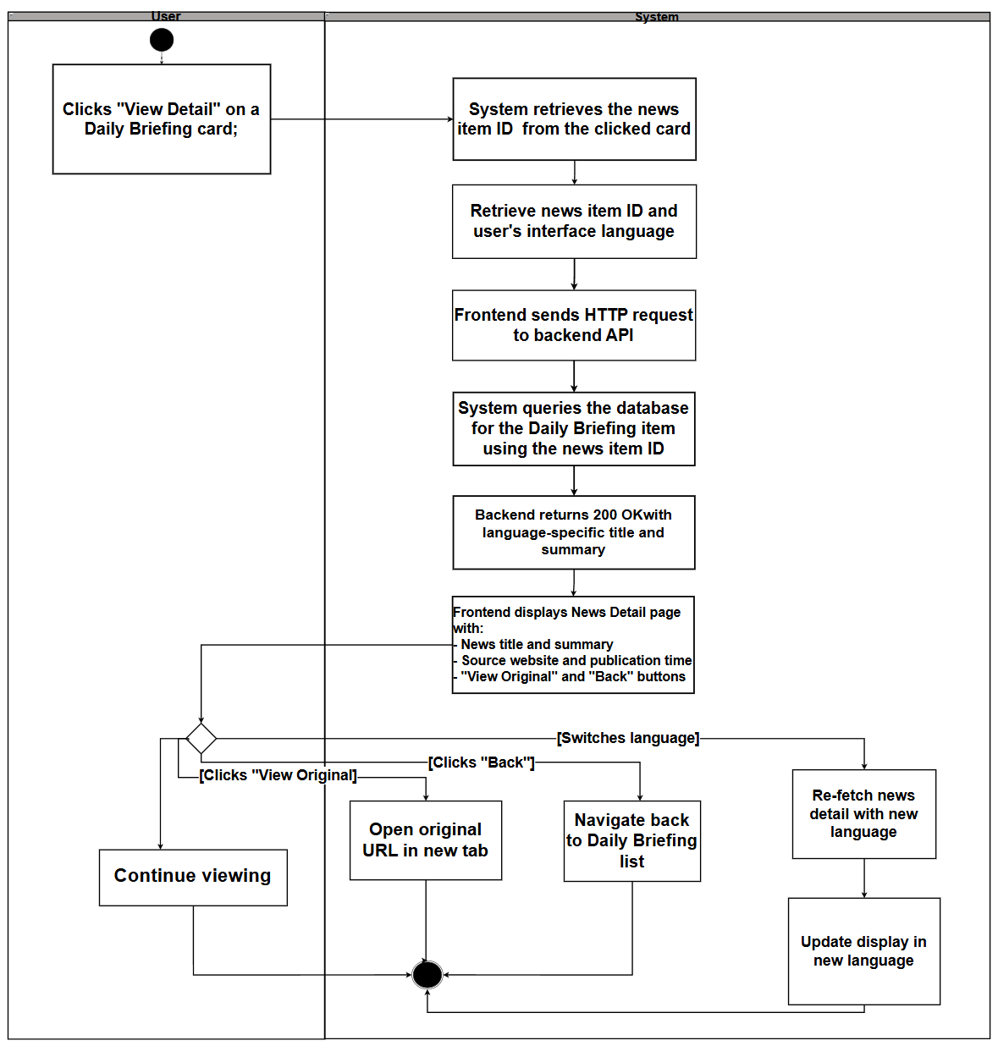

2.1.3.3 UCD03 Switch Interface Language
URS‑03 :User can click a language switch button at any time to change the interface language between Chinese and English and continue browsing Daily Briefing items in the newly selected language.
SRS-030: System shall call setLanguage (newLang) function, which validates the language code ("zh" or "en").
SRS-031: System shall update the current language state and attempts to store the preference in localStorage with key 'userLanguage'.
SRS-032: Upon a language switch, the system shall notify all listening components via a languageChanged event, requiring them to refetch their content from the backend API using the new language parameter
SRS-034: System shall refresh the current page display with:
-All interface text, labels, and buttons in the new language (via i18n translation system, automatically updated when language changes)
-All content (titles, summaries, etc.) in the new language (from API response)<br>
-Dates and times formatted as "DD-MM-YYYY HH:mm" .
-Current page context maintained (same page number, same selected item ID, same filter parameters if applicable)
-Element Plus UI components locale updated (zhcn or en)

Use Case ID | UC03
Use Case Name | Switch Interface Language
Actors | User
Description | User can click a language switch button at any time to change the interface language between Chinese and English and continue browsing Daily Briefing items in the newly selected language.
Trigger | User clicks the language switch button on any page of the application
Preconditions | 1. User may or may not be logged into the BridgeU platform (language switching is available on both login page and authenticated pages).  2. User is viewing any page of the application.  3. The system has bilingual content available (Chinese and English versions) for the current page.  4. The browser supports local Storage (for storing language preference).
Use Case Input Specification
Input | type | Constraint |  | Example
Selected Language | String | Must be "zh" (Chinese) or "en" (English) |  | "en"
Post conditions | 1.User's interface language preference is updated to the newly selected language  2.Current page content is refreshed and displayed in the newly selected language  3.User can continue browsing in the newly selected language without losing their current context
Normal Flows | User |  | System
 | 1. User clicks the language switch button (e.g., "🇨🇳 中文" or "🇺🇸 EN" in sidebar, or "EN/中文" toggle on login page) on the current page  7. User continues browsing in the newly selected language |  | 2. System calls setLanguage (newLang) function, which validates the language code ("zh" or "en")  3. System updates the current language state and attempts to store the preference in localStorage with key 'userLanguage'  4. Notify all listening components via a languageChanged event, requiring them to refetch their content from the backend API using the new language parameter  5. Components receive the content in the newly selected language from API responses  6. System refreshes the current page display with:  - All interface text, labels, and buttons in the new language (via i18n translation system, automatically updated when language changes)  - All content (titles, summaries, etc.) in the new language (from API response)  - Dates and times formatted as "DD-MM-YYYY HH:mm" (consistent format for both languages)  - Current page context maintained (same page number, same selected item ID, same filter parameters if applicable)  - Element Plus UI components locale updated (zhcn or en)
Alternative Flow
Exception Flow
Assumption | The user has an internet connection .

AD03: Switch Interface Language
The Activity Diagram for Switch Interface Language illustrates the interaction between the User and the System when the user changes the interface language:
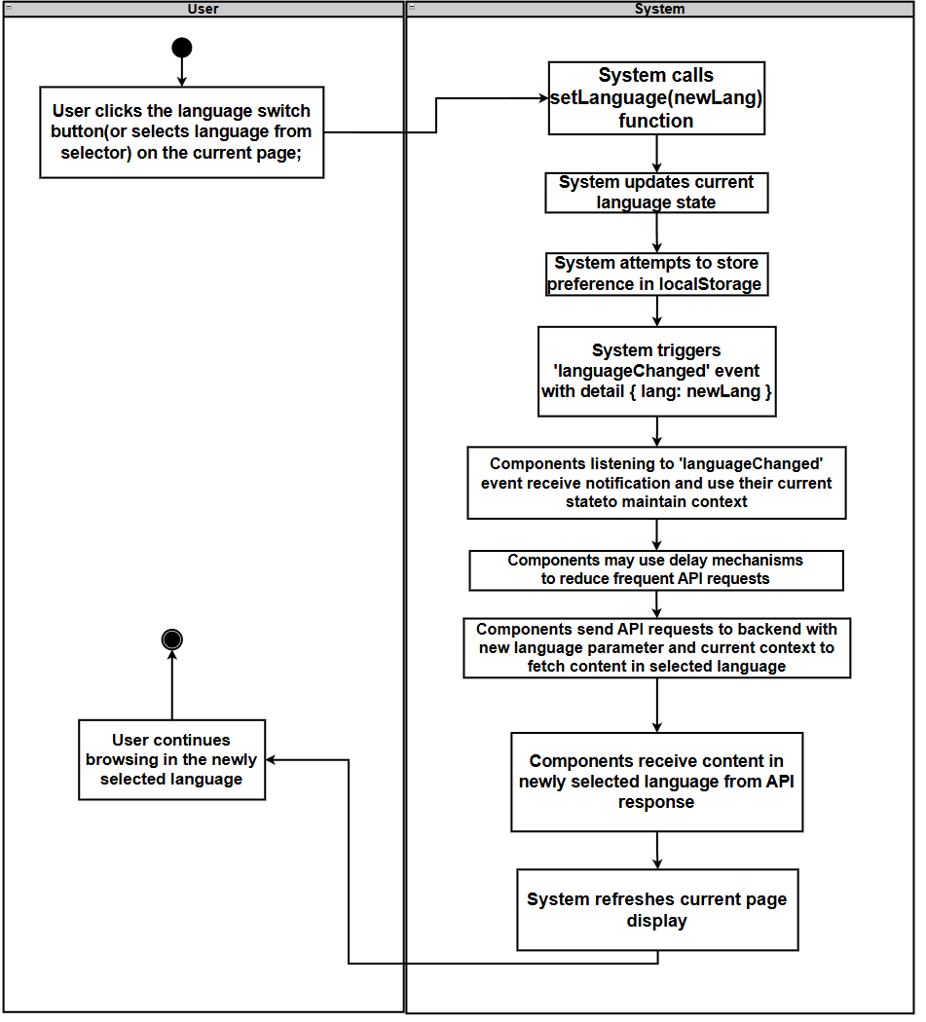

2.1.3.4 UCD04 jump to original Link
URS04: The User can jump to the original text link to read the full report from the source website when viewing news details.
SRS-035: System shall check whether a "Read Original" action is available for the current news item.
SRS-036: System shall render the "Read Original" button in the current interface language.
SRS-037: System shall open original link in new browser tab(keeps current BridgeU page unchanged.
Use Case ID | UC04
Use Case Name | Jump to Original Link
Actors | User
Description | User can click the "Read Original" button on the Daily Briefing list page or News Detail page to open the original news article from the source website in a new browser tab.
Trigger | User clicks the "Read Original" button on a Daily Briefing card (list page) or on the News Detail page
Preconditions | 1. User is viewing the Daily Briefing list page (UI01) or the News Detail page (UI02).  2. The user has internet connectivity to access external websites.
Use Case Input Specification
Input | type | Constraint |  | Example
Post conditions | The original news article from the source website is opened in a new browser tab
Normal Flows | User |  | System
 | 1. User views a Daily Briefing item on the list page or the News Detail page.  4. User click the “Read Original” button |  | 2. System checks whether a "Read Original" action is available for the current news item.  3. System renders the "Read Original" button in the current interface language.  5. System opens original link in new browser tab(keeps current BridgeU page unchanged.
Alternative Flow
Exception Flow
Assumption | The user has an internet connection .

AD04:
This activity diagram show the jump to orginal link shows the interaction between the user and the system when the user selects the jump to orginal link
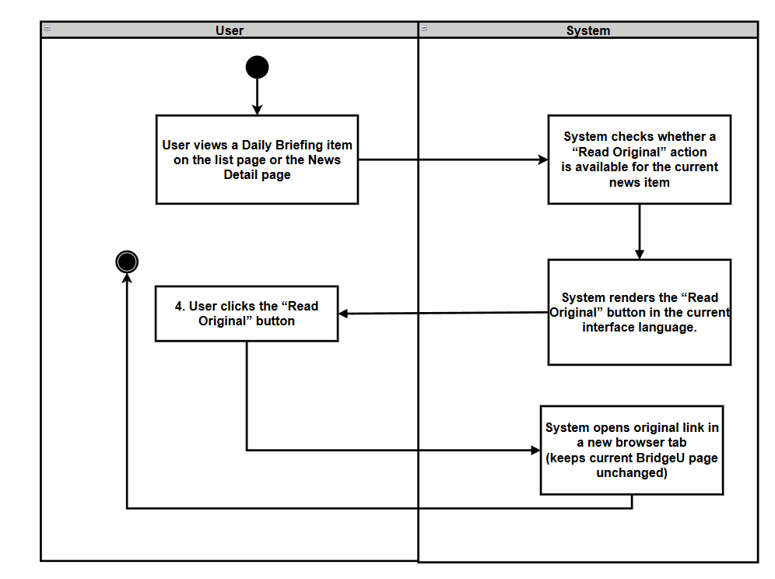

2.1.3.5 UCD05 Filter Daily Briefings News by Date
URS‑05：The User can filter news based on specific criteria (start date and end date) while browsing.
SRS-038: System shall display the filter panel with empty (optional) fields and shows the current news list (unfiltered), with pagination controls when multiple pages exist.
SRS-039: System shall update the filter model accordingly.
SRS-040: System shall clear Start Date and End Date and refreshes the list as unfiltered (page reset to 1).
SRS-041: System shall validate the filter inputs (if both dates are provided, Start Date ≤ End Date).
SRS-042: If validation passes, the system shall send a filter request to the backend API including any provided parameters (`startDate`, `endDate`) and the current UI language (`lang`).
SRS-043: Backend shall query the database for Daily Briefing items matching the provided conditions (date range on `publishDate`), orders results from newest to oldest by `publishDate`, and applies pagination.
SRS-044: Backend shall return the filtered news list (with pagination data) to the frontend.
SRS-045: System shall update the Daily Briefing list on UI-01 to show only filtered items (page reset to 1) and updates pagination controls accordingly.
SRS-046: System shall load and display the corresponding page of filtered results while preserving the current filter conditions.
SRS-047: System shall repeat the validation-and-query flow with the new conditions.

Use Case ID | UC-05
Use Case Name | Filter Daily Briefings News by Date
Actors | User
Description | User can filter Daily Briefing items by choosing an optional start date and an optional end date, and then browse only the items that meet these filter conditions.
Trigger | User is on the Daily Briefing list page (UI-01) and interacts with the filter panel (selects dates, then clicks the "Filter" button).
Preconditions | 1. User is logged into the BridgeU platform.  2. User has an active internet connection.  3. The Daily Briefing system has successfully crawled news from approved sources and stored publication dates.  4. The filter panel (date pickers) is visible on the Daily Briefing list page (UI-01).
Use Case Input Specification
Input | type | Constraint |  | Example
Start Date | Date | Must be a valid calendar date; must not be later than End Date |  | 01-01-2026
End Date | Date | Must be a valid calendar date; must not be earlier than Start Date |  | 03-01-2026
Post conditions | The Daily Briefing list page (UI-01) displays only news items that match the provided date conditions (if any), ordered from newest to oldest by publication date, with pagination.
Normal Flows | User |  | System
 | 1. User opens the Daily Briefing list page (UI-01) and sees the filter panel with date pickers.  3. User sets filter criteria (“Start Date” and/or “End Date”).  5. (Optional) User clicks the "Reset" button.  7. User clicks the "Filter" button.  13. User browses the filtered news list and can navigate between pages using pagination controls.  15. User may adjust filter criteria and click "Filter" again (or reset). |  | 2. System displays the filter panel with empty (optional) fields and shows the current news list (unfiltered), with pagination controls when multiple pages exist.  4. System updates the filter model accordingly.  6. System clears Start Date and End Date and refreshes the list as unfiltered (page reset to 1).  8. System validates the filter inputs (if both dates are provided, Start Date ≤ End Date).  [E1: Invalid date range]`  9. If validation passes, the system sends a filter request to the backend API including any provided parameters (`startDate`, `endDate`) and the current UI language (`lang`).  10. Backend queries the database for Daily Briefing items matching the provided conditions (date range on `publishDate`), orders results from newest to oldest by `publishDate`, and applies pagination.  11. Backend returns the filtered news list (with pagination data) to the frontend.  12. System updates the Daily Briefing list on UI-01 to show only filtered items (page reset to 1) and updates pagination controls accordingly.  [A1: No news match filter conditions]`  14. System loads and displays the corresponding page of filtered results while preserving the current filter conditions.  16. System repeats the validation-and-query flow with the new conditions.
Alternative Flow | A1: No news match filter conditions  A1.1 Backend returns an empty result set for the specified Filter (no records match date range conditions).  A1.2 System displays an empty list on the Daily Briefing page and shows a message "No news data available"  A1.3 Filter panel remains visible and retains the user's selected dates (if any) so that the user can easily adjust them.  A1.4 Use case ends or continues when the user modifies filter conditions and clicks "Filter" again.
Exception Flow | E1: Invalid date range  E1.1 System detects that Start Date is later than End Date during validation.  E1.2 System displays an inline validation error message (e.g., "Start date cannot be later than end date") near the date fields.  E1.3 System does not send a request to the backend.  E1.4 User can correct the dates and click "Filter" again (return to step 7).
Assumption | The user has an internet connection .

AD-05:
The Activity Diagram for Filter Daily Briefings News by Date illustrates the interaction between the “User“ and the “System” when the user filters Daily Briefing items by date range.
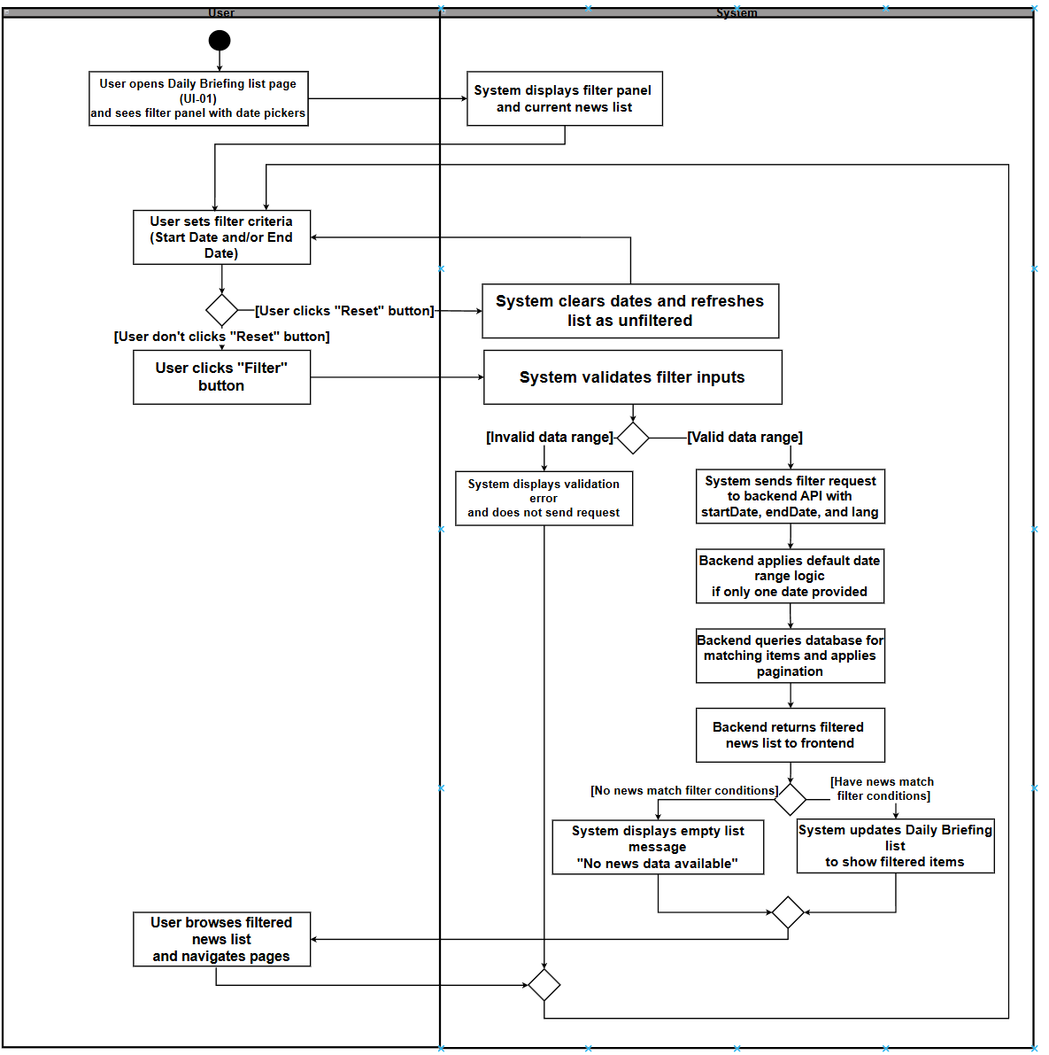

2.1.3.6 UCD06 Search for Daily Briefing News
URS06：User can type Chinese or English keywords into a search box on the Daily Briefing page and view only Daily Briefing items that match the entered keywords.
SRS-048: System shall display the search box with placeholder text and shows the current news list (unfiltered), with pagination controls when multiple pages exist.
SRS-049: System shall update the search keyword model accordingly.
SRS-050: System shall reset the current page to page 1.
SRS-051: System shall send a search request to the backend API including the keyword parameter (`keyword`), any date filter parameters (if set), and the current UI language (`lang`).
SRS-052: Backend shall search the database for Daily Briefing items where the keyword matches any of the searchable fields (title, originalContent , summary, and all translation fields). If date filters are provided, the search is limited to items within the date range. Results are ordered from newest to oldest by `publishDate` and paginated.
SRS-053: Backend shall return the search results (with pagination data) to the frontend.
SRS-054: System shall update the Daily Briefing list on UI-01 to show only matching items (page reset to 1) and updates pagination controls accordingly.
SRS-055: System shall load and displays the corresponding page of search results while preserving the current search keyword and any date filter conditions.
SRS-056: System shall repeat the search flow with the new keyword.
SRS-057: System shall clear the search keyword, resets the current page to page 1, and sends a new request without the keyword parameter (showing all news or filtered by date range if date filters are active).
Use Case ID | UC-06
Use Case Name | Search for Daily Briefing News
Actors | User
Description | User can type Chinese or English keywords into a search box on the Daily Briefing page and view only Daily Briefing items that match the entered keywords. The search can be combined with date filtering to narrow down results.
Trigger | User is on the Daily Briefing list page (UI-01) and enters keywords into the search box, then clicks the search button or presses Enter.
Preconditions | 1. User is logged into the BridgeU platform.  2. User has an active internet connection.  3. The Daily Briefing system has successfully crawled news from approved sources and stored publication dates and content.
Use Case Input Specification
Input | type | Constraint |  | Example
Keyword | String | Can be Chinese or English characters; can contain spaces; will be trimmed of leading/trailing whitespace |  | "泰国" or "Thailand" or "travel"
Post conditions | The Daily Briefing list page (UI-01) displays only news items that match the entered keyword (and any date filter conditions if set), ordered from newest to oldest by publication date, with pagination.
Normal Flows | User |  | System
 | 1. User opens the Daily Briefing list page (UI-01) and sees the search box.  3. User types keywords (Chinese or English) into the search box.  5. User clicks the "Search" button or presses “Enter”.  11. User browses the search results and can navigate between pages using pagination controls.  13. User may modify the search keyword and click "Search" again (or clear the keyword).  15. (Optional) User clicks the “clear button” in the search box. |  | 2. System displays the search box with placeholder text and shows the current news list (unfiltered), with pagination controls when multiple pages exist.  4. System updates the search keyword model accordingly.  6. System resets the current page to page 1.  7. System sends a search request to the backend API including the keyword parameter (`keyword`), any date filter parameters (if set), and the current UI language (`lang`).  8. Backend searches the database for Daily Briefing items where the keyword matches any of the searchable fields (title, originalContent , summary, and all translation fields). If date filters are provided, the search is limited to items within the date range. Results are ordered from newest to oldest by `publishDate` and paginated.  9. Backend returns the search results (with pagination data) to the frontend.  10. System updates the Daily Briefing list on UI-01 to show only matching items (page reset to 1) and updates pagination controls accordingly.  [A1: No news match search keyword]  12. System loads and displays the corresponding page of search results while preserving the current search keyword and any date filter conditions.  14. System repeats the search flow with the new keyword.  16. System clears the search keyword, resets the current page to page 1, and sends a new request without the keyword parameter (showing all news or filtered by date range if date filters are active).
Alternative Flow | [A1: No news match search keyword]  A1.1 Backend returns an empty result set for the specified search keyword (and any date filter conditions).  A1.2 System displays an empty list on the Daily Briefing page and shows a message "No news data available" .  A1.3 Search box remains visible and retains the user's entered keyword so that the user can easily modify it and retry.  A1.4 Use case ends or continues when the user modifies the keyword and clicks "Search" again.
Exception Flow
Assumption | The user has an internet connection .

AD-06
The Activity Diagram for Search for Daily Briefing News illustrates the interaction between the User and the System when the user searches for Daily Briefing items by entering keywords:
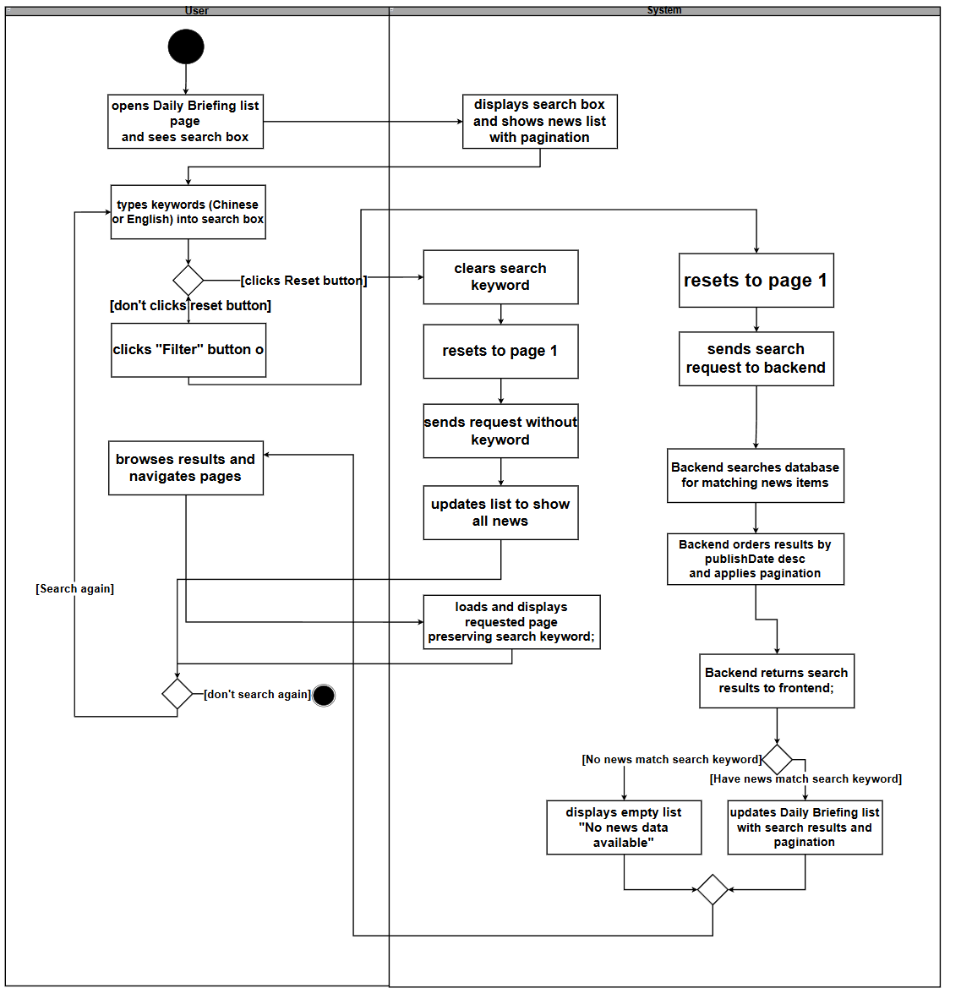

2.2 Feature 2

2.2.1 Use Case Diagram
The Community Interaction Platform centers on a single actor (User): the user can browse public posts (UC-07) and optionally filter by tag (UC-10) or search by keyword (UC-14), then view post details (UC-11) where they may like (UC-09), post comments (UC-13), or report inappropriate content (UC-12); the system may invoke Qwen AI to support content processing during post creation/publishing (UC-08) and to generate an AI comment summary (UC-015), and users can also manage private messages(UC-16) with message status management (UC-17) as an extension of messaging.
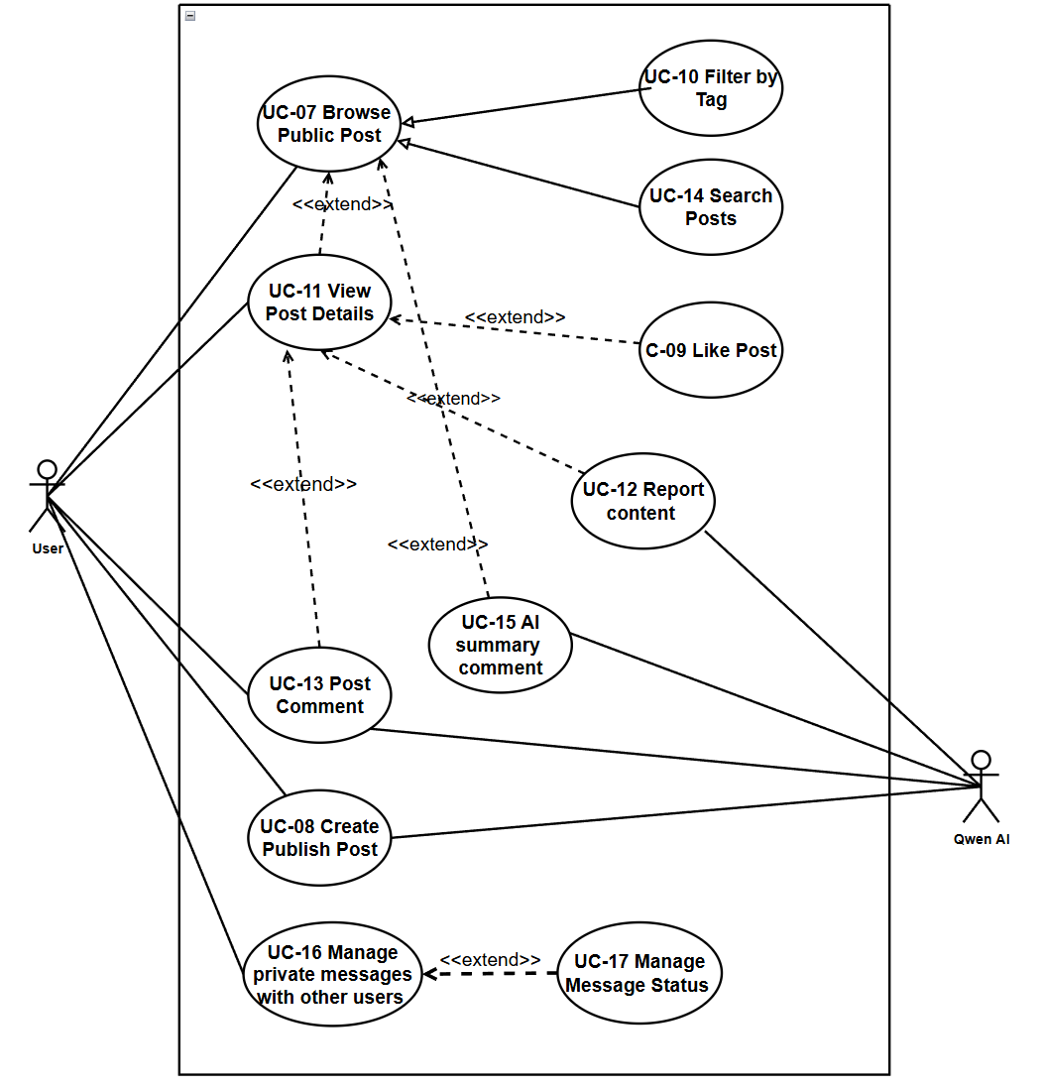

2.2.2 User Requirement Specification
- URS-07: The User can browse the community feed with posts ordered from newest to oldest, showing title, preview, tags, like count, and comment count.

- URS-08: The User can create or edit posts in their preferred language (Chinese, English), upload images, select a tag from predefined categories (Study, Housing, Travel, Part-time Job, Life Services), and have the system automatically translate language between Chinese and English content using Qwen AI for later display.

- URS-09 : The User can like or unlike posts to express feedback, and the like count updates immediately in the interface.

- URS-10: The User can filter posts in the community feed by selecting tags from the predefined list (Study, Housing, Travel, Part-time Job, Life Services).

- URS-11: The User can view post details including full text, images, tags, engagement metrics (likes, comments), and author profile when clicking on a post, in their current interface language.

- URS-12: The User can report posts/comments with structured reasons (Spam, Fraud or Scam, Illegal Service Promotion, Abusive Language, Other) and provide explanatory text.

- URS-13: The User can post comments to interact with other users, which will be automatically translated by the system into Chinese and English; users can delete their own comments.

- URS-14: The User can search posts by keyword across bilingual content (titles and body texts in both Chinese and English)。

- URS-15 : The User can view AI-generated summaries of all comments under a post in their chosen language.
- URS-16: Users can send and receive private messages, view message history, and manage conversations under the following rules:
- When the current user only follows another user one-way, they may start a conversation and send at most one initial private message (invite).
- When the users mutually follow each other (Friends), they may exchange multiple private messages as an ongoing conversation without limit.
- Users who do not follow the other user at all cannot start a private conversation.
- URS-17: Users can automatically mark messages as read by opening a session, and users can delete message records on their side as needed (effective only for the current user, not affecting the messages seen by the other party).

2.2.3 Use Case Description and Activity Diagram

2.2.3.1 UCD07 Browse Daily Briefings
URS-07: The User can browse the community feed with posts ordered from newest to oldest, showing title, preview, tags, like count, and comment count.
SRS-058: System shall open UI-03 and requests latest posts (page 1).
SRS-059: Backend shall return post list (newest to oldest) with pagination meta data.
SRS-060: System shall load corresponding page and renders post cards.

Use Case ID | UC-07
Use Case Name | Browse Daily Briefings
Actors | User
Description | User opens the community feed and browses posts ordered from newest to oldest.
Trigger | User clicks "Community" entry in navigation.
Preconditions | 1.User is logged into the platform.  2. Network connection is available.
Use Case Input Specification
Input | type | Constraint |  | Example
Page Number | Integer | Optional, default: 0 |  | 0
Page size | Integer | Optional, default: 20 |  | 20
Language | String | Optional, "zh" or "en" |  | “en”
Post conditions | User is viewing UI-Community-Feed with a list of posts (or an empty-state message).
Normal Flows | User |  | System
 | 1. User clicks "Community" in navigation.  4. User browses posts and changes page/scrolls. |  | 2. System opens UI-03 and requests latest posts (page 1).  [E1: Network timeout or connection error]  3. Backend returns post list (newest to oldest) with pagination metadata.  [A1: No posts data]  5. System loads corresponding page and renders post cards.
Alternative Flow | A1: No posts data  A1.1 Backend returns an empty list.  A1.2 System displays an empty-state message on UI-03.  A1.3 Use case end.
Exception Flow | E1: Network timeout or connection error  E1.1 Request fails due to network issues.  E1.2 System displays a localized error message and provides a retry action.  E1.3 Use case end.
Assumption | The user has an internet connection .

AD-07:
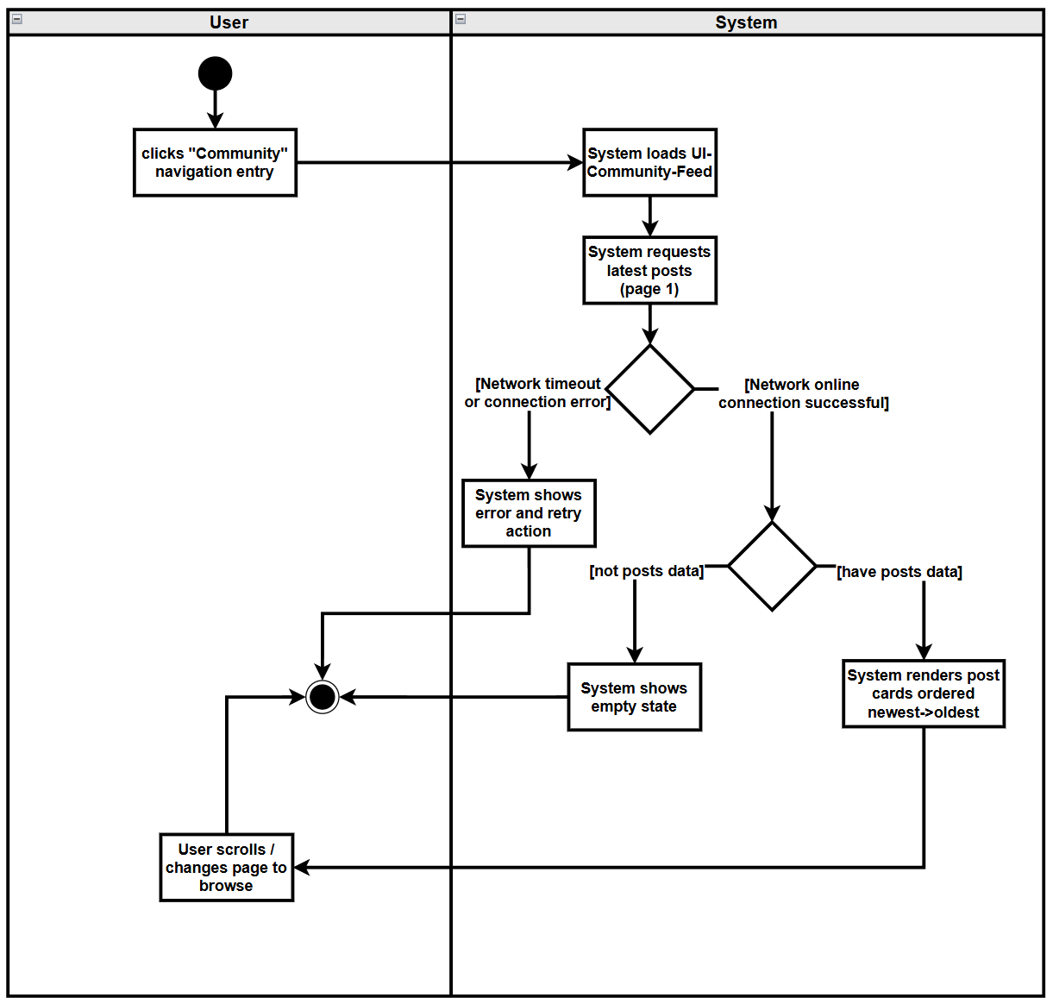

2.2.3.2 UCD08 Create Publish Post
URS-08: The User can create or edit posts in their preferred language (Chinese, English), upload images, select a tag from predefined categories (Study, Housing, Travel, Part-time Job, Life Services), and have the system automatically translate language between Chinese and English content using Qwen AI for later display.
SRS-061: System shall display editor with title/body/tag/image inputs.
SRS-062: System shall update editor model and shows previews.
SRS-063: System shall validate required fields and, if validation passes, frontend sends create-post request.
SRS-064: Backend shall save post and invokes Qwen AI translation to generate ZH/EN fields.
SRS-065: Backend shall return success with created post ID.
SRS-066: System shall navigate to feed or Post Detail and renders the post.

Use Case ID | UC-08
Use Case Name | Create Publish Post
Actors | User
Description | User creates a post with text,tags,images(optional) and publishes it to the community feed; the system stores bilingual content.
Trigger | User clicks "Create Post".
Preconditions | 1. User is logged in.  2. Network connection is available.
Use Case Input Specification
Input | type | Constraint |  | Example
Title | String | Required, not empty |  | "Looking for housing"
Body | String | Required, not empty |  | "I need a room near CMU"
Tag | String | Required, must be one of: Study, Housing, Travel, Part-time Job, Life Services |  | "Housing"
Image | File | Optional, image file (JPEG, PNG, GIF, WebP) |  | image.jpg
Post conditions | A new post is published and visible in the feed (and/or Post Detail page) in the selected language, with bilingual content stored on backend.
Normal Flows | User |  | System
 | 1. User opens UI-Community-PostEditor.  3. User fills title/body, selects tag(s), uploads images.  5. User clicks "Publish".  9. User views created post. |  | 2. System displays editor with title/body/tag/image inputs.  4. System updates editor model and shows previews.  6. System validates required fields and, if validation passes, frontend sends create-post request.  [A1: Validation failed]  7. Backend saves post and invokes Qwen AI translation to generate ZH/EN fields.  8. Backend returns success with created post ID.  10. System navigates to feed or Post Detail and renders the post.
Alternative Flow | A1: Validation failed  A1.1 System validates required fields (e.g., title/body not empty).  A1.2 System shows validation errors; user edits and resubmits.
Exception Flow
Assumption | The user has an internet connection .

AD-08
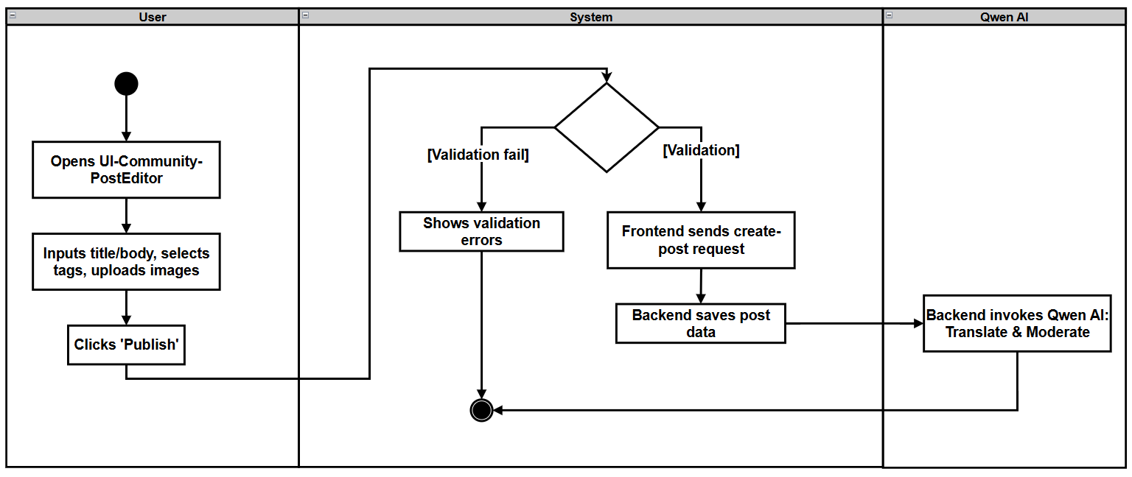

2.2.3.3 UCD09 Like Post
URS-09: The User can like posts to express positive feedback, and the like count updates immediately.
SRS-067: System shall toggle like state and updates like count optimistically.
SRS-068: Frontend shall send like/unlike request to backend.
SRS-069: Backend shall record like/unlike and returns updated counts/state.
SRS-070: System shall reconcile UI with backend response.
Use Case ID | UC-09
Use Case Name | Like Post
Actors | User
Description | User likes (or unlikes) a post and sees the like count update.
Trigger | User clicks the like button on a post.
Preconditions | 1. User is logged in.  2. Post is visible in feed or post detail.
Use Case Input Specification
Input | type | Constraint |  | Example
- | - | - |  | -
Post conditions | The post like state is updated for the user, and the like count is updated in UI.
Normal Flows | User |  | System
 | - User clicks Like on a post.  5. User continues browsing. |  | 2. System toggles like state and updates like count optimistically.  [A1: Unlike a liked post]  3. Frontend sends like/unlike request to backend.  4. Backend records like/unlike (idempotent) and returns updated counts/state.  6. System reconciles UI with backend response.
Alternative Flow | A1: Unlike a liked post  A1.1 User clicks Like again on an already-liked post.  A1.2 System toggles to unlike state and sends unlike request.  A1.3 Backend removes like (or toggles state) and returns updated counts.
Exception Flow
Assumption | The user has an internet connection .

AD-09
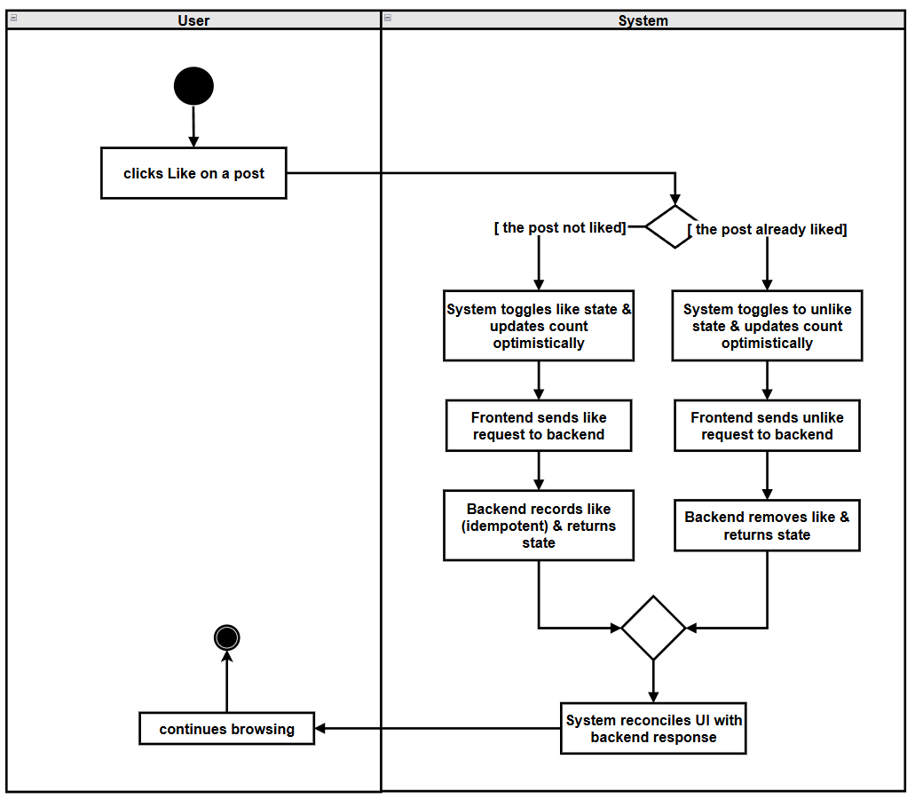

2.2.3.4 UCD10 Filter by Tag
URS-10: The User can filter posts by selecting tags from the predefined list (Study, Housing, Travel, Part-time Job, Life Services).
SRS-071: System shall update selected tag filter state.
SRS-072: System shall reset page to 1 and requests filtered posts.
SRS-073: Backend shall return filtered post list ordered newest->oldest.
SRS-074: System shall render filtered feed and pagination.
Use Case ID | UC-10
Use Case Name | Filter by Tag
Actors | User
Description | User filters the community feed by tag.
Trigger | User selects one or more tags and applies filter.
Preconditions | User is on UI-Community-Feed.
Use Case Input Specification
Input | type | Constraint |  | Example
- | - | - |  | -
Post conditions | Feed displays only posts matching selected tag(s) (or an empty-state message)
Normal Flows | User |  | System
 | - User selects tag(s) in tag filter.  3. User applies filter.  6. User browses filtered results. |  | - System updates selected tag filter state.  4. System resets page to 1 and requests filtered posts.  5. Backend returns filtered post list ordered newest->oldest.  [A1: No posts match the tag filter]  7. System renders filtered feed and pagination.
Alternative Flow | A1: No posts match the tag filter  A1.1 Backend returns an empty list.  A1.2 System shows empty-state message and keeps tag filter visible.  A1.3 Use case end.
Exception Flow
Assumption | The user has an internet connection .

AD-10：
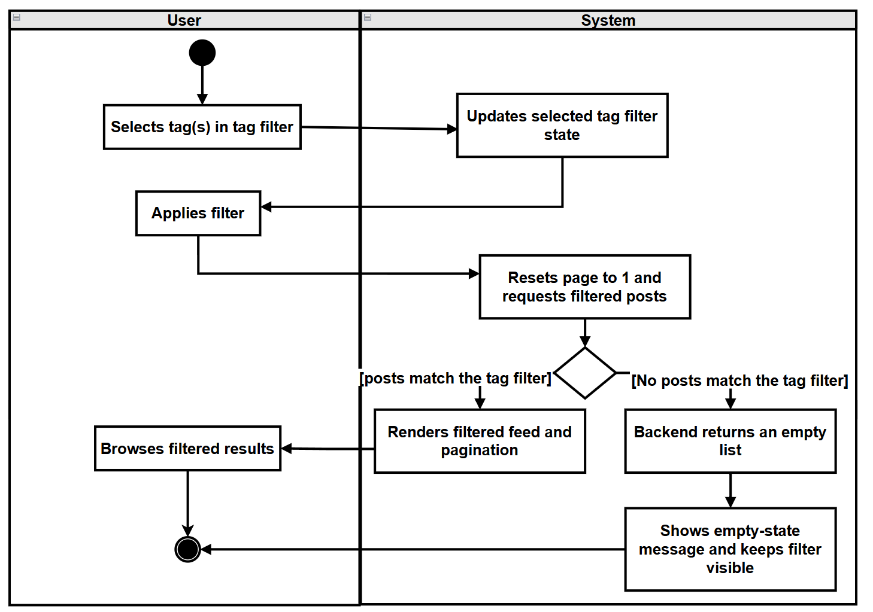

2.2.3.5 UCD11 View Post Details
URS-11: The User can view post details including full text, images, tags, engagement metrics (likes, comments), and author profile when clicking on a post, with content displayed in the current interface language using the stored bilingual fields
SRS-075: .System shall navigate to UI-04 and requests post details + comments.
SRS-076: Backend shall return post data (ZH/EN fields), images/tags/metrics, and comment list.
SRS-077: System shall render post body in selected language and displays comments/metrics.

Use Case ID | UC-11
Use Case Name | View Post Details
Actors | User
Description | User opens a post detail page and reads the post and its comments in selected language.
Trigger | User clicks a post card from feed/search results.
Preconditions | 1. User is logged in.  2. Post exists and is accessible.
Use Case Input Specification
Input | type | Constraint |  | Example
- | - | - |  | -
Post conditions | User is viewing UI-Community-PostDetail with post content and comment list displayed in current interface language.
Normal Flows | User |  | System
 | 1. User clicks a post card.  4. User reads post and scrolls comments. |  | 2.System navigates to UI-Community-PostDetail and requests post details + comments.  3.Backend returns post data (ZH/EN fields), images/tags/metrics, and comment list.  [A1: Post has no comments]  5. System renders post body in selected language and displays comments/metrics.
Alternative Flow | A1: Post has no comments  A1.1 Backend returns empty comment list.  A1.2 System displays "No comments yet" empty state in comments section.  A1.3 Use case end.
Exception Flow
Assumption | The user has an internet connection .
AD-11：
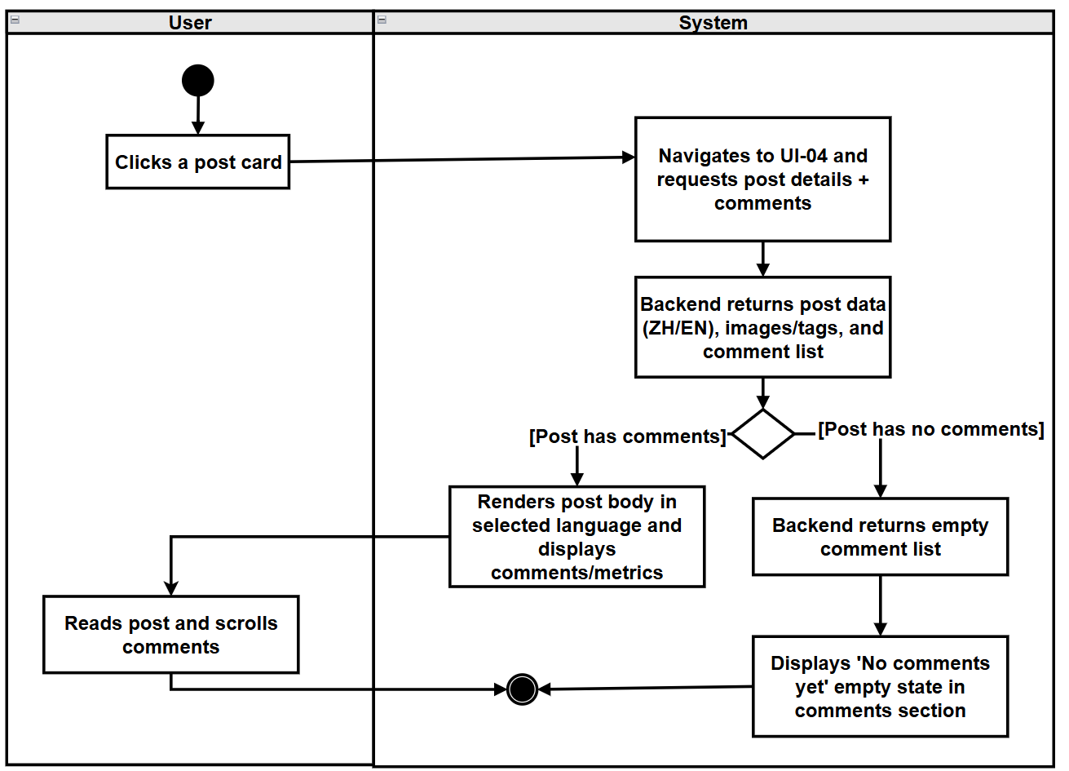

2.2.3.6 UCD12 Report Post/Comment
URS-12: The User can report posts/comments with structured reasons (Spam, Fraud or Scam, Illegal Service Promotion, Abusive Language, Other) and provide explanatory text.
SRS-078: System shall open the report dialog with structured reasons (Spam, Fraud or Scam, Illegal Service Promotion, Abusive Language, Other) and an optional description field.
SRS-079: System shall validate inputs.
SRS-080: Frontend shall send report request to backend with reporter ID, target type, target ID, reason, description.
SRS-081: Backend shall store report record with reporter ID, target type, target ID, reason, description, and timestamp.
SRS-082: Backend shall send reported content and metadata to Qwen AI for analysis (e.g., content category, severity score).
SRS-083: Backend shall optionally stores AI analysis result together with the report record for later moderation use.
SRS-084: Backend shall return success to frontend.
SRS-085: System shall show “Report submitted” message and closes dialog.
Use Case ID | UC-12
Use Case Name | Report content(Post/Comment)
Actors | User
Description | User reports about post/comment inappropriate content with a structured reason and optional description t.The System may use Qwen AI to automatically classify and prioritize reported content for moderation.
Trigger | User clicks "Report" on a post or comment.
Preconditions | 1. User is logged in.  2. Target post/comment is visible.
Use Case Input Specification
Input | type | Constraint |  |  | Example
Reason | String | Must be one of predefined reasons |  |  | “Spam”
Description (optional) | String | Max length (200) |  |  | "Repeated ads"
Post conditions | A report record is created, and user sees confirmation feedback.
Normal Flows | User |  | System | Qwen AI
 | 1. User clicks "Report" on a post/comment.  3. User selects a reason and enters optional description.  5. User submits report.  13.User sees confirmation. |  | 2. System opens the report dialog with structured reasons (Spam, Fraud or Scam, Illegal Service Promotion, Abusive Language, Other) and an optional description field.  [A1: User cancels reporting]  4.System validates inputs.  6.Frontend sends report request to backend with reporter ID, target type, target ID, reason, description.  7.Backend stores report record with reporter ID, target type, target ID, reason, description, and timestamp.  8.Backend sends reported content and metadata to Qwen AI for analysis (e.g., content category, severity score).  10.Backend optionally stores AI analysis result together with the report record for later moderation use.  11.Backend returns success to frontend.  12.System shows “Report submitted” message and closes dialog. | 9.Qwen AI analyzes the reported content and returns structured analysis (category, severity / risk score).
Alternative Flow | A1: User cancels reporting  A1.1 User closes the report dialog without submitting.  A1.2 System discards input and returns to previous view.  A1.3 Use case end.
Exception Flow
Assumption | The user has an internet connection .

AD-12:
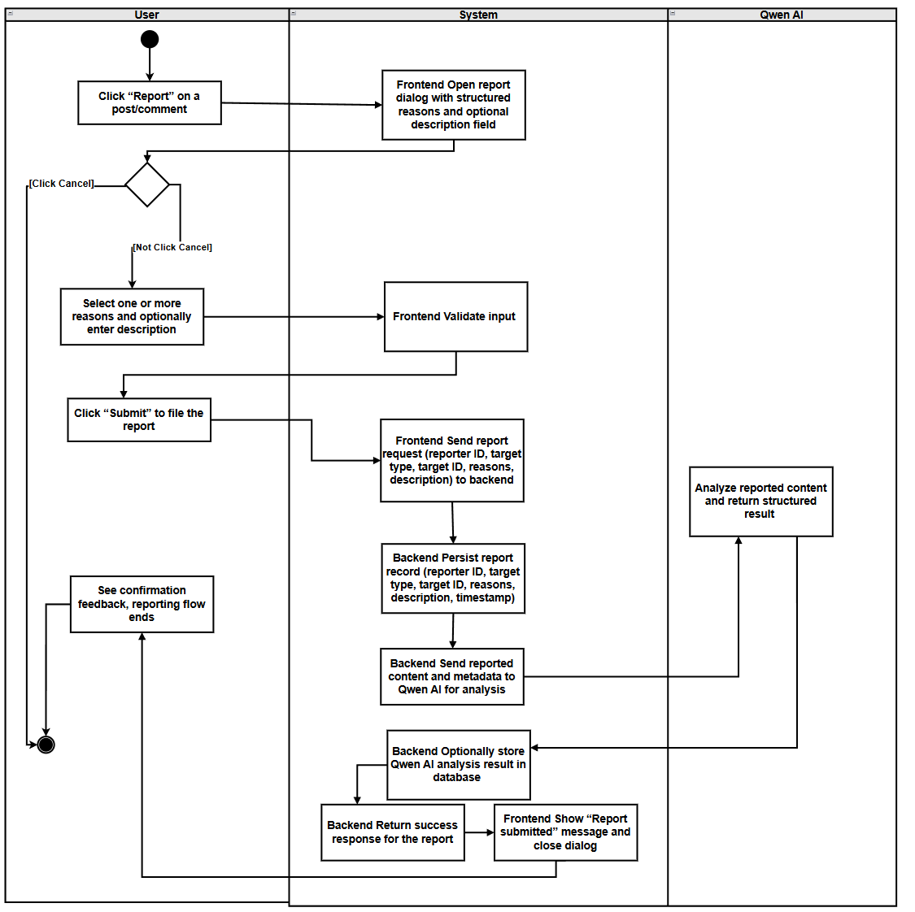

2.2.3.7 UCD-13: Post Comment
URS-13: The User can post comments to interact with other users, which will be automatically translated by the system into Chinese and English; users can delete their own comments.
SRS-086: System shall update comment input model.
SRS-087: System shall validate the comment and, if valid, frontend sends create-comment request.
SRS-088: Backend shall stores comment.
SRS-089: Backend shall return success with new comment.
SRS-090: System shall append comment to list and updates comment count.
Use Case ID | UC-13
Use Case Name | Post Comment
Actors | User
Description | User posts a comment under a post; the system translates and displays it.
Trigger | User submits comment on Post Detail page.
Preconditions | 1. User is logged in.  2. Post Detail page is loaded.
Use Case Input Specification
Input | type | Constraint |  |  | Example
Comment Text | String | Required, not empty after trimming |  |  | "Great post!"
Post conditions | A new comment is displayed under the post in current interface language, and backend stores bilingual comment content.
Normal Flows | User |  | System | Qwen AI
 | 1. User enters comment text.  3. User clicks "Submit".  8. User views the new comment. |  | 2. System updates comment input model.  4. System validates the comment and, if valid, frontend sends create-comment request.  5. Backend stores comment  7. Backend returns success with new comment.  9. System appends comment to list and updates comment count. | 6.translation to generate ZH/EN fields.
Alternative Flow
Exception Flow
Assumption | The user has an internet connection .
AD-13:
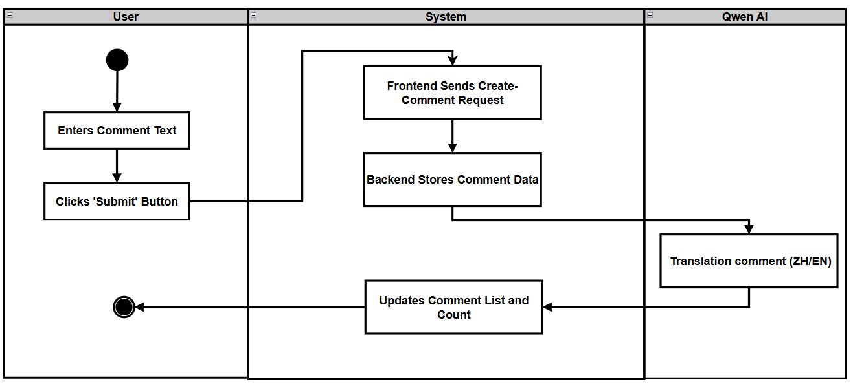

2.2.3.8 UCD-14 Search Posts
URS-14: The User can search posts by keyword across bilingual content (titles and body texts in both Chinese and English), and view posts ordered from newest to oldest.
SRS-091: System shall trim keyword, resets page to 1, and requests search results (keyword + tag filter).
SRS-092: Backend shall perform keyword-based matching using on bilingual titles/bodies and returns results ordered by from newest to oldest.
SRS-093: System shall render results list and pagination; keyword remains in search box.

Use Case ID | UC-14
Use Case Name | Search Posts
Actors | User
Description | User searches posts by keyword across bilingual content.
Trigger | User submits keyword in search box.
Preconditions | User is on UI-Community Page.
Use Case Input Specification
Input | type | Constraint |  | Example
Keyword | String | Not empty after trimming |  | "housing"
Post conditions | Feed shows search result posts ordered by relevance score (highest match score first, or empty-state)
Normal Flows | User |  | System
 | 1. User enters keyword and triggers search (Enter/Search).  4. User browses results. |  | 2. System trims keyword, resets page to 1, and requests search results (keyword + tag filter).  [E1: Network timeout or connection error]  3. Backend performs keyword-based matching using on bilingual titles/bodies and returns results ordered by from newest to oldest.  [A1: No results]  5. System renders results list and pagination; keyword remains in search box.
Alternative Flow | A1: No results  A1.1 Backend returns empty list.  A1.2 System shows empty-state message and keeps search box visible.  A1.3 Use case end.
Exception Flow | E1: Network timeout or connection error  E1.1 Search request fails due to network issues.  E1.2 System shows error and retry action; keyword remains.  E1.3 Use case end.
Assumption | The user has an internet connection .

AD-14:
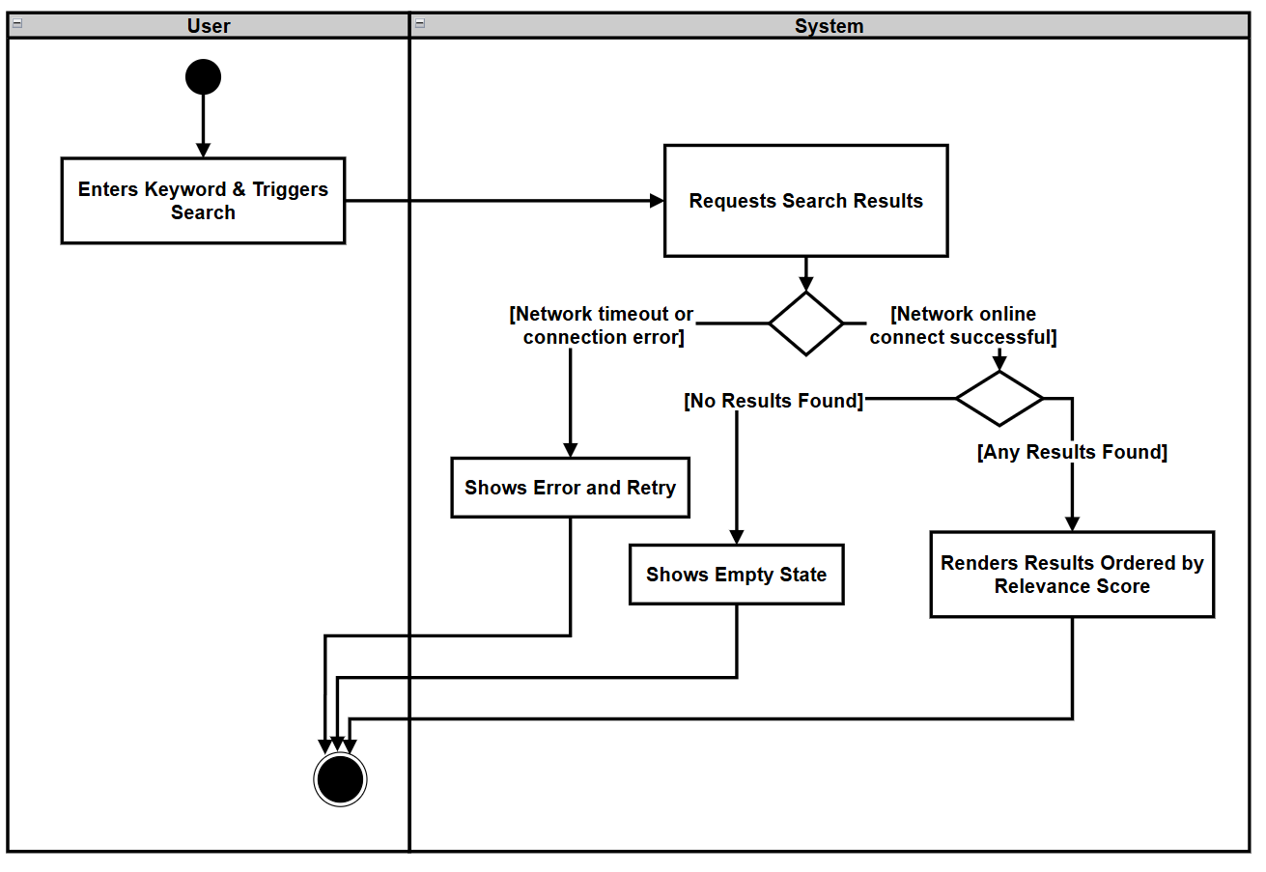

2.2.3.11 UCD-15 AI Summary Comment
URS-15: The User can view AI-generated summaries of all comments under a post in their chosen language.
SRS-094: System shall show the comment list and a "Summarize Comments" action.
SRS-095: Frontend shall send HTTP request to backend comment summary API with Post ID and `lang`
SRS-096: Backend shall collect comments of the post and invokes Qwen AI summarization.
SRS-097: Backend shall return summary text.
SRS-098: Frontend shall render the summary in the UI and marks it as AI-generated.

Use Case ID | UC-15
Use Case Name | AI Summary Comment
Actors | User
Description | User requests an AI-generated summary of all comments under a post and views the summary in their current interface language.
Trigger | User clicks the "Summarize Comments" action on the Post Detail page.
Preconditions | 1. User is viewing a Post Detail page.  2. Post data is loaded successfully.  3. There is at least one comment under the post  4. User has an active internet connection
Use Case Input Specification
Input | type | Constraint |  |  | Example
- | - | - |  |  | -
Post conditions | A comment summary is displayed on the Post Detail page in the user's selected language.
Normal Flows | User |  | System
 | 1. User opens the Post Detail page and scrolls to the comments section.  3. User clicks "Summarize Comments".  8. User views the summary. |  | 2. System shows the comment list and a "Summarize Comments" action.  4.Frontend sends HTTP request to backend comment summary API with Post ID and `lang`  [E1: Network timeout or connection error]  5. Backend collects comments of the post and invokes Qwen AI summarization.  7. Backend returns summary text.  9. Frontend renders the summary in the UI and marks it as AI-generated. | 6.summarize all the reviews
Alternative Flow | A1: No comments to summarize  A1.1 System detects comment count is 0.  A1.2 System disables the "Summarize Comments" action or shows message "No comments to summarize"  A1.3 Use case end.
Exception Flow | E1: Network timeout or connection error  E1.1 Request times out or fails due to network issues.  E1.2 Frontend displays a localized error message and provides a retry action.  E1.3 Use case end.
Assumption | The user has an internet connection .

AD-15:
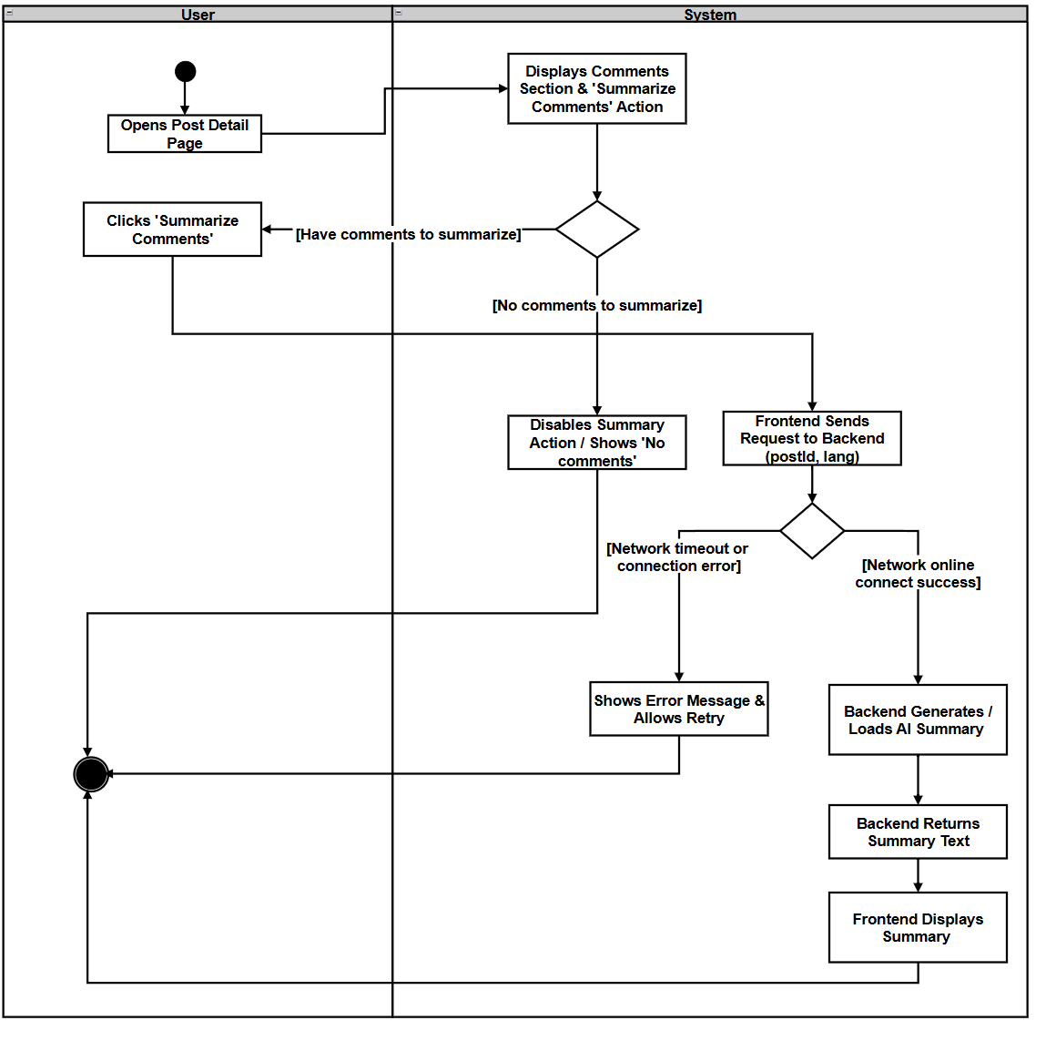

2.3.3.1 UCD-16: Manage private messages with other users
URS-16: Users can search other users by username (or partial username) to quickly start a private conversation with them. Users can send and receive private messages, view message history, and manage conversations under the following rules:
- When the current user only follows another user one-way, they may start a conversation and send at most one initial private message.
- When the users mutually follow each other (Friends), they may exchange multiple private messages as an ongoing conversation without limit.
- Users who do not follow the other user at all cannot start a private conversation.
SRS-099: System shall display the private messages page, including a search box “Search users by username…”.
SRS-100: Frontend shall send a search request (GET/api/users/search?username=...) to the backend.
SRS-101: Backend shall search users whose username matches the query and returns a list of candidate users (e.g., username, display name, avatar, online status).
SRS-102: Frontend shall take the selected user’s userId and proceeds with the “Open chat & load history” flow.
SRS-103: Frontend shall send a request to create or get a conversation (POST /api/messages/conversations with userId).
SRS-104: Backend shall check the follow relationship between current user and target user:
a. If the current user does not follow the target user, reject the request
b. If the current user follows the target user (one-way or mutual), find or create a Conversation and return its conversationId and isMutualFollow flag.
SRS-105: Frontend shall request message history for this conversation (GET /api/messages/conversations/{conversationId}).
SRS-106: Backend shall return ordered message history together with flags isMutualFollow and canSendMore
SRS-107: System shall render the chat UI, including message list, target user info, and current sending status based on isMutualFollow / canSendMore.
SRS-108: Frontend shall validate that message content is not empty after trimming, and checks that local canSendMore is true. If valid, it sends POST /api/messages/conversations/{conversationId}/messages with content.
SRS-109: Backend shall processe the send request:
a. If the users are not mutual follows and the current user has already sent one message in this conversation, reject the request
b. Otherwise, persist the message and update conversation state.
SRS-110: System shall append the new message to the conversation and returns success with updated canSendMore, and the frontend updates send button availability and helper text accordingly.

Use Case ID | UC-16
Use Case Name | Manage private messages with other users
Actors | User
Description | Mutually-following users start a chat, view history, and send messages.
Trigger | User opens a chat with another user.
Preconditions | 1. Users are mutually following.  2. User is logged in.
Use Case Input Specification
Input | type | Constraint |  | Example
Message Content | String | Not empty after trimming |  | “Hi!”
Post conditions | User can view message history and newly sent messages appear in the conversation.
Normal Flows | User |  | System
 | - User opens the Private Messages screen.  - User enters a (partial) username in the search box.  5.User reviews the returned list of matching users.  7.User clicks a target user in the search result list to start a chat.  9.User opens a chat with another user (either from an existing conversation list item or from the search result in step 7).  14.User sees the conversation view with historical messages (or an empty state if no history).  16.User types a message in the input box.  17.User clicks “Send Message”.  19.User sees the new message appear in the chat window. |  | 2. System displays the private messages page, including a search box “Search users by username…”.  4. Frontend sends a search request (GET/api/users/search?username=...) to the backend.  6. Backend searches users whose username matches the query and returns a list of candidate users (e.g., username, display name, avatar, online status).  8.Frontend takes the selected user’s userId and proceeds with the “Open chat & load history” flow.  10.Frontend sends a request to create or get a conversation (POST /api/messages/conversations with userId).  11.Backend checks the follow relationship between current user and target user:  a. If the current user does not follow the target user, reject the request  [E1: Not following]  b. If the current user follows the target user (one-way or mutual), find or create a Conversation and return its conversationId and isMutualFollow flag.  12. Frontend requests message history for this conversation (GET /api/messages/conversations/{conversationId}).  13. Backend returns ordered message history together with flags isMutualFollow and canSendMore  [A1: No message history may apply]  15. System renders the chat UI, including message list, target user info, and current sending status based on isMutualFollow / canSendMore.  18. Frontend validates that message content is not empty after trimming, and checks that local canSendMore is true. If valid, it sends POST /api/messages/conversations/{conversationId}/messages with content.  20. Backend processes the send request:  a. If the users are not mutual follows and the current user has already sent one message in this conversation, reject the request  [E2: Single-message limit reached]  b. Otherwise, persist the message and update conversation state.  21. System appends the new message to the conversation and returns success with updated canSendMore, and the frontend updates send button availability and helper text accordingly.
Alternative Flow | A1: No message history  A1.1 Backend returns empty history for a new conversation.  A1.2 System displays an empty chat state (“No messages yet”).  A1.3 Use case continues; the user can still send the first message, subject to follow and single-message rules.
Exception Flow | E1: Not following  E1.1 Backend detects current user does not follow the target user when creating/opening conversation.  E1.2 Backend rejects the request and returns an error such as "You must follow this user to start a conversation".  E1.3 System shows a user-friendly message and does not open the chat.  E2: Single-message limit reached  E2.1 Backend detects users are not mutual follows and the current user has already sent one message in this conversation.  E2.2 Backend rejects the send request and returns an error such as "You can only send one message until the other user follows you back" (code: SINGLE_MESSAGE_LIMIT).  E2.3 System shows a user-friendly message and disables further sending until mutual follow is established.
Assumption | The user has an internet connection .
AD-16:
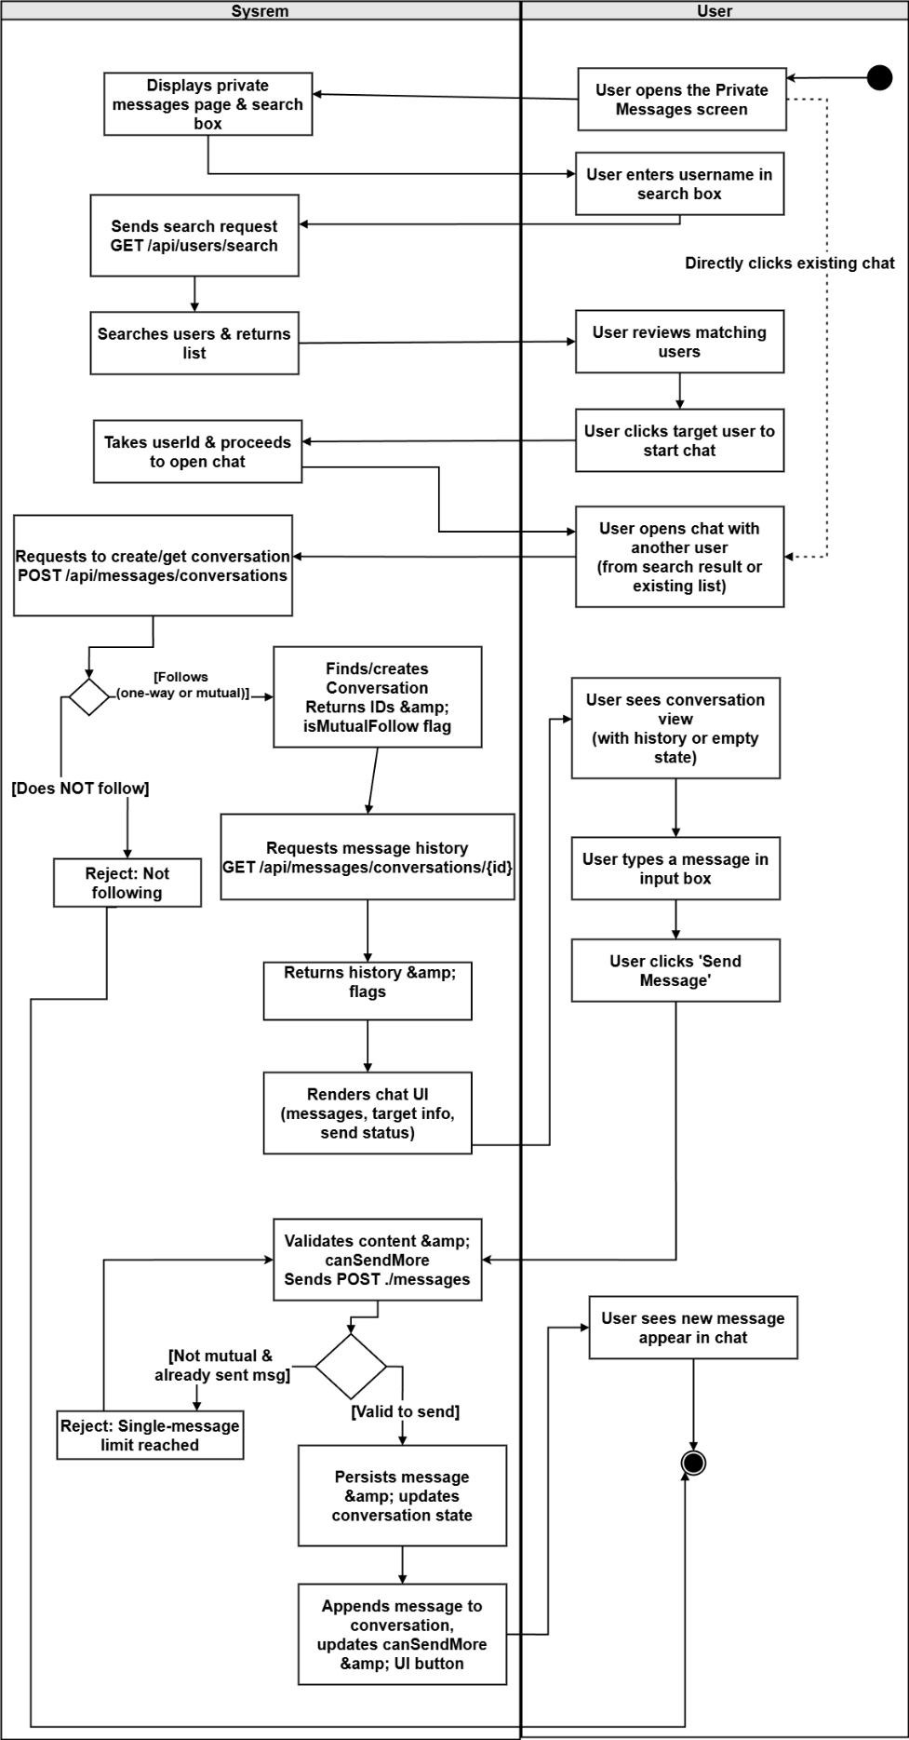

2.3.3.2 UCD-17:Manage Message Status
URS-17: Users can automatically mark messages as read by opening a session, and users can delete message records on their side as needed (effective only for the current user, not affecting the messages seen by the other party)
SRS-111: System shall mark incoming messages as read and updates unread indicators.
SRS-112: System shall ask for confirmation (optional) and, if confirmed, sends delete request.
SRS-113: Backend shall soft-deletes the message for the user and returns success.
SRS-114: System shall remove deleted message from view and refreshes status badges.
Use Case ID | UC-17
Use Case Name | Manage Message Status
Actors | User
Description | User marks messages as read and deletes messages for themselves.
Trigger | User opens a conversation or uses delete action on a message.
Preconditions | 1. User is logged in.  2. Conversation exists.
Use Case Input Specification
Input | type | Constraint |  | Example
- | - | - |  | -
Post conditions | Messages are marked read when appropriate; deleted messages are removed from the user's view; unread indicators update accordingly.
Normal Flows | User |  | System
 | - User opens a conversation.  3. User clicks delete on a message.  6. User continues chatting. |  | 2. System marks incoming messages as read and updates unread indicators.  4. System asks for confirmation (optional) and, if confirmed, sends delete request.  [A1: User don’t delete a Message ]  5. Backend soft-deletes the message for the user and returns success.  [E1: Network/server error]  7. System removes deleted message from view and refreshes status badges.
Alternative Flow | A1: User don’t delete a Message  A1.1 User cancels delete confirmation.  A1.2 System keeps the message visible and does not send request.  A1.3 Use case end.
Exception Flow | E1: Network/server error  E1.1 Delete/status update request fails due to network issues or backend returns 5xx(Server Error).  E1.2 System shows error message and keeps UI unchanged.  E1.3 Use case end.
Assumption | The user has an internet connection .
AD-17:
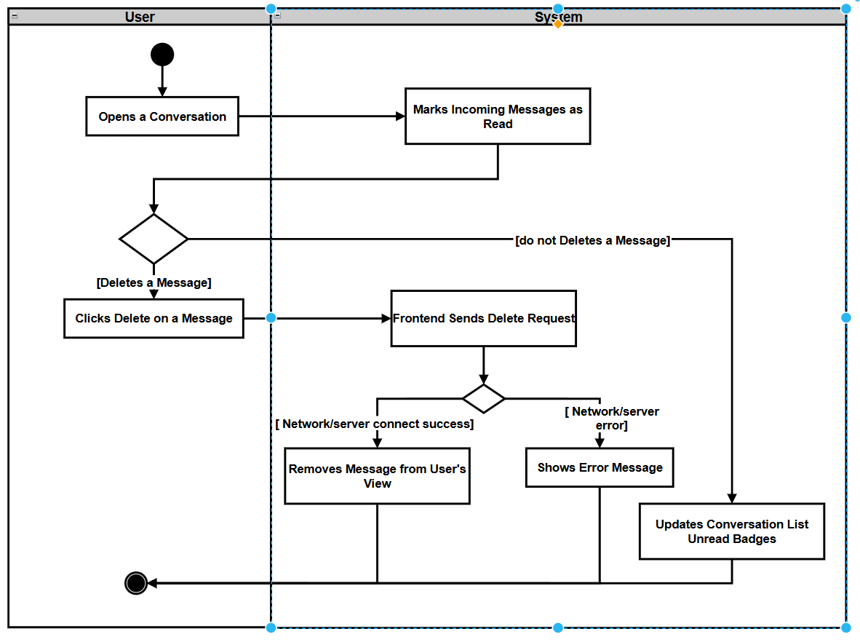

2.3 Feature 3

2.3.1 Use Case Diagram
This use case diagram covers user account and personal-center functions. The primary actor is the User, who can register an account (UC-19), with two alternative registration paths: register with phone number (UC-19.1) which relies on an external SMS service for verification, and register with email (UC-19.2) which relies on an external Email service. After registration, the user can log in (UC-20) and log out (UC-21), edit their profile (UC-22), view their friends/followers list (UC-18), view their own community posts (UC-23), and view their submitted reports (UC-24). Additionally, the user can use the Forgot password (UC-25) function, which extends the Log In (UC-20) use case. This recovery process branches into two specific methods: SMS-based Password Reset (UC-25.1), which interacts with the external SMS service, and Email-based Password Reset (UC-25.2), which interacts with the external Email service.
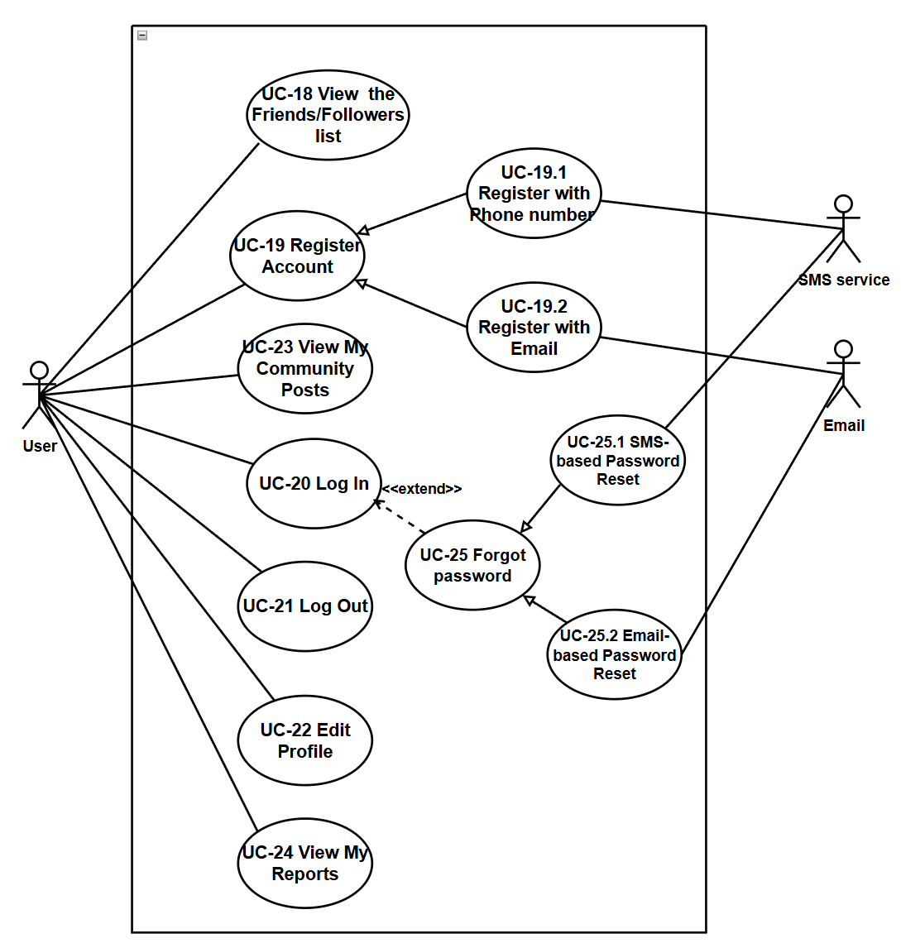

2.3.2 User Requirement Specification
URS-18 - View the Friends/Followers list：The User can view lists of mutual Friends and Followers, and navigate to their profiles. The User can view a Friends list that shows only users who have a mutual follow relationship with the User (both sides follow each other), and a Followers list that shows users who follow the User. From either list, the User can click a user’s avatar to open that user’s profile page.
URS-19 - Register Account: The User can register a new account using email or phone number with verification codes.
URS‑20 – Log In: The User can log in using username/email/phone number and password, receiving a JWT token for authentication.
URS‑21 – Log Out: The User can log out to end the current session and clear authentication tokens.
URS‑22 – Edit Profile: The User can view and update their profile information including display name, avatar, and preferred language.
URS‑23 – View My Community Posts : The User can view all their own community posts with moderation status (pending, approved, rejected).The User can delete his post
URS-24 – View My Report: The User can view all reports they have submitted from their profile page, including report status (PENDING, REVIEWED, RESOLVED, DISMISSED), target type (POST or COMMENT), reasons, description, review notes from administrators, AI-derived review information (such as confidence score and violation snippets), and timestamps.
URS-25-Forget Password: Users can securely reset their account password if they forget it, using either their registered email address or bound mobile phone number.

2.3.3 Use Case Description and Activity Diagram

2.3.3.1 UCD-18 View the Friends/Followers list
URS-18：The User can view lists of mutual Friends and Followers, and navigate to their profiles.The User can view a Friends list that shows only users who have a mutual follow relationship with the User (both sides follow each other), and a Followers list that shows users who follow the User. From either list, the User can click a user’s avatar to open that user’s profile page.
SRS-115: System shall display profile information and action buttons including " Followers" and "Friends".
SRS-116: System shall open the corresponding list modal and sends request to the appropriate endpoint
SRS-117: Backend shall return the corresponding user list.
SRS-118: System shall close the modal and navigates to the selected user's profile page.

Use Case ID | UC-18
Use Case Name | View Followers/Friends List
Actors | User
Description | The User can view lists of mutual Friends and Followers, and navigate to their profiles.The User can view a Friends list that shows only users who have a mutual follow relationship with the User (both sides follow each other), and a Followers list that shows users who follow the User. From either list, the User can click a user’s avatar to open that user’s profile page.
Trigger | User clicks the Followers count or Friends (mutual follows) count on a profile page.
Preconditions | User is logged in.
Use Case Input Specification
Input | type | Constraint |  | Example
Post conditions | The selected list (Followers or Friends) is displayed  When the user selects a listed user, the system navigates to that user's profile page.
Normal Flows | User |  | System
 | 1.User opens profile page (own or another user's).  3. User clicks Followers count or Friends (mutual follows) count.  6. User clicks a listed user's avatar. |  | 2. System displays profile information and action buttons including " Followers" and "Friends".  4. System opens the corresponding list modal and sends request to the appropriate endpoint  5. Backend returns the corresponding user list.  [A1: No users in list]  7.System closes the modal and navigates to the selected user's profile page.
Alternative Flow | A1: No users in list  A1.1 Backend returns an empty list.  A1.2 System displays an empty state message: "No users".  A1.3 Use case end.
Exception Flow
Assumption | The user has an internet connection .
AD-18
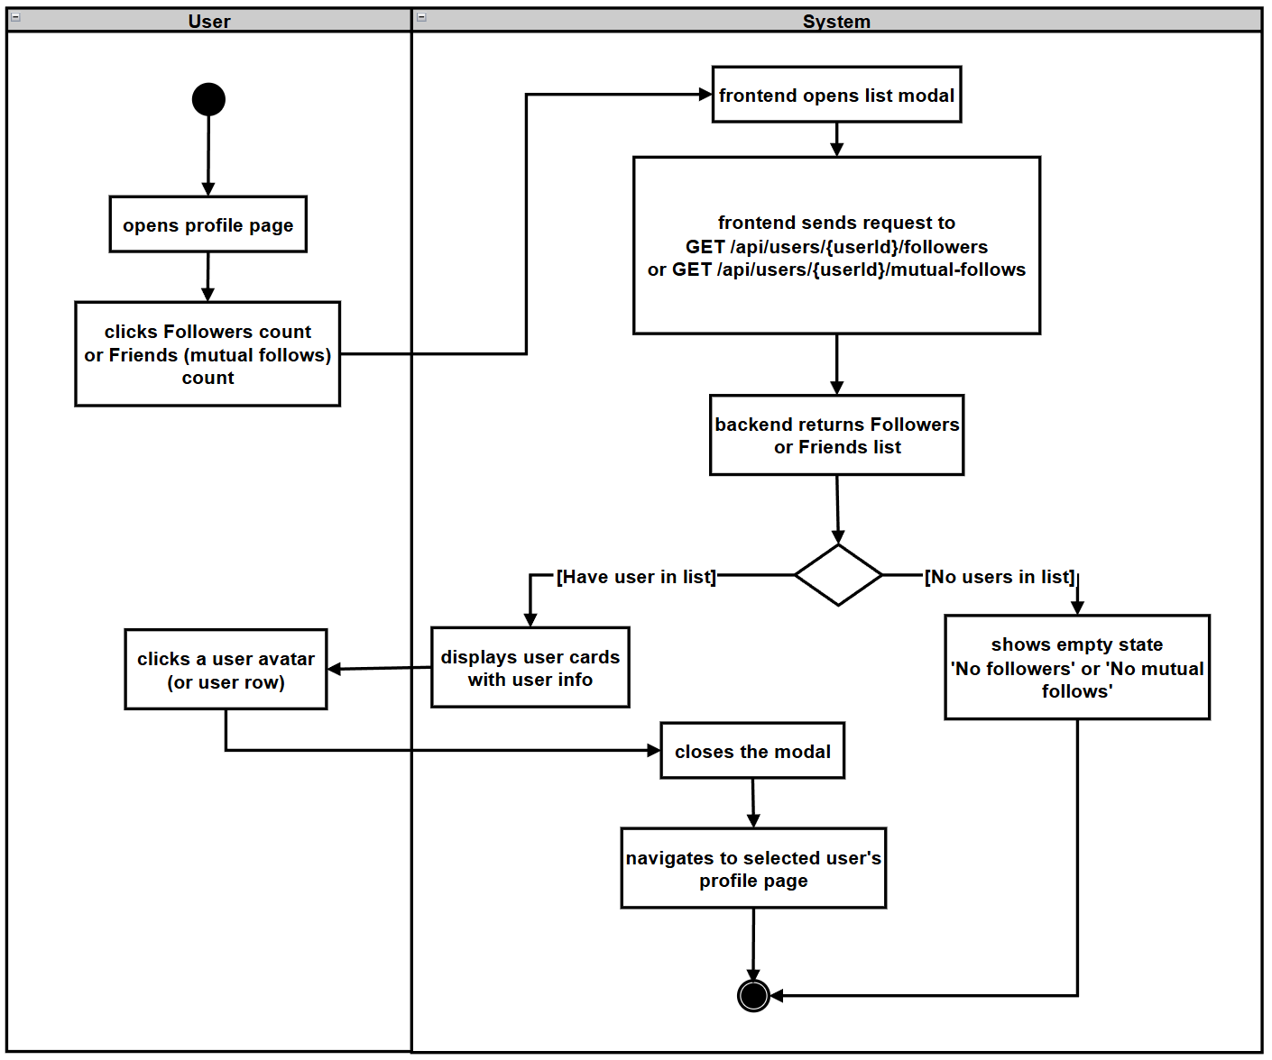

2.3.3.2UCD-19: Register Account
URS-19: The User can register a new account using email or phone number with verification codes.
SRS-119: System shall display registration form with phone-related fields.
SRS-120: System shall validate phone format and calls Firebase (SMS service) from frontend to send a 6-digit SMS verification code to the phone.
SRS-121: System shall display success message: "Verification code sent".
SRS-122: System shall validate the code format (6 digits).
SRS-123: System shall use Firebase (client-side) to verify the SMS code with the SMS service; on success, Firebase marks the SMS session as verified.
SRS-124: System shall display success message: "Verification successful" and enables the registration form fields.
SRS-125: System shall validate form fields.
SRS-126: System shall send registration request to backend via `POST /api/auth/register/phone` with phone, username, password, and preferred language (without the SMS code).
SRS-127: Backend shall check for duplicate phone/username, creates user account with hashed password based on the phone number, and returns success (assuming SMS verification has been handled on the client side, or at least the code was sent).
SRS-128: System shall display registration form with email-related fields.
SRS-129: System shall validate email format
SRS-130: System shall check if email is already registered.
SRS-131: System shall call POST /api/auth/send-verification-code.
SRS-132: System shall send /api/auth/verify-code to backend and validates code.
SRS-133: System shall validate form fields (Pwd, Username).
SRS-134: System shall sends POST /api/auth/register to backend.
SRS-135: System shall backend checks for duplicate username.

Use Case ID | UC-19.1
Use Case Name | Register with Phone number
Actors | User
Description | User registers a new account using a phone number. Phone registration uses SMS verification via Firebase (as SMS service). The UI requires that the SMS verification code must be verified before allowing registration
Trigger | User clicks "Register" or navigates to the registration page.
Preconditions | 1. User is not logged in.  2. User has access to their phone number for verification code.  3. Network connection is available.
Use Case Input Specification
Input | type | Constraint |  |  | Example
Phone | number | Valid phone number |  |  | 123456
Verification Code | String | 6-digit numeric code required (Firebase SMS) |  |  | “123456”
Username | String | Unique, alphanumeric, not empty |  |  | "john_doe"
Password | String | Must contain both uppercase and lowercase letters |  |  | "Password123"
Post conditions | A new user account is created in the system.  User is logged in automatically (or redirected to login page).
Normal Flows | User |  | System | SMS service
 | 1. User opens registration page and selects “phone” as registration method.  3. User enters phone number and clicks "Send Verification Code".  7. User receives SMS code and enters it in the form.  9. User clicks "Verify Code".  13. User fills in username, password, display name, and selects preferred language.  15. User clicks "Register". |  | 2. System displays registration form with phone-related fields.  4. System validates phone format and calls Firebase (SMS service) from frontend to send a 6-digit SMS verification code to the phone.  [E1: Invalid phone format]  6. System displays success message: "Verification code sent".  8. System validates the code format (6 digits).  10. System uses Firebase (client-side) to verify the SMS code with the SMS service; on success, Firebase marks the SMS session as verified.  [A1: Invalid or expired code]  12. System displays success message: "Verification successful" and enables the registration form fields.  14. System validates form fields.  [A2: Validation failed]  16. System sends registration request to backend via `POST /api/auth/register/phone` with phone, username, password, and preferred language (without the SMS code).  17. Backend checks for duplicate phone/username, creates user account with hashed password based on the phone number, and returns success (assuming SMS verification has been handled on the client side, or at least the code was sent).  [E2: Duplicate username/email/phone]  18. System automatically logs in. | 5. SMS service sends SMS with 6-digit verification code to the user's phone.  11. SMS service responds with verification success/failure.
Alternative Flow | A1: Invalid or expired code  A1.1 Firebase (SMS service) returns an error: code is invalid, expired, or already used.  A1.2 System displays error message: "Invalid or expired verification code"  A1.3 User can request a new code and retry. Registration cannot proceed until verification is successful.  A2: Validation failed  A2.1 System validates form fields and detects errors (e.g., password doesn't contain uppercase/lowercase, username already taken on frontend check).  A2.2 System displays validation errors next to relevant fields.  A2.3 User corrects errors and resubmits.
Exception Flow | E1: Invalid phone format  E1.1 System detects invalid phone number format.  E1.2 System displays error message: "Invalid phone format".  E1.3 User corrects phone and retries.  E2: Duplicate username/email/phone  E2.1 Backend detects that username, email, or phone number already exists.  E2.2 Backend returns error with specific field information.  E2.3 System displays error message: "Username/Email/Phone already registered".  E2.4 User chooses a different username/phone and retries.  E3: Incorrect password format  E3.1:Backeend detects that password format is incorrect  E3.2:Fills details again
Assumption | The user has an internet connection .

Use Case ID | UC-19.2
Use Case Name | Register with Email
Actors | User
Description | User registers a new account using email with verification code validation.
Trigger | User clicks "Register" or navigates to the registration page.
Preconditions | 1. User is not logged in.  2. User has access to their email for verification code.  3. Network connection is available.
Use Case Input Specification
Input | type | Constraint |  |  | Example
Email/Phone | String | Valid email format or phone number |  |  | "user@example.com"
Verification Code | String | 6-digit numeric code |  |  | “123456”
Username | String | Unique, alphanumeric, not empty |  |  | "john_doe"
Password | String | Must contain both uppercase and lowercase letters |  |  | "Password123"
Post conditions | A new user account is created in the system.  User is logged in automatically (or redirected to login page).
Normal Flows | User |  | System | Email service
 | 1. User opens registration page and selects “email” as registration method.  3. User enters email and clicks "Send Verification Code".  8. Receives email & enters 6-digit code. Clicks 'Verify Code'.  10. Fills details (Username, Pwd, Name, Lang) & clicks 'Register'. |  | - System displays registration form with email-related fields.  4. System validates email format  [E1: Invalid format]  5. Checks if email is already registered.  [E2: Duplicate email found]  6. Calls POST /api/auth/send-verification-code.  9. Sends /api/auth/verify-code to backend and validates code.  [A1: Invalid code]  11. Validates form fields (Pwd, Username).  [A2: Validation failed]  12. Sends POST /api/auth/register to backend.  13. Backend checks for duplicate username.  [E3: Duplicate username found]  14. Creates account & returns success.  15. Auto login. | 7. Delivers verification email with 6-digit code.
Alternative Flow | A1: Invalid code  A1.1 Backend returns error: code is invalid or expired.  A1.2 System displays error message: "Invalid code".  A1.3 User re-enters the code or requests a new one.  A2: Validation failed  A2.1 System validates form fields and detects errors (The password must contain both uppercase and lowercase letters, and it must be at least 6 characters long,username format).  A2.2 System displays validation errors next to the relevant fields.  A2.3 User corrects the errors and resubmits.
Exception Flow | E1: Invalid email format  E1.1 System detects invalid email format.  E1.2 System displays error message: "Invalid email format".  E1.3 User corrects the email address and retries.  E2: Duplicate email found  E2.1 System detects that the email address already exists in the database.  E2.2 System displays error message: "Already registered"  E2.3 User chooses a different email or proceeds to login.  E3: Duplicate username found  E3.1 Backend detects that the chosen username already exists.  E3.2 System displays error message: "Already registered"E3.3 User chooses a different username and retries.
Assumption | The user has an internet connection .

AD-19:
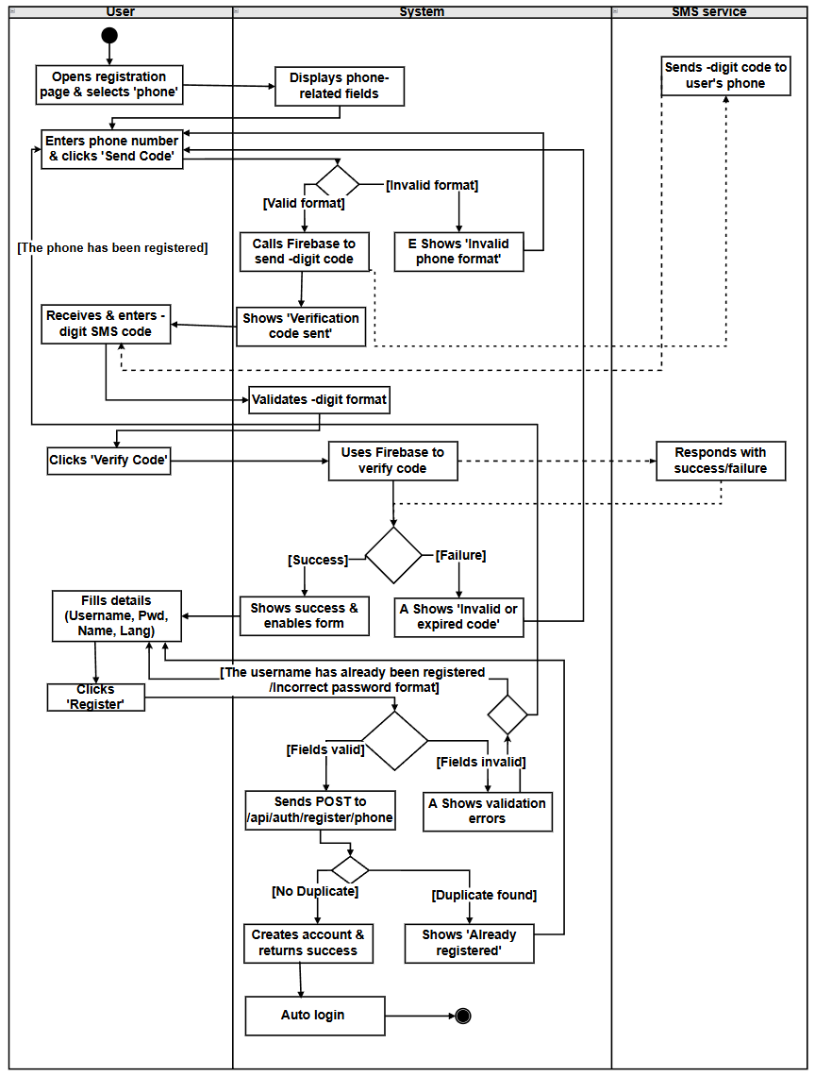

AD-20:
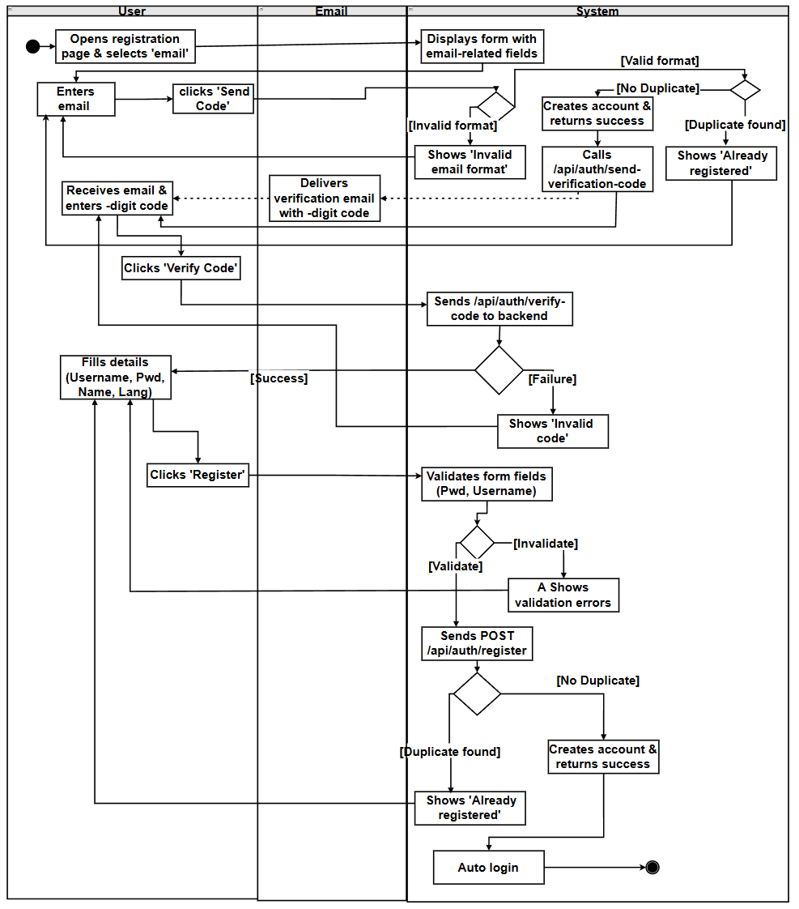

2.2.3.3 UCD-20: Log In
URS-20: The User can log in using username/email/phone number and password, receiving a JWT token for authentication.
SRS-136:
SRS-137:
SRS-138:
SRS-139:
SRS-140:
SRS-141:
SRS-142:
SRS-143:
SRS-144:
SRS-145:
SRS-146:
SRS-147:
SRS-148:
SRS-149:

Use Case ID | UC-20
Use Case Name | Log In
Actors | User
Description | User logs in using username/email/phone number and password, receiving a JWT token for authenticated access.
Trigger | User clicks "Log In" or navigates to the login page.
Preconditions | Network connection is available.
Use Case Input Specification
Input | type | Constraint |  | Example
Username/Email/phone number | String | Valid username or email address or phone number. |  | "john_doe" or user@example.com or +660951747068
Password | String | The password must contain both uppercase and lowercase letters, and it must be at least 6 characters long. |  | "Password123"
Post conditions | User is authenticated and receives a JWT token.  User is redirected to the main application.  JWT token is stored for subsequent API requests.
Normal Flows | User |  | System
 | 1. User opens login page.  3. User enters login identifier (username / email / phone number) and password.  5. User clicks "Log In".  9. User views main application. |  | 2. System displays login form with login identifier (username / email / phone number) and password fields, and a "Forgot Password" link.  4.System validates form fields (not empty).  [A1: Validation failed]  [A2: User clicks "Forgot Password"]  6. System sends login request to backend with credentials.  [E1: Network timeout or connection error]  7. Backend authenticates credentials and generates JWT token.  [E2: Invalid credentials]  8. Backend returns 200 OK with JWT token and user information.  10. System stores JWT token, updates user state, and redirects to main application .
Alternative Flow | A1: Validation failed  A1.1 System detects empty login identifier (username / email / phone number) or password fields.  A1.2 System displays validation error: " Please fill in all required fields "  A1.3 User fills in missing fields and retries.  A2: User clicks "Forgot Password"  A2.1 User clicks "Forgot Password" link on the login page.  A2.2 System navigates to the password reset page (UI-ForgotPassword) and starts the password reset use case (UC-25).  A2.3 After the password reset succeeds, the system redirects the user back to the login page.  A3: Password validation failed  A3.1 System detects password does not meet requirements (must contain uppercase and lowercase) or passwords do not match.  A3.2 System displays validation error: " Incorrect username or password“.  A3.3 User corrects password and resubmits the password reset form.
Exception Flow | E1: Network timeout or connection error  E1.1 Login request fails due to network issues.  E1.2 System displays a localized error message and allows retry.  E1.3 Use case end.  E2: Invalid credentials  E2.1 Backend returns 401 Unauthorized: username / email / phone number or password is incorrect.  E2.2 System displays error message: " Incorrect username email, phone number or password”.  E2.3 User can retry with correct credentials or use "Forgot Password" link.
Assumption | The user has an internet connection .
AD-21:
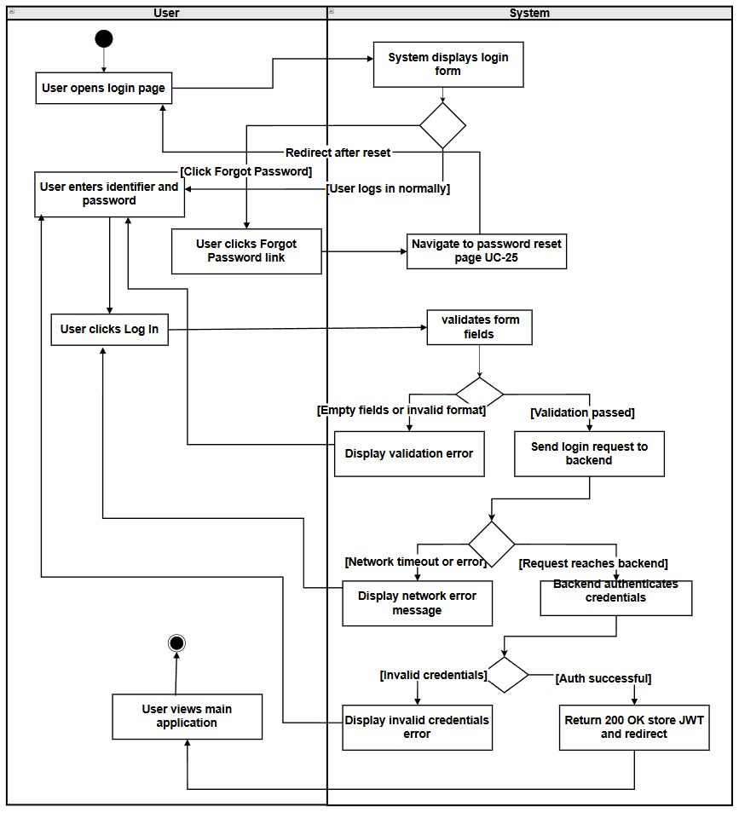

2.2.3.4 UCD-21: Log Out
URS-21: The User can log out to end the current session and clear authentication tokens.
SRS-92: The system shall provide a "Log Out" action (button or menu item) accessible from the user profile menu or navigation bar.
SRS-93: When the user clicks "Log Out", the system shall clear the stored JWT token and user session data.
SRS-94: The system shall redirect the user to the login page or home page (if public access is allowed).
SRS-95: After logout, all subsequent API requests that require authentication shall fail with 401 Unauthorized, and the system shall redirect to login if needed.
Use Case ID | UC-21
Use Case Name | Log Out
Actors | User
Description | User logs out to end the current session and clear authentication tokens.
Trigger | User clicks "Log Out" button or menu item.
Preconditions | 1. User is logged in (has valid JWT token).  2. User is viewing the application.
Use Case Input Specification
Input | type | Constraint |  | Example
None | - | - |  | -
Post conditions | User session is ended.  JWT token is cleared from client storage.  User is redirected to login page or home page.  User cannot access authenticated features until logging in again.
Normal Flows | User |  | System
 | 1. User clicks "Log Out" button or menu item.  7. User views login page. |  | 2. System immediately proceeds with logout.  3. System clears JWT token from localStorage/sessionStorage.  4. System clears user state and session data.  5.System ends session locally without backend request (stateless JWT).  6. System redirects user to login page.
Alternative Flow
Exception Flow
Assumption | The user has an internet connection .

AD-22:
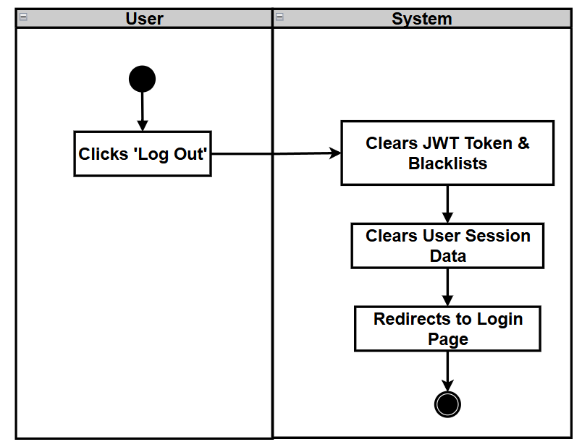

2.2.3.5 UCD-22: View/Edit Profile
URS-22: The User can view and update their profile information including display name, avatar, and preferred language.
SRS-96: The system shall provide a profile page (UI-Profile) accessible from the user menu or navigation, showing current user information: username, display name, avatar, email, preferred language, and account creation date.
SRS-97: The system shall load current user profile via GET /api/users/me (requires authentication via JWT token provided in the Authorization: Bearer <token> header).
SRS-98: The system shall provide an "Edit Profile" action that allows users to update:
- Display name:
- Optional.
- Must consist only of English alphabet characters (A–Z, a–z) after trimming (no digits, spaces, or symbols).
- Avatar:
- Optional image upload.
- Acceptable formats: JPEG, PNG, GIF, WebP.
- Maximum file size: 5 MB.
- Preferred language:
- Required.
- Must be "zh" (Chinese) or "en" (English).
When the display name is changed and is non-empty after trimming, the system shall treat this new display name as the candidate username/login name (subject to backend validation and uniqueness), and shall mark that a username change has occurred for subsequent logout behavior.
SRS-99: The system shall support avatar image upload via POST /api/users/me/avatar (accepts image files: JPEG, PNG, GIF, WebP, with maximum size 5 MB) and returns the avatar URL. If the avatar upload fails, the profile update operation shall be aborted and an error message shall be shown to the User.
SRS-100: The system shall update profile information via PUT /api/users/me with updated fields (displayName, avatar URL as avatar, and preferredLanguage).When the request contains a non-blank displayName, the backend shall also update the username field to the trimmed displayName so that the new name becomes the login username.Before updating the username, the backend shall verify that no other user is using the same username; if a duplicate is found, it shall reject the update and return an appropriate error (e.g., “Username already taken” / “用户名已被使用”), and the frontend shall display a localized error message while keeping the user on the edit form.
SRS-101: Upon successful update, the system shall:
- Refresh the profile display with the updated user information.
- Update the user state throughout the application (including cached user data in local storage).
- If the display name has been changed (and thus the login username), the system shall clear the current authentication state and force the User to log in again using the new username.
SRS-102: If the preferred language is changed, the system shall immediately update the interface language to the new preferred language, persist the preference, and notify other UI components via an application-wide language change event so that all relevant content is re-rendered in the selected language.
SRS-103: If profile update fails (network/server error, validation error, or username conflict), the system shall display a localized error message and allow retry without leaving the edit form. Validation errors (e.g., invalid display name format, invalid avatar type/size, invalid language value) shall be indicated next to the relevant fields where possible, and the User shall be allowed to correct and resubmit.
Use Case ID | UC-22
Use Case Name | Edit Profile
Actors | User
Description | The User can view and update their profile information including display name, avatar, and preferred language.
Trigger | User opens profile page, clicks "Edit Profile".
Preconditions | User is logged in.
Use Case Input Specification
Input | type | Constraint |  | Example
Username | String | Optional, allows English characters |  | "John Doe"
Avatar Image | File | Optional, image file (JPEG, PNG, GIF, WebP), max size limit |  | image.jpg
Preferred Language | String | Must be "zh" or "en" |  | “en”
Post conditions | Profile information is updated in the system.  Updated profile is displayed to the user.  User state is updated throughout the application.  Interface language is updated if preferred language changed.
Normal Flows | User |  | System
 | 1. User opens profile page.  4. User views profile information.  6. User clicks "Edit Profile".  8. User updates display name, selects new avatar image (optional), or changes preferred language.  10. User clicks "Save".  14. User views updated profile. |  | 2. System sends request to `GET /api/users/me` with JWT token.  3. Backend returns user profile information.  5. System displays profile: username, display name, avatar, email, preferred language, account creation date, and user-related statistics  7. System displays edit form with current values pre-filled.  9. System validates inputs (display name format, image file type/size, language value).  [A1: Validation failed]  11. If avatar image is selected, system uploads image via `POST /api/users/me/avatar` and receives avatar URL.  [E3: Avatar upload failed]  12. System sends update request via `PUT /api/users/me` with updated fields.  [E1: Network timeout or connection error]  [E2: Unauthorized]  [E4: Server error]  [A2: Username conflict]  13. Backend updates user profile and returns updated user information.  [A3: Display name changed and update successful (forced re-login)]  15. System refreshes profile display, updates user state, and if preferred language changed, updates interface language immediately.
Alternative Flow | A1: Validation failed  A1.1 System detects invalid input (e.g., image file too large, invalid file type, display name contains invalid characters).  A1.2 System displays validation errors next to relevant fields.  A1.3 User corrects errors and resubmits.  A2: Username conflict  A2.1 While processing PUT /api/users/me, the backend detects that the new display name (used as username) already exists for another user.  A2.2 The backend rejects the update and returns an appropriate error code.  A2.3 The system displays a localized error message (e.g., “Username already taken” / “用户名已被使用”) and keeps the user on the edit form.  A2.4 The user chooses a different display name and retries, returning to step 10 of the normal flow.  A3: Display name changed and update successful (forced re-login)  A3.1 Backend successfully updates the profile and username based on the new display name.  A3.2 System refreshes the profile data in memory and local storage.A3.3 System detects that the display name (used as username) has changed compared to the previous value.  A3.4 System clears current authentication data (e.g., JWT token, stored user information, session flags).  A3.5 System displays a localized message indicating that the username has been updated and the user must log in again.  A3.6 System redirects or reloads to the login page, ending the current session.
Exception Flow | E1: Network timeout or connection error  E1.1 Request fails due to network issues.  E1.2 System displays a localized error message and allows retry.  E1.3 Use case end.  E2: Unauthorized  E2.1 JWT token is invalid or expired.  E2.2 System redirects user to login page.  E2.3 Use case end.  E3: Avatar upload failed  E3.1 Avatar upload request fails (network error, file too large, invalid format).  E3.2 System displays error message: "Avatar upload failed".  E3.3 User can retry upload or skip avatar update.  E4: Server error  E4.1 Backend returns 5xx (service error) error due to internal error.  E4.2 System displays error message and allows retry.  E4.3 Use case end.
Assumption | The user has an internet connection .

AD-23:
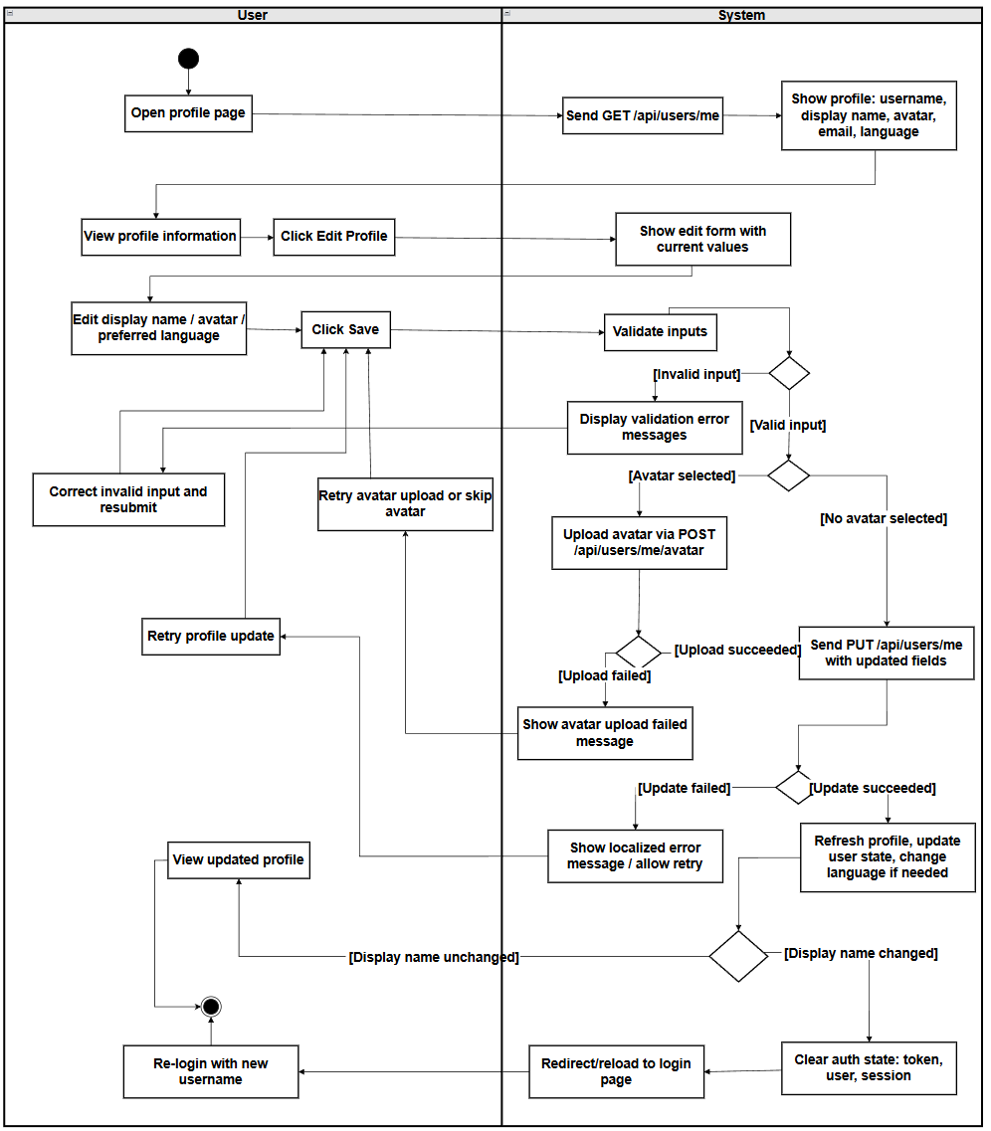

2.2.3.6 UCD-23: View My Community Posts
URS-23: The User can view all their own community posts with moderation status (pending, approved, rejected).The User can delete his post
SRS-104: The system shall provide a "View My Community Posts" button on the profile page (UI-Profile) that navigates to a dedicated posts list page (UI-MyPosts).
SRS-105: The system shall load the current user's posts via `GET /api/users/me/posts` (requires authentication), which returns all posts created by the current user including all moderation statuses:PENDING_REVIEW, APPROVED, and REJECTED.
SRS-106: UI-MyPosts shall display the user's posts ordered by creation time (newest first),showing at least: title, body preview, creation timestamp, moderation status badge (PENDING_REVIEW, APPROVED, REJECTED), and the review note if the post is rejected.(Additional fields such as like count and comment count may also be displayed.)
SRS-107: The system shall display posts with appropriate, localized status badges for easy identification.For the English UI, PENDING_REVIEW shall be shown as "Pending Review", APPROVED as "Published",and REJECTED as "Rejected". For the Chinese UI, they shall be shown as “待审核”、“已发布”、“已拒绝”.
SRS-108: If a post is rejected, the system shall display the review note (rejection reason) provided by administrators.
SRS-109: If the user has not created any posts, the system shall display a localized empty-state message indicating that the user has no posts (e.g., "You have not posted anything yet").
SRS-110: If the request to fetch posts fails (e.g., network or server error), the system shall display a localized error message and provide a retry action on UI-MyPosts.
SRS-111: On UI-MyPosts and the "My Posts" preview section of UI-Profile, the system shall provide a "Delete" button for each post owned by the current user.
SRS-112: When the user clicks the "Delete" button for a post, the system shall display a confirmation dialog asking the user to confirm the deletion (e.g., "Are you sure you want to delete this post?").
SRS-113: If the user confirms the deletion, the system shall send a `DELETE /api/posts/{postId}` request (requires authentication) for the selected post and, while the request is in progress, shall disable further delete actions for that post and indicate a "Deleting..." state.
SRS-114: If the delete request succeeds, the system shall remove the deleted post from the currently displayed list and show a localized success message. If the delete request fails, the system shall keep the post in the list and show a localized error message.

Use Case ID | UC-23
Use Case Name | View My Community Posts
Actors | User
Description | The User can view all their own community posts with moderation status (pending, approved, rejected).The User can delete his post
Trigger | User clicks "View My Community Posts" on the profile page.
Preconditions | User is logged in.
Use Case Input Specification
Input | type | Constraint |  | Example
Language | String | Optional, "zh" or "en" for content language |  | “en”
Post conditions | User views a list of all their submitted posts with complete details including moderation status and review notes.
Normal Flows | User |  | System
 | 1. User opens their profile page.  3. User clicks "View My Community Posts".  6. User views the posts list.  8. User can click on a post to view details or scroll through the list or click the "Delete" button on one of their posts.  10. User confirms deletion. |  | 2. System displays profile information and action buttons including "View My Community Posts".  4. Frontend navigates to the UI-MyPosts page and, using the authenticated session, sends a request GET /api/users/me/posts?lang={zh\|en} to load the current user's community posts.  [E1: Network timeout or connection error]  [E2: Unauthorized]  5. Backend, based on the currently logged-in user, retrieves all posts created by that user (including all statuses:PENDING_REVIEW, APPROVED, REJECTED) and returns the list ordered by creation time (newest first).  7. System displays posts ordered by creation time (newest first), showing:  - Title and body preview  - Creation timestamp  - Status badge (PENDING_REVIEW, APPROVED, REJECTED)  - Review note (if rejected)  -Additional fields such as like count and comment count may also be displayed.  [A1: No posts created]  9. If the user clicks "Delete", the system shows a confirmation dialog ("Are you sure you want to delete this post?").  11. System sends a request to delete the selected post and, if successful, removes the post from the list and shows a success message.  [E3: Delete failed]
Alternative Flow | A1: No posts created  A1.1 System detects that the user has not created any posts.  A1.2 System displays a localized empty state message indicating that the user has no posts.  A1.3 Use case end.
Exception Flow | E1: Network timeout or connection error  E1.1 Request to fetch posts fails due to network issues.  E1.2 System displays a localized error message and provides a retry action.  E1.3 Use case end.  E2: Unauthorized  E2.1 JWT token is invalid or expired.  E2.2 System displays a localized "unauthorized" message on UI-MyPosts and does not display any posts.  E2.3 Use case end.  E3: Delete failed  E3.1 Backend fails to delete the post (e.g., server error or permission issue).  E3.2 System shows an error message and keeps the post in the list.  E3.3 Use case continues with the posts list displayed.
Assumption | The user has an internet connection .
AD-24:
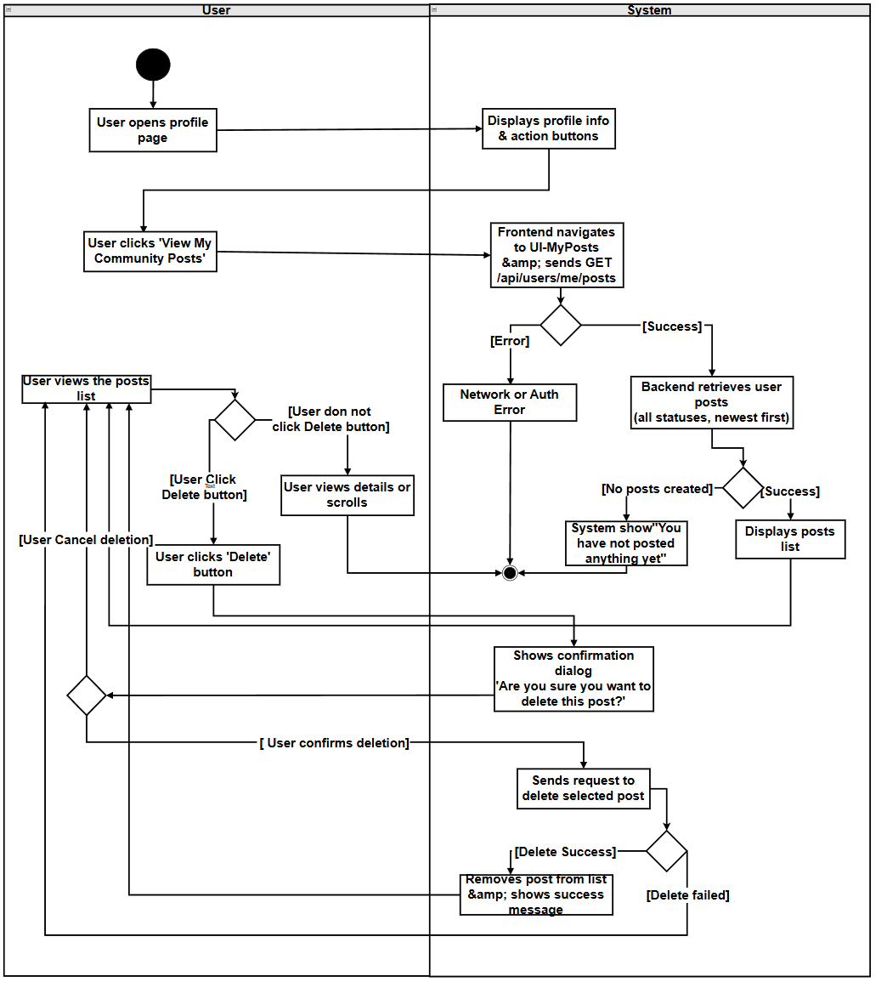

2.2.3.7 UCD-24: View My Reports
URS-24:The User can view all reports they have submitted from their profile page, including report status (PENDING, REVIEWED, RESOLVED, DISMISSED), target type (POST or COMMENT), reasons, description, review notes from administrators, AI-derived review information (such as confidence score and violation snippets), and timestamps.
SRS-115:The system shall provide a "View My Reports" button on the user profile page (UI-Profile) that, when clicked, navigates to a dedicated reports list page (UI-MyReports).
SRS-116：UI-MyReports shall display all reports submitted by the current user, as returned by the backend, ordered by creation time (newest first).For each report, UI-MyReports shall display at least the following information:
- Target type (POST/COMMENT) badge
- Reasons (list of selected reasons)
- Description (if provided)
- Status badge (PENDING, REVIEWED, RESOLVED, DISMISSED)
- Creation timestamp
- Review timestamp (if reviewed)
- Review notes (if available)
- AI information (if available), including:
- AI confidence score
- Violation snippet
SRS-117：The backend shall provide functionality to retrieve all reports submitted by the authenticated user, including all report details and status information (such as target type, target ID, reasons, description, status, creation timestamp, review timestamp, review notes, AI confidence score, and violation snippet), and shall return the list ordered by creation time (newest first).
SRS-118：The system shall display reports with appropriate status badges (PENDING, REVIEWED, RESOLVED, DISMISSED) and target type indicators (POST/COMMENT) for easy identification on UI-MyReports.
SRS-119：If the user has not submitted any reports, the system shall display a localized empty state message indicating that no reports have been submitted (e.g., “You have not submitted any reports yet.”).
SRS-120：If the request to fetch reports fails (due to network or server error), the system shall display a localized error message and provide a retry action (e.g., a “Retry” button) that triggers a new attempt to fetch the reports.

Use Case ID | UC-24
Use Case Name | View My Reports
Actors | User
Description | User views all reports they have submitted, including status, target type, reasons, description, review notes, and timestamps.
Trigger | User clicks "View My Reports" on the profile page.
Preconditions | 1. User is logged in.  2. User is viewing their profile page.
Use Case Input Specification
Input | type | Constraint |  | Example
None | - | - |  | -
Post conditions | User views a list of all their submitted reports with complete details including status and review information.
Normal Flows | User |  | System
 | 1. User opens their profile page.  3. User clicks "View My Reports".  6. User views the reports list.  8. User can scroll through the list and view details of each report. |  | 2. System displays profile information and action buttons including "View My Reports".  4. System navigates to UI-MyReports page and sends request to backend to retrieve current user's reports.  [E1: Network timeout or connection error]  5. Backend retrieves all reports submitted by the current user and returns report list  [E2: Server error]  7. System displays reports ordered by creation time (newest first), showing for each report:  - Target type (POST/COMMENT) badge  - Target ID - Status badge (PENDING, REVIEWED, RESOLVED, DISMISSED)  - Reasons (list of selected reasons)  - Description (if provided)  - Creation timestamp  - Review timestamp (if reviewed)  - Review notes (if available)  - AI information (if available), including AI confidence score and violation snippet.  [A1: No reports submitted]  9. System continues to display report cards with all available information.
Alternative Flow | A1: No reports submitted  A1.1 System detects that the user has not submitted any reports.  A1.2 System displays an empty state message: "No reports" .  A1.3 Use case end.
Exception Flow | E1: Network timeout or connection error  E1.1 Request to fetch reports fails due to network issues.  E1.2 System displays a localized error message and provides a retry action.  E1.3 Use case end.  E2: Server error  E2.1 Backend returns 5xx (service error) error due to internal error.  E2.2 System displays an error message and provides a retry action.  E2.3 Use case end.
Assumption | The user has an internet connection .

AD-25:
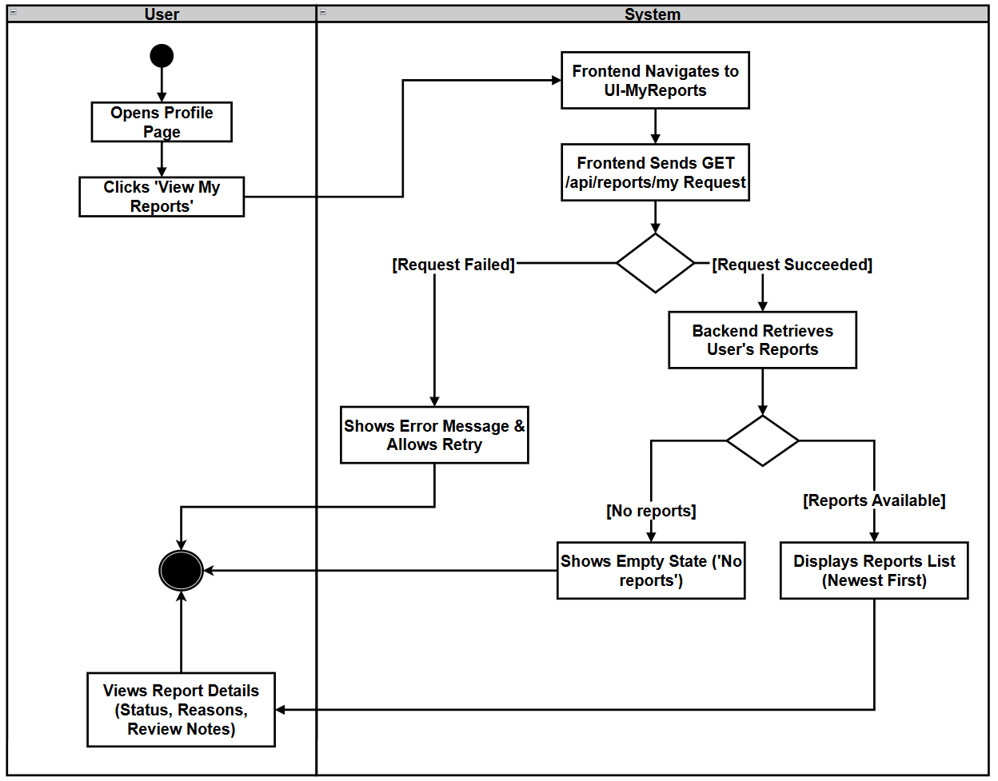

2.2.3.8 UCD-25: Forget Password
URS-25: Users can securely reset their account password if they forget it, using either their registered email address or bound mobile phone number.
SRS-121: When the user clicks the "Forget Password" button on the login page, the system should display a single-page password reset form where the user can:
- Select the reset method: Email or Phone.
- Enter the corresponding identifier (email address or phone number).
- Send the verification code.
- Enter and verify the received verification code.
- Enter the new password and confirm the new password.
This form should also provide options such as "Re-send Verification Code" (when a verification code has been sent) and "Return to Login Page".
SRS-122: The system should use a selected method to send password reset verification codes periodically:
- Cooling Mechanism: On the password reset page, before sending the verification code, the front end needs to check the timestamp of the last sent code (`lastPasswordResetCodeSentAt`); if the user attempts to send the verification code again within 60 seconds, the front end should not call the backend or Firebase, and should display a localized error message: "Excessive sending frequency, please wait one minute before trying again".
This timestamp will be saved in `localStorage` with the key "lastPasswordResetCodeSentAt" to ensure that the 60-second cooling mechanism remains effective when the page is reloaded or accessed again.
- Email Reset: The system should send the email reset code via `POST /api/auth/forgot-password/send-code`, with parameters: `identifier=<email address>`, `type="email"`.
- Phone Reset: The system should send a text message verification code through Firebase phone authentication using the input phone number; the phone number must include the country code (e.g. `+66...`), otherwise the system will display a localized verification error and will not attempt to send the text message.
SRS-123: Before allowing the user to perform the password reset operation, the system needs to verify the password reset verification code:
- Email Reset:
- The system requires the input of a 6-digit verification code. If the cleaned verification code is not a 6-digit number, the front-end should display a localized verification error.
- When the user requests to verify the verification code, the front-end should call `POST /api/auth/verify-code` and pass the following parameters: `identifier=<email address>`, `code=<6-digit verification code>`, `type="email"`, `purpose="reset password"`.
- If the backend indicates that the verification code is invalid, the system should display "Incorrect verification code, please try again".
- Phone Reset:
- The system will use the Firebase confirmation object returned when sending a text message to verify the verification code, and mark the verification code as verified upon successful confirmation. - If the confirmation object is missing or the verification fails, the system should display the corresponding localized error message and mark the code status as "unverified".
SRS-124: The system will only reset the user's password after successfully verifying the reset method, and will execute the following password policy:
- Password Policy:
- The new password must contain at least one lowercase letter and one uppercase letter.
- The new password must be at least 6 characters long.
- The fields for new password and confirmation password must match.
- If any of these conditions are not met, the system will display a localized error (for example, "Password must be at least six characters" / "Password must be at least 6 characters", if the new password and confirmation new password do not match, the system will display the message "passwordsNotMatch"), and will not call the backend.
- Email Reset:
- After the email verification code is successfully verified and the password policy check is passed, the front-end will call
`POST /api/auth/forgot-password/reset`, and pass the parameters: `identifier=<email address>`, `code=<cleared 6-digit verification code>`, `newPassword=<new password>`, `type="email".
- Phone Reset:
- After completing the SMS verification code validation through Firebase and the password policy check is passed, the front-end will call
`POST /api/auth/forgot-password/reset/phone`, and pass the parameters: `phone=<phone number>`, `newPassword=<new password>`.

Use Case ID | UC-25.1
Use Case Name | SMS-based Password Reset
Actors | User
Description | User resets password using an SMS verification code sent and verified via Firebase Phone Authentication, and then returns to the login page.
Trigger | User clicks "Forgot Password" on the login page and selects the Phone method.
Preconditions | 1. User has (or believes they have) a registered account with a phone number.  2. Network connection is available.  3. Firebase Phone Authentication is correctly configured on the frontend.
Use Case Input Specification
Input | type | Constraint |  |  | Example
Phone number | String | Must include country code (e.g. starts with `+`) |  |  | `+66912345678`
SMS verification code | String | Code returned by SMS and verified via Firebase |  |  | ‘123456’
New password | String | Must meet password policy |  |  | ‘Password123456‘
Post conditions | - User’s password associated with the phone number is updated successfully.  - User is redirected back to the login page and can log in with the new password.
Normal Flows | User |  | System | SMS Service
 | 1. User clicks "Forgot Password" on the login page and selects the Phone method.  3. User enters phone number and clicks "Send SMS Code".  8. User receives the SMS, enters the SMS verification code into the form and clicks "Verify".  12. After SMS verification succeeds, user enters “New Password” and “Confirm New Password”, then clicks"Reset Password".  15. User sees the success result. |  | 2. System displays the single-page password reset form with method selector, phone input, SMS code input and new password fields.  4. System checks `lastPasswordResetCodeSentAt` in memory and `localStorage`.  [A1: Cooldown not elapsed]  5. System validates that the phone number starts with `"+"` (contains country code); if not, it shows a localized error (e.g. "Please enter phone with country code, e.g. +66...") and does not contact Firebase.  6. If validation and cooldown pass, system calls `sendSmsCode(phone)` to invoke Firebase Phone Authentication and stores the returned confirmation object (`forgotPasswordPhoneConfirmation`).  [E1: Firebase send failed]  9. System cleans the code (trim spaces and keep digits only) and uses the stored Firebase confirmation object to call `confirmation.confirm(cleanCode)`.  [E2: Firebase verify failed or missing confirmation]  10. If confirmation succeeds, system sets the code status as verified in the UI (e.g. shows "Verified").  13. System validates the new password on the frontend according to the password policy (must contain at least one lowercase and one uppercase letter, length ≥ 6, and match confirmation). If validation fails it shows localized errors and does not call backend.  14. If validation passes and the SMS code has been verified, system calls `POST /api/auth/forgot-password/reset/phone` with `phone=<phone number>`, `newPassword=<new password>`. Backend locates the user by phone and updates the password.  [E3: Reset password failed]  16. System shows " "Password reset successfully" and navigates the user back to the login form. | 7. SMS Service (Firebase) sends an SMS verification code to the provided phone number.  11. SMS Service (Firebase) verifies the code and returns success or failure.
Alternative Flow | A1: Cooldown not elapsed  A1.1 When user clicks "Send SMS Code" again within 60 seconds since `lastPasswordResetCodeSentAt`, system detects the time difference is less than 60 seconds.  A1.2 System shows localized message "Too many requests. Please try again in 1 minute." and “does not” invoke Firebase.  A1.3 User can wait until 60 seconds have passed and click "Send SMS Code" again.
Exception Flow | E1: Firebase send failed  E1.1 `sendSmsCode(phone)` throws an error or Firebase fails to send the SMS due to network, quota, or configuration issues.  E1.2 System displays a localized error message and allows user to retry sending the SMS code.  E2: Firebase verify failed or missing confirmation  E2.1 The Firebase confirmation object is missing (no active SMS session) or `confirmation.confirm(cleanCode)` fails (invalid/expired code, too many attempts, network error, etc.).  E1.2 System displays a localized error (e.g. from Firebase error message) and keeps the code status as unverified; password reset is not allowed until verification succeeds.  E1.3 User can request a new SMS code and retry verification.  E3: Reset password failed  E3.1 Backend fails to reset password due to user not found, server error or other validation failures.  E3.2 System displays a localized error message such as "Failed to reset password" and allows user to retry after correcting issues (for example, by re-verifying the code or re-entering data).
Assumption | The user has an internet connection .

AD-26
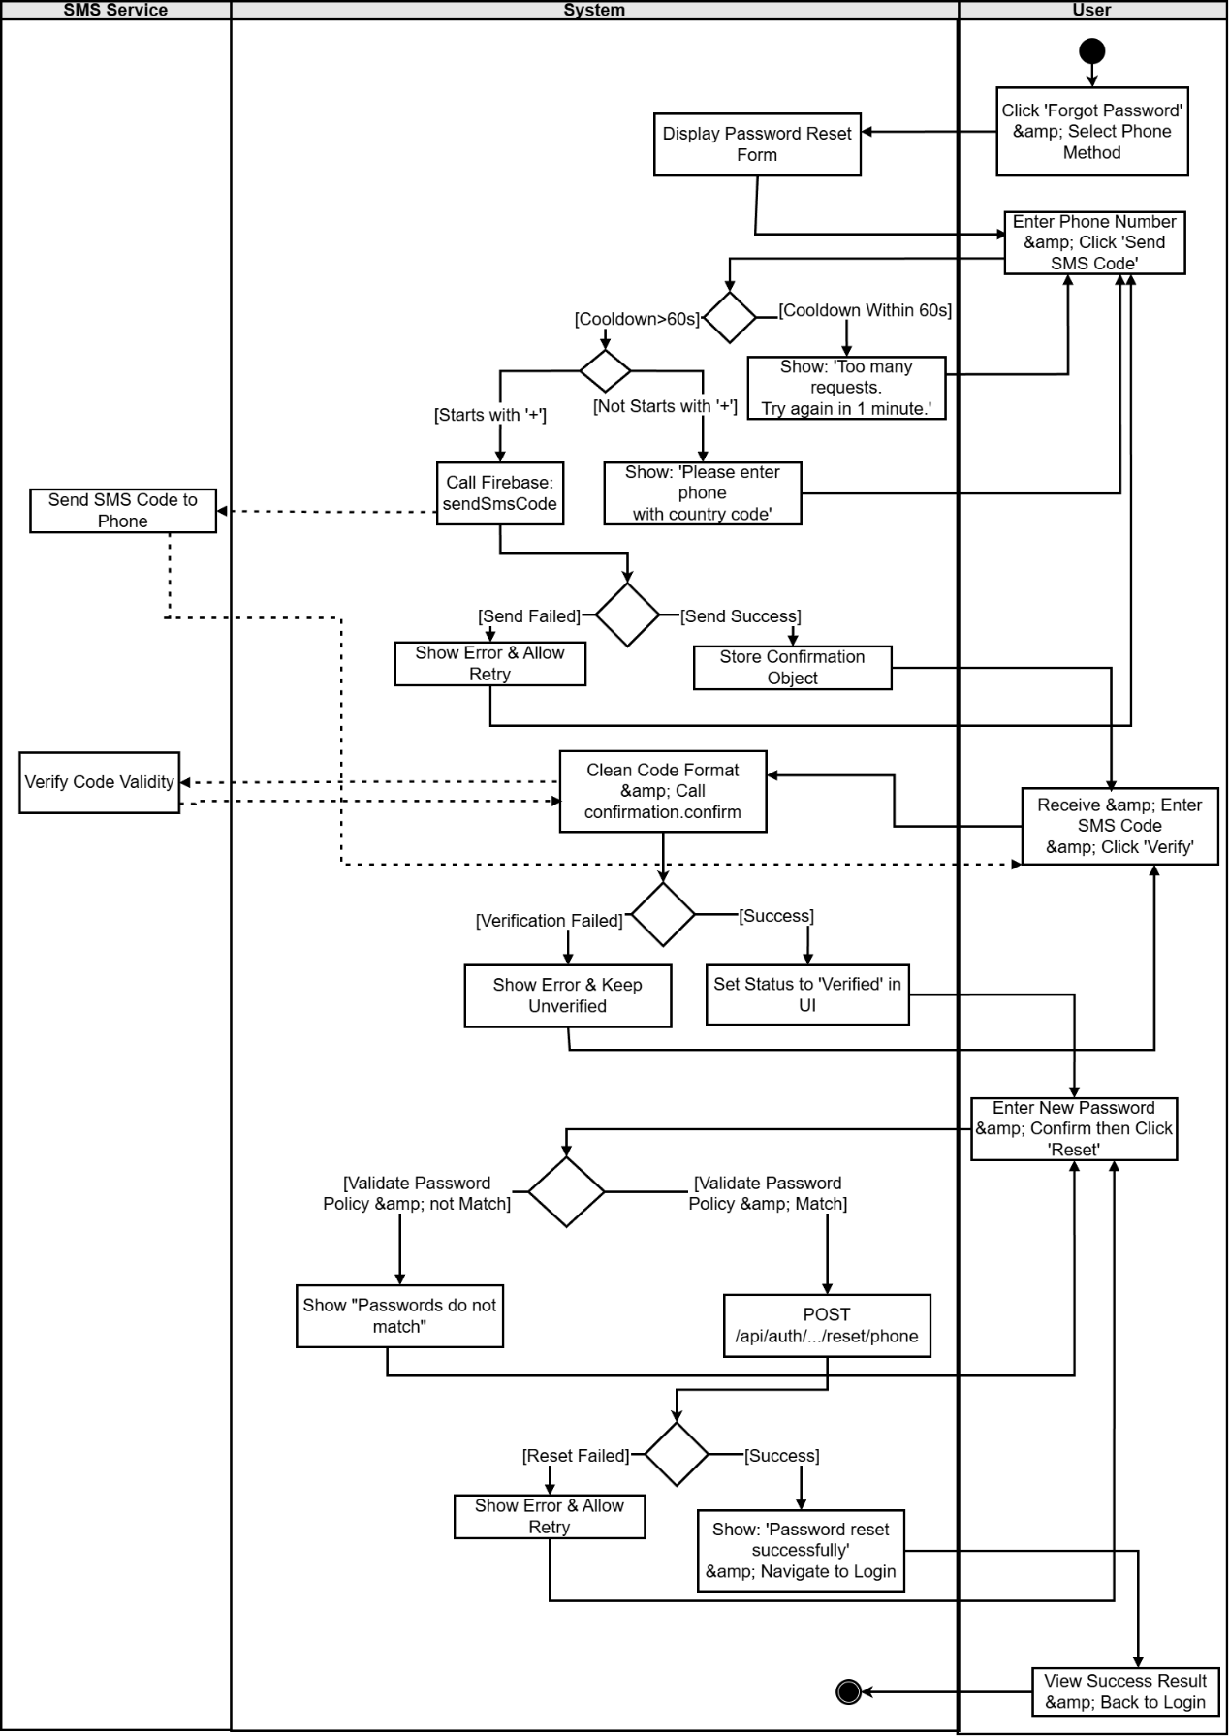
Use Case ID | UC-25.2
Use Case Name | Email-based Password Reset
Actors | User
Description | User resets password using an email verification code and then returns to the login page.
Trigger | User clicks "Forgot Password" on the login page and selects the Email method.
Preconditions | 1. User has (or believes they have) a registered account with an email.  2. Network connection is available.
Use Case Input Specification
Input | type | Constraint |  |  | Example
Email | String | Email address used for the account |  |  | user@example.com
Verification code | String | 6-digit numeric code |  |  | ‘123456’
New password | String | Must meet password policy |  |  | ‘Password123’
Post conditions | User’s password associated with the email address is updated successfully.  User is redirected back to the login page and can log in with the new password.
Normal Flows | User |  | System | Email Service
 | 1. User clicks "Forgot Password" on the login page and selects the “Email” method.  3. User enters their email address and clicks "Send Code".  7. User receives the email, enters the 6-digit verification code into the form, and clicks "Verify".  10. After the code is verified successfully (UI shows "Verified"), user enters New Password and Confirm New Password, then clicks "Reset Password".  13. User sees the success result. |  | 2. System displays the single-page password reset form with method selector, email input, verification code input and new password fields.  4.System checks `lastPasswordResetCodeSentAt` in memory and `localStorage`.  [A1: Cooldown not elapsed]  5. If cooldown has elapsed, system sends `POST /api/auth/forgot-password/send-code` with `identifier=email`, `type="email"` and sets a new `lastPasswordResetCodeSentAt` timestamp (also saved in `localStorage`).  [E1: Send code failed]  8. System cleans the code (trim spaces and keep digits only); if the cleaned code is not 6 digits, it shows a localized validation error and does not call backend.  9. When the code is 6 digits, system calls `POST /api/auth/verify-code` with `identifier=email`, `code=<clean 6-digit code>`, `type="email"`, `purpose="RESET_PASSWORD"`. Backend verifies and returns success or failure.  [E2: Invalid/expired code]  11. System validates the new password on the frontend according to the password policy (must contain at least one lowercase and one uppercase letter, length ≥ 6, and match confirmation). If validation fails it shows localized errors and does not call backend.  12. If validation passes, system cleans the stored verification code again and calls `POST /api/auth/forgot-password/reset` with `identifier=email`, `code=<clean 6-digit code>`, `newPassword=<new password>`, `type="email"`. Backend verifies the code again with purpose `"RESET_PASSWORD"`, locates the user by email and updates the password.  [E3: Reset password failed]  14. System shows "Password reset successfully" and navigates the user back to the login form, where they can log in with the new password. | 6. Email Service sends a password reset verification email with a 6-digit code to the user.
Alternative Flow | A1: Cooldown not elapsed  A1.1 When user clicks "Send Code" again within 60 seconds since `lastPasswordResetCodeSentAt`, system detects the time difference is less than 60 seconds.  A1.2 System shows localized message "Too many requests. Please try again in 1 minute." and does not call backend or Email Service.  A1.3 User can wait until 60 seconds have passed and click "Send Code" again.
Exception Flow | E1: Send code failed  E1.1 Backend returns an error while handling `POST /api/auth/forgot-password/send-code` (e.g., internal server error or email sending failure).  E1.2 System displays a localized error such as "Failed to send verification code, please try again" and allows user to retry.  E2: Invalid/expired code  E2.1 Backend indicates that the verification code is incorrect, expired, already used, or invalid for purpose `"RESET_PASSWORD"`.  E2.2 System displays a localized error message such as "Incorrect verification code, please try again" and keeps the code status as unverified.  E2.3 User can re-enter the code or click "Re-send Code" and repeat the verification.  E3: Reset password failed  E3.1 Backend fails to reset password due to user not found, server error or other validation failures.  E3.2 System displays a localized error message such as "Failed to reset password" and allows user to retry after correcting issues (for example, by re-verifying the code or re-entering data).
Assumption | The user has an internet connection .
AD-27: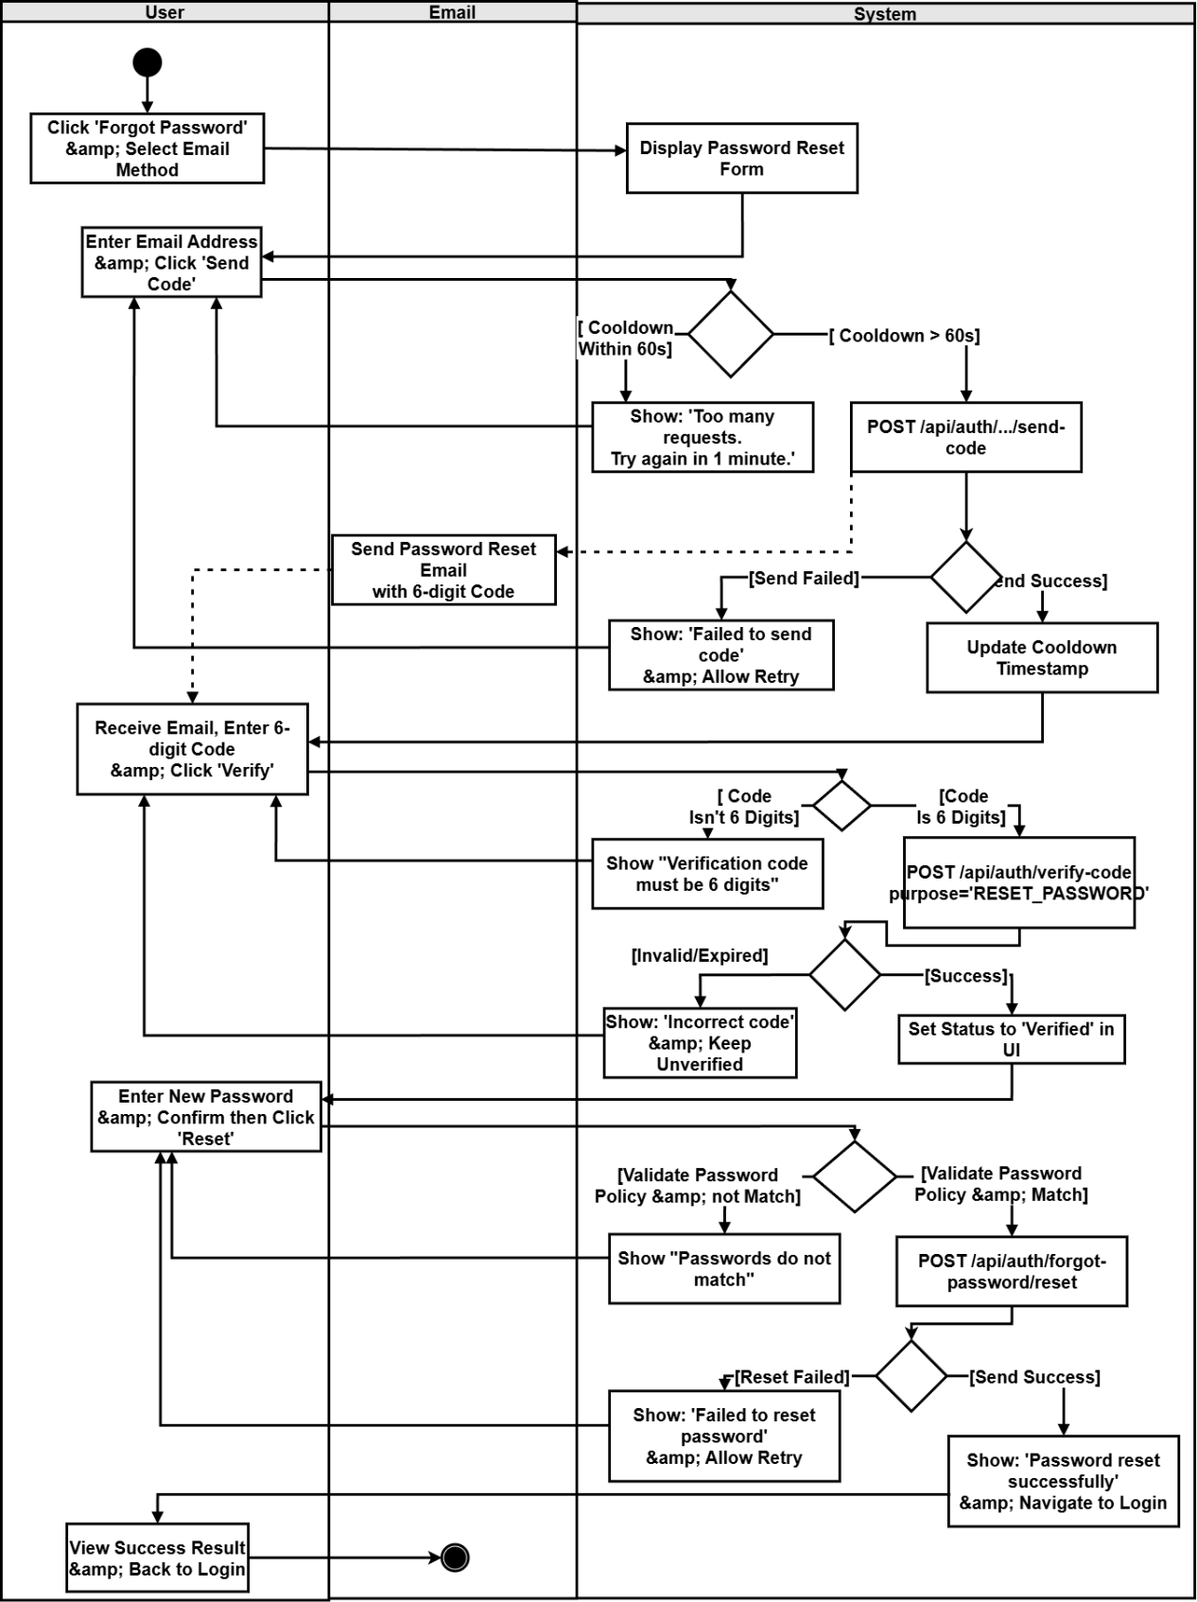

Chapter 3 User Interface Design
UI-01 Daily Briefing Page
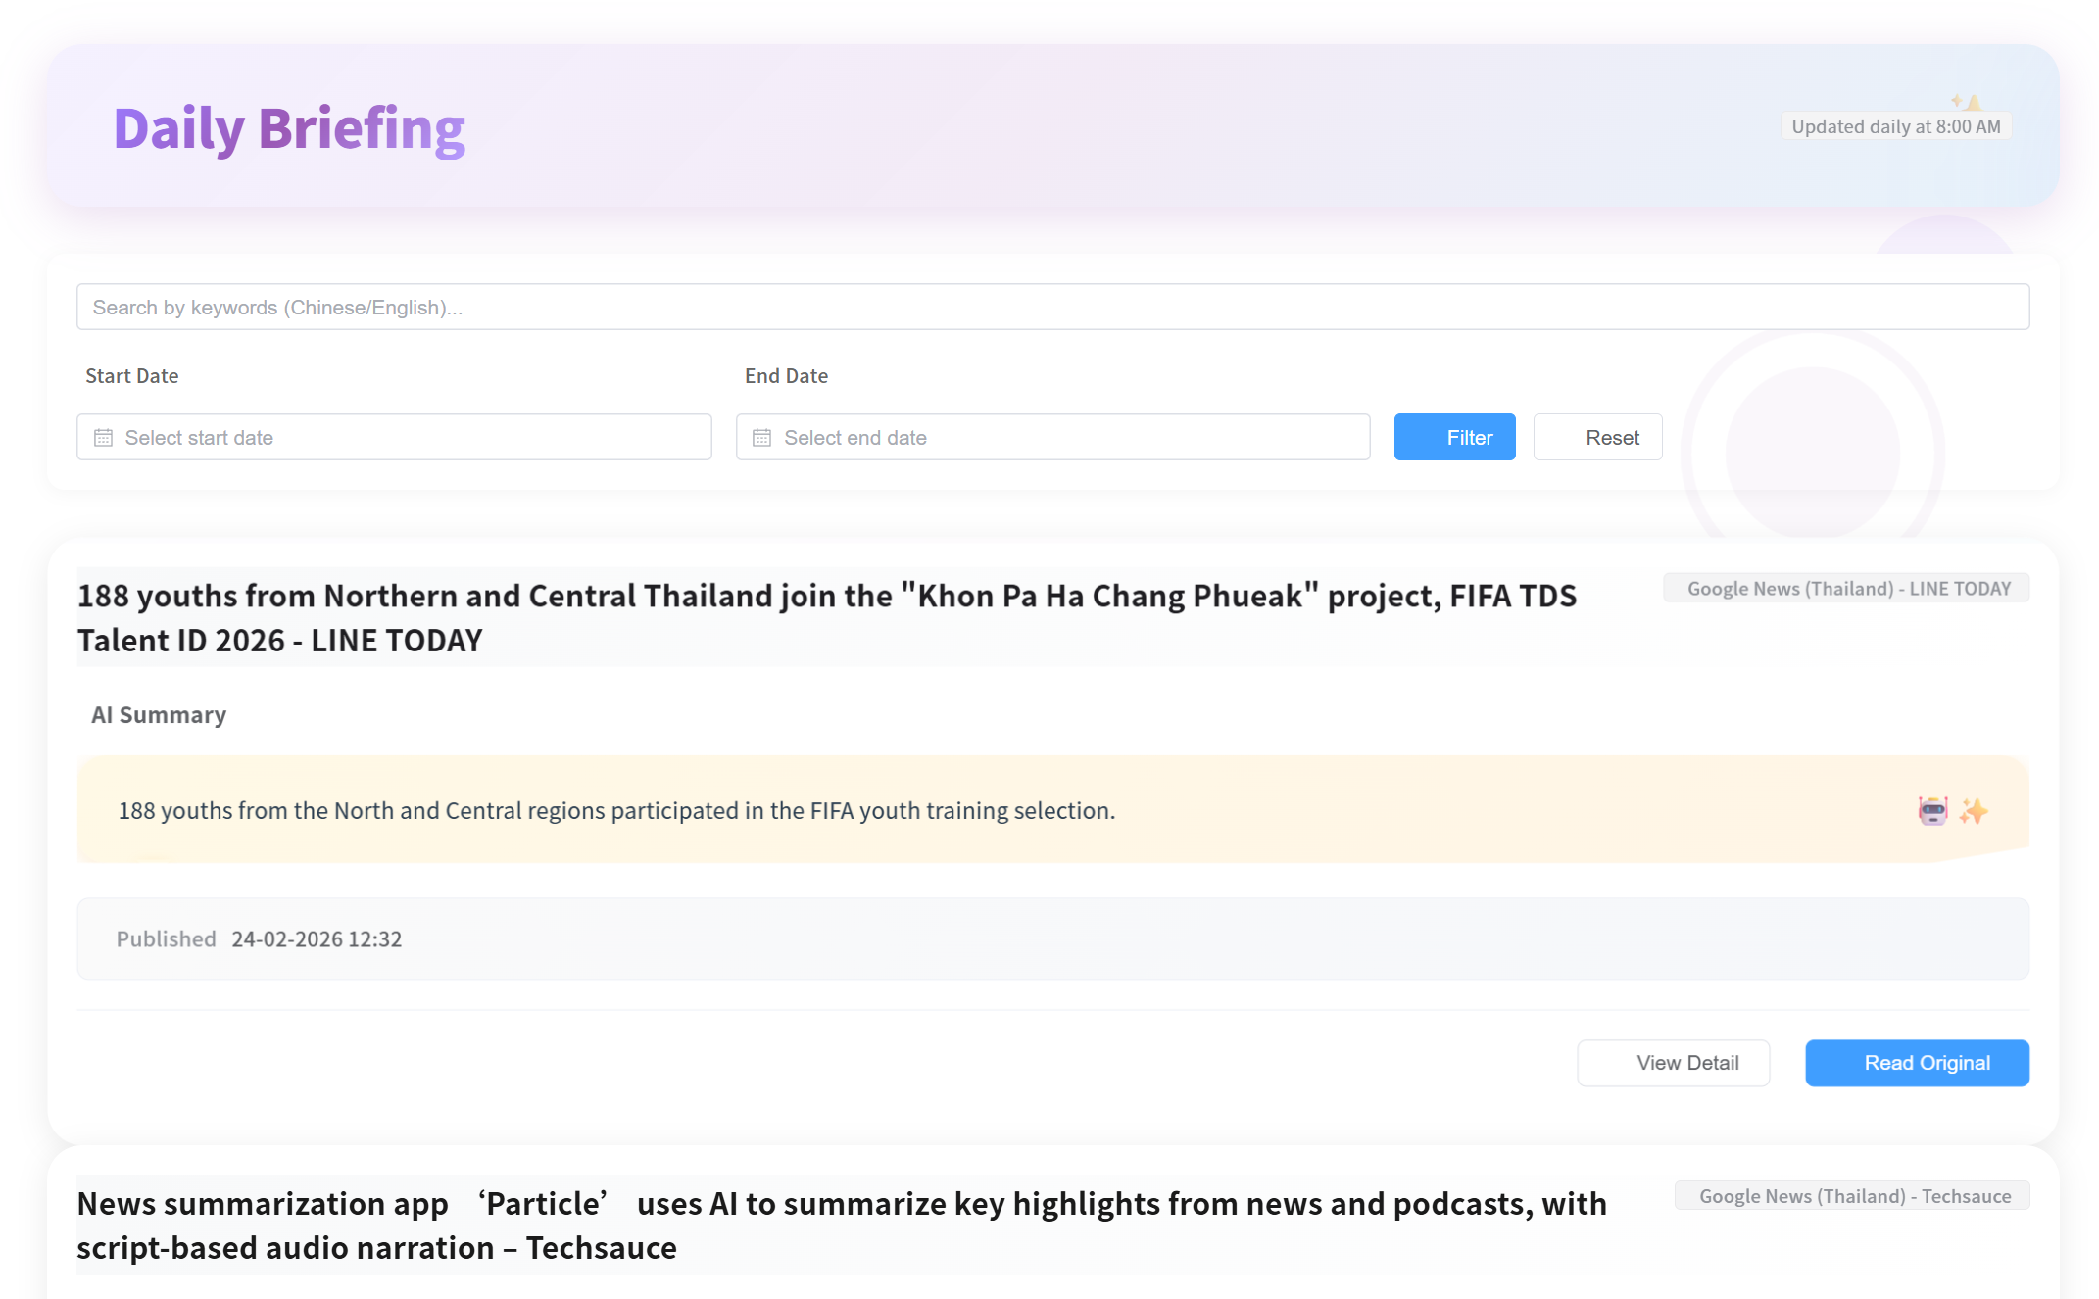
UI-01-01 Invalid date filtering
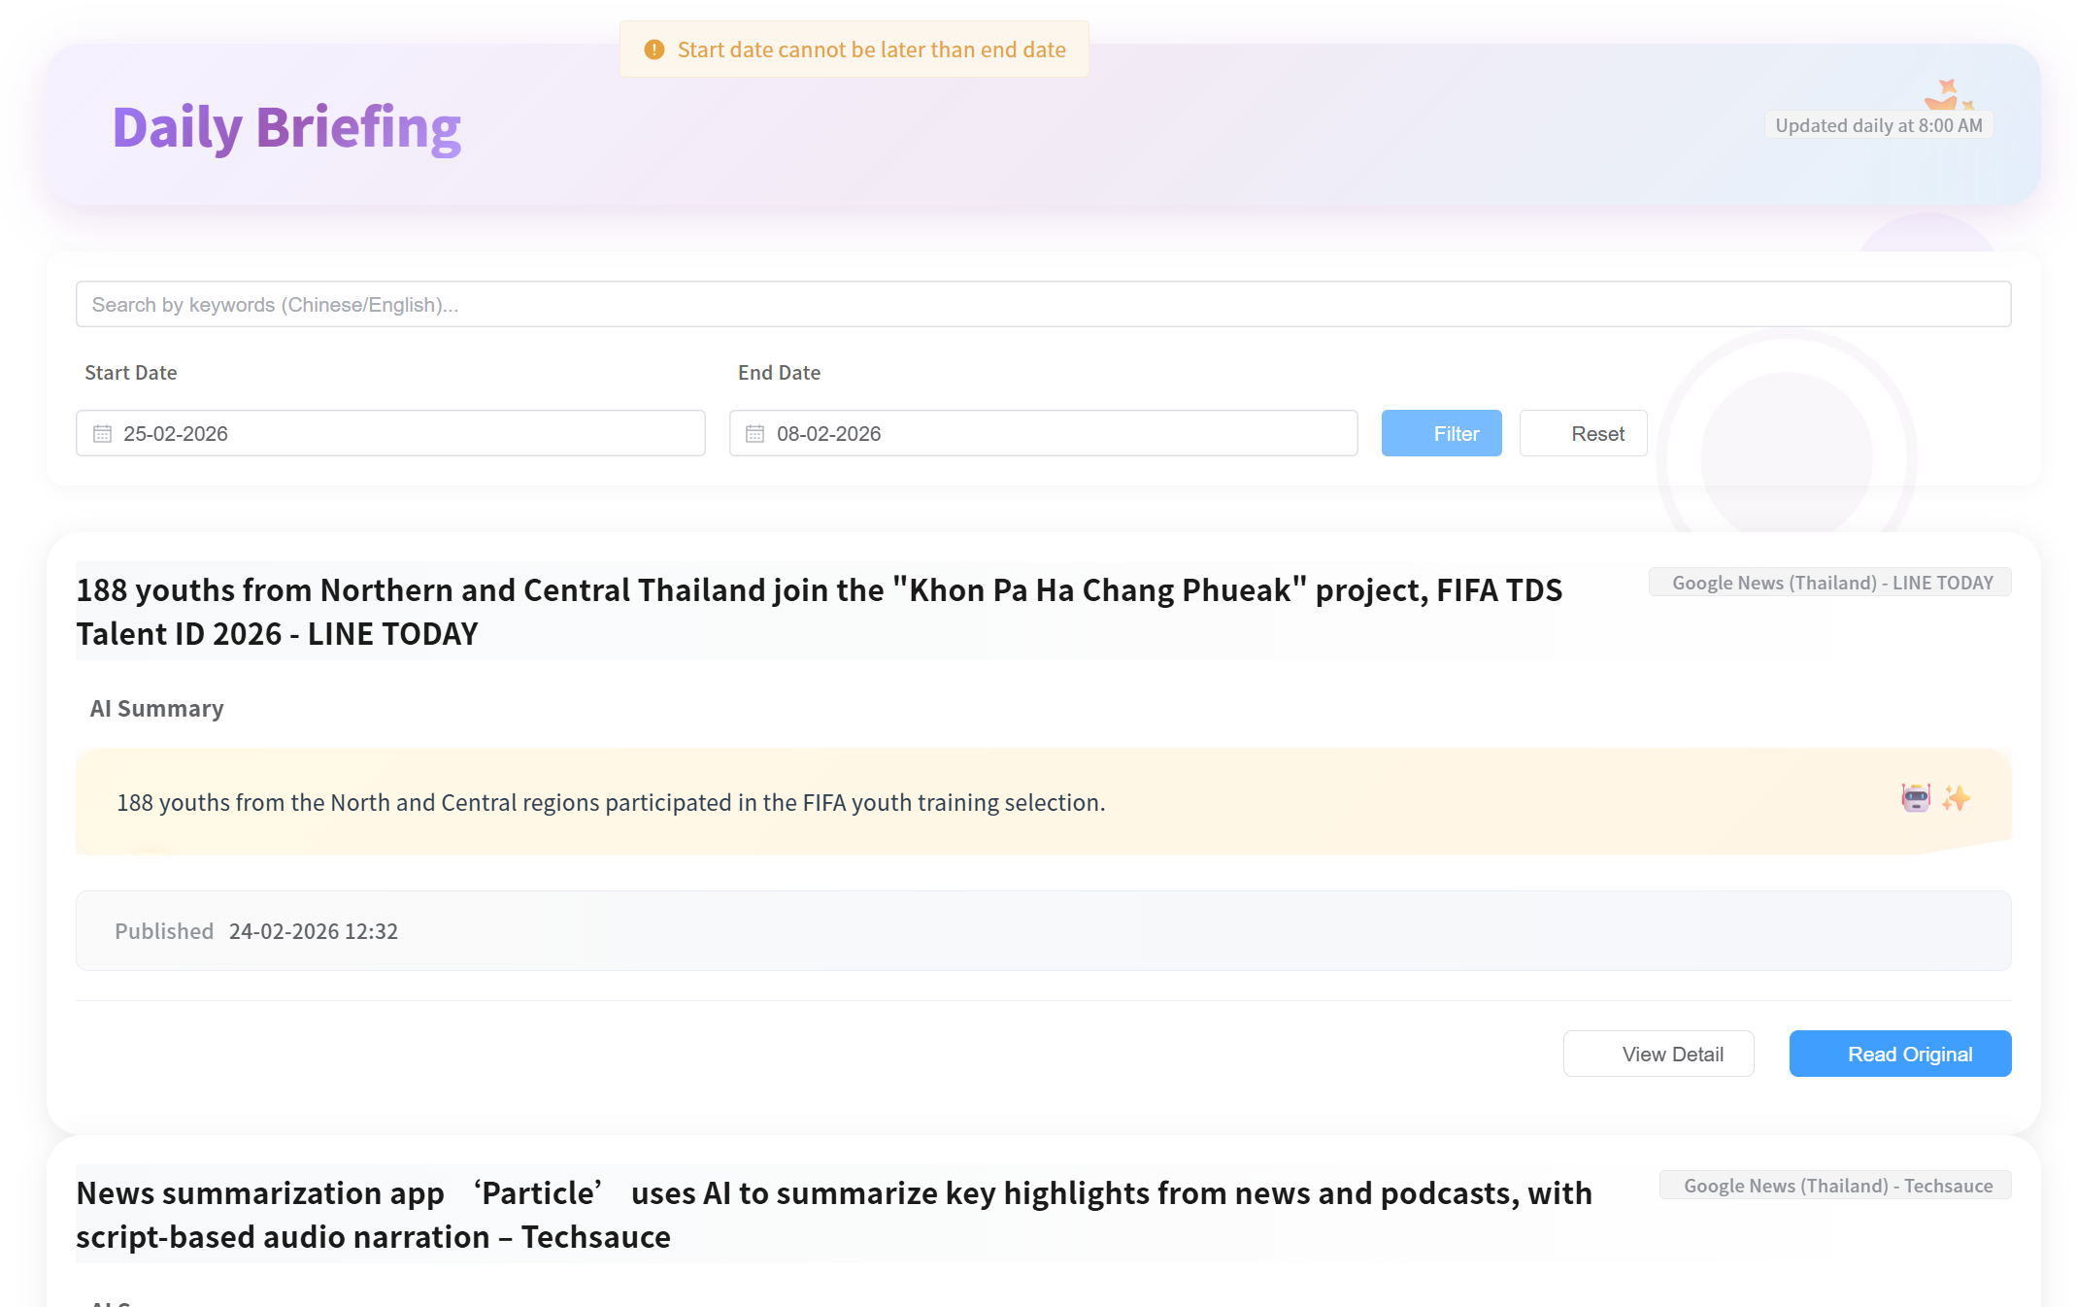
UI-01-02 Select the page number
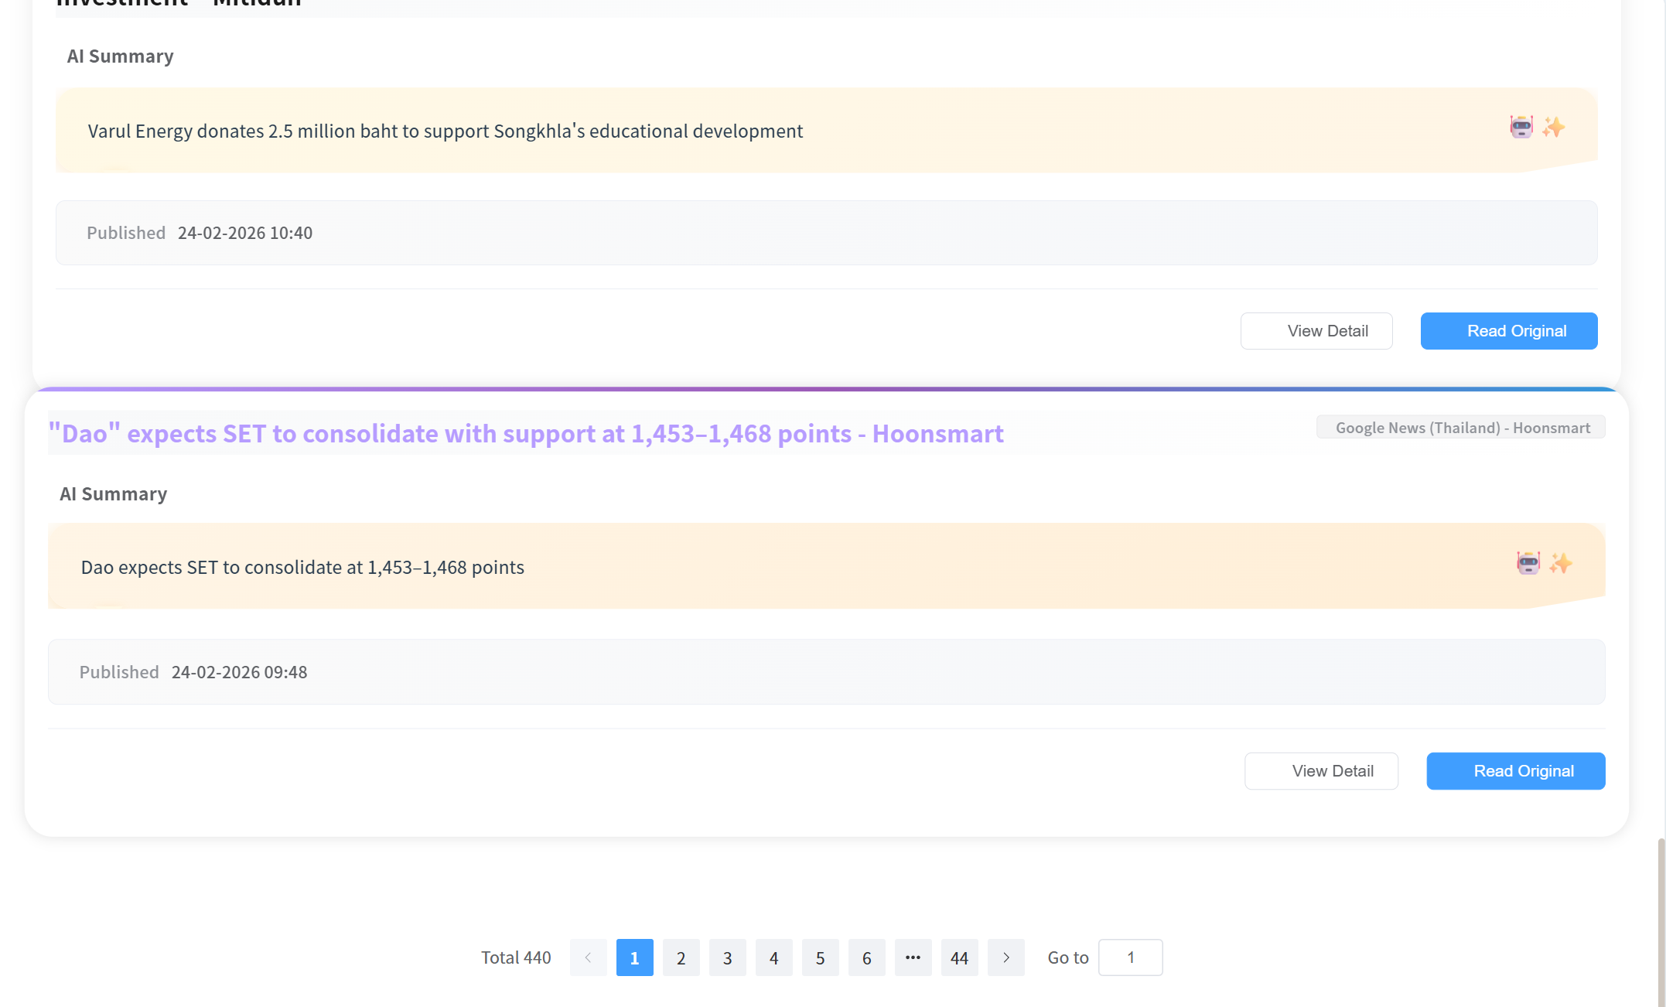
UI-02: Daily Briefing Page
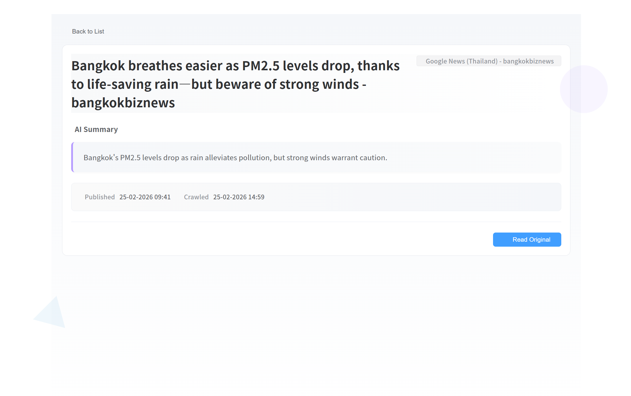
UI-03:Community Page
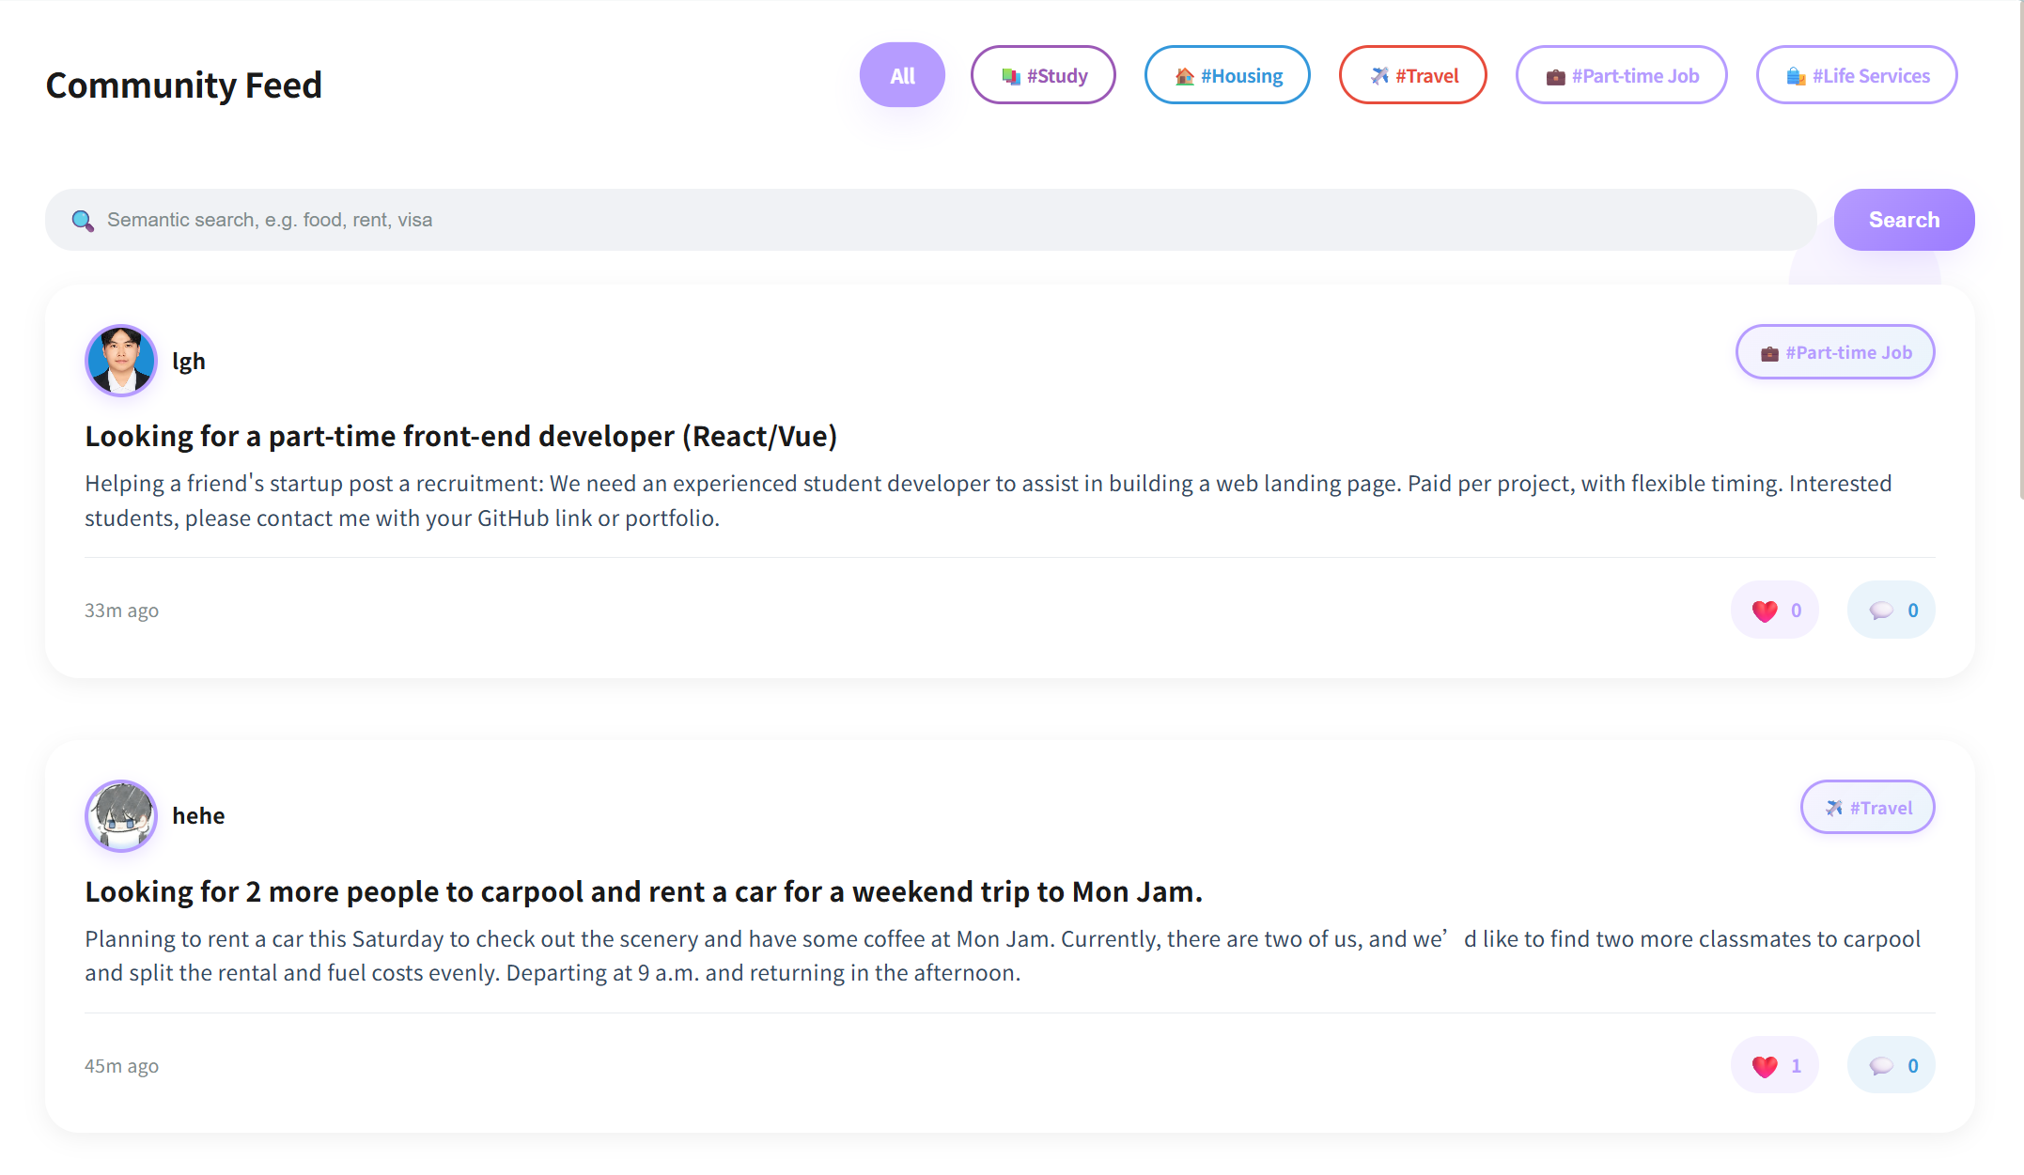
UI-03-01:Search post
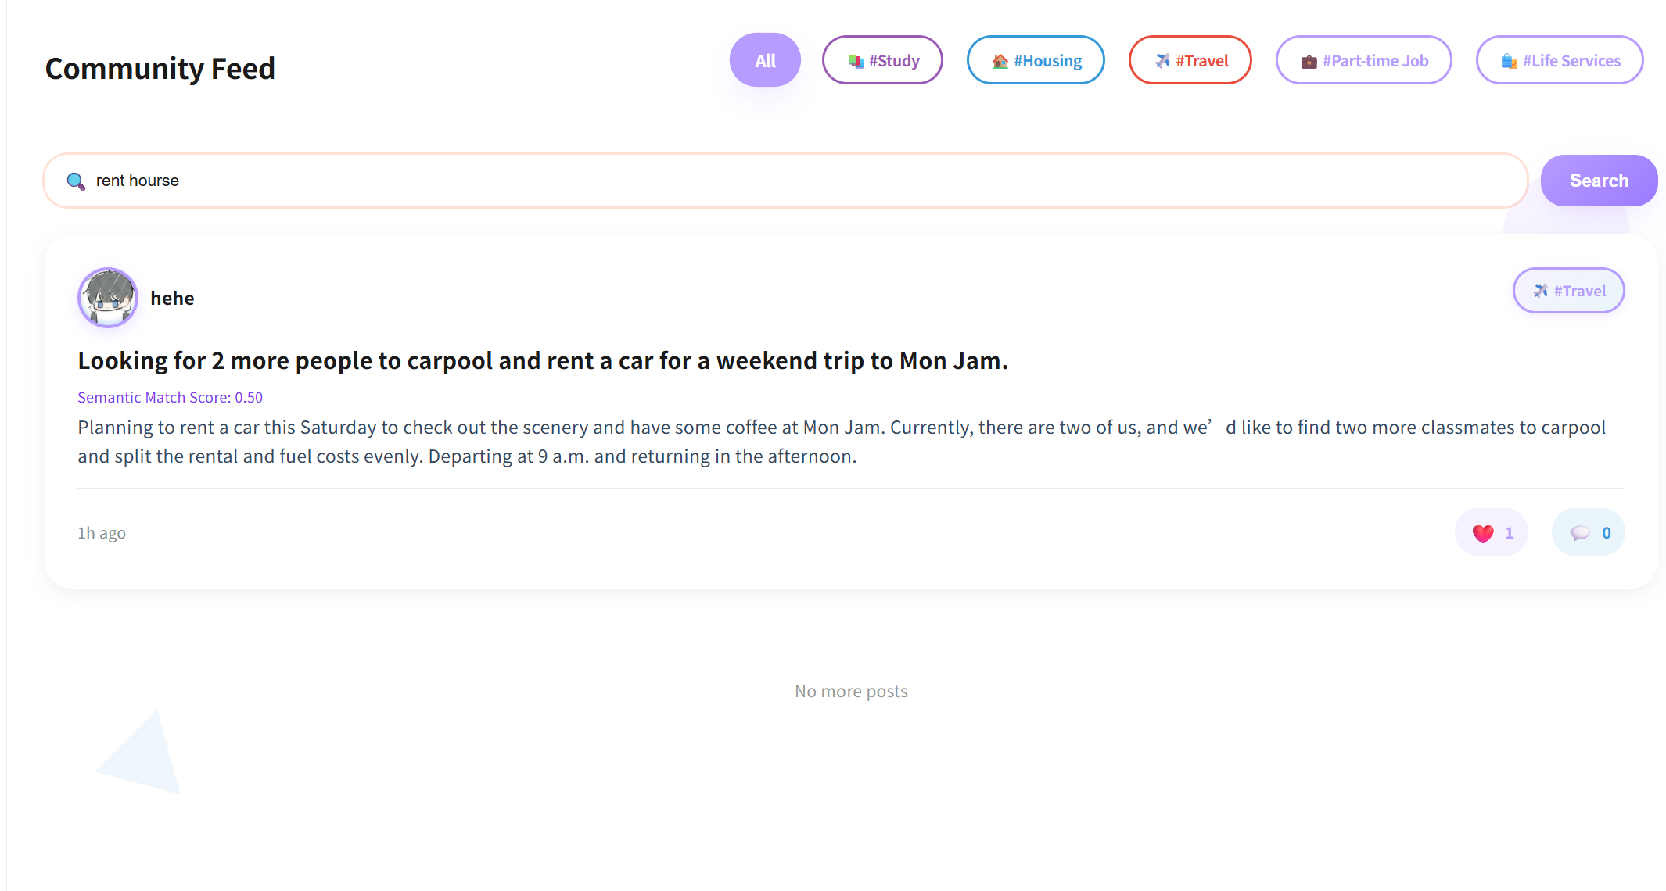

UI-03-02:Filter post by tag
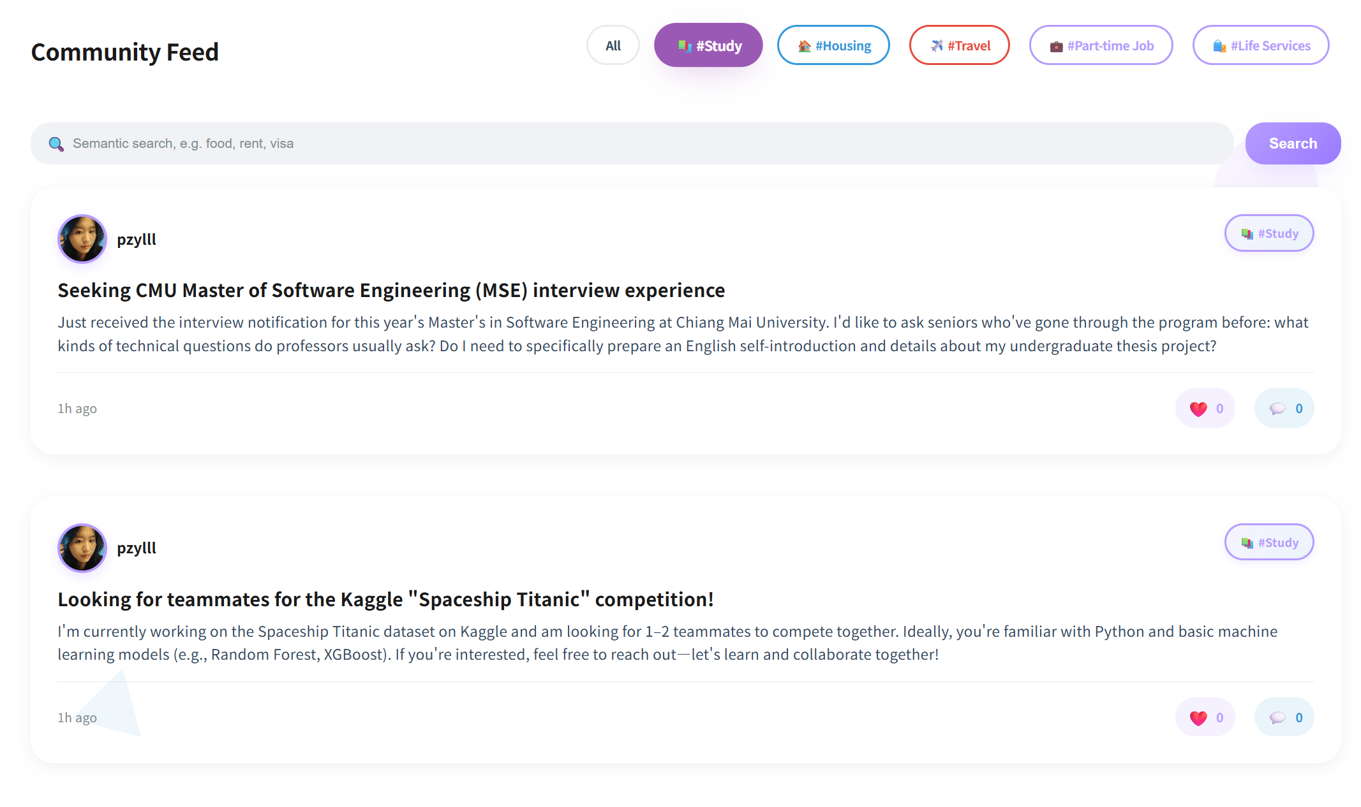
UI-04:Post detail page
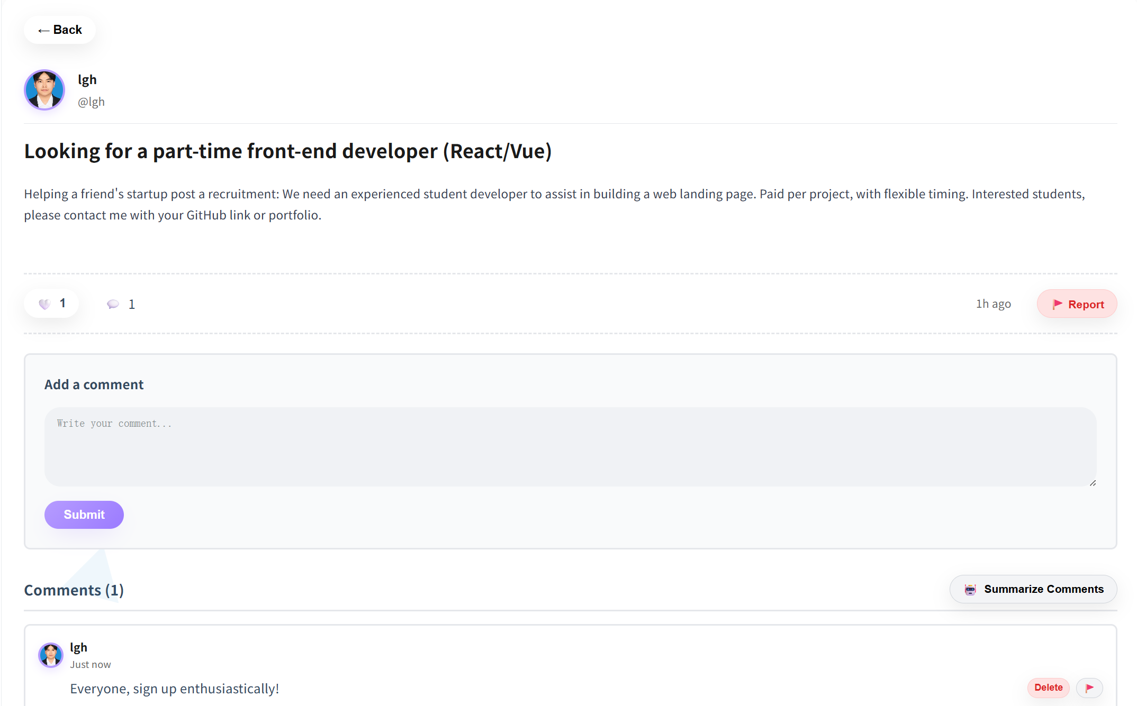

UI-04—01:Other user’s profile page
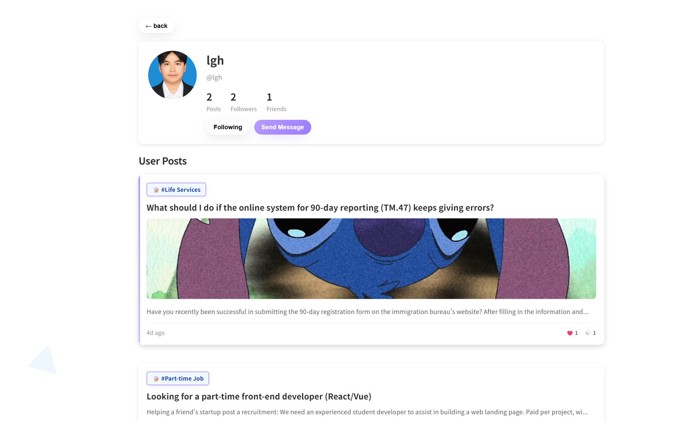
UI-05: Create Pubilc Post Page
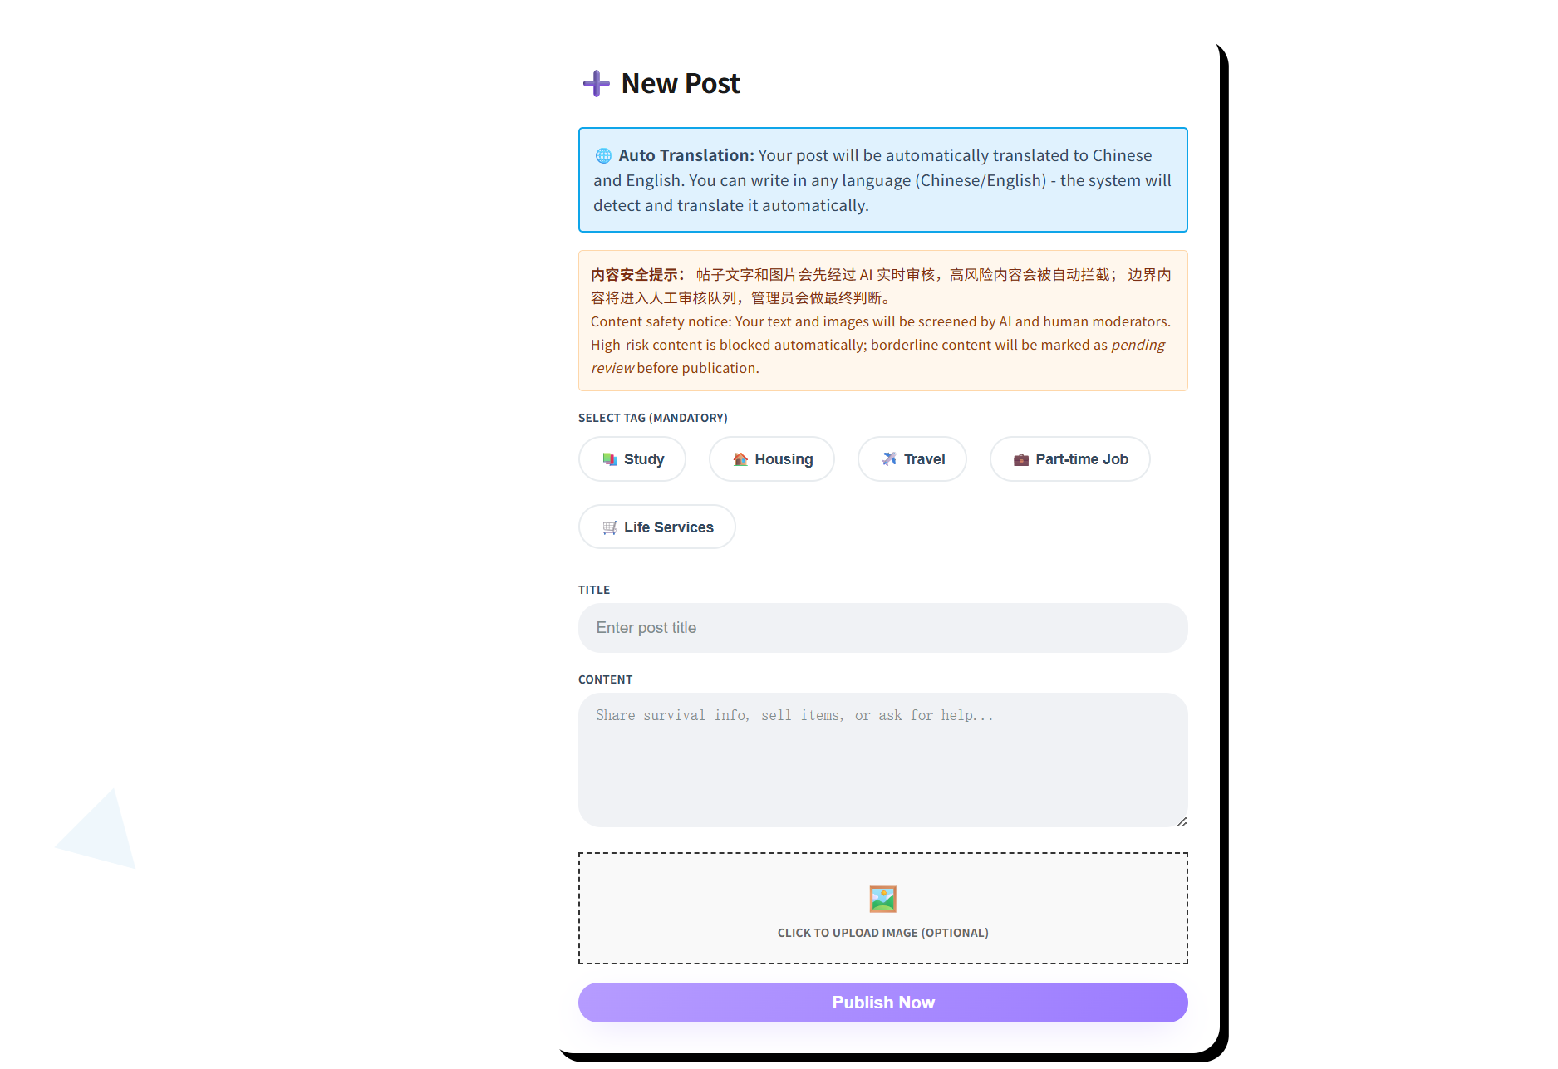
UI-05-01:Creat Pubilc Post
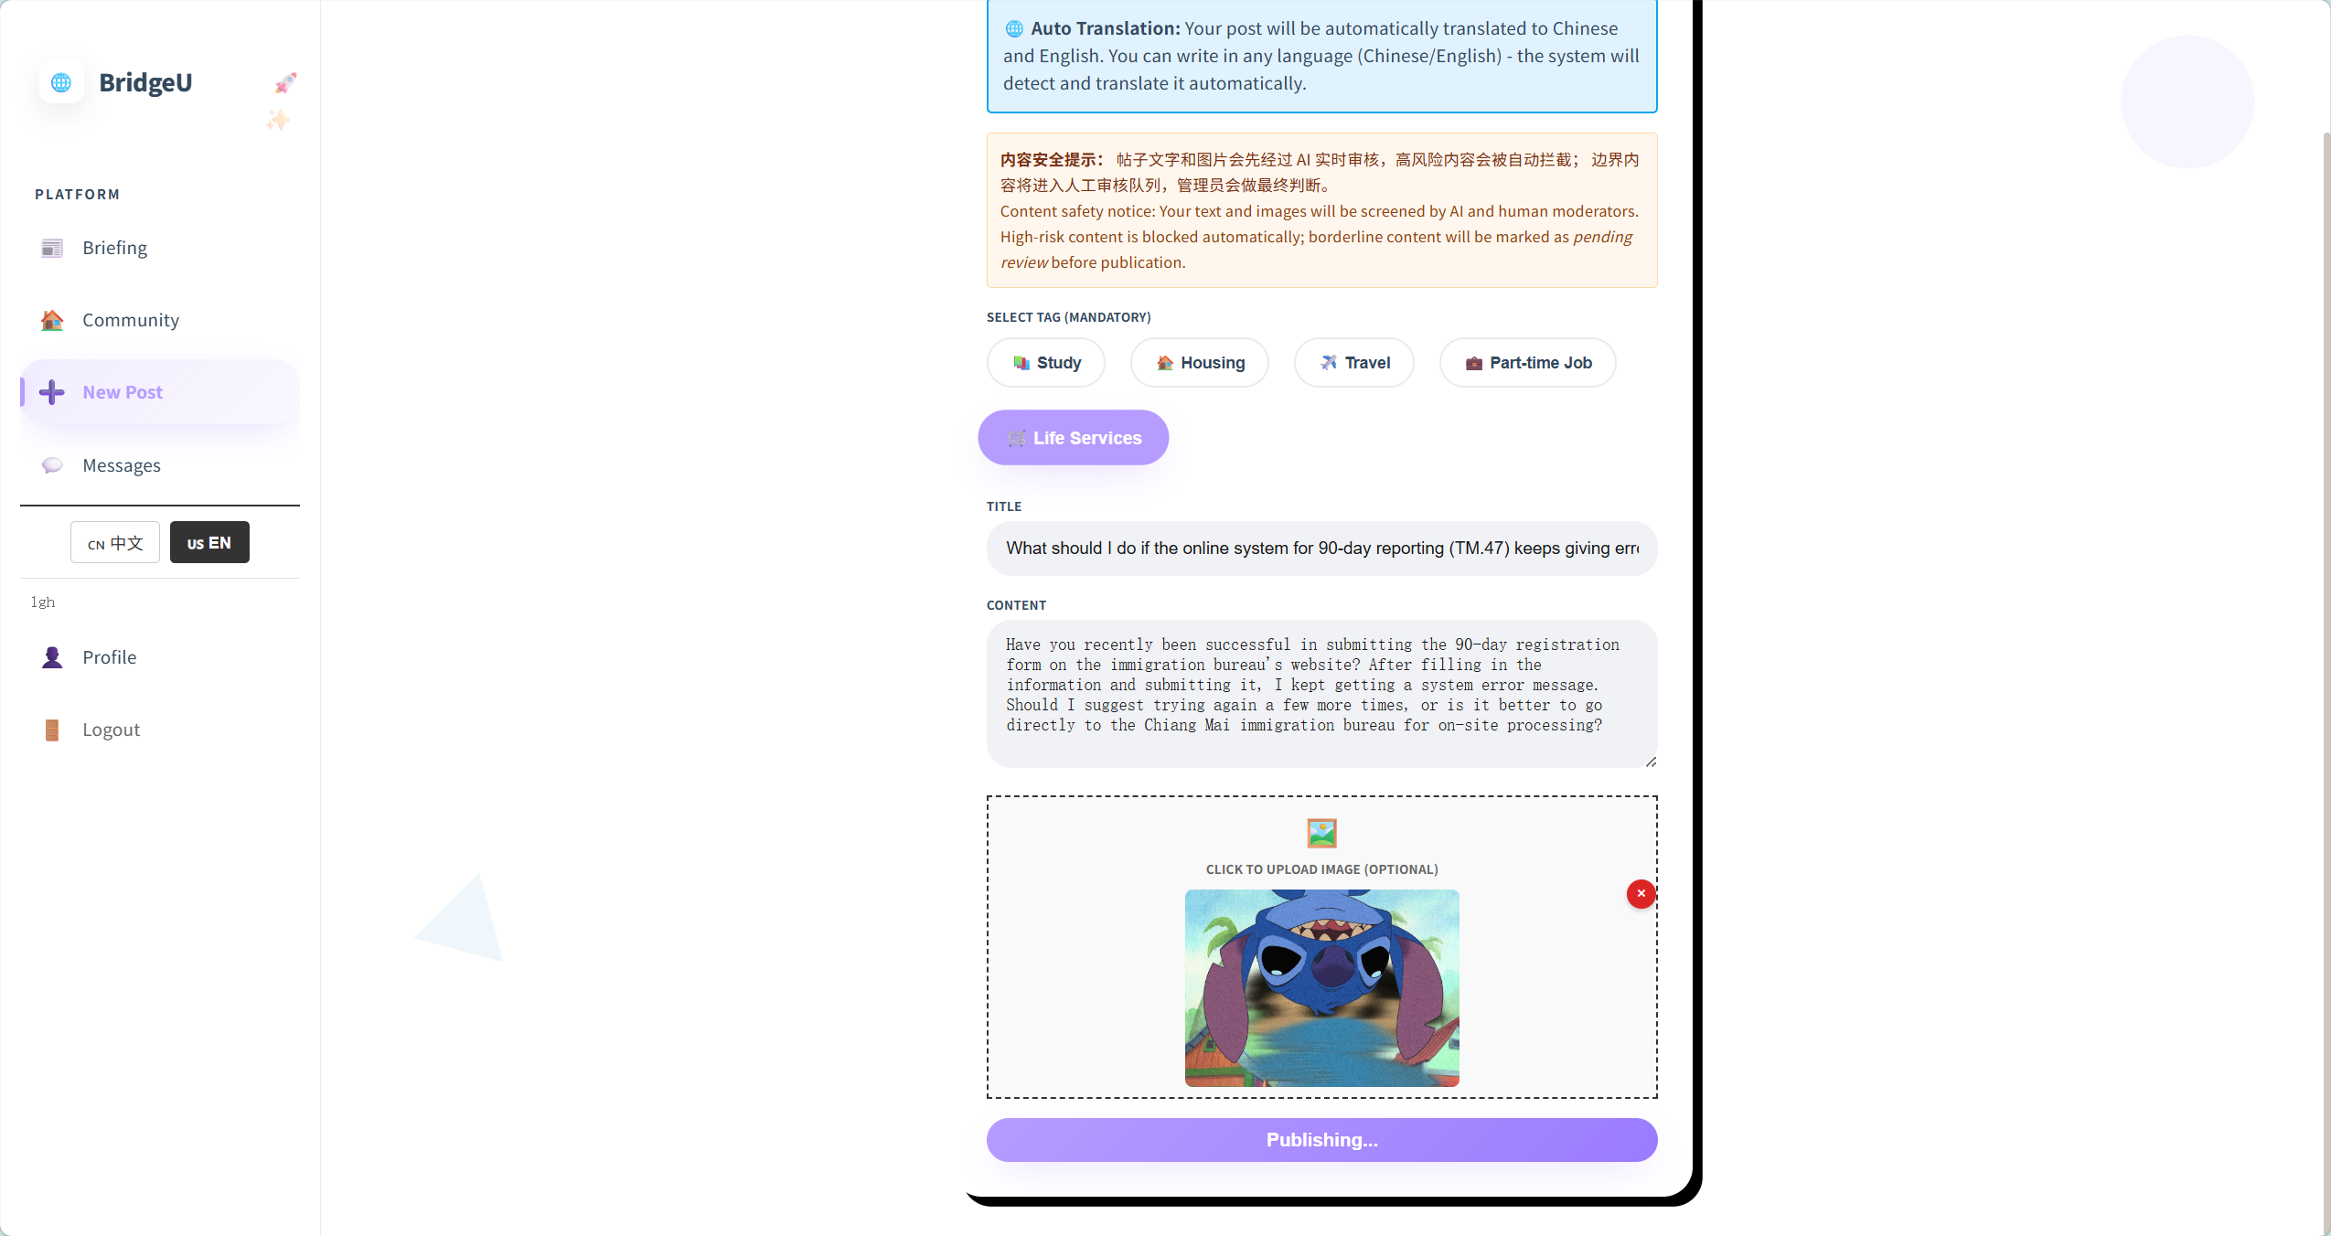
UI-06: Private Message Page
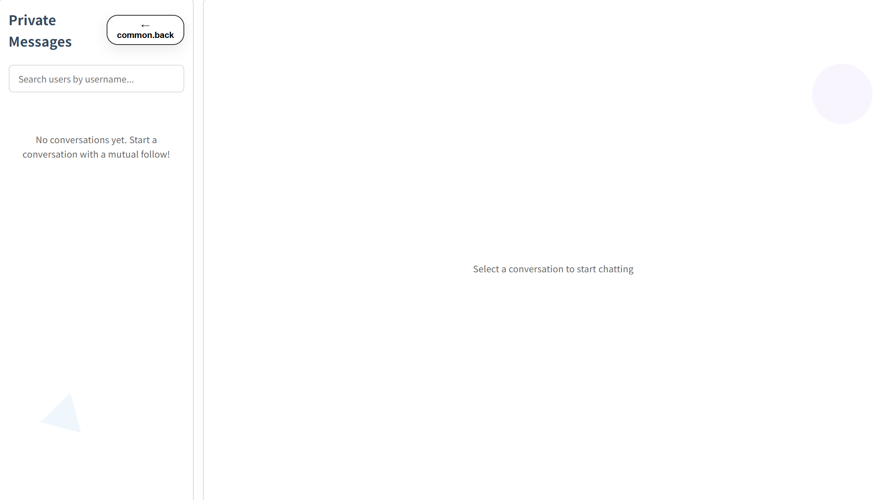
UI-06-01: One-way following
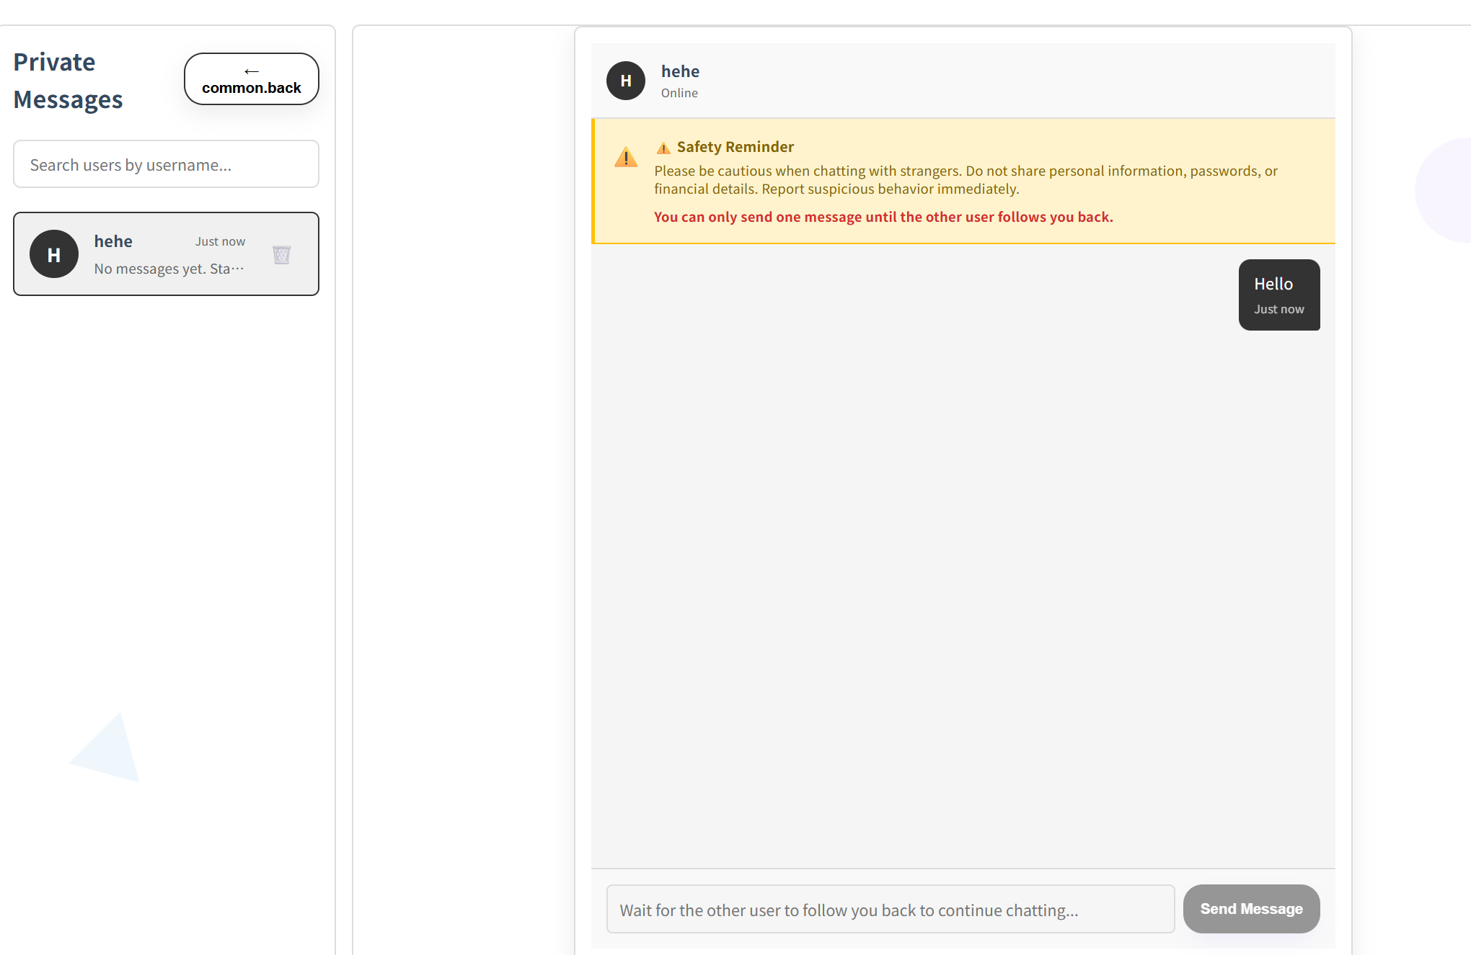

UI-06-02:Mutual Following
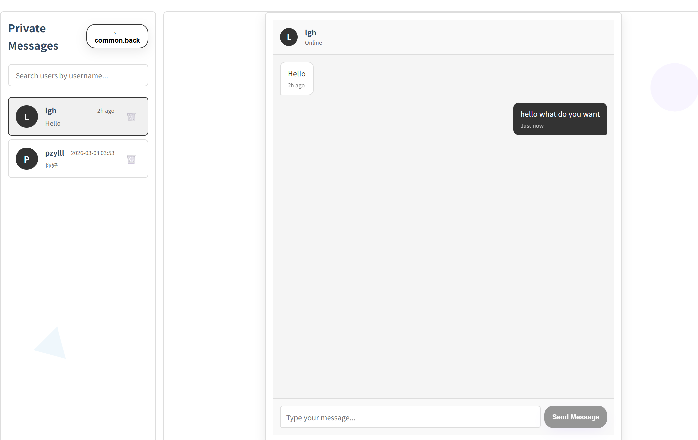
UI-06-03:Search users by username
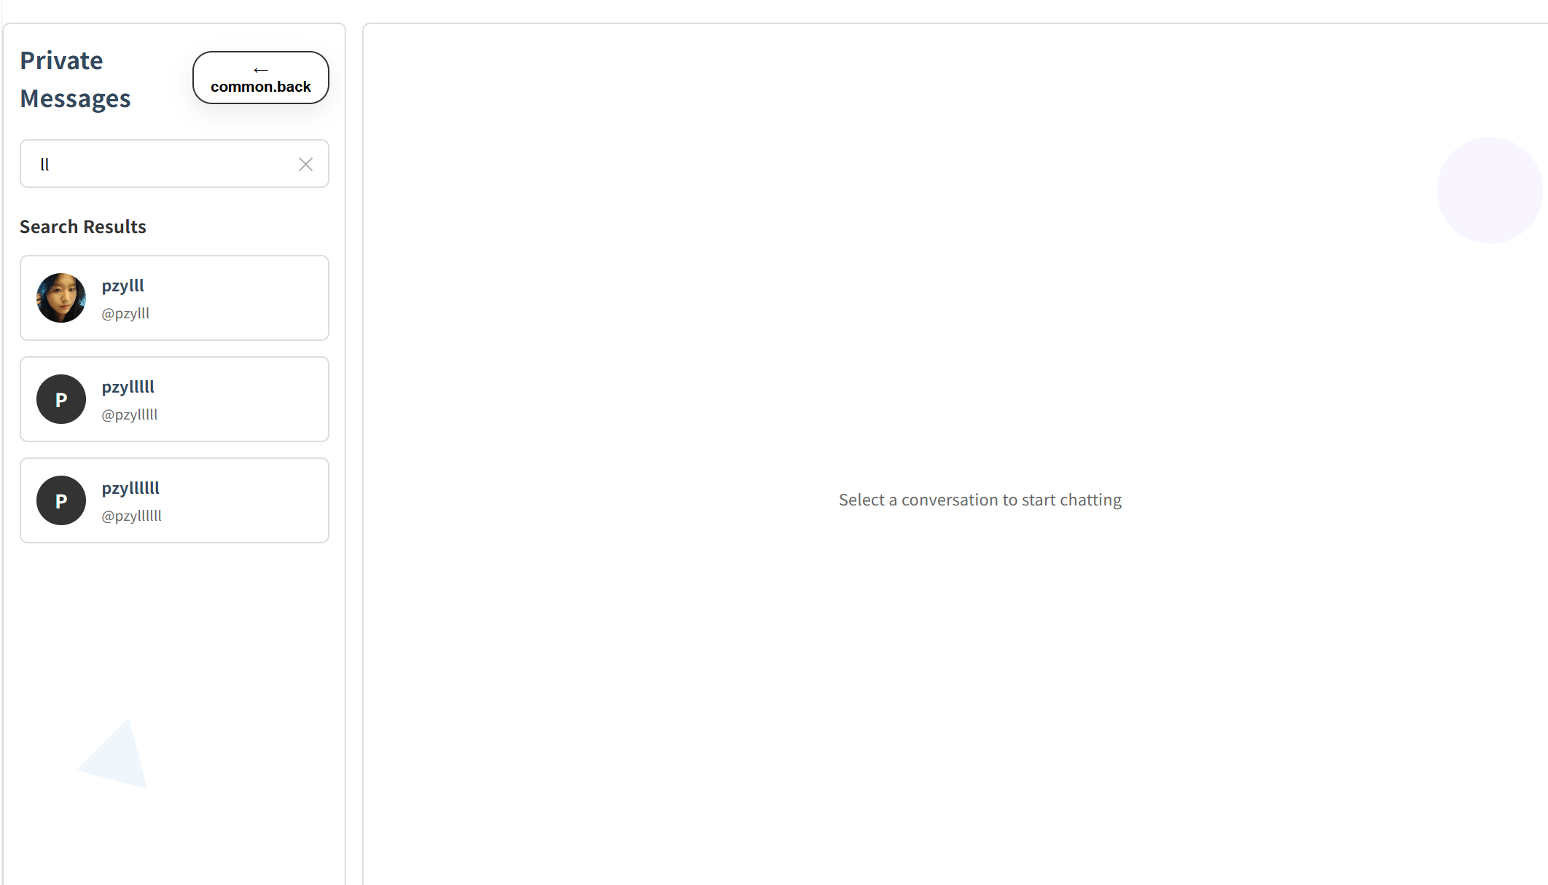

UI-07:Profile page
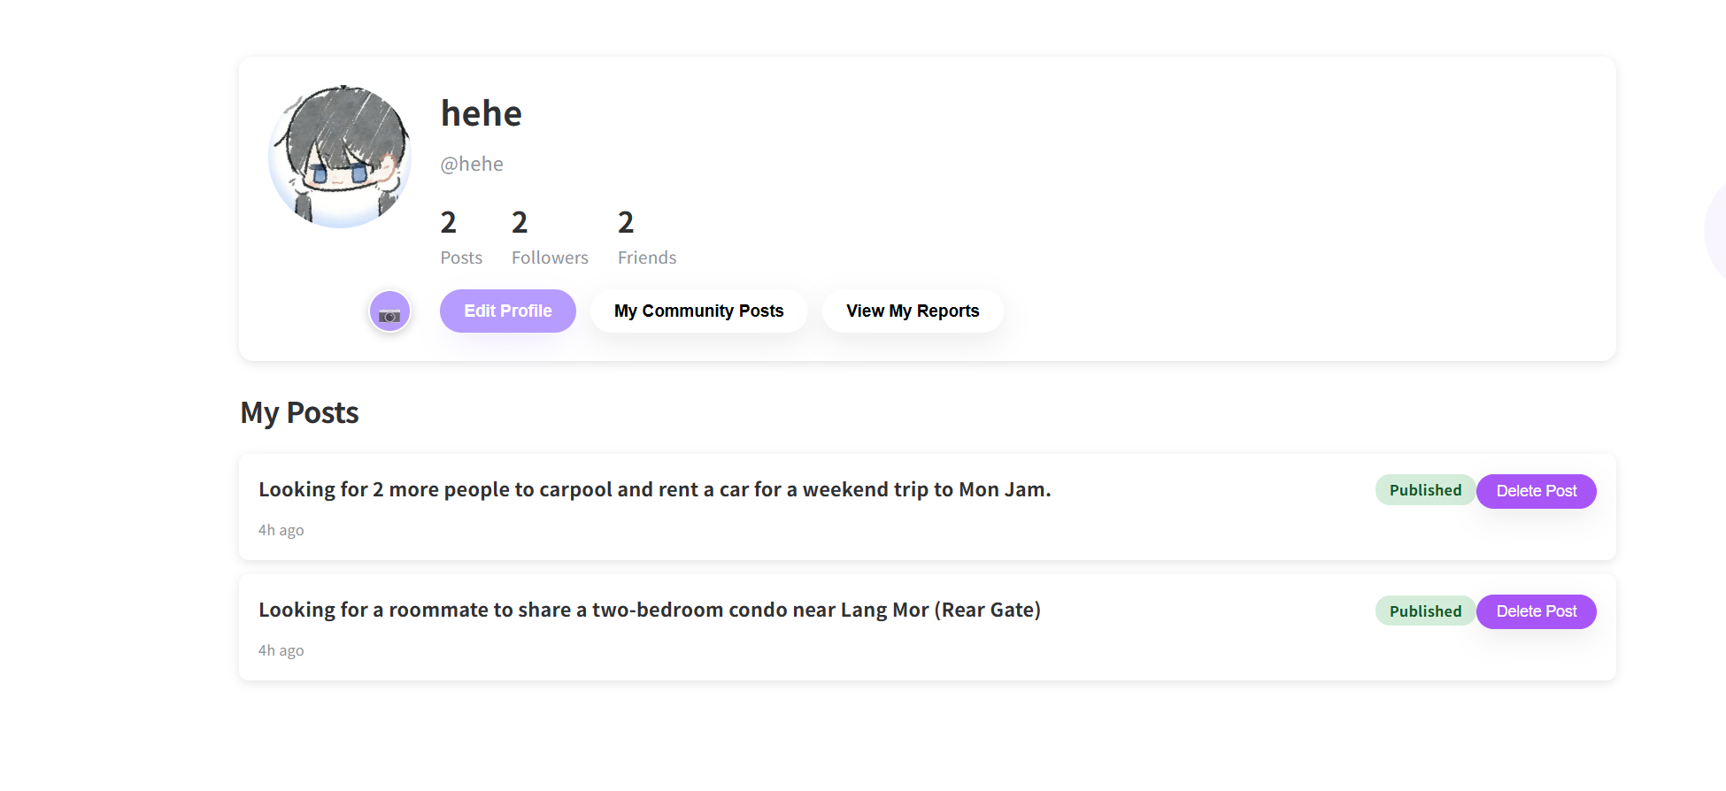

UI-07-01:Edit Profile page
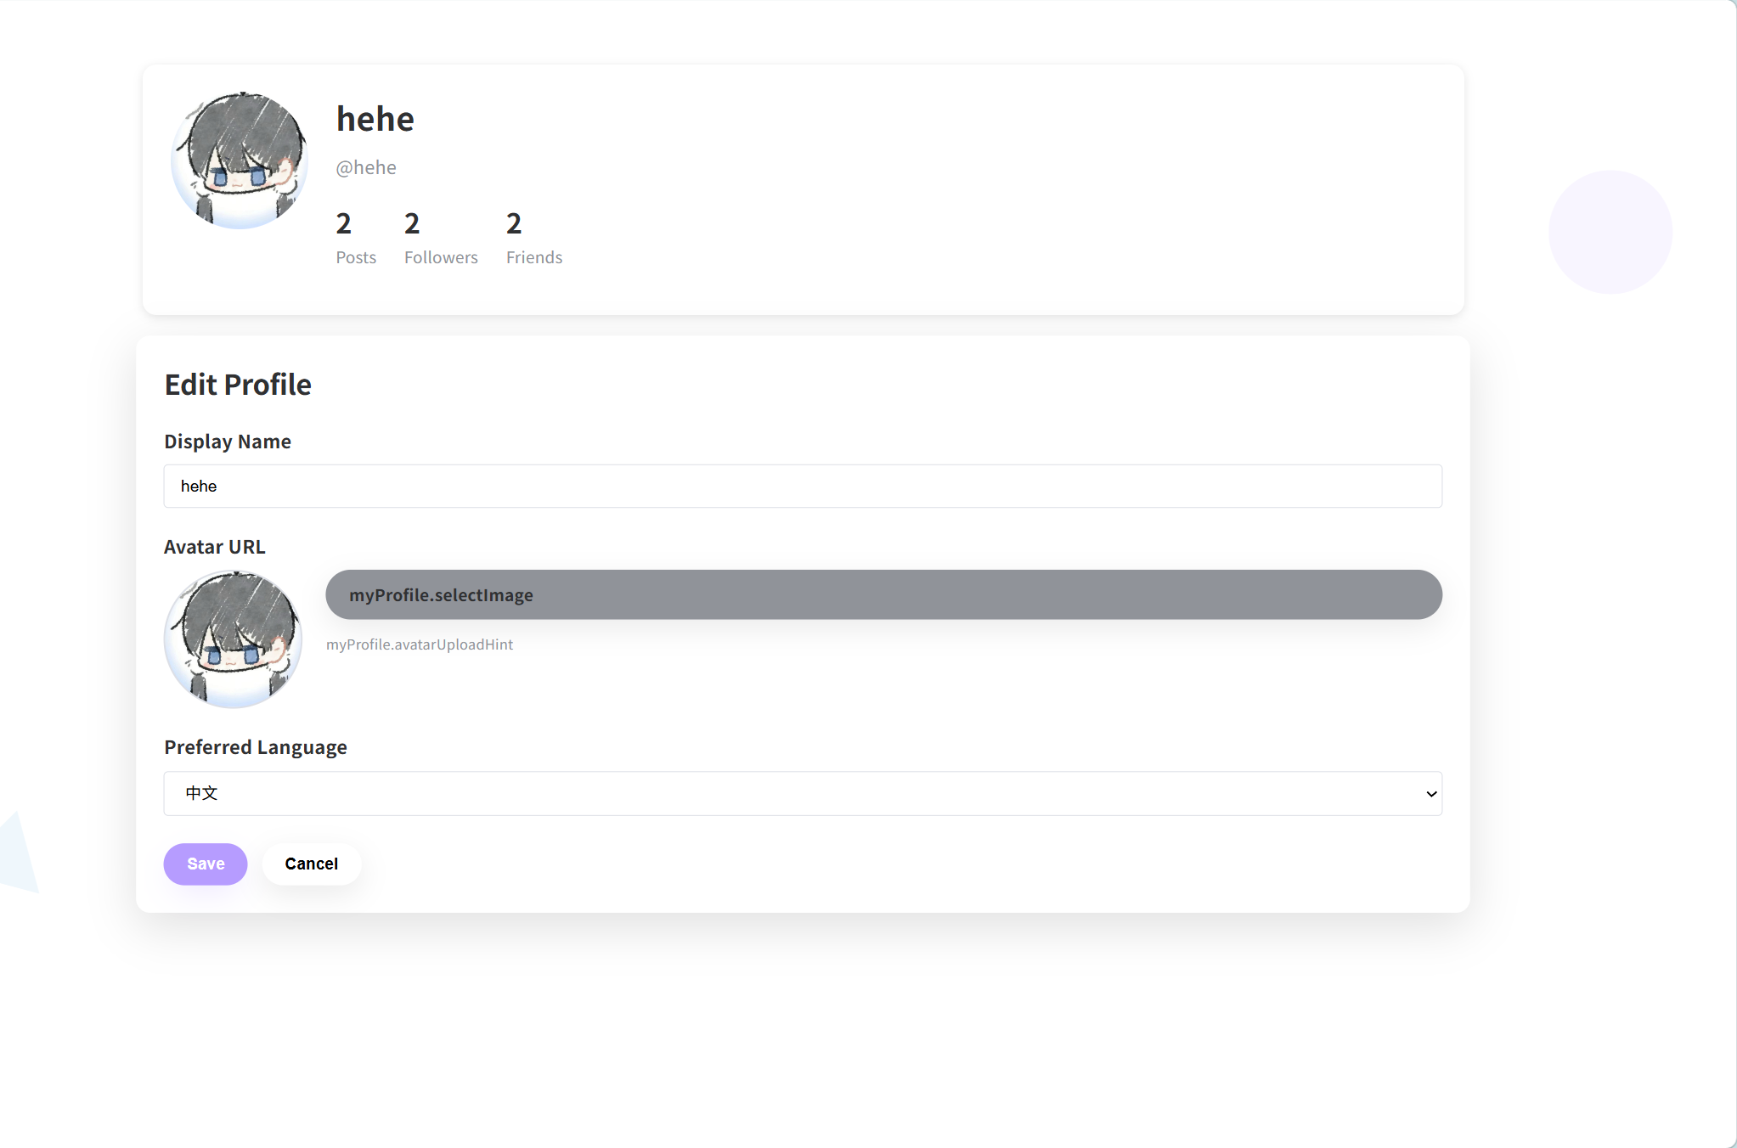

UI-07-02:Followers List Page
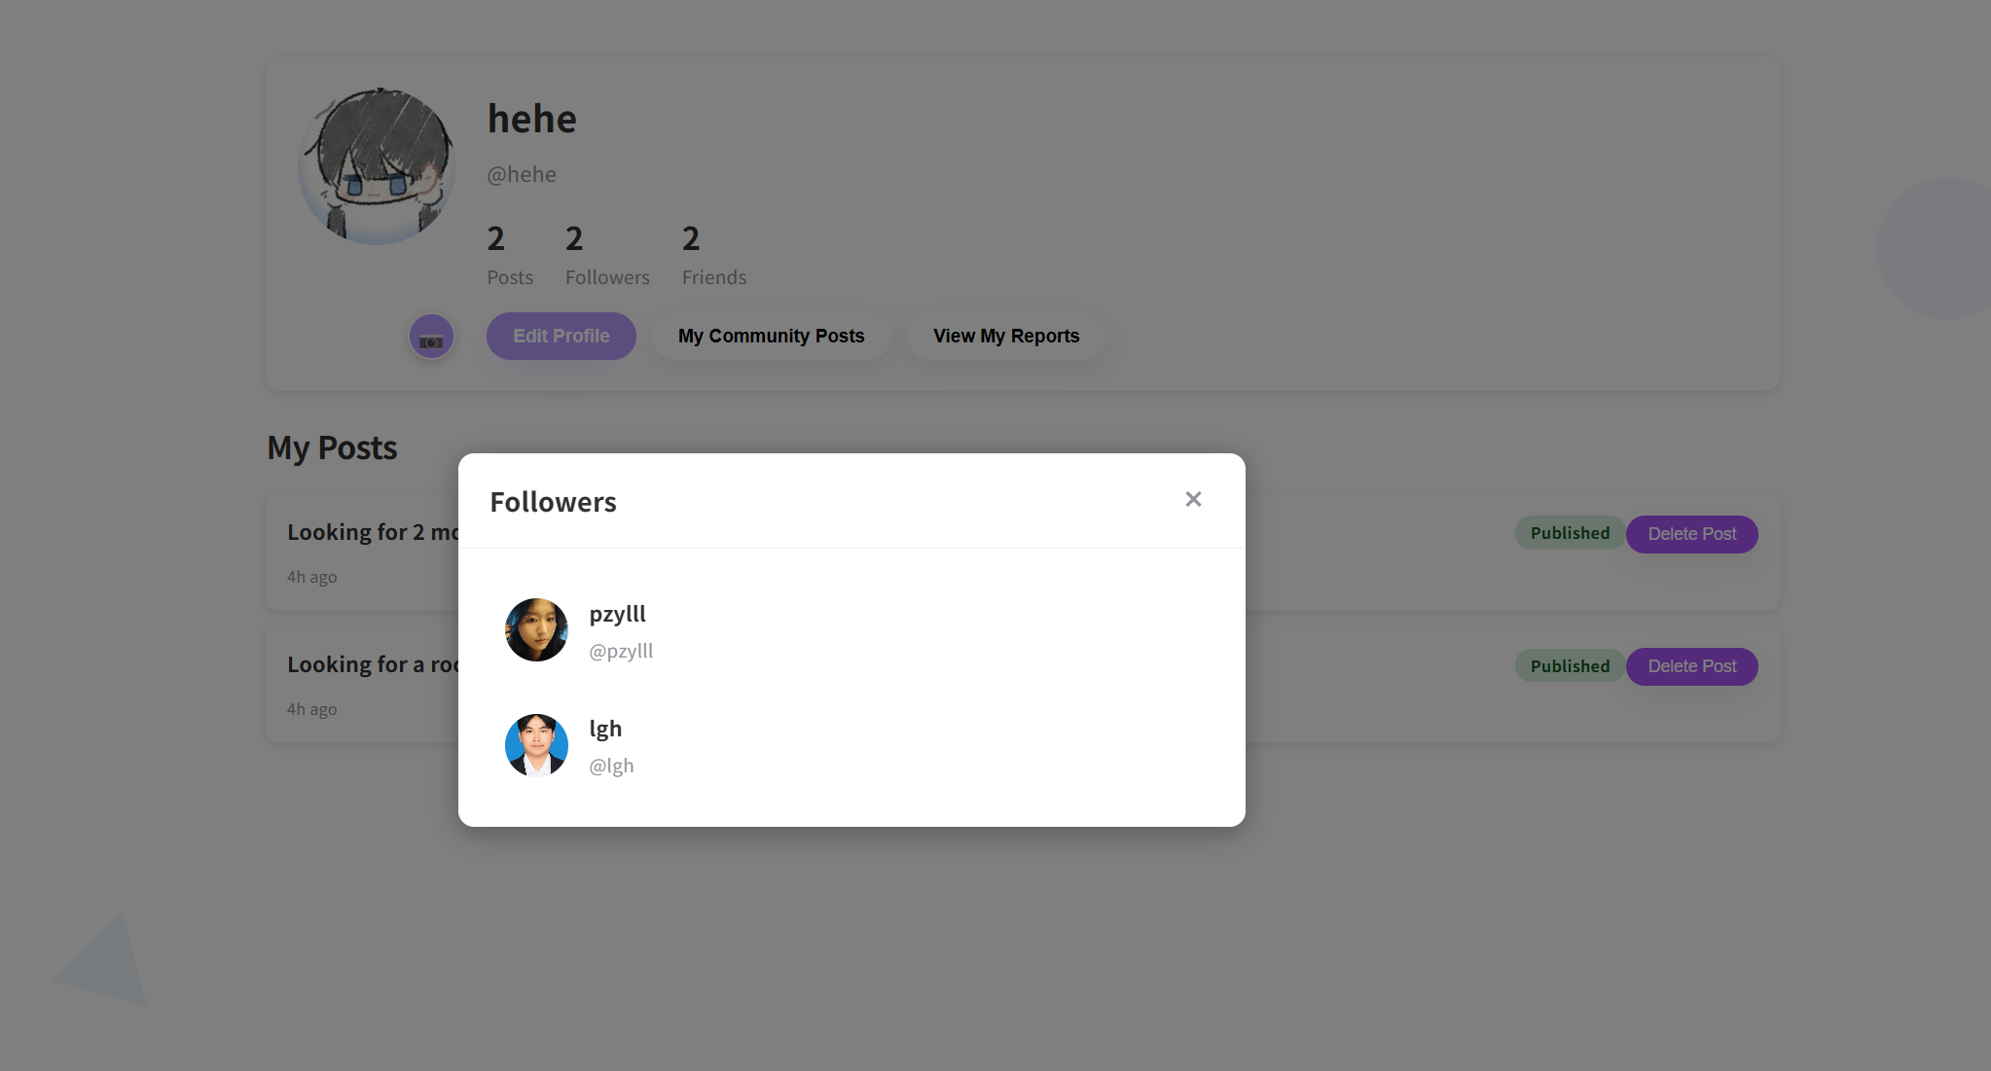

UI-07-03:Fridens List Page
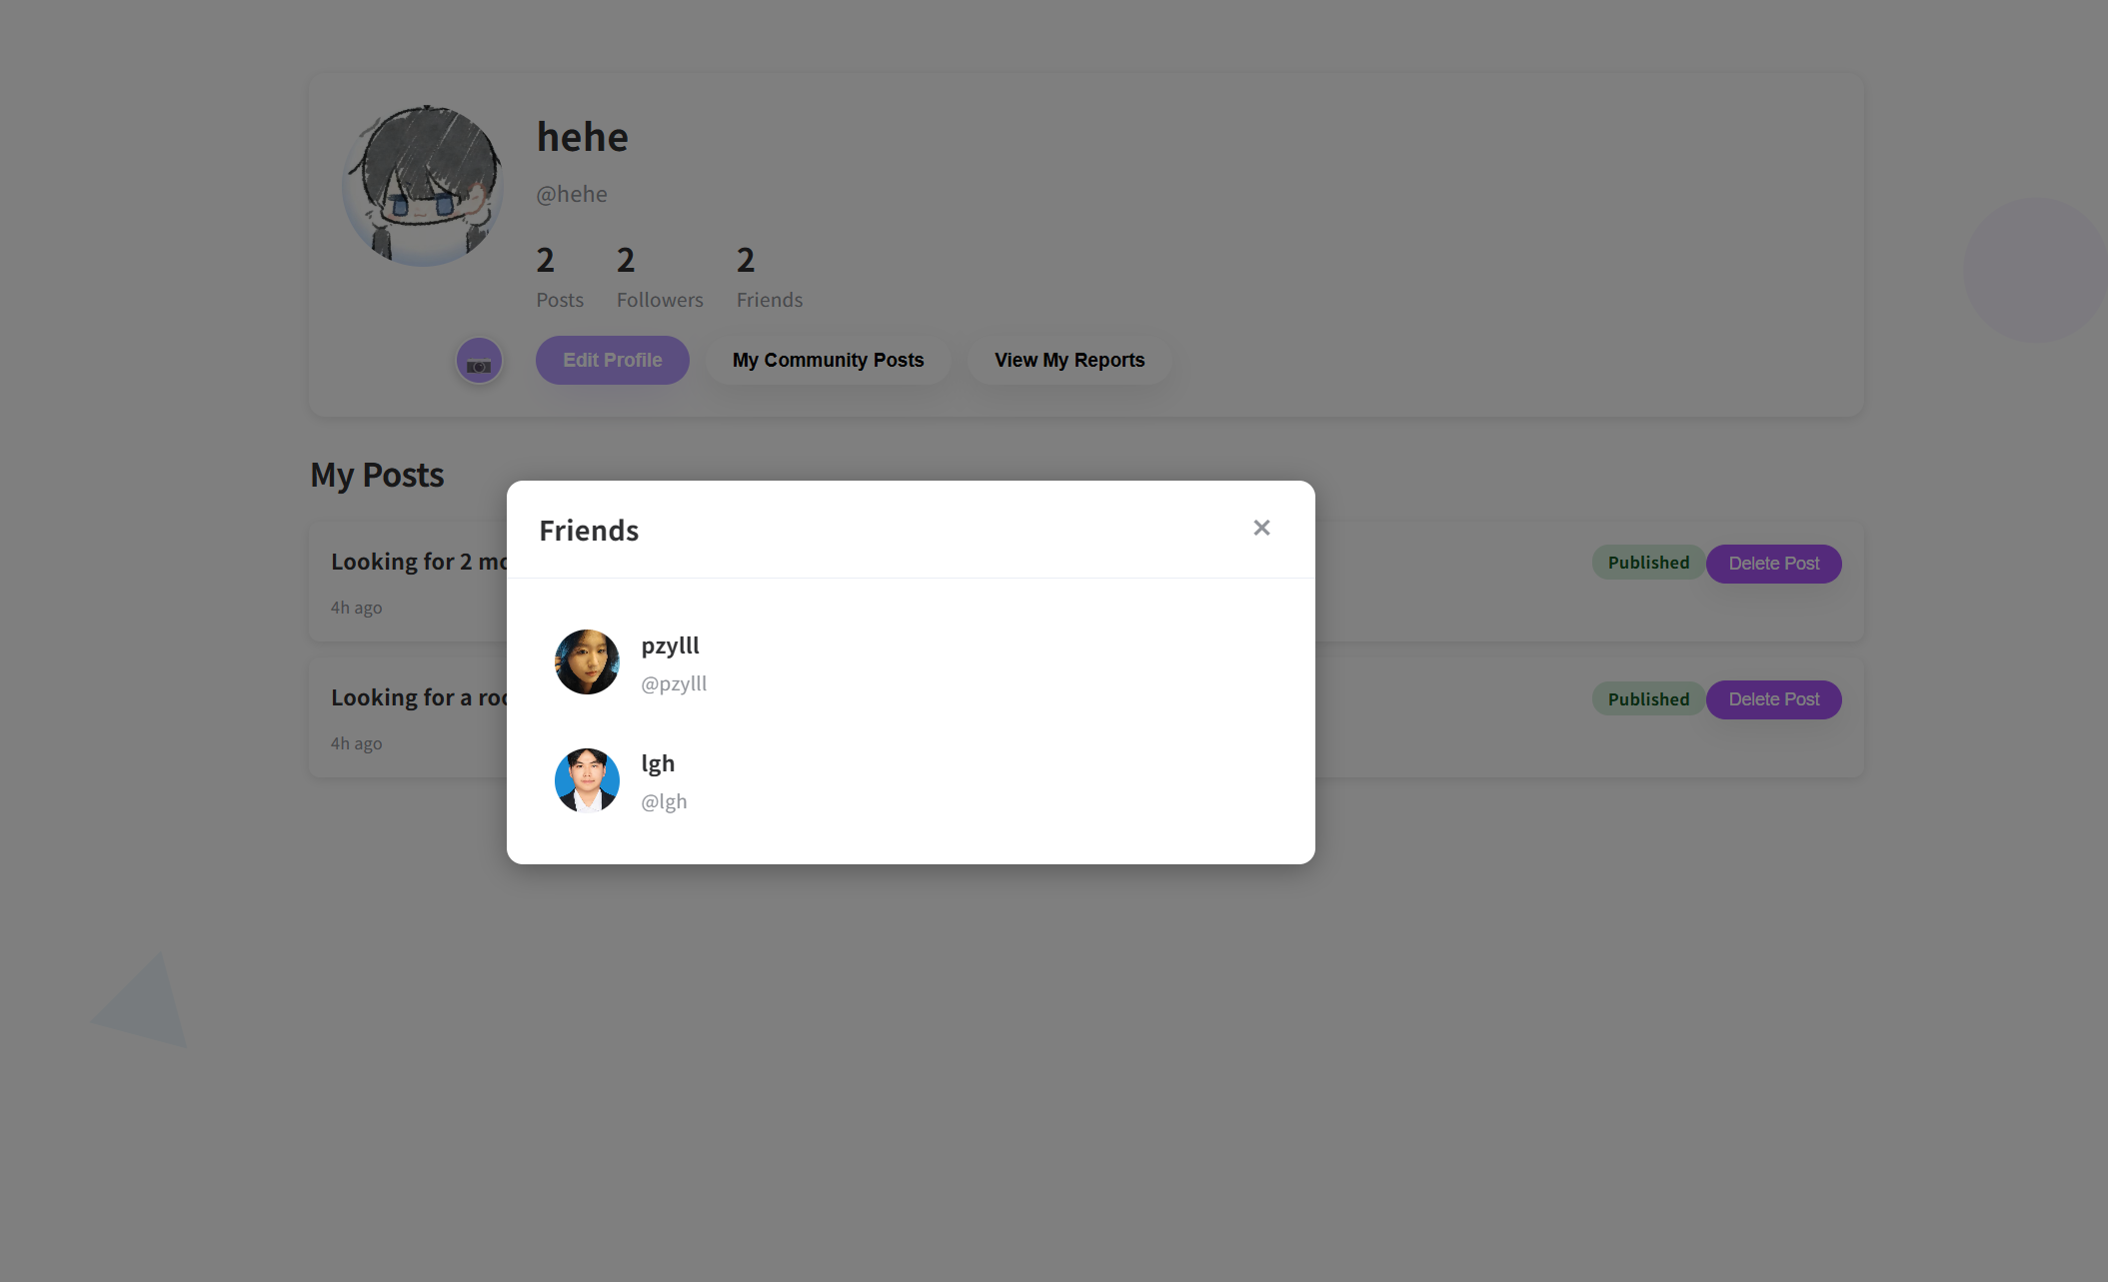

UI-08:My Community Posts Page
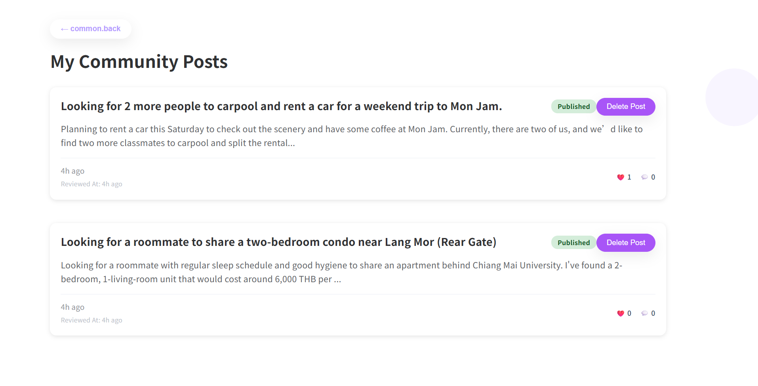

UI-09:My Reports Page
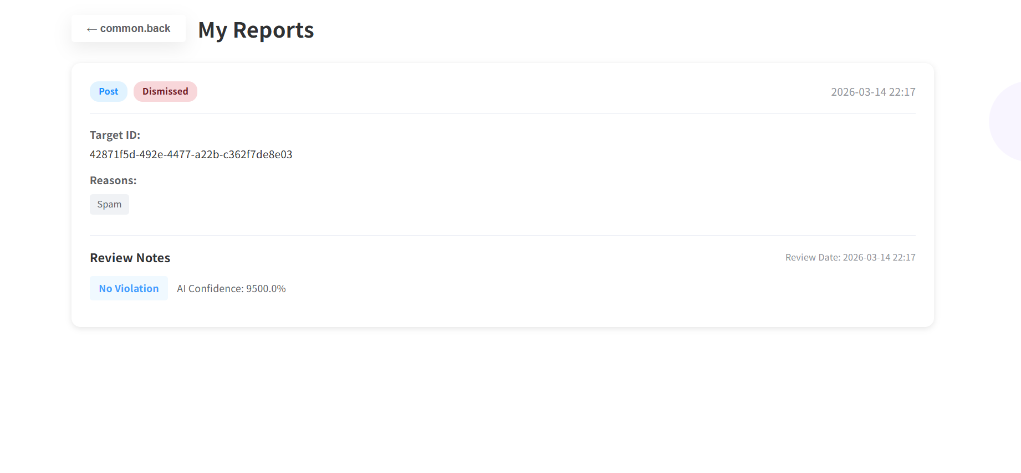
UI-10:Login Page
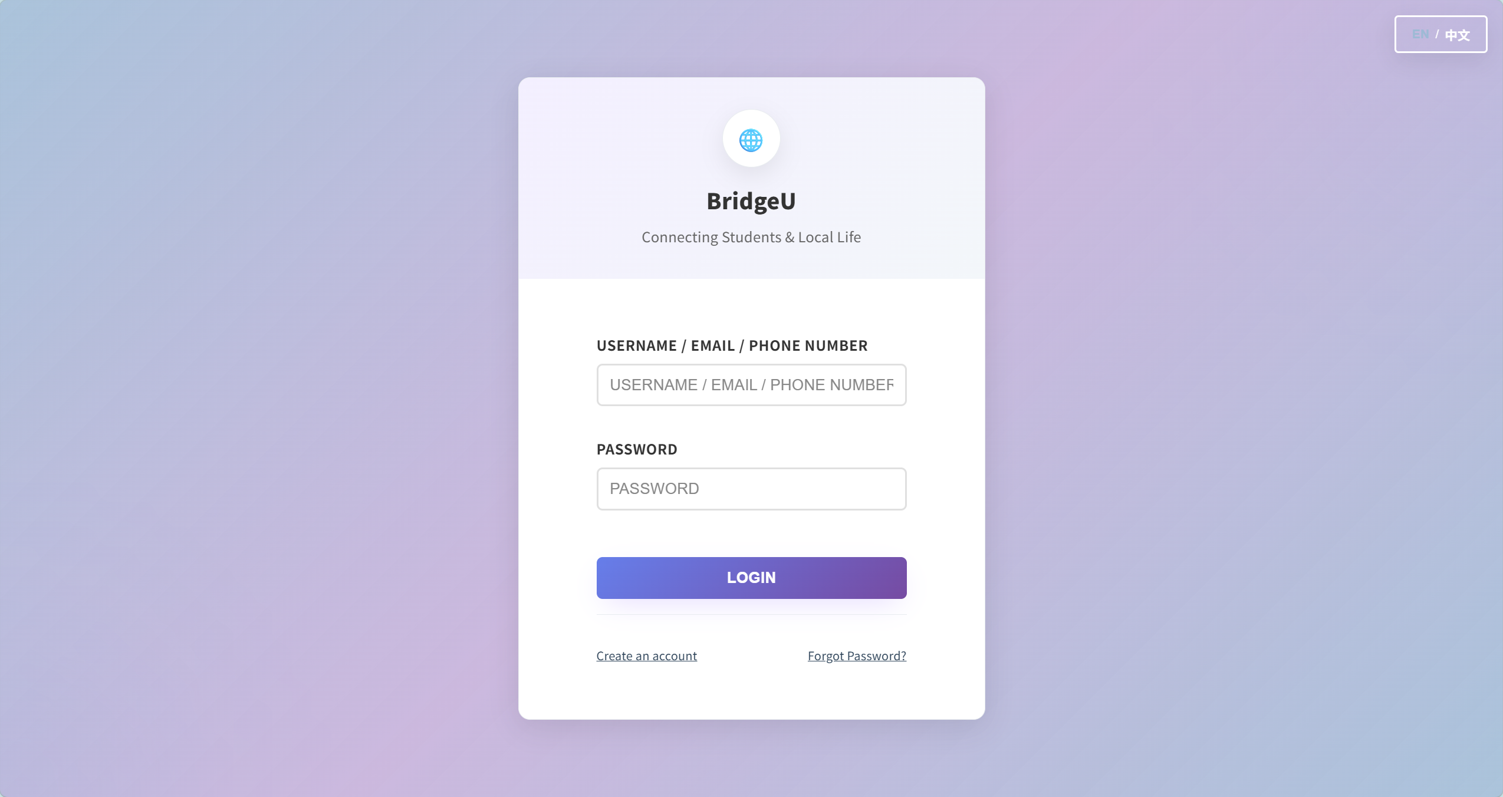

UI-11:Forgot Password Page
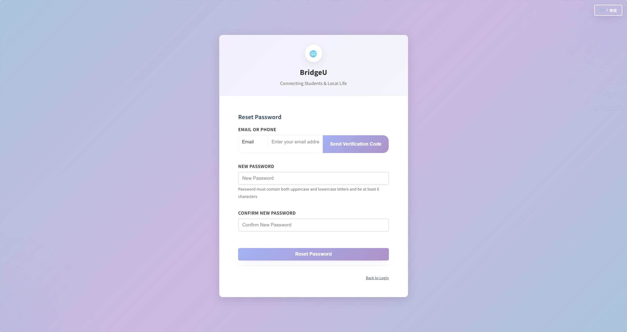

UI-12: Registration page
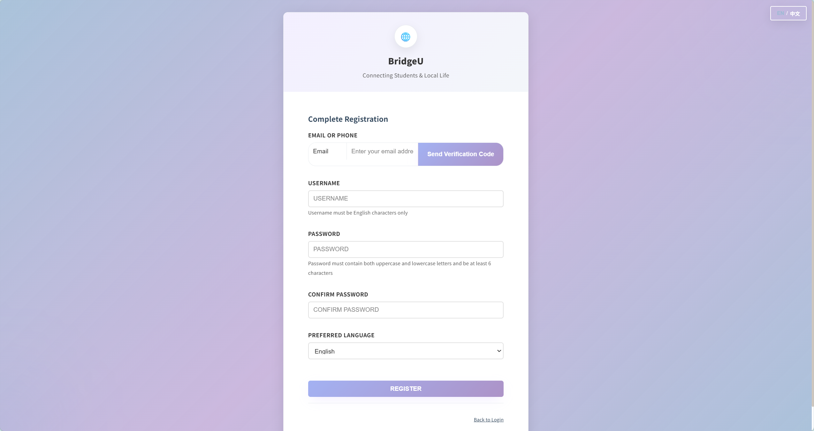

UI-13: Sidebar UI
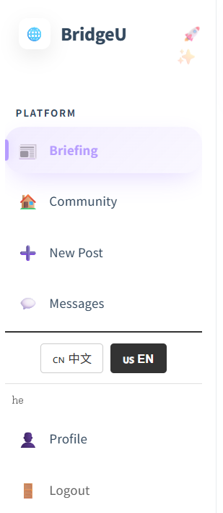

Chapter 4 Chinese and English comparison table
1. Universal button
18n Key | English | 中文
common.loading | Loading... | 加载中...
common.error | Error | 错误
common.success | Success | 成功
common.cancel | Cancel | 取消
common.confirm | Confirm | 确认
common.save | Save | 保存
common.delete | Delete | 删除
common.edit | Edit | 编辑
common.close | Close | 关闭
common.retry | retry | 重试
common.back | back | 返回
common.saving | Saving… | 保存中...

2. Login / Registration page
i18n Key | English | 中文
login.username | USERNAME | 用户名
login.email | EMAIL | 电子邮箱
login.phone | PHONE NUMBER | 手机号码
login.password | PASSWORD | 密码
login.confirmPassword | CONFIRM PASSWORD | 确认密码
login.login | LOGIN | 登录
login.register | REGISTER | 注册
login.create | Create an account | 创建新账户
login.hasAccount | Have an account? Login | 已有账户？登录
login.forgotPassword | Forgot Password? | 忘记密码？
login.backToLogin | Back to Login | 返回登录
login.pleaseWait | Please wait... | 请稍候...
login.preferredLanguage | Preferred Language | 语言偏好
login.selectMethod | Select Registration Method | 选择注册方式
login.emailOrPhone | Email or Phone | 邮箱或手机
login.sendCode | Send Verification Code | 发送验证码
login.resendCode | Resend Code | 重新发送
login.verificationCode | Verification Code | 验证码
login.verify | Verify | 验证
login.completeRegistration | Complete Registration | 完成注册
login.resetPassword | Reset Password | 重置密码

3. Sidebar navigation
i18n Key | English | 中文
sidebar.platform | PLATFORM | 平台
sidebar.briefing | Briefing | 每日简报
sidebar.communityFeed | Community | 社区
sidebar.newPost | New Post | 发布帖子
sidebar.messages | Messages | 私信
sidebar.profile | Profile | 个人资料
sidebar.logout | Logout | 退出登录

4. Post list / search
i18n Key | English | 中文
postList.search | Search | 搜索
search.search | Search | 搜索
search.searching | Searching... | 搜索中...
search.noMatches | No matches | 无匹配结果

5. button on the post details page
i18n Key | English | 中文
postDetail.back | Back | 返回
postDetail.follow | Follow | 关注
postDetail.following | Following | 已关注
postDetail.addComment | Add a comment | 添加评论
postDetail.submitComment | Submit | 提交
postDetail.summarizeComments | Summarize Comments | 总结评论
postDetail.summarizing | Summarizing... | 总结中...
postDetail.report | Report | 举报
postDetail.reportPost | Report Post | 举报帖子
postDetail.reportComment | Report Comment | 举报评论
postDetail.submitReport | Submit Report | 提交举报
postDetail.myReports | My Reports | 我的举报
postDetail.viewMyReports | View My Reports | 查看我的举报
postDetail.delete | Delete | 删除
postDetail.deleting | Deleting... | 删除中...
postDetail.confirmDeleteComment | Are you sure you want to delete this comment? | 确定要删除这条评论吗？
postDetail.commentDeleted | Comment deleted successfully | 评论删除成功

6. Message
i18n Key | English | 中文
messages.title | Private Messages | 私信
messages.newConversation | New Conversation | 新建会话
messages.sendMessage | Send Message | 发送消息
messages.sending | Sending... | 发送中...
messages.deleteConversation | Delete Conversation | 删除会话
messages.confirmDelete | Are you sure you want to delete this conversation? | 确定要删除此会话吗？
messages.deleted | Conversation deleted | 会话已删除
messages.deleteFailed | Failed to delete conversation | 删除会话失败
messages.markAsRead | Mark as Read | 标记为已读

7. myProfile, myPosts.
I8n Key | English | 中文
myProfile.editProfile | Edit Profile | 编辑资料
myProfile.changeAvatar | Change Avatar | 更换头像
myProfile.updateSuccess | Profile updated successfully | 个人资料更新成功
myProfile.updateFailed | Failed to update profile | 更新个人资料失败
myProfile.saving | Saving... | 保存中...
myPosts.title | My Community Posts | 我的社区帖子

8. newPost.
i18n Key | English | 中文
newPost.title | New Post | 发布新帖
newPost.autoTranslation | Auto Translation: | 自动翻译：
newPost.selectTag | Select Tag (Mandatory) | 选择标签（必填）
newPost.community | Community | 社区
newPost.authorId | Author ID | 作者ID
newPost.postTitle | Title | 标题
newPost.content | Content | 内容
newPost.uploadImage | Upload Image (Optional) | 上传图片（可选）
newPost.publish | Publish Now | 立即发布
newPost.publishing | Publishing... | 发布中...

9. dailyBriefing, dailyBriefingDetail.
i18n Key | English | 中文
briefing.readOriginal | Read Original → | 阅读原文 →
briefing.previous | Previous | 上一页
briefing.next | Next | 下一页
dailyBriefing.filter | Filter | 筛选
dailyBriefing.reset | Reset | 重置
dailyBriefing.resetFilters | Reset Filters | 重置筛选
dailyBriefing.viewDetail | View Detail | 查看详情
dailyBriefing.readOriginal | Read Original | 阅读原文
dailyBriefingDetail.back | Back to List | 返回列表
dailyBriefingDetail.readOriginal | Read Original | 阅读原文

