BridgeU - Project Plan
System Name: BridgeU – Bilingual Community & Daily Briefing Platform for International Students in Thailand
Prepared by: ZhiYiPan
Project Advisor: Asst. Prof. Pattama Longani, Ph.D.
Date: 12/02/2026

1. Introduction

1.1 Purpose
The purpose of this Project Plan is to define the project management activities, resources, and schedule required to successfully deliver the BridgeU web application.
It provides a high-level view of the work products (Proposal, SRS, SDD, Test Plan, Source Code), clarifies responsibilities, and describes how the project will be monitored and controlled in alignment with ISO/IEC 29110 and the detailed requirements and design documented in the BridgeU-SRS and BridgeU-SDD.

1.2 Project Overview
BridgeU is a web-based platform that helps international students in Thailand adapt to local life and connect with each other and local merchants.
The system provides:
Daily Briefing System – automatically crawls news from Google News RSS, summarizes it using Qwen AI, and presents bilingual (Chinese/English) daily briefings with powerful search and date filters.
Community Interaction Platform – a bilingual forum where users can create posts, comment, like, follow each other, and use private messaging, with Qwen AI-based translation, content moderation, and comment summarization to ensure a safe environment.
Authentication & Profile Management – secure registration (email or phone + verification code), login/logout, profile editing (display name, avatar, preferred language), and a “My Community Posts” view showing post review status.
The architecture is a standard client-server web system: a Vue.js frontend communicates with a Spring Boot backend via REST APIs, persisting data in a MySQL 8 database and integrating with Aliyun Qwen AI services.

1.3 Project Scope
The project scope covers the following major functional areas (features), which are consistent with the Proposal, SRS, and SDD:

Feature #1: Daily Briefing System
- Scheduled crawling of Thai news at 8:00 AM daily from approved media sources.
- AI-generated Chinese/English titles and summaries using Qwen AI.
- Daily Briefing list with pagination, keyword search, date range and source filters, and a button to open the original news link.

Feature #2: Community Interaction Platform
- Bilingual post creation and editing with predefined tags (Study, Housing, Travel, Part-time Job, Life Services).
- Infinite-scroll community feed with keyword and tag filters, likes, comments, AI comment summary, and report functions.
- Mutual-follow management and one-to-one private messaging (conversation list, message history, read/unread/delete).

Feature #3: Authentication & Profile / My Community Activity
- Registration via email or phone with verification codes, secure password rules, and login/logout.
- Profile management (display name, avatar, preferred language) and real-time language switching across the UI.
- “My Community Posts” page showing the user’s posts and their AI review status (awaiting moderation, approved, rejected).

Non-functional scope includes performance (responsive UI, pre-generated AI summaries), security (JWT, password hashing), and maintainability (layered architecture, clear API contracts as detailed in SRS/SDD).

2. Project Deliverables (Work Products)
- Project Proposal
- Project Management Plan (PMP)
- Software Requirement Specification (SRS)
- Software Design Document (SDD)
- Software Test Plan & Test Record
- Final Software Product (Source Code & Executable)

3. Management Procedures
  - Project Team & Roles
ZhiYiPan: Responsible for Requirement Analysis, UI/UX Design, Backend Development Database Design, Integration Testing, Documentation

3.2 Monitoring and Controlling
- Meeting Schedule:
Regular consultation with the advisor to review progress, discuss issues, and validate design/testing decisions.
Additional meetings before each major milestone (Proposal defense, Progress I, Final presentation).
- Software Development Life Cycle (SDLC):
The project adopts an “iterative and incremental” approach aligned with ISO/IEC 29110:
Iteration 1 (Proposal & Architecture): clarify objectives, target users, high‑level features, and architecture.
Iteration 2 (Progress I): complete SRS and SDD, implement “Feature 1”, and prepare initial test cases.
Iteration 3 (Final Progress): implement “Feature 2” and “Feature 3”, refine design, and complete full testing and documentation.

4. Quality Standards
This project follows the ISO/IEC 29110 standard for Very Small Entities (VSE), focusing on two main processes:
- Project Management (PM) Process:
Establish clear scope, schedule, roles, and risks in the Project Plan.
Periodically assess progress against the milestone plan and adjust when needed.
Perform formal closure with final report, presentation, and advisor evaluation.
- Software Implementation (SI) Process:
analysis, design, construction, and testing:
Requirements are documented in `BridgeU-SRS.md` with use cases and non‑functional constraints.
Design is captured in `BridgeU-SDD` (architecture, DFDs, ERD, data dictionary, component design).
Construction follows a layered architecture (Controller → Service → Repository → Entity/DTO) as described in the SDD.
Testing is guided by `BridgeU-TestPlan.md`, including unit, integration, and system tests, and recorded to provide objective evidence of requirement coverage.

5. Software Configuration Management

5.1 Naming Conventions
Format: BridgeU-[DocumentName]_v[Version].[Extension]
- Example: BridgeU-ProjectPlan_v1.0.docx

5.2 Project Repository
- Document Storage: Microsoft OneDrive
- Version Control: GitHub

6. Project Schedule & Milestones
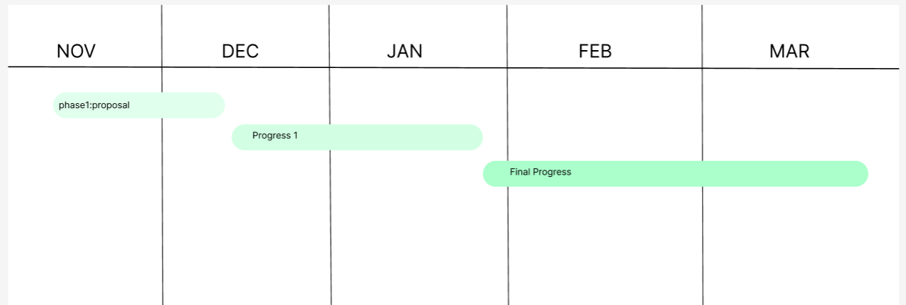
Phase 1. Proposal: 20 Nov 2025 –19 DEC 2025=29 days
Phase 2. Progress I: 20 DEC 2025 –26 Jan 2026 = 36 days
Phase 3. Final Progress: 26 Jan 2026 –20 Mar 2026 = 54 days
Phase 1. Proposal: 20 Nov 2025 –19 Dec 2025=29 days
Tasks | Start date | End date | Duration | Responsibility
Research and writing proposal document | 20 November 2025 | 9 December 2025 | 19 | ZHIYI PAN
Prepare for the Presentation | 9 December 2025 | 19 December 2025 | 10 | ZHIYI PAN

Phase 2. Progress I: 25 Dec 2025 –26 Jan = 36 days
Tasks | Start date | End date | Duration | Responsibility
Software requirement specification document | 25 December 2025 | 28 December 2025 | 3 | ZHIYI PAN
Project plan document | 28 December 2025 | 31 December 2025 | 3 | ZHIYI PAN
Software design document | 1 January 2026 | 8 January 2026 | 7 | ZHIYI PAN
Feature #1 implement | 8 January 2026 | 22 January 2026 | 13 | ZHIYI PAN
Prepared Progress I report and presentation | 20 January 2026 | 26 January 2026 | 6 | ZHIYI PAN
Phase 3. Final Progress: 26 Jan 2026 –20 Mar 2026 = 54 days
Tasks | Start date | End date | Duration | Responsibility
Feature #2 implement | 27 January 2026 | 10 February 2026 | 13 | ZHIYI PAN
Feature #3 implement | 11 February 2026 | 25 February 2026 | 13 | ZHIYI PAN
Test code | 26 February 2026 | 11 March 2026 | 15 | ZHIYI PAN
Prepared final report and presentation | 12 March 2026 | 25 March 202 | 13 | ZHIYI PAN

