BridgeU
Test Plan

Zhiyi Pan 652115558

Bachelor of Science
Software Engineering Program

Department College of Arts,Media,and
Technology
Chiang Mai University
January 2026
Project Advisor
Pattama Longani, Ph.D.

Chapter 1 Introduction
1.1 Purpose and Scope
The purpose of the Test Plan document for the BridgeU system is to establish a test plan of the unit testing to discover the potential bugs or defects. The unit testing covers all implemented methods in the BridgeU system.

1.2 Acronyms and Definitions
Acronyms
URS | User Requirement Specification
UTC | Unit Test Case
STC | System Test Case
TD | Test Data
SRS | Software Requirement Specification
SDD | Software Design Development
API | Application Programming Interface
REST | Representational State Transfer
HTTP | Hypertext Transfer Protocol
JSON | JavaScript Object Notation
JWT | JSON Web Token
RSS | Really Simple Syndication

Definition
Name | Definition
Test Plan | A document that describes the scope, approach, resources, and schedule of intended test activities. It identifies test items, the features to be tested, the testing tasks, who will do each task, and any risks requiring contingency planning.
Unit Test | A test of individual programs or modules in order to remove design or programming errors. In the context of BridgeU, unit tests verify the functionality of individual methods in Vue.js components, Spring Boot controllers, services, and repositories.
System Testing | Testing conducted on a complete and integrated system to evaluate the system's compliance with its specified requirements. For BridgeU, system testing verifies the integration between frontend Vue.js components and backend Spring Boot API endpoints.
Test Case | A set of test inputs, execution conditions, and expected results developed for a particular objective, such as to exercise a particular program path or to verify compliance with a specific requirement. Each test case in BridgeU includes Test ID, Test Function, Description, Input, and Expected Result.
Test Coverage | The degree to which a test suite exercises the code or requirements. In BridgeU test plan, coverage includes all implemented methods in the Daily Briefing System feature, including frontend component methods and backend API endpoints.
Daily Briefing | A news aggregation feature in BridgeU that automatically captures and summarizes Thai news from approved government and mainstream media sources via Google News RSS, providing bilingual (Chinese/English) access to daily news briefings for international students.
NewsBriefDTO  Pagination | Data Transfer Object used in BridgeU backend to transfer news summary data from the server to the frontend. It contains translated title and summary in the requested language (Chinese or English), excluding Thai content.
Bilingual Interface | A user interface that supports multiple languages. BridgeU Daily Briefing System supports both Chinese (zh) and English (en) interfaces, allowing users to switch between languages dynamically.
Date Filter | A filtering mechanism that allows users to filter news items by publication date range. In BridgeU, users can specify start date and end date to retrieve news published within a specific time period.
Keyword Search | A search functionality that allows users to find news items containing specific keywords. In BridgeU, keyword search queries across multiple fields including title, summary, and translation fields (titleZh, summaryZh, titleEn, summaryEn).
Traceability | The ability to trace the history, application or location of an item or activity, or work products or activities, by means of recorded identification. In BridgeU test plan, traceability ensures that test cases can be traced back to specific requirements and use cases.
Pagination | A mechanism for dividing a large dataset into smaller, manageable pages. In BridgeU Daily Briefing System, pagination allows users to browse news items page by page, with configurable page size (default 10 items per page).

Chapter 2 Test Plan and Test Procedure
2.1 Test Objective
The objectives of testing the BridgeU system are:
1. To detect and fix all bugs and defects across all system features
2. To cover all functional, non-functional, and user interface-related requirements
3. To ensure that all API endpoints return correct responses according to the specifications
4. To validate that all user interactions (search, filter, pagination, etc.) work as expected
5. To ensure proper error handling and user feedback mechanisms throughout the system
6. To verify integration between frontend and backend components
7. To validate data consistency and integrity across all features
2.2 Scope of Testing
The scope of testing covers all BridgeU system essential functions using unit testing, system testing, and integration testing.
2.3 Test Responsibility
Name | Responsibility
Unit Test | ZhiYiPan
System Test | ZhiYiPan
Test Record | ZhiYiPan

2.4 Test Strategy
The BridgeU system testing follows a structured approach:
Test Planning:
Test case design based on use case descriptions and system requirements
Test data preparation and environment setup
Test schedule and resource allocation
Test Case Design:
Each test case includes Test ID, Test Function, Description, Input, and Expected Result
Test cases are designed based on use case descriptions and system requirements
Test cases cover both normal flows and exception flows
Test cases are organized by feature and test level (unit, system, integration)
Test Execution:
Unit tests are executed for individual methods and functions
System tests are executed for complete feature workflows
Integration tests verify component interactions
Test results are recorded with actual outputs and pass/fail status
Test Documentation:
All test cases are documented with clear descriptions and expected results
Test execution results are recorded with timestamps
Failed tests are logged with detailed error messages and steps to reproduce

2.5 Result of Testing

Test Execution:
Each test case is executed and produces an actual output
Test results are compared against expected results
Pass/Fail Criteria:
Pass: The actual result matches the expected result exactly
Fail: The actual result differs from the expected result, or an unexpected error occurs
Test Record:
All test results are documented with timestamps and execution details
Failed tests are logged with detailed error messages, stack traces, and steps to reproduce
Test coverage reports are generated to ensure all methods and use cases are tested
Test summary reports provide an overview of test execution status and coverage metrics

Chapter 3 Unit test

3.1 Feature 1

3.1.1 Unit Test Cases

3.1.1.1 UTC-01: Test fetchDailyBriefing()
Description: Tests the frontend component method for fetching daily briefing list, verifying it correctly handles pagination, language parameters, search keywords, date filters, and properly processes API responses and error cases.
Test ID: UTC-01
Test Function: fetchDailyBriefing()
Test Cases:
ID | Description | Input | Expected Result
1 | Verify that fetchDailyBriefing() successfully retrieves news list with default parameters | {  "currentPage": 0,  "pageSize": 10,  "currentLang": "en",  "searchKeyword": "",  "filterStartDate": null,  "filterEndDate": null  } | {  "apiRequest": {  "method": "GET",  "url": "/api/news/daily-briefing",  "params": { "page": 0, "size": 10, "lang": "en" }  },  "newsList": "array of news items",  "pagination": {  "totalElements": "> 0",  "totalPages": ">= 1"  },  "loading": false,  "error": null  }
2 | Verify that fetchDailyBriefing() handles API error response correctly | {  "apiResponse": {  "success": false,  "message": "Error message"  }  } | {  "error": "Error message",  "loading": false,  "newsList": "keeps previous value (not reset to empty array)"  }
3 | Verify that fetchDailyBriefing() includes keyword parameter when searchKeyword is provided | {  "searchKeyword": "Thailand"  } | {  "apiRequest": {  "params": {  "keyword": "Thailand"  }  }  }
4 | Verify that fetchDailyBriefing() includes date parameters when filters are provided | {  "filterStartDate": "2026-01-01",  "filterEndDate": "2026-01-31"  } | {  "apiRequest": {  "params": {  "startDate": "2026-01-01",  "endDate": "2026-01-31"  }  }  }
5 | Verify that fetchDailyBriefing() includes language parameter | API request includes params.lang = "zh" (and page=0, size=10) | API request includes params.lang = "zh"

3.1.2 UTC-02: Test fetchNewsDetail()
Description:Tests the frontend component method for fetching news details, verifying it correctly retrieves news details based on news ID and language parameters, and handles 404 errors and network errors.
Test ID: UTC-02
Test Function: fetchNewsDetail()
Test Cases:
ID | Description | Input | Expected Result
1 | Verify that fetchNewsDetail() successfully retrieves news detail | {  "newsId": 123,  "currentLang": "en"  } | {  "news": {  "id": 123,  "title": "not empty",  "summary": "not empty"  },  "loading": false,  "error": null  }
2 | Verify that fetchNewsDetail() handles 404 error when news not found | {  "apiResponse": {  "status": 404  }  } | {  "error": "dailyBriefingDetail.notFound",  "loading": false,  "news": null  }
3 | Verify that fetchNewsDetail() includes language parameter | {  "currentLang": "zh"  } | {  "apiRequest": {  "params": {  "lang": "zh"  }  }  }
4 | Verify that fetchNewsDetail() sets originalContent when available and not Thai | {  "apiResponse": {  "originalContent": "English content"  }  } | {  "originalContent": "English content"  }
5 | Verify that fetchNewsDetail() sets originalContent to null when content is Thai | {  "apiResponse": {  "content": "Thai content"  }  } | {  "originalContent": null  }

3.1.1.3 UTC-03: Test handleSearch()
Description:Tests the frontend component method for handling search operations, verifying it resets pagination, triggers search requests, and correctly handles clearing search keywords.
Test ID: UTC-03
Test Function: handleSearch()
Test Cases:
ID | Description | Input | Expected Result
1 | handleSearch() resets currentPage=1 and triggers fetchDailyBriefing() | {  "currentPage": 5,  "searchKeyword": "Thailand"  } | {  "currentPage": 1,  "fetchDailyBriefingCalled": true  }

3.1.1.4 UTC-04: Test applyFilters()
Description:Tests the frontend component method for applying date filters, verifying it correctly sets start and end dates, resets pagination, and triggers data refetch.
Test ID: UTC-04
Test Function: applyFilters()
Test Cases:
ID | Description | Input | Expected Result
1 | applyFilters() validates invalid date range and does not fetch | {  "filterStartDate": "2026-01-31",  "filterEndDate": "2026-01-01"  } | {  "warningMessageDisplayed": true,  "fetchDailyBriefingCalled": false  }

3.1.1.5 UTC-05: Test resetFilters()
Description:Tests the frontend component method for resetting filters, verifying it clears date filters and search keywords,resets pagination, and refetches all news data.
Test ID: UTC-05
Test Function: resetFilters()
Test Cases:
ID | Description | Input | Expected Result
1 | Verify that resetFilters() clears all filter values | {  "searchKeyword": "test",  "filterStartDate": "2026-01-01",  "filterEndDate": "2026-01-31",  "currentPage": 5  } | {  "searchKeyword": "",  "filterStartDate": null,  "filterEndDate": null,  "currentPage": 1,  "fetchDailyBriefingCalled": true  }

3.1.1.6 UTC-06: Test handlePageChange()
Description:Tests the frontend component method for handling page changes, verifying it correctly updates the current page number and refetches news data for the corresponding page.
Test ID: UTC-06
Test Function: handlePageChange(page)
Test Cases:
ID | Description | Input | Expected Result
1 | handlePageChange(page) updates currentPage, triggers fetch, and scrolls to top. | {  "page": 3  } | {  "currentPage": 3,  "fetchDailyBriefingCalled": true,  "windowScrollToCalledWith": { "top": 0, "behavior": "smooth" }  }

3.1.1.7 UTC-07: Test normalizeDateValue()
Description: Tests the utility method for normalizing date values, verifying it correctly handles various date input formats (strings, Date objects, null, etc.) and returns normalized date values.
Test ID: UTC-07
Test Function: normalizeDateValue(value)
Test Cases:
ID | Description | Input | Expected Result
1 | normalizeDateValue(value) normalizes Date and string inputs { | {  "inputs": ["Date(2026-01-02)", "2026-12-25", "yyyy-01-Tu"]  } | {  "returnValues": ["2026-01-02", "2026-12-25", null]  }

3.1.1.8 UTC-08: Test formatDate()
Description: Tests the utility method for formatting dates, verifying it correctly formats date displays based on the current interface language (Chinese or English) and handles various date input formats.
Test ID: UTC-08
Test Function: formatDate(date)
Test Cases:
ID | Description | Input | Expected Result
1 | formatDate(date) returns dd-MM-yyyy HH:mm and handles invalid input | {  "inputs": ["Date(2026-01-02 03:04)", "invalid-date"]  } | {  "returnValues": ["02-01-2026 03:04", ""]  }
3.1.1.9 UTC-09: Test convertToDTO()
Description:Tests the backend service method for converting news entities to Data Transfer Objects (DTOs), verifying it correctly selects Chinese or English versions of titles and summaries based on the language parameter.
Test ID: UTC-09
Test Function: convertToDTO(news, lang)
Test Cases:

ID | Description | Input | Expected Result
1 | convertToDTO(news, lang) Thai title never leaks; uses EN fallback when lang=zh and EN translation exists | {  "news": { "title": "Thai", "summary": "Thai", "titleZh": "", "summaryZh": "", "titleEn": "English Title", "summaryEn": "English Summary" },  "lang": "zh"  } | {  "dto": { "title": "English Title", "summary": "English Summary" }  }
2 | convertToDTO(news, lang) uses Chinese translation when lang=zh | {  "news": { "titleZh": "中文标题", "summaryZh": "中文摘要" },  "lang": "zh"  } | {  "dto": { "title": "中文标题", "summary": "中文摘要" }  }
3 | convertToDTO(news, lang) uses English translation when lang=en | {  "news": { "titleEn": "English Title", "summaryEn": "English Summary" },  "lang": "en"  } | {  "dto": { "title": "English Title", "summary": "English Summary" }  }

3.1.1.10 UTC-10: Test getDailyBriefing() – Backend
Description:Tests the backend controller API method for retrieving daily briefing list, verifying it correctly handles pagination, language, date filtering, keyword search parameters, and returns appropriate response data.
Test ID: UTC-10
Test Function: getDailyBriefing()
Test Cases:
ID | Description | Input | Expected Result
1 | Verify that getDailyBriefing() returns paginated news list with default parameters | {  "page": 0,  "size": 10,  "lang": "en",  "startDate": null,  "endDate": null,  "keyword": null  } | {  "success": true,  "data": "array of NewsBriefDTO",  "pagination": {  "totalElements": ">= 0",  "totalPages": ">= 0"  },  }
2 | getDailyBriefing() filters by keyword (trimmed) | {  "keyword": "Thailand"  } | {  "httpStatus": 200,  "success": true,  "data": "array size >= 0 (test asserts size=1 for prepared mock page)",  "assertions": [  "keyword is trimmed before repository call",  "NewsRepository.findByKeyword(\"Thailand\", pageable) is called",  "NewsRepository.findAll(pageable) is NOT called"  ]  }
3 | getDailyBriefing() filters by publish date range | {  "startDate": "2026-01-01",  "endDate": "2026-01-31"  } | {  "httpStatus": 200,  "success": true,  "data": "array size >= 0 (test asserts size=1 for prepared mock page)",  "assertions": [  "NewsRepository.findByPublishDateBetweenOrdered(start,end,pageable) is called",  "NewsRepository.findAll(pageable) is NOT called"  ]  }
4 | getDailyBriefing() combines keyword + publish date filters | {  "keyword": "Thailand",  "startDate": "2026-01-01",  "endDate": "2026-01-31"  } | {  "httpStatus": 200,  "success": true,  "data": "array size >= 0 (test asserts size=1 for prepared mock page)",  "assertions": [  "NewsRepository.findByKeywordAndPublishDateBetween(\"Thailand\", start, end, pageable) is called"  ]}
5 | getDailyBriefing() ignores invalid date format and returns ALL news | {  "startDate": "invalid-date"  } | {  "httpStatus": 200,  "success": true,  "data": "array size >= 0 (test asserts size=0 for prepared empty page)",  "assertions": [  "invalid date is ignored",  "NewsRepository.findAll(pageable) is called",  "NewsRepository.findByPublishDateBetweenOrdered(...) is NOT called"  ]  }
6 | getDailyBriefing() returns error response on exception | {  "error": "Database connection error"  } | {  "success": 500,  "message": contains 'Database connection error  "  }

3.1.1.11 UTC-11: Test getNewsDetail() – Backend
Description: Tests the backend controller API method for retrieving news details, verifying it correctly returns news details based on news ID and language parameters, and handles cases where news does not exist.
Test ID: UTC-11
Test Function: getNewsDetail()
Test Cases:

ID | Description | Input | Expected Result
1 | Verify that getNewsDetail() returns news detail for valid ID | {  "id": 123,  "lang": "en"  } | {  "success": true,  "data": {  "id": 123,  "title": "not empty",  "summary": "not empty"  }  }
2 | Verify that getNewsDetail() returns 404 for non-existent ID | {  "id": 99999,  "lang": "en"  } | {  "status": 404,  "success": false,  "message": "contains 'News not found"  }
3 | Verify that getNewsDetail() returns Chinese translation when lang='zh' | {  "id": 123,  "lang": "zh",  "news": {  "titleZh": "exists"  }  } | {  "data": {  "title": "news.titleZh",  "summary": "news.summaryZh"  }  }
4 | Verify that getNewsDetail() excludes Thai originalContent | {  "news": {  "originalContent": "contains Thai characters"  }  } | {  "originalContent": null  }
5 | Verify that getNewsDetail() includes non-Thai originalContent | {  "news": {  "originalContent": "English content"  }  } | {  "originalContent": "English content"  }
6 | Verify that getNewsDetail() returns error response on exception | {  "error": "Database error"  } | {  "status": 500,  "success": false,  "message": “contains 'Database error"  }

3.1.1.12 UTC-12: Test findByKeyword()
Description: Tests the backend repository method for searching news by keyword, verifying it performs fuzzy matching searches across multiple fields (titles, summaries, Chinese and English versions) and supports pagination.
Test ID: UTC-12
Test Function: findByKeyword(keyword, pageable)
Test Cases:

ID | Description | Input | Expected Result
1 | findByKeyword(keyword, pageable) returns matched news ordered by publishDate desc (case-insensitive) | {  "keyword": "visa"  } | {  "returnValue": "Page totalElements = 2, ordered by publishDate desc (test asserts titles order: 'Other topic' then 'Thailand visa update')"  }
2 | findByKeyword(keyword, pageable) searches in translation fields | {  "keyword": "中文",  "news": {  "titleZh": "contains '中文'"  }  } | {  "returnValue": "Page totalElements = 1, matched by translation fields (titleZh/titleEn/summaryZh/summaryEn)"  }
3 | findByKeyword(keyword, pageable) returns empty page when no matches | {  "keyword": "nonexistentkeyword12345"  } | {  "returnValue": "Page totalElements = 0, content size = 0"  }
4 | findByKeyword(keyword, pageable) respects pagination | {  "keyword": "Thailand",  "pageable": {  "page": 0,  "size": 10  }} | {  "returnValue": "Page0 content size = 10, Page1 content size = 5 (totalElements = 15)"  }

3.1.1.13 UTC-13: Test findByPublishDateBetweenOrdered()
Description:Tests the backend repository method for querying news by publication date range, verifying it correctly filters news within the specified date range, orders by publication date in descending order, and supports pagination.
Test ID: UTC-13
Test Function: findByPublishDateBetweenOrdered(startDate, endDate, pageable)`
Test Cases:
ID | Description | Input | Expected Result
1 | Verify that findByPublishDateBetweenOrdered() filters by date range | {  "startDate": "2026-01-01",  "endDate": "2026-01-31",  "news": {  "publishDate": "in range"  }  } | {  "returnValue": "Page totalElements = 2, ordered by publishDate desc (test asserts titles order: 'InRange-2' then 'InRange-1')"  }
2 | Verify that findByPublishDateBetweenOrdered() includes boundary dates | {  "startDate": "2026-01-15T00:00:00",  "endDate": "2026-01-15T23:59:59",  "news": {  "publishDate": "2026-01-15"  }  } | {  "returnValue": "Page totalElements = 3, includes boundary dates, ordered DESC (AtEnd, Middle, AtStart)"  }
3 | Verify that findByPublishDateBetweenOrdered() returns empty page when no matches | {  "startDate": "2026-12-01",  "endDate": "2026-12-31",  "news": "none in this range"  } | {  "returnValue": "Page totalElements = 0, content size = 0"  }
4 | Verify that findByPublishDateBetweenOrdered() respects pagination | {  "startDate": "2026-01-01",  "endDate": "2026-01-31",  "pageable": {  "page": 0,  "size": 10  }  } | {  "returnValue": "Page0 content size = 10 (totalElements = 12)"  }

3.2 Feature 2

3.2.1 Unit Test Case
3.2.1.1 UTC-14: Test fetchPosts() – Community Feed List
Description:Tests the frontend API wrapper method for fetching the community feed list, verifying it correctly attaches the language parameter, passes through query parameters (page, size, q), and handles success and error responses from the backend `GET /api/posts` endpoint.
Test ID: UTC-14
Test Function: fetchPosts(params)
Test Cases:
ID | Description | Input | Expected Result
1 | fetchPosts - basic query with explicit lang=en | `{ "params": { "q": "scholarship", "page": 0, "size": 10, "lang": "en" } }` | `{ "apiRequest": { "method": "GET", "url": "/api/posts", "params": { "q": "scholarship", "page": 0, "size": 10, "lang": "en" }, "timeout": 60000 }, "apiResponse": { "success": true, "data": [ { "id": "p1", "title": "Scholarship for international students" } ] } }`
2 | fetchPosts - when lang omitted uses language preference | `{ "params": { "q": "visa", "page": 1, "size": 5 }, "getLanguagePreference()": "en" }` | `{ "apiRequest": { "method": "GET", "url": "/api/posts", "params": { "q": "visa", "page": 1, "size": 5, "lang": "en" }, "timeout": 60000 }, "apiResponse": { "success": true, "data": [] } }`

3.2.1.2 UTC-15: Test fetchPostDetail()
Description: Tests the frontend API wrapper method for fetching a single post detail, verifying it correctly sends the `postId` path parameter and `lang` query parameter, and correctly unwraps the backend response payload into the component.
Test ID: UTC-15
Test Function: fetchPostDetail(postId, lang)
Test Cases:
ID | Description | Input | Expected Result
1 | fetchPostDetail - with explicit lang=zh | `{ "postId": "post-123", "lang": "zh" }` | `{ "apiRequest": { "method": "GET", "url": "/api/posts/post-123", "params": { "lang": "zh" } }, "apiResponse": { "success": true, "post": { "id": "post-123", "title": "test post detail" } } }`

3.1.1.3 UTC-16: Test createPost()
Description: Tests the frontend API wrapper method `createPost(payload, token)` which calls `POST /api/posts`, verifying it sends the request body and attaches the `Authorization` header when a token is provided.
Test ID: UTC-16
Test Function: createPost(payload, token)
Test Cases:
ID | Description | Input | Expected Result
1 | createPost - success (with token header) | `{ "payload": { "title": "Hello", "body": "First post", "lang": "en" }, "token": "fake-token" } | { "apiRequest": { "method": "POST", "url": "/api/posts", "headers": { "Authorization": "Bearer fake-token" }, "body": { "title": "Hello", "body": "First post", "lang": "en" } }, "apiResponse": { "success": true, "post": { "id": "p100", "title": "Hello" } } }

3.2.1.4 UTC-17: Test addComment()
Description: Tests the frontend API wrapper method `addComment(postId, content, lang, token)` which calls `POST /api/posts/{postId}/comments`, verifying it sends the comment payload, includes `lang` as a query parameter, and attaches `Authorization` when a token is provided.
Test ID: UTC-17
Test Function: addComment(postId, content, lang, token)
Test Cases:
ID | Description | Input | Expected Result
1 | addComment - success (lang omitted uses preference + token header) | { "postId": "p100", "content": "Nice post", "lang": null, "token": "fake-token", "getLanguagePreference()": "en" } | { "apiRequest": { "method": "POST", "url": "/api/posts/p100/comments", "params": { "lang": "en" }, "headers": { "Authorization": "Bearer fake-token" }, "body": { "content": "Nice post" } }, "apiResponse": { "success": true, "comment": { "id": "c1", "content": "Nice post" } } }

3.1.1.5 UTC-18: Test getCommentSummary()
Description: Tests the frontend API wrapper method `getCommentSummary(postId, lang)` which calls `GET /api/posts/{postId}/comments/summary`, verifying it includes the `lang` query parameter.
Test ID: UTC-18
Test Function: getCommentSummary(postId, lang)
Test Cases:
ID | Description | Input | Expected Result
1 | getCommentSummary - success (explicit lang=zh) | { "postId": "p100", "lang": "zh" } | { "apiRequest": { "method": "GET", "url": "/api/posts/p100/comments/summary", "params": { "lang": "zh" } }, "apiResponse": { "success": true, "summary": { "total": 2 } } }

3.2.1.6 UTC-19: Test deleteComment()
Description: Tests the frontend API wrapper method `deleteComment(postId, commentId, token)` which calls `DELETE /api/posts/{postId}/comments/{commentId}`, verifying it attaches the `Authorization` header.
Test ID: UTC-19
Test Function: deleteComment(postId, commentId, token)
Test Cases:
ID | Description | Input | Expected Result
1 | deleteComment - success (with token header) | { "postId": "p100", "commentId": "c1", "token": "fake-token" } | { "apiRequest": { "method": "DELETE", "url": "/api/posts/p100/comments/c1", "headers": { "Authorization": "Bearer fake-token" } }, "apiResponse": { "success": true } }

3.2.1.7 UTC-20: Test toggleLike()
Description: Tests the frontend API wrapper method `toggleLike(postId, token)` which calls `POST /api/posts/{postId}/like`, verifying it attaches the `Authorization` header.
Test ID: UTC-20
Test Function: toggleLike(postId, token)
Test Cases:
ID | Description | Input | Expected Result
1 | toggleLike - success (with token header) | { "postId": "p100", "token": "fake-token" } | { "apiRequest": { "method": "POST", "url": "/api/posts/p100/like", "headers": { "Authorization": "Bearer fake-token" }, "body": {} }, "apiResponse": { "success": true, "liked": true, "likeCount": 1 } }

3.2.1.8 UTC-21: Test searchAll()
Description: Tests the frontend API wrapper method `searchAll(params)` which calls `GET /api/search`, verifying it passes through query parameters (e.g., query, lang).
Test ID: UTC-21
Test Function: searchAll(params)
Test Cases:
ID | Description | Input | Expected Result
1 | searchAll - success (passes through params) | { "params": { "query": "visa", "lang": "en" } } | { "apiRequest": { "method": "GET", "url": "/api/search", "params": { "query": "visa", "lang": "en" } }, "apiResponse": { "success": true, "communities": [], "posts": [] } }`

3.3 Feature 3

3.3.1 Unit Test Case
3.3.1.1 UTC-22: Test registerWithVerification()
Description: Tests the frontend API wrapper method `registerWithVerification(payload)` which calls `POST /api/auth/register`.
Test ID: UTC-22
Test Function: registerWithVerification(payload)
Test Cases:
ID | Description | Input | Expected Result
1 | registerWithVerification - success case | { "payload": { "username": "alice", "identifier": "alice@example.com", "password": "P@ssw0rd!", "code": "123456", "type": "email", "displayName": "alice", "preferredLanguage": "en" } } | { "apiRequest": { "method": "POST", "url": "/api/auth/register", "body": { "username": "alice", "identifier": "alice@example.com", "password": "P@ssw0rd!", "code": "123456", "type": "email", "displayName": "alice", "preferredLanguage": "en" } }, "apiResponse": { "success": true, "token": "fake-jwt-token", "user": { "id": "u-1", "username": "alice" } } }
2 | registerWithVerification - server error (mocked response) | `{ "payload": { "username": "bob", "identifier": "bob@example.com", "password": "Password123", "code": "654321", "type": "email", "displayName": "bob", "preferredLanguage": "en" } } | { "apiRequest": { "method": "POST", "url": "/api/auth/register", "body": { "username": "bob", "identifier": "bob@example.com", "password": "Password123", "code": "654321", "type": "email", "displayName": "bob", "preferredLanguage": "en" } }, "apiResponse": { "success": false, "message": "Username already taken" } }

3.3.1.2 UTC-23: Test login()
Description: Tests the frontend login method ensuring it sends correct credentials, stores JWT token and user info on success, and handles invalid-credential errors.
Test ID: UTC-23
Test Function: login()
Test Cases:
ID | Description | Input | Expected Result
1 | login - success case | { "payload": { "username": "alice", "password": "P@ssw0rd!" } } | `{ "apiRequest": { "method": "POST", "url": "/api/auth/login", "body": { "username": "alice", "password": "P@ssw0rd!" } }, "apiResponse": { "token": "jwt-token", "expiresIn": 3600, "user": { "id": "u-1", "username": "alice" } } }

3.3.1.3 UTC-24: Auth API Wrapper Tests
Description: The following API wrapper unit tests are implemented in `frontend/src/__tests__/api.test.js` and the TestPlan inputs/outputs below match the test code exactly.
Test ID: UTC-24
Test Cases:
ID | Description | Input | Expected Result
1 | Auth - sendVerificationCode (email) | { "input": { "identifier": "alice@example.com", "type": "email" } } | { "apiRequest": { "method": "POST", "url": "/api/auth/send-verification-code", "body": { "identifier": "alice@example.com", "type": "email" }, "timeout": 60000 }, "apiResponse": { "success": true } }
2 | Auth - verifyCode (REGISTER) | { "input": { "identifier": "alice@example.com", "code": "123456", "type": "email", "purpose": "REGISTER" } } | { "apiRequest": { "method": "POST", "url": "/api/auth/verify-code", "body": { "identifier": "alice@example.com", "code": "123456", "type": "email", "purpose": "REGISTER" } }, "apiResponse": { "success": true, "verified": true } }
3 | Auth - registerWithPhone (success) | { "payload": { "phone": "+66912345678", "username": "phoneUser", "password": "Password123" } } | { "apiRequest": { "method": "POST", "url": "/api/auth/register/phone", "body": { "phone": "+66912345678", "username": "phoneUser", "password": "Password123" } }, "apiResponse": { "success": true, "userId": "u-phone" } }
4 | Auth - sendPasswordResetCode (email) | {“input": { "identifier": "alice@example.com", "type": "email" } } | { "apiRequest": { "method": "POST", "url": "/api/auth/forgot-password/send-code", "body": { "identifier": "alice@example.com", "type": "email" }, "timeout": 60000 }, "apiResponse": { "success": true } }
5 | Auth - resetPassword (email) | `{ "input": { "identifier": "alice@example.com", "code": "123456", "newPassword": "Password123", "type": "email" } }` | { "apiRequest": { "method": "POST", "url": "/api/auth/forgot-password/reset", "body": { "identifier": "alice@example.com", "code": "123456", "newPassword": "Password123", "type": "email" } }, "apiResponse": { "success": true } }
6 | Auth - resetPasswordWithPhone | { "input": { "phone": "+66912345678", "newPassword": "Password123" } } | { "apiRequest": { "method": "POST", "url": "/api/auth/forgot-password/reset/phone", "body": { "phone": "+66912345678", "newPassword": "Password123" } }, "apiResponse": { "success": true } }

3.3.1.4 UTC-25: User Follow API Wrapper Tests
Description: Tests the frontend API wrapper methods for user follow-related queries, verifying they call the correct endpoints (`/api/users/{userId}/followers`, `/api/users/{userId}/mutual-follows`), attach the `Authorization: Bearer <token>` header, and correctly unwrap the backend response payload. These are API wrapper unit tests with mocked Axios (no real backend dependency).
Test ID: UTC-25
Test Cases:
ID | Description | Input | Expected Result
1 | getFollowers - returns empty list (empty state) | { "input": { "userId": "user123", "token": "fake-token" } } | { "apiRequest": { "method": "GET", "url": "/api/users/user123/followers", "headers": { "Authorization": "Bearer fake-token" } }, "apiResponse": { "success": true, "data": [], "count": 0 } }
2 | getFollowers - returns follower list | { "input": { "userId": "user123", "token": "fake-token" } } | { "apiRequest": { "method": "GET", "url": "/api/users/user123/followers", "headers": { "Authorization": "Bearer fake-token" } }, "apiResponse": { "success": true, "data": [ { "id": "u1", "username": "alice", "displayName": "Alice", "avatar": null, "isFollowing": true }, { "id": "u2", "username": "bob", "displayName": "Bob", "avatar": null, "isFollowing": false } ], "count": 2 } }
3 | getUserMutualFollows - returns empty list | { "input": { "userId": "user123", "token": "fake-token" } } | { "apiRequest": { "method": "GET", "url": "/api/users/user123/mutual-follows", "headers": { "Authorization": "Bearer fake-token" } }, "apiResponse": { "success": true, "data": [], "count": 0 } }`
4 | getUserMutualFollows - returns mutual follow list | { "input": { "userId": "user123", "token": "fake-token" } } | { "apiRequest": { "method": "GET", "url": "/api/users/user123/mutual-follows", "headers": { "Authorization": "Bearer fake-token" } }, "apiResponse": { "success": true, "data": [ { "id": "u10", "username": "carol", "displayName": "Carol", "avatar": null, "isFollowing": true } ], "count": 1 } }

Chapter 4 System test

4.1 STC-01: View Daily Briefing List (Default)
Description: This system test verifies that the integrated frontend and backend correctly display the Daily Briefing list using default parameters, including pagination and basic data fields, and that no Thai text appears in the UI.
Prepared Data:
- Backend Spring Boot application running on port 8080.
- Frontend Vue application running and configured to proxy `/api` to backend.
- Database contains at least 20 valid news records with non-Thai `titleEn` / `summaryEn` or `titleZh` / `summaryZh` (some records may still have Thai in original data, which must not be shown on UI).
Test script:
1. Open the BridgeU website in a web browser and navigate to the “Daily Briefing” page
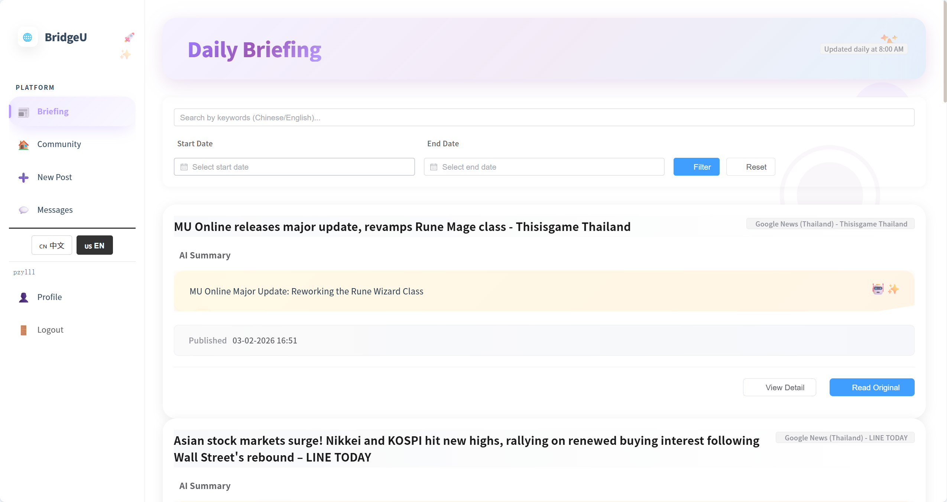

2. Observe that no search keyword, date filter, or source filter is selected (default state).

3. Verify that the page displays a list of 10 news items with titles, summaries, sources, publish dates, and actions (such as “View Detail” and “Open Original”).
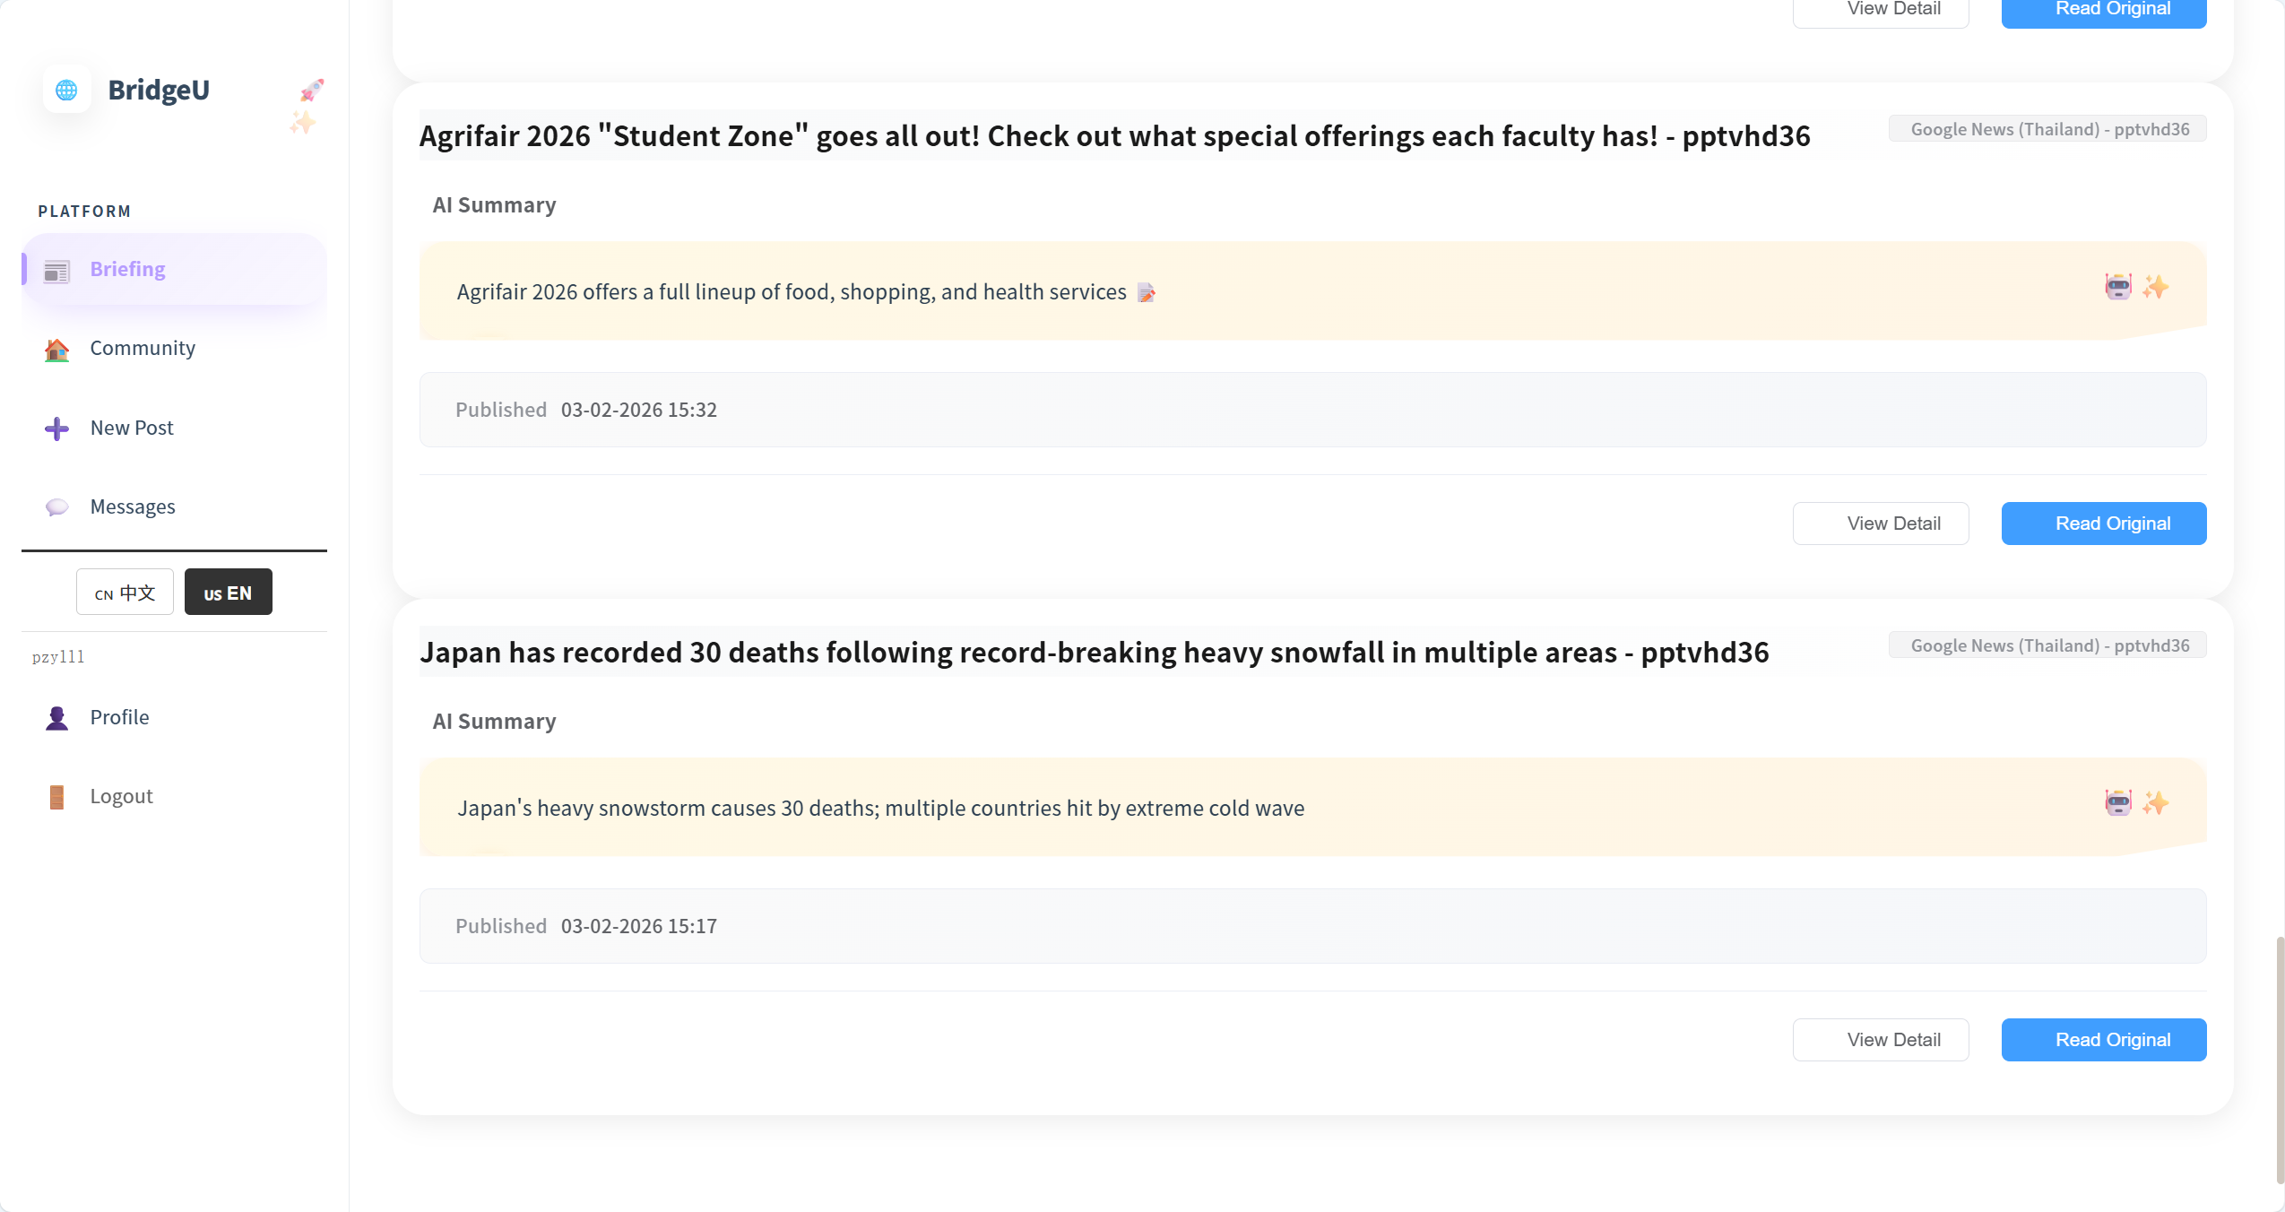

4. Verify that the pagination bar shows at least 2 pages when the total number of news records is greater than 10.
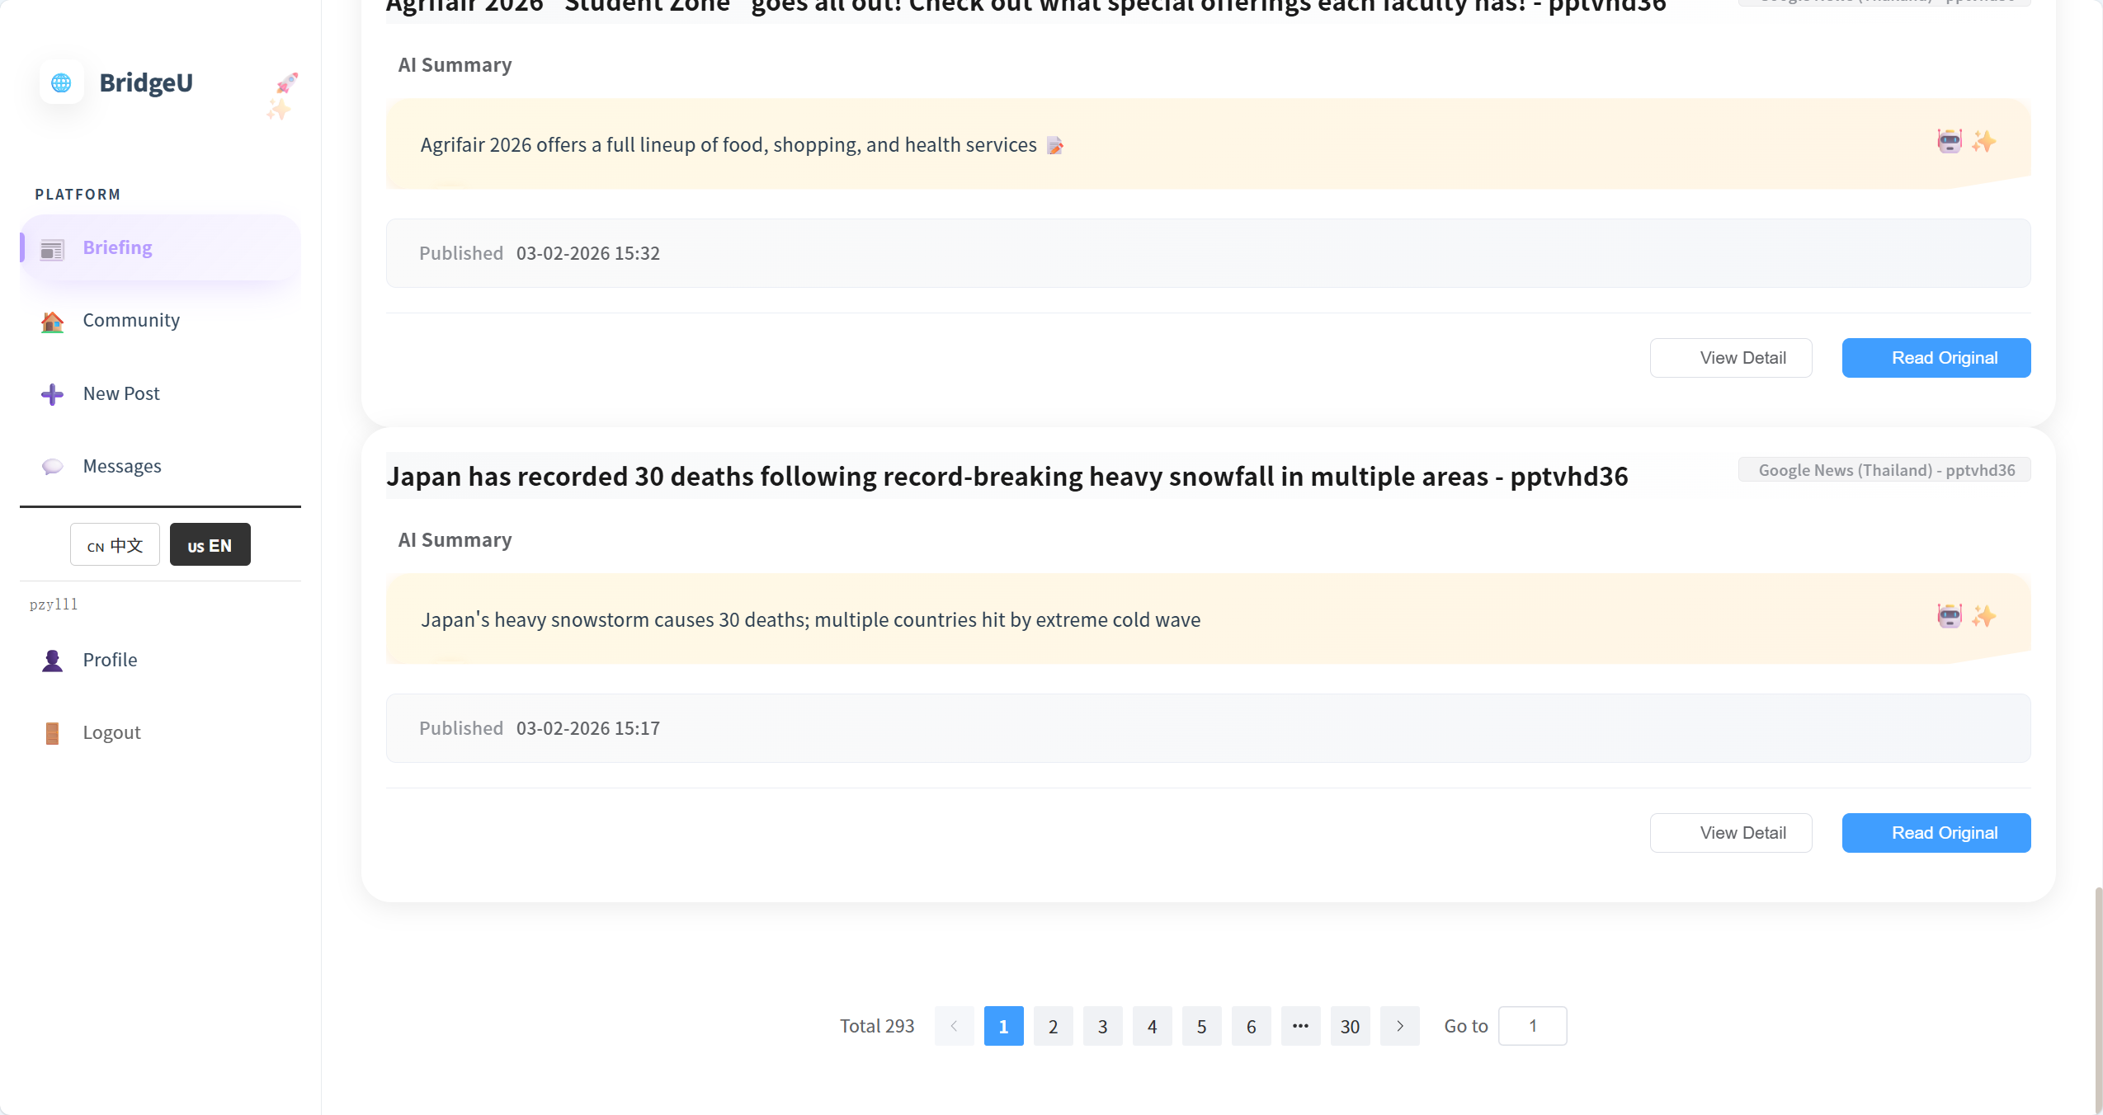
5. Scroll through all news items on the first page and verify that all visible titles and summaries are in Chinese or English only, with no Thai characters displayed.
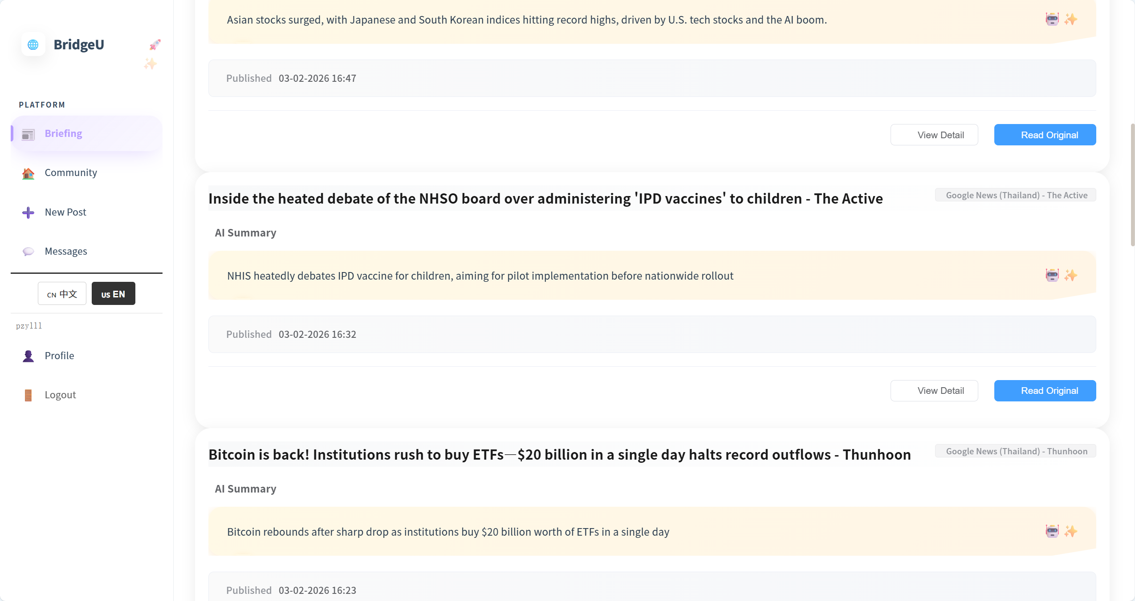

Test Case:

NO | Description | Input | Expected Result
1 | Open Daily Briefing page with default state | Open BridgeU in a browser and navigate to “Daily Briefing” page with no filters applied. | Page shows 10 news cards with title, summary, source, publish date and actions; no search keyword, date or source filter is selected.
2 | Verify pagination behaviour | Scroll to bottom of list. | Pagination bar shows at least 2 pages when total news records > 10.
3 | Check UI language rule | Inspect all items on first page. | All visible titles and summaries are in Chinese or English only; no Thai characters appear anywhere in the list.
4 | Click the "Briefing" button in the sidebar, and the button style will change | Click the "Briefing" button | The button changes from white to purple, and the color of the text changes from black to dark purple

4.2 STC-02: Filter News by Date Range
Description: This system test verifies that the system correctly filters Daily Briefing news items by publish date range across frontend and backend.
Prepared Data:
Same environment as STC-01.
Database contains news items whose `publishDate` covers at least the last 30 days.
Test script:
1. Open the Daily Briefing page(UI-01) in the browser.


2. When user click the Select Date box, the calendar pops up
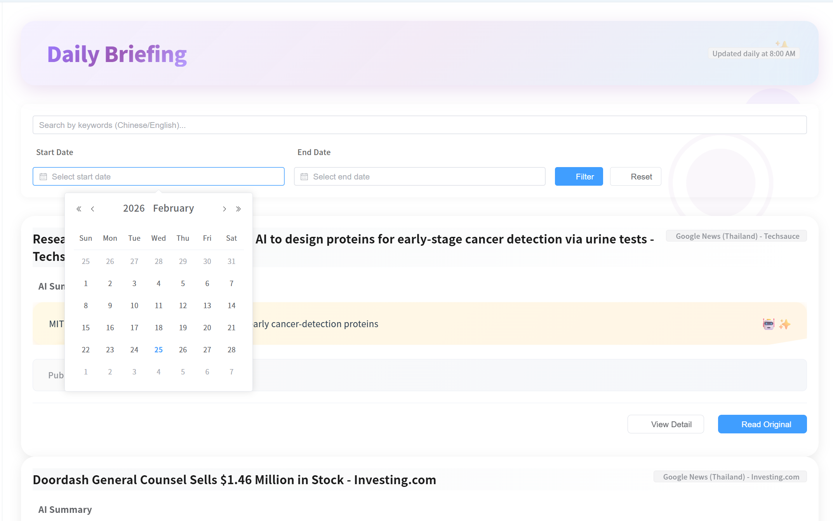
Test Case:
NO | Description | Input | Expected Result
1 | Filter list by fixed date range | Set start date `01-01-2026`, end date `07-01-2026` and click “Apply Filters”. | Only news with a publication time between 01-01-2026 and 07-01-2026 is displayed in the list
2 | Filter with only start date | Press “Reset” button, set start date `10-01-2026`, leave end date empty, click “Apply Filters”. | The press releases shown in the list are all after 10-01-2026 (inclusive) until the current date; There is no error message on the page, and the filtering takes effect successfully.
3 | Filter with only end date and inferred start date | Press “Reset” button, set end date `20-01-2026`, leave start date empty, click “Apply Filters”. | System show start date as 30 days before `20-01-2026`; results only include news in this computed range.
4 | Validate invalid date range | Set start date `10-02-2026`, end date `01-02-2026`, click “Apply Filters”. | Frontend shows validation warning (start date cannot be later than end date).
5 | When you click the Select Date box, the calendar pops up | click the Select Date box | The calendar pops up, and you can click to select the date (day, month, year)

4.3 STC-03: Search Daily Briefing by Keyword
Description: This system test verifies that keyword search works end-to-end, including parameter passing and search scope.
Prepared Data:
Same environment as STC-01.
Database contains news items whose `title`, `summary`, or translation fields (`titleZh`, `titleEn`, `summaryZh`, `summaryEn`) contain the keyword “Thailand”
Test script:
1. Open the Daily Briefing page(UI-01) in the browser.
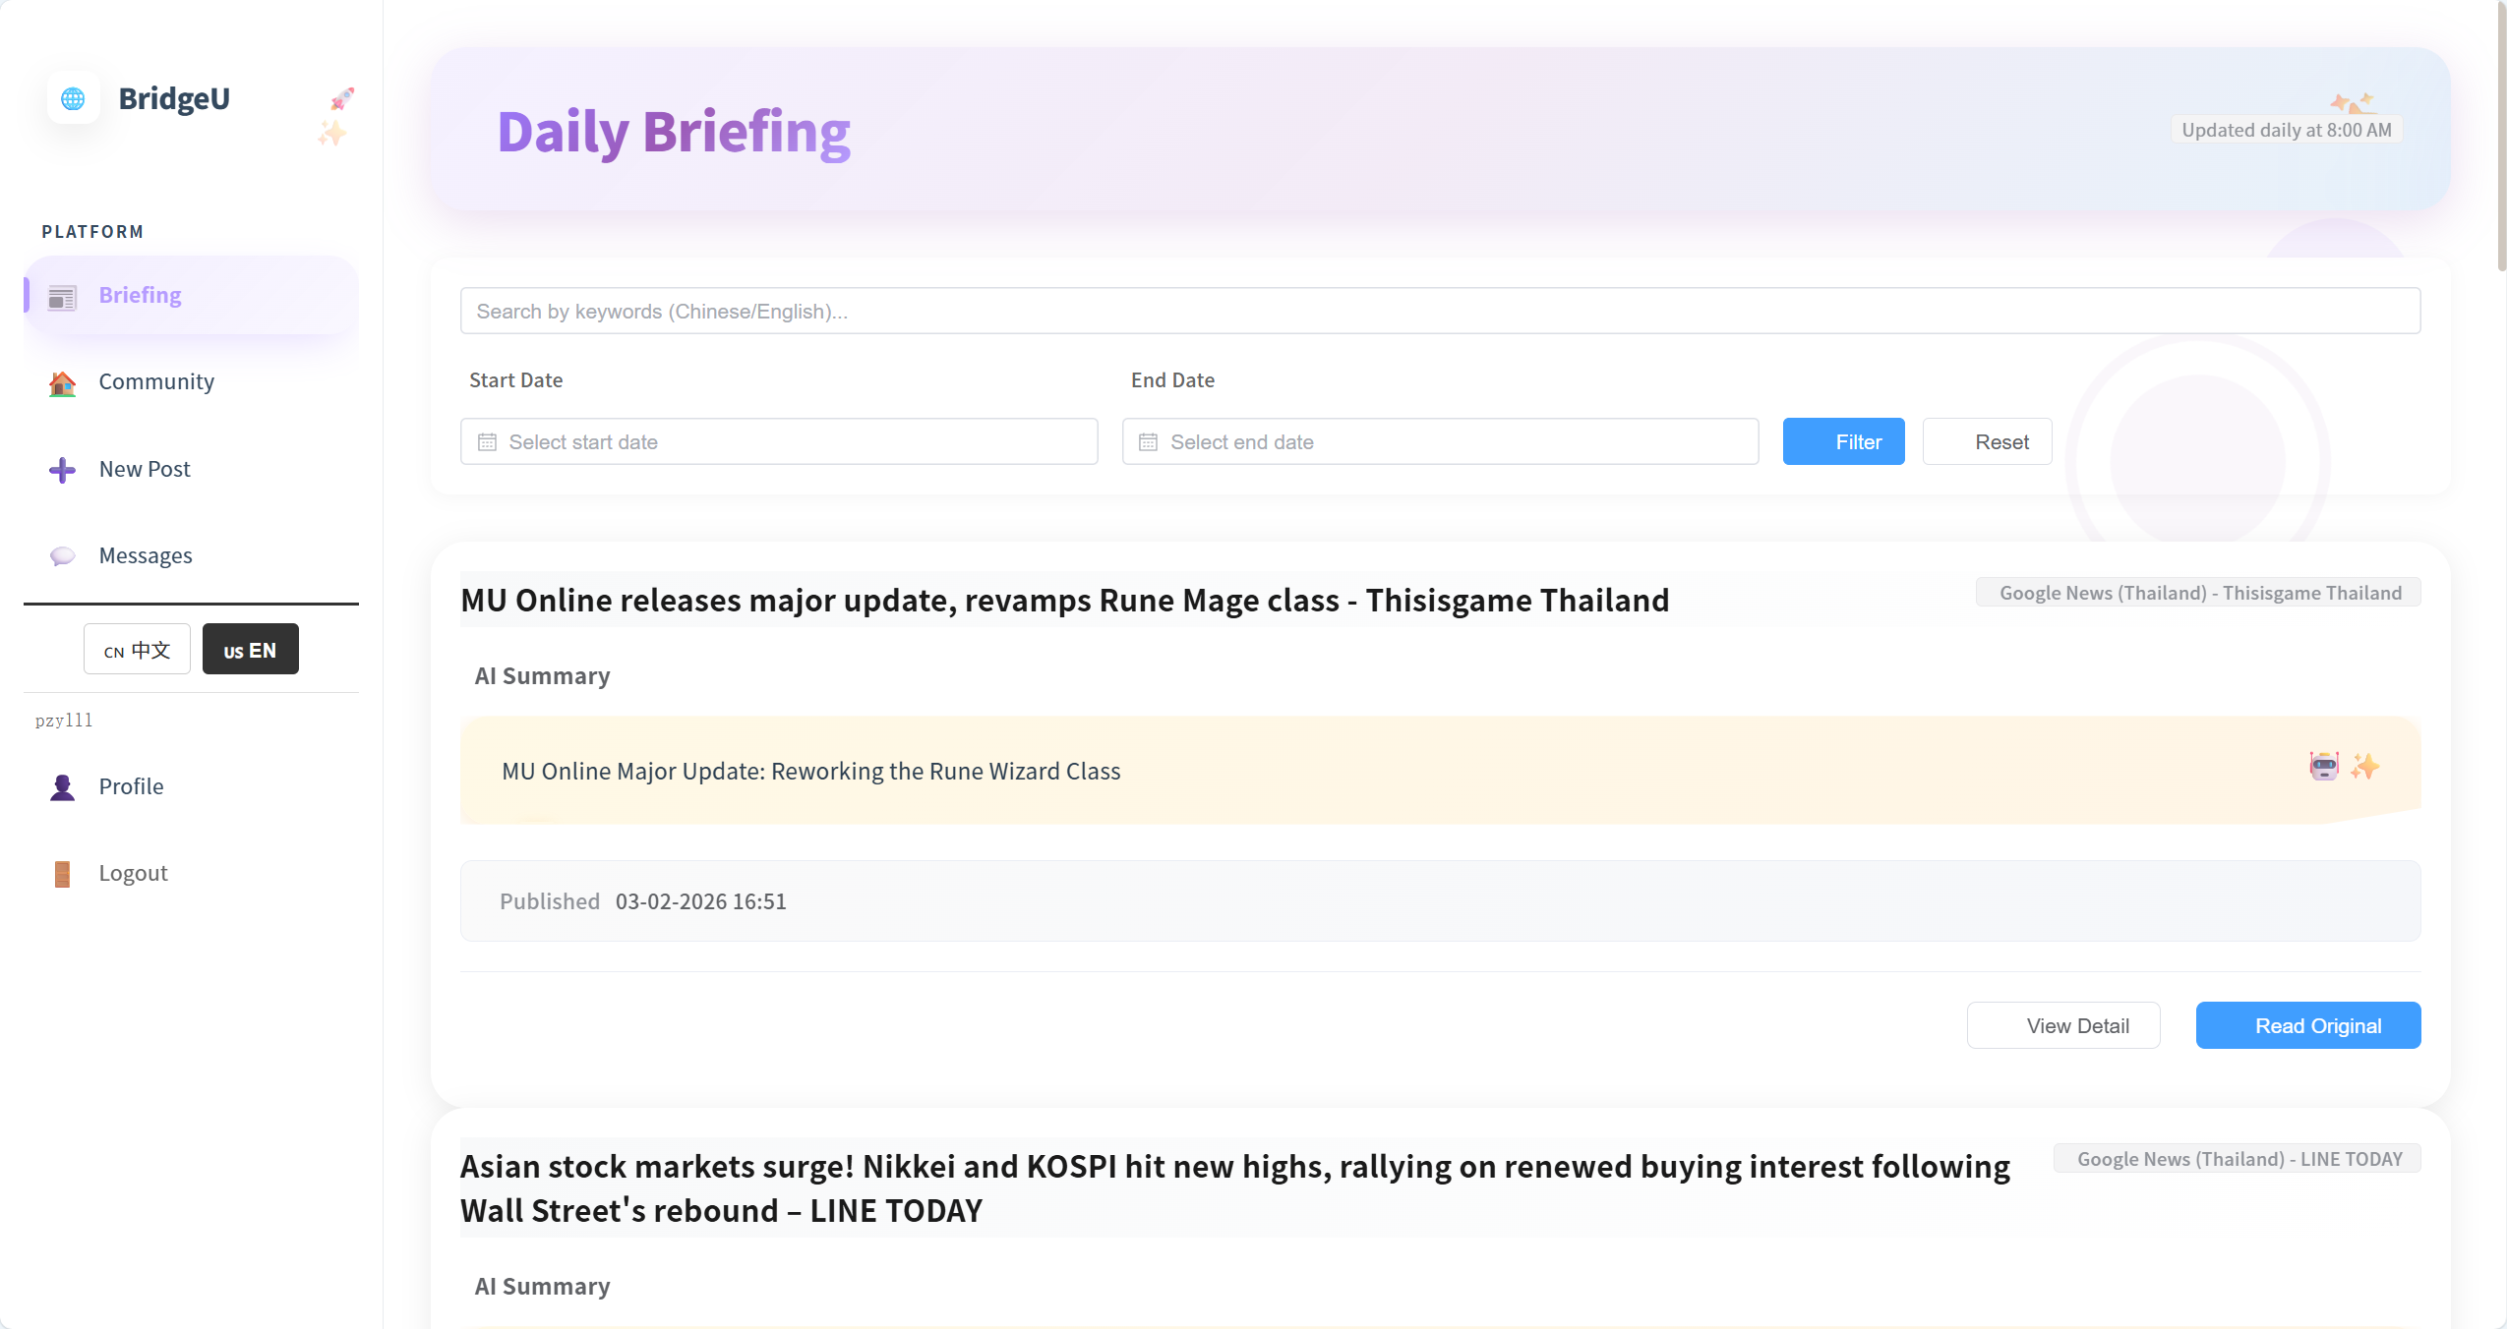

2. Optionally navigate to any page that already exists
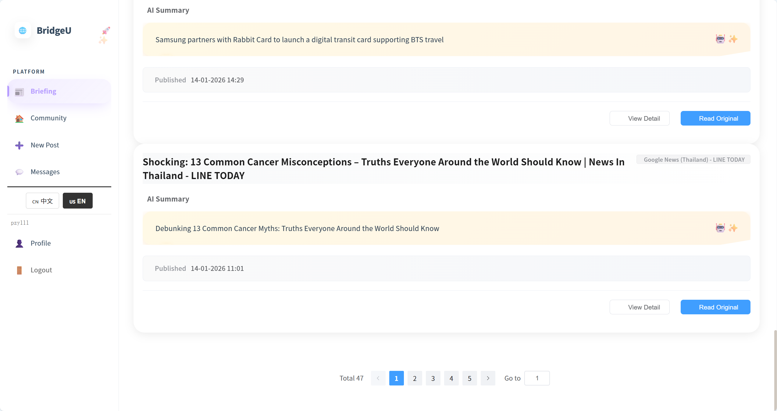

Test Case:
NO | Description | Input | Expected Result
1 | Search by keyword | | Enter `Thailand` in search box and click “Filter” button. | UI resets current page to 1,returned list only contains news whose title, originalContent, summary or any translation field includes “thailand” (case-insensitive).
2 | Clear keyword search | Clear search box and click “Search” again. | New request has no `keyword` parameter; list shows unfiltered results (respecting only any active date/source filters).
3 | Combine keyword and date filters | enter `student`, set a valid date range, click “Search”. | Request includes both `keyword` and `startDate`/`endDate`; results only include items matching both the keyword and the date range.
4 | Optionally navigate to any page that already exists | Enter page number “8” | The system will navigate to page 8
5 | Optionally navigate to any page that already exists | Click the number “4” | The system will navigate to page 4
6 | When click on a page number, the color changes | Click the number “4” | The color of the number 4 will change from black to blue
7 | When the number page belongs, the number button on the bottom page changes from white to blue, and the number changes from black to white | Click the number “4” | The page 4, the number button on the bottom page changes from white to blue, and the number changes from black to white.

4.4 STC-04: Switch Interface Language
Description: This system test verifies that switching between English and Chinese interfaces correctly reloads the Daily Briefing list using appropriate translations while still hiding Thai content.
Prepared Data:
Same environment as STC-01.
Database contains a dedicated test set of news records where “every record has both English and Chinese translations” (`titleEn`/`summaryEn` and `titleZh`/`summaryZh`).

Test script:
1.Ensure the interface language is set to “English (en)”, then open the Daily Briefing list.
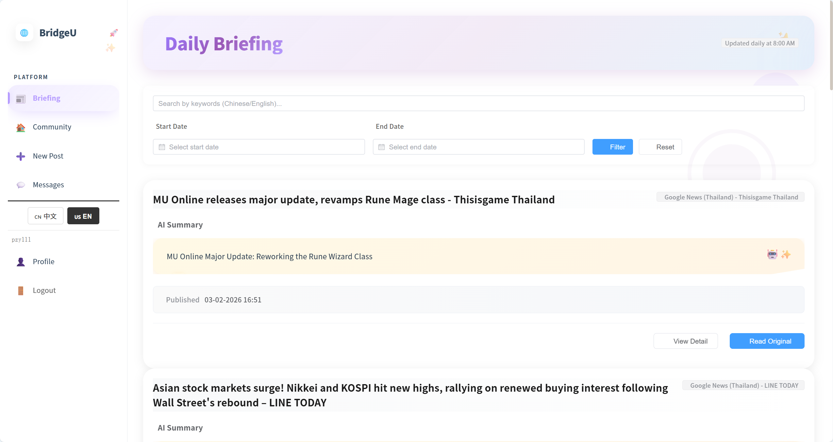

2.Use the language toggle in the UI to switch the interface language to Chinese (zh)
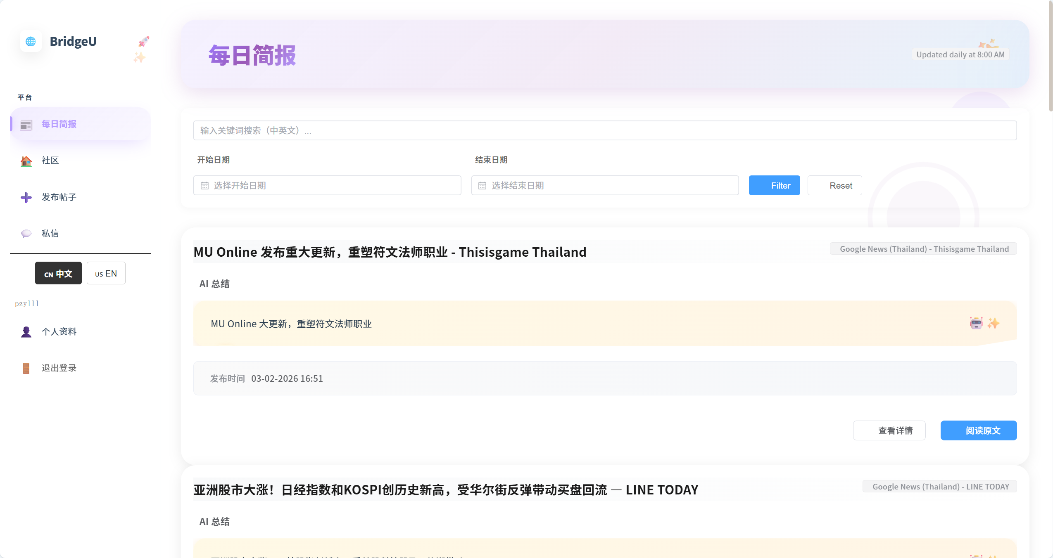

NO | Description | Input | Expected Result
1 | Load list in Englis | Set interface language to `en`, open Daily Briefing list. | News list shows titles/summaries in English
2 | Switch to Chinese | Use language toggle to switch to `zh`. | News list shows titles/summaries in Chinese
3 | Button color changes | Click “usEN” | The button will change from white to black, and the words in the button will change from black to white

4.5 STC-05: View News Detail
Description: This system test verifies that selecting a news item from the list opens the detail view and correctly retrieves full information from the backend, including rules for `originalContent`.
Prepared Data:
Same environment as STC-01.
Database contains at least one news record
Test script:
1. Open the Daily Briefing list and choose a news item , Click the “View Detail"action for this item.
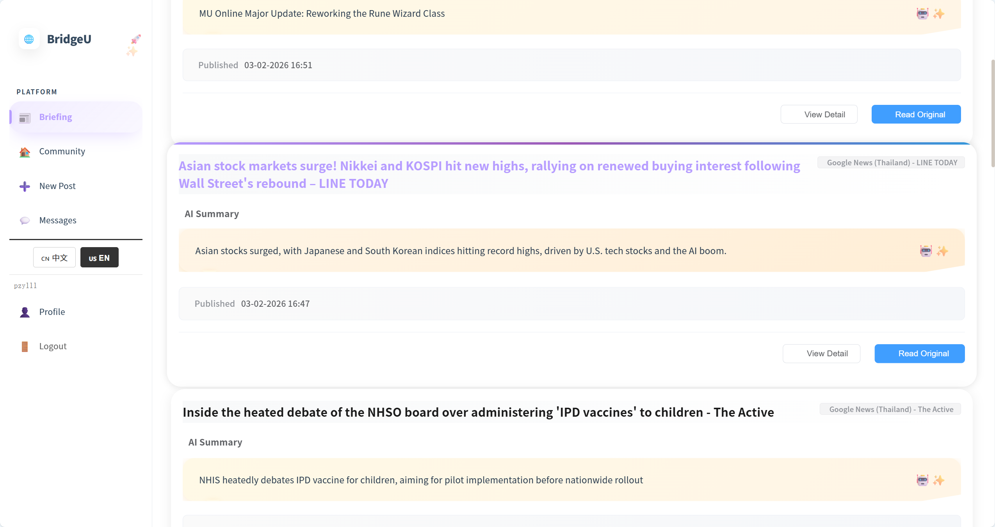

2. Confirm that the detail page displays only translated title/summary (or placeholders) and does not show any Thai original text.
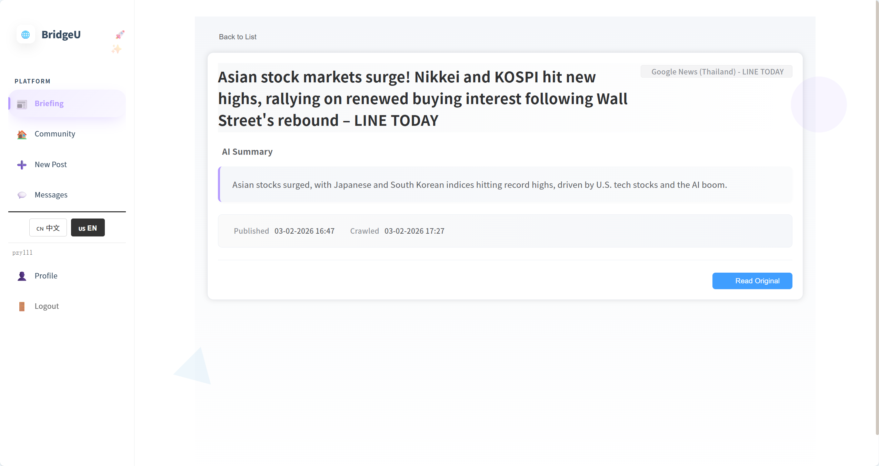
Test Case:
NO | Description | Input | Expected Result
1 | Open detail content | From list, click “View Detail” on news item | Detail page shows title, summary, source, publish date and original content section. |
2 | When the mouse hovers over the post, the style changes | The mouse hovers over the post | The post title changes from black to purple, the post outline becomes larger, and there is a gradient color bar at the top
3 | When click “View detail” button,the button style change | click “View detail” button | The button color changes from white to blue, and the font changes from black to dark blue

4.6 STC-06: Open Original News Link
Description: This system test verifies that the “Open Original” action correctly opens the original news article URL from backend data, both from the list and from the detail view.
Prepared Data:
Same environment as STC-01.
Selected news items have a valid `originalUrl` field in the database.
Test script:
1. Open the Daily Briefing list and find a news item that has a visible “Open Original” action.
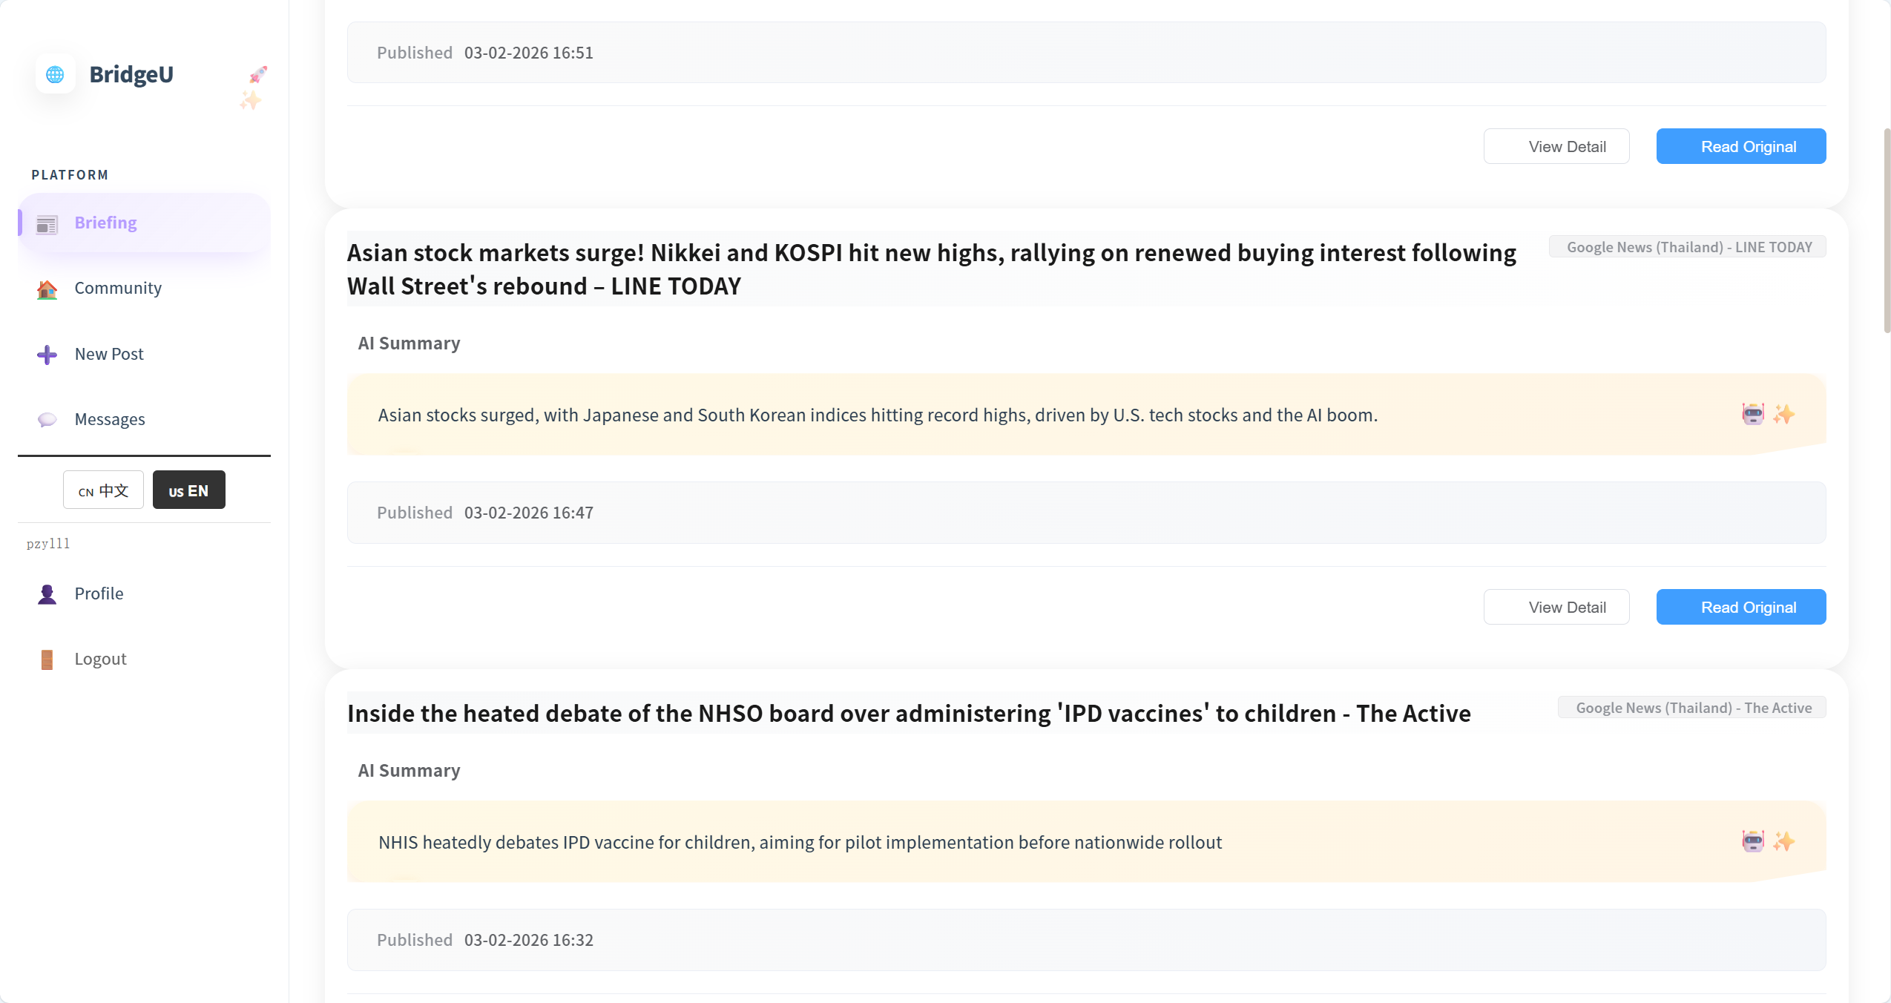

2. From the Daily Briefing list, click “View Detail” on the same news item to open the detail page.
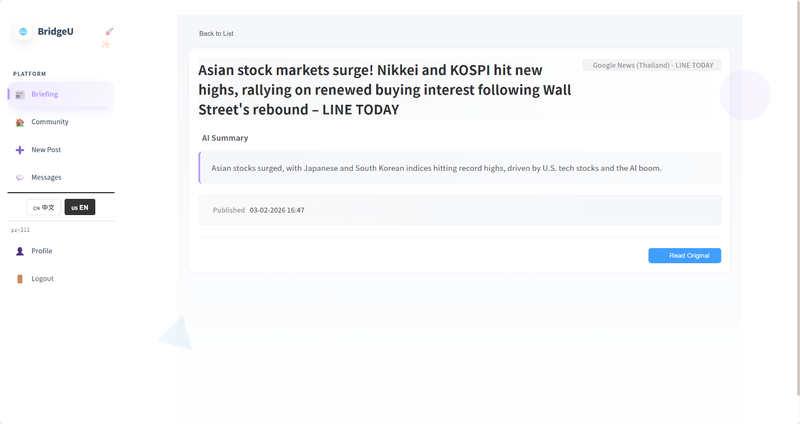

Test Case:
NO | Description | Input | Expected Result
1 | Open original link from list | On Daily Briefing list, click “Open Original” for a news item with valid `originalUrl`. | Browser opens this news tab
2 | Open original link from detail | From the same item, click “View Detail” then “Open Original” on detail page. | Browser opens this news tab
3 | When click “Read Original” button,the button style change | click “Read Original” button | Button color and font lightened

4.7 STC-07:View Community Feed List
Description: This system test verifies that the community feed (`PostList.vue`) correctly displays posts by calling `GET /api/posts` with `q`, `page`, `size`, `lang`, and that tag filters and search work as implemented.
Prepared Data: Backend Spring Boot application running on port 8080
Test script:

1. Verify that the page displays the community feed with a search box and tag pills.
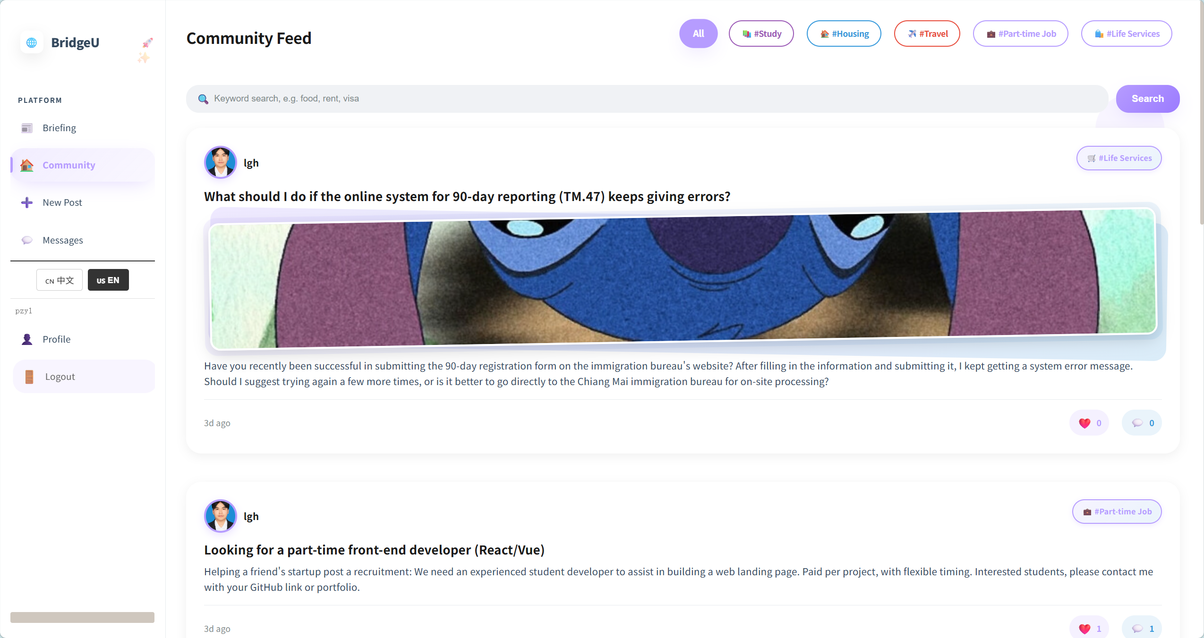

est Case:
NO | Description | Input | Expected Result
1 | Open community feed | Click "Community" in sidebar. | Page shows post list with search box and tag pills; posts are visible with key fields
2 | Click "Community" in sidebar the button will change style | Click "Community" in sidebar. | The button’s color will become purple,the word will change deep purple
3 | When the mouse hovers over a post,the post will have a dynamic effect. | When the mouse hovers over a post | The post will rise up, and it will return to its original position when the mouse is moved away.
4 | Search posts by keyword | Enter keyword, click Search. | List updates to show posts relevant to keyword (or empty state if none).
5 | Filter posts by tag | Click “study” | List updates to show posts relevant to “study”
 | Reset tag filter | Click “All”. | Full list is shown again (within the current feed page).

4.8 STC-08: View Post Detail and Interact (Like, Comment, Follow)
Description: This system test verifies that clicking a post opens the detail page and that user interactions (like, comment, follow) update the UI correctly.
Prepared Data: At least one post
Test script:

- Click one post in Community Page

2. Verify that the detail page shows title, body, author, like count, comment count, and a “Back” button.
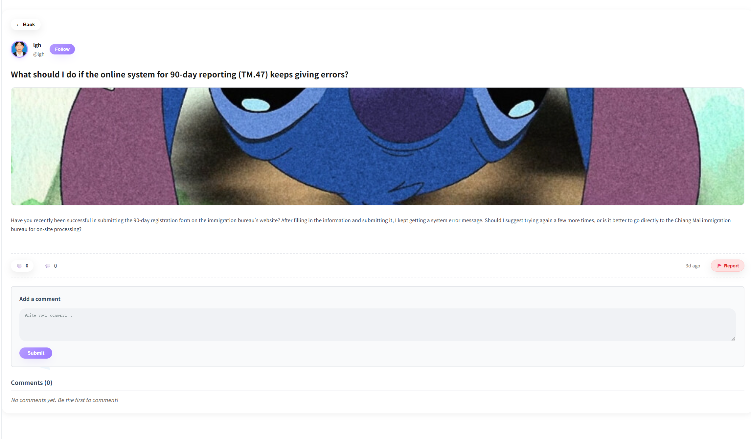

3.If have comment,user can click Summarize Comments.
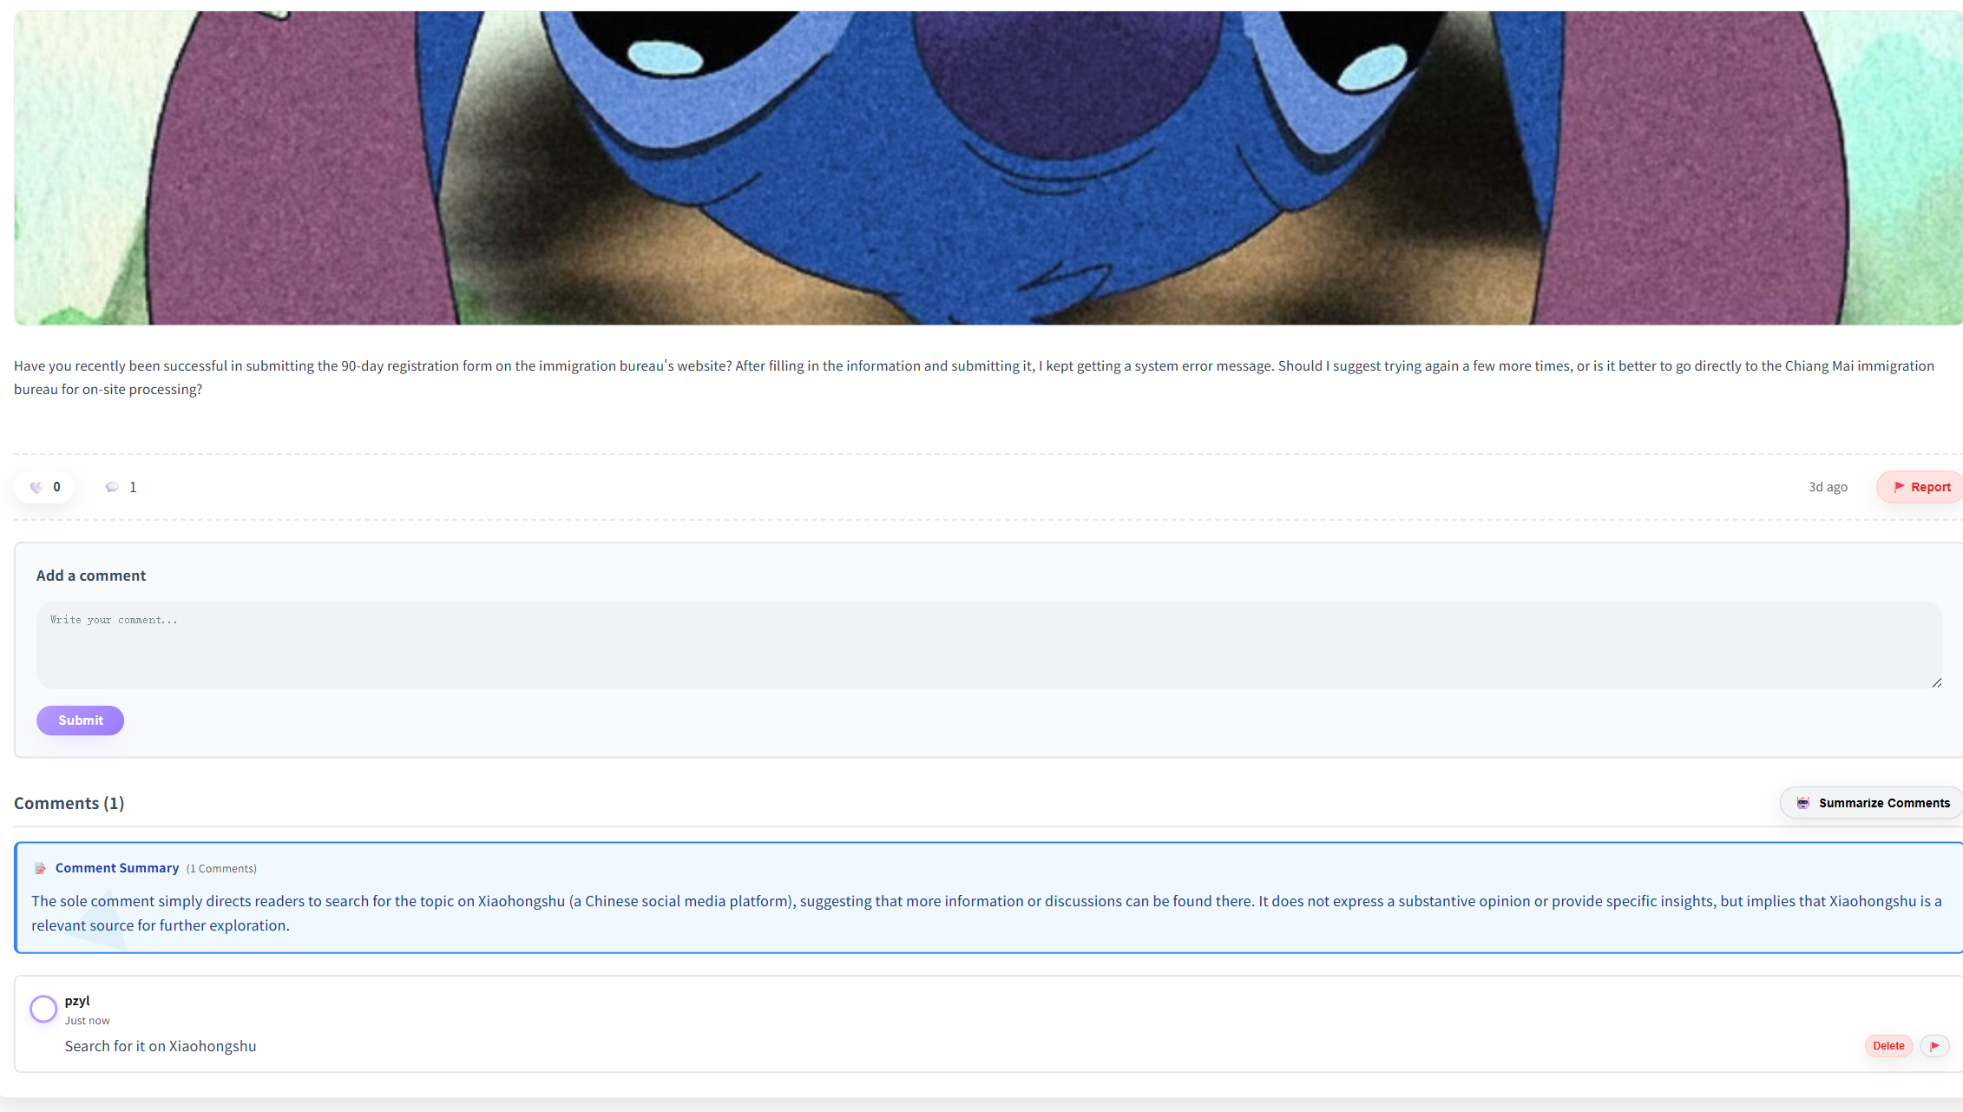
4.Click user’s avatar,navigate to this user’s profile page
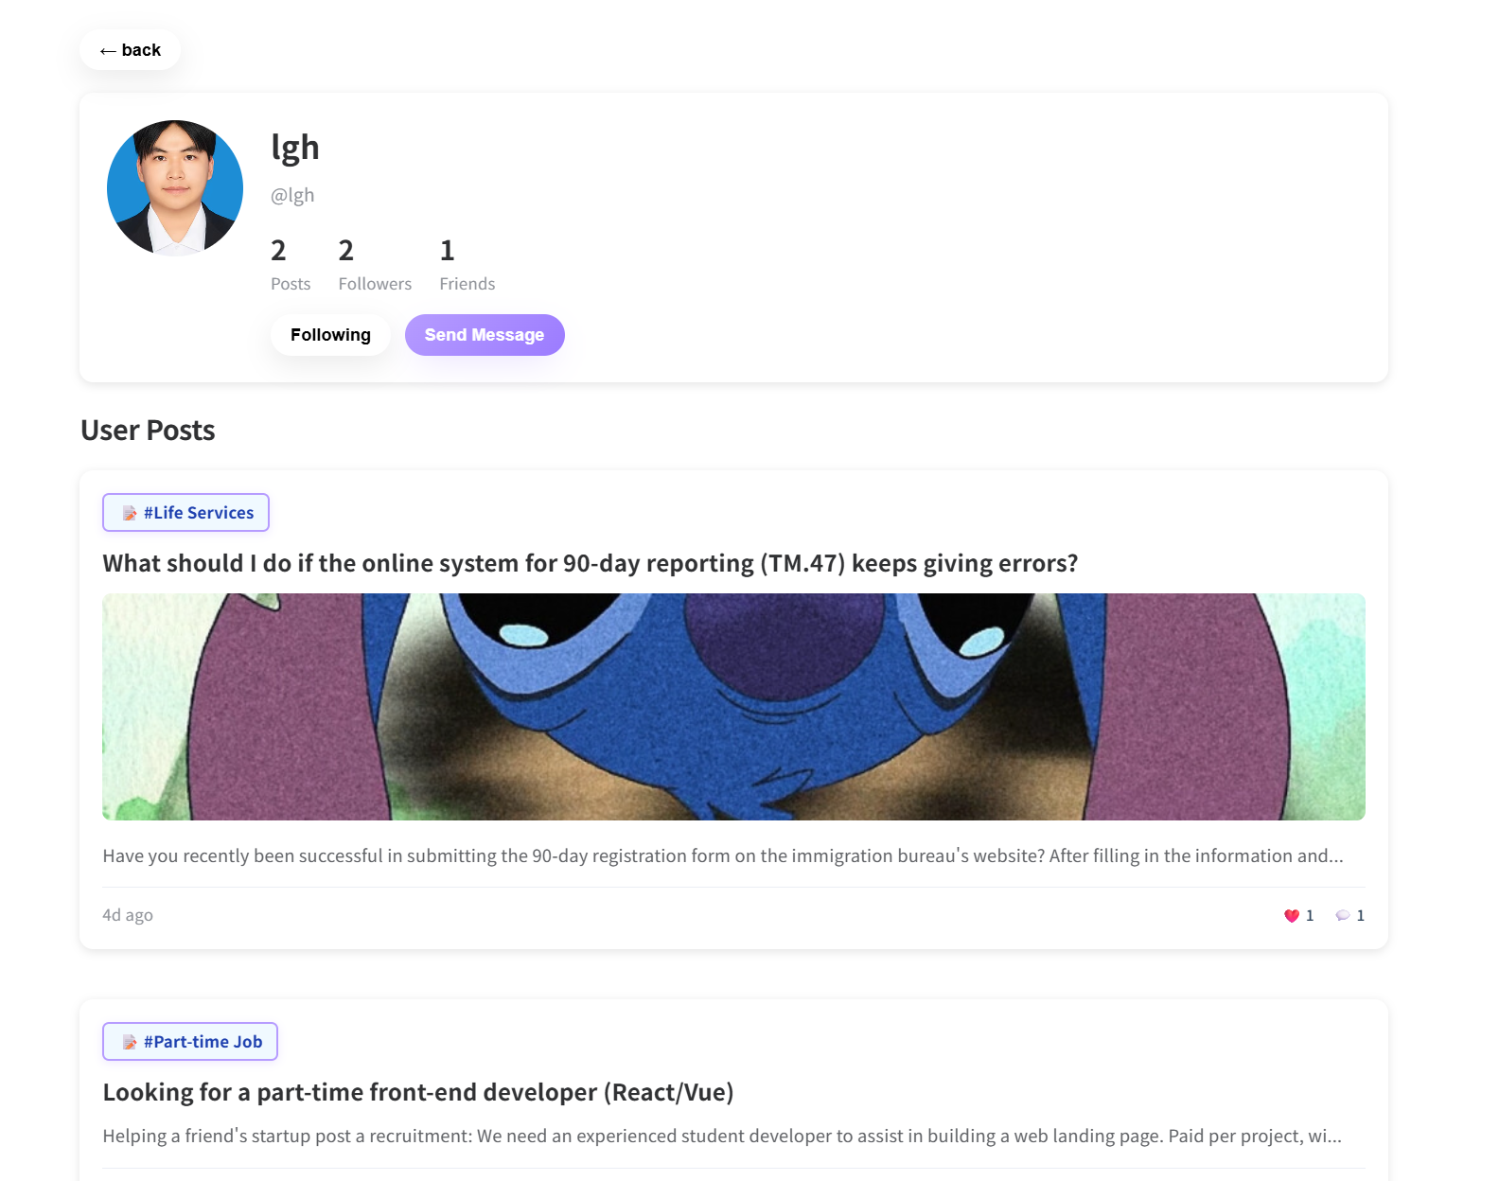
Test Case:
No | Description | Input | Expected Result
1 | Open post detail | Click a post in the feed. | Detail page is displayed with title/body/author and like/comment counts.
2 | Toggle like | Click Like button. | Like icon toggles (🤍↔❤️) and like count updates.
3 | Add comment | Enter comment, submit. | New comment appears in the comments list.
4 | Follow author | Click Follow on another user's post. | Button changes to “Following” (and is consistent after page refresh within the same session if applicable).
5 | Navigate back | Click Back. | Returns to community feed or previous page.
6 | Follow button | Click Follow | The button change color from purple to white,word change color from white to purple.
7 | Summarize Comments | Click Summarize Comments. | The comments below this post will be summarized into one paragraph.
8 | View the post’s owner’s profile | Click the avatar which in this post detail page | Navigate to post’s owner’s profile.

4.9 STC-09: Create New Post
Description: This system test verifies that the New Post flow allows the user to create a post and that the new post appears in the app after submission.
Prepared Data: None
Test script:

1. Click New Post in the sidebar.
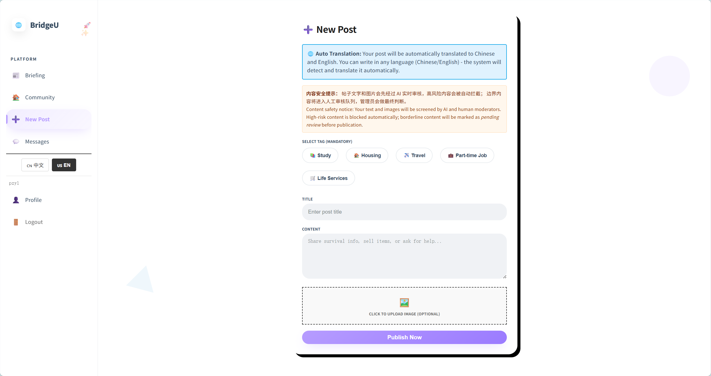

Test Case:
NO | Description | Input | Expected Result
1 | Open new post form | Click "New Post" in sidebar. | Form shows tag selection, title, content, image upload.
2 | Submit post | Fill title, content, select tag, submit. | “Post submission received. It will appear in the list after it passesreview.” showed
3 | Only fill in the content. | Fill content | “Please select a tag” warned
4 | Only choose the tag | Choose “study” | “Title cannot be empty” warned
5 | Fill tag and title | Choose “study”  Fill title | Choose “study” warned
6 | Only fill the title | Fill title | “Please select a tag” warned
7 | Only fill tag and content | Fill tag and content | “Title cannot be empty” warned

4.10 STC-10: Report Content
Description: This system test verifies that a user can report a “post” or a “comment” from the post detail page and receives clear success/error feedback in the UI.
Prepared Data: At least one post exists with at least one comment.
Test script:

1. Click Report on the post. Select at least one report reason, optionally enter description, then click Submit.

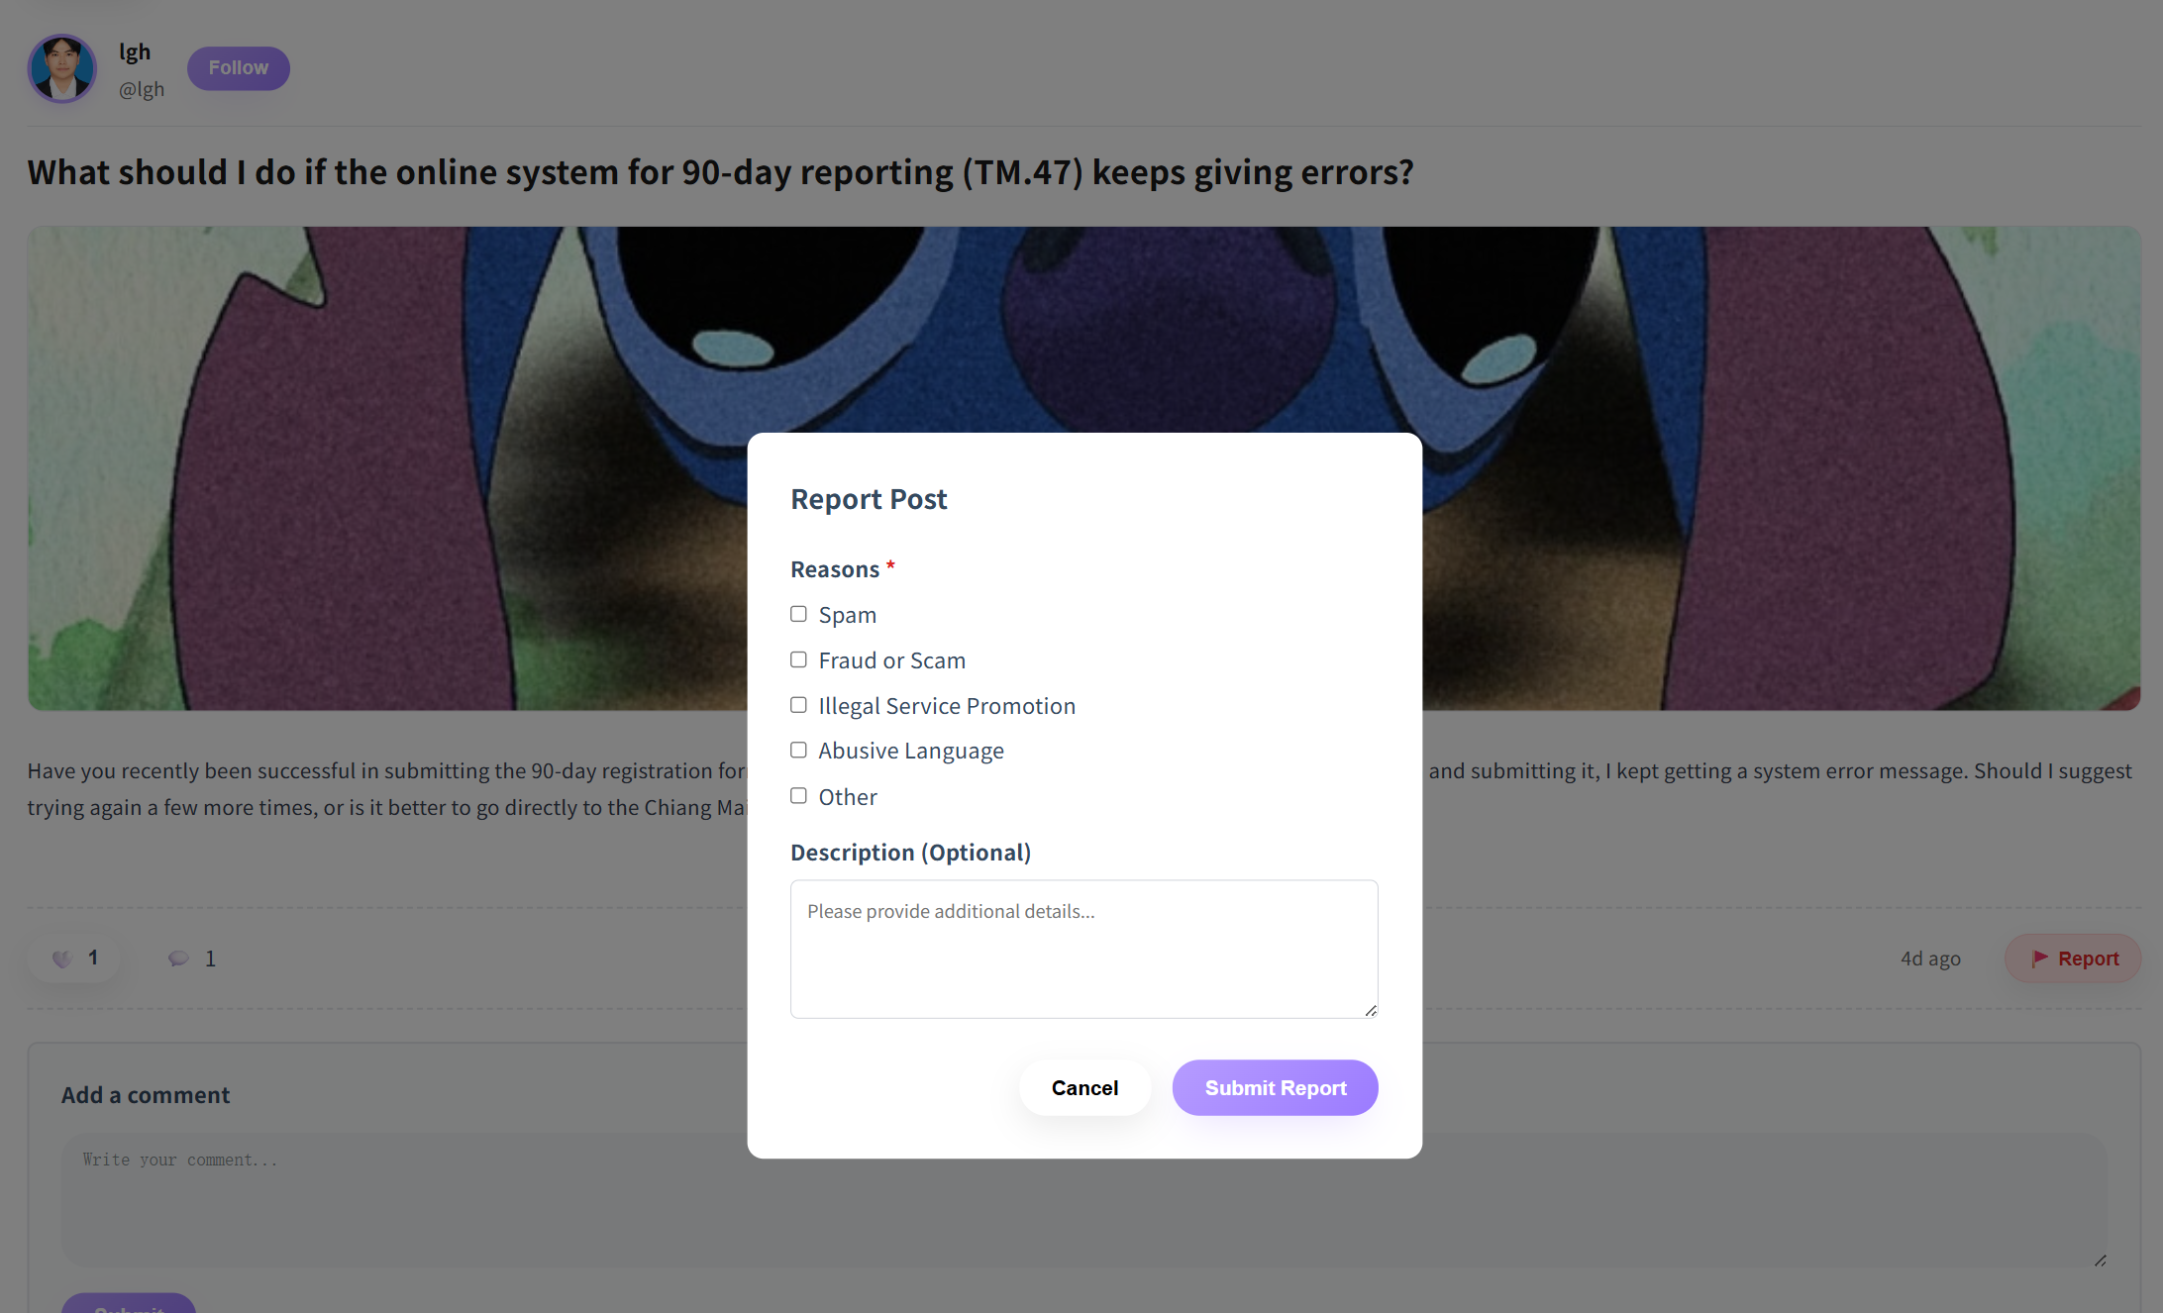
Test Case:
NO | Description | Input | Expected Result
1 | Report a post | In PostDetail, click 🚩 Report → choose reasons → Submit. | “Report submitted successfully. Al review is in progress.” is shown; dialog closes; user stays on the same post detail page.
2 | Report a comment | In PostDetail, report a comment → choose reasons → Submit. | “Report submitted successfully. Al review is in progress.” is shown; dialog closes; user stays on the same post detail page.
3 | Block invalid report submission | Try submit with no reason selected. | Report is not submitted.

4.11 STC-11: Manage Message Status
Description: This system test verifies that unread indicators in Messages update correctly when a user opens a conversation,and verification One-way follow-up can only send one message, while two-way follow-up enables normal message sending.Verification can search .
Prepared Data: none
Test script:
- Click Messages in the sidebar.
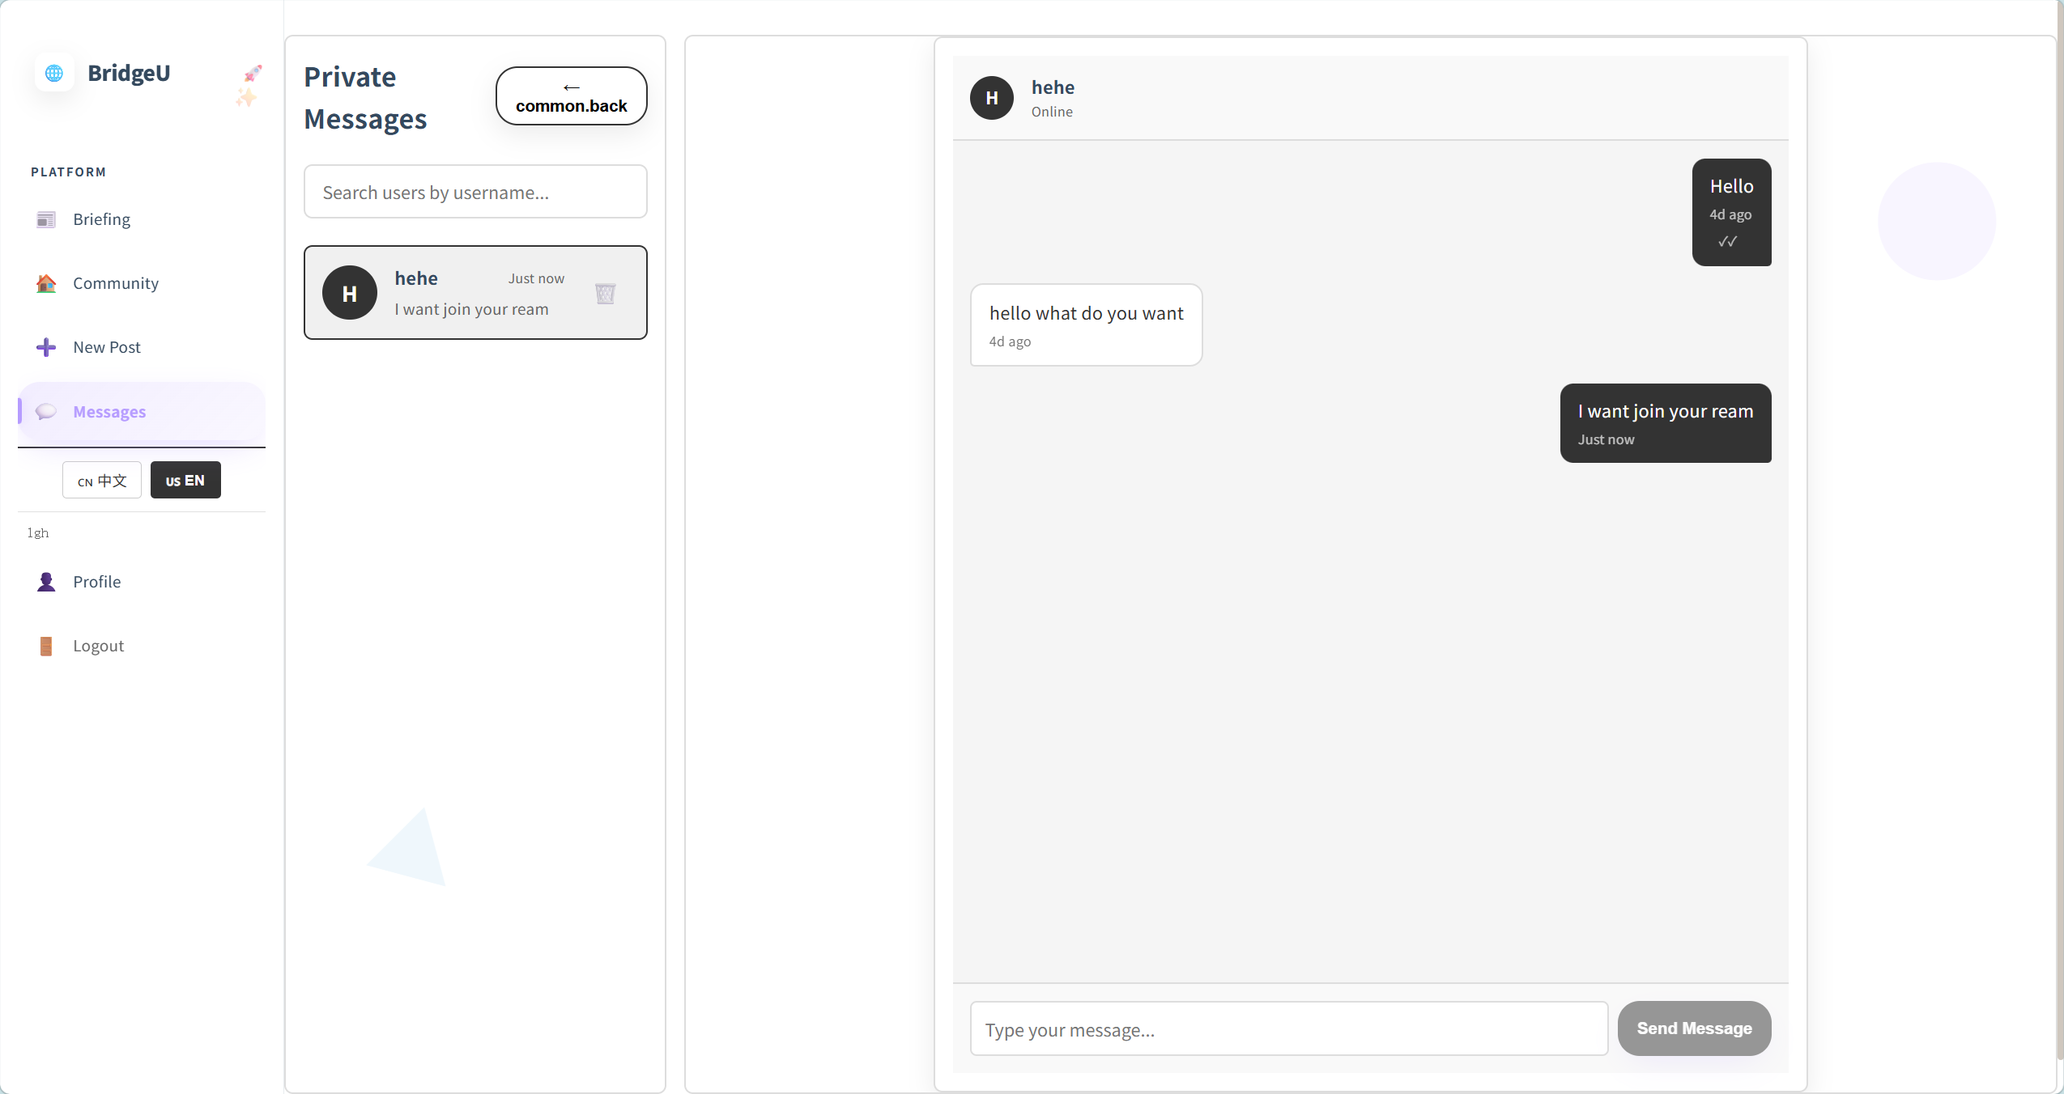
2. One-way follow-up can only send one message
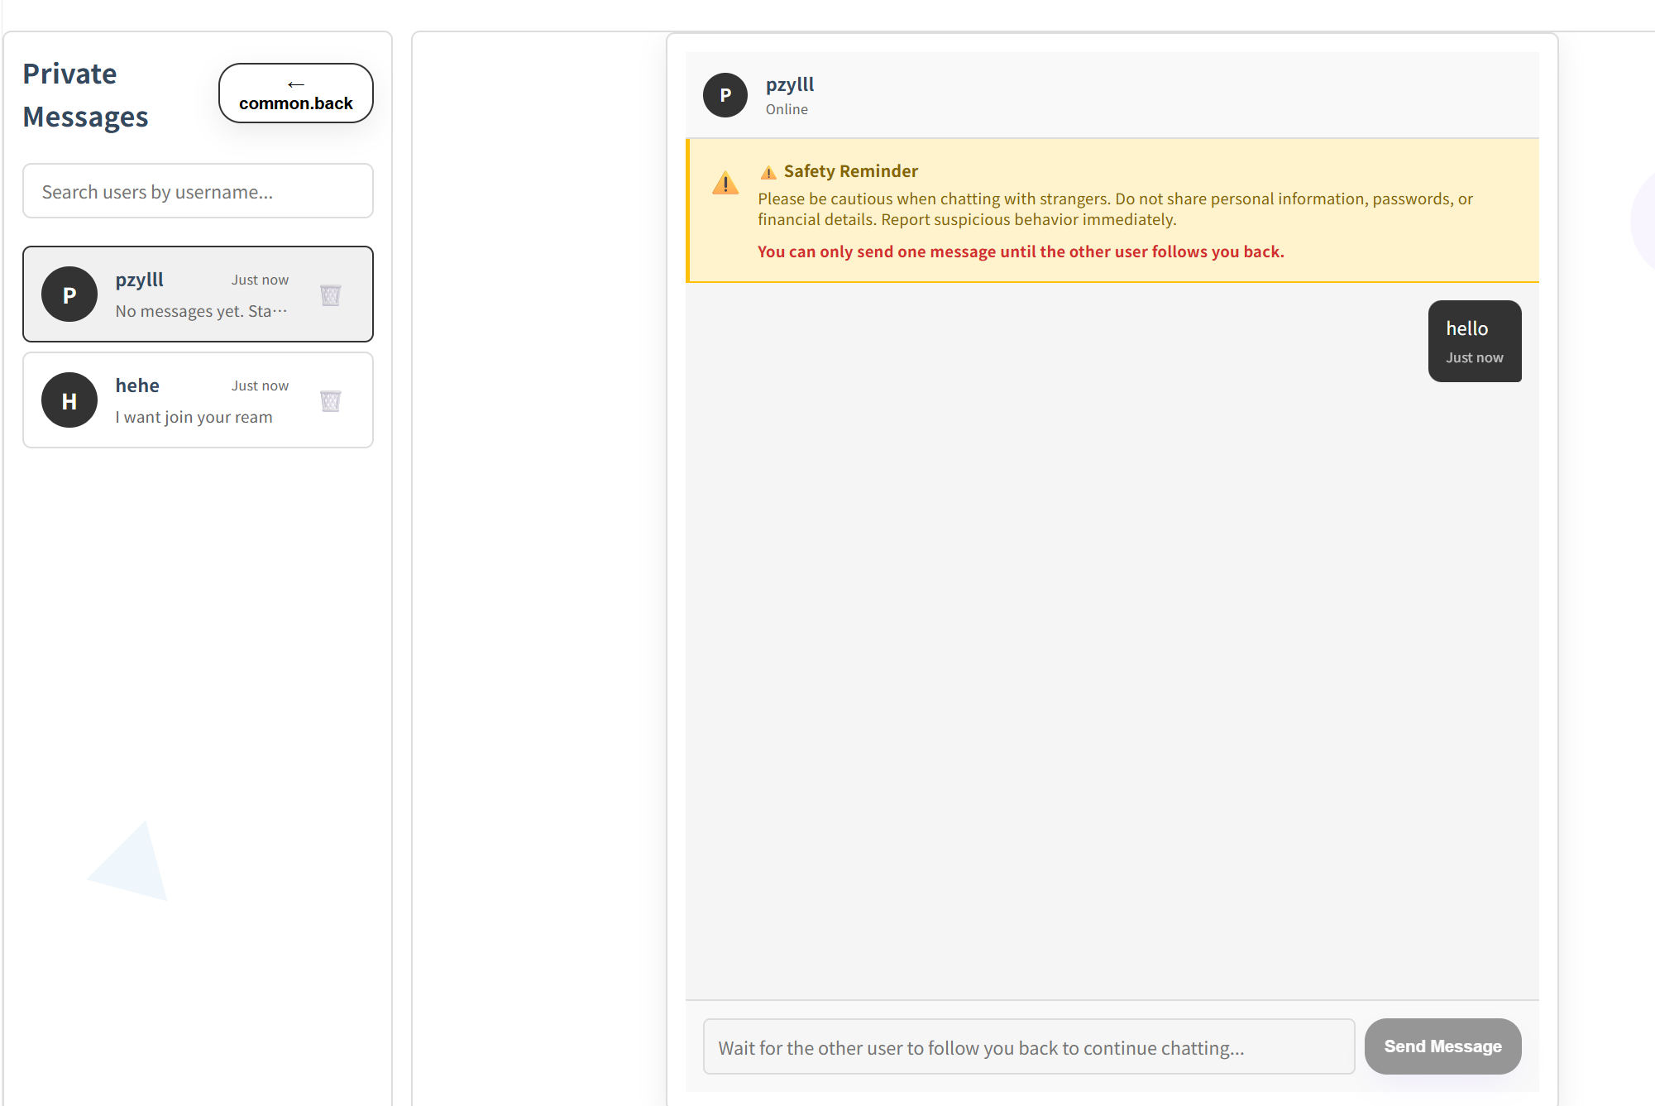
3. search users by username.
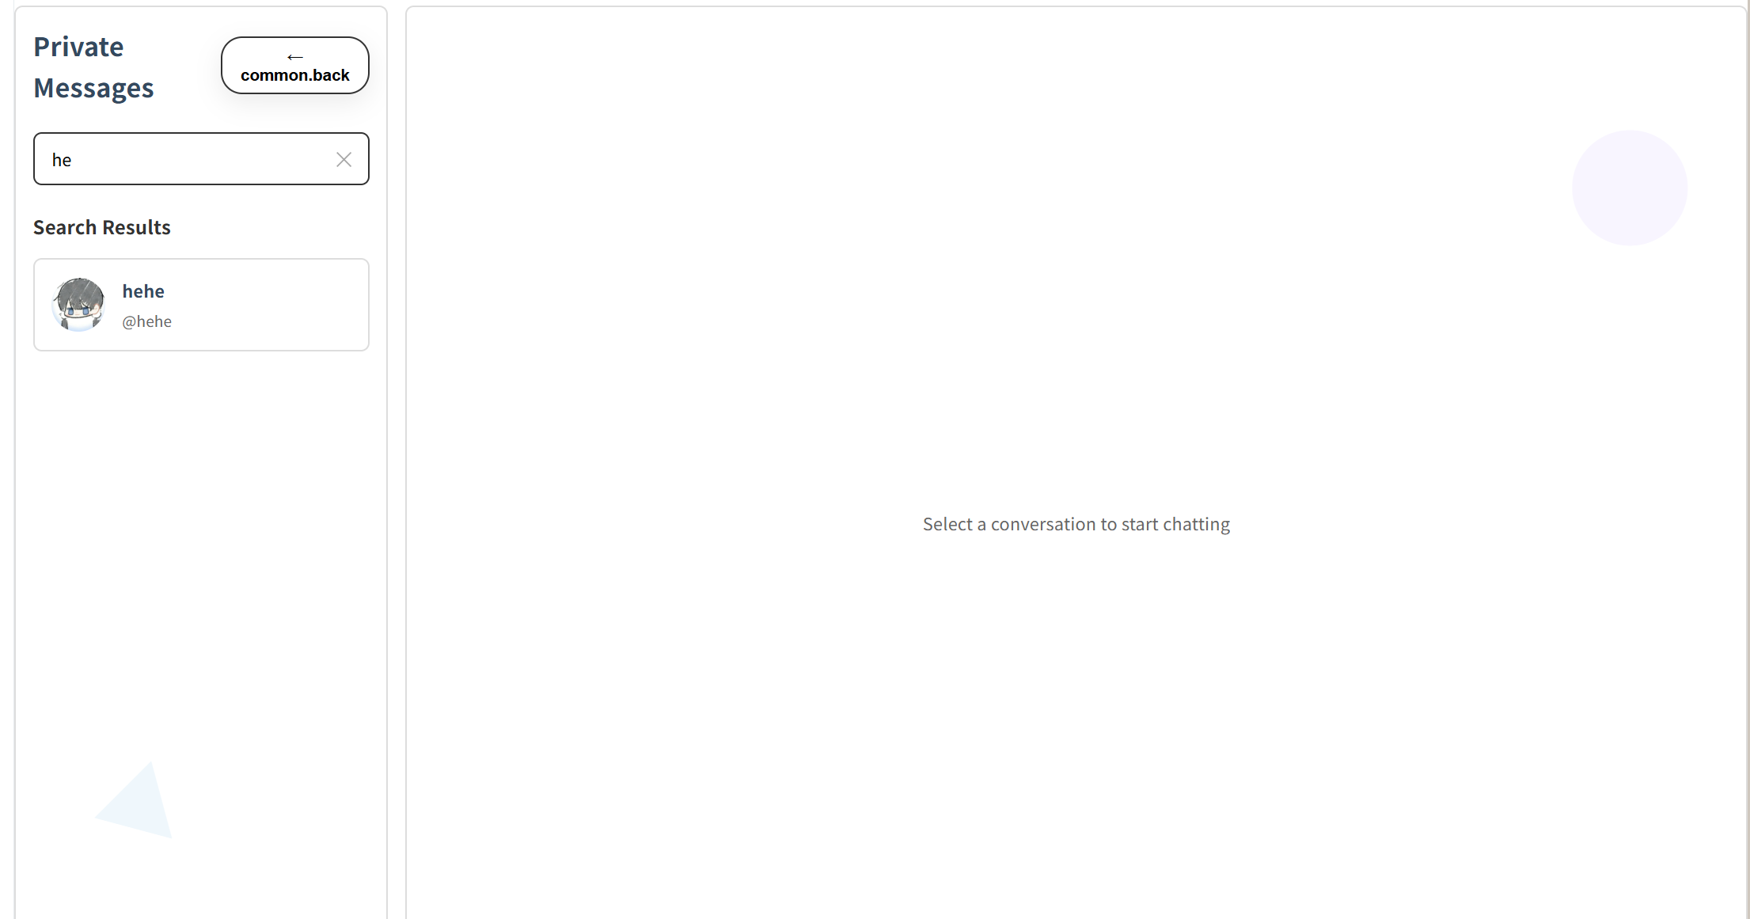

Test Case:
NO | Description | Input | Expected Result
1 | Mark conversation as read | Open a conversation with unread badge. | Unread badge cleared / count becomes 0; messages are visible.
2 | One-way follow-up can only send one message | Input “hello” | Shows “Safety Reminder  Please be cautious when chatting with strangers. Do not share personal information, passwords, or financial details. Report suspicious behavior immediately.  You can only send one message until the other user follows you back.  ” and can’t send message.
3 | Search users by username | Fill “he” | Showed the username include “he”

4.12 STC-12: Login
Description: This system test verifies that users can log in successfully and see the main app UI, and that invalid credentials show an error without entering the app.
Prepared Data:
Test script:
1. Open BridgeU in a browser, Verify that the login form is displayed with username/email and password fields, and links for "Create account" and "Forgot Password".

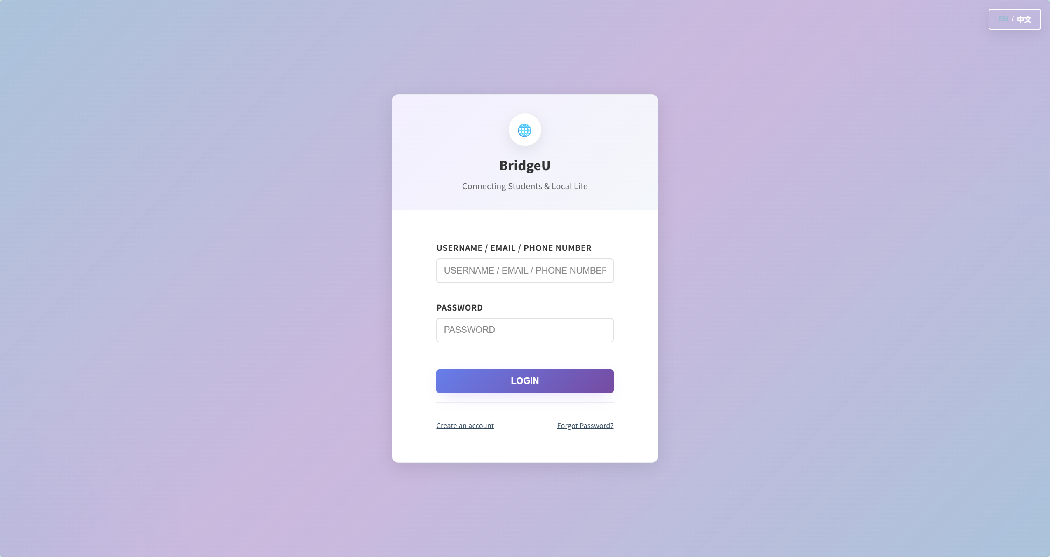

est Case:
NO | Description | Input | Expected Result
1 | Login with valid credentials | Enter username/email/phone and password, click Login. | Main app is displayed; user is treated as logged-in
2 | Login with wrong  password | Enter wrong password, click Login. | Showed “Incorrect username or password”
3 | Login with invalid credentials | Enter nothing | Showed “Please fill in all required fields”
4 | Login with only username(or email phone)/password | Only fill username(or email phone) /password | Showed “Please fill in all required fields”
5 | Go to Registration page | Click “Create an account” | Go to Registration page successful
6 | Go to Forgot password page | Click “Forgot password?” | Go to Forgot password page successful

4.13 STC-13: Registration with Email Verification
Description: This system test verifies that users can create an account using “Email” verification and see clear UI feedback for each step.
Prepared Data: Email verification codes can be received in the test environment.
Test script:
- On the login page, click “Create an account” then select Email to Register
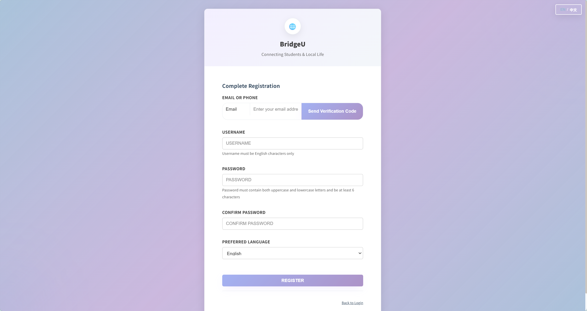
Test Case:
No | Description | Input | Expected Result
1 | Send verification code | Enter email, click Send Code. | Success feedback shown; code input is enabled/visible.
2 | Verify code and register | Enter code, verify, fill form, register. | Verification step succeeds; account is created; user can proceed to logged-in app or login page.
3 | Send code with empty identifier | Leave email/phone field empty; click Send Code. | Error message displayed: Please enter email or phone number .
4 | Send code with invalid email format | Select Email method, enter an invalid email (missing @ or domain); click Send Code. | Error message displayed: Please enter a valid email address .
5 | Send code too frequently | Click Send Code repeatedly within 1 minute. | Error message displayed: Too many requests. Please try again in 1 minute. .
6 | Backend rejects registration (e.g. username taken) | Enter valid inputs but use an identifier/username that the backend rejects; click Register. | Error message shown in UI (backend error/message), e.g. Username already taken or an equivalent localized message.
7 | Verify with non-6-digit code | Enter code that is not 6 digits (e.g. 4 digits); click Verify. | Error message displayed: Verification code must be 6 digits .
8 | Verify with wrong code | Enter a wrong 6-digit code and click Verify. | Error message displayed: Incorrect verification code, please try again ,
9 | Click Register before sending code | Fill username/password/etc., but do not send verification code; click Register. | Can not click
10 | Click Register before verifying code | Send code successfully, but do not click Verify; click Register. | Can not click
11 | Invalid username (non-English) | Enter username containing non-English characters; click Register. | Error message displayed: Username must contain only English characters .
12 | Weak password | Enter password that lacks uppercase/lowercase requirement; click Register. | Error message displayed: Password must contain both uppercase and lowercase letters and be at least 6 characters .
13 | Password too short | Enter password shorter than 6 characters; click Register. | Error message displayed: Password must be at least 6 characters .
14 | Password confirmation mismatch | Enter password and a different confirm password; click Register. | Error message displayed: Passwords do not match .
15 | Verify SMS with empty code | Enter nothing in the SMS code box; click Verify. | Can not Click

4.14 STC-14: Registration with Phone (Firebase SMS + Backend Register)
Description: : This system test verifies that users can create an account using “Phone” verification (SMS) and complete registration with clear UI feedback.
Prepared Data: Phone verification SMS can be received in the test environment.
Test script:
1. On the login page, click “Create an account” then select phone to Register
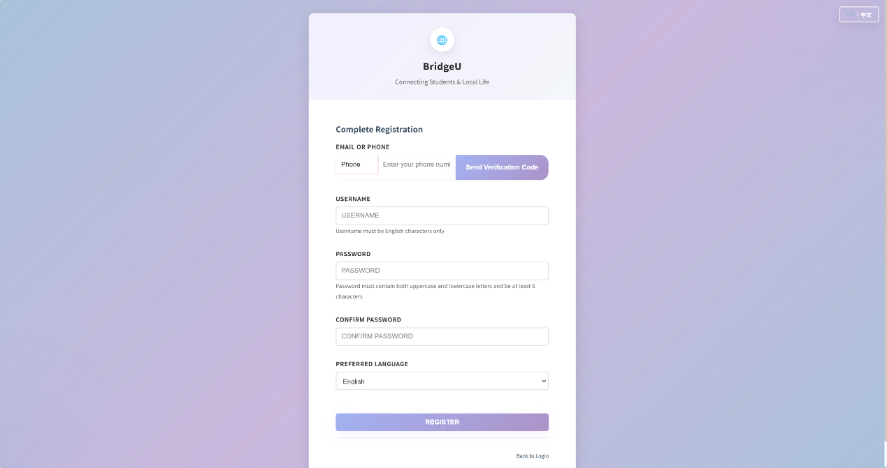

Test Case:
No | Description | Input | Expected Result
1 | Send SMS code | Enter phone +66..., click Send Code. | UI shows code-sent feedback; code input is enabled/visible.
2 | Verify SMS and register | Enter SMS code, verify, fill form, register. | Verification succeeds; account is created; user can proceed to logged-in appa.
3 | Send SMS with empty identifier | Leave phone/email field empty; click Send Code. | Error message displayed: Please enter email or phone number .
4 | Send SMS with missing country code (+) | Select Phone method, enter a phone number that does not start with +; click Send Code. | Error message displayed: Please enter phone with country code, e.g. +66... .
5 | Send SMS too frequently | Click Send Code repeatedly within 1 minute. | Error message displayed: Too many requests. Please try again in 1 minute. .
6 | Verify SMS with empty code | Enter nothing in the SMS code box; click Verify. | Can not Click
7 | Verify SMS with non-6-digit code | Enter a code that is not 6 digits; click Verify. | Error message displayed: Verification code must be 6 digits .
8 | Verify SMS with wrong code | Enter a wrong SMS code; click Verify. | Error message displayed in UI (Firebase/verification error), typically an “incorrect/expired code” message such as Incorrect verification code, please try again .
9 | Click Register before sending code | Fill username/password/etc., but do not send SMS code; click Register. | Cab not click
10 | Click Register before verifying code | Send SMS code successfully, but do not click Verify; click Register. | Can not click
11 | Invalid username (non-English) | Enter username containing non-English characters; click Register. | Error message displayed: Username must contain only English characters .
12 | Weak password | Enter password that lacks uppercase/lowercase requirement; click Register. | Error message displayed: Password must contain both uppercase and lowercase letters and be at least 6 characters (EN).
13 | Password too short | Enter password shorter than 6 characters; click Register. | Error message displayed: Password must be at least 6 characters .
14 | Password confirmation mismatch | Enter password and a different confirm password; click Register. | Error message displayed: Passwords do not match .
15 | Backend rejects registration (phone/account issues) | Enter valid inputs but use a phone/username that the backend rejects; click Register. | Error message shown in UI (backend `error`/`message`), e.g. `Username already taken` or an equivalent localized message.

4.15.STC-15:Log Out
Description: This system test verifies that users can log out and are returned to the login screen.
Prepared Data: User is logged in.
Test script:
- From any page in the main app, click “Logout” in the sidebar.
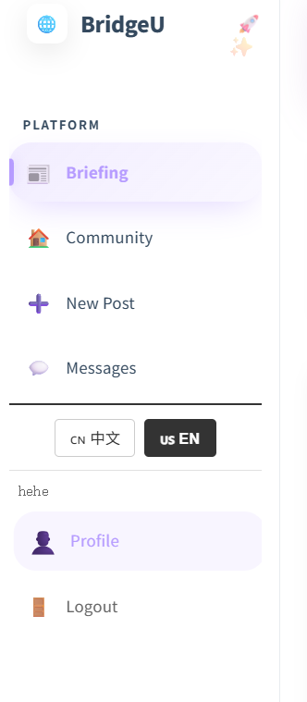
Test Case:
NO | Description | Input | Expected Result
1 | Logout | Click Logout in sidebar. | Login page shown; app requires login to access authenticated pages.

4.16.STC-16: Forgot Password (Email)
Description: This system test verifies that users can reset password using Email verification and then log in with the new password.
Prepared Data: None
Test script:
- On the login page, click “Forgot Password.Select Email method.
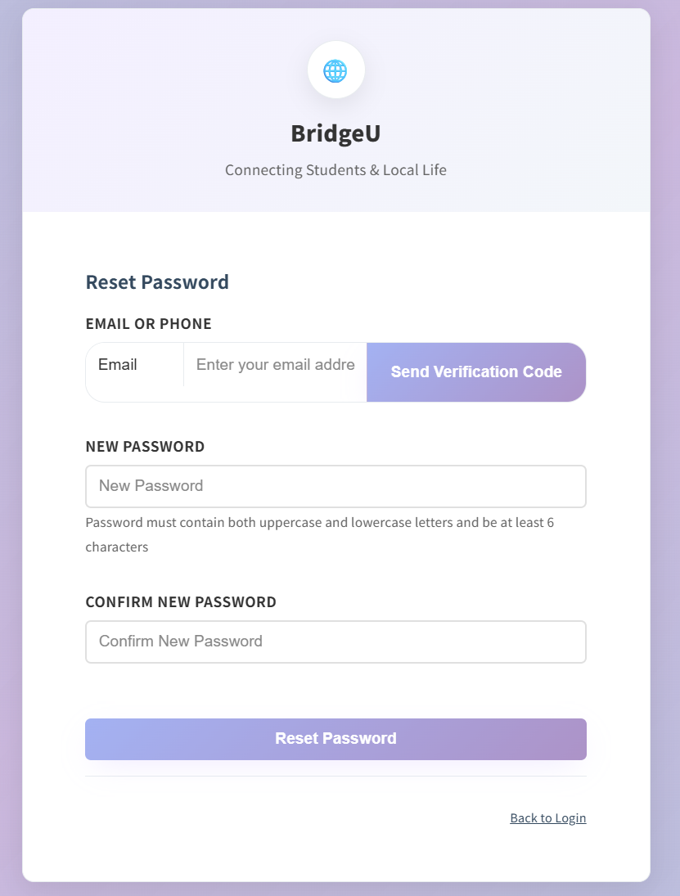
Test Case:
No | Description | Input | Expected Result
1 | Send reset code | Enter email, click Send Code. | Code-sent feedback shown; code input is enabled/visible.
2 | Reset password | Enter code and new password, submit. | Success message shown; user can log in with new password.
3 | Send reset code with empty identifier | Leave email field empty; click Send Code. | Can not click
4 | Send reset code too frequently | Click Send Code repeatedly within 1 minute. | Error message displayed: Too many requests. Please try again in 1 minute.
5 | Verify with empty code | Enter nothing in the code box; click Verify. | Can not click
6 | Verify with non-6-digit code | Enter a code that is not 6 digits; click Verify. | Error message displayed: / Verification code must be 6 digits .
7 | Verify with wrong email code | Enter a wrong 6-digit code; click Verify. | UI shows a clear verification error,” Incorrect verification code, please try again”
8 | Verify when identifier becomes empty | After sending a code, clear the email field and try to click Verify. | Error message displayed: Identifier cannot be empty.
9 | Reset while code is not sent yet | Without sending a code, try to access/reset (Reset Password button remains unusable). | Reset Password remains disabled until code is sent; user cannot complete reset.
10 | Reset with password confirmation mismatch | Enter different new password and confirm password; click Reset Password. | Error message displayed: Passwords do not match .
11 | Reset with weak password | Use a password that lacks uppercase/lowercase requirement; click Reset Password. | Error message displayed: Password must contain both uppercase and lowercase letters and be at least 6 characters .
12 | Reset with too short password | Use a password shorter than 6 characters; click Reset Password. | Error message displayed: Password must be at least 6 characters .
4.17 STC-17: Forgot Password (Phone)
Description: This system test verifies that users can reset password using Email verification and then log in with the new password.
Prepared Data: None
Test script:
- On the login page, click “Forgot Password.Select Phone method.
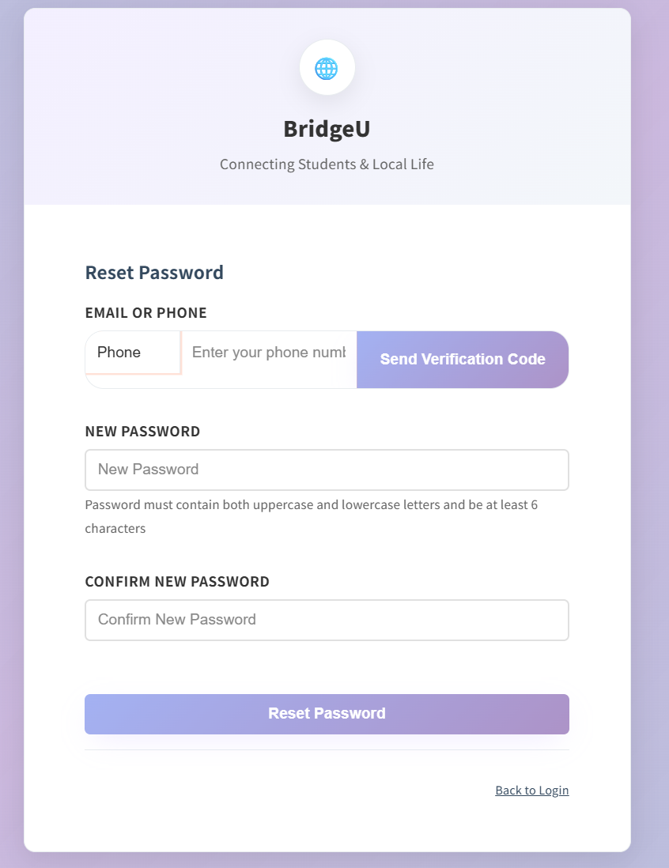

Test Case:
No | Description | Input | Expected Result
1 | Verify SMS and reset password | Phone method → Send Code → Verify → Reset. | SMS verification succeeds; success message shown; user can log in with new password.
2 | Send code with empty identifier | Choose Phone method, leave the phone field empty, click Send Code. | Can not click
3 | Send code with invalid phone format | Choose Phone method, enter a phone number that does not start with +, click Send Code. | Error message is shown: Please enter phone with country code, e.g. +66... .
4 | Send code too frequently | Click Send Code repeatedly within 1 minute. | Error message is shown: Too many requests. Please try again in 1 minute. .
5 | Verify with empty SMS code | After sending code, leave the SMS code field empty and click Verify. | Can not click
6 | Verify with wrong/expired SMS code | Enter an incorrect 6-digit SMS code and click Verify. | Error message is shown indicating the verification failed
7 | Click Reset without successful verification | Send code, but do not complete SMS verification; try to reset. | Can not click
8 | Reset with weak password | Enter a password that does not meet the uppercase/lowercase requirement; click Reset Password. | Error message shown: Password must contain both uppercase and lowercase letters and be at least 6 characters .
9 | Reset with too short password | Enter a password shorter than 6 characters; click Reset Password. | Error message shown: Password must be at least 6 characters .
10 | Reset with non-matching confirmation | Enter new password and a different confirmation password; click Reset Password. | Error message shown: Passwords do not match .

4.18.STC-18: View and Edit My Profile
Description: This system test verifies that the Profile page shows current user info and that editing profile updates what the user sees.
Prepared Data: User is logged in.
Test script:
1.Click Profile in the sidebar.
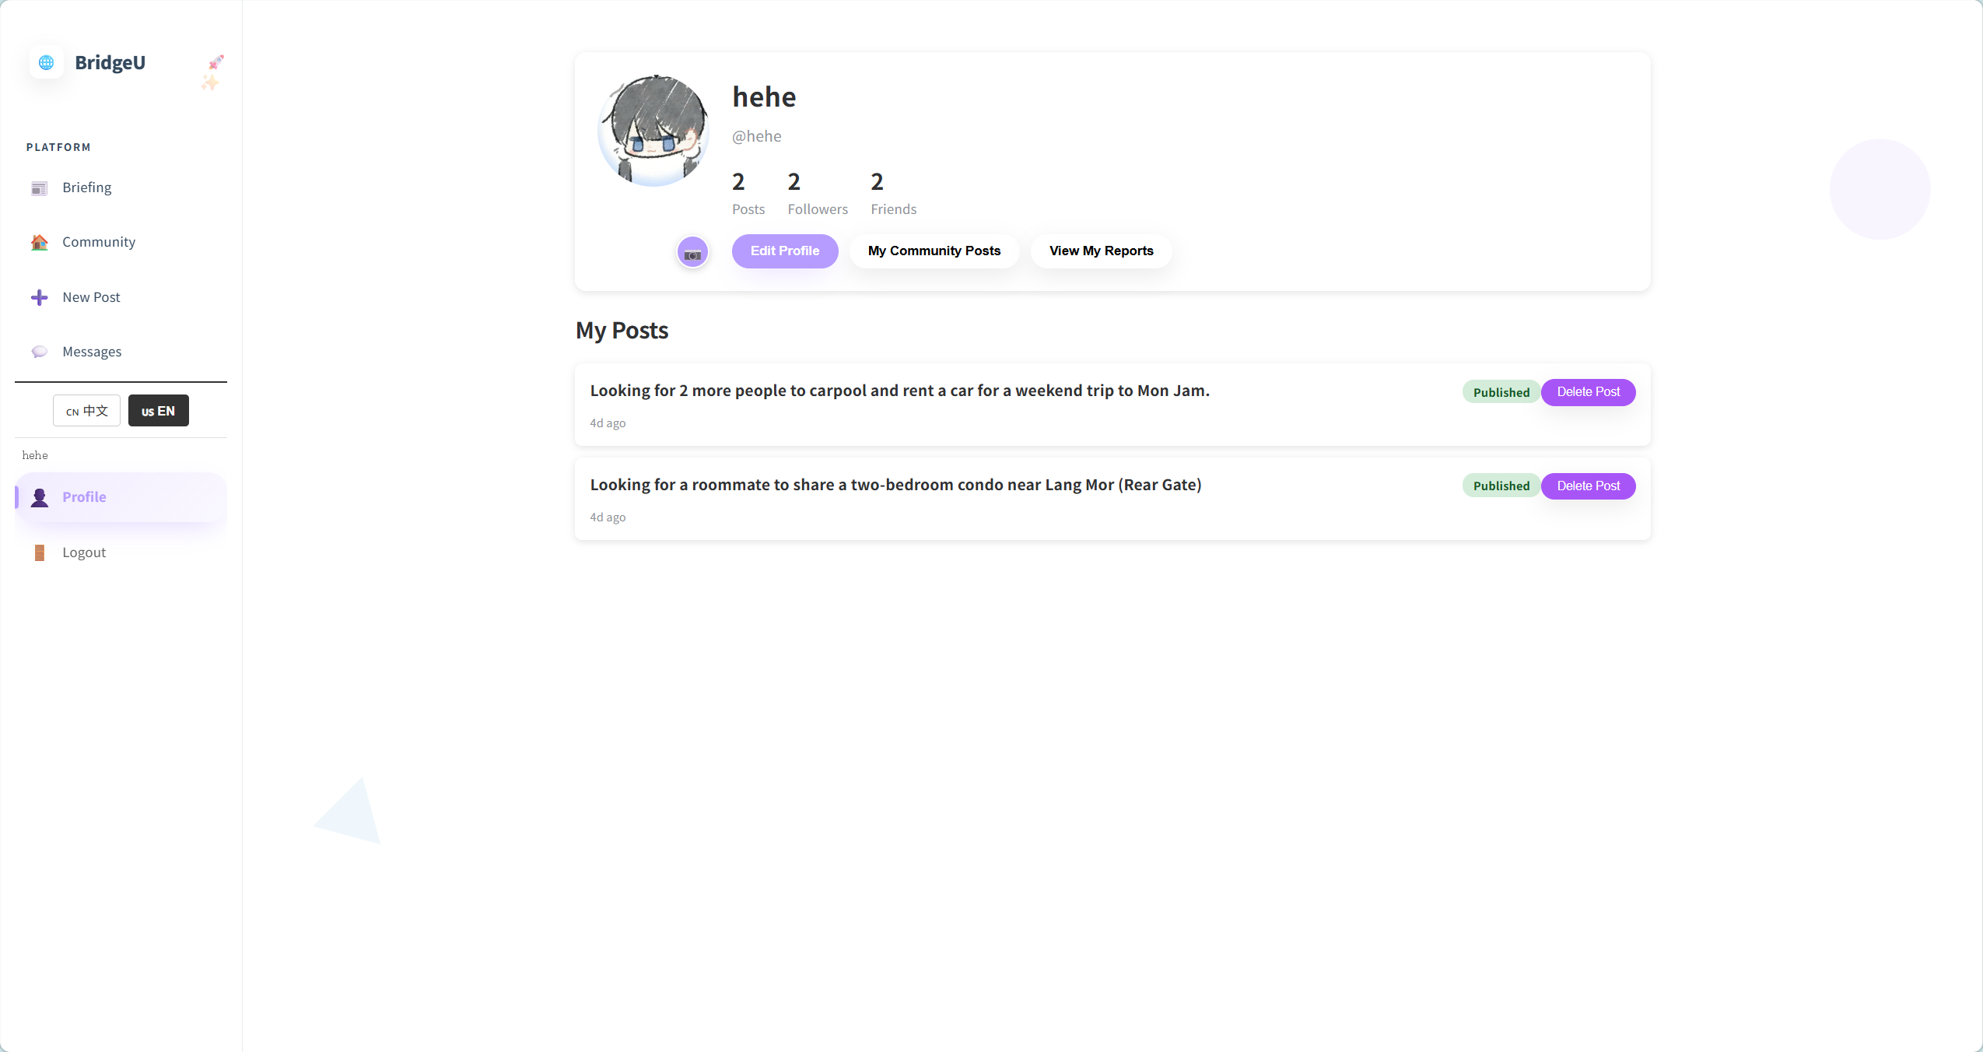
2. Click Edit Profile and change displayName (and optionally avatar).
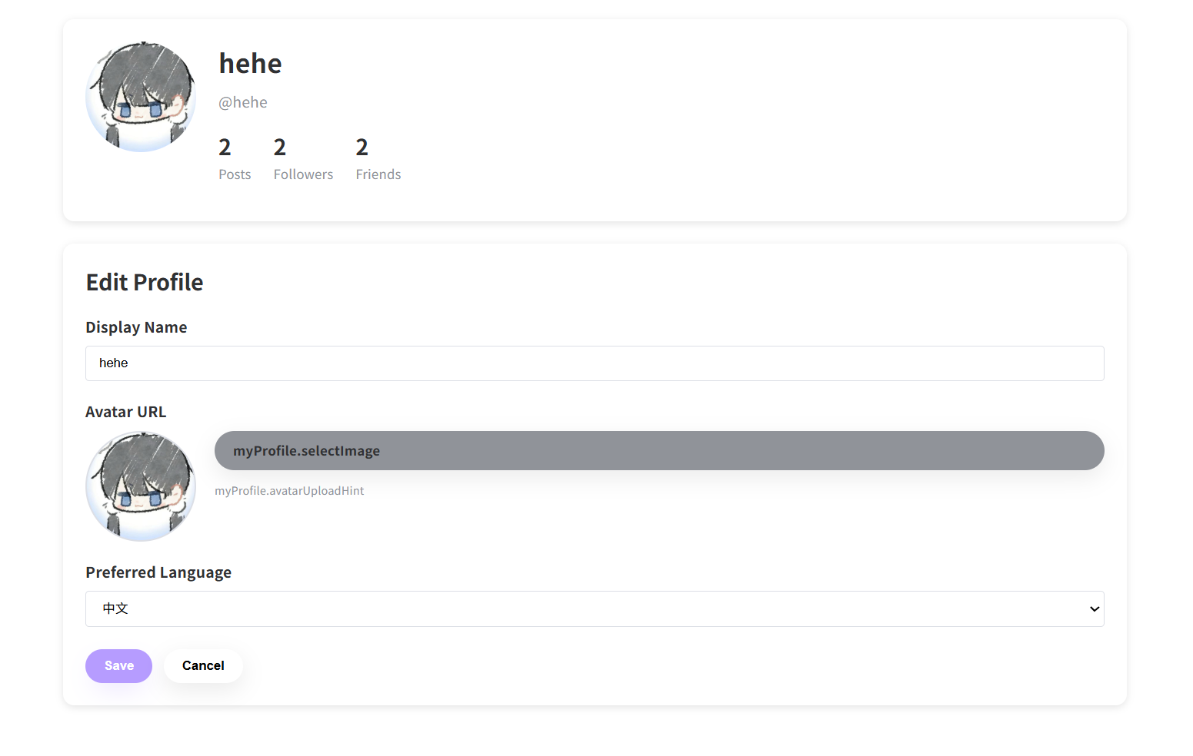
Test Case:
NO | Description | Input | Expected Result
1 | View profile | Click Profile in sidebar. | Profile shows avatar, displayName, username, stats (posts, followers, mutual follows).
2 | Edit profile username | Click Edit Profile, change displayName, save. | The front-end indicates that your personal information has been updated and your username has been changed. Please log in again. Then go back to the login page and log in using the new username.
3 | Edit profile avatar | Click Edit Profile, change avatar submit | Profile is updated; new avatar is shown.
4 | Edit profile Preferred Language | Click Edit Profile, change avatar save | Profile is updated; new language is shown.
5 | Delete post | Click delete post,then click yes | System show “Are you sure you want to delete this post? Yes/cancel”,then delete successful.
6 | Cancel delete post | Click delete post,then click cancel | System show “Are you sure you want to delete this post? Yes/cancel”,then delete cancel.

4.19.STC-19: View My Community Posts
Description: This system test verifies that the user can open **My Community Posts** from `MyProfile.vue` and view their posts list (`MyPosts.vue`).
Prepared Data: User is logged in and has at least 1 post.
Test script:
1. Click My Community Posts.
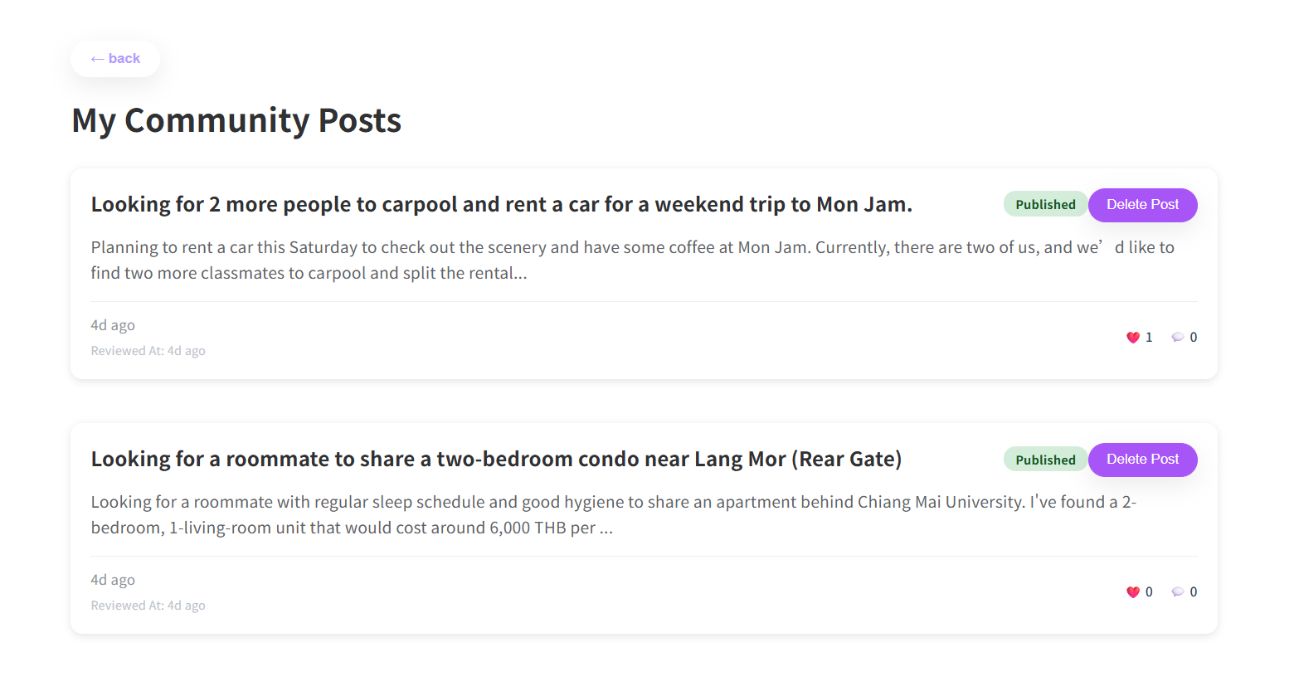
Test Case:
NO | Description | Input | Expected Result
1 | View my posts list | Click Profile → My Community Posts. | Navigates to MyPosts list and displays user's posts.
2 | Delete post | Click delete post,then click yes | System show “Are you sure you want to delete this post? Yes/cancel”,then delete successful.
3 | Cancel delete post | Click delete post,then click cancel | System show “Are you sure you want to delete this post? Yes/cancel”,then delete cancel.
4 | View the post detail | Click the post | Navigates to post detail page.
5 | Back to Profile Page | Click “Back” | Navigates to Profile page

4.20 STC-20: View My Reports
Description: This system test verifies that the user can open My Reports from Profile Page and view their reports list
Prepared Data:
Test script:
- Click “Profile”in the sidebar. Click “My Reports”.
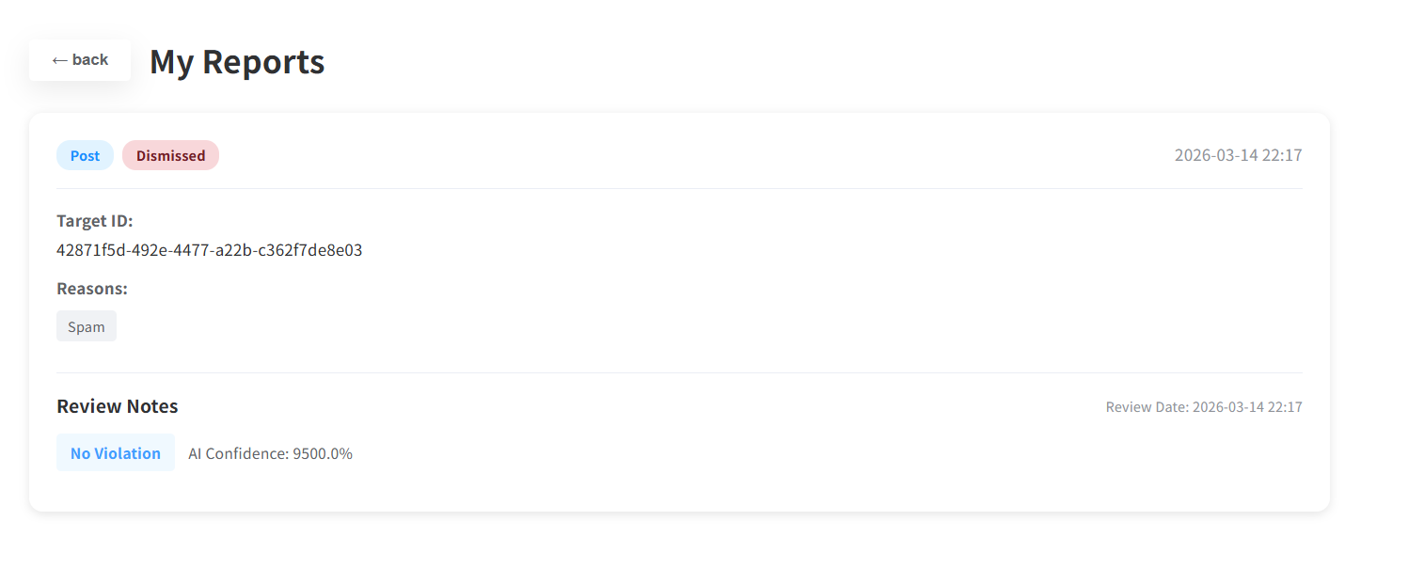
Test Case:
NO | Description | Input | Expected Result
1 | View my reports list | Click Profile → My Reports. | Navigates to MyReports view and displays user's reports (or empty state).
2 | Back to Profile Page | Click “Back” | Navigates to Profile page

4.21 STC-21: View the Friends/Followers list
Description: This system test verifies that users can view Followers (one-way follow) list, Friends (mutual follow) list.
Prepared Data: None
Test script:
1.Click the Followers
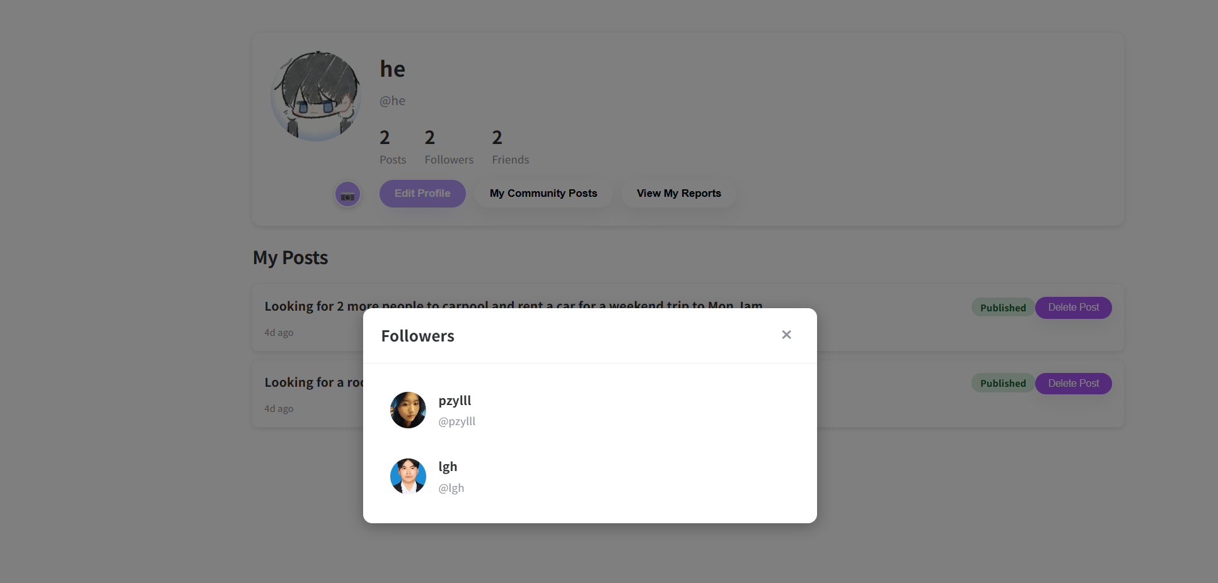
- Click the Friends
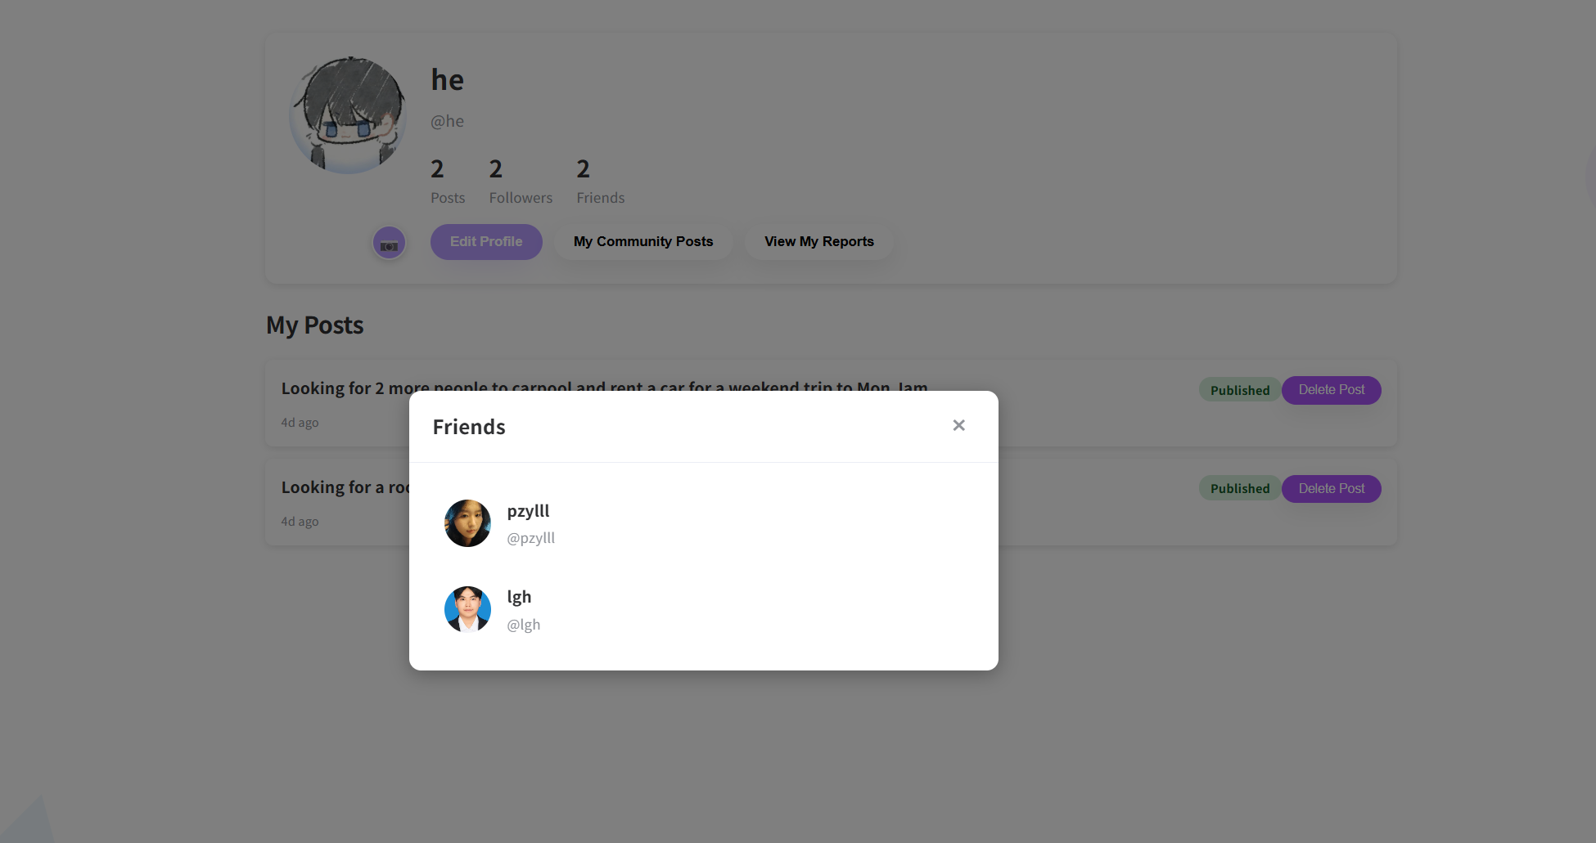
3.Click one user, system will navigate to this user’s profile page
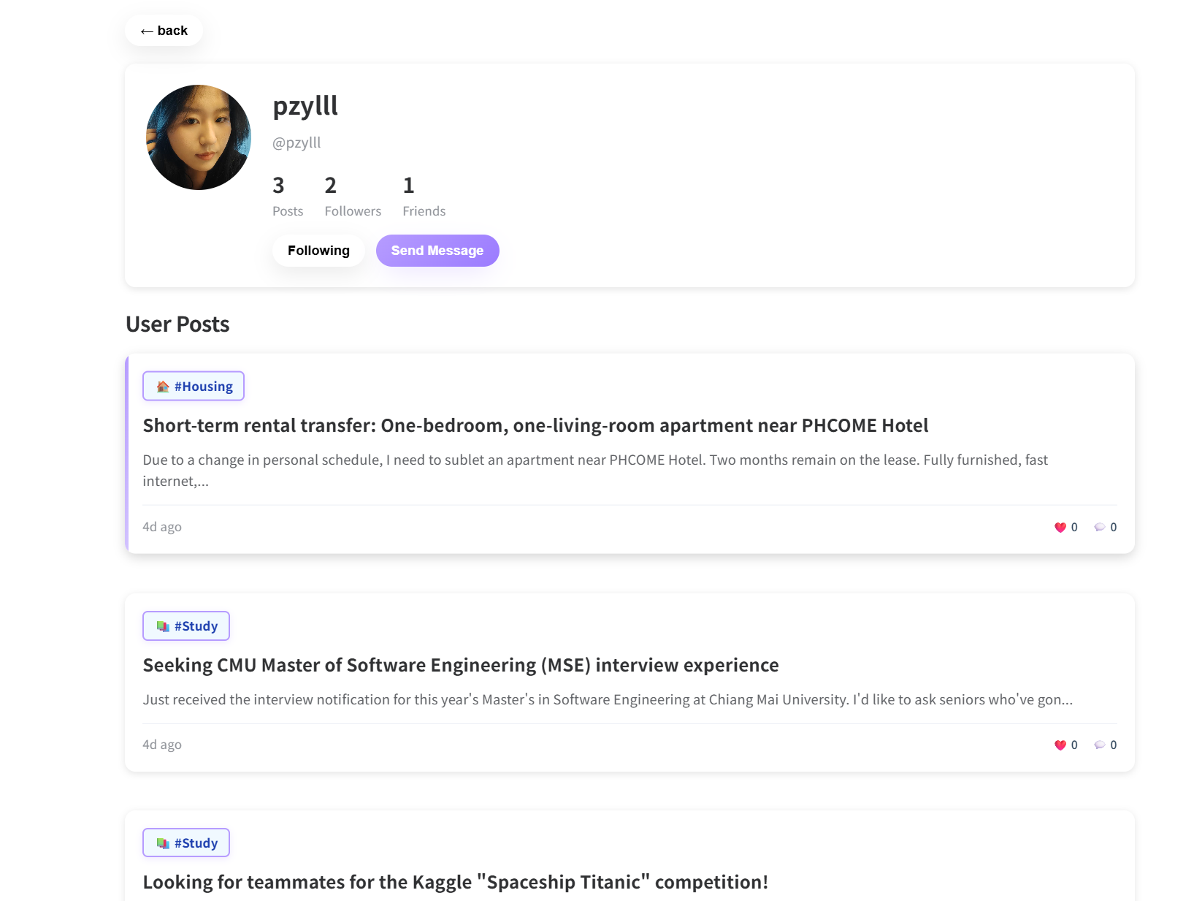
Test Case:
NO | Description | Input | Expected Result
1 | View Follower list | Click Followers. | System show Followers list
2 | View Friends (mutual- follow) list | Click Friends. | System show Frends list
3 | Send message | Click send message | Navigate to Message Page
4 | Back to Profile Page | Click “Back” | Navigates to Profile page
5 | Unfollow the user | Click “Following” | System change from “Following” to “Follow”

