BridgeU
Project Proposal

Zhiyi Pan 652115558

Bachelor of Science
Software Engineering Program

Department College of Arts, Media, and Technology Chiang Mai University November 2025

Project Advisor
Asst. Prof. Pattama Longani, Ph.D.

Document History
Document Name | Version | History | Status | Date | Editable | Reviewer
BridgeU-Proposal | BridgeU-Proposal  V.0.1 | Add Chapter 1  • Introduction and  Background  Add Chapter 2  • Business Review  • Business Tools /  Software Review  Add Chapter 3  • Development  Tools Review  Add Chapter 4  • Quality Standard  • Project  Management  Process  • Software  implementation  process  Add Chapter 5  Software Configuration Management  • Naming Convention  • Change  Management  • Project Repository Add Chapter 6  • Motivation  • Aims and  Objective  • Deliverables and  Limits  •System Architecture  •Software Process  •Feature  •User journey  Add Chapter 7  • References | Draft | 20/11/2025 | ZHIYI PAN | Asst. Prof. Pattama Longani, Ph.D.

Table of content
page
Chapter 1 | Introduction and Rationale 6
Chapter 2|Literature Review 7
2.1 Business Review 7
2.2.1 Overview 7
2.1.2 Target 8
2.1.3 Benefit 9
2.2Business Tools / Software Review 10
2.2.1 Facebook Groups 10
2.2.2 Xiaohongshu (Little Red Book) 11
2.2.3 reddit 12
2.2.4 Feature Comparison 13
Chapter 3 | Development Tools Review 14
Chapter 4 | Quality Standard 21
4.1 Project Management Process 21
4.2 Software implementation process 21
Chapter 5 | Software Configuration Management 22
5.1 Naming Convention 22
5.2 Change Management 22
5.3 Project Repository 23
Chapter 6 Literature Review 24
6.1 Motivation 24
6.2 Aims and Objective 24
6.2.1 Aims 24
6.2.2 Objective 24
6.3 Deliverables and Limits 25
6.3.1 Deliverables 25
6.3.2 Limits 25
6.4 System Architecture 25
6.5 Software Process 26
6.6 Feature 27
6.7 User journey 28
Chapter 7 References 42

Chapter 1 | Introduction and Rationale
In today's digital age, studying abroad has become an integral part of global education and cultural exchange. Regardless of language, ethnicity, or cultural background, students aspire to gain quality education and life experiences in foreign lands. However, for international students navigating life alone overseas, integrating into local communities, managing daily logistics (such as housing, visas, and transportation), and finding a sense of belonging often present significant challenges.
A significant pain point in current study abroad experiences is the inefficiency of information access and social barriers. International students often find themselves in a dilemma: “When facing difficulties, they don't know whom to ask,” and “When they have valuable experiences, they don't know whom to share them with.” While generic social media platforms exist, there is a lack of a structured platform specifically designed for “cross-regional, cross-cultural mutual assistance.” Furthermore, traditional forum searches rely on precise keywords. When users search using different linguistic habits—such as slang or vague descriptions—they often fail to find valuable past experience posts.
To address these issues, we developed BridgeU. This international student mutual aid community integrates natural language processing (NLP) technology. BridgeU connects not only compatriots (e.g., Chinese students in Thailand) but also complementary groups (e.g., Thai students in China), creating a mutually beneficial ecosystem where “everyone gains value.”
BridgeU's core strength lies in its intelligent support features: an NLP semantic search engine and an AI-powered Q&A bot. The system understands synonyms and distills optimal answers from vast post archives to provide users with tailored responses. Through these capabilities, BridgeU strives to make international students' lives more convenient and supportive, positioning itself as an essential tool for modern study abroad experiences in the digital age.

Chapter 2|Literature Review

2.1 Business Review

2.2.1 Overview

Figure 1 International students
In today's globalized educational landscape, studying abroad has become a common phenomenon. However, when students find themselves in a foreign land, language barriers, culture shock, and delayed access to information often pose the greatest obstacles to their integration into local life. While traditional social media platforms offer connectivity, they lack precise categorization for specific “home country-destination country” groups and fail to effectively address the pain point of reading lengthy guides in a foreign language.
To address these challenges, we introduce BridgeU—an AI-powered mutual aid platform for international students. BridgeU transcends a social network to become an intelligent life assistant. It leverages Alibaba Cloud's large language model (QwenAI) for article summarization and translation services, utilizes Elasticsearch for precise semantic search, and establishes high-quality private social networks through a “mutual follow” mechanism. Our goal is to empower every international student to find their community on BridgeU, overcome language barriers, and achieve genuine mutual support and exchange.

2.1.2 Target
2.1.2.1 Problems
- Community categorization chaos: Traditional platforms struggle to locate specific “country of origin -> destination country” communities.

- Language barriers: Useful local posts (e.g., Thai-language rental listings) remain inaccessible due to comprehension gaps, while translation tools involve cumbersome switching.

- Difficulty reading lengthy posts: Struggling to quickly extract key information from lengthy guide posts.

- Low search efficiency: Keyword matching fails to recognize the connection between “finding food” and “delicious food.”

- Social harassment: Open messaging systems lead to an influx of spam messages.

2.1.2.2 Solutions
- Multi-dimensional Category Management: The system presets and manages specific sections such as “Chinese in the UK” and “Thais in China.”

- AI-Assisted Reading: Integrates Alibaba Cloud's large language model to instantly summarize lengthy articles into user-preferred languages (e.g., Thai/Chinese).

- Elasticsearch Semantic Search: Delivers high-performance full-text search and semantic matching capabilities.

- Mutual Follow Social Mechanism: Online chat is enabled only after mutual following, ensuring social interaction quality.

2.1.3 Benefit
The development of BridgeU not only resolves technical challenges but also creates significant social and user value.
1.For Users (International Students):
- Breaking Language Barriers: Through integrated AI translation and summarization features, international students no longer miss crucial daily information (such as local housing listings or part-time job opportunities) due to language barriers (e.g., Thai, Korean), greatly expanding their access to essential resources.
- Improving Decision Efficiency: Semantic search enables users to find precise results using their native language habits; AI summarization distills the core of lengthy guides in seconds, saving substantial reading time.
- Building Quality Connections: The “mutual follow” requirement for messaging effectively filters out unwanted interactions, ensuring every conversation is based on mutual consent. This enhances the depth and safety of social connections.
- Enhancing Belonging: The precise “Hometown Community” feature helps users quickly find their community abroad, alleviating feelings of loneliness.
2.For Administrators/Platform:
- Efficient Governance: A robust backend management system (covering users, roles, and community administration) simplifies maintaining order, enabling swift responses to reports and handling of violations.
- Content Accumulation: Through categorized management and AI assistance, the platform accumulates a vast, structured repository of high-quality cross-border living knowledge, forming its long-term core competitiveness.
3. For Society (Social Value):
Promoting Cultural Integration: BridgeU connects not only compatriots but also “complementary groups” (e.g., Thais in China and Chinese in Thailand), fostering authentic cross-cultural exchange and mutual support. This embodies the community spirit of “meeting each other's needs and achieving mutual benefit.”

2.2Business Tools / Software Review
Several similar applications are currently available on the market, but they differ significantly from BridgeU. Below is an analysis of several key competitors:

2.2.1 Facebook Groups
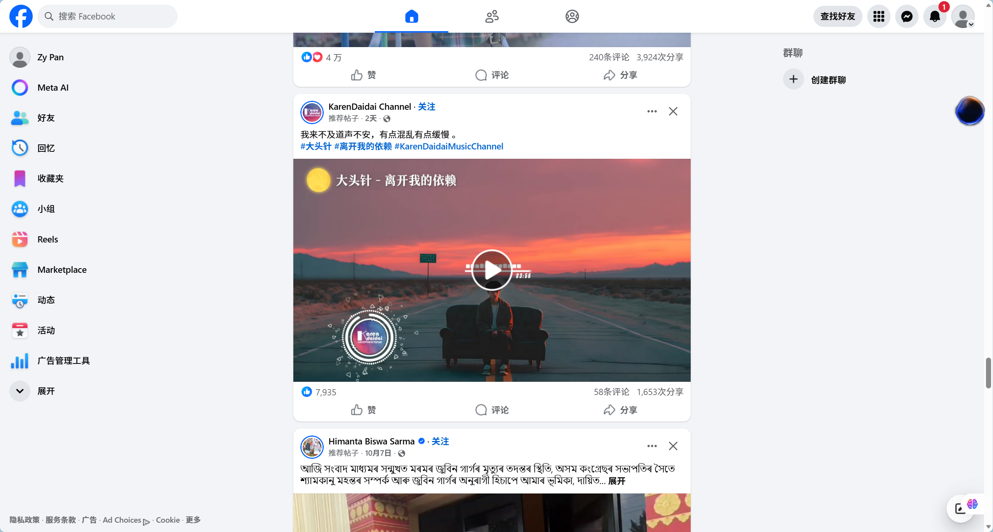
Figure 2 Facebook Groups
Facebook Groups are currently one of the most widely used mutual aid tools among international students worldwide.
Pros:
- Huge user base with broad coverage.
Cons:
- Extremely weak search functionality, chaotic information flow, and lack of specialized features tailored for international student scenarios (e.g., secondhand transaction verification, AI summarization).

2.2.2 Xiaohongshu (Little Red Book)
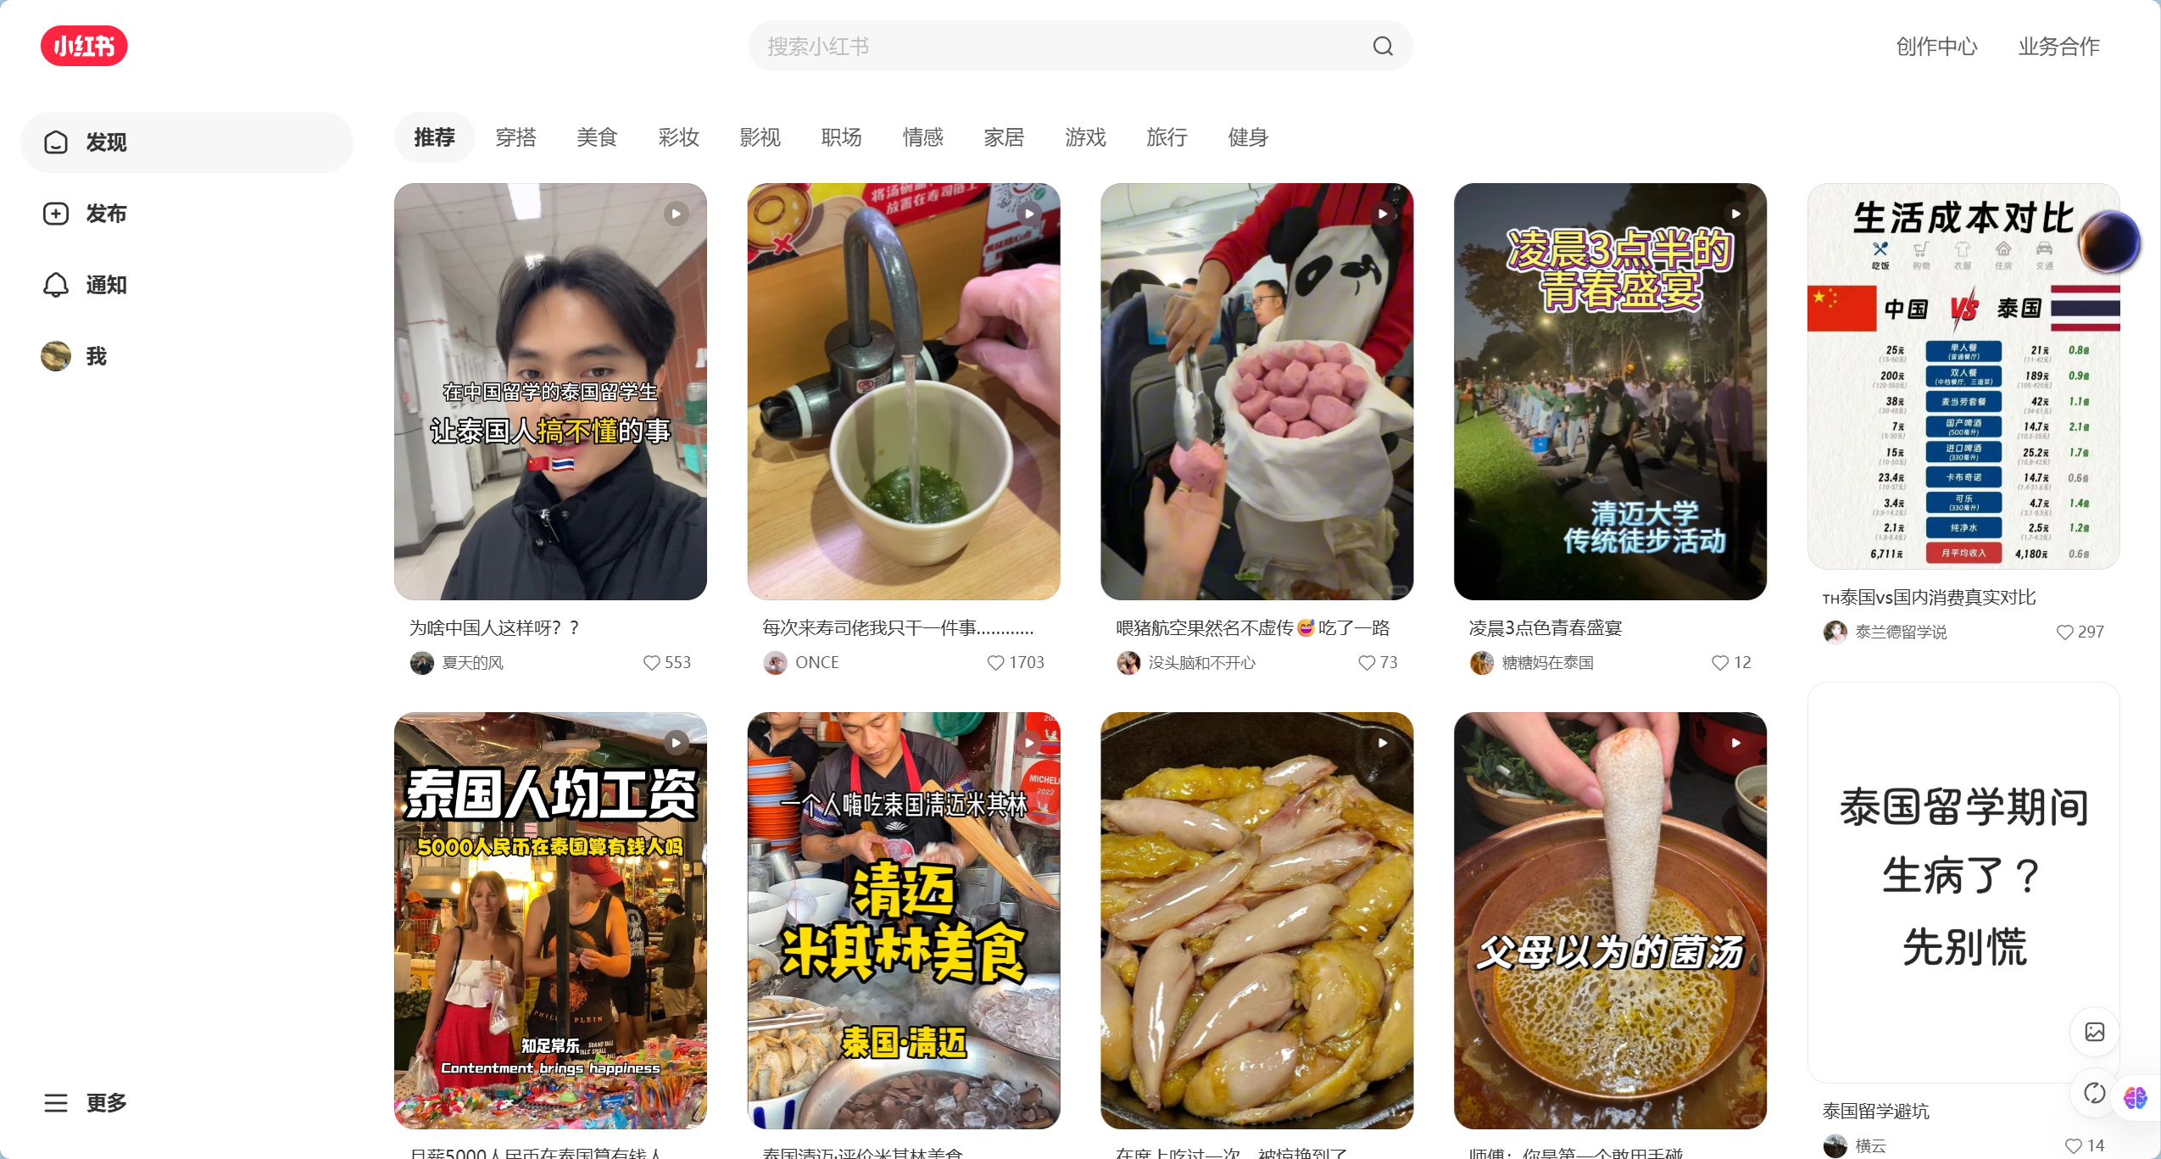
Figure 3 Little Red Book
Xiaohongshu is currently the most popular lifestyle sharing platform among Chinese international students.

Pros:
- Rich content, precise algorithmic recommendations, aesthetically pleasing interface.
Cons:
- Primarily one-way content consumption with limited two-way mutual support mechanisms; primarily serves Chinese-speaking users, making it difficult to connect with local students.

2.2.3 reddit
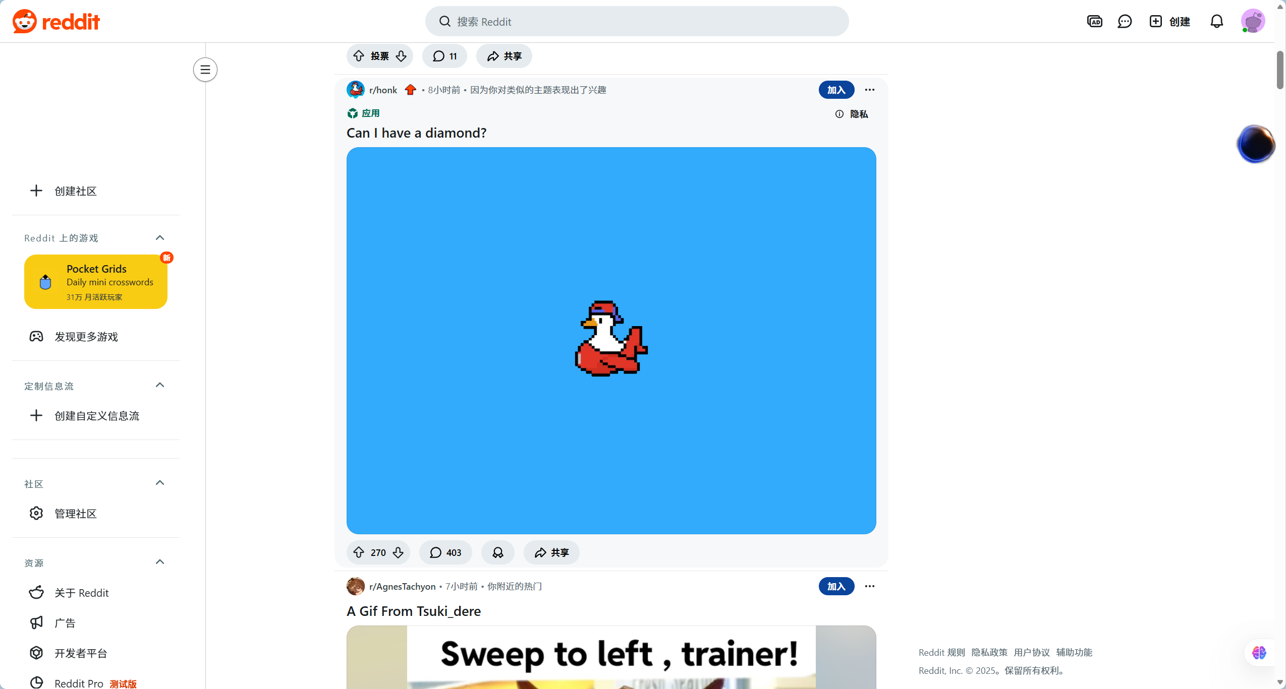
Figure 4 reddit

Reddit is one of the world's largest online forums, hosting numerous study abroad-related subreddits.

Pros:
- Structured discussions: Clear topic-based section categorization (e.g., r/studyabroad, r/Thailand).
- Anonymity: Users feel comfortable asking genuine questions.
Cons:
- Geeky interface: Less user-friendly for non-technical users.
- Language barrier: Primarily English-based, lacking multilingual support and translation tools.
- Limited social features: Focuses on public discussions, lacking private one-on-one support mechanisms.

2.2.4 Feature Comparison
Features | Facebook Groups | Little Red Book | Reddit | BridgeU
Web-based Access | ✓ | ✓ | ✓ | ✓
Origin->Dest |  |  |  | ✓
AI Summary |  |  |  | ✓
Semantic Search |  | ✓ |  | ✓
Mutual Follow Chat |  | ✓ |  | ✓
Translation | ✓ | ✓ |  | ✓
Admin Panel | ✓ | ✓ | ✓ | ✓

Chapter 3 | Development Tools Review

Figure 5 Visual Studio Code
Description
Visual Studio Code, or VS Code, is a lightweight but powerful source code editor which runs on your desktop and is available for Windows, macOS, and Linux. It comes with built-in support for JavaScript, TypeScript, and Node.js and has a rich ecosystem of extensions for other languages (such as C++, C#, Java, Python, PHP, Go) and runtimes (such as .NET and Unity).
Alternative technologies
Eclipse
Reasons for this choice
We will use Visual Studio Code as the primary IDE for frontend development. Its extensive plugin ecosystem, particularly Vetur and Volar, provides excellent support for Vue.js development, including syntax highlighting, intelligent code completion (IntelliSense), and snippet generation. The integrated terminal and Git support further streamline the development workflow, allowing for efficient version control and command execution directly within the editor.


Figure 6 Vue Framework
Description
Vue.js is an open-source model–view–viewmodel front end JavaScript framework for building user interfaces and single-page applications. It was created by Evan You and is maintained by him and the rest of the active core team members. It features an incrementally adoptable architecture that focuses on declarative rendering and component composition.
Alternative technologies
- React
Reasons for this choice
We will use Vue.js (specifically Vue 2) for the frontend development because of its gentle learning curve and the intuitive two-way data binding feature, which simplifies form handling and state management in our community-driven application. Its component-based architecture allows for the creation of reusable UI elements, and the integration with Element UI will significantly accelerate the development of a polished and responsive user interface.



Figure 7 IntelliJ IDEA

Description
IntelliJ IDEA is an integrated development environment (IDE) written in Java for developing computer software. It is developed by JetBrains (formerly IntelliJ) and is available as an Apache 2 Licensed community edition and in a proprietary commercial edition. Both can be used for commercial development. It provides comprehensive facilities to computer programmers for software development.
Alternative technologies
- Eclipse
- NetBeans
Reasons for this choice
We have selected IntelliJ IDEA as the main development tool for the backend due to its superior support for the Java ecosystem and the Spring Boot framework. Its intelligent code analysis, powerful refactoring tools, and seamless integration with build tools like Maven greatly enhance productivity. The built-in database tools and Spring initializr support make it the optimal choice for building robust enterprise-level applications with Spring Boot.

Figure 8 Springboot
Description
Spring Boot is an open-source Java-based framework used to create a micro Service. It is developed by Pivotal Team and is used to build stand-alone and production-ready spring applications. It provides a good platform for Java developers to develop a stand-alone and production-grade spring application that you can just run.
Reasons for this choice
Spring Boot is chosen for the backend service due to its ability to simplify the configuration and deployment of Spring applications. Its "convention over configuration" approach reduces boilerplate code, allowing us to focus on business logic. The seamless integration with MyBatis-Plus provides a powerful yet simple way to interact with the database, while its robust security features and scalability make it ideal for handling the complex logic of user management and content processing in BridgeU.


Figure 9 MySQL
Description
MySQL is an open-source relational database management system (RDBMS). Its name is a combination of "My", the name of co-founder Michael Widenius's daughter, and "SQL", the abbreviation for Structured Query Language. A relational database organizes data into one or more data tables in which data types may be related to each other; these relationships help structure the data.
Alternative technologies
- PostgreSQL
- Oracle Database
- MongoDB
Reasons for this choice
We will use MySQL 8 as the primary relational database management system. It is renowned for its reliability, performance, and ease of use. MySQL 8's support for JSON data types offers flexibility for storing semi-structured data if needed, while its ACID compliance ensures data integrity for critical transactions such as user registrations and post publishing. Its widespread use means there is ample community support and documentation available.


Figure 10 MySQL
Description
Elasticsearch is a search engine based on the Lucene library. It provides a distributed, multitenant-capable full-text search engine with an HTTP web interface and schema-free JSON documents. Elasticsearch is developed in Java and is released as open source under the terms of the Apache License.
Alternative technologies
- Apache Solr
- Algolia
Reasons for this choice
We will incorporate Elasticsearch to power the semantic search functionality of BridgeU. Its inverted index structure allows for extremely fast full-text searches, which is crucial for retrieving relevant community posts based on user queries. Elasticsearch's ability to handle complex search requirements, such as fuzzy matching and relevance scoring, will significantly improve the user experience compared to traditional SQL search methods.



Figure 11 Aliyun Qwen

Description
Aliyun Qwen (Tongyi Qianwen) is a large language model (LLM) developed by Alibaba Cloud. It is designed to understand and generate human-like text across a wide range of languages and domains. It offers capabilities in natural language understanding, text generation, translation, and summarization, accessible via API for integration into various applications.
Alternative technologies
- OpenAI GPT-4
- Baidu Ernie Bot
Reasons for this choice
We have chosen Aliyun Qwen as our AI service provider because of its exceptional performance in processing and understanding Asian languages, particularly Chinese and Thai, which are central to our target user demographic. Its API offers low latency and high availability within the region, making it the ideal choice for implementing real-time features such as article summarization and cross-language translation on the BridgeU platform.

Chapter 4 | Quality Standard
ISO 29110 for Very Small Entity (VSE)
ISO/IEC 29110-4-1:2011 is applicable to Very Small Entities (VSEs). A Very Small Entity (VSE) is defined as an enterprise, organization, department, or project having up to 25 people. A set of standards and guides has been developed according to a set of VSEs' characteristics and needs. The guides are based on subsets of appropriate standards elements, referred to as VSE profiles. The purpose of a VSE profile is to define a subset of International Standards relevant to the VSE context.

4.1 Project Management Process
The purpose of the software management process is to establish, develop and carry out systematically the task of the software implementation project, which allows complying with the project's objective in the expected quality.
The 4 activities in the project management process:
- Project Planning
- Project Plan Execution
- Project Assessment and Control
- Project Closure

4.2 Software implementation process
The purpose of the software implementation process is the systematic performance of the analysis, design, construction, integration, and test activities for new or modified software products according to the specified requirements. There are 6 Activities:
- Software Implementation Initiation
- Software Requirement Analysis
- Software Architectural and Detailed Design
- Software Construction
- Software Integration and Tests
- Software Deliver

Chapter 5 | Software Configuration Management

Chapter 6 Literature Review

6.1 Motivation
The development of BridgeU originated from a deep understanding of the challenges international students face in their daily lives. Studying abroad is not just about academic pursuit; it is also about navigating a new culture, language, and social environment. We observed that international students often struggle with "information islands" where valuable local knowledge is fragmented across various platforms and languages. Additionally, language barriers often prevent students from fully accessing local resources, leading to feelings of isolation and helplessness. Therefore, BridgeU was created to bridge this gap. By leveraging advanced technologies such as Large Language Models (LLM) and Semantic Search, we aim to provide a platform that empowers students to access information effortlessly and build meaningful connections across cultures in the digital era.

6.2 Aims and Objective

6.2.1 Aims
BridgeU aims to help international students overcome language and information barriers, enabling them to integrate into local life more efficiently and build a supportive cross-cultural community.

6.2.2 Objective
- A website that allows users to access precise community information through an Elasticsearch-powered Semantic Search engine, solving the problem of inefficient keyword matching.
- A website that integrates Aliyun Qwen AI to provide real-time article summarization and translation, breaking down language barriers for non-native speakers.
- A website that fosters high-quality social interactions through a mutual-follow chat system, ensuring a safe and respectful communication environment.
- A website that provides a structured classification system for community posts (e.g., "Thai students in China"), allowing users to quickly find relevant peer groups.

6.3 Deliverables and Limits

6.3.1 Deliverables
- Project Proposal
- Software Project Plan Document
- Software Requirement Specification (SRS)
- Software Design Document (SDD)
- Software Test Plan Document
- Software Test Record Document
- Software Traceability Document
- Software Product

6.3.2 Limits
- BridgeU is a website that requires an internet connection.
- The accuracy of the AI summary and translation depends on the capabilities of the Aliyun Qwen model API.
- The chat feature only supports text input.+

6.4 System Architecture
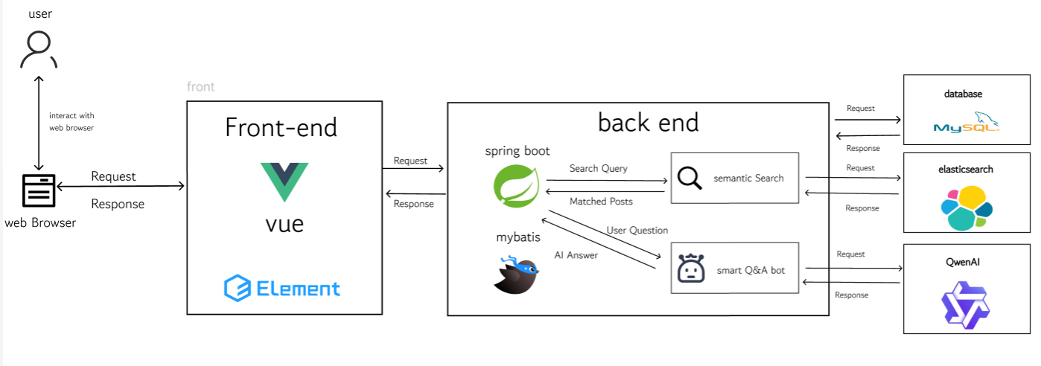
Figure 12 System Architecture
Description:
The system architecture consists of a front-end built using Vue.js 2 and Element UI, which provides a responsive user interface. The back-end is built with Spring Boot, a robust Java framework, handling business logic and RESTful API requests. MySQL 8 is used as the primary database for storing structured user and post data. Elasticsearch is integrated to provide high-performance semantic search capabilities. Additionally, the system connects to the Aliyun Qwen API to perform natural language processing tasks such as summarization and translation. Axios is used for communication between the front-end and back-end.

6.5 Software Process
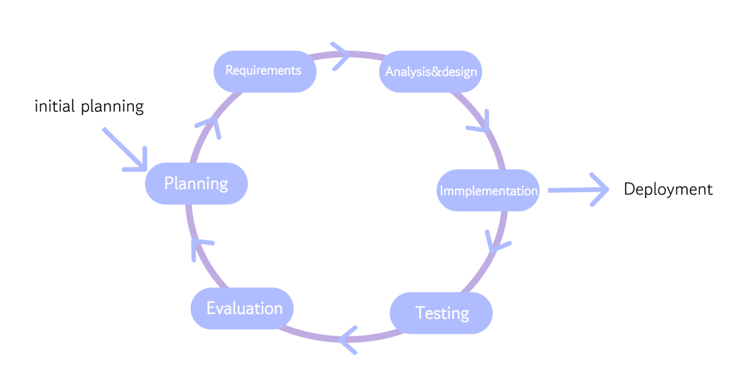v
Figure 13 Software Process
An iterative process model is used to develop the BridgeU software. This model divides the development process into rounds, or iterations. Each round includes planning, design, development, and testing of specific features (e.g., first iteration for User Auth, second for Community Posts). This allows for flexibility in adjusting requirements based on feedback and testing results throughout the development lifecycle.

6.6 Feature
Feature #1: Admin Management System Description:
This feature empowers administrators to maintain the order and structure of the community. Admins can manage user accounts
, define user roles, and dynamically configure community categories (e.g., creating a new board for "Chinese in UK"). Additionally, admins have the authority to moderate content by deleting violating posts to ensure a healthy community environment.
Feature #2: AI-Powered Content Processing Description:
This feature utilizes the Aliyun Qwen Large Language Model to assist users in consuming content across languages. Users can click a "Summarize" button on long articles, and the system will generate a concise summary in their preferred language (e.g., summarizing a Thai rental guide into Chinese). It also supports full-text translation, making local information accessible to everyone.
Feature #3: Semantic Search Engine Description:
This feature leverages Elasticsearch to provide an advanced search experience. Unlike traditional SQL LIKE queries, this engine understands the semantic meaning of search terms. For example, searching for "food" will retrieve posts containing "restaurant," "dining," or "snacks," significantly improving the efficiency of information retrieval for users.
Feature #4: Mutual-Follow Social System Description:
This feature is designed to create a high-quality social environment. Users can follow other users they find interesting. However, the direct messaging (chat) function is unlocked only when two users follow each other mutually. This mechanism prevents spam and harassment, ensuring that conversations happen between users with established mutual interest.

6.7 User journey
A user journey describes the experience a user has with the BridgeU platform from start to finish.
The journey begins when the user logs into the BridgeU website. They are presented with the Community Homepage, which serves as the central hub for information exchange. As shown in Figure 14 the layout features a navigation sidebar on the left, providing quick access to "Community," "Post," "Message," and "Profile."
In the main content area, the user sees a diverse feed of mutual aid posts. Each post card is distinctively marked with a "Country Tag" in the top-right corner (e.g., TH->CN for a Thai student in Beijing, or CN->UK for a Chinese student in London), allowing users to instantly identify the community context. The user can browse through topics ranging from visa help (TM30 reporting) to second-hand sales and language exchange. Additionally, the top filter bar allows the user to switch between specific community boards (e.g., viewing only "CN->TH" posts) or use the search bar to find specific keywords.
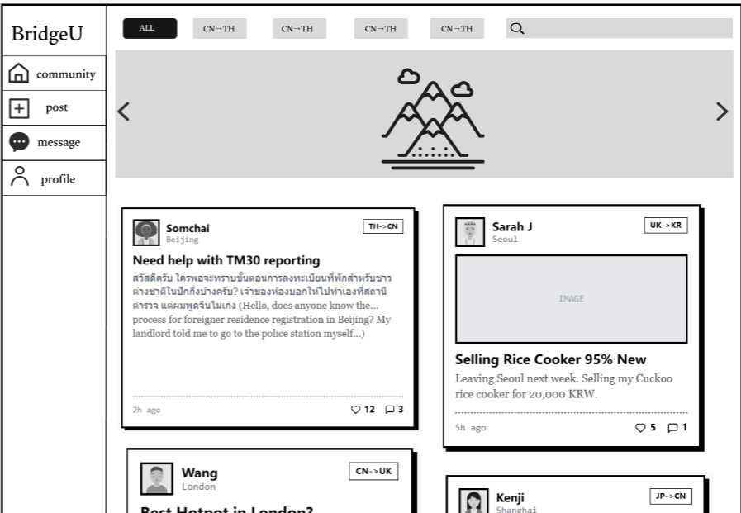
Figure 14 UI01-Communitypage
After browsing the feed, the user clicks on a specific post that catches their interest, such as "Need help with TM30 reporting" by Somchai. The user is directed to the Post Detail Page.
As shown in Figure 15, the user notices that the post content is a mix of English and Thai. To understand the specific details written in Thai, the user utilizes the embedded "AI Assistant" feature. The user selects "Translate to English" from the dropdown menu and clicks the "Generate Summary" button. The system instantly calls the Aliyun Qwen API and displays two key pieces of information within the AI box:
- A concise Summary of the user's intent (e.g., "The user is asking for help regarding TM30...").
- A full Translation of the original text into the selected language.

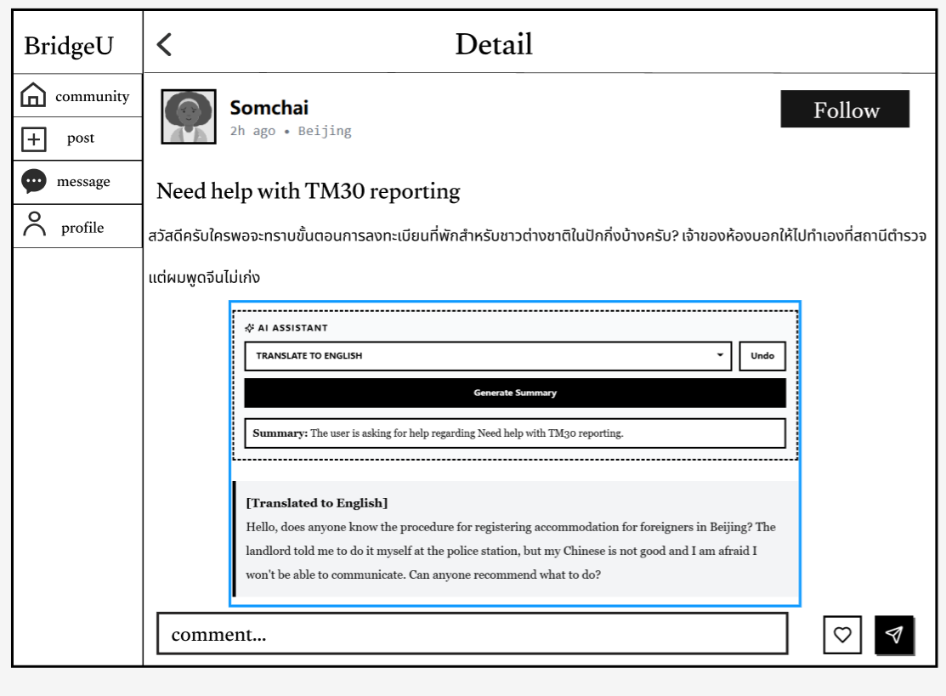
Figure 15 UI02-Detailpage

The user has a specific inquiry regarding their stay but might not know the exact keywords. They click on the Search Bar and type "visa extend".
As shown in Figure16, the system utilizes Elasticsearch for semantic retrieval. Instead of relying solely on exact keyword matching, the engine understands the search intent and associates "visa extend" with related terms like "immigration," "TM30," and "residence permit." The search results prioritize high-value posts, such as "Visa Extension Queue" and "Need help with TM30 reporting," ensuring the user finds both what they asked for and closely related necessary information. Furthermore, the system suggests Related Topics chips (e.g., Work Permit, 90 Days Report) to help the user navigate the complex immigration landscape.
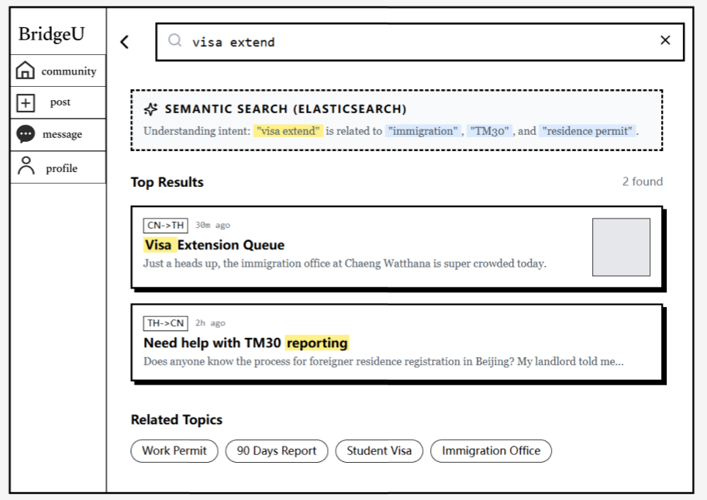
Figure 16 UI03-Searchpage

Inspired by the helpful community, the user decides to contribute by sharing their own experience. They navigate to the "Post" tab from the left sidebar.
As shown in Figure 17, the user is first presented with a clean Create Post interface featuring a prominent "+" button and a "Start Writing" call-to-action. Upon clicking this button, the system transitions to the Post Editor interface (as seen in Figure 18.)
In the editor, the user can upload multimedia content (e.g., a video of their dormitory) by clicking the designated "Click to upload video" area. Below that, a text box allows them to "Enter text here..." to describe their story or question. Once satisfied, they click the "Click to upload the post" button to publish their content to the community feed.

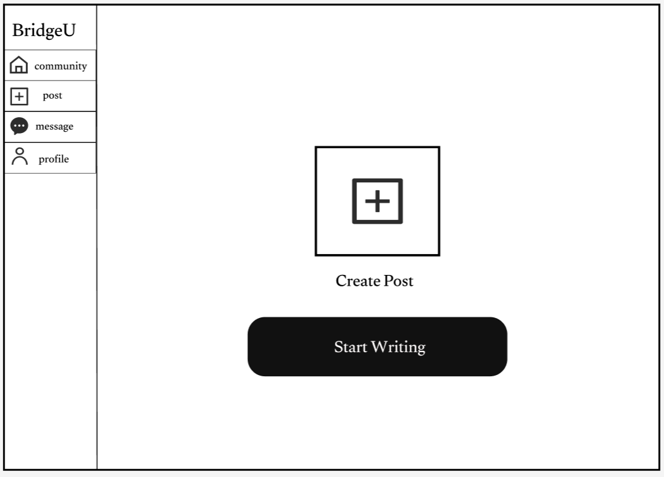
Figure 17 UI03-Creatpostpage01
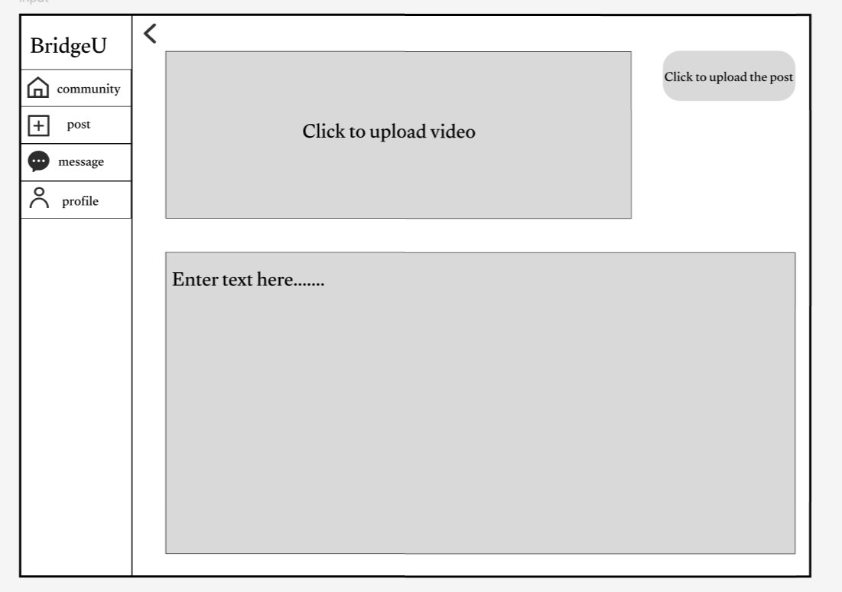
Figure 18 UI04-Creatpostpage02

The user navigates to the "Message" tab to check their conversations.
As shown in Figure 19, the message list clearly distinguishes between active chats and restricted ones.
- Active Chats: Conversations with users like Somchai and Wang Dali are accessible because both parties follow each other. The interface shows the last message snippet and timestamp.
- Restricted Interactions: For users like Sarah Jenkins and Kenji, the system displays a grayed-out state with the label "Mutual follow required". This visual cue reinforces the platform's safety mechanism, ensuring that direct messaging is only possible when there is a mutual connection, thereby reducing unwanted spam.

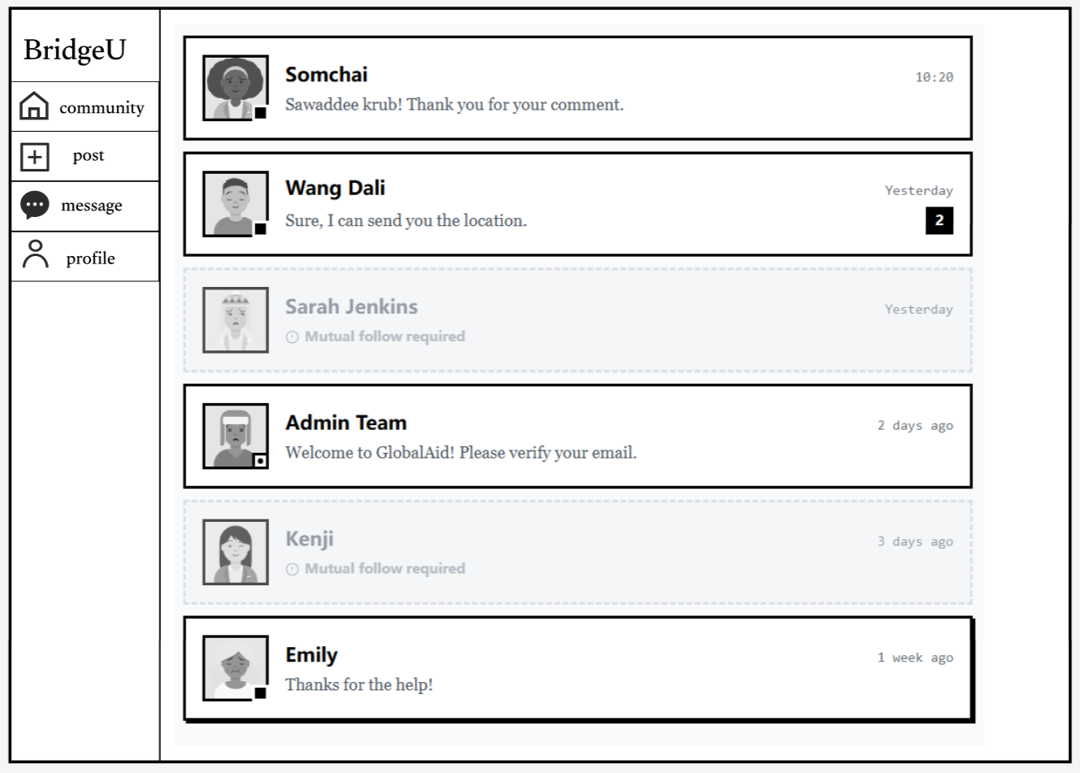
Figure 19 UI05-Messagepage01
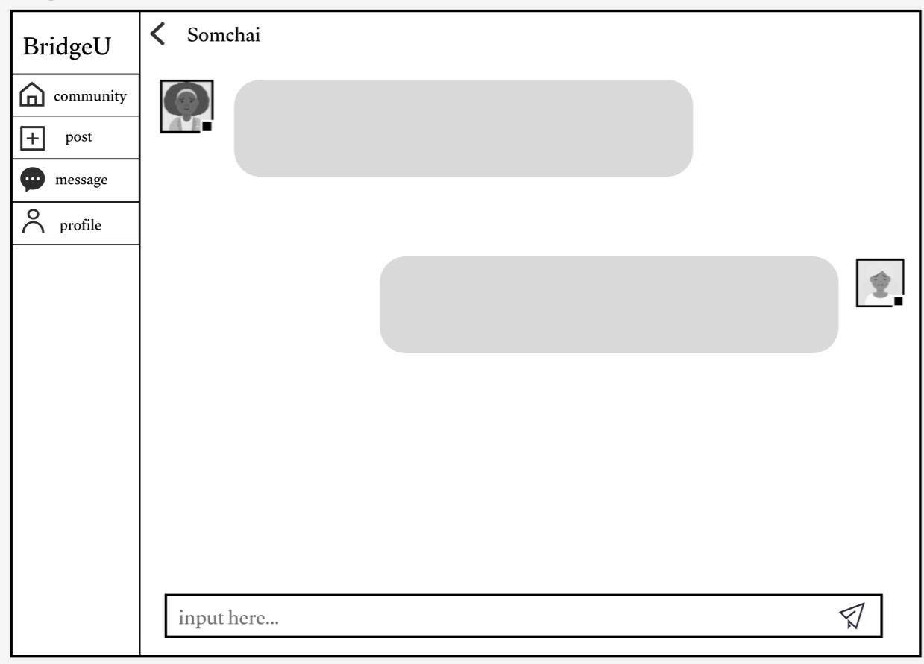
Figure 20 UI06-Messagepage

The user navigates to the "Profile" tab to manage their identity on the platform.
As shown in Figure 21, the profile page provides a clear overview of the user's public persona.
- Identity Info: It displays the user's name ("Li Ming"), unique ID, and crucially, their community context ("China CN -> Thailand TH"), which helps others understand their background.
- Bio: A short bio allows users to express their interests (e.g., "Student in Bangkok. Love Muay Thai and Hotpot"), facilitating better social connections.
- Stats: The page tracks social engagement with "Following" and "Followers" counts.
- Edit Capability: An "Edit" button is readily available for updating personal details.

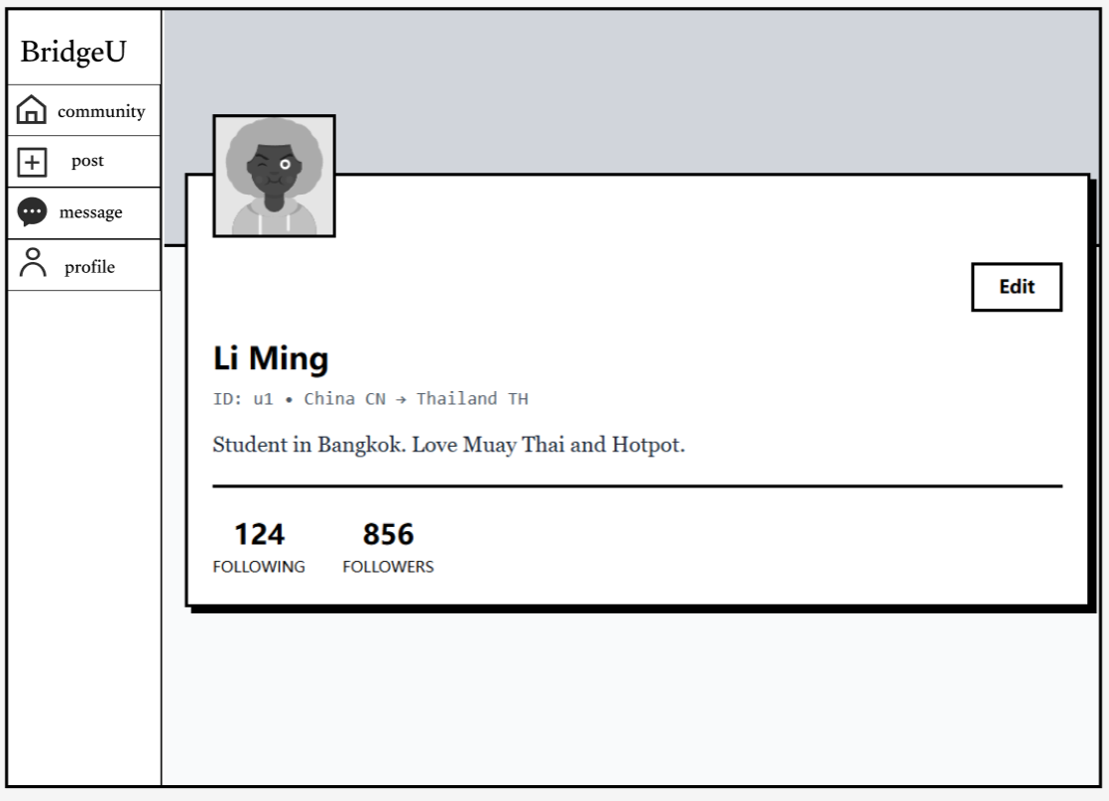
Figure 21 UI07-Profilepage
To ensure the community remains safe and organized, the Administrator logs into the backend system.
As shown in Figure 22, the admin dashboard provides a centralized control panel with a sidebar menu for "User Manage,"
User Management: In the active view, the admin can see a list of all registered users with details like name, email, phone, and role. Crucially, the Operation column provides tools to Edit user roles or Delete (ban) violating accounts directly.
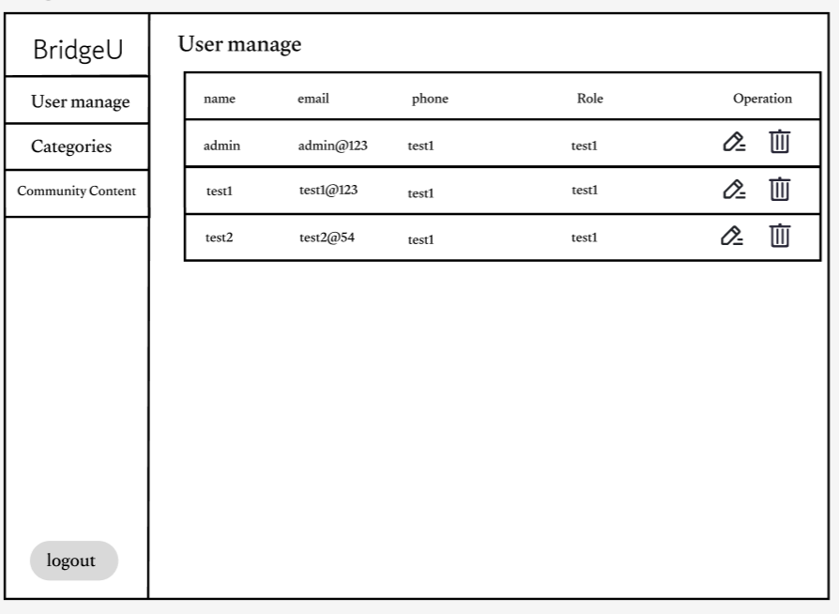
Figure 22 UI08-Usermanagepage

In addition to managing users, the Administrator is responsible for maintaining the quality of information on the platform. They switch to the "Community Content" tab.
As shown in Figure [Number], this interface presents a comprehensive list of all community posts, displaying the Post Title, Author, and Category (e.g., "TH->CN"). This view allows the admin to quickly scan for irrelevant or violating content.
- Moderation Action: For instance, the admin spots a spam post titled "BUY CAT NOW CHEAP" posted by "Spam Bot" in the "All" category.
- Enforcement: The admin clicks the "Delete" button in the Actions column to permanently remove the post, ensuring the feed remains relevant and safe for students. The "View" button allows them to inspect the content in detail before taking action.

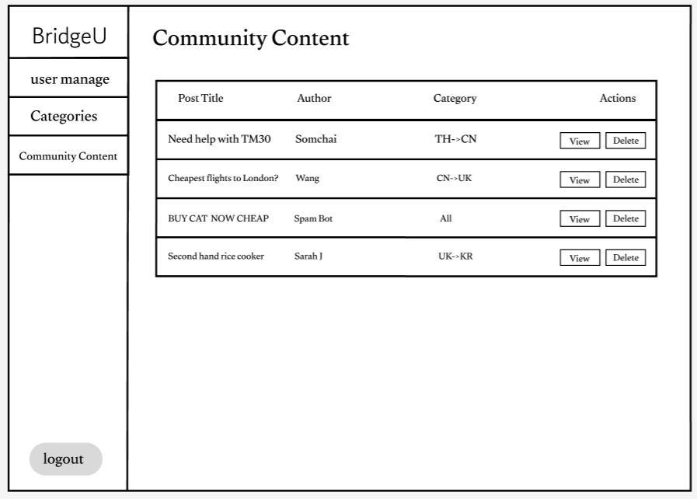
Figure 23 UI09-CommunityContentpage

To keep the community structured and relevant to evolving student needs, the Administrator navigates to the "Categories" tab.
As shown in Figure [Number], this interface allows for dynamic management of the mutual-aid boards.
- Visualization: The admin sees clear cards representing current active categories like "Chinese in Thailand," "Chinese in UK," "Thailand in China," and "All Regions (Global)."
- Management: Each category card has "Edit" and "Delete" icons, allowing the admin to rename boards or remove obsolete ones.
- Expansion: A prominent "+Add" button in the top right corner enables the admin to create new community boards as the platform expands to new regions (e.g., "Korean in USA").

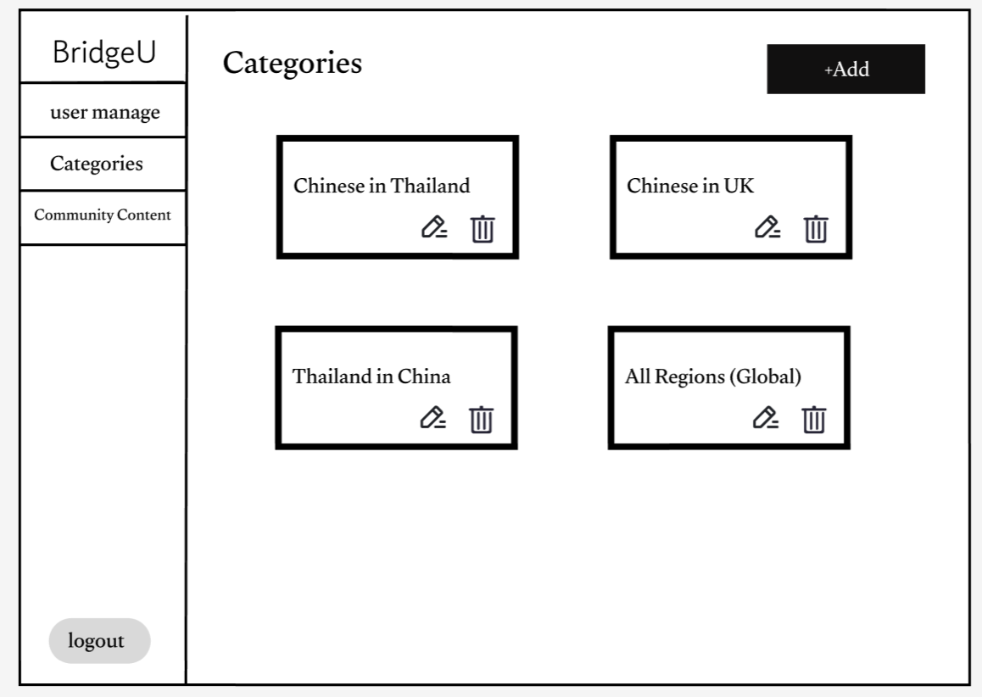
Figure 24 UI10-Categoriesmanage

6.8 Schedule Plan
6.8.1 Progress Report
Normal plan
Senior Project Event | Deliverables
Proposal Presentation | Project Proposal
Progress I Presentation | - Software project plan document  - Software requirement document  - Software design document  - Software test plan document  - Software test record document  - Software traceability document
Progress II Presentation | - Software project plan document  - Software requirement document  - Software design document  - Software test plan document  - Software test record document  - Software traceability document
Final Progress | - Final Progress Report  - Software product  - Project document
6.8.2 Milestone
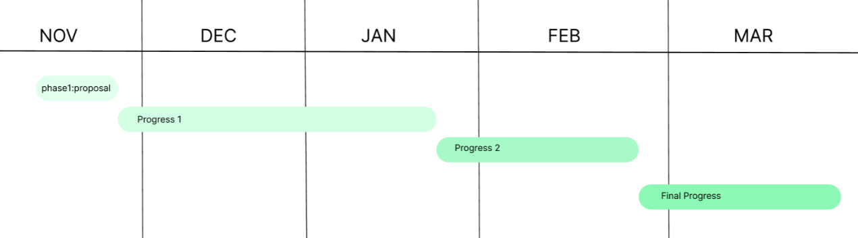
Phase 1. Proposal: 20 Nov 2025 –28 Nov 2025=8 days
Phase 2. Progress I: 29 Nov 2025 –21 Jan = 54 days
Phase 3. Progress II: 22 Jan 2025 –26 Feb 2026 = 36 days
Phase 4. Final Progress: 27 Feb 2026 –25 Mar 2026 = 28 days
Figure Milestone

Phase 1. Proposal: 20 Nov 2025 –28 Nov 2025=8 days
Tasks | Start date | End date | Duration | Responsibility
Research and writing proposal document | 20 November 2025 | 24 November 2025 | 5 | ZHIYI PAN
Prepare for the Presentation | 25 November 2025 | 28 November 2025 | 3 | ZHIYI PAN
Phase 2. Progress I: 29 Nov 2025 –21 Jan = 54 days
Tasks | Start date | End date | Duration | Responsibility
Software requirement specification document | 29 November 2025 | 5 December 2025 | 7 | ZHIYI PAN
Project plan document | 6 December 2025 | 8 December 2025 | 3 | ZHIYI PAN
Software design document | 9 December 2025 | 15 December 2025 | 7 | ZHIYI PAN
Feature #1 Admin Management implement | 16 December 2025 | 31 December 2025 | 16 | ZHIYI PAN
Feature #2 User & Community implement | 1 January 2026 | 14 January 2026 | 14 | ZHIYI PAN
Prepared Progress I report and presentation | 15 January 2026 | 21 January 2026 | 7 | ZHIYI PAN
Phase 3. Progress II: 22 Jan 2025 –26 Feb 2026 = 36 days
Tasks | Start date | End date | Duration | Responsibility
Software test plan document | 22 January 2026 | 25 January 2026 | 4 | ZHIYI PAN
Feature #3 Semantic Search implement | 26 January 2026 | 8 February 2026 | 14 | ZHIYI PAN
Feature #4 AI Content Processing implement | 9 February 2026 | 20 February 2026 | 12 | ZHIYI PAN
Prepared Progress II report and presentation | 21 February 2026 | 26 February 2026 | 6 | ZHIYI PAN
Phase 4. Final Progress: 27 Feb 2026 –25 Mar 2026 = 28 days
Tasks | Start date | End date | Duration | Responsibility
Wrap up and review all of the documents | 27 February 2026 | 10 March 2026 | 12 | ZHIYI PAN
Prepared final report and presentation | 11 March 2026 | 25 March 202 |  | ZHIYI PAN

5.1 Naming Convention
The filename format that we use for all documents is: BridgeU-[File Name] V.[Version].[FileType]
- File Name: The name of each process phase or specific document.
- Version: This part is the version of the file. The version number will be in this format “[Main version].[Subversion]”.
- File Type: The type of the file format, for example, .docx or .pdf.
For code files, we follow specific conventions:
- Frontend Components: PascalCase (e.g., LoginView.vue, PostCard.vue)
- Backend Classes: PascalCase (e.g., UserController.java, PostService.java)
- Database Tables: snake_case (e.g., user_profiles, community_posts)

5.2 Change Management
Change management manages all of the changes in the project during the development process. All the change requests will be recorded into the change record document. The procedures for managing changes are:
- Discuss with an advisor about the change.
- Record the change information to change the document.
- Send the change request to an advisor.
- Request accepted: change document and software follow the change information.
- Request rejected: continue and find alternative solutions.

5.3 Project Repository
- Microsoft Word: For document management
- GitHub: For source code management
Item | File Name | File Type | Baseline Version
Project Proposal | BridgeU-Proposal V.[Version] | .docx
Project Plan | BridgeU-ProjectPlan V.[Version] | .docx
Software Requirement Specification | BridgeU-SRS V.[Version] | .docx
Software Design Document | BridgeU-SDD V.[Version] | .docx
Test Plan | BridgeU-TestPlan V.[Version] | .docx
Test Record | BridgeU-TestRecord V.[Version] | .docx
Traceability Record | BridgeU-TraceabilityRecord V.[Version] | .docx
Software Product | BridgeU-SoftwareProduct V.[Version] | .docx

Chapter 7 References
[1] Pan, Z. (2025). BridgeU: International Student Mutual Aid Community Project Proposal. Chiang Mai University.
[2] Elasticsearch. (n.d.). Elasticsearch: The Official Distributed Search & Analytics Engine. [Online]. Available at: https://www.elastic.co/elasticsearch (Accessed on November 24, 2025).
[3] Alibaba Cloud. (2024). Tongyi Qianwen (Qwen) API Documentation. [Online]. Available at: https://help.aliyun.com/zh/dashscope/developer-reference/api-details (Accessed on November 24, 2025).
[4] Vue.js. (n.d.). Introduction — Vue.js. [Online]. Available at: https://v2.vuejs.org/v2/guide/ (Accessed on November 24, 2025).
[5] Spring. (n.d.). Spring Boot. [Online]. Available at: https://spring.io/projects/spring-boot (Accessed on November 24, 2025).
[6] MySQL. (n.d.). MySQL 8.0 Reference Manual. [Online]. Available at: https://dev.mysql.com/doc/refman/8.0/en/ (Accessed on November 24, 2025).
[7] ISO/IEC. (2011). ISO/IEC 29110-4-1:2011 Software engineering — Lifecycle profiles for Very Small Entities (VSEs) — Part 4-1: Profile specifications: Generic profile group. [Standard]. Available at: https://www.iso.org/standard/51153.html (Accessed on November 24, 2025).
[8] Jurafsky, D., & Martin, J. H. (2024). Speech and Language Processing. Stanford University. [Online]. Available at: https://web.stanford.edu/~jurafsky/slp3/ (Accessed on November 24, 2025).
[9] Element Plus. (n.d.). A Vue 3 based component library for designers and developers. [Online]. Available at: https://element-plus.org/en-US/ (Accessed on November 24, 2025).
[10] Baomidou. (n.d.). MyBatis-Plus Introduction. [Online]. Available at: https://www.google.com/search?q=https://baomidou.com/pages/24112f/ (Accessed on November 24, 2025).

