BridgeU: A Bilingual Community Platform for International Students in Thailand
Zhiyi Pan  Software Engineering Program  College of Arts, Media and Technology  Chiang Mai University  Chiang Mai, Thailand  pzyllll@outlook.com | Pattama Longani  Software Engineering Program  College of Arts, Media and Technology  Chiang Mai University  Chiang Mai, Thailand  pattama.l@cmu.ac.th

Abstract—International students in Thailand face significant barriers in accessing local news, building social connections, and adapting to an unfamiliar environment. This paper presents BridgeU, a bilingual (Chinese/English) web-based community platform designed to address these challenges. BridgeU provides three integrated features: a Daily Briefing system that automatically aggregates Thai news via Google News RSS and translates it into Chinese and English using Qwen AI; a Community Page that enables peer-to-peer knowledge sharing with AI-powered moderation and translation; and an Authentication and Profile system with email and SMS verification. The system is built using Vue.js 3 on the frontend and Spring Boot 3 on the backend, with MySQL 8 as the primary database and JWT-based stateless authentication. A competitive analysis against Facebook Groups, Xiaohongshu, and Reddit confirms that BridgeU uniquely combines bilingual AI news aggregation with a structured, moderated community space. Testing covered 25 unit test suites and 21 system test cases across all features, confirming that all core functional requirements were satisfied.
Keywords—international students, web platform, software, software design .
I. Introduction
The globalization of higher education has driven rapid growth in international student mobility. According to UNESCO, the number of internationally mobile students exceeded 6 million by 2022, with institutions in Southeast Asia, including Thailand, receiving a growing share [1]. Chinese students represent one of the largest groups of internationally mobile students globally, and their presence at Thai universities has increased substantially in recent years. International students frequently encounter compounded challenges upon arrival in a host country. Research by Hofhuis et al. [2] demonstrated that social network site (SNS) use significantly affects the wellbeing of international students through acculturation and adaptation processes. The study found that interactions with host-country contacts on SNS were positively associated with sociocultural adaptation, while isolation from local information sources remained a persistent barrier. Similarly, Zhou and Yin [3] conducted an integrative review of research on international students’ social media use, concluding that platform affordances play a critical role in determining whether technology facilitates or impedes cross-cultural adjustment. In Thailand, international students face a specific challenge: the majority of local news, public announcements, and community information is published exclusively in Thai. Existing general-purpose tools such as Facebook Groups, Xiaohongshu, and Reddit do not fully address this need. Furthermore, no dedicated platform exists to connect Chinese-speaking international students in Thailand or provide a unified community space tailored to their needs.To address these gaps, this paper proposes and evaluates BridgeU, a bilingual web-based community platform. BridgeU is designed around three core features: (1) the Daily Briefing System automatically collects Thai news via Google News RSS and translates summaries into Chinese and English using Qwen AI; (2) the Community Page provides an AI-moderated forum for likes, comments, and follow relationships; and (3) the Authentication and Profile System supports registration via email or SMS verification and JWT-based session management. The remainder of this paper is organized as follows: Section II reviews prior work and identifies the research gap; Section III presents the platform architecture and implementation of the three core features; Section IV reports the user evaluation design and results; and Section V discusses findings, limitations, and conclusions.
II. Related Work
This section reviews related work relevant to BridgeU, covering the multi-dimensional challenges (language barriers, cultural distance, need for dedicated digital communities) faced by international students, a competitive analysis of existing platforms (Facebook Groups, Xiaohongshu, Reddit) that reveals their limitations in meeting the specific needs of international students in Thailand, as well as key technical and functional foundations including RSS-based news aggregation with AI translation (via Qwen AI), the Vue.js 3 and Spring Boot 3 web application architecture, JWT-based secure authentication following OWASP standards, and AI-assisted content moderation—all of which collectively justify the design and feasibility of BridgeU as a specialized, bilingual, Thailand-focused community platform filling the gaps of existing tools. Unit tests and system tests were designed to verify whether the system meets the expectations.
A. Challenges Faced by International Students
A growing body of literature documents the multi-dimensional difficulties experienced by international students. Gautam et al. [4] identified language barriers, cultural distance, loss of social support networks, and academic adjustment as primary stressors. Dong et al. [5] found that social media usage significantly affects social capital and learning engagement among international students in the United States, highlighting the dual role of digital platforms as both connectors and potential sources of isolation. The British Council [6] further reported strong demand among international students for private, topic-specific digital communities where they can discuss practical matters such as visa policies, housing, and affordability. These findings directly motivate the design of BridgeU as a specialized, structured platform rather than a repurposed general-purpose social network.
B. Competitive Analysis of Existing Platforms
Several widely used platforms are currently adopted by international students in Thailand as informal information and community channels. A comparative analysis of three key platforms—Facebook Groups, Xiaohongshu (Little Red Book), and Reddit—reveals important limitations that BridgeU is designed to overcome.
1) Facebook Groups:
Facebook Groups are currently one of the most widely used mutual-aid tools among international students worldwide [7]. Their advantages include a large existing user base and broad reach. However, Facebook Groups have a high language threshold: content is predominantly in Thai and English, making them difficult for Chinese students to use. Information retrieval is extremely poor, with no structured tags, so rental listings, job posts, and casual chat are all mixed together, making targeted search effectively impossible.
2) Xiaohongshu (Little Red Book):
Xiaohongshu is the most popular lifestyle sharing platform among Chinese international students [8]. It offers rich content, algorithm-based recommendations, and an aesthetically pleasing interface. However, it suffers from a serious “tourist perspective” bias: content is overly focused on travel, food, and check-ins, and lacks in-depth, practical accumulation for long-term residents. Its closed Chinese ecosystem means it is impossible to reach local Thais, landlords, or international students from other language backgrounds.
3) Reddit:
Reddit is one of the world’s largest online forums and hosts numerous study-abroad-related subreddits (e.g., Thailand, studyabroad) [9]. It offers structured topic-based categorization and an environment where users feel comfortable asking genuine questions under pseudonymity. However, its interface is unfriendly to non-technical users, and it operates as a pure English environment with no multilingual translation support, effectively excluding most Chinese students and local Thai community members.
TABLE I. Competitive Feature Comparison
Feature | Facebook Groups | Xiao- hongshu | Reddit | BridgeU
Web-based Access | ✓ | ✓ | ✓ | ✓
Bilingual (CN/EN) Interface |  |  |  | ✓
AI News Aggregation (RSS) |  |  |  | ✓
AI Auto-Translation | ✓ | ✓ |  | ✓
AI Content Moderation |  |  |  | ✓
Structured Post Tags |  |  | ✓ | ✓
Community Forum / Post Feed | ✓ | ✓ | ✓ | ✓
Thailand-Focused Content |  |  |  | ✓

As shown in Table I, none of the existing platforms combines bilingual AI news aggregation, structured post tags, AI-powered content moderation, and Thailand-focused community features in a single free-to-use web platform. BridgeU is designed to fill this gap by integrating all of these capabilities.
C. News Aggregation and Automatic Translation
RSS (Really Simple Syndication) has been established as a practical and standardized mechanism for news aggregation. Kasioumis et al. [10] proposed a distributed RSS platform demonstrating the scalability of RSS-based approaches. Atlas [11] showed that combining RSS feeds with third-party news APIs significantly improves content coverage. The integration of large language models into translation pipelines has become increasingly feasible. Yuen and Schlote [12] reviewed AI applications in language learning and noted that AI-powered tools can bridge cultural and linguistic gaps effectively, provided appropriate quality controls are in place. BridgeU applies this principle by using Qwen AI (Alibaba Cloud) to generate Chinese and English summaries at ingestion time, so translated content is always immediately available to users.
D. Web Application Architecture
Wang et al. [13] demonstrated the effectiveness of Vue.js and Spring Boot for building scalable online education platforms, noting that Vue.js’s reactivity system and component-based model reduce frontend complexity while Spring Boot’s auto-configuration accelerates backend development. Kaya and Ozdemir [14] further evaluated Spring Boot-based REST API implementations under the OWASP security framework, identifying JWT authentication as the recommended stateless session mechanism. BridgeU adopts this architecture with Vue.js 3 on the frontend and Spring Boot 3 on the backend, connected via RESTful APIs over HTTPS. MySQL 8 is used as the primary relational database, and Docker provides containerized deployment.
E. Authentication and Security
JSON Web Tokens have become the de facto standard for stateless authentication in modern web applications. Bucko et al. [15] demonstrated that JWT-based authentication can be further strengthened by incorporating user behavior history for anomaly detection. The OWASP Cheat Sheet for JWT [16] prescribes best practices including HTTPS for all token transmissions, short expiry windows, and server-side signature validation. BridgeU implements these practices: passwords are hashed using BCrypt with salt before storage, tokens are signed with HMAC-SHA256, and all protected endpoints validate the token on every request.
F. Community Platforms and AI-Assisted Moderation
Hofhuis et al. showed that interactions within peer networks on SNS platforms are associated with improved adaptation outcomes for international students. Roczey and Szenasi [17] proposed an automated moderation helper system using AI-based text classification, demonstrating that machine learning classifiers can reliably flag rule-violating content with high precision. BridgeU applies Qwen AI for both automatic translation of user-generated content and content security review before publication, maintaining community quality without requiring immediate manual review for every submission.
III. Platform Design and Implementation
This section systematically elaborates on the overall architecture, core functional modules, and data persistence design of the BridgeU platform. It first introduces the system's technical stack and layered architecture, then details the implementation logic, user interaction flows, and structural design of three core features—the Daily Briefing System, Community Page, and Authentication & Profile System—supported by use case diagrams, class diagrams, and interface screenshots. Finally, it presents the database entity-relationship design, clarifying the data association and constraint rules of the entire platform, fully demonstrating the feasibility and completeness of the system design.BridgeU is designed as a web-based platform targeting Chinese-speaking international students at Thai universities. The frontend is implemented with Vue.js 3 and Element UI, using Axios for HTTP communication between the frontend and backend. The backend is built with Spring Boot, exposing RESTful APIs and using MyBatis as the persistence framework for database access. MySQL 8 serves as the primary relational database for storing structured user and post data. Elasticsearch is integrated to provide high-performance semantic search capabilities. The system also connects to the Aliyun Qwen API to perform natural language processing tasks such as summarization and translation. The overall system architecture is illustrated in Fig. 1.
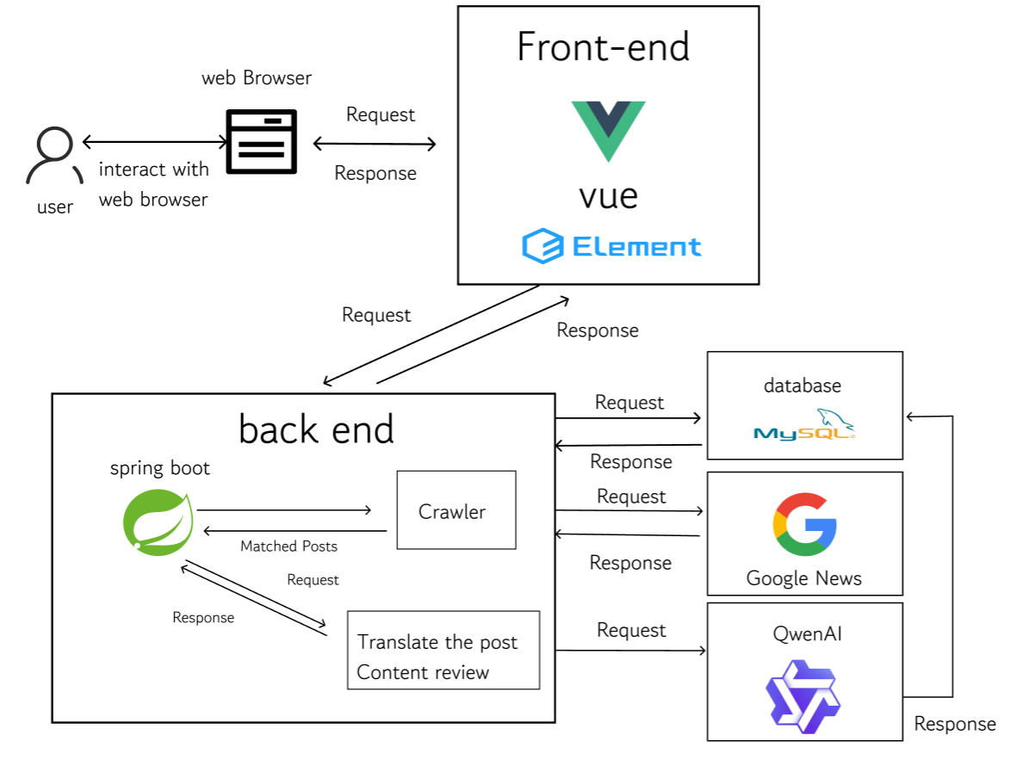
Fig.1. System Architecture
This system has 3 features as follows:
A. Feature 1:Bilingual Daily News Aggregation Module
Feature 1 integrates user interaction and backend processing in one Daily Briefing workflow. Users can browse news collected from Google News RSS, open detailed content, jump to original sources, switch between Chinese and English, filter by date range, and search by keyword. On the implementation side, translated titles/summaries are prepared in advance and exposed through paginated APIs, so users can retrieve bilingual results with low latency. Figure 2 presents the use case view of this end-to-end workflow.
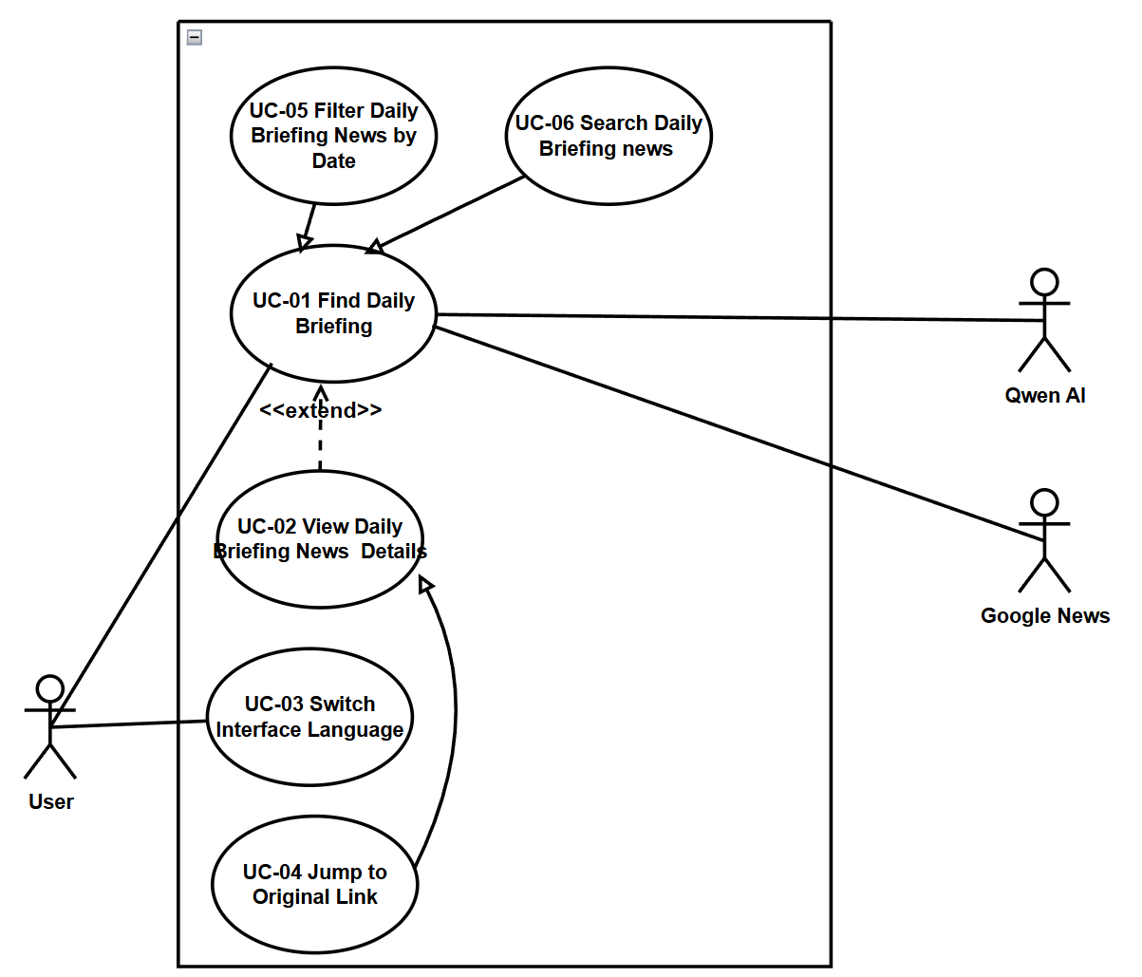
Fig.2. Use Case Diagram of Bilingual Daily News Aggregation Module
Fig. 3 shows the layered implementation architecture of Feature 1, including frontend view components (DailyBriefing, DailyBriefingDetail), backend business logic (NewsController), data access layer (NewsRepository), and core data objects (News, NewsBriefDTO). The frontend handles list rendering, pagination, filtering, and detail display, while the backend coordinates repository queries, converts entities to DTOs, and exposes RESTful APIs for bilingual news retrieval.
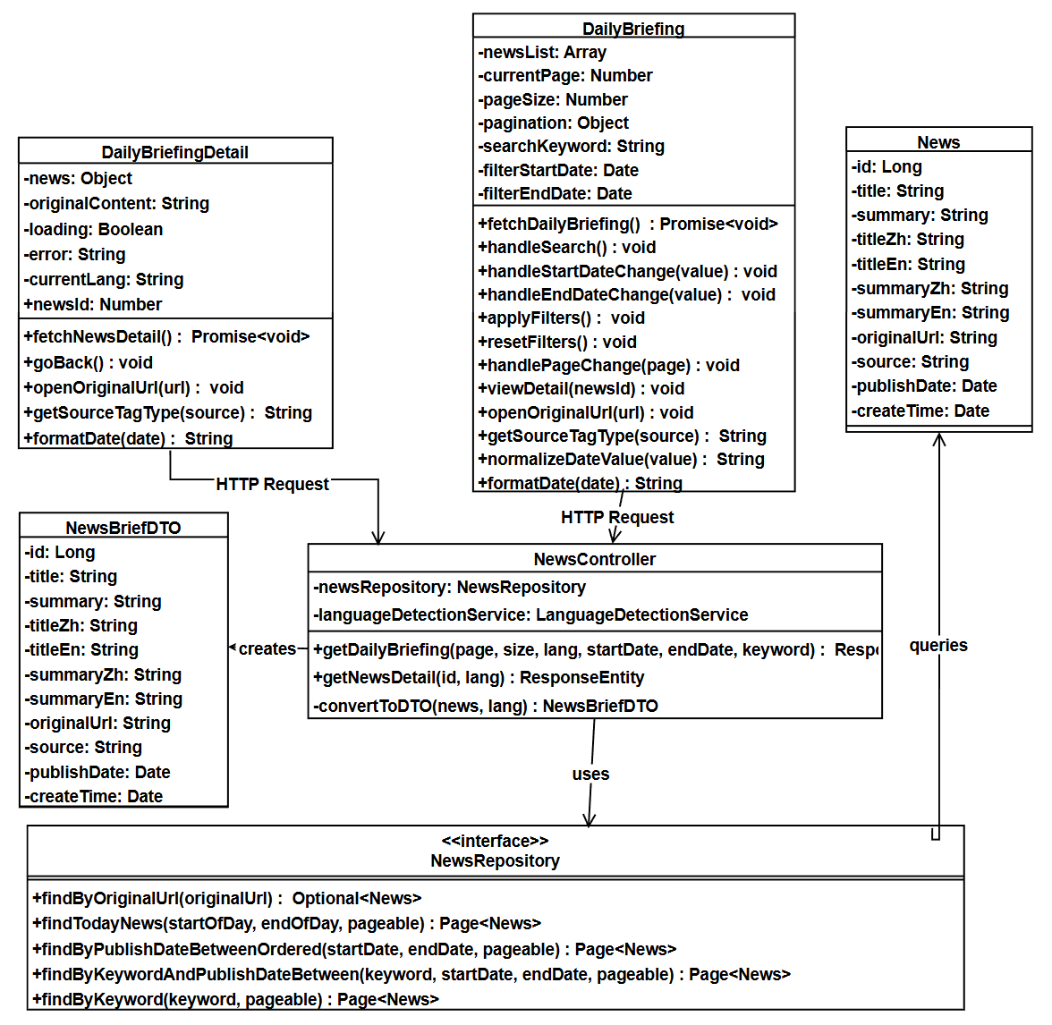
Fig.3. Class Diagram of Bilingual Daily News Aggregation Module
Users can access bilingual daily briefings generated from Thai news sources, view translated titles and summaries in their selected language, open detailed pages, and jump to original news links when needed. Users can also search by keyword, filter by date range, and browse results in paginated order from newest to oldest, which supports fast and practical information access. The UI of feature 1 is shown in Fig. 4.
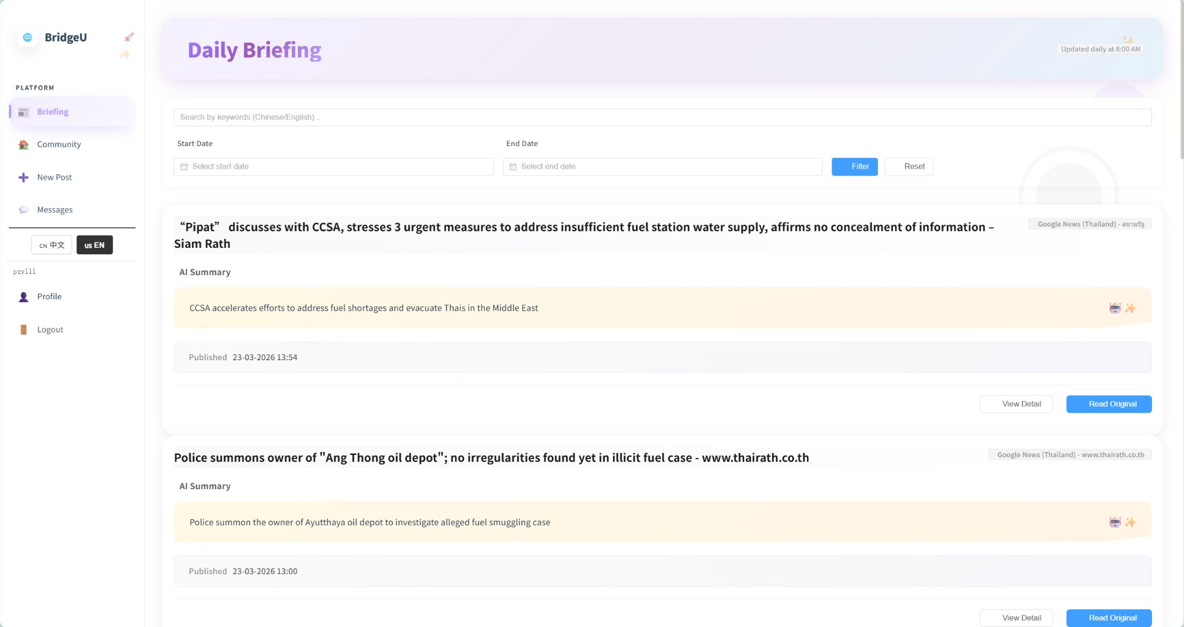
Fig.4. Daily Briefing System interface
B. Feature 2: Community Knowledge Sharing and Private Message Module
Feature 2 integrates community interaction and private messaging in one workflow. Users can browse posts, filter by tag, search by keyword, view post details, like posts, add comments, report inappropriate content, and manage private conversations. AI-assisted translation, moderation, and comment summarization are embedded in this process to keep communication bilingual and manageable. Figure 5 presents the use case view of Feature 2.
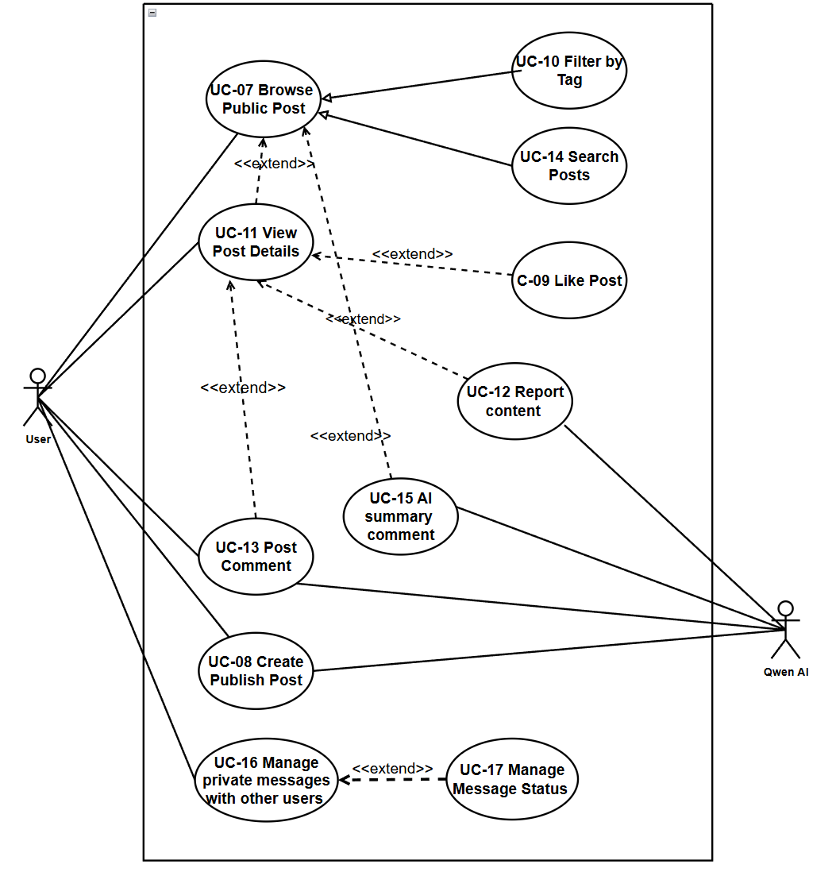
Fig.5. Use Case Diagram of Community Knowledge Sharing and Private Message Module
Fig.6 shows the layered architecture of the Community Page module, covering frontend view components, backend controllers, service layers, data access repositories, and core data entities. The frontend components (CommunityFeed, PostDetail) manage the community feed rendering, post detail display, user interactions (posting, commenting, liking, reporting), and state management. The backend PostController, MessageController, and ReportController coordinate business logic, including post creation with AI translation/moderation, comment management, private messaging, and content reporting, while relying on CommunityPostRepository and CommentRepository for data persistence. Core entities like CommunityPost, Comment, and AppUser store user-generated content and user information, with associated DTOs and service layers enabling multilingual support, AI content moderation, and efficient data flow between frontend and backend.
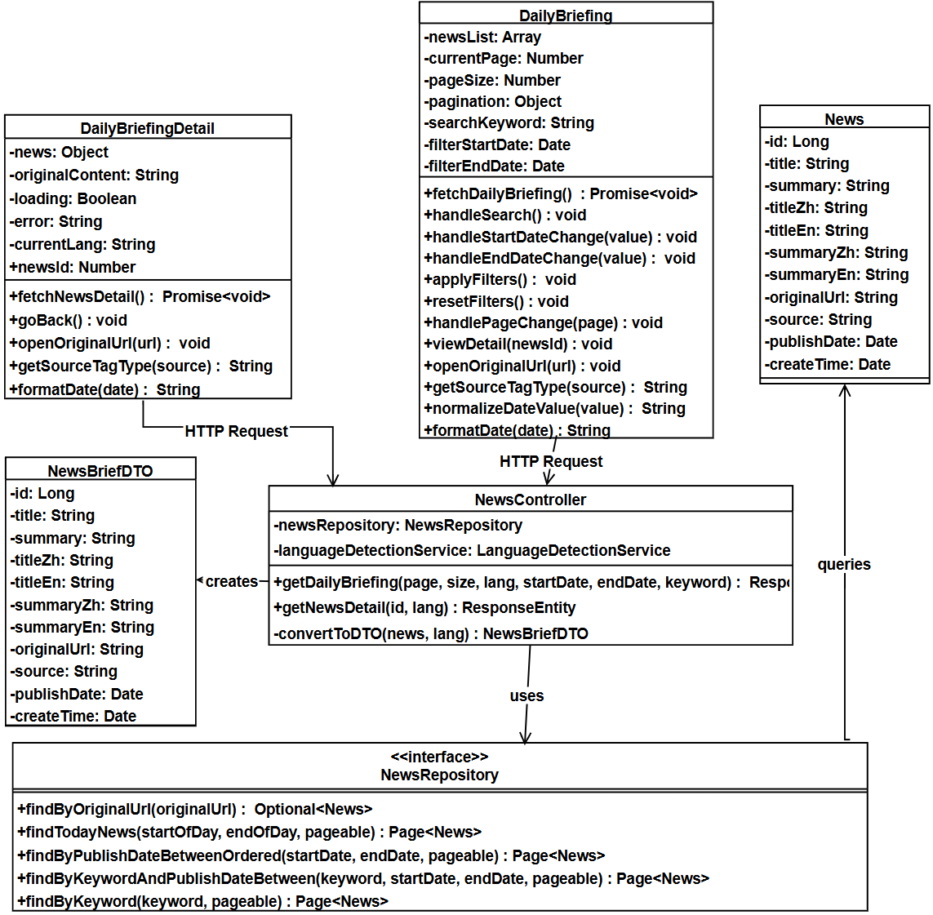
Fig.6. Class Diagram of Community Knowledge Sharing and Private Message Module
Users can create posts in Chinese or English and receive bilingual content support, browse approved community posts by category, interact through likes and comments, and submit reports for posts or comments using predefined reasons. Users can also view AI-generated comment summaries for long threads and communicate through private messaging based on follow relationships. This design supports practical peer-to-peer knowledge sharing for international students across Study, Housing, Travel, Part-time Job, and Life Services categories. The feature interfaces are shown in Fig. 7-9.
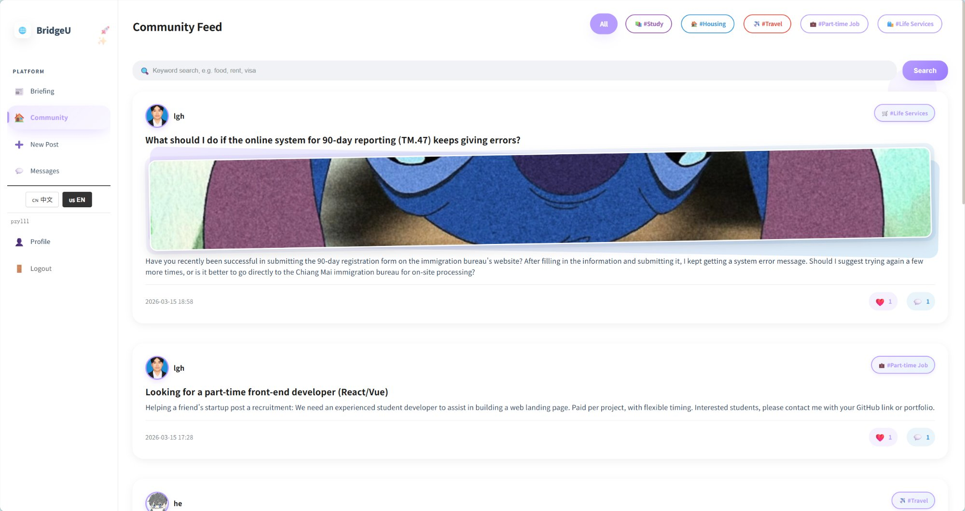
Fig.7. Community Page interface
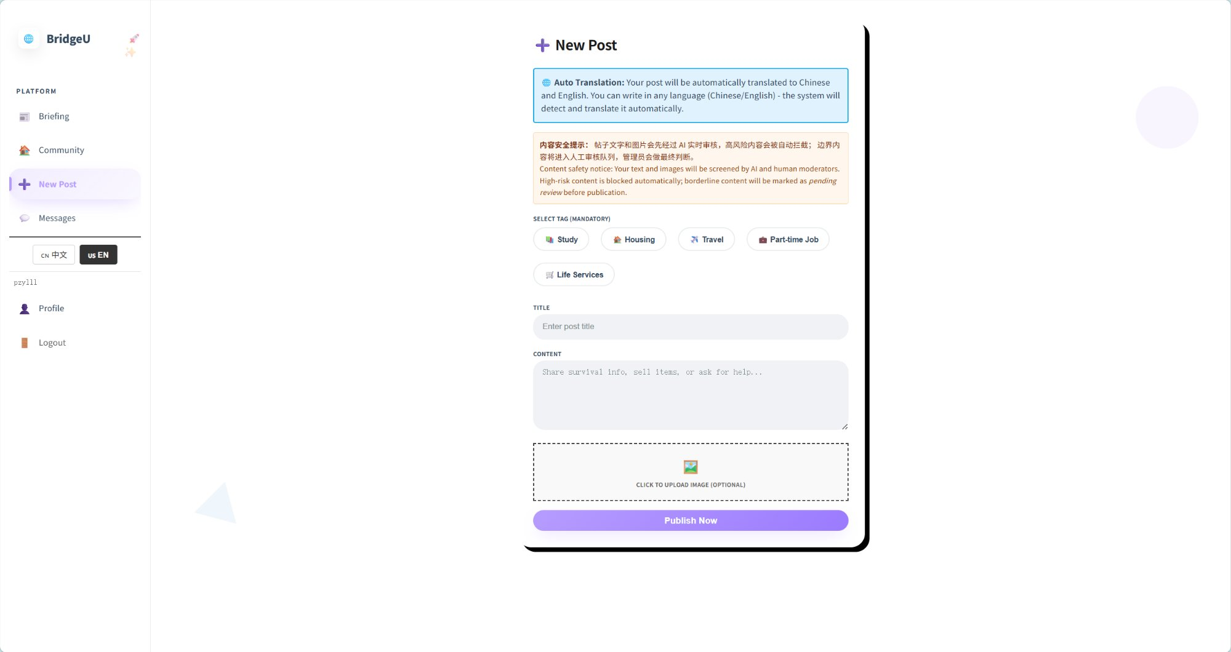
Fig.8. Create New Post interface
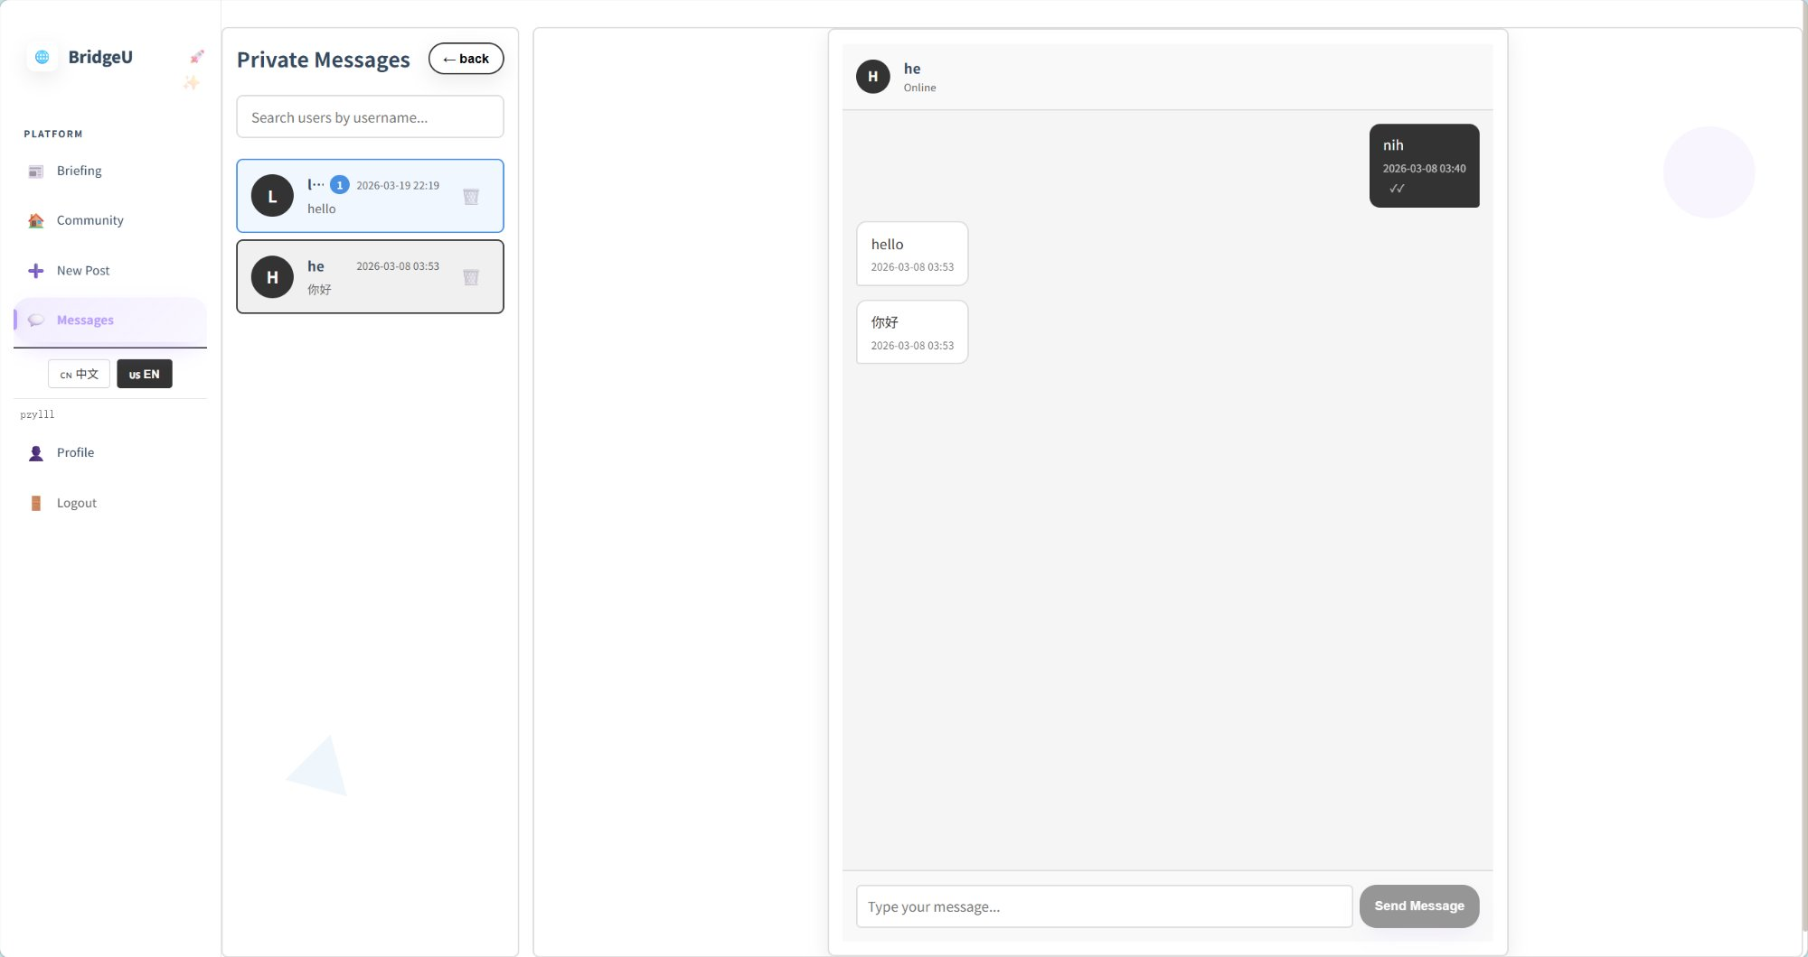
Fig.9. Private messaging interface
C. Feature 3: User Authentication and Profile Management Module
Feature 3 integrates secure account access and personal profile management in one workflow. Users can register with either phone or email verification, log in and log out, recover forgotten passwords, edit profile information, view followers/friends, review their own posts, and check submitted reports. This feature combines authentication security with practical self-service account management. Fig.10 presents the use case view of Feature 3.
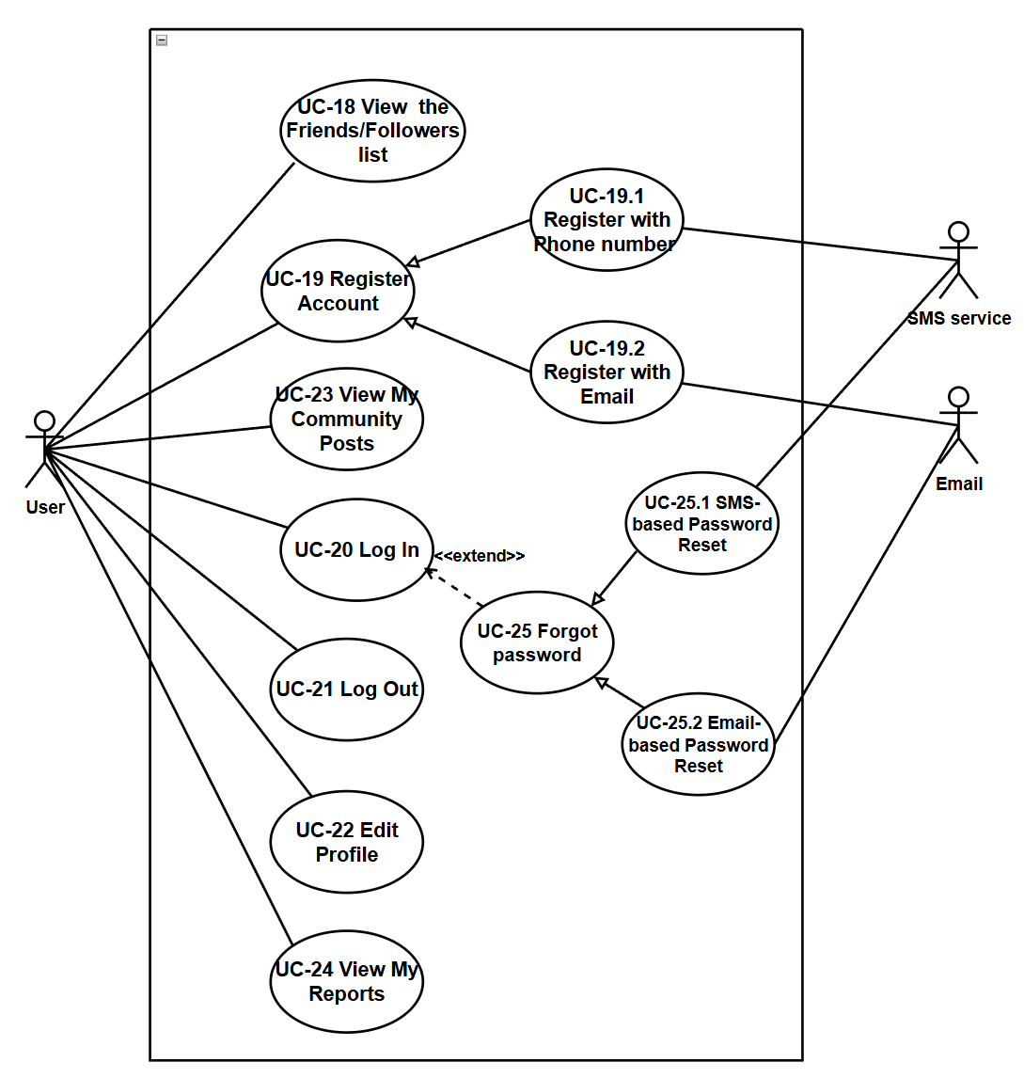
Fig.10. Use Case Diagram of User Authentication and Profile Management Module
Fig.11 shows the layered architecture of the Authentication and Profile System module, covering frontend view components, backend controllers, service layers, data access repositories, and core data entities. The frontend components (RegisterPage, LoginPage, ProfilePage) manage user registration, login, password reset, and profile management operations. The backend AuthController, UserController, and ReportController coordinate business logic including JWT-based authentication, verification code sending, profile updates, follow relationships, and report management, relying on repositories like AppUserRepository, Verification CodeRepository, and UserFollowRepository for data persistence. Core entities such as AppUser, VerificationCode, UserFollow, and Report store user accounts, verification records, social relationships, and content reports, with supporting services (JwtService, EmailService, SmsService) enabling secure authentication, multi-channel verification, and efficient data flow between frontend and backend.
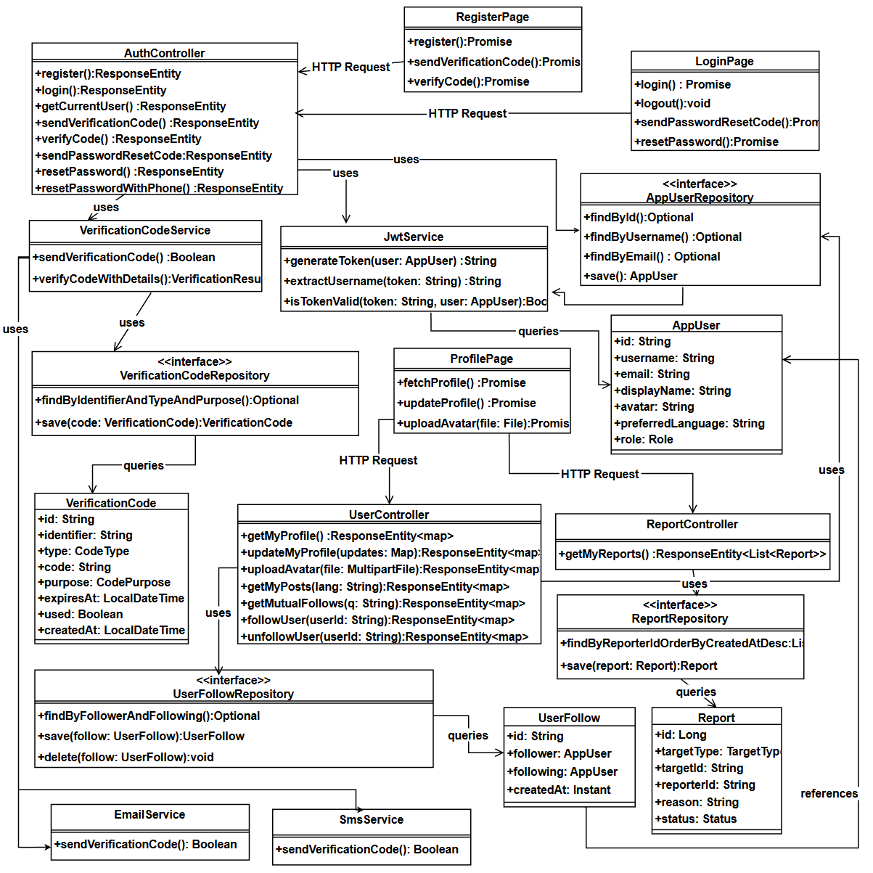
Fig.11. Class Diagram of User Authentication and Profile Management Module
Users can complete registration through email or phone verification, log in securely, and reset passwords when needed. After authentication, users can view and update profile data (such as display name, avatar, and preferred language), review personal social statistics, and access personal records including own posts, submitted reports, and follower/friend lists. This design ensures secure access while keeping profile operations clear and user-centered. The feature interface is shown in Fig.12.
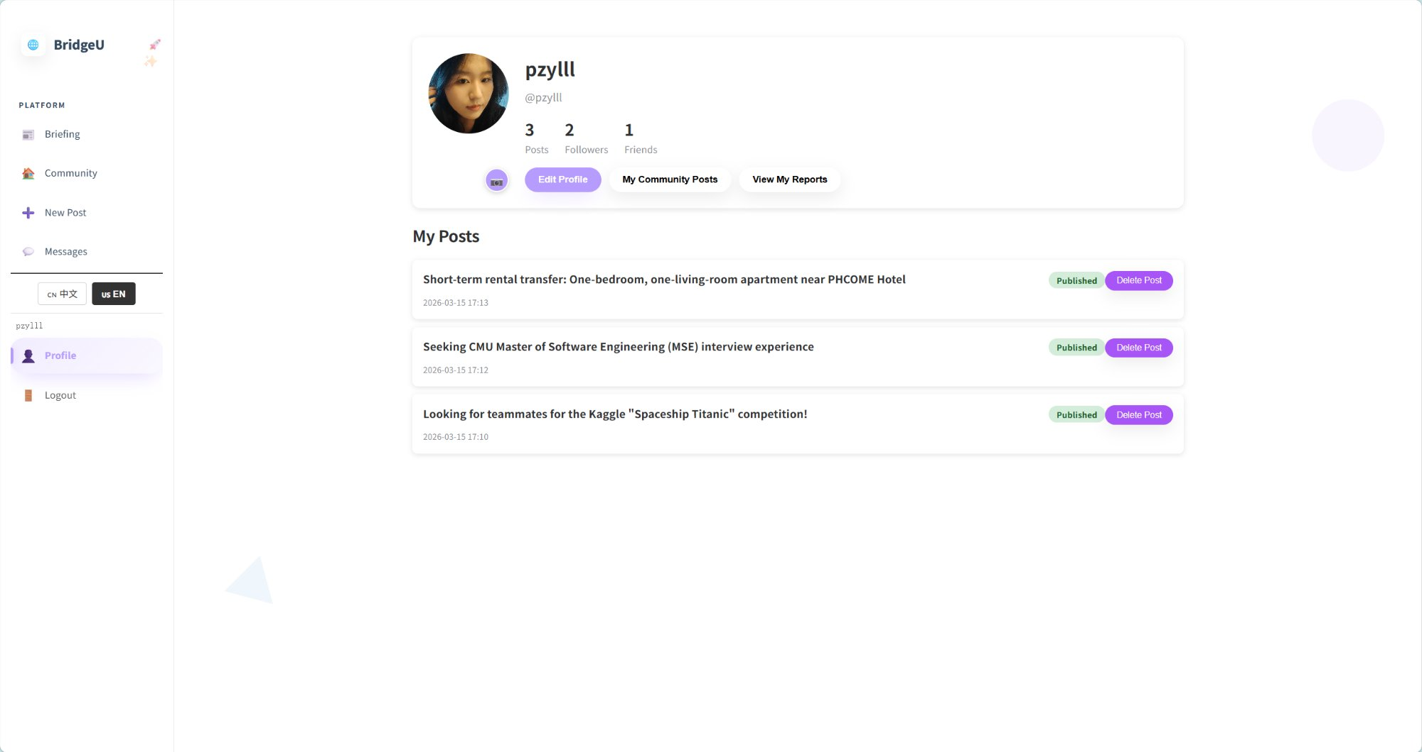
Fig.12. User profile page interface
D.Database Design
Relationships are enforced through foreign keys: USERS to POSTS (1:N), USERS to COMMENTS (1:N), USERS to POST_LIKES (1:N), USERS to CONVERSATION (1:N, via `user1_id` and `user2_id`), USERS to MESSAGE (1:N, via `sender_id` and `receiver_id`), USERS to REPORT (1:N), USERS to NOTIFICATIONS (1:N), USERS to USER_FOLLOWS (1:N, via `follower_id` and `following_id`), POSTS to COMMENTS (1:N), POSTS to POST_LIKES (1:N), POSTS to NOTIFICATIONS (1:N), REPORT to REPORT_REASONS (1:N), REPORT to NOTIFICATIONS (1:N), and CONVERSATION to MESSAGE (1:N). The `VERIFICATION_CODES` table stores codes by `identifier` (email/phone) rather than a direct foreign key to `USERS`. A data dictionary defines field types, constraints, and validation rules for all entities. Fig. 13 illustrates the Entity-Relationship Diagram of the BridgeU platform.
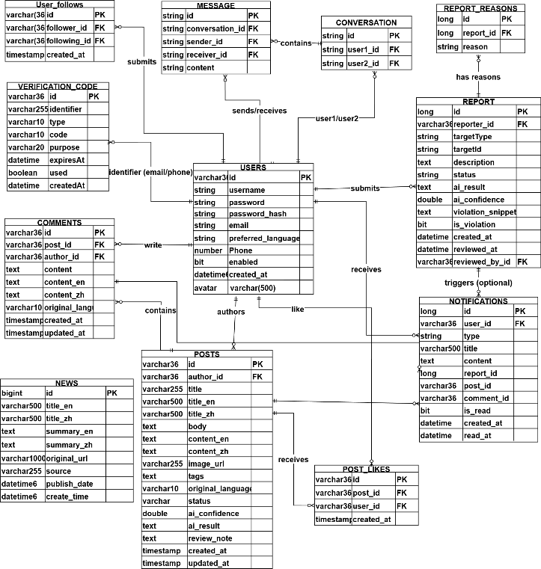
Fig.13.Database Design
E. Test Strategy
Testing followed a structured two-level strategy: unit testing, system testing. Unit tests targeted individual frontend Vue.js component methods and backend Spring Boot controller, service, and repository methods. System tests verified end-to-end workflows through the fully integrated system. A total of 25 unit test suites and 21 system test cases were defined. The pass/fail criterion required an exact match between actual results and the expected results specified in the Test Plan document.
IV. User Evaluation
A. Evaluation Design
This section reports how BridgeU was evaluated with real users, describing the evaluation design, data collection methods, and key findings from interviews and questionnaires.
To assess BridgeU’s usability and relevance to its target users, a two-phase evaluation was conducted combining semi-structured interviews and a structured questionnaire. The evaluation targeted international students currently enrolled at Chiang Mai University who were not involved in the system’s development. A total of five participants took part in the interview phase and fifteen participants completed the questionnaire, yielding qualitative depth alongside quantitative breadth. The combined approach follows the mixed-methods evaluation strategy recommended by Creswell and Plano Clark [18], wherein qualitative findings are used to interpret and contextualize quantitative results.
B. Semi-Structured Interview
Five international students,all enrolled in undergraduate programs at CAMT, participated in individual semi-structured interviews lasting 20–30 minutes each. Interviews were conducted in English or Chinese according to participant preference. The interview guide covered four themes: current information-access habits, first impressions and navigability of BridgeU, perceived usefulness of each feature, and suggestions for improvement. Thematic analysis [19] was applied to the transcripts, and three recurring themes emerged across participants.
Theme 1 – Perceived usefulness of the Bilingual Daily News Aggregation Module (Feature 1) All five participants reported that they currently obtain Thailand-related information through social platforms. They regarded the Daily Briefing System as more reliable because it aggregates content from official Thai news sources. Four participants expressed strong satisfaction with the bilingual language-switching function, describing the experience as natural and convenient. One participant commented: “I did not know there were Thai government announcements like this. Having them in Chinese is very helpful.” These responses reflect strong user recognition of Feature 1 in solving language and information-access barriers.
Theme 2 – User experience of the Community Knowledge Sharing and Private Message Module (Feature 2) and social interaction demands. Four participants hoped for a dedicated mobile application, as they mainly use mobile devices for social and information browsing. Two suggested adding push notifications for subscribed topic tags. One participant mentioned that the single-message restriction for one-way follows may reduce willingness to initiate contact, and proposed an optional greeting mechanism. These comments reflect user expectations for Feature 2 and provide clear directions for future improvement.
Theme 3 – Usability of the User Authentication and Profile Management Module (Feature 3). All participants agreed that the registration, login, and profile management processes were clear and easy to understand. They found the email and SMS verification mechanisms secure and trustworthy, and appreciated the simplicity of profile editing and social relationship management. This indicates that Feature 3 effectively supports stable and secure platform access.
C. Questionnaire
Following the interviews, a structured questionnaire was distributed to fifteen international students at CAMT via a shared Google Form link. Participants were asked to explore BridgeU independently for at least 20 minutes before responding. The questionnaire comprised twelve Likert-scale items (1 = Strongly Disagree, 5 = Strongly Agree) covering usability, feature usefulness, and overall satisfaction, plus one open-ended question for general comments. Table III presents the mean scores and standard deviations for all twelve items.
TABLE III. User Questionnaire Results (n = 15, Scale 1–5)
No | Questionnaire Item | Evaluated Feature | Mean | SD
Q1 | The Daily Briefing makes it easier for me to access Thai news in my preferred language. | Feature 1 | 4.53 | 0.64
Q2 | The keyword search and date filter functions help me find relevant news quickly. | Feature1 | 4.40 | 0.74
Q3 | Switching between Chinese and English interfaces is smooth and intuitive. | Feature1 | 4.60 | 0.51
Q4 | I feel the AI-generated news summaries are accurate and informative. | Feature1 | 4.13 | 0.83
Q5 | The Community Page’s tag-based filtering helps me find posts relevant to my needs. | Feature2 | 4.47 | 0.64
Q6 | Creating and submitting a post on the Community Page is straightforward. | Feature2 | 4.33 | 0.72
Q7 | The AI comment summarization feature saves time when reading long discussion threads. | Feature2 | 4.20 | 0.78
Q8 | The private messaging system is useful for communicating with other community members. | Feature2 | 4.00 | 0.85
Q9 | The registration process is clear and easy to complete. | Feature3 | 4.27 | 0.70
Q10 | The overall interface is visually clear and easy to navigate. | Overall | 4.40 | 0.63
Q11 | BridgeU effectively addresses the information needs of international students. | Overall | 4.53 | 0.52
Q12 | I would recommend BridgeU to other international students in Thailand. | Overall | 4.47 | 0.64
— | Overall Average |  | 4.36 | 0.68

The results show highly positive feedback across all features. The bilingual interface (Q3, Mean = 4.60) and the ability of BridgeU to meet real information needs (Q1, Q11, Mean = 4.53) received the highest scores. The lowest score appeared in Q8 (private messaging, Mean = 4.00), which is consistent with interview feedback that the single-message limit may restrict initial communication. The overall average score of 4.36 indicates strong user satisfaction. Open-ended comments further supported interview findings: ten participants highlighted the Daily Briefing as their most frequently used function, and seven requested a mobile version as a top priority for future development.
This study designed and implemented BridgeU, a bilingual web platform for Chinese-speaking international students in Thailand, and validated its usability via mixed-methods user evaluation (5 interviews, 15 questionnaires). The results confirm the platform effectively addresses core user pain points of language barriers and information inaccessibility, while also identifying key areas for optimization aligned with user feedback. Feature 1 (Daily Briefing System) achieved the highest questionnaire ratings, with bilingual switching (Q3, Mean=4.60) and news accessibility (Q1, Mean=4.53) being the most recognized features. Interview feedback further validated the reliability of its official Thai news sources and the practical value of batch-processed AI translation/summarization. Feature 2 (Community Page) received positive scores for tag-based filtering (Q5, Mean=4.47) and post creation (Q6, Mean=4.33), while Feature 3 (Authentication and Profile System) earned a stable score for registration usability (Q9, Mean=4.27), showing a good balance between security and ease of use. The overall satisfaction score of 4.36/5 and high rating for addressing user needs (Q11, Mean=4.53) confirm BridgeU fills the gap for specialized Thai international student support platforms, even though the small, single-university sample and short 20-minute usage session introduce potential generalizability and novelty bias limitations.
Conclusions
This study successfully developed BridgeU, a bilingual web platform with three core features—Daily Briefing System, Community Page, and Authentication and Profile System—tailored for Chinese-speaking international students in Thailand. Mixed-methods user evaluation yielded an overall satisfaction score of 4.36/5, validating the platform’s usability, practicality, and alignment with target user needs.
This system’s evaluation has several limitations. First, the sample sizes are relatively small (n = 5 interviews, n = 15 questionnaires) and limited to one university, so results may not fully generalize to all international students in Thailand. Second, the evaluation relied on a short 20-minute usage session rather than long-term real-world usage, which may lead to bias caused by novelty effects. Third, participants were recruited through personal networks, potentially introducing selection bias. Future work will expand the sample size, adopt random sampling, conduct longitudinal usage tracking, and use standardized scales such as the System Usability Scale (SUS) [20] to obtain more reliable and generalizable evidence.
Acknowledgment
The author thanks Pattama Longani, Ph.D. (Project Advisor, Software Engineering Program, College of Arts, Media and Technology, Chiang Mai University) for guidance throughout the development and documentation of BridgeU. This project was completed as part of the Bachelor of Science in Software Engineering program.

References
[1] UNESCO, "Global flow of tertiary-level students," UNESCO Institute for Statistics, 2022. [Online]. Available: http://uis.unesco.org/en/uis-student-flow
[2] J. Hofhuis, M. C. van Egmond, F. E. Lutz, and K. von Reventlow, "The effect of social network sites on international students' acculturation, adaptation, and wellbeing," Frontiers in Communication, vol. 8, 2023, doi: 10.3389/fcomm.2023.1186527.
[3] S. Zhou and J. Yin, "International students' social media use: An integrative review of research over a decade," Journalism & Mass Communication Quarterly, 2024, doi: 10.1177/10283153241275037.
[4] C. Gautam, A. Lowery, C. Mays, and D. Durant, "Challenges for global learners: A qualitative study of the concerns and difficulties of international students," Journal of International Students, vol. 6, no. 2, pp. 501–526, 2016.
[5] J. Dong, S. Lee, C. Wang, and D. M. Shannon, "Impact on social capital and learning engagement due to social media usage among the international students in the U.S.," Education and Information Technologies, vol. 28, no. 7, pp. 8027–8050, 2023, doi: 10.1007/s10639-022-11520-8.
[6] British Council, "Social media analysis of the UK's prospective international students," 2023. [Online]. Available: https://opportunities-insight.britishcouncil.org/
[7] Meta Platforms, Inc., "Facebook," [Online]. Available: https://www.facebook.com
[8] Xiaohongshu, "Xiaohongshu (Little Red Book)," [Online]. Available: https://www.xiaohongshu.com
[9] Reddit, Inc., "Reddit," [Online]. Available: https://www.reddit.com

[10] N. Kasioumis, V. Banos, and H. Kalb, "Towards building a personal RSS feed manager," in Proc. Int. Conf. on Web Engineering, 2013, pp. 194–201.
[11] V. Papageorgiou and I. Drakoulis, "Atlas: News aggregation service," in Proc. IEEE 4th Int. Conf. on Information, Intelligence, Systems and Applications (IISA), 2013, doi: 10.1109/IISA.2013.6623756.
[12] C. L. Yuen and N. Schlote, "Learner experiences of mobile apps and artificial intelligence to support additional language learning," Journal of Educational Technology & Society, vol. 27, no. 2, 2024, doi: 10.1177/00472395241238693.
[13] K. Wang et al., "Design and implementation of an online education platform based on microservice architecture," in Proc. 2022 IEEE Int. Conf. on Artificial Intelligence in Education, 2022.
[14] A. Kaya and B. Ozdemir, "A secure digital image marketplace: Microservices and OWASP API security using Spring Boot," in Proc. 2024 IEEE Int. Conf. on Engineering and Emerging Technologies(ICEET), 2024, doi: 10.1109/ICEET.2024.10750956.
[15] A. Bucko, K. Vishi, B. Krasniqi, and B. Rexha, "Enhancing JWT authentication and authorization in web applications based on user behavior history," Computers, vol. 12, no. 4, p. 78, 2023, doi: 10.3390/computers12040078.
[16] OWASP Foundation, "JSON Web Token for Java Cheat Sheet," OWASP Cheat Sheet Series, 2024. [Online]. Available: https://cheatsheetseries.owasp.org/cheatsheets/JSON_Web_Token_for_Java_Cheat_Sheet.html
[17] B. Roczey and S. Szenasi, "Automated moderation helper system using artificial intelligence based text classification," in Proc. 2023 IEEE 17th Int. Symp. on Applied Computational Intelligence and Informatics (SACI), pp. 477–482, doi: 10.1109/SACI58269.2023.10158593.
[18] J. W. Creswell and V. L. Plano Clark, Designing and Conducting Mixed Methods Research, 3rd ed. Thousand Oaks, CA: SAGE Publications, 2017.
[19] V. Braun and V. Clarke, "Using thematic analysis in psychology," Qualitative Research in Psychology, vol. 3, no. 2, pp. 77–101, 2006, doi: 10.1191/1478088706qp063oa.
[20] J. Brooke, "SUS: A quick and dirty usability scale," in Usability Evaluation in Industry, P. W. Jordan et al., Eds. London: Taylor & Francis, 1996, pp. 189–194.

