BridgeU: A Bilingual Community Platform for International Students in Thailand
Zhiyi Pan  Software Engineering Program  College of Arts, Media and Technology  Chiang Mai University  Chiang Mai, Thailand  pzyllll@outlook.com | Pattama Longani  Software Engineering Program  College of Arts, Media and Technology  Chiang Mai University  Chiang Mai, Thailand  pattama.l@cmu.ac.th

Abstract—International students in Thailand face significant barriers in accessing local news, building social connections, and adapting to an unfamiliar environment. This paper presents BridgeU, a bilingual (Chinese/English) web-based community platform designed to address these challenges. BridgeU provides three integrated features: a Daily Briefing system that automatically aggregates Thai news via Google News RSS and translates it into Chinese and English using Qwen AI; a Community Page that enables peer-to-peer knowledge sharing with AI-powered moderation and translation; and an Authentication and Profile system with email and SMS verification. The system is built using Vue.js 3 on the frontend and Spring Boot 3 on the backend, with MySQL 8 as the primary database and JWT-based stateless authentication. A competitive analysis against Facebook Groups, Xiaohongshu, and Reddit confirms that BridgeU uniquely combines bilingual AI news aggregation with a structured, moderated community space. Testing covered 25 unit test suites and 21 system test cases across all features, confirming that all core functional requirements were satisfied.
Keywords—international students, community platform, news aggregation, bilingual interface, Vue.js, Spring Boot, JWT authentication, Qwen AI, cross-cultural adaptation
I. Introduction
The globalization of higher education has driven rapid growth in international student mobility. According to UNESCO, the number of internationally mobile students exceeded 6 million by 2022, with institutions in Southeast Asia, including Thailand, receiving a growing share [1]. Chinese students represent one of the largest groups of internationally mobile students globally, and their presence at Thai universities has increased substantially in recent years. International students frequently encounter compounded challenges upon arrival in a host country. Research by Hofhuis et al. [2] demonstrated that social network site (SNS) use significantly affects the wellbeing of international students through acculturation and adaptation processes. The study found that interactions with host-country contacts on SNS were positively associated with sociocultural adaptation, while isolation from local information sources remained a persistent barrier. Similarly, Zhou and Yin [3] conducted an integrative review of research on international students’ social media use, concluding that platform affordances play a critical role in determining whether technology facilitates or impedes cross-cultural adjustment. In Thailand, international students face a specific challenge: the majority of local news, public announcements, and community information is published exclusively in Thai. Existing general-purpose tools such as Facebook Groups, Xiaohongshu, and Reddit do not fully address this need. Furthermore, no dedicated platform exists to connect Chinese-speaking international students in Thailand or provide a unified community space tailored to their needs.To address these gaps, this paper proposes and evaluates BridgeU, a bilingual web-based community platform. BridgeU is designed around three core features: (1) the Daily Briefing System automatically collects Thai news via Google News RSS and translates summaries into Chinese and English using Qwen AI; (2) the Community Page provides an AI-moderated forum for likes, comments, and follow relationships; and (3) the Authentication and Profile System supports registration via email or SMS verification and JWT-based session management. This paper describes the design rationale, competitive positioning, system architecture, feature implementation, and testing outcomes.
II. Related Work
This section reviews related work relevant to BridgeU, covering the multi-dimensional challenges (language barriers, cultural distance, need for dedicated digital communities) faced by international students, a competitive analysis of existing platforms (Facebook Groups, Xiaohongshu, Reddit) that reveals their limitations in meeting the specific needs of international students in Thailand, as well as key technical and functional foundations including RSS-based news aggregation with AI translation (via Qwen AI), the Vue.js 3 and Spring Boot 3 web application architecture, JWT-based secure authentication following OWASP standards, and AI-assisted content moderation—all of which collectively justify the design and feasibility of BridgeU as a specialized, bilingual, Thailand-focused community platform filling the gaps of existing tools. Unit tests and system tests were designed to verify whether the system meets the expectations.
A. Challenges Faced by International Students
A growing body of literature documents the multi-dimensional difficulties experienced by international students. Gautam et al. [4] identified language barriers, cultural distance, loss of social support networks, and academic adjustment as primary stressors. Dong et al. [5] found that social media usage significantly affects social capital and learning engagement among international students in the United States, highlighting the dual role of digital platforms as both connectors and potential sources of isolation. The British Council [6] further reported strong demand among international students for private, topic-specific digital communities where they can discuss practical matters such as visa policies, housing, and affordability. These findings directly motivate the design of BridgeU as a specialized, structured platform rather than a repurposed general-purpose social network.
B. Competitive Analysis of Existing Platforms
Several widely used platforms are currently adopted by international students in Thailand as informal information and community channels. A comparative analysis of three key platforms—Facebook Groups, Xiaohongshu (Little Red Book), and Reddit—reveals important limitations that BridgeU is designed to overcome.
1) Facebook Groups:
Facebook Groups are currently one of the most widely used mutual-aid tools among international students worldwide [7]. Their advantages include a large existing user base and broad reach. However, Facebook Groups have a high language threshold: content is predominantly in Thai and English, making them difficult for Chinese students to use. Information retrieval is extremely poor, with no structured tags, so rental listings, job posts, and casual chat are all mixed together, making targeted search effectively impossible.
2) Xiaohongshu (Little Red Book):
Xiaohongshu is the most popular lifestyle sharing platform among Chinese international students [8]. It offers rich content, algorithm-based recommendations, and an aesthetically pleasing interface. However, it suffers from a serious “tourist perspective” bias: content is overly focused on travel, food, and check-ins, and lacks in-depth, practical accumulation for long-term residents. Its closed Chinese ecosystem means it is impossible to reach local Thais, landlords, or international students from other language backgrounds.
3) Reddit:
Reddit is one of the world’s largest online forums and hosts numerous study-abroad-related subreddits (e.g., r/Thailand, r/studyabroad) [9]. It offers structured topic-based categorization and an environment where users feel comfortable asking genuine questions under pseudonymity. However, its interface is unfriendly to non-technical users, and it operates as a pure English environment with no multilingual translation support, effectively excluding most Chinese students and local Thai community members.

TABLE I. Competitive Feature Comparison
Feature | Facebook Groups | Xiao- hongshu | Reddit | BridgeU
Web-based Access | ✓ | ✓ | ✓ | ✓
Bilingual (CN/EN) Interface |  |  |  | ✓
AI News Aggregation (RSS) |  |  |  | ✓
AI Auto-Translation | ✓ | ✓ |  | ✓
AI Content Moderation |  |  |  | ✓
Structured Post Tags |  |  | ✓ | ✓
Community Forum / Post Feed | ✓ | ✓ | ✓ | ✓
Thailand-Focused Content |  |  |  | ✓

As shown in Table I, none of the existing platforms combines bilingual AI news aggregation, structured post tags, AI-powered content moderation, and Thailand-focused community features in a single free-to-use web platform. BridgeU is designed to fill this gap by integrating all of these capabilities.
C. News Aggregation and Automatic Translation
RSS (Really Simple Syndication) has been established as a practical and standardized mechanism for news aggregation. Kasioumis et al. [10] proposed a distributed RSS platform demonstrating the scalability of RSS-based approaches. Atlas [11] showed that combining RSS feeds with third-party news APIs significantly improves content coverage. The integration of large language models into translation pipelines has become increasingly feasible. Yuen and Schlote [12] reviewed AI applications in language learning and noted that AI-powered tools can bridge cultural and linguistic gaps effectively, provided appropriate quality controls are in place. BridgeU applies this principle by using Qwen AI (Alibaba Cloud) to generate Chinese and English summaries at ingestion time, so translated content is always immediately available to users.
D. Web Application Architecture
Wang et al. [13] demonstrated the effectiveness of Vue.js and Spring Boot for building scalable online education platforms, noting that Vue.js’s reactivity system and component-based model reduce frontend complexity while Spring Boot’s auto-configuration accelerates backend development. Kaya and Ozdemir [14] further evaluated Spring Boot-based REST API implementations under the OWASP security framework, identifying JWT authentication as the recommended stateless session mechanism. BridgeU adopts this architecture with Vue.js 3 on the frontend and Spring Boot 3 on the backend, connected via RESTful APIs over HTTPS. MySQL 8 is used as the primary relational database, and Docker provides containerized deployment.
E. Authentication and Security
JSON Web Tokens have become the de facto standard for stateless authentication in modern web applications. Bucko et al. [15] demonstrated that JWT-based authentication can be further strengthened by incorporating user behavior history for anomaly detection. The OWASP Cheat Sheet for JWT [16] prescribes best practices including HTTPS for all token transmissions, short expiry windows, and server-side signature validation. BridgeU implements these practices: passwords are hashed using BCrypt with salt before storage, tokens are signed with HMAC-SHA256, and all protected endpoints validate the token on every request.
F. Community Platforms and AI-Assisted Moderation
Hofhuis et al. showed that interactions within peer networks on SNS platforms are associated with improved adaptation outcomes for international students. Roczey and Szenasi [17] proposed an automated moderation helper system using AI-based text classification, demonstrating that machine learning classifiers can reliably flag rule-violating content with high precision. BridgeU applies Qwen AI for both automatic translation of user-generated content and content security review before publication, maintaining community quality without requiring immediate manual review for every submission.
III. Platform Design and Implementation
This section systematically elaborates on the overall architecture, core functional modules, and data persistence design of the BridgeU platform. It first introduces the system's technical stack and layered architecture, then details the implementation logic, user interaction flows, and structural design of three core features—the Daily Briefing System, Community Page, and Authentication & Profile System—supported by use case diagrams, class diagrams, and interface screenshots. Finally, it presents the database entity-relationship design, clarifying the data association and constraint rules of the entire platform, fully demonstrating the feasibility and completeness of the system design.
A. System Overview
BridgeU is designed as a web-based platform targeting Chinese-speaking international students at Thai universities. The frontend is implemented with Vue.js 3 and Element UI, using Axios for HTTP communication between the frontend and backend. The backend is built with Spring Boot, exposing RESTful APIs and using MyBatis as the persistence framework for database access. MySQL 8 serves as the primary relational database for storing structured user and post data. Elasticsearch is integrated to provide high-performance semantic search capabilities. The system also connects to the Aliyun Qwen API to perform natural language processing tasks such as summarization and translation. The overall system architecture is illustrated in Fig. 1.
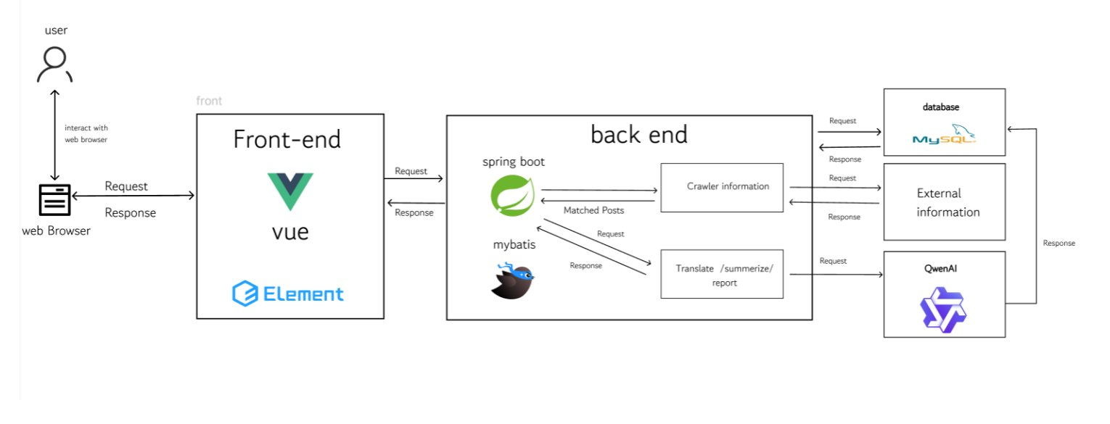
Fig.1. System Architecture
B. Feature 1:Bilingual Daily News Aggregation Module
This system is centered around the "Daily Briefing" function. Users can view the daily news briefings obtained by the system from Google News and generated by Qwen AI's summary on the page. By clicking on any item, they can view the more detailed news content and, when necessary, quickly jump to the original news link. At the same time, users can freely switch between the interface languages in Chinese and English. They can also use the date filtering function to view the briefings within a time range, or quickly locate the news they are interested in through keyword search, thereby efficiently browsing and managing daily news information within a unified interface.
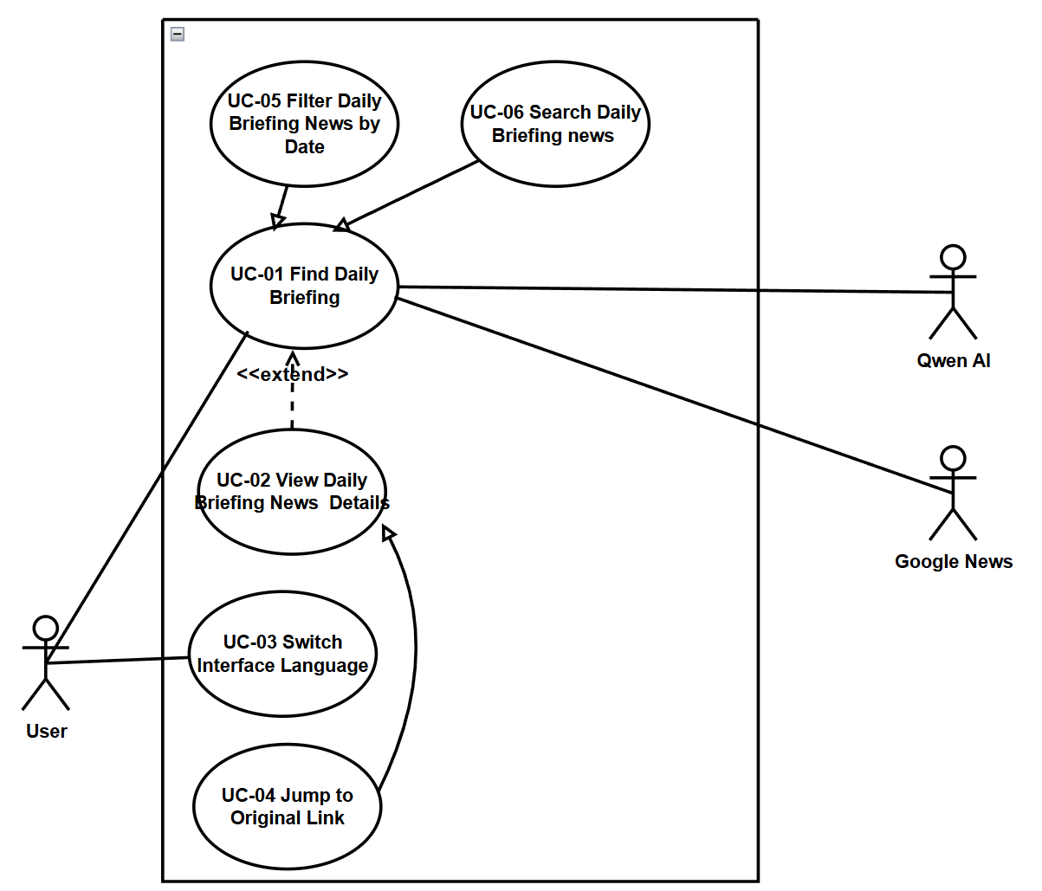
Fig.2. User Case Diagram of Bilingual Daily News Aggregation Module
This class diagram illustrates the layered architecture of the feature 1, encompassing frontend view components (DailyBriefing, DailyBriefingDetail), backend business logic (NewsController), data access layer (NewsRepository), and core data entities (News, NewsBriefDTO). The frontend components manage news list rendering, pagination, search/filter operations, and detail page display, while the backend NewsController coordinates database queries via NewsRepository, converts raw News entity data into frontend-facing NewsBriefDTO objects, and exposes RESTful APIs for frontend communication, enabling efficient Bilingual news aggregation and user interaction.
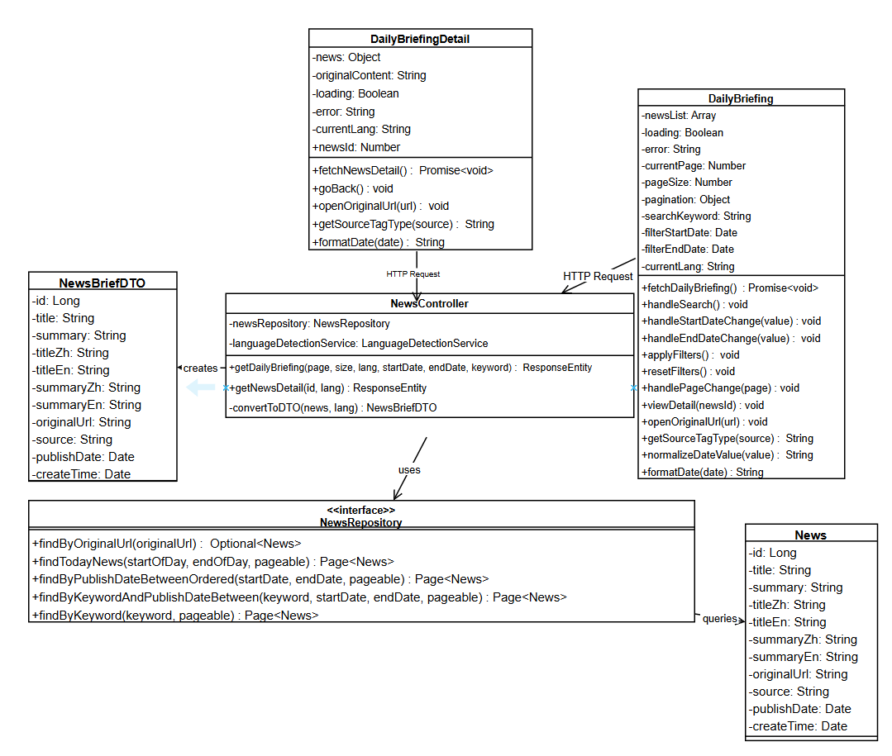
Fig.3. Class Diagram of Bilingual Daily News Aggregation Module
This feature addresses the most critical information barrier: the inaccessibility of Thai-language local news for non-Thai-speaking international students. At 08:00 daily, the system crawls Google News RSS feeds. For each item, the system calls the Qwen AI API to generate Chinese and English versions of the title and summary, which are stored persistently in the database. This batch-preprocessing approach eliminates real-time API latency during user browsing.The frontend renders a paginated list of 10 news cards per page, each showing the translated title, AI-generated summary, source label, and publication date in the user’s current language. Users can search by keyword across both Chinese and English translation fields simultaneously, filter by publication date range, and toggle between Chinese and English interfaces dynamically. The backend’s Data Transfer Object (DTO) conversion suppresses all Thai original text from user-facing responses. Custom JPQL repository queries support keyword search (findByKeyword),date-rangefiltering (findByPublishDateBetweenOrdered), and combined filters, all returning results ordered by publication date descending. The feature interface is shown in Fig. 4.
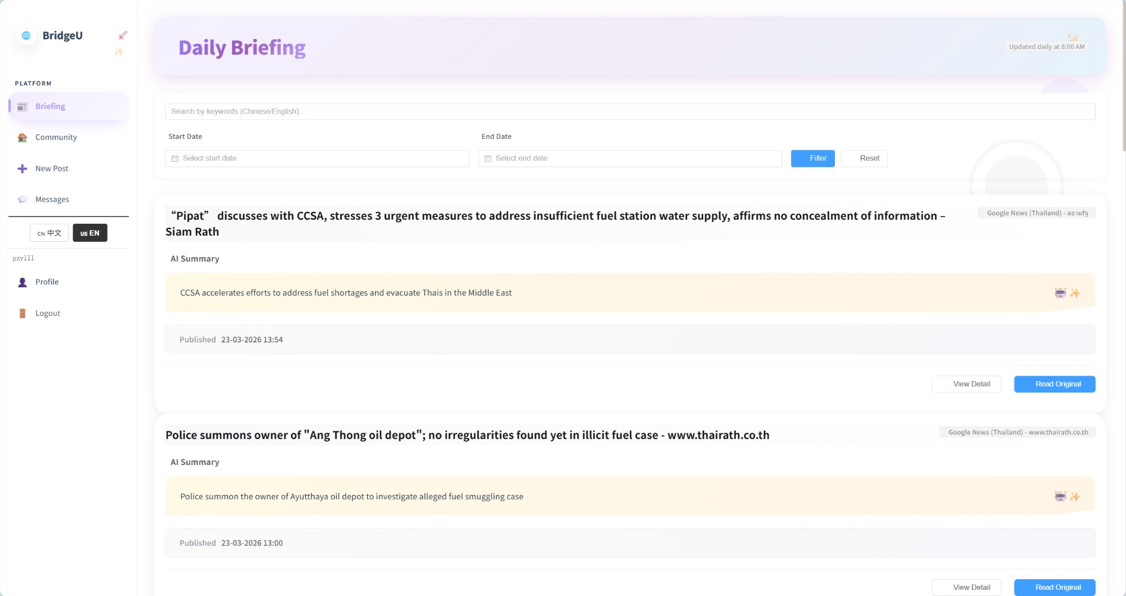
Fig.4. Daily Briefing System interface
C. Feature 2: Community Knowledge Sharing and Private Message Module
This feature centers on a single actor (User): the user can browse public posts (UC-07) and optionally filter by tag (UC-10) or search by keyword (UC-14), then view post details (UC-11) where they may like (UC-09), post comments (UC-13), or report inappropriate content (UC-12); the system may invoke Qwen AI to support content processing during post creation/publishing (UC-08) and to generate an AI comment summary (UC-015), and users can also manage private messages(UC-16) with message status management (UC-17) as an extension of messaging.
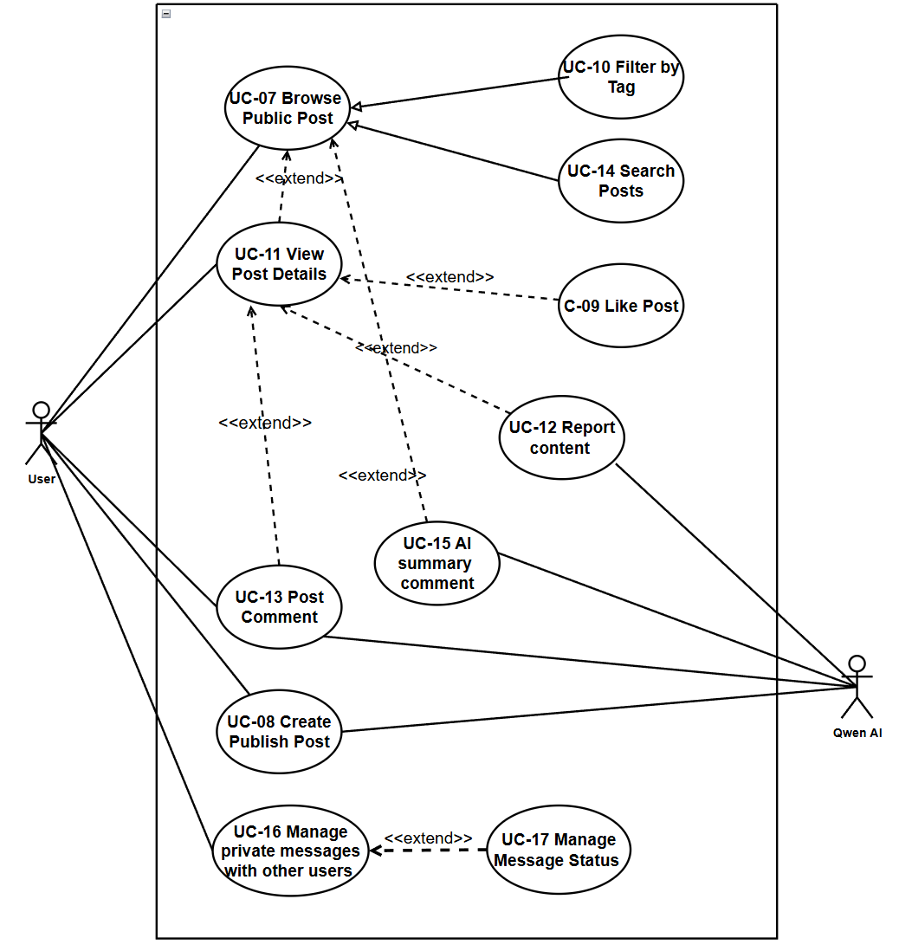
Fig.5. User Case Diagram of Community Knowledge Sharing and Private Message Module
This class diagram models the layered architecture of the Community Page module, covering frontend view components, backend controllers, service layers, data access repositories, and core data entities. The frontend components (CommunityFeed, PostDetail) manage the community feed rendering, post detail display, user interactions (posting, commenting, liking, reporting), and state management. The backend PostController, MessageController, and ReportController coordinate business logic, including post creation with AI translation/moderation, comment management, private messaging, and content reporting, while relying on CommunityPostRepository and CommentRepository for data persistence. Core entities like CommunityPost, Comment, and AppUser store user-generated content and user information, with associated DTOs and service layers enabling multilingual support, AI content moderation, and efficient data flow between frontend and backend.
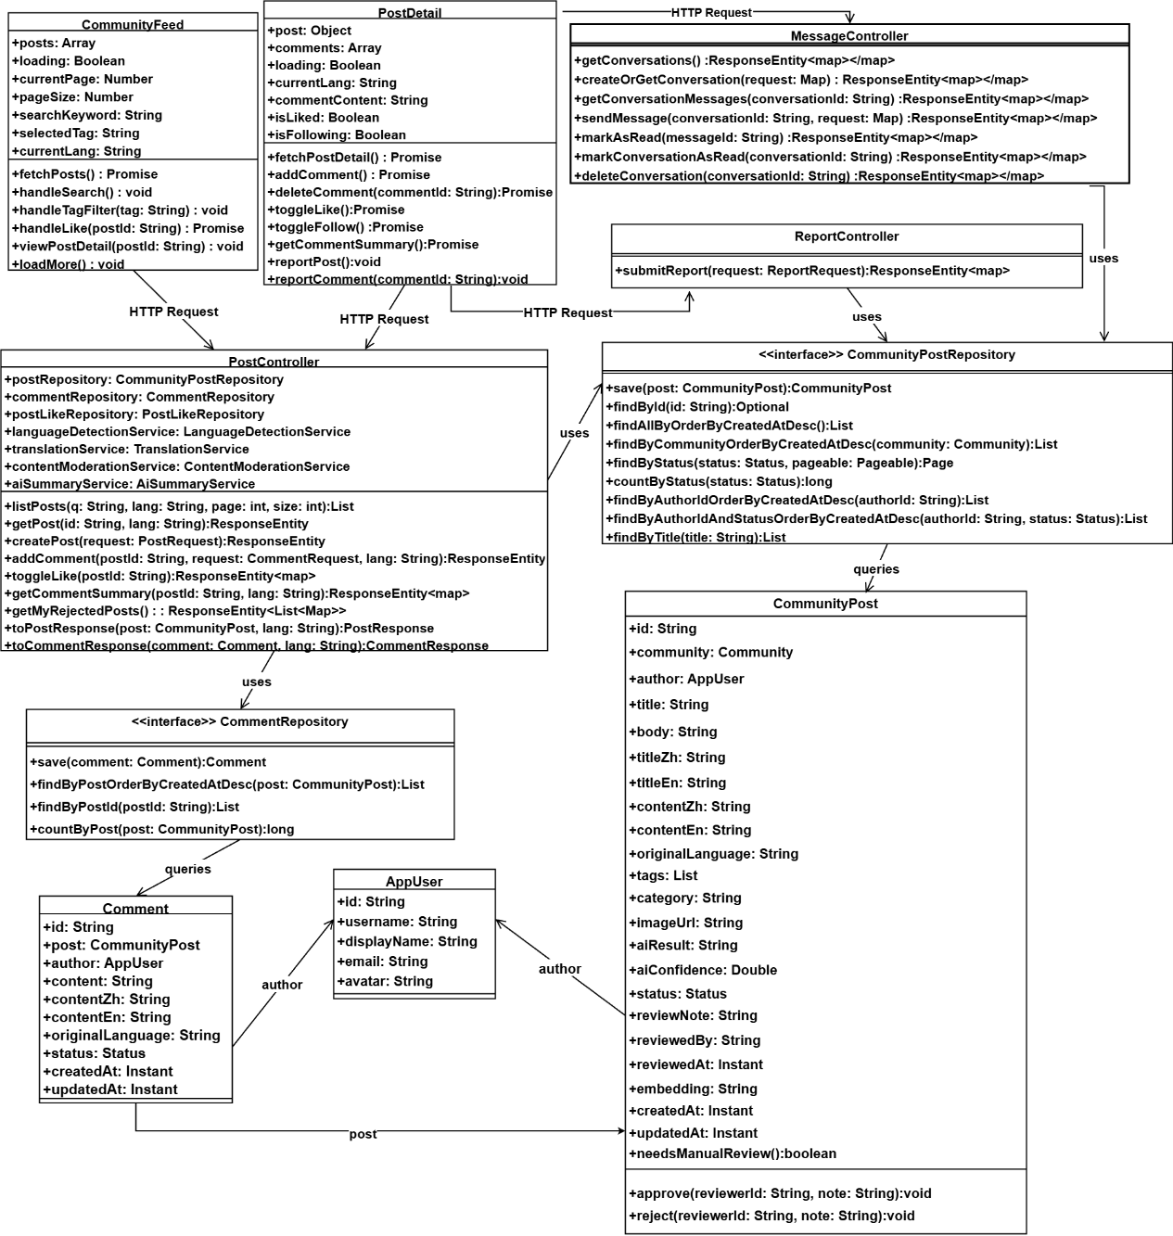
Fig.6. Class Diagram of Community Knowledge Sharing and Private Message Module
This feature enables peer-to-peer knowledge sharing among international students across five predefined categories: Study, Housing, Travel, Part-time Job, and Life Services. When a user submits a post in Chinese or English, the system asynchronously calls Qwen AI to generate the other language version and conduct a content security review. The original content is immediately saved and the user receives a response, while AI processing runs in the background [14]. Only after Qwen AI confirms the content passes moderation checks does the post appear in the community feed.Within each post, users may add comments, toggle a like reaction, and generate an AI-summarized paragraph of all comments—useful for long discussion threads. The follow relationship is asymmetric: mutual follows create a “Friends” relationship enabling unrestricted private messaging, while one-way follows are limited to a single initial message to reduce unsolicited contact. Users can report posts or comments by selecting predefined reasons (Spam, Fraud or Scam, Illegal Service Promotion, Abusive Language, Other), after which Qwen AI reviews the reported content and provides a judgment. The Community Page also supports keyword search across post titles and body texts in currently languages. The Community Page feed, New Post form, and private messaging interface are shown in Fig. 7-9.
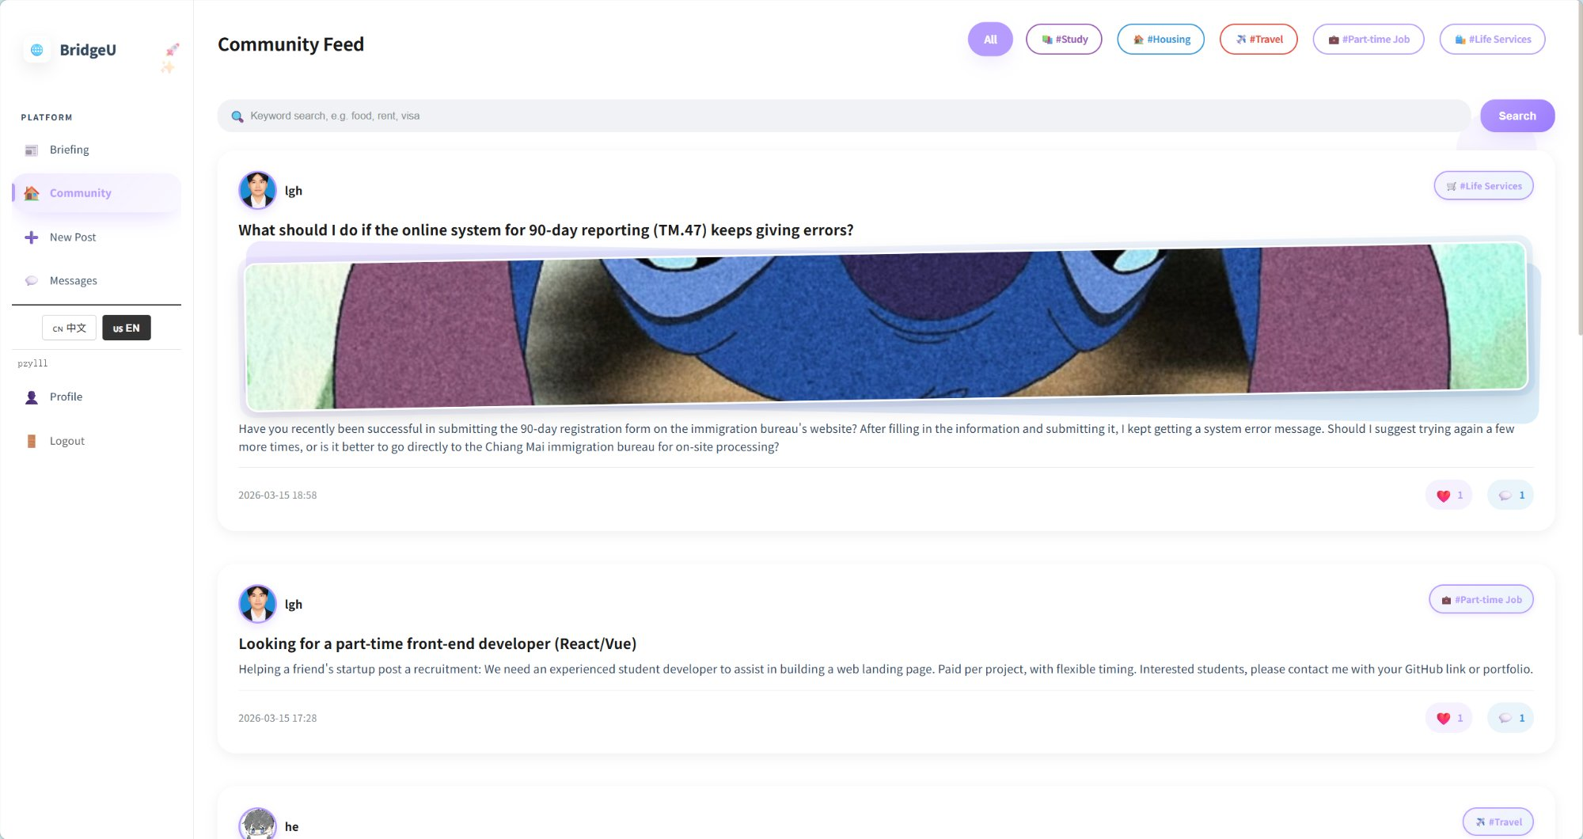
Fig.7. Community Page interface
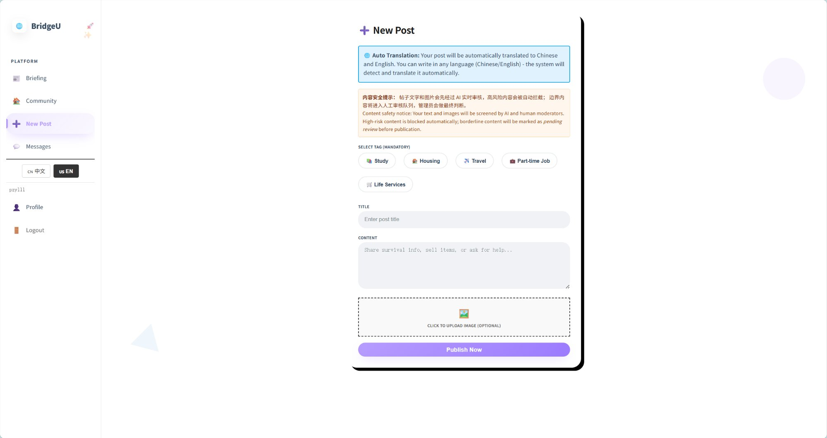
Fig.8. Create New Post interface
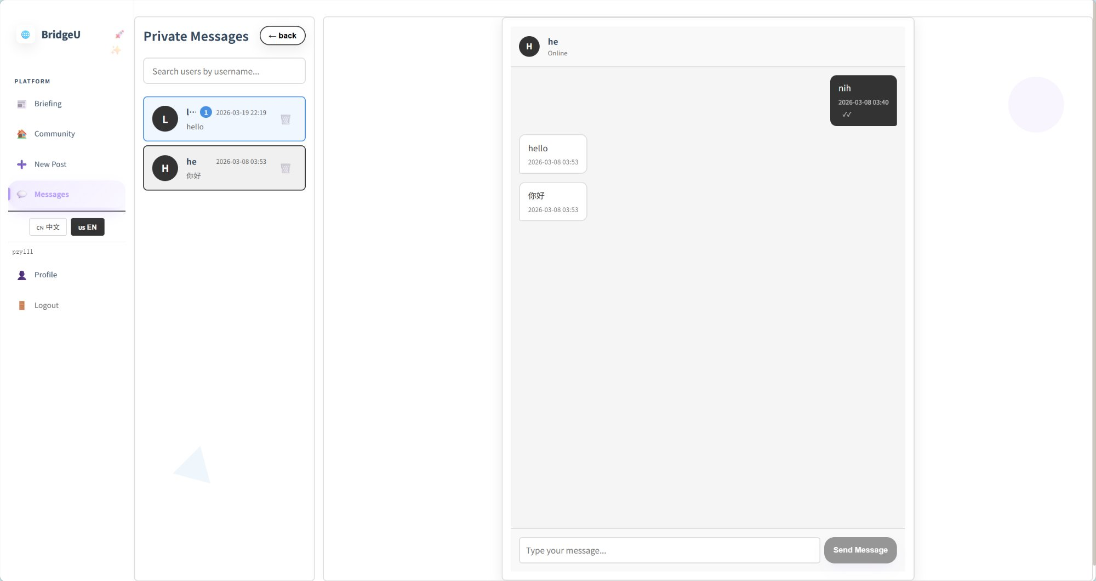
Fig.9. Private messaging interface
D. Feature 3: User Authentication and Profile Management Module
This use case diagram covers user account and personal-center functions. The primary actor is the User, who can register an account (UC-19), with two alternative registration paths: register with phone number (UC-19.1) which relies on an external SMS service for verification, and register with email (UC-19.2) which relies on an external Email service. After registration, the user can log in (UC-20) and log out (UC-21), edit their profile (UC-22), view their friends/followers list (UC-18), view their own community posts (UC-23), and view their submitted reports (UC-24). Additionally, the user can use the Forgot password (UC-25) function, which extends the Log In (UC-20) use case. This recovery process branches into two specific methods: SMS-based Password Reset (UC-25.1), which interacts with the external SMS service, and Email-based Password Reset (UC-25.2), which interacts with the external Email service.
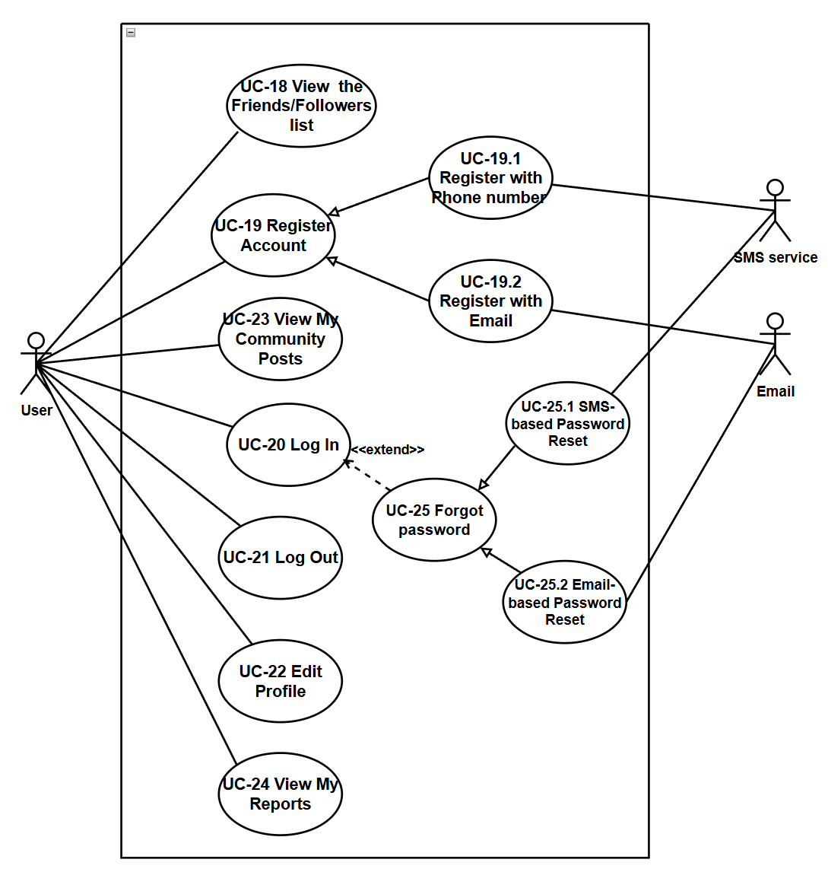
Fig.10. User Case Diagram of User Authentication and Profile Management Module
This class diagram illustrates the layered architecture of the Authentication and Profile System module, covering frontend view components, backend controllers, service layers, data access repositories, and core data entities. The frontend components (RegisterPage, LoginPage, ProfilePage) manage user registration, login, password reset, and profile management operations. The backend AuthController, UserController, and ReportController coordinate business logic including JWT-based authentication, verification code sending, profile updates, follow relationships, and report management, relying on repositories like AppUserRepository, VerificationCodeRepository, and UserFollowRepository for data persistence. Core entities such as AppUser, VerificationCode, UserFollow, and Report store user accounts, verification records, social relationships, and content reports, with supporting services (JwtService, EmailService, SmsService) enabling secure authentication, multi-channel verification, and efficient data flow between frontend and backend.
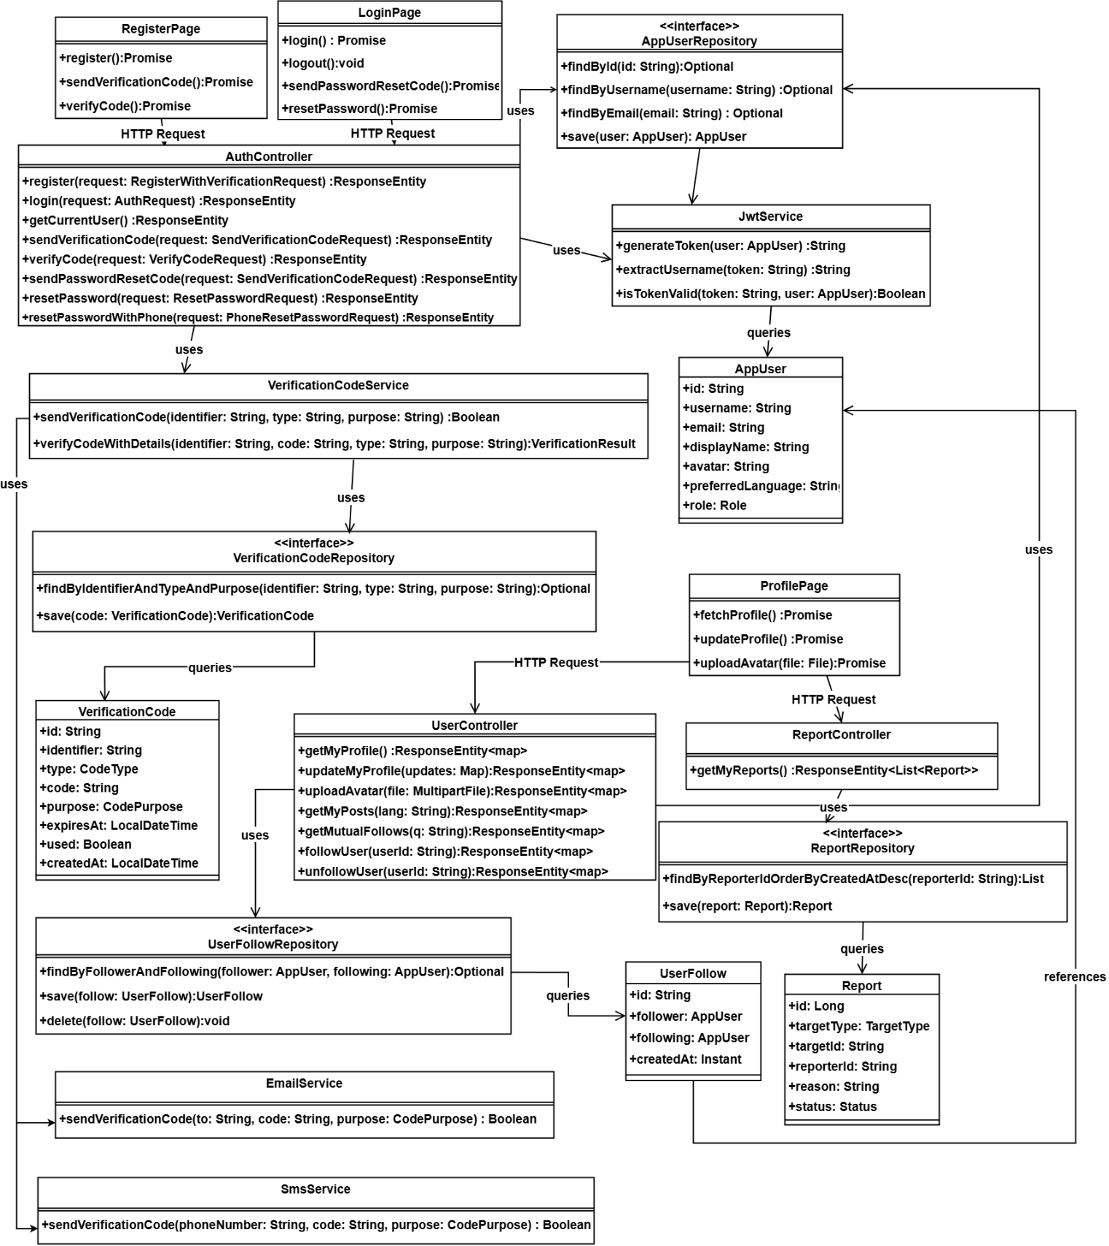
Fig.11. Class Diagram of User Authentication and Profile Management Module
This feature provides secure user registration, login, and profile management. Registration supports two verification pathways: email (via server-side SMTP verification code) and phone (via Firebase SMS). Both pathways require a 6-digit verification code before the registration form is unlocked. Passwords are validated to contain both uppercase and lowercase letters and are stored as BCrypt hashes . Display names are restricted to English characters to prevent encoding conflicts. If the user forgets the password, the option to forget the password is provided on the login page, and the user can send a verification code to reset the password through the phone number or email.Upon successful login, Spring Security generates a JWT signed with HMAC-SHA256, containing the user’s ID, username, and token expiry. The client stores the token in sessionStorage and attaches it as a Bearer token in the Authorization header of all authenticated requests. The Profile page displays avatar, display name, username, and social statistics (posts, followers, mutual follows). Users can edit their display name, avatar URL, and preferred language; changing the username requires re-authentication. Additional profile views include My Community Posts (with Qwen AI moderation status: published, pending, or rejected), My Reports (showing AI review judgments for submitted reports), and Followers/Friends lists with direct navigation to user profiles or the messaging interface when click the user’s avatar. The feature interface is shown in Fig.12. 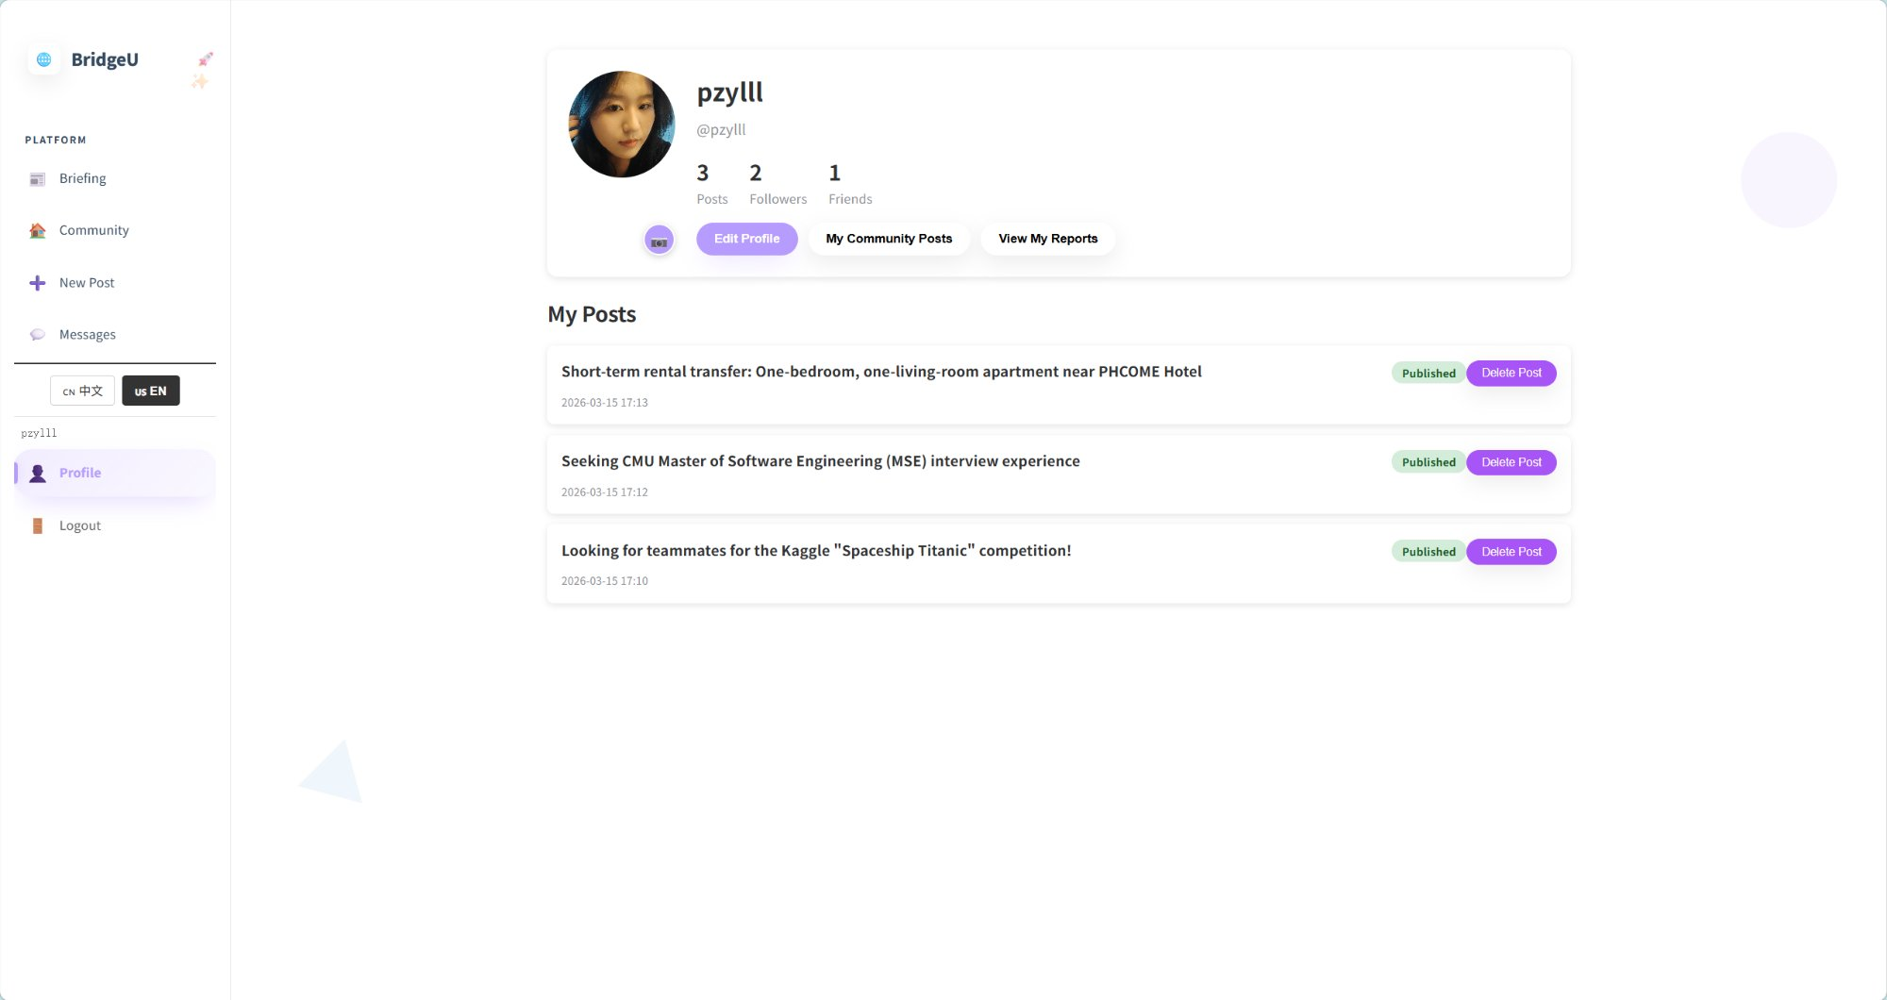
Fig.12. User profile page interface
E.Database Design
Relationships are enforced through foreign keys: USERS to POSTS (1:N), USERS to COMMENTS (1:N), USERS to POST_LIKES (1:N), USERS to CONVERSATION (1:1), USERS to MESSAGE (1:N), USERS to REPORT (1:N), USERS to NOTIFICATIONS (1:N), USERS to VERIFICATION_CODE (1:1), POSTS to COMMENTS (1:N), POSTS to POST_LIKES (1:N), POSTS to NOTIFICATIONS (1:N), REPORT to REPORT_REASONS (1:N), REPORT to NOTIFICATIONS (1:N), CONVERSATION to MESSAGE (1:N). A data dictionary defines field types, constraints, and validation rules for all entities. Fig. 13 illustrates the Entity-Relationship Diagram of the BridgeU platform.
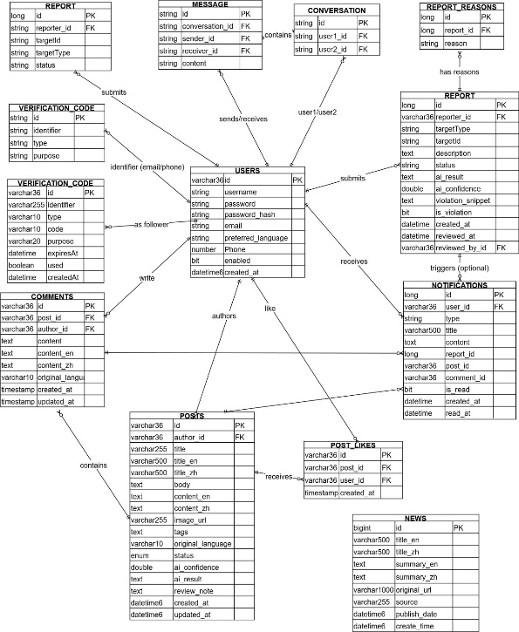
Fig.13.Database Design
F. Test Strategy
Testing followed a structured two-level strategy: unit testing, system testing. Unit tests targeted individual frontend Vue.js component methods and backend Spring Boot controller, service, and repository methods. System tests verified end-to-end workflows through the fully integrated system. A total of 25 unit test suites and 21 system test cases were defined. The pass/fail criterion required an exact match between actual results and the expected results specified in the Test Plan document.
IV. User Evaluation
A. Evaluation Design
To assess BridgeU’s usability and relevance to its target users, a two-phase evaluation was conducted combining semi-structured interviews and a structured questionnaire. The evaluation targeted international students currently enrolled at Chiang Mai University who were not involved in the system’s development. A total of five participants took part in the interview phase and fifteen participants completed the questionnaire, yielding qualitative depth alongside quantitative breadth. The combined approach follows the mixed-methods evaluation strategy recommended by Creswell and Plano Clark [18], wherein qualitative findings are used to interpret and contextualize quantitative results.
B. Semi-Structured Interview
Five international students,all enrolled in undergraduate programs at CAMT, participated in individual semi-structured interviews lasting 20–30 minutes each. Interviews were conducted in English or Chinese according to participant preference. The interview guide covered four themes: current information-access habits, first impressions and navigability of BridgeU, perceived usefulness of each feature, and suggestions for improvement. Thematic analysis [19] was applied to the transcripts, and three recurring themes emerged across participants.
Theme 1 – Perceived usefulness of the Bilingual Daily News Aggregation Module (Feature 1) All five participants reported that they currently obtain Thailand-related information through social platforms. They regarded the Daily Briefing System as more reliable because it aggregates content from official Thai news sources. Four participants expressed strong satisfaction with the bilingual language-switching function, describing the experience as natural and convenient. One participant commented: “I did not know there were Thai government announcements like this. Having them in Chinese is very helpful.” These responses reflect strong user recognition of Feature 1 in solving language and information-access barriers.
Theme 2 – User experience of the Community Knowledge Sharing and Private Message Module (Feature 2) and social interaction demands. Four participants hoped for a dedicated mobile application, as they mainly use mobile devices for social and information browsing. Two suggested adding push notifications for subscribed topic tags. One participant mentioned that the single-message restriction for one-way follows may reduce willingness to initiate contact, and proposed an optional greeting mechanism. These comments reflect user expectations for Feature 2 and provide clear directions for future improvement.
Theme 3 – Usability of the User Authentication and Profile Management Module (Feature 3). All participants agreed that the registration, login, and profile management processes were clear and easy to understand. They found the email and SMS verification mechanisms secure and trustworthy, and appreciated the simplicity of profile editing and social relationship management. This indicates that Feature 3 effectively supports stable and secure platform access.
C. Questionnaire
Following the interviews, a structured questionnaire was distributed to fifteen international students at CAMT via a shared Google Form link. Participants were asked to explore BridgeU independently for at least 20 minutes before responding. The questionnaire comprised twelve Likert-scale items (1 = Strongly Disagree, 5 = Strongly Agree) covering usability, feature usefulness, and overall satisfaction, plus one open-ended question for general comments. Table III presents the mean scores and standard deviations for all twelve items.
TABLE III. User Questionnaire Results (n = 15, Scale 1–5)
No | Questionnaire Item | Evaluated Feature | Mean | SD
Q1 | The Daily Briefing makes it easier for me to access Thai news in my preferred language. | Feature 1 | 4.53 | 0.64
Q2 | The keyword search and date filter functions help me find relevant news quickly. | Feature1 | 4.40 | 0.74
Q3 | Switching between Chinese and English interfaces is smooth and intuitive. | Feature1 | 4.60 | 0.51
Q4 | The Community Page’s tag-based filtering helps me find posts relevant to my needs. | Feature2 | 4.47 | 0.64
Q5 | I feel the AI-generated news summaries are accurate and informative. | Feature1 | 4.13 | 0.83
Q6 | Creating and submitting a post on the Community Page is straightforward. | Feature2 | 4.33 | 0.72
Q7 | The AI comment summarization feature saves time when reading long discussion threads. | Feature2 | 4.20 | 0.78
Q8 | The registration process is clear and easy to complete. | Feature3 | 4.27 | 0.70
Q9 | The private messaging system is useful for communicating with other community members. | Feature2 | 4.00 | 0.85
Q10 | The overall interface is visually clear and easy to navigate. | Overall | 4.40 | 0.63
Q11 | BridgeU effectively addresses the information needs of international students. | Overall | 4.53 | 0.52
Q12 | I would recommend BridgeU to other international students in Thailand. | Overall | 4.47 | 0.64
— | Overall Average |  | 4.36 | 0.68

The results show highly positive feedback across all features. The bilingual interface (Q3, Mean = 4.60) and the ability of BridgeU to meet real information needs (Q1, Q11, Mean = 4.53) received the highest scores. The lowest score appeared in Q9 (private messaging, Mean = 4.00), which is consistent with interview feedback that the single-message limit may restrict initial communication. The overall average score of 4.36 indicates strong user satisfaction. Open-ended comments further supported interview findings: ten participants highlighted the Daily Briefing as their most frequently used function, and seven requested a mobile version as a top priority for future development.
D. Evaluation Limitations
This evaluation has several limitations. First, the sample sizes are relatively small (n = 5 interviews, n = 15 questionnaires) and limited to one university, so results may not fully generalize to all international students in Thailand. Second, the evaluation relied on a short 20-minute usage session rather than long-term real-world usage, which may lead to bias caused by novelty effects. Third, participants were recruited through personal networks, potentially introducing selection bias. Future work will expand the sample size, adopt random sampling, conduct longitudinal usage tracking, and use standardized scales such as the System Usability Scale (SUS) [20] to obtain more reliable and generalizable evidence.
V. Discussion and Conclusions
A. Discussion
This study designed and implemented BridgeU, a bilingual web platform for Chinese-speaking international students in Thailand, and validated its usability via mixed-methods user evaluation (5 interviews, 15 questionnaires). The results confirm the platform effectively addresses core user pain points of language barriers and information inaccessibility, while also identifying key areas for optimization aligned with user feedback.
Feature 1 (Daily Briefing System) achieved the highest questionnaire ratings, with bilingual switching (Q3, Mean=4.60) and news accessibility (Q1, Mean=4.53) being the most recognized features. Interview feedback further validated the reliability of its official Thai news sources and the practical value of batch-processed AI translation/summarization. The slightly lower score for AI summary accuracy (Q5, Mean=4.13) indicates room for improvement in processing Thailand-specific terminology, a limitation tied to third-party LLM API performance.
Feature 2 (Community Page) received positive scores for tag-based filtering (Q4, Mean=4.47) and post creation (Q6, Mean=4.33), proving its structured design solves information disorder in general social platforms. AI comment summarization (Q7, Mean=4.20) was valued for improving interaction efficiency, but private messaging (Q9, Mean=4.00) scored lowest—consistent with interview feedback that the one-way follow single-message limit overly restricted initial social contact. Users also universally requested a native mobile application, reflecting a misalignment between the web-only design and mobile-centric browsing habits.
Feature 3 (Authentication and Profile System) earned a stable score for registration usability (Q8, Mean=4.27), with participants affirming the balance of security (dual-channel verification, BCrypt hashing) and ease of use (intuitive profile management). This validates the platform’s security design avoids overly complex operations while ensuring data protection.
The overall satisfaction score of 4.36/5 and high rating for addressing user needs (Q11, Mean=4.53) confirm BridgeU fills the gap for specialized Thai international student support platforms. Qualitative and quantitative results were highly consistent, strengthening evaluation reliability, though the small, single-university sample and short 20-minute usage session introduce potential generalizability and novelty bias limitations.
B. Conclusions
This study successfully developed BridgeU, a bilingual web platform with three core features—Daily Briefing System, Community Page, and Authentication and Profile System—tailored for Chinese-speaking international students in Thailand. Mixed-methods user evaluation yielded an overall satisfaction score of 4.36/5, validating the platform’s usability, practicality, and alignment with target user needs.Key conclusions include: 1) The AI-powered Daily Briefing System effectively breaks Thai news language barriers, with seamless bilingual switching emerging as the most valued feature, proving batch-processed AI translation is a feasible solution for cross-border information access. 2) The structured Community Page enables efficient peer knowledge sharing, while the private messaging mechanism requires optimization to balance privacy protection and social connectivity. 3) The Authentication and Profile System achieves a strong balance of security and user experience, laying a solid foundation for platform trust and personalization. 4) BridgeU successfully addresses the core pain points of language barriers, information inaccessibility, and social disconnection for its target users, delivering unique value as a specialized support platform.Based on user feedback and evaluation limitations, future work will focus on: optimizing the private messaging mechanism with a flexible opt-in icebreaker feature; developing a native mobile application (the top user request); fine-tuning Qwen AI with Thailand-specific corpus to improve summary/translation accuracy; expanding evaluation to multiple Thai universities with longitudinal tracking and standardized SUS scales; and adding push notifications for subscribed community tags.
In summary, BridgeU provides a practical specialized platform solution for Chinese-speaking international students adapting to Thailand, integrating AI and user-centered design to solve their unique challenges. The positive evaluation results confirm its core value, and the identified optimization directions offer a clear roadmap for subsequent iteration. This study also provides a reference for designing cross-border student support platforms, emphasizing the importance of aligning technical design with targeted user needs.
Acknowledgment
The author thanks Pattama Longani, Ph.D. (Project Advisor, Software Engineering Program, College of Arts, Media and Technology, Chiang Mai University) for guidance throughout the development and documentation of BridgeU. This project was completed as part of the Bachelor of Science in Software Engineering program.

References
[1] UNESCO, "Global flow of tertiary-level students," UNESCO Institute for Statistics, 2022. [Online]. Available: http://uis.unesco.org/en/uis-student-flow
[2] J. Hofhuis, M. C. van Egmond, F. E. Lutz, and K. von Reventlow, "The effect of social network sites on international students' acculturation, adaptation, and wellbeing," Frontiers in Communication, vol. 8, 2023, doi: 10.3389/fcomm.2023.1186527.
[3] S. Zhou and J. Yin, "International students' social media use: An integrative review of research over a decade," Journalism & Mass Communication Quarterly, 2024, doi: 10.1177/10283153241275037.
[4] C. Gautam, A. Lowery, C. Mays, and D. Durant, "Challenges for global learners: A qualitative study of the concerns and difficulties of international students," Journal of International Students, vol. 6, no. 2, pp. 501–526, 2016.
[5] J. Dong, S. Lee, C. Wang, and D. M. Shannon, "Impact on social capital and learning engagement due to social media usage among the international students in the U.S.," Education and Information Technologies, vol. 28, no. 7, pp. 8027–8050, 2023, doi: 10.1007/s10639-022-11520-8.
[6] British Council, "Social media analysis of the UK's prospective international students," 2023. [Online]. Available: https://opportunities-insight.britishcouncil.org/
[7] Meta Platforms, Inc., "Facebook," [Online]. Available: https://www.facebook.com
[8] Xiaohongshu, "Xiaohongshu (Little Red Book)," [Online]. Available: https://www.xiaohongshu.com
[9] Reddit, Inc., "Reddit," [Online]. Available: https://www.reddit.com

[10] N. Kasioumis, V. Banos, and H. Kalb, "Towards building a personal RSS feed manager," in Proc. Int. Conf. on Web Engineering, 2013, pp. 194–201.
[11] V. Papageorgiou and I. Drakoulis, "Atlas: News aggregation service," in Proc. IEEE 4th Int. Conf. on Information, Intelligence, Systems and Applications (IISA), 2013, doi: 10.1109/IISA.2013.6623756.
[12] C. L. Yuen and N. Schlote, "Learner experiences of mobile apps and artificial intelligence to support additional language learning," Journal of Educational Technology & Society, vol. 27, no. 2, 2024, doi: 10.1177/00472395241238693.
[13] K. Wang et al., "Design and implementation of an online education platform based on microservice architecture," in Proc. 2022 IEEE Int. Conf. on Artificial Intelligence in Education, 2022.
[14] A. Kaya and B. Ozdemir, "A secure digital image marketplace: Microservices and OWASP API security using Spring Boot," in Proc. 2024 IEEE Int. Conf. on Engineering and Emerging Technologies(ICEET), 2024, doi: 10.1109/ICEET.2024.10750956.
[15] A. Bucko, K. Vishi, B. Krasniqi, and B. Rexha, "Enhancing JWT authentication and authorization in web applications based on user behavior history," Computers, vol. 12, no. 4, p. 78, 2023, doi: 10.3390/computers12040078.
[16] OWASP Foundation, "JSON Web Token for Java Cheat Sheet," OWASP Cheat Sheet Series, 2024. [Online]. Available: https://cheatsheetseries.owasp.org/cheatsheets/JSON_Web_Token_for_Java_Cheat_Sheet.html
[17] B. Roczey and S. Szenasi, "Automated moderation helper system using artificial intelligence based text classification," in Proc. 2023 IEEE 17th Int. Symp. on Applied Computational Intelligence and Informatics (SACI), pp. 477–482, doi: 10.1109/SACI58269.2023.10158593.
[18] J. W. Creswell and V. L. Plano Clark, Designing and Conducting Mixed Methods Research, 3rd ed. Thousand Oaks, CA: SAGE Publications, 2017.
[19] V. Braun and V. Clarke, "Using thematic analysis in psychology," Qualitative Research in Psychology, vol. 3, no. 2, pp. 77–101, 2006, doi: 10.1191/1478088706qp063oa.
[20] J. Brooke, "SUS: A quick and dirty usability scale," in Usability Evaluation in Industry, P. W. Jordan et al., Eds. London: Taylor & Francis, 1996, pp. 189–194.

