BridgeU
Project Proposal

Zhiyi Pan 652115558

Bachelor of Science
Software Engineering Program

Department College of Arts, Media, and Technology Chiang Mai University November 2025

Project Advisor
Asst. Prof. Pattama Longani, Ph.D.

Document History
Document Name | Version | History | Status | Date | Editable | Reviewer
BridgeU-Proposal | BridgeU-Proposal  V.0.1 | Add Chapter 1  • Introduction and  Background  Add Chapter 2  • Business Review  Technology review  • Business Tools /  Software Review  Add Chapter 3  • Development  Tools Review  • Technology  Review  Add Chapter 4  • Project  Management  Process  • Software  implementation  process  Add Chapter 5  • Naming Convention • Change  Management  • Project Repository Add Chapter 6  • Motivation  • Aims and  Objective  • Deliverables and  Limits  Add Chapter 7  • References | Draft | 20/11/2025 | ZHIYI PAN | Asst. Prof. Pattama Longani, Ph.D.
BridgeU-Proposal | BridgeU-Proposal  V.0.2 | Update Chapter 1  • Introduction and  Background  Update Chapter 2  • Business Review  Technology review  • Business Tools /  Software Review  • Technology  Review  Update Chapter 4  • Project  Management  Process  • Software  implementation  process  Update Chapter 6  • Motivation  • Aims and  Objective  • Deliverables and  Limits | Draft | 25/11/2025 | ZHIYI PAN | Asst. Prof. Pattama Longani, Ph.D.
BridgeU-Proposal | BridgeU-Proposal  V.0.3 | Update Chapter 1  Update  Chapter 2:2.1.3 | Draft | 29/11/2025 | ZHIYI PAN | Asst. Prof. Pattama Longani, Ph.D.

Table of content
page
Chapter 1 | Introduction and Rationale 7
Chapter 2|Literature Review 8
2.1 Business Review 8
2.2.1 Overview 8
2.1.2 Target 10
2.1.3 Benefit 11
2.2Business Tools / Software Review 12
2.2.1 Facebook Groups 12
2.2.2 Xiaohongshu (Little Red Book) 13
2.2.3 reddit 14
2.2.4 Feature Comparison 15
Chapter 3 | Development Tools Review 16
Chapter 4 | Quality Standard 23
4.1 Project Management Process 23
4.2 Software implementation process 23
Chapter 5 | Software Configuration Management 24
5.1 Naming Convention 24
5.2 Change Management 24
5.3 Project Repository 25
Chapter 6 Project Management and Planning 26
6.1 Motivation 26
6.2 Aims and Objective 26
6.2.1 Aims 26
6.2.2 Objective 26
6.3 Deliverables and Limits 27
6.3.1 Deliverables 27
6.3.2 Limits 27
6.4 System Architecture 28
6.5 Software Process 29
6.6 Feature 30
6.7 User journey 31
6.8 Schedule Plan 42
6.9 Risk Management and Mitigation 44
6.9.1 Technical & Data Acquisition Risks 44
6.9.2Business & Trust Risks 46
6.9.3 Legal & Compliance Risks 48
Chapter 7 References 49

Chapter 1 | Introduction and Rationale
In Thailand's diverse educational landscape, university campuses are home to students from all over the world - although this community is vibrant and multicultural, it faces a distinct crack.
The group of international students is actually split into two huge and disconnected circles:
- The Chinese Sphere: Chinese international students account for nearly 50% of the international student population. Due to language habits, they often rely on WeChat and live in a relatively closed Chinese-speaking environment.
- The Global Sphere: Students from all other countries (such as Germany, Nigeria, Myanmar, the United States, etc.) mainly use English as Lingua Franca for daily communication and socializing (Facebook/WhatsApp).
In addition to language isolation, the existing information ecosystem also suffers from serious "content bias". The current social media platforms (such as Instagram, Xiaohongshu, and TikTok) are overly flooded with "travel-oriented" content - screens are filled with popular coffee shop check-ins, photo tips for Zhengwang Temple, and recommendations for night market delicacies. However, for international students who need to live in Thailand for a long time, the "essential survival information" they truly need is extremely scarce and hard to find. For instance, few bloggers would elaborate on "the specific materials for student visa renewal", "the course selection and withdrawal regulations of universities", or "where to purchase essential daily necessities for long-term living alone (such as transformers and mosquito repellent). The "essential survival needs" of international students have been overlooked. In addition, there is a huge problem of "economic opportunity mismatch" : many local Thai residents (landlords, second-hand motorcycle sellers) find it easier to do business with Chinese students studying abroad, but due to their inability to speak Chinese and not using wechat, they are completely unable to reach this large customer base.
To address these challenges, we have launched BridgeU, a bilingual AI mutual assistance platform specifically designed for all international students and local service providers in Thailand.
BridgeU not only serves students but also acts as a "local economic accelerator". We utilize the Chinese-English translation function provided by Aliyun Qwen AI of Alibaba Cloud to enable Thai landlords and car dealership owners who do not understand Chinese to post supply and demand information in simple English and directly reach tens of thousands of Chinese students studying abroad. BridgeU makes life more convenient for international students and also provides local Thais with a new way to earn money.

Chapter 2|Literature Review

2.1 Business Review

2.1.1 Overview

Figure 1 International students in Thai
In today's international education landscape of Thailand, university campuses have become a melting pot of diverse cultures, gathering students from China, Europe, Africa, America and Southeast Asia. However, when these international students are in a foreign land, they all face the resource islands caused by language barriers and the extreme scarcity of survival information.
At present, the group of international students is actually divided into two parallel worlds:
- The Chinese-speaking circle centered on WeChat: Nearly 50% of Chinese students studying abroad live in a relatively closed Chinese-speaking environment.
- The global English-speaking circle centered on Facebook/WhatsApp: Students from Europe, Africa and other Asian countries mainly communicate in English.
This fragmentation has led to an all-round "mismatch of resources and opportunities" : A German student sells original textbooks on Facebook but fails to reach Chinese students who urgently need to buy books; A Chinese student wanted to find a roommate to share the rent, but missed the Nigerian student who was looking for a place to live because he only posted on wechat. At the same time, local businesses in Thailand have also lost huge business opportunities due to their inability to bridge these two platforms.
Furthermore, no matter which country the international students come from, the existing social media platforms fail to meet their needs. These platforms overly cater to the "tourist perspective", filled with popular check-in tips for Internet celebrities, while the key information that truly concerns the "long-term survival" of international students (such as visa regulations, school rules, and the purchase of essential daily necessities) is hard to find.
To address these universal challenges, we have launched BridgeU - an AI-driven bilingual mutual assistance platform for international students in Thailand. BridgeU not only serves Chinese students but is also committed to becoming a hub connecting international students with the local community. By using Alibaba Cloud's large model (Qwen AI), it breaks down the language barriers between Chinese and English, enabling Chinese students to understand the world and the world to understand Chinese students. At the same time, use ai to aggregate authoritative survival intelligence. Our goal is to empower every student studying in Thailand, regardless of nationality, to break boundaries, access genuine survival resources and achieve true international integration.

2.1.2 Target
2.1.2.1 Problems
- At present, among the international students in Thailand, there exists a serious phenomenon of "digital tribalization" and information silos caused by cross-platform interaction. Chinese students studying abroad rely heavily on WeChat for socializing and information acquisition, while those from Europe, America and other Southeast Asian countries are mainly active on Facebook and Instagram. This kind of platform isolation based on nationality and usage habits has led to the international student community being divided into two parallel worlds that are not connected to each other. The obstruction of information flow makes it impossible for resources to be shared on a broader scale (such as second-hand goods trading, house subletting, academic exchanges, etc.), resulting in the idleness and waste of resources where "there is demand on one side and supply on the other, but they are not visible to each other due to platform barriers".
- The gap in local business services and the monopoly of intermediaries: In the local life service sector, there is a lack of a direct and transparent bilingual communication channel between local Thai merchants and international students. Due to language barriers (Thai/English/Chinese) and the mismatch of information channels, a large number of high-quality local small and medium-sized businesses (such as restaurants, car rentals, and accommodations) are unable to directly reach the group of international students. This information asymmetry has given rise to a large number of gray intermediaries who profit from the "information gap". These intermediaries often monopolize housing or vehicle resources, making huge profits by raising prices. This not only increases the living costs of international students but also compresses the profit margins of local businesses, leading to inefficiency and unfairness in the market mechanism.
- Lagging manual supervision and trust crisis: The existing Facebook groups or wechat groups mainly rely on manual administrators for review, which is extremely inefficient and subjective. A large number of currency exchange frauds, ghostwriting advertisements and pornographic information are rampant at night and cannot be dealt with in time, resulting in extremely low community trust.
- Language barriers and information lag: The vast majority of international students in Thailand do not possess advanced Thai reading skills, which leads to significant "lag" and "blind spots" when they obtain key social information. The official release channels for visa policy updates from the Thai immigration Bureau, emergency administrative notifications from schools, and sudden social news in the local area usually give priority to Thai, followed by English, and Chinese is rarely used.This Hierarchy of Language in Information Dissemination leads international students to often obtain "second-hand information" only through word-of-mouth in wechat groups. This second-hand information, after being relayed multiple times, is highly prone to distortion, misinterpretation or even rumors, causing students to miss the visa renewal window period, violate local laws and regulations or fail to take timely risks in case of emergencies. Relying solely on fragmented social networks can no longer meet the rigid demands of international students for the Accuracy and Timeliness of information.

2.1.2.2 Solutions
- Bilingual AI Commercial Bridge: The system integrates Alibaba Cloud's Qwen large model for automatic Chinese-English translation. Enable local Thais who do not understand Chinese to do business directly with Chinese students and break down commercial barriers. It can also enable Chinese international students to communicate and interact better with other international students
- AI-driven Automatic Content Moderation (AI-Powered Auto-Moderation):To reduce the cost of manual maintenance and enhance security, the system integrates an intelligent AI review layer. While the AI model automatically pre-reviews each graphic and text post to identify potential scams, hate speech, and sensitive content in multi-language environments, it does not completely replace human oversight. Instead, it acts as a powerful filter, handling the vast majority of clear-cut cases. Ambiguous or low-confidence content is flagged and escalated to human administrators for final judgment. This hybrid approach significantly reduces operational pressure while ensuring high accuracy and preventing false positives.
- Automated Intelligence Robot: Back-end crawlers capture authoritative English media (such as Bangkok Post) and government websites. AI automatically summarizes and provides accurate "survival intelligence" rather than hearsay rumors.

2.1.3 Benefit
The development of BridgeU not only addressed technical challenges but also created significant social and user value.
1. For users (international students) :
- Breaking down survival barriers: Being able to obtain non-tourism-oriented "hardcore" life guides reduces the risk of being fined for not understanding the law.
- Reduce living costs: By directly connecting with local landlords and sellers in Thailand through AI translation, it avoids the price hikes by intermediaries and maximizes the utilization of resources.
- Establishing a secure connection: The mutual follow-up mechanism filters out invalid social interactions, ensuring that every communication is based on the true intentions of both parties.
2. For local service providers in Thailand :
Income Generation: For the first time, we have the tools to directly reach the huge Chinese student market. Landlords, used car dealers and motorcycle shop owners can easily monetize their services by Posting in simple English.
3. For administrators/platforms (operational efficiency) :
Cost-Effective Hybrid Moderation: While the system leverages AI to automatically process and intercept 99% of non-compliant content, it does not rely solely on automation. Ambiguous or low-confidence cases are flagged and escalated to a human review queue for final verification. This hybrid approach significantly reduces the need for a large dedicated moderation team while ensuring accuracy and preventing false positives, thereby balancing operational efficiency with content safety.

2.2Business Tools / Software Review
Several similar applications are currently available on the market, but they differ significantly from BridgeU. Below is an analysis of several key competitors:

2.2.1 Facebook Groups
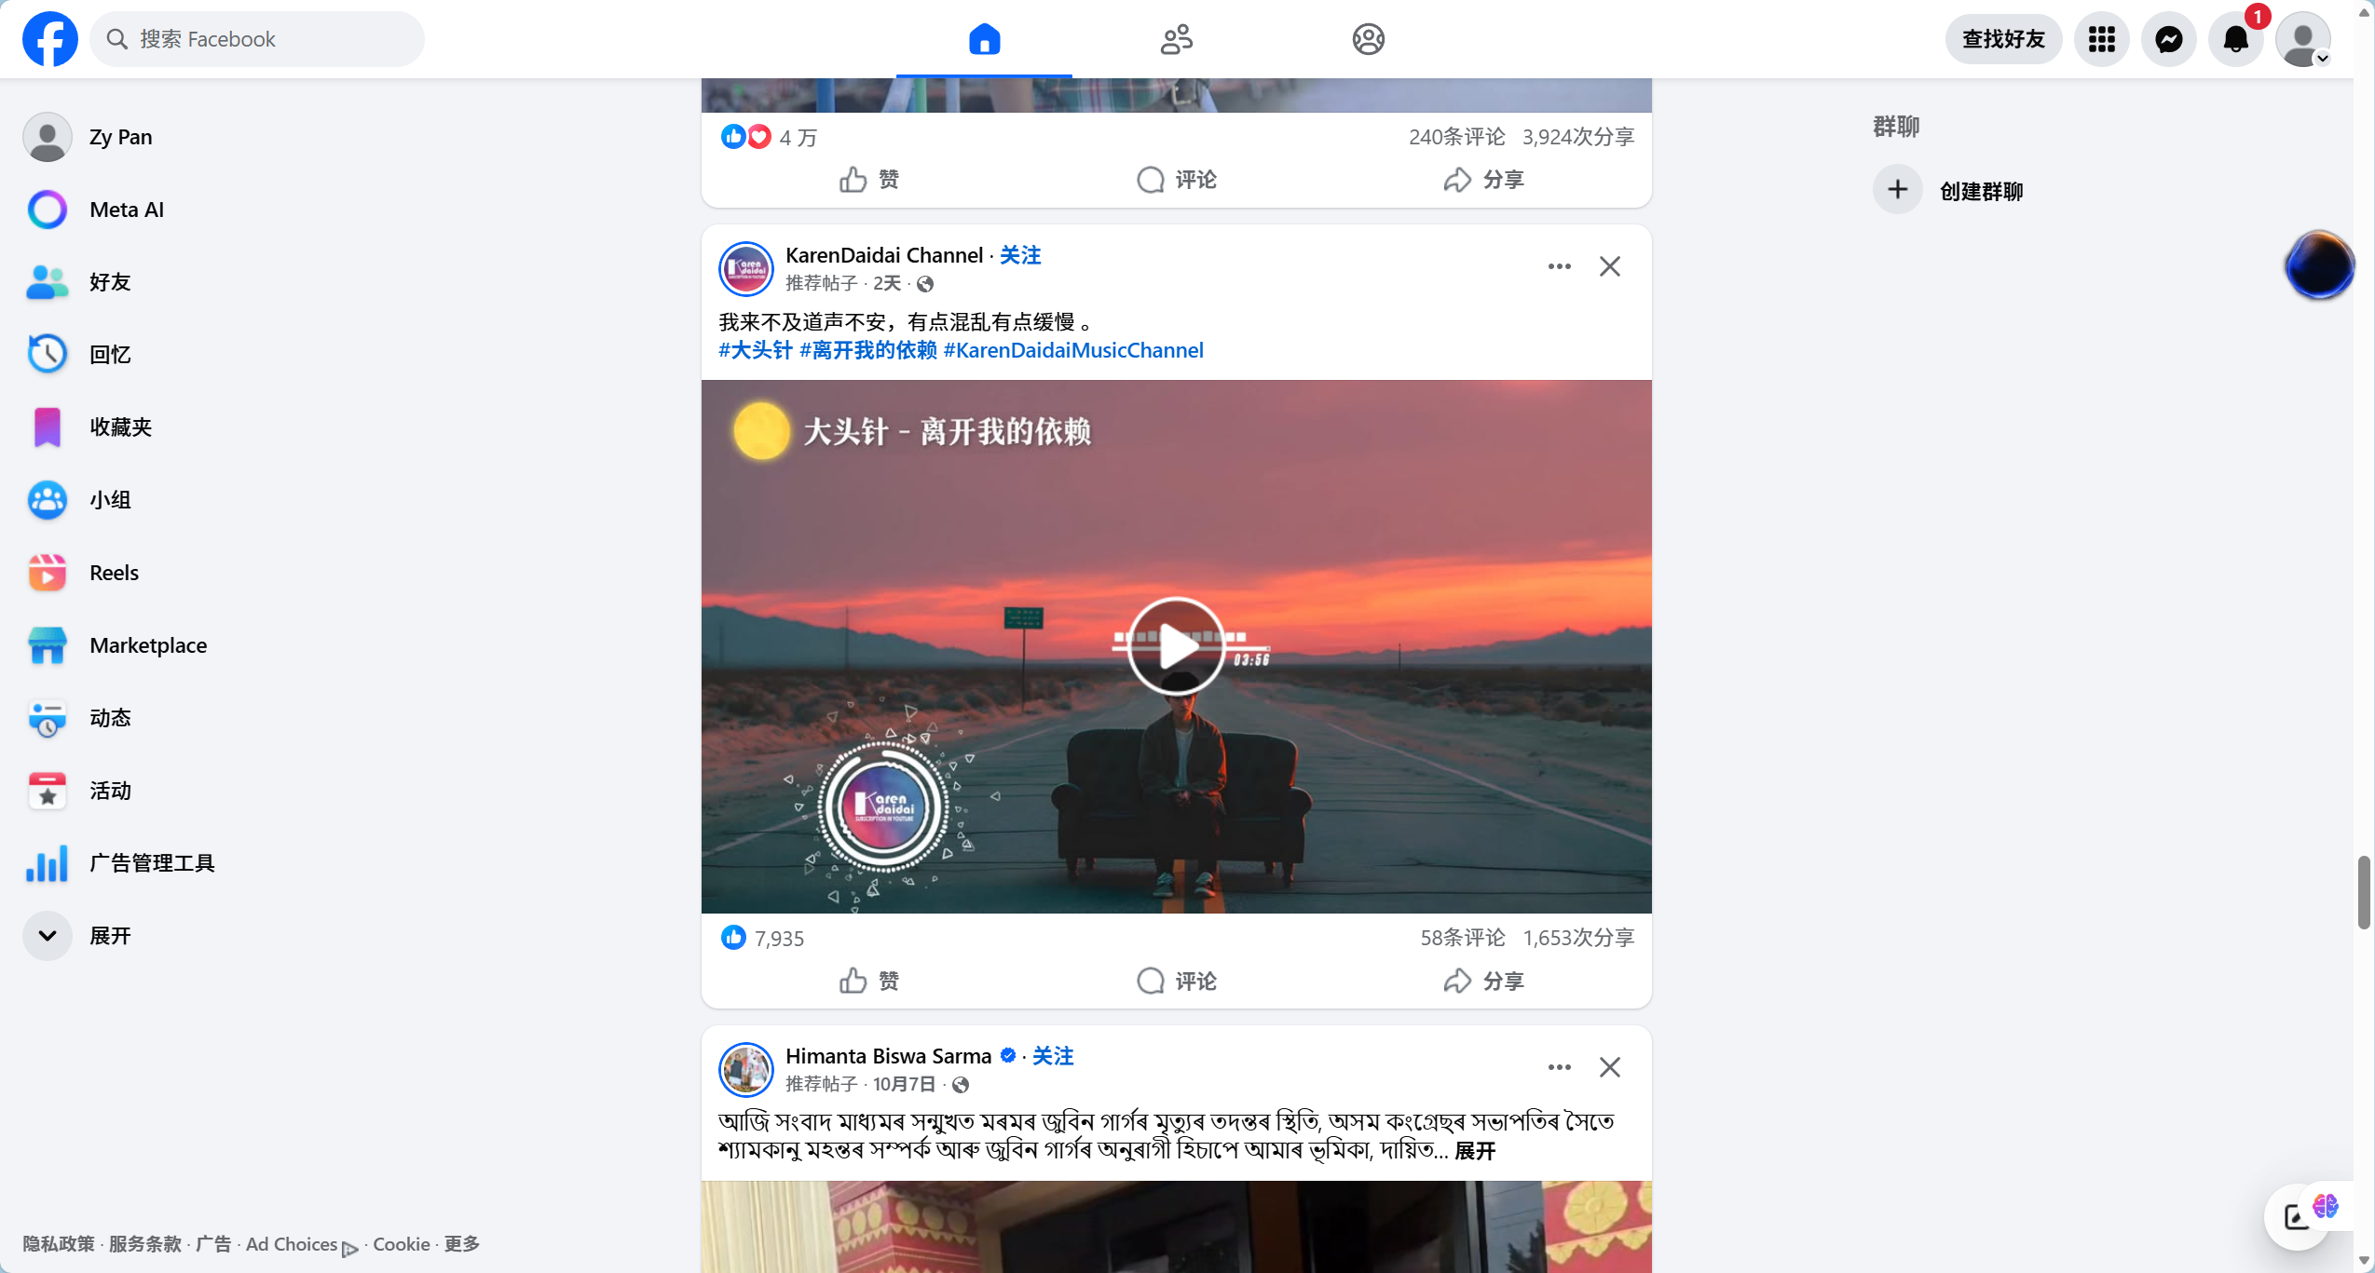
Figure 2 Facebook Groups
Facebook Groups are currently one of the most widely used mutual aid tools among international students worldwide.
Pros:
- Huge user base with broad coverage.
Cons:
- High language threshold: Mainly Thai and English content, which is difficult for Chinese students to use.
- The information retrieval is extremely poor: There are no structured tags, and rental stickers, car sale stickers and casual chats are all mixed together. It's like looking for a needle in a haystack to find information.

2.2.2 Xiaohongshu (Little Red Book)
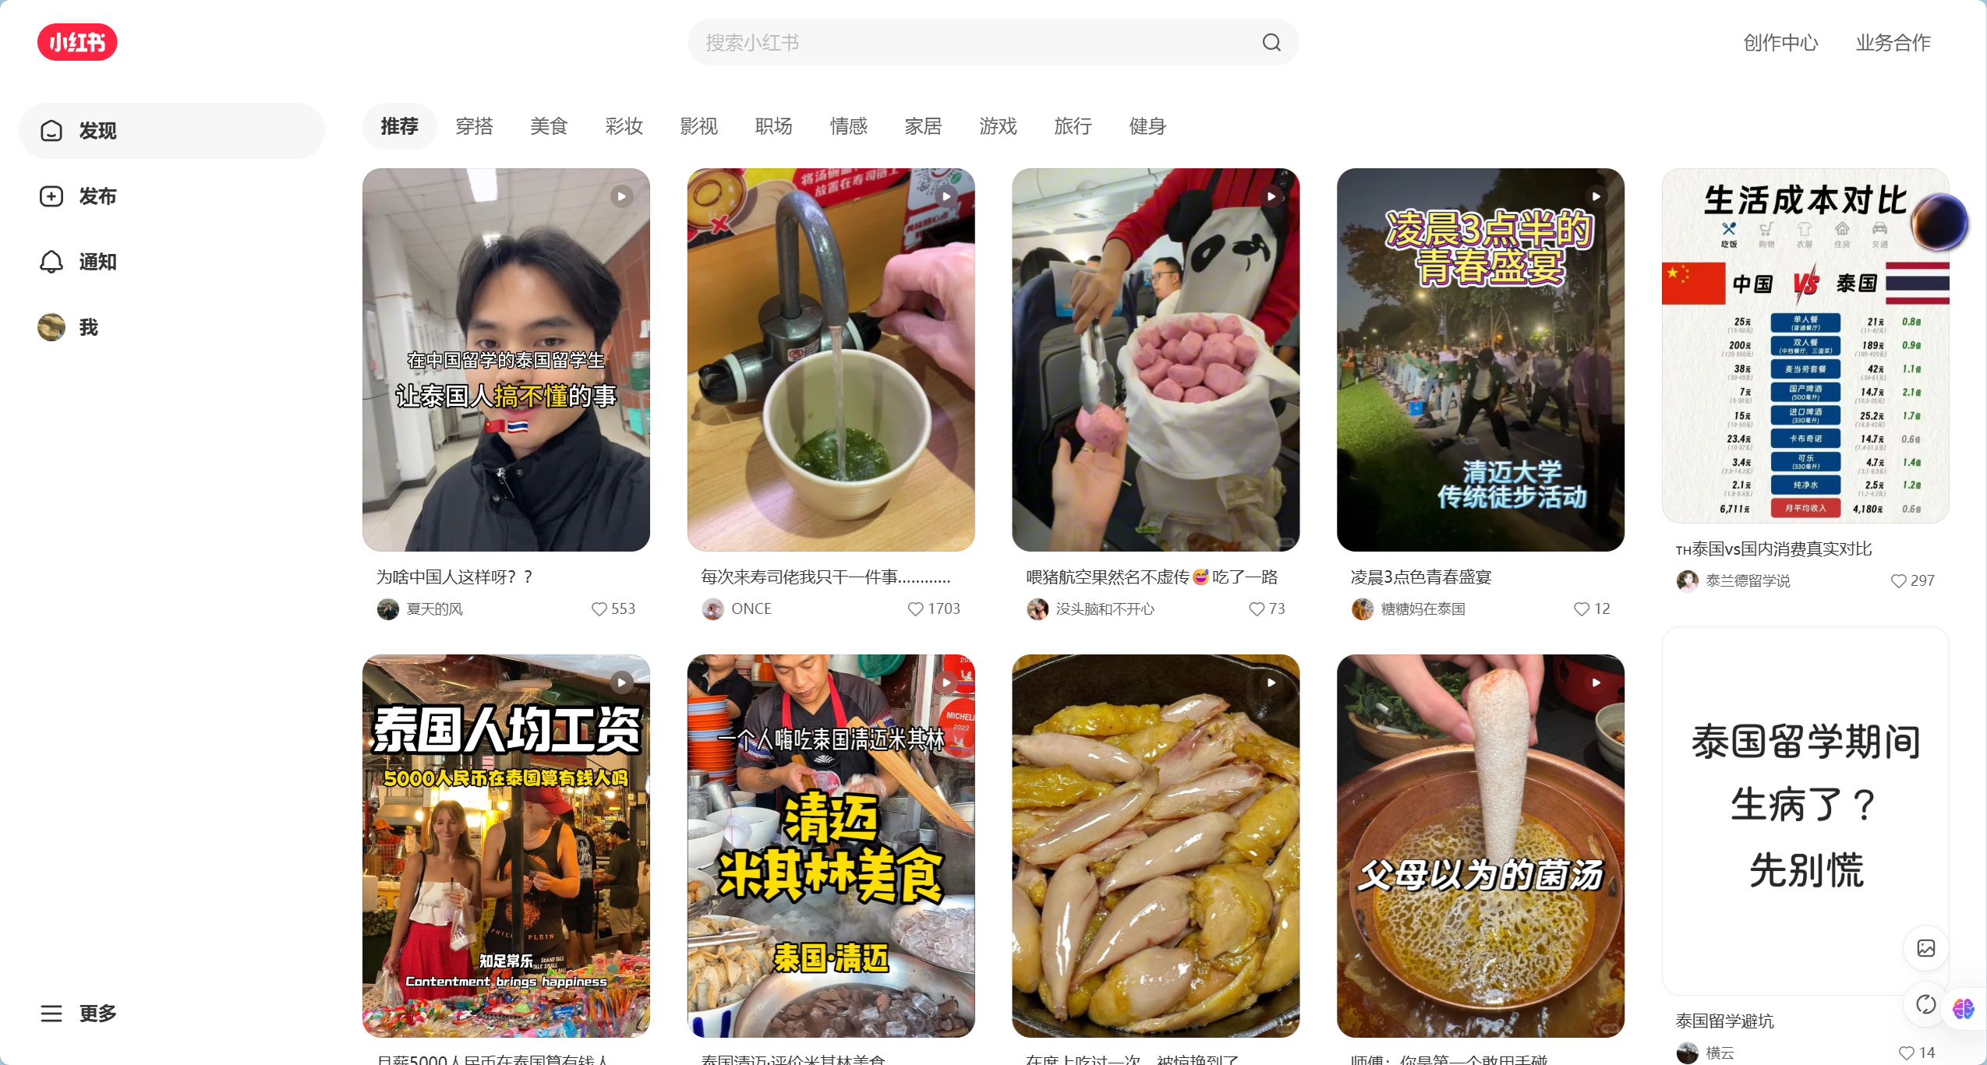
Figure 3 Little Red Book
Xiaohongshu is currently the most popular lifestyle sharing platform among Chinese international students.

Pros:
- Rich content, precise algorithmic recommendations, aesthetically pleasing interface.
Cons:
- Serious "tourist perspective" bias: The content is overly focused on travel, food and check-ins, lacking in-depth accumulation on long-term residence and compliance.
- The closed Chinese ecosystem: Only Chinese people are using it, and it is impossible to reach local Thais and international students who own the properties and second-hand cars.

2.2.3 reddit
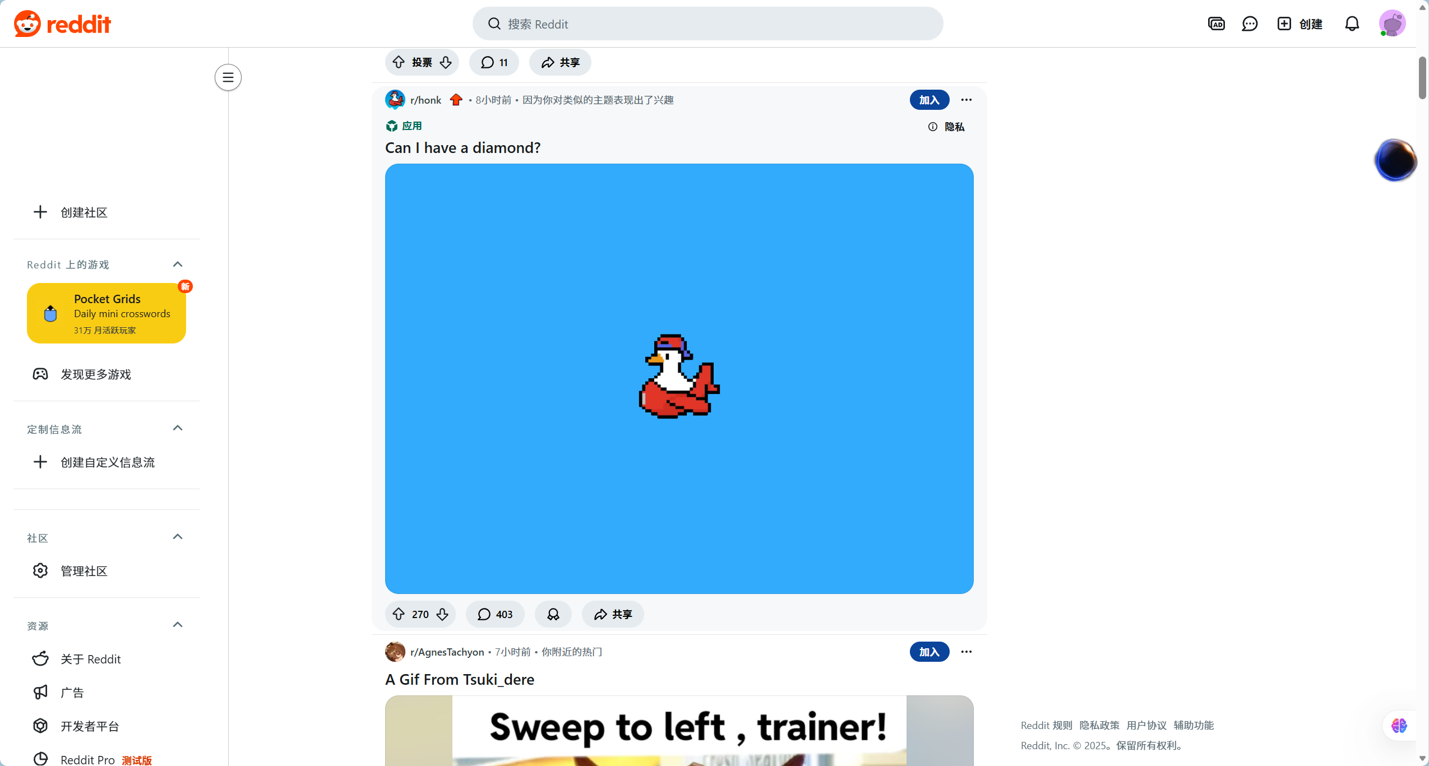
Figure 4 reddit
Reddit is one of the world's largest online forums, hosting numerous study abroad-related subreddits.

Pros:
- Structured discussions: Clear topic-based section categorization (e.g., r/studyabroad, r/Thailand).
- Anonymity: Users feel comfortable asking genuine questions.
Cons:
- Geeky interface: Unfriendly to non-technical users.
- Pure English environment: Multilingual translation is not supported, and most Chinese students and local lower-level merchants in Thailand (with poor English skills) are excluded.
- Lack of commercial functionality: Focused on discussion, not suitable for second-hand transactions or rental matching

2.2.4 Feature Comparison
Features | Facebook Groups | Little Red Book | Reddit | BridgeU
Web-based Access | ✓ | ✓ | ✓ | ✓
Origin->Dest | ✗ | ✓ | ✗ | ✓
Robot Intelligence | ✗ | ✗ | ✗ | ✓
AI Auto-Moderation | ✗ | ✓ | ✓ | ✓
Mandatory Tags | ✗ | ✗ | ✓ | ✓
Translation | ✓ | ✓ |  | ✓
Admin Panel | ✓ | ✓ | ✓ | ✓
Bilingual Translation | ✓ | ✗ | ✗ | ✓
Local Biz Connect | ✓ | ✗ | ✗ | ✓
Mutual | ✓ | ✗ | ✓ | ✓

Chapter 3 | Development Tools Review

Figure 5 Visual Studio Code
Description
Visual Studio Code, or VS Code, is a lightweight but powerful source code editor which runs on your desktop and is available for Windows, macOS, and Linux. It comes with built-in support for JavaScript, TypeScript, and Node.js and has a rich ecosystem of extensions for other languages (such as C++, C#, Java, Python, PHP, Go) and runtimes (such as .NET and Unity).
Alternative technologies
Eclipse
Reasons for this choice
We will use Visual Studio Code as the primary IDE for frontend development. Its extensive plugin ecosystem, particularly Vetur and Volar, provides excellent support for Vue.js development, including syntax highlighting, intelligent code completion (IntelliSense), and snippet generation. The integrated terminal and Git support further streamline the development workflow, allowing for efficient version control and command execution directly within the editor.


Figure 6 Vue Framework
Description
Vue.js is an open-source model–view–viewmodel front end JavaScript framework for building user interfaces and single-page applications. It was created by Evan You and is maintained by him and the rest of the active core team members. It features an incrementally adoptable architecture that focuses on declarative rendering and component composition.
Alternative technologies
- React
Reasons for this choice
We will use Vue.js for the frontend development because of its gentle learning curve and the intuitive two-way data binding feature, which simplifies form handling and state management in our community-driven application. Its component-based architecture allows for the creation of reusable UI elements, and the integration with Element UI will significantly accelerate the development of a polished and responsive user interface.



Figure 7 IntelliJ IDEA

Description
IntelliJ IDEA is an integrated development environment (IDE) written in Java for developing computer software. It is developed by JetBrains (formerly IntelliJ) and is available as an Apache 2 Licensed community edition and in a proprietary commercial edition. Both can be used for commercial development. It provides comprehensive facilities to computer programmers for software development.
Alternative technologies
- Eclipse
- NetBeans
Reasons for this choice
We have selected IntelliJ IDEA as the main development tool for the backend due to its superior support for the Java ecosystem and the Spring Boot framework. Its intelligent code analysis, powerful refactoring tools, and seamless integration with build tools like Maven greatly enhance productivity. The built-in database tools and Spring initializr support make it the optimal choice for building robust enterprise-level applications with Spring Boot.

Figure 8 Springboot
Description
Spring Boot is an open-source Java-based framework used to create a micro Service. It is developed by Pivotal Team and is used to build stand-alone and production-ready spring applications. It provides a good platform for Java developers to develop a stand-alone and production-grade spring application that you can just run.
Reasons for this choice
Spring Boot is chosen for the backend service due to its ability to simplify the configuration and deployment of Spring applications. Its "convention over configuration" approach reduces boilerplate code, allowing us to focus on business logic. The seamless integration with MyBatis-Plus provides a powerful yet simple way to interact with the database, while its robust security features and scalability make it ideal for handling the complex logic of user management and content processing in BridgeU.


Figure 9 MySQL
Description
MySQL is an open-source relational database management system (RDBMS). Its name is a combination of "My", the name of co-founder Michael Widenius's daughter, and "SQL", the abbreviation for Structured Query Language. A relational database organizes data into one or more data tables in which data types may be related to each other; these relationships help structure the data.
Alternative technologies
- PostgreSQL
- Oracle Database
- MongoDB
Reasons for this choice
We will use MySQL 8 as the primary relational database management system. It is renowned for its reliability, performance, and ease of use. MySQL 8's support for JSON data types offers flexibility for storing semi-structured data if needed, while its ACID compliance ensures data integrity for critical transactions such as user registrations and post publishing. Its widespread use means there is ample community support and documentation available.



Figure 10 Aliyun Qwen

Description
Aliyun Qwen (Tongyi Qianwen) is a large language model (LLM) developed by Alibaba Cloud. It is designed to understand and generate human-like text across a wide range of languages and domains. It offers capabilities in natural language understanding, text generation, translation, and summarization, accessible via API for integration into various applications.
Alternative technologies
- OpenAI GPT-4
- Baidu Ernie Bot
Reasons for this choice
We have chosen Aliyun Qwen as our AI service provider because of its exceptional performance in processing and understanding Asian languages, particularly Chinese and Thai, which are central to our target user demographic. Its API offers low latency and high availability within the region, making it the ideal choice for implementing real-time features such as article summarization and cross-language translation on the BridgeU platform.


Figure 11 GitHub
Description
GitHub is a website that provides Git (Version Control Repository) services as well as a
source code repository for many large projects, including Kubernetes, NET, Node.js, Python, PyTorch, and Swift, helping to facilitate the development of software and make the work process go more smoothly and quickly. [8]
Alternative technologies
• GitLab
Reasons for this choice
We will use GitHub as a collaboration tool for sharing code and developing it together. It
helps in managing the code and tracking code changes. Track project progress, report issues, and collaborate on effective solutions.

Chapter 4 | Quality Standard
ISO 29110 for Very Small Entity (VSE)
ISO/IEC 29110-4-1:2011 is applicable to Very Small Entities (VSEs). A Very Small Entity (VSE) is defined as an enterprise, organization, department, or project having up to 25 people. A set of standards and guides has been developed according to a set of VSEs' characteristics and needs. The guides are based on subsets of appropriate standards elements, referred to as VSE profiles. The purpose of a VSE profile is to define a subset of International Standards relevant to the VSE context.

4.1 Project Management Process
The purpose of the software management process is to establish, develop and carry out systematically the task of the software implementation project, which allows complying with the project's objective in the expected quality.
The 4 activities in the project management process:
- Project Planning
- Project Plan Execution
- Project Assessment and Control
- Project Closure

4.2 Software implementation process
The purpose of the software implementation process is the systematic performance of the analysis, design, construction, integration, and test activities for new or modified software products according to the specified requirements. There are 6 Activities:
- Software Implementation Initiation
- Software Requirement Analysis
- Software Architectural and Detailed Design
- Software Construction
- Software Integration and Tests
- Software Deliver

Chapter 5 | Software Configuration Management

5.1 Naming Convention
The filename format that we use for all documents is: BridgeU-[File Name] V.[Version].[FileType]
- File Name: The name of each process phase or specific document.
- Version: This part is the version of the file. The version number will be in this format “[Main version].[Subversion]”.
- File Type: The type of the file format, for example, .docx or .pdf.
For code files, we follow specific conventions:
- Frontend Components: PascalCase (e.g., LoginView.vue, PostCard.vue)
- Backend Classes: PascalCase (e.g., UserController.java, PostService.java)
- Database Tables: snake_case (e.g., user_profiles, community_posts)

5.2 Change Management
Change management manages all of the changes in the project during the development process. All the change requests will be recorded into the change record document. The procedures for managing changes are:
- Discuss with an advisor about the change.
- Record the change information to change the document.
- Send the change request to an advisor.
- Request accepted: change document and software follow the change information.
- Request rejected: continue and find alternative solutions.

5.3 Project Repository
- Microsoft Word: For document management
- GitHub: For source code management
Item | File Name | File Type | Baseline Version
Project Proposal | BridgeU-Proposal V.[Version] | .docx
Project Plan | BridgeU-ProjectPlan V.[Version] | .docx
Software Requirement Specification | BridgeU-SRS V.[Version] | .docx
Software Design Document | BridgeU-SDD V.[Version] | .docx
Test Plan | BridgeU-TestPlan V.[Version] | .docx
Test Record | BridgeU-TestRecord V.[Version] | .docx
Traceability Record | BridgeU-TraceabilityRecord V.[Version] | .docx
Software Product | BridgeU-SoftwareProduct V.[Version] | .docx

Chapter 6 Project Management and Planning

6.1 Motivation
The development motivation of BridgeU stems from a profound insight into the daily predicaments faced by international students in Thailand. Studying abroad is not only an academic pursuit but also a reconstruction of one's lifestyle. We have observed that although Thai campuses are highly internationalized, the student body is deeply fragmented by "language" and "nationality". Chinese students (accounting for about 50%) live in the "Chinese island" built by wechat, while local Thais who have access to abundant local resources (such as cheap housing and second-hand motorcycles) and other international students live in the "English/Thai circle" of Facebook. This fragmentation has led to serious information asymmetry and waste of resources. Furthermore, the existing information channels overly focus on "short-term travel", while neglecting the "survival necessities" of international students in terms of visa regulations and long-term residence. Therefore, BridgeU aims to break down these barriers, creating a borderless mutual assistance and business connection platform to empower every student and local service provider.

6.2 Aims and Objective

6.2.1 Aims
BridgeU aims to eliminate language barriers through AI technology and establish a bilingual mutual assistance ecosystem that connects Chinese students, global students and local Thai merchants. It is not only a center for information exchange, but also a bridge connecting the local economy with the consumption demands of international students.

6.2.2 Objective
- Integrate Aliyun Qwen AI of Alibaba Cloud to provide two-way translation between Chinese and English, enabling users to post demands and conduct business transactions across language barriers.
- Deploy an automated Intelligence Robot to capture and summarize authoritative local English news in Thailand, ensuring that all students can equally obtain accurate policy information.
- Realize automatic review by artificial intelligence to filter out fraudulent and non-compliant content in multi-language environments. If it cannot be identified, it will be left to manual review to improve the speed and efficiency of the review
- Establish a Mutual-Follow social mechanism to ensure the security and trustworthiness of private message communication.

6.3 Deliverables and Limits

6.3.1 Deliverables
- Project Proposal
- Software Project Plan Document
- Software Requirement Specification (SRS)
- Software Design Document (SDD)
- Software Test Plan Document
- Software Test Record Document
- Software Traceability Document
- Software Product

6.3.2 Limits
- BridgeU is a Web application that requires a stable Internet connection to run.
- The accuracy of AI translation and summary depends on the performance of Alibaba Cloud's Qwen model API, which may have limitations in handling certain Thai slang.
- Crawler robots only capture publicly available English information sources and do not involve password-protected private data.

6.4 System Architecture
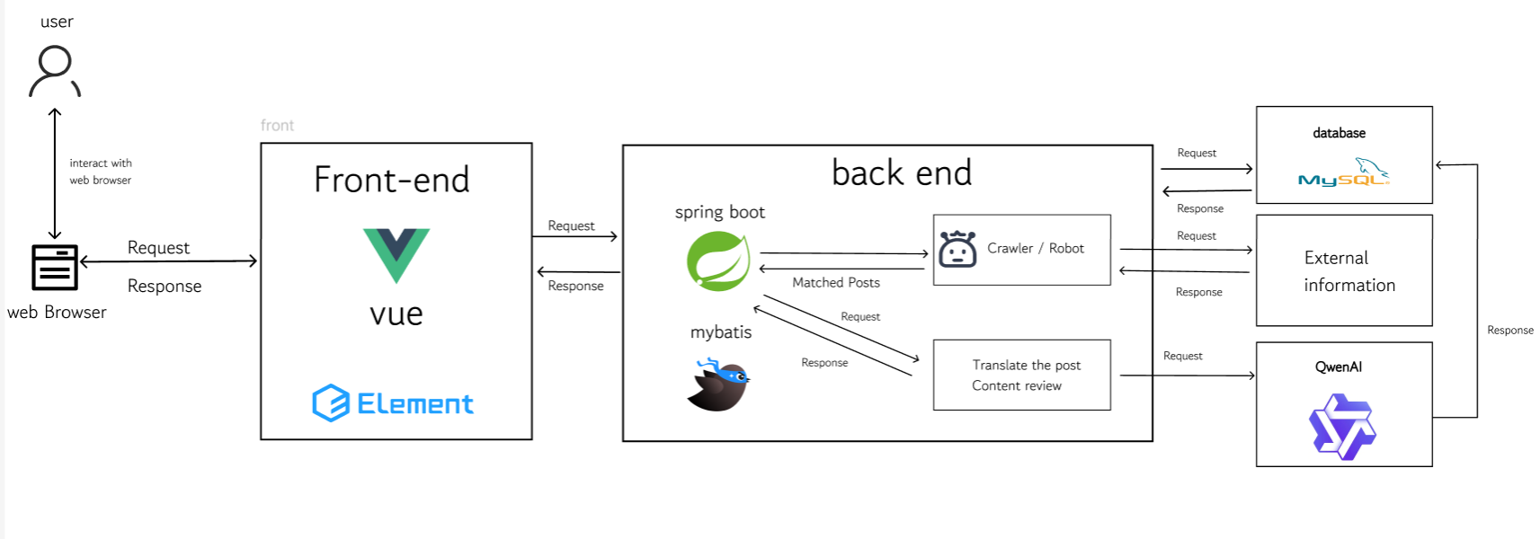
Figure 12 System Architecture
Description:
The system architecture consists of a front-end built using Vue.js 2 and Element UI, which provides a responsive user interface. The back-end is built with Spring Boot, a robust Java framework, handling business logic and RESTful API requests. MySQL 8 is used as the primary database for storing structured user and post data. Elasticsearch is integrated to provide high-performance semantic search capabilities. Additionally, the system connects to the Aliyun Qwen API to perform natural language processing tasks such as summarization and translation. Axios is used for communication between the front-end and back-end.

6.5 Software Process
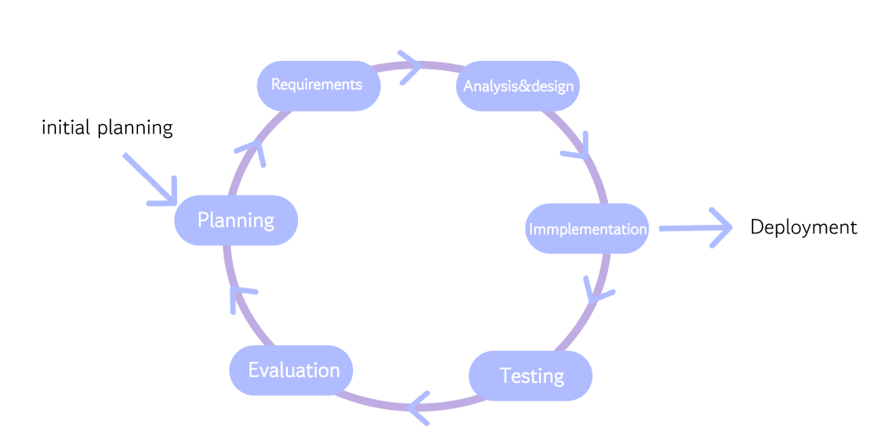v
Figure 13 Software Process
An iterative process model is used to develop the BridgeU software. This model divides the development process into rounds, or iterations. Each round includes planning, design, development, and testing of specific features (e.g., first iteration for User Auth, second for Community Posts). This allows for flexibility in adjusting requirements based on feedback and testing results throughout the development lifecycle.

6.6 Feature
Feature #1 Automated Intelligence Robot
This function is designed to break the information cocoon. The robots deployed at the back end regularly crawl authoritative English media in Thailand (such as the Bangkok Post) and university official websites. The captured original text is sent to Alibaba Cloud Qwen AI to generate a concise Chinese/English Briefing (Daily Briefing) and push it to the homepage. This ensures that international students can obtain accurate information on policy changes in the first place.
Feature #2 Bilingual AI Commercial Bridge
This is the core business engine of the platform. By using large language models, the system automatically translates user-generated content (UGC) between Chinese and English. For instance, rental posts made by Thai landlords in English will automatically generate Chinese copies. This enables Chinese students studying abroad to browse local resources without obstacles and helps local service providers open up the Chinese market.
Feature #3 AI-Powered Hybrid Content Moderation (AI + Human Loop)
To maintain a safe community environment while minimizing manual workload, the system integrates a dual-layer moderation mechanism:
- Layer 1: Real-time AI Screening (The First Line of Defense): Before any post or image is published, it is analyzed by the AI model. The AI scans for high-risk content such as scams (e.g., currency exchange fraud patterns), hate speech, or pornographic material. Non-compliant content is automatically blocked instantly.
- Layer 2: Human-in-the-Loop Review (The Safety Net): For content that the AI flags as "suspicious" but not definitively "illegal" (e.g., ambiguous language), the system marks it as "Pending Review" and forwards it to a human administrator. This allows admins to focus only on complex cases, significantly improving efficiency while ensuring fairness.

6.7 User journey
The journey begins when a user (e.g., a Chinese international student or a local Thai landlord) navigates to the BridgeU web address. They are presented with a clean and accessible Login Interface, as shown in Figure 14.（Here, we will first demonstrate it on the English page）.User can choose to log in and register as a student or merchant
Understanding that language is the first barrier to entry, the platform features a prominent Language Toggle button in the top-right corner.
- Action: The user can simply click to switch the interface language between English and Chinese .
- Result: Upon selection, the entire page content—including the slogan "Connecting Students & Local Life", input labels, and navigation buttons—instantly updates to the selected language.
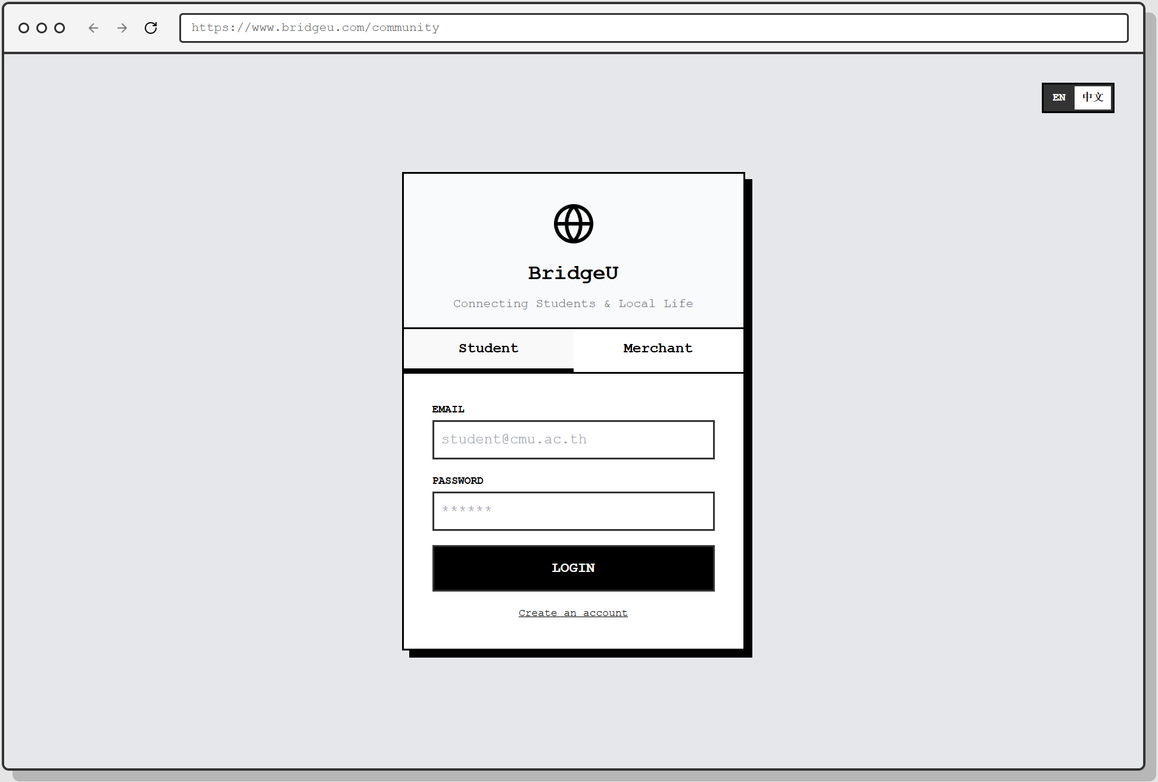
Figure 14 loginpage01

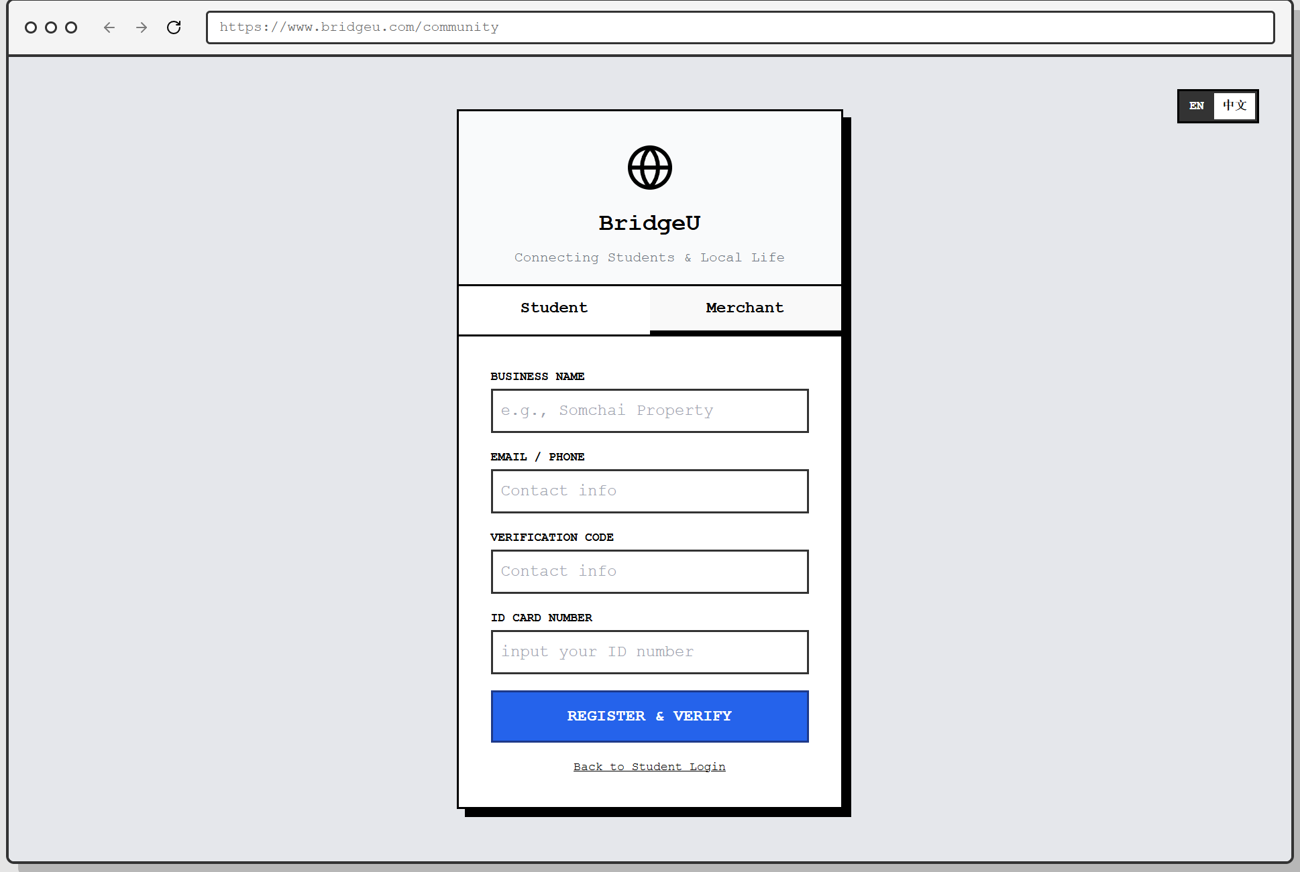
Figure 15 loginpage02
Upon entering the main Community Homepage, the user is not just presented with a list of posts, but with a structured and intelligent information hub, as shown in Figure 15
- Daily Briefing (Automated Info-Aggregator): At the very top, a special card labeled "DAILY BRIEFING" grabs the user's attention. This content is automatically crawled from authoritative external sources (e.g., Bangkok Post, CMU Official) by the system's robot. The integrated AI then processes this raw data to generate a concise summary and translates it into both English and Chinese (e.g., "Thailand approves new 10-year LTR visa"). This proactively pushes critical "trends" to the user, solving the "information gap" problem.
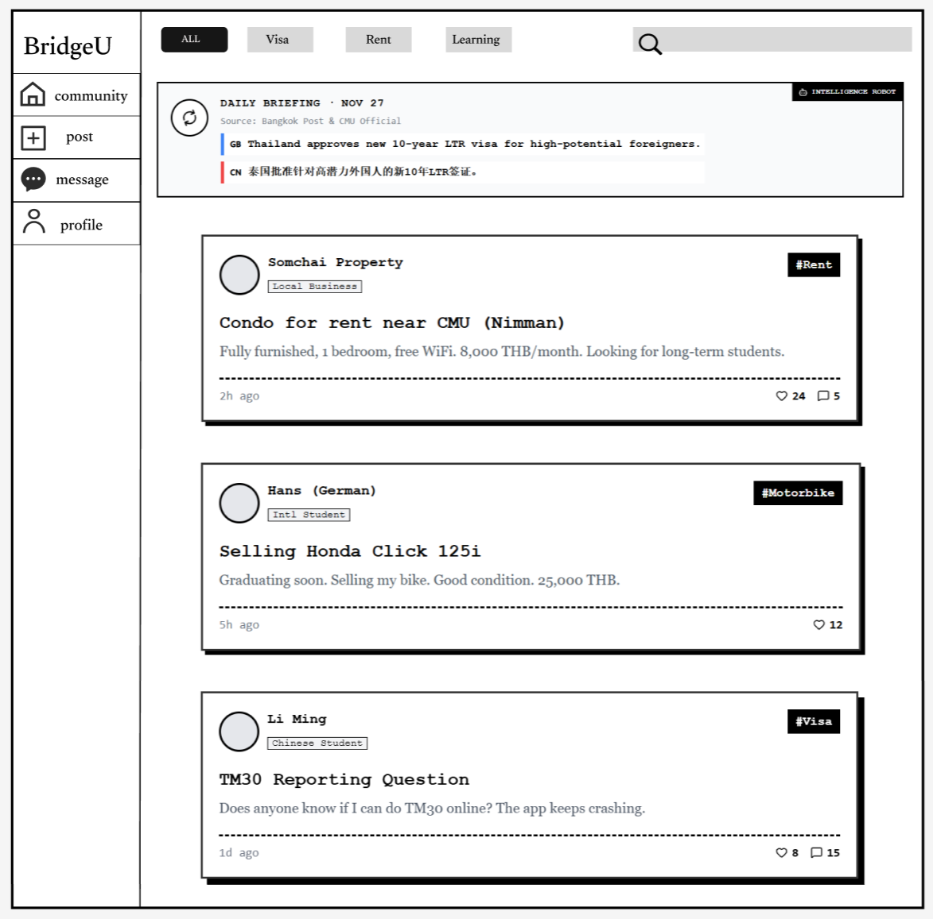
Figure 16 communityPage

Interested in a specific listing, such as the "Condo for rent near CMU," the user clicks on the card to enter the Post Detail Page.
As shown in Figure16, this page offers a focused view of the information:
- Author Verification: The author, "Somchai Property," is clearly tagged as a "Local Business", helping the user assess credibility. A "Follow" button is prominently placed next to the profile.
- Engagement: The user can read the full description and view existing discussions in the Comments section.
- Gated Communication: To prevent harassment, the "Contact Host" section on the right features a "Chat Now" button. " Requires Mutual Follow"*. This reminds the user that they cannot send private messages immediately; they must first click "Follow" and wait for the host to follow back, ensuring a consensual connection before chatting.
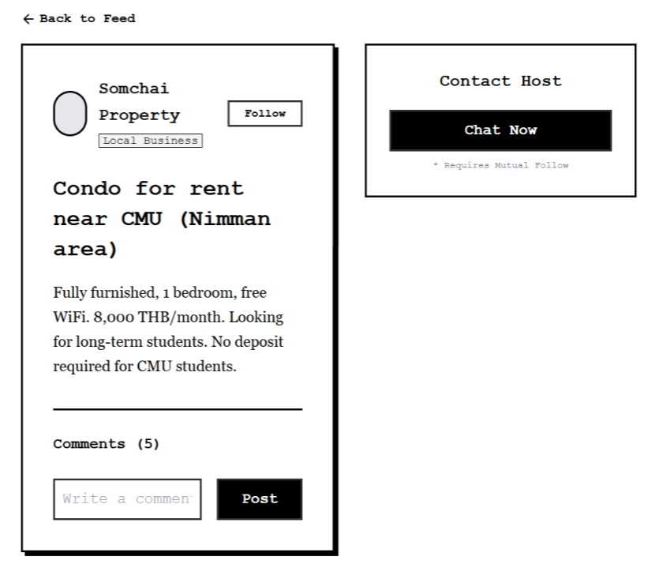
Figure 16 postPage
The user decides to contribute to the community by sharing a question or experience. They navigate to the "Post" tab.
To maintain a healthy community environment without relying on 24/7 manual moderation, BridgeU integrates an AI-Powered Content Moderation system that works in real-time.
1. Drafting & AI Scanning: As shown in Figure17, the user selects a mandatory tag (e.g., #Learning) and inputs their text. Upon clicking "Publish Now", the system enters a "Processing" state. A prompt "AI is scanning for scams & hate speech..." appears, indicating that the content is being analyzed by the backend LLM engine before entering the database.
2. Intelligent Interception (The "Guard"): In a scenario where a user attempts to post profanity or abusive language (as seen in Figure 18), the AI detects the violation immediately. The system blocks the request and displays a red warning: "Blocked: Content contains prohibited word." This proactive measure filters out toxic content at the source.
3. Successful Publication: Conversely, when the content is verified as safe (e.g., "how to learning English"), the system displays a green "Safe Content" confirmation, and the post is successfully published to the community feed (as shown in Figure 19).
4. If the ai is unsure whether there is a violation, it will feed back to the human administrator, who will handle it manually

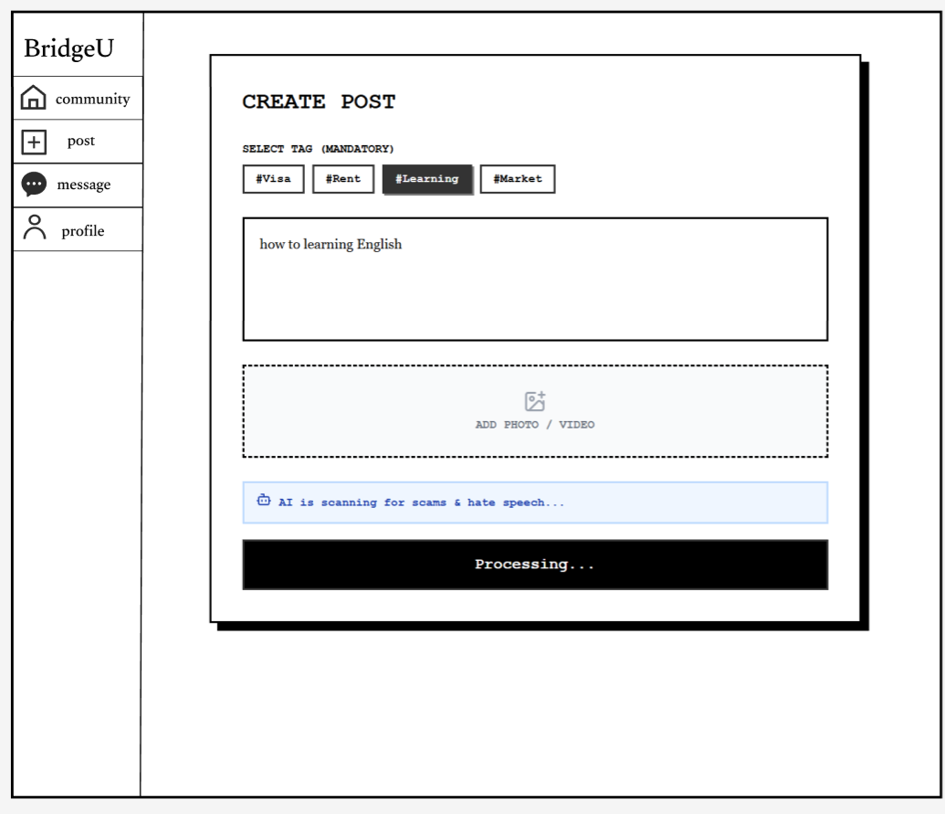
Figure 17 CreatePosstPage01
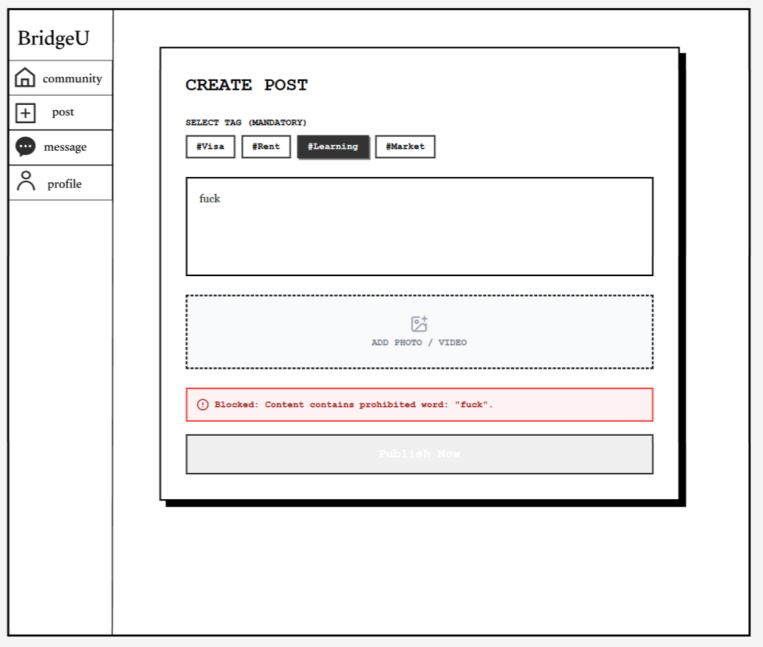
Figure 18 CreatePosstPage02

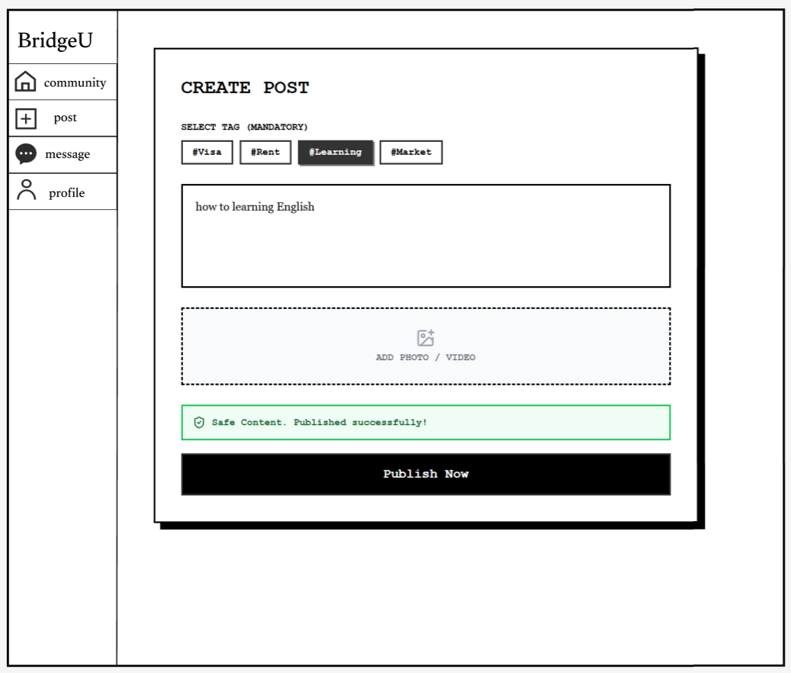
Figure 19 CreatePosstPage03

The user navigates to the "Message" tab to check their conversations.As shown in Figure 20, the Message List provides a clear overview of active conversations.
- Overview: It displays the contact's name (e.g., "Somchai Property", "Wang Dali"), a snippet of the last message, and a timestamp. An unread badge (e.g., "2") alerts the user to new messages.
- Safety Cue: A "Stranger" tag might appear for users who haven't mutually followed each other yet, reminding the user of the platform's safety protocols.
Clicking on a conversation opens the Chat Interface (as seen in Figure 20).
- Real-time Interaction: The user can exchange text messages with the host (e.g., "Is the room still available?"). 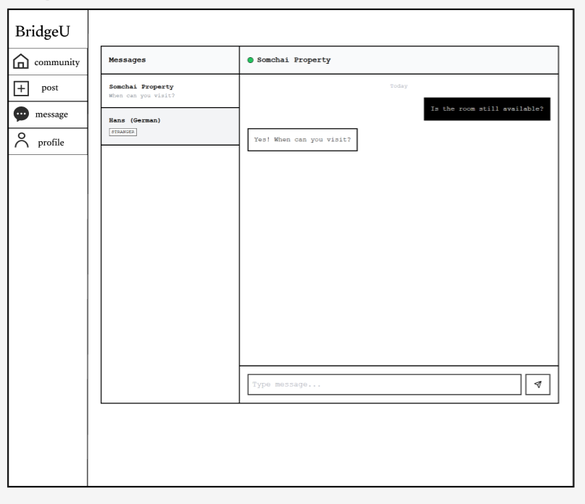
Figure 20 MessagePage01
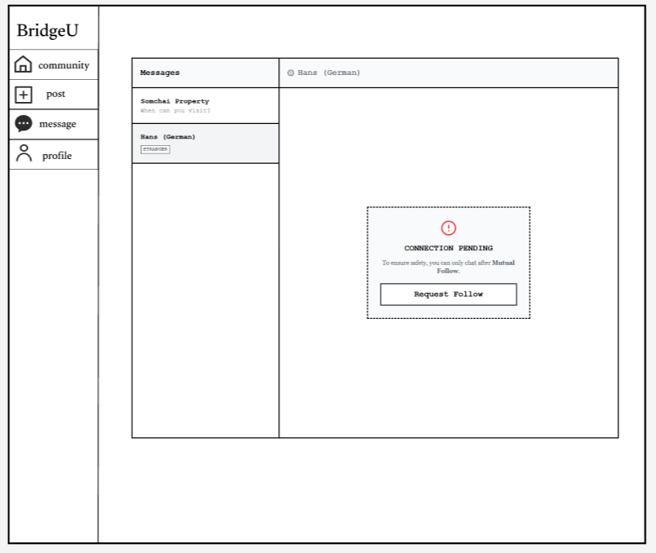
Figure21 MessagePage02

manage their presence on the platform, the user navigates to the "Profile" tab.
As shown in Figure 22, the Profile Page serves as the user's identity card within the community.
- Identity Tags: Clear tags like "Chinese Student" and "Chiang Mai, Thailand" immediately establish the user's background, fostering trust in this cross-border community.
- Activity Log: The "My Posts" section acts as a history log, allowing the user to track their requests (e.g., "#Rent Looking for 1-bedroom condo") and interactions.
- Social Stats: The "Following" and "Followers" counts reflect the user's social standing and credibility.
To update their information, the user clicks the "Edit Profile" button. This opens the Edit Interface as seen in Figure 23.
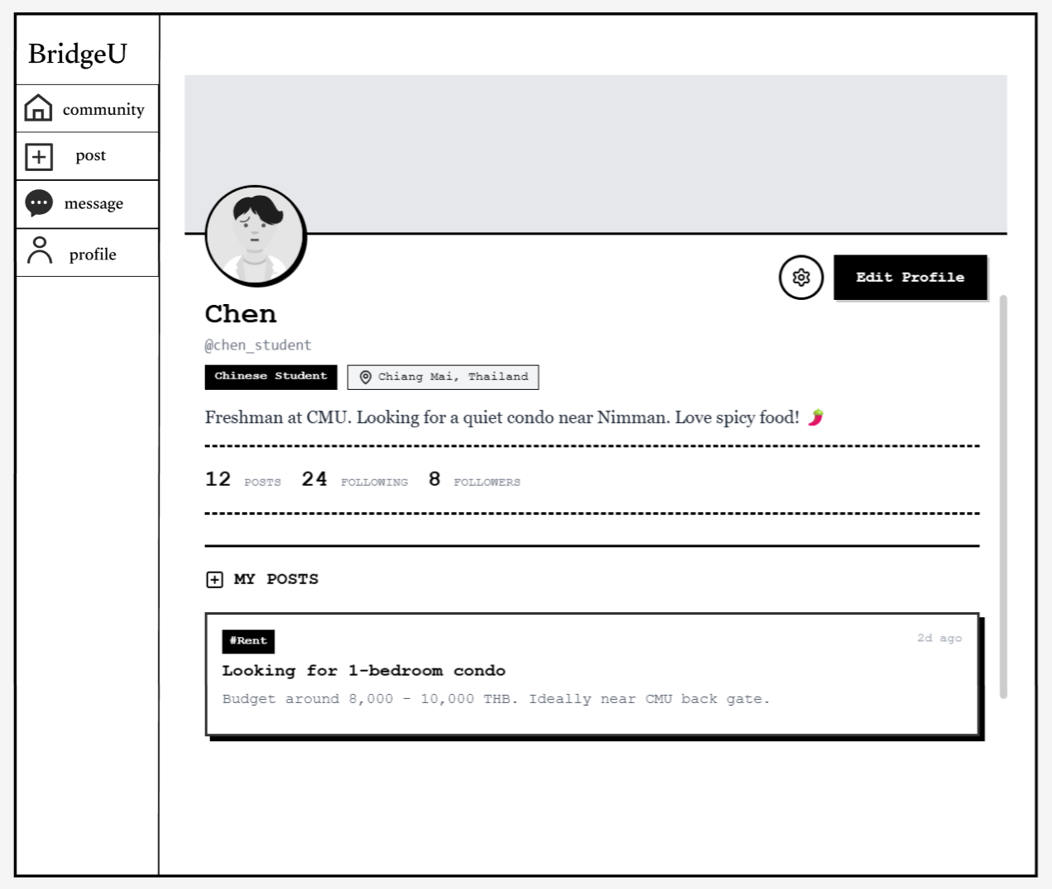
Figure22 ProfilePage

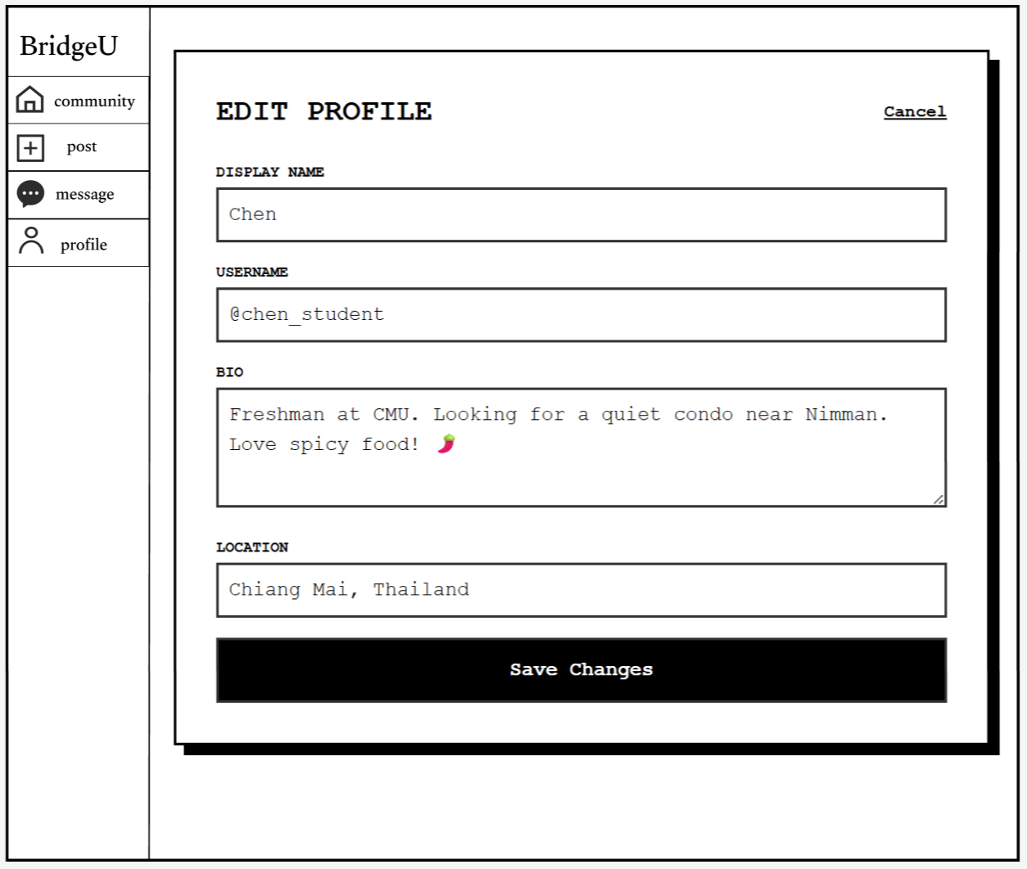
Figure23EditProfilePage

6.8 Schedule Plan
6.8.1 Progress Report
Normal plan
Senior Project Event | Deliverables
Proposal Presentation | Project Proposal
Progress I Presentation | - Software project plan document  - Software requirement document  - Software design document  - Software test plan document  - Software test record document  - Software traceability document
Progress II Presentation | - Software project plan document  - Software requirement document  - Software design document  - Software test plan document  - Software test record document  - Software traceability document
Final Progress | - Final Progress Report  - Software product  - Project document
6.8.2 Milestone
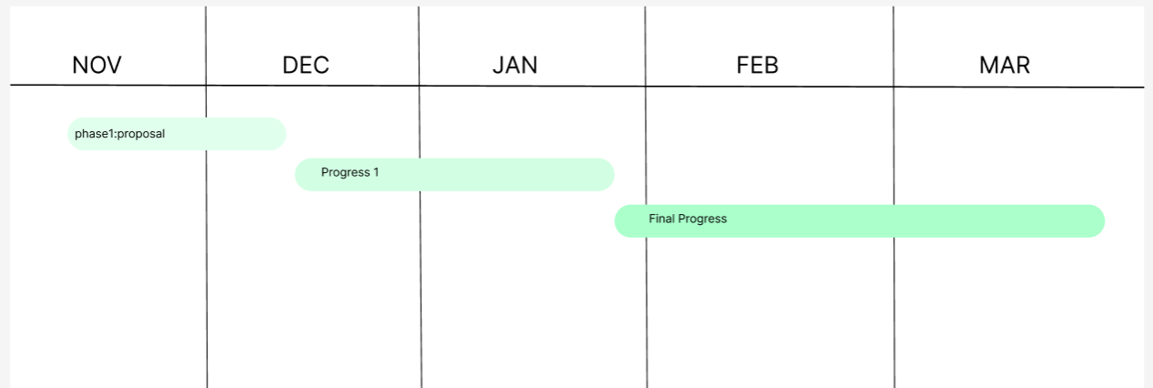
Phase 1. Proposal: 20 Nov 2025 –19 DEC 2025=29 days
Phase 2. Progress I: 20 DEC 2025 –26 Jan 2026 = 36 days
Phase 3. Final Progress: 26 Jan 2026 –20 Mar 2026 = 54 days
Figure Milestone

Phase 1. Proposal: 20 Nov 2025 –19 Dec 2025=29 days
Tasks | Start date | End date | Duration | Responsibility
Research and writing proposal document | 20 November 2025 | 9 December 2025 | 19 | ZHIYI PAN
Prepare for the Presentation | 9 December 2025 | 19 December 2025 | 10 | ZHIYI PAN
Phase 2. Progress I: 19 Dec 2025 –26 Jan = 36 days
Tasks | Start date | End date | Duration | Responsibility
Software requirement specification document | 20 December 2025 | 27 December 2025 | 6 | ZHIYI PAN
Project plan document | 28 December 2025 | 31 December 2025 | 3 | ZHIYI PAN
Software design document | 1 January 2026 | 8 January 2026 | 7 | ZHIYI PAN
Feature #1 implement | 8 January 2026 | 22 January 2026 | 14 | ZHIYI PAN
Prepared Progress I report and presentation | 20 January 2026 | 26 January 2026 | 6 | ZHIYI PAN
Phase 3. Final Progress: 26 Jan 2026 –20 Mar 2026 = 54 days
Tasks | Start date | End date | Duration | Responsibility
Feature #2 implement | 27 January 2026 | 10 February 2026 | 14 | ZHIYI PAN
Feature #3 implement | 11 February 2026 | 25 February 2026 | 14 | ZHIYI PAN
Test code | 26 February 2026 | 11 March 2026 | 15 | ZHIYI PAN
Prepared final report and presentation | 12 March 2026 | 25 March 202 | 13 | ZHIYI PAN

6.9 Risk Management and Mitigation

6.9.1 Technical & Data Acquisition Risks
Risk Factor | Description | Impact | Mitigation Strategy
Anti-Scraping / Blocking by Target Sites | Target news sources (e.g., Government websites, Bangkok Post) may update their firewalls, IP blocking policies, or robots.txt protocols to prohibit scraping, causing an "Intelligence Blackout." | Critical | 1.S Protocol: Prioritize integrating RSS feeds (e.g., Bangkok Post RSS). This is an officially sanctioned data distribution channel, offering high stability and full compliance.  2. Choose public websites that do not require login and provide public information to the general public to avoid disclosing others' personal information
AI API Service Dependency | Core features (translation, summarization) rely heavily on Aliyun Qwen API. Risks include service downtime, response timeouts, or budget overruns. | High | 1. Circuit Breaker Mechanism: If API response time exceeds 5 seconds, automatically pause AI processing and temporarily display the original text (English/Chinese) on the frontend to ensure core readability.  2. Caching Strategy: Cache translation results for high-frequency static content (e.g., pinned news, popular posts) in Redis to reduce real-time API calls by 80%.
AI Hallucination | Generative AI may misinterpret the original news meaning or make semantic errors when translating transaction amounts (e.g., translating 10,000 as 1,000). | Medium | 1. Source Comparison Principle: Mandatorily display a "View Original" button on the UI and label content as "AI-Generated, for reference only."  2. Key Number Highlighting: For sensitive figures like amounts and dates, bypass AI fuzziness by extracting and displaying the original digits directly.

6.9.2Business & Trust Risks
Risk Factor | Description | Impact Level | Mitigation Strategy
Identity Fraud & Online Scams | Scammers posing as students to conduct currency exchange fraud, or merchants posting fake property listings to steal deposits. | Critical | 1. Dual-Track Verification System:  - Students: Must verify via a university domain email (.ac.th) to lock in a real student identity.  - Merchants: Must upload a Thai National ID (Thai ID) for KYC (Know Your Customer) real-name authentication to ensure accountability.  2. Risk Warnings: A multi-language warning is permanently displayed in the chat interface: "The platform prohibits online direct transfers. Please ensure offline inspection/viewing before trading."
Platform Cold Start Failure | A lack of user posts in the early stages leads to new users finding a "ghost town" and churning immediately. | High | Passive Aggregation Strategy:  Before merchants onboard, the Robot proactively crawls high-quality, compliant listings from public platforms like Facebook Marketplace. These are AI-translated and populated into BridgeU. This ensures the first batch of users has rich content to view (e.g., "This Week's Featured Motorbikes"), retaining users and attracting merchants to claim their shops.

6.9.3 Legal & Compliance Risks
Risk Factor | Description | Impact Level | Mitigation Strategy
PDPA Data Privacy Compliance | Violating Thailand's Personal Data Protection Act (PDPA) by leaking student emails or merchant ID documents. | Critical | 1. Data Encryption: All sensitive fields (ID numbers, passwords, emails) are stored in MySQL using AES-256 standard encryption.  2. Minimal Collection: Collect only information essential for verification; do not track irrelevant user activity.  3. User Authorization: The registration process includes a clear, mandatory PDPA consent checkbox.
Copyright Infringement | Scraping and displaying full articles from news media may infringe on intellectual property rights. | Medium | 1. Transformative Use: The system does not store/display the full original text, but only displays a short Summary regenerated by AI.  2. Attribution & Traffic Redirection: Every piece of machine-generated intelligence mandatorily includes a Source Link, directing traffic back to the original website, aligning with internet citation ethics.

Chapter 7 References
[1] Pan, Z. (2025). BridgeU: International Student Mutual Aid Community Project Proposal. Chiang Mai University.
[2] Elasticsearch. (n.d.). Elasticsearch: The Official Distributed Search & Analytics Engine. [Online]. Available at: https://www.elastic.co/elasticsearch (Accessed on November 24, 2025).
[3] Alibaba Cloud. (2024). Tongyi Qianwen (Qwen) API Documentation. [Online]. Available at: https://help.aliyun.com/zh/dashscope/developer-reference/api-details (Accessed on November 24, 2025).
[4] Vue.js. (n.d.). Introduction — Vue.js. [Online]. Available at: https://v2.vuejs.org/v2/guide/ (Accessed on November 24, 2025).
[5] Spring. (n.d.). Spring Boot. [Online]. Available at: https://spring.io/projects/spring-boot (Accessed on November 24, 2025).
[6] MySQL. (n.d.). MySQL 8.0 Reference Manual. [Online]. Available at: https://dev.mysql.com/doc/refman/8.0/en/ (Accessed on November 24, 2025).
[7] ISO/IEC. (2011). ISO/IEC 29110-4-1:2011 Software engineering — Lifecycle profiles for Very Small Entities (VSEs) — Part 4-1: Profile specifications: Generic profile group. [Standard]. Available at: https://www.iso.org/standard/51153.html (Accessed on November 24, 2025).
[8] Jurafsky, D., & Martin, J. H. (2024). Speech and Language Processing. Stanford University. [Online]. Available at: https://web.stanford.edu/~jurafsky/slp3/ (Accessed on November 24, 2025).
[9] Element Plus. (n.d.). A Vue 3 based component library for designers and developers. [Online]. Available at: https://element-plus.org/en-US/ (Accessed on November 24, 2025).
[10] Baomidou. (n.d.). MyBatis-Plus Introduction. [Online]. Available at: https://www.google.com/search?q=https://baomidou.com/pages/24112f/ (Accessed on November 24, 2025).

