BridgeU
Project Proposal

Zhiyi Pan 652115558

Bachelor of Science
Software Engineering Program

Department College of Arts, Media, and Technology Chiang Mai University November 2025

Project Advisor
Asst. Prof. Pattama Longani, Ph.D.

Table of Content
Chapter 1 | Introduction 3
Chapter 2 | Target User 5
Chapter 3 | Feature 7
Chapter 4 | User Journey 11
Chapter 5 | Business Review 22
5.1 Facebook Groups 22
5.2 Xiaohongshu (Little Red Book) 23
5.3 reddit 24
5.4 Feature Comparison 25
Chapter 6 |Software Review 26
6.1 Frontend Architecture & User Experience (UX) 26
6.2 Backend Security & Authentication 26
6.3 AI Integration & Performance 27
6.4 Data Persistence & Search 28
Chapter 7 | Objective 29
Chapter 8 | System Architecture 30
Chapter 9 | Limits 31
Chapter 10 | Milestone 32
Chapter 11 | References 34

Chapter 1 | Introduction
In the current digital age, studying abroad has become an increasingly common experience for students seeking international education and cultural exchange. Thailand, as a popular destination for international students, hosts thousands of students who come to pursue higher education and immerse themselves in a new cultural environment. These students bring diverse perspectives, languages, and experiences that enrich the academic and social landscape of Thai universities.
However, the problem that most international students face when arriving in Thailand is the significant challenge of adapting to their new environment. Language barriers make it difficult to access timely local news and official announcements. Students struggle to find relevant information about daily life, academic resources, housing, part-time job opportunities, and local events. Additionally, building meaningful connections with peers and local merchants becomes challenging when communication is hindered by language differences.
So, I developed a web-based platform called “BridgeU” to solve the above-mentioned problems. BridgeU offers many features that make the adaptation process easier for international students, merchants, and the broader community. The platform provides a “Daily Briefing System” that automatically captures and summarizes Thai news from approved government and mainstream media sources, providing bilingual (Chinese/English) access to daily news briefings for users. At 8:00 AM every day, the system captures news from pre-approved Thai government and mainstream media websites (Bangkok Post, The Nation Thailand), and saves each article as a Daily Briefing record, including original title, summary generated by Qwen AI, source website name, original URL, publication time, and crawl timestamp. The system generates both Chinese and English versions for the title and abstract, and the interface only displays one of them in the current language. Users can browse paginated news lists ordered from newest to oldest, search using any keywords in either language, filter by date range and news source, click original button to open the original URL, and seamlessly switch between Chinese and English interfaces at any time.
Additionally, BridgeU features a comprehensive “Community Interaction System” that enables bilingual posting, commenting, and messaging. This community interaction platform allows users to create, browse, and interact with posts through likes, comments, and private messaging, with Qwen AI-powered automatic translation, content moderation, and comment summarization to ensure safe and accessible communication in both Chinese and English. There are five predefined tags (Study, Housing, Travel, Part-time Job, Life Services) in the community interaction. Users can create posts in Chinese or English, upload images, and select tags from these predefined categories. The system automatically translates content to the other language using Qwen AI and conducts content security review by Qwen AI. Users can filter posts by tags, search across post content, like posts, add comments (with the ability to delete their own comments), view AI-generated comment summaries. For users who establish mutual-follow relationships, BridgeU provides a private messaging system that allows one-to-one conversations, message status management (read/unread/delete), and mutual-follow list management.
To ensure security and proper access control, BridgeU implements an "Authentication and Profile Management System" that lets users register new accounts with different methods (email address or phone number). Users can select email registration and enter their email address in the registration form. The system sends a verification code email to the email address. Users enter the received verification code on the page, then set a password (password must contain both uppercase and lowercase letters), fill in the display name (name only allows English characters) and select the interface language. Alternatively, users can select phone registration and enter their mobile phone number in the registration form. The system sends a text message containing a verification code to the mobile phone number. Users enter the received verification code, then set a password (password must contain both uppercase and lowercase letters), fill in the display name (name only allows English characters) and select the language interface. After submission, the system creates a new account and redirects the user to the login page. After logging in, users can manage their profiles, view their own community posts with moderation status (published, pending review, or rejected, reviewed by Qwen AI), and customize their display names, avatars.
In summary, BridgeU is a platform that facilitates the adaptation process for international students in Thailand and creates an engaging.It helps make the transition to life in Thailand easier and more enjoyable by providing centralized access to local news, Chinese and English community interactions, and secure authentication. Enabling students to efficiently access relevant information, build meaningful connections, BridgeU will be an essential tool for international student support in todays and future digital eras.

Chapter 2 | Target User
Users of BridgeU form a diverse community that includes international students studying in Thailand and local merchants who provide services to the international student community.
International students represent the core user base, coming primarily from China but also including students from other Asian countries, Europe, and other regions who are pursuing undergraduate, graduate, or exchange programs at Thai universities and educational institutions. These students are typically aged 18-30, enrolled in various programs including bachelor's degrees, master's degrees, doctoral programs, and short-term exchange programs. They have varying levels of English proficiency, with many preferring Chinese as their primary language for interface interaction. Students are comfortable with modern web browsers, mobile devices, and social media platforms, and come from diverse cultural backgrounds, seeking to adapt to Thai culture while maintaining connections with their home culture.
Students need timely access to Thai news, official announcements, university updates, and local events in their preferred language (Chinese or English), as they struggle with language barriers when trying to read Thai news sources directly. They require information about housing options, transportation, part-time job opportunities, local services, and cultural activities, often lacking knowledge about local resources and how to access them. Students seek connections with peers who share similar experiences, challenges, and interests, wanting to find study groups, roommates, travel companions, and friends . They need access to academic information, study materials, course recommendations, and tips from senior students about navigating the Thai education.
Local merchants represent businesses and service providers who specifically target the international student market in Thailand, including restaurants, cafes, accommodation providers (apartments, condos, hostels), tutoring services, language schools, travel agencies, part-time job agencies, mobile phone and internet service providers, and various retail businesses.
Merchants need effective channels to reach international students who may not be familiar with local businesses or traditional advertising methods, seeking to attract new customers from the international student community. Merchants want to promote their services to students who are actively looking for specific solutions, such as housing, part-time jobs, or study-related services, and aim to build trust and establish long-term relationships through community participation, helpful information sharing, and responsive customer service.

Chapter 3 | Feature
Feature 1:Daily Briefing System
The Daily Briefing System automatically captures and summarizes Thai news from Google News, providing bilingual (Chinese/English) access to daily news briefings for User. At 8 a.m. every day, the system captures news from the Google News, and saves each article as a Daily Briefing record, including original title, summary generated by the system call Qwen AI to summarize, source website name, original URL, publication time provided by the source. The system generates both Chinese and English versions for the title and abstract, and the interface only displays one of them in the current language. When the User opens the Daily Briefing page, the system returns a paginated list of Daily Briefing record from new to old according to the release time. The list card displays: title, summary, source, publication time (using only the current interface language), and provides a button to enter the detail page. User can also click original button to opens the original URL of the news. Users can enter any keywords in the search box on the page. System searches by keyword among Daily Briefing titles and abstracts (both Chinese and English versions) in the database,then System returns Daily Briefing items related to that word in the current language
User can set filtering conditions: start date(day-month-year), end date(day-month-year). The system applies all filtering conditions, only returns the Daily Briefing news that meets the conditions, and displays them in chronological order(new to old).

Feature 2: Community Page
This community Interaction where users can create, browse, and interact with posts through likes, comments, and private messaging, with Qwen AI-powered automatic translation, content moderation, and comment summarization to ensure safe and accessible communication in both Chinese and English. There are five community Interaction (Study, Housing, Travel, Part-time Job, Life Services) in the community Interaction.
User can open the community page and see the stream of post which post time from new to old. Scrolling down will load more posts. Each post card shows title, preview of the main text, selected tags (Study, Housing, Travel, Part-time Job, Life Services), number of likes, and number of comments. User can enter Chinese/English keywords. The system will search in all post titles and body texts (in both Chinese and English versions) and only return the list of matching posts. For user who follow each other, both sides will appear in each other's mutual follow list. Open the mutual follow list, you can sending a private message directly to the author.
User can search for the names of those they follow, view their profiles(name,their posts), send private messages directly from the list or unfollow those they already follow.User can open existing one-on-one private messages or create new one-on-one private messages, send and receive messages with mutual followers, and view the history in the conversation interface.Mark the session as read/unread in the session list, or delete the entire session so that it no longer appears in the list.
User can create or edit their own posts: enter Chinese/English titles and text, upload pictures, and select tags (Study, Housing, Travel, Part-time Job, Life Services). When submitting for release, the system will call Qwen AI to automatically translates and generates another language version and conducts a content security review by Qwen AI.
Users can click on post to enter the post details page. On the post detail page, User can view the full text about this post, pictures, tags(Study, Housing, Travel, Part-time Job, Life Services), total number of likes, total number of comments. Clicking on the author's avatar can show the author's profile(avatar,name,author’s posts). The detail page also supports subsequent operations: liking(click “like” button to like post), commenting (User can enter Chinese/English comments under a certain post, along with the commenter's name and timestamp. User can also delete the comment you have already published), reporting post - in the reporting form, select one or more predefined reasons (Spam, Fraud or Scam, Illegal Service Promotion, Abusive Language, Other), and you can fill in the explanatory text. After submission, it enters the subsequent review (the Qwen AI will judge the post/comment pass or not). There is an "AI Summary" button next to the comment. After clicking it, users can view the summaries of all comments under the post in their chosen language

Feature 3：Authentication and profile system
Feature 3 provides an authentication and profile system that lets users register new accounts with different methods (email address or phone number), log in and log out securely, and manage their own profile information and community posts, including a password, a display name, an optional avatar image, and a preferred interface language (Chinese or English). When new users register, users can select email registration and enter their email address in the registration form. The system sends a verification code email to the email address. Users enter the received verification code on the page, then set a password (password must contain both uppercase and lowercase letters), fill in the display name (name only allows English characters) and select the interface language. Alternatively, users can select phone registration and enter their mobile phone number in the registration form. The system sends a text message containing a verification code to this mobile phone number. Users enter the received verification code on the page, then set a password (password must contain both uppercase and lowercase letters), fill in the display name (name only allows English characters) and select the language interface. After submission, the system creates a new account for this email address or phone number, and the user is redirected to the login page. Registered users open the login page and enter their respective name and passwords in the login form. Once the verification is successful, the user will be redirected to the community system page. When logged in, users can click the "Log Out" button to end the current session. The system clears the login status and returns to the login page. If they want to use the system again, they need to re-enter the name and password to log in. After logging in, users can open the "Profile" page to view the name, avatar and own posts saved in the current account. Users can enter the "My Community Posts" list from the profile module. The system displays all community posts published by the current account in this list. Each post shows its title, publication time, and current review status(use Qwen AI to review) . Users can modify profile fields (display name, avatar, preferred language) on the page and submit the form. The system updates the account information with the new values. After refreshing the page, users can see the latest information.

Chapter 4 | User Journey
When a new user visits the homepage, they click "Register" to switch to the registration mode. Users choose to register via Email or Phone. Enter the contact information and click "Get Code" to obtain the verification code. Set a password containing both upper- and lower-case letters, enter a Display Name limited to English characters (such as "Alex Zhang"), and select your preferred language (English/Chinese). Click "Create Account" to complete the registration, and then jump back to the login page and log in.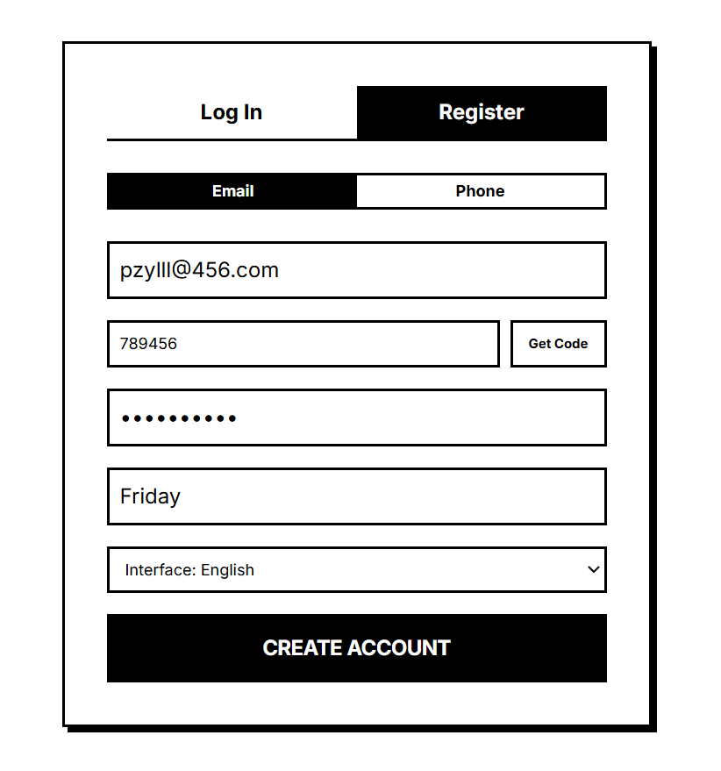
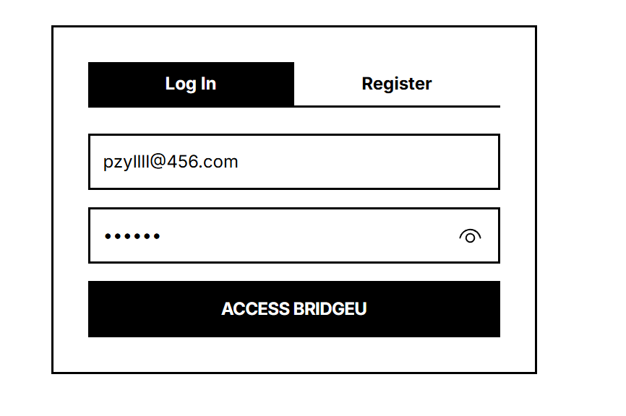

After successful login, users directly enter the landing page of Daily Briefing. Users see The list of news cards from Google News.
The user wants to search for visa news on a specific date. He entered the keyword "Visa" in the Filter bar at the top, and set Start Date and End Date. After clicking "Apply Filters", the list is updated in real time to display the matches. 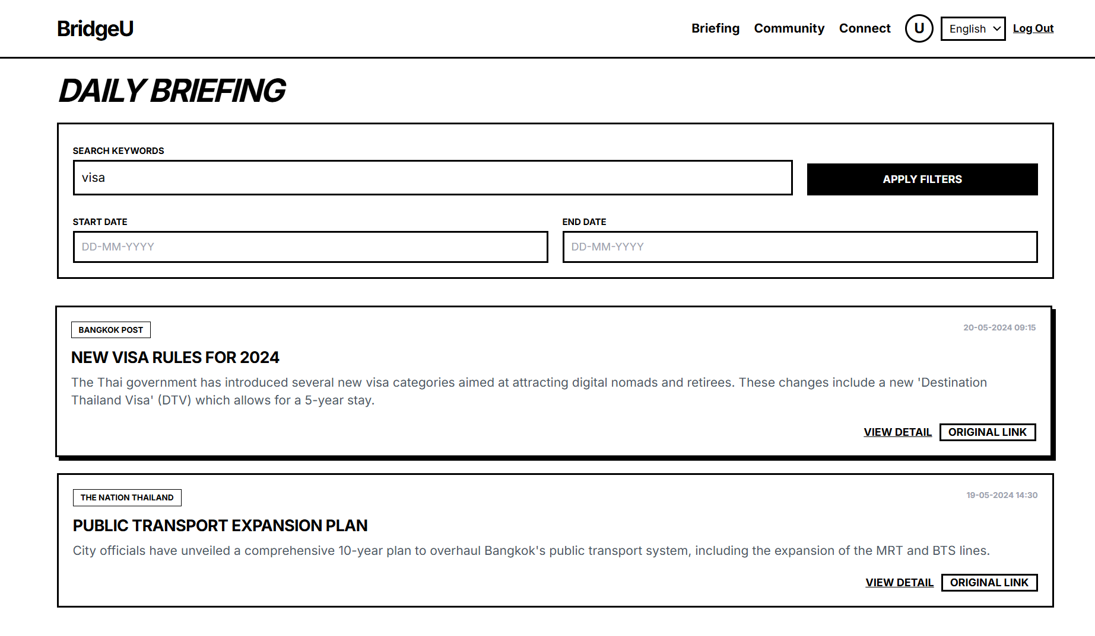

The user clicks on "View Detail" of a certain piece of news. Enter the detail page and users read the AI Summary generated by Qwen AI. The user can view the publish Time and Original title.
When users click "Open Original Source", they will be redirected to the external original news webpage for verification. After reading, click "← Back to Briefings" to return to the list.
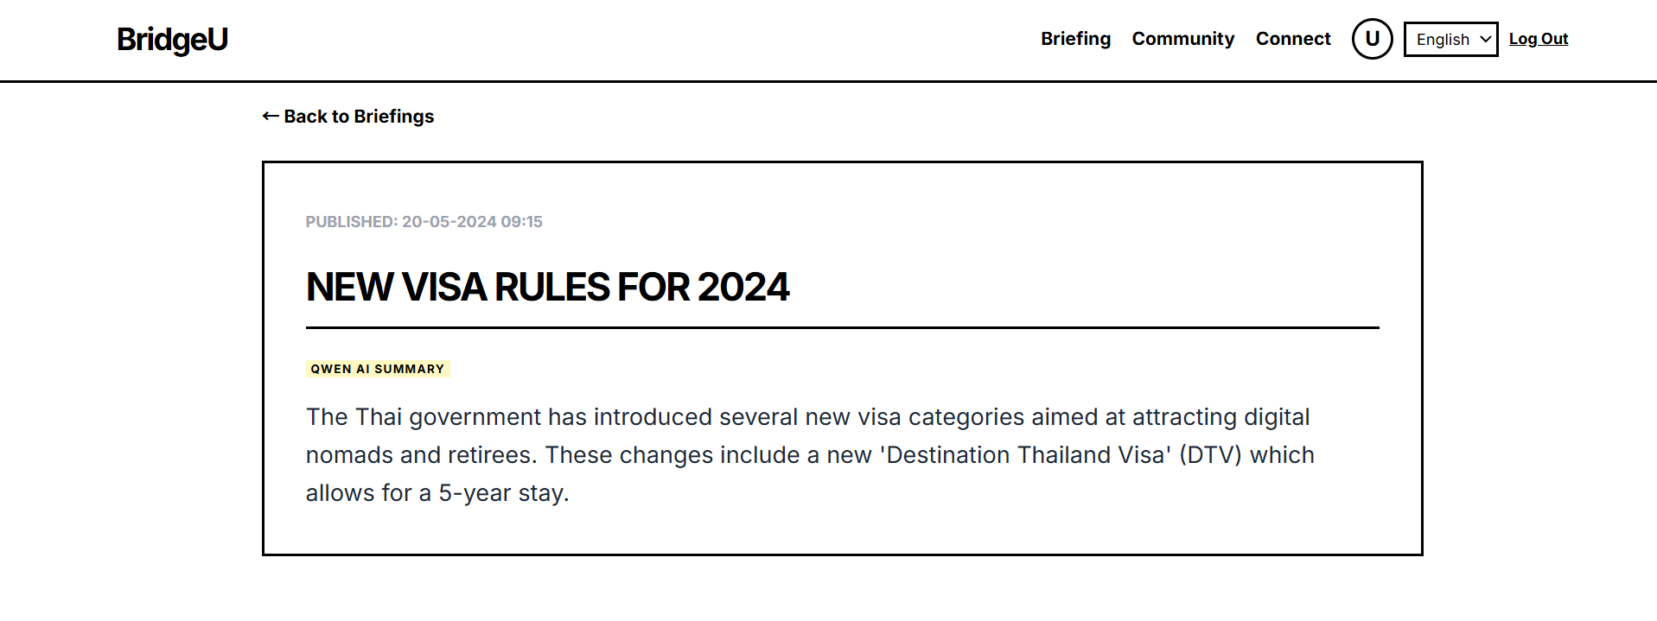

Users switch to the Community page through the top navigation bar.
The user wants to find specific information about part-time jobs. He entered keywords (such as "Tutor") in the SEARCH box at the top of the community and clicked the "SEARCH" button. The system retrieves the titles and main texts of all posts in real time, and the list is updated immediately, only displaying posts related to the keyword.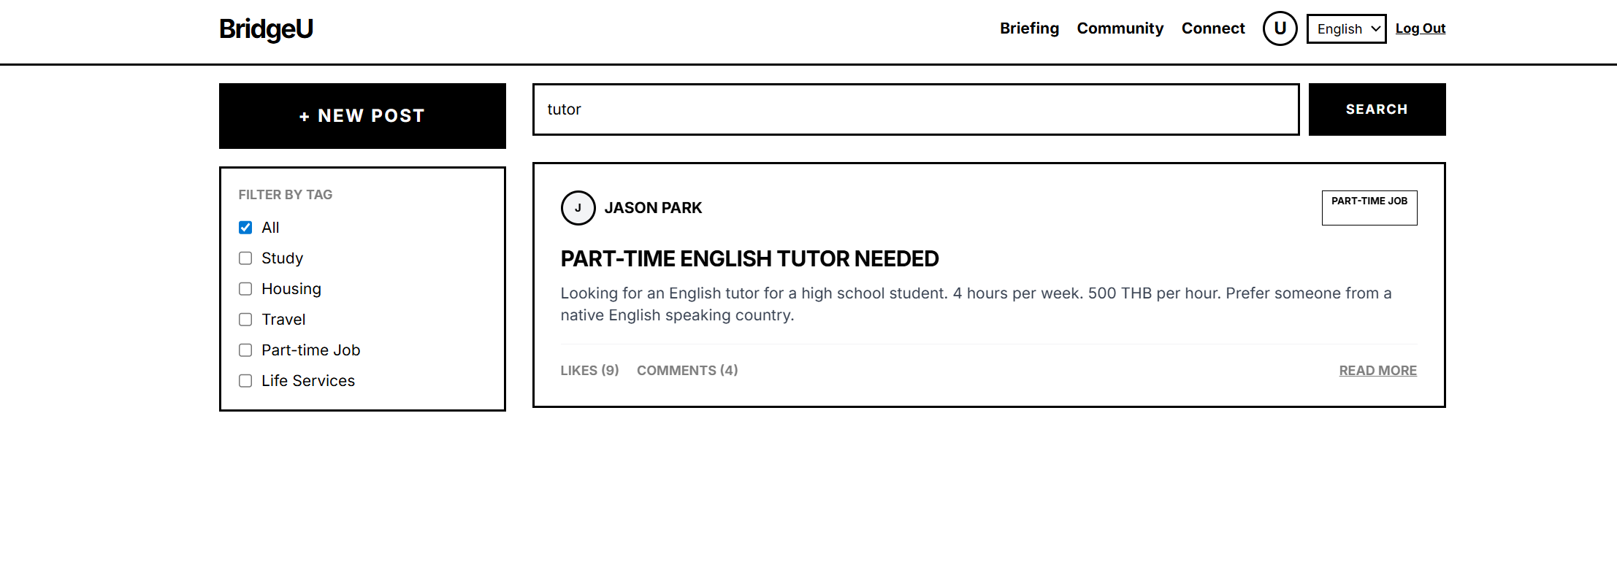

The user wants to see information about renting a house. In the TAB filter on the left sidebar, check the "Housing" TAB. The information flow will refresh and only display posts related to renting.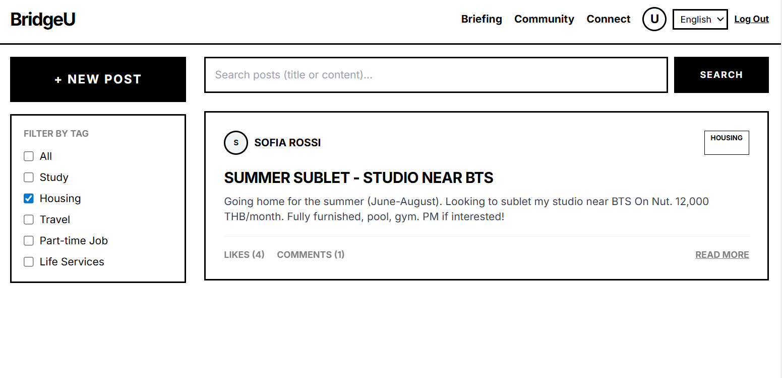

The user clicks on the post to enter the detail page.
AI comment Summary: There are a lot of comments under the post. Users do not want to read them one by one. Click the " AI Summary" button above the comment section. The system displays an intelligent summary of the comments (for example: "Potential tenants mainly ask whether the utility bill is included").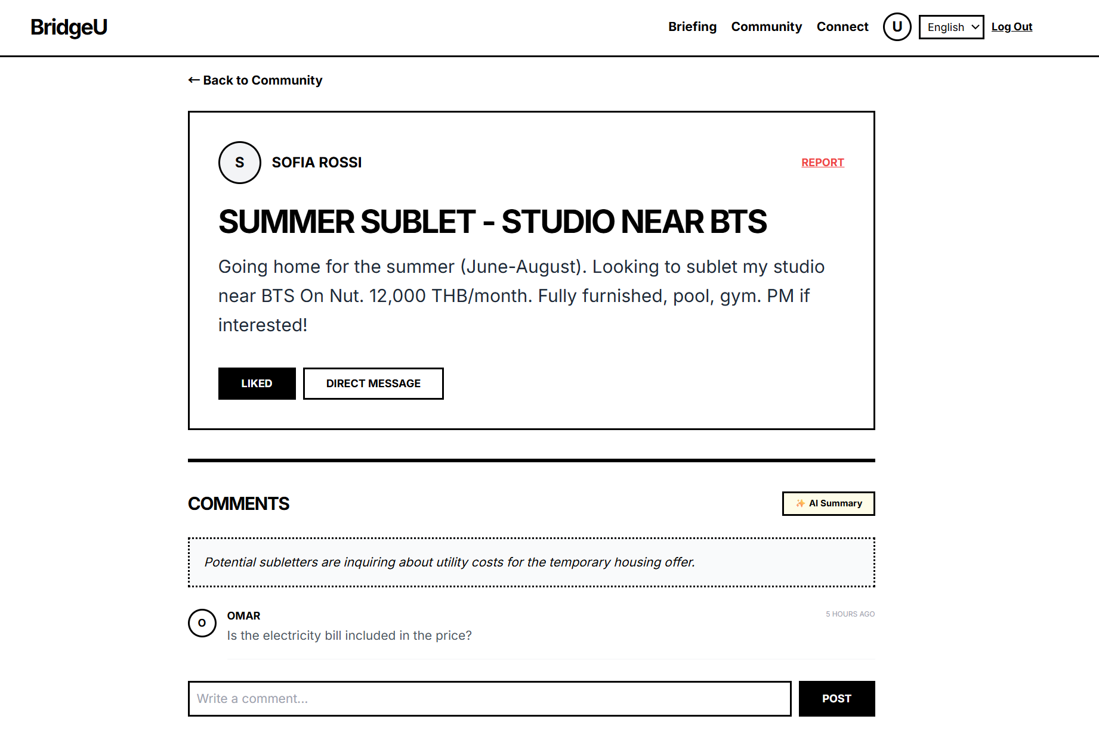

Reporting function: If a user discovers that a certain comment is suspected of Fraud, they click the "Report" button, check "Fraud or Scam" in the pop-up modal box and submit it.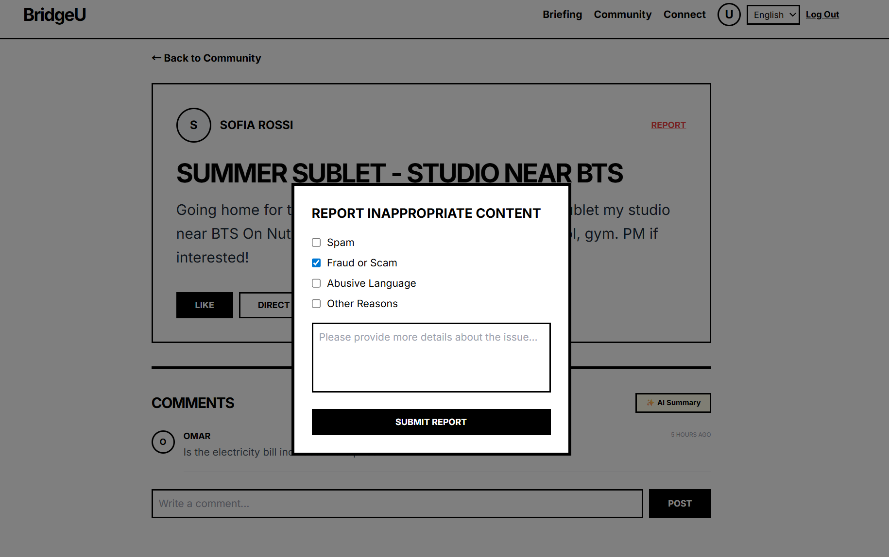

On the post detail page, if the user is interested in the poster, click the "Direct Message" button.
Instant Messaging: The page automatically jumps to the Connect (Relationships) module and selects the author.
The user enters "Hi, is the room still available?" in the chat window on the right. And send.
For conversations that are no longer needed, users click "Delete Thread" to remove them from the list
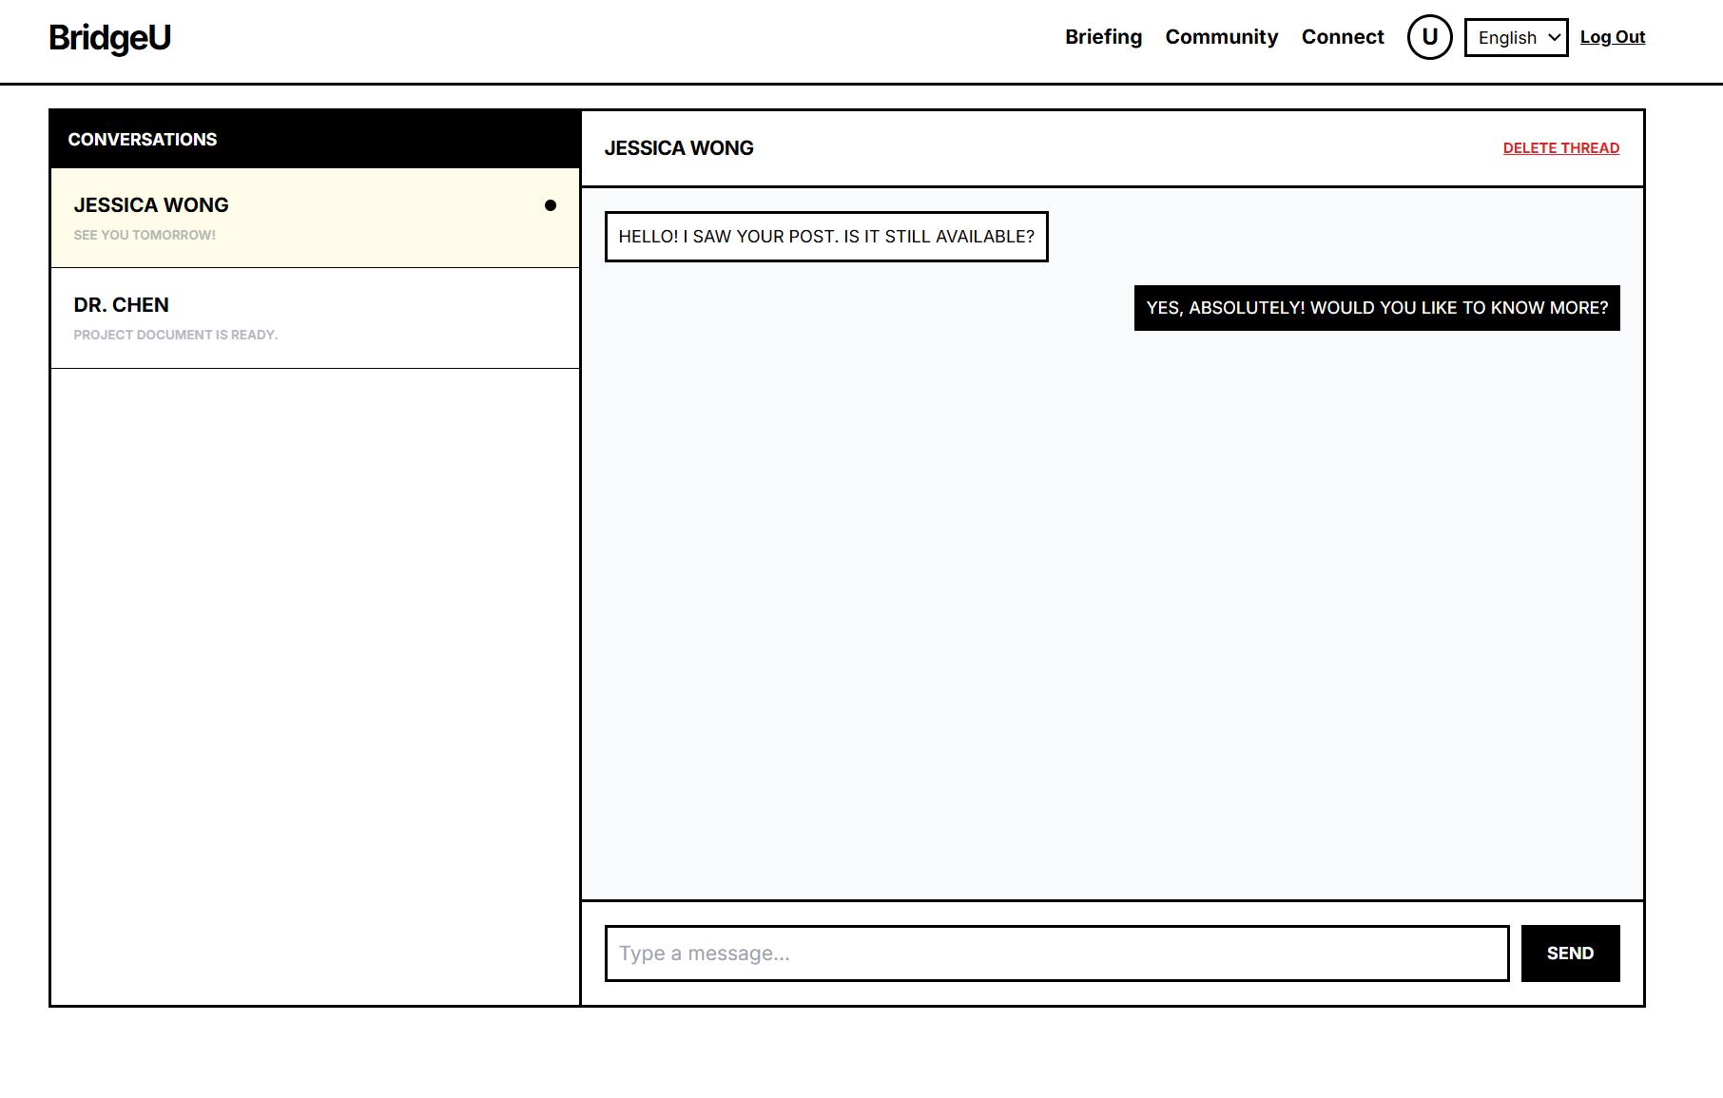

Fill in the title and the main text (at this time, the system prompt content will be automatically translated by Qwen AI).
Select the "Part-time Job" TAB and simulate uploading pictures.
Click "Publish Post", and the system prompts that the post has been submitted to the AI review queue.
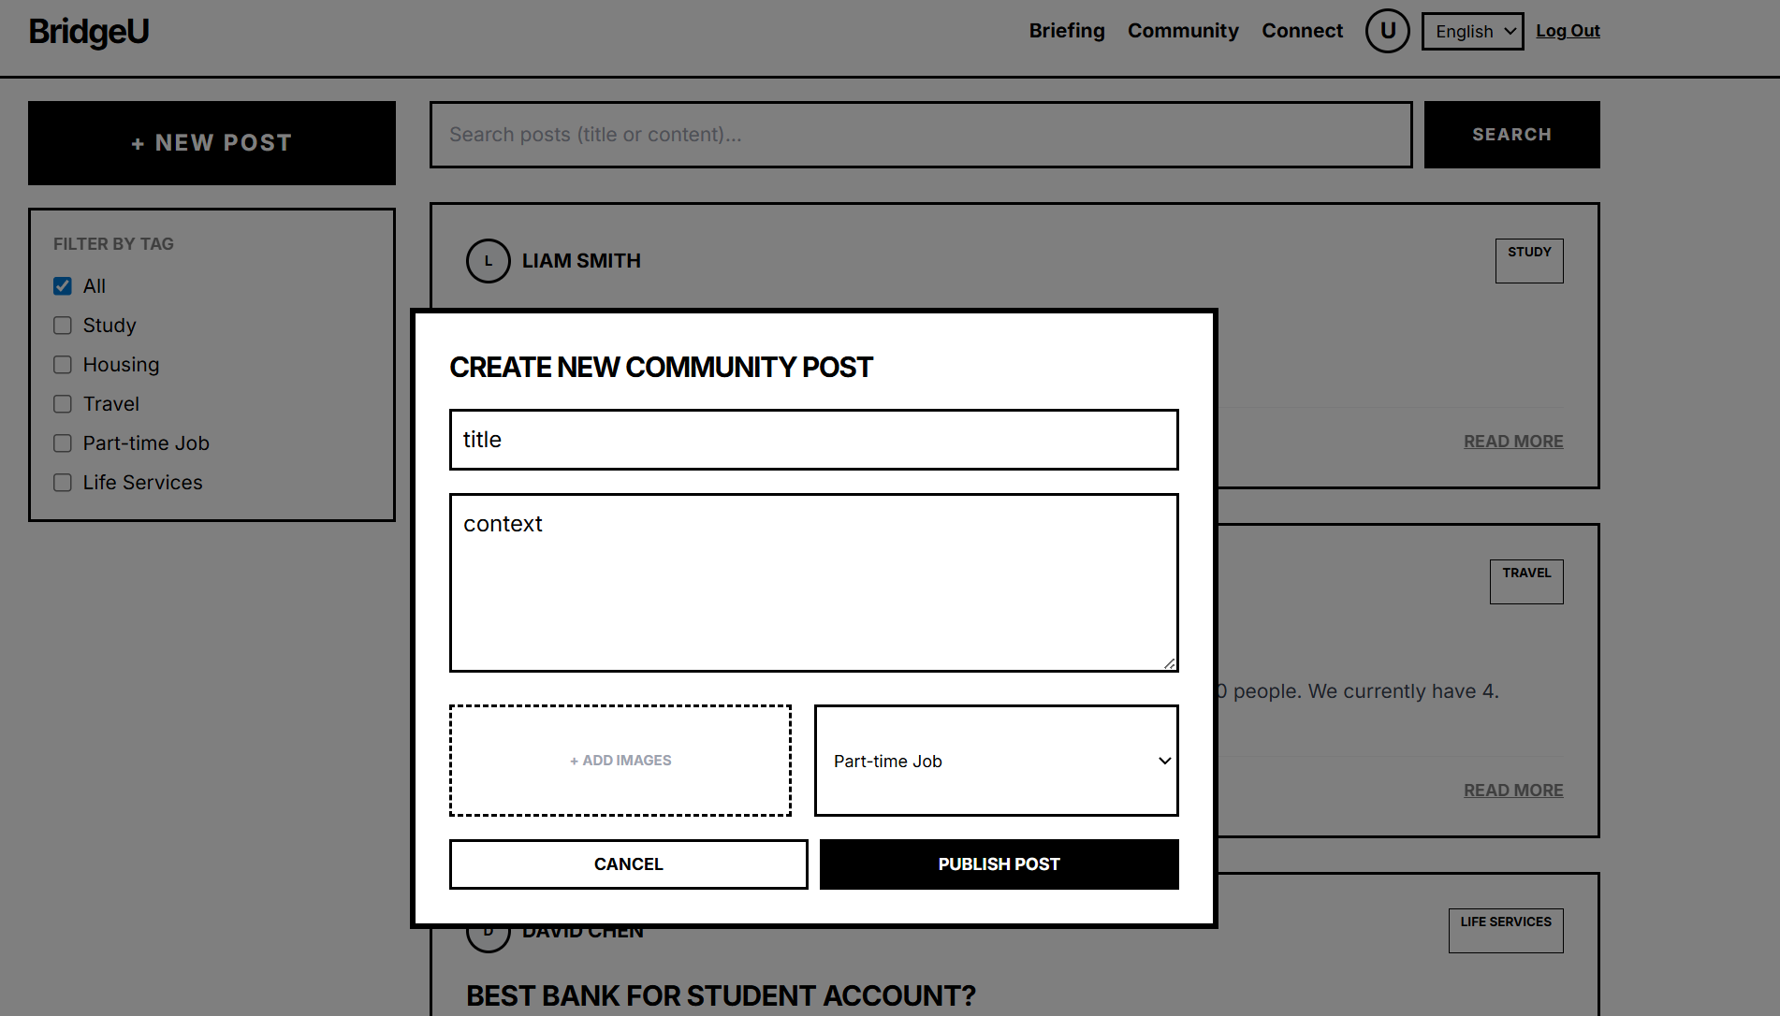

The user clicks on the "U" avatar in the top navigation bar to enter the Profile page.
Users can see their avatars, names and current language Settings.
In the "My Community Activity" list, the user sees that the status of the part-time post just Published is "Awaiting AI Moderation", while the status of the previous post is "Published".
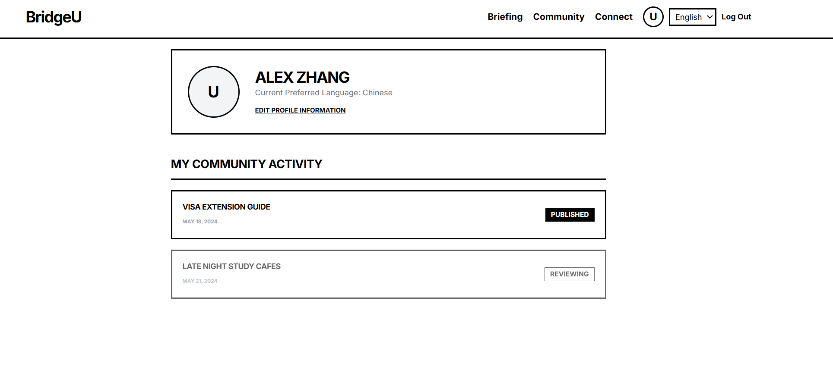

The user clicks "Edit Profile Information" to modify the display name or switch the interface language preference, and it takes effect immediately after saving.
Log Out: After use, the user clicks "Log Out" in the navigation bar to safely exit the system.
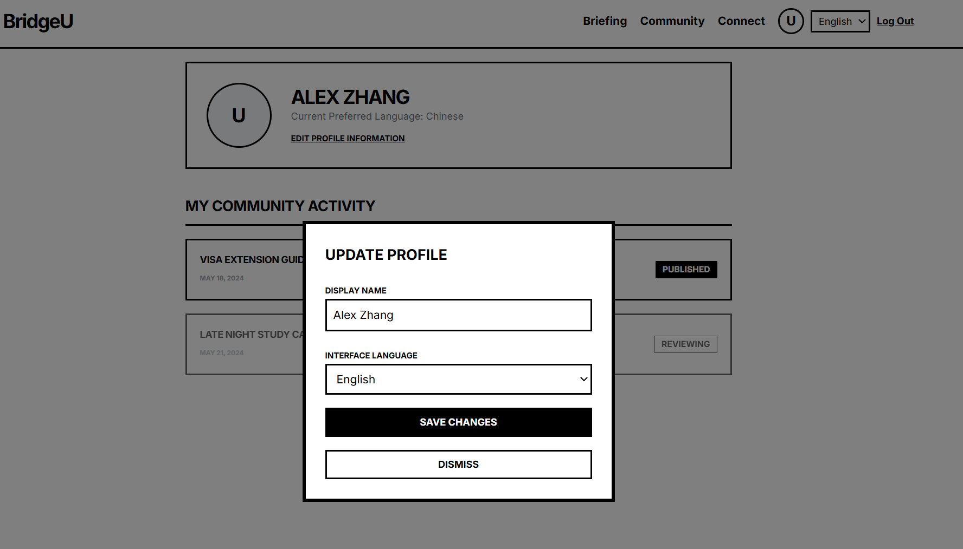

Chapter 5 | Business Review
Several similar applications are currently available on the market, but they differ significantly from BridgeU. Below is an analysis of several key competitors:

5.1 Facebook Groups
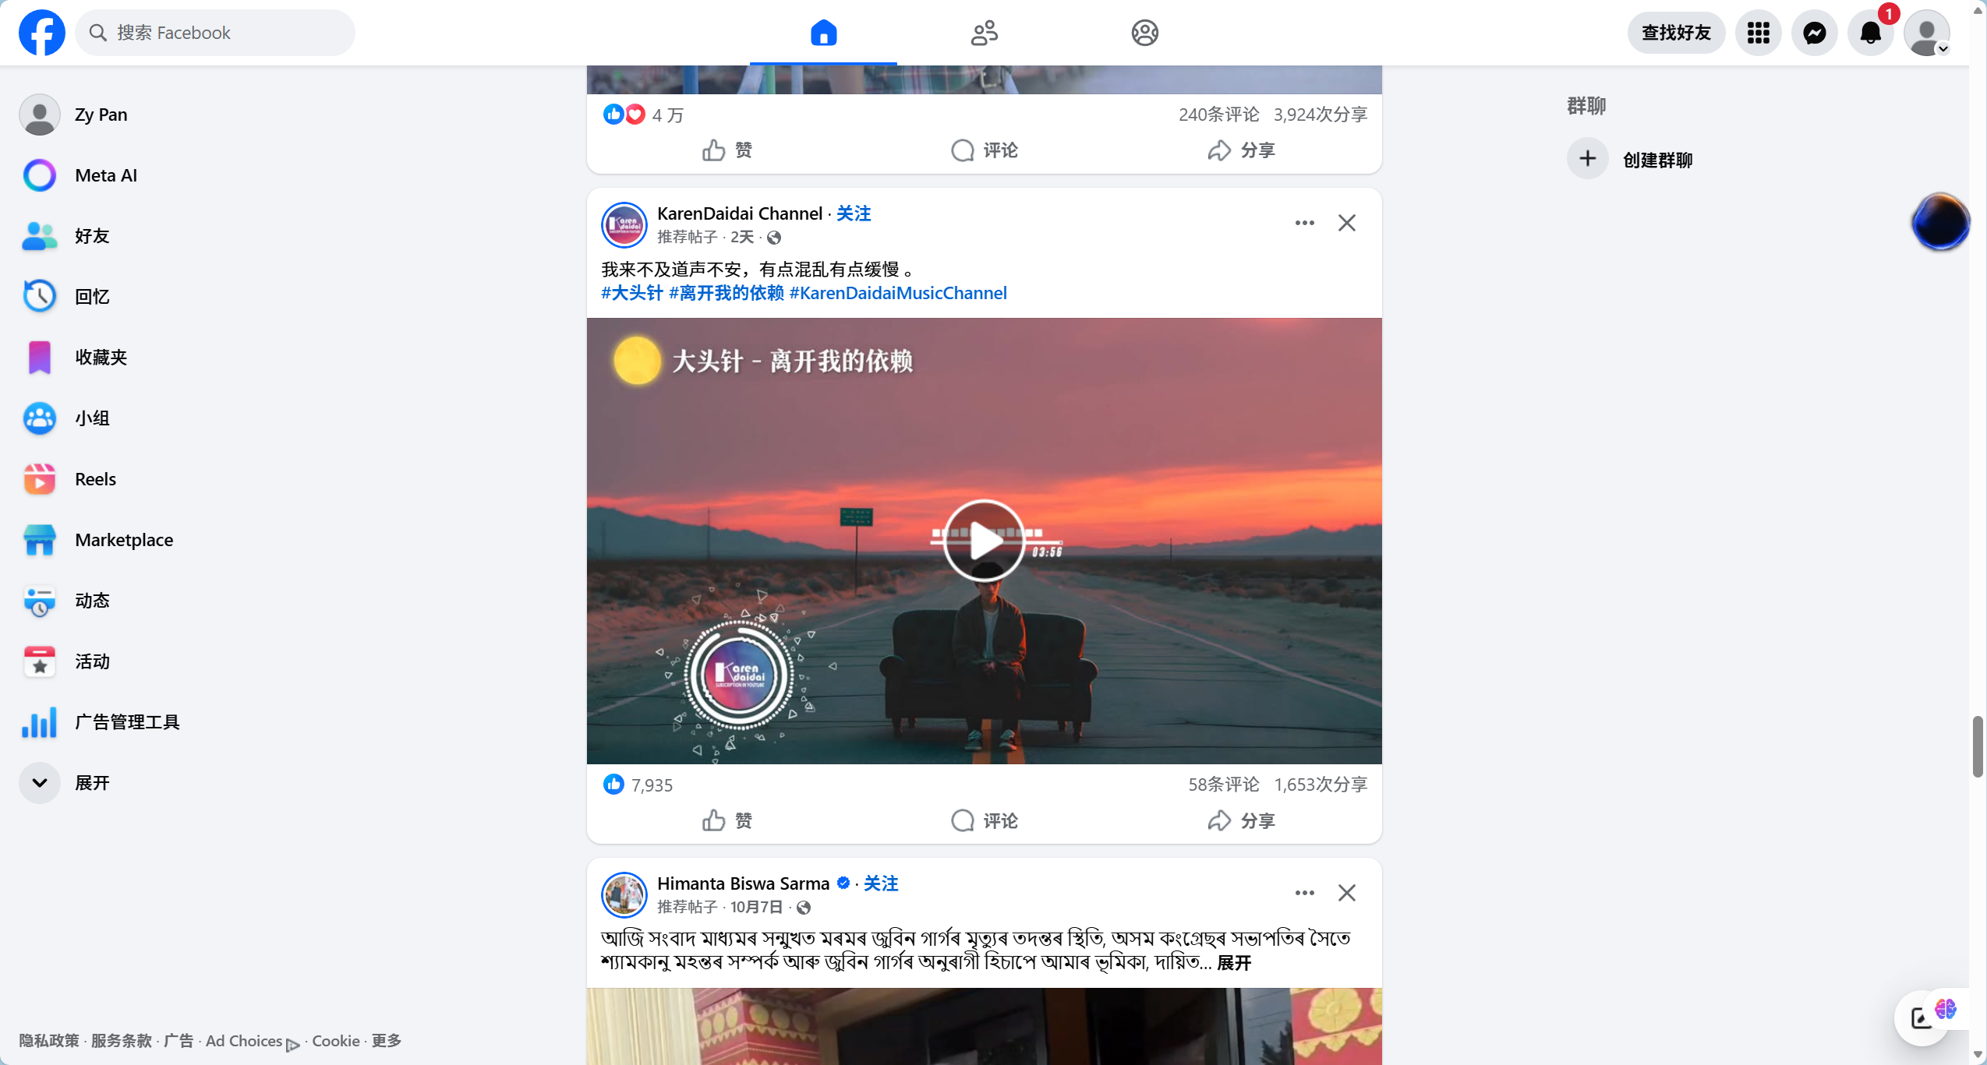
Facebook Groups are currently one of the most widely used mutual aid tools among international students worldwide.
Pros:
- Huge user base with broad coverage.
Cons:
- High language threshold: Mainly Thai and English content, which is difficult for Chinese students to use.
- The information retrieval is extremely poor: There are no structured tags, and rental stickers, car sale stickers and casual chats are all mixed together. It's like looking for a needle in a haystack to find information.

5.2 Xiaohongshu (Little Red Book)
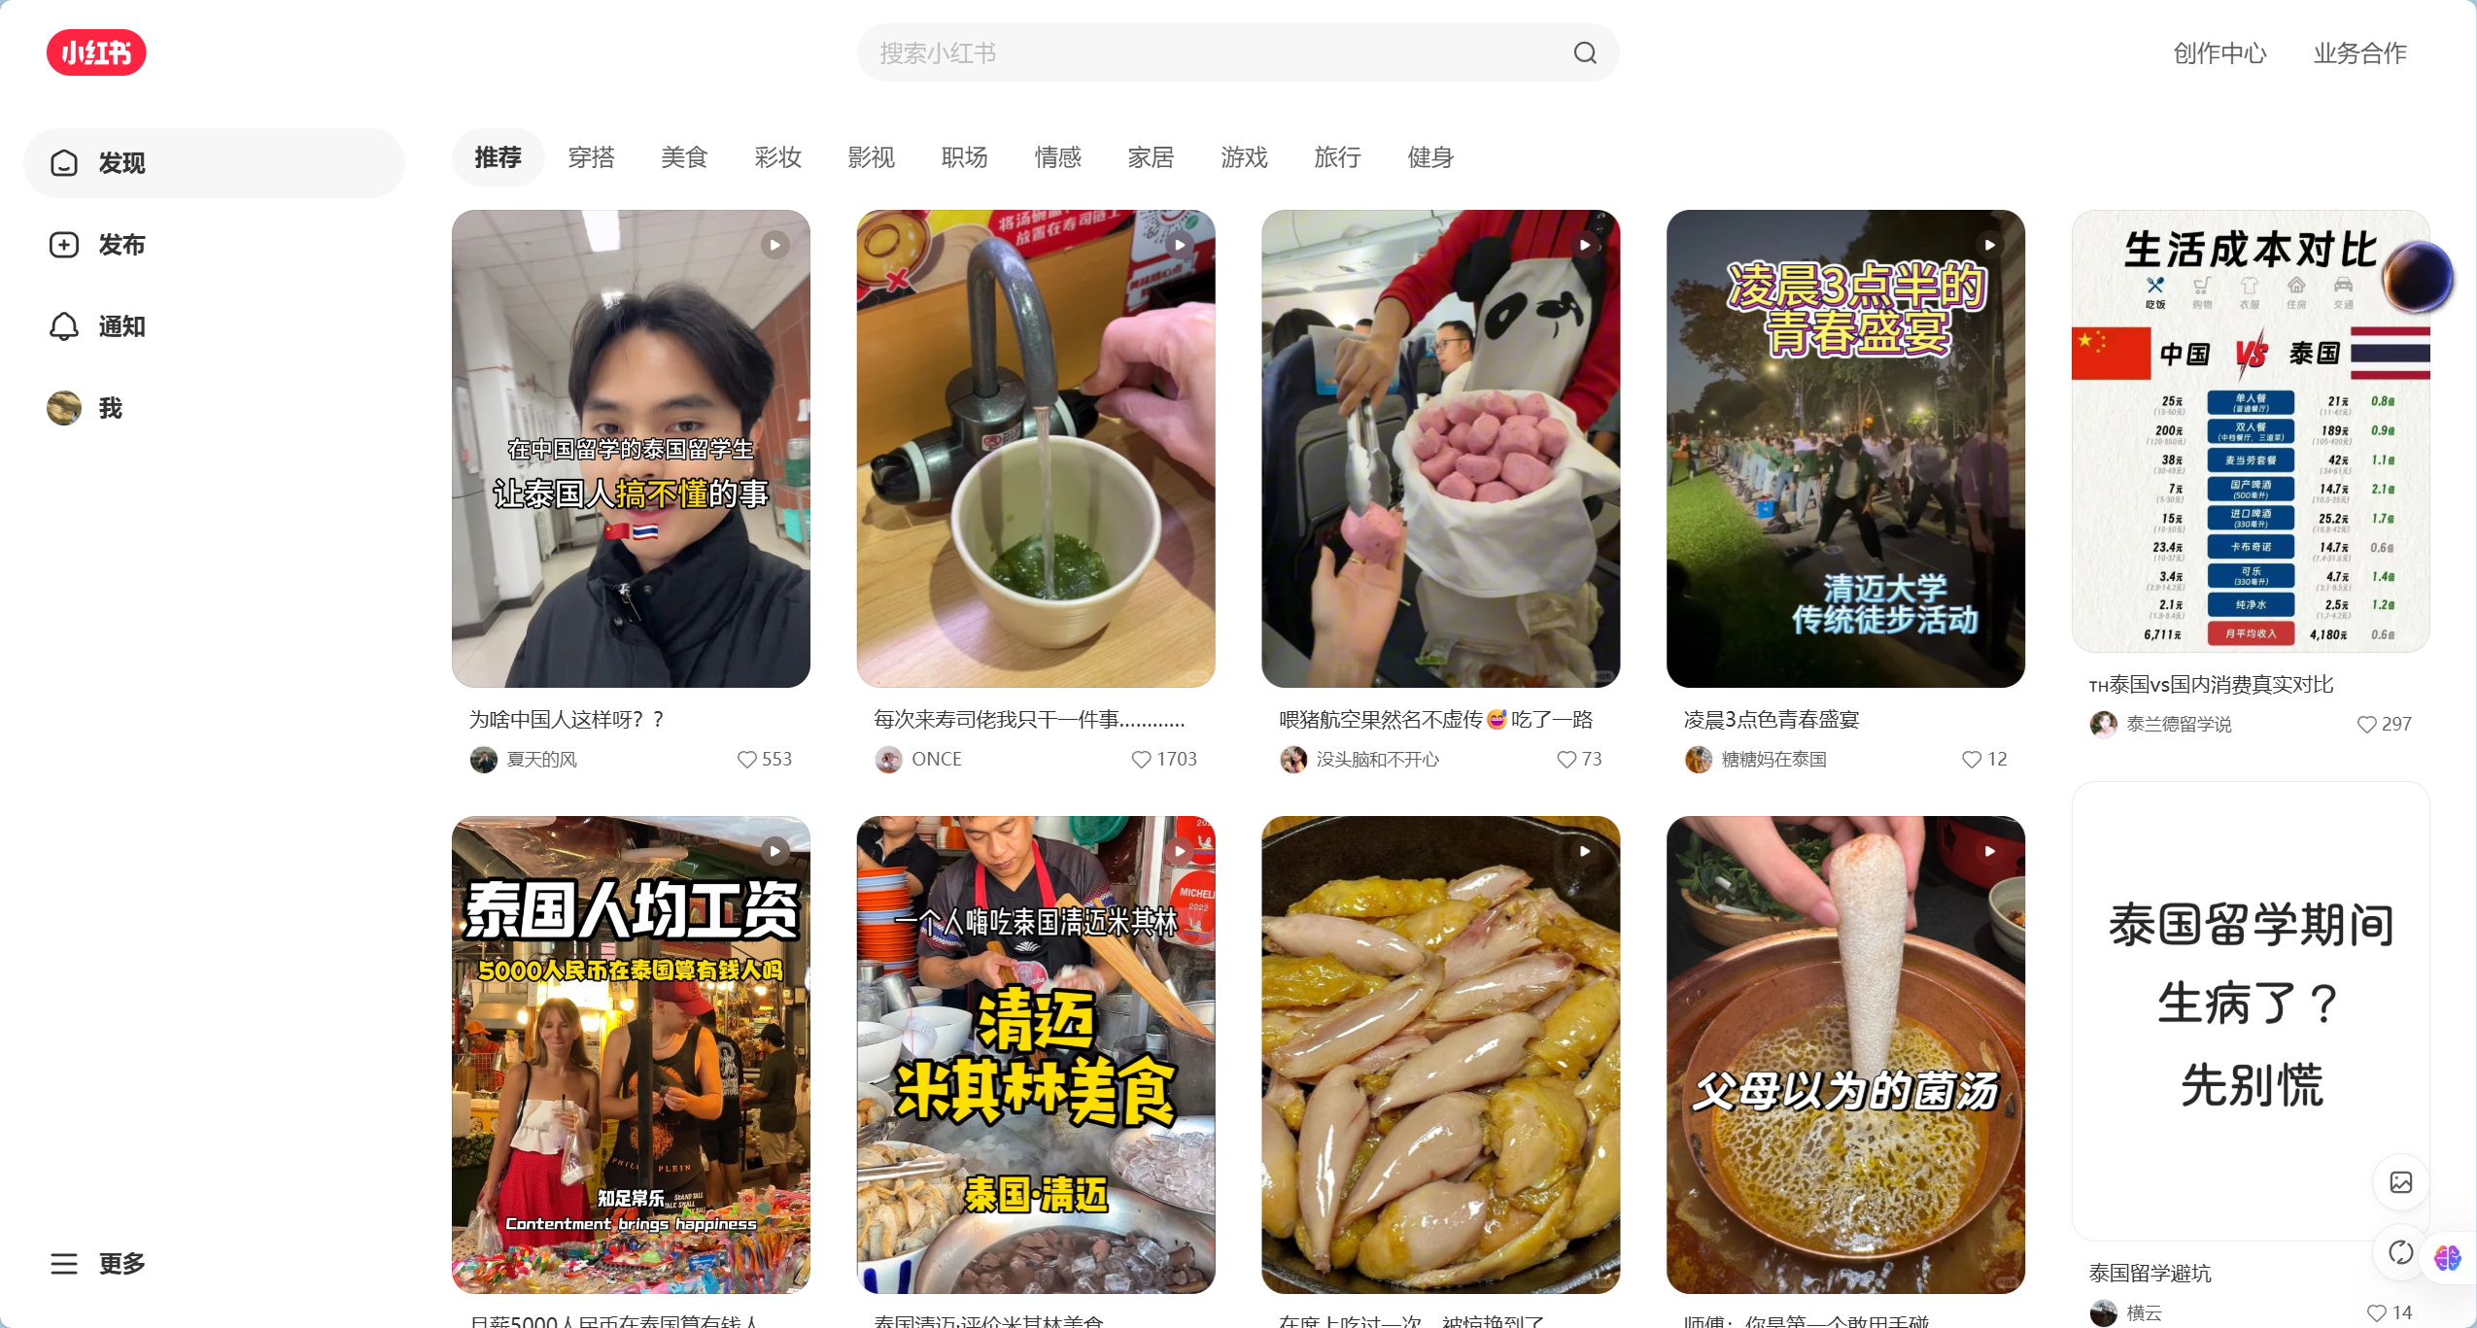
Xiaohongshu is currently the most popular lifestyle sharing platform among Chinese international students.

Pros:
- Rich content, precise algorithmic recommendations, aesthetically pleasing interface.
Cons:
- Serious "tourist perspective" bias: The content is overly focused on travel, food and check-ins, lacking in-depth accumulation on long-term residence and compliance.
- The closed Chinese ecosystem: Only Chinese people are using it, and it is impossible to reach local Thais and international students who own the properties and second-hand cars.

5.3 reddit
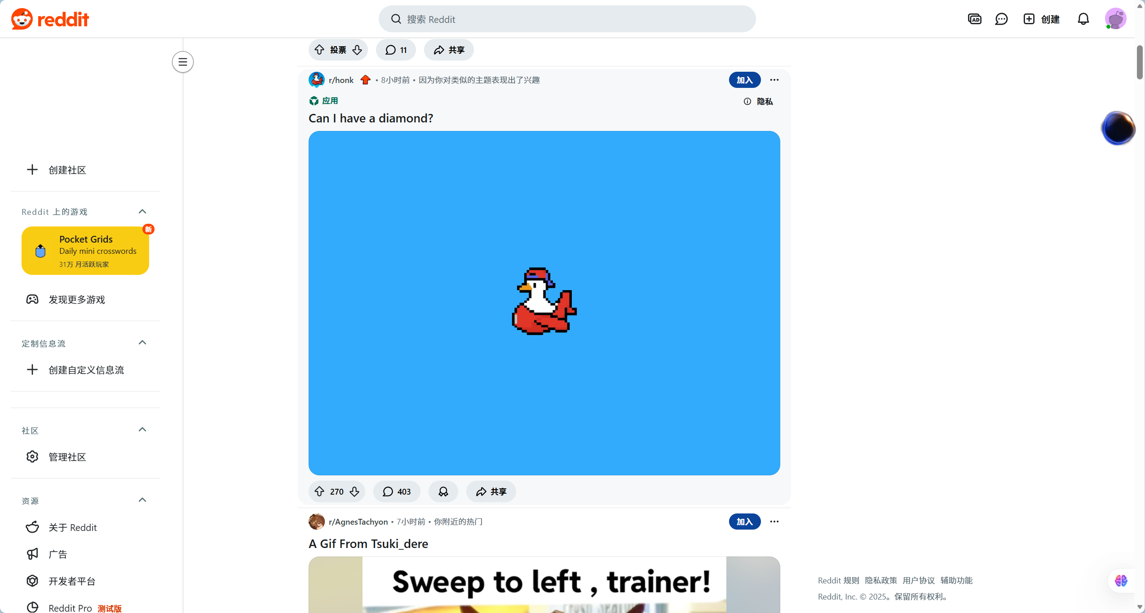
Reddit is one of the world's largest online forums, hosting numerous study abroad-related subreddits.

Pros:
- Structured discussions: Clear topic-based section categorization (e.g., studyabroad, r/Thailand).
- +++Anonymity: Users feel comfortable asking genuine questions.
Cons:
- Geeky interface: Unfriendly to non-technical users.
- Pure English environment: Multilingual translation is not supported, and most Chinese students and local lower-level merchants in Thailand (with poor English skills) are excluded.
- Lack of commercial functionality: Focused on discussion, not suitable for second-hand transactions or rental matching

5.4 Feature Comparison
Features | Facebook Groups | Little Red Book | Reddit | BridgeU
Web-based Access | ✓ | ✓ | ✓ | ✓
Robot Intelligence |  |  |  | ✓
AI Auto-Moderation |  | ✓ | ✓ | ✓
Mandatory Tags |  |  | ✓ | ✓
Translation | ✓ | ✓ |  | ✓

Chapter 6 |Software Review

6.1 Frontend Architecture & User Experience (UX)
To ensure the "immediate effect" of profile updates and seamless language switching described in the User Journey, the frontend is built using Vue.js, a progressive JavaScript framework that provides excellent support for bilingual interfaces and real-time updates.
Reactivity System: The profile management module utilizes Vue's reactive data binding. When a user updates their display name, avatar, or language preference in the profile page, the changes are reflected instantly across all components without requiring a full page reload. This reactive system also powers the community feed, where new posts, likes, and comments appear dynamically as users interact with the platform, enhancing the user experience by providing immediate visual feedback.
Internationalization (i18n): The language switching feature is implemented using Vue I18n, a dedicated internationalization library. All static text, including navigation menus, buttons, form labels, and system messages, is stored in JSON resource files for both Chinese and English. When a user toggles the language switch button, the application dynamically re-renders all text components throughout the interface, ensuring that Daily Briefing news, community posts, comments, and all UI elements adapt instantly to the user's preferred language (English or Chinese). This seamless language switching is critical for international students who may need to switch between languages while browsing news or communicating with peers.

6.2 Backend Security & Authentication
The authentication system is critical for maintaining user trust and data integrity, particularly for the flexible registration methods (email or phone number) and secure session management required by international students.
Session Management: BridgeU uses Spring Security with JWT (JSON Web Token) for stateless session management. When a user logs in with their registered email address or phone number and password, the system generates a JWT token that contains user identification information. The "Log Out" functionality triggers a secure token invalidation process: the client-side JWT is cleared from local storage, and the server maintains a token blacklist to ensure that logged-out tokens cannot be reused. This approach ensures that users are safely logged out and prevents unauthorized access from shared devices, which is particularly important for students using public computers or shared devices in dormitories or libraries.
Data Protection: User passwords, which must contain both uppercase and lowercase letters as specified in the registration requirements, are never stored in plain text. They are hashed using BCrypt with salt before storage in the MySQL database, complying with industry-standard security practices. The dual registration verification mechanism (email verification code for email registration, SMS verification code for phone registration) adds an additional layer of security to prevent bot account creation and ensure that only legitimate users can access the platform. Display names are validated to allow only English characters, preventing potential injection attacks and ensuring consistent data formatting.

6.3 AI Integration & Performance
The core differentiation of BridgeU lies in its AI-powered features, including Qwen AI for automatic translation, content moderation, and comment summarization, which are essential for creating a safe and accessible bilingual community platform.
API Latency Management: The integration with Qwen AI (Alibaba Cloud) is optimized for performance to ensure responsive user experience. For the Daily Briefing System, news summaries are pre-generated at 8:00 AM daily through batch processing when the system crawls news from Bangkok Post and The Nation Thailand. This batch processing approach means that when users browse the Daily Briefing page, the Chinese and English summaries are already available in the database, eliminating real-time API calls and minimizing loading time. Similarly, when users click the "AI Summary" button to view comment summaries under community posts, the system can retrieve pre-processed summaries or generate them efficiently without blocking the user interface.
Asynchronous Processing: For user-generated content (community posts and comments), the translation and content moderation requests are handled asynchronously using Spring Boot's asynchronous processing capabilities. When a user submits a post in Chinese or English, the system immediately saves the original content and returns a response to the user, while the Qwen AI translation (to generate the other language version) and content security review are processed in the background. This ensures that the user interface remains responsive and users can continue browsing or creating other content while the AI processes their submission. Only after Qwen AI confirms that the content passes moderation checks will the post be published to the community feed, maintaining content quality without compromising user experience.

6.4 Data Persistence & Search
To support the comprehensive "Search" and "Filter" functionalities required by the Daily Briefing System and Community Interaction modules, BridgeU employs a hybrid storage and search architecture.
Full-Text Search Capabilities: The system implements full-text search functionality using MySQL 8.0's built-in full-text search features, optimized for bilingual content. Daily Briefing titles and abstracts (stored in both Chinese and English versions) are indexed, allowing users to search using keywords in either language and receive results in their current interface language. Similarly, community post titles and body texts (also stored in Chinese and English) are searchable across both language versions. This enables users to find relevant content instantly, such as searching for "Visa" news in the Daily Briefing or "Part-time Job" posts in the community, regardless of which language they use for their search query.
Structured Storage: MySQL 8.0 is used as the primary relational database, ensuring data integrity and consistency for all structured data. User profiles (display name, avatar, preferred language), authentication credentials, mutual-follow relationships, private messages, post metadata (tags, likes, comments), and Daily Briefing records (title, summary, source, publication time, crawl timestamp) are all stored in normalized database tables. The database schema supports efficient querying for filtering operations, such as filtering Daily Briefing news by date range (start date, end date) and source (Bangkok Post, The Nation Thailand), or filtering community posts by predefined tags (Study, Housing, Travel, Part-time Job, Life Services). Foreign key constraints and indexes ensure referential integrity and optimize query performance for pagination, filtering, and relationship lookups.

Chapter 7 | Objective
1. Develop a Daily Briefing System that automatically captures and summarizes Thai news from approved sources (Bangkok Post, The Nation Thailand) and provides Chinese/English summaries using Qwen AI
2. Create a Community Interaction Platform that supports bilingual posting, commenting, and messaging with Qwen AI-powered translation, content moderation, and comment summarization
3. Implement Secure Authentication with flexible registration (email address or phone number) and password requirements (uppercase and lowercase letters)
4. Enable real-time language switching (Chinese/English) across all features
5. Provide comprehensive search and filtering capabilities for news and community posts
6. Support mutual-follow relationships and private messaging between users
7. Enable users to filter Daily Briefing news by date range and source
8. Support tag-based filtering for community posts (Study, Housing, Travel, Part-time Job, Life Services)
9. Provide AI-generated comment summarization feature for community posts
10. Enable users to report posts/comments with predefined reasons (Spam, Fraud or Scam, Illegal Service Promotion, Abusive Language, Other)
11. Support post editing and comment deletion functionality
12. Enable users to view own profiles and manage mutual-follow lists

Chapter 8 | System Architecture
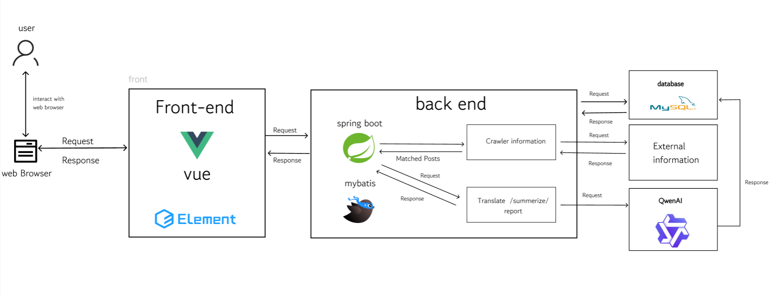

Description:
The system architecture consists of a front-end built using Vue.js 2 and Element UI, which provides a responsive user interface. The back-end is built with Spring Boot, a robust Java framework, handling business logic and RESTful API requests. MySQL 8 is used as the primary database for storing structured user and post data. Elasticsearch is integrated to provide high-performance semantic search capabilities. Additionally, the system connects to the Aliyun Qwen API to perform natural language processing tasks such as summarization and translation. Axios is used for communication between the front-end and back-end.

Chapter 9 | Limits
- Connectivity and Accessibility BridgeU is designed as a web-based application. Consequently, it requires a stable and continuous Internet connection to function. Users 2ithout internet access or those in areas with unstable network conditions will be unable to access real-time translation services, news updates, or community features.
- AI Dependency and Accuracy The core functionality of the platform relies heavily on the Alibaba Cloud Qwen Model API for translation and summarization. The accuracy of the system is therefore bound by the performance of this third-party API. Specifically, the model may encounter limitations when processing highly localized Thai slang, dialect-heavy text, or context-specific academic jargon, which could result in occasional translation inaccuracies.
- Data Acquisition Constraints The Automated Intelligence Robot (Crawler) operates under strict ethical and legal boundaries. It is programmed to capture information only from publicly available sources (Bangkok Post, The Nation Thailand). The system cannot and will not access password-protected pages, private Facebook groups, or encrypted personal data, which limits the scope of information to public domain data only.

Chapter 10 | Milestone
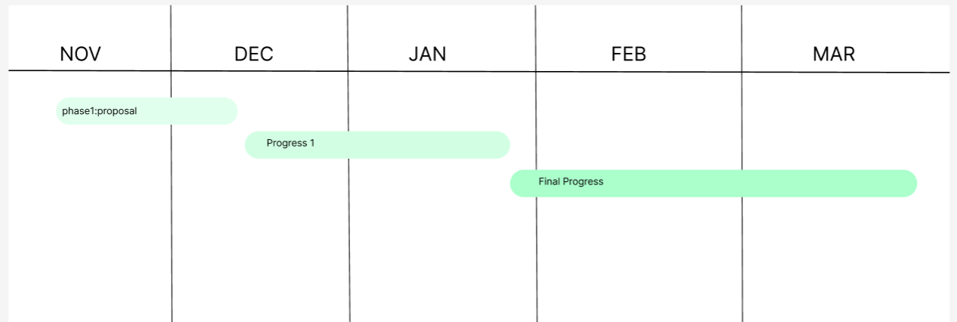
Phase 1. Proposal: 20 Nov 2025 –19 DEC 2025=29 days
Phase 2. Progress I: 20 DEC 2025 –26 Jan 2026 = 36 days
Phase 3. Final Progress: 26 Jan 2026 –20 Mar 2026 = 54 days
Phase 1. Proposal: 20 Nov 2025 –19 Dec 2025=29 days
Tasks | Start date | End date | Duration | Responsibility
Research and writing proposal document | 20 November 2025 | 9 December 2025 | 19 | ZHIYI PAN
Prepare for the Presentation | 9 December 2025 | 19 December 2025 | 10 | ZHIYI PAN

Phase 2. Progress I: 25 Dec 2025 –26 Jan = 36 days
Tasks | Start date | End date | Duration | Responsibility
Software requirement specification document | 25 December 2025 | 28 December 2025 | 3 | ZHIYI PAN
Project plan document | 28 December 2025 | 31 December 2025 | 3 | ZHIYI PAN
Software design document | 1 January 2026 | 8 January 2026 | 7 | ZHIYI PAN
Feature #1 implement | 8 January 2026 | 22 January 2026 | 13 | ZHIYI PAN
Prepared Progress I report and presentation | 20 January 2026 | 26 January 2026 | 6 | ZHIYI PAN
Phase 3. Final Progress: 26 Jan 2026 –20 Mar 2026 = 54 days
Tasks | Start date | End date | Duration | Responsibility
Feature #2 implement | 27 January 2026 | 10 February 2026 | 13 | ZHIYI PAN
Feature #3 implement | 11 February 2026 | 25 February 2026 | 13 | ZHIYI PAN
Test code | 26 February 2026 | 11 March 2026 | 15 | ZHIYI PAN
Prepared final report and presentation | 12 March 2026 | 25 March 202 | 13 | ZHIYI PAN

Chapter 11 | References
[1] Alibaba Cloud. (2024). Tongyi Qianwen (Qwen) Large Language Model API Documentation. [Online]. Available at: https://www.alibabacloud.com/help/en/model-studio/developer-reference/use-qwen-by-calling-api
[2] Vue.js. (n.d.). The Progressive JavaScript Framework. [Online]. Available at: https://vuejs.org/guide/introduction.html
[3] Element Plus. (n.d.). A Vue 3 based component library for designers and developers. [Online]. Available at: https://element-plus.org/en-US/component/overview.html
[4] Kazuya Kawaguchi. (n.d.). Vue I18n Documentation. [Online]. Available at: https://kazupon.github.io/vue-i18n/
[5] Axios. (n.d.). Promise based HTTP client for the browser and node.js. [Online]. Available at: https://axios-http.com/
[6] Spring. (n.d.). Spring Boot Framework Documentation. [Online]. Available at: https://spring.io/projects/spring-boot
[7] VMware, Inc. (n.d.). Spring Security Documentation. [Online]. Available at: https://spring.io/projects/spring-security
[8] MySQL. (2024). MySQL 8.0 Reference Manual. Oracle Corporation. [Online]. Available at: https://dev.mysql.com/doc/refman/8.0/en/
[9] Elasticsearch. (n.d.). Elasticsearch: The Official Distributed Search & Analytics Engine. [Online]. Available at: https://www.elastic.co/elasticsearch
[10] Bangkok Post Public Company Limited. (n.d.). Bangkok Post. [Online]. Available at: https://www.bangkokpost.com
[11] Nation Group (Thailand) Public Company Limited. (n.d.). The Nation Thailand. [Online]. Available at: https://www.nationthailand.com
[12] Meta Platforms, Inc. (n.d.). Facebook. [Online]. Available at: https://www.facebook.com
[13] Xiaohongshu. (n.d.). Xiaohongshu (Little Red Book). [Online]. Available at: https://www.xiaohongshu.com
[14] Reddit, Inc. (n.d.). Reddit. [Online]. Available at: [suspicious link removed]

