BridgeU
Software Requirement Specification

Zhiyi Pan 652115558

Bachelor of Science
Software Engineering Program

Department College of Arts, Media, and
Technology
Chiang Mai University
December 2025
Project Advisor
Asst. Prof. Pattama Longani, Ph.D.

Document History

Document  Name | Version | History | Status | Date | Editable | Reviewer
BridgeUSRS | BridgeUSRS V.0.1 | AddChapter1 •1.1Purposeand Scope •1.2User Character is •1.3Acronyms and Definitions AddChapter2 Progress1 •UseCase Diagram •UseCase Description | Draft | 12/12/2025 | ZHIYI PAN | Asst.Prof. Pattama Longani, Ph.D.

Chapter 1 Introduction

1.1 Purpose and Scope
The purpose of the software design development is to present a complete software design of the BridgeU project. This document contains the outline of the software architecture, functions used, and activity diagrams with the user interface for this project. BridgeU aims to eliminate language barriers through AI technology and establish a bilingual mutual assistance ecosystem connecting Chinese students, global students, and local Thai merchants.

1.2 User Characteristics
Users:
All people who can log in.
Description:
The target users of our software are international students studying in Thailand, merchants providing services to the international student community， they share the common goal of creating a supportive bilingual community that facilitates adaptation to life in Thailand and enables seamless information sharing and communication.

1.3 Acronyms and Definitions
SRS | Software Requirement Specification
URS | User Requirement Specification
UTC | Unit Test Case
STC | System Test Case
UC | Use Case
SRC | Software Requirements Specification
RSS | Really Simple Syndication
JWT | JSON Web Token
AI | Artificial Intelligence
LLM | Large Language Model

Definition
Name | Definition
IEEE | Institute for Electrical and Electronics Engineers. Biggest global interest  group for engineers of different branches and computer scientists.
Plan | A document series of tasks requires meeting an objective, typically  including the associated schedule, budget, resources, organizational  description and work breakdown structure.
Feature | Feature Transformation of input parameters to output parameters based  on a specified algorithm. It describes the functionality of the product in  the language of the product. Used for requirements analysis, design,  coding, testing or maintenance.
Project  Management | The application of knowledge, skills, tools, and techniques to project  activities in order to meet or exceed stakeholder needs and expectations  from a project.
Project Plan | A formal, approved document used to guide both project execution and  project control. The primary uses of the project plan are to document  planning assumptions and the decision, to facilitate communication  among stakeholders, and to document approved scope, cost, and  schedule baseline.
Risk | An uncertain event or condition that, if it occurs, has a positive or  negative effect on a project’s objectives. It is a function of the  probability of occurrence of a given threat’s occurrence.
Risk  Management | The systematic application of management policies, procedures and  practices to the tasks of identifying, analyzing, evaluating, treating and  monitoring risk.
System Testing | Testing conducted on a complete and integrated system for evaluate the  system’s compliance with its specified requirements.
Unit Test | A test of individual programs or modules in order to remove a design or  programming errors.
Traceability | The ability to trace the history, application or location of an item or  activity, or work products or activities, by means of recorded  identification. The establishment and maintenance of relationships  between such items. Horizontal traceability describes the relationship  between work products of the same type (e.g. Customer requirements).  Vertical traceability describes the relationship between work products,  which build or derived from each other (e.g., from customer  requirements to qualification test cases). Bidirectional traceability  allows to directly following relationships in both directions.
Use Case | A use case is a description of a specific interaction between a system  and its users to accomplish a particular goal or task. It outlines the  sequence of steps or actions that a user performs in the system and  describes the system's responses to those actions. Use cases help to  identify and define the functional requirements of a system from the  perspective of its users.
Activity Diagram | Activity diagram is another important behavioral diagram in UML  diagram to describe dynamic aspects of the system. Activity diagram is  essentially an advanced version of flow chart that modeling the flow  from one activity to another activity.

Chapter 2 Specification Requirement

2.1 Feature 1
Feature 1: Daily Briefing System
The Daily Briefing System automatically captures and summarizes Thai news from Google News, providing bilingual (Chinese/English) access to daily news briefings for User. At 8 a.m. every day, the system captures news from the Google News, and saves each article as a Daily Briefing record, including original title, summary generated by the system call Qwen AI to summarize, source website name, original URL, publication time provided by the source. The system generates both Chinese and English versions for the title and abstract, and the interface only displays one of them in the current language. When the User opens the Daily Briefing page, the system returns a paginated list of Daily Briefing record from new to old according to the release time. The list card displays: title, summary, source, publication time (using only the current interface language), and provides a button to enter the detail page. User can also click original button to opens the original URL of the news. Users can enter any keywords in the search box on the page. System searches by keyword among Daily Briefing titles and abstracts (both Chinese and English versions) in the database,then System returns Daily Briefing items related to that word in the current language
User can set filtering conditions: start date(daymonthyear), end date(daymonthyear). The system applies all filtering conditions, only returns the Daily Briefing news that meets the conditions, and displays them in chronological order(new to old).

2.1.1 Use Case Diagram
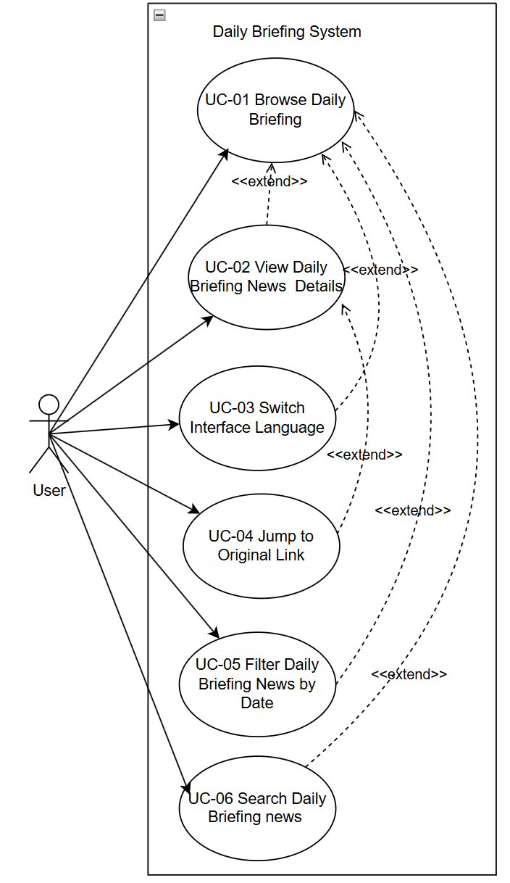

2.1.2 User Requirement Specification
URS01 – View Daily Briefings
User can open the Daily Briefing page and browse a paginated list of recent Daily Briefing items ordered from newest to oldest by publication time in their current interface language.
URS02 – View Daily Briefing news details
User can select a Daily Briefing item from the list and view a news detail page that shows the complete information (title, AI generated summary of News, publication time,View Original button, "Back" button) for that item in their current interface language (English/Chinese).
URS‑03 – Switch Interface Language
User can click a language switch button at any time to change the interface language between Chinese and English and continue browsing Daily Briefing items in the newly selected language.
URS‑04 – Jump to the original link
User can click an “Open original article” button on a Daily Briefing item and read the full original news article on the external official website in a new browser tab.
URS‑05 – Filter Daily Briefings News by Date
The User can filter news based on specific criteria (start date and end date) while browsing.
URS06 – Search for Daily Briefing News
User can type Chinese or English keywords into a search box on the Daily Briefing page and view only Daily Briefing items that match the entered keywords.

2.1.3 Use Case Description and Activity Diagram

2.1.3.1 UCD01 View Daily Briefings
URS01: User can open the Daily Briefing page and browse a paginated list of recent Daily Briefing items ordered from newest to oldest by publication time in their current interface language.
- SRS01: The system shall display the "Briefing" navigation item in the sidebar navigation menu on every page.

- SRS02: The system shall display the Daily Briefing page [UI01] when the "Briefing" navigation item is clicked, showing a paginated list of Daily Briefing items.

- SRS03: The system shall order Daily Briefing items from newest to oldest based on publication time from the source website.

- SRS04: The system shall display Daily Briefing items in the user's current interface language (Chinese or English), showing only the title and summary in the selected language.

- SRS05: Each Daily Briefing card on the list shall display: title, AIgenerated summary, source website name (original or localized name), and publication time (formatted according to the current interface language).

- SRS06: The system shall implement pagination to display Daily Briefing items, providing pagination controls (page number, previous/next buttons) for users to navigate through pages.

- SRS07: The system shall provide a "View Detail" button on each Daily Briefing card to navigate to the news detail page.
Use Case ID | UC01
Use Case Name | View Daily Briefings
Created By | ZhiYi Pan |  | Last Update By | ZhiYi Pan
Date Created | 04/01/2026 |  | Last Revision Date
Actors | User
Description | This use case describes the process by which a user navigates to the Daily Briefing page and browses a paginated list of recent news items from Google News. The list displays news items ordered from Google News new to old by publication time, with all content displayed in the user's current interface language (Chinese or English).
Trigger | User clicks on the "Briefing" navigation item in the sidebar menu.
Preconditions | 1. User is logged into the BridgeU platform.  2. User has an active internet connection.  3. The Daily Briefing system has successfully crawled news from approved sources (Google News).
Use Case Input Specification
Input | type | Constraint |  |  | Example
Current Interface Language | String | Must be "zh" (Chinese) or "en" (English) |  |  | "en"
Post conditions | User are in "Daily Briefing page" (UI01: Daily Briefing page)
Normal Flows | User |  | System
 | 1.User clicks on the "Briefing" navigation item in the sidebar  7. User clicks pagination controls (e.g., "Next" button).  9. User clicks "View Detail" on a specific card. |  | 2. System checks if the user is logged in and the login session is valid (verifies authentication token)  [E2: User session expired]  3. System retrieves the user's current interface language preference (Chinese or English)  4. System queries the database for the first page of Daily Briefing items, ordered by publication time (newest first)  [E1: Cannot connect to database]  [E3: Network timeout]  5. System retrieves the corresponding language version (Chinese or English) for each Daily Briefing item's title and summary  6. System displays the Daily Briefing page (UI01) with paginated list of news items(Each card includes title, summary, source, time, and "View Detail" button)  [A1: No news items available]  8. System loads and displays the next set of news items.  10. System navigates to the News Detail Page.
Alternative Flow | A1: No News Items Available  A1.1 System show "No news available at this time" message  A1.2 Use case end.
Exception Flow | E1: Cannot connect to database  E1.1 System show "Unable to load news. Please try again later." message  E1.2 System logs the error for administrator review  E1.3 Use case end.  E2: User Session Expired  E2.1 System redirect the user to the login page  E2.2 System show "Your session has expired. Please log in again." message  E2.3 Use case end.  E3: Network Timeout  E3.1 System show "Request timeout. Please check your internet connection and try again." message  E3.2 User can retry the operation  E3.3 Go to Step 4
Note | 1. The user has a stable internet connection.  2. The Daily Briefing crawling system runs successfully at 8:00 AM daily.  3. News items have been successfully translated into both Chinese and English versions.  4. The user's browser supports modern web technologies (JavaScript, CSS, HTML5).

AD01: View Daily Briefings
Activity Diagram for View Daily Briefings, which explains the steps between a User and the System for browsing aggregated news.
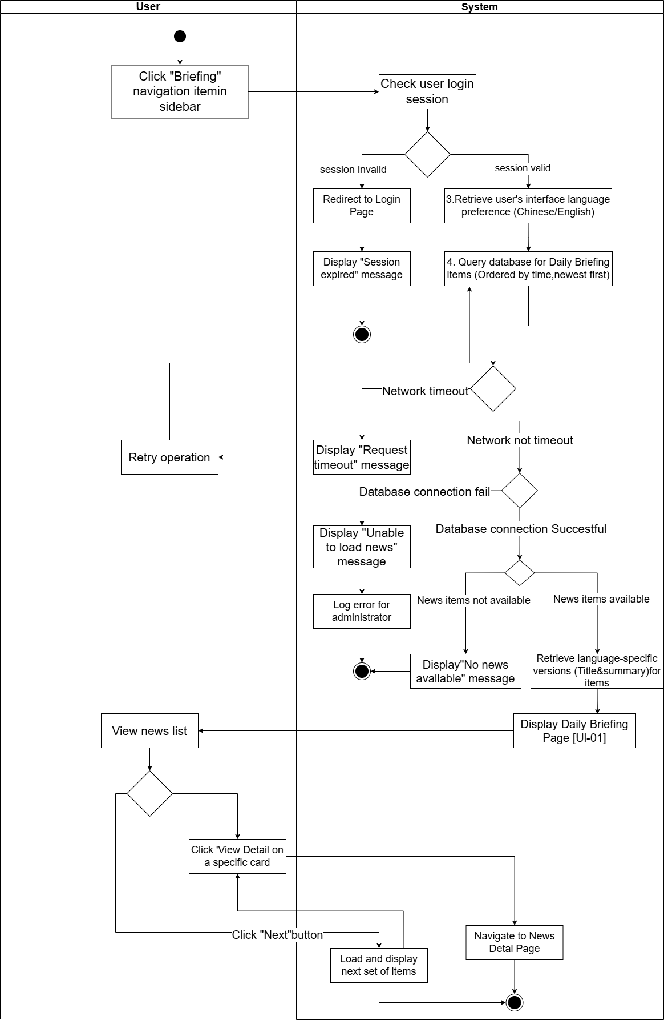

2.1.3.2 UCD02 View Daily Briefing news details
URS02: User can select a Daily Briefing item from the list and view a news detail page that shows the complete information (title, summary, publication time, View Original button) for that item in their current interface language (English/Chinese).
- SRS08: The system shall provide a "View Detail" button on each Daily Briefing card in the list page (UI01) to navigate to the news detail page (UI02).

- SRS09: The system shall display the News Detail page (UI02) when a user clicks the "View Detail" button on a Daily Briefing card.

- SRS10: The system shall retrieve the selected Daily Briefing item from the database using the news item ID passed from the list page.

- SRS11: The system shall display the news detail page content in the user's current interface language (Chinese or English), showing the title and summary in the selected language.

- SRS12: The News Detail page (UI02) shall display the following information in the user's current interface language:
  - News title
  - AI generated summary
  - Source website name
  - Publication time

- SRS13: The system shall provide a "Back" button on the News Detail page to return to the Daily Briefing list page.

- SRS14: The system shall provide a "View Original" button that triggers the browser to open the original news article URL in a new tab when clicked.
Use Case ID | UC02
Use Case Name | View Daily Briefing news details
Created By | ZhiYi Pan |  | Last Update By
Date Created | 04/01/2026 |  | Last Revision Date
Actors | User
Description | User can select a Daily Briefing item from the list and view a news detail page that shows the complete information (title, AI generated summary of News, publication time,View Original button, "Back" button) for that item in their current interface language (English/Chinese).
Trigger | User clicks the "View Detail" button on a Daily Briefing card in the Daily Briefing list page (UI01)
Preconditions | 1. User has an active internet connection.  2. User is viewing the Daily Briefing list page (UI-01).  3. At least one Daily Briefing item exists in the list.
Use Case Input Specification
Input | type | Constraint |  |  | Example
News Item ID | Integer | Must be a valid news item ID that exists in the database |  |  | 123
Current Interface Language | String | Must be "zh" (Chinese) or "en" (English) |  |  | “en”
Post conditions | User is viewing the News Detail page (UI02) displaying the complete information for the selected Daily Briefing item
Normal Flows | User |  | System
 | 1. User clicks the "View Detail" button on a Daily Briefing card in the list page  12. User views the news details  13. User switches the interface language (Chinese/English) using the language switcher (optional)  18. User clicks the "View Original" button (optional)  20. User clicks the "Back" button (optional) |  | 2. System retrieves the news item ID from the clicked card  3. System retrieves the user's current interface language preference (Chinese or English)  4. Frontend sends HTTP request to backend API with news item ID and language parameter  5. Backend receives request (authentication not required for this endpoint)  6. Backend queries the database for the Daily Briefing item using the news item ID  [E1: Database error or server error]  [E4: News item not found]  7. Backend retrieves the corresponding language version (Chinese or English) for the news item's title and summary  8. Backend returns response with success status and news detail data  9. Frontend receives HTTP response from backend  [E2: Authentication token invalid or expired]  [E3: Network timeout or connection error]`  10. Frontend checks if response.status is 200 and response.data.success is true  11. System displays the News Detail page (UI-02) with the complete information:  - News title (in current interface language)  - AI-generated summary (in current interface language)  - Source website name  - Publication time (formatted according to current interface language)  - "View Original" button (disabled if originalUrl is invalid or missing)  - "Back" button  14. Frontend triggers a language change event and updates the current language preference  15. System re-fetches the news detail data from the API with the new language parameter  16. System updates the News Detail page display with content in the new language (title, summary, formatted dates)  17. Use case continues from Step 12  19. System triggers the browser to open the original URL in a new tab  [E5: Original URL invalid or missing]  21. System navigates the user back to the Daily Briefing list page (UI-01)
Alternative Flow
Exception Flow | E1: Database error or server error  E1.1 Backend catches an exception while processing the request  E1.2 Backend returns a 500 Internal Server Error response with message "Failed to fetch news detail: [error details]"  E1.3 Backend logs the error with full details for administrator review  E1.4 Frontend receives the 500 error response in catch block  E1.5 Frontend checks if error.response.status === 500  E1.6 Frontend displays the error message from error.response.data.message or default localized message 'dailyBriefingDetail.networkError'  E1.7 Use case end.  E2: Authentication token invalid or expired  E2.1 Backend returns a 401 Unauthorized response (if authentication is required for this operation)  E2.2 Frontend detects the 401 error and clears the invalid token from localStorage  E2.3 Frontend triggers an authentication error event and displays "Login expired, please log in again" message  E2.4 System redirects the user to the login page  E2.5 Use case ends.E3: News item not found  E3: Network timeout or connection error  E3.1 Request exceeds the configured timeout or network connection fails  E3.2 Frontend catches the network error or timeout in catch block  E3.3 Frontend checks if error.response exists (defensive check per code implementation)  E3.4 If error.response exists and error.response.data.message exists, frontend displays that message  E3.5 Otherwise, frontend displays localized error message using i18n key 'dailyBriefingDetail.networkError' or error.message  E3.6 Use case end.  E4: News item not found  E4.1 System queries the database but cannot find a news item with the provided ID  E4.2 System returns a 404 Not Found response with message "News not found with id: [id]"  E4.3 Frontend receives the 404 error response in catch block  E4.4 Frontend checks if error.response.status === 404  E4.5 Frontend displays the localized error message using i18n key 'dailyBriefingDetail.notFound'  E4.6 System provides a "Back" button to return to the Daily Briefing list page (always displayed at top)  E4.7 Use case end.  E5: Original URL invalid or missing  E5.1 System disables the "View Original" button (rendered with `:disabled="!news.originalUrl"`). The button is visually distinct (grayed out) and non-clickable.  E5.2 Use case continues (user can still view other details)
Note | The news detail page displays information in the user's current interface language preference.  If the user switches language while viewing details, the page content should update accordingly.  The "View Original" button triggers the browser to open the original article in a new tab to preserve the user's current browsing context.  The frontend implements defensive programming checks in the error handling catch block, including handling of edge cases such as 200 status codes in catch blocks (which should not normally occur but are handled for safety).  Error handling follows the activity diagram specification, with detailed checks for HTTP response status codes and error message availability.

AD02 View Daily Briefing news details
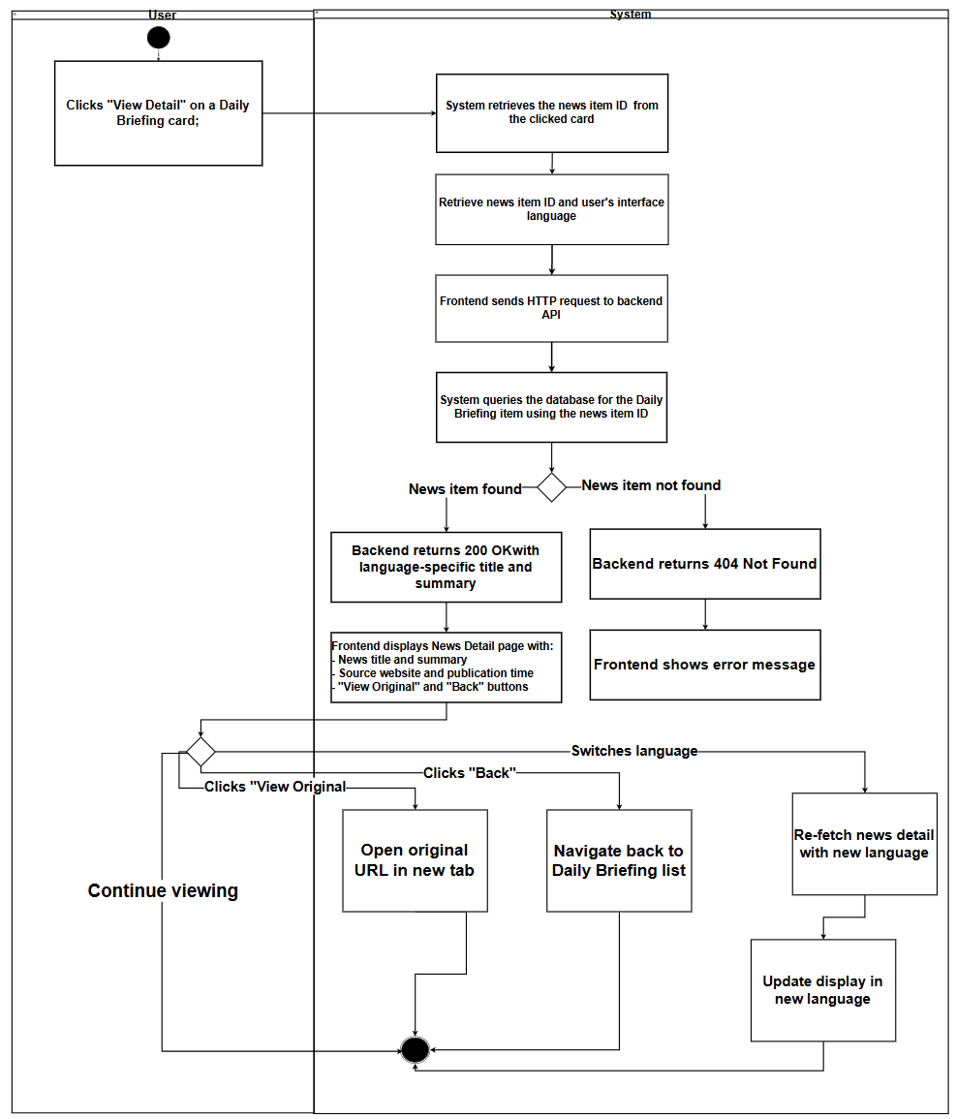
The Activity Diagram for View Daily Briefings shows how the User and the System interact when view the daily briefing list（UI01）

2.1.3.3 UCD03
URS‑03 – Switch Interface Language
User can click a language switch button at any time to change the interface language between Chinese and English and continue browsing Daily Briefing items in the newly selected language.
- SRS15: The system shall provide a language switch button (or language selector) on every page of the application, accessible from the sidebar (for loggedin users) or login page (for nonloggedin users). The sidebar displays two separate buttons: "中文" (Chinese) and "EN" (English), while the login page displays a single toggle button showing "EN/中文".

- SRS16: The system shall display the current interface language (Chinese or English) in the language switch control, allowing users to toggle between "中文" (Chinese) and "English" (English).

- SRS17: When the user clicks the language switch button, the system shall immediately update the user's interface language preference and persist it in local Storage with the key 'user Language'. Note: The user profile's preferred Language field is only updated when the user explicitly saves their profile in the My Profile page. Language switching via the sidebar buttons only updates local Storage for the current session.

- SRS18: The system shall refresh the current page content immediately after the language switch, displaying all interface text, labels, buttons, and content in the newly selected language.

- SRS19: The system shall refetch any displayed content (e.g., Daily Briefing items, news details) from the backend API with the new language parameter (lang="zh" or lang="en") to ensure content is displayed in the selected language. The system triggers a 'language Changed' custom event with detail { lang: new Lang } to notify all components to refresh their content.

- SRS20: The system shall maintain the user's current page context (e.g., current page number, selected news item ID, filter parameters) when switching languages, so the user can continue browsing without losing their place. For example, if the user is on page 3 of the Daily Briefing list, switching language will reload page 3 in the new language.

- SRS21: The system shall format dates and times in the format "DD-MM-YYYY HH:mm" (daymonthyear hour:minute) for both Chinese and English interfaces. The date format remains consistent across languages, but all interface labels and content text are translated according to the selected language.

Use Case ID | UC03
Use Case Name | Switch Interface Language
Created By | ZhiYi Pan |  | Last Update By
Date Created | 05/01/2026 |  | Last Revision Date
Actors | User
Description | User can click a language switch button at any time to change the interface language between Chinese and English and continue browsing Daily Briefing items in the newly selected language.
Trigger | User clicks the language switch button on any page of the application
Preconditions | 1. User may or may not be logged into the BridgeU platform (language switching is available on both login page and authenticated pages).  2. User is viewing any page of the application (Login page, Daily Briefing list page, News Detail page, Community page, etc.).  3. The system has bilingual content available (Chinese and English versions) for the current page.  4. The browser supports local Storage (for storing language preference).
Use Case Input Specification
Input | type | Constraint |  |  | Example
Selected Language | String | Must be "zh" (Chinese) or "en" (English) |  |  | "en"
Current Page Context | Object | Contains current page state (page number, selected item ID, etc.) |  |  | { page: 1, itemId: 12345 }
Post conditions | 1.User's interface language preference is updated to the newly selected language  2.Current page content is refreshed and displayed in the newly selected language  3.User can continue browsing in the newly selected language without losing their current context
Normal Flows | User |  | System
 | 1. User clicks the language switch button (e.g., "🇨🇳 中文" or "🇺🇸 EN" in sidebar, or "EN/中文" toggle on login page) on the current page  7. User continues browsing in the newly selected language |  | 2. System calls setLanguage (newLang) function, which validates the language code ("zh" or "en")  [E1: Language change event fails]  3. System updates the current language state and attempts to store the preference in localStorage with key 'userLanguage'  • Note: The user profile's preferredLanguage field is NOT automatically updated here. It is only updated when the user explicitly saves their profile in the My Profile page.  • System triggers a 'languageChanged' custom event with detail { lang: newLang } to notify all listening components (the event is triggered as part of the localStorage write attempt, so it fires even if localStorage write fails)  [E2: Storage update fails]  4. All components listening to 'languageChanged' event receive the notification  • Each component uses its current state (page number, selected item ID, filter parameters, etc.) to maintain context  • Components refetch their content from the backend API with the new language parameter (lang="zh" or lang="en")  • For Daily Briefing list: calls fetchDailyBriefing() with params.lang = newLang, maintaining current page and filters  • For News Detail: calls fetchNewsDetail(newsId) with params.lang = newLang, maintaining the same newsId<br>  [E3: API request fails]  [E4: Network timeout]  5. Components receive the content in the newly selected language from API responses  6. System refreshes the current page display with:  - All interface text, labels, and buttons in the new language (via i18n translation system, automatically updated when language changes)  - All content (titles, summaries, etc.) in the new language (from API response)<br>  - Dates and times formatted as "DD-MM-YYYY HH:mm" (consistent format for both languages)<br>  - Current page context maintained (same page number, same selected item ID, same filter parameters if applicable)<br>  - Element Plus UI components locale updated (zhcn or en)
Alternative Flow | A1: User switches language multiple times in quick succession]`  A1.1 Components may use debouncing or delay mechanisms (e.g., set Timeout) to reduce frequent API requests when language is switched multiple times quickly  A1.2 System processes the most recent language switch request, and previous requests may complete but their results may be overwritten by newer requests  A1.3 Use case continues from Step 3
Exception Flow | E1: Language change event fails  E1.1 System detects that the language code is invalid (not "zh" or "en")  E1.2 System logs a warning to console (e.g., "Unsupported language: {lang}") but does not display an error message to the user  E1.3 System maintains the current language setting (no change occurs)  E1.4 Use case end.  E2: Storage update fails  E2.1 System attempts to update the language preference in localStorage (key: 'userLanguage') but fails (e.g., localStorage quota exceeded, localStorage disabled in browser)  E2.2 System logs error to console (e.g., "Failed to save language preference to localStorage") but does not display an error message to the user (language switch still proceeds for current session)  E2.3 The 'languageChanged' event has already been triggered (before the localStorage write failure was detected), so components will still receive the notification and refresh their content  E2.4 System may still proceed with the language switch for the current session, but the preference may not persist across browser sessions  E2.5 Use case continues from Step 4 (language switch completes, but preference may not be saved)  [E3: API request fails]  E3.1 System sends API request with new language parameter but receives an error response (e.g., 500 Internal Server Error, 404 Not Found)  E3.2 System displays an error message to the user (e.g., "Failed to load content in the selected language. Please try again.") and may show an error state in the UI  E3.3 System keeps the new language setting (localStorage and UI language have already been updated), but content may not be displayed or may show in the previous language if cached  E3.4 User can retry by refreshing the page or switching language again  E3.5 Use case end.  E4: Network timeout  E4.1 Request to fetch content in the new language exceeds the configured timeout  E4.2 System displays a localized timeout message (e.g., "Request timeout. Please check your internet connection and try again.")  E4.3 User can retry the language switch operation  E4.4 Use case end.
Note | The language switch should be instantaneous from the user's perspective, with minimal loading time. The system uses eventdriven architecture where components listen to 'languageChanged' events and automatically refresh.  The system maintains the user's current browsing context (page number, selected item ID, filter parameters) when switching languages. For example, if the user is on page 3 of Daily Briefing with filter "Bangkok Post", switching language will reload page 3 with the same filter in the new language.  If the user switches language while viewing a specific news detail page, the system reloads the news detail in the new language while maintaining the same news item ID (newsId).  The language preference is stored in localStorage with key 'userLanguage' and persists across browser sessions. When a user logs in, if the user profile has a preferredLanguage field, it is loaded and synchronized with localStorage. However, when switching language via the sidebar buttons, only localStorage is updated; the user profile's preferredLanguage field is only updated when the user explicitly saves their profile in the My Profile page.  The system uses a centralized i18n system (frontend/src/i18n/index.js) that manages translations for all UI text. When language changes, all components using the t() translation function automatically display text in the new language.  The system supports two languages: "zh" (Chinese) and "en" (English). The default language is "en" if no preference is stored.

AD03: Switch Interface Language
The Activity Diagram for Switch Interface Language illustrates the interaction between the User and the System when the user changes the interface language:
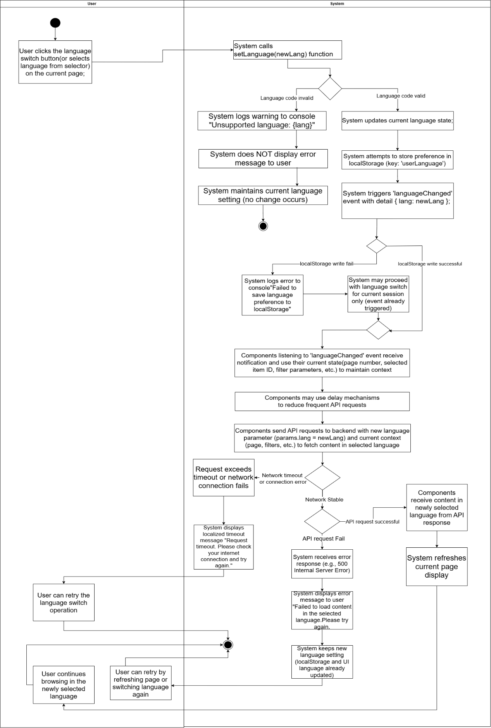

2.1.3.4 UCD04
URS04: The User can jump to the original text link to read the full report from the source website when viewing news details.
- SRS22: The system shall display a "Read Original" button (or "阅读原文"(Read Original) in Chinese interface) on both the Daily Briefing list page and the News Detail page. The button shall be clearly visible and accessible to users.

- SRS23: The system shall display the "Read Original" button with an external link icon (e.g., "elicontopright") to indicate that clicking it will open an external website in a new browser tab.

- SRS24: The system shall disable the "Read Original" button if the news item does not have a valid originalUrl field (i.e., originalUrl is null, undefined, or empty string). When disabled, the button shall be visually distinct (e.g., grayed out) and nonclickable.

- SRS25: When the user clicks the "Read Original" button, the system shall call the `openOriginalUrl(url)` method with the news item's originalUrl value. Inside the method, the system shall check if the url parameter is valid using `if (url)`. If the url is valid, the system shall execute `window.open(url, '_blank')` to open the original URL in a new browser tab, allowing the user to read the full report from the source website while maintaining their current browsing context in the BridgeU application. If the url is null, undefined, or empty (falsy), the method shall return without executing `window.open()`, and no new tab shall be opened.

- SRS26: The system shall handle cases where the original URL is invalid or inaccessible. If the URL fails to load in the new tab, the browser's native error handling shall be used (e.g., browser displays "This site can't be reached" or similar error message). The BridgeU application shall not display additional error messages, as the external website loading is handled by the browser.

Use Case ID | UC04
Use Case Name | Jump to Original Link
Created By | ZhiYi Pan |  | Last Update By
Date Created | 06/01/2026 |  | Last Revision Date
Actors | User
Description | User can click the "Read Original" button (or "阅读原文" in Chinese interface) on the Daily Briefing list page or News Detail page to open the original news article from the source website in a new browser tab.
Trigger | User clicks the "Read Original" button on a Daily Briefing card (list page) or on the News Detail page
Preconditions | 1. User is viewing the Daily Briefing list page (UI01) or the News Detail page (UI02).  2. The news item has a valid originalUrl field (not null, undefined, or empty string).  3. The user's browser supports opening new tabs (window.open API).  4. The user has internet connectivity to access external websites.
Use Case Input Specification
Input | type | Constraint |  |  | Example
Original URL | String | Must be a valid HTTP/HTTPS URL |  |  | https://www.bangkokpost.com/thailand/general/1234567/newstitle"
Post conditions | The original news article from the source website is opened in a new browser tab  The user's current browsing context in the BridgeU application remains unchanged (user stays on the same page)  The user can read the full report from the source website while maintaining access to the BridgeU application
Normal Flows | User |  | System
 | 1. User views a Daily Briefing item on the list page or News Detail page and identifies the "Read Original" button (displayed with an external link icon). The button is enabled and clickable (the news item has a valid originalUrl field)  [A1: News item does not have a valid originalUrl field]  3. User clicks the enabled "Read Original" button  [A2: User clicks "Read Original" button multiple times in quick succession]  5. User views the original news article in the new browser tab |  | 2. System displays the "Read Original" button as enabled and clickable (rendered with `:disabled="!news.originalUrl"` evaluating to false, meaning originalUrl is valid)  4. System calls the `openOriginalUrl(url)` method with the news item's originalUrl value  - 4a. System checks if the url parameter is valid using `if (url)` as a defensive check  - 4b. System executes `window.open(url, '_blank')` to open the original URL in a new browser tab  - 4c. The new tab opens (background or foreground depending on browser settings)  - 4d. The BridgeU application tab remains active and unchanged  Note: For edge cases (invalid URL parameter, browser blocks popup, URL fails to load), see Exception Flows [E1], [E2], [E3]  6. System maintains the user's current browsing context in the BridgeU application (user remains on the same page, same scroll position, same language setting)
Alternative Flow | A1: News item does not have a valid originalUrl field  A1.1 User views a Daily Briefing item on the list page or News Detail page  A1.2 System checks if the news item has a valid originalUrl field  A1.3 If originalUrl is null, undefined, or empty: System disables the button (rendered with `:disabled="!news.originalUrl"`)  A1.4 Button is visually distinct (grayed out) and nonclickable  A1.5 User cannot click the button (button is disabled)  A1.6 Use case end.  A2: User clicks "Read Original" button multiple times in quick succession  A2.1 System may open multiple tabs with the same original URL (one tab per click)  A2.2 Each click triggers a new `window.open()` call, which may result in multiple tabs being opened  A2.3 Use case continues from Step 5  Note: The current implementation does not prevent multiple tabs from being opened. Browser settings may control whether multiple tabs are opened or if the existing tab is reused.
Exception Flow | E1: URL parameter is invalid]`  E1.1 System calls the `openOriginalUrl(url)` method with the news item's originalUrl value  E1.2 Inside the method, the system checks if the url parameter is valid using `if (url)`  E1.3 If the url is null, undefined, or empty (falsy), the method returns without executing `window.open()`  E1.4 No new tab is opened  E1.5 System does not display an error message to the user (as this is a clientside operation)  E1.6 Use case end.  Note: The current implementation uses a simple `if (url)` check before calling `window.open()`. If the URL is falsy (null, undefined, or empty string), the method returns without opening a tab. This aligns with the button's disabled state when `originalUrl` is invalid. However, if the button is enabled but the url parameter passed to the method is somehow invalid, this exception flow handles that case.  E2: Browser blocks popup  E2.1 Browser's popup blocker prevents `window.open()` from opening a new tab (e.g., user has popup blocker enabled, or browser security settings block the action)  E2.2 Browser may display a notification to the user (e.g., "Popup blocked" message in browser UI)  E2.3 No new tab is opened  E2.4 User can manually allow popups for the BridgeU domain or disable popup blocker  E2.5 Use case end.  E3: URL fails to load  E3.1 New tab opens successfully, but the original URL fails to load (e.g., website is down, URL is invalid, network error, CORS issue)  E3.2 Browser displays its native error message (e.g., "This site can't be reached", "404 Not Found", "ERR_CONNECTION_REFUSED")  E3.3 BridgeU application does not display additional error messages (external website loading is handled by the browser)  E3.4 User can see the browser's error message in the new tab  E3.5 User can close the error tab and return to the BridgeU application  E3.6 Use case end.
Note | The "Read Original" button is available on both the Daily Briefing list page and the News Detail page, providing consistent functionality across different views.  The button text is localized: "Read Original" in English interface and "阅读原文" in Chinese interface, with an external link icon (e.g., "elicontopright") to indicate it opens an external website.  The button is automatically disabled if the news item does not have a valid originalUrl, preventing user confusion and unnecessary clicks.  Opening the original URL in a new tab allows users to read the full report from the source website while maintaining their browsing context in the BridgeU application. Users can easily switch between tabs to compare information or return to the BridgeU application.  The system does not track or log when users click the "Read Original" button, as this is a simple navigation action to an external website.  If the original URL is accessible, the user can read the full article, view images, and access additional content that may not be available in the Daily Briefing summary.

AD04 Switch Interface Language
The Activity Diagram for Switch Interface Language illustrates the interaction between the User and the System when the user changes the interface language:
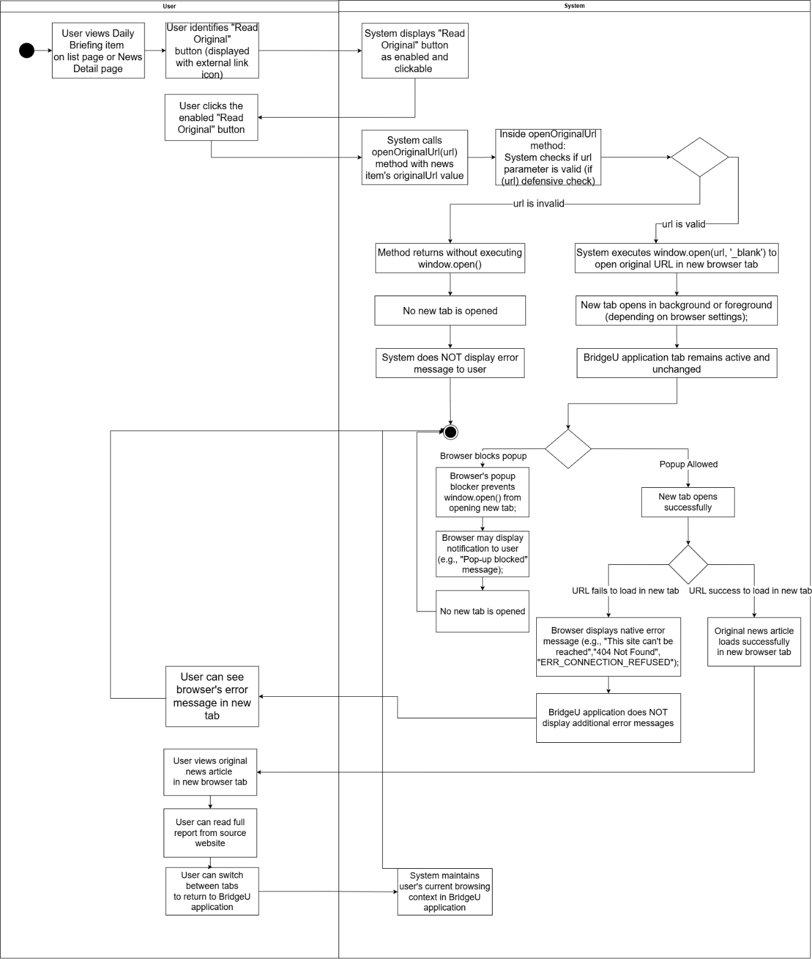

2.1.3.5 UCD05
URS‑05 – Filter Daily Briefings News by Date
The User can filter news based on specific criteria (start date and end date) while browsing.
- SRS27: The system shall provide a filter panel on the Daily Briefing list page (UI01) containing:
A “Start Date” picker (optional).
An “End Date” picker (optional).
A "Filter" action button.
A "Reset" action button that clears both date fields.
- SRS28: When the user clicks the "Filter" button, the system shall validate that:
If both dates are provided, Start Date ≤ End Date.
If validation fails, the system shall display an appropriate error message and shall not send a filter request to the backend.
- SRS29: When validation succeeds, the system shall send a filter request to the backend including the provided filter parameters:
`startDate` (optional)
`endDate` (optional)
- SRS30: The backend shall query the Daily Briefing data such that:
If `startDate` and/or `endDate` is provided, only news items whose publication date (`publishDate`) falls within the date range (inclusive) are returned.
If only `startDate` is provided, the backend shall set `endDate` to today.
If only `endDate` is provided, the backend shall set `startDate` to 30 days before the provided end date.
Results shall be paginated and ordered from newest to oldest by publication date (`publishDate` descending).
- SRS31: The system shall update the Daily Briefing list page (UI01) to display only the filtered news items, resetting the results view to the first page while preserving pagination controls for navigating through multiple result pages.

- SRS32: If no news items match the filter conditions, the system shall display an empty list and a user-friendly message "No news data available" while keeping the filter panel visible so that the user can adjust conditions and retry.

Use Case ID | UC-05
Use Case Name | Filter Daily Briefings News by Date
Created By | ZhiYi Pan |  | Last Update By | 14/01/2026
Date Created | 08/01/2026 |  | Last Revision Date
Actors | User
Description | User can filter Daily Briefing items by choosing an optional start date and an optional end date, and then browse only the items that meet these filter conditions.
Trigger | User is on the Daily Briefing list page (UI-01) and interacts with the filter panel (selects dates, then clicks the "Filter" button).
Preconditions | 1. User is logged into the BridgeU platform.  2. User has an active internet connection.  3. The Daily Briefing system has successfully crawled news from approved sources and stored publication dates.  4. The filter panel (date pickers) is visible on the Daily Briefing list page (UI-01).
Use Case Input Specification
Input | type | Constraint |  |  | Example
Start Date | Date | Must be a valid calendar date; must not be later than End Date |  |  | 01-01-2026
End Date | Date | Must be a valid calendar date; must not be earlier than Start Date |  |  | 03-01-2026
Post conditions | The Daily Briefing list page (UI-01) displays only news items that match the provided date conditions (if any), ordered from newest to oldest by publication date, with pagination.
Normal Flows | User |  | System
 | 1. User opens the Daily Briefing list page (UI-01) and sees the filter panel with date pickers.  3. User sets filter criteria (“Start Date” and/or “End Date”).  5. (Optional) User clicks the "Reset" button.  7. User clicks the "Filter" button.  13. User browses the filtered news list and can navigate between pages using pagination controls.  15. User may adjust filter criteria and click "Filter" again (or reset). |  | 2. System displays the filter panel with empty (optional) fields and shows the current news list (unfiltered), with pagination controls when multiple pages exist.  4. System updates the filter model accordingly.  6. System clears Start Date and End Date and refreshes the list as unfiltered (page reset to 1).  8. System validates the filter inputs (if both dates are provided, Start Date ≤ End Date).  [E1: Invalid date range]`  9. If validation passes, the system sends a filter request to the backend API including any provided parameters (`startDate`, `endDate`) and the current UI language (`lang`).  [E2: Authentication token invalid or expired]  [E3: Network timeout or connection error]  10. Backend queries the database for Daily Briefing items matching the provided conditions (date range on `publishDate`), orders results from newest to oldest by `publishDate`, and applies pagination.  [E4: Database error or server error]  11. Backend returns the filtered news list (with pagination data) to the frontend.  12. System updates the Daily Briefing list on UI-01 to show only filtered items (page reset to 1) and updates pagination controls accordingly.  [A1: No news match filter conditions]`  14. System loads and displays the corresponding page of filtered results while preserving the current filter conditions.  16. System repeats the validation-and-query flow with the new conditions.
Alternative Flow | A1: No news match filter conditions  A1.1 Backend returns an empty result set for the specified Filter (no records match date range conditions).  A1.2 System displays an empty list on the Daily Briefing page and shows a message "No news data available"  A1.3 Filter panel remains visible and retains the user's selected dates (if any) so that the user can easily adjust them.  A1.4 Use case ends or continues when the user modifies filter conditions and clicks "Filter" again.
Exception Flow | E1: Invalid date range  E1.1 System detects that Start Date is later than End Date during validation.  E1.2 System displays an inline validation error message (e.g., "Start date cannot be later than end date") near the date fields.  E1.3 System does not send a request to the backend.  E1.4 User can correct the dates and click "Filter" again (return to step 7).  E2: Authentication token invalid or expired  E2.1 System returns a 401 Unauthorized response (if authentication is required for this operation).  E2.2 Frontend detects the 401 error and clears the invalid token from localStorage.  E2.3 Frontend triggers an authentication error event and displays "Login expired, please log in again" message.  - E2.4 System redirects the user to the login page.  - E2.5 Use case ends.  E3: Network timeout or connection error  E3.1 The request to the backend times out or fails due to network issues.  E3.2 System displays an error message "Network request failed, please try again later"  E3.3 User may retry the operation by clicking a "Retry" button or by clicking "Filter" again; the system re-sends the request with the same filter parameters (return to step 9).  E4: Database error or server error  E4.1 Backend encounters an error while querying the database and returns a 500 Internal Server Error.  E4.2 Frontend displays an error message "Failed to fetch news"  E4.3 Backend logs the error details for administrator review.  E4.4 User may retry by clicking "Filter" again after adjusting conditions, or retry later.
Note | The filter panel allows users to set optional Start Date and/or End Date. When only one date is provided, the backend applies default date range logic (if only Start Date is provided, End Date defaults to today; if only End Date is provided, Start Date defaults to 30 days before the End Date).  Filtered results are displayed in chronological order (newest to oldest by publication date) and reset to page 1 when filter conditions are applied.  The filter panel remains visible after filtering, allowing users to adjust conditions and re-filter without losing their filter settings.  When the user clicks "Reset", all filter fields are cleared and the list is refreshed to show unfiltered results, resetting pagination to page 1.

AD-05
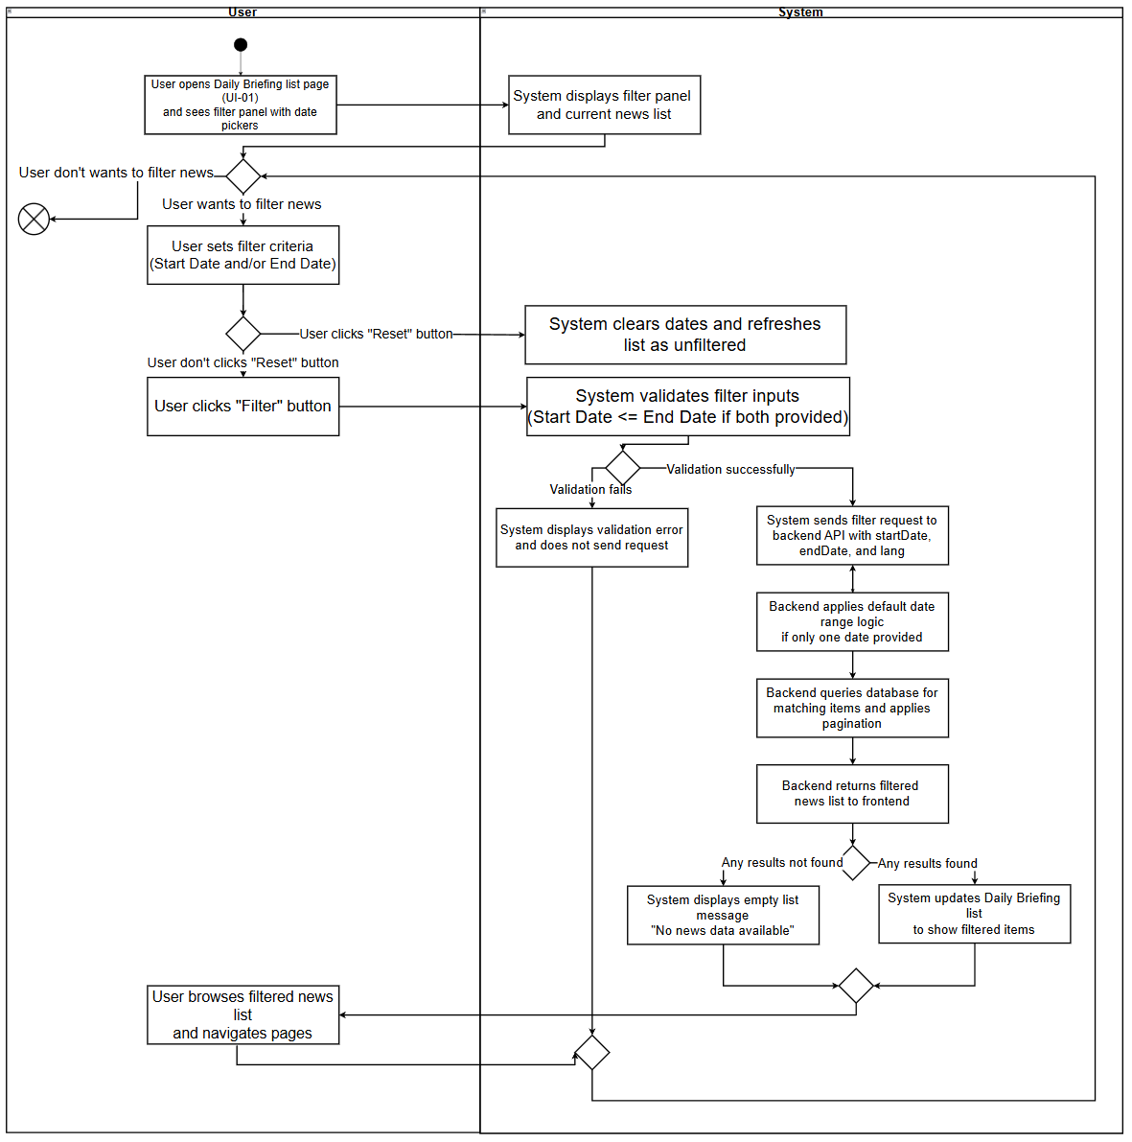
The Activity Diagram for Filter Daily Briefings News by Date illustrates the interaction between the “User“ and the “System” when the user filters Daily Briefing items by date range.

2.1.3.6 UCD06
URS06 – Search for Daily Briefing News
User can type Chinese or English keywords into a search box on the Daily Briefing page and view only Daily Briefing items that match the entered keywords.
- SRS-33: The system shall provide a search box on the Daily Briefing list page (UI-01) that allows users to enter keywords in Chinese or English. The search box shall have:
A text input field with placeholder text "Search by keywords (Chinese/English)..."
A search button (icon: "el-icon-search") that triggers the search when clicked.
Support for triggering search by pressing the Enter key.
A clear button that appears when the search box contains text, allowing users to clear the search keyword and trigger a new search.
- SRS-34: When the user enters keywords and triggers the search (by clicking the search button or pressing Enter), the system shall:
Trim whitespace from the keyword input.
Reset the current page to page 1.
Send a search request to the backend API including the keyword parameter (`keyword`) and the current UI language (`lang`).
If the user has also set date filter conditions (Start Date and/or End Date), the system shall include those parameters in the same request, allowing combined search and date filtering.
- SRS-35: The backend shall search for Daily Briefing items where the keyword matches any of the following fields (case-insensitive partial match):
`title` (original title)
`originalContent` (original content)
`summary` (AI-generated summary)
`titleZh` (Chinese translated title)
`titleEn` (English translated title)
`summaryZh` (Chinese translated summary)
`summaryEn` (English translated summary)

- SRS-36: The backend shall apply the search logic as follows:
If only a keyword is provided (no date filter), the system shall search across all historical news in the database.
If both keyword and date range are provided, the system shall search only within news items whose publication date (`publishDate`) falls within the specified date range (inclusive).
Results shall be “paginated” and ordered from newest to oldest by “publication date”(`publishDate` descending).
- SRS-37: The system shall update the Daily Briefing list page (UI-01) to display only the news items that match the search keyword, “resetting the results view to the first page” while preserving pagination controls for navigating through multiple result pages.
- SRS-38: If no news items match the search keyword (and any date filter conditions), the system shall display an empty list and a user-friendly message "No news data available" while keeping the search box visible and retaining the entered keyword so that the user can modify it and retry.
- SRS-39: When the user clears the search keyword (by clicking the clear button), the system shall:
Clear the search keyword from the input field.
Reset the current page to page 1.
Send a new request to the backend without the keyword parameter, effectively showing all news (or filtered by date range if date filters are active).

Use Case ID | UC-06
Use Case Name | Search for Daily Briefing News
Created By | ZhiYi Pan |  | Last Update By
Date Created | 08/01/2026 |  | Last Revision Date
Actors | User
Description | User can type Chinese or English keywords into a search box on the Daily Briefing page and view only Daily Briefing items that match the entered keywords. The search can be combined with date filtering to narrow down results.
Trigger | User is on the Daily Briefing list page (UI-01) and enters keywords into the search box, then clicks the search button or presses Enter.
Preconditions | 1. User is logged into the BridgeU platform.  2. User has an active internet connection.  3. The Daily Briefing system has successfully crawled news from approved sources and stored publication dates and content.  4. The search box is visible on the Daily Briefing list page (UI-01).
Use Case Input Specification
Input | type | Constraint |  |  | Example
Keyword | String | Can be Chinese or English characters; can contain spaces; will be trimmed of leading/trailing whitespace |  |  | "泰国" or "Thailand" or "travel"
Post conditions | The Daily Briefing list page (UI-01) displays only news items that match the entered keyword (and any date filter conditions if set), ordered from newest to oldest by publication date, with pagination.
Normal Flows | User |  | System
 | 1. User opens the Daily Briefing list page (UI-01) and sees the search box.  3. User types keywords (Chinese or English) into the search box.  5. User clicks the "Search" button or presses “Enter”.  12. User browses the search results and can navigate between pages using pagination controls.  14. User may modify the search keyword and click "Search" again (or clear the keyword).  16. (Optional) User clicks the “clear button” in the search box. |  | 2. System displays the search box with placeholder text and shows the current news list (unfiltered), with pagination controls when multiple pages exist.  4. System updates the search keyword model accordingly.  6. System trims whitespace from the keyword input.  [E1: Invalid keyword input]  7. System resets the current page to page 1.  8. System sends a search request to the backend API including the keyword parameter (`keyword`), any date filter parameters (if set), and the current UI language (`lang`).  [E2: Authentication token invalid or expired]  [E3: Network timeout or connection error]`  9. Backend searches the database for Daily Briefing items where the keyword matches any of the searchable fields (title, originalContent , summary, and all translation fields). If date filters are provided, the search is limited to items within the date range. Results are ordered from newest to oldest by `publishDate` and paginated.  [E4: Database error or server error]  10. Backend returns the search results (with pagination data) to the frontend.  11. System updates the Daily Briefing list on UI-01 to show only matching items (page reset to 1) and updates pagination controls accordingly.  [A1: No news match search keyword]  13. System loads and displays the corresponding page of search results while preserving the current search keyword and any date filter conditions.  15. System repeats the search flow with the new keyword.  17. System clears the search keyword, resets the current page to page 1, and sends a new request without the keyword parameter (showing all news or filtered by date range if date filters are active).
Alternative Flow | [A1: No news match search keyword]  A1.1 Backend returns an empty result set for the specified search keyword (and any date filter conditions).  A1.2 System displays an empty list on the Daily Briefing page and shows a message "No news data available" .  A1.3 Search box remains visible and retains the user's entered keyword so that the user can easily modify it and retry.  A1.4 Use case ends or continues when the user modifies the keyword and clicks "Search" again.
Exception Flow | [E1: Invalid keyword input]  E1.1 System detects that the keyword input exceeds the maximum allowed length (e.g., more than 200 characters) or contains invalid characters after trimming whitespace.  E1.2 System displays an inline validation error message near the search box (e.g., "Keyword is too long" or "Invalid characters in keyword").  E1.3 System does not send a request to the backend.  E1.4 User can correct the keyword and click "Search" again (return to step 5).  [E2: Authentication token invalid or expired]  E2.1 System returns a 401 Unauthorized response (if authentication is required for this operation).  E2.2 Frontend detects the 401 error and clears the invalid token from localStorage.  E2.3 Frontend triggers an authentication error event and displays "Login expired, please log in again" message.  E2.4 System redirects the user to the login page.  E2.5 Use case ends.  [E3: Network timeout or connection error]  E3.1 The request to the backend times out or fails due to network issues.  E3.2 System displays an error message "Network request failed, please try again later" .  E3.3 User may retry the operation by clicking the "Search" button again; the system re-sends the request with the same search parameters (return to step 8).  [E4: Database error or server error]  E4.1 Backend encounters an error while querying the database and returns a 500 Internal Server Error.  E4.2 Frontend displays an error message "Failed to fetch news".  E4.3 Backend logs the error details for administrator review.  E4.4 User may retry by clicking "Search" again after modifying the keyword, or retry later.
Note | The search functionality can be combined with date filtering. When both keyword and date filters are provided, the system searches only within news items that match both the keyword and the date range.  If only a keyword is provided (no date filter), the system searches across all historical news in the database.  Search results are displayed in chronological order (newest to oldest by publication date) and reset to page 1 when a new search is performed.  The search box remains visible after searching, allowing users to modify keywords and re-search without losing their search context.  When the user clears the search keyword, the system removes the keyword filter and shows all news (or filtered by date range if date filters are active), resetting pagination to page 1.

AD-06
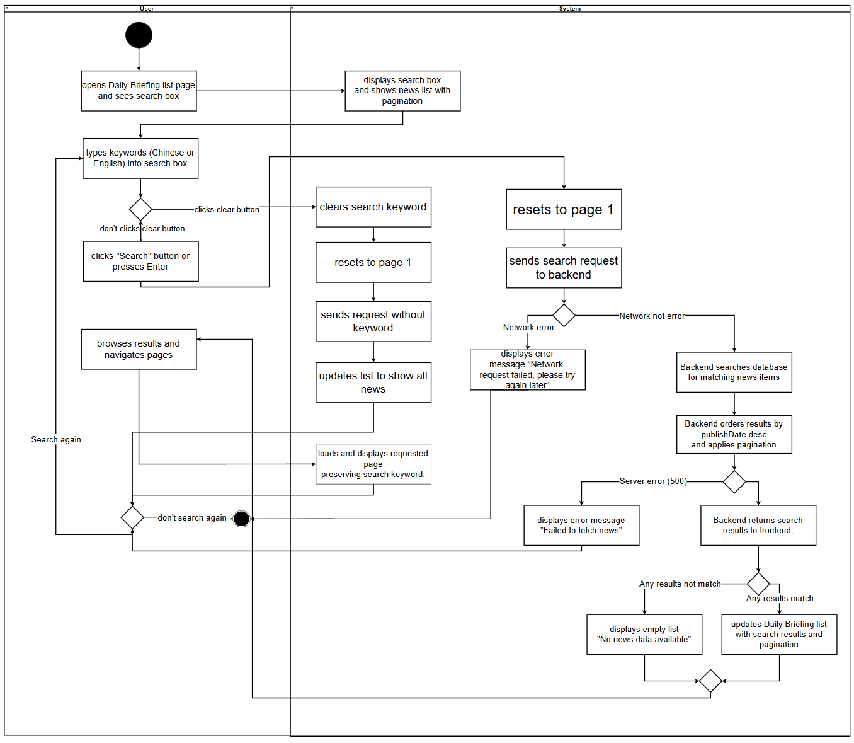
The Activity Diagram for Search for Daily Briefing News illustrates the interaction between the User and the System when the user searches for Daily Briefing items by entering keywords:

2.2.1 Use Case Diagram
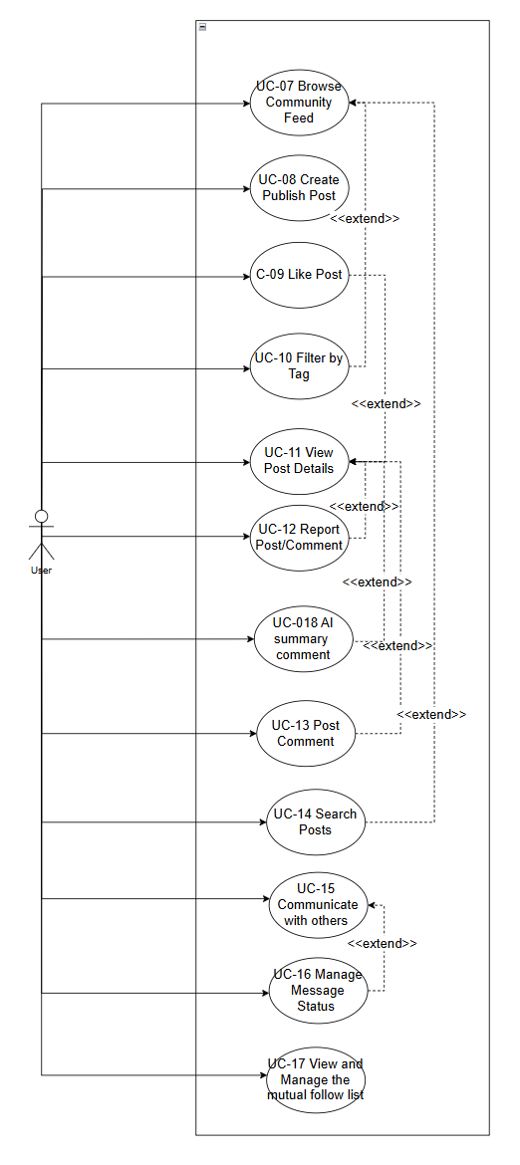

2.2.2 User Requirement Specification
- URS-07: The User can browse the community feed with posts ordered from newest to oldest, showing title, preview, tags, like count, and comment count.

- URS-08: The User can create or edit posts in their preferred language (Chinese, English), upload images, select a tag from predefined categories (Study, Housing, Travel, Part-time Job, Life Services), and have the system automatically generate bilingual (Chinese/English) content using Qwen AI for later display.

- URS-09 : The User can like or unlike posts to express feedback, and the like count updates immediately in the interface.

- URS-10: The User can filter posts in the community feed by selecting tags from the predefined list (Study, Housing, Travel, Part-time Job, Life Services).

- URS-11: The User can view post details including full text, images, tags, engagement metrics (likes, comments), and author profile when clicking on a post, in their current interface language.

- URS-12: The User can report posts/comments with structured reasons (Spam, Fraud or Scam, Illegal Service Promotion, Abusive Language, Other) and provide explanatory text.

- URS-13: The User can post comments to interact with other users, which will be automatically translated by the system into Chinese and English; users can delete their own comments.

- URS-14: The User can search posts by keyword across bilingual content (titles and body texts in both Chinese and English)。

- URS-15: Users who follow each other mutually can send and receive private messages and view message history.
- URS-16: The User can manage message status in conversations, including marking messages as read and deleting messages for themselves.

- URS-17： The User can manage mutual follow relationships: search for users, view profiles, follow/unfollow users, and view mutual follow lists.

- URS-18 : The User can view AI-generated summaries of all comments under a post in their chosen language.

Use Case ID | UC-08
Use Case Name
Created By | ZhiYi Pan |  | Last Update By
Date Created |  |  | Last Revision Date
Actors
Description
Trigger
Preconditions
Use Case Input Specification
Input | type | Constraint |  |  | Example
Post conditions
Normal Flows | User |  | System
Alternative Flow
Exception Flow
Note

