BridgeU
Project Proposal

Zhiyi Pan 652115558

Bachelor of Science
Software Engineering Program

Department College of Arts, Media, and Technology Chiang Mai University November 2025

Project Advisor
Asst. Prof. Pattama Longani, Ph.D.

Table of content

Chapter 1 | Introduction 4
Chapter 2 | Target User and Soulation 5
2.1 Target User 5
2.1.1 Chinese International Students: Deeply Dependent on a Closed Digital Ecosystem 5
2.1.2. Global International Students: Seeking Cross-Cultural Exchange and Resources 6
2.1.3. Local Thai Merchants & Service Providers 6
2.2 Proposed Solutions 6
2.2.1. Bilingual AI Commercial Bridge 7
2.2.2. AI-Powered Hybrid Auto-Moderation 7
2.2.3. Automated Intelligence Robot 8
Chapter 3 | User Journey 8
3.1 The user journey of international students 8
3.2 The user journey of admin 18
Chapter 4 | Business Review 20
4.1. Overview 20
4.2 Target 21
4.2.1 Problems 21
4.2.2 Solutions 23
4.2.3 Benefit 23
Chapter 5 |Software Review 25
5.1 Facebook Groups 25
5.2 Xiaohongshu (Little Red Book) 26
5.3 reddit 27
5.4 Feature Comparison 28
Chapter 6 | Aims and Objective 28
6.1 Aims 28
6.2 Objective 28
Chapter 7 | System Architecture 29
Chapter 8 | Feature 30
Chapter 9 | Limits 31
Chapter 10 | Milestone 32
Chapter 11 | References 34

Chapter 1 | Introduction
In Thailand's diverse educational landscape, university campuses are home to students from all over the world - although this community is vibrant and multicultural, it faces a distinct crack.
The group of international students is actually split into two huge and disconnected circles:
- The Chinese Sphere: Chinese international students account for nearly 50% of the international student population. Due to language habits, they often rely on WeChat and live in a relatively closed Chinese-speaking environment.
- The Global Sphere: Students from all other countries (such as Germany, Nigeria, Myanmar, the United States, etc.) mainly use English as Lingua Franca for daily communication and socializing (Facebook/WhatsApp).
In addition to language isolation, the existing information ecosystem also suffers from serious "content bias". The current social media platforms (such as Instagram, Xiaohongshu, and TikTok) are overly flooded with "travel-oriented" content - screens are filled with popular coffee shop check-ins, photo tips for Zhengwang Temple, and recommendations for night market delicacies. However, for international students who need to live in Thailand for a long time, the "essential survival information" they truly need is extremely scarce and hard to find. For instance, few bloggers would elaborate on "the specific materials for student visa renewal", "the course selection and withdrawal regulations of universities", or "where to purchase essential daily necessities for long-term living alone (such as transformers and mosquito repellent). The "essential survival needs" of international students have been overlooked. In addition, there is a huge problem of "economic opportunity mismatch" : many local Thai residents (landlords, second-hand motorcycle sellers) find it easier to do business with Chinese students studying abroad, but due to their inability to speak Chinese and not using wechat, they are completely unable to reach this large customer base.
To address these challenges, we have launched BridgeU, a bilingual AI mutual assistance platform specifically designed for all international students and local service providers in Thailand.
BridgeU not only serves students but also acts as a "local economic accelerator". We utilize the Chinese-English translation function provided by Aliyun Qwen AI of Alibaba Cloud to enable Thai landlords and car dealership owners who do not understand Chinese to post supply and demand information in simple English and directly reach tens of thousands of Chinese students studying abroad. BridgeU makes life more convenient for international students and also provides local Thais with a new way to earn money.

Chapter 2 | Target User and Soulation

2.1 Target User
This project targets three core groups within Thailand's international education ecosystem, addressing the specific dilemmas faced by each:

2.1.1 Chinese International Students: Deeply Dependent on a Closed Digital Ecosystem
This group constitutes the largest demographic of international students in Thailand but faces severe "digital tribalization".
- The Dilemma of Information Silos: Due to a long-term reliance on WeChat for information acquisition, they exist in a parallel digital world, isolated from other international students who predominantly use Facebook and Instagram.
- Survival Information Lag and Blind Spots: The vast majority lack advanced Thai reading skills. Consequently, they face significant "blind spots" regarding official announcements from the Thai Immigration Bureau, university administrative notifications, and sudden social news, which are typically prioritized in Thai or English. They are forced to rely on "second-hand information" passed down through WeChat groups, which is highly prone to distortion and rumors.
- Cost of Living Premium: Lacking direct channels to contact local merchants, they are compelled to rely on gray intermediaries for housing and vehicle rentals, suffering from long-term financial losses due to inflated prices caused by information asymmetry .

2.1.2. Global International Students: Seeking Cross-Cultural Exchange and Resources
This group includes students from Europe, the Americas, and Southeast Asia who primarily communicate in English and are active within the Facebook and WhatsApp ecosystems.
- Resource Mismatch: Although they may possess idle resources (e.g., textbooks, second-hand goods), they cannot reach the massive Chinese student market. This leads to a situation where "supply and demand exist on both sides but remain invisible to each other due to platform barriers," resulting in resource waste.
- Social Segregation: Existing platform barriers hinder deep academic exchange and cultural interaction with the Chinese student community, which makes up nearly half of the international student population.

2.1.3. Local Thai Merchants & Service Providers
This group comprises local landlords, second-hand car dealers, and SME owners who hold high-quality local resources but face bottlenecks in market reach.
- Dual Barriers of Language and Channel: Unable to speak Chinese and not using WeChat, they cannot directly connect with their largest potential customer base—Chinese international students.
- Compressed Profit Margins: Current market mechanisms force them to rely on intermediaries to acquire customers. This not only erodes their profits through commissions but also renders their final prices less competitive due to intermediary markups, leading to market inefficiency and unfairness .

2.2 Proposed Solutions
To address the aforementioned issues of "information silos," "trust crises," and "resource mismatch," BridgeU proposes a comprehensive technical solution driven by AI.

2.2.1. Bilingual AI Commercial Bridge
Addressing the commercial divide caused by language barriers, the system deeply integrates Alibaba Cloud's Qwen Large Language Model (LLM) to construct a seamless cross-language transaction environment.
- Breaking Commercial Language Barriers: This feature allows Thai merchants who do not understand Chinese to post property or product listings in simple English. The system automatically translates these into accurate Chinese for Chinese students. This mechanism eliminates dependence on intermediaries, allowing merchants to reach the Chinese market directly while enabling students to access services at lower, local prices.
- Facilitating Cross-Community Fusion: Beyond commerce, the translation engine empowers daily communication between Chinese students and other international students, dismantling social isolation based on nationality.

2.2.2. AI-Powered Hybrid Auto-Moderation
To tackle scams and trust issues caused by the lag in manual moderation within existing groups, the platform builds a dual-layer defense system combining "AI Intelligent Pre-screening + Human Review".
- 24/7 Intelligent Risk Control: The AI model performs real-time pre-screening of every text and image post, automatically identifying and intercepting potential currency exchange scams, ghostwriting advertisements, hate speech, and pornographic content. This resolves the issue of regulatory vacuums during nighttime hours and enhances overall community trust.
- Human-Machine Synergy: The AI does not completely replace humans but acts as a high-efficiency filter for clear-cut violations. Ambiguous or low-confidence content is automatically flagged and escalated to human administrators for final judgment . This hybrid model ensures high accuracy while significantly reducing manual maintenance costs.
- Trusted Social Mechanism: The platform introduces a "Mutual Follow" mechanism to filter out invalid or harassing social requests, ensuring that every private communication is based on the mutual consent of both parties.

2.2.3. Automated Intelligence Robot
To solve the problems of information lag and the spread of rumors, the system deploys automated crawler robots on the backend.
- Aggregation of Authoritative Sources: The robots regularly crawl authoritative English media (such as the Bangkok Post) and government official websites.
- Generation of Survival Intelligence: Using AI technology, the crawled content is automatically summarized and distilled to provide students with accurate, non-hearsay "survival intelligence". This ensures students are timely informed of visa policy changes and legal regulations, effectively avoiding legal risks caused by information asymmetry.

Chapter 3 | User Journey

3.1 The user journey of international students
The journey begins when a user (e.g., a Chinese international student or a local Thai landlord) navigates to the BridgeU web address. They are presented with a clean and accessible Login Interface, as shown in Figure 1.（Here, we will first demonstrate it on the English page）.User can choose to log in and register as a student or merchant
Understanding that language is the first barrier to entry, the platform features a prominent Language Toggle button in the top-right corner.
- Action: The user can simply click to switch the interface language between English and Chinese .
- Result: Upon selection, the entire page content—including the slogan "Connecting Students & Local Life", input labels, and navigation buttons—instantly updates to the selected language.
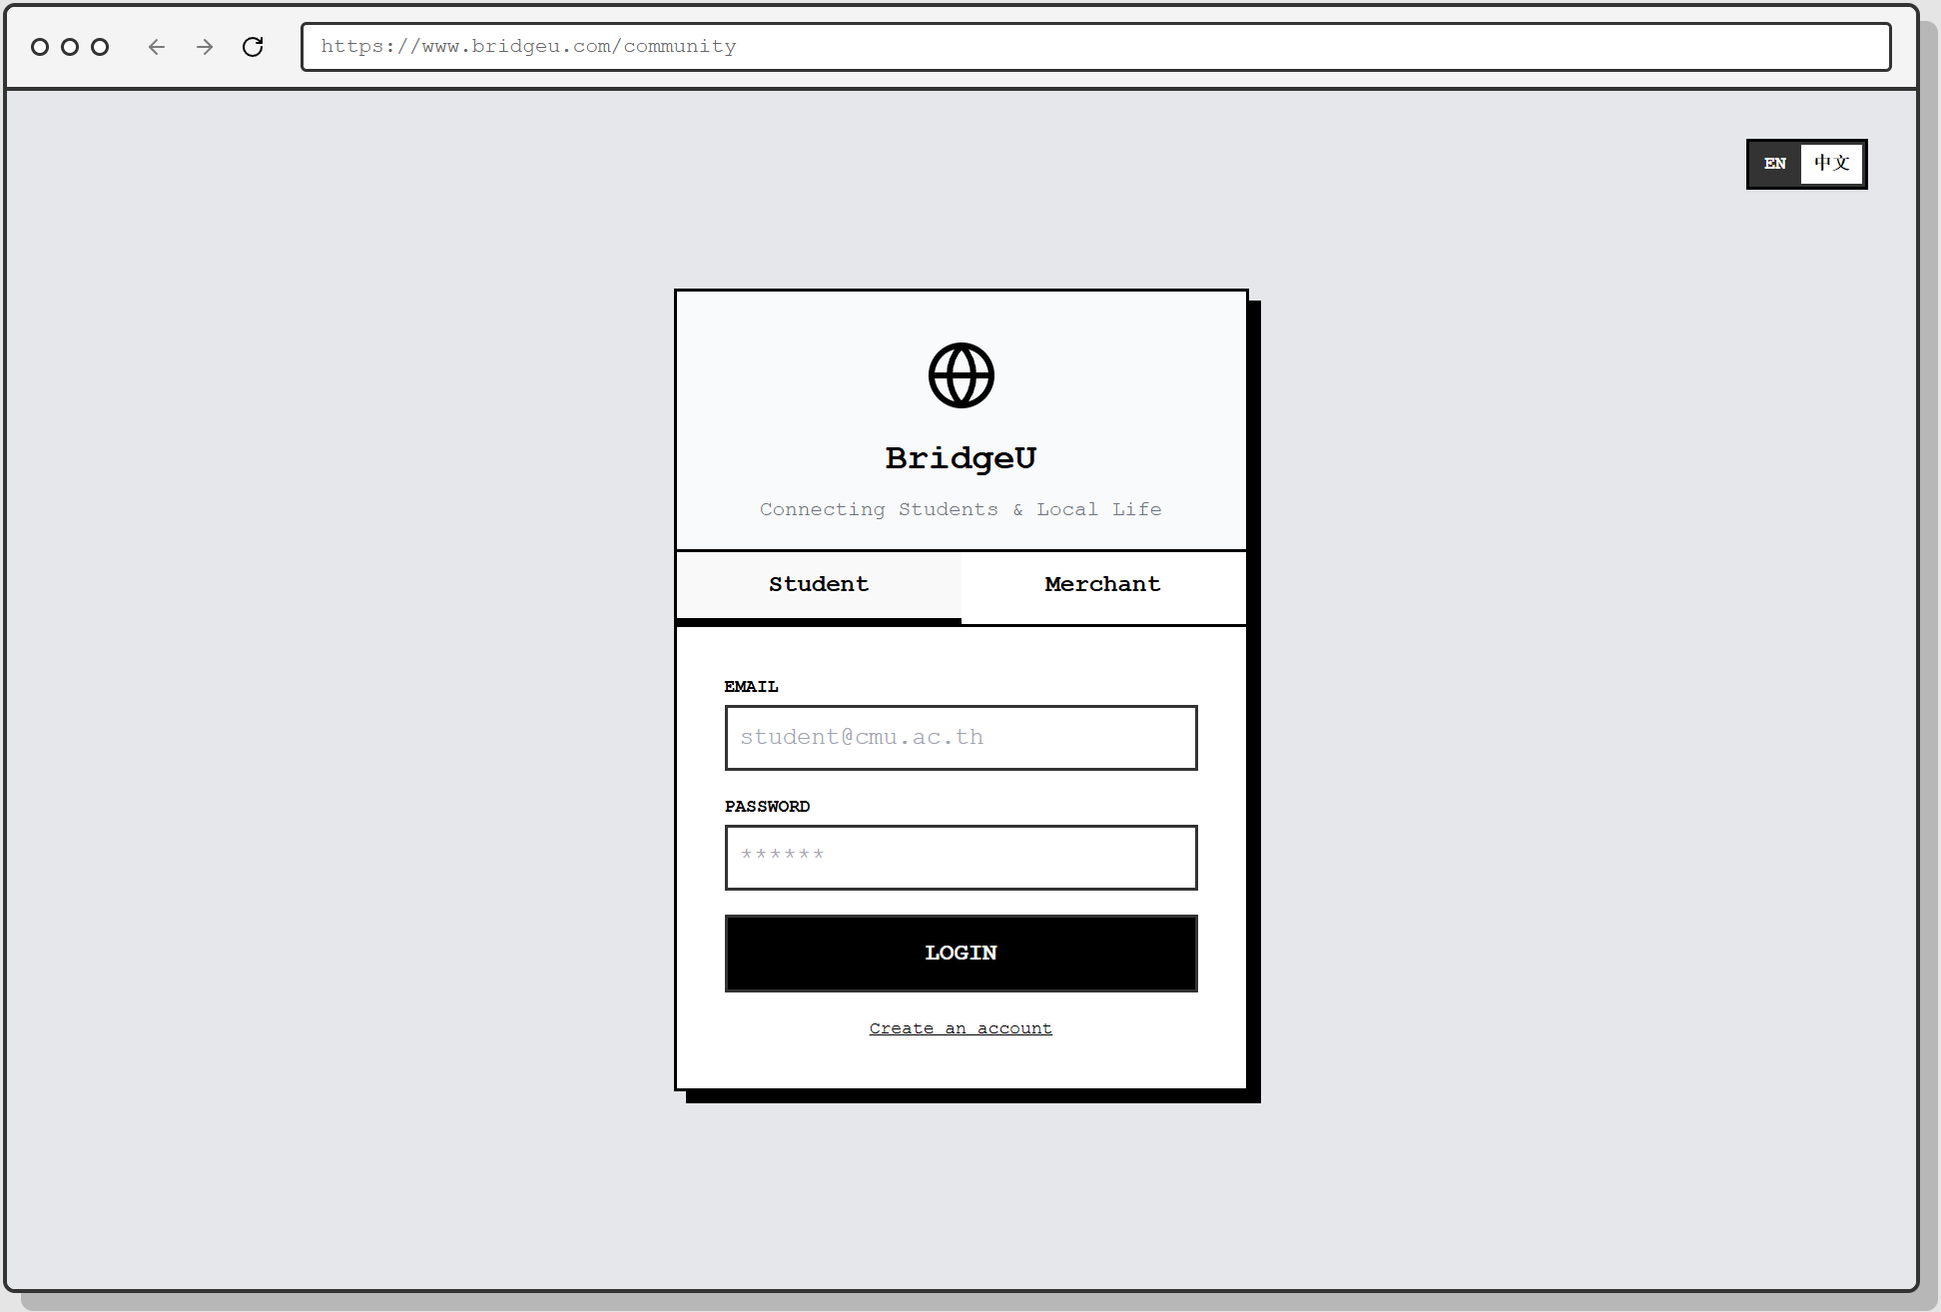
Figure 1 loginpage01

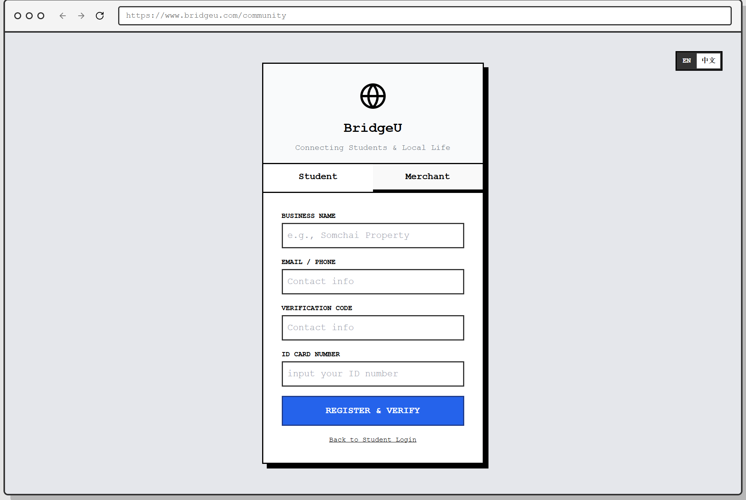
Figure 2 loginpage02
Upon entering the main Community Homepage, the user is not just presented with a list of posts, but with a structured and intelligent information hub, as shown in Figure 3
- Daily Briefing (Automated Info-Aggregator): At the very top, a special card labeled "DAILY BRIEFING" grabs the user's attention. This content is automatically crawled from authoritative external sources (e.g., Bangkok Post, CMU Official) by the system's robot. The integrated AI then processes this raw data to generate a concise summary and translates it into both English and Chinese (e.g., "Thailand approves new 10-year LTR visa"). This proactively pushes critical "trends" to the user, solving the "information gap" problem.
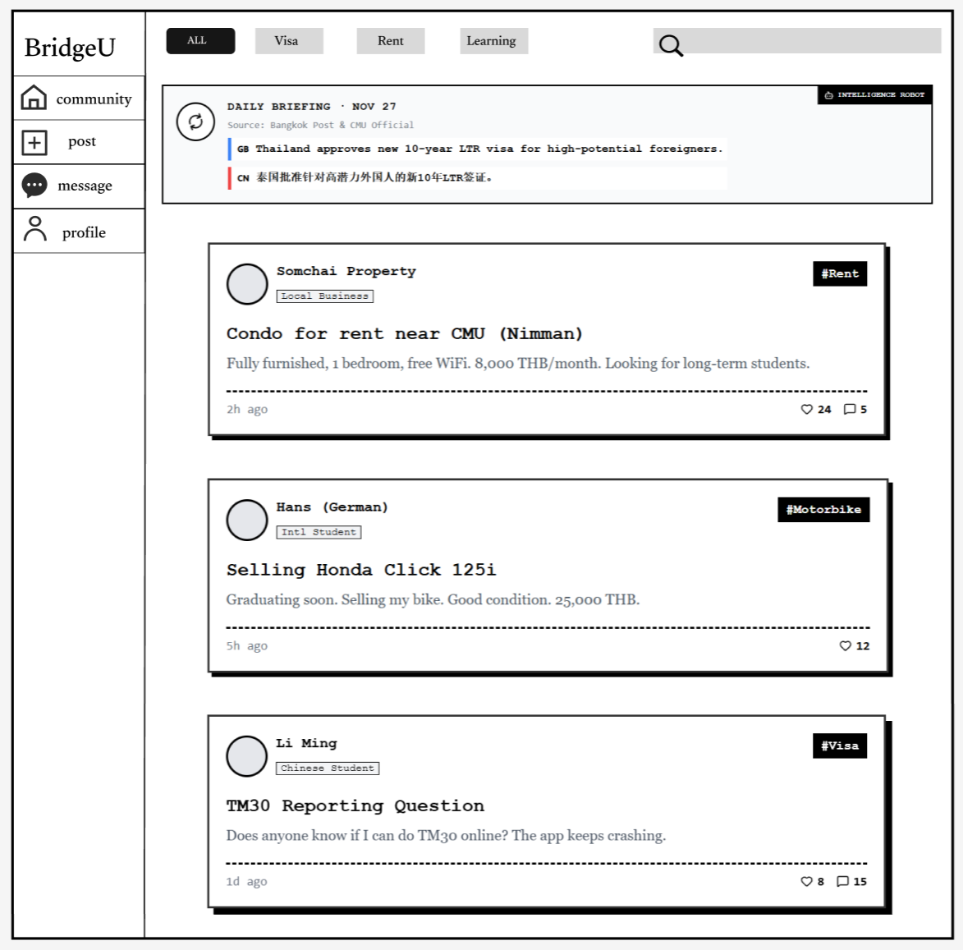
Figure 3 communityPage

Interested in a specific listing, such as the "Condo for rent near CMU," the user clicks on the card to enter the Post Detail Page.
As shown in Figure 4, this page offers a focused view of the information:
- Author Verification: The author, "Somchai Property," is clearly tagged as a "Local Business", helping the user assess credibility. A "Follow" button is prominently placed next to the profile.
- Engagement: The user can read the full description and view existing discussions in the Comments section.
- Gated Communication: To prevent harassment, the "Contact Host" section on the right features a "Chat Now" button. " Requires Mutual Follow"*. This reminds the user that they cannot send private messages immediately; they must first click "Follow" and wait for the host to follow back, ensuring a consensual connection before chatting.
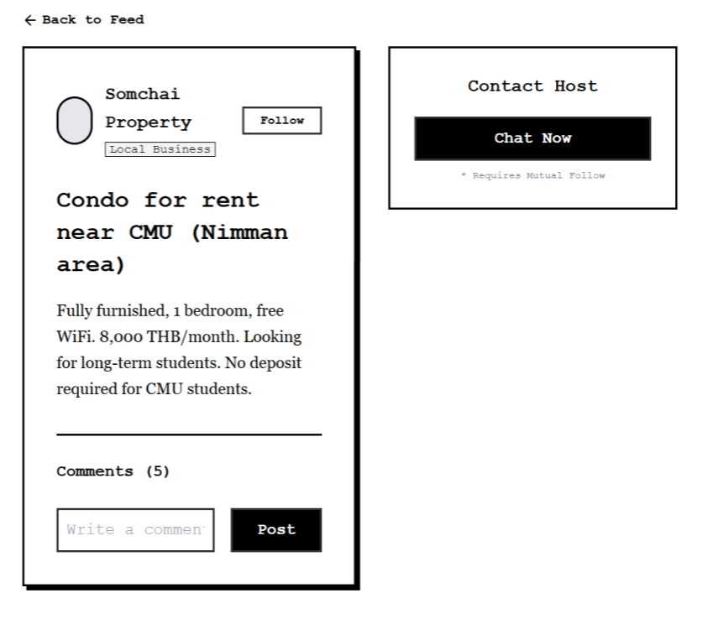
Figure 4 postPage
The user decides to contribute to the community by sharing a question or experience. They navigate to the "Post" tab.
To maintain a healthy community environment without relying on 24/7 manual moderation, BridgeU integrates an AI-Powered Content Moderation system that works in real-time.
1. The user selects a mandatory tag (e.g., #Learning) and inputs their text. Upon clicking "Publish Now", the system enters a "Processing" state. A prompt "AI is scanning for scams & hate speech..." appears, indicating that the content is being analyzed by the backend LLM engine before entering the database.
2. Intelligent Interception (The "Guard"): In a scenario where a user attempts to post illegal language (as seen in Figure 6), the AI detects the violation immediately. The system blocks the request and displays a red warning: "Blocked: Content contains prohibited word." This proactive measure filters out toxic content at the source.
3. Successful Publication: When the content is verified as safe (e.g., "how to learning English"), the system displays a green "Safe Content" confirmation, and the post is successfully published to the community feed (as shown in Figure 7).
4. If the ai is unsure whether there is a violation, it will feed back to the human administrator, who will handle it manually
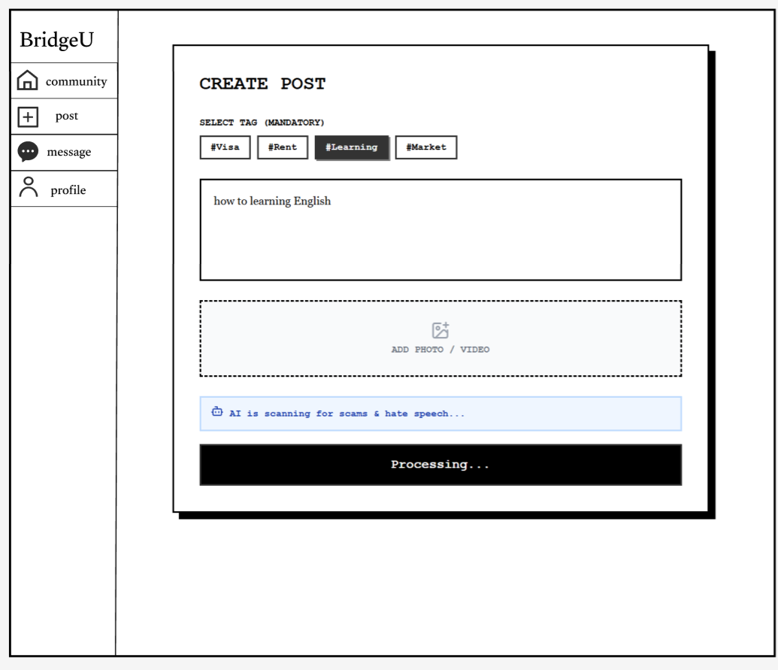
Figure 5 CreatePosstPage01
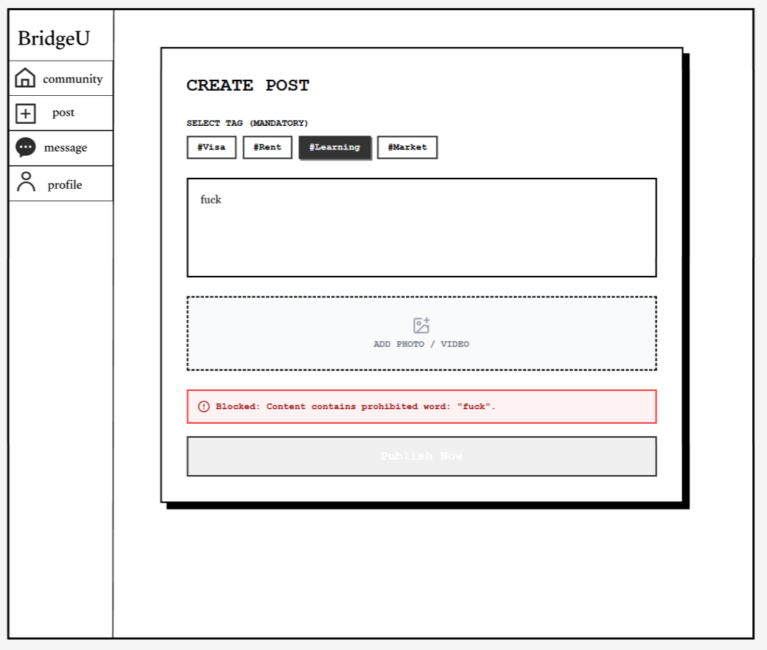
Figure 6 CreatePosstPage02
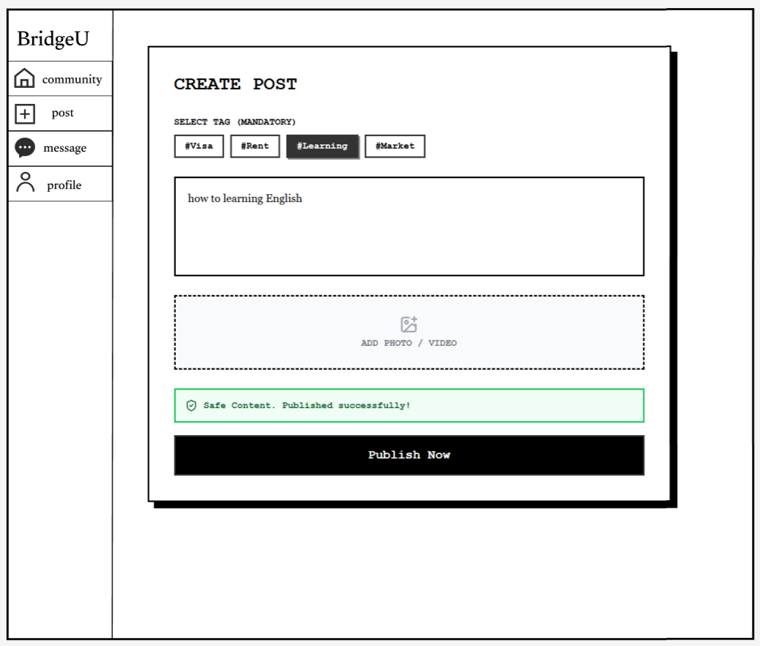
Figure 7 CreatePosstPage03
The user navigates to the "Message" tab to check their conversations.As shown in Figure 8, the Message List provides a clear overview of active conversations.
- Safety Cue: A "Stranger" tag might appear for users who haven't mutually followed each other yet, reminding the user of the platform's safety protocols.
Clicking on a conversation opens the Chat Interface (as seen in Figure 9).
- Real-time Interaction: The user can exchange text messages with the host (e.g., "Is the room still available?"). 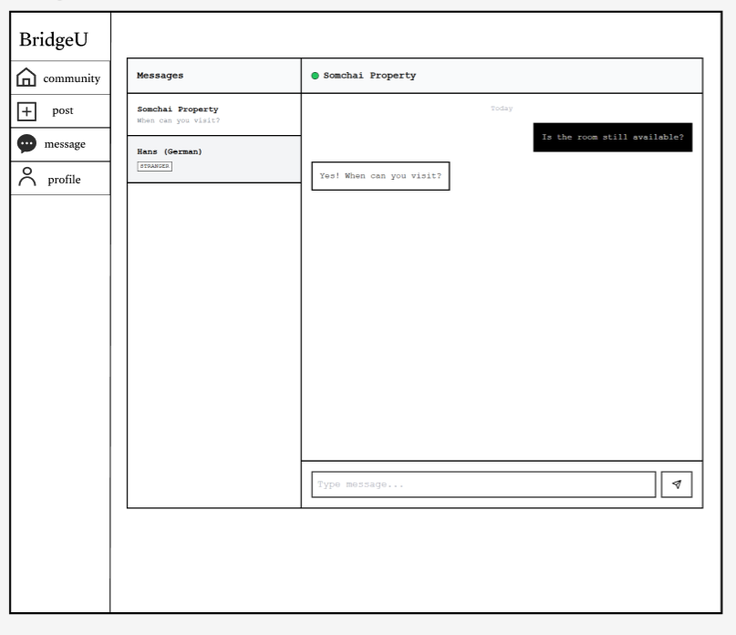
Figure 8 MessagePage01
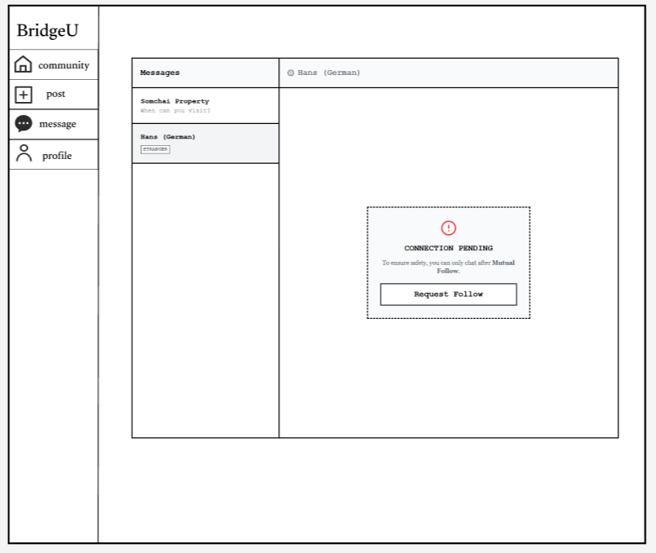
Figure 9 MessagePage02

The user navigates to the "Profile" tab.
As shown in Figure 10, the Profile Page serves as the user's identity card within the community.
- Activity Log: The "My Posts" section acts as a history log, allowing the user to track their requests (e.g., "#Rent Looking for 1-bedroom condo") and interactions.
- Social Stats: The "Following" and "Followers" counts reflect the user's social standing and credibility.
To update their information, the user clicks the "Edit Profile" button. This opens the Edit Interface as seen in Figure 11.
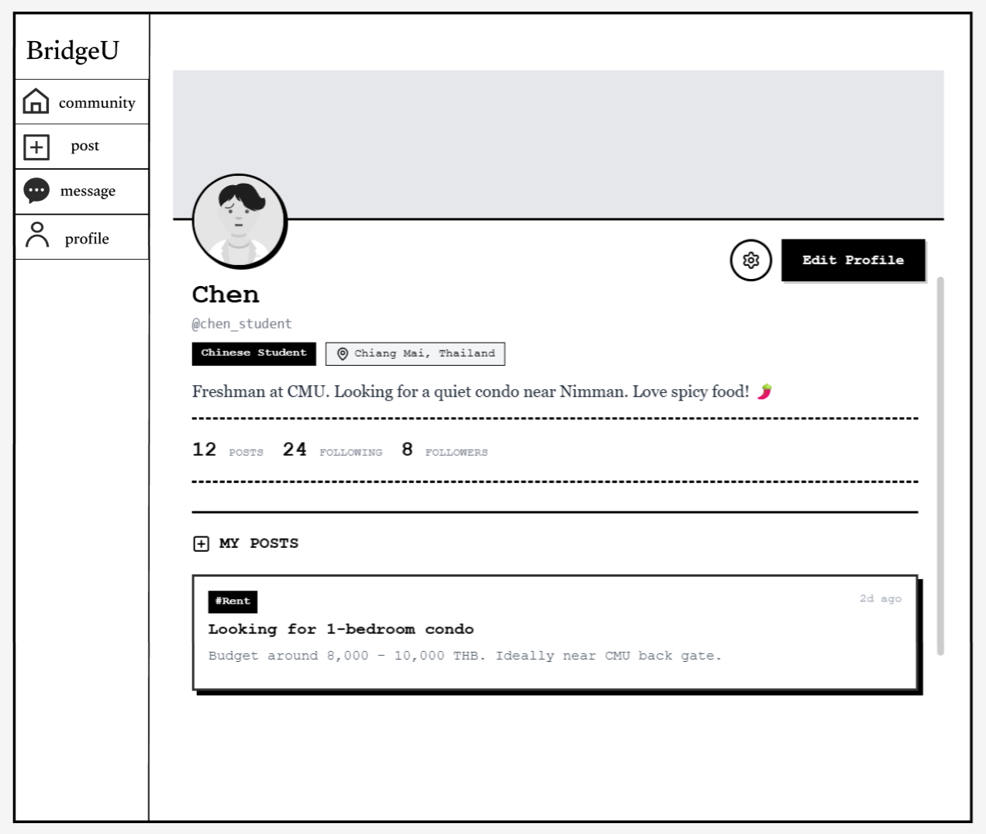
Figure10 ProfilePage

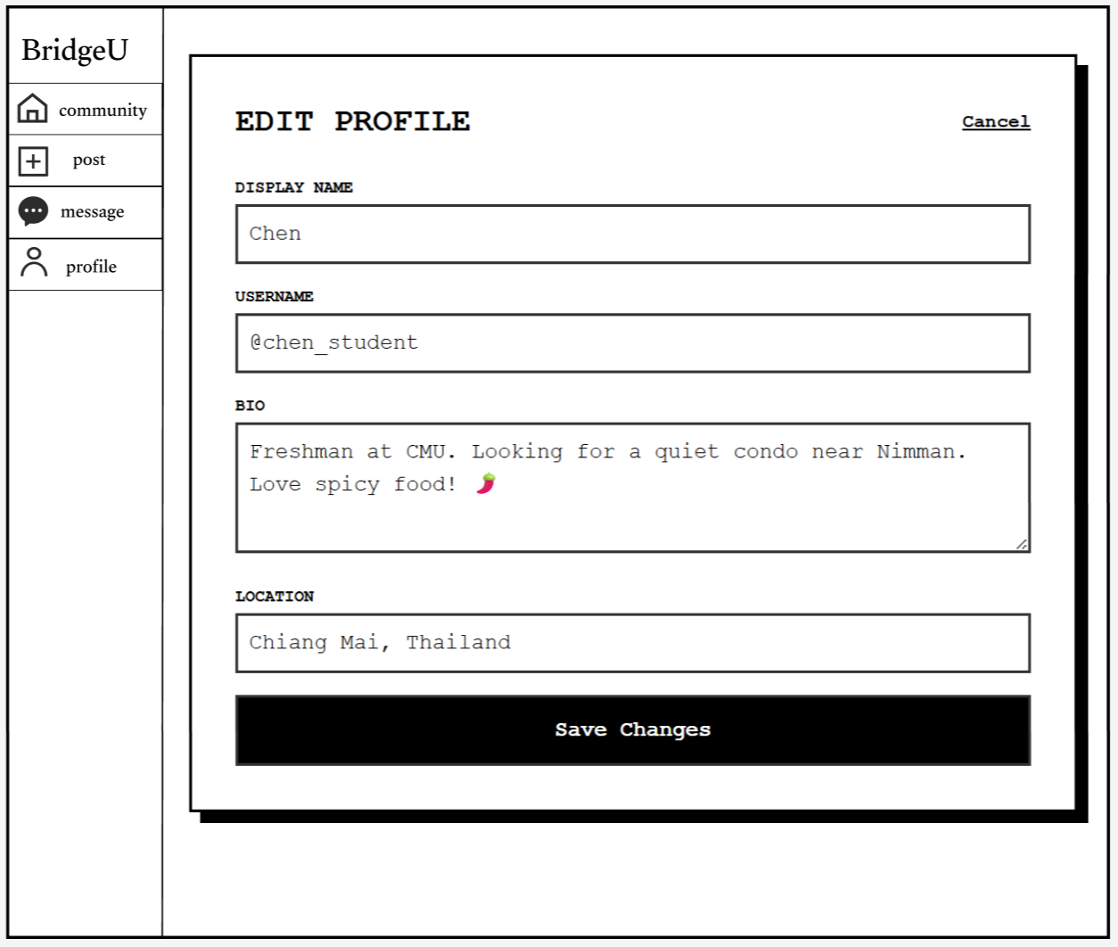
Figure 11EditProfilePage

3.2 The user journey of admin
Upon logging into the “Admin Dashboard”, the administrator immediately assesses the community's status through real-time statistics (9 users, 109 posts) and quickly identifies a critical workflow priority via the yellow "Pending" indicator.
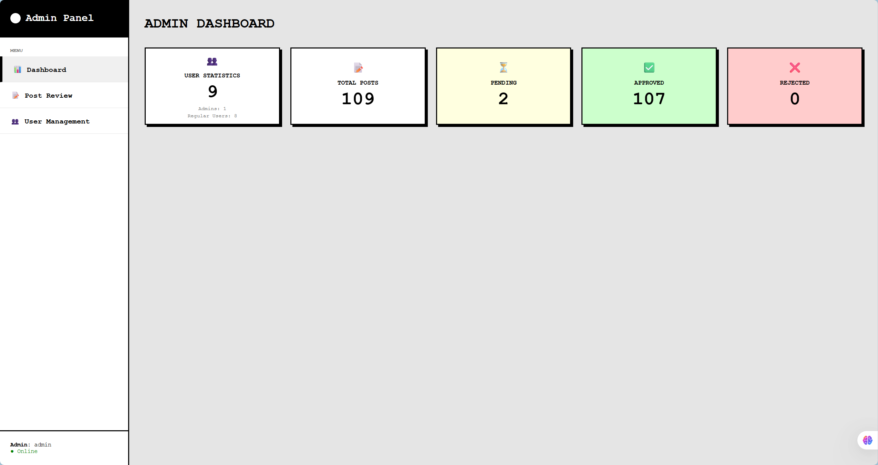
Figure 12 DashboardPage
Enter the post review page, where administrators can review posts
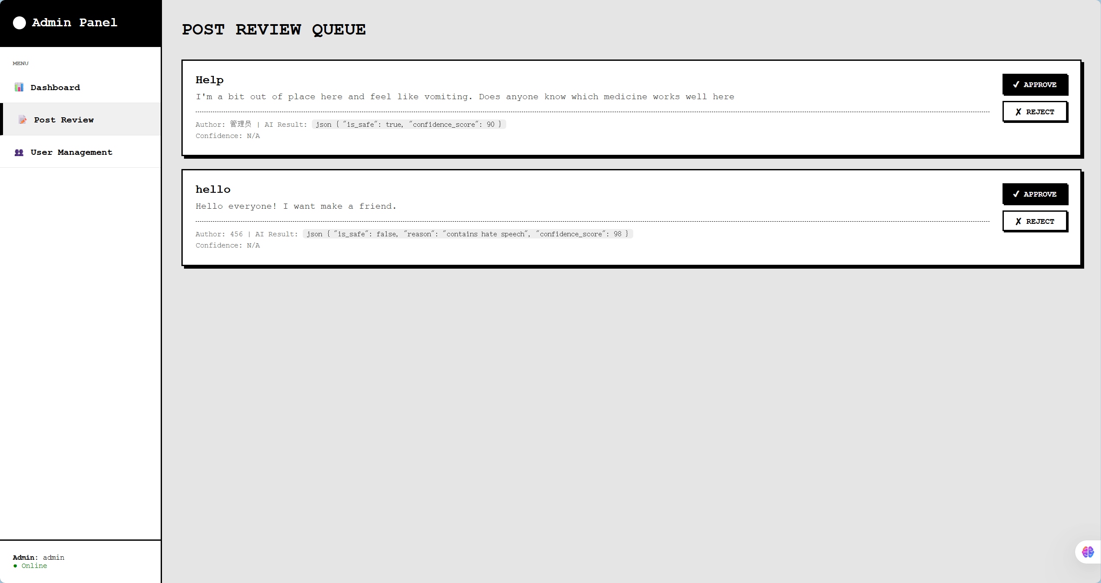
Figure 13 PostReviewPage
Administrators can view the usernames, bound email addresses, current roles and account statuses of all registered users, unblock users who have been disabled or successfully appealed, and suspend the accounts of users who violate the rules
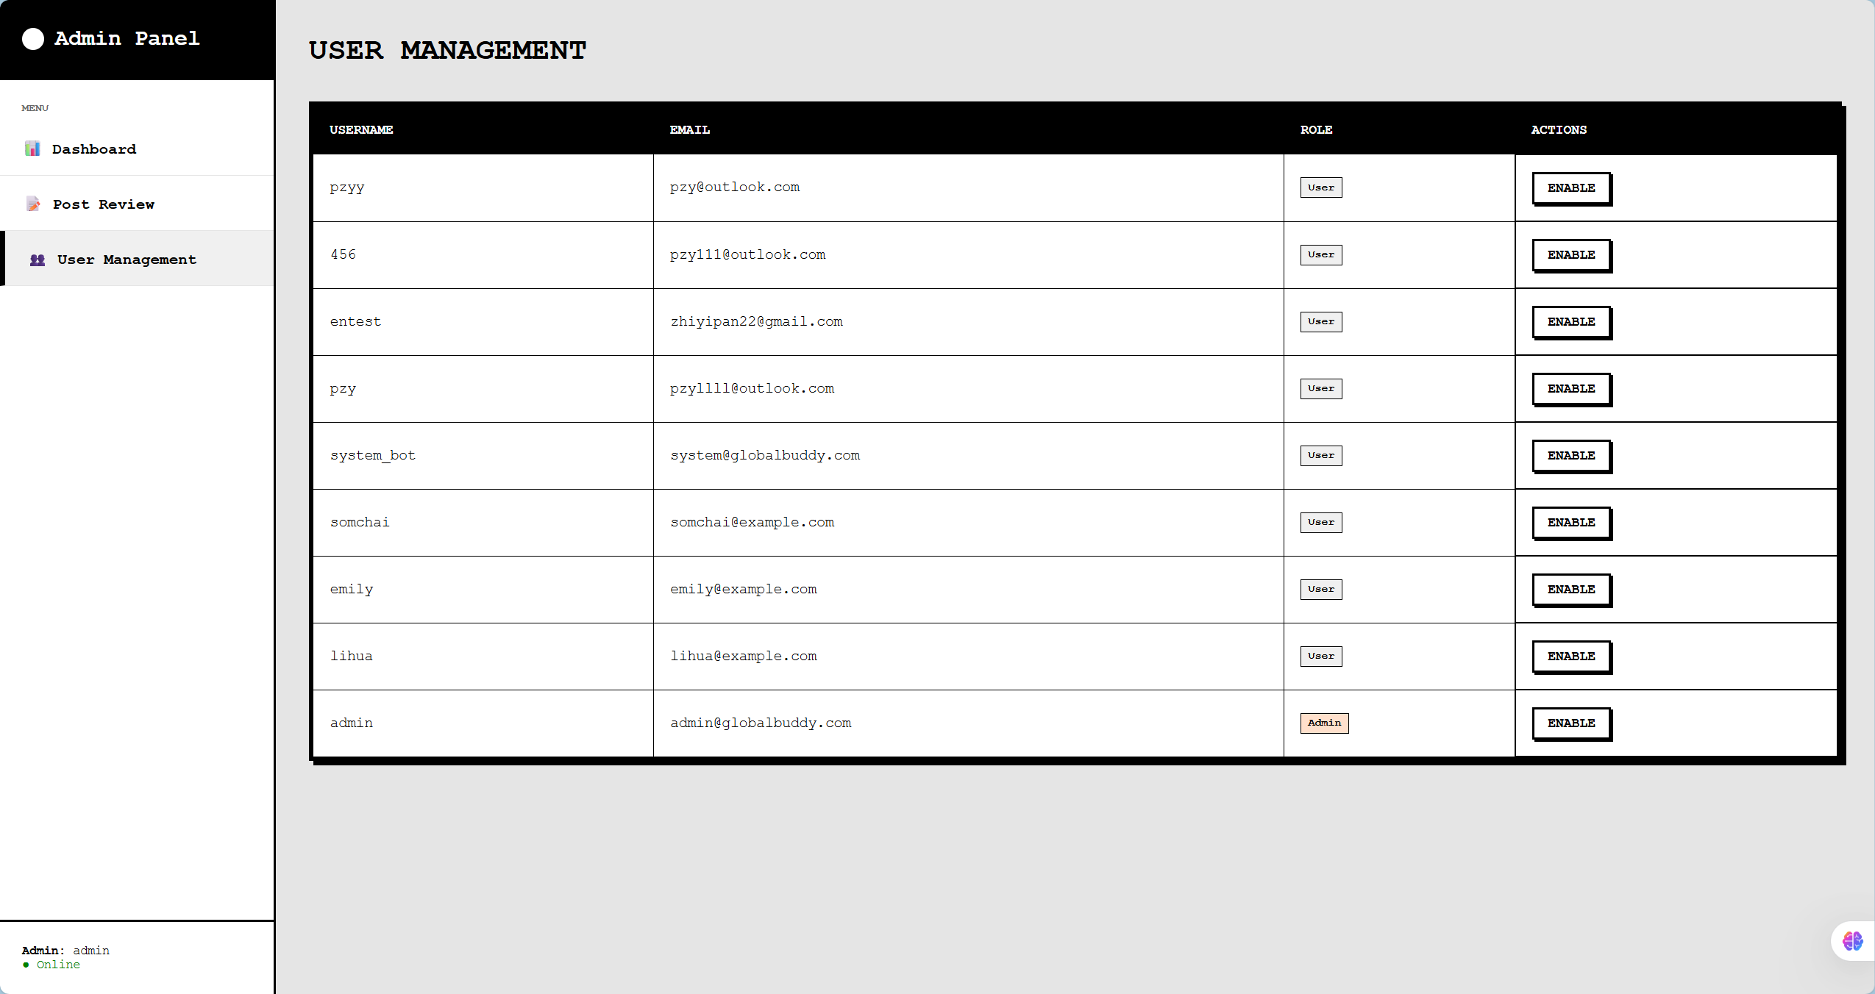
Figure 14 UserManagementPage

Chapter 4 | Business Review

4.1. Overview

Figure 15 International students in Thai
In today's international education landscape of Thailand, university campuses have become a melting pot of diverse cultures, gathering students from China, Europe, Africa, America and Southeast Asia. However, when these international students are in a foreign land, they all face the resource islands caused by language barriers and the extreme scarcity of survival information.
At present, the group of international students is actually divided into two parallel worlds:
- The Chinese-speaking circle centered on WeChat: Nearly 50% of Chinese students studying abroad live in a relatively closed Chinese-speaking environment.
- The global English-speaking circle centered on Facebook/WhatsApp: Students from Europe, Africa and other Asian countries mainly communicate in English.
This fragmentation has led to an all-round "mismatch of resources and opportunities" : A German student sells original textbooks on Facebook but fails to reach Chinese students who urgently need to buy books; A Chinese student wanted to find a roommate to share the rent, but missed the Nigerian student who was looking for a place to live because he only posted on wechat. At the same time, local businesses in Thailand have also lost huge business opportunities due to their inability to bridge these two platforms.
Furthermore, no matter which country the international students come from, the existing social media platforms fail to meet their needs. These platforms overly cater to the "tourist perspective", filled with popular check-in tips for Internet celebrities, while the key information that truly concerns the "long-term survival" of international students (such as visa regulations, school rules, and the purchase of essential daily necessities) is hard to find.
To address these universal challenges, we have launched BridgeU - an AI-driven bilingual mutual assistance platform for international students in Thailand. BridgeU not only serves Chinese students but is also committed to becoming a hub connecting international students with the local community. By using Alibaba Cloud's large model (Qwen AI), it breaks down the language barriers between Chinese and English, enabling Chinese students to understand the world and the world to understand Chinese students. At the same time, use ai to aggregate authoritative survival intelligence. Our goal is to empower every student studying in Thailand, regardless of nationality, to break boundaries, access genuine survival resources and achieve true international integration.

4.2 Target

4.2.1 Problems
- At present, among the international students in Thailand, there exists a serious phenomenon of "digital tribalization" and information silos caused by cross-platform interaction. Chinese students studying abroad rely heavily on WeChat for socializing and information acquisition, while those from Europe, America and other Southeast Asian countries are mainly active on Facebook and Instagram. This kind of platform isolation based on nationality and usage habits has led to the international student community being divided into two parallel worlds that are not connected to each other. The obstruction of information flow makes it impossible for resources to be shared on a broader scale (such as second-hand goods trading, house subletting, academic exchanges, etc.), resulting in the idleness and waste of resources where "there is demand on one side and supply on the other, but they are not visible to each other due to platform barriers".
- The gap in local business services and the monopoly of intermediaries: In the local life service sector, there is a lack of a direct and transparent bilingual communication channel between local Thai merchants and international students. Due to language barriers (Thai/English/Chinese) and the mismatch of information channels, a large number of high-quality local small and medium-sized businesses (such as restaurants, car rentals, and accommodations) are unable to directly reach the group of international students. This information asymmetry has given rise to a large number of gray intermediaries who profit from the "information gap". These intermediaries often monopolize housing or vehicle resources, making huge profits by raising prices. This not only increases the living costs of international students but also compresses the profit margins of local businesses, leading to inefficiency and unfairness in the market mechanism.
- Lagging manual supervision and trust crisis: The existing Facebook groups or wechat groups mainly rely on manual administrators for review, which is extremely inefficient and subjective. A large number of currency exchange frauds, ghostwriting advertisements and pornographic information are rampant at night and cannot be dealt with in time, resulting in extremely low community trust.
- Language barriers and information lag: The vast majority of international students in Thailand do not possess advanced Thai reading skills, which leads to significant "lag" and "blind spots" when they obtain key social information. The official release channels for visa policy updates from the Thai immigration Bureau, emergency administrative notifications from schools, and sudden social news in the local area usually give priority to Thai, followed by English, and Chinese is rarely used.This Hierarchy of Language in Information Dissemination leads international students to often obtain "second-hand information" only through word-of-mouth in wechat groups. This second-hand information, after being relayed multiple times, is highly prone to distortion, misinterpretation or even rumors, causing students to miss the visa renewal window period, violate local laws and regulations or fail to take timely risks in case of emergencies. Relying solely on fragmented social networks can no longer meet the rigid demands of international students for the Accuracy and Timeliness of information.

4.2.2 Solutions
- Bilingual AI Commercial Bridge: The system integrates Alibaba Cloud's Qwen large model for automatic Chinese-English translation. Enable local Thais who do not understand Chinese to do business directly with Chinese students and break down commercial barriers. It can also enable Chinese international students to communicate and interact better with other international students
- AI-driven Automatic Content Moderation (AI-Powered Auto-Moderation):To reduce the cost of manual maintenance and enhance security, the system integrates an intelligent AI review layer. While the AI model automatically pre-reviews each graphic and text post to identify potential scams, hate speech, and sensitive content in multi-language environments, it does not completely replace human oversight. Instead, it acts as a powerful filter, handling the vast majority of clear-cut cases. Ambiguous or low-confidence content is flagged and escalated to human administrators for final judgment. This hybrid approach significantly reduces operational pressure while ensuring high accuracy and preventing false positives.
- Automated Intelligence Robot: Back-end crawlers capture authoritative English media (such as Bangkok Post) and government websites. AI automatically summarizes and provides accurate "survival intelligence" rather than hearsay rumors.

4.2.3 Benefit
The development of BridgeU not only addressed technical challenges but also created significant social and user value.
1. For users (international students) :
- Breaking down survival barriers: Being able to obtain non-tourism-oriented "hardcore" life guides reduces the risk of being fined for not understanding the law.
- Reduce living costs: By directly connecting with local landlords and sellers in Thailand through AI translation, it avoids the price hikes by intermediaries and maximizes the utilization of resources.
- Establishing a secure connection: The mutual follow-up mechanism filters out invalid social interactions, ensuring that every communication is based on the true intentions of both parties.
2. For local service providers in Thailand :
Income Generation: For the first time, we have the tools to directly reach the huge Chinese student market. Landlords, used car dealers and motorcycle shop owners can easily monetize their services by Posting in simple English.
3. For administrators/platforms (operational efficiency) :
Cost-Effective Hybrid Moderation: While the system leverages AI to automatically process and intercept 99% of non-compliant content, it does not rely solely on automation. Ambiguous or low-confidence cases are flagged and escalated to a human review queue for final verification. This hybrid approach significantly reduces the need for a large dedicated moderation team while ensuring accuracy and preventing false positives, thereby balancing operational efficiency with content safety.

Chapter 5 |Software Review
Several similar applications are currently available on the market, but they differ significantly from BridgeU. Below is an analysis of several key competitors:

5.1 Facebook Groups
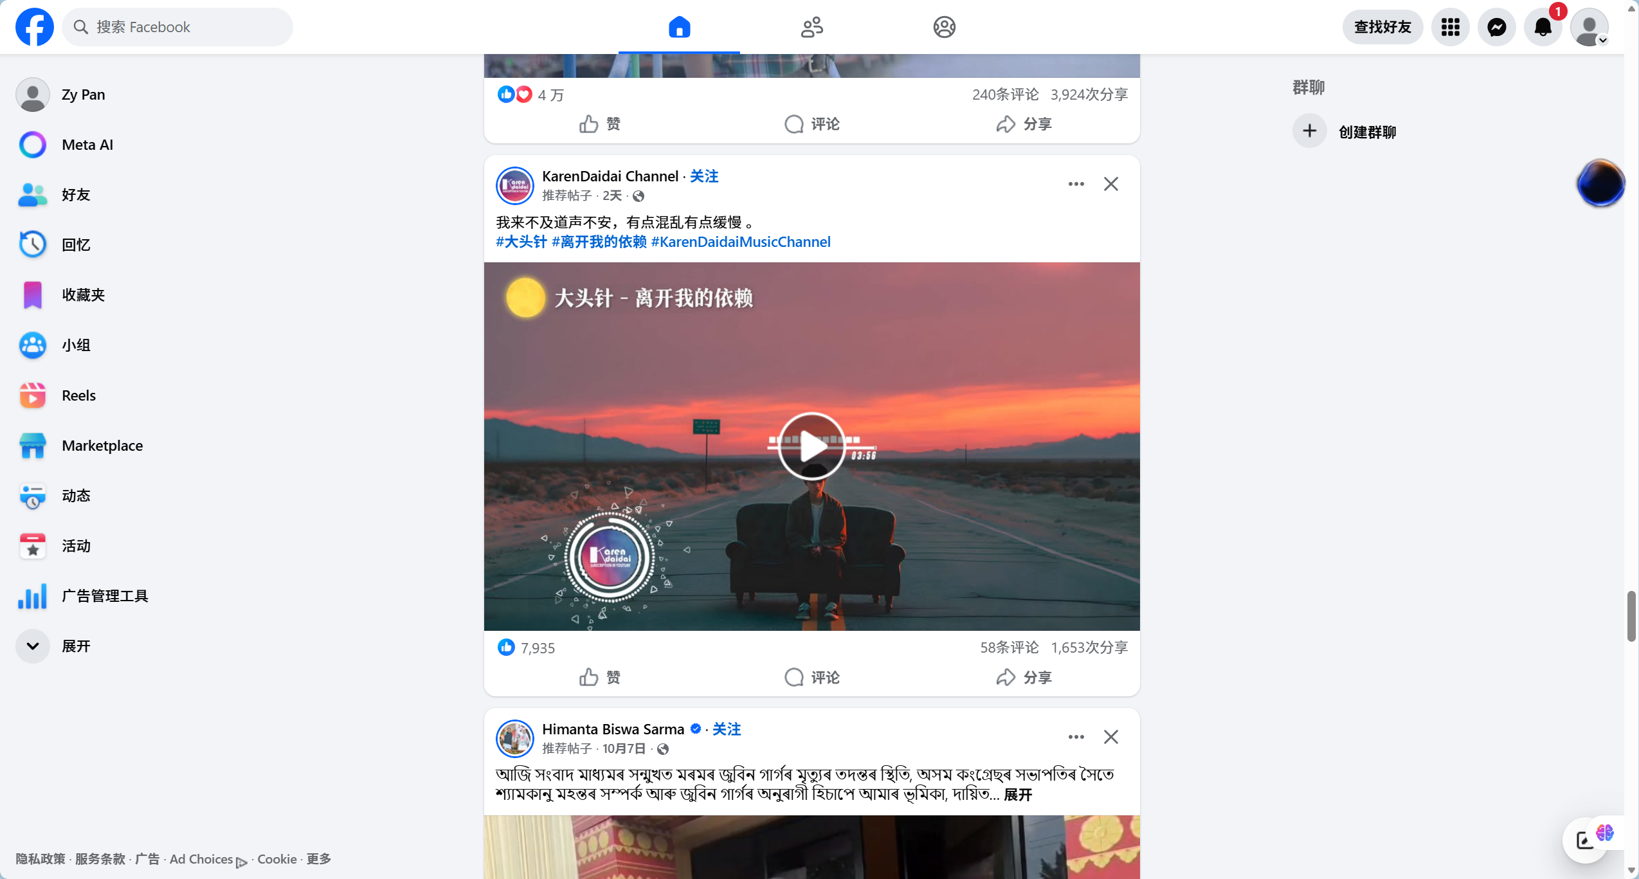
Figure 16 Facebook Groups
Facebook Groups are currently one of the most widely used mutual aid tools among international students worldwide.
Pros:
- Huge user base with broad coverage.
Cons:
- High language threshold: Mainly Thai and English content, which is difficult for Chinese students to use.
- The information retrieval is extremely poor: There are no structured tags, and rental stickers, car sale stickers and casual chats are all mixed together. It's like looking for a needle in a haystack to find information.

5.2 Xiaohongshu (Little Red Book)
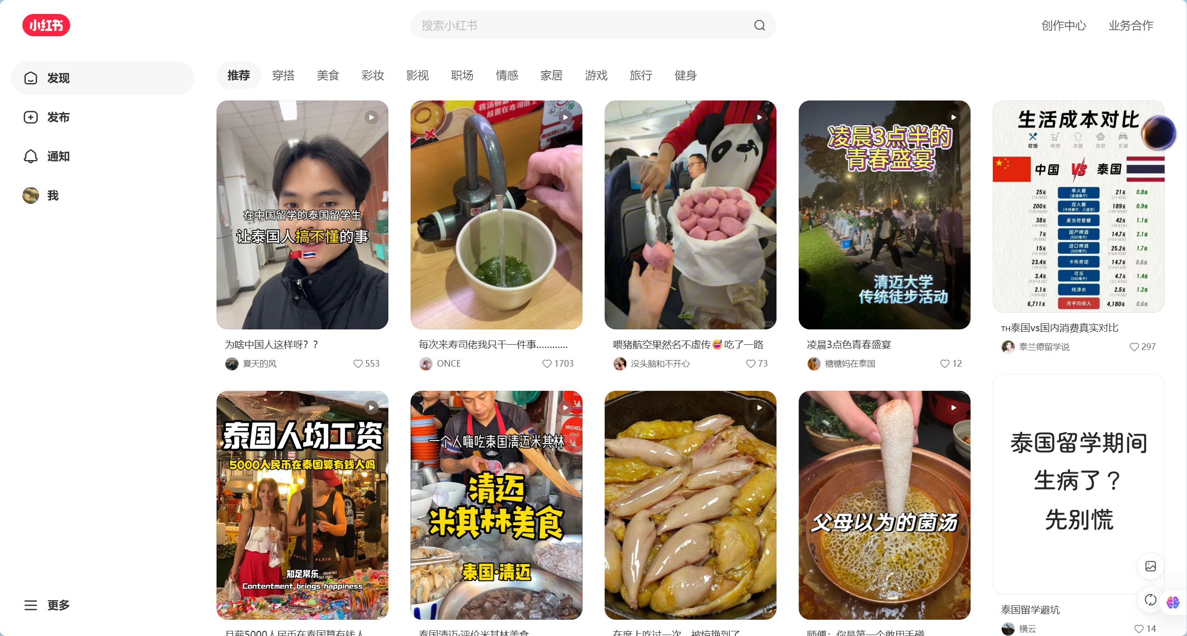
Figure 17 Little Red Book
Xiaohongshu is currently the most popular lifestyle sharing platform among Chinese international students.

Pros:
- Rich content, precise algorithmic recommendations, aesthetically pleasing interface.
Cons:
- Serious "tourist perspective" bias: The content is overly focused on travel, food and check-ins, lacking in-depth accumulation on long-term residence and compliance.
- The closed Chinese ecosystem: Only Chinese people are using it, and it is impossible to reach local Thais and international students who own the properties and second-hand cars.

5.3 reddit
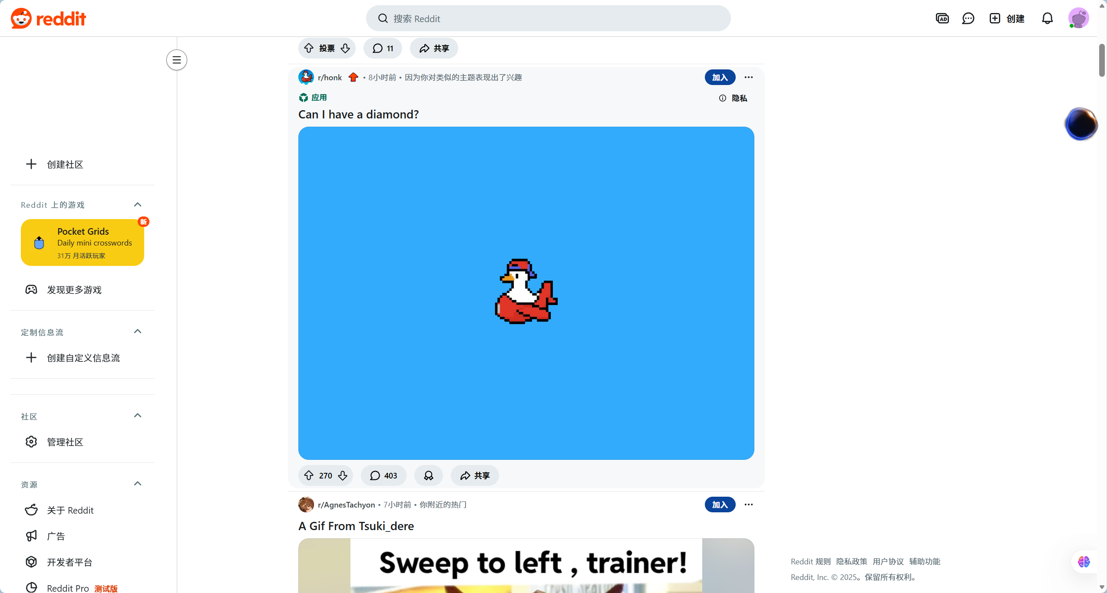
Figure 18 reddit
Reddit is one of the world's largest online forums, hosting numerous study abroad-related subreddits.

Pros:
- Structured discussions: Clear topic-based section categorization (e.g., r/studyabroad, r/Thailand).
- Anonymity: Users feel comfortable asking genuine questions.
Cons:
- Geeky interface: Unfriendly to non-technical users.
- Pure English environment: Multilingual translation is not supported, and most Chinese students and local lower-level merchants in Thailand (with poor English skills) are excluded.
- Lack of commercial functionality: Focused on discussion, not suitable for second-hand transactions or rental matching

5.4 Feature Comparison
Features | Facebook Groups | Little Red Book | Reddit | BridgeU
Web-based Access | ✓ | ✓ | ✓ | ✓
Origin->Dest | ✗ | ✓ | ✗ | ✓
Robot Intelligence | ✗ | ✗ | ✗ | ✓
AI Auto-Moderation | ✗ | ✓ | ✓ | ✓
Mandatory Tags | ✗ | ✗ | ✓ | ✓
Translation | ✓ | ✓ |  | ✓
Admin Panel | ✓ | ✓ | ✓ | ✓
Bilingual Translation | ✓ | ✗ | ✗ | ✓
Local Biz Connect | ✓ | ✗ | ✗ | ✓
Mutual | ✓ | ✗ | ✓ | ✓

Chapter 6 | Aims and Objective

6.1 Aims
BridgeU aims to eliminate language barriers through AI technology and establish a bilingual mutual assistance ecosystem that connects Chinese students, global students and local Thai merchants. It is not only a center for information exchange, but also a bridge connecting the local economy with the consumption demands of international students.

6.2 Objective
- Integrate Aliyun Qwen AI of Alibaba Cloud to provide two-way translation between Chinese and English, enabling users to post demands and conduct business transactions across language barriers.
- Deploy an automated Intelligence Robot to capture and summarize authoritative local English news in Thailand, ensuring that all students can equally obtain accurate policy information.
- Realize automatic review by artificial intelligence to filter out fraudulent and non-compliant content in multi-language environments. If it cannot be identified, it will be left to manual review to improve the speed and efficiency of the review
- Establish a Mutual-Follow social mechanism to ensure the security and trustworthiness of private message communication.

Chapter 7 | System Architecture
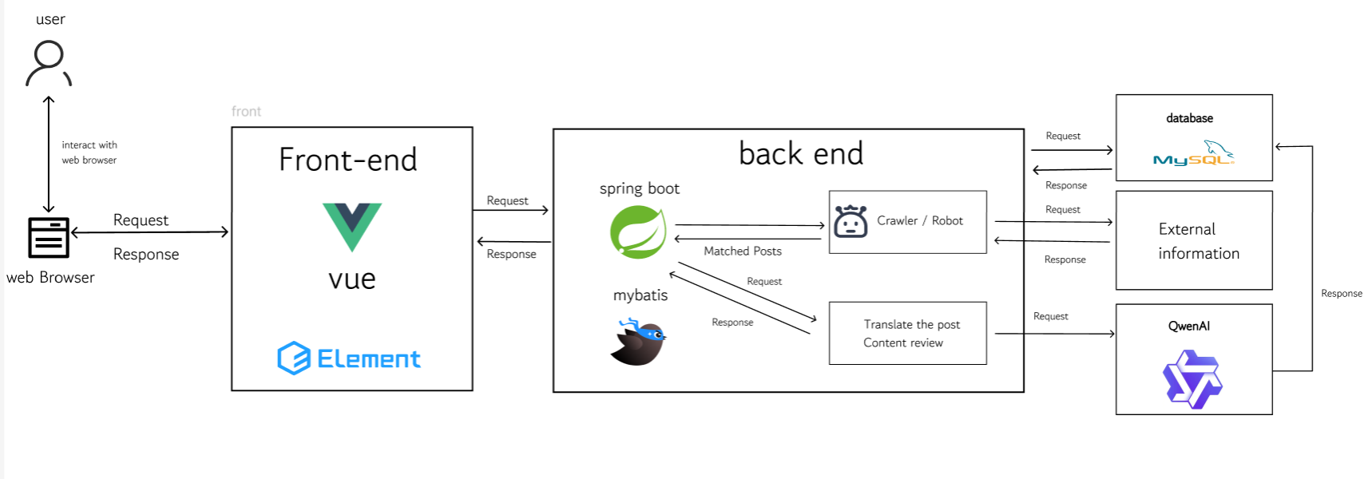
Figure 19 System Architecture
Description:
The system architecture consists of a front-end built using Vue.js 2 and Element UI, which provides a responsive user interface. The back-end is built with Spring Boot, a robust Java framework, handling business logic and RESTful API requests. MySQL 8 is used as the primary database for storing structured user and post data. Elasticsearch is integrated to provide high-performance semantic search capabilities. Additionally, the system connects to the Aliyun Qwen API to perform natural language processing tasks such as summarization and translation. Axios is used for communication between the front-end and back-end.

Chapter 8 | Feature
Feature #1 Automated Information Aggregation Bot
This feature is designed to break the "information cocoon" for international students. Backend automated robots regularly crawl authoritative media sources in Thailand (such as the Bangkok Post) and official university websites to capture raw data. The system then utilizes Alibaba Cloud Qwen AI to process this original text and generate concise Daily Briefings (summaries). This ensures that students can access the most critical policy changes and news updates immediately upon visiting the homepage.
Feature #2 AI Intelligent Translation Engine
Serving as the core linguistic engine of the platform, this function uses Large Language Models (LLMs) to provide seamless, bi-directional translation for all platform content. It automatically translates the generated news briefings into Chinese/English and processes User-Generated Content (UGC) in real-time. For example, rental posts written by Thai landlords in English are automatically converted into Chinese copies. This eliminates language barriers, enabling students to access local resources effortlessly while helping local service providers expand into the Chinese market.
Feature #3 AI-Powered Hybrid Content Moderation (AI + Human Loop)
To maintain a safe community environment while minimizing manual workload, the system integrates a dual-layer moderation mechanism:
- Layer 1: Real-time AI Screening (The First Line of Defense): Before any post or image is published, it is analyzed by the AI model. The AI scans for high-risk content such as scams (e.g., currency exchange fraud patterns), hate speech, or pornographic material. Non-compliant content is automatically blocked instantly.
- Layer 2: Human-in-the-Loop Review (The Safety Net): For content that the AI flags as "suspicious" but not definitively "illegal" (e.g., ambiguous language), the system marks it as "Pending Review" and forwards it to a human administrator. This allows admins to focus only on complex cases, significantly improving efficiency while ensuring fairness.

Chapter 9 | Limits
- Connectivity and Accessibility BridgeU is designed as a web-based application. Consequently, it requires a stable and continuous Internet connection to function. Users 2ithout internet access or those in areas with unstable network conditions will be unable to access real-time translation services, news updates, or community features.
- AI Dependency and Accuracy The core functionality of the platform relies heavily on the Alibaba Cloud Qwen Model API for translation and summarization. The accuracy of the system is therefore bound by the performance of this third-party API. Specifically, the model may encounter limitations when processing highly localized Thai slang, dialect-heavy text, or context-specific academic jargon, which could result in occasional translation inaccuracies.
- Data Acquisition Constraints The Automated Intelligence Robot (Crawler) operates under strict ethical and legal boundaries. It is programmed to capture information only from publicly available sources (e.g., public news websites like Bangkok Post, university announcement boards). The system cannot and will not access password-protected pages, private Facebook groups, or encrypted personal data, which limits the scope of information to public domain data only.

Chapter 10 | Milestone
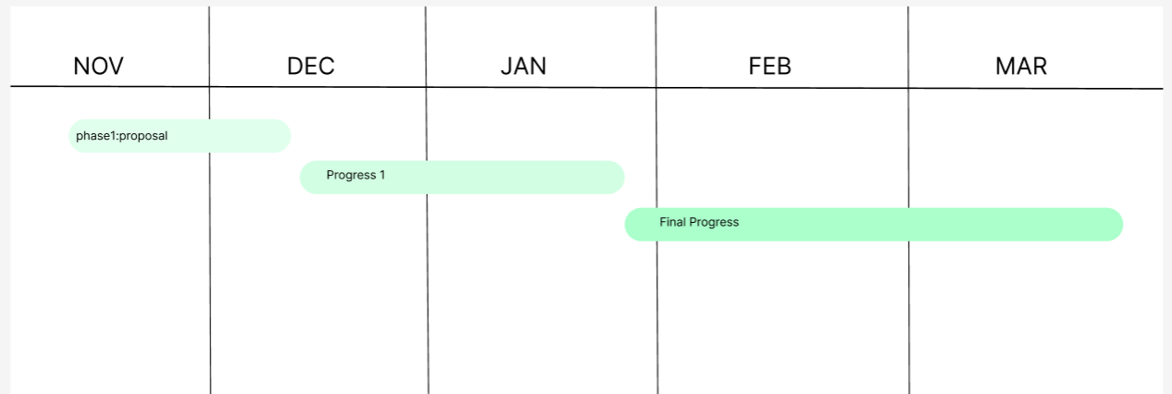
Phase 1. Proposal: 20 Nov 2025 –19 DEC 2025=29 days
Phase 2. Progress I: 20 DEC 2025 –26 Jan 2026 = 36 days
Phase 3. Final Progress: 26 Jan 2026 –20 Mar 2026 = 54 days
Figure 20 Milestone
Phase 1. Proposal: 20 Nov 2025 –19 Dec 2025=29 days
Tasks | Start date | End date | Duration | Responsibility
Research and writing proposal document | 20 November 2025 | 9 December 2025 | 19 | ZHIYI PAN
Prepare for the Presentation | 9 December 2025 | 19 December 2025 | 10 | ZHIYI PAN

Phase 2. Progress I: 19 Dec 2025 –26 Jan = 36 days
Tasks | Start date | End date | Duration | Responsibility
Software requirement specification document | 20 December 2025 | 27 December 2025 | 6 | ZHIYI PAN
Project plan document | 28 December 2025 | 31 December 2025 | 3 | ZHIYI PAN
Software design document | 1 January 2026 | 8 January 2026 | 7 | ZHIYI PAN
Feature #1 implement | 8 January 2026 | 22 January 2026 | 14 | ZHIYI PAN
Prepared Progress I report and presentation | 20 January 2026 | 26 January 2026 | 6 | ZHIYI PAN
Phase 3. Final Progress: 26 Jan 2026 –20 Mar 2026 = 54 days
Tasks | Start date | End date | Duration | Responsibility
Feature #2 implement | 27 January 2026 | 10 February 2026 | 14 | ZHIYI PAN
Feature #3 implement | 11 February 2026 | 25 February 2026 | 14 | ZHIYI PAN
Test code | 26 February 2026 | 11 March 2026 | 15 | ZHIYI PAN
Prepared final report and presentation | 12 March 2026 | 25 March 202 | 13 | ZHIYI PAN

Chapter 11 | References
[1] Alibaba Cloud. (2024). Tongyi Qianwen (Qwen) Large Language Model API Documentation. [Online]. Available at: https://www.alibabacloud.com/help/en/model-studio/developer-reference/use-qwen-by-calling-api
[2] Vue.js. (n.d.). The Progressive JavaScript Framework. [Online]. Available at: https://vuejs.org/guide/introduction.html
[3] Spring. (n.d.). Spring Boot Framework Documentation. [Online]. Available at: https://spring.io/projects/spring-boot
[4] MySQL. (2024). MySQL 8.0 Reference Manual. Oracle Corporation. [Online]. Available at: https://dev.mysql.com/doc/refman/8.0/en/
[5] Elasticsearch. (n.d.). Elasticsearch: The Official Distributed Search & Analytics Engine. [Online]. Available at: https://www.elastic.co/elasticsearch
[6] Element Plus. (n.d.). A Vue 3 based component library for designers and developers. [Online]. Available at: https://element-plus.org/en-US/component/overview.html

