BridgeU
Project Proposal

Zhiyi Pan 652115558

Bachelor of Science
Software Engineering Program

Department College of Arts, Media, and Technology Chiang Mai University November 2025

Project Advisor
Asst. Prof. Pattama Longani, Ph.D.

Chapter 1 | Introduction
In Thailand’s diverse higher education landscape, campuses host international students from many regions. While this community is vibrant and multicultural, international students still face very practical difficulties in getting reliable local information, communicating across languages, and connecting with trustworthy local services.
At present, the international student population can roughly be divided into two communication circles. Chinese international students, who make up a large proportion of the community, tend to rely on Chinese‑language tools and channels. Students from other countries mainly use English and gather on platforms such as Facebook and WhatsApp. Because these circles rarely overlap, important information, opportunities, and resources often fail to flow between them.
Existing social media platforms also show a strong “tourist‑oriented” bias. They focus on travel tips and entertainment content but provide very limited support for long‑term study and life in Thailand. For example, it is difficult for students to quickly find clear, up‑to‑date information about visa and immigration policies, university regulations, or practical matters such as housing and local services. At the same time, many local Thai landlords and small service providers would like to serve international students but cannot communicate in Chinese and lack direct, bilingual channels to reach them.
BridgeU is proposed to address these specific gaps. It is a bilingual, AI‑powered platform for international students in Thailand and local service providers. Through three core capabilities—authoritative news and policy aggregation, AI‑driven bilingual translation, and safe, moderated community interaction—BridgeU helps students access reliable “survival information”, communicate across language barriers, and discover trustworthy local services. In parallel, it offers Thai landlords and small businesses a simple way to publish listings in English and automatically reach Chinese‑speaking students, creating new, transparent economic opportunities for both sides.

Chapter 2 | Target User
This project targets three core groups within Thailand's international education ecosystem, addressing the specific dilemmas faced by each:

2.1 Chinese International Students: Deeply Dependent on a Closed Digital Ecosystem
This group constitutes the largest demographic of international students in Thailand and faces a set of practical challenges that BridgeU is designed to address.
• Limited Access to Official Information: Many Chinese international students rely on informal channels or friends’ summaries to understand announcements from Thai government agencies, universities, and immigration offices. This often leads to delays or misunderstandings about visas, academic regulations, and public policies.
• Language Barriers in Daily Decisions: Important information such as rental listings, campus notices, and local service offers is often provided only in Thai or English. Students who are not fluent in these languages struggle to make informed decisions about housing, part‑time jobs, and daily life.
• Lack of Trusted, Localised Platforms: Existing platforms used by Chinese students are not tailored to Thailand’s context and rarely aggregate local Thai news or university updates in bilingual form. There is no single, trustworthy platform that combines authoritative news, campus information, and local life services in Chinese and English.

2.2. Global International Students: Seeking Cross-Cultural Exchange and Resources
This group includes students from Europe, the Americas, and Southeast Asia who primarily communicate in English and are active within the Facebook and WhatsApp ecosystems.
- Resource Mismatch: Although they may possess idle resources (e.g., textbooks, second-hand goods), they cannot reach the massive Chinese student market. This leads to a situation where "supply and demand exist on both sides but remain invisible to each other due to platform barriers," resulting in resource waste.
- Social Segregation: Existing platform barriers hinder deep academic exchange and cultural interaction with the Chinese student community, which makes up nearly half of the international student population.

2.3. Local Thai Merchants & Service Providers
This group includes Thai landlords, small accommodation providers, and local service owners who wish to reach Chinese international students but are constrained by language and marketing channels.
• Difficulty Reaching Chinese Students: Most local merchants cannot communicate in Chinese and lack direct access to Chinese‑speaking platforms. As a result, their housing or service information rarely reaches Chinese students in a clear and trustworthy manner.
• High Dependence on Intermediaries: Without a direct, bilingual communication channel, merchants often rely on agents or middlemen, which increases transaction costs and reduces price transparency for both sides.
BridgeU involves these merchants by providing a straightforward way to publish bilingual listings. Merchants can submit basic housing or service information in simple English, and the system automatically generates a corresponding Chinese version for Chinese students. BridgeU offers a channel where local merchants can present their services in both English and Chinese to students who are actively searching for accommodation and local support.

Chapter 3 | Feature
Feature #1 Automated Information Aggregation Bot
This feature is designed to break the "information cocoon" for international students. Backend automated robots regularly crawl authoritative media sources in Thailand (Bangkok Post、Council of University Presidents of Thailand) and official university websites to capture raw data. The system then utilizes Alibaba Cloud Qwen AI to process this original text and generate concise Daily Briefings (summaries). This ensures that students can access the most critical policy changes and news updates immediately upon visiting the homepage.
Feature #2 AI Intelligent Translation Engine
Serving as the core linguistic engine of the platform, this function uses Large Language Models (LLMs) to provide seamless, bi-directional translation for all platform content. It automatically translates the generated news briefings into Chinese/English and processes User-Generated Content (UGC) in real-time. For example, rental posts written by Thai landlords in English are automatically converted into Chinese copies. This eliminates language barriers, enabling students to access local resources effortlessly while helping local service providers expand into the Chinese market.
Feature #3 AI-Powered Hybrid Content Moderation (AI + Human Loop)
To maintain a safe community environment while minimizing manual workload, the system integrates a dual-layer moderation mechanism:
1.Layer 1: Real-time AI Screening (The First Line of Defense): Before any post or image is published, it is analyzed by the AI model. The AI scans for high-risk content such as scams (e.g., currency exchange fraud patterns), hate speech, or pornographic material. Non-compliant content is automatically blocked instantly.
2.Layer 2: Human-in-the-Loop Review (The Safety Net): For content that the AI flags as "suspicious" but not definitively "illegal" (e.g., ambiguous language), the system marks it as "Pending Review" and forwards it to a human administrator. This allows admins to focus only on complex cases, significantly improving efficiency while ensuring fairness.

Chapter 4 | User Journey

4.1 The user journey of international students
The journey begins when a user (e.g., a Chinese international student or a local Thai
landlord) navigates to the BridgeU web application. On the landing page, the user can choose to log in or sign up as either a student or a merchant. After logging in,
the system provides role‑specific functions, such as browsing bilingual news briefings for students or publishing rental listings for merchants.
Understanding that language is the first barrier to entry, the platform includes a
Language Toggle button in the top‑right corner.
• Action: The user can click the Language Toggle button to switch the interface language between English and Chinese.
• Result: After the selection, interface labels and navigation elements are displayed in the chosen language, while key content (such as news briefings and selected posts) is shown in bilingual format .
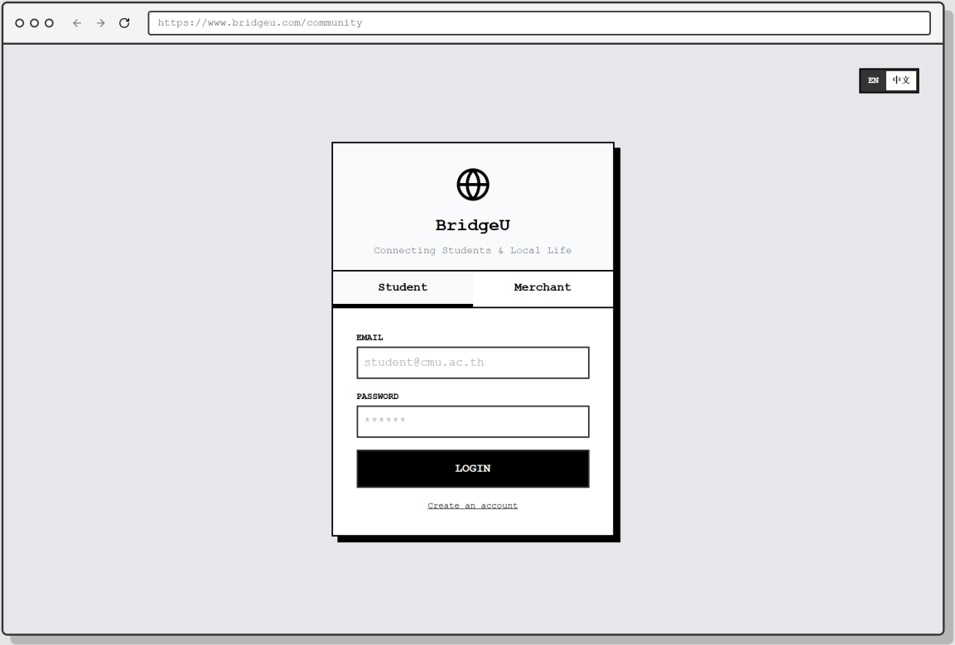
Figure 1 loginpage01

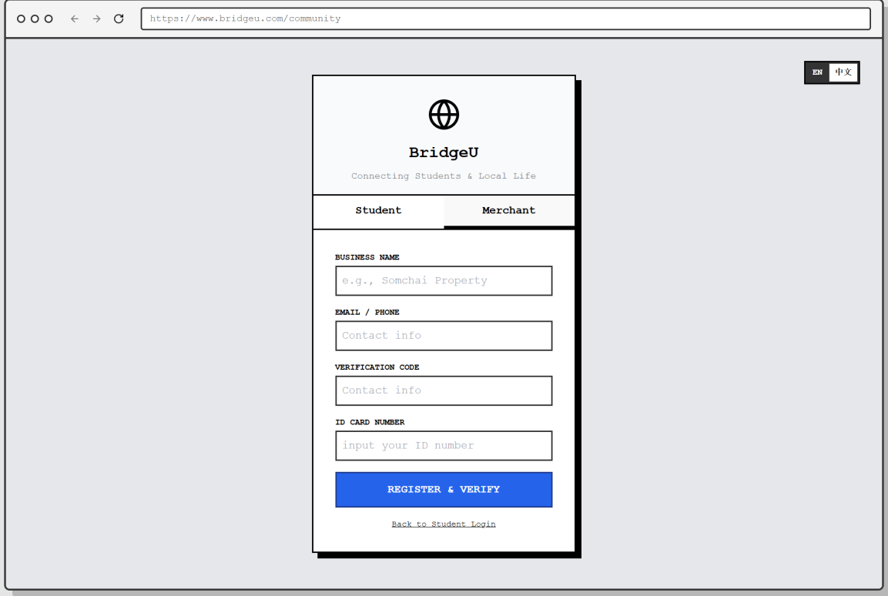
Figure 2 loginpage02

Upon entering the main Community Homepage, the user is not just presented
with a list of posts, but with a structured and intelligent information hub, as shown in Figure 3
• | Daily Briefing (Automated Info-Aggregator): At the very top, a special card  •
labeled "DAILY BRIEFING" grabs the user's attention. This content is
automatically crawled from authoritative external sources (e.g., Bangkok Post, CMU Official) by the system's robot. The integrated AI then processes this
raw data to generate a concise summary and translates it into both English and Chinese (e.g., "Thailand approves new 10-year LTR visa"). This proactively
pushes critical "trends" to the user, solving the "information gap" problem.
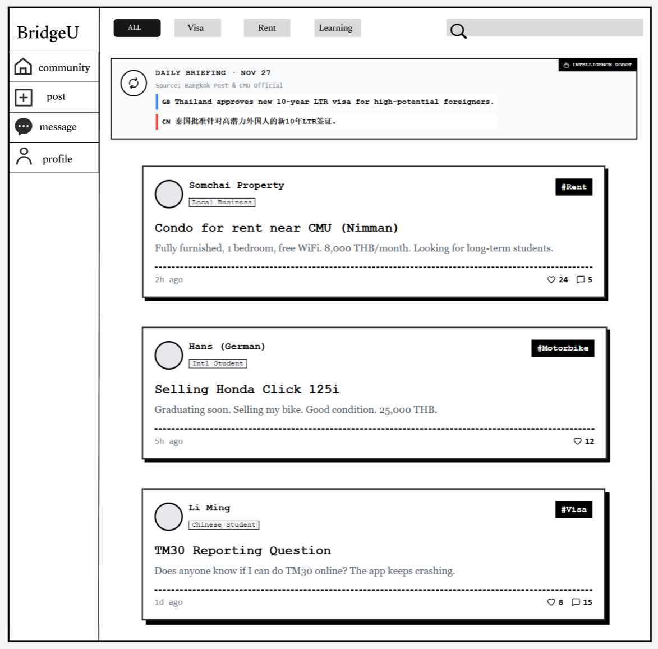
Figure 3 communityPage

Interested in a specific listing, such as the "Condo for rent near CMU," the user
clicks on the card to enter the Post Detail Page.
As shown in Figure 4, this page offers a focused view of the information:
• | Author Verification: The author, "Somchai Property," is clearly tagged as a  •
"Local Business", helping the user assess credibility. A "Follow" button is prominently placed next to the profile.
• | Engagement: The user can read the full description and view existing  •
discussions in the Comments section.
• | Gated Communication: To prevent harassment, the "Contact Host" section on
the right features a "Chat Now" button. " Requires Mutual Follow"*. This reminds the user that they cannot send private messages immediately; they
must first click "Follow" and wait for the host to follow back, ensuring a
consensual connection before chatting.
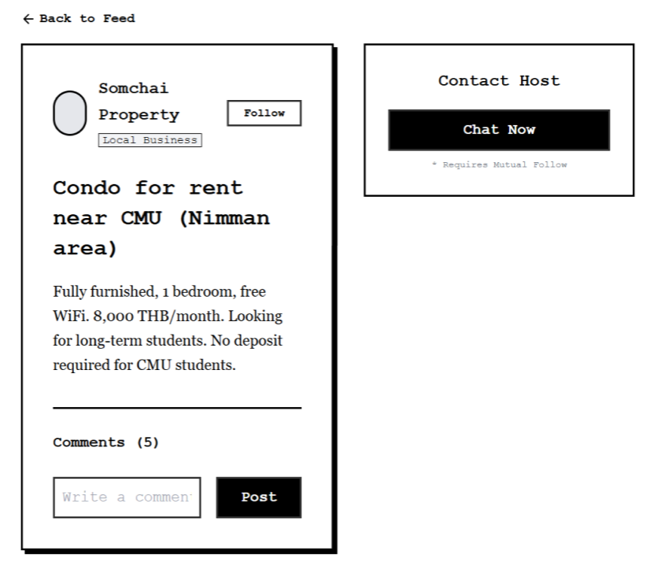
Figure 4 postPage

The user decides to contribute to the community by sharing a question or
experience. They navigate to the "Post" tab.
To maintain a healthy community environment without relying on 24/7 manual
moderation, BridgeU integrates an AI-Powered Content Moderation system that
works in real-time.
1. The user selects a mandatory tag (e.g., #Learning) and inputs their text. Upon
clicking "Publish Now", the system enters a "Processing" state. A prompt "AI is scanning for scams & hate speech..." appears, indicating that the content is being
analyzed by the backend LLM engine before entering the database.
2. Intelligent Interception (The "Guard"): In a scenario where a user attempts to post
illegal language (as seen in Figure 6), the AI detects the violation immediately. The system blocks the request and displays a red warning: "Blocked: Content contains
prohibited word." This proactive measure filters out toxic content at the source.
3. Successful Publication: When the content is verified as safe (e.g., "how to learning
English"), the system displays a green "Safe Content" confirmation, and the post is successfully published to the community feed (as shown in Figure 7).
4. If the ai is unsure whether there is a violation, it will feed back to the human administrator, who will handle it manually
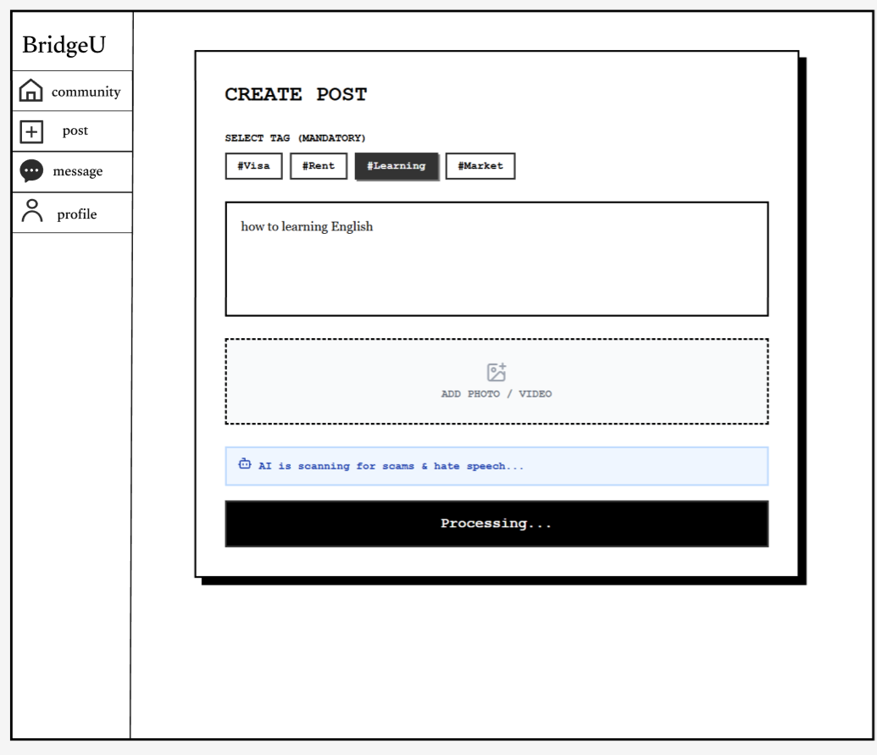
Figure 5 CreatePosstPage01
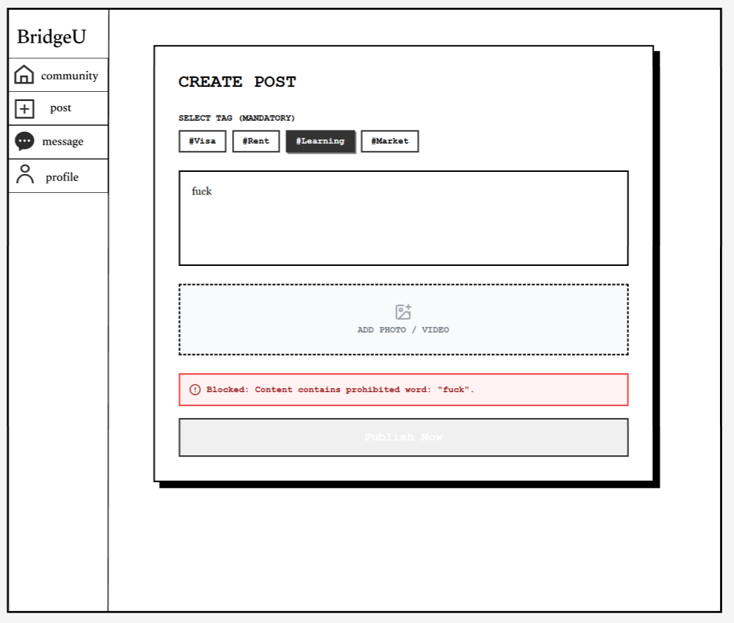
Figure 6 CreatePosstPage02
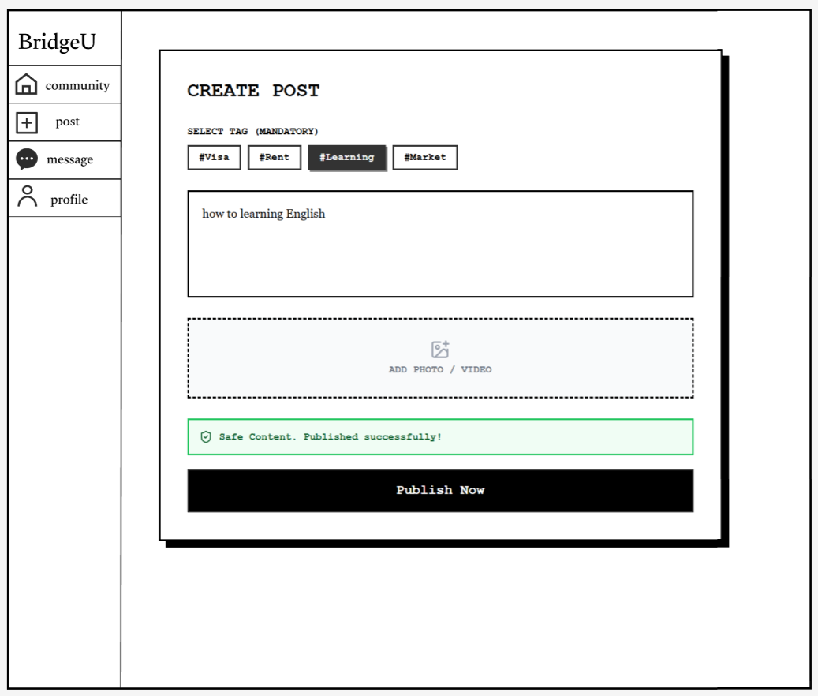
Figure 7 CreatePosstPage03

The user navigates to the "Message" tab to check their conversations.As shown
in Figure 8, the Message List provides a clear overview of active conversations.
• | Safety Cue: A "Stranger" tag might appear for users who haven't mutually followed each other yet, reminding the user of the platform's safety protocols.  •
Clicking on a conversation opens the Chat Interface (as seen in Figure 9).
• | Real-time Interaction: The user can exchange text messages with the host (e.g., "Is the room still available?").  •
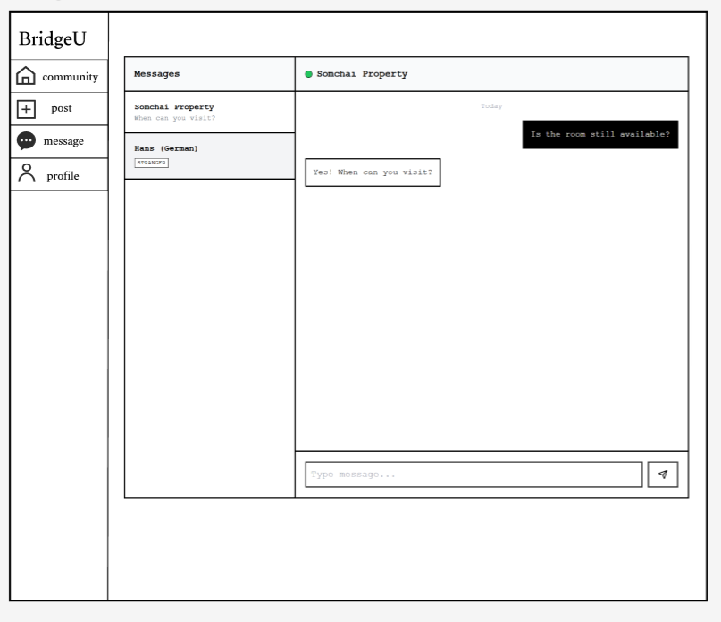
Figure 8 MessagePage01

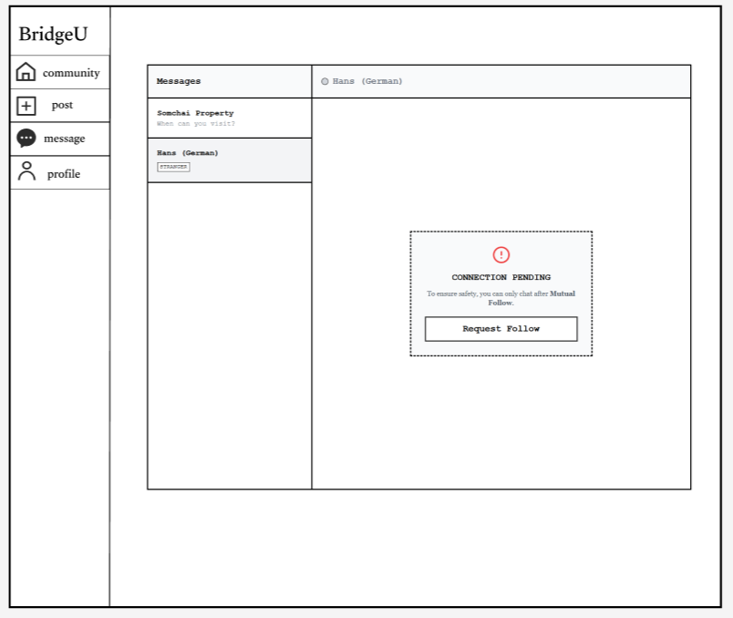
Figure 9 MessagePage02

The user navigates to the "Profile" tab.
As shown in Figure 10, the Profile Page serves as the user's identity card within
the community.
• | Activity Log: The "My Posts" section acts as a history log, allowing the user  •
to track their requests (e.g., "#Rent Looking for 1-bedroom condo") and interactions.
• | Social Stats: The "Following" and "Followers" counts reflect the user's social  •
standing and credibility.
To update their information, the user clicks the "Edit Profile" button. This opens the
Edit Interface as seen in Figure 11.
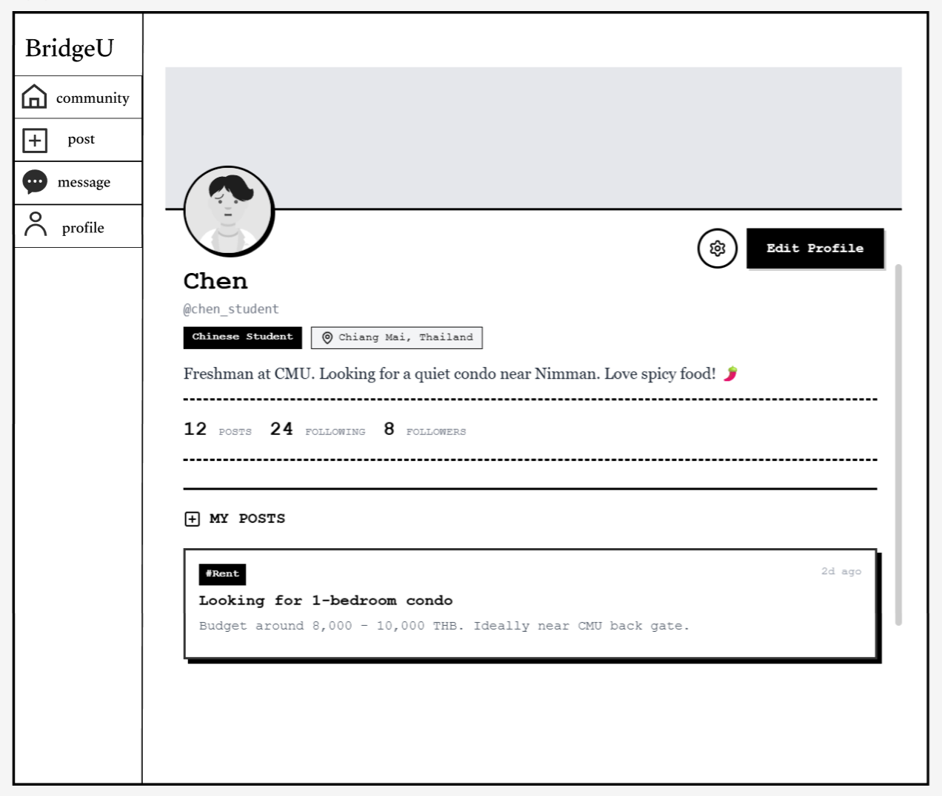
Figure10 ProfilePage

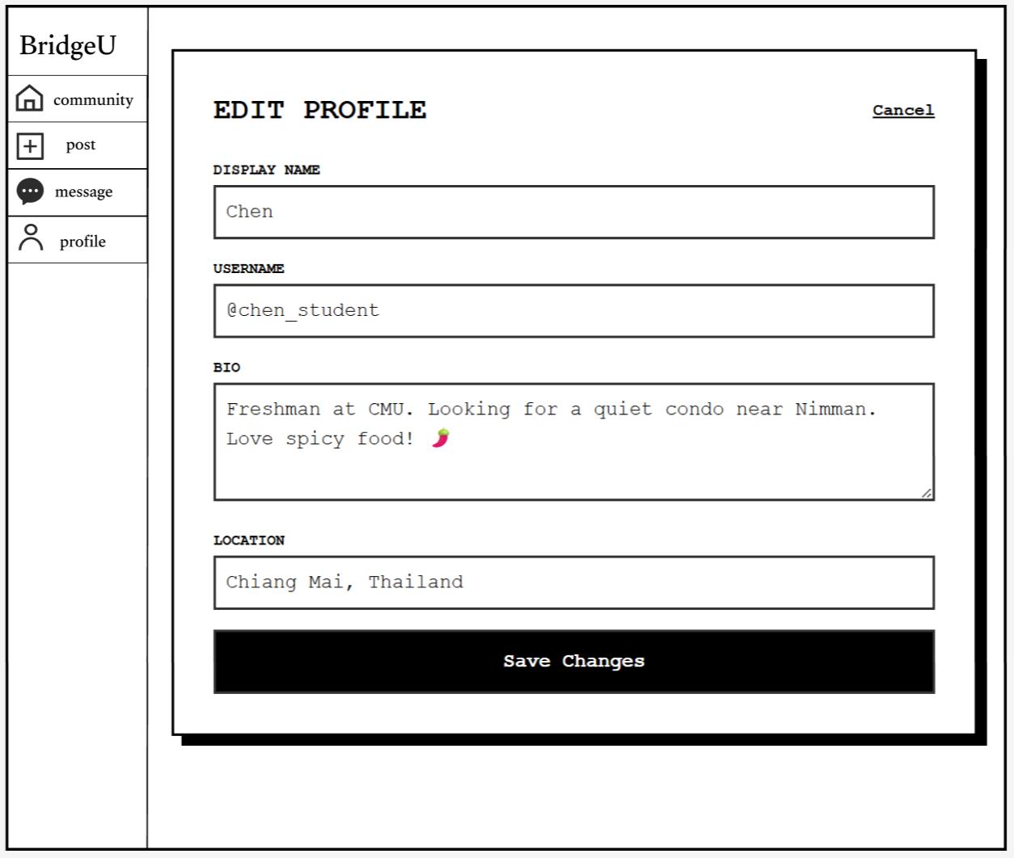
Figure 11EditProfilePage

4.2 The user journey of admin
Upon logging into the “Admin Dashboard”, the administrator immediately
assesses the community's status through real-time statistics (9 users, 109 posts) and quickly identifies a critical workflow priority via the yellow "Pending" indicator.
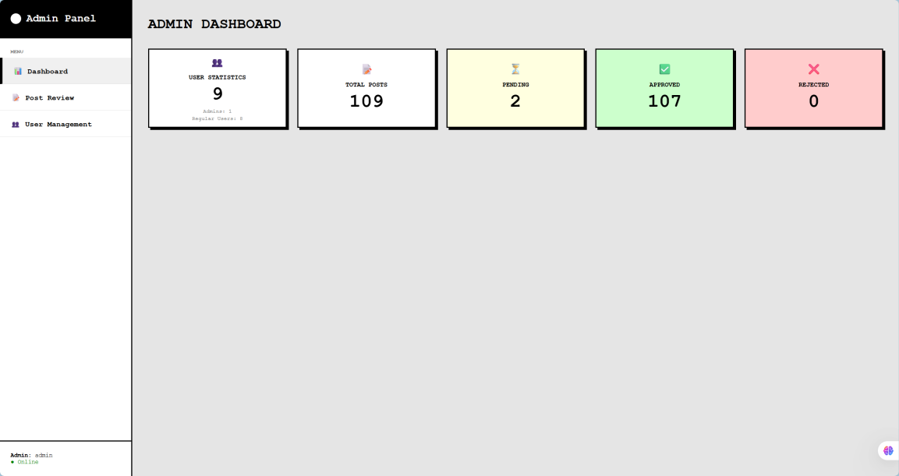
Figure 12 DashboardPage
Enter the post review page, where administrators can review posts
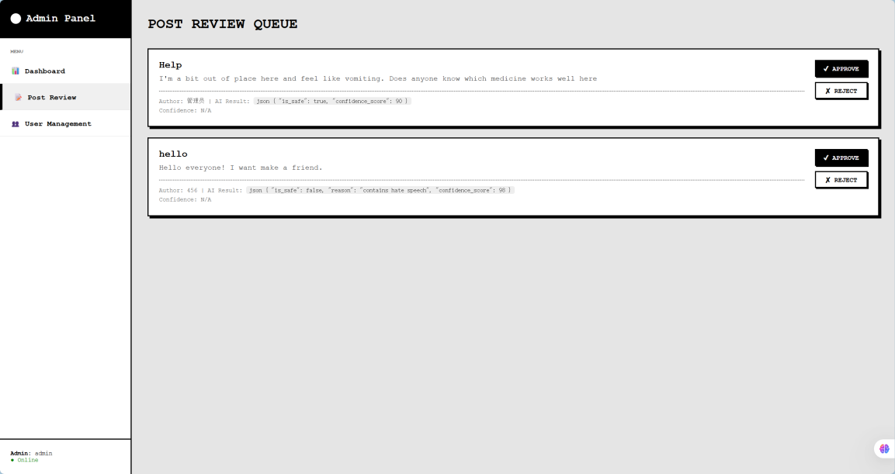
Figure 13 PostReviewPage

Administrators can view the usernames, bound email addresses, current roles and
account statuses of all registered users, unblock users who have been disabled or successfully appealed, and suspend the accounts of users who violate the rules
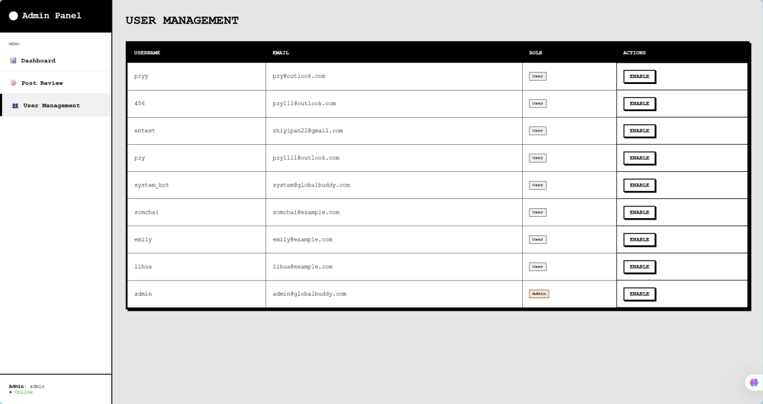
Figure 14 UserManagementPage

Chapter 5 | Business Review

5.1. Overview

Figure 15 International students in Thai
In Thailand’s international education environment, university campuses bring together students from China, Europe, Africa, the Americas and across Asia. Once they arrive, however, many international students quickly encounter “information islands” caused by language barriers and the lack of reliable, survival‑oriented information (e.g. visa, housing, safety, university rules).
In practice, international students are often distributed across separate digital and language ecosystems. Because content rarely crosses languages or platforms, resources such as second‑hand goods, housing, or academic opportunities are not efficiently shared, even when there is clear demand and supply on both sides. Local Thai businesses face similar challenges: without an easy bilingual channel to reach students, they must either rely on informal intermediaries or under‑utilise their existing inventory.
At the same time, mainstream social platforms are not designed specifically for the “long‑term survival” needs of international students. Their feeds tend to prioritise short‑term, tourist‑style content, while critical information such as visa policy updates, university regulations, health and safety advisories or how to access basic public services is fragmented, hard to filter, and often not available in students’ preferred languages.
BridgeU is proposed as an AI‑enabled, bilingual support platform that directly targets these gaps. It positions itself as infrastructure that connects international students and local communities in Thailand. By using Alibaba Cloud’s Qwen large language model for Chinese–English translation, and by aggregating trustworthy information from official and reputable online sources, BridgeU aims to reduce language barriers, improve the flow of survival‑related information and support more meaningful academic, social and commercial interactions between international students and local stakeholders.

5.2 Target

5.2.1 Problems
Cross‑language, cross‑platform information silos
International students in Thailand are scattered across multiple platforms and languages, which makes it difficult to match needs and resources (e.g. second‑hand trading, subletting, study groups). At present there is no dedicated, bilingual space that aggregates these posts and makes them mutually understandable across Chinese and English.
Limited, fragmented access between local businesses and students
Many Thai landlords and small service providers can communicate in basic English but lack an efficient way to present their offers to international students in a bilingual, trustworthy environment. As a result, informal intermediaries step in to “translate and distribute” information, often charging high mark‑ups. This increases the living cost for students and reduces the net income for local providers.
Difficulty accessing timely, authoritative survival information
Policy changes from the Immigration Bureau, university announcements or urgent public safety notifications are typically published first in Thai or English on official websites. Many students do not regularly follow these sources or lack the language ability to quickly interpret them, and instead depend on second‑hand summaries in informal chat groups. This creates a risk of outdated, incomplete or distorted information when making important decisions (e.g. visa renewal, safety precautions).

5.2.2 Solutions
Bilingual AI Communication Bridge
BridgeU provides a dedicated posting and messaging space where user‑generated content is automatically translated between Chinese and English using Alibaba Cloud’s Qwen large language model. Students and local providers can publish one post and have it understood by users in both language groups, without needing to duplicate content across multiple platforms. This directly targets the cross‑language, cross‑platform silo problem and enables more efficient matching of supply and demand.
Integrated channel for local service providers
Within the same interface, Thai landlords and small service providers can list housing, transport and daily‑life services in English and have them automatically made available in Chinese. International students can contact them directly inside BridgeU, instead of through informal intermediaries. This reduces information asymmetry, lowers the effective transaction cost and brings both sides onto a transparent, bilingual marketplace.
AI‑driven hybrid content moderation
BridgeU embeds an AI moderation layer that pre‑screens every text and image post for patterns related to scams, illegal services, hate speech and explicit content in multiple languages. Obvious violations are automatically blocked or hidden; uncertain cases are routed into a human review queue inside the admin console. This design substantially reduces repetitive moderation workload, while still keeping a human‑in‑the‑loop for sensitive decisions, and therefore improves community safety at a realistic operational cost.
Automated aggregation of authoritative “survival intelligence”
On the back end, BridgeU connects to official and reputable online sources (e.g. government portals, university websites, selected news outlets) via RSS feeds or compliant crawling. New items are summarised by AI into short, student‑friendly briefs in Chinese and English, and categorised into topics such as visas, academic regulations, health and safety or local public services. This creates a single, structured “survival information” layer that students can consult instead of relying only on rumours circulating in chat groups.

5.2.3 Benefit
For international students
- Lower survival barriers: Students can access concise, bilingual guidance on visas, housing norms, university policies and safety issues in one place, reducing the risk of mistakes caused by missing or misunderstood information.
- Lower living and search costs: Direct communication with local landlords and service providers, assisted by automatic translation, reduces dependence on intermediaries and shortens the time needed to find suitable options.
- Safer online environment: AI‑assisted moderation and clearer community rules filter out a large portion of obvious scams and inappropriate content, making it easier for students to trust and use the platform.
For local service providers in Thailand
- Direct access to a defined student segment: Landlords and small businesses can reach a concentrated group of international students through a single, bilingual channel, instead of experimenting across fragmented platforms. This can increase utilisation of their existing assets (rooms, vehicles, services) and reduce marketing friction.
For platform operators and administrators
- Scalable operations with controlled risk: By combining AI pre‑screening with human review for edge cases, BridgeU reduces the need for a large full‑time moderation team while still maintaining oversight over sensitive decisions. This supports sustainable platform operations and a more trustworthy community atmosphere.

