BridgeU
Test Plan

Zhiyi Pan 652115558

Bachelor of Science
Software Engineering Program

Department College of Arts,Media,and
Technology
Chiang Mai University
January 2026
Project Advisor
Pattama Longani, Ph.D.

Chapter 1 Introduction
1.1 Purpose and Scope
The purpose of the Test Plan document for the BridgeU system is to establish a test plan of the unit testing to discover the potential bugs or defects. The unit testing covers all implemented methods in the BridgeU system.

1.2 Acronyms and Definitions
Acronyms
URS | User Requirement Specification
UTC | Unit Test Case
STC | System Test Case
TD | Test Data
SRS | Software Requirement Specification
SDD | Software Design Development
API | Application Programming Interface
REST | Representational State Transfer
HTTP | Hypertext Transfer Protocol
JSON | JavaScript Object Notation
JWT | JSON Web Token
RSS | Really Simple Syndication

Definition
Name | Definition
Test Plan | A document that describes the scope, approach, resources, and schedule of intended test activities. It identifies test items, the features to be tested, the testing tasks, who will do each task, and any risks requiring contingency planning.
Unit Test | A test of individual programs or modules in order to remove design or programming errors. In the context of BridgeU, unit tests verify the functionality of individual methods in Vue.js components, Spring Boot controllers, services, and repositories.
System Testing | Testing conducted on a complete and integrated system to evaluate the system's compliance with its specified requirements. For BridgeU, system testing verifies the integration between frontend Vue.js components and backend Spring Boot API endpoints.
Test Case | A set of test inputs, execution conditions, and expected results developed for a particular objective, such as to exercise a particular program path or to verify compliance with a specific requirement. Each test case in BridgeU includes Test ID, Test Function, Description, Input, and Expected Result.
Test Coverage | The degree to which a test suite exercises the code or requirements. In BridgeU test plan, coverage includes all implemented methods in the Daily Briefing System feature, including frontend component methods and backend API endpoints.
Daily Briefing | A news aggregation feature in BridgeU that automatically captures and summarizes Thai news from approved government and mainstream media sources via Google News RSS, providing bilingual (Chinese/English) access to daily news briefings for international students.
NewsBriefDTO  Pagination | Data Transfer Object used in BridgeU backend to transfer news summary data from the server to the frontend. It contains translated title and summary in the requested language (Chinese or English), excluding Thai content.
Bilingual Interface | A user interface that supports multiple languages. BridgeU Daily Briefing System supports both Chinese (zh) and English (en) interfaces, allowing users to switch between languages dynamically.
Date Filter | A filtering mechanism that allows users to filter news items by publication date range. In BridgeU, users can specify start date and end date to retrieve news published within a specific time period.
Keyword Search | A search functionality that allows users to find news items containing specific keywords. In BridgeU, keyword search queries across multiple fields including title, summary, and translation fields (titleZh, summaryZh, titleEn, summaryEn).
Traceability | The ability to trace the history, application or location of an item or activity, or work products or activities, by means of recorded identification. In BridgeU test plan, traceability ensures that test cases can be traced back to specific requirements and use cases.
Pagination | A mechanism for dividing a large dataset into smaller, manageable pages. In BridgeU Daily Briefing System, pagination allows users to browse news items page by page, with configurable page size (default 10 items per page).

Chapter 2 Test Plan and Test Procedure
2.1 Test Objective
The objectives of testing the BridgeU system are:
1. To detect and fix all bugs and defects across all system features
2. To cover all functional, non-functional, and user interface-related requirements
3. To ensure that all API endpoints return correct responses according to the specifications
4. To validate that all user interactions (search, filter, pagination, etc.) work as expected
5. To ensure proper error handling and user feedback mechanisms throughout the system
6. To verify integration between frontend and backend components
7. To validate data consistency and integrity across all features
2.2 Scope of Testing
The scope of testing covers all BridgeU system essential functions using unit testing, system testing, and integration testing.
2.3 Test Responsibility
Name | Responsibility
Unit Test | ZhiYiPan
System Test | ZhiYiPan
Test Record | ZhiYiPan

2.4 Test Strategy
The BridgeU system testing follows a structured approach:
Test Planning:
Test case design based on use case descriptions and system requirements
Test data preparation and environment setup
Test schedule and resource allocation
Test Case Design:
Each test case includes Test ID, Test Function, Description, Input, and Expected Result
Test cases are designed based on use case descriptions and system requirements
Test cases cover both normal flows and exception flows
Test cases are organized by feature and test level (unit, system, integration)
Test Execution:
Unit tests are executed for individual methods and functions
System tests are executed for complete feature workflows
Integration tests verify component interactions
Test results are recorded with actual outputs and pass/fail status
Test Documentation:
All test cases are documented with clear descriptions and expected results
Test execution results are recorded with timestamps
Failed tests are logged with detailed error messages and steps to reproduce

2.5 Result of Testing

Test Execution:
Each test case is executed and produces an actual output
Test results are compared against expected results
Pass/Fail Criteria:
Pass: The actual result matches the expected result exactly
Fail: The actual result differs from the expected result, or an unexpected error occurs
Test Record:
All test results are documented with timestamps and execution details
Failed tests are logged with detailed error messages, stack traces, and steps to reproduce
Test coverage reports are generated to ensure all methods and use cases are tested
Test summary reports provide an overview of test execution status and coverage metrics

Chapter 3 Unit test

3.1 Feature 1

3.1.1 Unit Test Cases

3.1.1.1 UTC-01: Test fetchDailyBriefing()
Description: Tests the frontend component method for fetching daily briefing list, verifying it correctly handles pagination, language parameters, search keywords, date filters, and properly processes API responses and error cases.
Test ID: UTC-01
Test Function: fetchDailyBriefing()
Test Cases:
ID | Description | Input | Expected Result
1 | Verify that fetchDailyBriefing() successfully retrieves news list with default parameters | {  "currentPage": 0,  "pageSize": 10,  "currentLang": "en",  "searchKeyword": "",  "filterStartDate": null,  "filterEndDate": null  } | {  "apiRequest": {  "method": "GET",  "url": "/api/news/daily-briefing",  "params": { "page": 0, "size": 10, "lang": "en" }  },  "newsList": "array of news items",  "pagination": {  "totalElements": "> 0",  "totalPages": ">= 1"  },  "loading": false,  "error": null  }
2 | Verify that fetchDailyBriefing() handles API error response correctly | {  "apiResponse": {  "success": false,  "message": "Error message"  }  } | {  "error": "Error message",  "loading": false,  "newsList": "keeps previous value (not reset to empty array)"  }
3 | Verify that fetchDailyBriefing() includes keyword parameter when searchKeyword is provided | {  "searchKeyword": "Thailand"  } | {  "apiRequest": {  "params": {  "keyword": "Thailand"  }  }  }
4 | Verify that fetchDailyBriefing() includes date parameters when filters are provided | {  "filterStartDate": "2026-01-01",  "filterEndDate": "2026-01-31"  } | {  "apiRequest": {  "params": {  "startDate": "2026-01-01",  "endDate": "2026-01-31"  }  }  }
5 | Verify that fetchDailyBriefing() includes language parameter | API request includes params.lang = "zh" (and page=0, size=10) | API request includes params.lang = "zh"

3.1.2 UTC-02: Test fetchNewsDetail()
Description:Tests the frontend component method for fetching news details, verifying it correctly retrieves news details based on news ID and language parameters, and handles 404 errors and network errors.
Test ID: UTC-02
Test Function: fetchNewsDetail()
Test Cases:
ID | Description | Input | Expected Result
1 | Verify that fetchNewsDetail() successfully retrieves news detail | {  "newsId": 123,  "currentLang": "en"  } | {  "news": {  "id": 123,  "title": "not empty",  "summary": "not empty"  },  "loading": false,  "error": null  }
2 | Verify that fetchNewsDetail() handles 404 error when news not found | {  "apiResponse": {  "status": 404  }  } | {  "error": "dailyBriefingDetail.notFound",  "loading": false,  "news": null  }
3 | Verify that fetchNewsDetail() includes language parameter | {  "currentLang": "zh"  } | {  "apiRequest": {  "params": {  "lang": "zh"  }  }  }
4 | Verify that fetchNewsDetail() sets originalContent when available and not Thai | {  "apiResponse": {  "originalContent": "English content"  }  } | {  "originalContent": "English content"  }
5 | Verify that fetchNewsDetail() sets originalContent to null when content is Thai | {  "apiResponse": {  "content": "Thai content"  }  } | {  "originalContent": null  }

3.1.1.3 UTC-03: Test handleSearch()
Description:Tests the frontend component method for handling search operations, verifying it resets pagination, triggers search requests, and correctly handles clearing search keywords.
Test ID: UTC-03
Test Function: handleSearch()
Test Cases:
ID | Description | Input | Expected Result
1 | handleSearch() resets currentPage=1 and triggers fetchDailyBriefing() | {  "currentPage": 5,  "searchKeyword": "Thailand"  } | {  "currentPage": 1,  "fetchDailyBriefingCalled": true  }

3.1.1.4 UTC-04: Test applyFilters()
Description:Tests the frontend component method for applying date filters, verifying it correctly sets start and end dates, resets pagination, and triggers data refetch.
Test ID: UTC-04
Test Function: applyFilters()
Test Cases:
ID | Description | Input | Expected Result
1 | applyFilters() validates invalid date range and does not fetch | {  "filterStartDate": "2026-01-31",  "filterEndDate": "2026-01-01"  } | {  "warningMessageDisplayed": true,  "fetchDailyBriefingCalled": false  }

3.1.1.5 UTC-05: Test resetFilters()
Description:Tests the frontend component method for resetting filters, verifying it clears date filters and search keywords,resets pagination, and refetches all news data.
Test ID: UTC-05
Test Function: resetFilters()
Test Cases:
ID | Description | Input | Expected Result
1 | Verify that resetFilters() clears all filter values | {  "searchKeyword": "test",  "filterStartDate": "2026-01-01",  "filterEndDate": "2026-01-31",  "currentPage": 5  } | {  "searchKeyword": "",  "filterStartDate": null,  "filterEndDate": null,  "currentPage": 1,  "fetchDailyBriefingCalled": true  }

3.1.1.6 UTC-06: Test handlePageChange()
Description:Tests the frontend component method for handling page changes, verifying it correctly updates the current page number and refetches news data for the corresponding page.
Test ID: UTC-06
Test Function: handlePageChange(page)
Test Cases:
ID | Description | Input | Expected Result
1 | handlePageChange(page) updates currentPage, triggers fetch, and scrolls to top. | {  "page": 3  } | {  "currentPage": 3,  "fetchDailyBriefingCalled": true,  "windowScrollToCalledWith": { "top": 0, "behavior": "smooth" }  }

3.1.1.7 UTC-07: Test normalizeDateValue()
Description: Tests the utility method for normalizing date values, verifying it correctly handles various date input formats (strings, Date objects, null, etc.) and returns normalized date values.
Test ID: UTC-07
Test Function: normalizeDateValue(value)
Test Cases:
ID | Description | Input | Expected Result
1 | normalizeDateValue(value) normalizes Date and string inputs { | {  "inputs": ["Date(2026-01-02)", "2026-12-25", "yyyy-01-Tu"]  } | {  "returnValues": ["2026-01-02", "2026-12-25", null]  }

3.1.1.8 UTC-08: Test formatDate()
Description: Tests the utility method for formatting dates, verifying it correctly formats date displays based on the current interface language (Chinese or English) and handles various date input formats.
Test ID: UTC-08
Test Function: formatDate(date)
Test Cases:
ID | Description | Input | Expected Result
1 | formatDate(date) returns dd-MM-yyyy HH:mm and handles invalid input | {  "inputs": ["Date(2026-01-02 03:04)", "invalid-date"]  } | {  "returnValues": ["02-01-2026 03:04", ""]  }
3.1.1.9 UTC-09: Test convertToDTO()
Description:Tests the backend service method for converting news entities to Data Transfer Objects (DTOs), verifying it correctly selects Chinese or English versions of titles and summaries based on the language parameter.
Test ID: UTC-09
Test Function: convertToDTO(news, lang)
Test Cases:

ID | Description | Input | Expected Result
1 | convertToDTO(news, lang) Thai title never leaks; uses EN fallback when lang=zh and EN translation exists | {  "news": { "title": "Thai", "summary": "Thai", "titleZh": "", "summaryZh": "", "titleEn": "English Title", "summaryEn": "English Summary" },  "lang": "zh"  } | {  "dto": { "title": "English Title", "summary": "English Summary" }  }
2 | convertToDTO(news, lang) uses Chinese translation when lang=zh | {  "news": { "titleZh": "中文标题", "summaryZh": "中文摘要" },  "lang": "zh"  } | {  "dto": { "title": "中文标题", "summary": "中文摘要" }  }
3 | convertToDTO(news, lang) uses English translation when lang=en | {  "news": { "titleEn": "English Title", "summaryEn": "English Summary" },  "lang": "en"  } | {  "dto": { "title": "English Title", "summary": "English Summary" }  }

3.1.1.10 UTC-10: Test getDailyBriefing() – Backend
Description:Tests the backend controller API method for retrieving daily briefing list, verifying it correctly handles pagination, language, date filtering, keyword search parameters, and returns appropriate response data.
Test ID: UTC-10
Test Function: getDailyBriefing()
Test Cases:
ID | Description | Input | Expected Result
1 | Verify that getDailyBriefing() returns paginated news list with default parameters | {  "page": 0,  "size": 10,  "lang": "en",  "startDate": null,  "endDate": null,  "keyword": null  } | {  "success": true,  "data": "array of NewsBriefDTO",  "pagination": {  "totalElements": ">= 0",  "totalPages": ">= 0"  },  }
2 | getDailyBriefing() filters by keyword (trimmed) | {  "keyword": "Thailand"  } | {  "httpStatus": 200,  "success": true,  "data": "array size >= 0 (test asserts size=1 for prepared mock page)",  "assertions": [  "keyword is trimmed before repository call",  "NewsRepository.findByKeyword(\"Thailand\", pageable) is called",  "NewsRepository.findAll(pageable) is NOT called"  ]  }
3 | getDailyBriefing() filters by publish date range | {  "startDate": "2026-01-01",  "endDate": "2026-01-31"  } | {  "httpStatus": 200,  "success": true,  "data": "array size >= 0 (test asserts size=1 for prepared mock page)",  "assertions": [  "NewsRepository.findByPublishDateBetweenOrdered(start,end,pageable) is called",  "NewsRepository.findAll(pageable) is NOT called"  ]  }
4 | getDailyBriefing() combines keyword + publish date filters | {  "keyword": "Thailand",  "startDate": "2026-01-01",  "endDate": "2026-01-31"  } | {  "httpStatus": 200,  "success": true,  "data": "array size >= 0 (test asserts size=1 for prepared mock page)",  "assertions": [  "NewsRepository.findByKeywordAndPublishDateBetween(\"Thailand\", start, end, pageable) is called"  ]}
5 | getDailyBriefing() ignores invalid date format and returns ALL news | {  "startDate": "invalid-date"  } | {  "httpStatus": 200,  "success": true,  "data": "array size >= 0 (test asserts size=0 for prepared empty page)",  "assertions": [  "invalid date is ignored",  "NewsRepository.findAll(pageable) is called",  "NewsRepository.findByPublishDateBetweenOrdered(...) is NOT called"  ]  }
6 | getDailyBriefing() returns error response on exception | {  "error": "Database connection error"  } | {  "success": 500,  "message": contains 'Database connection error  "  }

3.1.1.11 UTC-11: Test getNewsDetail() – Backend
Description: Tests the backend controller API method for retrieving news details, verifying it correctly returns news details based on news ID and language parameters, and handles cases where news does not exist.
Test ID: UTC-11
Test Function: getNewsDetail()
Test Cases:

ID | Description | Input | Expected Result
1 | Verify that getNewsDetail() returns news detail for valid ID | {  "id": 123,  "lang": "en"  } | {  "success": true,  "data": {  "id": 123,  "title": "not empty",  "summary": "not empty"  }  }
2 | Verify that getNewsDetail() returns 404 for non-existent ID | {  "id": 99999,  "lang": "en"  } | {  "status": 404,  "success": false,  "message": "contains 'News not found"  }
3 | Verify that getNewsDetail() returns Chinese translation when lang='zh' | {  "id": 123,  "lang": "zh",  "news": {  "titleZh": "exists"  }  } | {  "data": {  "title": "news.titleZh",  "summary": "news.summaryZh"  }  }
4 | Verify that getNewsDetail() excludes Thai originalContent | {  "news": {  "originalContent": "contains Thai characters"  }  } | {  "originalContent": null  }
5 | Verify that getNewsDetail() includes non-Thai originalContent | {  "news": {  "originalContent": "English content"  }  } | {  "originalContent": "English content"  }
6 | Verify that getNewsDetail() returns error response on exception | {  "error": "Database error"  } | {  "status": 500,  "success": false,  "message": “contains 'Database error"  }

3.1.1.12 UTC-12: Test findByKeyword()
Description: Tests the backend repository method for searching news by keyword, verifying it performs fuzzy matching searches across multiple fields (titles, summaries, Chinese and English versions) and supports pagination.
Test ID: UTC-12
Test Function: findByKeyword(keyword, pageable)
Test Cases:

ID | Description | Input | Expected Result
1 | findByKeyword(keyword, pageable) returns matched news ordered by publishDate desc (case-insensitive) | {  "keyword": "visa"  } | {  "returnValue": "Page totalElements = 2, ordered by publishDate desc (test asserts titles order: 'Other topic' then 'Thailand visa update')"  }
2 | findByKeyword(keyword, pageable) searches in translation fields | {  "keyword": "中文",  "news": {  "titleZh": "contains '中文'"  }  } | {  "returnValue": "Page totalElements = 1, matched by translation fields (titleZh/titleEn/summaryZh/summaryEn)"  }
3 | findByKeyword(keyword, pageable) returns empty page when no matches | {  "keyword": "nonexistentkeyword12345"  } | {  "returnValue": "Page totalElements = 0, content size = 0"  }
4 | findByKeyword(keyword, pageable) respects pagination | {  "keyword": "Thailand",  "pageable": {  "page": 0,  "size": 10  }} | {  "returnValue": "Page0 content size = 10, Page1 content size = 5 (totalElements = 15)"  }

3.1.1.13 UTC-13: Test findByPublishDateBetweenOrdered()
Description:Tests the backend repository method for querying news by publication date range, verifying it correctly filters news within the specified date range, orders by publication date in descending order, and supports pagination.
Test ID: UTC-13
Test Function: findByPublishDateBetweenOrdered(startDate, endDate, pageable)`
Test Cases:
ID | Description | Input | Expected Result
1 | Verify that findByPublishDateBetweenOrdered() filters by date range | {  "startDate": "2026-01-01",  "endDate": "2026-01-31",  "news": {  "publishDate": "in range"  }  } | {  "returnValue": "Page totalElements = 2, ordered by publishDate desc (test asserts titles order: 'InRange-2' then 'InRange-1')"  }
2 | Verify that findByPublishDateBetweenOrdered() includes boundary dates | {  "startDate": "2026-01-15T00:00:00",  "endDate": "2026-01-15T23:59:59",  "news": {  "publishDate": "2026-01-15"  }  } | {  "returnValue": "Page totalElements = 3, includes boundary dates, ordered DESC (AtEnd, Middle, AtStart)"  }
3 | Verify that findByPublishDateBetweenOrdered() returns empty page when no matches | {  "startDate": "2026-12-01",  "endDate": "2026-12-31",  "news": "none in this range"  } | {  "returnValue": "Page totalElements = 0, content size = 0"  }
4 | Verify that findByPublishDateBetweenOrdered() respects pagination | {  "startDate": "2026-01-01",  "endDate": "2026-01-31",  "pageable": {  "page": 0,  "size": 10  }  } | {  "returnValue": "Page0 content size = 10 (totalElements = 12)"  }

3.2 Feature 2

3.2.1 Unit Test Case
3.2.1.1 UTC-14: Test fetchPosts() – Community Feed List
Description:Tests the frontend API wrapper method for fetching the community feed list, verifying it correctly attaches the language parameter, passes through query parameters (page, size, q), and handles success and error responses from the backend `GET /api/posts` endpoint.
Test ID: UTC-14
Test Function: fetchPosts(params)
Test Cases:
ID | Description | Input | Expected Result
1 | fetchPosts - basic query with explicit lang=en | `{ "params": { "q": "scholarship", "page": 0, "size": 10, "lang": "en" } }` | `{ "apiRequest": { "method": "GET", "url": "/api/posts", "params": { "q": "scholarship", "page": 0, "size": 10, "lang": "en" }, "timeout": 60000 }, "apiResponse": { "success": true, "data": [ { "id": "p1", "title": "Scholarship for international students" } ] } }`
2 | fetchPosts - when lang omitted uses language preference | `{ "params": { "q": "visa", "page": 1, "size": 5 }, "getLanguagePreference()": "en" }` | `{ "apiRequest": { "method": "GET", "url": "/api/posts", "params": { "q": "visa", "page": 1, "size": 5, "lang": "en" }, "timeout": 60000 }, "apiResponse": { "success": true, "data": [] } }`

3.2.1.2 UTC-15: Test fetchPostDetail()
Description: Tests the frontend API wrapper method for fetching a single post detail, verifying it correctly sends the `postId` path parameter and `lang` query parameter, and correctly unwraps the backend response payload into the component.
Test ID: UTC-15
Test Function: fetchPostDetail(postId, lang)
Test Cases:
ID | Description | Input | Expected Result
1 | fetchPostDetail - with explicit lang=zh | `{ "postId": "post-123", "lang": "zh" }` | `{ "apiRequest": { "method": "GET", "url": "/api/posts/post-123", "params": { "lang": "zh" } }, "apiResponse": { "success": true, "post": { "id": "post-123", "title": "test post detail" } } }`

3.1.1.3 UTC-16: Test createPost()
Description: Tests the frontend API wrapper method `createPost(payload, token)` which calls `POST /api/posts`, verifying it sends the request body and attaches the `Authorization` header when a token is provided.
Test ID: UTC-16
Test Function: createPost(payload, token)
Test Cases:
ID | Description | Input | Expected Result
1 | createPost - success (with token header) | `{ "payload": { "title": "Hello", "body": "First post", "lang": "en" }, "token": "fake-token" } | { "apiRequest": { "method": "POST", "url": "/api/posts", "headers": { "Authorization": "Bearer fake-token" }, "body": { "title": "Hello", "body": "First post", "lang": "en" } }, "apiResponse": { "success": true, "post": { "id": "p100", "title": "Hello" } } }

3.2.1.4 UTC-17: Test addComment()
Description: Tests the frontend API wrapper method `addComment(postId, content, lang, token)` which calls `POST /api/posts/{postId}/comments`, verifying it sends the comment payload, includes `lang` as a query parameter, and attaches `Authorization` when a token is provided.
Test ID: UTC-17
Test Function: addComment(postId, content, lang, token)
Test Cases:
ID | Description | Input | Expected Result
1 | addComment - success (lang omitted uses preference + token header) | { "postId": "p100", "content": "Nice post", "lang": null, "token": "fake-token", "getLanguagePreference()": "en" } | { "apiRequest": { "method": "POST", "url": "/api/posts/p100/comments", "params": { "lang": "en" }, "headers": { "Authorization": "Bearer fake-token" }, "body": { "content": "Nice post" } }, "apiResponse": { "success": true, "comment": { "id": "c1", "content": "Nice post" } } }

3.1.1.5 UTC-18: Test getCommentSummary()
Description: Tests the frontend API wrapper method `getCommentSummary(postId, lang)` which calls `GET /api/posts/{postId}/comments/summary`, verifying it includes the `lang` query parameter.
Test ID: UTC-18
Test Function: getCommentSummary(postId, lang)
Test Cases:
ID | Description | Input | Expected Result
1 | getCommentSummary - success (explicit lang=zh) | { "postId": "p100", "lang": "zh" } | { "apiRequest": { "method": "GET", "url": "/api/posts/p100/comments/summary", "params": { "lang": "zh" } }, "apiResponse": { "success": true, "summary": { "total": 2 } } }

3.2.1.6 UTC-19: Test deleteComment()
Description: Tests the frontend API wrapper method `deleteComment(postId, commentId, token)` which calls `DELETE /api/posts/{postId}/comments/{commentId}`, verifying it attaches the `Authorization` header.
Test ID: UTC-19
Test Function: deleteComment(postId, commentId, token)
Test Cases:
ID | Description | Input | Expected Result
1 | deleteComment - success (with token header) | { "postId": "p100", "commentId": "c1", "token": "fake-token" } | { "apiRequest": { "method": "DELETE", "url": "/api/posts/p100/comments/c1", "headers": { "Authorization": "Bearer fake-token" } }, "apiResponse": { "success": true } }

3.2.1.7 UTC-20: Test toggleLike()
Description: Tests the frontend API wrapper method `toggleLike(postId, token)` which calls `POST /api/posts/{postId}/like`, verifying it attaches the `Authorization` header.
Test ID: UTC-20
Test Function: toggleLike(postId, token)
Test Cases:
ID | Description | Input | Expected Result
1 | toggleLike - success (with token header) | { "postId": "p100", "token": "fake-token" } | { "apiRequest": { "method": "POST", "url": "/api/posts/p100/like", "headers": { "Authorization": "Bearer fake-token" }, "body": {} }, "apiResponse": { "success": true, "liked": true, "likeCount": 1 } }

3.2.1.8 UTC-21: Test searchAll()
Description: Tests the frontend API wrapper method `searchAll(params)` which calls `GET /api/search`, verifying it passes through query parameters (e.g., query, lang).
Test ID: UTC-21
Test Function: searchAll(params)
Test Cases:
ID | Description | Input | Expected Result
1 | searchAll - success (passes through params) | { "params": { "query": "visa", "lang": "en" } } | { "apiRequest": { "method": "GET", "url": "/api/search", "params": { "query": "visa", "lang": "en" } }, "apiResponse": { "success": true, "communities": [], "posts": [] } }`

3.3 Feature 3

3.3.1 Unit Test Case
3.3.1.1 UTC-22: Test registerWithVerification()
Description: Tests the frontend API wrapper method `registerWithVerification(payload)` which calls `POST /api/auth/register`.
Test ID: UTC-22
Test Function: registerWithVerification(payload)
Test Cases:
ID | Description | Input | Expected Result
1 | registerWithVerification - success case | { "payload": { "username": "alice", "identifier": "alice@example.com", "password": "P@ssw0rd!", "code": "123456", "type": "email", "displayName": "alice", "preferredLanguage": "en" } } | { "apiRequest": { "method": "POST", "url": "/api/auth/register", "body": { "username": "alice", "identifier": "alice@example.com", "password": "P@ssw0rd!", "code": "123456", "type": "email", "displayName": "alice", "preferredLanguage": "en" } }, "apiResponse": { "success": true, "token": "fake-jwt-token", "user": { "id": "u-1", "username": "alice" } } }
2 | registerWithVerification - server error (mocked response) | `{ "payload": { "username": "bob", "identifier": "bob@example.com", "password": "Password123", "code": "654321", "type": "email", "displayName": "bob", "preferredLanguage": "en" } } | { "apiRequest": { "method": "POST", "url": "/api/auth/register", "body": { "username": "bob", "identifier": "bob@example.com", "password": "Password123", "code": "654321", "type": "email", "displayName": "bob", "preferredLanguage": "en" } }, "apiResponse": { "success": false, "message": "Username already taken" } }

3.3.1.2 UTC-23: Test login()
Description: Tests the frontend login method ensuring it sends correct credentials, stores JWT token and user info on success, and handles invalid-credential errors.
Test ID: UTC-23
Test Function: login()
Test Cases:
ID | Description | Input | Expected Result
1 | login - success case | { "payload": { "username": "alice", "password": "P@ssw0rd!" } } | `{ "apiRequest": { "method": "POST", "url": "/api/auth/login", "body": { "username": "alice", "password": "P@ssw0rd!" } }, "apiResponse": { "token": "jwt-token", "expiresIn": 3600, "user": { "id": "u-1", "username": "alice" } } }

3.3.1.3 UTC-24: Auth API Wrapper Tests
Description: The following API wrapper unit tests are implemented in `frontend/src/__tests__/api.test.js` and the TestPlan inputs/outputs below match the test code exactly.
Test ID: UTC-24
Test Cases:
ID | Description | Input | Expected Result
1 | Auth - sendVerificationCode (email) | { "input": { "identifier": "alice@example.com", "type": "email" } } | { "apiRequest": { "method": "POST", "url": "/api/auth/send-verification-code", "body": { "identifier": "alice@example.com", "type": "email" }, "timeout": 60000 }, "apiResponse": { "success": true } }
2 | Auth - verifyCode (REGISTER) | { "input": { "identifier": "alice@example.com", "code": "123456", "type": "email", "purpose": "REGISTER" } } | { "apiRequest": { "method": "POST", "url": "/api/auth/verify-code", "body": { "identifier": "alice@example.com", "code": "123456", "type": "email", "purpose": "REGISTER" } }, "apiResponse": { "success": true, "verified": true } }
3 | Auth - registerWithPhone (success) | { "payload": { "phone": "+66912345678", "username": "phoneUser", "password": "Password123" } } | { "apiRequest": { "method": "POST", "url": "/api/auth/register/phone", "body": { "phone": "+66912345678", "username": "phoneUser", "password": "Password123" } }, "apiResponse": { "success": true, "userId": "u-phone" } }
4 | Auth - sendPasswordResetCode (email) | {“input": { "identifier": "alice@example.com", "type": "email" } } | { "apiRequest": { "method": "POST", "url": "/api/auth/forgot-password/send-code", "body": { "identifier": "alice@example.com", "type": "email" }, "timeout": 60000 }, "apiResponse": { "success": true } }
5 | Auth - resetPassword (email) | `{ "input": { "identifier": "alice@example.com", "code": "123456", "newPassword": "Password123", "type": "email" } }` | { "apiRequest": { "method": "POST", "url": "/api/auth/forgot-password/reset", "body": { "identifier": "alice@example.com", "code": "123456", "newPassword": "Password123", "type": "email" } }, "apiResponse": { "success": true } }
6 | Auth - resetPasswordWithPhone | { "input": { "phone": "+66912345678", "newPassword": "Password123" } } | { "apiRequest": { "method": "POST", "url": "/api/auth/forgot-password/reset/phone", "body": { "phone": "+66912345678", "newPassword": "Password123" } }, "apiResponse": { "success": true } }

3.3.1.4 UTC-25: User Follow API Wrapper Tests
Description: Tests the frontend API wrapper methods for user follow-related queries, verifying they call the correct endpoints (`/api/users/{userId}/followers`, `/api/users/{userId}/mutual-follows`), attach the `Authorization: Bearer <token>` header, and correctly unwrap the backend response payload. These are API wrapper unit tests with mocked Axios (no real backend dependency).
Test ID: UTC-25
Test Cases:
ID | Description | Input | Expected Result
1 | getFollowers - returns empty list (empty state) | { "input": { "userId": "user123", "token": "fake-token" } } | { "apiRequest": { "method": "GET", "url": "/api/users/user123/followers", "headers": { "Authorization": "Bearer fake-token" } }, "apiResponse": { "success": true, "data": [], "count": 0 } }
2 | getFollowers - returns follower list | { "input": { "userId": "user123", "token": "fake-token" } } | { "apiRequest": { "method": "GET", "url": "/api/users/user123/followers", "headers": { "Authorization": "Bearer fake-token" } }, "apiResponse": { "success": true, "data": [ { "id": "u1", "username": "alice", "displayName": "Alice", "avatar": null, "isFollowing": true }, { "id": "u2", "username": "bob", "displayName": "Bob", "avatar": null, "isFollowing": false } ], "count": 2 } }
3 | getUserMutualFollows - returns empty list | { "input": { "userId": "user123", "token": "fake-token" } } | { "apiRequest": { "method": "GET", "url": "/api/users/user123/mutual-follows", "headers": { "Authorization": "Bearer fake-token" } }, "apiResponse": { "success": true, "data": [], "count": 0 } }`
4 | getUserMutualFollows - returns mutual follow list | { "input": { "userId": "user123", "token": "fake-token" } } | { "apiRequest": { "method": "GET", "url": "/api/users/user123/mutual-follows", "headers": { "Authorization": "Bearer fake-token" } }, "apiResponse": { "success": true, "data": [ { "id": "u10", "username": "carol", "displayName": "Carol", "avatar": null, "isFollowing": true } ], "count": 1 } }

Chapter 4 System test

4.1 STC-01: View Daily Briefing List (Default)
Description: This system test verifies that the integrated frontend and backend correctly display the Daily Briefing list using default parameters, including pagination and basic data fields, and that no Thai text appears in the UI.
Prepared Data:
- Backend Spring Boot application running on port 8080.
- Frontend Vue application running and configured to proxy `/api` to backend.
- Database contains at least 20(See Appendix A for details.) valid news records with non-Thai `titleEn` / `summaryEn` or `titleZh` / `summaryZh`.
Test script:
- Open the BridgeU website in a web browser and navigate to the “Daily Briefing” page.
- Observe that no search keyword, date filter is selected (default state).
- Verify that the page displays a list of 10 news items(first 10 rowss in News Table) with titles, summaries, sources, publish dates, and actions (such as “View Detail” and “Open Original”).

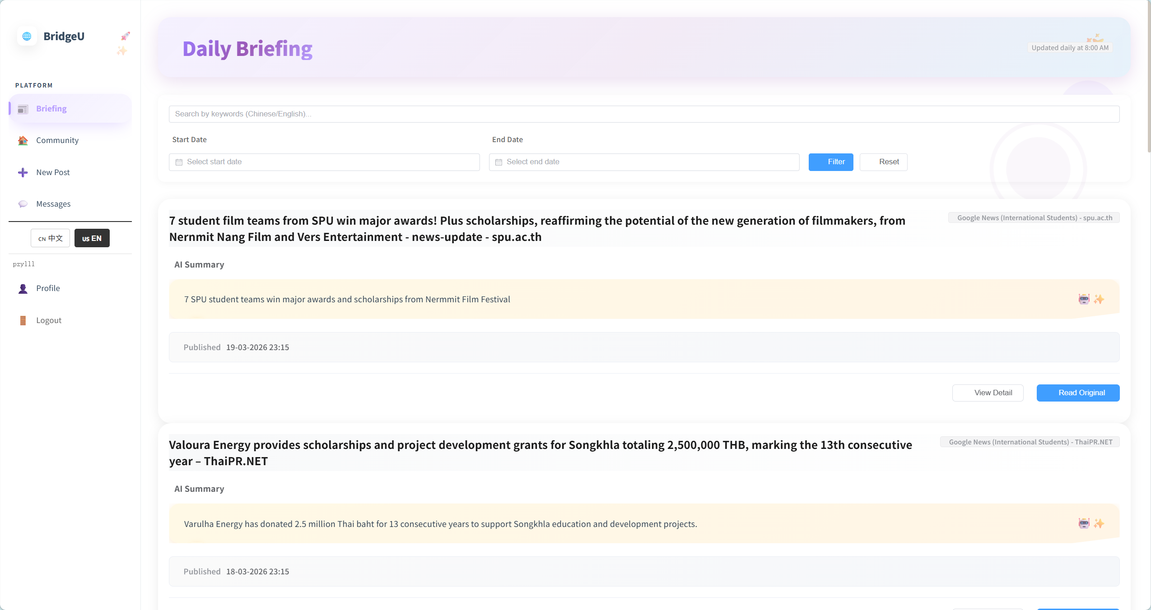
- Verify that the pagination bar shows pagination as 10 news.
- Scroll through all news items on the first page and verify that all visible titles and summaries are in Chinese or English only, with no Thai characters displayed.

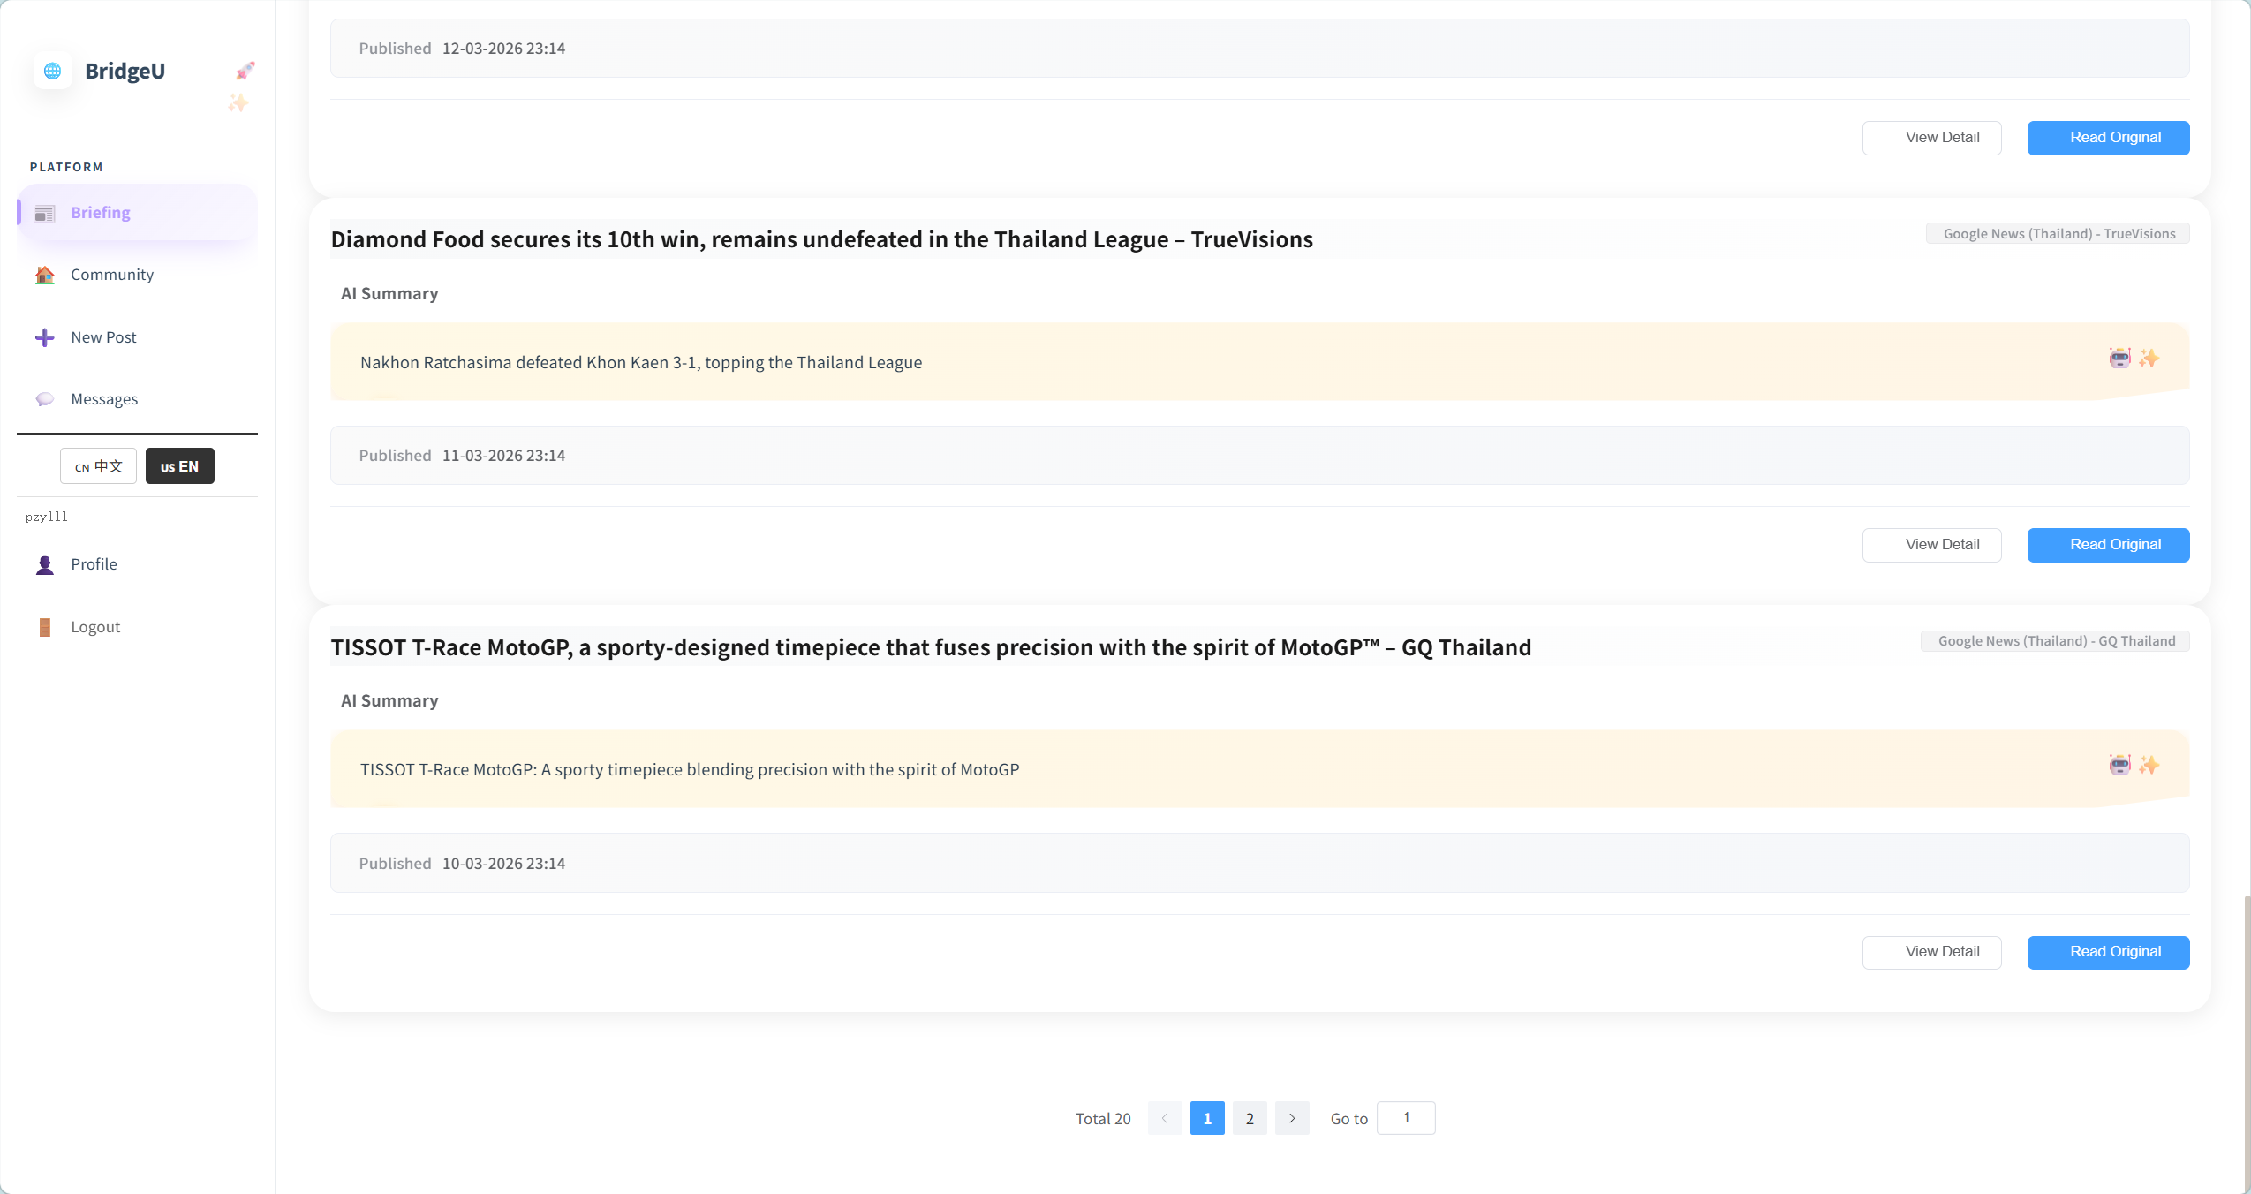
Test Case:

NO | Description | Test step | Expected Result
1 | Verify default state of Daily Briefing page | Navigate to the "Daily Briefing" page with no filters applied. | Page shows exactly 10 news cards containing title, summary, source, and publish date; no search or date filters are active.
2 | Verify pagination component behaviour | Scroll to the bottom of the news list. | A pagination bar is displayed, showing at least 2 clickable pages.
3 | Verify UI language display rule | Inspect the news titles and summaries on the first page. | All visible texts are in Chinese or English only; zero Thai characters appear in the content area.
4 | Verify active styling of Sidebar button | Click the "Briefing" button in the left sidebar. | The button background changes from white to purple, and the text color changes from black to dark purple.
4.2 STC-02: Filter News by Date Range
Description: This system test verifies that the system correctly filters Daily Briefing news items by publish date range across frontend and backend.
Prepared Data:
Same environment as STC-01.
Database contains news items whose `publishDate` covers at least the last 30 days.
Test script:
1. Open the Daily Briefing page(UI-01) in the browser.
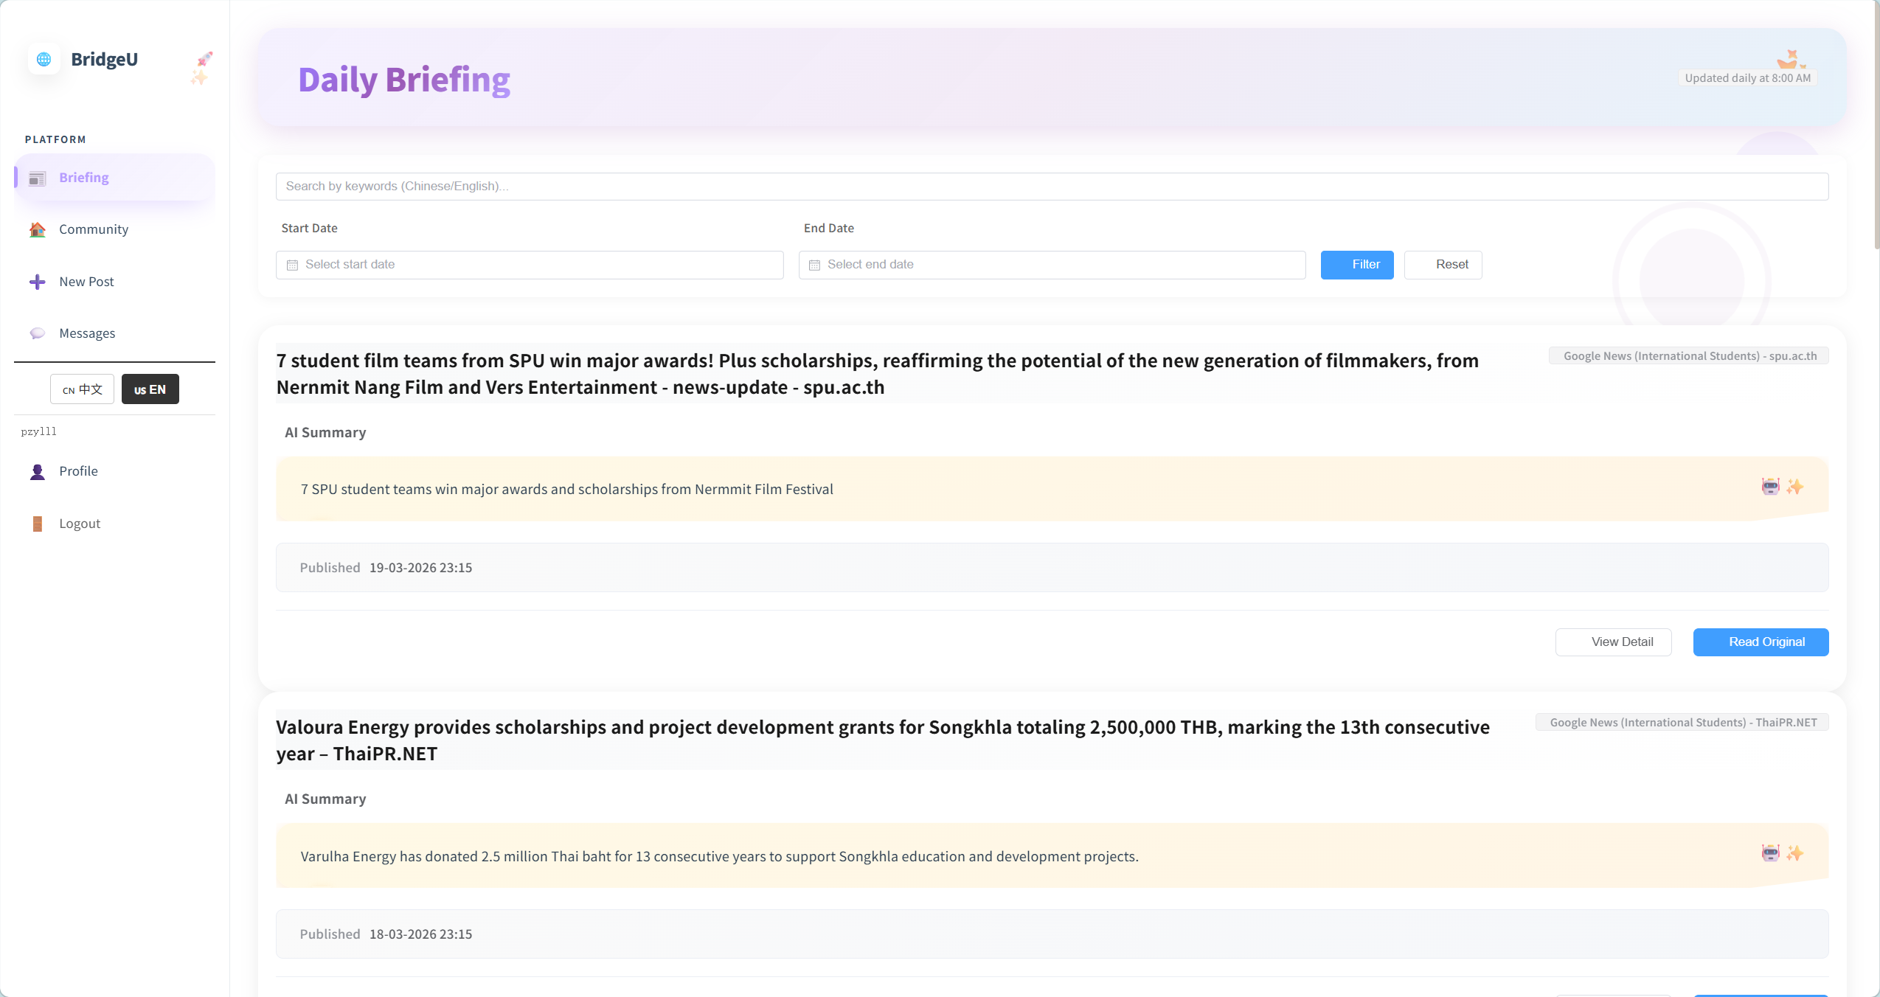
2.Fill start date and end date.
3.Click “Fitter” button.
Test Case:
NO | Description | Test step | Expected Result
1 | Verify filtering news by a specific date range | Set start date to 01-03-2026, set end date to 07-03-2026, and click "Apply Filters". | The list updates to display only news published between 01-03-2026 and 07-03-2026 (inclusive).
2 | Verify filtering news with only a start date | Click "Reset", set start date to 10-03-2026, leave end date empty, and click "Apply Filters". | The list displays only news published from 10-03-2026 up to the current date; no errors occur.
3 | Verify filtering news with only an end date (inferred start date) | Click "Reset", set end date to 20-03-2026, leave start date empty, and click "Apply Filters". | The system automatically sets the start date to 30 days prior; the list displays only news within this computed range.
4 | Verify validation for an invalid date range | Set start date to 10-03-2026, set end date to 01-03-2026, and click "Apply Filters". | The system prevents the action and displays a validation warning ( "Start date cannot be later than end date").
5 | Verify calendar popup functionality on date input | Click the "Select Date" input field. | A calendar component pops up smoothly, allowing the user to select a specific day, month, and year.
6 | Verify reset fitter date | Click “Reset” button. | The selection date has been reset and the page has returned to the page displaying all news.

4.3 STC-03: Search Daily Briefing by Keyword
Description: This system test verifies that keyword search works end-to-end, including parameter passing and search scope.
Prepared Data:
Same environment as STC-01.
Database contains news items whose `title`, `summary`, or translation fields (`titleZh`, `titleEn`, `summaryZh`, `summaryEn`) contain the keyword “Thailand”
Test script:
1. Open the Daily Briefing page(UI-01) in the browser.

2.Fill keyword into search bar
3.Click “Fitter” button.
Test Case:
NO | Description | Test step | Expected Result
1 | Verify search functionality by keyword | Enter Thailand in the search box and click the "Fitter" button. | The UI resets to page 1. The returned list only contains news where the title, content, summary, or translation includes "Thailand" (case-insensitive).
2 | Verify clearing the keyword search | Clear the text in the search box and click the "Fitter" button again. | The keyword parameter is removed. The list displays unfiltered results (respecting only other active date/source filters).
3 | Verify combined keyword and date filters | Enter student in the search box, set a valid date range, and click "Search". | The system applies both filters. The results only display items matching both the keyword and the specified date range.
4 | Verify pagination via manual page number input | Enter "2" into the page number input field and trigger the navigation. | The system successfully navigates to page 2 and displays the corresponding news items.
5 | Verify pagination via clicking page numbers | Click the page number "2" on the bottom pagination bar. | The system successfully navigates to page 2 and displays the corresponding news items.
6 | Verify interaction feedback on pagination buttons | Click the page number "2" on the pagination bar. | The text color of the clicked number temporarily changes to indicate the click action.
7 | Verify active state styling of the current page button | Successfully navigate to page 2. | The active page button updates its styling to indicate current location: the background changes from white to blue, and the text color changes from black to white.

4.4 STC-04: Switch Interface Language
Description: This system test verifies that switching between English and Chinese interfaces correctly reloads the Daily Briefing list using appropriate translations while still hiding Thai content.
Prepared Data:
Same environment as STC-01.
Database contains a dedicated test set of news records where “every record has both English and Chinese translations” (`titleEn`/`summaryEn` and `titleZh`/`summaryZh`).
Test script:
1.Ensure the interface language is set to “English (en)”, then open the Daily Briefing list.
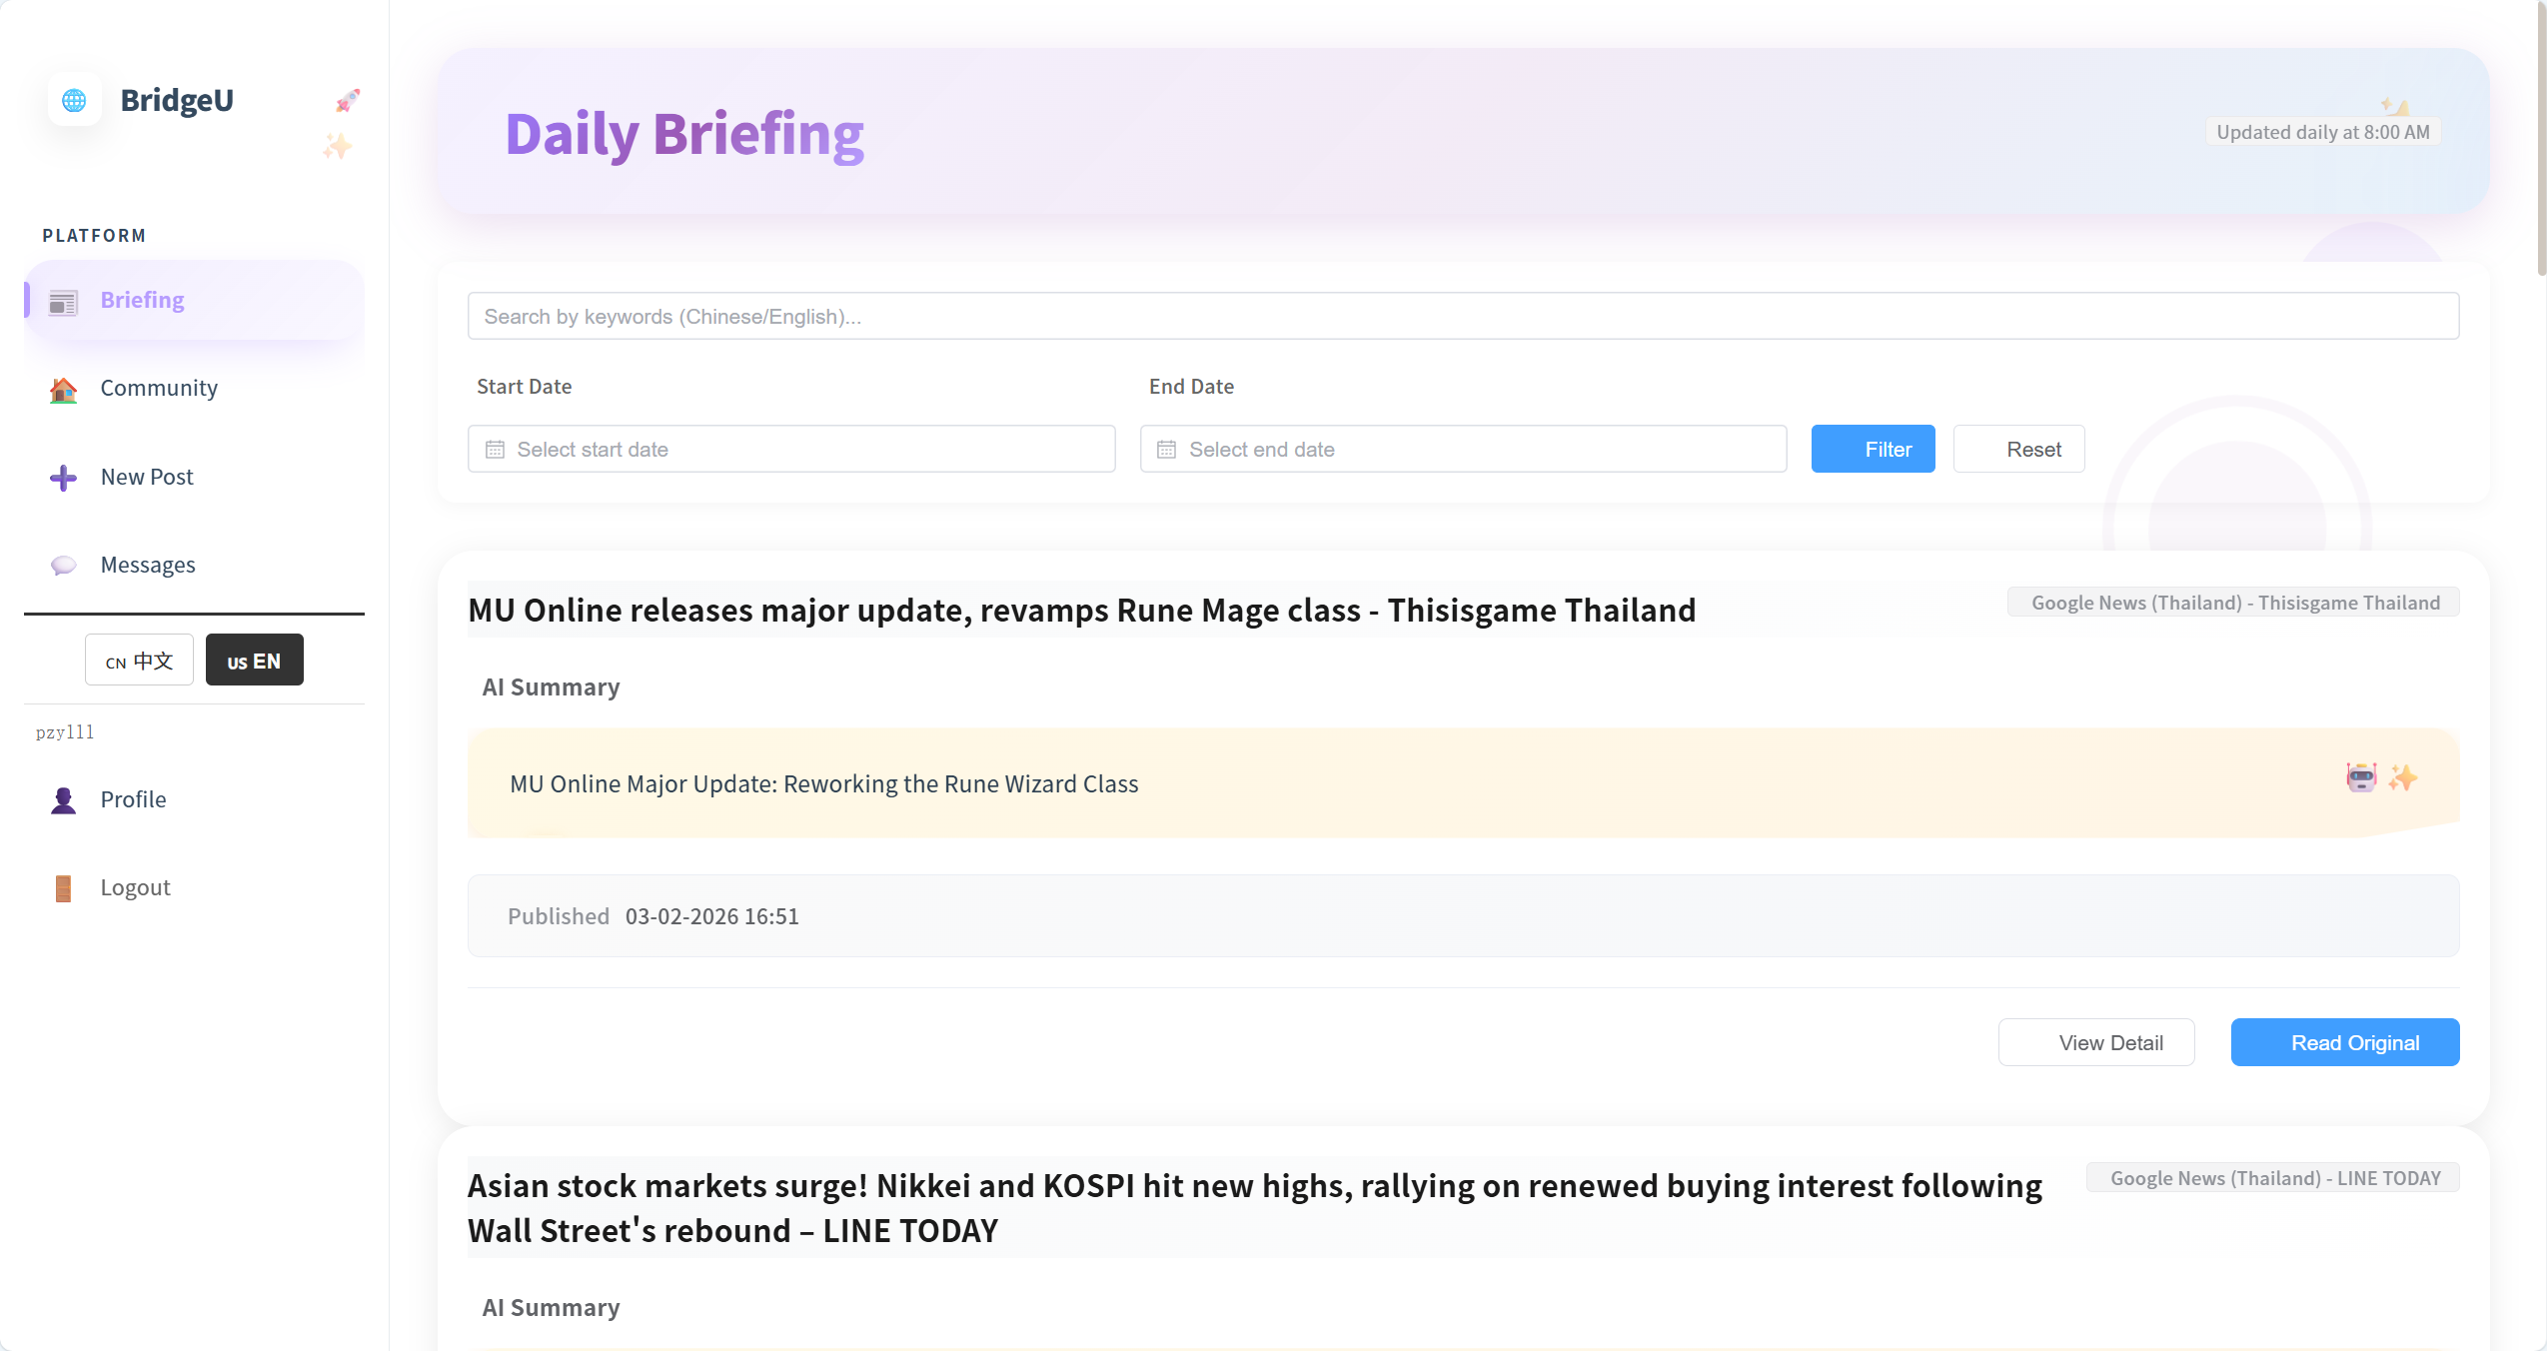

2.Use the language toggle in the UI to switch the interface language to Chinese (zh)
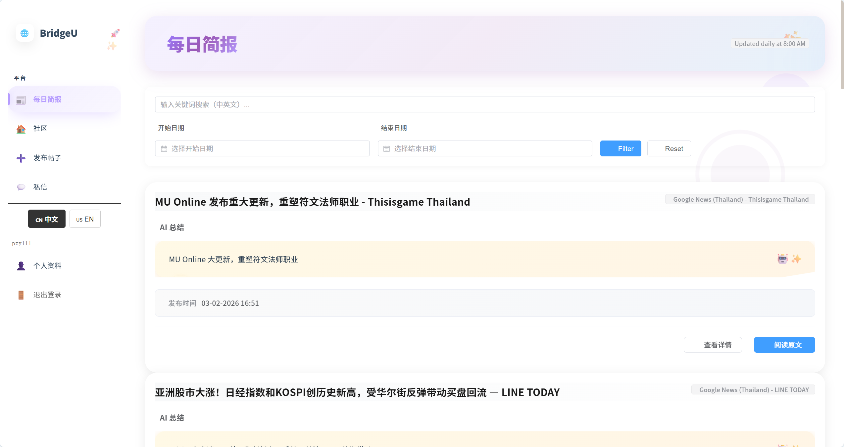

NO | Description | Test step | Expected Result
1 | Verify loading the Daily Briefing list in English | Set the interface language to en and open the Daily Briefing list. | The news list successfully displays all titles and summaries in English.
2 | Verify switching the interface language to Chinese | Use the language toggle button to switch the language to zh. | The news list instantly updates to display all titles and summaries in Chinese.
3 | Verify active state styling of the language toggle button | Click the "usEN" language toggle button. | The button background changes from white to black, and the text color changes from black to white to indicate it is currently active.

4.5 STC-05: View News Detail
Description: This system test verifies that selecting a news item from the list opens the detail view and correctly retrieves full information from the backend, including rules for `originalContent`.
Prepared Data:
Same environment as STC-01.
Database contains at least one news record
Test script:
1. Open the Daily Briefing list and choose a news item , Click the “View Detail"action for this item.
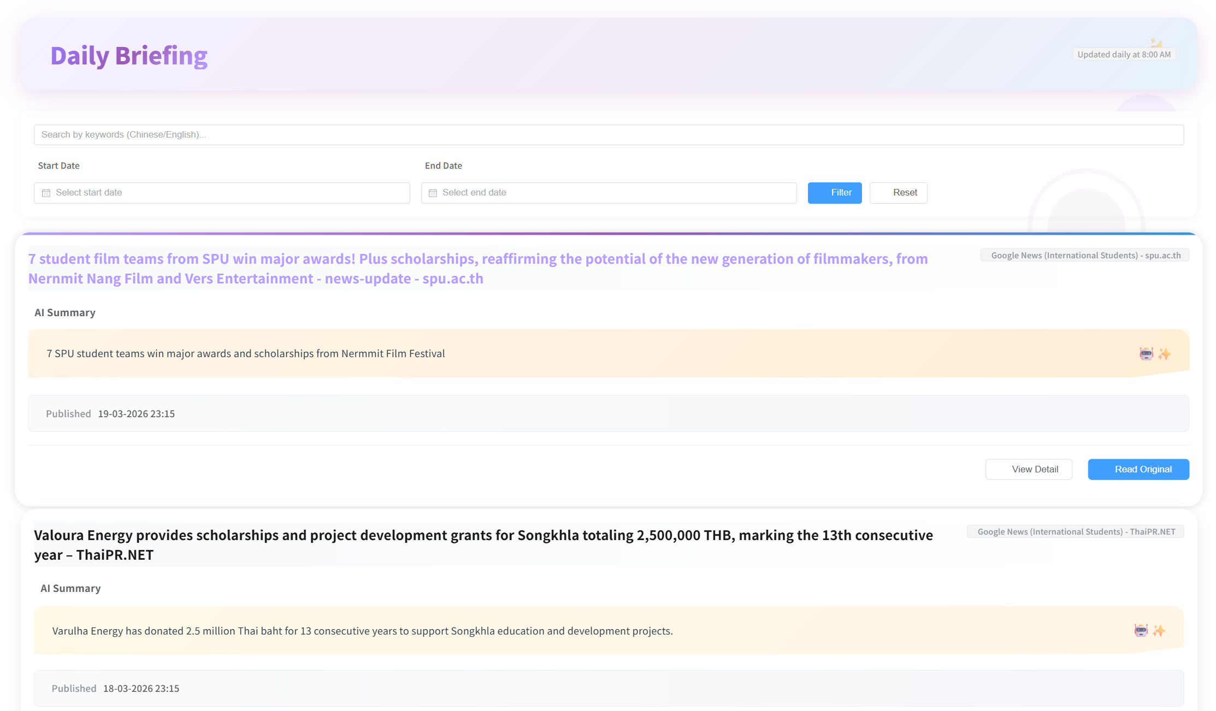
2. Confirm that the detail page displays only translated title/summary (or placeholders) and does not show any Thai original text.
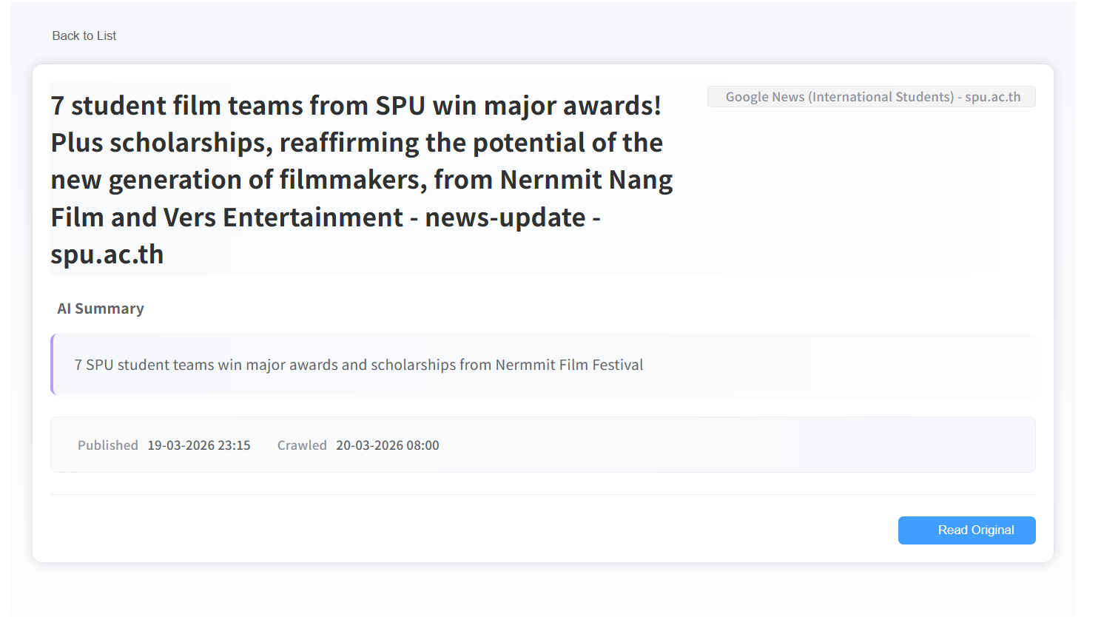

Test Case:
NO | Description | Test step | Expected Result
1 | Verify navigating to the news detail page | Click the "View Detail" button on any news item from the list. | The detail page successfully loads, displaying the complete title, summary, source, publish date, and original content section.
2 | Verify hover effects on the news post card | Hover the mouse cursor over a news post card in the list. | The post title color changes from black to purple, the card outline visibly enlarges, and a gradient color bar appears at the top of the card.
3 | Verify active state styling of the "View Detail" button | Click the "View Detail" button. | The button background color changes from white to blue, and the text color changes from black to dark blue.
4.6 STC-06: Open Original News Link
Description: This system test verifies that the “Open Original” action correctly opens the original news article URL from backend data, both from the list and from the detail view.
Prepared Data:
Same environment as STC-01.
Selected news items have a valid `originalUrl` field in the database.
Test script:
1. Open the Daily Briefing list and find a news item that has a visible “Open Original” action.


2. From the Daily Briefing list, click “View Detail” on the same news item to open the detail page.


Test Case:
NO | Description | Test step | Expected Result
1 | Verify opening the original news link from the list view | On the Daily Briefing list, click the "Open Original" button for a news item with a valid originalUrl. | The browser successfully opens a new tab and navigates to the external original news source.
2 | Verify opening the original news link from the detail page | Click "View Detail" to enter a news item's detail page, then click the "Open Original" button. | The browser successfully opens a new tab and navigates to the external original news source.
3 | Verify the active state styling of the "Read Original" button | Click the "Read Original" button. | The button's background color and text font visibly lighten to indicate the active (clicked) state.

4.7 STC-07:View Community Feed List
Description: This system test verifies that the community feed (`PostList.vue`) correctly displays posts by calling `GET /api/posts` with `q`, `page`, `size`, `lang`, and that tag filters and search work as implemented.
Prepared Data: Backend Spring Boot application running on port 8080
Test script:

1. Verify that the page displays the community feed with a search box and tag pills.
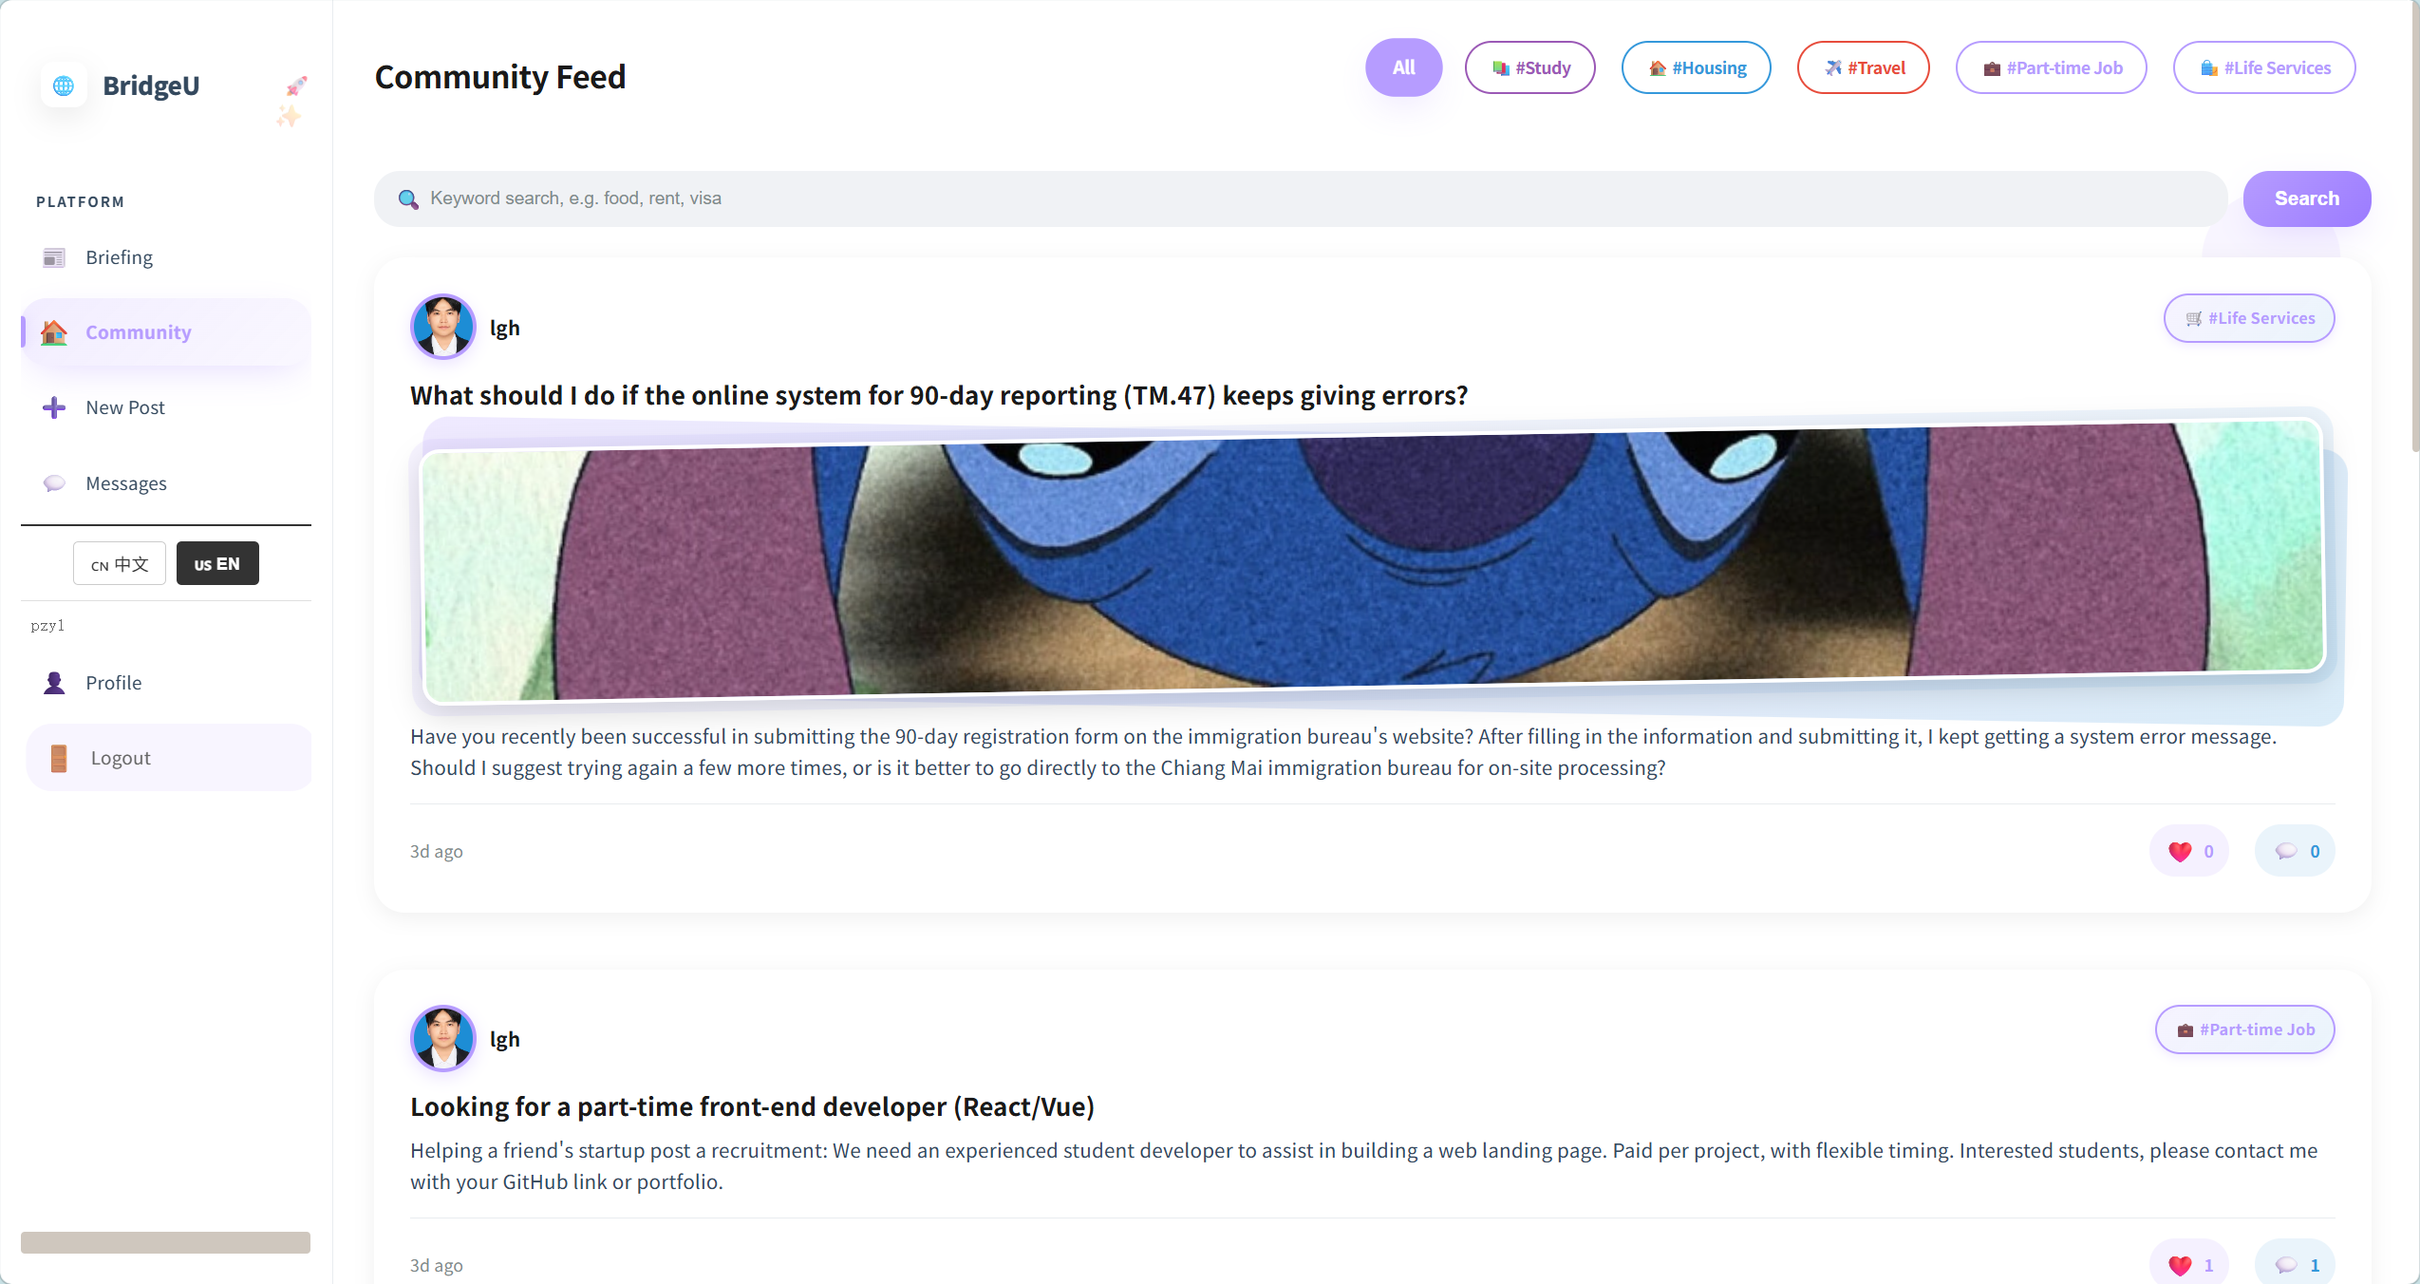

Test Case:
NO | Description | Test step | Expected Result
1 | Verify loading the Community feed | Click the "Community" link in the sidebar. | The page successfully loads the post list, displaying a search box, tag filter pills, and a feed of posts with their key fields visible.
2 | Verify active state styling of the Community sidebar button | Click the "Community" button in the sidebar. | The button's background color changes to purple, and the text color changes to deep purple to indicate it is active.
3 | Verify hover animation on community post cards | Hover the mouse cursor over a post card, then move the cursor away. | The post card smoothly rises (elevates) on hover, and instantly returns to its original position when the mouse is removed.
4 | Verify searching community posts by keyword | Enter a valid keyword in the search box and click "Search". | The list updates to display only posts relevant to the keyword (or shows an appropriate empty state message if no matches are found).
5 | Verify filtering community posts by a specific tag | Click the "study" tag filter pill. | The list updates to display only posts associated with the "study" tag.
6 | Verify resetting the tag filter | Click the "All" tag filter pill. | The tag filter is cleared, and the full list of community posts is displayed again.

4.8 STC-08: View Post Detail and Interact (Like, Comment, Follow)
Description: This system test verifies that clicking a post opens the detail page and that user interactions (like, comment, follow) update the UI correctly.
Prepared Data: At least one post
Test script:

- Click one post in Community Page

2. Verify that the detail page shows title, body, author, like count, comment count, and a “Back” button.
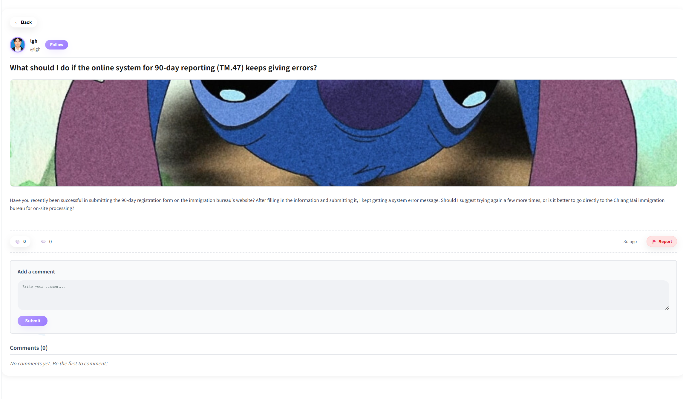

3.If have comment,user can click Summarize Comments.
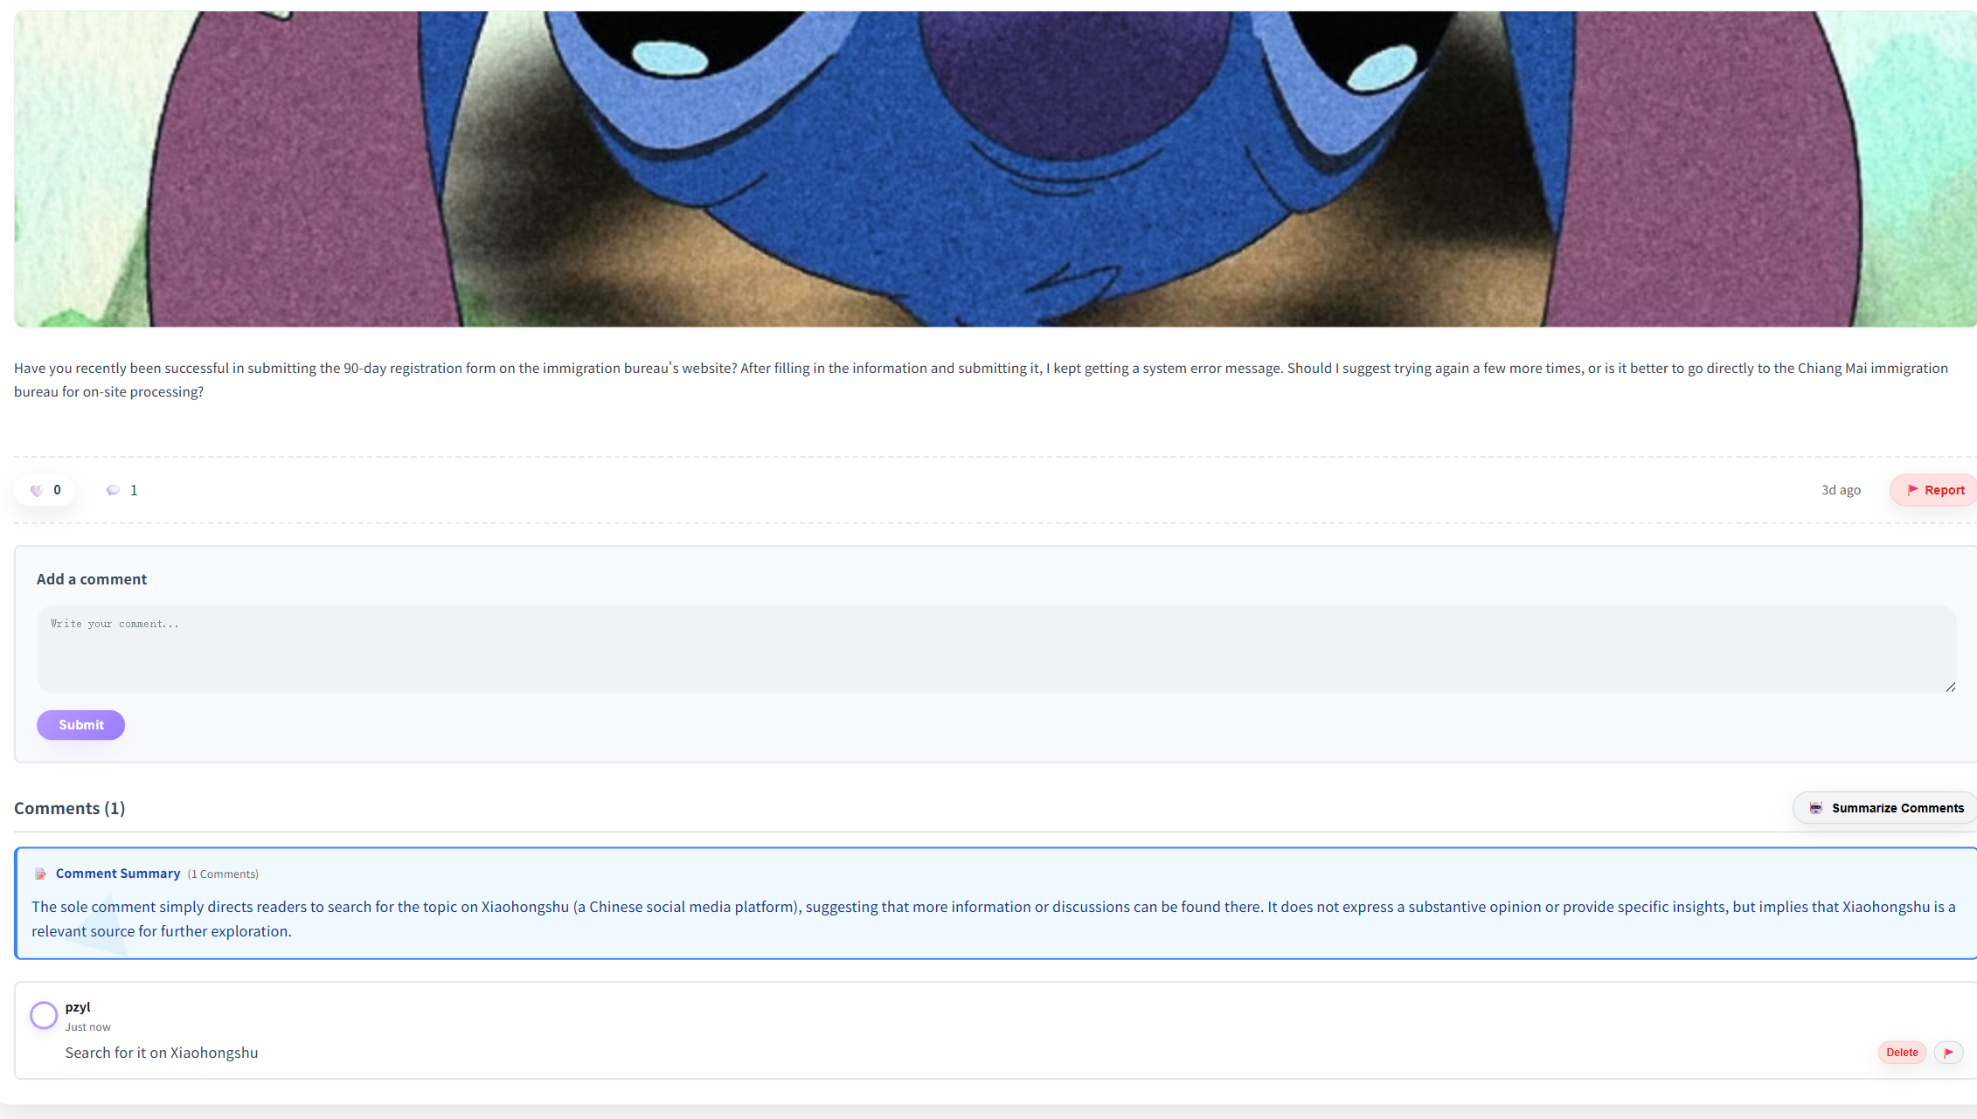
4.Click user’s avatar,navigate to this user’s profile page
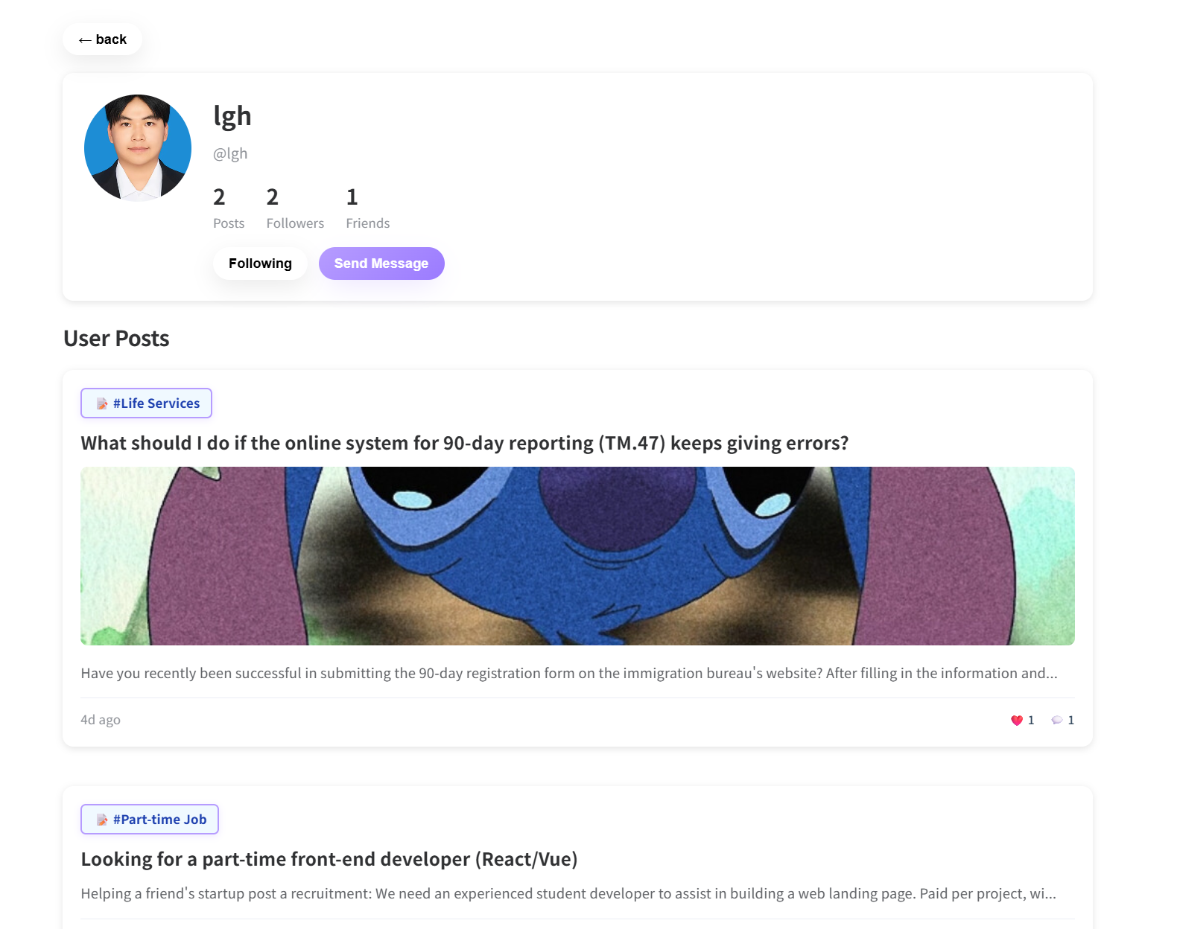

Test Case:
NO | Description | Test step | Expected Result
1 | Verify opening a post detail page | Click on a post card in the community feed. | The detail page successfully loads, displaying the full post title, body, author information, and accurate like/comment counts.
2 | Verify toggling the "Like" status on a post | Click the "Like" button on a post. | The heart icon toggles its state (e.g., from empty 🤍 to filled ❤️), and the total like count instantly updates.
3 | Verify submitting a new comment | Enter text into the comment input field and click the submit button. | The new comment is instantly appended to the comments list under the post.
4 | Verify following the author of a post | Click the "Follow" button on a post created by another user. | The button text changes to "Following", and this active state persists even if the page is refreshed.
5 | Verify the "Back" navigation functionality | Click the "Back" button (or browser back arrow) from the post detail page. | The system successfully navigates back to the community feed or the previously visited page.
6 | Verify the active state styling of the "Follow" button | Click the "Follow" button. | The button's background color changes from purple to white, and the text color changes from white to purple to indicate the active state.
7 | Verify the AI "Summarize Comments" functionality | Click the "Summarize Comments" button. | The system processes the comment data and successfully generates a single-paragraph summary of the discussion.
8 | Verify navigating to the post author's profile | Click on the author's avatar inside the post detail page. | The system successfully navigates to the profile page of the post's owner.

4.9 STC-09: Create New Post
Description: This system test verifies that the New Post flow allows the user to create a post and that the new post appears in the app after submission.
Prepared Data: None
Test script:

1. Click New Post in the sidebar.
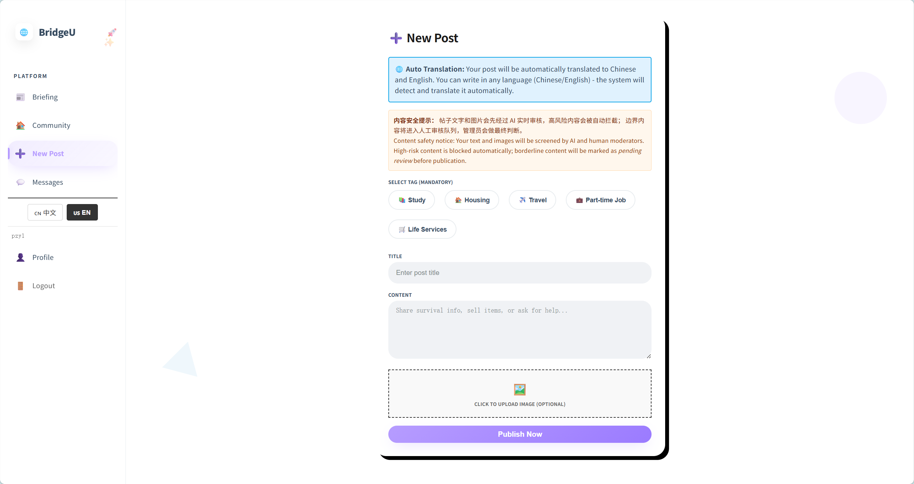
Test Case:
NO | Description | Test step | Expected Result
1 | Verify opening the "New Post" form | Click the "New Post" button in the sidebar. | The form successfully loads, displaying the tag selection dropdown, title input, content text area, and image upload section.
2 | Verify successful post submission | Fill in the title and content, select a valid tag, and click "Submit". | A success message is displayed: "Post submission received. It will appear in the list after it passes review."
3 | Verify form validation when only content is provided | Fill in the content field only, leave the tag and title empty, and attempt to submit. | The system prevents submission and displays the warning message: "Please select a tag."
4 | Verify form validation when only a tag is selected | Select the "study" tag, leave the title and content empty, and attempt to submit. | The system prevents submission and displays the warning message: "Title cannot be empty."
5 | Verify form validation when only tag and title are provided | Select the "study" tag, fill in the title, leave the content empty, and attempt to submit. | The system prevents submission and displays a warning message (e.g., "Content cannot be empty").
6 | Verify form validation when only the title is provided | Fill in the title field only, leave the tag and content empty, and attempt to submit. | The system prevents submission and displays the warning message: "Please select a tag."
7 | Verify form validation when only tag and content are provided | Select a valid tag, fill in the content, leave the title empty, and attempt to submit. | The system prevents submission and displays the warning message: "Title cannot be empty."

4.10 STC-10: Report Content
Description: This system test verifies that a user can report a “post” or a “comment” from the post detail page and receives clear success/error feedback in the UI.
Prepared Data: At least one post exists with at least one comment.
Test script:

1. Click Report on the post. Select at least one report reason, optionally enter description, then click Submit.
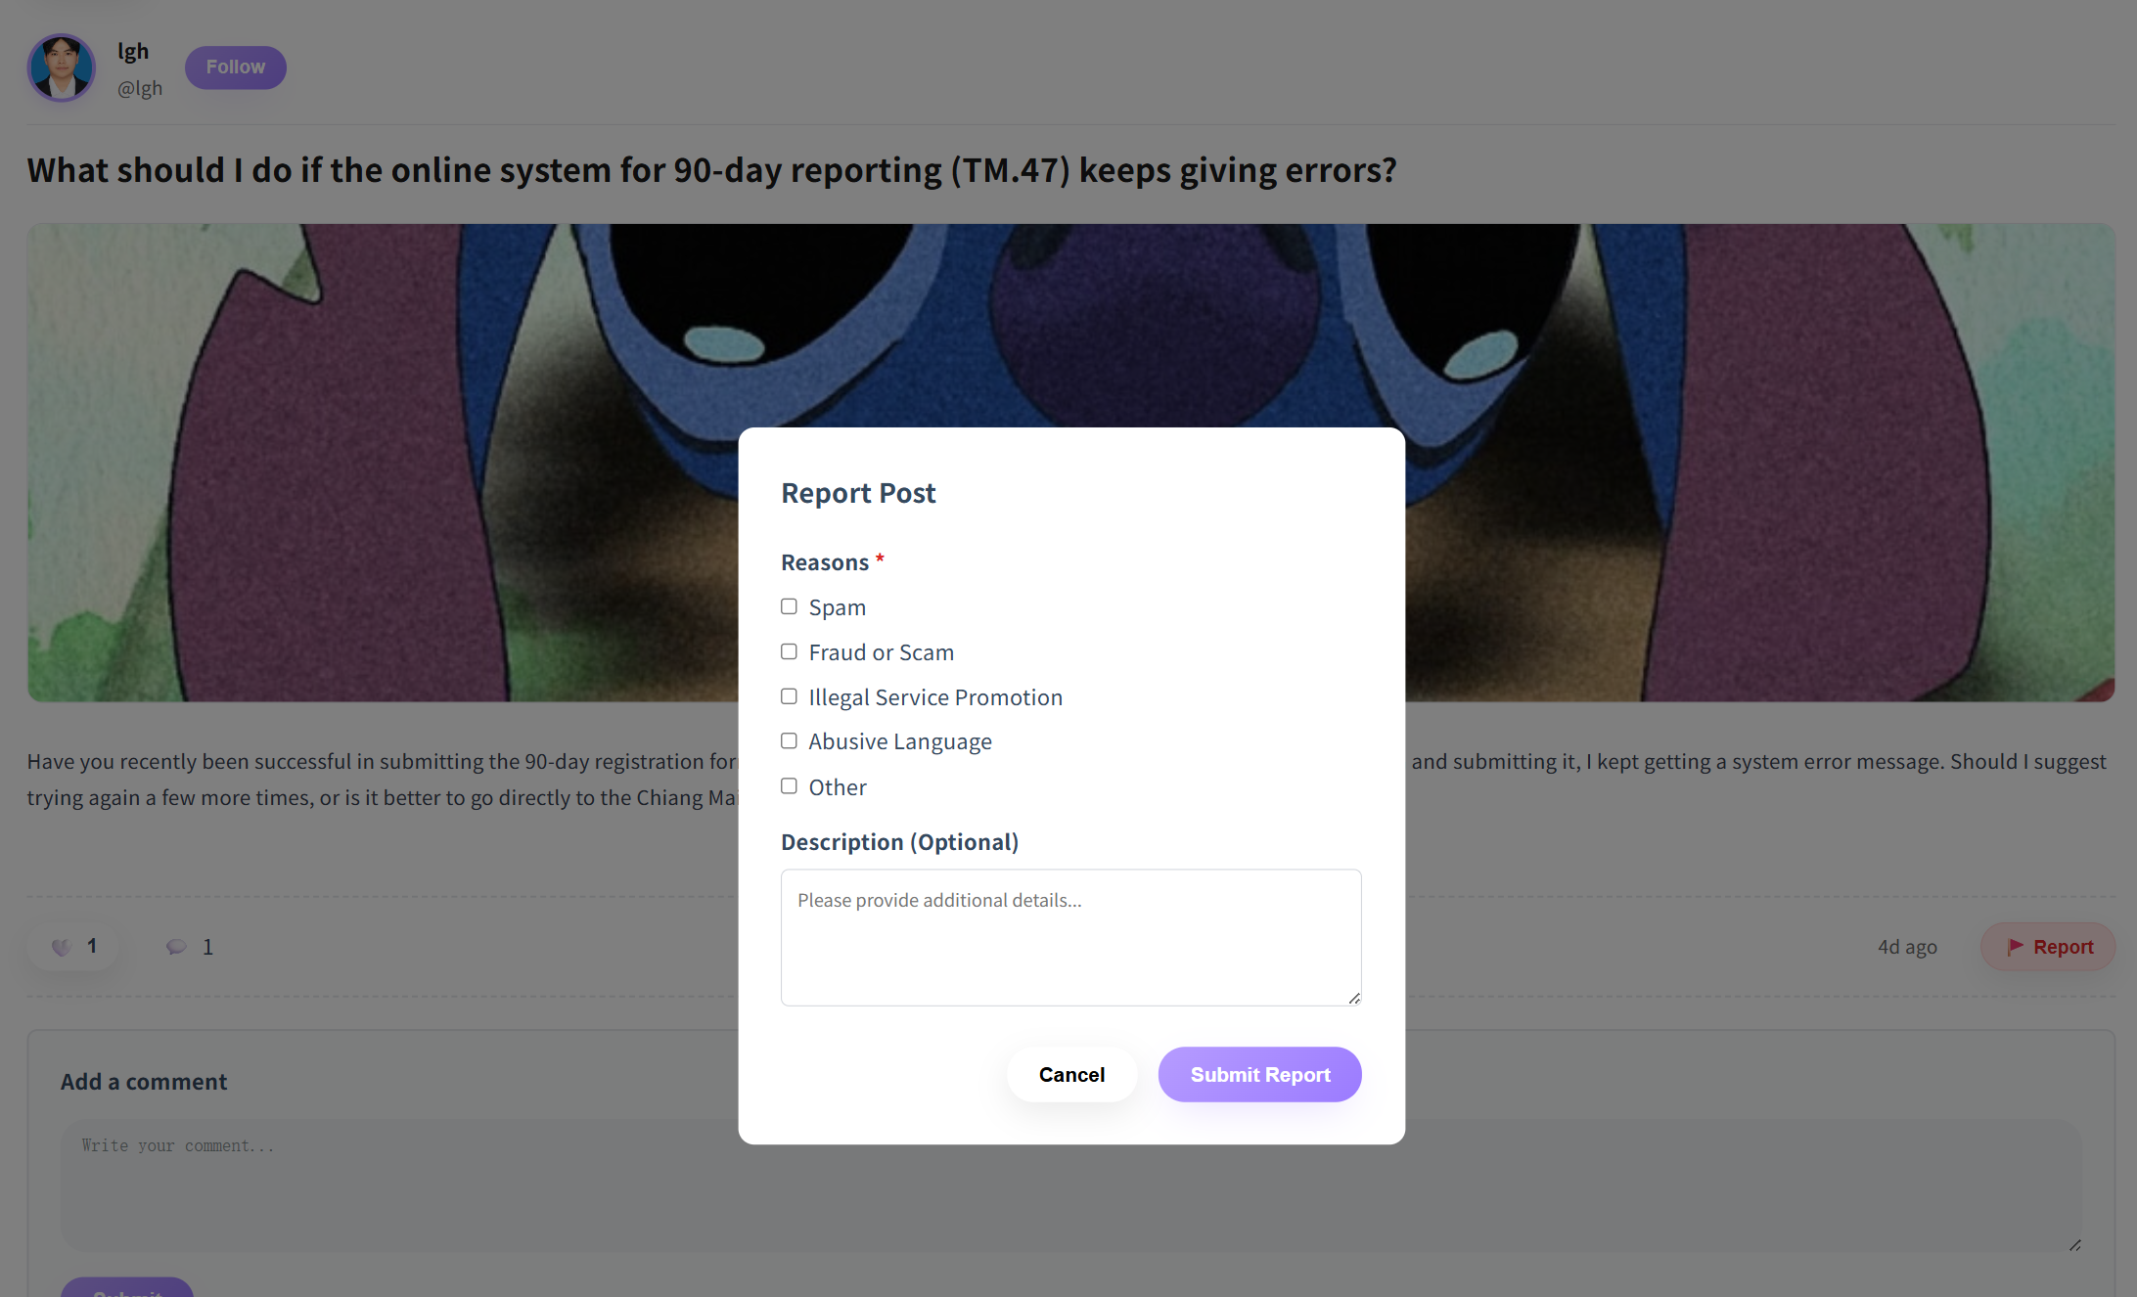
Test Case:
NO | Description | Test step | Expected Result
1 | Verify reporting a post functionality | Navigate to a post detail page, click the "Report" button, select an appropriate reason, and click "Submit". | A success message is displayed: "Report submitted successfully. AI review is in progress." The dialog closes, and the user remains on the same post detail page.
2 | Verify reporting a comment functionality | Navigate to a post detail page, click the "Report" button on a specific comment, select a reason, and click "Submit". | A success message is displayed: "Report submitted successfully. AI review is in progress." The dialog closes, and the user remains on the same post detail page.
3 | Verify validation when submitting an invalid report | Click the "Report" button, leave the reason selection empty, and attempt to click "Submit". | The system prevents the submission. The report dialog remains open, and a validation warning (e.g., "Please select a reason") is displayed.

4.11 STC-11: Manage Message Status
Description: This system test verifies that unread indicators in Messages update correctly when a user opens a conversation,and verification One-way follow-up can only send one message, while two-way follow-up enables normal message sending.Verification can search .
Prepared Data: none
Test script:
- Click Messages in the sidebar.
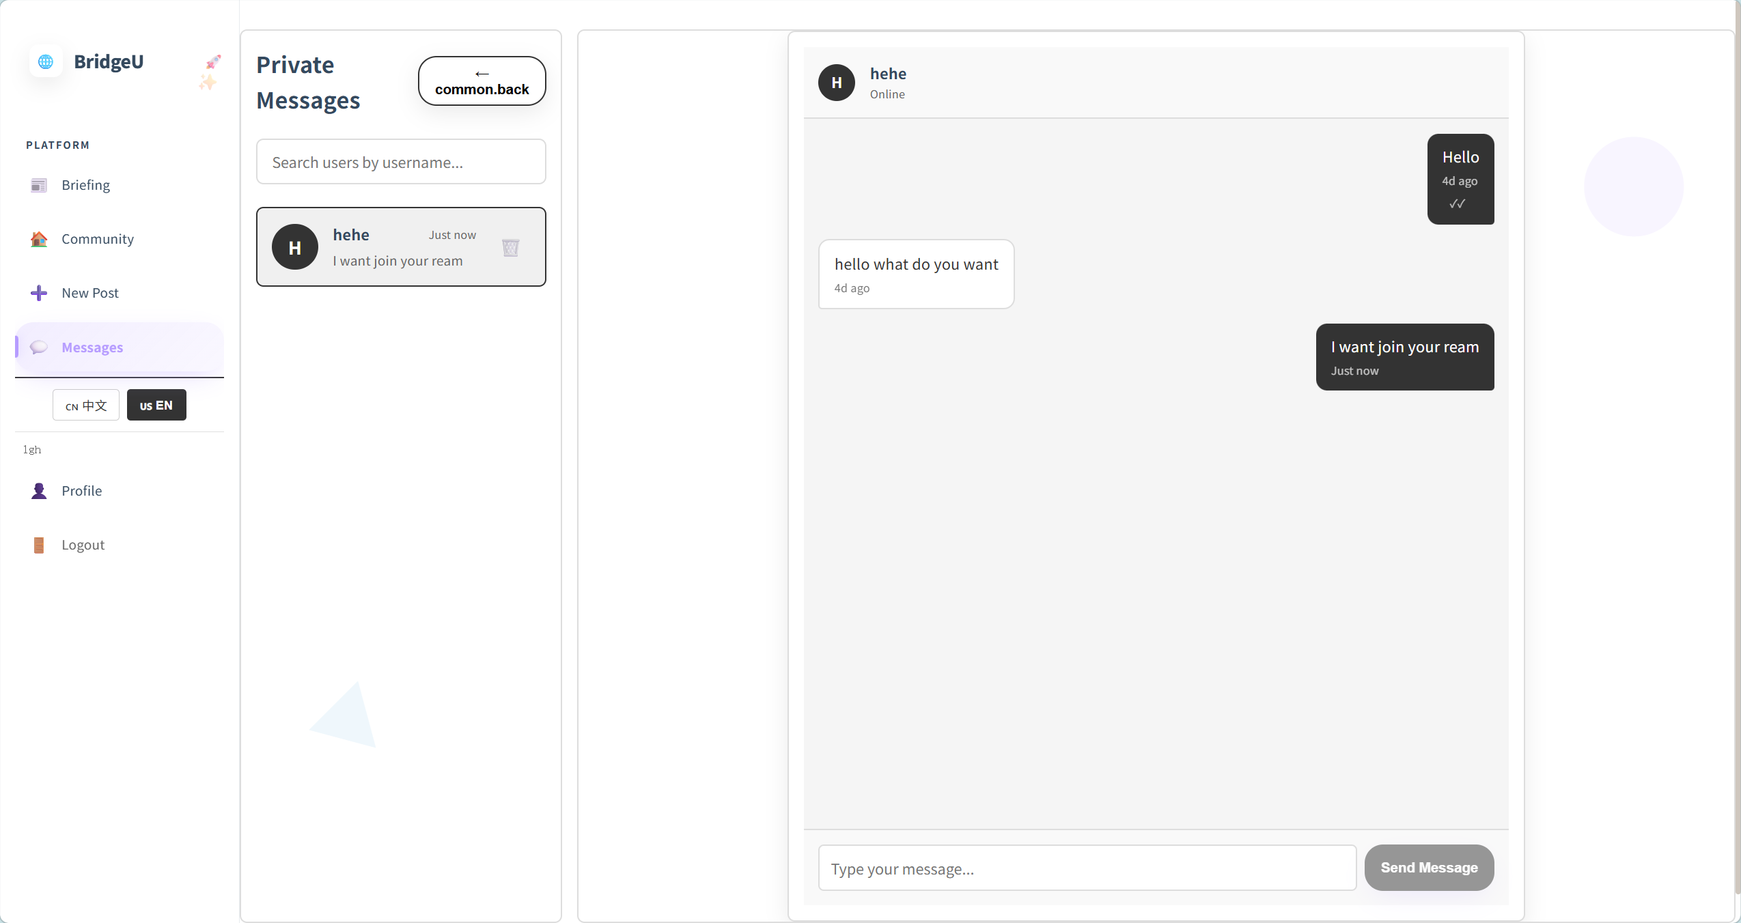

2. One-way follow-up can only send one message
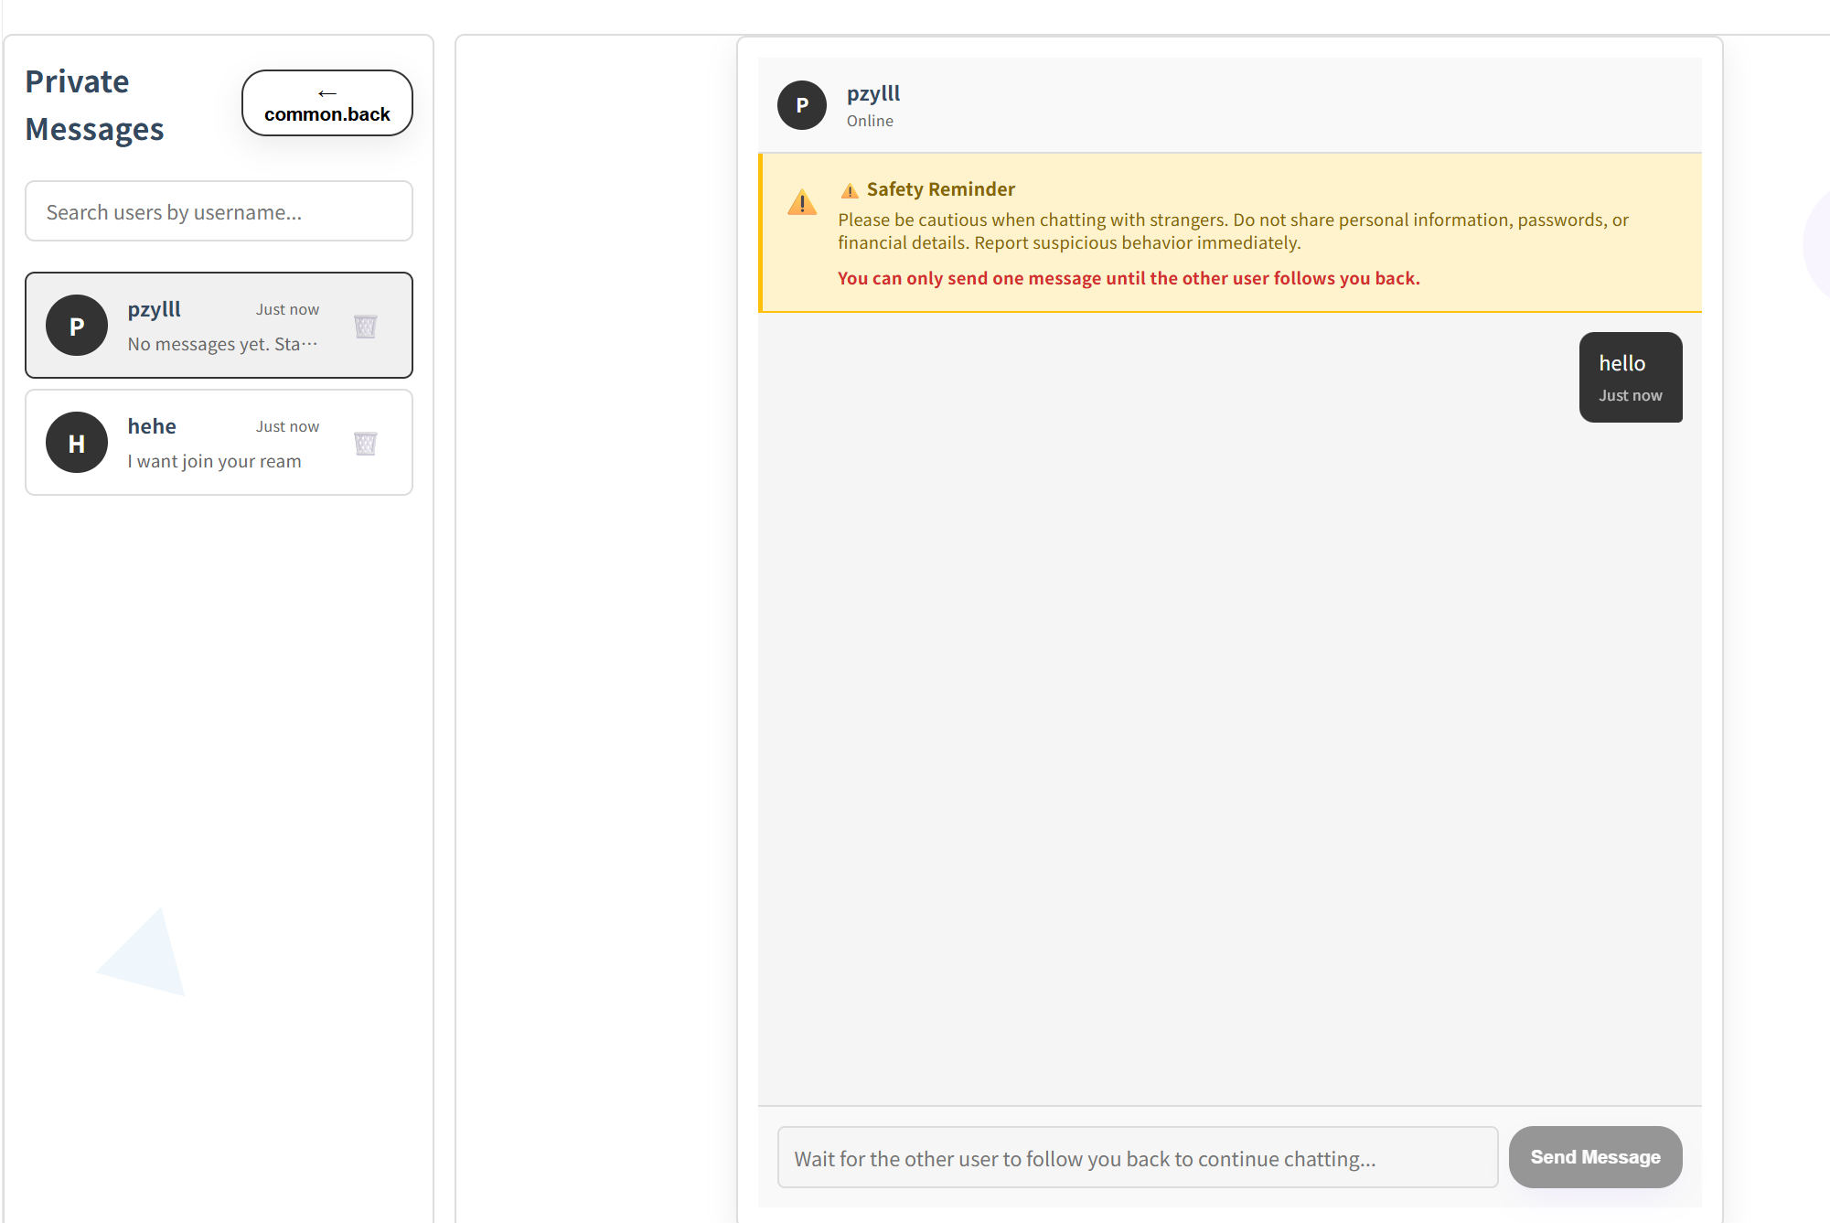
3. search users by username.
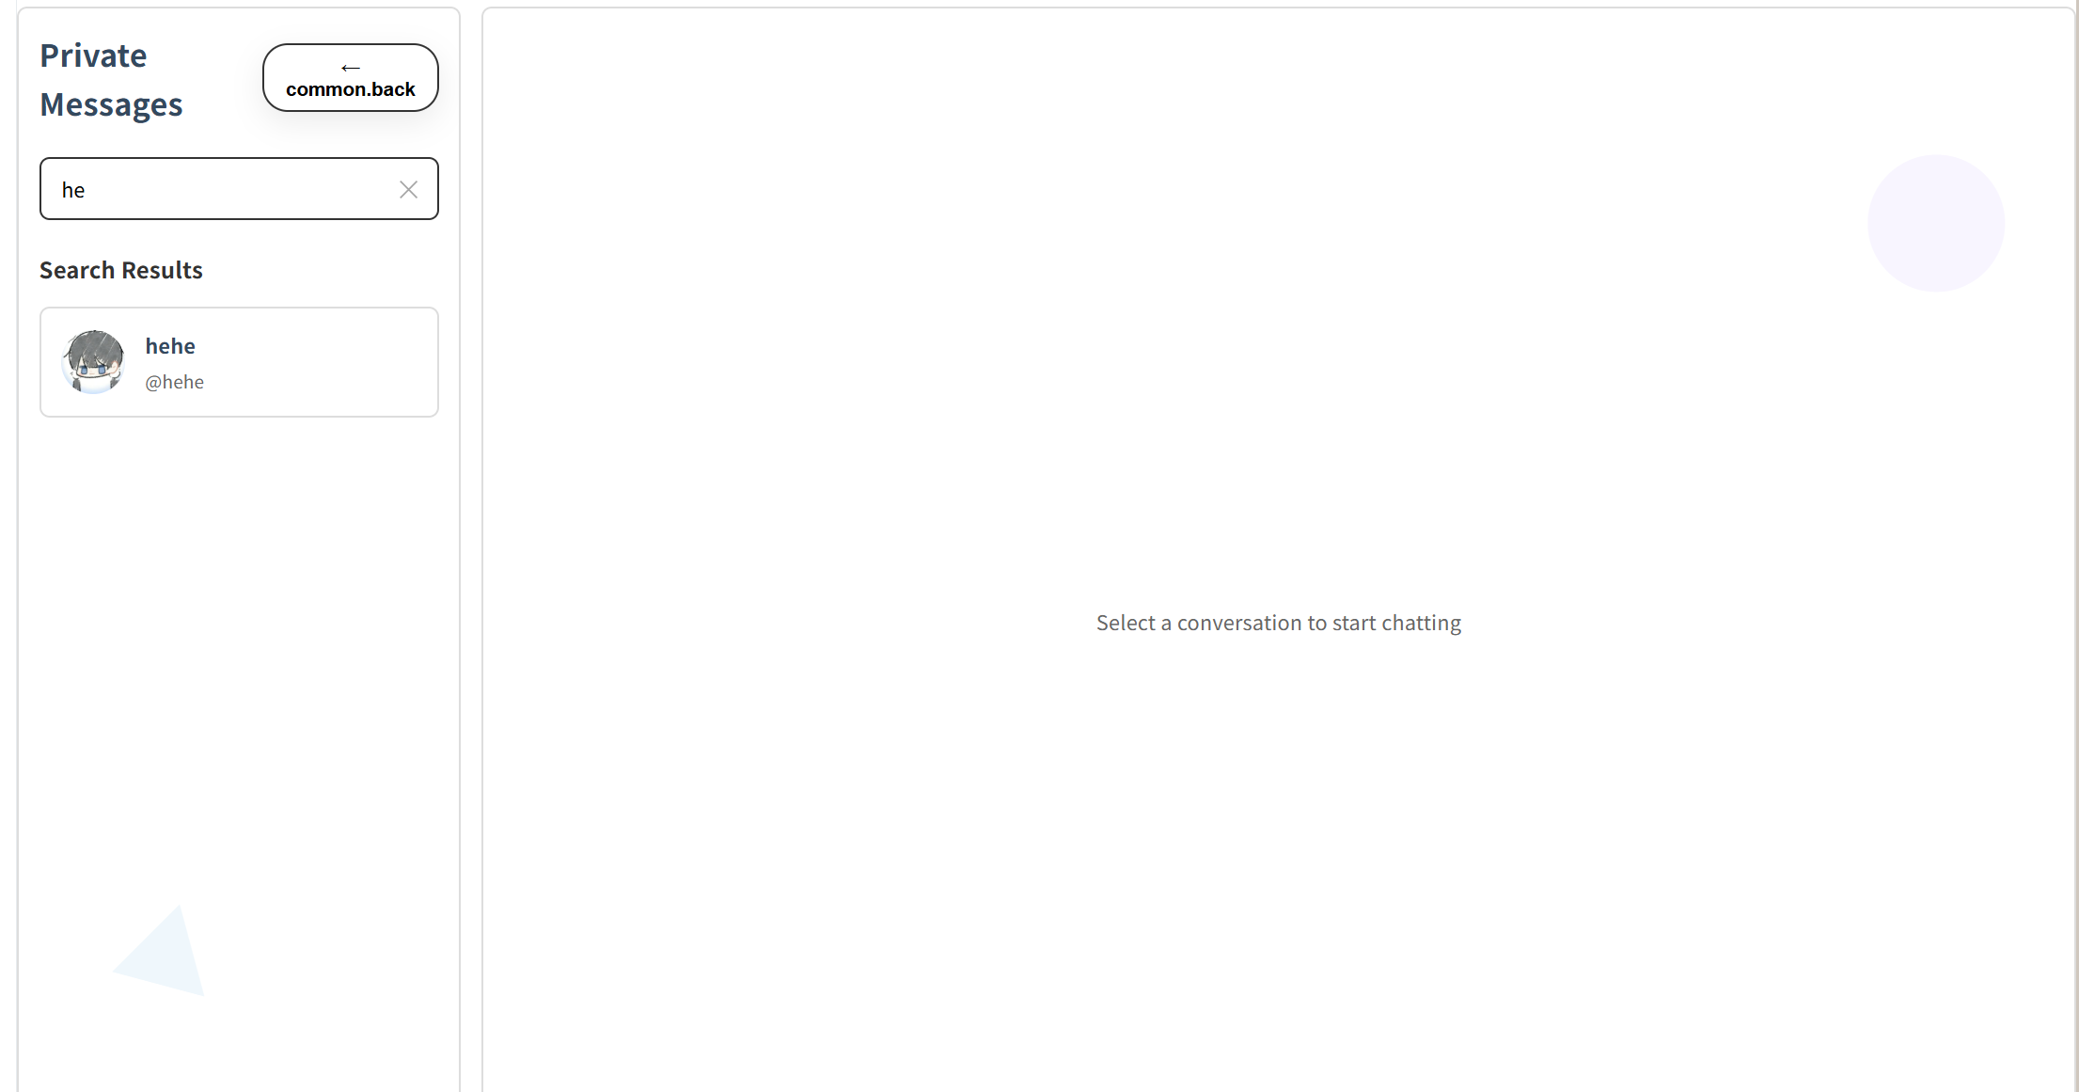

Test Case:
NO | Description | Test step | Expected Result
1 | Verify clearing the unread conversation badge | Open a conversation that displays an unread message badge. | The unread badge is instantly cleared (or the count becomes 0), and all messages within the conversation are visible.
2 | Verify message limits for one-way following | In a chat with a user who does not follow you back (and where one message has already been sent), input "hello" and attempt to send. | The system prevents the message from being sent and displays a persistent warning: "Safety Reminder: Please be cautious when chatting with strangers... You can only send one message until the other user follows you back."
3 | Verify searching users by partial username | Enter "he" into the user search input field. | The user list instantly updates to display only users whose usernames contain the substring "he" (case-insensitive).

4.12 STC-12: Login
Description: This system test verifies that users can log in successfully and see the main app UI, and that invalid credentials show an error without entering the app.
Prepared Data:
Test script:
1. Open BridgeU in a browser, Verify that the login form is displayed with username/email and password fields, and links for "Create account" and "Forgot Password".

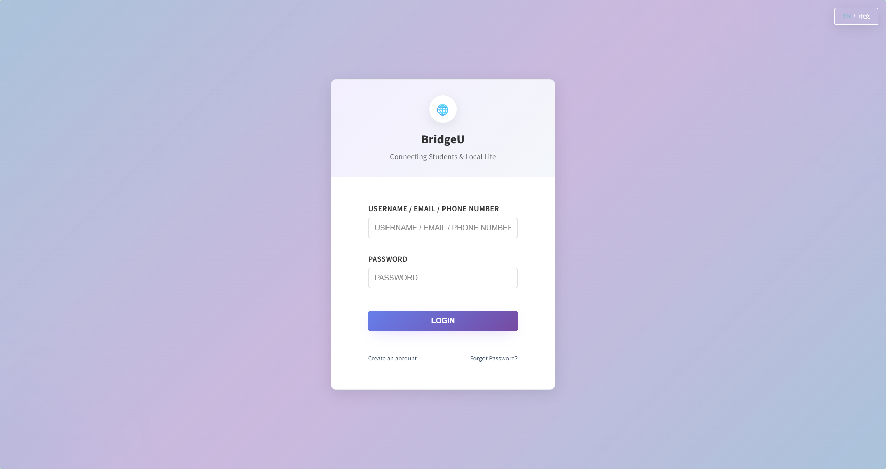
2.Fill username/email/ phone number and password
Test Case:
NO | Description | Test step | Expected Result
1 | Verify successful login with valid credentials | Enter a valid registered username (or email/phone) and the correct password, then click "Login". | The system successfully authenticates the user, navigates to the main application page, and maintains the active logged-in state.
2 | Verify login failure with an incorrect password | Enter a valid username (or email/phone) but an incorrect password, then click "Login". | The system denies access and displays the error message: "Incorrect username or password".
3 | Verify form validation when submitting empty fields | Leave both the username and password fields empty, and attempt to click "Login". | The system prevents submission and displays the warning message: "Please fill in all required fields".
4 | Verify form validation when submitting partial credentials | Fill in only the username (or email/phone) leaving the password empty, or vice versa, then click "Login". | The system prevents submission and displays the warning message: "Please fill in all required fields".
5 | Verify navigation to the Registration page | Click the "Create an account" link on the login screen. | The user is successfully navigated to the user Registration page.
6 | Verify navigation to the Forgot Password page | Click the "Forgot password?" link on the login screen. | The user is successfully navigated to the password recovery/reset page.

4.13 STC-13: Registration with Email Verification
Description: This system test verifies that users can create an account using “Email” verification and see clear UI feedback for each step.
Prepared Data: Email verification codes can be received in the test environment.
Test script:
- On the login page, click “Create an account” then select Email to Register
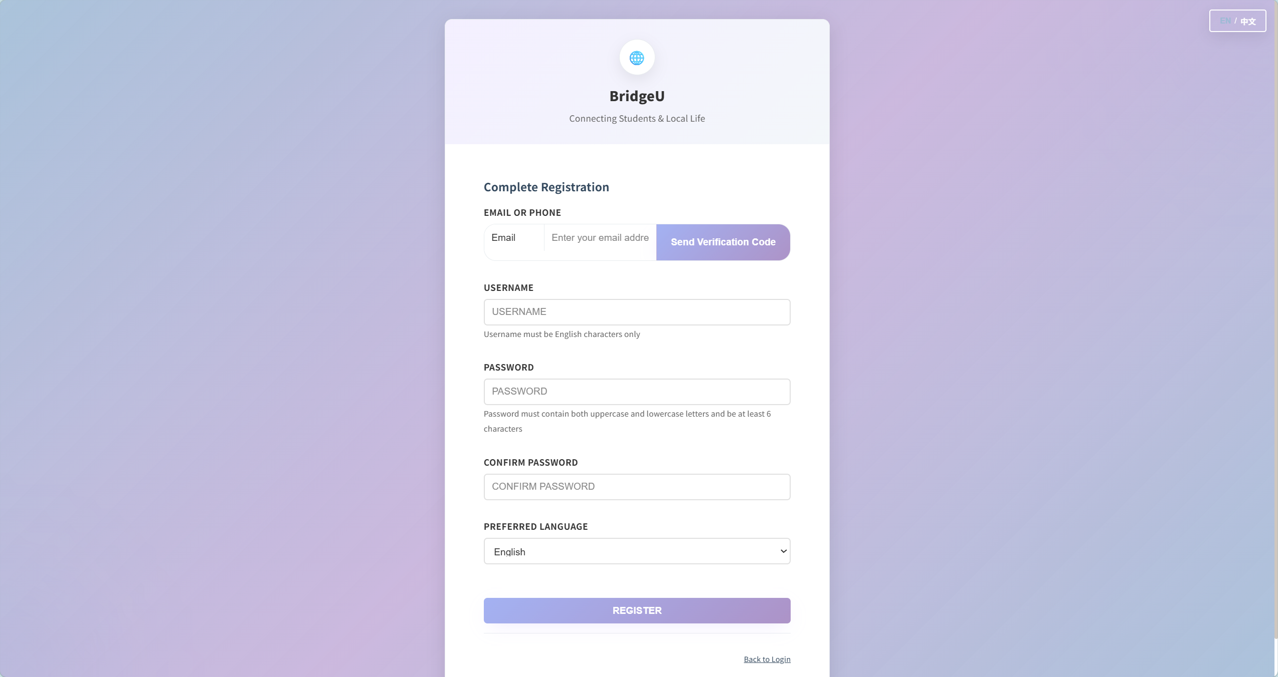
2.Fill email ,username,password,confirm password and select language
Test Case:
NO | Description | Test step | Expected Result
1 | Verify sending the verification code successfully | Enter a valid email or phone number and click "Send Code". | A success feedback message is shown, and the verification code input field becomes enabled/visible.
2 | Verify successful registration with a valid verification code | Enter the received 6-digit code, click verify, fill out the rest of the form, and click "Register". | The verification succeeds, the account is successfully created in the backend, and the user can proceed to the app or login page.
3 | Verify validation when sending a code with an empty field | Leave the email/phone field empty and click "Send Code". | The system prevents the action and displays the error message: "Please enter email or phone number."
4 | Verify validation when sending a code to an invalid email | Enter an invalid email address (e.g., missing '@' or domain) and click "Send Code". | The system prevents the action and displays the error message: "Please enter a valid email address."
5 | Verify rate limiting for sending verification codes | Click "Send Code" repeatedly within a 1-minute window. | The system prevents multiple sends and displays the error message: "Too many requests. Please try again in 1 minute."
6 | Verify registration failure when the username is already taken | Enter valid inputs but use a username that already exists in the database, then click "Register". | The backend rejects the request, and the UI displays the error message: "Username already taken."
7 | Verify validation for a non-6-digit verification code | Enter a code that is not exactly 6 digits (e.g., 4 digits) and click "Verify". | The system prevents verification and displays the error message: "Verification code must be 6 digits."
8 | Verify validation for an incorrect verification code | Enter an incorrect 6-digit code and click "Verify". | The system denies verification and displays the error message: "Incorrect verification code, please try again."
9 | Verify the "Register" button state before sending a code | Fill in the username and password fields, but do not request or enter a verification code. | The "Register" button remains disabled (cannot be clicked) to prevent incomplete submission.
10 | Verify the "Register" button state before verifying the code | Send the code successfully, but do not click the "Verify" button, then attempt to click "Register". | The "Register" button remains disabled (cannot be clicked) until the verification process is completed.
11 | Verify validation for a username with non-English characters | Enter a username containing non-English characters (e.g., Chinese/Thai) and click "Register". | The system prevents submission and displays the error message: "Username must contain only English characters."
12 | Verify validation for a weak password | Enter a password that lacks either an uppercase or a lowercase letter, then click "Register". | The system prevents submission and displays the error message: "Password must contain both uppercase and lowercase letters and be at least 6 characters."
13 | Verify validation for a password that is too short | Enter a password shorter than 6 characters and click "Register". | The system prevents submission and displays the error message: "Password must be at least 6 characters."
14 | Verify validation for password confirmation mismatch | Enter a valid password, but enter a different string in the confirm password field, then click "Register". | The system prevents submission and displays the error message: "Passwords do not match."
15 | Verify the "Verify" button state with an empty code field | Leave the SMS code input box completely empty. | The "Verify" button remains disabled (cannot be clicked) until a code is entered.

4.14 STC-14: Registration with Phone (Firebase SMS + Backend Register)
Description: : This system test verifies that users can create an account using “Phone” verification (SMS) and complete registration with clear UI feedback.
Prepared Data: Phone verification SMS can be received in the test environment.
Test script:
1. On the login page, click “Create an account” then select phone to Register
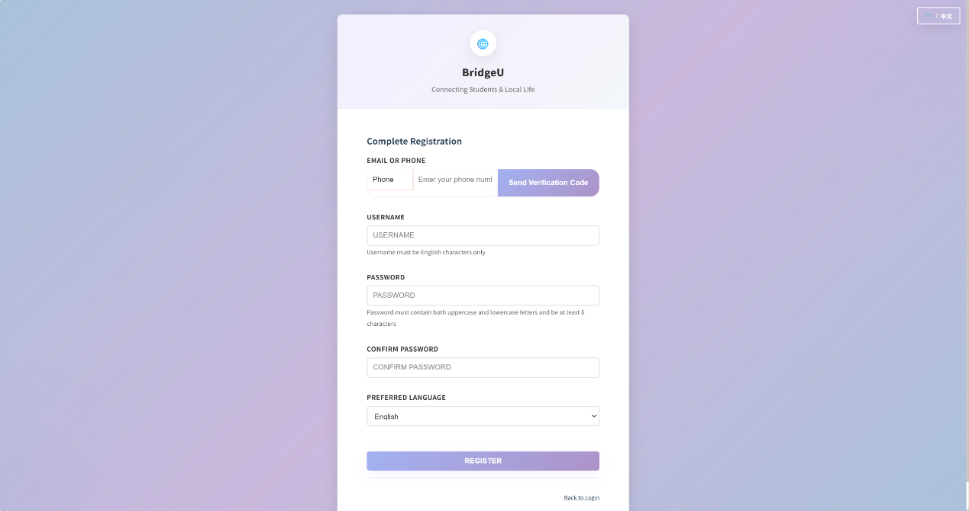
2.Fill phone number ,username,password,confirm password and select language
Test Case:
NO | Description | Test step | Expected Result
1 | Verify sending the SMS verification code successfully | Enter a valid phone number with a country code (e.g., +66...), and click "Send Code". | A success feedback message is displayed, and the SMS code input field becomes enabled/visible.
2 | Verify successful registration with a valid SMS code | Enter the received SMS code, click "Verify", fill out the remaining form fields, and click "Register". | The verification succeeds, the account is successfully created, and the user can proceed to the main application.
3 | Verify validation when sending SMS with an empty identifier field | Leave the phone number field empty and click "Send Code". | The system prevents the action and displays the error message: "Please enter email or phone number."
4 | Verify validation when sending SMS without a country code | Select the Phone method, enter a phone number without the "+" prefix, and click "Send Code". | The system prevents the action and displays the error message: "Please enter phone with country code, e.g. +66..."
5 | Verify rate limiting for sending SMS codes | Click "Send Code" repeatedly within a 1-minute window. | The system prevents multiple sends and displays the error message: "Too many requests. Please try again in 1 minute."
6 | Verify the "Verify" button state with an empty SMS code field | Leave the SMS code input box completely empty. | The "Verify" button remains disabled (cannot be clicked) until a code is entered.
7 | Verify validation for a non-6-digit SMS code | Enter an SMS code that is not exactly 6 digits and attempt to click "Verify". | The system prevents verification and displays the error message: "Verification code must be 6 digits."
8 | Verify validation for an incorrect SMS code | Enter an incorrect 6-digit SMS code and click "Verify". | The system denies verification and displays the Firebase/backend error message (e.g., "Incorrect verification code, please try again").
9 | Verify the "Register" button state before sending an SMS code | Fill in the form fields, but do not request or enter an SMS verification code. | The "Register" button remains disabled (cannot be clicked) to prevent incomplete submission.
10 | Verify the "Register" button state before verifying the SMS code | Send the SMS code successfully and enter it, but do not click "Verify", then attempt to click "Register". | The "Register" button remains disabled (cannot be clicked) until the SMS verification process is successfully completed.
11 | Verify validation for a username with non-English characters | Enter a username containing non-English characters and click "Register". | The system prevents submission and displays the error message: "Username must contain only English characters."
12 | Verify validation for a weak password | Enter a password that lacks either an uppercase or a lowercase letter, then click "Register". | The system prevents submission and displays the error message: "Password must contain both uppercase and lowercase letters and be at least 6 characters."
13 | Verify validation for a password that is too short | Enter a password shorter than 6 characters and click "Register". | The system prevents submission and displays the error message: "Password must be at least 6 characters."
14 | Verify validation for password confirmation mismatch | Enter a valid password, but enter a different string in the confirm password field, then click "Register". | The system prevents submission and displays the error message: "Passwords do not match."
15 | Verify registration failure when the backend rejects the phone number/username | Enter valid inputs but use a phone number or username that already exists or is restricted, then click "Register". | The backend rejects the request, and the UI displays the corresponding localized error message (e.g., "Username already taken").

4.15.STC-15:Log Out
Description: This system test verifies that users can log out and are returned to the login screen.
Prepared Data: User is logged in.
Test script:
- From any page in the main app, click “Logout” in the sidebar.
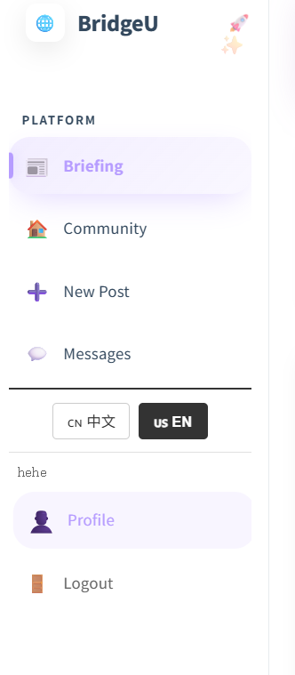
Test Case:
NO | Description | Test step | Expected Result
1 | Verify successful user logout and session termination | Click the "Logout" button in the sidebar menu. | The user is successfully logged out and redirected to the Login page. The active session is terminated, and the system immediately restricts access to all authenticated pages.

4.16.STC-16: Forgot Password (Email)
Description: This system test verifies that users can reset password using Email verification and then log in with the new password.
Prepared Data: None
Test script:
- On the login page, click “Forgot Password.Select Email method.
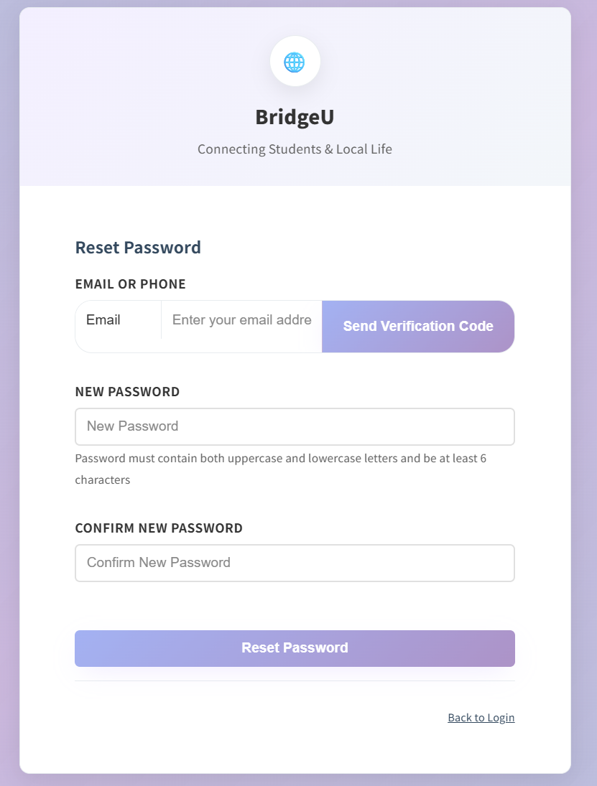
2.Fill Email,new password and confirm new password. Then click Reset Password.

Test Case:
NO | Description | Test step | Expected Result
1 | Verify sending the password reset code successfully | Enter a valid registered email address and click "Send Code". | Code-sent feedback is successfully displayed, and the verification code input field becomes enabled/visible.
2 | Verify successful password reset | Enter the received verification code, input a valid new password (and confirm it), then click "Submit/Reset". | A success message is displayed, the password is updated in the database, and the user can successfully log in with the new password.
3 | Verify the "Send Code" button state with an empty identifier | Leave the email field completely empty. | The "Send Code" button remains disabled (cannot be clicked).
4 | Verify rate limiting for sending reset codes | Click "Send Code" repeatedly within a 1-minute window. | The system prevents multiple sends and displays the error message: "Too many requests. Please try again in 1 minute."
5 | Verify the "Verify" button state with an empty code field | Leave the verification code input box completely empty. | The "Verify" button remains disabled (cannot be clicked) until a code is entered.
6 | Verify validation for a non-6-digit verification code | Enter a verification code that is not exactly 6 digits and click "Verify". | The system prevents verification and displays the error message: "Verification code must be 6 digits."
7 | Verify validation for an incorrect email verification code | Enter an incorrect 6-digit code and click "Verify". | The UI displays a clear verification error message: "Incorrect verification code, please try again."
8 | Verify validation when the identifier is cleared after sending a code | After successfully sending a code, clear the email field and attempt to click "Verify". | The system prevents the action and displays the error message: "Identifier cannot be empty."
9 | Verify the "Reset Password" button state before a code is sent | Without requesting or sending a verification code, attempt to access or submit the reset form. | The "Reset Password" button remains disabled (cannot be clicked) until a verification code is successfully sent and verified.
10 | Verify validation for password confirmation mismatch during reset | Enter a valid new password, but enter a different string in the confirm password field, then click "Reset Password". | The system prevents submission and displays the error message: "Passwords do not match."
11 | Verify validation for a weak new password | Enter a new password that lacks either an uppercase or a lowercase letter, then click "Reset Password". | The system prevents submission and displays the error message: "Password must contain both uppercase and lowercase letters and be at least 6 characters."
12 | Verify validation for a new password that is too short | Enter a new password shorter than 6 characters and click "Reset Password". | The system prevents submission and displays the error message: "Password must be at least 6 characters."

4.17 STC-17: Forgot Password (Phone)
Description: This system test verifies that users can reset password using Email verification and then log in with the new password.
Prepared Data: None
Test script:
- On the login page, click “Forgot Password.Select Phone method.
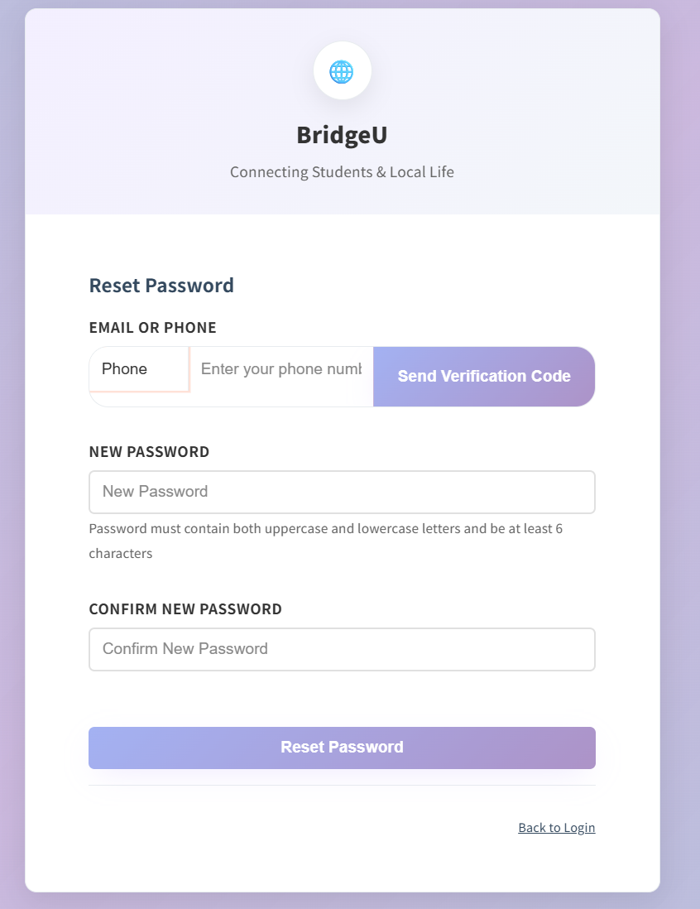
2.Fill phone number , new password and confirm new password. Then click Reset Password.
Test Case:
NO | Description | Test step | Expected Result
1 | Verify successful password reset via SMS verification | Select the Phone method, click "Send Code", input the received SMS code, click "Verify", set a valid new password, and submit. | SMS verification succeeds, a success message is displayed, and the user can successfully log in with the new password.
2 | Verify the "Send Code" button state with an empty identifier | Select the Phone method and leave the phone number input field completely empty. | The "Send Code" button remains disabled (cannot be clicked).
3 | Verify validation when sending SMS without a country code | Select the Phone method, enter a phone number without the "+" prefix, and attempt to click "Send Code". | The system prevents the action and displays the error message: "Please enter phone with country code, e.g. +66..."
4 | Verify rate limiting for sending SMS reset codes | Click "Send Code" repeatedly within a 1-minute window. | The system prevents multiple sends and displays the error message: "Too many requests. Please try again in 1 minute."
5 | Verify the "Verify" button state with an empty SMS code field | After successfully sending an SMS code, leave the SMS code input box completely empty. | The "Verify" button remains disabled (cannot be clicked) until a code is entered.
6 | Verify validation for a wrong or expired SMS code | Enter an incorrect or expired 6-digit SMS code and click "Verify". | The system denies verification and displays a clear error message indicating the verification failed.
7 | Verify the "Reset" button state without successful SMS verification | Request an SMS code, but do not complete the verification step, then attempt to submit the reset form. | The "Reset Password" button remains disabled (cannot be clicked) until the SMS code is successfully verified.
8 | Verify validation for a weak new password | Enter a new password that lacks either an uppercase or a lowercase letter, then click "Reset Password". | The system prevents submission and displays the error message: "Password must contain both uppercase and lowercase letters and be at least 6 characters."
9 | Verify validation for a new password that is too short | Enter a new password shorter than 6 characters and click "Reset Password". | The system prevents submission and displays the error message: "Password must be at least 6 characters."
10 | Verify validation for password confirmation mismatch | Enter a valid new password, but enter a different string in the confirm password field, then click "Reset Password". | The system prevents submission and displays the error message: "Passwords do not match."

4.18.STC-18: View and Edit My Profile
Description: This system test verifies that the Profile page shows current user info and that editing profile updates what the user sees.
Prepared Data: User is logged in.
Test script:
1.Click Profile in the sidebar.
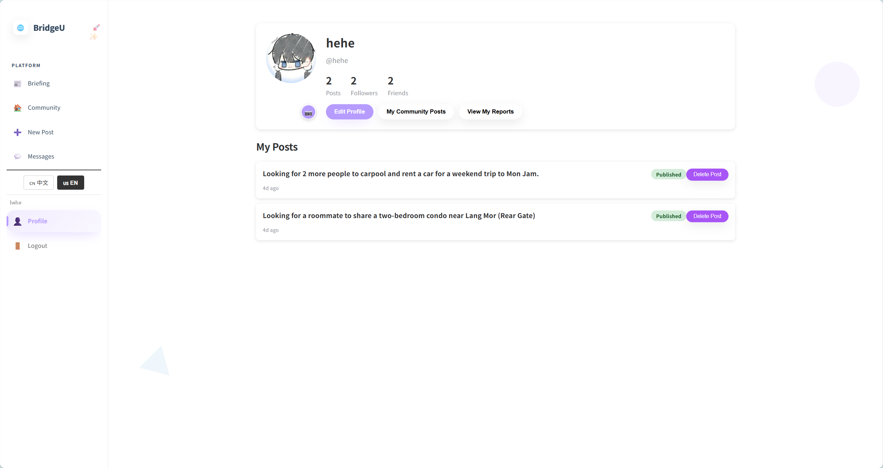
2. Click Edit Profile
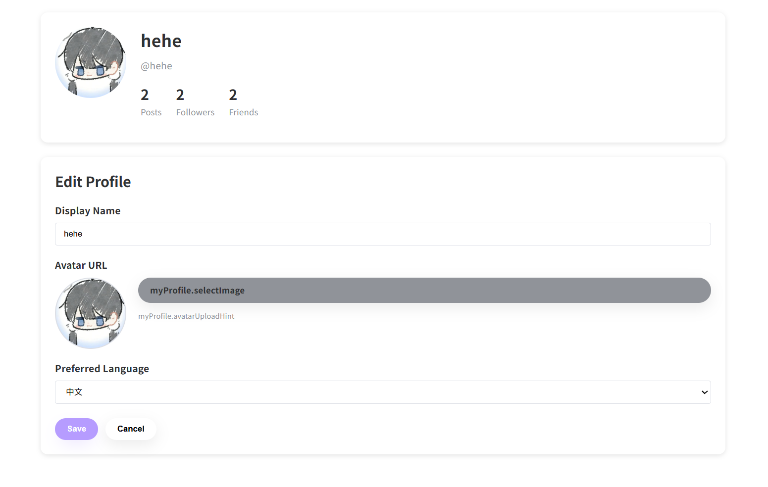
3. Change displayName, avatar,preferred language.
4.Click save.
Test Case:
NO | Description | Test step | Expected Result
1 | Verify viewing the user profile | Click the "Profile" button in the sidebar. | The profile page successfully loads, displaying the user's avatar, display name, username, and accurate statistics (e.g., total posts, followers, mutual follows).
2 | Verify editing the profile username | Click "Edit Profile", change the username field, and click "Save". | A success message is displayed indicating the information has been updated. The system forces a logout, redirects to the Login page, and the user can successfully log in using the new username.
3 | Verify updating the profile avatar | Click "Edit Profile", upload a new avatar image, and click "Submit/Save". | The profile is successfully updated, and the new avatar is instantly displayed on the profile page and across the UI.
4 | Verify changing the preferred language setting | Click "Edit Profile", select a new language from the preferred language dropdown, and save. | The profile is successfully updated, and the system's interface language updates to reflect the new preferred language.
5 | Verify confirming the deletion of a post | Click the "Delete" button on one of your own posts, then click "Yes" on the pop-up. | A confirmation dialog appears ("Are you sure you want to delete this post?"). Upon clicking "Yes", the post is successfully deleted and removed from the feed/profile.
6 | Verify canceling the deletion of a post | Click the "Delete" button on one of your own posts, then click "Cancel" on the pop-up. | A confirmation dialog appears ("Are you sure you want to delete this post?"). Upon clicking "Cancel", the dialog closes, and the post remains untouched in the feed/profile.

4.19.STC-19: View My Community Posts
Description: This system test verifies that the user can open **My Community Posts** from `MyProfile.vue` and view their posts list (`MyPosts.vue`).
Prepared Data: User is logged in and has at least 1 post.
Test script:
- 1. Click “Profile”in the sidebar.


2. Click My Community Posts.
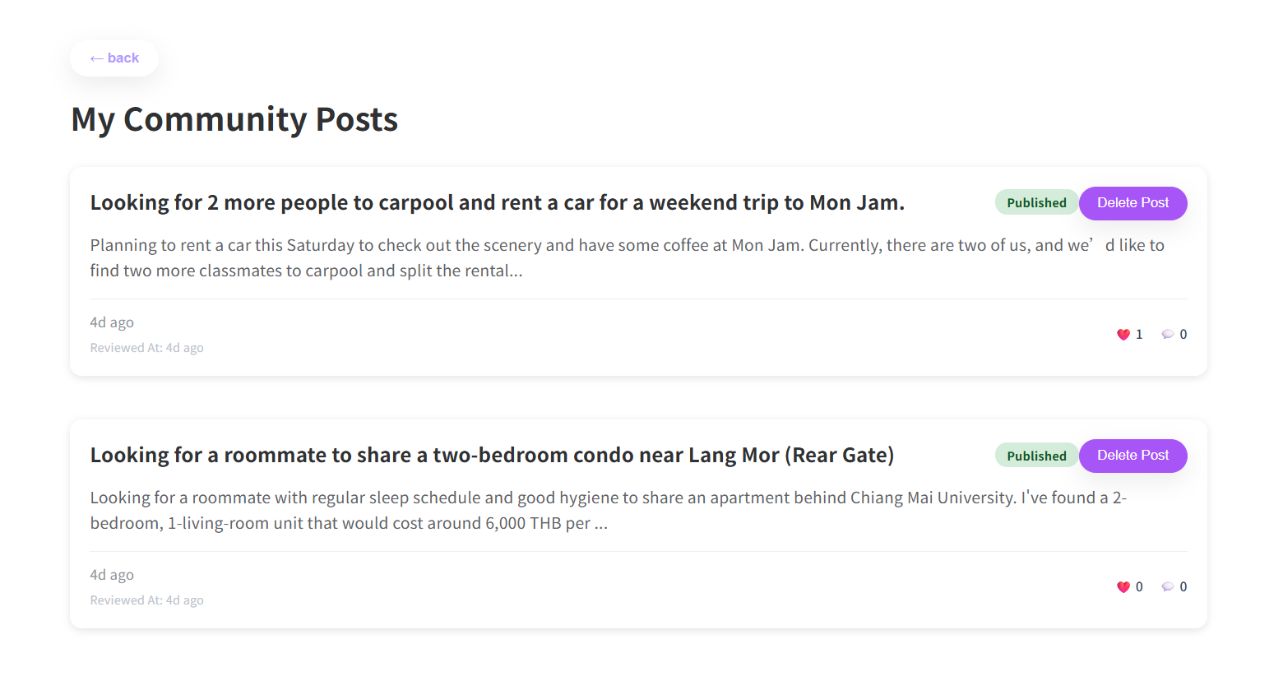
2.Click “Delete Post”
Test Case:
NO | Description | Test step | Expected Result
1 | Verify navigating to the "My Community Posts" list | Navigate to the Profile page and click the "My Community Posts" button. | The system successfully navigates to the My Posts list, displaying all the posts created by the current user.
2 | Verify confirming the deletion of a post | Click the "Delete" button on a post in the list, then click "Yes" on the confirmation prompt. | A confirmation dialog appears ("Are you sure you want to delete this post?"). Upon clicking "Yes", the post is successfully deleted and removed from the list.
3 | Verify canceling the deletion of a post | Click the "Delete" button on a post in the list, then click "Cancel" on the confirmation prompt. | A confirmation dialog appears ("Are you sure you want to delete this post?"). Upon clicking "Cancel", the dialog closes, and the post remains visible in the list.
4 | Verify viewing the details of a specific post | Click on a specific post card in the "My Posts" list. | The system successfully navigates to the post detail page, displaying the full content of the selected post.
5 | Verify the "Back" navigation to the Profile page | Click the "Back" button from the "My Posts" list. | The system successfully navigates back to the main Profile page.

4.20 STC-20: View My Reports
Description: This system test verifies that the user can open My Reports from Profile Page and view their reports list
Prepared Data:
Test script:
1.Click “Profile”in the sidebar.

2.Click “My Reports”.
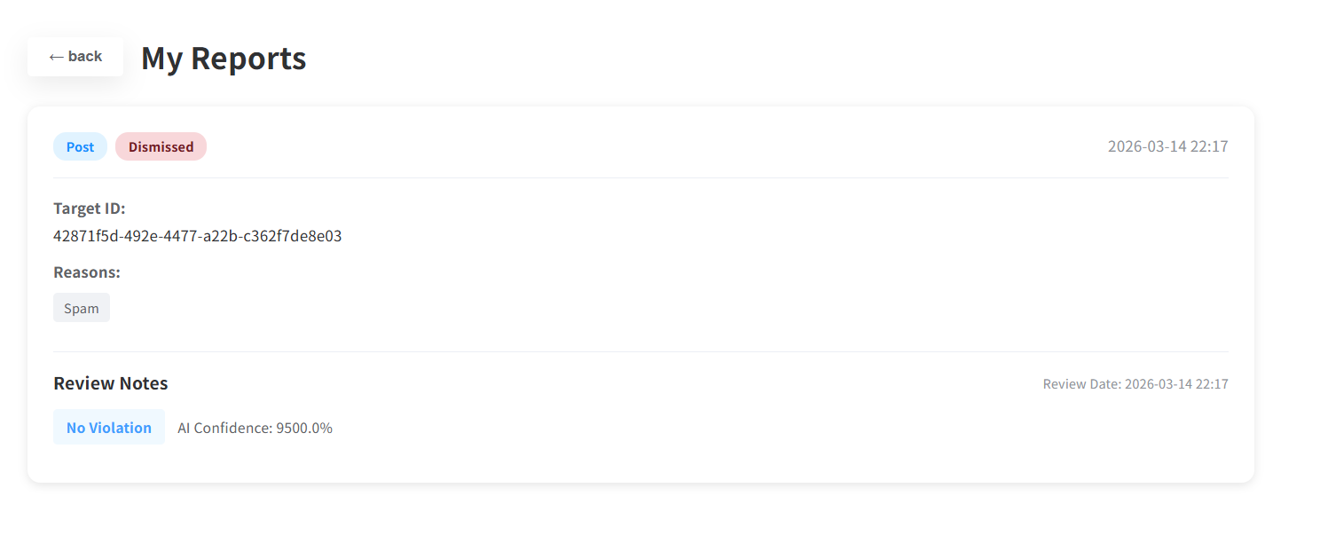
Test Case:
NO | Description | Test step | Expected Result
1 | Verify navigating to the "My Reports" list | Navigate to the Profile page and click the "My Reports" link/button. | The system successfully navigates to the "My Reports" view, displaying a list of all reports submitted by the user (or an appropriate empty state message if no reports exist).
2 | Verify the "Back" navigation to the Profile page | Click the "Back" button from the "My Reports" view. | The system successfully navigates back to the main Profile page.

4.21 STC-21: View the Friends/Followers list
Description: This system test verifies that users can view Followers (one-way follow) list, Friends (mutual follow) list.
Prepared Data: None
Test script:
1.Click “Profile”in the sidebar.

2.Click the “Followers”
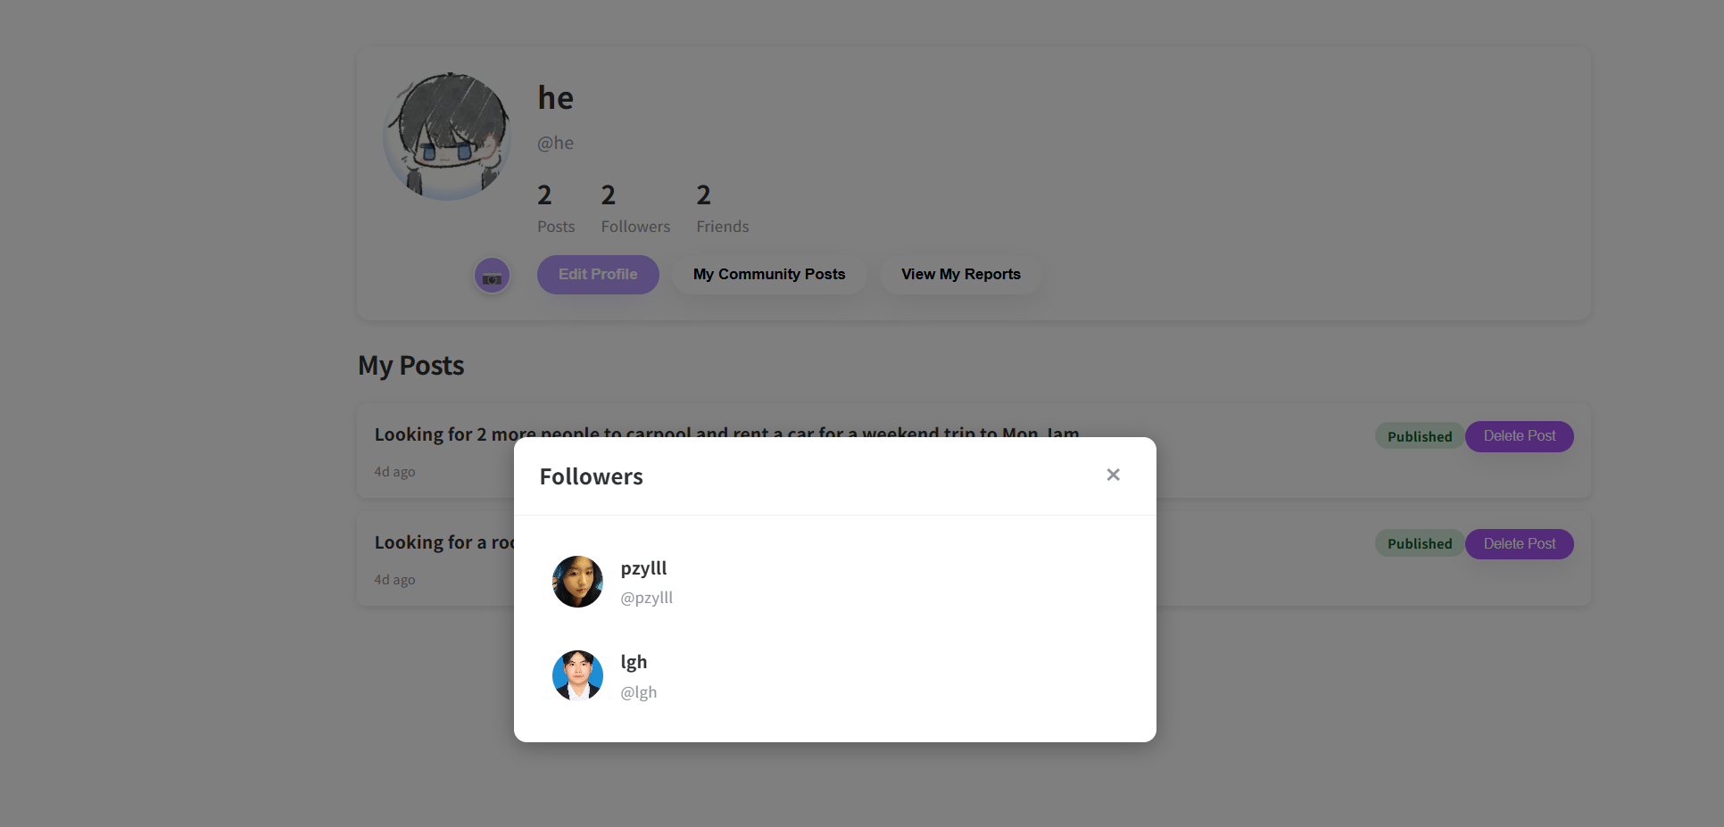

3.Click the “Friends”
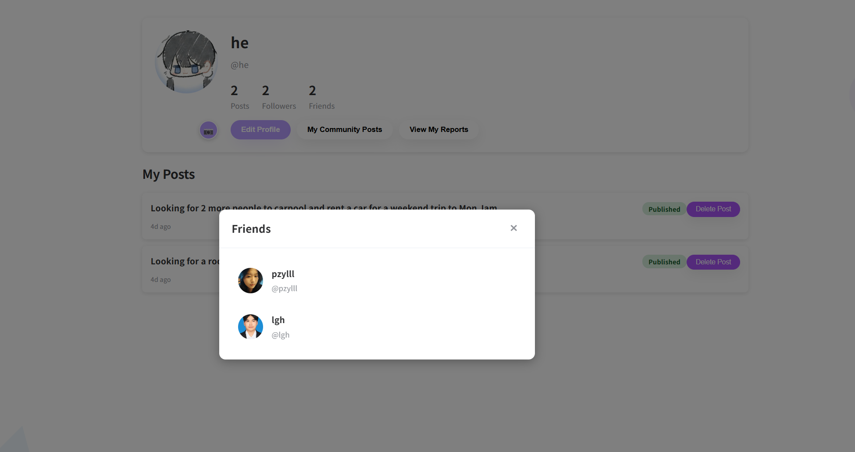
3.Click one user, system will navigate to this user’s profile page.
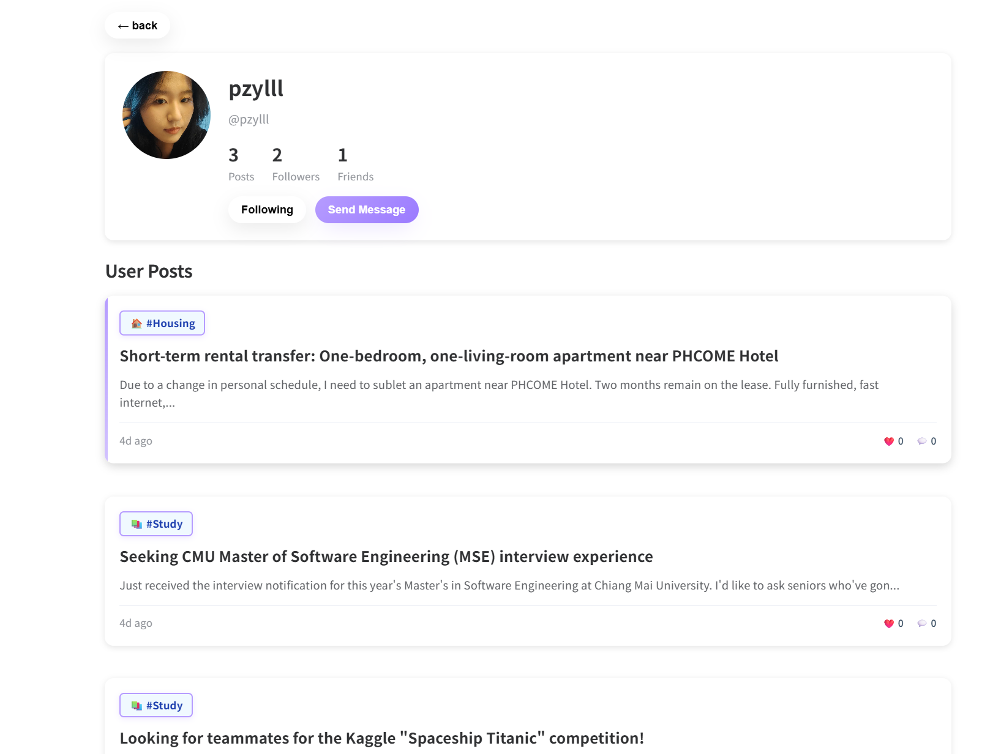
Test Case:
NO | Description | Test step | Expected Result
1 | Verify viewing the Followers list | Click the "Followers" link or count on the profile page. | The system successfully loads and displays a list of all users who follow the account.
2 | Verify viewing the Friends (mutual follows) list | Click the "Friends" link or count on the profile page. | The system successfully loads and displays a list of mutually followed users (Friends).
3 | Verify navigating to the Message page | Click the "Send Message" button on a user's profile or card. | The system successfully navigates to the Message page, initiating a chat session with that specific user.
4 | Verify the "Back" navigation to the Profile page | Click the "Back" button from the Followers/Friends list view. | The system successfully navigates back to the main Profile page.
5 | Verify unfollowing a user | Click the active "Following" button on a user's profile or card. | The system successfully unfollows the user, and the button text instantly updates from "Following" back to "Follow" (along with its default styling).

Appendix A
