from tkinter import * # import tkinter library  
import tkinter as tk  
from tkinter import ttk  
from tkinter import messagebox  
from PIL import ImageTk,Image  
import os  
  
Win = Tk() # Create a window  
Win.title("FriendsList") # Give a name to the window  
Win.geometry("700x500") # set the window size  
Win.configure(background = "Yellow2")  
style = ttk.Style()  
style.theme_use('alt')  
style.configure('TButton', background = 'lightblue', foreground = 'blue', width = 15, borderwidth=4, focusthickness=3, focuscolor='yellow')  
style.map('TButton', background=[('active','red')])  
path = "friends/"  
pics = []  
picON = False  
  
def quit():  
 answer = messagebox.askquestion("Confirm","Are you sure you wantto quit?")  
 if answer == "yes":  
 Win.destroy()  
 else:  
 messagebox.showinfo("Information","Keep Going!")  
for file in os.listdir("friends/"):  
 print(file)  
def show():  
 i = 0  
 for file in os.listdir(path):  
 print(file)  
 pics.append(file)  
 print(pics)  
 file = os.path.join(path,file)  
 print(file)  
 image = Image.open(file)  
 print("path&filename: ",file)  
 print("image: "+str(image))  
 resizedImage = image.resize((105,90), Image.ANTIALIAS)  
 photo = ImageTk.PhotoImage(resizedImage)  
 print(photo)  
 imgLabel = Label(Win,image = photo)  
 imgLabel.grid(row=1, column=1+i, sticky=NE)  
 imgLabel.image = photo  
 i=i+1  
  
  
  
imgButton = ttk.Button(Win, text = "Show Friends", command= show)  
imgButton.grid(row=0, column=1, sticky=NE)  
imgButton = ttk.Button(Win, text = "Clear All", command= show)  
imgButton.grid(row=0, column=2, sticky=NE)  
imgButton = ttk.Button(Win, text = "Delete a Friend", command= show)  
imgButton.grid(row=0, column=3, sticky=NE)  
imgButton = ttk.Button(Win, text = "Add New Friend", command= show)  
imgButton.grid(row=0, column=4, sticky=NE)  
QuitButton = ttk.Button(Win, text= "Quit", command= Win.destroy)  
QuitButton.grid(row = 0, column = 5, sticky= E)  
  
Win.mainloop()

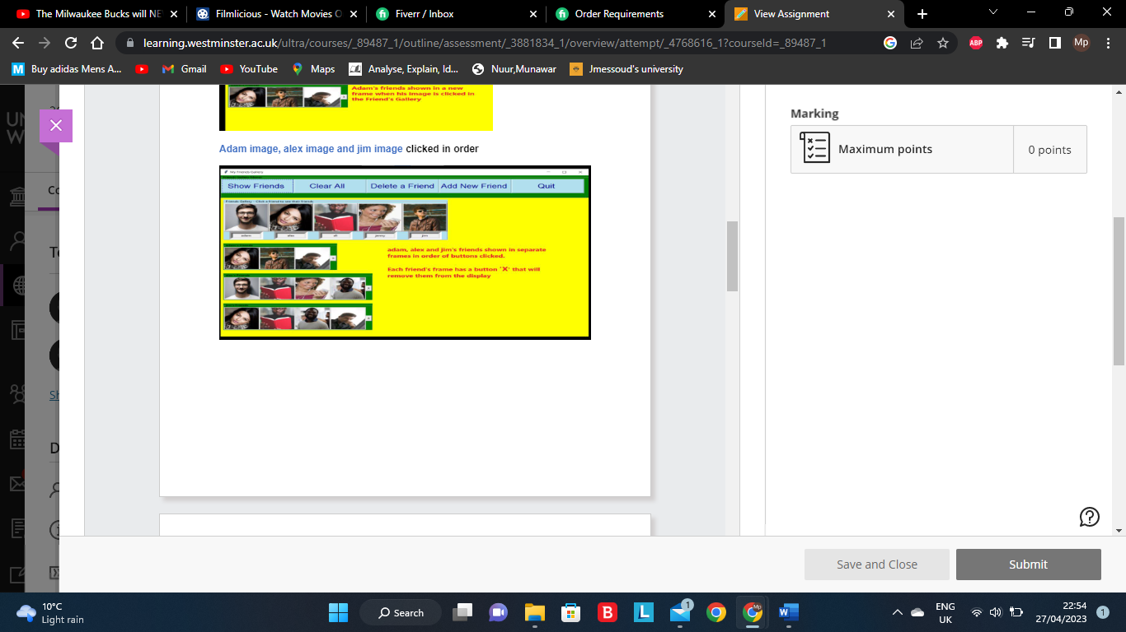

This is the layout of how it should look with the buttons each providing functions

* Opening screen - Menu frame with the buttons
* Clear All activated when no gallery is visible
* Show Friends button pressed when no gallery is visible
* Show Friends button pressed when gallery is visible
* Adam image, alex image and jim image clicked in order

Code layout is at the top just needs to be in that layout