**Deliverable #10: Collaboration**

After finishing the main functional requirements of our app, we sent the demo video from Assignment 2 to our client, Dr. Jason Donev.

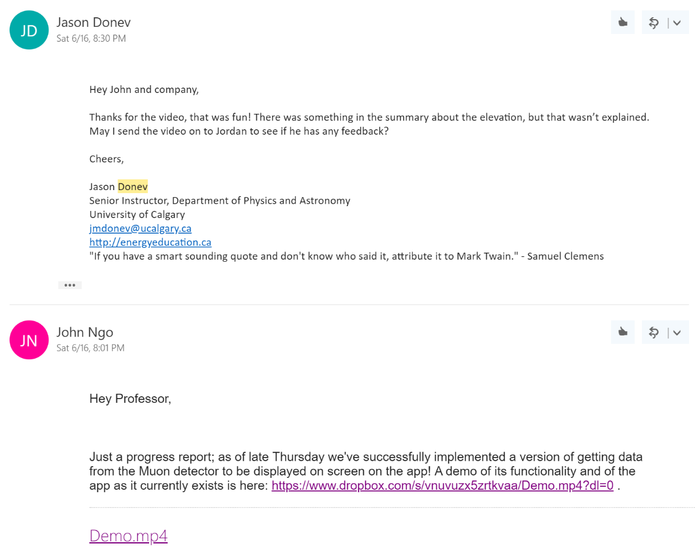

Jordan was a student of Dr. Donev who created the muon detector that we used to test our app. Thanks to our client, we were luckily able to receive some feedback from him as well.

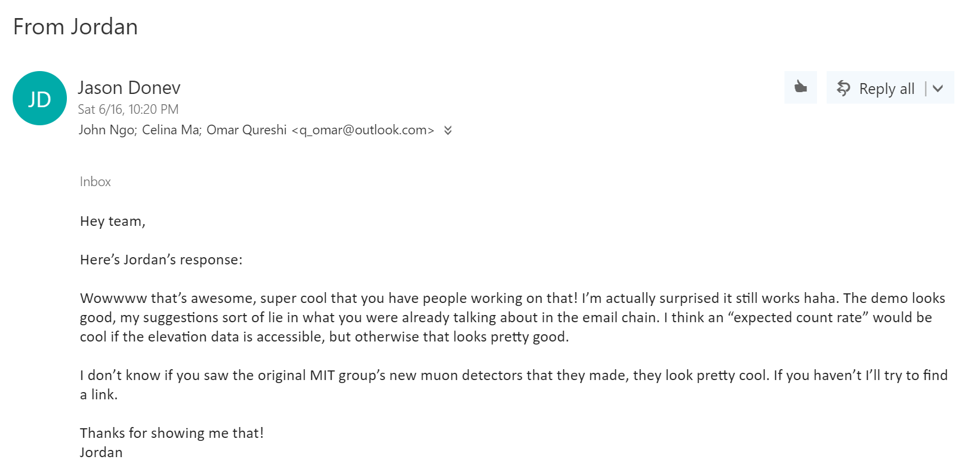

We had slight miscommunications when arranging a time to meet Dr. Donev before our class presentation. Thankfully, we found a new time to meet under short notice.

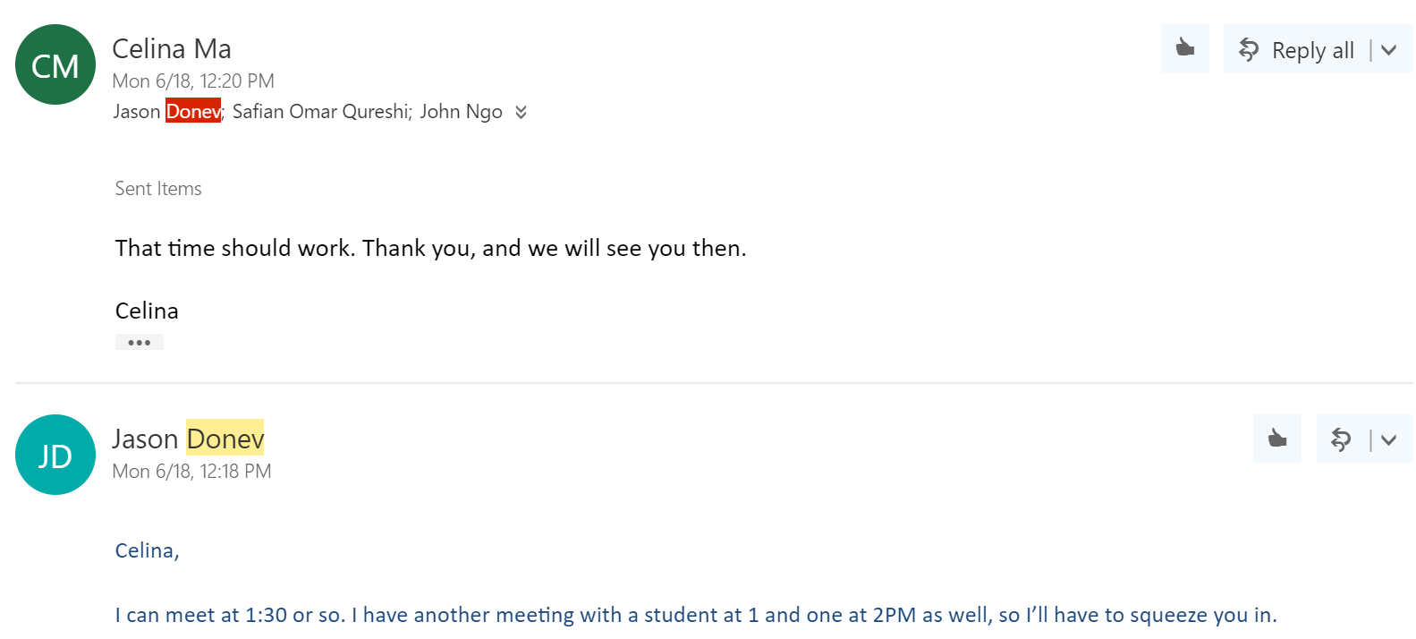

Our final meeting with Dr. Donev was on Monday, June 18th. Omar was unable to attend this meeting,but John and Celina were present.

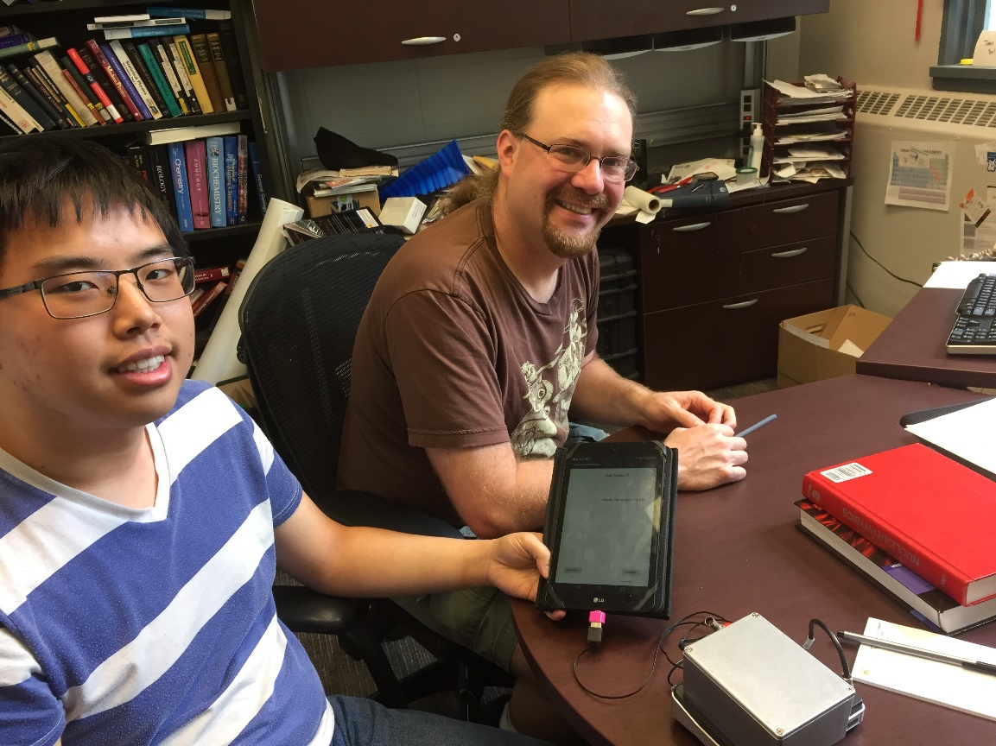

Figure xx: An image of John and Dr. Donev testing out the muon detector app during the meeting.

As a pleasant surprise, Dr. Donev also introduced us to a visiting nuclear physicist, whom he was speaking with just before our appointment. We briefly explained our application to her and allowed her to try it. It was helpful to see someone unfamiliar with our system interact with it for the first time; she was interested in our app and thought the interface was intuitive.

After the nuclear physicist left, we continued to discuss our app with Dr. Donev. The implementation of our product’s basic functional requirements was complete at this point, so we did not have much to ask about regarding the assignment. We mainly discussed where to take our project in the future.

Dr. Donev suggested that our app should allow the user to change how long a data recording session lasts, since it only allows the user to record for one minute. We also talked about implementing the data log feature that had been desired since the start of the project. Dr. Donev provided his physics knowledge to estimate how many muon events the app would need to store in extreme conditions, which we wanted to know due to our memory concerns. The meeting ended with Dr. Donev wishing us luck with the project and hoping to hear about our progress in the future.

Overall, Dr. Donev has been a fantastically helpful and supportive client for our team. He was always willing to give suggestions for improvement and meet with us, despite his busy schedule. Again, our greatest challenge with communicating with our customer was finding convenient times to meet in-person. We struggled a bit with rescheduling meetings and beginning appointments on time, but we still made the most of the time we had. For the most part, communication about the project itself was successful, with misunderstandings being resolved quickly.