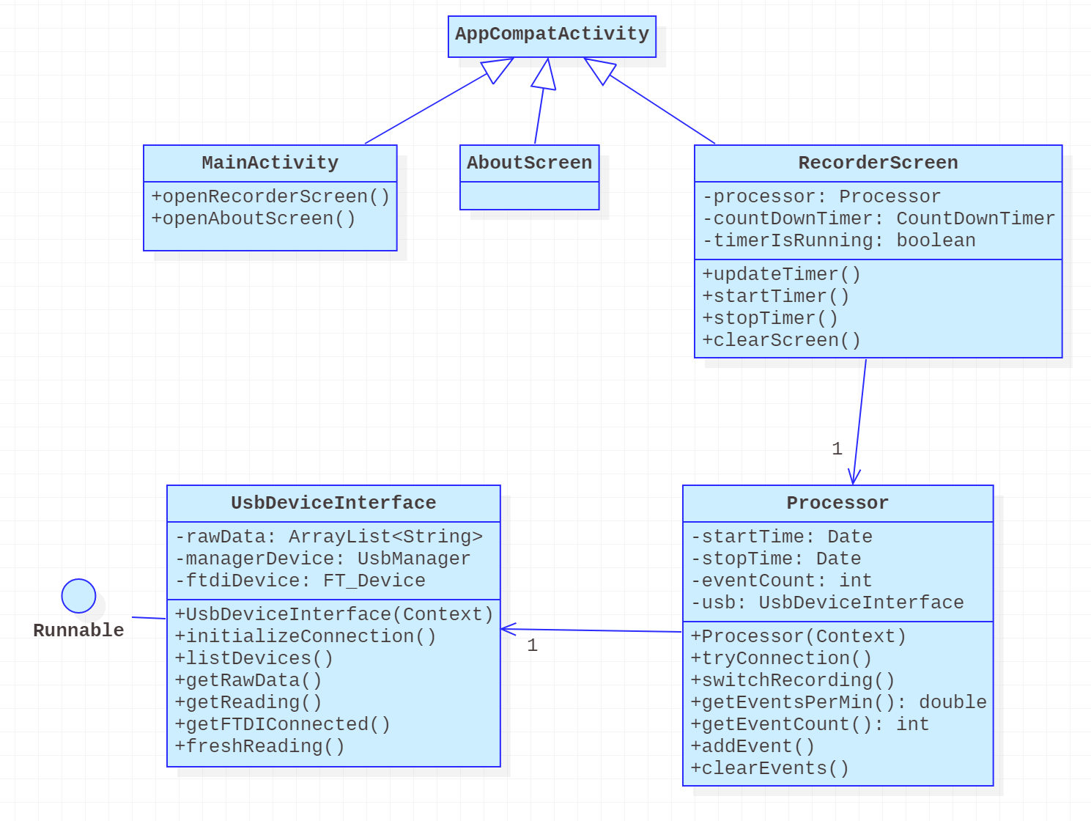

At the top of our diagram, there are three classes extending the class AppCompatActivity. This indicates that these are the main Activities of our app, representing the screens the user can access; MainActivity, AboutScreen and RecorderScreen correspond to the Main Menu, About, and Recorder screens respectively.

The Main Menu screen allows the user to access the About and Recorder screens. Thus, MainActivity has the methods openRecorderScreen and openAboutScreen. The About screen simply displays information, so it does not have relevant attributes and operations to show.

RecorderScreen maintains a reference to a Processor object, which communicates between the UsbDeviceInterface and the RecorderScreen.

The RecorderScreen starts a timer when the user chooses to start recording. This is conveyed to the Processor, which will save the time recording starts and initialize the UsbDeviceInterface. The UsbDeviceInterface will open a wired connection to the muon detector and store raw data from it. When this data needs to be interpreted and displayed on the RecorderScreen, the Processor will make requests to the UsbDeviceInterface and update eventCount according to the amount of raw data saved.

When the recording session timer ends or when the user wishes to clear their saved data, the RecorderScreen sends another signal to Processor. The Processor will then reset its saved data and the raw data in UsbDeviceInterface as needed.