**Exercise Title:**

Introduction to Jupyter Notebooks and GitHub

**Objective:**

To familiarize students with Jupyter Notebooks by writing simple Python code, documenting with Markdown, and uploading the notebook to GitHub.

**Part 1: Creating and Writing Code in a Jupyter Notebook**

Start a New Notebook:

If using Anaconda, launch Jupyter Notebook and create a new notebook.

If using Google Colab, start a new notebook directly.

Write a Simple Python Code:

In the first cell, write a Python function to calculate the factorial of a number.

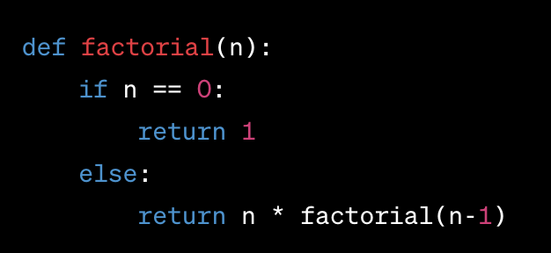

In the second cell, call this function with a test value, like factorial(5), and execute it.

**Part 2: Documenting with Markdown**

Above the code cell, insert a Markdown cell.

Write a brief introduction about what the notebook is for. Use headers, bullet points, or bold text for emphasis.

After the code cell, insert another Markdown cell.

Explain how the factorial function works. Include details about the recursive approach.

**Part 3: Uploading to GitHub**

Save the Notebook:

Save the notebook with an appropriate name, like factorial_function.ipynb.

Create a new repository named data-science-exercises. Upload the Notebook.