**2. Here's a list of frequently used Git commands along with brief explanations:**

**How to do group project in GitHub?**

Using GitHub for a group project is a great way to collaborate on code, documents, or any files in a version-controlled environment. Here's a step-by-step guide on setting it up for group projects and adding your teachers (q_tong@uncg.edu) as collaborators:

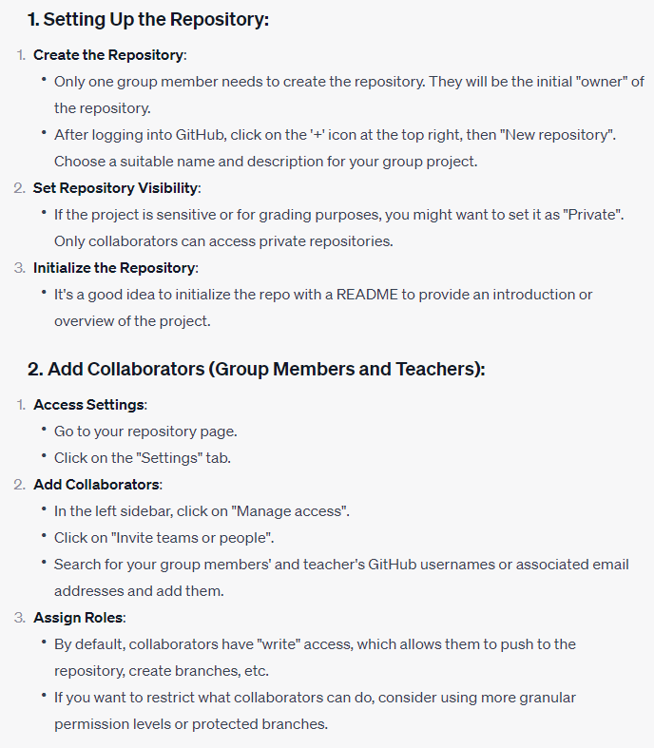

**Brief intro of Command Prompt and Terminal**

Both the Windows Command Prompt (often just referred to as "Command Prompt") and the macOS Terminal are command-line interfaces (CLIs) that allow users to interact with the system using textual commands. Here's a brief introduction to using each:

