Sishir Yeety

July 21, 2020

Tutorial 2

Part 1

1.

ms_tick is calculated by the function HAL_GetTick() which runs the line:

if(msTick % DATA_PERIOD_MS == 0 && msTickPrev != msTick)

Basically what happens is that the % is the remainder of the division between msTick and DATA_PERIOD_MS and the && and != makes sure that msTick is not equal to the previous tick. From here, the time is calculated to output on the Terminal window. It is basically reading the time counter on the SensorTile board, which is running the above command. HAL_gettick is returning how many milliseconds have elapsed since the SensorTile started recording data.

2.

DATA_PERIOD_MS is at 100ms. The amount calculated in step 4 of section 3.1 is 0.1s, which is equivalent. Therefore, it is expected.

3.

|  |  |  |
| --- | --- | --- |
| **Time Stamps** |  |  |
| t 1 = 00:04:00.97 | T1 = t2-t1= | 00:00:01.00 |
| t 2 = 00:04:01.97 | T2 = t3-t2= | 00:00:01.00 |
| t 3 = 00:04:02.97 | T3 = t4-t3= | 00:00:01.00 |
| t 4 = 00:04:03.97 | T4 = t5-t4= | 00:00:01.00 |
| t 5 = 00:04:04.97 | T5 = t6 –t5= | 00:00:01.00 |
| t 6 = 00:04:05.97 | - | - |
| **AVERAGE** | (t1+t2+t3+t4+t5)/5 | 1 second |

Yes, this agrees with the expectations as 1000ms is equivalent to 1s.

4.

5.

6.

7.

Largest angular velocity on a single axis from above screenshot on Z axis

8.

9.

Largest angular velocity on a single axis

10.

Largest after modifying parameters

Part 2

1.

2.

|  |  |  |  |
| --- | --- | --- | --- |
|  | R | Phi | Thetha |
| Az ~ +1000, Ax ~0, Ay ~0 | 1013.225 | 2.818 | -128.480 |
| Az ~ -1000, Ax ~0, Ay ~0 | 1004.24 | 157.684 | 169.574 |
| Az ~ +1000, Ax ~0, Ay ~0 | 1029.051 | 5.679 | 125.406 |
| Az ~ -1000, Ax ~0, Ay ~0 | 1004.385 | 157.810 | 169.519 |
| Az ~ +1000, Ax ~0, Ay ~0 | 1005.226 | 15.696 | -81.836 |
| Az ~ -1000, Ax ~0, Ay ~0 | 991.598 | 152.430 | 169.326 |

3.

What is a state machine?

A state machine is a behavior model that shows a finite number of states. Depending on the current state and input, the machine will perform an action which can be a state transition and then produce an output.

Example

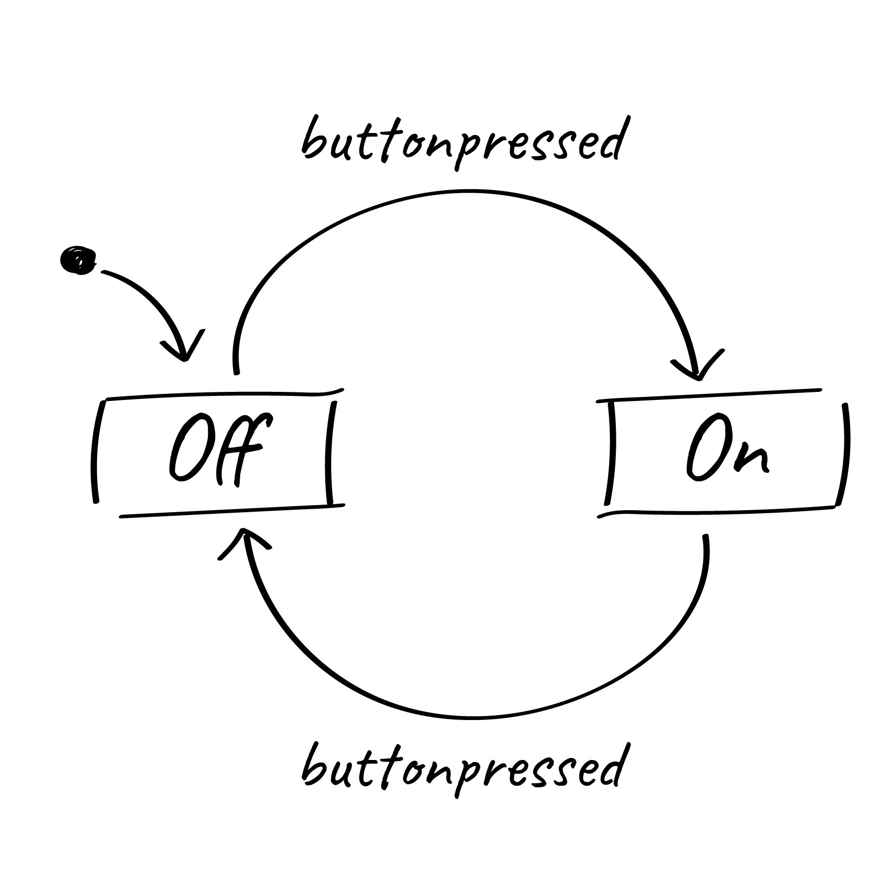

Resource used: <https://www.itemis.com/en/yakindu/state-machine/documentation/user-guide/overview_what_are_state_machines>

4.

Passing parameters by reference: This is when we pass the argument’s reference in the calling fxn to the corresponding formal parameter of the called function. This is so the copy of the actual parameter’s address is in made in memory

Example

Resource used: <https://www.educative.io/edpresso/pass-by-value-vs-pass-by-reference>

5.

6.

Video attached to canvas