Sishir Yeety

July 22, 2020

Tutorials 6 and 7

Part 1

1.

SBC: SensorTile

SensorTile specs:

– STM32L476JG – 32-bit ultra-low-power MCU with Cortex®M4F

– LSM6DSM – iNEMO inertial module: 3D accelerometer and 3D gyroscope

– LSM303AGR – Ultra-compact high-performance eCompass module: ultra-low power 3D accelerometer and 3D magnetometer

– LPS22HB – MEMS nano pressure sensor: 260-1260 hPa absolute digital output barometer

– MP34DT05-A – 64 dB SNR digital MEMS microphone

– BlueNRG-MS – Bluetooth low energy network processor

– BALF-NRG-02D3 – 50 Ω balun with integrated harmonics filter

– LD39115J18R – 150 mA low quiescent current low noise LDO 1.8 V

Resource: <https://www.st.com/en/evaluation-tools/steval-stlkt01v1.html>

Cables: the two recommended AmazonBasics gold-plated USB 2.0/3.0 cables

USB Hub: no hub

USB Dongles: 2 AmazonBasics USB-C to USB-A dongles

Other:

Computer: Mid-2018 15inch MacBook Pro 15inch, 32gb RAM, 1TB, Core i9 and Raspberry Pi W Zero Starter Kit

2.

Figure 4

Part 2

1.

Figure 5

Figure 6

Figure 7

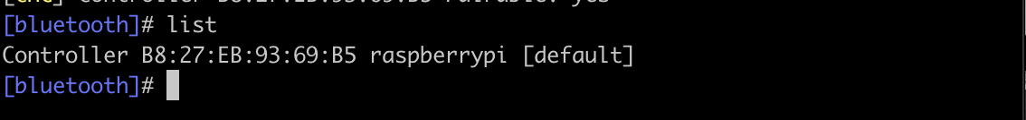

Figure 8



Figure 9



Figure 10

Figure 11

Figure 12

Figure 13

Figure 14

Figure 15

Part 2 (Tutorial 7)

1.

2.

3.

Figure 1

Figure 2

Figure 3

Figure 4



Figure 5 and Figure 6

Figure 7

Figure 8/9/10

Figure 11/12

Figure 13 and 15

Figure 14

Figure 16/17/18/19

Figure 20

Figure 21

Figure 22

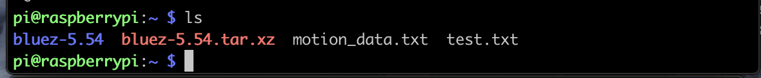

Figure 23

4.

Submitted as part of tutorial

5.

Data translation

1. Press=100638 Temp1=307
2. Press=100641 Temp1=307
3. Press=100640 Temp1=307
4. Press=100642 Temp1=307
5. Press=100641 Temp1=307
6. Press=100640 Temp1=307
7. Press=100640 Temp1=307
8. Press=100641 Temp1=307
9. Press=100638 Temp1=307
10. Press=100640 Temp1=307
11. Press=100640 Temp1=307