## **Qian Yi Wang**

<https://www.linkedin.com/in/qian-yi-wang-0897471b4/> – <https://github.com/q1an-w>

(514)-702-9109 – [qianyi.wang02@gmail.com](mailto:qianyi.wang02@gmail.com) – Montreal, Qc

## 23rd August 2023

**Software Engineering Intern (Ref: xxxxx) with Microsoft**

To whom it may concern,

I am writing to express my interest in the software engineering position offered at Microsoft. As a second year Computer Engineering student, I have grown fond of full-stack development as it allows me to work with both the functionality and the client-side interface. At my past internship with Nuance Communications, I was able to grow and develop my skills in this interest with support from my seniors. As a result, I have a strong desire to experience Microsoft’s work environment.

I am convinced that I am the candidate you are looking for, as I am a dedicated individual who can bring his fast-learning and communication skills to rapidly become a contributing member of the software development team. My knowledge in object-oriented languages such as Java/C++ and front-end languages such as JS/HMTL/CSS makes me very comfortable with the full-stack flow. Using the Express and React frameworks, I developed a job application and posting website along with a team of other students. Acting as software lead, I designed the project flow and architecture as well as coached my teammates in understanding how the backend, front-end and deployment pipeline all linked together. Additionally, using React Hash Routing, I implemented multi-page functionality on a single-page deployment service (GH pages) using Hashed routes. I believe my experience with Express, Spring Boot, React, MongoDB, GitHub and the Agile process give me a good understanding of the full-stack development cycle, which helps me adapt quickly to other similar languages, frameworks, and deployment platforms. Finally, my experience working as a software development intern at Nuance also helped me become knowledgeable with the company and project development structure, from attending stand-up and reporting progress to teamwork and project use-case demonstration to higher ups and non-technical teams.

I am confident my experiences would make me a productive and cooperative member of the software development team. I hope to assist Microsoft’s efforts to develop the system and learn more about the company’s growth environment. Thank you for your time, and I look forward to further discussing my interest and qualifications.

Sincerely,

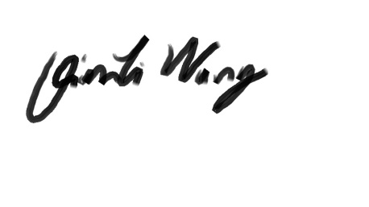

Qian Yi Wang