Documentation

This document provides some information for the implementation of ProgrammationGL Preuve Project.

Please consider the code under the my github repository: https://github.com/uvsq21501412

Exercice 1.

Classes under fr.uvsq.coo.projet.ex1.* package

Note: Mostly classes has a javadoc explanation of their uses in the application and the reason why its created. Please take a look if interested since technical and design deeper details may not apperar in the doc.

Running:
The FiltrageStartup class has a main method for creating messages and apply list as example.
Use mvn:Exec after packaging for running it with maven or import into eclipse and run it.

Technical technologies used:

Eclipse
Maven 3.0
Java 8
Junit 4.*

Design

Below the very high level design of the implementation:

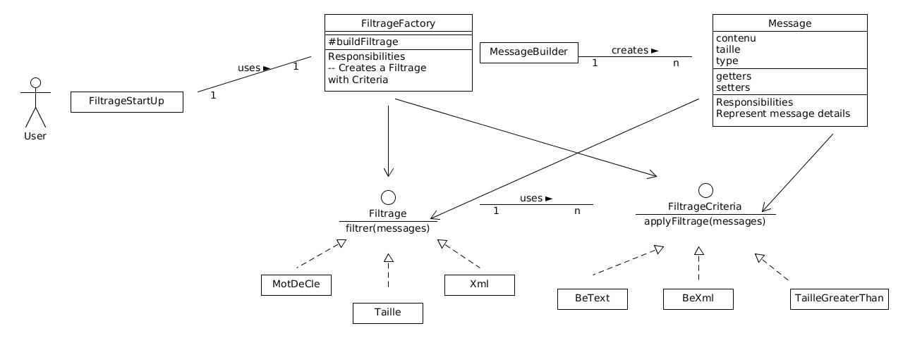

Summary:

For following OCP principle basically we need to keep our code able to be extended. So the idea is work with interfaces and have solid classes implementing it.
The message class represents our messages, its created by a builder external to the message class itselft for reducing the 'couplage' between objects.
A Filtrage represents the kind of filtrage applied, which can be in our case xml, taille and Mot de cle. The idea behind is mostly show the OCP. So you can have specific behavior in each kind of filtrage. In our case, they dont have real difference. We could have a generic Filtrage instead
The Filtrage Criteria represents what criterias we can have in a Filtrage, like being a text or xml, a taille greater than/less than some size and so on. The actual filter of messages goes there.
This code is really tied to OCP since its solid classes so its ''closed for changes'' and “open for features'' . An good example of that is if you want to add more criterias just need to add a newclass and implement your criteria. The same for the a Filtrage. If we can have different types of message we could also interface it. but I dont find necessary in this case. I encourage in have a look into classes javadoc.

Design Patterns:
Factory for filtrage creation
Builder for Message instanciation
Strategy filter implementation.
Chain of Responsability: Not implemented but fits if more than one filtrage criteria is used to the same list.
Etc...

Exercice 2

Note: Mostly classes has a javadoc explanation of their uses in the application and the reason why its created. Please take a look if interested since technical and design deeper details may not apperar in the doc.

Classes under : fr.uvsq.coo.projet.ex2.*

Running:

The DessinStartup has the main methods for running. Package it with maven or import to your IDE.
It expects to have mongodb database installed running in your machine. All will be created on the fly.

Technical frameworks:

Eclipse
Maven 3.0
Java 8
Junit 4.*
Mongodb database / Mongodb Driver

Design:

Consider the high level design below
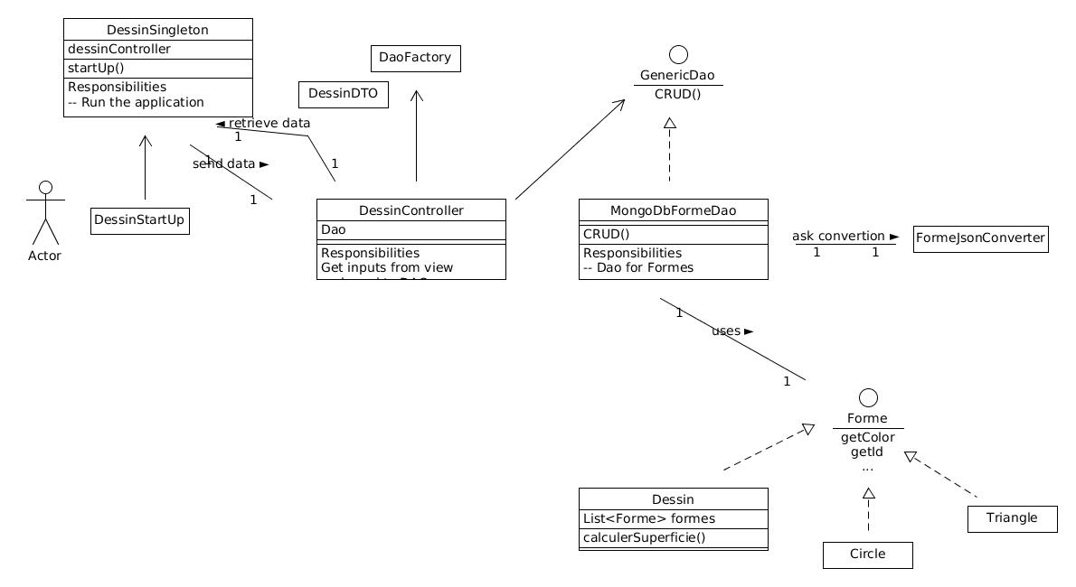

Summary :
Basically we need to do a CRUD for ''formes'' and ''dessins'' and support some operations with it.
Model Layer : Forme represents the generic interfaces. Both formes ( circle, triangle, etc ) and dessins implements it but since dessin has a list of formes it has a differents way for calculating the superficie. This is basically the idea of Composite design however the calculateSuperficie is not created on the Interface. The reason of it is that I use calculateSuperficie at constructor level to make it simple and its not a good idea having public methods ( or any overridable methods ) inside the construtor. The Dao layer will use those classes for managing the information into the DB

Data Layer:
I'm using mongodb for storing the information https://www.mongodb.com/
Mongodb is a NoSQL db document oriented with javascript grammar. Basically all the info belongs to the same “Collection” ( similar to a sql table ) in my db design.
Since its the only database in the app I skipped to created factories, abstract factories and also many levels of inheritance in the DAO.
MongodbFormeDao represents the class for storing info in mongodb. It presumes that is installed on localhost on default port. It implements method for reading, update, delete, creating and list. It has a class JsonConverter class for transforming entities objects into Json ( documents ) .

UI – Controller
A Simple console UI was build into the DesignSingleton ( method startup ) . It pass all the information to a Controller class which adjust it to the DAO object. For reloading information ( reading / list ) it uses a DataTransferObject for sending to the UI

Design Patterns
Composite ( Dessin and Formes )
DAO
MVC ( just the concept of model-view-controller layers )
DTO – sending info to UI
etc..

Requeriments Notes / Assumptions

- All deeper geometry details has not implemented. Except for the circles, figures do not consider coordinates and only sides.
- Figures cannot be rotated : for that being accomplished I would need to store cordinates instead of sides, calculate the distance between two points for the sides, calculate the center, push back the figure to the cartesian origin, rotate and move back to its place. However I will put below a piece of code that do it:

* //TRANSLATE TO ORIGIN
double x1 = p1.getX() - center.x; double y1 = p1.getY() * - center.y;
*
* //APPLY ROTATION
double temp_x1 = x1 * Math.cos(angle) - y1 *
* Math.sin(angle)); double temp_y1 = x1 * Math.sin(angle) + y1 * Math.cos(angle));
*
* //TRANSLATE BACK
p1.setLocation(temp_x1 + center.x, temp_y1 + center.y); You
* have to do this for each point. Also you will need to find the center of the
* rectangle center.x and center.y.

The UI is meant to exemplify the API, and not really show all the cases. For instance the modify is not supported, there. But found it implemented in my DAO

Some working prints in my console ( red lines are just database logs.. ) :

