<%@**taglib prefix**="c" **uri**="http://java.sun.com/jsp/jstl/core" %>

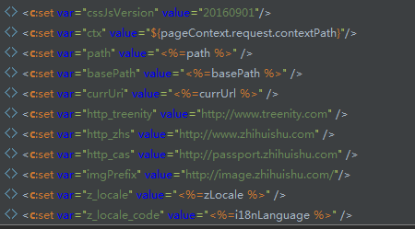

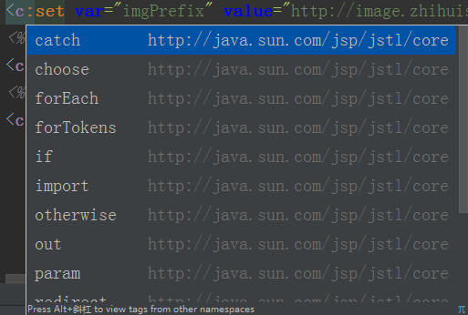

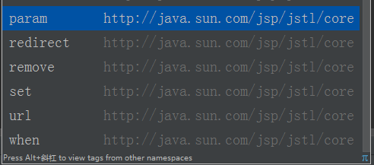

<%@**taglib prefix**="fn" **uri**="http://java.sun.com/jsp/jstl/functions" %>

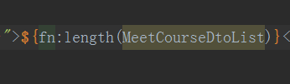

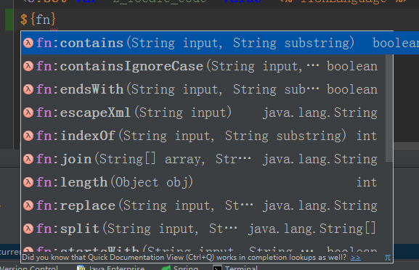

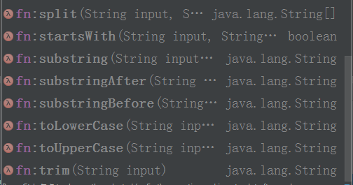

使用fmt 对时间进行格式化的时候需要引入如下

<%@**taglib prefix**="fmt" **uri**="http://java.sun.com/jsp/jstl/fmt" %>

1. **<input** type="text" class="easyui-my97" id="replyTime"
2. value="<fmt:formatDate value="${rb.replyTime}" pattern="yyyy-MM-dd"**/>**"
3. name="replyTime"
4. data-options="disabled:false,startDate:'%y-%M-%d',dateFmt:'yyyy-MM-dd'"**>**

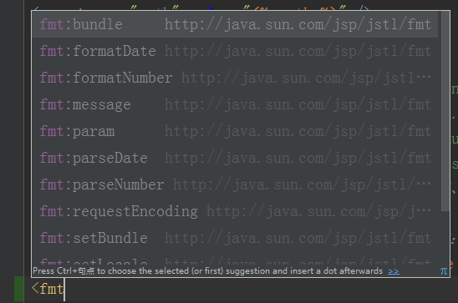

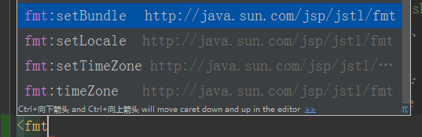

<%@**taglib prefix**="spring" **uri**="http://www.springframework.org/tags" %>

<**spring:message code**="secondstep_xia" />

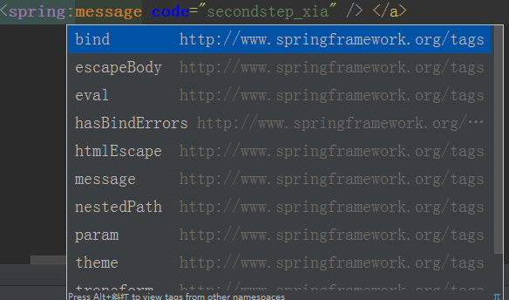

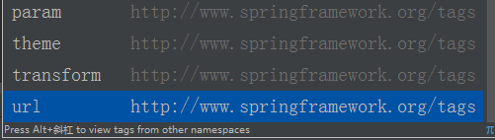

xmlns:tx="http://www.springframework.org/schema/tx"

http://www.springframework.org/schema/tx   
http://www.springframework.org/schema/tx/spring-tx.xsd

<tx:annotation-driven />

读取资源文件配置

<context:property-placeholder location="classpath:jdbc.properties,classpath:config.properties  
 ,http://conf.zhihuishu.com/redis.uri.properties" />

可以直接读取外部url