EXPLAIN SELECT * from c_order



EXPLAIN SELECT * from c_order WHERE orderId = 3

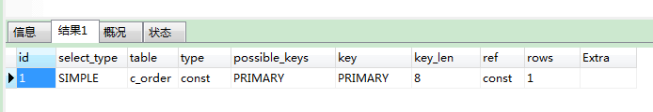

EXPLAIN SELECT * from c_order WHERE totalPrice > 0

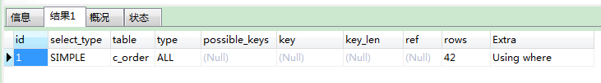

EXPLAIN SELECT * from c_order WHERE totalPrice = 3

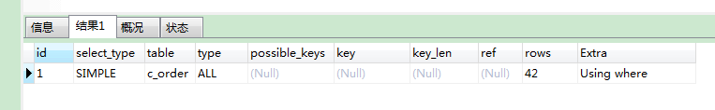

alter table c_order add index price(totalPrice)

EXPLAIN SELECT * from c_order WHERE totalPrice = 3

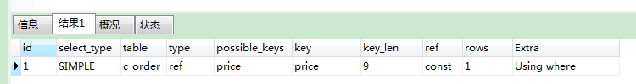

------------------------------------------------------------------

alter table c_order add fulltext ccn(contactName)

EXPLAIN SELECT * from c_order WHERE contactName = '联系人74023'

alter table c_order add index ccn(contactName)

EXPLAIN SELECT * from c_order WHERE contactName = '联系人74023'

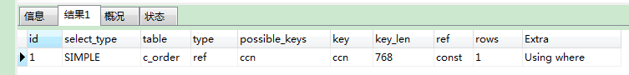

EXPLAIN SELECT * from c_order WHERE contactName like '%联系人%'

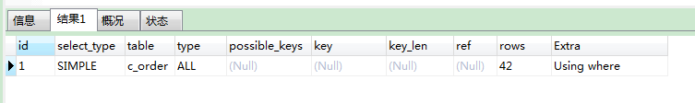

EXPLAIN SELECT * from c_order WHERE contactName = '联系人74023'

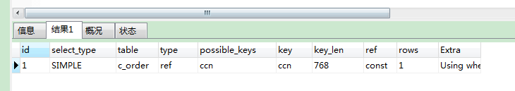

EXPLAIN SELECT * from c_order WHERE contactName is null

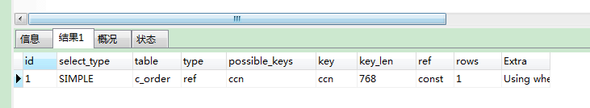

EXPLAIN SELECT * from c_order WHERE contactName is not null

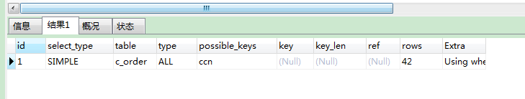

ps:

对于varchar建立的INDEX

= is null 不会全表扫描

is not null like 会全表扫描

------------------------------------------------------------------

主键type:const

全表扫描type:All ref:const

索引type:ref ref:const

EXPLAIN SELECT * from c_order WHERE orderid > 10 and contactName like '%联系人%'

EXPLAIN SELECT * from c_order WHERE contactName like '%联系人%' and orderid > 10

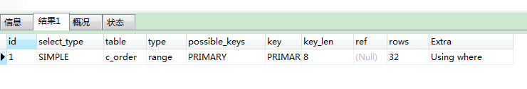

EXPLAIN SELECT * from c_order WHERE orderid <> 10

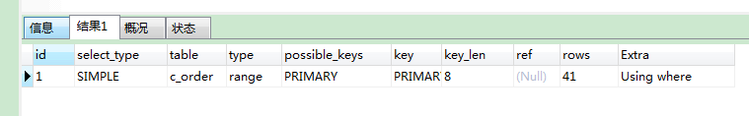

EXPLAIN SELECT * from c_order WHERE orderid < 10 or orderid > 10

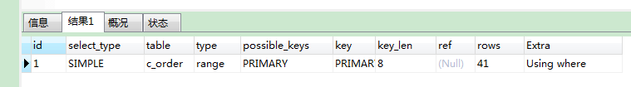

EXPLAIN SELECT * from c_order WHERE orderid not in(10)

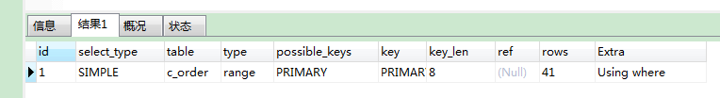

EXPLAIN SELECT * from c_order WHERE orderid between 10 and 13

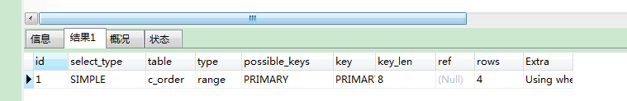

EXPLAIN SELECT * from c_order WHERE orderid not between 10 and 13

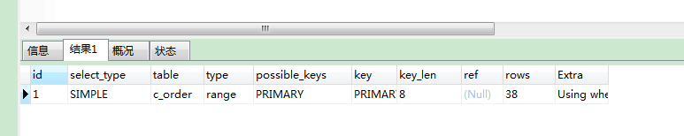

ps: not in <> 主键并不会导致全表扫描

between and主键并不会导致全表扫描

between and 等同 []

not between and 主键并不会导致全表扫描

not between and 等同 x>MAX and x < MIN

---------------------------------------------------------------------------------------------------------

totalprice double

EXPLAIN SELECT * from c_order WHERE totalprice not in(10)

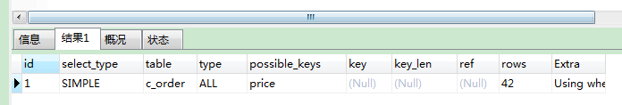

EXPLAIN SELECT * from c_order WHERE totalprice <> 10

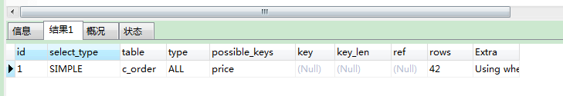

EXPLAIN SELECT * from c_order WHERE totalprice < 10 or totalprice > 10

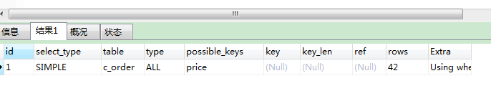

EXPLAIN SELECT * from c_order WHERE totalprice in(10)

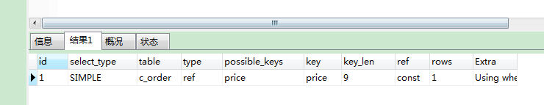

EXPLAIN SELECT * from c_order WHERE totalprice in(10,11,12)

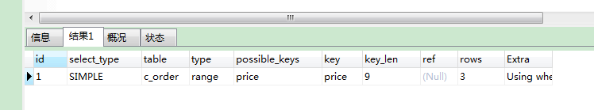

EXPLAIN SELECT * from c_order WHERE totalprice =10

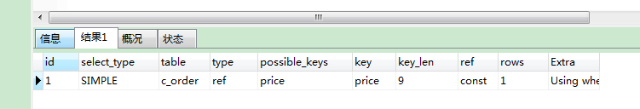

EXPLAIN SELECT * from c_order WHERE not EXISTS(SELECT 1 from c_order where totalprice=10)

------------------------------------------------------

status int

alter table c_order add index stts(status)

EXPLAIN SELECT * from c_order WHERE status not in(0)

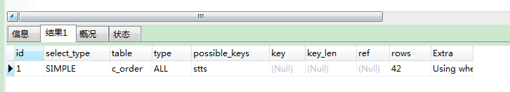

EXPLAIN SELECT * from c_order WHERE status < 10 or status > 10

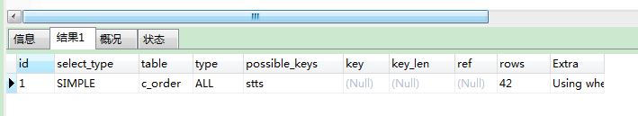

EXPLAIN SELECT * from c_order WHERE status in(10,11,12)

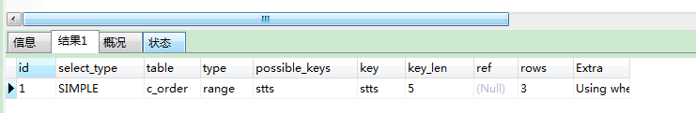

EXPLAIN SELECT * from c_order WHERE status in(10,100,1000)

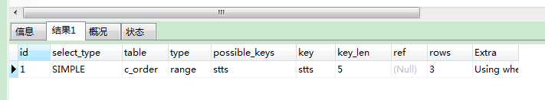

EXPLAIN SELECT * from c_order WHERE status not between 10 and 13

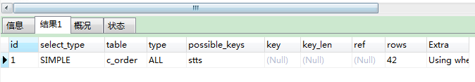

EXPLAIN SELECT * from c_order WHERE status between 10 and 13

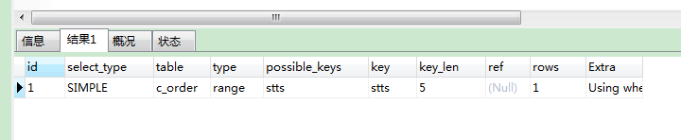

EXPLAIN SELECT * from c_order WHERE status is null

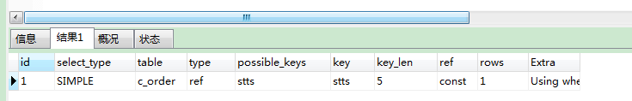

EXPLAIN SELECT * from c_order WHERE status is not null

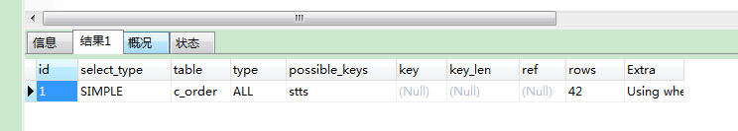

EXPLAIN SELECT * from c_order WHERE status-1 > 10

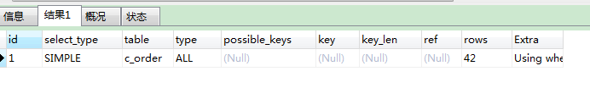

ps: not in <> INDEX会导致全表扫描

in = INDEX不会导致全表扫描

between and INDEX并不会导致全表扫描

between and 等同 []

not between and INDEX会导致全表扫描

not between and 等同 x>MAX and x < MIN

is不会导致全表扫描

isnot null会导致全表扫描

对列进行操作会导致全表扫描