打算新建的时候出现2种文件夹

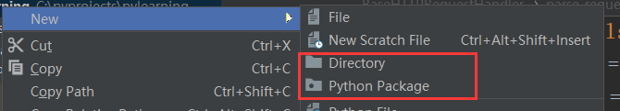

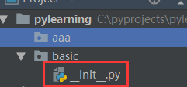 选择python package会在目录下多生成一个文件

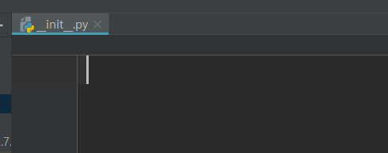里面是空的

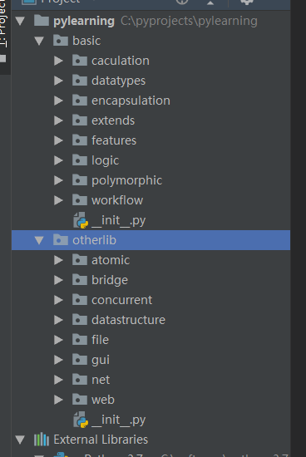按照学习图迅速地创建了这么多的文件夹，都是需要学习的东西。有了框架，学习起来更有针对性，也更有效率。

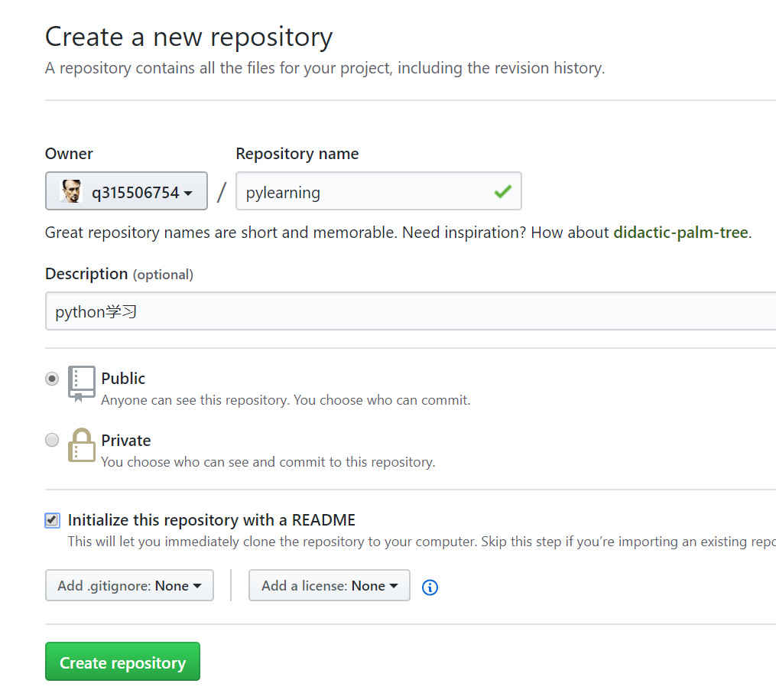

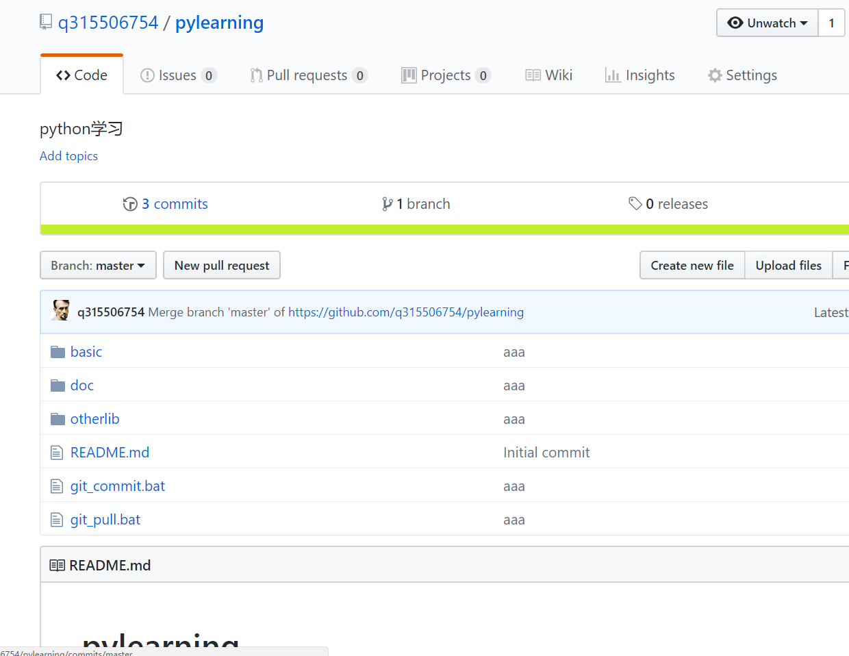

已经成功push上去，可以随时随地学python了

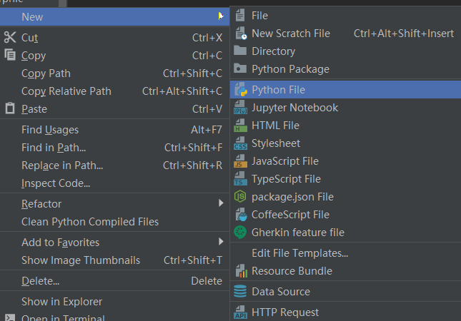

输出hello world，目测新建这个文件

其它语言的经验让我直接猜api

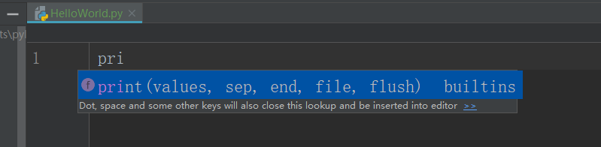

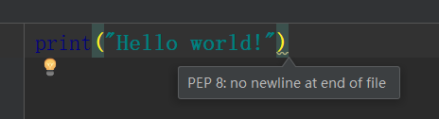

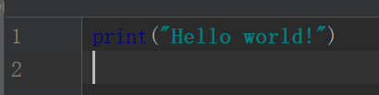

<https://www.python.org/dev/peps/>



<https://www.python.org/dev/peps/pep-0008/>

是一些建议的代码风格

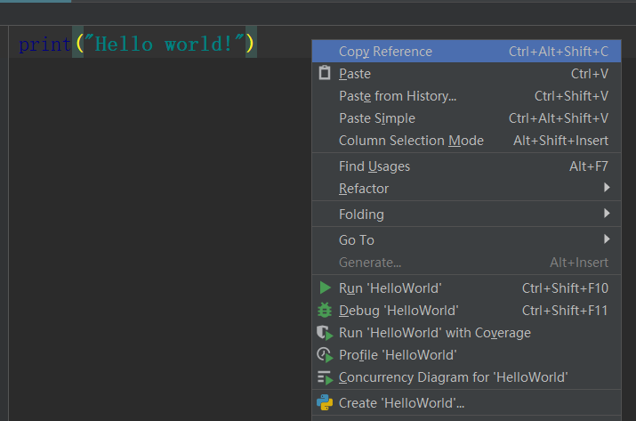

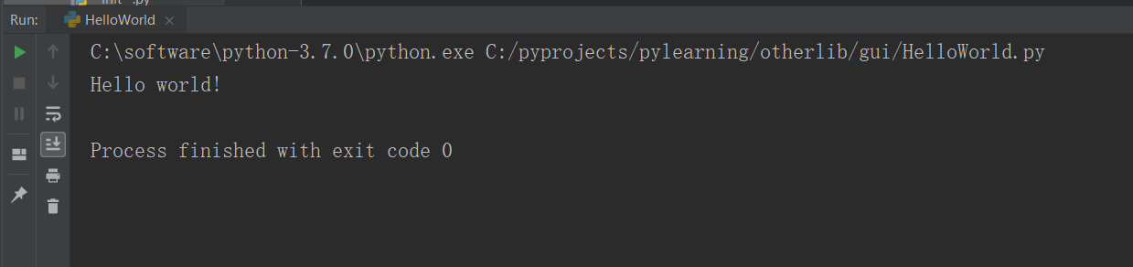

已向python迈出第一步

2018年8月17日14:35:58

试试ide 的 debug功能

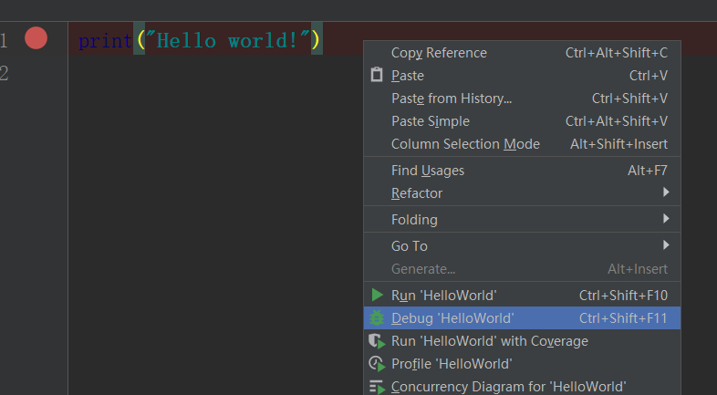

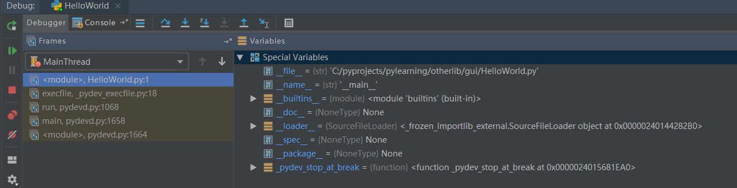

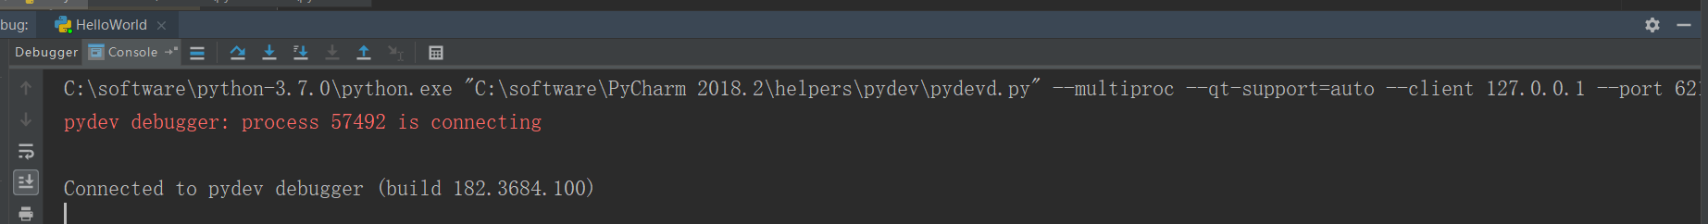

C:\software\python-3.7.0\python.exe "C:\software\PyCharm 2018.2\helpers\pydev\pydevd.py" --multiproc --qt-support=auto --client 127.0.0.1 --port 62108 --file C:/pyprojects/pylearning/otherlib/gui/HelloWorld.py

放开断点后

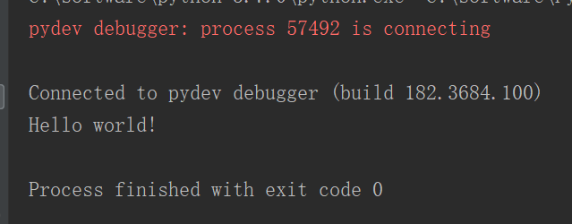

这让我好奇java的是什么来着，好像有点忘了。

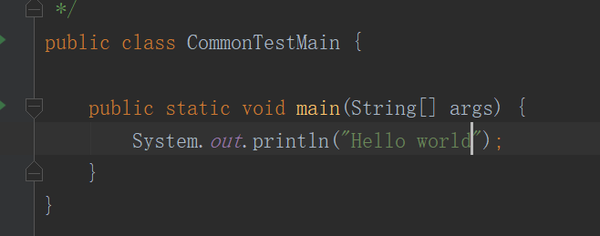

普通运行



Debug

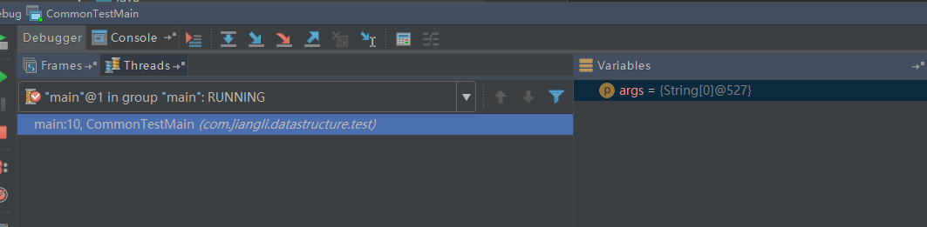

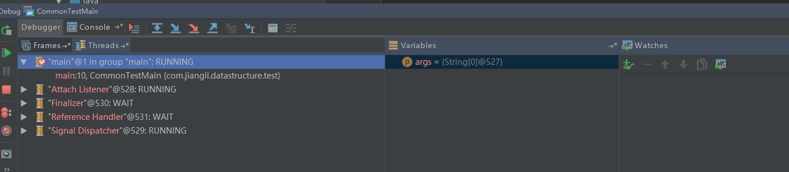

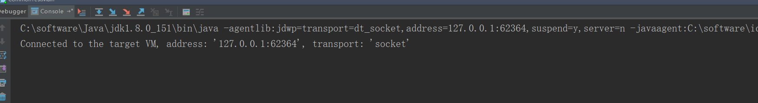

C:\software\Java\jdk1.8.0_151\bin\java -agentlib:jdwp=transport=dt_socket,address=127.0.0.1:62364,suspend=y,server=n -javaagent:C:\software\ideaIU-2017.3.3.win\plugins\Groovy\lib\agent\gragent.jar -javaagent:C:\software\ideaIU-2017.3.3.win\lib\rt\debugger-agent.jar=C:\Users\Jiangli\AppData\Local\Temp\capture1339.props -Dfile.encoding=UTF-8 -classpath C:\software\Java\jdk1.8.0_151\jre\lib\charsets.jar;C:\software\Java\jdk1.8.0_151\jre\lib\deploy.jar;C:\software\Java\jdk1.8.0_151\jre\lib\ext\access-bridge-64.jar;C:\software\Java\jdk1.8.0_151\jre\lib\ext\cldrdata.jar;C:\software\Java\jdk1.8.0_151\jre\lib\ext\dnsns.jar;C:\software\Java\jdk1.8.0_151\jre\lib\ext\jaccess.jar;C:\software\Java\jdk1.8.0_151\jre\lib\ext\jfxrt.jar;C:\software\Java\jdk1.8.0_151\jre\lib\ext\localedata.jar;C:\software\Java\jdk1.8.0_151\jre\lib\ext\nashorn.jar;C:\software\Java\jdk1.8.0_151\jre\lib\ext\sunec.jar;C:\software\Java\jdk1.8.0_151\jre\lib\ext\sunjce_provider.jar;C:\software\Java\jdk1.8.0_151\jre\lib\ext\sunmscapi.jar;C:\software\Java\jdk1.8.0_151\jre\lib\ext\sunpkcs11.jar;C:\software\Java\jdk1.8.0_151\jre\lib\ext\zipfs.jar;C:\software\Java\jdk1.8.0_151\jre\lib\javaws.jar;C:\software\Java\jdk1.8.0_151\jre\lib\jce.jar;C:\software\Java\jdk1.8.0_151\jre\lib\jfr.jar;C:\software\Java\jdk1.8.0_151\jre\lib\jfxswt.jar;C:\software\Java\jdk1.8.0_151\jre\lib\jsse.jar;C:\software\Java\jdk1.8.0_151\jre\lib\management-agent.jar;C:\software\Java\jdk1.8.0_151\jre\lib\plugin.jar;C:\software\Java\jdk1.8.0_151\jre\lib\resources.jar;C:\software\Java\jdk1.8.0_151\jre\lib\rt.jar;C:\myprojects\algorithem\DataStructure\target\test-classes;C:\myprojects\algorithem\DataStructure\target\classes;C:\Portable\zhihuishu\m2repos\org\jetbrains\kotlin\kotlin-stdlib-jre8\1.1.4-3\kotlin-stdlib-jre8-1.1.4-3.jar;C:\Portable\zhihuishu\m2repos\org\jetbrains\kotlin\kotlin-stdlib\1.1.4-3\kotlin-stdlib-1.1.4-3.jar;C:\Portable\zhihuishu\m2repos\org\jetbrains\annotations\13.0\annotations-13.0.jar;C:\Portable\zhihuishu\m2repos\org\jetbrains\kotlin\kotlin-stdlib-jre7\1.1.4-3\kotlin-stdlib-jre7-1.1.4-3.jar;C:\Portable\zhihuishu\m2repos\org\jetbrains\kotlin\kotlin-test\1.1.4-3\kotlin-test-1.1.4-3.jar;C:\myprojects\algorithem\Common\target\classes;C:\Portable\zhihuishu\m2repos\org\slf4j\slf4j-log4j12\1.5.8\slf4j-log4j12-1.5.8.jar;C:\Portable\zhihuishu\m2repos\org\slf4j\slf4j-api\1.5.11\slf4j-api-1.5.11.jar;C:\Portable\zhihuishu\m2repos\log4j\log4j\1.2.16\log4j-1.2.16.jar;C:\Portable\zhihuishu\m2repos\commons-logging\commons-logging\1.1.1\commons-logging-1.1.1-javadoc.jar;C:\Portable\zhihuishu\m2repos\net\sf\json-lib\json-lib\2.3\json-lib-2.3-jdk15.jar;C:\Portable\zhihuishu\m2repos\commons-collections\commons-collections\3.1\commons-collections-3.1.jar;C:\Portable\zhihuishu\m2repos\commons-lang\commons-lang\2.5\commons-lang-2.5.jar;C:\Portable\zhihuishu\m2repos\commons-logging\commons-logging\1.1.1\commons-logging-1.1.1.jar;C:\Portable\zhihuishu\m2repos\net\sf\ezmorph\ezmorph\1.0.3\ezmorph-1.0.3.jar;C:\Portable\zhihuishu\m2repos\commons-beanutils\commons-beanutils\1.8.3\commons-beanutils-1.8.3.jar;C:\Portable\zhihuishu\m2repos\org\springframework\data\spring-data-mongodb\1.3.1.RELEASE\spring-data-mongodb-1.3.1.RELEASE.jar;C:\Portable\zhihuishu\m2repos\org\springframework\spring-tx\4.1.5.RELEASE\spring-tx-4.1.5.RELEASE.jar;C:\Portable\zhihuishu\m2repos\org\springframework\spring-context\4.1.5.RELEASE\spring-context-4.1.5.RELEASE.jar;C:\Portable\zhihuishu\m2repos\org\springframework\spring-aop\4.1.5.RELEASE\spring-aop-4.1.5.RELEASE.jar;C:\Portable\zhihuishu\m2repos\org\springframework\spring-beans\4.1.5.RELEASE\spring-beans-4.1.5.RELEASE.jar;C:\Portable\zhihuishu\m2repos\org\springframework\spring-core\4.1.5.RELEASE\spring-core-4.1.5.RELEASE.jar;C:\Portable\zhihuishu\m2repos\org\springframework\spring-expression\4.1.5.RELEASE\spring-expression-4.1.5.RELEASE.jar;C:\Portable\zhihuishu\m2repos\org\springframework\data\spring-data-commons\1.6.1.RELEASE\spring-data-commons-1.6.1.RELEASE.jar;C:\Portable\zhihuishu\m2repos\org\mongodb\mongo-java-driver\2.10.1\mongo-java-driver-2.10.1.jar;C:\Portable\zhihuishu\m2repos\cglib\cglib-nodep\3.1\cglib-nodep-3.1.jar;C:\Portable\zhihuishu\m2repos\commons-io\commons-io\2.4\commons-io-2.4.jar;C:\Portable\zhihuishu\m2repos\org\springframework\spring-context-support\3.2.4.RELEASE\spring-context-support-3.2.4.RELEASE.jar;C:\Portable\zhihuishu\m2repos\commons-codec\commons-codec\20041127.091804\commons-codec-20041127.091804.jar;C:\Portable\zhihuishu\m2repos\org\apache\httpcomponents\httpclient\4.2.3\httpclient-4.2.3.jar;C:\Portable\zhihuishu\m2repos\org\apache\httpcomponents\httpcore\4.2.3\httpcore-4.2.3.jar;C:\Portable\zhihuishu\m2repos\org\apache\httpcomponents\httpmime\4.2.3\httpmime-4.2.3.jar;C:\Portable\zhihuishu\m2repos\commons-httpclient\commons-httpclient\3.1\commons-httpclient-3.1.jar;C:\Portable\zhihuishu\m2repos\redis\clients\jedis\2.4.2\jedis-2.4.2.jar;C:\Portable\zhihuishu\m2repos\org\apache\commons\commons-pool2\2.0\commons-pool2-2.0.jar;C:\Portable\zhihuishu\m2repos\javax\servlet\servlet-api\2.5\servlet-api-2.5.jar;C:\Portable\zhihuishu\m2repos\aopalliance\aopalliance\1.0\aopalliance-1.0.jar;C:\Portable\zhihuishu\m2repos\org\aspectj\aspectjweaver\1.7.3\aspectjweaver-1.7.3.jar;C:\Portable\zhihuishu\m2repos\org\aspectj\aspectjrt\1.7.3\aspectjrt-1.7.3.jar;C:\myprojects\algorithem\Test\target\classes;C:\Portable\zhihuishu\m2repos\org\springframework\spring-test\3.1.1.RELEASE\spring-test-3.1.1.RELEASE.jar;C:\Portable\zhihuishu\m2repos\junit\junit\4.10\junit-4.10.jar;C:\Portable\zhihuishu\m2repos\org\hamcrest\hamcrest-core\1.1\hamcrest-core-1.1.jar;C:\software\ideaIU-2017.3.3.win\lib\idea_rt.jar com.jiangli.datastructure.test.CommonTestMain

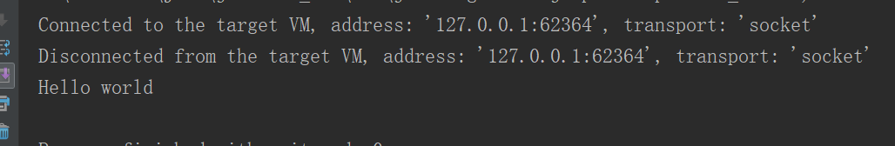

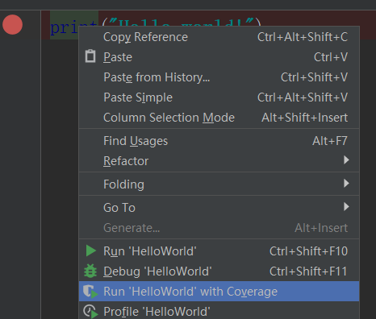

覆盖率测试



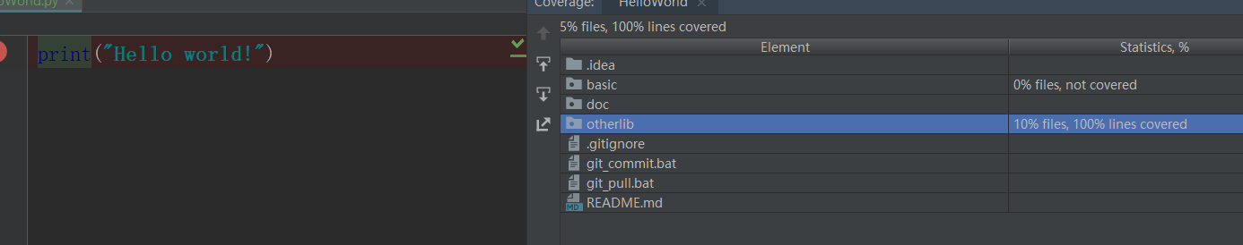

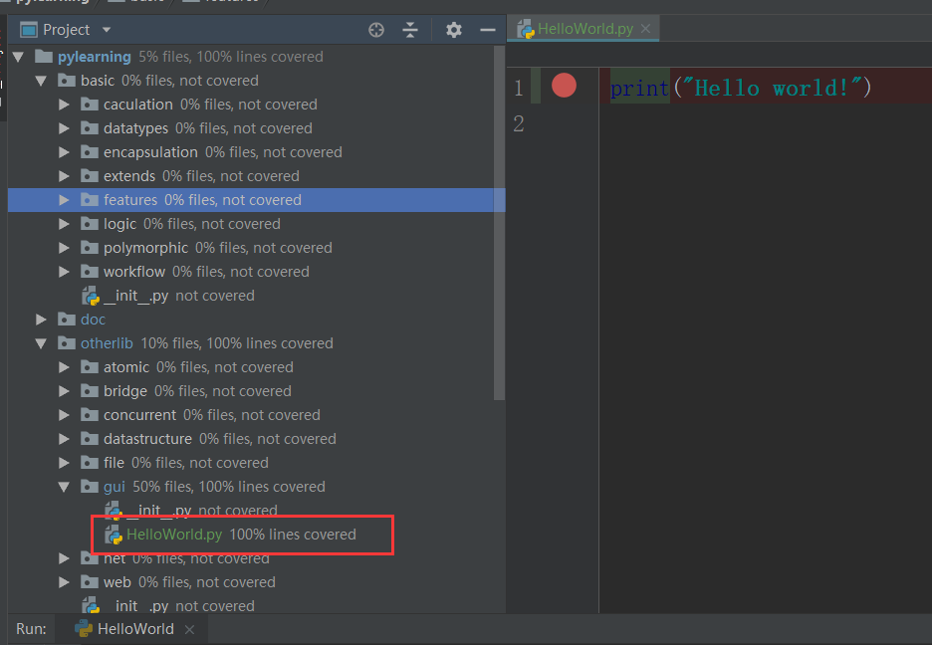

实际有2行，但结果为100%，说明覆盖率不包括空行

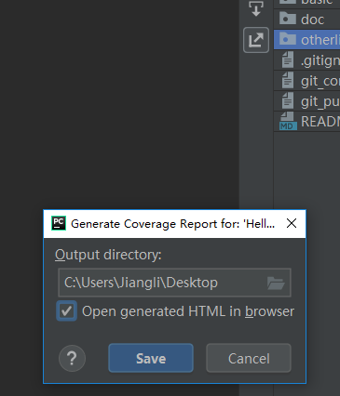有个按钮能生成覆盖率报告

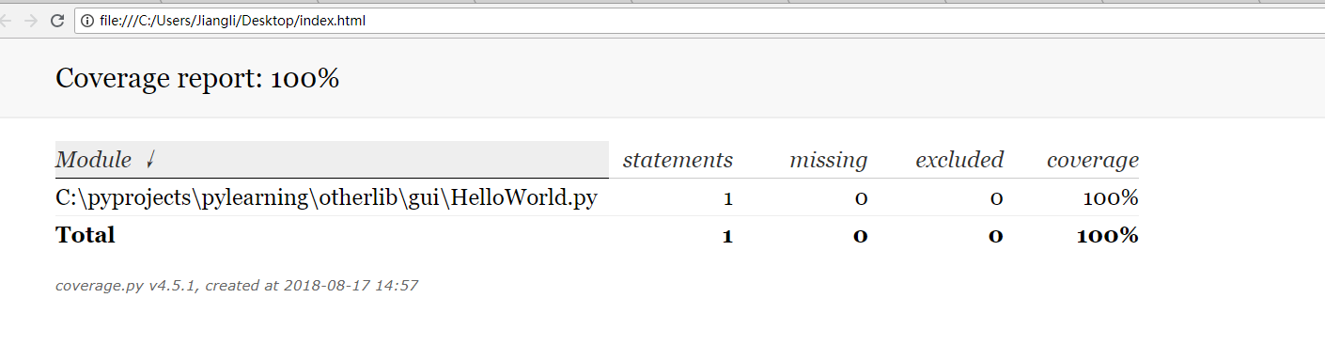

看起来还可以，写了不需要的代码可以通过这个功能找到删除，保持代码简洁性。

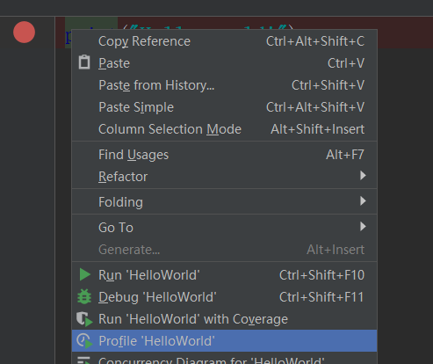

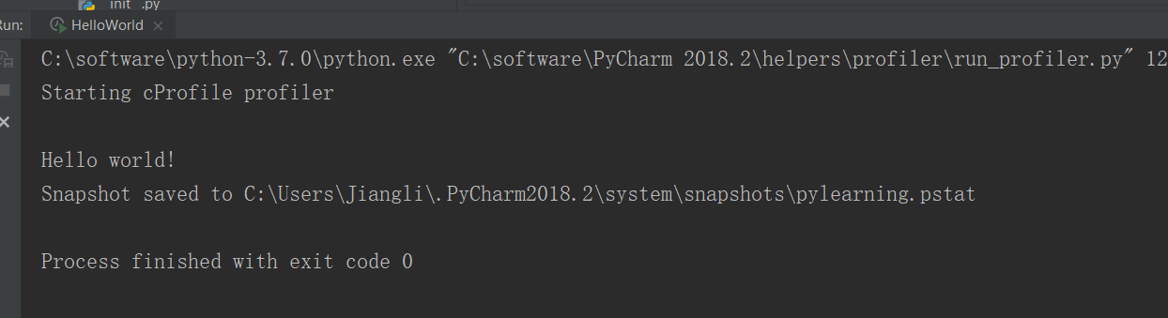

C:\software\python-3.7.0\python.exe "C:\software\PyCharm 2018.2\helpers\profiler\run_profiler.py" 127.0.0.1 63986 C:/pyprojects/pylearning/otherlib/gui/HelloWorld.py

可以看出，实际上是一个py脚本去分析另一脚本

生成的结果在下面

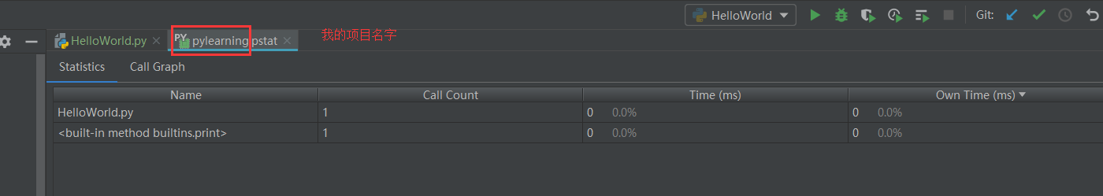

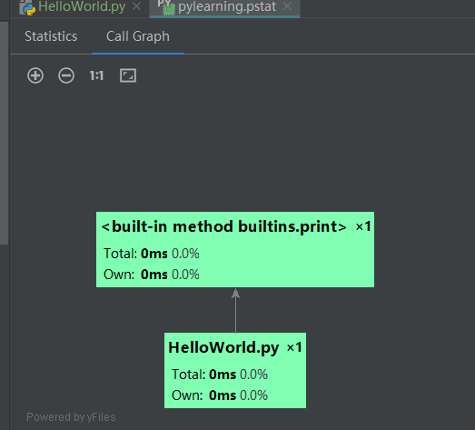

可以得出结论，这是性能测试功能，还能看出调用关系

这

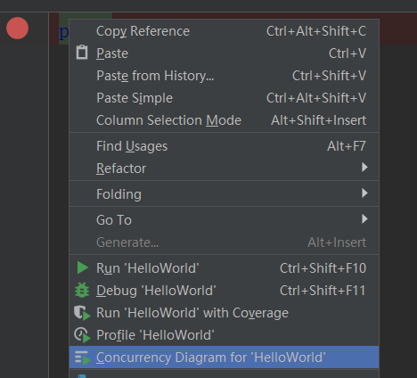

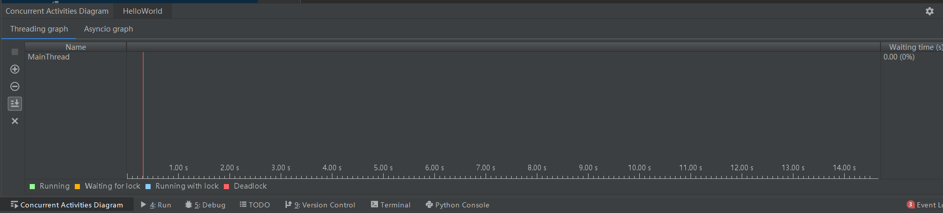

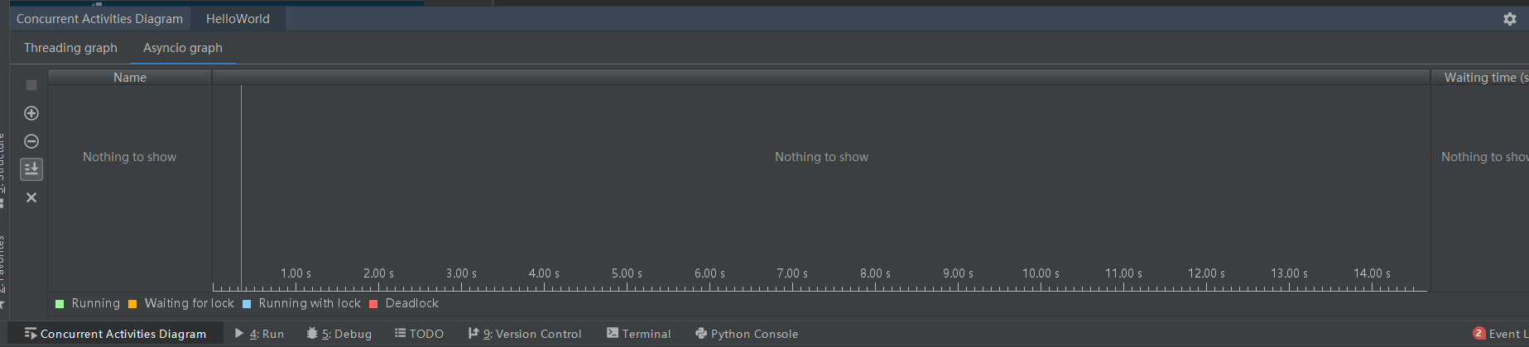

目前不知道有什么用，等以后学了线程再来看。

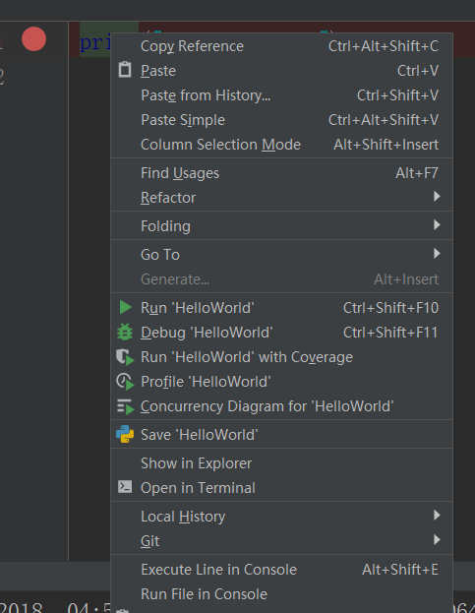

行执行模式

运行后

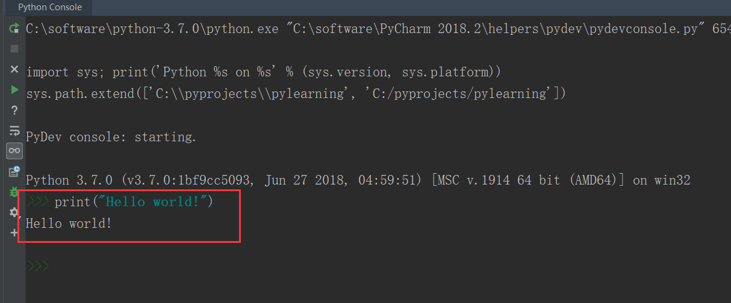

有执行语句和输出结果

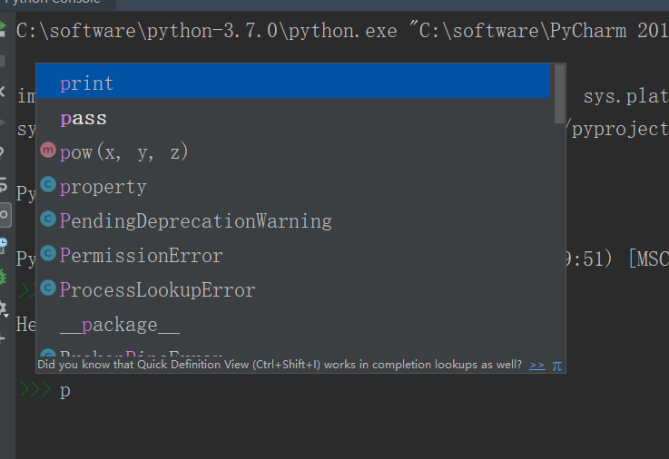控制台竟然有上下文提示，惊呆。

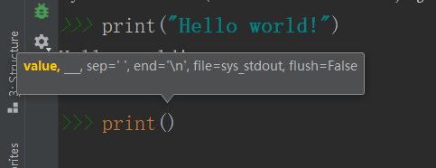

还有参数提示

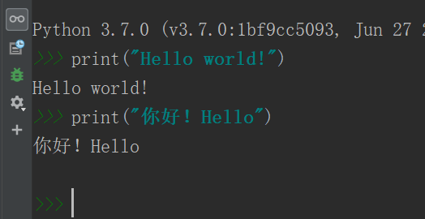

按↑键能切换在历史执行记录中切换

也能通过按钮进入图形化界面手动选择历史记录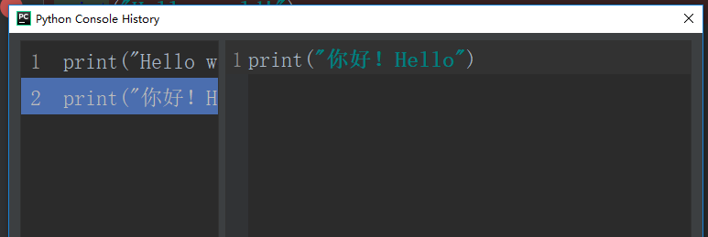

这功能非常方便