**(測資用wordpad或記事本開啟)**

**Theorem:**

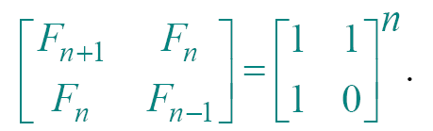

*Proof of theorem.* (Induction on *n*.)

Base (*n* = 1):

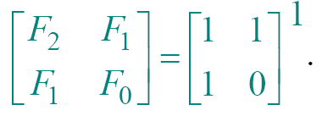

Inductive step (*n* ≥ 2):

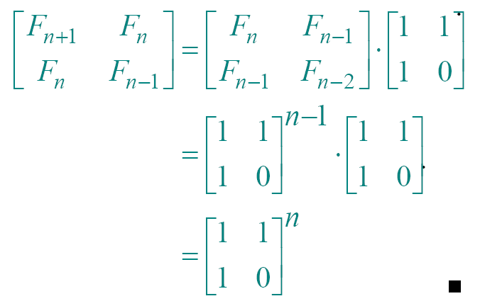

It is constant time to compute 2*2 matrix multiplication.

Use recursive squaring to compute the matrix to the power of n.

Time = Θ(lg *n*) .

Needs Matrix operations in C/C++.