2015正常平倉的獲勝比率:91/95 = 0.9578947368421052

2016正常平倉的獲勝比率: 66/71 = 0.9295774647887324

2017正常平倉的獲勝比率: 60/61 = 0.9836065573770492

2018正常平倉的獲勝比率: 186/194=0.9587628865979382

2015單筆虧損之平均值: -1.9423369473684153

單筆獲利之平均值: 1.7272962616822394

2016單筆虧損之平均值: -2.622681967213117

單筆獲利之平均值: 1.5835394594594567

2017單筆虧損之平均值: -4.320467777777775

單筆獲利之平均值: 2.2440652173912974

2018單筆虧損之平均值: -8.409108646616536

單筆獲利之平均值: 5.591676532663314

2015 New AR BIC篩選:

-2.2

len: 81

strategy win: 53

Profit: 18.317879999999874

Profit win: 54

-2.3

Len:90

Strategy Win:60

Profit:40.19456999999983

Profit win:61

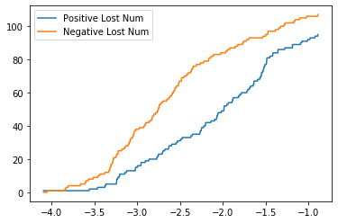

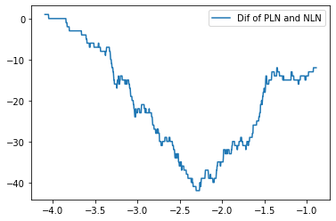

2016 New AR BIC篩選:

-2.2

len: 70

strategy win: 47

Profit: 5.580099999999778

Profit win: 48

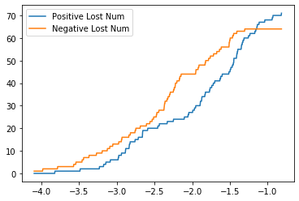

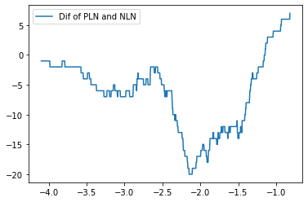

2017 New AR BIC篩選:

-2.2

len: 81

strategy win: 49

Profit: 8.413339999999515

Profit win: 56

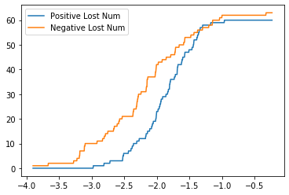

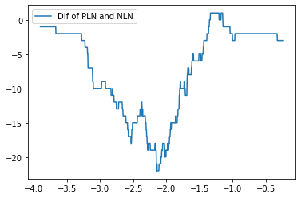

2018 New AR BIC篩選:

-2.2

len: 199

strategy win: 136

Profit: 382.15867999999944

Profit win: 139

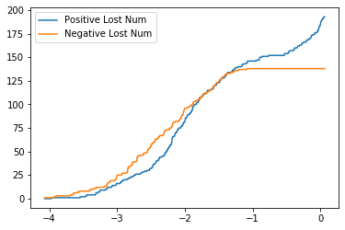

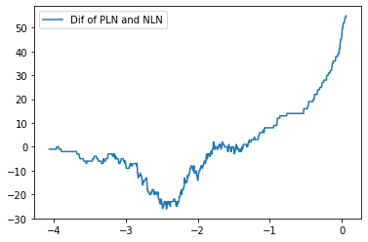

2015 RsM

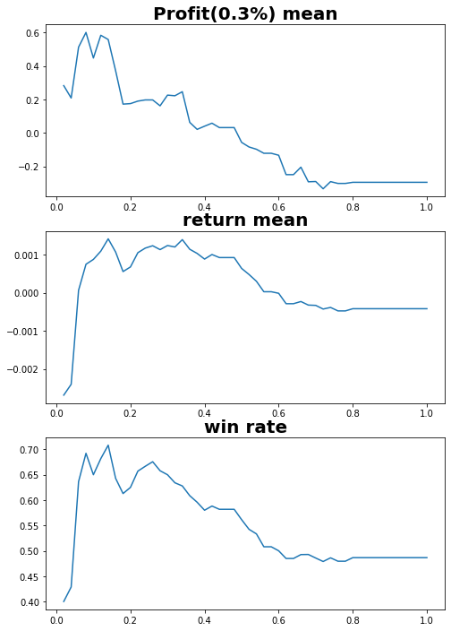

2015 RsC

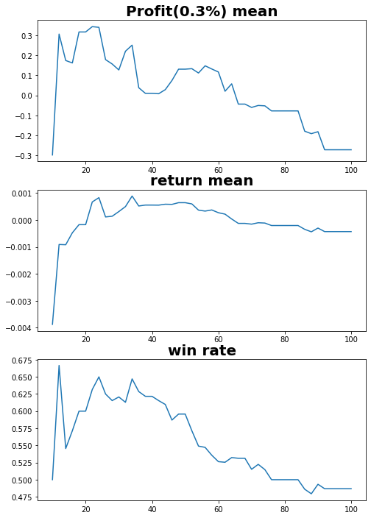

2015 M

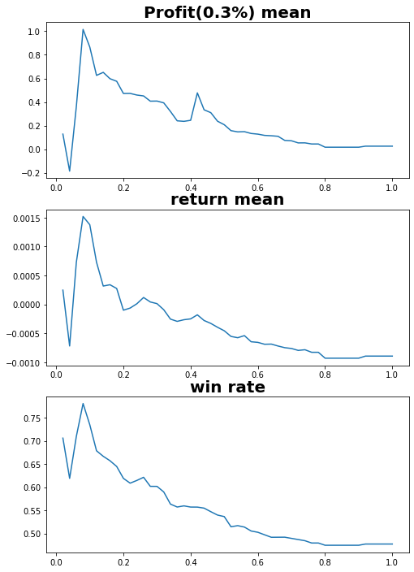

2015 C

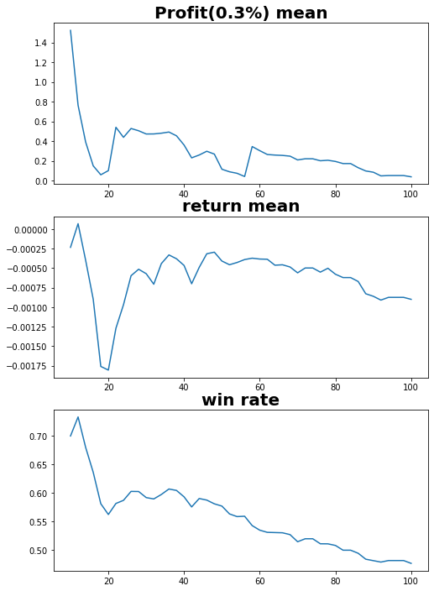

2016 RsM

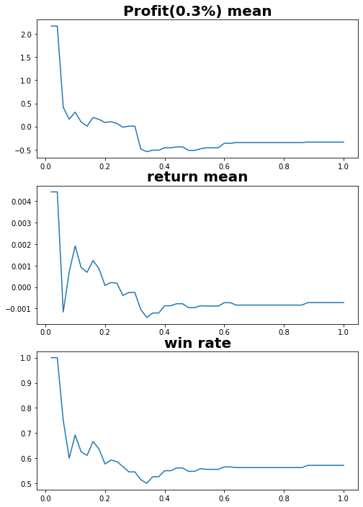

2016 RsC

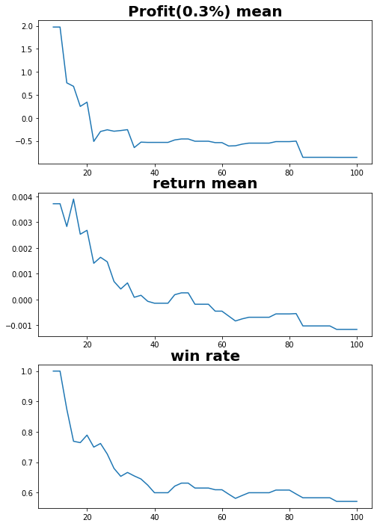

2016 M

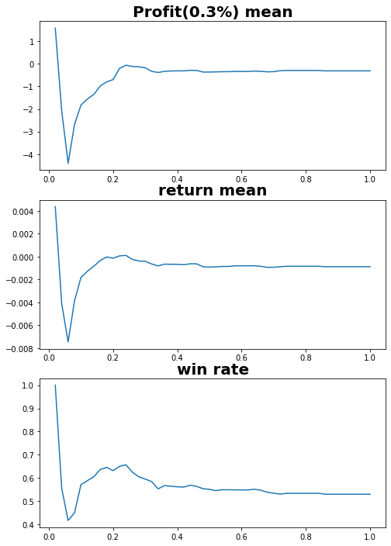

2016 C

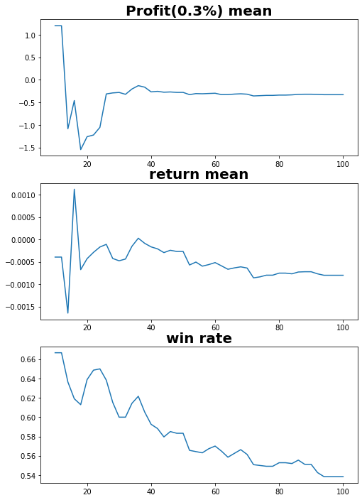

2017 RsM

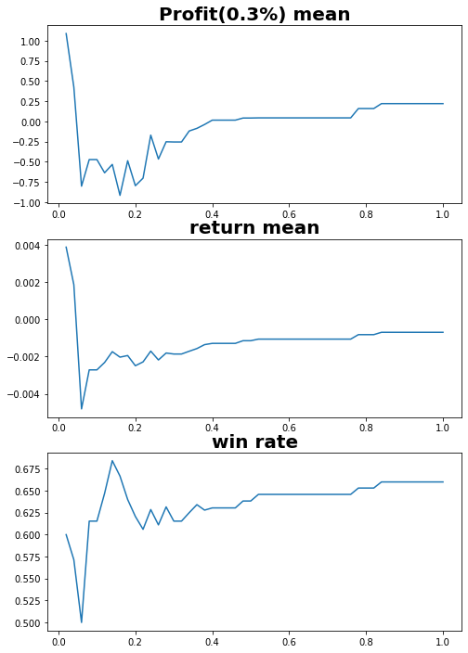

2017 RsC

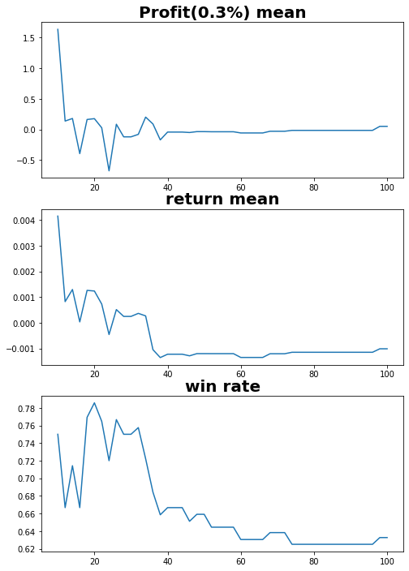

2017 M

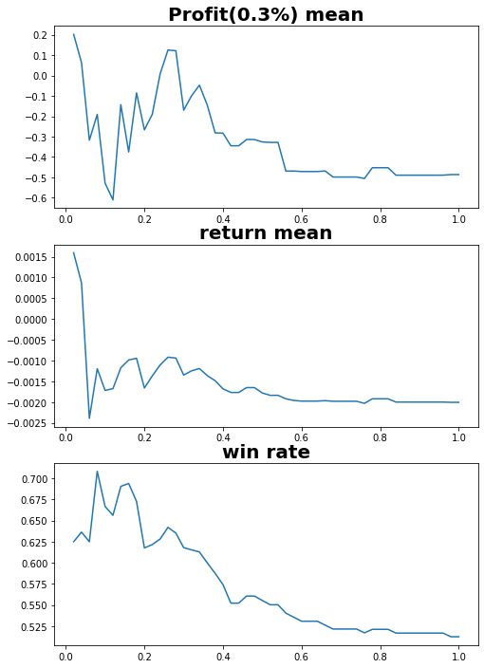

2017 C

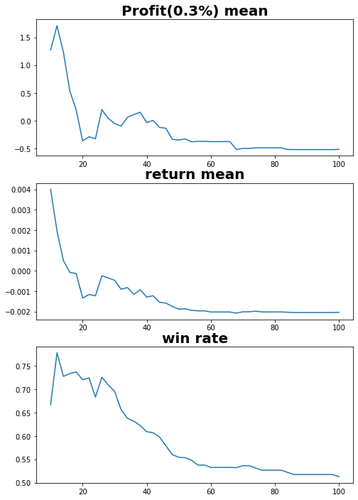

2018 RsM

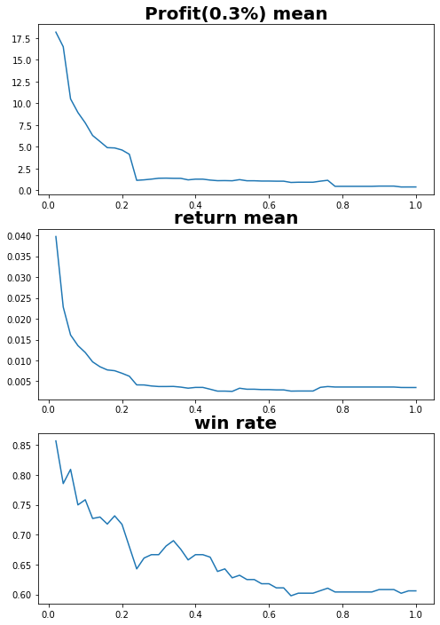

2018 RsC

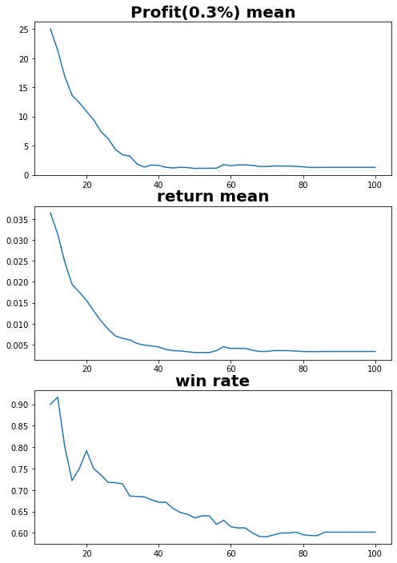

2018 M

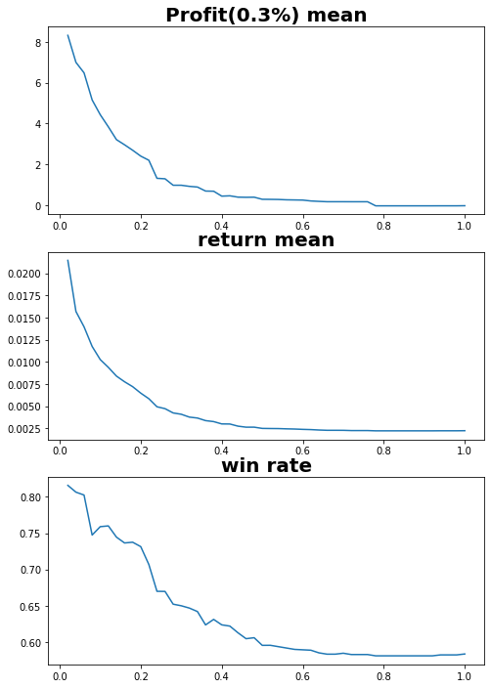

2018 C

