MOHAMMED ALSAHLI
202167910

table
Task Name | Input Parameters | Type | Description
StartupTask | None | Run-to-Completion | Performs initial system calibration: servo sweeps 90°→180°→0°→90°, LED alternates red/green, buzzer sounds continuously
ServoTask | None | Periodic | Controls servo motor: sweeps 0°↔180° at 100°/sec when enabled, freezes during alarms, parks at 90° when disabled
ToFTask | None | Periodic | Measures distance using ToF sensor, detects objects within 1m range, manages 3-second alarm timing
BuzzerTask | None | Periodic | Controls buzzer: sounds during alarm periods, silent otherwise
LEDTask | None | Periodic | Manages RGB LED: solid green (ready), flashing green (sweeping), flashing red (alarm)
ButtonTask | None | Periodic | Handles button presses to toggle between ready and sweeping states

Block diagram
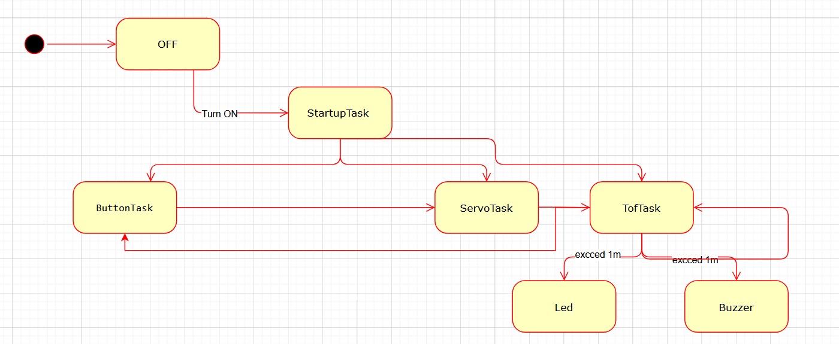

(c) Semaphores and Mutexes (where & why)
- Binary Semaphore – buttonSem (ISR → ButtonTask)
  - Where: Given in buttonISR() via xSemaphoreGiveFromISR; taken in ButtonTask with xSemaphoreTake.
  - Why: Safely transfers the button event from interrupt context to a FreeRTOS task without doing heavy work in the ISR. Debounced to avoid spurious toggles.
- Mutex – distanceMutex (protect shared sensor state)
  - Where: Used in ToFTask when writing distanceMM, objectDetected, and alarmHoldUntilMs.
  - Why: Ensures consistent updates to shared data that other tasks (LED/Buzzer/Servo) read. Prevents race conditions and partial writes.

Assumptions
- ToF address and clock: VL53L4CX at 0x29, I²C at 100 kHz. It was randomly choose 0x14 I don’t know why so I assume its 0x29 .
- Sweep speed: Implemented as 1° every 10 ms to meet 100°/s.

problems or limitations in your solution.
- LED hardware: The kit uses a discrete RGB LED on pins 2/4/5 (common-anode), not as mentioned because the built-in LED on my esp32 is broken .
- Servo direction: Depending on horn mounting, clockwise/counterclockwise may invert. We added SERVO_FLIP to guarantee the required 90→180→0→90 sequence on our hardware.
- No Error Recovery: If ToF sensor fails, system continues without distance measurements

