**King Fahd University of Petroleum & Minerals**

**College of Computer Science and Engineering**

**Information and Computer Science Department**

**ICS 202 – Data Structures**

# Hashing

**Objectives**

The objective of this lab is to study hashing.

**Outcomes**

After completing this Lab, students are expected to:

• Program hash tables,

• Apply hash functions

**Lab Exercises**

The objective of this lab is to implement Hashtables. Design and implement the following:

1. class Entry<T> – this class represents an entry in a hashtable. It has three components:
   1. an Object of type T (called dataObject) that holds the data.
   2. a String (called status) that can have one of these values: “E” (empty), “D” (deleted) or “O” (occupied).
   3. A toString method that prints the contents of the dataObject
   4. A hash method that gets the hashCode of the object (This is from the built-in java hashCode).
2. class HashTable<T> – [name your class HashTable with an uppercase ‘T’, this is to avoid conflict with the java class Hashtable]. This class represents the hashtable. Its main data structure is an array of Entry objects. (of size ‘size’ which you may specify in the constructor). Your class should support the following methods:
   1. Insert an object in the hashtable public boolean insert(T dataObject). Its return value is true, if the insertion is successful, false otherwise. You should also create a method public int findNextAvailableSlot(int currentSlot) that finds the next available slot if the current slot is occupied. Use linear probing.
   2. Delete an object public boolean delete(T dataObject)
   3. Finds the dataObject – public int find(T dataObject). It returns the location of the data object if found, –1 otherwise.
   4. toString( ) – print the contents of the hashtable.

Use a simple remainder hash function. Make sure you hash the dataObject’s hashcode before insertion, deletion and retrieval. Use linear probing for the probe sequence.

1. Write a main method to test your program with the lecture example (given in the below).

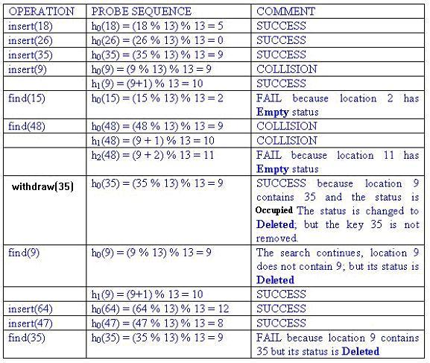

Your output should be as follows:

