Fox And Hounds Game
CS 4795

Team members: Medha Madhub, Chanchal Preet Kaur, Fatima Asif

Abstract
This project is about building an AI agent that can play the Fox and Hounds game using simple decision-making techniques like the Minimax with Alpha Beta pruning and heuristic evaluation function (a scoring system) to help make decisions.
One main thing that we noticed was that the AI’s performance depends a lot on how we design the evaluation function. At the beginning, the AI kept making the same moves again and again, so every game was ending in the exact same way. It felt like the AI was stuck in a loop and not really “thinking”.
After we improved the evaluation logic, the gameplay became more interesting as the moves started to change and different outcomes were possible. So, when we played AI vs AI, sometimes the fox won whereas sometimes the hounds won which made it feel more realistic.
Another thing we observed was that increasing the search depth helped the AI make better decisions but it also made the program slower. It is kind of like thinking more before making a decision, a better choice but takes more time.
Overall, we learned that even small changes in the logic can make a big difference in how the AI behaves.

Introduction
We chose the Fox and Hounds game because it is a simple but strategic game that clearly shows how AI makes decisions. There are two sides, both with opposite goals so, it is perfect for using search-based AI techniques like Minimax and Alpha Beta pruning.
Another reason we chose this game is because the rules are easy to understand but it is not easy to solve. Anyone can learn the rules quickly but making a smart AI for it takes proper planning and logic.
Through this project, we learned how AI looks at different possible moves and tries to choose the best one. Since AI cannot check every possible future move, it uses a scoring system (evaluation function) to guess which move is better.
We also learned that the evaluation function is very important. It is like the brain of AI. If the scoring is bad, the AI makes bad decisions.
For example, it’s like choosing food, if your scoring system says junk food is the best, you will keep picking it even if it is not actually good for you.
We also faced real problems like repeated moves, slow performance and wrong game results. Fixing these helped us understand how important testing and improvements are.

Problem Definition
The problem we are trying to solve is to make a computer play the Fox and Hounds game in a smart way.
Think of it like this: one player is a fox trying to escape and the other player is the four hounds trying to trap the fox. The fox can move in forward as well as backward directions but the hounds can only move in forward direction so, they have to work together to block the fox.
Now imagine replacing the human player with a computer. The computer has to decide which move to make at each and every step.
The problem is that there are many possible moves every time. The AI has to think ahead and guess what might happen next.
But it cannot check everything because that would take a lot of time. It is like trying to think about every possible move in a chess game, it would take forever.
So, the real question becomes:
How can we make the AI choose a good move quickly without checking everything?
To solve this, we use Minimax to look ahead a few steps and an evaluation function to score each situation and decide what is better.

Key idea
The main idea of our project is to show how an AI can actually learn and improve over time while playing a game. We chose Fox and Hounds because it’s a strategy game where one side, the fox, is trying to escape, and the other side, the hounds, are trying to trap it. So, it naturally fits a situation where the AI has to think ahead and make decisions against an opponent.
To do this, we used the Minimax algorithm with Alpha-Beta pruning. Basically, this means the AI looks ahead at different possible moves and tries to pick the one that gives it the best outcome, while assuming the opponent is also playing optimally. Since it can’t look all the way to the end of the game, it uses something called a heuristic evaluation function to score how good a position is.
What makes our project different is the learning part. Instead of keeping the evaluation function fixed, we let the AI play many games against itself and then adjust the weights of the evaluation function based on the results. For example, if certain positions lead to winning more often, the AI starts valuing those positions more. Over time, this helps the AI make better decisions.
So, in simple terms, the AI is not just thinking ahead using Minimax, but it is also learning from its past games. This allows it to avoid repeating mistakes and become more strategic. Even though the learning method is relatively simple, it still shows a clear improvement in performance and demonstrates how AI systems can adapt and get better with experience.

Details
The overall performance of our AI improved significantly after introducing the learning component. At the beginning, the AI relied on an initial heuristic evaluation function that was not well tuned, which caused repetitive and predictable behaviour. In particular, the fox often lost in similar situations because it could not properly evaluate dangerous positions or recognize good escape paths.
We also encountered an issue in the game logic where the fox was sometimes declared the winner even though there were still legal moves available. This was due to an error in the win condition checking, which caused some games to end incorrectly. After identifying this problem, we fixed the win condition logic so that the game only ends when the correct conditions are met.
After implementing self-play, the AI was able to adjust the weights of its evaluation function based on game outcomes. This allowed it to gradually improve how it evaluates board states. As a result, the gameplay became more varied and less repetitive, and the AI started making more effective decisions. A clear example of this improvement is that the fox’s win rate increased and the fox and hounds both started having good win rates, showing that the learning component had a measurable impact.
However, performance is still influenced by the depth of the Minimax search. A deeper search allows the AI to consider more future possibilities and generally leads to better decisions, but it also increases computation time. This can cause lag during gameplay, especially when the branching factor is high. Therefore, there is an important trade-off between decision quality and efficiency, and we had to choose a depth that balances both.
Overall, the system was able to function effectively and demonstrate clear improvement over time. Despite some limitations in performance and decision depth, the AI successfully showed learning behaviour, produced more strategic gameplay, and achieved a good balance between efficiency and decision quality.

Striking Successes
One of the most striking successes of our project is the clear improvement in AI behaviour after learning. Initially, the AI would often repeat the same mistakes, such as moving into easily predictable traps or failing to block obvious escape paths. After training through self-play, these patterns were reduced, and the AI began to explore different strategies depending on the situation. This made the gameplay more dynamic and realistic.
Another important success is the improvement in coordination and positioning, especially for the hounds. After learning, the hounds became more effective at maintaining a formation that restricts the fox’s movement and gradually forces it into a corner. At the same time, the fox showed better mobility and decision-making, choosing moves that increased its chances of escaping instead of getting trapped early. The game was therefore more competitive.
In addition, the use of Alpha-Beta pruning played a key role in improving performance. By eliminating branches of the search tree that do not need to be explored, it reduced the number of states the AI had to evaluate. This allowed the AI to search deeper or respond faster without significantly increasing computation time, making the game smoother.

Striking failures
One of the main issues we faced early on was that the fox kept losing in the same scenario repeatedly. The AI would fall into predictable patterns and make similar mistakes each game, which made the gameplay repetitive and unbalanced. This highlighted a limitation in the initial evaluation function, as it was not capturing important aspects of the game such as escape paths or dangerous positions. This issue was one of the main motivations for introducing the learning component, so the AI could adapt and avoid repeating the same mistakes over time.

Fox was losing every time in the same scenario:
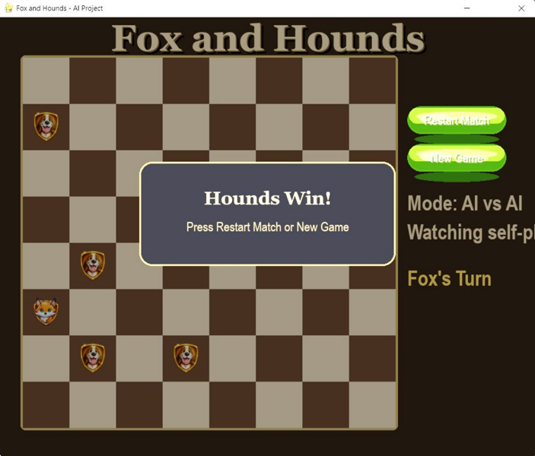
Improved the code so they are not ending up in same scenario: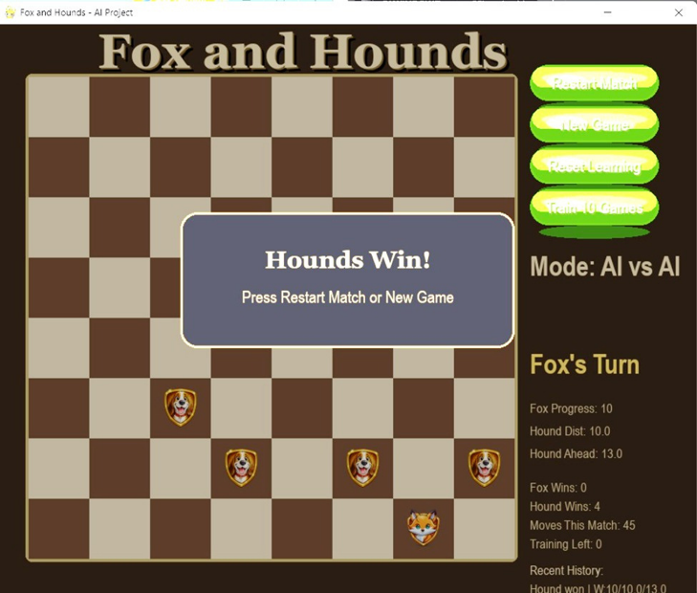
Another issue we encountered was related to the game logic rather than the AI itself. At one point, the fox was being declared the winner even when there were still legal moves available. This was due to an error in how the win condition was checked, which caused some games to end earlier than they should have. Because of this, some of our early results were not fully reliable. After identifying the problem, we corrected the win condition logic so that the game only ends when the correct conditions are actually met.
Another limitation comes from the depth of the Minimax algorithm. Since the AI cannot search all the way to the end of the game, it sometimes makes decisions that seem good at first but lead to problems later on. For example, the fox may move into a position that looks safe in the short term but eventually leads to being trapped. This shows that the AI is still somewhat short-sighted when the search depth is limited.
We also noticed performance issues when increasing the search depth. While a deeper search improves the quality of decisions, it also increases the number of positions the AI needs to evaluate. This can slow down the game and cause noticeable lag, especially in more complex situations. Because of this, we had to limit the depth to keep the game running smoothly, even if it meant sacrificing some decision quality.
Finally, the learning component has its own limitations. Although the AI improves by adjusting the weights of its evaluation function, it still depends on the features that were originally designed. This means it can only learn within those limits and may miss more complex strategies that are not included in the evaluation. As a result, the AI improves over time, but it does not become perfect.

Results
After training first 5 games:
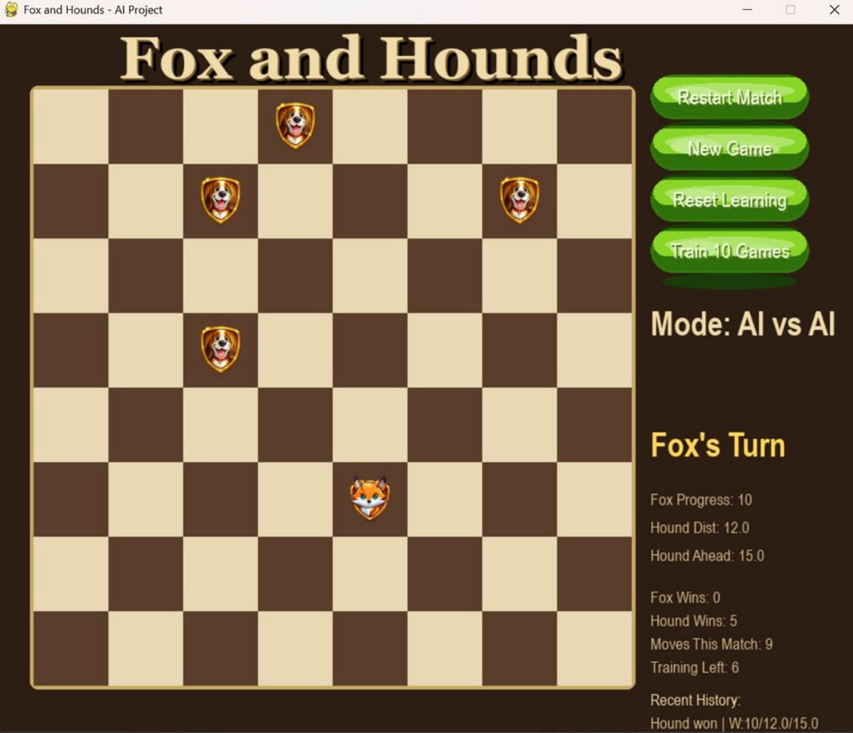
After training 80+ games:
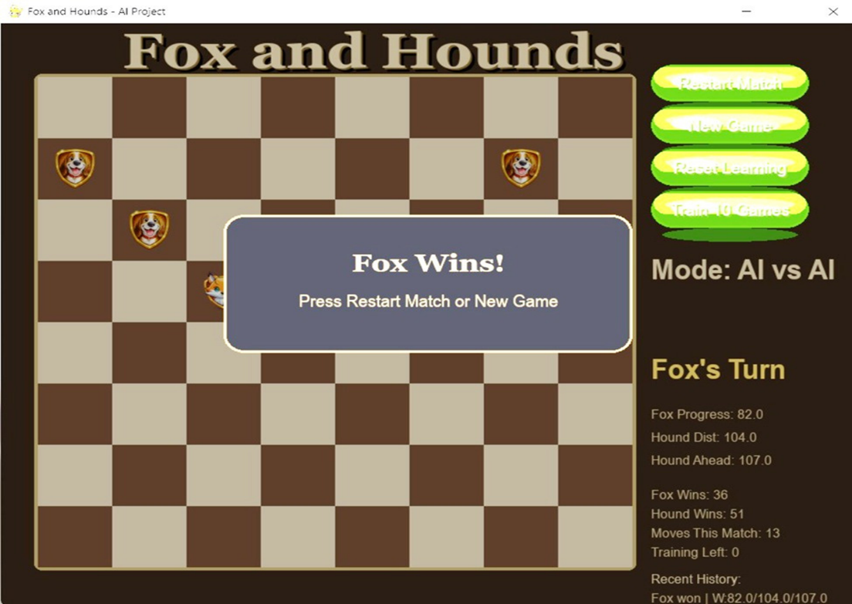
Related works
There are several alternative approaches to designing AI for game-playing problems like Fox and Hounds. One common approach is to use a standard Minimax algorithm with a fixed evaluation function. While this method is simpler to implement, it does not allow the AI to improve over time, since its behaviour is entirely determined by the initial heuristic. For our project, this would not have met our goal of demonstrating learning.
Another possible approach is to use deeper search with more advanced heuristics. A deeper search allows the AI to explore more future game states and generally leads to stronger decision-making. However, this approach is computationally expensive and can significantly slow down the game, making it less suitable for an interactive application like ours.
A more advanced alternative is reinforcement learning, where the AI learns optimal strategies through repeated experience without relying heavily on manually designed evaluation functions. While this method can produce very strong agents, it requires a large number of training games, more complex implementation, and greater computational resources. Given the scope of our project, this approach was not practical to implement.
Therefore, we instead chose to use Minimax with Alpha-Beta pruning combined with a learning-based evaluation function because it provides a good balance between performance, simplicity, and adaptability. This approach allowed us to clearly demonstrate how an AI can improve over time while still maintaining reasonable efficiency during gameplay.

Conclusion
This project was able to demonstrate how an AI agent can make decisions and improve its performance in a strategic game environment. By implementing Minimax with alpha beta pruning and a learning-based function, we were able to show that AI behaviour is highly dependent on how it evaluates game states.
When we started working on this project, the AI showed repetitive and predictable behaviour as the evaluation function was weak. However, after improving evaluation logic, the AI became more dynamic, strategic, and capable of producing varied outcomes. This highlights the importance of the evaluation function and the impact of learning in improving AI performance.
There were noticeable trade-offs between decision and efficiency. While deeper search improves decision-making, it increases computational time, requiring a balance for practical use. Although the learning components improved performance, it remained limited by the features defined in the evaluation function.
Overall, this project provided valuable insight into how search algorithms, heuristics, and learning work together in game AI. It showed that even simple learning mechanisms can significantly enhance performance and that iterative testing and refinement are essential in building effective AI systems.

Suggest future works
We plan to improve the learning mechanism by using more advanced techniques such as reinforcement learning. This would allow the AI to learn optimal strategies without relying heavily on manually designed evaluation features.
Another improvement could be enhancing the evaluation function by adding more complex features, such as better detection of long-term traps, escape routes, and coordination between hounds. This would help the AI make more strategic decisions beyond short-term gains.
We also want to improve the performance by optimizing the Minimax algorithm. Techniques such as iterative deepening, move ordering, or parallel processing could allow deeper searches without significantly increasing computation time.

Bibliography
- Machine learning with foxes and hounds. (December,2018).https://scholarworks.calstate.edu/downloads/1v53k187p
- Fox and Hounds Rules and Discussion. Reddit. https://www.reddit.com/r/Ruleshorror/comments/1gn9iw0/fox_and_hounds/
- Fox and Hounds Game Description and Mathematical Discussion.https://drive.google.com/file/d/1xLaMRQraN_g-Fbjvh91DkRVkSYHsuM1z/view?usp=sharing
- Fox and Hounds Strategy and Analysis. Gilith Blog. https://gilith.wordpress.com/2018/11/26/fox-hounds/
- Fox and Hounds – Game Explanation. YouTube video. https://www.youtube.com/watch?v=6VjNwmGAyzo
- Fox and Geese (Fox and Hounds) Mobile Game Application. (January, 2024). Google Play Store. https://play.google.com/store/apps/details?id=com.donkeycat.foxandgeese&h=en_CA
- GeeksforGeeks. (2023).Minimax Algorithm in Game Theory.https://www.geeksforgeeks.org/dsa/minimax-algorithm-in-game-theory-set-4-alpha-beta-pruning/

Appendix
GitHub: https://github.com/q62ur/CS-4795-AI-Project

Contributions
- Chanchal Preet Kaur
Worked on the game interface and overall implementation including graphics, layout and integrating different parts of the system. Found and generated images, set them into the game and added audio elements such as background music and sound effects to improve the overall experience.
Handled extensive testing and debugging by running the program many times to identify issues in gameplay and logic. Played hundreds of matches, including AI vs AI to check for bugs, track progress and observe how the AI was improving over time.
Played additional matches specifically to analyse changes in AI behaviour and check whether the AI was becoming smarter and more consistent.
Helped fix bugs across the entire project including issues in the game logic, evaluation function and overall, AI behaviour. Fixed problems such as repetitive scenarios and incorrect game outcomes and continuously improved the code to make the gameplay more dynamic and reliable.
Contributed to writing the final report including sections such as Abstract, Introduction and Problem Definition.
- Fatima Asif
My primary contribution to this project was the design and improvement of the evaluation function used by the AI agent. I developed the initial heuristic model and continuously refined it based on observed gameplay results, which played a key role in improving the AI’s decision-making and overall performance.
In addition to this, I was actively involved in testing the system throughout the development process.
I also took responsibility for designing and creating the final PowerPoint presentation, ensuring that the project’s concepts and results were communicated clearly and effectively. Furthermore, I contributed to writing and organizing sections of the final report, helping maintain structure, clarity, and coherence.
Overall, my contributions focused on improving the intelligence of the AI, ensuring the reliability of the system through testing, and effectively presenting the project outcomes.
- Madha Madhub
I worked on improving the game’s AI and gameplay logic. I implemented the Minimax algorithm with Alpha-Beta pruning so the AI could make better decisions more efficiently. To reduce lag and improve performance, I adjusted and lowered the search depth. I also implemented an AI vs AI mode, allowing both sides to play automatically using the similar logic as in the regular game.
I fixed several bugs that were affecting the game throughout the process. This included issues where the fox was declared the winner too early, cases where the game would freeze, and problems with movement and win conditions. I improved special cases like when the fox has a clear path to win and made sure the same logic works for both player vs AI and AI vs AI modes. I also adjusted animation speed for smoother gameplay and cleaned up the comments at the end.
I also contributed to writing the report by explaining the key idea, describing the performance of the AI, and identifying the most important successes and failures of the project. I analysed the results and discuss limitations and compared our approach to other possible methods and explaining why they were not chosen.

