Pet Adoption Management System
GitHub Link: https://github.com/q62ur/CS1103-Project
Chanchalpreet Kaur
Student ID: 3772677
Course: CS 1103
Instructor: Jong-Kyou Kim

Abstract
This project focuses on building a Pet Adoption Management System using Java and SQLite. The system manages data related to pets, adopters, shelters, staff and adoption applications through a structured relational database. One important finding from this implementation is that even small improvements in validation and logic can significantly improve system reliability. For example, the system was initially able to accept invalid IDs but after adding validation checks, it became more realistic and secure. Another key observation is that the structure of the database plays a major role in how data can be managed efficiently as a well designed schema makes operations such as searching, updating and tracking much easier and more reliable.

Introduction
This project was chosen because pet adoption is a real world problem where managing data properly is very important. Shelters need to keep track of pets, adopters and adoption applications and doing this manually can quickly become confusing and inefficient. This project demonstrates how a relational database system can be used to organize and manage such data effectively.
The System
Through this project, concepts such as relational database design, SQL operations and Java database connectivity using JDBC were applied. The system also considers real world constraints such as data validation and consistency. For example if a user tries to adopt a pet that is already adopted, the system prevents this action. Without a structured system, such errors could easily occur which shows the importance of using a database driven approach. The Pet Adoption Management System is a console based application developed using Java and SQLite. The system is designed to organize and manage all information related to pets, adopters, shelters, staff and adoption processes within a structured database. Each type of data is stored in a separate table which helps maintain clarity and reduces the chances of data inconsistency.
This project satisfies the minimal requirements by including an ER diagram, creating database tables using SQL DDL statements, defining relationships using primary and foreign keys, inserting sample data and connecting the application to the database using JDBC. It satisfies the moderate requirements by creating a database instance and performing SQL operations such as insert, select and update. The challenge requirements are addressed through the implementation of a menu driven Java application that interacts with the database and allows users to perform different operations.
The system provides functionality for viewing available pets, viewing adopters, submitting adoption applications, viewing adoption records, resetting pet availability and searching pets by species. These features allow users to interact with the database in a simple and efficient way.

Database Structure
The database for this system is designed using multiple related tables, including Shelter, Pet, Adopter, Staff, AdoptionApplication and AdoptionRecord. Each table stores specific information and together they represent the complete structure of the system.
Primary keys are used in each table to uniquely identify records while foreign keys are used to establish relationships between tables. For example, the Pet table includes a reference to the Shelter table which indicates where the pet is located. Similarly, the AdoptionApplication table connects adopters and pets, allowing the system to track which user has applied for which pet.
This structured design ensures that data is organized and consistent across the system. It also allows the system to efficiently retrieve and update information without duplication or confusion.

ER DIAGRAM
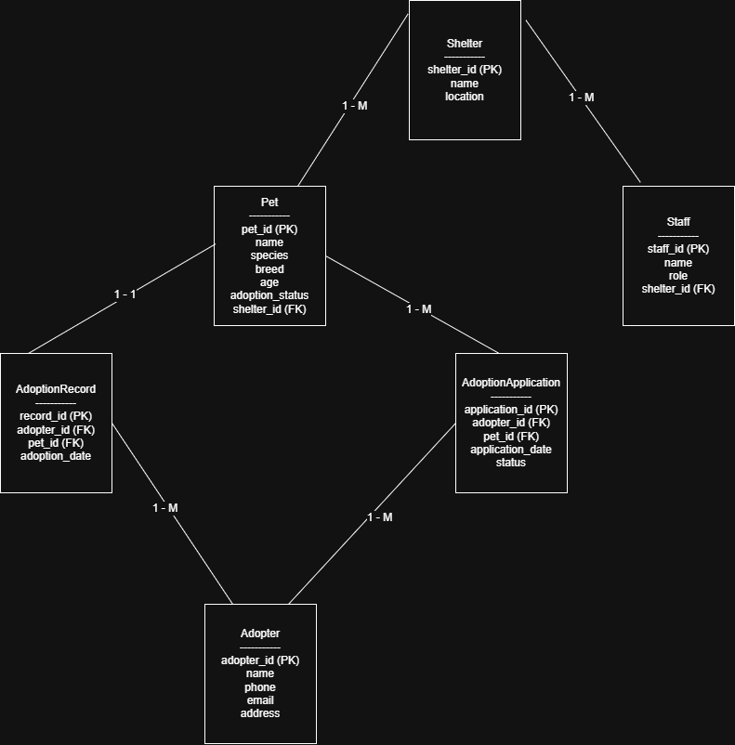

DDL(Creating Tables)
The database schema for this project was created using SQL DDL statements, mainly through the CREATE TABLE command. These statements define the structure of each table including column names, data types, primary keys and foreign keys. This step is important because it creates the foundation of the database and ensures that all data is stored in an organized way.
The main entity tables in the system are Shelter, Pet, Adopter and Staff. These tables store the core information needed for the application such as pet details, adopter details, shelter information and staff records. In addition to these entity tables, the system also includes AdoptionApplication and AdoptionRecord which are used to represent adoption related processes and relationships between adopters and pets.
The relationships shown in the ER diagram are implemented in the database using foreign keys. For example, the Pet table contains shelter_id to connect each pet to a shelter, the Staff table also contains shelter_id to show which shelter a staff member belongs to and the AdoptionApplication and AdoptionRecord tables connect adopters with pets. This design helps maintain referential integrity and ensures that related data remains consistent throughout the system.

DML(Using the Data)
The system uses SQL DML operations to interact with the data stored in the database. These operations include inserting new records, retrieving existing data and updating information when required. These actions allow the system to function dynamically and reflect real time changes.
For example, when a user submits an adoption application, a new record is inserted into the AdoptionApplication table. At the same time, the system updates the adoption_status of the selected pet to "Adopted". The system also uses SELECT queries to display available pets, adopters and adoption records to the user.
Although DELETE operations are part of standard database functionality, the main focus of this system is on insert, select and update operations which are directly used in the application.

JDBC Connection
The system connects the Java application to the SQLite database using JDBC. JDBC allows the program to send SQL queries to the database and retrieve results. In this project, the DriverManager class is used to establish the connection, the Statement object is used to execute SQL queries and the ResultSet is used to store and display the results.
This connection allows the application to interact with the database in real time making it possible to view, insert and update data as needed.

Application Program
The system includes a menu driven Java application that allows users to interact with the database. When the program is executed, it displays a menu with multiple options such as viewing available pets, viewing adopters, submitting adoption applications, viewing adoption records, resetting pet availability, viewing shelters and searching pets by species.
Each option in the menu is connected to a specific function in the program which executes the required SQL queries. For example, selecting the option to view available pets runs a SELECT query while submitting an adoption application performs both an INSERT operation and an UPDATE operation. This design allows the system to handle multiple tasks efficiently.
The application also includes basic input validation to ensure that only valid data is entered. In addition to the console based program, a simple graphical user interface was explored using Java Swing as an extension. However, the main implementation of the system remains console based.

Input Validation
The system includes input validation to reduce errors and improve data reliability. Before an adoption application is submitted, the program checks whether the adopter ID and pet ID entered by the user are valid. If either ID does not exist in the database, the system displays an error message instead of continuing.
The program also checks the adoption status of the selected pet. If the pet is already marked as adopted, the system prevents another adoption from being submitted for the same pet. These checks help maintain consistency in the database and make the application more realistic.

Search Feature
The system includes a search feature that allows users to find pets based on their species. Instead of viewing all records, users can enter a specific species such as "Dog" or "Cat" and the system will display only the matching results. This is done using a SELECT query with a condition on the species field.
This feature improves the usability of the system by making it easier to filter and access relevant data quickly.

Conclusion
This project demonstrates how a relational database system can be used to manage real world data effectively. By combining SQL with Java through JDBC, the system is able to store, retrieve and update data in a structured and efficient way.
Through this project, a better understanding of database design, data relationships and input validation was developed. It also showed how integrating a database with an application can create a functional system that handles real-world scenarios such as pet adoption. Overall, the project provides a simple but complete example of how database driven applications are built and used.

Bibliography
The concepts and implementation of SQL and database design in this project were supported by SQLite documentation. The integration of Java with the database using JDBC was based on Java JDBC documentation. These resources were used to understand database structure, query execution and interaction between the application and the database.

Appendix
Appendix A: DDL Statements
CREATE TABLE IF NOT EXISTS Shelter
(
shelter_id INT PRIMARY KEY,
name VARCHAR(100) NOT NULL,
location VARCHAR(100) NOT NULL
);

CREATE TABLE IF NOT EXISTS Pet
(
pet_id INT PRIMARY KEY,
name VARCHAR(100) NOT NULL,
species VARCHAR(50) NOT NULL,
breed VARCHAR(50),
age INT,
adoption_status VARCHAR(20) NOT NULL,
shelter_id INT,
FOREIGN KEY (shelter_id) REFERENCES Shelter(shelter_id)
);

CREATE TABLE IF NOT EXISTS Adopter
(
adopter_id INT PRIMARY KEY,
name VARCHAR(100) NOT NULL,
phone VARCHAR(20),
email VARCHAR(100),
address VARCHAR(200)
);

CREATE TABLE IF NOT EXISTS Staff
(
staff_id INT PRIMARY KEY,
name VARCHAR(100) NOT NULL,
role VARCHAR(50),
shelter_id INT,
FOREIGN KEY (shelter_id) REFERENCES Shelter(shelter_id)
);

CREATE TABLE IF NOT EXISTS AdoptionApplication
(
application_id INT PRIMARY KEY,
adopter_id INT,
pet_id INT,
application_date DATE,
status VARCHAR(20),
FOREIGN KEY (adopter_id) REFERENCES Adopter(adopter_id),
FOREIGN KEY (pet_id) REFERENCES Pet(pet_id)
);

CREATE TABLE IF NOT EXISTS AdoptionRecord
(
record_id INT PRIMARY KEY,
adopter_id INT,
pet_id INT,
adoption_date DATE,
FOREIGN KEY (adopter_id) REFERENCES Adopter(adopter_id),
FOREIGN KEY (pet_id) REFERENCES Pet(pet_id)
);

Appendix B: Sample Insert Statements
INSERT INTO Shelter VALUES
(1, 'Happy Tails Shelter', 'Saint John'),
(2, 'Safe Paws Shelter', 'Fredericton');

INSERT INTO Pet VALUES
(1, 'Max', 'Dog', 'Labrador', 3, 'Available', 1),
(2, 'Bella', 'Cat', 'Siamese', 2, 'Available', 1),
(3, 'Charlie', 'Dog', 'Beagle', 4, 'Available', 2);

INSERT INTO Adopter VALUES
(1, 'John Smith', '1234567890', 'john@example.com', 'Saint John'),
(2, 'Emma Brown', '9876543210', 'emma@example.com', 'Fredericton');

INSERT INTO Staff VALUES
(1, 'Alice Green', 'Manager', 1),
(2, 'Bob White', 'Volunteer', 2);

INSERT INTO AdoptionRecord VALUES
(1, 2, 3, '2026-03-18');
Appendix C: Java Source Code
The Java source code for this project includes the files DatabaseSetup.java, PetAdoptionApp.java, and PetAdoptionGUI.java. These files were used to create the database schema, implement the menu driven application and explore a simple graphical user interface. The complete source code is attached with the project submission.
Appendix D: Class Diagram
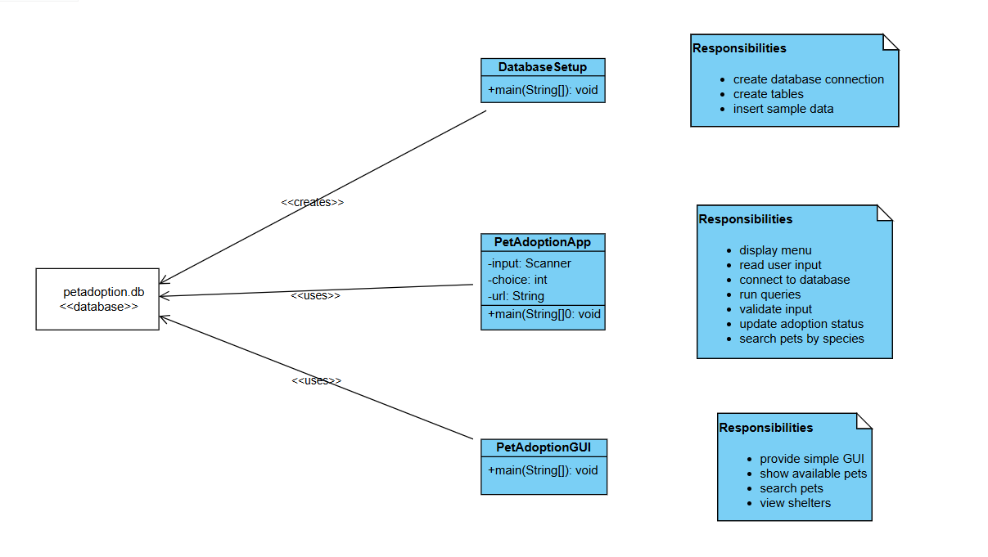

Appendix E: User Guide
To run the system, the user must first execute the DatabaseSetup.java file to create the database and initialize the tables with sample data. After that, the PetAdoptionApp.java file should be run to start the application.
Once the program starts, a menu is displayed with multiple options. The user can select different options to view available pets, view adopters, submit adoption applications, view adoption records, reset pet availability, view shelters or search pets by species. The user is required to enter valid IDs when prompted and the system will display appropriate messages for invalid inputs.
A simple graphical interface is also available through PetAdoptionGUI.java which allows basic interaction such as viewing pets and searching by species.

