Word Wars: Human vs. Machine

Group members: Medha Madhub, Fatima Asif, Chanchal Preet Kaur

Problem we explored:
Does AI generated speech actually sound like a real person talking or does it still sound like a robot trying to write a speech?
While many people study AI writing in essays or books, our project’s main focus is on speech. This is important because spoken language is different from written language. When people talk in real life, they use pauses, repetition, informal words, and sometimes incomplete sentences. These features make speech sound natural and human.
To explore this, we used real human speech data from sources such as TED Talks and Mozilla datasets. We then compared this data to speech generated by an AI model (ChatGPT). Our goal was to analyse whether AI-generated text follows the same patterns as real human conversation.
We looked at differences in structure, word choice, and flow. We wanted to see if AI can truly replicate the natural style of human speech, or if it still produces text that feels artificial or overly structured.

Background and Context:
In recent years, there has been a strong increase in AI-generated content. This includes things like AI-generated podcasts, voice assistants, chatbots, and digital characters. Because of this, people are now interacting with computers more often in their daily lives, especially through speech and conversation.
As AI continues to improve, the way it generates text is becoming more natural and more similar to how humans speak. This makes it harder to tell the difference between something written by a person and something created by AI. Real human conversations usually contain pauses, repetition, less formal language and are not very structured.
Because of these changes, it is important to understand whether we can still distinguish between a transcript created by a human and one generated by AI. If AI speech becomes too similar to human speech, it could affect how we trust and understand the information we receive.
In our project, we aim to analyse and distinguish between real human speech and AI-generated synthetic speech using data mining techniques. With most of us being heavily dependent on AI, it is important to identify patterns that allow us to differentiate between real speech from artificial text.
In this project we will be using the following datasets:
1) TED Talks
2) Mozilla Common Voice
3) Synthetic datasets
Our goal is to train the classification models that can accurately identify the source of speech text.

Summarize and cite previous related works:
We found some studies that have explored the problem of distinguishing between human-written and AI-generated text using machine learning techniques. While most of this work focuses on text-based detection, our project extends this problem to speech transcripts, which can still be treated as text after preprocessing. Many of these studies use approaches similar to ours and report comparable performance.
Many earlier works used approaches similar to ours, such as TF-IDF combined with models like Logistic Regression, Support Vector Machines (SVM), and Naive Bayes. For example, Zeng (2024) compared these models and found that Logistic Regression and SVM can achieve strong performance in text classification tasks, often exceeding 90% accuracy.
More recent research focuses on deep learning and transformer-based models such as BERT and DistilBERT, which are able to capture deeper contextual and semantic patterns in text. Studies show that these models generally outperform traditional methods due to their ability to understand context rather than relying only on word frequency (Alikhanov et al., 2026; Prova, 2024).
However, an important issue highlighted is generalization. A review by Kehkashan et al. (2025) shows that although many detection models achieve high accuracy, they often struggle to generalize across different datasets and domains. This is consistent with our findings, where cross-domain validation led to a significant drop in performance.
Additionally, research evaluating real-world detection tools shows that they are not always reliable. Weber-Wulff et al. (2023) found that many AI detection systems produce inconsistent results and can misclassify both human-written and AI-generated text.

What motivated us to do this project and what questions we attempt to answer
The motivation for this project comes from the growing presence of AI-generated content in today’s digital world. As tools for generating text and speech continue to improve, it is becoming increasingly difficult to determine whether a piece of content was created by a human or by an AI. This raises an important issue of authenticity, especially when people rely a lot more on digital content for information and communication nowadays.
Most existing research focuses on written text, such as essays or articles. However, our project focuses specifically on spoken-style text. This is important because human speech has unique features that are often difficult for AI to fully replicate, and analysing them may help identify differences between human and AI-generated transcripts.
In addition, the other idea that motivated us is related to trust and security. If AI-generated speech becomes indistinguishable from real human speech, it could lead to some major problems such as misinformation or “deepfake” content. For example, AI can now be used to imitate a person’s voice, which could be misused in situations like scams or spreading false information. There have already been several reported cases of this type of misuse, which shows that this is not just a theoretical problem. Being able to detect these differences is therefore important for maintaining trust in digital communication.
The main questions we sought to answer are the following: First, are there specific linguistic patterns identified using methods such as TF-IDF, that consistently appear in human speech (for example, in TED Talks or Mozilla data) but are absent or different in AI-generated text? Second, how accurately can classification models, such as Support Vector Machines (SVM) and Logistic Regression, label a text sample as either “human” or “synthetic” based on these extracted features?

Data we explored
For this project, we used two main types of data: real human speech transcripts and AI-generated speech. The human speech data was taken from sources such as TED Talks and the Mozilla Common Voice dataset. These sources provide examples of how people naturally speak in different contexts.
To compare this with AI, we generated our own speech transcripts using an AI model (ChatGPT). These transcripts were designed to imitate spoken language, similar to how a person would give a talk or explain something.
Before analysing the data, we first examined the structure of each dataset to identify the relevant columns and understand the type of information they contained. We then selected and extracted only the columns that included the speech text, since this was the main focus of our analysis.
After extracting the relevant data, we combined all datasets into a single dataset. We added a new column called “source” which indicated where each text sample originated from.
Next, we cleaned the dataset by removing missing values and duplicate entries to ensure the data was reliable. We also performed text preprocessing to normalize the texts, which included converting all text to lowercase, removing extra spaces, and eliminating punctuation and special characters. In addition, very short text entries (for example, with fewer than three words) were removed, as they did not provide meaningful information for analysis.
Finally, we prepared the data by applying feature extraction techniques such as TF-IDF, which allowed us to represent the text in a numerical format suitable for classification models.

Key idea
The key idea driving this project is that human speech and AI-generated text may have different linguistic “fingerprints.” Even though AI has become very effective at imitating how we write, we expected that real human speech would still contain certain natural characteristics, like a natural “messiness” or rhythm that a computer might not be able to perfectly replicate.
Based on this idea, we were hoping to discover whether the differences between human and synthetic speech can be identified and measured using data analysis techniques. In particular, we wanted to determine if there are specific words or patterns that appear more frequently in human speech compared to AI-generated text, or vice versa. For example, we were interested in whether human speech tends to include more informal or expressive language, while AI-generated speech might appear more structured or neutral.
Another important idea we wanted to discover was how accurately machine learning models, such as Support Vector Machines and Logistic Regression, can detect these differences. We wanted to see if these models are strong enough to reliably classify a transcript as either human or synthetic based on the extracted features.
Finally, we were interested in whether these patterns remain consistent across different types of human speech. By comparing professional speech (such as TED Talks) with more everyday speech (such as Mozilla data), we aimed to understand if there is a general human speech pattern that can be recognized regardless of the context.
Overall, we hoped to determine whether the “human element” in spoken language can still be detected by machines, or if AI-generated text has become advanced enough to closely match real human speech.

Our efforts and the results
Our main effort in this project was to build a machine learning pipeline capable of distinguishing between human speech and AI-generated text. After collecting and preparing the data, we applied TF-IDF feature extraction, resulting in 11,083 samples represented by 5,000 features.
We trained three models: Naive Bayes, Logistic Regression, and Support Vector Machines. All models achieved very high accuracy, with Logistic Regression and SVM reaching nearly 99.8%. At first, we believed this proved that machine learning models can clearly distinguish between human and AI-generated text.
However, the extremely high accuracy led to an important insight. We suspected that the models might not be learning true linguistic differences, but instead relying on simpler patterns or dataset-specific shortcuts.
To investigate this, we conducted several additional experiments.
First, we trained a Random Forest model, which also achieved very high accuracy (99%). This confirmed that the strong performance was not limited to a specific model.
Next, we applied improved feature engineering, including removing stop words and reducing the vocabulary size. The accuracy only dropped slightly (from about 99.7% to 99.5%), suggesting that common words were not the main reason for the high performance.
We then tested whether text length was a major factor by normalizing all samples to a fixed length. The model still achieved nearly identical accuracy, showing that length alone was not responsible.
To further analyse the problem, we used character-level TF-IDF features, removing dependence on word meaning entirely. Surprisingly, the model still achieved extremely high accuracy, indicating that it was learning deeper structural or stylistic patterns rather than vocabulary.
We also performed more extreme tests, such as shuffling word order to destroy sentence structure. Even then, the model maintained very high accuracy. This showed that grammar and sentence structure were not the key factors.
Through both quantitative and qualitative analysis, we discovered clear differences between the datasets. TED samples were very long and formal, Mozilla samples were short and conversational, and synthetic text was more structured and grammatically complete. These structural and distributional differences made the classification task much easier than expected.
The most important result came from cross-domain validation. When we trained the model on one real dataset (TED) and tested it on another (Mozilla), the accuracy dropped to around 19%. This proved that the model did not learn a general concept of real versus synthetic text, but instead learned dataset-specific patterns.

Final Insight
Through a series of experiments, including feature analysis, text normalization, structural investigation, qualitative analysis, and cross-domain validation, it was determined that the classification models achieve high accuracy due to inherent differences between datasets rather than genuine detection of synthetic text.
Initially, we believed the models had successfully learned to distinguish real and AI-generated text. However, further analysis revealed that this assumption was incorrect.
The drastic drop in performance during cross-domain testing demonstrates that the models are not learning generalizable patterns of AI-generated text. Instead, they are exploiting dataset-specific lexical and structural characteristics.
This highlights a key limitation of the study and emphasizes the importance of using balanced and comparable datasets when evaluating machine learning models for authenticity detection.

What we learned
At the beginning, our project revealed what seemed like a “digital divide” between human and machine-generated text. Our initial results showed nearly perfect accuracy, leading us to believe that machine learning models could reliably distinguish synthetic text from human speech. However, this result led to an important insight: the models might be relying on shortcuts rather than truly understanding language.
Our observations
Our initial models, Support Vector Machines (SVM) and Logistic Regression, achieved near-perfect accuracy (99.8% and 99.7%), while Naive Bayes performed slightly lower (95%). This suggested that more advanced models were capturing relationships between words rather than just individual word frequencies.
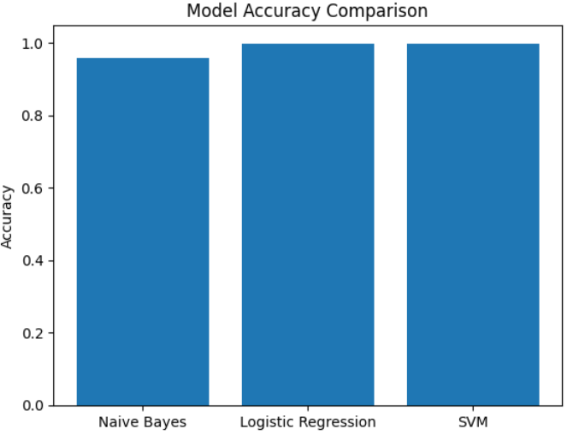
Figure 1: Model Accuracy Comparison
The figure 1 shows this performance difference, where SVM and Logistic Regression significantly outperform Naive Bayes. While this initially appeared to confirm strong model performance, it raised concerns that the task might be too easy due to hidden patterns in the data.
To better understand this, we analysed TF-IDF features to identify the most important words in each dataset. The visualizations show clear differences in vocabulary across datasets. The synthetic dataset contains more specific and narrative-like words such as “decided,” “campus,” and “roommate,” giving it a more structured and predictable style. In contrast, the TED dataset relies on more general and formal words like “we,” “you,” and “the,” while the Mozilla dataset reflects more casual, conversational language.
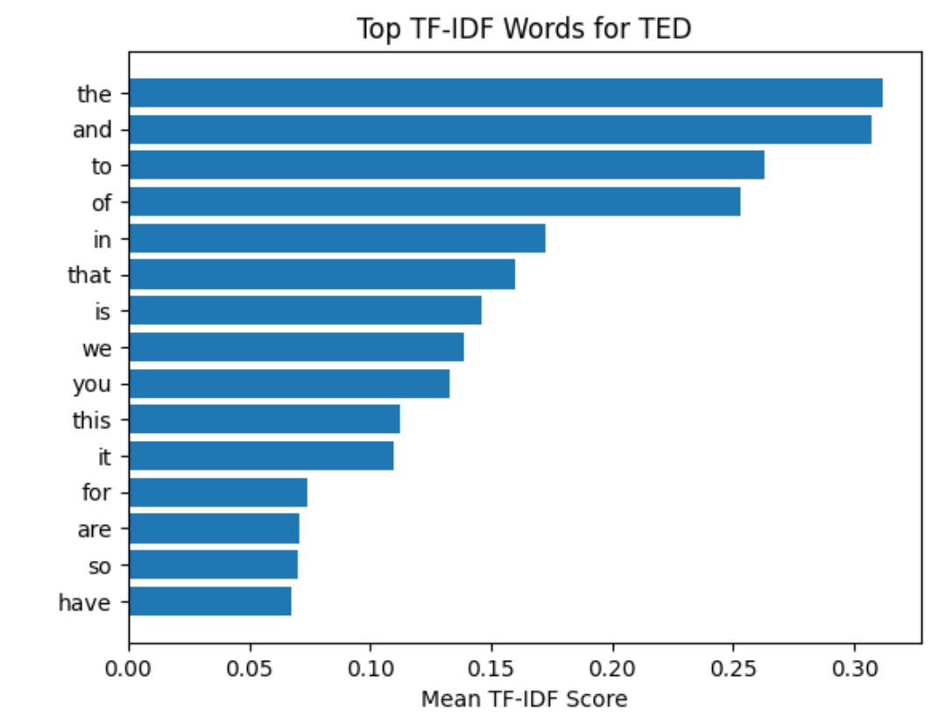
Figure 2: TF-IDF Words for TED
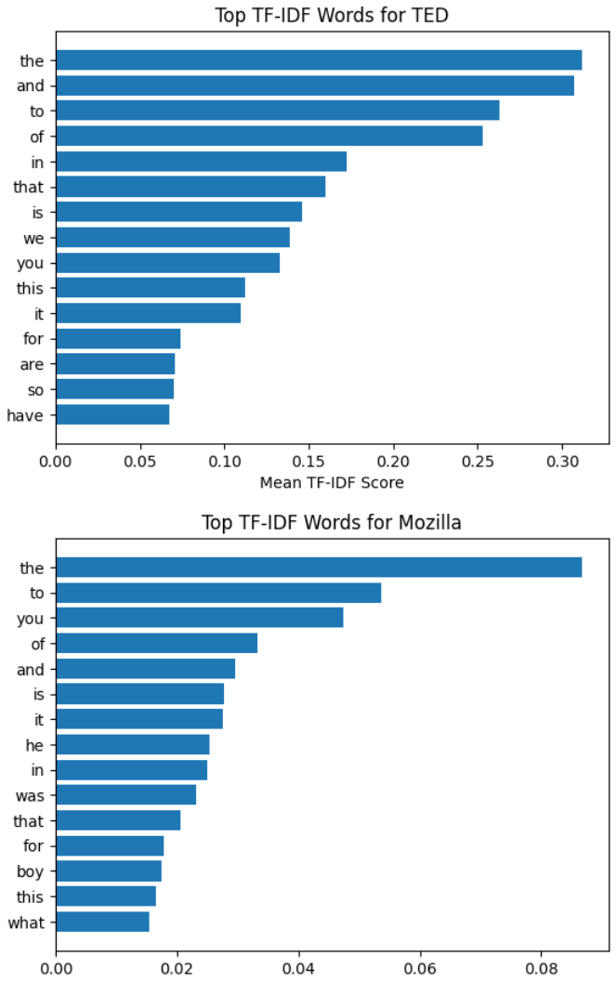
Figure 3: TF-IDF Word for Mozilla
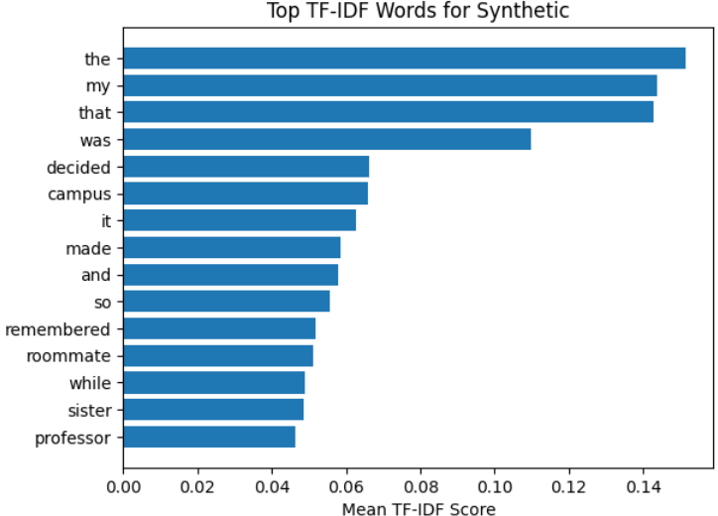
Figure 4: TF-1DF Words for Synthetic
These differences indicate that the datasets each have their own vocabulary “signature.” This suggests that the models are not only learning how words relate to each other, but also identifying patterns specific to each dataset. This helps explain why models like SVM and Logistic Regression perform so well, as they are better at capturing these patterns.
However, the consistently high accuracy across different models and feature setups suggests that the task may be easier than it appears. The visualizations indicate that structural and stylistic differences between datasets, such as word choice and level of formality, may be acting as shortcuts for the model.
To confirm this, we performed cross-domain validation. When the model was trained on one dataset (TED) and tested on another (Mozilla), the accuracy dropped dramatically to around 19%. This result shows that the model is not learning a general distinction between human and AI-generated text, but instead relying on dataset-specific patterns that do not transfer to new data.
Overall, we learned that high accuracy does not necessarily mean a model has learned the intended task. The visualizations and validation results together show that the models are primarily exploiting differences in vocabulary, structure, and style between datasets rather than truly distinguishing human and synthetic text.
This showed us that dataset design is very important. If the data is not balanced or consistent, the model might get high accuracy by picking up easy patterns instead of actually learning the difference between real and synthetic text.
Future Improvements
There are many ways this experiment can be further improved to enhance the robustness and generalizability of the results.
First, instead of relying on a single source for synthetic data generation, future work could incorporate multiple AI models such as Claude, Gemini, and DeepSeek. This would introduce greater diversity in the generated text and allow for a more comprehensive evaluation of how different AI systems mimic human speech patterns.
In addition to this, the current synthetic dataset consists of short, simple sentences. When experimenting again paragraph-text should be used instead of sentences to reflect real-world speech and writing structures. This would make the classification task more challenging and realistic, leading to more useful insights.
Another improvement could be that the synthetic dataset should be generated with a wider range of contexts and topics. This would ensure that the AI-generated datasets closely mirror the variety of real-life datasets.
Finally, maintaining a more balanced dataset across all classes is important. While the current dataset shows some imbalance between sources, future work should aim to ensure equal representation of each class. This would help prevent bias in model training and lead to more reliable performance evaluation.
Appendix: Contribution Statement
Member 1: Medha Madhub
I was responsible for implementing and evaluating the machine learning models used in this project. I split the dataset into training and testing sets with an 80/20 split. I trained multiple classification models, like Naive Bayes, Logistic Regression, and Support Vector Machines (SVM), using the TF-IDF feature representation. I also performed model evaluation using metrics such as accuracy, precision, recall, and F1-score, and generated confusion matrices to better understand the performance of each model. I also created a comparison table to analyze how the different models performed relative to each other.
I suggested conducting qualitative analysis of the datasets to better understand differences in writing style and structure. I was also responsible for writing and organizing the final report, ensuring that our journey throughout this project was properly documented and the results, and insights were clearly presented.
Member 2: Chanchal Preet Kaur
I was responsible for identifying and selecting the datasets used in this project. I also handled data preparation and preprocessing including loading, exploring, cleaning and combining multiple datasets into a single structured dataset. I performed text preprocessing tasks such as removing punctuation, special characters and very short entries and applied TF-IDF for feature extraction.
I worked extensively with the Random Forest model including training, evaluation and feature importance analysis and compared performance before and after feature engineering improvements.
I also played a major role in investigating the unusually high accuracy of the models by conducting experiments such as text length analysis and normalization, character level analysis, structural analysis, word shuffling and cross domain validation.
Through these experiments, I helped identify that the models were learning dataset specific patterns rather than truly distinguishing between real and synthetic text.
Additionally, I maintained and organized the GitHub repository, ensuring that all code, datasets and final deliverables were properly structured and updated.
Member 3: Fatima Asif
I proposed the initial idea of analysing real VS AI generated dataset to find out how well AI can mimic reality. I was responsible for developing the data visualizations used to analyse and present the dataset, including distribution plot, bar charts, heat maps and performance comparisons.
I also took the initiative in contributing in writing, formatting and organizing the final report to ensure structure and clarity. Additionally, I designed and created the PowerPoint presentation used to communicate our findings effectively.

GitHub Link: https://github.com/q62ur/CS4403-Term-Project
References
Alikhanov, A., Amangeldi, A., Demeubay, D., Akhmetzhan, D., Moldakhmetov, N., Polat, O., & Zharas, G. (2026). AI generated text detection. arXiv. https://arxiv.org/pdf/2601.03812

Kehkashan, T., Riaz, R. A., Al-Shamayleh, A. S., Akhunzada, A., Ali, N., Hamza, M., & Akbar, F. (2025). AI-generated text detection: A comprehensive review of methods, datasets, and applications. Computer Science Review, 58, 100793. https://doi.org/10.1016/j.cosrev.2025.100793

Prova, N. N. I. (2024). Detecting AI generated text based on NLP and machine learning approaches. arXiv. https://doi.org/10.48550/arXiv.2404.10032

Weber-Wulff, D., Anohina-Naumeca, A., Bjelobaba, S., Foltýnek, T., Guerrero-Dib, J., Popoola, O., Šigut, P., & Waddington, L. (2023). Testing of detection tools for AI-generated text. *International Journal for Educational Integrity, 19*(1), 26. https://doi.org/10.1007/s40979-023-00146-z

Zeng, M. (2024). Research on AI-Generated Text Detection Based on Machine Learning Models. Transactions on Computer Science and Intelligent Systems Research, 7, 229-233. https://doi.org/10.62051/8k1jga32

