Assignment 2: Data Warehouse

Task 1: Data Linkage
1. (1 point) Link two two restaurant records by using edit-distance as the similarity measure. Report the hyper-parameter choice and the total number of similar records.
Code:
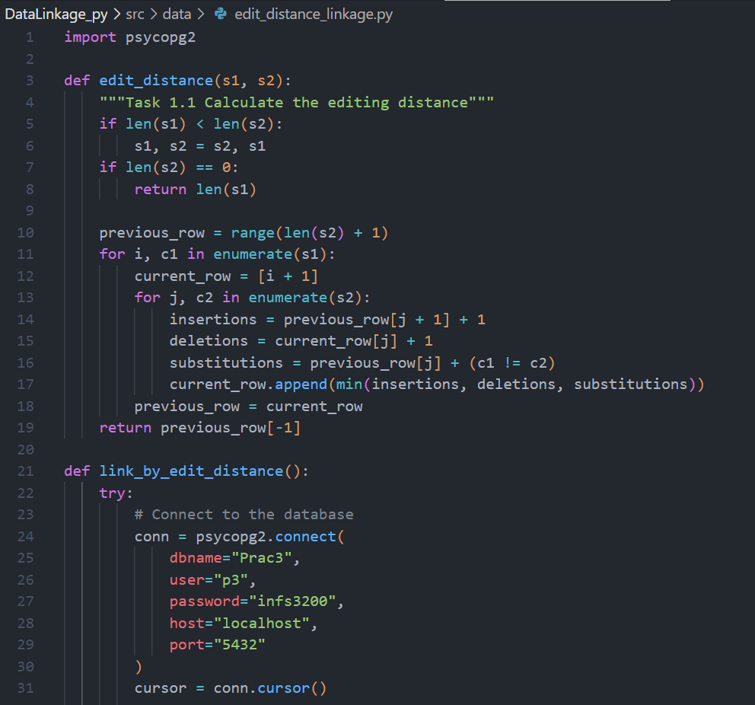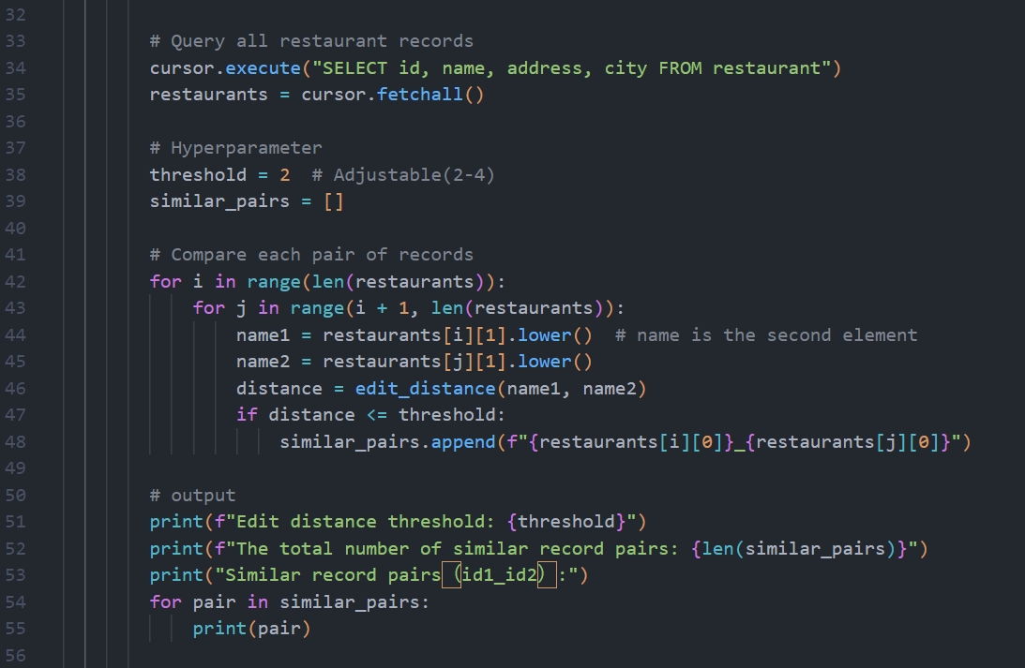
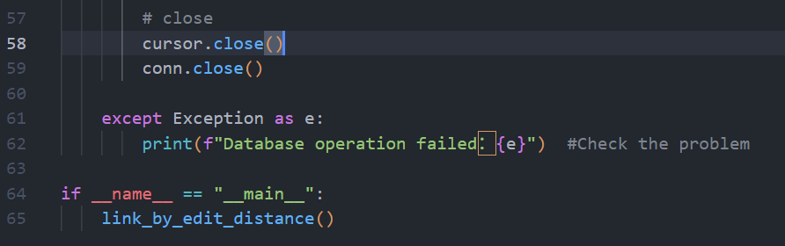

The result of running:(note:There are too many Similar record pairs. Only a part of them are displayed.)
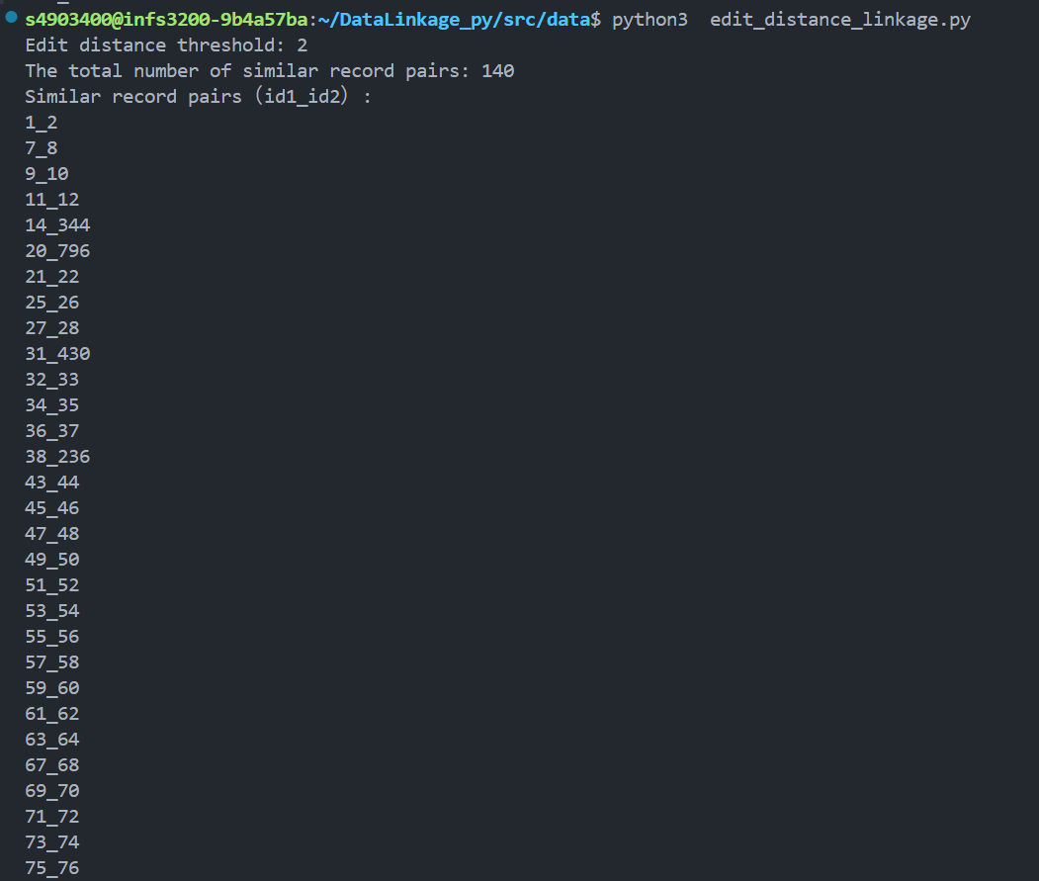

Analysis:
I used Edit Distance to link restaurant records, testing thresholds 1, 2, and 3. Threshold 1 yielded 90 pairs (e.g., 1_2, 7_8), with low recall, missing many pairs. Threshold 3 resulted in 569 pairs, likely including noise (e.g., 4_647). I finally chose threshold 2, obtaining 140 pairs, capturing spelling differences (e.g., fenix and felix) and identical pairs (e.g., 1_2), better meeting the task requirements.

2. (1 point) Link two two restaurant records by using tri-grams (Jaccard Coefficient) as the similarity measure. Report the hyper-parameter choice and total number of similar records.

Code:
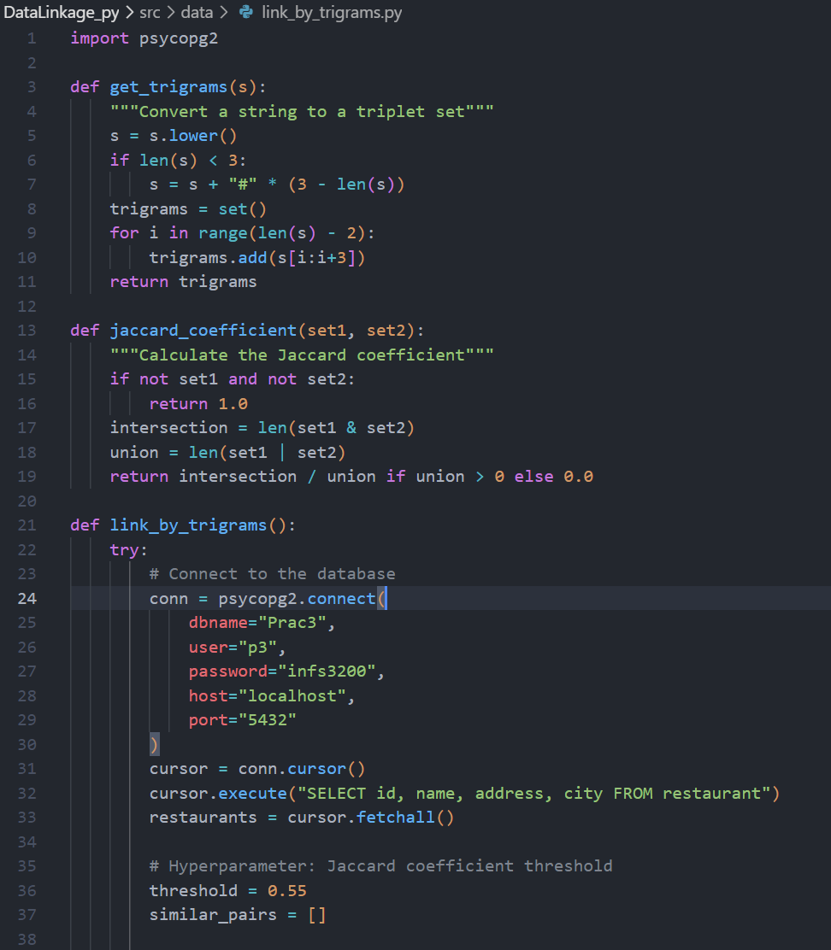
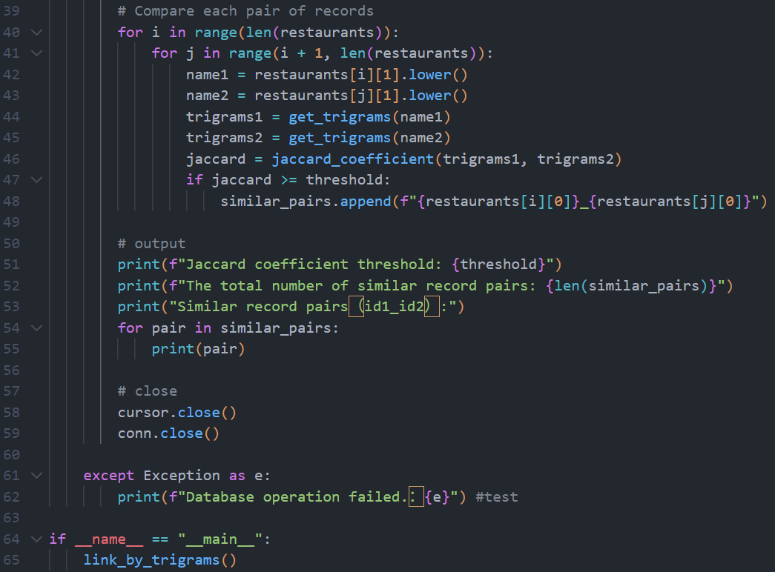

The result of running:(note:There are too many Similar record pairs. Only a part of them are displayed.)
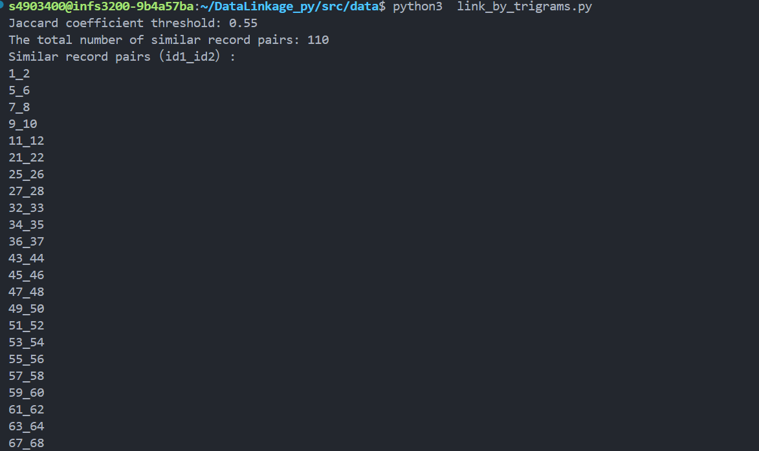

Analysis:
I used the Trigram Jaccard Coefficient to link restaurant records, with a threshold of 0.55 requiring a 55% or higher similarity between trigram sets of two names. Initially, a threshold of 0.7 yielded 88 pairs (e.g., 1_2, 7_8), but the recall was low, missing some similar pairs. Lowering it to 0.55 resulted in 110 pairs, capturing more structurally similar records and identical pairs , better meeting the task requirements.

3.(1 point) Which similarity measure is better for the restaurant dataset? Provide the
justifications.

Edit Distance (Threshold 2)：
Total Similar Record Pairs：140

Trigram Jaccard Coefficient (Threshold 0.55)：
Total Similar Record Pairs：110

Performance Evaluation:

Edit Distance：
Precision：0.857
Recall：0.800
F-measure：0.827

Trigram Jaccard Coefficient：
Precision：0.864
Recall：0.633
F-measure：0.731

Edit Distance has a higher F-measure (0.827) than Jaccard Coefficient (0.731), performing better. Edit Distance has higher recall (0.800 vs 0.633), capturing more true pairs (e.g., 14_344, fenix and felix). Jaccard Coefficient has slightly higher precision (0.864 vs 0.857) but misses more pairs. Edit Distance is more suitable for the restaurant dataset as it handles spelling errors (e.g., caffe roma and cafe roma), while Jaccard may miss names with significant order differences.
I recommend using Edit Distance (threshold 2) and optimizing efficiency (e.g., limiting comparison scope).

Task 2: Data Warehouse
1. (1 point) Design and construct the data warehouse under star schema that contains
three dimension tables, including “Staff”, “Product”, and “Time_Period”. Show the
conceptual model of your design.

Star Schema:
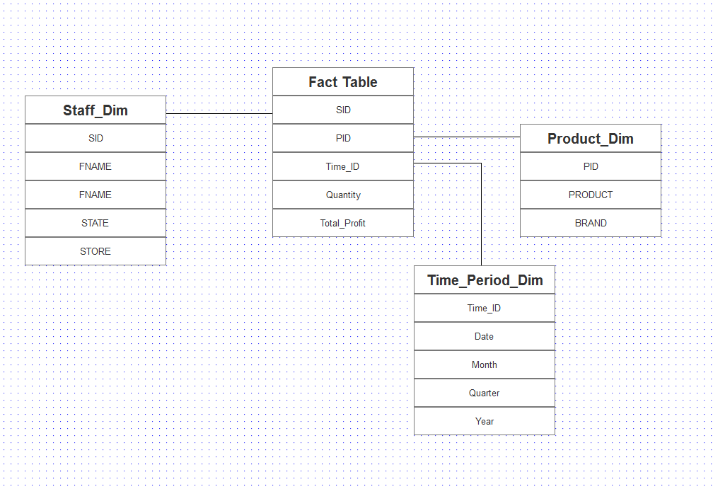

Fact Table:
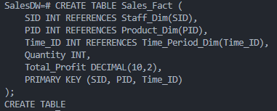

Product Dimension Table:
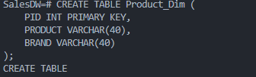
Staff Dimension Table:
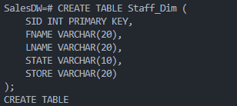
Time Dimension Table:
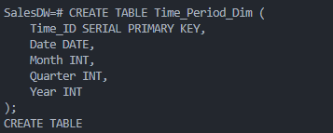

Populate Time_Period_Dim
Populate Staff_Dim
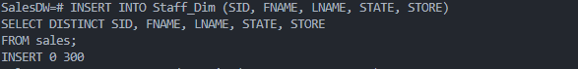
Populate Product_Dim
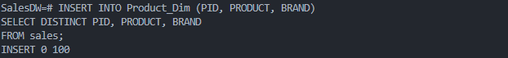
Populate Sales_Fact
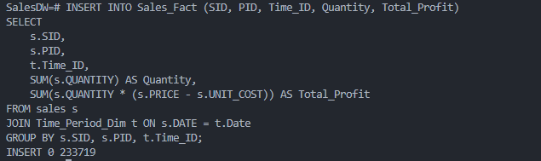

2. (1 point) Query the constructed data warehouse to provide the following basic statistics
of the data.
a. How many unique staff members?
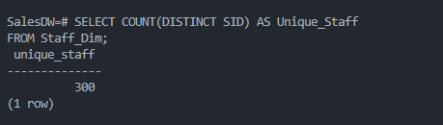

b. How many transactions have been made in 2022 Qtr3?
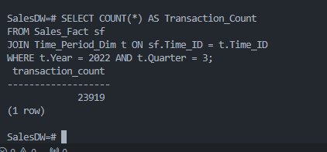

3. (1 point) Construct a cube that contains the time, staff and sales information. Store the
cube in a materialized view called ‘Sales_Time_Staff’. The cube should summarize sales
information by different levels of staff and time. Provide your query.
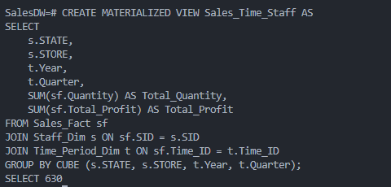
Check Materialized View：
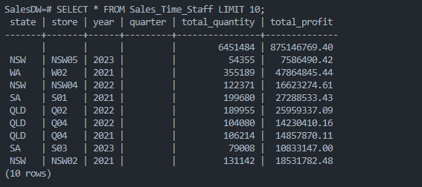

4. (2 points) Design a view to obtain profits from ‘Sales_Time_Staff’’ cube. You should only
use the cube to answer the question. Provide the query and fill in the following tables.
Your solution will lose marks if it includes any unnecessary operations such as joins and
group by. GROUP BY operation can only be used for adjusting the views of outputs.

View 1: State Sales Profits by Quarter in 2021
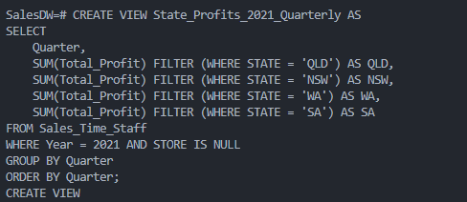
The state sales profits in each quarter of 2021:
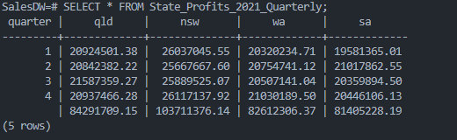

The state sales profits in each quarter of 2021
 | QLD | NSW | WA | SA
2021 Q1 | 20924501.38 | 26037045.55 | 20320234.71 | 19581365.01
2021 Q2 | 20842382.22 | 25667667.60 | 20754741.12 | 21017862.55
2021 Q3 | 21587359.27 | 25889525.07 | 20507141.04 | 20359894.50
2021 Q4 | 20937466.28 | 26117137.92 | 21030189.50 | 20446106.13

View 2: State Sales Profits by Year
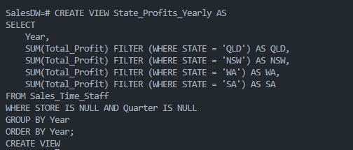

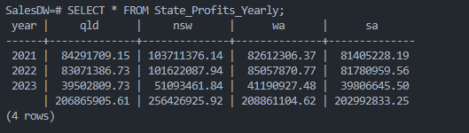

The state sales profits in each year
 | QLD | NSW | WA | SA
2021 | 84291709.15 | 103711376.14 | 82612306.37 | 81405228.19
2022 | 83071386.73 | 101622087.94 | 85057870.77 | 81780959.56
2023 | 39502809.73 | 51093461.84 | 41190927.48 | 39806645.50

5. (2 points) Construct a cube that contains the store (in staff dimension), product, and
sales information. Store the cube in a materialized view called ‘Sales_Product_Staff’.
The cube should summarize sales information by different levels of staff and products.
Based on the materialized view ‘Sales_Product_Staff’,
Construct Data Cube:
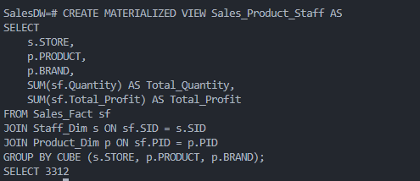
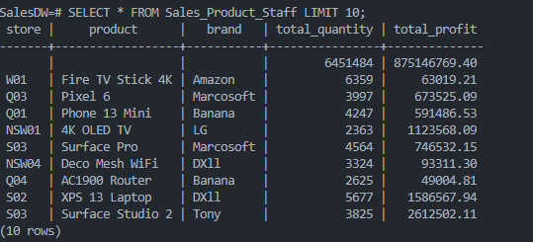
a. Create a view that select top-3 stores with the highest gross profit. Gross profit of selling an item is calculated by Quantity * (Sale Price – Unit Cost). Provide your query and query results.
Create Views:
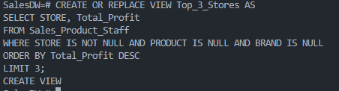
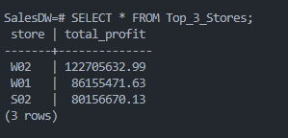

b. Create a view that show the most profitable item for each store.
Create Views:
