Title of program-project: |  | Using of Innovative ICT to Improve Quality of Education in Small Schools in Rural Area
Name of implementing organization: |  |  | Central China Normal University

Internal or external evaluations, reports on impact assessments

1 External evaluations from Media Reports 2
2 Internal evaluations from County Education Bureau's evaluation 4

1 External evaluations from Media Reports
Table 1 List of Reports about the Implement Process and Achievement of the Project
Reported Date | Media | Reported Content
2018.05.10 | Guangming Daily | Let Rural Teachers “Be Able to Reach the Rural Small-schools,Stay there and Teach well"  http://epaper.gmw.cn/gmrb/html/2018-05/10/nw.D110000gmrb_20180510_1-15.htm
2018.04.22 | China Teacher Daily | Cracking the "Shortcomings" in Rural Teacher Team Construction  http://www.jyb.cn/zgjsb/201804/t20180424_1054542.html
2018.04.09 | China Youth Daily | Five "blind spots" to be Remedied in Three-year Rural Teacher Support Plan  http://zqb.cyol.com/html/2018-04/09/nw.D110000zgqnb_20180409_1-10.htm
2017.12.14 | People's Daily | How can Internet Make Change to Education  http://paper.people.com.cn/rmrb/html/2017-12/14/nw.D110000renmrb_20171214_1-17.htm
2017.11.16 | China Education Daily | Use the New Internet Thinking to Run Education Making People Satisfied  http://paper.jyb.cn/zgjyb/html/2017-11/16/content_489422.htm?div=-1
2017.10.12 | China Education Daily | Make Great Efforts to Provide people a Better and Fairer Education  http://paper.jyb.cn/zgjyb/html/2017-10/12/content_486873.htm?div=-1
2017.08.31 | CPPCC Daily | Education Poverty Alleviation: How can Universities and Colleges be Motivated and Effective? http://www.rmzxb.com.cn/c/2017-08-31/1759015.shtml
2017.08.09 | CPPCC Daily | Informationized Sky-ladder from Central China Normal University to Liangshan "Cliff Village"  http://epaper.rmzxb.com.cn/detail.aspx?id=408650
2017.06.14 | CPPCC Daily | Education Targeted Alleviation Needs Further Practical Measures  http://whkj.rmzxb.com.cn/c/2017-06-14/1592521.shtml
2017.03.14 | Guangming Daily | Give Priority to Education Development  http://epaper.gmw.cn/gmrb/html/2017-03/14/nw.D110000gmrb_20170314_4-01.htm
2016.07.13 | China Education Daily | Look for the Breakout and Dare to Face Tough  http://paper.jyb.cn/zgjyb/html/2016-07/13/content_459808.htm?div=-1
2016.06.20 | China Youth Daily | Whether Informatization can Promote Rural Small-schools’ Renaissance (Voleme 1)  http://zqb.cyol.com/html/2016-06/20/nw.D110000zgqnb_20160620_1-10.htm
2016.06.27 | China Youth Daily | Whether Informatization can Promote Rural Small-schools’ Renaissance (Voleme 2)  http://zqb.cyol.com/html/2016-06/27/nw.D110000zgqnb_20160627_1-10.htm
2016.03.03 | CPPCC Daily | Targeted Poverty Alleviation: Great Potential of Education Informatization  http://www.rmzxb.com.cn/c/2016-03-03/719041.shtml
2015.02.10 | Guangming Daily | Informatization Promoting Balanced Development of Basic Education  http://epaper.gmw.cn/gmrb/html/2015-02/10/nw.D110000gmrb_20150210_6-15.htm?div=-1
2014.11.19 | IFENG.COM | Children from the Mountains can "audit" the Lessons of The Primary School Attached to Central China Normal University  http://news.ifeng.com/a/20141119/42508808_0.shtml
2014.05.21 | China Education Daily | Central China Normal University： Digital School is Linked to Children Heart to Heart  http://paper.jyb.cn/zgjyb/html/2014-05/21/content_417457.htm
2014.03.08 | xinhuanet.com | Ma Min: Suggestions on Accelerating the Implementation of “Rural Small-schools Revitalization Plan”  http://www.jyb.cn/china/gnxw/201403/t20140308_573128.html

2 Internal evaluations from County Education Bureau's evaluation
- Chongyang County Education Bureau, Xianning City, Hubei Province, as a partner, evaluation of the project
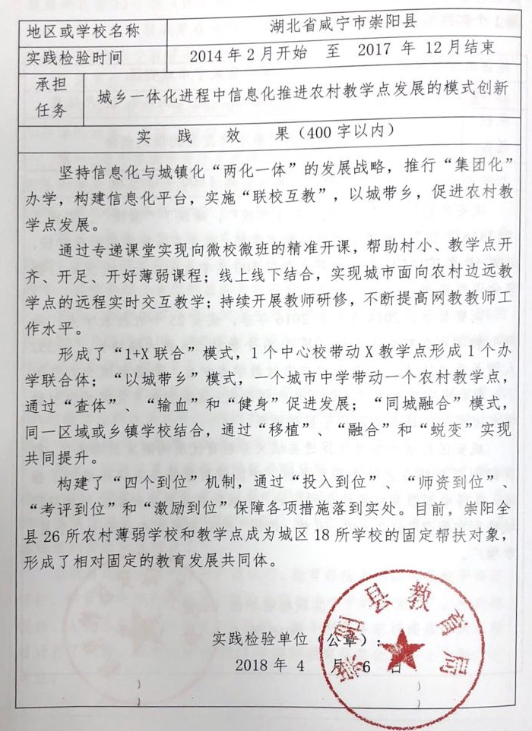
(2) Enshi city Education Bureau, Hubei Province, as a partner, evaluation of the project
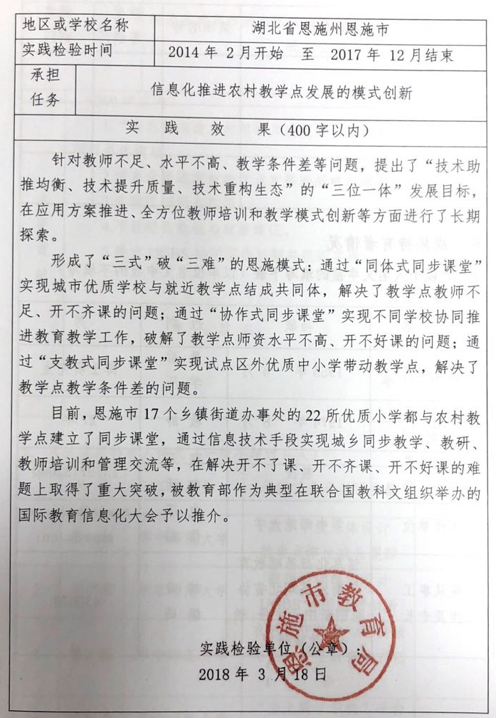
(3) Xian’an District Education Bureau, Xianning City, Hubei Province, as a partner, evaluation of the project
