Maximum Independent Set as a Telecom Problem
Design notes for a neutral-atom demo on OpenCelliD Bangkok data
Working notes · 3 August 2026

This document collects a working discussion on framing Maximum Independent Set (MIS) as a cell-tower channel-assignment problem, the physical justification for the graph model, the constraints of running it on neutral-atom hardware, and a fully worked 26-node example.

1. The mapping: co-channel reuse
MIS is not a technique that solves telecom. It is a shape. The telecom situation happens to have that shape, so the situation can be rewritten as MIS and handed to any MIS solver, classical or quantum.
The translation:
- Vertex = a base station or sector antenna.
- Edge (u,v) = u and v conflict; their coverage discs overlap, or the SINR at some shared user drops below threshold if both transmit on the same carrier.
- Independent set = a set of towers, no two of which conflict, so all can be assigned the same frequency channel and transmit simultaneously.
- Maximum independent set = the largest number of towers that can be lit up on a single channel.
Spectrum is licensed and expensive, so "how much of the network can run off one slice of bandwidth?" is a question with a real cost attached.
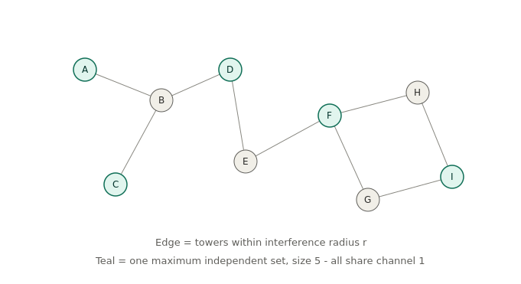
Figure 1 — A nine-tower conflict graph. Teal nodes form a maximum independent set of size 5.

Weighted variant
Give each tower a weight: population covered, expected traffic, revenue per hour. Maximum Weighted Independent Set (MWIS) then maximises served subscribers on channel 1 rather than raw tower count.

Maximal versus maximum
A maximal independent set (one that cannot be extended) is automatically a dominating set: every unselected tower is adjacent to at least one selected tower, meaning it is within radius r of one. A maximal IS is therefore a valid set of cluster heads or relay coordinators, with no two heads colliding and every tower having a head nearby. This is the standard MIS-based clustering used in mesh backhaul and ad-hoc networks, and it is a genuinely different story from the maximum-cardinality one.

The full problem is colouring
One MIS yields one channel. Partitioning the whole vertex set into independent sets gives one channel per part, and the chromatic number is the minimum spectrum needed to serve every tower. The standard greedy heuristic is literally "extract an MIS, delete it, repeat", so MIS is the inner loop of the real operational problem. MIS is the engine, not the whole car.

2. Why towers conflict
Nothing is wrong with the towers themselves. Any LTE tower can be tuned to any channel in its licensed band; there is no per-tower incompatibility. The problem lives at the receiver, not the transmitter.
Radio is a shared medium. A channel is a slice of frequency, and every device tuned to that slice hears everything transmitted on it within earshot. If two towers with overlapping coverage both transmit on channel 1, a phone in the overlap receives both waveforms superimposed on the same frequency and has no way to separate them. They are not addressed to different frequencies, so there is nothing to filter on.
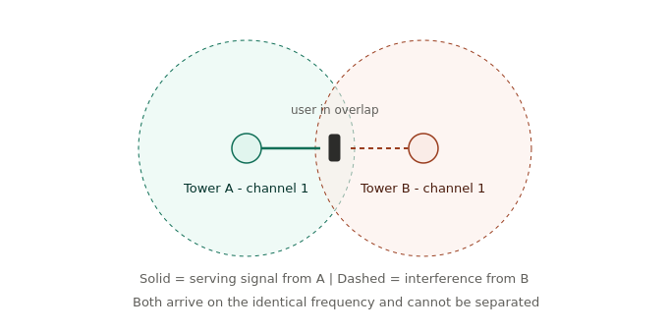
Figure 2 — Co-channel interference in a coverage overlap zone.
The receiver can only treat the unwanted signal as noise. Decoding succeeds or fails on the signal-to-interference-plus-noise ratio:
SINR = P_serving / ( sum of P_j for all other transmitters + N )
Near the middle of the overlap, P_A is approximately equal to P_B, so SINR approaches 0 dB regardless of how strong either transmitter is. Turning up the power does not help; it raises numerator and denominator together. The user gets no throughput despite being well inside two coverage areas. The failure is caused by having too many neighbours on the same frequency, not by weak signal.
Why not give every tower its own channel? Spectrum is finite and expensive. An operator in Bangkok holds perhaps 100 MHz total across bands, carved into a handful of usable carriers, against thousands of masts. Frequency reuse is forced, and the question becomes which towers can share.

A note on modern networks
Modern LTE and 5G actually run reuse-1, with every cell on the same carrier, and manage the resulting interference dynamically through scheduling, power control, coordinated beamforming, and inter-cell interference coordination. Hard frequency planning is largely a GSM-era artifact. But the underlying conflict structure does not disappear; it moves down a layer. Two conflicting cells cannot schedule the same resource block in the same subframe, which is the identical combinatorial problem with time-frequency slots instead of channels. To be technically current, frame the vertex set as cells competing for a resource block and the colouring as a scheduling problem. The graph, the MIS, and the Rydberg encoding are unchanged.

3. Why overlapping discs mean conflict
Received power falls off with distance as P(d) = P0 * d^(-alpha), with alpha around 3.5 in dense urban environments. Define a tower’s coverage radius R as the distance where its signal drops to the noise floor. That is what the disc means: inside it the tower is audible above noise, outside it the signal is buried.
For a user at point x served by tower A, with B transmitting on the same channel:
SINR(x) = P0 * dA^(-alpha) / ( P0 * dB^(-alpha) + N )
Case 1 — discs do not overlap. Any point where A is decodable lies inside A’s disc, hence outside B’s disc, hence dB > R, hence P_B < N. The interference term is smaller than the thermal noise already present, so it can degrade SINR by at most 3 dB. Bounded, tolerable, no conflict.
Case 2 — discs overlap. There exists a region where both P_A > N and P_B > N. Along the perpendicular bisector inside that region, dA is approximately dB, so SINR is approximately 0 dB no matter what power is used. Anyone standing there is unserviceable. Conflict.
The edge criterion is therefore not a vague notion of nearness. It is precisely: there exists a point where the interferer is above the noise floor while the server is still in range. Overlap is exactly the geometric condition for that point to exist.
Bookkeeping note. Discs of radius R overlap if and only if d(u,v) < 2R. When the edge condition is written as d <= r, that r is 2R, not the coverage radius. Getting this wrong doubles or halves the scale factor onto the hardware.

Where the model breaks
This is the protocol model in the wireless literature: binary, pairwise, geometric. The truthful version is the physical model, where the denominator sums over all simultaneous transmitters and the constraint is a single global inequality per user. Three concrete failures:
- Aggregation. Twenty towers each individually below the noise floor can sum above it. The pairwise graph declares them all mutually compatible and they collectively break the receiver.
- Threshold, not equality. Failure does not require P_A to equal P_B; it requires SINR below the modulation threshold beta, so the true boundary is a smooth ratio condition dB/dA < beta^(1/alpha), not a hard binary one.
- Discs are not discs. Sectorised antennas radiate lobes, and high-rise environments make propagation wildly anisotropic. Real coverage maps look nothing like circles.

Why the approximation is accepted anyway
The physical model is not a graph problem. A global sum constraint over all active transmitters has no vertices-and-edges representation, so there is no MIS, no colouring, and nothing to encode.
The protocol model is the only version that produces a graph, and it is specifically a unit-disk graph, which is the one structure Rydberg blockade implements natively. Blockade is itself a binary distance threshold: two atoms within R_b cannot both be excited, with no aggregation and no ratio. The hardware and the protocol model share the same idealisation, which is why the encoding is free rather than requiring penalty terms. The abstraction made to get a solvable problem turns out to be the same abstraction physics gives for free.

4. Plain-language version
Imagine a large hall where everyone must hold a conversation by shouting. If two shouters are far apart, there is no problem; standing near one, that one is clearly loudest and can be followed. If two shouters are close together and a listener stands between them, both arrive at the same volume and neither can be followed. Both conversations are ruined even though both people are shouting perfectly loudly.
Towers are the shouters. Phones are the listeners. A channel is a language: everyone shouting in the same language interferes with everyone else in that language, and the number of permitted languages is small and expensive.
The translation is then mechanical. Write every tower as a dot. Draw a line between two dots if those towers are close enough to ruin each other. The question "which towers can shout at once in the same language?" becomes "pick dots with no lines between them", and "as many as possible" makes it maximum independent set. The physics disappears once the lines are drawn; after that there is nothing left but dots and lines, and any MIS solver can work on it without knowing what a tower is.

5. Iterating: from one channel to a full plan
A common misreading is that the MIS gives the towers that can share a channel and the leftovers are those that cannot. The second half is wrong. The leftovers are not a group that cannot share a channel; they are simply the towers that did not get channel 1. Most get along fine with each other, having been excluded only because each conflicted with something already selected, not because they conflict with one another.
The correct reading is that the MIS is channel 1, and the leftovers form a smaller instance of the identical problem. Run MIS on the leftovers for channel 2, then again for channel 3, and so on. The number of rounds is how much spectrum the network needs.

Deleting nodes, not edges
Remove the selected nodes; their edges disappear as a consequence. Removing only the edges and leaving the MIS nodes in place would make them isolated dots with no constraints, and the next round would happily select them again, putting them on two channels while some other tower gets none.
Edges into the MIS are not being ignored. They were constraints on channel-1 membership, that decision is made and locked, and they carry no information about channel 2. Tower B conflicting with tower A is irrelevant once A is transmitting on a different frequency. Interference only exists between towers sharing a channel.
Formally each round operates on the induced subgraph G[V \ S], where "induced" means an edge is kept only when both endpoints survived.
channels = []
H = G.copy()

while H.number_of_nodes() > 0:
S = solve_mis(H) # exact ILP, greedy, or Aquila
channels.append(S)
H.remove_nodes_from(S) # edges go with them

# channels[0] = channel 1, channels[1] = channel 2, ...

Two guarantees follow. First, it terminates: an MIS on a non-empty graph is always non-empty, so every round removes at least one tower. Second, every tower gets exactly one channel, since each node is deleted in precisely the round it is selected and never reappears. The rounds form a clean partition, so the colouring is automatically valid with no repair step.
One honest caveat: greedy repeated-MIS does not guarantee the minimum number of channels. Taking the largest possible group first can strand awkward towers and force an extra round later. Optimal colouring is its own problem, harder than a single MIS.

6. Worked example: 26 towers
The instance below was generated the same way real cell data would be prepared: random positions with a minimum separation, edge drawn whenever two towers fall within one interference radius. 26 towers, 58 conflict pairs, average degree 4.5, maximum degree 8.
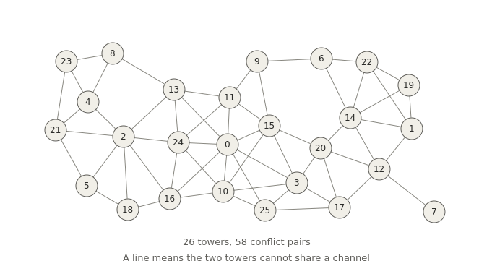
Figure 3 — The full conflict graph.

Round 1
Exact maximum independent set over all 26 towers: nine of them, namely 6, 7, 8, 18, 19, 20, 21, 24 and 25. Every line in the picture has at least one grey endpoint.
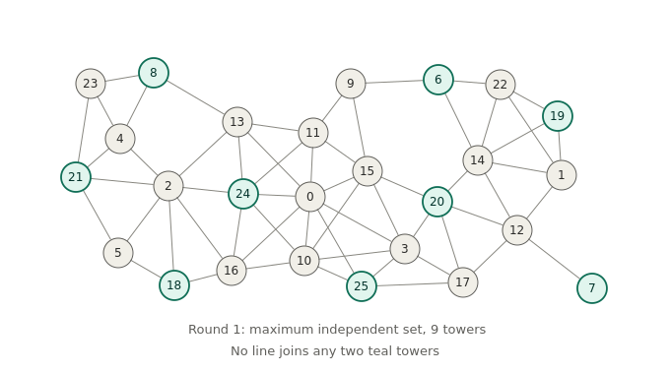
Figure 4 — Round 1. Nine towers assigned to channel 1.

Round 2
Deleting those nine takes 32 of the 58 conflicts with them, leaving 17 towers and 26 edges. The leftovers still conflict plenty among themselves. Round 2 selects 8 towers: 3, 5, 9, 12, 13, 16, 22 and 23.
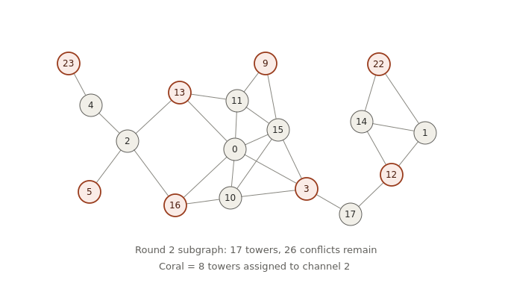
Figure 5 — Round 2 subgraph. Eight towers assigned to channel 2.

Round 3
The graph now collapses hard: 9 towers and 7 edges. Round 3 takes five of them: 4, 10, 11, 14 and 17.
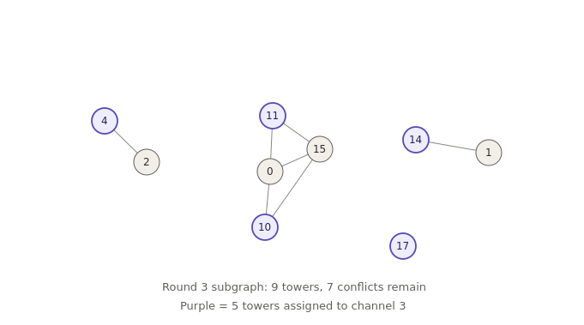
Figure 6 — Round 3 subgraph. Five towers assigned to channel 3.

Rounds 4 and 5
Four towers survive into round 4 (0, 1, 2 and 15) with a single edge left, between 0 and 15. Round 4 takes {1, 2, 15}, and tower 0 sits alone in round 5. Tower 0 is the busiest node in the graph, with degree 8 and a position dead centre of the map, and every earlier round claimed one of its neighbours.
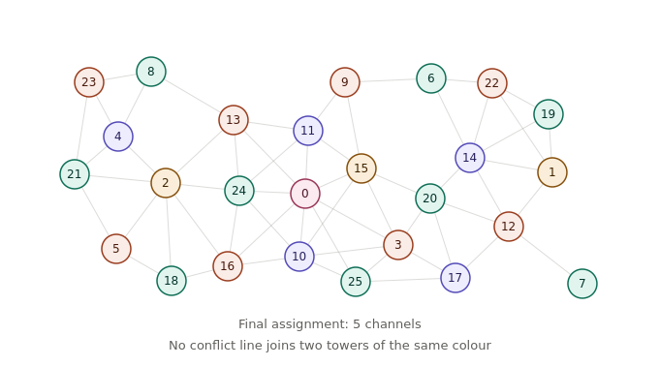
Figure 7 — Final assignment across five channels.
Round sizes go 9, 8, 5, 3, 1. The shrinkage is the thing to point at in a demo: each pass gets easier because the conflicts thin out faster than the towers do.

The caveat, made concrete
Repeated-MIS used 5 channels on this instance. An exhaustive colouring search on the same graph shows that 4 channels is achievable and 3 is not, so greedy overspent by one. Grabbing the largest set first (9 towers) stranded tower 0, whose eight neighbours were all claimed early, leaving it needing a channel of its own. This is a far better demonstration of "greedy is not optimal" than a hand-wave, and it justifies running an exact ILP alongside as a baseline.

7. Running it on OpenCelliD Bangkok data
Real cell data gives a genuine unit-disk instance rather than a synthetic one. Two things make or break it, and neither is qubit count.

Data caveats
Collapse colocated sectors. OpenCelliD rows are cells, not masts. A single tower appears as three to six rows (sectors by bands by radio type) at identical or near-identical coordinates. Left in, the result is zero-distance pairs that cannot be mapped to atoms and a graph that is mostly cliques. Filter to one radio type, then cluster anything within roughly 30 m into a single vertex.
Do not trust the range column as a coverage radius. It is derived from the spread of crowdsourced observations, making it a measurement-confidence radius rather than a cell radius, with values from 0 to tens of kilometres on the same street. Use a fixed interference radius per radio class (500 to 800 m is defensible for urban Bangkok LTE) and keep range and sample count as optional vertex weights instead. That also supplies a clean MWIS story, with weight proportional to observed traffic.

The binding constraint: dynamic range
Aquila’s limits are roughly 256 atoms, a 75 by 76 micrometre field of view, and a 4 micrometre minimum atom spacing. Blockade radius at full Rabi drive is:
R_b = ( C6 / Omega )^(1/6) which is about 8.4 um at Omega/2pi = 2.5 MHz
One scale factor s (micrometres per metre) makes the interference radius land on the blockade radius: s = R_b / r. Everything else follows from that choice.
- Minimum tower separation: s * d_min >= 4 um, so d_min must be at least about 0.48r. With r = 500 m, any two towers closer than roughly 240 m must be merged or dropped.
- Map extent: 75 / s = 8.9r. With r = 500 m, the whole scene can only be about 4.5 km across.
This means one district of Bangkok, not the city. A 4 by 4 km window such as Sukhumvit between Asok and Thong Lo, or the Silom and Sathorn block, thinned to 60 to 150 masts. Check max(d) / d_min on the actual data before anything else; if it exceeds roughly 19, the array will not fit no matter how it is scaled.

Pipeline
- Preprocess. Filter to the Bangkok bounding box, restrict to one radio type, dedupe masts, crop to a district, thin by minimum separation, and export id, lat, lon, x_m, y_m and weight.
- Build the graph. Project to a local metric frame (UTM zone 47N, so distances are in metres rather than degrees), then add an edge where the distance is within r. scipy.spatial.cKDTree.query_pairs(r) does this in one call.
- Classical baselines. Exact ILP via PuLP and CBC for the true optimum, which is fine up to a few hundred nodes, plus greedy-by-degree so participants can watch a heuristic underperform.
- Quantum. Bloqade-python with rydberg_h, atom positions set to the scaled tower coordinates, and an adiabatic sweep on the detuning. Emulate locally first, then submit the real instance to Aquila.
- Visualise. Folium or deck.gl over a Bangkok basemap, with selected towers filled and edges drawn, plus a bitstring histogram from the quantum run.
For MWIS, Aquila’s local detuning pattern allows per-site bias: heavier towers receive deeper detuning and are correspondingly more likely to end up excited.

The QUBO, for gate-based or annealing routes
maximise sum_i w_i x_i - lambda * sum_(i,j) in E x_i x_j , lambda > max_i w_i
The penalty makes any edge violation strictly worse than dropping one endpoint, so every optimal bitstring is a valid channel assignment.

Framing for participants
Be upfront that a 100-node MIS is not a quantum advantage claim; CBC solves it in milliseconds. The demo’s value is that the constraint is not encoded but physical: two atoms inside the blockade radius simply cannot both be excited. Participants can see this on the map, because the blockade circles are the interference circles. That is the moment worth engineering the demo around, and it is far more legible on real geometry than on a random graph.

