Paper Title (use Paper_Title_MFOI2020 style)
FirstNamel LastNamel, FirstName2 LastName2 (use Authors_MFOI2020 style)
Abstract
(use Abstract_Head_MFOI2020 style)
Place here short abstract in English. Please do not exceed 100 words. (use Abstract_MFOI2020 style).
Keywords: computer science, information technologies, workshop proceedings (do not exceed 5-6 terms).
- Introduction (use Heading_Section_MFOI2020 style)
The authors for MFOI’2020 Conference Proceedings are requested to follow instruction given in this sample paper. This template provides authors with most of needed formatting specifications.
Organizing Committee recommends preparing paper using this template style set. Your paper is required to be 6-16 pages (one page approximating A5 size).
- Page Setup
This template has been tailored for output on the A5 paper size. The Times New Roman 11pt font should be used for main text with line spacing 1 (use Normal_MFOI2020 style). All margins, column widths, line spaces, and text fonts are prescribed; please do not alter them. The page margins and size are given in Table 1.
- Page layout description
Paper size | А5 (148x210)
Inside margin | 15mm
Outside margin | 15mm
Top margin | 10mm
Bottom margin | 10mm
Paragraph indent should be 7 mm. The indent for the first paragraph in section should be 0 mm.
- Page Layout
Title must be written using Times New Roman font, 14pt, regular, сenter, with line spacing 1,5 lines. The spacing between title and authors line is 6pt. Author's names (without affiliation) should be typed using Times New Roman 11pt font, center. Author's affiliation (institution, address, E-mail) should be given in the bottom of the paper using Times New Roman 10pt font, aligned to the left. The spacing between authors names and affiliation line is 6pt.
In the beginning of the paper abstract and keywords should be given. Abstract should be about 100 words. Please, use Times New Roman 10pt regular font for abstract and keywords.
Paper text may be divided in a number of sections. Section titles should be typed using Times New Roman 12pt font. For numbering use Arabic numbers. The space between last section and next section title should be 12pt, between section title and section should be 3pt.
Equations should be centered and labelled. Equation numbers, within parentheses, are to position flush right, as in Eq. (1), using a right tab stop (use Equation_MFOI2020 style).
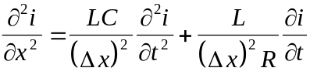 (1)
Larger equation must be split in multiple lines, as in Eq. (2). Number equations consecutively.
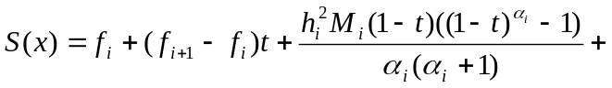
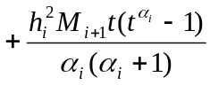 (2)
where the following notations are used:
.
Tables must have caption located above the table. Table captions should be written using Times New Roman 11pt font (use Table_title_MFOI2020 style).
All figures must be stored in *.eps or *.jpg format with the minimum resolution of 300 dpi. Each figure must have a caption under the figure (see Fig.1). For figure captions Times New Roman 11pt font should be used (use Legend_Fig_MFOI2020 style).
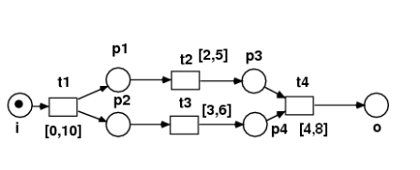
- Caption for Figure 1.
When you refer to an equation, a figure, a table, a section or literature references in the text of the paper please use the following expressing: Eq. (1), Eqs. (1) and (2), Fig. 1, Figs. 1 and 2, Table 1, Tables 1 and 2, Section 1, [1], [2, 4-7].
- Examples for Definitions, Theorems etc
Below there is example for Definition, Theorem and Corollary layout. Also pattern for Example is given. These layouts are recommended, but not obligatory.
- Example of subsection 1 (use Heading Subsection FOI2020 style)
Definition 1 [3]. A vertex y is called copy for vertex x(x≠y), in graph G = (X;U) if Γ(x)= Γ(y).
Theorem 1 [6]. If T is a tree with at least 3 vertexes, then graph G= L(T, T₀) is d-convex simple and planar.
- Example of subsection 2
Corollary 1 - For a graph K with n≥3, we have:
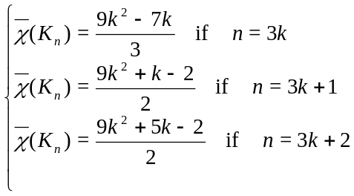
- Example of Subsubsection (use Heading Subsubsection FOI2020 style)
Example 1 Let A=Q[x², xy] ⊆ Q[x, y] and use the degree lexicographical order with x>y. The set F={x², xy} is a SAGBI basis for A. Let g=x³y+x² and h=x⁴+x²y² in A. A Hilbert basis for the set of solutions of the equation (3) is:
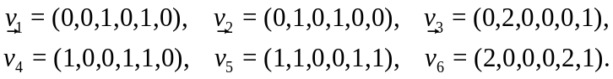
Thus 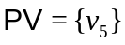, so by Algorithm 1 a syzygy family for (g, h) is {G^{(1,1,0)}-H^{(0,1,1)}}={–x³y³+x⁴}.
- Conclusion
In this paper the instructions for preparing camera ready paper for including in the Proceedings of the International Conference FOI’2020 is given.
Acknowledgments. ….. has supported part of the research for this paper. (use Acknowledgments_MFOI2020 style)
References
- Use References_FOI2020 Style
- A.A. Waksman. Permutation Network. Journal of the ACM, vol. 15, no 1 (1968), pp. 159-163.
- M. Portz. A generallized description of DES-based and Benes-based permutation generators. LNCS, vol. 718 (1992), pp. 397-409.
- M. Kwan. The design of the ICE encryption algorithm. The 4th International Workshop, Fast Software Encryption - FSE '97 Proc. LNCS, vol. 1267 (1997), pp. 69-82.
- B. Van Rompay, L.R. Knudsen, V. Rijmen. Differential cryptanalysis of the ICE encryption algorithm. The 6th International Workshop, Fast Software Encryption - FSE'98 Proc. LNCS, vol. 1372 (1998), pp. 270-283.
- M. Sweedler. Ideal bases and valuation rings. Manuscript, 1988.
- H. Öfverbeck. HilbertSagbiSg, Maple packages for Hilbert, SAGBI and SAGBI-Gröbner basis calculations, 2005. http://www.maths.lth.se/matematiklu/personal/hans/maple.

FirstNamel LastNamel¹, FirstName2 LastName2²
¹Affiliation/Institution: use Author_Affiliation_MFOI2020 style
E-mail:
²Affiliation/Institution: use Author_Affiliation_MFOI2020 style
E-mail:

