**Mockup**

**Persona**

**Git Commit**

Committed from the terminal using ssh keys, added my name to the README.md on the repo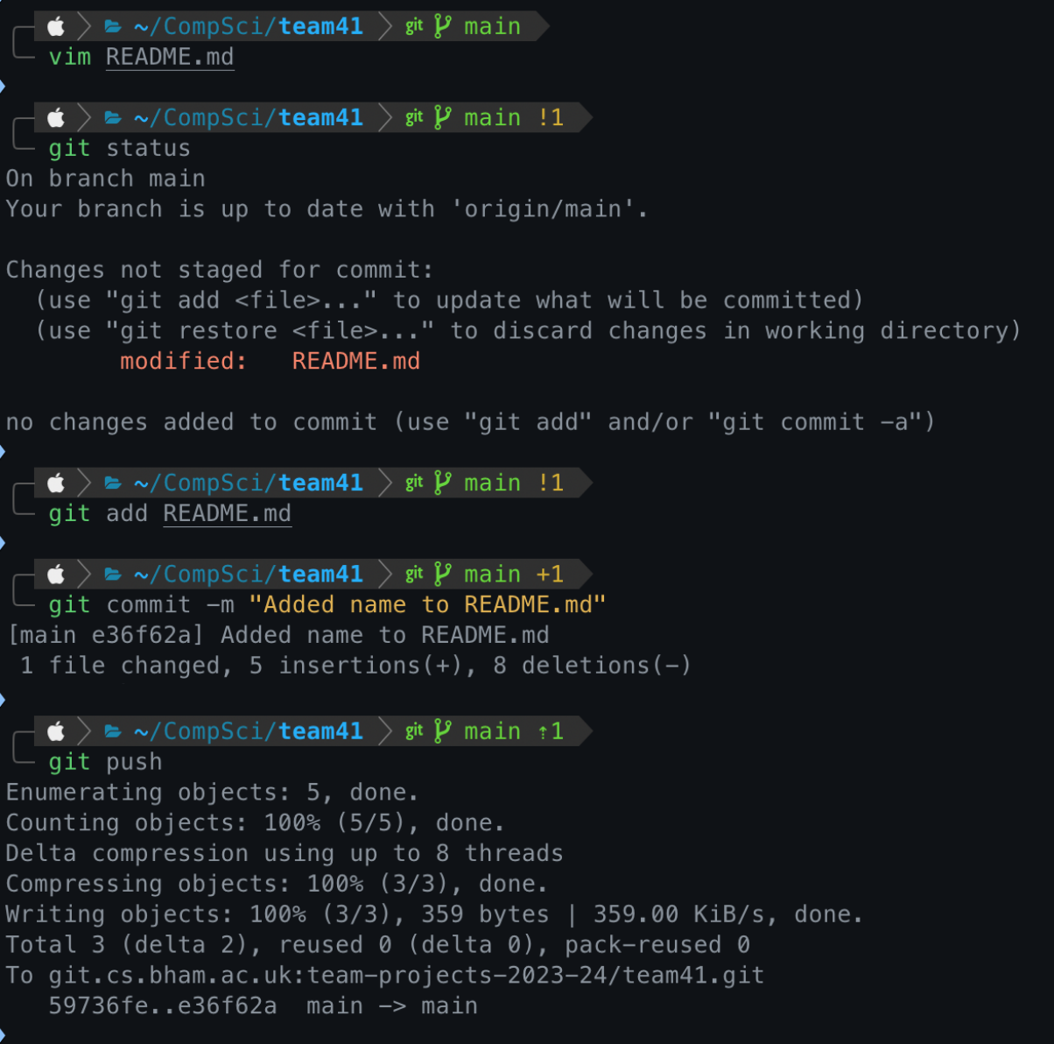

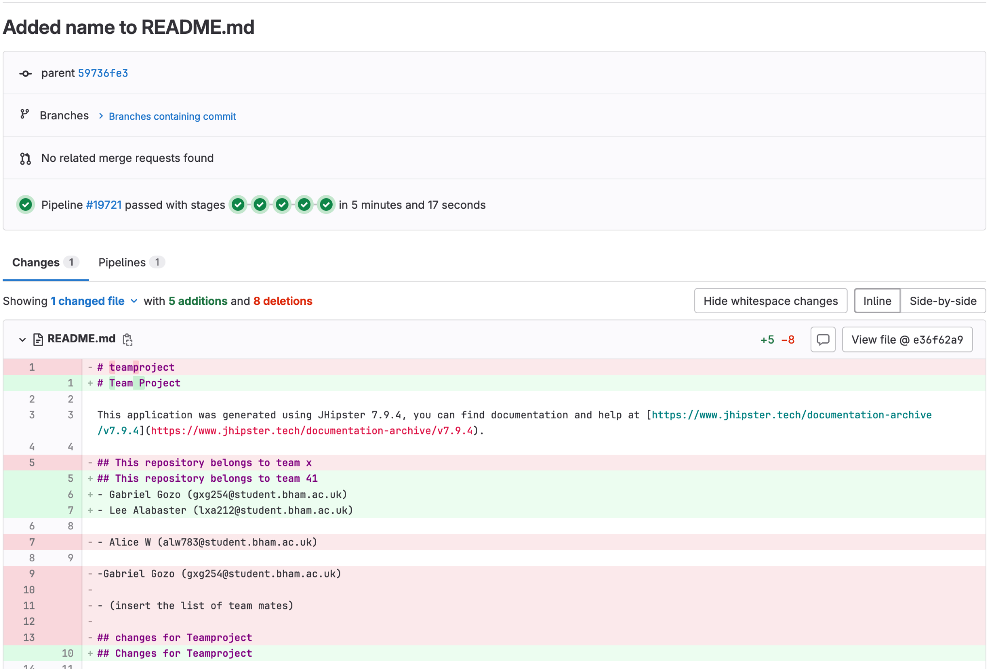

**Timesheets**

My timesheets are available for both my team and my tutor on my personal github page: <https://github.com/qPalee/Timesheets>

Here is a screenshot of the first timesheet