**Mockup**

My mockups are for the seating plan feature of our app, the source files are saved on my GitHub page: <https://github.com/qPalee/Team-Project>

Both were created using Balsamiq as agreed with my team.

This first one is a mockup from a student’s perspective. They can see where they are other students are seated in each class they are in

The second one is a mockup from a teacher’s perspective. They can adjust the seating plan if needed or regenerate it again if they wanted to.

**Persona**

This persona represents a student who will use the Seating Plan

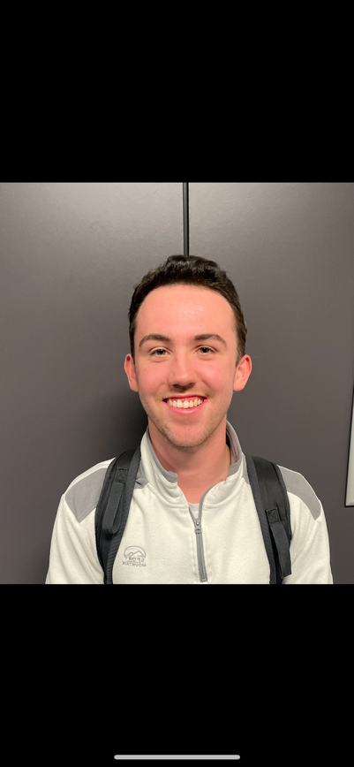

**Bio:**

Oliver is a very hard-working student who is looking forward to his exams to ensure he does to

the best of his ability. He thoroughly enjoys school and always put in 110% to push himself and

pursue his dreams of becoming a Cartographer.

**Goals:**

* Work as hard as possible in school.
* Spend time with friends and family.
* Spend time playing Spikeball.

**Oliver Titheradge**

**Frustrations:**

* Teachers taking too long on the register.
* Students not knowing where to sit.
* Students in the wrong classrooms.

**Technical capabilities:**Good at using a different range of software however struggles with software which requires more precise inputs due to a condition where his hands can shake uncontrollably.

**Personal Info:**

Age: 16

Accessibility: No

Work: Student

Pronouns: he/him

**Git Commit**

Committed from the terminal using ssh keys, added my name to the README.md on the repo.

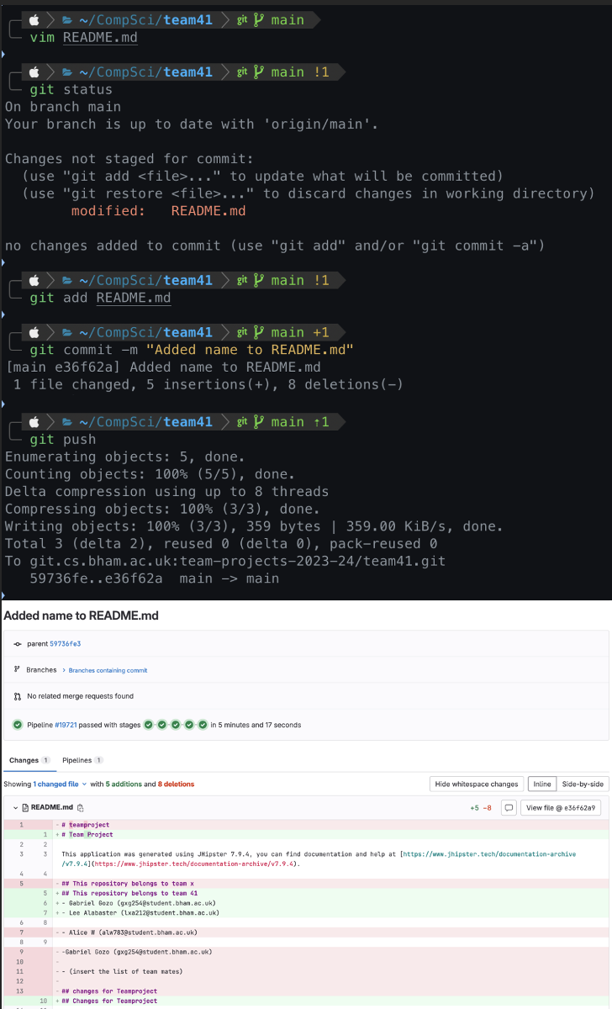

**Timesheets**

My timesheets are available for both my team and my tutor on my personal GitHub <https://github.com/qPalee/Team-Project/tree/main/timesheets>

Here is a screenshot of the first timesheet, which is week2.xlsx:

