qPNCA User Guide

(version 1.0.21)

J.A.M. Huisman

March 19, 2020

Table of Contents

1 Introduction 4

2 qPNCA functions 4

2.1 Main functions 4

2.2 Internally used functions 4

2.3 Wrapper function qPNCA 4

3 Dataset requirements 5

4 Execution 5

5 Output 7

5.1 Result datasets 7

5.2 Regression plots 7

5.3 Summarising PDF sheet 8

6 Workflow 9

6.1 BLOQ corrections (correct.loq.r) 9

6.2 Elimination half-life estimation (est.thalf.r) 10

6.3 Regression plots 11

6.4 Cmax and tmax calculation (calc.ctmax.r) 11

6.5 Time deviation corrections (correct.time.r) 12

6.6 Missing concentration imputations (correct.conc.r) 13

6.7 Overview of time corrections and imputations (tab.corr.r) 15

6.8 Calculation of PK parameters, no half-life needed (calc.par.r) 15

6.9 Calculation of Parameters that do need thalf (calc.par.th.r) 17

6.10 Creation of summary sheets (nca.sum.r) 18

7 References 18

8 Flowcharts 19

8.1 Flowchart of corrections and imputations for t = 0 (predose) 20

8.2 Flowchart of corrections and imputations for t = tstart, tend and teval 21

8.3 Flowchart of corrections and imputations for t = tau 22

List of Tables

Table 1: Arguments of the qPNCA function 5

Table 2: argument values used in the examples 9

Table 3: LOQ substitution rules 9

Table 4: Arguments for correct.loq function 9

Table 5: Arguments for est.thalf function 10

Table 6: Parameters returned from est.thalf function 10

Table 7: Arguments for the plot.reg function 11

Table 8: Arguments for the calc.ctmax function 12

Table 9: Parameters returned from calc.ctmax function 12

Table 10: Time deviation correction rules 12

Table 11: Arguments of the correct.time function 13

Table 12: Missing concentration imputation rules 14

Table 13: Arguments of the correct.time function 14

Table 14: Arguments of the tab.corr function 15

Table 15: Arguments of the calc.par function 16

Table 16: Parameters returned from the calc.par function 16

Table 17: Arguments of the calc.par.th function 17

Table 18: Parameters returned from the calc.par.th function 17

Table 19: Arguments of the nca.sum function 18

# Introduction

qPNCA is an R package for pharmacokinetic (PK) parameter calculations developed within qPharmetra. It consists of a set of functions for time deviation corrections, missing concentration imputations and parameter calculations. Parameter calculations are based on the NCA Parameter Guideline (*reference*). The output of the package comprises R datasets containing the final PK parameters, regression plots and information regarding the time corrections and concentration imputations applied.

# qPNCA functions

## Main functions

The main qpNCA functions perform the actual time deviation corrections, missing concentration imputations and parameter calculations. As most functions need the output from previous functions as input, the order of function calls is mandatory. Main qPNCA functions should be called in the following order:

1. **correct.loq** (LOQ handling)
2. **est.thalf** (estimate terminal half-life)
3. **plot.reg** (plot PK curve with regression line)
4. **calc.ctmax** (calculate Cmax and tmax on uncorrected data)
5. **correct.time** (time deviation corrections)
6. **correct.conc** (missing concentration imputations)
7. **tab.corr** (tabulates applied time corrections and concentration imputations)
8. **calc.par**  (PK parameter calculations that do not need half-life)
9. **calc.par.th** (PK parameter calculations that DO need half-life)
10. **nca.sum** (summarise NCA results per curve)

## Internally used functions

Apart from the main qPNCA functions the package contains a number of functions that are called by the main functions internally and do not need intervention by the user:

* **interpol** (interpolation rules)
* **trap** (trapezoidal rules for AUC calculations)
* **trapm** (trapezoidal rules for AUMC calculations)
* **lag.lead**  (defines lag and lead values, needed by the main functions)
* **filenamefun** (derives plot filename from by variables)
* **titlefun** (derives plot title from by variables)

Detailed descriptions of the functions can be found in Appendix A.

## Wrapper function qPNCA

To facilitate the execution of the individual functions a wrapper function (qPNCA) is available. The function calls the individual functions in the correct order.

# Dataset requirements

For correct execution of the NCA analysis the input data should meet the following requirements:

**Input dataset**The input dataset must contain:

- variables identifying a single concentration-time profile over one dosing interval (by-variables)  
- a variable containing the nominal time after the last dose  
- a variable containing the actual time after the last dose  
- a variable containing the dependent variable  
- a variable indicating whether an observation is below the LOQ (value=1) or not (value=0)   
- a variable containing the LLOQ value

**Covariates dataset**The covariates dataset should have only one record per by-group and contains variables which should be kept within the final parameter dataset (e.g. demographics, treatment codes). This dataset must contain a variable with the dose amount given for that particular by-group.

# Execution

The wrapper function is called in the following way:

qPNCA (x, by=c("subject"), nomtimevar="ntad", timevar="time", depvar="dv",   
bloqvar="bloq", loqvar="loq", loqrule=1,  
includeCmax="Y", exclvar=NA, plotdir=NA, pdfdir=NA, timelab="timevar", deplab="depvar",  
tau=NA, tstart=NA, tend=NA, teval=NA,  
cov=NA, dose=NA, factor=NA, reg="SD", ss="N", route="EV", method=1)

Arguments of the wrapper function are described in Table 1.

Table 1: Arguments of the qPNCA function

| **Argument** | **Description** | **Default value** | **Manda- tory?** |
| --- | --- | --- | --- |
| x | Input dataset name |  | Y |
| by | by-variable(s), e.g. c("subject","day"). Each by-group should contain concentration-time information for one dosing interval | “subject” | Y |
| nomtimevar | variable name containing the nominal sampling time | “ntad” | Y |
| timevar | variable name containing the actual sampling time | “tad” | Y |
| depvar | variable name containing the dependent variable (e.g., concentration) | “dv” | Y |
| bloqvar | variable name containing the BLOQ flag  (0: no, 1: yes) | “bloq” | Y |
| loqvar | variable name containing the LOQ value (e.g., 0.1) | “loq” | Y |
| loqrule | rule number to be applied to the LOQ values in the curve:  before first after first measurable  measurable concentration  concentration  first other  consecutive consecutive  LOQ LOQ  ------------------ ---------------- ----------------  1: 0 NA NA  2: 0 0 0  3: 0 0.5*LOQ NA  4: 0 0.5*LOQ 0 | 1 | Y |
| includeCmax | include results of regression including Cmax in thalf selection? (y/n) | “Y” | Y |
| exclvar | variable name containing information about points to be excluded (these should have <exclvar>=1) | NA | N |
| plotdir | folder where regression plots (.PNG) and NCA summary sheets (.PDF) will be saved; leave empty for standard output | NA | N |
| pdfdir | folder where NCA summary sheets (.PDF) will be saved; if not present it will be created | NA | N |
| timelab | X-axis label in regression plots | “timevar” | N |
| deplab | Y-axis label in regression plots | “depvar” | N |
| tau | dosing interval (for multiple dosing), if not requested, leave empty | NA | N |
| tstart | start time of partial AUC (start>0), if not requested, leave empty | NA | N |
| tend | end time of partial AUC, if not requested, leave empty | NA | N |
| teval | user selected AUC interval (starting at t=0), if not requested, leave empty | NA | N |
| cov | co-variates dataset, containing variables to be merged with each curve (e.g. demographics). Must contain the dose variable | NA | Y |
| dose | variable containing the dose amount | NA | Y |
| factor | conversion factor for CL and V calculation (e.g. dose in mg, conc in ng/mL, factor=1000 to get CL in L/h and V in L) | 1 | N |
| reg | regimen, "SD" or "MD" | “SD” | Y |
| ss | is steady state reached (Y/N) | “N” | Y |
| route | route of drug administration ("EV", "IVB", ”IVI”)* | “EV” | Y |
| method | method for trapezoidal rule:  1: linear up - linear down  2: linear up - logarithmic down  3: linear before Tmax, logarithmic after Tmax | 1 | Y |

* EV: Extravascular IVB: Intravenous bolus IVI: Intravenous infusion

# Output

The qPNCA package produces three types of output: result datasets, regression plots and summarising PDF sheets.

## Result datasets

The output generated during the execution are gathered in an R list object. The following output datasets will be generated:

**half_life**: contains all relevant information and results from the regression analysis

**covariates**: contains relevant covariates for each curve

**corrections**: contains information about what deviation corrections have been applied to each individual concentration-time curve

**ct_corr:** contains corrected concentration-time curves

**pkpar:** contains individual pharmacokinetic parameters

## Regression plots

Regression plots will be made after the half-life estimation step. The user can choose to plot to standard output or to save the plots as *.png files to a specific folder (see *plotdir* argument). The file name is automatically generated and reflects the by-variables for that particular curve (e.g. “subject_1_day_1.png”. An example of a regression plot (filename: id_5.png) is given below.

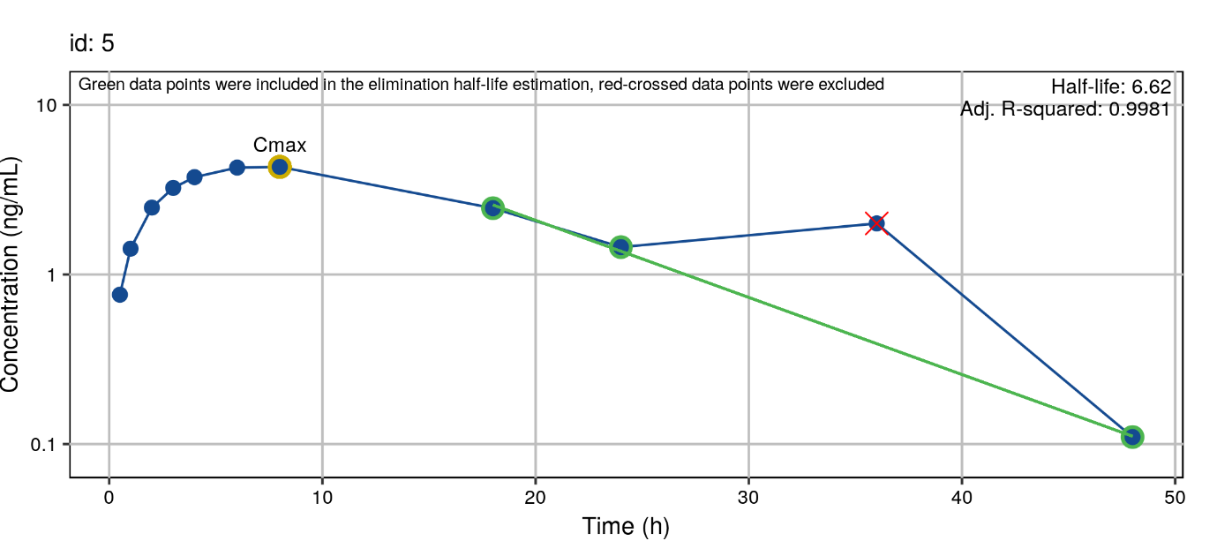

In this plot the following items are indicated:

- Cmax (Yellow, even if no half-life was estimated)

- points used in regression and resulting regression line (green)

- points excluded from regression (red crossed)

- estimate of elimination half-life and adjusted R-squared

## Summarising PDF sheet

On this sheet the regression plot, analysis details and final PK parameters for each curve are collected on a single page. These PDF sheets can be included in the Appendices of the final report. An example summary sheet is given below:

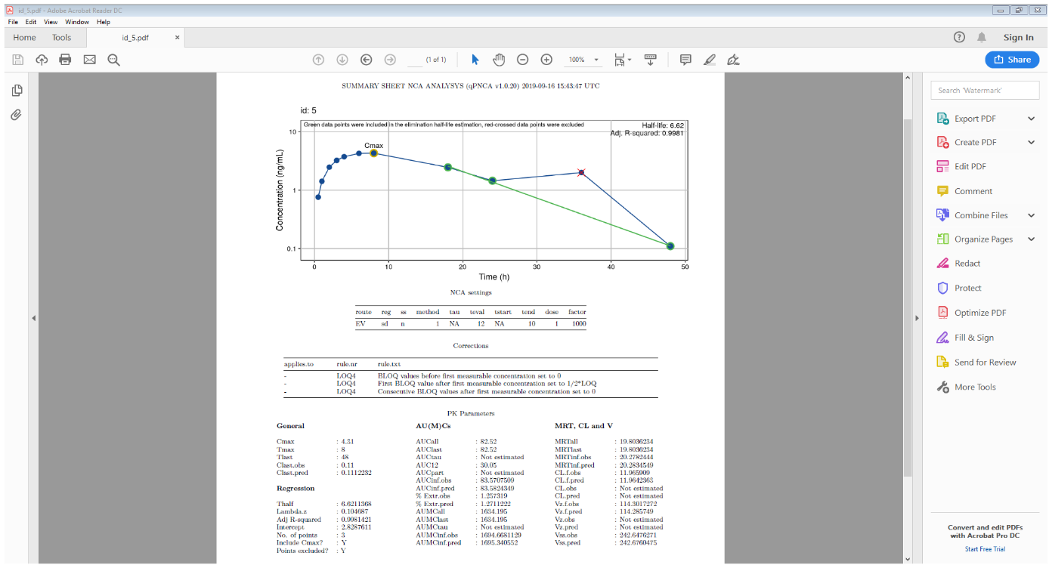

# Workflow

This paragraph describes the qpNCA main functions and their use in more detail. The user should apply the qpNCA functions on each concentration-time profile in the input dataset (for example, by using the dplyr::group_by function). In the examples below, it is assumed that individual curves in the input file *df* are identified by the *subject* and *period* variables. Furthermore, the following values are used for the arguments:

Table 2: argument values used in the examples

|  |  |  |
| --- | --- | --- |
| **Argument** | **Description** | **Value** |
| nomtimevar | variable name containing the nominal time after last dose | “ntad” |
| timevar | variable name containing the actual time after last dose | “tad” |
| depvar | variable name containing the dependent variable | “dv” |
| bloqvar | variable name containing the BLOQ flag (0: no, 1: yes) | “bloq” |
| loqvar | variable name containing the LOQ value | “loq” |
| exclvar | variable name containing information about points to be excluded in the thalf estimation (these should have <*exclvar*>=1) | “excl” |
| plotdir | Folder where regression plots will be stored | “plots” |
| pdfdir | Folder where NCA summary sheets wil be stored | “pdfs” |

## BLOQ corrections (correct.loq.r)

Imputes LOQ values according to the chosen LOQ substitution rule. Table 3 shows the available substitution rules and how LOQ values will be imputed.

Table 3: LOQ substitution rules

|  |  |  |  |
| --- | --- | --- | --- |
| **Rule nr.** | **Before first measurable concentration** | **After first measurable concentration** | |
| **First consecutive BLOQ** | **Other consecutive BLOQs** |
| 1 | 0 | NA | NA |
| 2 | 0 | 0 | 0 |
| 3 | 0 | 0.5*LOQ | NA |
| 4 | 0 | 0.5*LOQ | 0 |

Function call:

loqed = df %>% group_by(subject,period) %>%   
do (correct.loq(x,nomtimevar="ntad",timevar="tad",depvar="dv",  
 bloqvar="bloq",loqvar="loq",loqrule=1)) %>%  
ungroup

Arguments of the correct.loq function are described in Table 4.

Table 4: Arguments for correct.loq function

| **Argument** | **Description** | **Default value** | **Manda-tory?** |
| --- | --- | --- | --- |
| x | input dataset name (if called within dplyr: .) |  | Y |
| nomtimevar | variable name containing the nominal sampling time | “ntad” | Y |
| timevar | variable name containing the sampling time | “tad” | Y |
| depvar | variable name containing the dependent variable (e.g., concentration) | “dv” | Y |
| bloqvar | variable name containing the BLOQ flag (0: no, 1: yes) | ”bloq” | Y |
| loqvar | variable name containing the LOQ value | “loq” | Y |
| loqrule | rule number to be applied to the LOQ values in the curve | 1 | Y |

The result of the function is a dataset with imputed BLOQ concentrations using the chosen imputation rule.

## Elimination half-life estimation (est.thalf.r)

Estimates terminal half-life and related parameters based on the procedure described in the NCA Parameter Guideline.

The function starts with the last three sample points and performs log-linear regression on it. It then adds one sampling point at a time (including and ending at tmax) and performs the regression again. The results of the regression with the highest adjusted R-squared are returned. Visual outliers can be excluded from the regression analysis.

Function call:

th = df %>% group_by(subject,period) %>%  
 do(est.thalf(.,timevar="tad",depvar=“dv",includeCmax="Y",exclvar=”excl”)) %>%  
 ungroup

Arguments of the est.thalf function are described in Table 5. The result of the function is a dataset with regression parameters for each curve. The parameters are listed in Table 6.

Table 5: Arguments for est.thalf function

| **Argument** | **Description** | **Default value** | **Manda-tory?** |
| --- | --- | --- | --- |
| timevar | actual time after last dose | “tad” | Y |
| depvar | dependent variable | “dv” | Y |
| includeCmax | can Cmax be part of subset used for regression? (Y/N) | “Y” | Y |
| exclvar | variable name containing information about points to be excluded (these should have *<exclvar>*=1) | NA | N |

Table 6: Parameters returned from est.thalf function

| **Parameter** | **Description** |
| --- | --- |
| no.points | number of data points used in the regression analysis |
| intercept | estimated intercept |
| lambda_z | -1*estimated slope |
| r.squared | square of the correlation coefficient |
| adj.r.squared | adjusted square of the correlation coefficient |
| thalf | elimination half-life |
| start_th | time of first sample included in the thalf estimation |
| end_th | time of last sample included in the thalf estimation |
| includeCmax | include results of regression including Cmax in selection? (y/n) |
| points_excluded | are time points excluded from the half-life estimation? (y/n) |

The output dataset will be used in both time deviation corrections and missing concentration imputations.

## Regression plots

The user can choose to create plots (*.PNG) which depicts details regarding the estimation of the elimination rate constant.

Function call:

plot.reg(x,by=c("subject",”period”),th=th,bloqvar="bloq",timevar="tad",depvar="dv",  
 exclvar="excl",plotdir="plots",timelab="Time (h)",deplab="Concentration (ng/mL)")

Arguments of the plot.reg function are described in Table 7: Arguments for the plot.reg function. The result of the function is a graphical file (*.PNG) for each curve. See paragraph 5.2 for more details about the information in the graph.

Table 7: Arguments for the plot.reg function

| **Argument** | **Description** | **Default value** | **Manda-tory?** |
| --- | --- | --- | --- |
| x | input dataset, in most cases the dataset that also serves as input for the est.thalf.r function | x | Y |
| by | list of variables that identify a single PK curve | c("id") | Y |
| th | file name of file with lamdba_z information for each curve | NA | Y |
| bloqvar | variable name containing the BLOQ flag (0: no, 1: yes) | ”bloq” | Y |
| timevar | variable name containing the sampling time | “tad” | Y |
| depvar | variable name containing the dependent variable (e.g., concentration) | “dv” | Y |
| exclvar | variable name containing information about points to be excluded (these should have *<exclvar>*=1) | NA | Y |
| plotdir | folder where plots will be saved; if empty plots will be sent to standard output | NA | Y |
| timelab | label for the time axis of the plot | “timevar” | Y |
| deplab | label for the Y-axis (dependent variable) of the plot | “depvar” | Y |

## C­max and tmax calculation (calc.ctmax.r)

Calculates Cmax and tmax from uncorrected data. When maximum concentrations occur at various time points in the same individual concentration vs. time profile, the first occurrence will be considered for Cmax and tmax. If all concentrations are NA, both Cmax and tmax are set to NA.

Function call:

ctmax = df %>% group_by(subject,period) %>%  
 do(calc.ctmax(.,timevar="tad",depvar="dv")) %>%  
 ungroup

Arguments of the calc.ctmax function are described in Table 8. The result of the function is a dataset containing the parameters described in Table 9.

Table 8: Arguments for the calc.ctmax function

| **Argument** | **Description** | **Default value** | **Manda-tory?** |
| --- | --- | --- | --- |
| timevar | actual time after last dose | “tad” | Y |
| depvar | dependent variable | “dv” | Y |

Table 9: Parameters returned from calc.ctmax function

| **Parameter** | **Description** |
| --- | --- |
| Cmax | maximum concentration |
| tmax | time of first occurence of Cmax |

## Time deviation corrections (correct.time.r)

Time deviation corrections are needed if actual time after dose deviates from nominal time after dose at critical time points. Critical time points can be t=0, t=tau, t=teval (where teval is the last time point of the partial area AUC0-teval), tstart and tend (if AUC­tstart-tend is requested).

qpNCA corrects time deviations by applying specific rules to the critical time points, as stated in Table 10.

Table 10: Time deviation correction rules

|  |  |  |  |
| --- | --- | --- | --- |
| **Rule nr.** | **Regimen** | **Description** | **Applied to** |
| SDT-1 | sd | Set actual time to 0 | t=0 |
| SDT-2 | sd | Correct concentration at deviating time **by interpolation** | t=tau, tstart, tend, teval |
| SDT-3 | sd | Correct concentration at deviating time  **by extrapolation** | t=tau, tend, teval |
| MDT-1 | md | if predose sample taken after dosing, set actual time to 0 and conc to NA | t=0 |
| MDT-2 | md | Correct concentration at deviating time **by interpolation** | t=tau, tstart, tend, teval |
| MDT-3 | md | Correct concentration at deviating time **by extrapolation** | t=0, tau, tend, teval |
| MDT-3a | md | Set actual time to 0 if concentration is BLOQ | t=0 |

Function call:

df_tc= df %>% group_by(subject,period) %>%  
 do(correct.time(.,by=c(”subject”,”period”),nomtimevar="ntad",timevar="tad",depvar=“dv",  
 tau=,tstart=,tend=,teval=24,th=th,reg="SD“, method=1)) %>%  
 ungroup

Arguments of the correct.time function are described in Table 11.

Table 11: Arguments of the correct.time function

| **Argument** | **Description** | **Default value** | **Manda-tory?** |
| --- | --- | --- | --- |
| by | by-variable(s), e.g. c("subject","day"). Each by-group should contain concentration-time information for one dosing interval | “subject” | Y |
| nomtimevar | variable containing the nominal sampling time | “ntad” | Y |
| timevar | actual time after last dose | “tad” | Y |
| depvar | dependent variable | “dv” | Y |
| tau | dosing interval (for multiple dosing) | NA | N |
| teval | user selected AUC interval, if not requested, leave empty | NA | N |
| tstart | start time of partial AUC (start>0) | NA | N |
| tend | end time of partial AUC | NA | N |
| th | file name of file with lamdba_z information for each curve | NA | N |
| reg | regimen, "SD" or "MD“ | “MD” | Y |
| method | method of interpolation:  1: linear up - linear down  2: linear up - logarithmic down | 1 | Y |

The result of the function is a dataset with:

- Time deviation corrections applied to each requested critical time point  
- Correction rule number and explanatory text

This dataset will be the input dataset for the missing concentration imputations.

## Missing concentration imputations (correct.conc.r)

Missing concentrations at critical time points need to be imputed before corresponding AUCs can be calculated. This function will take the output dataset from correct.time.r as input dataset. qpNCA imputes missing concentrations by applying specific rules to the critical time points as described in Table 12.

Table 12: Missing concentration imputation rules

| **Rule nr.** | **Regimen** | **Description** | **Applied to** |
| --- | --- | --- | --- |
| SDC-1 | sd | Set concentration to 0 (only non-endogenous compounds) | t=0 |
| SDC-2 | sd | impute missing concentration **by interpolation** | t=tau, tstart, tend, teval |
| SDC-3 | sd | impute missing concentration **by extrapolation** | t=tau, tend, teval |
| SDC-4 | sd (IVB) | impute missing concentration by **back-extrapolation** | t=0 |
| MDC-1 | md | impute missing concentration by existing conc at t=0 or t=tau* | t=0, tau |
| MDC-2 | md | impute missing concentration **by interpolation** | t=tau, tstart, tend, teval |
| MDC-3 | md | impute missing concentration **by extrapolation** | t=tau, tend, teval |
| MDC-4 | md (IVB) | impute missing concentration by **back-extrapolation** | t=0 |

* *only if steady state has been reached*

Function call:

df_tc_cc= df_tc %>% group_by(subject,period) %>%  
 do(correct.conc(.,by=c(“subject”,”period”),nomtimevar="ntad",tau=,  
 tstart=,tend=,teval=24,th=th,reg="SD",ss="n“,  
 method=1,route=“EV”)) %>% ungroup

Arguments of the correct.conc function are described in Table 13.

Table 13: Arguments of the correct.time function

| **Argument** | **Description** | **Default value** | **Manda-tory?** |
| --- | --- | --- | --- |
| by | by-variable(s), e.g. c("subject","day"). Each by-group should contain concentration-time information for one dosing interval | “subject” | Y |
| nomtimevar | variable containing the nominal sampling time | “ntad” | Y |
| tau | dosing interval (for multiple dosing) | NA | N |
| teval | user selected AUC interval (start: t=0) | NA | N |
| tstart | start time of partial AUC (start: t>0) | NA | N |
| tend | end time of partial AUC | NA | N |
| th | file name of file with lamdba_z information for each curve | NA | N |
| reg | regimen, "sd" or "md“ | “SD” | Y |
| ss | is steady state reached? (y/n) | “n” | Y |
| method | method of interpolation:  1: linear up - linear down  2: linear up - logarithmic down | 1 | Y |
| route | : route of drug administration ("EV", "IVB", ”IVI”) | “EV” | Y |

The result of the function is a dataset with:

- Concentration imputations applied to each requested critical time point  
- Correction rule number and explanatory text

This dataset will be the input dataset for both the overview of time corrections and imputations (tab.corr.r) and the parameter calculation (calc.par.r).

## Overview of time corrections and imputations (tab.corr.r)

This function summarizes the time deviation corrections and concentration imputations applied to the entire dataset. If records are added because a critical time point record is missing, this will also be documented. It takes the resulting dataset after time deviation correction and concentration imputation as input dataset.

Function call:

corrtab= df_tc_cc %>%  
 tab.corr(.,nomtimevar="ntad",by=c(“subject","period"))

Arguments of the tab,corr function are described in Table 14.

Table 14: Arguments of the tab.corr function

| **Argument** | **Description** | **Default value** | **Manda-tory?** |
| --- | --- | --- | --- |
| nomtimevar | variable containing the nominal time | “ntad” | Y |
| by | by-variable(s), e.g. c("subject","period") | “subject” | Y |

The result of the function is a dataset with:

- A record for each deviating time point containing:

- Time deviation correction rule applied  
- Concentration imputation rule applied  
- Textual explanation  
- Info about the critical time point(s) involved  
- If records are added because a critical time point record is missing,  
 this will also be documented

## Calculation of PK parameters, no half-life needed (calc.par.r)

This function produces all requested parameters for which half-life is not needed in the calculation. It takes the resulting dataset after time deviation correction and concentration imputation as input dataset.

Function call:

par= df_tc_cc %>% group_by(subject,period) %>%   
 do(calc.par(.,tau=,tstart=,tend=,teval=24,  
 route="EV", method=)) %>%   
 ungroup

Arguments of the calc.par function are described in Table 15. The result of the function is a dataset containing the parameters described in Table 16.

Table 15: Arguments of the calc.par function

| **Argument** | **Description** | **Default value** | **Manda-tory?** |
| --- | --- | --- | --- |
| tau | dosing interval (for multiple dosing) | NA | N |
| teval | user selected AUC interval | NA | N |
| tstart | start time of partial AUC (start>0) | NA | N |
| tend | end time of partial AUC | NA | N |
| route | route of drug administration ("EV", "IVB", ”IVI”) | “EV” | Y |
| method | method for trapezoidal rule:  1: linear up - linear down  2: linear up - logarithmic down  3: linear before first tmax, logarithmic after first tmax | 1 | Y |

Table 16: Parameters returned from the calc.par function

| **Parameter** | **Description** |
| --- | --- |
| t0.ok | flags if t=0 concentration could be corrected/imputes. If not, no AUCs starting at t=0 are calculated |
| tlast.ok | flags if there is at least one measurable concentration. If not, no AUClast can be calculated |
| tlast | time of last sample with measurable concentration |
| clast.obs | observed concentration at tlast |
| aucall | auc calculated over all observations, including values below LOQ (which are set to 0) |
| auclast | auc calculated using all observations up to and including the last measurable concentration (clast.obs at tlast) |
| aumcall | aumc calculated over all observations, including values below LOQ (which are set to 0) |
| aumclast | aumc calculated using all observations up to and including the last measurable concentration (clast.obs at tlast) |
| mrtall | mean residence time based on aucall |
| mrtlast | mean residence time based on auclast |
| tau | the dosing interval (if specified) |
| calc.tau | flags if AUCtau could be calculated |
| auctau | auc calculated over the dosing interval, only calculated if tau is specified |
| aumctau | aumc calculated over the dosing interval, only calculated if tau is specified |
| teval | user selected AUC interval starting at t=0 (if specified) |
| calc.teval | flags if AUCteval could be calculated |
| aucxx | auc calculated from t=0 up to/including teval, only calculated if teval is specified (xx is substituted by teval) |
| calc.part | flags if AUCpart could be calculated |
| tstart | start time of partial AUC (if specified) |
| tend | end time of partial AUC (if specified) |
| aucx_y | partial auc from time=x up to/including time=y, where x>0, only calculated if tstart and tend are specified |
| c0 | back-extrapolated concentration at t=0 for IV bolus administration |
| area.back.extr | area back-extrapolated to 0 |

This dataset will be the input dataset for the functions that calculates PK parameters that do need half-life for calculation.

## Calculation of Parameters that do need thalf (calc.par.th.r)

This function calculates the PK parameters for which a half-life is needed for calculation. It takes the output dataset from the calc.par.r function as input dataset. Besides a dataset containing the half-life information it needs a covariate dataset that at least contains the “group_by”-variables and a variable that contains the dose amount associated with the curve.

Function call:

par_th= calc.par.th(x=par,by=c(“subject”,”period”),th=th ,cov=cov,dose=“dose",factor=1000,reg="SD",ss="N")

Arguments of the calc.par function are described in Table 17. The result of the function is a dataset containing the parameters calculated by the *est.thalf* and *calc.par* functions and the extra parameters described in Table 18.

Table 17: Arguments of the calc.par.th function

| **Argument** | **Description** | **Default value** | **Manda-tory?** |
| --- | --- | --- | --- |
| x | result parameter dataset from calc.par | par | Y |
| by | by-variable(s), e.g. c("subject","day"). Each by-group should contain concentration-time information for one dosing interval | “subject” | Y |
| th | result dataset from est.thalf | th | Y |
| cov | co-variates dataset | cov | Y |
| dose | variable containing the dose amount | “dose” | Y |
| factor | conversion factor for CL and V calculation (e.g. dose in mg, conc in ng/mL, factor=1000) | 1 | Y |
| reg | regimen, "sd" or "md" | “SD” | Y |
| ss | is steady state reached (y/n) | “N” | Y |

Table 18: Parameters returned from the calc.par.th function

| **Parameter** | **Description** |
| --- | --- |
| t0.ok | flags if t=0 concentration could be corrected/imputes. If not, no AUCs starting at t=0 are calculated |
| tlast.ok | flags if there is at least one measurable concentration. If not, no AUClast can be calculated |
| tlast | time of last sample with measurable concentration |
| clast.obs | observed concentration at tlast |
| aucall | auc calculated over all observations, including values below LOQ (which are set to 0) |
| auclast | auc calculated using all observations up to and including the last measurable concentration (clast.obs at tlast) |
| clast.pred | predicted concentration at tlast |
| aucinf.obs | aucinf based on observed concentration at tlast |
| aucinf.pred | aucinf based on predicted concentration at tlast |
| aumcinf.obs | area under the first moment curve extrapolated to infinity, based on observed concentration at tlast |
| aumcinf.pred | area under the first moment curve extrapolated to infinity, based on predicted concentration at tlast |
| cl.f.obs | clearance based on aucinf.obs, at steady state based on auctau |
| cl.f.pred | clearance based on aucinf.pred |
| mrt.obs | mean residence time based on aumcinf.obs and aucinf.obs |
| mrt.pred | mean residence time based on aumcinf.pred and aucinf.pred |
| vz.f.obs | distribution volume based on cl.f.obs, at steady state based on auctau |
| vz.f.pred | distribution based on cl.f.pred |
| vss.obs | steady-state volume based on cl.obs and mrt.obs |
| vss.pred | steady-state volume based on cl.pred and mrt.pred |
| pctextr.pred | percentage of AUC extrapolated to infinity, based on aucinf.pred |
| pctextr.obs | percentage of AUC extrapolated to infinity, based on aucinf.obs |
| pctback.pred | percentage of AUC extrapolated back to 0, based on aucinf.pred |
| pctback.obs | percentage of AUC extrapolated back to 0, based on aucinf.obs |

## Creation of summary sheets (nca.sum.r)

This function produces a one-page sheet for each curve containing the regression plot (if created), NCA settings, applied time deviation corrections and missing concentration imputations and estimated PK parameters.

Function call:

nca.sum(x,corrfile=corrtab,by=c("subject",”period”),plotdir="plots",pdfdir=”pdfs”)

Arguments of the nca.sum function are described in Table 19.

Table 19: Arguments of the nca.sum function

| **Argument** | **Description** | **Default value** | **Manda-tory?** |
| --- | --- | --- | --- |
| x | result parameter dataset from calc.par | par_all | Y |
| corrfile | result dataset from tab.corr | corrtab | Y |
| by | list of variables that identify a single PK curve | c(“id”) | Y |
| plotdir | folder where plots will be saved; if empty plots will not be added to the summary sheet | NA | Y |
| pdfdir | folder where NCA summary sheets (.PDF) will be saved; if not present it will be created | NA | Y |

# References

Rowland and Tozer (2011). *Clinical Pharmacokinetics and Pharmacodynamics: Concepts and applications*, 4th ed. Wolters Kluwer, Philadelphia.

Gabrielsson and Weiner (1997). *Pharmacokinetic and Pharmacodynamic Data Analysis:*

*Concepts and Applications*, 2nd ed. Swedish Pharmaceutical Press, Stockholm.

Gibaldi and Perrier (1982). *Pharmacokinetics*, 2nd ed. Marcel Dekker, New York.

# Flowcharts

## Flowchart of corrections and imputations for t = 0 (predose)

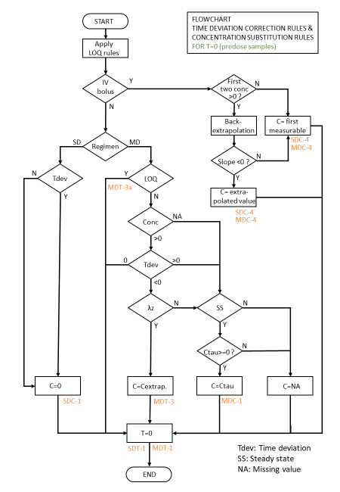

## Flowchart of corrections and imputations for t = tstart, tend and teval

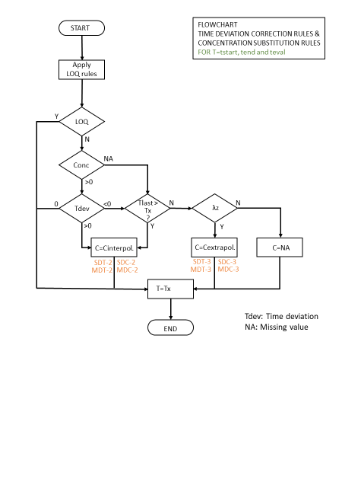

## Flowchart of corrections and imputations for t = tau

