**Evaluation Techniques:**

* Preferences of neighbour users
* Past performance of the current system (legitimacy)
* Past preferences of given users (based on contents of items)
* Ratings of recommended item (given by other users or neighbours)
* Criteria matching the recommendation (even if given by user)
* Reciprocal explanations (list benefits for both parties)

**Possible Explanation Techniques:**

* Table/pie chart/histogram with ratings of n closest neighbours for all recommended movies. (note: most similar for recom 1 might not be the same user as most similar for recom 2).

|  |  |  |  |  |
| --- | --- | --- | --- | --- |
|  | Recom 1 | Recom 2 | Recom 3 | Recom 4 |
| Most like |  |  |  |  |
| Second-most like |  |  |  |  |
| Third-most like |  |  |  |  |

* Clustered bar chart/pie chart of favourite k genres (only ratings of 4 and 5) of n closest neighbours (clustered in order of proximity?).
* Histogram/scatter plot showing genres of n closest items (annotations of titles).

**Aims of Explanations methods:**

* Transparency: explain how the system works.
* Scrutability: allow users to tell if system is mistaken.
* Trustworthiness: increase user’s confidence in the system.
* Effectiveness: enable users to make the correct decisions.
* Persuasiveness/Promotion: convince users to follow recommendation.
* Efficiency: help users make decisions faster.
* Satisfaction: increase user experience and satisfaction from recommendation.

**Visualisations of Metrics:**

Can add small textual explanations on each page.

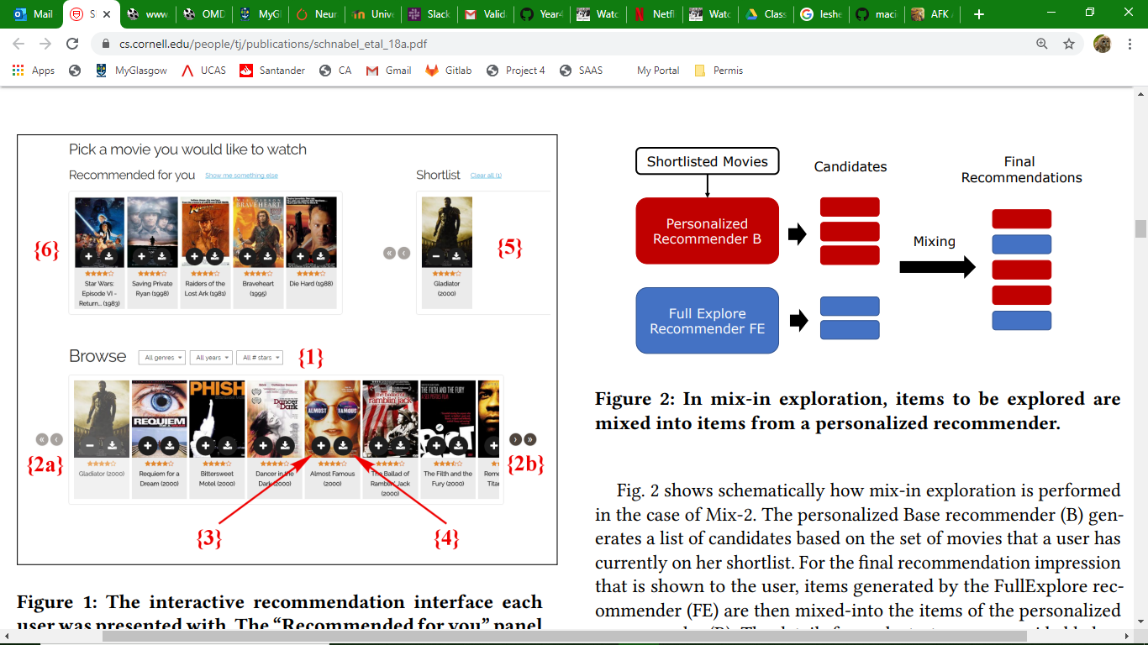

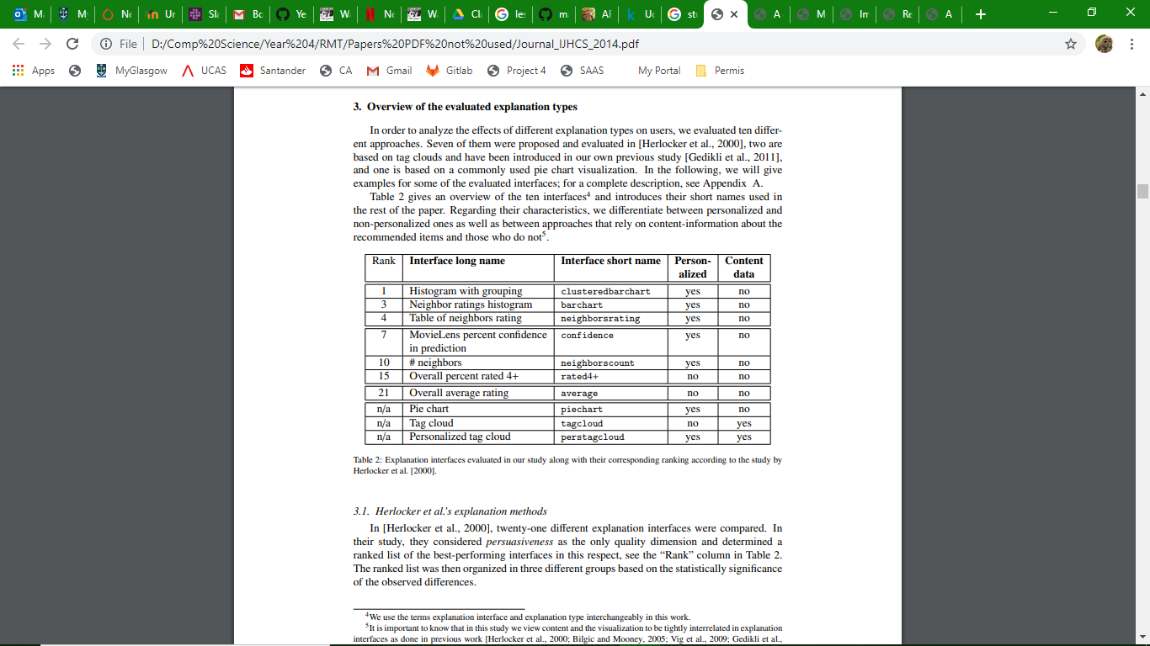

* Histogram: top 10 or 20 genres for the user, ratings given to a movie by similar users (how many users are considered similar?), similarity (genre?) to other items in user’s profile.
* Single-value (stars) showing average rating of the movie. Prediction Confidence display for MovieLens.
* Radar chart
* Line graph
* Tables
* Pie chart
* Text
* Likert Scale 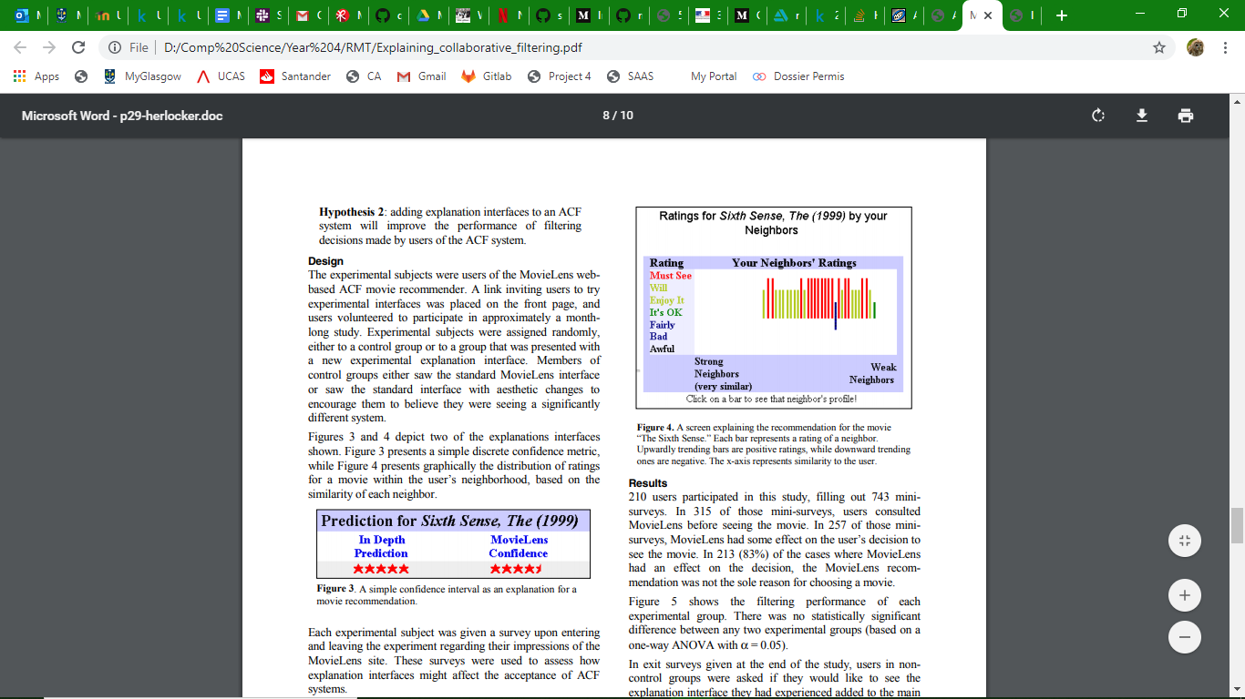

**UI:**

* TK Framework to build a GUI in Python (cross-platform). Good for graphical UIs. Abundance of online models and resources.