**<UCCG System>**

**Testing Plan & Report**

**<Version 4.0>**

**<19/05/2019>**

<

**何朗轩 1730026028**

**李东华1730026039**

**李俊江 1730026044**

**余家慧 1730026139**

>

**Computer Science and Technology Program**

**United International College**

1. Document Change Log

|  |  |  |  |
| --- | --- | --- | --- |
| ***Change Date*** | ***Changed By*** | ***Version*** | ***Change Description*** |
| *18/05/2019* | *He langxuan* | *1.0* | *Prepared Document* |
| 19/05/2019 | He langxuan | 2.0 | Upload the admin test of Schedule Management Page |
| 19/05/2019 | Yu jiahui | 3.0 | Upload the User part testing reprot |
| 19/05/2019 | Li junjiang | 4.0 | Upload the Administrator information page testing report |
|  |  |  |  |
|  |  |  |  |
|  |  |  |  |
|  |  |  |  |
|  |  |  |  |
|  |  |  |  |

1. Table of Contents

1. Document Change Log 2

2. Table of Contents 3

3. Design Overview 4

4. Tools and Standards 5

4.1. Tools 5

4.2. Standards 5

5. User Interface Design 6

5.1. Usage Scenario 1 6

5.2. Usage Scenario 2 6

6. Database Design 7

7. Diagrams 8

1. Testing Plan

## Overview of the Testing Plan

Testing Plan is to maintaining functions in each page are work properly. Testing plan will start when the prototype of the project has finished. This testing report is to record the testing methods that our team have done and reporting errors that have appeared. Because the UCCG System can be separate into two functional independent part: User function part and Administrator function part. There are two team(each has two member) who responsible for User and Admin.

User: Li donghua, Yujiahui

Admin: He langxuan, Li junjiang

## Testing Methods

*User Part*

Four main functions are included in this part— user register、team register 、reset account and login.

### Testing user registration

There are ten elements in this page that need users to input—student id、email、user name、password 、password-confirmed、security question1 and answer、security question2 and answer、phone number.

1. All data are required

Input information and last one input empty to see whether it can submit or not.

1. E-mail should require its format

Using a string like ‘0000000’ which is obviously not an email address to test whether it can submit or not.

1. The password must equal to the password-checked

Input differently in ‘Your Password’ and ‘Confirm your Password’ to see whether it can submit or not.

1. Already registered id cannot register again

Use an id that has already registered before to test whether it can register again.

1. The username of the users has to be identical

Using a username that already existed in database to check whether it can be used in more than one user.

### Testing login

Use the student id and password that just registered before to test whether the register is successes and the login page worked.

### Reset account

Four elements are required in this page—student id、two security question answers and phone number. Test the security answer and phone number to confirm whether unmatched answers and phone number in that lost account can submit and direct to reset password page.

### Team register

1. The student id in the ‘leader_id’ field must match the password in the database. Try invalid password to see whether it can create a new team under the id or not.
2. The team name has to be unique. Check an already used team name to see whether it can be registered or not.
3. Team member ‘s student id cannot be repeated. Try to fill to input of team member ‘s student id with a same id to see whether it can work or not.

### Competition sign up

* 1. Check the id and the password
  2. If sign up as an individual, check whether the password is valid to the student id. If sign up as a team, check whether the password is valid to the team leader’s account.
  3. Check the permission. A player that already be forbidden to game cannot participate in an event.
  4. Check an account that has been banned to see whether it can sign up or not.
  5. Check whether the individuals or the team has already signed up to the event.

*Administrator Part*

### Create a new Event

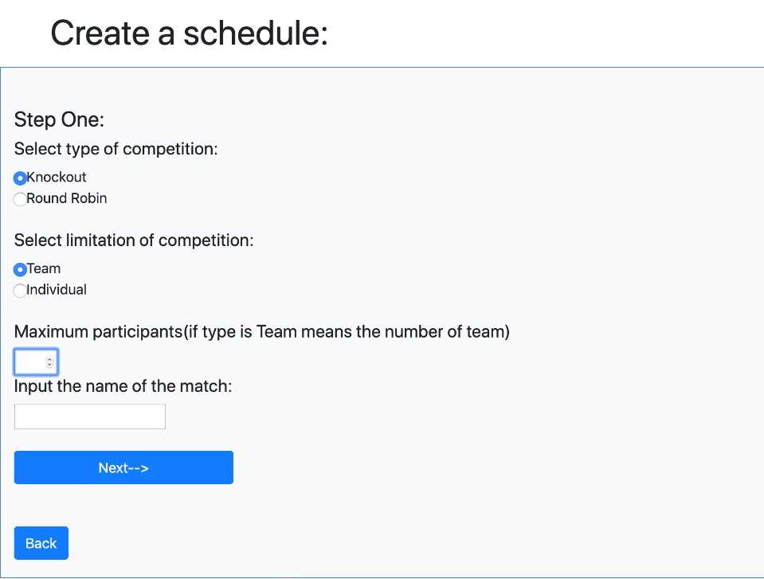

1. If there is an input box miss data, it cannot submit for process
2. Input box that input the maximum number cannot input a non-number character
3. If the name has already existed in the database it will show error message
4. If submit successful it will show the success message and database will have the data

### Edit a Exist Event

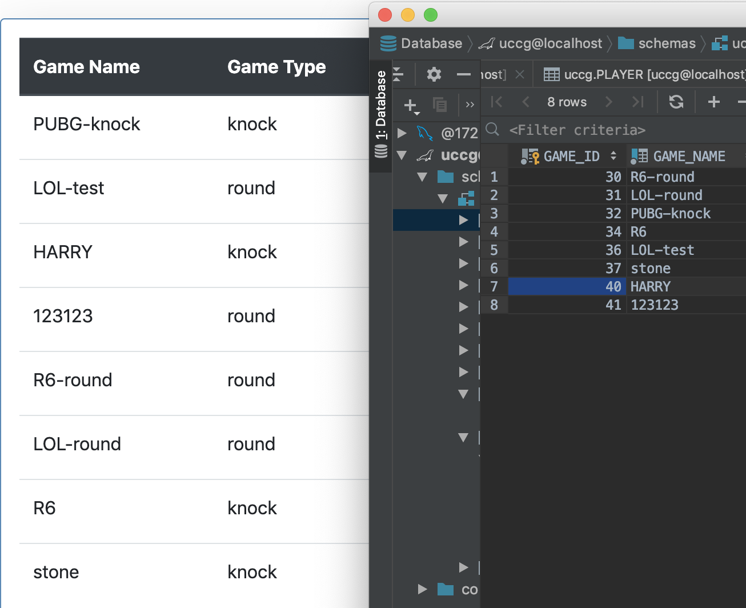

1. Check if all the event in database are displayed

C:\Users\harry\AppData\Local\Temp\WeChat Files\cad30aa967b01339b3ccf59e4bae755.pngC:\Users\harry\AppData\Local\Temp\WeChat Files\2904ef4360a83414184178c9d705129.png

1. Check if the condition of event can be edit(Available, onMatching , Stopped) when event is available ,it can change to onMatching and stop. When it is stopped it need to click reset button to reset the condition. When the event is onMatching, the edit button will be functional. Finally check if the database have applied the change

. 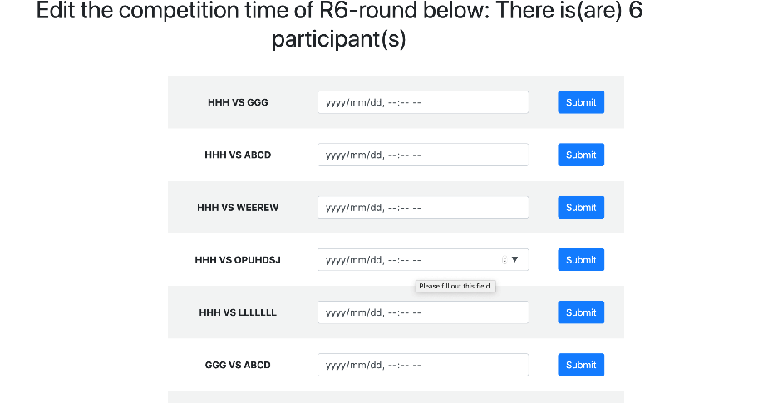

1. All the event has edit time function. In the edit time page. It will display the arrangement according to game type (knock-out or round robin). The page only can upload one time arrangement at once. After click submit button,time arrange will show below. Especially for knock-out type game if there is a team by in the current round it won’t display the time arrange input box, it will display a message: bye this round and submit button. After submission it will show the bye below. Check the database if all the time arrangement is uploaded

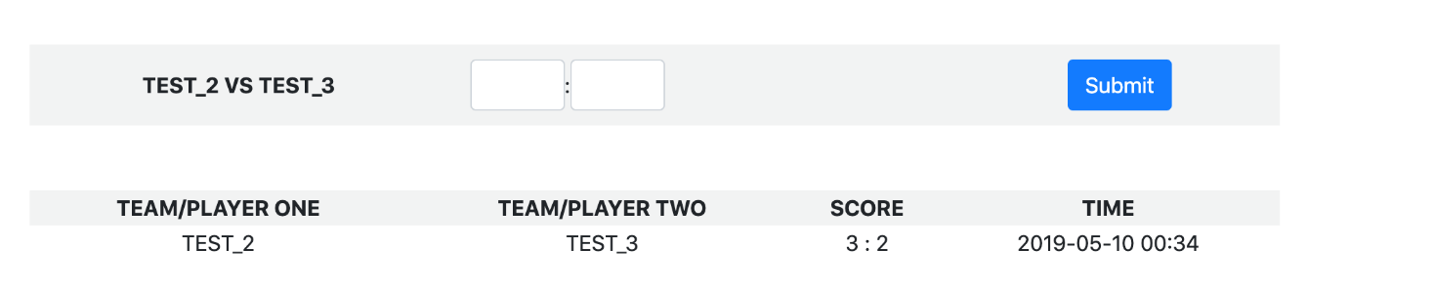

1. All the event have edit score page. Administrator can update the score between two teams/players if they have time arrangement. Two teams/players have same score is not allowed and it will show the warning message. If successful submit the score the result will display below. Check if the database has updated the score

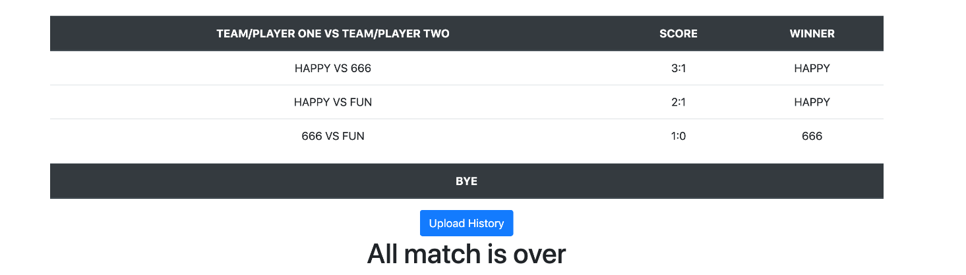

5. Only when the game type is round robin it will have the upload result page. In this page, it won’t show the upload result button until all the game arrangements are finished. After click on the Upload result button all the match result will be uploaded to database and show the success message. The history cannot be uploaded twice. If do ,it will show the error message



1. When the game type is knock out. It will have knock-out page. It will display all the result of each match that have scores. If the score haven’t finished , it won’t appear the Generate the next round button. After click on the generate button all the game result of current round will be uploaded to database , the current round will add one , the current round record will be deleted. Check the database if the history is uploaded and previous round result is cleaned. Check the edit time page if the game arrangement has changed. There is a special condition that if there is a round only have three participants, it will change the mode to round robin.

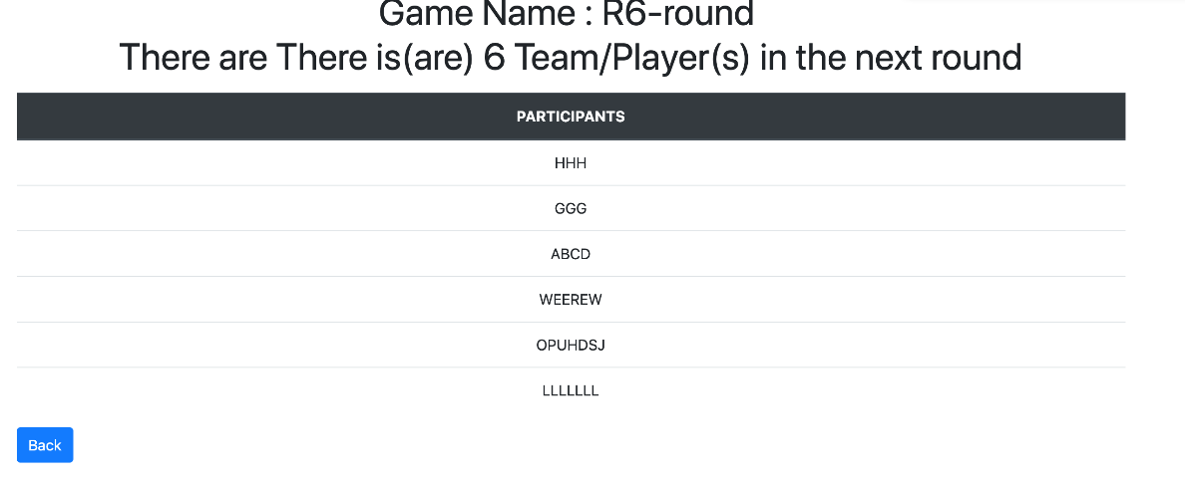

7.All the game event will have view page. In this page, it will show the participants in the current round.

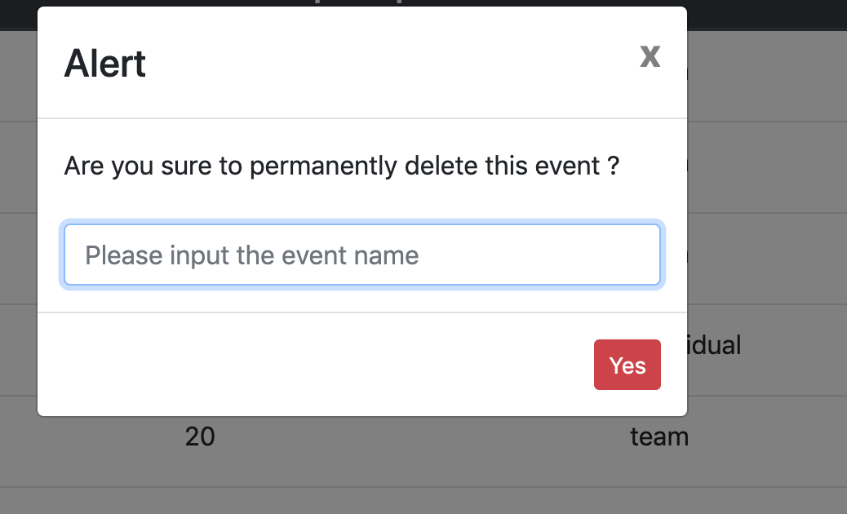

1. Administrator can delete a event if they want, if click on the delete button it will show the alert, After type the event name, if the name exist, it will successfully delete every information about the event. If it is not exist it will show the error message.

### Information Query

Administrator can search the information of the game, team and user.

When you choose the type of the table, website will show a condition line to administrator. And administrator also can click the “add a condition” button to add a condition line or click a “delete” button to delete the last line.

The condition lines can be multiple, so administrator query information by lots of condition, such as search the users’ student ID between 1730026000 to 1730030000(student ID ≥ 1730026044 and student ID ≤ 17300300000), but also is useful in searching by date, team ID, etc.

step:

1. Delete all the condition lines and query
2. Searching information by one condition line
3. Searching information by a few condition line

3.2.2 User permission update

Administrator can update the user permission to ban (not allow the user to use his/her account), user, player, team leader, project leader, chief leader (top administrator)

Step:

1. Fill nothing and click the update button
2. Fill a wrong ID and update
3. Fill a right ID and update

4.2.1 Information Query Error

1. Result shows nothing(solved)
2. Result can not follow the condition(solved)
3. Different table have different column

4.2.2 User permission update Error

1. Can not change the permission
2. Show success when the user not found
3. Testing Report

## Overview of the Testing

The testing plan is stated when the prototype of this system has done. Up to now, we spend one week and a half to test and improve the system. In the latest testing, most of the bugs and errors are fixed during the test, and we add some functional design to give user a better experience.

## Error Report

1. Contributions

*<Please provide the contributions of team members of your group.>*

|  |  |  |  |  |
| --- | --- | --- | --- | --- |
| Student ID | Name (in Pinyin/Chinese) | Contribution (in %) | Responsibilities/Work Done, Database design | Remarks |
| 1730026028 | He langxuan | 30% | Admin - Schedule Management |  |
| 1730026039 | Li donghua | 30% | User information page, competition registration page, registration page |  |
| 1730026044 | Li junjiang | 30% | and administrator information edit page |  |
| 1730026139 | Yu jiahui | 10% | Team registration page find password page |  |
|  |  |  |  |  |