**Learn Automation (Web + Automation) Step by steps**

By - @Amit Sahu

Notes by Author – just collecting the resources from different places and consolidating for quick access

Initial version of the document is created for mac OS , will update this further for windows

Software Testing –

[]

What is Software testing ?

[]

What is the need of Software Testing ?

[]

Automation Testing ?

[]

Why and what to Automate?

[]

How much to Automate ?

[]

Different approaches

[]

When to start

[]

What tool to select

[]

How to select a tool for your project

[]

Why selenium

[]

Why Appium

[]

Type of the frameworks

[]

Some Reference links

[]

**Getting started with the setup**

Install Java

Check whether you have java installed in your system

*java -version*

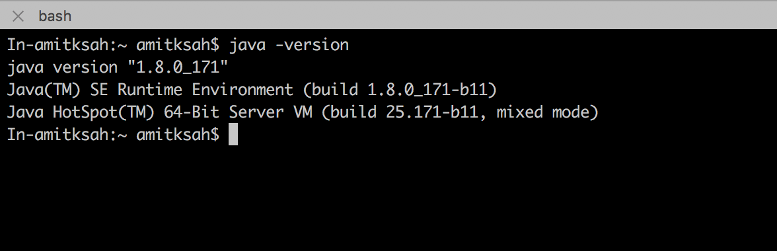

*If not ()*

[*https://java.com/en/download/help/mac_install.xml*](https://java.com/en/download/help/mac_install.xml)

*“so , java is installed now move forward for any of the build tool .  
We can use maven / gradle ”*

**Maven**

How to install maven

Check whether you have maven installed in your mac

*mvn -v*

**

*If not install using brew helper*

*Same time install the gradle as well , which we will use for Mobile (why – Even I am looking for a good justification)*

**Gradle**

*How to install gradle*

*Check the gradle version*

*gradle -v*

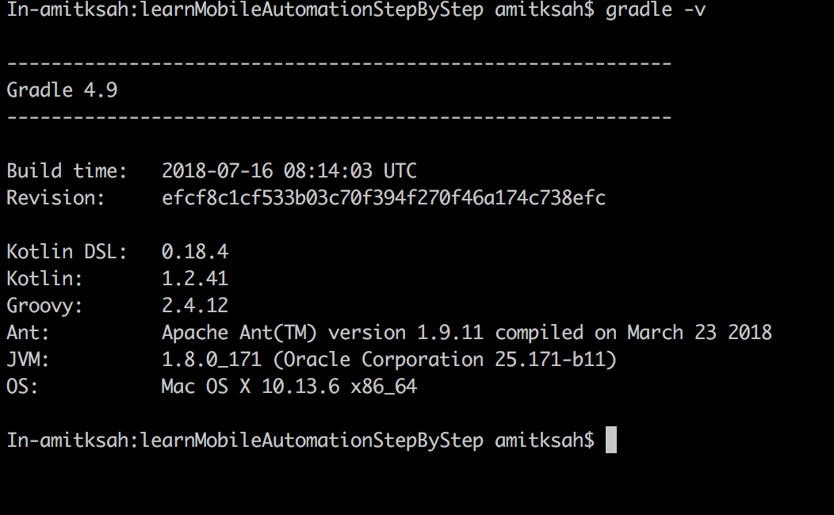

*Install npm*

*Check the npm version*

*npm -v*

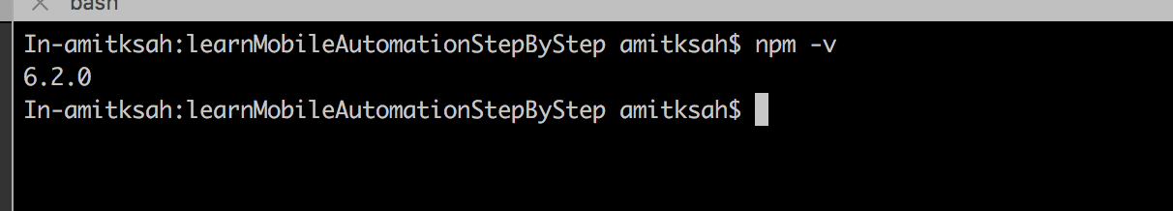

*Node*

*Check the node installation / version*

*node -v*

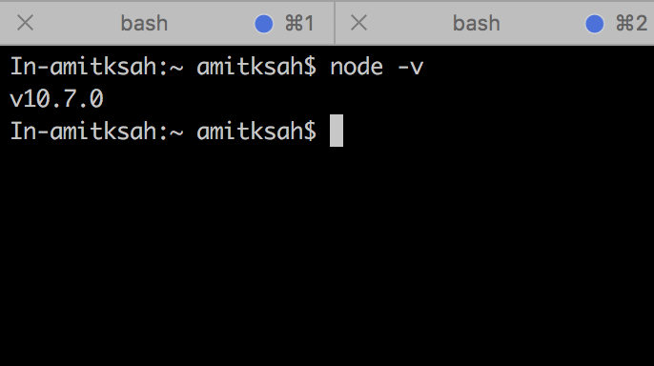

*Install Appium doctor*

*Appium -doctor –android*